Name of Journal: World Journal of Clinical Cases
Manuscript NO: 72032
Manuscript Type: CASE REPORT

Primary isolated central nervous system acute lymphoblastic leukemia with BCR-ABL1 rearrangement: A case report

Chen Y et al. A rare care of leukemia

Yan Chen, Quan-Yi Lu, Jing-Yuan Lu, Xiu-Li Hong

Yan Chen, Quan-Yi Lu, Jing-Yuan Lu, Xiu-Li Hong, Department of Hematology, Zhongshan Hospital of Xiamen University, Xiamen 361000, Fujian Province, China

Author contributions: Lu QY designed the research; Lu JY and Hong XL performed the research; Chen Y analyzed the data and wrote the manuscript; all authors have read and approve the final manuscript.

Supported by the Science and Technology Plan Guide Project of Fujian Province, No. 2019D009.

Corresponding author: Quan-Yi Lu, MD, Chief Doctor, Department of Hematology, Zhongshan Hospital of Xiamen University, No. 209 Hubin South Road, Xiamen 361000, Fujian Province, China. luquanyi@xmu.edu.cn

Received: October 21, 2021
Revised: January 4, 2022
Accepted: March 15, 2022
Published online: May 6 2022
Abstract
BACKGROUND
BCR-ABL1 fusion gene is associated with a poor prognosis and a high incidence in central nervous system (CNS) leukemia. CNS invasion which detected at the initial diagnosis is commonly with bone marrow infiltration. It is uncommon for the leukemia cells to be located primarily in the CNS without bone marrow involvement.

CASE SUMMARY
We here report the rare initial presentation of CNS-restricted BCR-ABL-positive acute lymphoblastic leukemia in a 30-year-old female patient who clinically manifested with leukemic meningitis, with no involvement in peripheral blood or bone marrow. Identification of abnormal phenotypes of blast cells, and BCR-ABL1 rearrangement in the cerebrospinal fluid alone established the diagnosis of primary CNS-isolated acute lymphocytic leukemia. The patient received a combination of intrathecal therapy and high-dose chemotherapy. But the benefits of the treatments were short-lived and she experienced recurrence.

CONCLUSION
Flow cytometry in combination with molecular genetic analysis improved diagnostic accuracy. New approaches that may enhance the efficacy of the existing therapies and cure CNS leukemia are required.

Key Words: Acute lymphoblastic leukemia; BCR-ABL1; Diagnosis; Primary central nervous system leukemia; Treatment; Case report

©The Author(s) 2022. Published by Baishideng Publishing Group Inc. All rights reserved.

Citation: Chen Y, Lu QY, Lu JY, Hong XL. Primary isolated central nervous system acute lymphoblastic leukemia with BCR-ABL1 rearrangement: A case report. World J Clin Cases 2022; 10(13): 4242-4248
URL: https://www.wjgnet.com/2307-8960/full/v10/i13/4242.htm
DOI: https://dx.doi.org/10.12998/wjcc.v10.i13.4242

Core Tip: We report a rare newly diagnosed case in a female patient with BCR-ABL-positive leukemia cells primarily located in the arachnoid surface and the subarachnoid space, clinically manifesting as leukemic meningitis, without blood and bone marrow involvement. Given the rarity of this specific presentation of B cell-acute lymphocytic leukemia, the diagnosis and treatment approach are challenging.

INTRODUCTION
Acute leukemia (AL) is a malignancy hematologic disease of bone marrow (BM)-derived immature cells, which most often involves the BM and peripheral blood but may also manifest in extramedullary tissue. Acute lymphocytic leukemia (ALL) patients appear to have a higher incidence of central nervous system (CNS) disease than acute myelogenous leukemia. CNS leukemia can be present at the initial diagnosis concurrent with bone marrow involvement, but it also can develop at any time during the natural course of AL, even after years of complete remission, as isolated CNS relapse^{[1]}. In a few cases, leukemia cells are isolated to the CNS primarily without involvement of bone marrow. However, these cases are all non-lymphoid leukemia^{[2-4]}. We here report a rare case of newly diagnosed BCR-ABL-positive ALL primarily located in the superficial arachnoid and the subarachnoid space, clinically manifesting as leukemic meningitis, without peripheral blood or bone marrow involvement.

CASE PRESENTATION
Chief complaints
A 30-year-old Chinese woman presented with 2 mo history of unsteadiness while walking starting in May 2020.

History of present illness
A mo later, she presented with progressive difficulty in walking and both lower limbs dragging.

History of past illness
She denied a history of fever, wasting and night sweats.

Personal and family history
She had no personal or family history of malignancy.

Physical examination
On physical examination, no lymphadenopathy or organomegaly was detected. The myodynamia of left distant and proximate limb were grade 5- and grade 3+ respectively. The myodynamia of right distant and proximate limb were grade 5- and grade 4- respectively. Meningeal stimulation sign was negative. Cranial nerve examination and sensory examination was within normal limits.

Laboratory examinations
Complete blood counts showed white blood cells 4.08 × 10⁹/L (normal: 4-10 × 10⁹/L), hemoglobin 134 g/L (normal: 110-160 g/L), and platelets 280 × 10⁹/L (normal: 100-300 × 10⁹/L). Peripheral blood smears were negative. Lumbar puncture demonstrated increased opening pressure (220 mm H₂O) and was hypercellular with numerous large malignant cells in cerebrospinal fluid (CSF) (Figure 1). As central nervous system leukemia was suspected, the patient referred to our hematology department for further evaluation.
Flow cytometry of lumbar puncture indicated an aberrant lymphoblast population (92.8%); expression of cells of differentiation (CD) 19, CD10, CD34, human leukocyte antigen D related, CD13, and cCD79a; and absence of CD33, CD117, CD20, CD7, CD15, and cytoplasmic myeloperoxidase (Figure 2). Immunophenotype was consistent with pre-B cell-ALL. Polymerase chain reaction (PCR) screening covered 56 transcripts of myeloid fusion proteins and 15 transcripts of lymphoblastic fusion proteins, and showed the presence of BCR-ABL1 chimeric oncogene, encoding proteins of 190 kDa (p190) in CSF. This was quantified by real-time reverse transcriptase-PCR assay and found to be 24.061% (Table 1). Fluorescence in situ hybridization from the CSF revealed that 89.5% of the 200 cells screened had BCR-ABL fusion signals (Figure 3). Next-generation sequencing for BCR-ABL1 kinase domain mutation of CSF malignant cells did not show any mutations.
Bone marrow biopsies were performed several times, and were normocellular by flow cytometry and cytological analysis. No genetic mutations were found in BM by next-generation sequencing (NGS). PCR screening of the same transcripts with CNS was negative and indicated absence of BCR-ABL1 (p190).

Imaging examinations
There were no obvious abnormalities on brain and spine magnetic resonance imaging (MRI). Positron emission tomography-computed tomography (PET-CT) scans demonstrated no hypermetabolic involvement in other areas. There was no evidence of occuping diseases.

FINAL DIAGNOSIS
Primary isolated central nervous system acute lymphoblastic leukemia with BCR-ABL1 rearrangement.

TREATMENT
The patient initially received chemotherapy on July 23, 2020. Treatment consisted of methotrexate (3.5 g/m²) on day 1 plus cytarabine (2 g/m²) on day 2 and was combined with triple intrathecal chemotherapy including methotrexate 10 mg, cytarabine 50 mg and dexamethasone 5mg twice a week. After the treatments for 3 wk, she was free from symptoms. CSF cytology, flow cytometry, and BCR-ABL1 (p190) transcripts remained positive. She then underwent three cycles of methotrexate (3.5 g/m²) in combination with cytarabine (2 g/m²) twice daily on days 2 and 3, with repeating treatment every 3 wk and seven courses of intrathecal chemotherapy. CSF cytology became negative, but the disease remained detectable by flow cytometry in September 30, 2020. Due to financial reasons, the patient discontinued treatment.

OUTCOME AND FOLLOW-UP
She returned 4 mo later reporting the same symptoms with positive CSF cytology. Peripheral blood and bone marrow continued to be negative by flow cytometry. The patient received dasatinib (140 mg/d) in combination with steroids and intrathecal agents, but dasatinib was discontinued after 4 wk due to hematologic toxicity. After myelosuppression recovery, CSF cytology remained positive. The patient rejected further systemic drugs and only accepted intrathecal triple therapy intermittently. The patient is currently alive, with positive CSF cytology in September 2021.

DISCUSSION
BCR-ABL1 fusion is associated with a higher incidence of CNS leukemia than other B cell precursor-ALL^{[5]}. Here, we report a case of BCR-ABL1 positive for ALL that was primarily isolated to CNS with no involvement in blood or bone marrow. Given the rarity of this condition, no standard diagnostic assessment or treatment is currently available. The most valuable diagnostic procedure was the detection of aberrant cells in the CSF. PET-CT and MRI can exclude brain parenchyma and spinal cord occupancy. Laboratory techniques including molecular biology, molecular genetics, and flow cytometry in combination with cytology improved diagnostic accuracy in the ALL with unique presentation^{[6-8]}. In the present case, identification of abnormal phenotype of blast cells, and BCR-ABL1 rearrangement in the CSF alone established the diagnosis of primary CNS-isolated ALL.
Because this is a CNS-restricted disease, treatment protocols were based on the diagnosis of primary CNS lymphoma. The patient showed a clinical response to systemic and intrathecal chemotherapy. High-dose chemotherapy with stem-cell rescue was strongly recommended, but she declined. Unfortunately, the benefits of the treatments were short-lived and she experienced recurrence.
CSF blast cells did not show any BCR-ABL1 kinase domain mutation by sequencing. Imatinib does not penetrate the CNS well^{[9]}. Dasatinib has been reported to exhibit better penetration into the CSF than imatinib in in vitro studies^{[10]}. However, the use of a higher dasatinib dosage (140 mg/d) was unable offer a proper control of the patient’s CNS leukemia. Other case reports also presented that dasatinib failed to prevent CNS progression^{[11-13]}. Factors except for ABL kinase domain mutations might influence dasatinib efficacy in the CNS, such as dose intensity of dasatinib, lack of protein binding, and comedications known to decrease dasatinib plasma concentrations, but data are limited in this regard to come to a conclusion.
The mechanisms fostering primary CNS leukemia are unknown. CNS involvement is a difficult problem in the treatment of ALL. In order to develop novel treatment programmers, it is essential to investigate the molecular mechanisms of CNS leukemia.
Recent studies have shown that anti-CD19 chimeric antigen receptor (CAR) T cell effectively and safely eliminate leukemia cells in the CNS^{[14,15]}. Some patients who received no further therapy for CNS leukemia after CAR-T cells infusion experienced sustained remission for more than 5 mo. Cellular therapies may be able to cross blood-brain barrier in the brain. But systematic studies with larger amount of patients are needed to evaluate the superiority of CAR-T cells in CNS leukemia.

CONCLUSION
CSF examination is the most useful laboratory test in the diagnosis of the rare primary CNS-isolated ALL. Flow cytometry in combination with PCR/NGS analyses improved diagnostic accuracy and facilitated subsequent analysis of minimal residual disease. Current CNS leukemia treatment strategies are not specific and associated with long-term toxicity. CAR-T cell therapy is a new and promising approach that may improve the efficacy of the existing therapies and eliminate CNS leukemia cells.

REFERENCES
1 Deak D, Gorcea-Andronic N, Sas V, Teodorescu P, Constantinescu C, Iluta S, Pasca S, Hotea I, Turcas C, Moisoiu V, Zimta AA, Galdean S, Steinheber J, Rus I, Rauch S, Richlitzki C, Munteanu R, Jurj A, Petrushev B, Selicean C, Marian M, Soritau O, Andries A, Roman A, Dima D, Tanase A, Sigurjonsson O, Tomuleasa C. A narrative review of central nervous system involvement in acute leukemias. Ann Transl Med 2021; 9: 68 [PMID: 33553361 DOI: 10.21037/atm-20-3140]
2 Liu H, Guinipero TL, Schieffer KM, Carter C, Colace S, Leonard JR, Orr BA, Kahwash SB, Brennan PJ, Fitch JR, Kelly B, Magrini VJ, White P, Wilson RK, Mardis ER, Cottrell CE, Boué DR. De novo primary central nervous system pure erythroid leukemia/sarcoma with t(1;16)(p31;q24) NFIA/CBFA2T3 translocation. Haematologica 2020; 105: e194-e197 [PMID: 31949013 DOI: 10.3324/haematol.2019.231928]
3 Celebisoy N, Bayam FE, Cağirgan S, Hekimgil M. Primary central nervous system leukemia presenting with an isolated oculomotor palsy. J Clin Neurosci 2008; 15: 1144-1145 [PMID: 18710807 DOI: 10.1016/j.jocn.2007.09.021]
4 Park C, Suh D, Ramey A, Heston C, Abromowitch M. Isolated central nervous system primary acute monoblastic leukemia presenting as papilledema. Pediatr Blood Cancer 2016; 63: 2256-2257 [PMID: 27569601 DOI: 10.1002/pbc.26152]
5 Sanchez R, Ayala R, Alonso RA, Martínez MP, Ribera J, García O, Sanchez-Pina J, Mercadal S, Montesinos P, Martino R, Barba P, González-Campos J, Barrios M, Lavilla E, Gil C, Bernal T, Escoda L, Abella E, Amigo ML, Moreno MJ, Bravo P, Guàrdia R, Hernández-Rivas JM, García-Guiñón A, Piernas S, Ribera JM, Martínez-López J. Clinical characteristics of patients with central nervous system relapse in BCR-ABL1-positive acute lymphoblastic leukemia: the importance of characterizing ABL1 mutations in cerebrospinal fluid. Ann Hematol 2017; 96: 1069-1075 [PMID: 28451802 DOI: 10.1007/s00277-017-3002-1]
6 Bromberg JE, Breems DA, Kraan J, Bikker G, van der Holt B, Smitt PS, van den Bent MJ, van't Veer M, Gratama JW. CSF flow cytometry greatly improves diagnostic accuracy in CNS hematologic malignancies. Neurology 2007; 68: 1674-1679 [PMID: 17502548 DOI: 10.1212/01.wnl.0000261909.28915.83]
7 Gaipa G, Cazzaniga G, Valsecchi MG, Panzer-Grümayer R, Buldini B, Silvestri D, Karawajew L, Maglia O, Ratei R, Benetello A, Sala S, Schumich A, Schrauder A, Villa T, Veltroni M, Ludwig WD, Conter V, Schrappe M, Biondi A, Dworzak MN, Basso G. Time point-dependent concordance of flow cytometry and real-time quantitative polymerase chain reaction for minimal residual disease detection in childhood acute lymphoblastic leukemia. Haematologica 2012; 97: 1582-1593 [PMID: 22581001 DOI: 10.3324/haematol.2011.060426]
8 Wood B, Wu D, Crossley B, Dai Y, Williamson D, Gawad C, Borowitz MJ, Devidas M, Maloney KW, Larsen E, Winick N, Raetz E, Carroll WL, Hunger SP, Loh ML, Robins H, Kirsch I. Measurable residual disease detection by high-throughput sequencing improves risk stratification for pediatric B-ALL. Blood 2018; 131: 1350-1359 [PMID: 29284596 DOI: 10.1182/blood-2017-09-806521]
9 Takayama N, Sato N, O'Brien SG, Ikeda Y, Okamoto S. Imatinib mesylate has limited activity against the central nervous system involvement of Philadelphia chromosome-positive acute lymphoblastic leukaemia due to poor penetration into cerebrospinal fluid. Br J Haematol 2002; 119: 106-108 [PMID: 12358909 DOI: 10.1046/j.1365-2141.2002.03881.x]
10 Porkka K, Koskenvesa P, Lundán T, Rimpiläinen J, Mustjoki S, Smykla R, Wild R, Luo R, Arnan M, Brethon B, Eccersley L, Hjorth-Hansen H, Höglund M, Klamova H, Knutsen H, Parikh S, Raffoux E, Gruber F, Brito-Babapulle F, Dombret H, Duarte RF, Elonen E, Paquette R, Zwaan CM, Lee FY. Dasatinib crosses the blood-brain barrier and is an efficient therapy for central nervous system Philadelphia chromosome-positive leukemia. Blood 2008; 112: 1005-1012 [PMID: 18477770 DOI: 10.1182/blood-2008-02-140665]
11 Papageorgiou SG, Pappa V, Economopoulou C, Tsirigotis P, Konsioti F, Ionnidou ED, Chondropoulos S, Vasilatou D, Papageorgiou E, Economopoulos T, Dervenoulas J. Dasatinib induces long-term remission in imatinib-resistant Philadelphia chromosome-positive acute megakaryoblastic leukemia but fails to prevent development of central nervous system progression. Leuk Res 2010; 34: e254-e256 [PMID: 20392492 DOI: 10.1016/j.leukres.2010.03.032]
12 Frigeri F, Arcamone M, Luciano L, Di Francia R, Pane F, Pinto A. Systemic dasatinib fails to prevent development of central nervous system progression in a patient with BCR-ABL unmutated Philadelphia chromosome-positive leukemia. Blood 2009; 113: 5028-5029 [PMID: 19443672 DOI: 10.1182/blood-2008-11-191080]
13 Kiran PK, Badarke GV, Suresh CN, Srinivas BJ, Naik R. Isolated central nervous system blast crisis in a case of chronic myeloid leukemia on dasatinib. South Asian J Cancer 2018; 7: 170 [PMID: 30112332 DOI: 10.4103/sajc.sajc_63_18]
14 He X, Xiao X, Li Q, Jiang Y, Cao Y, Sun R, Jin X, Yuan T, Meng J, Ma L, Lu W, Lyu C, Liu K, Zhao M. Anti-CD19 CAR-T as a feasible and safe treatment against central nervous system leukemia after intrathecal chemotherapy in adults with relapsed or refractory B-ALL. Leukemia 2019; 33: 2102-2104 [PMID: 30846865 DOI: 10.1038/s41375-019-0437-5]
15 Rheingold SR, Chen LN, Maude SL, Aplenc R, Barker C, Barrett DM, Callahan C, Cebry K, Kulikovskaya I, Lacey SF. Efficient trafficking of chimeri antigen receptor (CAR)-modified T cells to CSF and induction of durable CNS remissions in children with CNS/combined relapsed/refractory ALL. Blood 2015; 58: 434-442 [DOI:10.1080/08977190802227828]

Footnotes
Informed consent statement: Written informed consent was obtained from the patient for publication of this case report.

Conflict-of-interest statement: The authors declared that they have no conflicts of interest regarding this work.

CARE Checklist (2016) statement: The authors have read the CARE Checklist (2016), and the manuscript was prepared and revised according to the CARE Checklist (2016).

Open-Access: This article is an open-access article that was selected by an in-house editor and fully peer-reviewed by external reviewers. It is distributed in accordance with the Creative Commons Attribution NonCommercial (CC BY-NC 4.0) license, which permits others to distribute, remix, adapt, build upon this work non-commercially, and license their derivative works on different terms, provided the original work is properly cited and the use is non-commercial. See: https://creativecommons.org/Licenses/by-nc/4.0/

Provenance and peer review: Unsolicited article; Externally peer reviewed.
Peer-review model: Single blind

Peer-review started: October 21, 2021
First decision: December 17, 2021
Article in press: March 15, 2022

Specialty type: Hematology
Country/Territory of origin: China
Peer-review report’s scientific quality classification
Grade A (Excellent): 0
Grade B (Very good): B, B
Grade C (Good): 0
Grade D (Fair): 0
Grade E (Poor): 0

P-Reviewer: Ghimire R, Nepal; Trifan A, Romania S-Editor: Guo XR L-Editor: A P-Editor: Guo XR
Figure Legends
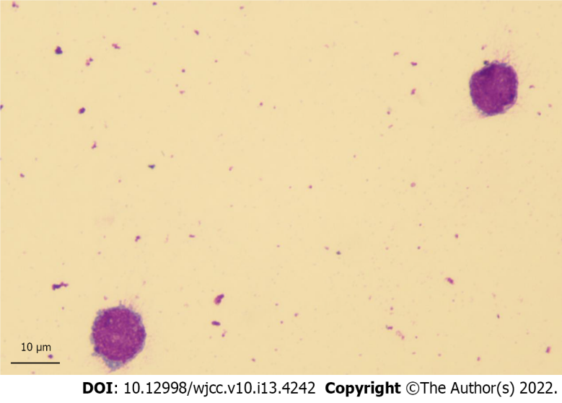
Figure 1 Atypical lymphocytes on cerebrospinal fluid cytology. Giemsa stain (Magnification: 100 ×).
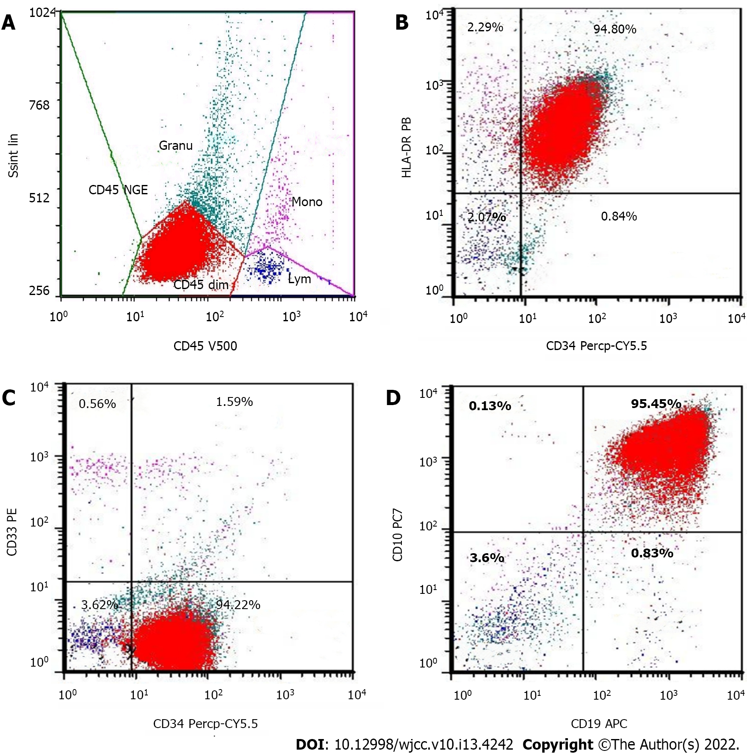
Figure 2 Flow cytometry detection of blast infiltration of cerebrospinal fluid in the patient. The leukemic population is depicted in red. A: There is a cells of differentiation (CD) 45-dim population of abnormal cells with low-side scatter (painted red); B: These cells are positive for human leukocyte antigen D related (HLA-DR) and CD34; C: These cells are positive for CD34 and negative for CD33; D: These cells are positive for CD19 and CD10. Ssint lin: Side Scatter Lineage; HLA-DR PB: Human leukocyte antigen D related; CD45 NGE: Cluster of differentiation 45 negative; CD45 dim: Cluster of differentiation 45 dim; Mono: Monocyte; Lym: Lymphocyte; CD34 Percp-CY5.5: Cluster of differentiation 34 Peridinin-chlorophyll proteins-Cyanine5.5; CD33 PE: Cluster of differentiation 33 Phycoerytherin; CD19 APC: Cluster of differentiation 19 Allophycocyanin; CD10 PC7: Cluster of differentiation 10 Phycoerytherin-Cyanine 7.
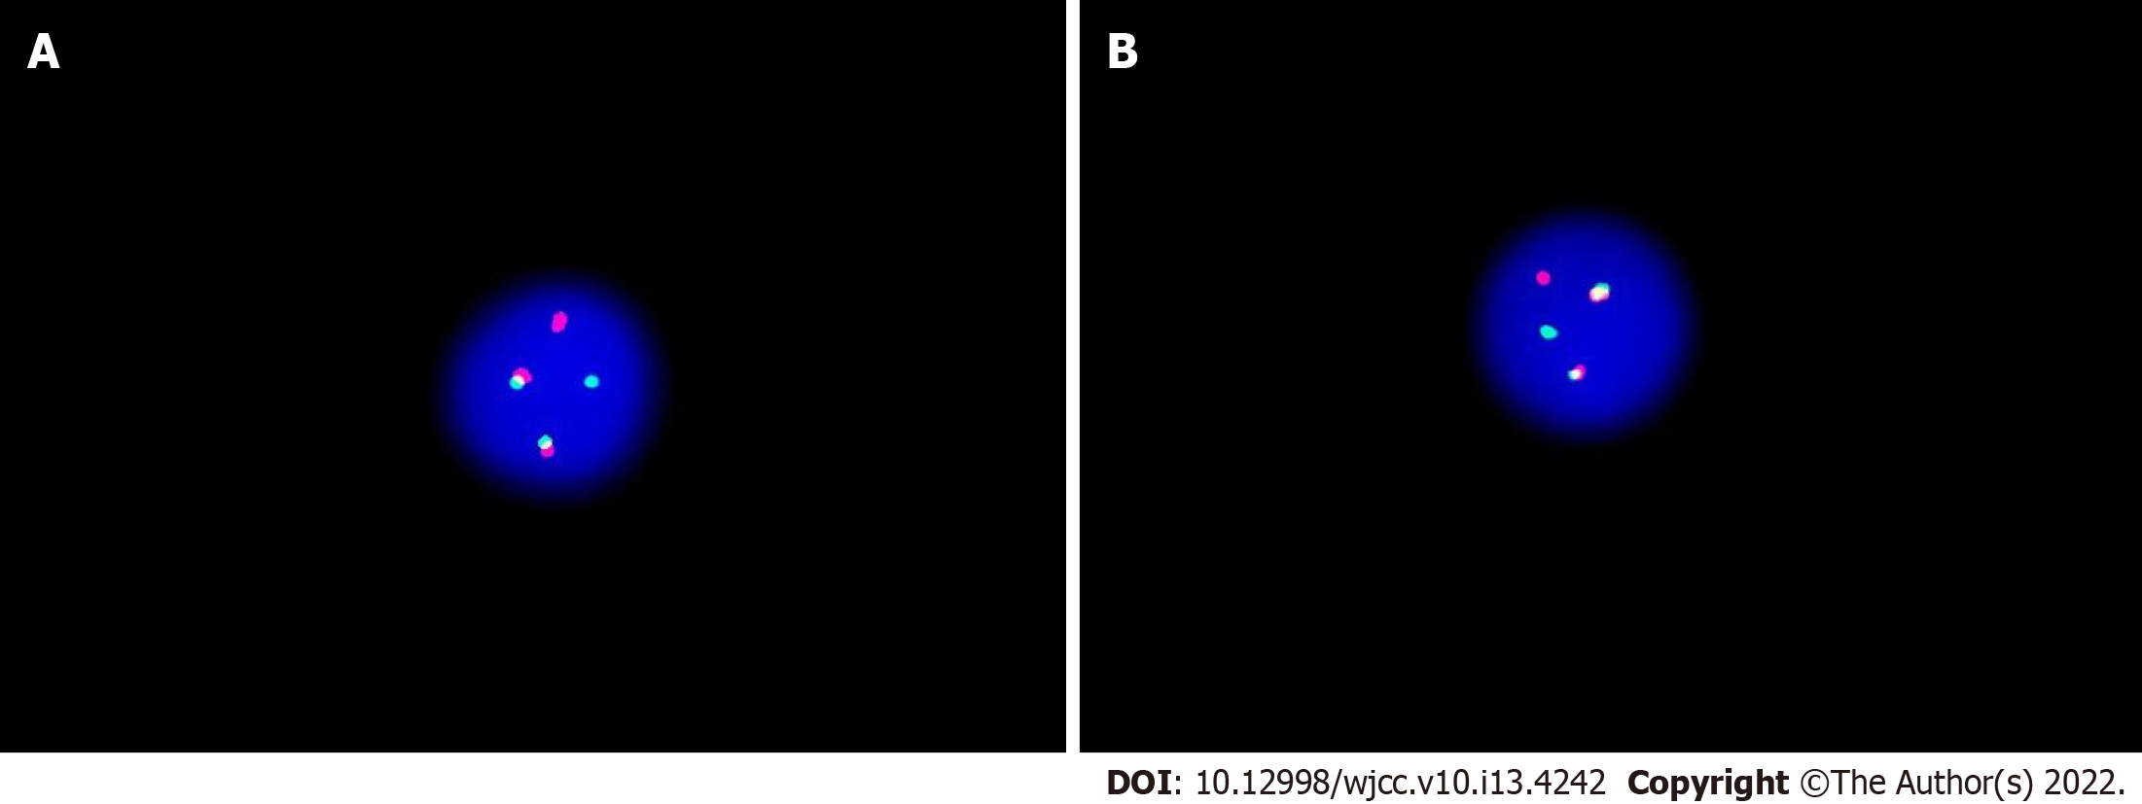
Figure 3 The fusion of BCR-ABL1 loci of cerebrospinal fluid was detected by fluorescence in situ hybridization using the vysis extra signal probeyielding red-green fusion signal. A: The image shows 1 green, 1 red, and 2 yellow signals a result of fusion of red and green; B: The fusion signal indicates a reciprocal translocation between chromosomes 9 and 22 forming a BCR-ABL fusion gene.
Table 1 Detection of BCR-ABL1 fusion gene copy number by real-time quantitative polymerase chain reaction in cerebrospinal fluid
Test | Result
BCR-ABL1(p190) | Positive
BCR-ABL1(p210) | Negative
BCR-ABL1 gene copy number | 18580
ABL1 gene copy number | 77222
BCR-ABL1/ABL1 | 24.061%
p190: Proteins of 190 kDa; p210: Proteins of 210 kDa.

Published by Baishideng Publishing Group Inc
7041 Koll Center Parkway, Suite 160, Pleasanton, CA 94566, USA
Telephone: +1-925-3991568
E-mail: bpgoffice@wjgnet.com
Help Desk: https://www.f6publishing.com/helpdesk
https://www.wjgnet.com

© 2022 Baishideng Publishing Group Inc. All rights reserved.

