Name of Journal: World Journal of Clinical Cases
Manuscript NO: 76958
Manuscript Type: CASE REPORT

Tislelizumab-related enteritis successfully treated with adalimumab: A case report

Chen N et al. Tislelizumab-related enteritis treated with adalimumab

Na Chen, Min-Jia Qian, Ru-Hui Zhang, Qi-Qi Gao, Chao-Chao He, Ya-Ke Yao, Jian-Ying Zhou, Hua Zhou

Na Chen, Chao-Chao He, Department of Clinical Pharmacy, The First Affiliated Hospital, Zhejiang University School of Medicine, Hangzhou 310003, Zhejiang Province, China

Min-Jia Qian, Ru-Hui Zhang, Ya-Ke Yao, Jian-Ying Zhou, Hua Zhou, Department of Respiratory and Critical Care Medicine, The First Affiliated Hospital, Zhejiang University School of Medicine, Hangzhou 310003, Zhejiang Province, China

Min-Jia Qian, Department of Critical Care Medicine, Zhuji People’s Hospital, Shaoxing 311800, Zhejiang Province, China

Qi-Qi Gao, Department of Pathology, The First Affiliated Hospital, Zhejiang University School of Medicine, Hangzhou 310003, Zhejiang Province, China

Chao-Chao He, Department of Pharmacy, Yiwu Central Hospital, Jinhua 322000, Zhejiang Province, China

Author contributions: All authors made substantial contributions to conception and design, acquisition of data, or analysis and interpretation of data; took part in drafting the article or revising it critically for important intellectual content; agreed to submit to the current journal; gave final approval of the version to be published; and agree to be accountable for all aspects of the work.

Corresponding author: Hua Zhou, MD, Associate Chief Physician, Department of Respiratory and Critical Care Medicine, The First Affiliated Hospital, Zhejiang University School of Medicine, No. 79 Qingchun Road, Shangcheng District, Hangzhou 310003, Zhejiang Province, China. zhouhua1@zju.edu.cn

Received: April 22, 2022
Revised: June 17, 2022
Accepted: August 25, 2022
Published online:

Abstract
BACKGROUND
With programmed death-1 (PD-1) inhibitors becoming the standard treatment for lung cancer, PD-1-related adverse reactions and treatment have gradually become prominent.

CASE SUMMARY
First reported case of tislelizumab-related enteritis successfully treated with adalimumab 40mg every 2 wk for 3 times in an advanced lung cancer patient who received first-line tislelizumab/pemetrexed/carboplatin for 4 cycles. The patient continued receiving the treatment of pemetrexed/carboplatin after symptoms, abdominal computed tomography and colonoscopy improved, significant diarrhea was not occurred.

CONCLUSION
Adalimumab can be an effective treatment option for patients with PD-1 antibody related enteritis if they do not respond well to glucocorticoid treatment.

Key Words: Tislelizumab; Adalimumab; Enteritis; Case report

Chen N, Qian MJ, Zhang RH, Gao QQ, He CC, Yao YK, Zhou JY, Zhou H. Tislelizumab-related enteritis successfully treated with adalimumab: A case report. World J Clin Cases 2022; In press

Core Tip: A patient with advanced lung cancer who developed diarrhea after receiving tislelizumab combined with pemetrexed and carboplatin, with poor response to glucocorticoid treatment. The symptoms were significantly improved after the use of adalimumab 10 mg, subcutaneous injection, every 2 wk for 3 times. Colonoscopy and intestinal mucosal pathology suggested improvement.

INTRODUCTION
With programmed death-1 (PD-1) inhibitors alone or combination as first-line treatment for advanced non-small lung cancer, treatment for PD-1-related adverse reactions also becomes one of challenges in cancer treatment. Tislelizumab (TISL), a humanized monoclonal antibody against PD-1^{[1]}, was launched in China in 2019. Compared with other PD-1 inhibitors, the biggest difference of TISL was modified in the constant region of the monoclonal antibody to remove its binding ability to FcγR receptor, so that it could no longer bind to type II macrophages with Fcγ receptor, thus the macrophages would no longer attack the T cells, thereby reducing the exhaustion of T cells and the potential mechanism of anti-PD-1 therapy resistance^{[1,2]}. Grade 3-4 adverse events due to TISL have been reported to be about 10%, with a diarrhea incidence of < 1%^{[3,4]}. Herein, we report the first use, to our knowledge, of adalimumab (ADA) in combination with methylprednisolone for TISL-related severe enteritis. The patient's symptoms were essentially relieved with treatment and he continued to receive chemotherapy-related treatment.

CASE PRESENTATION
Chief complaints
61-year-old man with diagnosis diarrhea, who was referred to our institution on day 19 after the last treatment for lung cancer, because of symptoms were aggravated, with the frequency of diarrhea up to 20-30 times/d.

History of present illness
The patient was diagnosed with lung cancer (right lung adenocarcinoma with multiple subcutaneous muscle metastases, cT3N2M1c, stage IV, KRAS mutation (G12C), PDL-1 50%) on September 14, 2020. From September 17, 2020 to December 2, 2020, the patient was given treatment of chemotherapy (pemetrexed 900 mg and Carboplatin 600 mg) plus TISL 200 mg every 21 to 28 d for 4 cycles. The date of the fourth treatment is December 2, 2020. Before the fourth treatment, the lung computed tomography (CT) showed that the lesion was smaller than that at diagnosis, and the subcutaneous nodule in buttock disappeared. The treatment result was assessed as partial response. On day 10 after the last treatment (hereafter day 10), the patient began to have fever (T_{max} 39.0 ℃), abdominal pain, and diarrhea (watery stools, more than 10 times/d). After defecation, the abdominal pain could be relieved. The patient was suspected of gastroenteritis and received drugs for anti-infection, antidiarrheal, rehydration and other symptomatic treatment at local hospital.

History of past illness
The patient’s past medical history was unremarkable except for hypertension.

Personal and family history
No positive personal or family history.

Physical examination
The patient had stable vital signs. Abdominal examination: flat and soft, positive tenderness, negative rebound tenderness, hyperactive bowel sounds, 6 times/min.

Laboratory examinations
Routine laboratory tests of a same-day showed white blood cells: 8.5 × 10⁹/L, C-reactive protein: 80.0 mg/L, procalcitonin: 0.13 ng/mL, interleukin-6: 2.04 pg/mL, interleukin-10 (IL-10): 2.57 pg/mL. A clinical diagnosis of PD-1 inhibitors induced enteritis was made, and the patient was asked to fast and oral methylprednisolone 16 mg bid was started. Subsequent tests for cytomegalovirus DNA, bacteria cultured in blood and feces, WBC and Clostridium difficile in stool were negative, fecal calprotectin was significantly increased to 218.4 ug/g.

Imaging examinations
Abdominal contrast-enhanced CT revealed edema and thickening of the small intestine, ascending colon, transverse colon, sigmoid colon, and rectum in the middle and lower abdomen, and multiple small diverticula in the blind ascending colon (Figure 1A and B). Colonoscopy showed extensive congestion and edema of the terminal ileum and colorectal mucosa (Figure 2A and B). Intestinal mucosal pathological examination revealed chronic inflammations of the mucosa with moderated dysplasia of glandular epithelium, and chronic inflammation of the mucosa with moderate-severe dysplasia of the glandular epithelium (Figure 3A and B).

FINAL DIAGNOSIS
Diagnosis of PD-1 antibody induced enteritis was confirmed.

TREATMENT
The patient was asked to fast and oral methylprednisolone 16 mg bid was started. On day 21, methylprednisolone was increased to 40 mg q12h intravenously, montmorillonite powder and probiotic treatment also were given. On day 23, ADA (biosimilar, HS016, China) 40 mg began to administered subcutaneously every 2 wk (on days 23, 37, 51) because previous treatments were ineffective. Fasting and intravenous nutritional support were also given, as well as drugs for symptomatic treatment including mesalazine, somatostatin, and loperamide. On day 29, the frequency of diarrhea decreased and the symptom of diarrhea disappeared on day 34. The patient tried to be given a small amount of liquid diet, but abdominal pain and diarrhea symptoms repeated after eating. the symptoms were improved after giving pinaverium bromide, during which montmorillonite powder, somatostatin, mesalamine and probiotics were gradually discontinued. On day 37, Methylprednisolone began to reduce to 40 mg qd intravenously, and the patient discharged on day 47 with methylprednisolone 16 mg bid po. The treatment process would be showed in Figure 4.

OUTCOME AND FOLLOW-UP
The patient had no abdominal pain, diarrhea, nausea or vomiting after discharge, and underwent abdominal enhanced CT and colonoscopy again on day 64. Abdominal CT showed no significant edema compared with before, and there were multiple small diverticula in the ascending colon (Figure 1C); Colonoscopy showed that the ileal mucosa was approximately normal, the ileocecal valve was labial, congested and eroded, the ileocecal junction and the ascending and transverse colon were scattered, the whole colon and rectal mucosa were congested, swollen and brittle (Figure 2C and D), and intestinal mucosal pathology revealed (ileocecal junction, ascending colon, transverse colon, descending colon, rectum) mucosal epithelial detachment and erosion, inflammatory granulation tissue hyperplasia was significantly reduced compared with the previous time (Figure 3C and D). On day 65, the patient continued to receive chemotherapy, once every 3-4 wk. There was no obvious diarrhea after chemotherapy. The dose of methylprednisolone was tapered to 8 mg/d after about 3 mo, and the tapering process was uneventful.

DISCUSSION
The majority of adverse events (AEs) reported in clinical trials related to TISL were grade 1-2, with the most common grade 3-4 AEs being hematotoxicity, followed by pneumonitis (2%) and colitis (0.5%-1%)^{[2,5]}. The patient developed severe diarrhea after receiving 4 cycles of TISL combined with chemotherapy. The cause of infection was excluded, and it was considered to be TISL-induced immune-related enteritis (Adverse Drug Reaction Probability Scale^{[6]} score was 7). For the management of severe immune checkpoint inhibitor–induced enteritis, the guidelines^{[7,8]} recommend prednisone/methylprednisolone at 1-2 mg/kg/day for 2 d, followed by the infliximab (IFX) and its analogues or vedolizumab for poor response. At that time, we could not obtain vedolizumab quickly, therefore considered the use of anti-tumor necrosis factor-α (TNF-α) monoclonal antibody. In contrast to the 25% murine chimeric monoclonal antibody of infliximab (IFX), ADA is a fully human monoclonal antibody that binds TNF-α. ADA has been approved with about 17 indications worldwide, including Crohn’s disease, ulcerative colitis, rheumatoid arthritis and ankylosing spondylitis. ADA (biosimilar, HS016, China) is approved in China forheumatoid arthritis, ankylosing spondylitis and psoriasis. Although the pathophysiology of immune checkpoint inhibitor-mediated immune-related adverse events (irAEs) were not yet fully understood, the role of immune checkpoint pathways in autoimmune diseases provides some clues: irAEs may be caused by some combination of autoreactive T cells, autoantibodies, and/or inflammatory cytokines, such as interleukin-17^{[9,10]}. One potential mechanism is T-cell activity against antigens present in tumor cells and healthy tissues^{[11,12]}. Inflammation in other normal tissues may result from increased levels of inflammatory cytokines that are downstream effects of T cell activation^{[13,14]}. It has been shown that the intestinal lamina propria of PD-1 inhibitor-induced enteritis is characterized by CD8 + T cell infiltration, accompanied by a certain concentration of TNF-α, and Treg cells predominate similar to inflammatory bowel disease^{[15]}. ADA can prevent the significant decrease in intestinal mucosal epithelial resistance caused by TNF-α and prevent the internalization of tight junction proteins after cytokine exposure, and can also reverse the TNF-α-induced down-regulation of connexin-1, claudin-2, claudin-4, occludin and the activation of PI3K signaling in T-84 cells, thereby preventing barrier dysfunction induced by TNF-α at the functional and structural as well as at the signaling level^{[16]}.
The patient received subcutaneous injection of ADA 40 mg once every two weeks after poor response after treatment with 1-2 mg/kg methylprednisolone for 2 d. The symptoms began to improve 6 d after the first injection of ADA, the dose of methylprednisolone was gradually reduced after the second injection because of the symptoms gradually improved. The second colonoscopy and pathological sections also confirmed that the mucosal epithelial detachment and erosion were significantly improved than before. This case is the first report of enteritis caused by PD-1 inhibitors treated with ADA, and there has been a previous case of arthritis caused by pembrolizumab treated with ADA^{[17]}.

CONCLUSION
PD-1 inhibitor may also cause other colonic diseases than enteritis, for example acute diverticulitis^{[18]}, whether colonoscopy and pathological examination were important to distinguish enteritis and acute diverticulitis cause by PD-1 inhibitor. In addition, the duration of glucocorticoid therapy after the development of severe immune checkpoint inhibitor–induced enteritis can be as long as several months, during which clinical experts should be alert to the possibility of infection with various opportunistic pathogens^{[19]}, especially cytomegalovirus. With the advent of the era of immunotherapy, both physicians and pharmacists need to be more familiar with the judgment and treatment of irAEs, especially the selection and management of various immunosuppressive agents or monoclonal antibodies when serious adverse reactions occur.

ACKNOWLEDGEMENTS
The authors thank the staff engaged in clinical care of the patient.

REFERENCES
1 Zhang T, Song X, Xu L, Ma J, Zhang Y, Gong W, Zhang Y, Zhou X, Wang Z, Wang Y, Shi Y, Bai H, Liu N, Yang X, Cui X, Cao Y, Liu Q, Song J, Li Y, Tang Z, Guo M, Wang L, Li K. The binding of an anti-PD-1 antibody to FcγRΙ has a profound impact on its biological functions. Cancer Immunol Immunother 2018; 67: 1079-1090 [PMID: 29687231 DOI: 10.1007/s00262-018-2160-x]
2 Liu SY, Wu YL. Tislelizumab: an investigational anti-PD-1 antibody for the treatment of advanced non-small cell lung cancer (NSCLC). Expert Opin Investig Drugs 2020; 29: 1355-1364 [PMID: 33044117 DOI: 10.1080/13543784.2020.1833857]
3 Shen L, Guo J, Zhang Q, Pan H, Yuan Y, Bai Y, Liu T, Zhou Q, Zhao J, Shu Y, Huang X, Wang S, Wang J, Zhou A, Ye D, Sun T, Gao Y, Yang S, Wang Z, Li J, Wu YL. Tislelizumab in Chinese patients with advanced solid tumors: an open-label, non-comparative, phase 1/2 study. J Immunother Cancer 2020; 8 [PMID: 32561638 DOI: 10.1136/jitc-2019-000437]
4 Song Y, Gao Q, Zhang H, Fan L, Zhou J, Zou D, Li W, Yang H, Liu T, Wang Q, Lv F, Guo H, Yang L, Elstrom R, Huang J, Novotny W, Wei V, Zhu J. Treatment of relapsed or refractory classical Hodgkin lymphoma with the anti-PD-1, tislelizumab: results of a phase 2, single-arm, multicenter study. Leukemia 2020; 34: 533-542 [PMID: 31520078 DOI: 10.1038/s41375-019-0545-2]
5 Desai J, Deva S, Lee JS, Lin CC, Yen CJ, Chao Y, Keam B, Jameson M, Hou MM, Kang YK, Markman B, Lu CH, Rau KM, Lee KH, Horvath L, Friedlander M, Hill A, Sandhu S, Barlow P, Wu CY, Zhang Y, Liang L, Wu J, Paton V, Millward M. Phase IA/IB study of single-agent tislelizumab, an investigational anti-PD-1 antibody, in solid tumors. J Immunother Cancer 2020; 8 [PMID: 32540858 DOI: 10.1136/jitc-2019-000453]
6 Naranjo CA, Busto U, Sellers EM, Sandor P, Ruiz I, Roberts EA, Janecek E, Domecq C, Greenblatt DJ. A method for estimating the probability of adverse drug reactions. Clin Pharmacol Ther 1981; 30: 239-245 [PMID: 7249508 DOI: 10.1038/clpt.1981.154]
7 Thompson JA, Schneider BJ, Brahmer J, Andrews S, Armand P, Bhatia S, Budde LE, Costa L, Davies M, Dunnington D, Ernstoff MS, Frigault M, Kaffenberger BH, Lunning M, McGettigan S, McPherson J, Mohindra NA, Naidoo J, Olszanski AJ, Oluwole O, Patel SP, Pennell N, Reddy S, Ryder M, Santomasso B, Shofer S, Sosman JA, Wang Y, Weight RM, Johnson-Chilla A, Zuccarino-Catania G, Engh A. NCCN Guidelines Insights: Management of Immunotherapy-Related Toxicities, Version 1.2020. J Natl Compr Canc Netw 2020; 18: 230-241 [PMID: 32135517 DOI: 10.6004/jnccn.2020.0012]
8 Haanen JBAG, Carbonnel F, Robert C, Kerr KM, Peters S, Larkin J, Jordan K; ESMO Guidelines Committee. Management of toxicities from immunotherapy: ESMO Clinical Practice Guidelines for diagnosis, treatment and follow-up. Ann Oncol 2017; 28: iv119-iv142 [PMID: 28881921 DOI: 10.1093/annonc/mdx225]
9 Postow MA, Sidlow R, Hellmann MD. Immune-Related Adverse Events Associated with Immune Checkpoint Blockade. N Engl J Med 2018; 378: 158-168 [PMID: 29320654 DOI: 10.1056/NEJMra1703481]
10 Esfahani K, Miller WH Jr. Reversal of Autoimmune Toxicity and Loss of Tumor Response by Interleukin-17 Blockade. N Engl J Med 2017; 376: 1989-1991 [PMID: 28514612 DOI: 10.1056/NEJMc1703047]
11 Johnson DB, Balko JM, Compton ML, Chalkias S, Gorham J, Xu Y, Hicks M, Puzanov I, Alexander MR, Bloomer TL, Becker JR, Slosky DA, Phillips EJ, Pilkinton MA, Craig-Owens L, Kola N, Plautz G, Reshef DS, Deutsch JS, Deering RP, Olenchock BA, Lichtman AH, Roden DM, Seidman CE, Koralnik IJ, Seidman JG, Hoffman RD, Taube JM, Diaz LA Jr, Anders RA, Sosman JA, Moslehi JJ. Fulminant Myocarditis with Combination Immune Checkpoint Blockade. N Engl J Med 2016; 375: 1749-1755 [PMID: 27806233 DOI: 10.1056/NEJMoa1609214]
12 Byrne EH, Fisher DE. Immune and molecular correlates in melanoma treated with immune checkpoint blockade. Cancer 2017; 123: 2143-2153 [PMID: 28543699 DOI: 10.1002/cncr.30444]
13 Tarhini AA, Zahoor H, Lin Y, Malhotra U, Sander C, Butterfield LH, Kirkwood JM. Baseline circulating IL-17 predicts toxicity while TGF-β1 and IL-10 are prognostic of relapse in ipilimumab neoadjuvant therapy of melanoma. J Immunother Cancer 2015; 3: 39 [PMID: 26380086 DOI: 10.1186/s40425-015-0081-1]
14 Harbour SN, Maynard CL, Zindl CL, Schoeb TR, Weaver CT. Th17 cells give rise to Th1 cells that are required for the pathogenesis of colitis. Proc Natl Acad Sci USA 2015; 112: 7061-7066 [PMID: 26038559 DOI: 10.1073/pnas.1415675112]
15 Musdal Y, Govindarajan S, Mannervik B. Exploring sequence-function space of a poplar glutathione transferase using designed information-rich gene variants. Protein Eng Des Sel 2017; 30: 543-549 [PMID: 28967959 DOI: 10.1093/protein/gzx045]
16 Fischer A, Gluth M, Pape UF, Wiedenmann B, Theuring F, Baumgart DC. Adalimumab prevents barrier dysfunction and antagonizes distinct effects of TNF-α on tight junction proteins and signaling pathways in intestinal epithelial cells. Am J Physiol Gastrointest Liver Physiol 2013; 304: G970-G979 [PMID: 23538493 DOI: 10.1152/ajpgi.00183.2012]
17 Oke AR, Wheater M, Karydis I, Wallis D. Successful use of adalimumab in immune checkpoint inhibitor-associated inflammatory arthritis. Rheumatol Adv Pract 2018; 2: rky001 [PMID: 31431951 DOI: 10.1093/rap/rky001]
18 Tursi A. Immune checkpoint inhibitors-induced acute diverticulitis. Eur J Gastroenterol Hepatol 2020; 32: 893-895 [PMID: 32472816 DOI: 10.1097/MEG.0000000000001713]
19 Ni J, Zhang X, Zhang L. Opportunistic bowel infection after corticosteroid dosage tapering in a stage IV lung cancer patient with tislelizumab-related colitis. Thorac Cancer 2020; 11: 1699-1702 [PMID: 32239681 DOI: 10.1111/1759-7714.13401]

Footnotes
Informed consent statement: Informed written consent was obtained from the patient for publication of this report and any accompanying images.

Conflict-of-interest statement: All the authors report no relevant conflicts of interest for this article.

CARE Checklist (2016) statement: The authors have read the CARE Checklist (2016), and the manuscript was prepared and revised according to the CARE Checklist (2016).

Open-Access: This article is an open-access article that was selected by an in-house editor and fully peer-reviewed by external reviewers. It is distributed in accordance with the Creative Commons Attribution NonCommercial (CC BY-NC 4.0) license, which permits others to distribute, remix, adapt, build upon this work non-commercially, and license their derivative works on different terms, provided the original work is properly cited and the use is non-commercial. See: https://creativecommons.org/Licenses/by-nc/4.0/

Provenance and peer review: Unsolicited article; Externally peer reviewed.
Peer-review model: Single blind

Peer-review started: April 22, 2022
First decision: June 8, 2022
Article in press:

Specialty type: Pharmacology and pharmacy
Country/Territory of origin: China
Peer-review report’s scientific quality classification
Grade A (Excellent): 0
Grade B (Very good): B, B
Grade C (Good): 0
Grade D (Fair): D
Grade E (Poor): 0

P-Reviewer: Dauyey K, Kazakhstan; He DH, China; Poddighe D, Kazakhstan S-Editor: Xing YX L-Editor: A P-Editor: Xing YX

Figure Legends
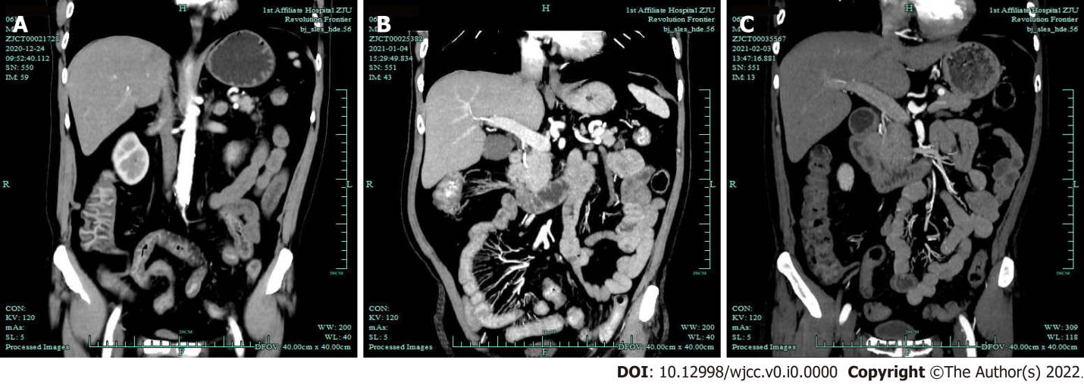
Figure 1 Abdominal contrast-enhanced computed tomography image of the patient at different stages of disease. A: Edema and thickening of the small intestine, ascending colon, transverse colon, sigmoid colon, and rectum in the middle and lower abdomen, and multiple small diverticula in the blind ascending colon; B: The small intestine and colon wall were still obviously edematous, which was similar to the computed tomography findings 10 d ago; C: No significant edema, and there were multiple small diverticula in the ascending colon.

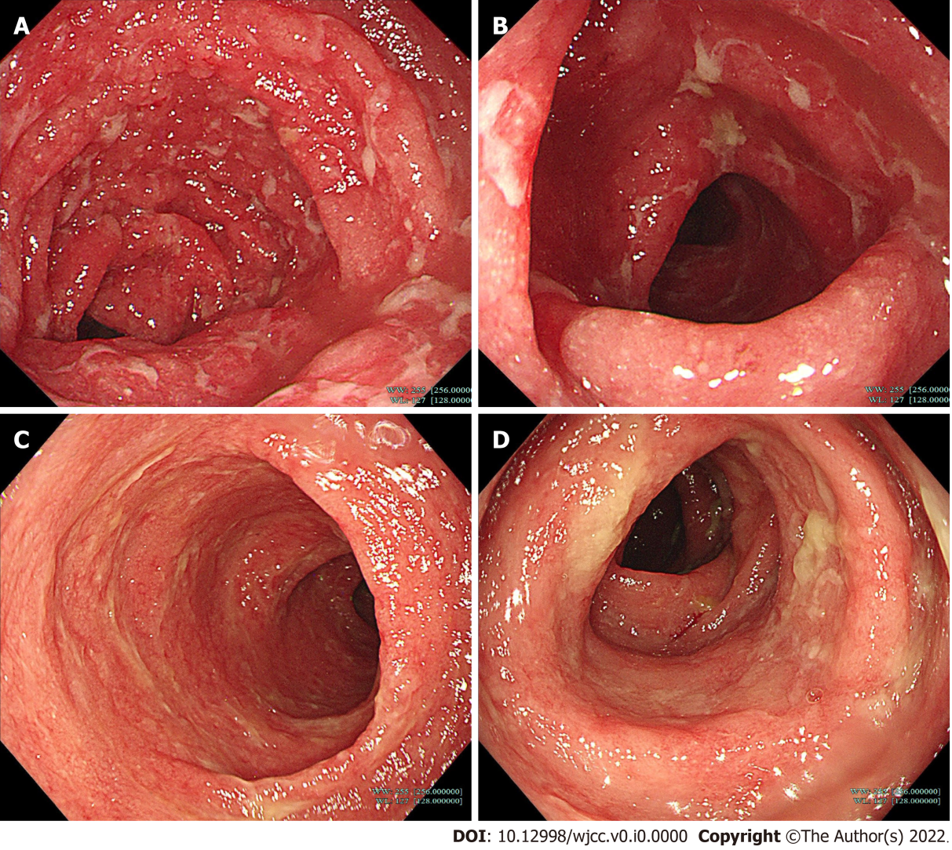
Figure 2 Colonoscopy manifestations of patients at different stages of disease. A and B: Extensive congestion and edema of the terminal ileum and colorectal mucosa, and necrosis and shedding on day 20; C and D: On day 64 showed that the mucosa in the venue was approximately normal, and there was still congestion and swelling of the whole colon and rectal mucosa, which was significantly improved than before.
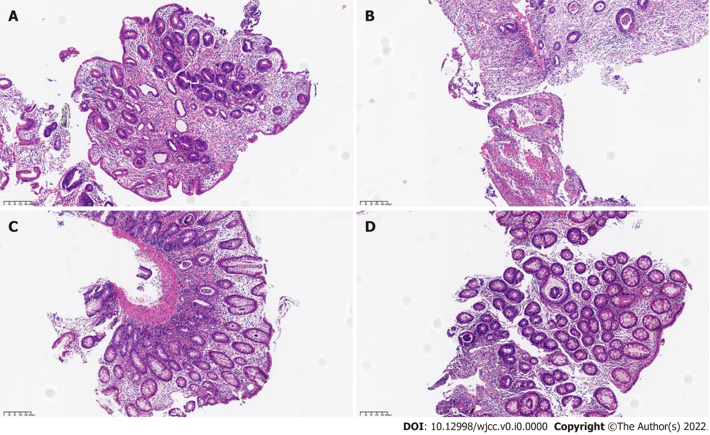
Figure 3 Pathological sections were examined by colonoscopy. Intestinal mucosal pathological examination revealed chronic inflammation of the mucosa (ileum, ascending colon, and descending colon) with moderate dysplasia of the glandular epithelium, and chronic inflammation of the mucosa (transverse colon and rectum) with moderate-severe dysplasia of the glandular epithelium. A: For the ileocecal junction on day 20; B: For the descending colon on day 20, mucosal epithelial sloughing erosion were not significant compared with the previous colonoscopy, but were still accompanied by moderate atypia and crypt abscess; C: For the ileocecal junction on day 64; D: For the descending colon on day 64.

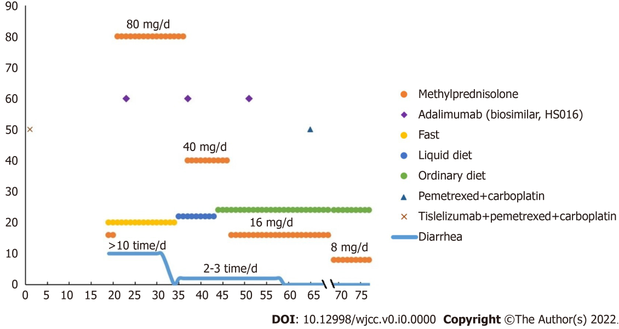
Figure 4 Treatment of tislelizumab-related enteritis.

