Name of Journal: World Journal of Clinical Cases
Manuscript NO: 61441
Manuscript Type: SYSTEMATIC REVIEWS

Systematic review and meta-analysis of the impact of deviations from a clinical pathway on outcomes following pancreatoduodenectomy

Karunakaran M et al. ERAS® in pancreatoduodenectomy

Monish Karunakaran, Pavan Kumar Jonnada, Savio George Barreto

Monish Karunakaran, Department of Gastrointestinal Surgery, Gastrointestinal Oncology, and Bariatric Surgery, Medanta Institute of Digestive and Hepatobiliary Sciences, Gurgaon 122001, Haryana, India

Monish Karunakaran, Department of Liver Transplantation and Regenerative Medicine, Medanta-The Medicity, Gurgaon 122001, Haryana, India

Pavan Kumar Jonnada, Surgical Oncology, Kidwai Memorial Institute of Oncology, Bengaluru 560029, Karnataka, India

Savio George Barreto, Division of Surgery and Perioperative Medicine, Flinders Medical Center, Bedford Park 5042, South Australia, Australia

Savio George Barreto, College of Medicine and Public Health, Flinders University, Bedford Park 5042, South Australia, Australia

Author contributions: Karunakaran M was responsible for the conceptualization of the study, selection of studies, interpretation of data and drafting of the manuscript; Jonnada PK was responsible for the selection of studies, statistical analysis and interpretation of data; Barreto SG was responsible for the conceptualization and design of the study, interpretation of data and critical review of the manuscript and final approval.

Corresponding author: Savio George Barreto, FAIS, FRACS, PhD, Doctor, Senior Lecturer, College of Medicine and Public Health, Flinders University, Bedford Park 5042, South Australia, Australia. georgebarreto@yahoo.com

Received: December 7, 2020
Revised: January 6, 2021
Accepted: March 12, 2021
Published online: May 6, 2021

Abstract
BACKGROUND
Enhanced recovery after surgery is steadily gaining importance in patients undergoing pancreatic surgery, including pancreatoduodenectomy (PD). While clinical pathways targeting enhanced-recovery can achieve their intended outcome in reducing length of stay, compliance to these pathways, and their relevance is poorly understood. The aim of this systematic review was to assess the impact of deviations from/non-compliance to a clinical pathway on post-PD outcomes.

AIM
To assess the impact of deviations from/non-compliance to a clinical pathway on post-PD outcomes.

METHODS
A systematic review of major reference databases was undertaken, according to preferred reporting items for systematic reviews and meta-analysis guidelines, between January 2000 and November 2020 relating to compliance with clinical pathways and its impact on outcomes in patients undergoing PD. A meta-analysis was performed using fixed-effects or random-effects models.

RESULTS
Eleven studies including 1852 patients were identified. Median overall compliance to all components of the clinical pathway was 65.7% [interquartile range (IQR): 62.7%-72.3%] with median compliance to post-operative parameters of the clinical pathway being 44% (IQR: 34.5%-52.25%). Meta-analysis using a fixed-effects model showed that ≥ 50% compliance to a clinical pathway predicted significantly fewer post-operative complications [pooled odds ratio (OR): 9.46, 95% confidence interval (CI): 5.00-17.90; P < 0.00001] and a significantly shorter length of hospital stay [pooled mean difference (MD): 4.32, 95%CI: -3.88 to -4.75; P < 0.0001]. At 100% compliance which was associated with significantly fewer post-operative complications (pooled OR: 11.25, 95%CI: 4.71-26.84; P < 0.00001) and shorter hospital stay (pooled MD of 4.66, 95%CI: 2.81-6.51; P < 0.00001).

CONCLUSION
Compliance to post-PD clinical pathways remains low. Deviations are associated with an increased risk of complications and length of hospital stay. Under-standing the relevance of deviations to clinical pathways post-PD presents pancreatic surgeons with opportunities to actively pursue an enhanced-recovery of their patients.

Key Words: Outcomes; Morbidity; Mortality; Quality; Surgery; Recovery

©The Author(s) 2021. Published by Baishideng Publishing Group Inc. All rights reserved.

Karunakaran M, Jonnada PK, Barreto SG. Systematic review and meta-analysis of the impact of deviations from a clinical pathway on outcomes following pancreatoduodenectomy. World J Clin Cases 2021; 9(13): 3024-3037 URL: https://www.wjgnet.com/2307-8960/full/v9/i13/3024.htm DOI: https://dx.doi.org/10.12998/wjcc.v9.i13.3024

Core Tip: Compliance to post-pancreatoduodenectomy clinical pathways remains low. Deviations are associated with an increased risk of complications and length of hospital stay. Understanding the relevance of deviations to clinical pathways post-pancreato-duodenectomy presents us with opportunities to actively pursue an enhanced-recovery of our patients.
INTRODUCTION
Pancreatic surgery is technically challenging and complex with a high risk of morbidity^{[1]}. There exists a wide variability in outcomes of pancreatic surgery even amongst high-volume providers^{[2]} which can be traced back to variations in quality and its indicators^{[3]}. A key strategy proven to improve outcomes following pancreatic surgery, especially pancreatoduodenectomy (PD), has been standardization not only in the technique of pancreatico-enteric anastomosis^{[4]}, but even peri-operative processes^{[1]}, including the development of post-operative clinical pathways^{[5]}.
Clinical pathways are standardized care plans for individual clinical problems that detail essential steps in patient care bearing in mind the expected postoperative course with the overall aim of improving outcomes^{[6]}. These pathways fall under the broad umbrella of enhanced recovery after surgery (ERAS®) protocols, an evidence-based concept propounded by Bardram et al^{[7]}. Pancreatic surgeons were amongst the last to integrate ERAS® pathways into perioperative patient care^{[8]} with the perceived inertia partly attributable to the complexity of the surgery and partly due to the high post-operative morbidity. There is now a steadily growing body of literature supporting the relevance and benefit of pathways targeting enhanced recovery on outcomes following PD in comparison to conventional care^{[9]}. However, auditing our own clinical pathway post-PD led us to the realization that while the pathway helped us achieve a reduced length of stay^{[5]}, the compliance to all parameters was low^{[6]} with increasing deviations portending complications and readmissions. These observations have been published by others, as well^{[10]}. Thus, in pancreatic surgery and especially PD, it is imperative that we investigate compliance to protocols, as well as the impact of deviations from clinical pathways^{[11]} because herein lies the potential to improve early detection of complications with the potential to treat them in a systematic and prompt fashion preventing death^{[12]} due to a “failure to rescue”^{[13]}.

MATERIALS AND METHODS
Search strategy
A literature search was performed on MEDLINE, SCOPUS, EMBASE, and Google Scholar databases for the articles published between January 2000 and November 2020 relating to compliance with clinical pathways and its impact on outcomes in patients undergoing PD. Articles were searched using Medical Education Subject Headings keywords: “Enhanced recovery OR Clinical pathways”, “Adherence OR Compliance”, “Deviations”, Pancreaticoduodenectomy OR Pancreatoduodenectomy, “Pancreatic cancer OR Pancreatic carcinoma OR Pancreatic adenocarcinoma”. Preferred reporting items for systematic reviews and meta-analysis guidelines (http://www.prisma-statement.org) were followed for searching and reporting of articles.

Study selection
Two authors (Jonnada PK and Karunakaran M) independently assessed titles and abstracts for eligibility. We perused the reference lists of articles and “related articles” function for similar additional articles. All the screened articles were assessed for eligibility, and any disagreement was fixed through mutual discussion. The accuracy of the extracted data was adjudicated further by a third author.

Inclusion criteria: (1) Studies conducted on patients undergoing PD with a clearly defined clinical pathway for post-operative care; and (2) Study should report on the patient compliance to the clinical pathway and impact of deviations from the pathway, or lack of compliance on outcomes in terms of adverse events and/or duration of hospitalization.

Exclusion criteria: (1) Did not report on compliance; (2) Did not report on the number of patients with a pre-defined level of compliance suffering adverse events and/or was impossible to calculate; and (3) Non-English language studies.

Quality assessment
Methodological quality of the studies was assessed independently by two authors (Jonnada PK and Karunakaran M) using Newcastle–Ottawa Scale^{[14]} and final scores were reached by general consensus. A study was considered to be of poor quality if it did not meet more than one criterion in the selection domain, if there was no score in the compatibility domain, and if it did not meet more than one of the criteria in the outcome domain. The Cochrane Collaboration’s tool^{[15]} for assessing risk of bias in individual studies was also used by the two independent authors and conflicts were resolved with mutual discussion.

Data extraction
A standardized data extraction form was used for data entry and analysis. Study selection process and preferred reporting items for systematic reviews and meta-analysis flow diagram for identifying studies are shown in Figure 1. For included studies, two authors (Jonnada PK and Karunakaran M) extracted the data using the agreed form. For each study that fulfilled the criteria, the following information was extracted: Name of the first author; year of publication; study setting; design of the study; duration of the study; geographical setting; age of patient; total sample; level of compliance to the intended clinical pathway; prevalence of deviation from the clinical pathway; impact of deviation from the clinical pathway on post-operative complications and length of hospital stay.

Data analysis and statistical methods
The statistical analysis was performed using RevMan software, version 5.3 (Cochrane Collaboration, the Nordic Cochrane Centre, Copenhagen, Denmark). Continuous variables were analyzed by the odds ratio (OR), and 95% confidence interval (CI) was recorded. Random variables were analyzed by the mean difference (MD), and 95%CI was recorded. Heterogeneity was evaluated using χ² and I² tests. I² of 0-40%, 30%-60%, 50%-70%, and > 75% represent low, moderate, substantial, and considerable heterogeneity, respectively. Studies with a P value of < 0.1 and I² > 50% indicated substantial heterogeneity. A random-effects model was used for assessment of the pooled OR if significant heterogeneity existed in the fixed-effects model. Else, the fixed-effects model was used with P > 0.10 and I² < 25%. The Z test was used to determine the pooled OR, and the significance was set to reject the null hypothesis at P < 0.05. Funnel plots were undertaken to consider possible bias. Compliance rates were expressed as median [interquartile range (IQR)].

RESULTS
The search yielded a total of 68 articles of which 57 were excluded based on the inclusion and exclusion criteria and following the screening of titles and abstracts (Figure 1). After excluding duplicates, the reviewers identified 11 studies^{[6,10,16-24]} for further analysis. The studies included in the analysis were published between January 2010 and November 2020. The sample sizes of the included studies ranged from 82 to 394 patients. Within these 11 studies^{[6,10,16-24]}, a total of 1852 patients underwent PD and were managed according to their respective institutional clinical pathways. Eight studies^{[6,10,17-19,22-24]} stratified patients according to a specific, albeit arbitrary, level of compliance and compared their immediate post-operative outcomes. The characteristics, methodology and conclusions of the included studies are provided in Tables 1 and 2. The included clinical pathways were quite heterogeneous in terms of the parameters used (Supplementary Table 1). Out of the 11 studies, 5 of them^{[6,17,18,22,24]} were included in the meta-analysis (Figure 1). The methodological quality of all included manuscripts was deemed acceptable as per Newcastle–Ottawa Scale.

Included studies
The 11 studies analyzed (Table 1) included 6 prospective^{[10,16,17,21-23]} and 5 retro-spective^{[6,18-20,24]} studies all published since 2014. There were 2 publications from India^{[11,23]}, Canada^{[18,20]} and Italy^{[16,22]}, and 1 each from Switzerland^{[19]}, Israel^{[21]}, Sweden^{[24]} and Greece^{[24]}, all from single centers, with 1 publication from multiple centers in Europe^{[10]}. The median overall compliance to all components of the clinical pathway was 65.7% (IQR: 62.7%-72.3%) with median compliance to post-operative parameters of the clinical pathway being 44% (IQR: 34.5%-52.25%) in the 4 included studies that reported the values.
Table 2 provides an overview of the morbidity^{[25]}, mortality and readmission rates in the various studies included in the analysis along with the length of stay and impact of deviations from/compliance to the clinical pathway parameters. The major effects of deviations from clinical pathways are on length of stay and complications. These aspects have been addressed in further detail in the meta-analysis below.
The rates of adherence to individual parameters within the clinical pathways in the various studies are presented in Supplementary Table 1.

Impact of deviations/non-compliance from clinical pathway on post-operative outcomes
The results of meta-analysis using a fixed-effects model showed that less frequent the deviation from clinical pathway objectively (expressed as ≥ 50% compliance with the prescribed parameters) resulted in significantly fewer post-operative complications (pooled OR: 9.46, 95%CI: 5.00-17.90; P < 0.00001) (Figure 2A). There was moderate heterogeneity (I² = 60% and P = 0.11) between the included studies. Patients with a 100% compliance demonstrated a significantly reduced risk of complications (pooled OR: 11.25, 95%CI: 4.71-26.84; P < 0.00001) (Figure 2B). There was no heterogeneity (I² = 0%; P = 0.80) between the included studies.
Patients with ≥ 50% compliance with the prescribed parameters also had a significantly shorter length of hospital stay (pooled MD: 4.32, 95%CI: -3.88 to -4.75; P < 0.0001) (Figure 3A). There was moderate heterogeneity (I² = 52% and P = 0.15). A 100% compliance to the pathway resulted in a significantly reduced hospital stay (pooled MD of 4.66, 95%CI: 2.81-6.51; P < 0.00001) (Figure 3B). However, there was significant heterogeneity between the included studies (I² = 90% and P < 0.00001).
There was minimal publication bias in the included studies as assessed by funnel plots (Figures 2 and 3).

DISCUSSION
These data highlight the importance of deviations from clinical pathways in PD on post-operative outcomes especially development of all complications (pancreas-specific, as well as, medical) and duration of length of stay. Individual studies also highlighted that reduced compliance with parameters assessed within the pathways was associated with a higher likelihood of needing re-exploration^{[23]}, higher mortality^{[6,23]}, 90-d readmission rates^{[6]} and overall hospitalization-related costs^{[18]}.
The addition of ERAS® to the pancreatic surgeons armamentarium has certainly helped improve outcomes^{[26,27]}, especially reductions in overall and minor morbidity, incidences of delayed gastric emptying, incisional and intra-abdominal infections, and shortened length of stay, without increasing 30-d readmission and mortality^{[9]}. It has been reported that up to 30% of patients are unable to receive adjuvant chemotherapy for pancreatic cancer for a variety of reasons^{[28]}. All of the benefits achieved from pursuing an enhanced recovery are, thus, of major relevance when specifically considering PD for pancreatic cancer and the importance of an enhanced recovery of the patient, sufficient to enable them to be fit to receive, and complete^{[29]}, adjuvant therapy that offers the best chance for cure^{[30,31]}.
Focusing on the enhanced recovery of our patients, the present analysis incorporating 11 studies^{[6,10,16-24]} has highlighted varying patterns of application of clinical pathways to PD. In four^{[10,16,22,23]} of the included studies, the teams employed a pre-, intra- and post-operative pathway, while in 6 other studies^{[6,17,18,20,21,24]} the teams focused on a post-operative clinical pathway alone. One study did not specify their protocol details^{[19]}. Not surprisingly, overall compliance to the pathways remained relatively high 65.7% (IQR: 62.7%-72.3%). Compliance to post-PD pathways is challenging given the major anatomical changes introduced by the surgery, itself. Hence, most studies reported compliance to this component varying between 34.5% and 52.25%. Comparison between studies show that the difference (between overall and post-operative compliance) widens as the number of post–operative parameters decrease. However, despite the apparently low compliance, the surgical teams were able to help their patients achieve the desired outcomes^{[11]}. This is likely a reflection of the culture (targeting enhanced recovery) of the team adopting these protocols by providing themselves, and their patients, with measurable and achievable goals.
Postoperative components of a clinical pathway display maximal variance and such deviations are known to correlate with the final outcomes^{[32]}. Lessons learnt from colorectal surgery suggest that postoperative compliance is the most difficult to achieve but is most strongly associated with optimal recovery^{[33]}. We, thus, focused on this aspect of enhanced recovery in patients undergoing PD. An important consideration at the present time then is “what would be the minimum acceptable level of compliance following PD to improve outcomes”. Once again, borrowing wisdom from colorectal surgery, Pędziwiatr et al^{[34]} demonstrated that a compliance of > 80% is required to decrease length of hospitalization. This is similar to the findings of Ahmed et al^{[35]} who noted that an overall protocol compliance of 77% resulted in no significant difference in outcomes following colorectal surgery compared with a compliance rate of 88%.
However, we must not lose focus of the aim of this study which is, namely, to enhance the value of information gleaned from this audit/analysis of deviations from clinical pathways post-PD to improve the care of pancreatic cancer patients undergoing surgery. Quite clearly, clinical pathways targeting early and meaningful recovery can reduce post-PD complications and length of stay in hospital after surgery. Being able to identify deviations from a clinical pathway presents an opportunity to identify patients who are likely to develop complications thereby triggering the need for closer monitoring. Such an approach is important, not because the deviations per se result in complications, but they are indicative of an impending complication. Early identification of such a patient provides the clinician with the benefit of “lead time”, wherein a timely intervention might avert a major complication and even the risk of mortality^{[6]}, thereby improving failure-to-rescue^{[36,37]} metrics and overall outcomes. The study by Karunakaran et al^{[6]} revealed that on multivariate analysis, the need to reinsert the nasogastric/Ryle’s tube [hazard ratio (HR): 3.7, 95%CI: 1.9-7.2; P < 0.0001], the inability to commence a soft diet on post-operative day 5 (HR: 2.7, 95%CI: 1.6-4.5; P < 0.0001), the failure to remove the indwelling urinary catheter on postoperative day 2 (HR: 1.9, 95%CI: 1.2-3.0; P < 0.01), and failure to cease perioperatively planned antibiotics on postoperative day 2 (HR: 3.1, 95%CI: 1.7-5.4; P < 0.0001) were the 4 deviations that were significantly associated with likelihood of re-admission within 90 d of discharge. Such exploratory analysis present data to alert pancreatic cancer surgeons with specific deviations that are linked to sinister outcomes, prompting directed action.
Identifying factors predictive of patient- and surgery-related factors associated with deviations is helpful. Advancing age^{[22,38]}, higher body mass index^{[6,22]}, hypoalbuminemia^{[6,38]}, cardiac co-morbidities^{[6]}, and the finding of a soft pancreas^{[22]} have been associated with an increased risk of deviations. Early characterization of patients who are less likely to comply can prompt prehabilitation measures and/or customized care pathways to avoid non-compliance and increase the efficacy of pathways. There is already evidence, though anecdotal, that intensive preoperative prehabilitation in the form of cardiorespiratory functional capacity strengthening training, muscular strength training and respiratory physiotherapy reduces postoperative pulmonary complications and shorten postoperative hospital stay after PD^{[39]}. Prehabilitation prior to pancreatic cancer surgery is still in its infancy. However, the emerging evidence is encouraging^{[40]} prompting the need for a concerted approach towards its implementation on a larger scale.
In the current meta-analysis, interestingly, the comparison of a 100% compliance vs any level of non-compliance revealed no heterogeneity (I² = 0%, P = 0.80) when predicting complications. However, there was significant heterogeneity (I² = 90%, P = 0.00001) when analyzing length of hospital stay. This reiterates the variability in practices that guide or determine length of stay and timing of discharge^{[41]}.
There are certain limitations of this study. This is a study data meta-analysis and not a patient-data meta-analysis, with their attendant risk of heterogeneity. Moreover, this approach prevented us from segregating patients who underwent PD for pancreatic cancer, from other indications. However, we do not think this should grossly interfere with the inferences of this study. Secondly, it is based on a limited number of studies. Thirdly, there has been a significant difference in the clinical pathway components between studies, though this is largely unavoidable and attributable to the practice of devising clinical pathways in accordance with the local protocols and socio-cultural needs. Finally, there is no universally accepted compliance cut-off to guide prediction of adverse events which precludes a head-to-head comparison between patient cohorts.
Nonetheless, this is the first systematic review addressing the impact of clinical pathway compliance on outcomes following PD and highlights that measures to improve compliance to clinical pathway components can potentially increase its success rates and improve quality. Further research on outcomes with respect to compliance is warranted to determine the minimum level of compliance to achieve these goals.

CONCLUSION
From a surgeon’s perspective, a margin-negative (R0) resection accomplished with minimal postoperative complications is certainly our best contribution to long-term survival in pancreatic cancer^{[42]}. However, it remains our responsibility to ensure that we contribute to the enhanced recovery of our patients to enable them to take the next step towards fighting their cancer. Understanding the relevance of deviations to clinical pathways post-PD presents us with opportunities to actively pursue an enhanced-recovery of our patients.

ARTICLE HIGHLIGHTS
Research background
Enhanced recovery after surgery is steadily gaining importance in patients undergoing pancreatic surgery, including pancreatoduodenectomy (PD). While clinical pathways targeting enhanced-recovery can achieve their intended outcome in reducing length of stay, compliance to these pathways, and their relevance is poorly understood.

Research motivation
Appreciating the importance of deviations from a clinical pathway for pancreatic surgery will empower surgeons not only to identify patients at risk of complications but also to develop strategies to improve the pathway and, in turn, patient outcomes.

Research objectives
The objective of this systematic review was to assess the impact of deviations from/non-compliance to a clinical pathway on post-PD outcomes.

Research methods
A systematic review and meta-analysis of the literature gleaned from a search performed on MEDLINE, SCOPUS, EMBASE, and Google Scholar databases for the articles published between January 2000 and November 2020 relating to compliance with clinical pathways and its impact on outcomes in patients undergoing PD, was performed.

Research results
Eleven studies including 1852 patients were identified. Median overall compliance to all components of the clinical pathway was 65.7% [interquartile range (IQR): 62.7%-72.3%] with median compliance to post-operative parameters of the clinical pathway being 44% (IQR: 34.5%-52.25%). Meta-analysis using a fixed-effects model showed that ≥ 50% compliance to a clinical pathway predicted significantly fewer post-operative complications [pooled odds ratio (OR): 9.46, 95% confidence interval (CI): 5.00-17.90; P < 0.00001] and a significantly shorter length of hospital stay (pooled mean difference 4.32, 95%CI: -3.88 to -4.75; P < 0.0001). A 100% compliance was associated with significantly fewer post-operative complications (pooled OR 11.25, 95%CI: 4.71-26.84; P < 0.00001) and shorter hospital stay (pooled mean difference of 4.66, 95%CI: 2.81-6.51; P < 0.00001).

Research conclusions
Compliance to post-PD clinical pathways remains low. Deviations are associated with an increased risk of complications and length of hospital stay.

Research perspectives
Understanding the relevance of deviations to clinical pathways post-PD presents pancreatic surgeons with opportunities to scrutinize (and amend) their existing pathways with the ultimate goal of enhancing the recovery of their patients.

REFERENCES
1 Shrikhande SV, Barreto SG, Somashekar BA, Suradkar K, Shetty GS, Talole S, Sirohi B, Goel M, Shukla PJ. Evolution of pancreatoduodenectomy in a tertiary cancer center in India: improved results from service reconfiguration. Pancreatology 2013; 13: 63-71 [PMID: 23395572 DOI: 10.1016/j.pan.2012.11.302]
2 Riall TS, Nealon WH, Goodwin JS, Townsend CM Jr, Freeman JL. Outcomes following pancreatic resection: variability among high-volume providers. Surgery 2008; 144: 133-140 [PMID: 18656618 DOI: 10.1016/j.surg.2008.03.041]
3 Bilimoria KY, Bentrem DJ, Lillemoe KD, Talamonti MS, Ko CY; Pancreatic Cancer Quality Indicator Development Expert Panel, American College of Surgeons. Assessment of pancreatic cancer care in the United States based on formally developed quality indicators. J Natl Cancer Inst 2009; 101: 848-859 [PMID: 19509366 DOI: 10.1093/jnci/djp107]
4 Shrikhande SV, Barreto G, Shukla PJ. Pancreatic fistula after pancreaticoduodenectomy: the impact of a standardized technique of pancreaticojejunostomy. Langenbecks Arch Surg 2008; 393: 87-91 [PMID: 17703319 DOI: 10.1007/s00423-007-0221-2]
5 Chaudhary A, Barreto SG, Talole SD, Singh A, Perwaiz A, Singh T. Early discharge after pancreatoduodenectomy: what helps and what prevents? Pancreas 2015; 44: 273-278 [PMID: 25479587 DOI: 10.1097/MPA.0000000000000254]
6 Karunakaran M, Barreto SG, Singh MK, Kapoor D, Chaudhary A. Deviations from a clinical pathway post pancreatoduodenectomy predict 90-day unplanned re-admission. Future Oncol 2020; 16: 1839-1849 [PMID: 32511024 DOI: 10.2217/fon-2020-0120]
7 Bardram L, Funch-Jensen P, Jensen P, Crawford ME, Kehlet H. Recovery after laparoscopic colonic surgery with epidural analgesia, and early oral nutrition and mobilisation. Lancet 1995; 345: 763-764 [PMID: 7891489 DOI: 10.1016/s0140-6736(95)90643-6]
8 Lassen K, Coolsen MM, Slim K, Carli F, de Aguilar-Nascimento JE, Schäfer M, Parks RW, Fearon KC, Lobo DN, Demartines N, Braga M, Ljungqvist O, Dejong CH; ERAS® Society; European Society for Clinical Nutrition and Metabolism; International Association for Surgical Metabolism and Nutrition. Guidelines for perioperative care for pancreaticoduodenectomy: Enhanced Recovery After Surgery (ERAS®) Society recommendations. Clin Nutr 2012; 31: 817-830 [PMID: 23079762 DOI: 10.1016/j.clnu.2012.08.011]
9 Wang XY, Cai JP, Huang CS, Huang XT, Yin XY. Impact of enhanced recovery after surgery protocol on pancreaticoduodenectomy: a meta-analysis of non-randomized and randomized controlled trials. HPB (Oxford) 2020; 22: 1373-1383 [PMID: 32811766 DOI: 10.1016/j.hpb.2020.07.001]
10 Roulin D, Melloul E, Wellg BE, Izbicki J, Vrochides D, Adham M, Hübner M, Demartines N. Feasibility of an Enhanced Recovery Protocol for Elective Pancreatoduodenectomy: A Multicenter International Cohort Study. World J Surg 2020; 44: 2761-2769 [PMID: 32270224 DOI: 10.1007/s00268-020-05499-x]
11 Karunakaran M, Barreto SG. ERAS® following pancreatoduodenectomy - more than just reducing hospital stay. HPB (Oxford) 2021; 23: 321 [PMID: 33246800 DOI: 10.1016/j.hpb.2020.11.007]
12 Penumadu P, Barreto SG, Goel M, Shrikhande SV. Pancreatoduodenectomy - preventing complications. Indian J Surg Oncol 2015; 6: 6-15 [PMID: 25937757 DOI: 10.1007/s13193-013-0286-z]
13 Ghaferi AA, Birkmeyer JD, Dimick JB. Complications, failure to rescue, and mortality with major inpatient surgery in medicare patients. Ann Surg 2009; 250: 1029-1034 [PMID: 19953723 DOI: 10.1097/sla.0b013e3181bef697]
14 Wells G, Shea B, O’Connell D, Peterson J, Welch V, Losos M, Tugwell P. The Newcastle-Ottawa Scale (NOS) for assessing the quality of nonrandomised studies in meta-analyses, 2013. [cited 5 February 2021]. Available from: https://www.researchgate.net/publication/288802810_The_Newcastle-Ottawa_Scale_NOS_for_Assessing_The_Quality_of_Nonrandomised_Studies_in_Meta-analyses
15 Higgins JP, Altman DG, Gøtzsche PC, Jüni P, Moher D, Oxman AD, Savovic J, Schulz KF, Weeks L, Sterne JA; Cochrane Bias Methods Group; Cochrane Statistical Methods Group. The Cochrane Collaboration's tool for assessing risk of bias in randomised trials. BMJ 2011; 343: d5928 [PMID: 22008217 DOI: 10.1136/bmj.d5928]
16 Braga M, Pecorelli N, Ariotti R, Capretti G, Greco M, Balzano G, Castoldi R, Beretta L. Enhanced recovery after surgery pathway in patients undergoing pancreaticoduodenectomy. World J Surg 2014; 38: 2960-2966 [PMID: 24870390 DOI: 10.1007/s00268-014-2653-5]
17 Zouros E, Liakakos T, Machairas A, Patapis P, Agalianos C, Dervenis C. Improvement of gastric emptying by enhanced recovery after pancreaticoduodenectomy. Hepatobiliary Pancreat Dis Int 2016; 15: 198-208 [PMID: 27020637 DOI: 10.1016/s1499-3872(16)60061-9]
18 Kagedan DJ, Devitt KS, Tremblay St-Germain A, Ramjaun A, Cleary SP, Wei AC. The economics of recovery after pancreatic surgery: detailed cost minimization analysis of an enhanced recovery program. HPB (Oxford) 2017; 19: 1026-1033 [PMID: 28865739 DOI: 10.1016/j.hpb.2017.07.013]
19 St-Amour P, St-Amour P, Joliat GR, Eckert A, Labgaa I, Roulin D, Demartines N, Melloul E. Impact of ERAS compliance on the delay between surgery and adjuvant chemotherapy in hepatobiliary and pancreatic malignancies. Langenbecks Arch Surg 2020; 405: 959-966 [PMID: 32918147 DOI: 10.1007/s00423-020-01981-1]
20 Tremblay St-Germain A, Devitt KS, Kagedan DJ, Barretto B, Tung S, Gallinger S, Wei AC. The impact of a clinical pathway on patient postoperative recovery following pancreaticoduodenectomy. HPB (Oxford) 2017; 19: 799-807 [PMID: 28578825 DOI: 10.1016/j.hpb.2017.04.015]
21 Tankel J, Sahnan K, Neumann M, Carmel O, Dagan A, Reissman P, Ben Haim M. Enhanced Recovery Deviation and Failure After Pancreaticoduodenectomy: Causative Factors and Impact. J Surg Res 2020; 245: 569-576 [PMID: 31494390 DOI: 10.1016/j.jss.2019.07.055]
22 Capretti G, Cereda M, Gavazzi F, Uccelli F, Ridolfi C, Nappo G, Donisi G, Evangelista A, Zerbi A. Enhanced Recovery After Pancreatic Surgery Does One Size Really Fit All? A Clinical Score to Predict the Failure of an Enhanced Recovery Protocol After Pancreaticoduodenectomy. World J Surg 2020; 44: 3600-3606 [PMID: 32734454 DOI: 10.1007/s00268-020-05693-x]
23 Agarwal V, Thomas MJ, Joshi R, Chaudhari V, Bhandare M, Mitra A, deSouza A, Ambulkar R, Shrikhande SV. Improved Outcomes in 394 Pancreatic Cancer Resections: the Impact of Enhanced Recovery Pathway. J Gastrointest Surg 2018; 22: 1732-1742 [PMID: 29777454 DOI: 10.1007/s11605-018-3809-7]
24 Williamsson C, Karlsson T, Westrin M, Ansari D, Andersson R, Tingstedt B. Sustainability of an Enhanced Recovery Program for Pancreaticoduodenectomy with Pancreaticogastrostomy. Scand J Surg 2019; 108: 17-22 [PMID: 29756520 DOI: 10.1177/1457496918772375]
25 Dindo D, Demartines N, Clavien PA. Classification of surgical complications: a new proposal with evaluation in a cohort of 6336 patients and results of a survey. Ann Surg 2004; 240: 205-213 [PMID: 15273542 DOI: 10.1097/01.sla.0000133083.54934.ae]
26 Cao Y, Gu HY, Huang ZD, Wu YP, Zhang Q, Luo J, Zhang C, Fu Y. Impact of Enhanced Recovery After Surgery on Postoperative Recovery for Pancreaticoduodenectomy: Pooled Analysis of Observational Study. Front Oncol 2019; 9: 687 [PMID: 31417868 DOI: 10.3389/fonc.2019.00687]
27 Xiong J, Szatmary P, Huang W, de la Iglesia-Garcia D, Nunes QM, Xia Q, Hu W, Sutton R, Liu X, Raraty MG. Enhanced Recovery After Surgery Program in Patients Undergoing Pancreaticoduodenectomy: A PRISMA-Compliant Systematic Review and Meta-Analysis. Medicine (Baltimore) 2016; 95: e3497 [PMID: 27149448 DOI: 10.1097/MD.0000000000003497]
28 Bilimoria KY, Bentrem DJ, Ko CY, Tomlinson JS, Stewart AK, Winchester DP, Talamonti MS. Multimodality therapy for pancreatic cancer in the U.S. : utilization, outcomes, and the effect of hospital volume. Cancer 2007; 110: 1227-1234 [PMID: 17654662 DOI: 10.1002/cncr.22916]
29 Valle JW, Palmer D, Jackson R, Cox T, Neoptolemos JP, Ghaneh P, Rawcliffe CL, Bassi C, Stocken DD, Cunningham D, O'Reilly D, Goldstein D, Robinson BA, Karapetis C, Scarfe A, Lacaine F, Sand J, Izbicki JR, Mayerle J, Dervenis C, Oláh A, Butturini G, Lind PA, Middleton MR, Anthoney A, Sumpter K, Carter R, Büchler MW. Optimal duration and timing of adjuvant chemotherapy after definitive surgery for ductal adenocarcinoma of the pancreas: ongoing lessons from the ESPAC-3 study. J Clin Oncol 2014; 32: 504-512 [PMID: 24419109 DOI: 10.1200/JCO.2013.50.7657]
30 Conroy T, Desseigne F, Ychou M, Bouché O, Guimbaud R, Bécouarn Y, Adenis A, Raoul JL, Gourgou-Bourgade S, de la Fouchardière C, Bennouna J, Bachet JB, Khemissa-Akouz F, Péré-Vergé D, Delbaldo C, Assenat E, Chauffert B, Michel P, Montoto-Grillot C, Ducreux M; Groupe Tumeurs Digestives of Unicancer; PRODIGE Intergroup. FOLFIRINOX vs gemcitabine for metastatic pancreatic cancer. N Engl J Med 2011; 364: 1817-1825 [PMID: 21561347 DOI: 10.1056/NEJMoa1011923]
31 Neoptolemos JP, Dunn JA, Stocken DD, Almond J, Link K, Beger H, Bassi C, Falconi M, Pederzoli P, Dervenis C, Fernandez-Cruz L, Lacaine F, Pap A, Spooner D, Kerr DJ, Friess H, Büchler MW; European Study Group for Pancreatic Cancer. Adjuvant chemoradiotherapy and chemotherapy in resectable pancreatic cancer: a randomised controlled trial. Lancet 2001; 358: 1576-1585 [PMID: 11716884 DOI: 10.1016/s0140-6736(01)06651-x]
32 Maessen J, Dejong CH, Hausel J, Nygren J, Lassen K, Andersen J, Kessels AG, Revhaug A, Kehlet H, Ljungqvist O, Fearon KC, von Meyenfeldt MF. A protocol is not enough to implement an enhanced recovery programme for colorectal resection. Br J Surg 2007; 94: 224-231 [PMID: 17205493 DOI: 10.1002/bjs.5468]
33 Aarts MA, Rotstein OD, Pearsall EA, Victor JC, Okrainec A, McKenzie M, McCluskey SA, Conn LG, McLeod RS; iERAS group. Postoperative ERAS Interventions Have the Greatest Impact on Optimal Recovery: Experience With Implementation of ERAS Across Multiple Hospitals. Ann Surg 2018; 267: 992-997 [PMID: 29303803 DOI: 10.1097/SLA.0000000000002632]
34 Pędziwiatr M, Kisialeuski M, Wierdak M, Stanek M, Natkaniec M, Matłok M, Major P, Małczak P, Budzyński A. Early implementation of Enhanced Recovery After Surgery (ERAS®) protocol - Compliance improves outcomes: A prospective cohort study. Int J Surg 2015; 21: 75-81 [PMID: 26231994 DOI: 10.1016/j.ijsu.2015.06.087]
35 Ahmed J, Khan S, Gatt M, Kallam R, MacFie J. Compliance with enhanced recovery programmes in elective colorectal surgery. Br J Surg 2010; 97: 754-758 [PMID: 20235087 DOI: 10.1002/bjs.6961]
36 El Amrani M, Clement G, Lenne X, Farges O, Delpero JR, Theis D, Pruvot FR, Truant S. Failure-to-rescue in Patients Undergoing Pancreatectomy: Is Hospital Volume a Standard for Quality Improvement Programs? Nationwide Analysis of 12,333 Patients. Ann Surg 2018; 268: 799-807 [PMID: 30048329 DOI: 10.1097/SLA.0000000000002945]
37 Amini N, Spolverato G, Kim Y, Pawlik TM. Trends in Hospital Volume and Failure to Rescue for Pancreatic Surgery. J Gastrointest Surg 2015; 19: 1581-1592 [PMID: 25794484 DOI: 10.1007/s11605-015-2800-9]
38 Zhang XY, Zhang XZ, Lu FY, Zhang Q, Chen W, Ma T, Bai XL, Liang TB. Factors associated with failure of enhanced recovery after surgery program in patients undergoing pancreaticoduodenectomy. Hepatobiliary Pancreat Dis Int 2020; 19: 51-57 [PMID: 31563597 DOI: 10.1016/j.hbpd.2019.09.006]
39 Kitahata Y, Hirono S, Kawai M, Okada KI, Miyazawa M, Shimizu A, Kobayashi R, Ueno M, Hayami S, Shimokawa T, Kouda K, Tajima F, Yamaue H. Intensive perioperative rehabilitation improves surgical outcomes after pancreaticoduodenectomy. Langenbecks Arch Surg 2018; 403: 711-718 [PMID: 30219924 DOI: 10.1007/s00423-018-1710-1]
40 Bundred JR, Kamarajah SK, Hammond JS, Wilson CH, Prentis J, Pandanaboyana S. Prehabilitation prior to surgery for pancreatic cancer: A systematic review. Pancreatology 2020; 20: 1243-1250 [PMID: 32826168 DOI: 10.1016/j.pan.2020.07.411]
41 Shah R, Diaz A, Tripepi M, Bagante F, Tsilimigras DI, Machairas N, Sigala F, Moris D, Barreto SG, Pawlik TM. Quality Versus Costs Related to Gastrointestinal Surgery: Disentangling the Value Proposition. J Gastrointest Surg 2020; 24: 2874-2883 [PMID: 32705613 DOI: 10.1007/s11605-020-04748-7]
42 Howard TJ, Krug JE, Yu J, Zyromski NJ, Schmidt CM, Jacobson LE, Madura JA, Wiebke EA, Lillemoe KD. A margin-negative R0 resection accomplished with minimal postoperative complications is the surgeon's contribution to long-term survival in pancreatic cancer. J Gastrointest Surg 2006; 10: 1338-45; discussion 1345-6 [PMID: 17175452 DOI: 10.1016/j.gassur.2006.09.008]

Footnotes
Conflict-of-interest statement: All the authors have no conflicts of Interest to declare.

PRISMA 2009 Checklist statement: The authors have read the PRISMA 2009 Checklist, and the manuscript was prepared and revised according to the PRISMA 2009 Checklist.

Open-Access: This article is an open-access article that was selected by an in-house editor and fully peer-reviewed by external reviewers. It is distributed in accordance with the Creative Commons Attribution NonCommercial (CC BY-NC 4.0) license, which permits others to distribute, remix, adapt, build upon this work non-commercially, and license their derivative works on different terms, provided the original work is properly cited and the use is non-commercial. See: http://creativecommons.org/Licenses/by-nc/4.0/

Manuscript source: Invited manuscript

Peer-review started: December 7, 2020
First decision: December 31, 2020
Article in press: March 12, 2021

Specialty type: Surgery
Country/Territory of origin: Australia
Peer-review report’s scientific quality classification
Grade A (Excellent): 0
Grade B (Very good): 0
Grade C (Good): C, C
Grade D (Fair): 0
Grade E (Poor): 0

P-Reviewer: Huo Q S-Editor: Zhang L L-Editor: A P-Editor: Wang LL

Figure Legends
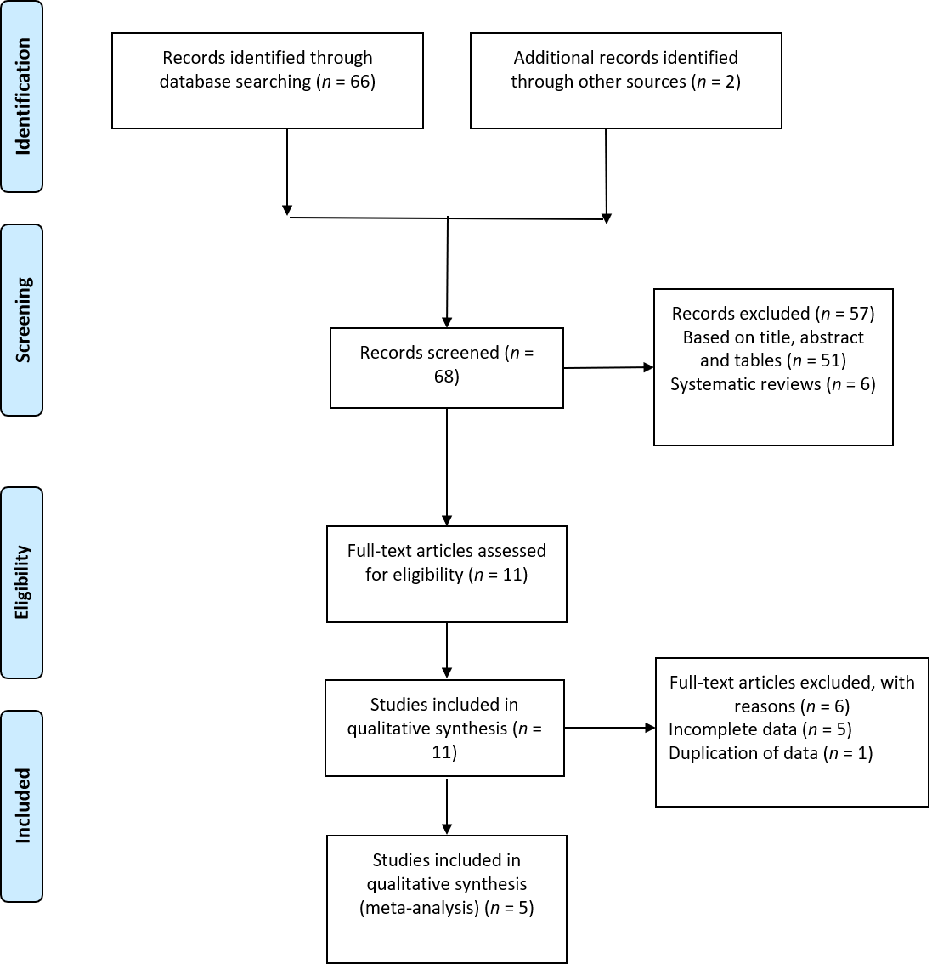
Figure 1 Preferred reporting items for systematic reviews and meta-analysis guidelines diagram.
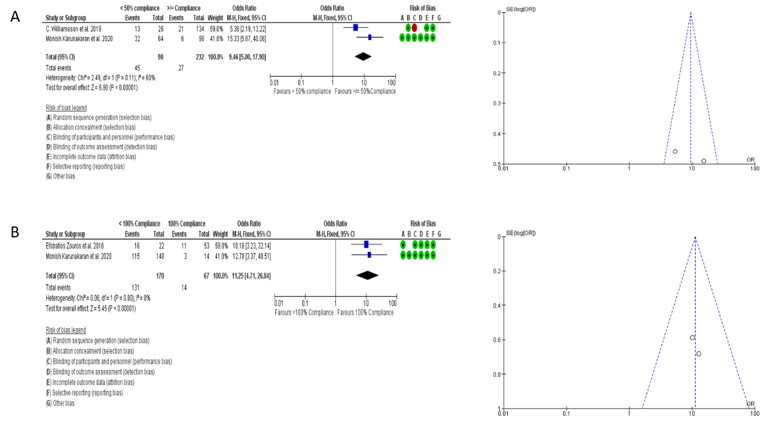
Figure 2 There was minimal publication bias in the included studies as assessed by funnel plots. A: Forest plot comparing ≥ 50% and < 50% compliance to the clinical pathway on overall post-pancreatoduodenectomy complications. Funnel plot shows moderate heterogeneity; B: Forest plot comparing 100% and < 100% compliance to the clinical pathway on overall post-pancreatoduodenectomy complications. Funnel plot shows no heterogeneity. CI: Confidence interval.
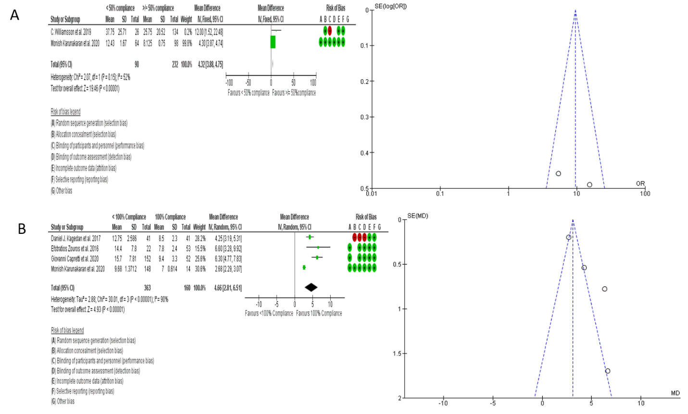
Figure 3 There was minimal publication bias in the included studies as assessed by funnel plots. A: Forest plot comparing ≥ 50% and < 50% compliance to the clinical pathway on post-pancreatoduodenectomy length of hospital stay. Funnel plot shows moderate heterogeneity; B: Forest plot comparing 100% and < 100% compliance to the clinical pathway on post-pancreatoduodenectomy length of hospital stay. Funnel plot shows significant heterogeneity. CI: Confidence interval.

Table 1 Summary of studies included in the analysis along with details of the clinical pathway, compliance and comparison between groups
Ref. | Study design | n | Age (yr) | Number of clinical pathway factors | Overall compliance (%) | Comparison groups (% of compliance) | NOS
Braga et al^{[16]}, 2014 | Prospective | 115 | 69 (61-74) | 12 (4 Pre- + 3 Intra- + 5 Post-op) | NA | No group stratification | -
Zouros et al^{[17]}, 2016¹ | Prospective | 75 | 65.9 ± 10.5 | 5 (Post-op) | NA | 100% (n = 53) vs < 100% (n = 22) | 7
Kagedan et al^{[18]}, 2017¹ | Retrospective | 82 | 65 (56-74) | 4 (Post-op) | NA | 100% (n = 134) vs < 100% (n = 134) | 6
Tremblay St-Germain et al^{[20]}, 2017 | Retrospective | 83 | 65 (29-85) | 8 (Post-op) | NA | No group stratification | -
Agarwal et al^{[23]}, 2018 | Prospective | 394 | 55 (18-81) | 13 (6 Pre + 4 Intra- + 3 Post-op) | 84 | ≥ 80% (n = 278) vs < 80% (n = 116) | -
Williamsson et al^{[24]}, 2019¹ | Retrospective | 160 | 66-69 | 8 (Post-op) | 52 | ≥ 50% (n = 134) vs < 50% (n = 26) | 7
Karunakaran et al^{[6]}, 2020¹ | Retrospective | 162 | 59 (19-84) | 8 (Post-op) | 53 | ≥ 50% (n = 98) vs < 50% (n = 64) | 7
Roulin et al^{[10]}, 2020 | Prospective | 390 | 65.3 ± 11.6 | 19 (7 Pre + 3 Intra- + 9 Post-op) | 62 (30 for post-operative components) | ≥ 70% (n = 85) vs < 70% (n = 305) | -
Tankel et al^{[21]}, 2020 | Prospective | 97 | 68 (17-85) | 7 (Post-op) | NA | No group stratification | -
Capretti et al^{[22]}, 2020¹ | Prospective | 205 | 64.7 ± 13.7 | 16 (5 Pre + 5 Intra- + 6 Post-op) | 68.4 | 100% (n = 52) vs < 100% (n = 152) | 7
St-Amour et al^{[19]}, 2020 | Retrospective | 89 | 68 (61-73) | NA | 63 (36 for post-op) | ≥ 67% vs < 67% | -
¹Included in the meta-analysis. NOS: Newcastle–Ottawa scale; NA: Not available.
Table 2 Summarising the morbidity, mortality and readmission rates along with length of stay and impact of deviations on these outcomes
Ref. | Length of stay¹ (d) | Complications (%) |  | Mortality (%) | Readmissions (%) | Impact of deviations/non-compliance to clinical pathway
 |  | Overall | ≥ CD 3
Braga et al^{[16]} | 14.6 ± 9.8 | 60 | 20 | 3.5 | 12.2 | Significantly lower deviations in patients with uneventful post-operative course; Lower compliance correlated with severity of postoperative complications; Low compliance to early oral feeding most likely to be associated with postoperative complications
Zouros et al^{[17]} | 9.7 ± 5.6 | 34.7 | 14.7 | 4 | 6.7 | < 100% compliance associated with significantly higher rates of postoperative complications (72.7% vs 20.8%; P < 0.001)
Kagedan et al^{[18]} | 9 (7-14) | NA | NA | 0.8 | 16 | < 100% compliance associated with longer length of stay (13 vs 7 d, P < 0.001) and greater mean total cost of the index postoperative hospitalization ($20392.81 CAD vs $10562.28 CAD, P < 0.002)
Tremblay St-Germain et al^{[20]} | 8 (4-35) | 67.5 | 29 | 0 | 22² | Failure to remove urinary catheter by POD 3, and initiate solid diet ≤ POD 4 (P < 0.01 and P < 0.001, respectively), more likely to have prolonged length of stay (> 8 d)
Agarwal et al^{[23]} | 12 (4-78) | 63.2 | 33.2 | 3.5 | 7.8 | < 80% compliance associated with significantly increased major complications (44% vs 28.7%, P < 0.004), CR-POPF (32.7% vs 20.8%, P < 0.012), longer length of stay [15 (4-61) vs 11 (5-78), P < 0.001)], re-explorations (17.2% vs 6.8%, P < 0.002), escalation of antibiotics (24.1% vs 14.7%, P < 0.025) and mortality (6.8% vs 2.1%, P = 0.021)
Williamsson et al^{[24]} | 12 (6-97) | 69.4 | 21.25 | 1.25 | 16.25² | < 50% compliance associated with delayed discharge [10 (6-77) vs 23 (8-97) d] and higher incidence of CD ≥ 3A complications [21 (16%) vs 13 (50%)]; ≥ 90% (n = 13) compliance had a median discharge of POD 8 (7-9) and no complication ≥ CD3A
Karunakaran et al^{[6]} | 10.8 ± 5.8 | 71 | 23.5 | 6.2 | 23.7² | < 50% compliance significantly higher risk of complications [DGE (79.7% vs 19.4%, P = 0.0001); POPF (22.2% vs 8.1%, P < 0.025); CD 3/4 complications (37.5% vs 6.1%, P < 0.0001)], longer length of stay (14 vs 10.8 d, P < 0.0001), 90-d readmissions (40.7% vs 14.3%, P = 0.0001) and mortality (14.1% vs 1%, P < 0.003)
Roulin et al^{[10]} | 14 (9-22) | 83.7 | 36.9 | 3.1 | 11.3 | < 70% compliance significantly increased length of stay [15 (10-23) vs 11 (7-16) d, P < 0.001], and overall (88.9% vs 78.8%, P < 0.029) and major (43.6 vs 28.2, P < 0.012) complications (especially respiratory and infectious)
Tankel et al^{[21]} | 14 (6-100) | NA | 21.6 | 2.1 | 28.9 | < 100% compliance had a longer length of stay ≥ 14 d
Capretti et al^{[22]} | 14.1 ± 8.6 | 54.6 | 15.6 | 1 | 3.4 | Sum of failed ERP components/deviations significantly correlated with postoperative complications
St-Amour et al^{[19]} | NA | NA | NA | NA | NA | No significant effect of ERAS® compliance on time to receipt of adjuvant chemotherapy from surgery, or disease-free survival
¹Expressed either as median (range) or mean (± SD).
²90-d readmissions (as opposed to others reporting 30-d readmissions). CD: Clavien-dindo; CAD: Canadian dollars; CR-POPF: Clinically-relevant post-pancreatectomy pancreatic fistula; DGE: Delayed gastric emptying; ERAS: Enhanced recovery after surgery; ERP: Enhanced recovery pathway; NA: Not available; POD: Post-operative day.

Published by Baishideng Publishing Group Inc
7041 Koll Center Parkway, Suite 160, Pleasanton, CA 94566, USA
Telephone: +1-925-3991568
E-mail: bpgoffice@wjgnet.com
Help Desk: https://www.f6publishing.com/helpdesk
https://www.wjgnet.com

© 2021 Baishideng Publishing Group Inc. All rights reserved.

