Name of Journal: World Journal of Orthopedics
ESPS Manuscript NO: 26002
Manuscript Type: Original Article

Retrospective Study
Windsurfing vs kitesurfing: Injuries at the North Sea over a 2-year period

van Bergen CJA et al. Windsurfing vs kitesurfing injuries

Christiaan JA van Bergen, Joris P Commandeur, Rik IK Weber, Daniel Haverkamp, Roelf S Breederveld

Christiaan JA van Bergen, Department of Orthopaedic Surgery, Spaarne Gasthuis, 2134 TM Hoofddorp, The Netherlands

Joris P Commandeur, Department of Surgery, Luzerner Kantonsspital, 6000 Luzern, Switzerland

Rik IK Weber, Daniel Haverkamp, Department of Orthopaedic Surgery, Slotervaartziekenhuis, 1066 EC Amsterdam, The Netherlands

Roelf S Breederveld, Department of Trauma Surgery, Red Cross Hospital, 1942 LE Beverwijk, The Netherlands

Author contributions: van Bergen CJA designed and performed the study and wrote the article; Commandeur JP helped perform the study; Weber RIK and Haverkamp D assisted in the analysis; Breederveld RS supervised the study; all authors reviewed and commented on the text and approved the final version.

Institutional review board statement: The study was reviewed and approved by the METC Noord-Holland Institutional Review Board.

Informed consent statement: All study participants provided informed consent prior to study enrolment.

Conflict-of-interest statement: The authors have no conflict of interest to report.

Data sharing statement: The anonymized dataset is available from the corresponding author at c.j.vanbergen@amc.nl.

Open-Access: This article is an open-access article which was selected by an in-house editor and fully peer-reviewed by external reviewers. It is distributed in accordance with the Creative Commons Attribution Non Commercial (CC BY-NC 4.0) license, which permits others to distribute, remix, adapt, build upon this work non-commercially, and license their derivative works on different terms, provided the original work is properly cited and the use is non-commercial. See: http://creativecommons.org/licenses/by-nc/4.0/

Manuscript source: Invited manuscript

Correspondence to: Christiaan JA van Bergen, MD, PhD, Orthopaedic Surgeon, Department of Orthopaedic Surgery, Spaarne Gasthuis, Spaarnepoort 1, 2134 TM Hoofddorp, The Netherlands. c.j.vanbergen@amc.nl
Telephone: +31-23-2240000
Fax: +31-20-5669117

Received: March 27, 2016
Peer-review started: March 30, 2016
First decision: May 13, 2016
Revised: September 26, 2016
Accepted: October 17, 2016
Article in press:
Published online:

Abstract
AIM
To analyze all windsurfing and kitesurfing (kiteboarding) injuries presented at our coastal hospital over a 2-year period.

METHODS
Twenty-five windsurfers (21 male; aged 31 ± 8 years) and 32 kitesurfers (23 male; aged 29 ± 11 years) presented at our hospital during the 2-year study period. Various injury data were recorded, including transport to hospital and treatment. After a median follow-up of 16 mo (range, 7-33 mo), 18 windsurfers (72%) and 26 kitesurfers (81%) completed questionnaires on the trauma mechanisms, the use of protective gear, time spent on windsurfing or kitesurfing, time to return to sports, additional injuries, and chronic disability.

RESULTS
Most patients sustained minor injuries but severe injuries also occurred, including vertebral and tibial plateau fractures. The lower extremities were affected the most, followed by the head and cervical spine, the upper extremities, and the trunk. The injury rates were 5.2 per 1000 h of windsurfing and 7.0 per 1000 h of kitesurfing (P = 0.005). The injury severity was the same between groups (P = 1.0). Less than 30% of the study population used protective gear. Kitesurfers had a higher number of injuries, and required transport by ambulance, inpatient hospital stay and operative treatment more often than windsurfers, but these differences were not statistically significant (P > 0.05). The median time to return to windsurfing and kitesurfing was 5 and 4 wk, respectively (P = 0.79). Approximately one-third of the patients in each group experienced chronic symptoms.

CONCLUSION
Kitesurfing results in a significantly higher injury rate than windsurfing in the same environmental conditions but the severity of the injuries does not differ.

Key words: General sports trauma; Extreme sports; Surfing; Epidemiology; Prevention

© The Author(s) 2016. Published by Baishideng Publishing Group Inc. All rights reserved.

Core tip: To our knowledge, this is the first study that directly compares kitesurfing and windsurfing in the same weather and environmental conditions, giving a unique insight in the injuries associated with these sports. Kitesurfing resulted in a significantly higher injury rate than windsurfing in the same environmental conditions but the severity of the injuries did not differ. The presented results may assist the health-care professional and the athlete in taking measures to prevent injuries and in advising or choosing the safer sport.

Van Bergen CJA, Commandeur JP, Weber RIK, Haverkamp D, Breederveld RS. Windsurfing vs kitesurfing: Injuries at the North Sea over a 2-year period. World J Orthop 2016; In press

INTRODUCTION
Windsurfing has a long history as a popular water sport since its introduction in 1971. It has been recognized as an Olympic sport since 1984. Various reports on windsurfing injuries have been published since 1988^{[1-6]}. Due to the technical developments, lighter and more sophisticated material, windsurfers have more possibilities to push out their frontiers, possibly exposing them to more dangerous situations (Figure 1).
Kitesurfing (or kiteboarding) is possibly the fastest growing water sport today. Using a small board and a kite of up to 20 m², surfers can achieve huge jumps and great speeds up to 55 knots (Figure 2). This extreme sport has been increasingly popular since it was developed in the late 1990s. In 2006, the total number of kitesurfers worldwide was estimated at around 210000, with 114465 inflatable kites sold that same year according to an in-depth worldwide industry survey^{[7]}. By 2008, the participation rate growth was between 35% and 50%^{[7]}. Despite the increasing popularity and possible dangers of this sport, little is known about injury prevalence or prevention^{[8]}. However, some reports did analyse kitesurfing injuries and even reported fatal accidents^{[9-12]}.
Windsurfing and kitesurfing are sports that have many fundamentals in common; wind is used to generate forward motion on the water, opening the possibility of performing tricks both on the water and in the air. However, the equipment used for these sports are completely different. Windsurfers use a sail with a mast directly connected to the board, whereas kitesurfers use a kite, which is attached to the athlete by multiple lines. Because of these differences, rates and severity of injuries may differ. Interestingly, these sports have never been compared in one study or in the same weather and environmental conditions. Providing comparative data may assist the athlete in taking measures to prevent injuries and in choosing the safer sport.
The aim of this study was to analyze and compare all kitesurfing and windsurfing injuries at our hospital over a 2-year period. We hypothesized that kitesurfing results in more frequent and more severe injuries than windsurfing.

MATERIALS AND METHODS
This is a retrospective study carried out according to a study protocol approved by the local medical ethics committee. All patients with windsurfing or kitesurfing injuries who presented at our hospital from September 2009 through September 2011 were included. September 2009 was chosen as the starting point of the study since our hospital then introduced the Electronic Patient Data (EPD) system, allowing for reliable inclusion of patients by search criteria.
A place at the North Sea close to our hospital is probably the most popular and most visited kitesurfing and windsurfing location of The Netherlands (Figure 3). Wind speeds are ≥ 4 Beaufort most of the days (60%-70%), and there are waves of up to 4 m. Injured individuals from this place typically present at the Emergency Department of our hospital because it is very close, between the beach and the highway.

Patient identification
The EPD was searched for windsurfing and kitesurfing injuries using the terms “surf” and “kite” with any possible prefix or extension. Thus, each patient with any of these terms - also as part of another word - mentioned in the patient charts was identified.

Data collection
Each patient’s chart was manually reviewed. Numerous patient data were recorded, including gender, date of birth, injury data [trauma mechanism, type of injury, affected body part(s)], site of injury (beach or water), transport to hospital, type of treatment, submission to hospital, or outpatient treatment.
Additionally, the patients were sent questionnaires with prepaid envelopes, accompanied by an information letter, containing the following items: (1) skill level (beginner, intermediate, advanced, expert); (2) number of years of experience; participant hours (number of days a year and mean number of hours a day); (3) cause of the injury; wind speed; (4) use of protective gear (helmet, vest) at the time of injury; (5) availability and use of a quick-release system (kitesurfing only); (6) time to return to windsurfing or kitesurfing; (7) additional injuries during the study period; and (8) chronic symptoms.
For windsurfing, the skill level was assessed by the study participants according to the following scale: Beginner, learning to windsurf, basic tacking and gybing; intermediate, basic beach starting, planing techniques, use of foot straps and harness; advanced, water starting, carve gybe, launching and landing in waves; expert, advances aerial and freestyle manoeuvres^{[1]}. For kitesurfing, the skill level was assessed by the study participants according to the following scale: Beginner, starting and landing the kite with help, downwind rides on the water; intermediate, easy manoeuvres such as jibes, upwind rides, and small jumps; advanced, high jumps and transition jumps; expert, high jumps with rotation and board-off jumps^{[9]}.
The questionnaire included any information that could not be retrieved from the charts for that specific patient.
The severity of the injury was classified as follows^{[9]}: (1) catastrophic, injuries leading to permanent disability or death; (2) severe, injuries resulting in absence from kitesurfing or windsurfing for more than 6 wk; (3) medium, injuries resulting in absence from kitesurfing or windsurfing for more than 1 d; and (4) mild, injuries resulting in incapacity to train or compete on a normal basis.

Statistical analysis
Data with a normal distribution are presented as mean ± standard deviation. Data with a skewed distribution are presented as median and range. Injury rates were calculated per 1000 h of windsurfing or kitesurfing. Various data were compared between windsurfing and kitesurfing with use of parametric or nonparametric statistical tests, depending on the number and distribution of data (Student t-test for age; Mann-Whitney U test for other continuous data; ² or Fisher’s Exact test for nominal and categorical data, where appropriate). A P-value of 0.05 was considered to be statistically significant.

RESULTS
The computer-generated search and manual chart review identified 57 patients (25 windsurfers and 32 kitesurfers) who had presented at our Emergency Department during the study period.

Baseline characteristics and protective gear
There were 44 male and 13 female patients with a mean age of 30 ± 10 (range, 11-57) years. Eighteen windsurfers (72%) and 26 kitesurfers (81%) completed the questionnaire. The median time to follow-up was 16 mo (range, 7-33 mo). Most baseline characteristics were not significantly different between the groups, but windsurfers had significantly more experience and a higher skills level than kitesurfers (Table 1). Only 17% in the windsurf group and 28% in the kitesurf group used protective gear such as helmets and body protectors (impact vests). A quick-release system was present in 24 (92%) out of 26 kitesurfers, but it was deployed by only eight (31%).

Injury rates
In the windsurf group, 32 injuries occurred during a total of 6146 windsurfing hours during the study period of 2 years. This corresponds with an overall injury rate of 5.2 injuries per 1000 h of windsurfing (Table 2). In the kitesurf group, 49 injuries occurred during a total of 6978 kitesurfing hours in 2 years, which corresponds with an overall injury rate of 7.0 injuries per 1000 h of kitesurfing. The difference between the groups was statistically significant (P = 0.005).

Injury patterns and severity
In the windsurf group, most injuries generally occurred during difficult manoeuvres such as forward and back loops, or due to unexpected wind gusts. Likewise, in the kitesurf group most injuries were caused by high jumps or wind gusts; additionally, many of the injuries in this group were caused by technical difficulties controlling the kite and/or board. Only few injuries in both groups were the result of collisions with other surfers.
Most patients in both groups sustained minor injuries, such as contusions, lacerations, and ankle sprains. However, numerous serious injuries also occurred. In the windsurf group, serious injuries included fractures of the tibial plateau and os trapezium. In the kitesurf group, there were fractures of the dens, L3 vertebral body, olecranon, scaphoid, tibial plateau, and talus. The lower extremities were affected the most, followed by the head and cervical spine, the upper extremities, and the trunk, respectively (Table 2).
The severity of the injuries was graded as medium or severe in most cases of both groups (Table 2). The injury severity was neither significantly different between the groups, nor associated with patient age, skills level, or the use of protective gear.
Although kitesurfers had a higher number of injuries and required transport by ambulance, inpatient hospital stay and operative treatment more frequently than windsurfers, these differences were not statistically significant (Table 2). Kitesurfing accidents happened significantly more on the beach than windsurfing accidents (P = 0.014).
The median time to return to sports was approximately 1 mo (Table 2). About one-third of the patients experienced chronic symptoms due to the accident at the time of follow-up (Table 2).

DISCUSSION
Windsurfing and kitesurfing are sports that are closely connected to the elements. As such, these sports have a certain level of unpredictability. These properties might be the reasons why these sports are so popular. However, the unpredictability might also impose a key factor in the risks associated with these sports. Therefore, finding typical trauma mechanisms and handles for prevention is challenging.

Injury rates
The main objective of this study was to investigate the incidence of injuries among both windsurfers and kitesurfers and thus generate an objective image of the risk incorporated in these sports. The results suggest that kitesurfing has a significantly higher injury rate than windsurfing. We found an injury rate of 5.2 per 1000 h of windsurfing compared to 7.0 injuries per 1000 h of kitesurfing.
The groups were comparable with regard to age, gender, weather conditions, and participant hours. However, the average experience and skills level were higher amongst windsurfers. One might speculate that less experienced athletes sustain more severe injuries, which could partially explain the outcomes of our study. However, another study found that having more experience increases the risk of significant injuries among recreational surfers^{[13]}. Therefore, the explanation for the different injury rates between the groups in our study might be found in the technical differences between sports and in the risks associated with the gear used, rather than the experience of the sportsmen.
In the literature, a few previous studies reported injury rates. A review of the literature identified an overall injury rate of 5.9 to 7.0 injuries per 1000 noncompetitive kitesurfing hours^{[12]}. A prospective kitesurf study showed an injury rate of 7 injuries per 1000 h of practicing the sport^{[9]}. This rate is the same as that found for kitesurfing in our retrospective study. For windsurfing, however, lower injury rates have been reported in retrospective studies. McCormick et al^{[4]} in 1988 found an injury rate of 0.22 injuries per 1000 h of practicing windsurfing. Other reported injury rates in windsurfing ranged from 1.1 to 2.0 injuries/person per year^{[1,6]}. These rates are somewhat lower than ours. Possible interpretations for these differences might be found in the different weather and water conditions between studies and in an evolution of the sport since 1988, possibly adding more risk. Furthermore, the rates found in our study might be overestimated because only injured individuals were included.
Both windsurfing and kitesurfing clearly have lower injury rates compared with other extreme sports and contact sports. For example, American football, motocross, and football (soccer) have injury rates of 36, 23, and 19 per 1000 h, respectively^{[14-16]}. However, conclusions from comparing injury rates between different studies should be interpreted with caution due to the lack of a uniform injury definition in sports science.

Injury patterns and severity
We found no difference in injury severity between the kitesurf and windsurf groups. In both groups, the majority of injuries were relatively minor, with the highest prevalence in the lower extremities. Previous studies showed comparable patterns, severity and location of injuries^{[1,9,11]}. The injury severity was not associated with patient age, skills level or the use of protective gear. However, the study may not have enough numbers in the subgroups to support this with confidence (causing a statistic error type II).
In windsurfing, the most common causes of injuries were technical manoeuvres and unexpected wind gusts. The leading causes of injuries in kitesurfing were jumps, wind gusts and lack of controlling the kite. These findings concur with other studies^{[9,11]}. The fact that kitesurfers lost control more often might be due to less experience, a difference in the technical aspects of controlling a kite, or a larger surface of a kite than a windsurf sail.
Dyson et al^{[1]} reported collision with equipment to be the major contributor to injuries of windsurfers. Nickel et al^{[9]} suggested separating designated areas for windsurfers and kitesurfers to prevent collisions. However, in our study that addressed both sports, collisions were reported infrequently. According to these results, separation of windsurfing and kitesurfing areas seems unnecessary.

Injury prevention
Little is known about the effect of protective gear in the prevention of windsurf and kitesurf related injuries. The equipment of both sports has evolved during the past decades. In windsurfing, the changes have been subtle. Booms are smaller and foot straps are designed for easier exit. Given the fact that kitesurfing is a relatively young sport, equipment evolution is most notable in this sport; the major advancement being a quick-release safety system, enabling kitesurfers to release the kite easily in case of emergency (Figure 4). Although most kitesurfers had a quick-release system on their kite, the minority deployed it. The use of protective gear such as helmets, impact vests and flotation devices has been accepted more and more. However, only still a small percentage of the athletes use protective equipment, as is shown in our study as well as previous studies^{[8,11]}. Better use of quick-release systems and protective gear offers possibilities for education and counseling.
In kitesurfing, significantly more accidents occurred on the beach (42% vs 6% for windsurfing. Launching and landing the kite on the beach are the times that kitesurfers are classically at risk, particularly if inexperienced, as an accident at this time means the kiter lands on a hard surface (beach) as opposed to water. These data provide another handle for prevention, with focus on education and awareness regarding the risk of injury during launching and landing the kite.
Other sources of injury prevention are exercises and warming up. Dyson et al^{[1]} reported a relatively high incidence of lower back problems amongst windsurfers and stated a possible role for back exercises in the prevention of these injuries. Lundgren et al^{[17]} found a protective effect of a warming-up before starting a kitesurf session.

Limitations
The identification of study patients through searching the EPD might not have detected patients in case the words “surf” or “kite” were not used in the patient’s file. The injury rates in this study were calculated retrospectively. It might be difficult for participants to estimate the hours they practiced sports during the time period of the study, although any uncertainty would affect both groups. Furthermore, only athletes who presented at our hospital were included. It might be conceivable that these windsurfers and kitesurfers are more prone to injuries than others. The total amount of windsurfers and kitesurfers is unknown. These factors might result in injury rates that are reported higher than they actually are. However, the results for kitesurfers are the same as those found in a prospective study^{[9]}, which might support the validity of our findings. Lastly, the group sizes in our study were limited. This may partially explain the fact that differences between groups concerning transport by ambulance, inpatient hospital stay and operative treatment did not reach statistical significance. Future studies following large groups of surfers prospectively throughout multiple seasons may provide the most reliable data to analyse and compare injuries.
In conclusion, to our knowledge, this is the first study that directly compares kitesurfing and windsurfing in the same conditions, giving a unique insight in the injuries associated with these sports during a 2-year period. The outcomes suggest that kitesurfing has a higher injury rate than windsurfing. The severity of injuries was similar.

COMMENTS
Background
Windsurfing has been a popular water sport for over three decades. Kitesurfing is possibly the fastest growing water sport today. Windsurfing and kitesurfing are sports that have many fundamentals in common; wind is used to generate forward motion on the water, opening the possibility of performing tricks both on the water and in the air. Thus, both extreme sports pose the athlete at risk for injuries. However, the equipment used for these sports are completely different. Windsurfers use a sail with a mast directly connected to the board, whereas kitesurfers use a kite, which is attached to the athlete by multiple lines. Because of these differences, rates and severity of injuries may differ.

Research frontiers
Various reports on windsurfing injuries have been published since 1988. Some other reports have analysed kitesurfing injuries and even reported fatal accidents. Current research aims to further identify trauma mechanisms and provide handles for prevention.

Innovations and breakthroughs
To our knowledge, this is the first study that directly compares kitesurfing and windsurfing in the same conditions, giving a unique insight in the injuries associated with these sports during a 2-year period. The outcomes suggest that kitesurfing has a higher injury rate than windsurfing. Injury data are presented and preventive measures are suggested.

Applications
The provided comparative data may assist the athlete and sport physician in taking measures to prevent injuries and in choosing the safer sport. This study forms a base for future research investiging larger groups of surfers prospectively to provide the most reliable data on injuries.

Peer-review
It is an interesting manuscript on investigating and comparing windsurf vs kite surf in the same conditions giving a description of the associated injuries. Overall the structure of the manuscript is very good and the language of the manuscript reaches the standard of publishing.
REFERENCES
1 Dyson R, Buchanan M, Hale T. Incidence of sports injuries in elite competitive and recreational windsurfers. Br J Sports Med 2006; 40: 346-350 [PMID: 16556791 DOI: 10.1136/bjsm.2005.023077]
2 Gosheger G, Jägersberg K, Linnenbecker S, Meissner HJ, Winkelmann W. [Injury patterns and prevention in World Cup windsurfing]. Sportverletz Sportschaden 2001; 15: 50-54 [PMID: 11475622 DOI: 10.1055/s-2001-14815]
3 Kalogeromitros A, Tsangaris H, Bilalis D, Karabinis A. Severe accidents due to windsurfing in the Aegean Sea. Eur J Emerg Med 2002; 9: 149-154 [PMID: 12131638 DOI: 10.1097/00063110-200206000-00009]
4 McCormick DP, Davis AL. Injuries in sailboard enthusiasts. Br J Sports Med 1988; 22: 95-97 [PMID: 3233460 DOI: 10.1136/bjsm.22.3.95]
5 Nathanson AT, Reinert SE. Windsurfing injuries: results of a paper- and Internet-based survey. Wilderness Environ Med 1999; 10: 218-225 [PMID: 10628281]
6 Neville V, Folland JP. The epidemiology and aetiology of injuries in sailing. Sports Med 2009; 39: 129-145 [PMID: 19203134 DOI: 10.2165/00007256-200939020-00003]
7 Kiteboarding Statistics: Worldwide Participation and Sales Figures. 2015. Available from: URL: http://www.sbckiteboard.com/search_article?news_id=418
8 Exadaktylos AK, Sclabas GM, Blake I, Swemmer K, McCormick G, Erasmus P. The kick with the kite: an analysis of kite surfing related off shore rescue missions in Cape Town, South Africa. Br J Sports Med 2005; 39: e26; discussion e26 [PMID: 15849279 DOI: 10.1136/bjsm.2004.014795]
9 Nickel C, Zernial O, Musahl V, Hansen U, Zantop T, Petersen W. A prospective study of kitesurfing injuries. Am J Sports Med 2004; 32: 921-927 [PMID: 15150038 DOI: 10.1177/0363546503262162]
10 Scheibe E, Lignitz E, Hinz P, Scheibe R. [Kitesurfing. A new trend sport but not without danger.]. Rechtsmedizin 2009; 19: 145-151 [DOI: 10.1007/s00194-009-0597-0]
11 Spanjersberg WR, Schipper IB. Kitesurfing: when fun turns to trauma-the dangers of a new extreme sport. J Trauma 2007; 63: E76-E80 [PMID: 17554218 DOI: 10.1097/TA.0b013e318046edfd]
12 Bourgois JG, Boone J, Callewaert M, Tipton MJ, Tallir IB. Biomechanical and physiological demands of kitesurfing and epidemiology of injury among kitesurfers. Sports Med 2014; 44: 55-66 [PMID: 24105613 DOI: 10.1007/s40279-013-0103-4]
13 Pikora TJ, Braham R, Mills C. The epidemiology of injury among surfers, kite surfers and personal watercraft riders: wind and waves. Med Sport Sci 2012; 58: 80-97 [PMID: 22824840 DOI: 10.1159/000338583]
14 Dick R, Ferrara MS, Agel J, Courson R, Marshall SW, Hanley MJ, Reifsteck F. Descriptive epidemiology of collegiate men's football injuries: National Collegiate Athletic Association Injury Surveillance System, 1988-1989 through 2003-2004. J Athl Train 2007; 42: 221-233 [PMID: 17710170]
15 Gobbi A, Tuy B, Panuncialman I. The incidence of motocross injuries: a 12-year investigation. Knee Surg Sports Traumatol Arthrosc 2004; 12: 574-580 [PMID: 15133584 DOI: 10.1007/s00167-004-0510-z]
16 Nielsen AB, Yde J. Epidemiology and traumatology of injuries in soccer. Am J Sports Med 1989; 17: 803-807 [PMID: 2516415 DOI: 10.1177/036354658901700614]
17 Lundgren L, Brorsson S, Osvalder AL. Comfort aspects important for the performance and safety of kitesurfing. Work 2012; 41 Suppl 1: 1221-1225 [PMID: 22316886]

P- Reviewer: Angoules A, Drampalos E, Hernandez-Sanchez S
S- Editor: Gong XM L- Editor: E- Editor:

Table 1 Baseline characteristics
 |  | Windsurfing | Kitesurfing | P-value
Age (yr) |  | 31 +/- 8 | 29 +/- 11 | 0.437
Gender (no. and % of patients) |  |  |  | 0.279
 | Male | 21 (84%) | 23 (72%)
 | Female | 4 (16%) | 9 (28%)
Experience (yr) |  | 15 (0-30) | 2 (0-12) | < 0.001
Annual participant hours |  | 106 (1-480) | 70 (1-810) | 0.184
Skills level |  |  |  | 0.001
 | Beginner | 1 (4%) | 11 (34%)
 | Intermediate | 0 (0%) | 6 (19%)
 | Advanced | 9 (36%) | 3 (9%)
 | Expert | 8 (32%) | 6 (19%)
Wind speed (Bft) |  | 6 (2-8.5) | 5 (2-9) | 0.362
Protective gear (no. and % of patients) |  | 3 (17%) | 7 (28%) | 0.480

Data are presented as mean +/- standard deviation in case of normal distribution, and as median (range) in case of skewed distribution.

Table 2 Injury data
 |  | Windsurfing | Kitesurfing | P-value
Number of injuries per 1000 h |  | 5.2 | 7.0 | 0.005
Affected body site (no. and % of patients) |  |  |  | 0.413
 | Head and cervical spine | 9 (36%) | 11 (34%)
 | Upper extremity | 6 (24%) | 5 (16%)
 | Trunk and thoracolumbar spine | 0 (0%) | 3 (9%)
 | Lower extremity | 10 (40%) | 13 (41%)
Injury severity (no. and % of patients) |  |  |  | 1.000
 | Mild | 3 (17%) | 5 (19%)
 | Medium | 6 (33%) | 9 (35%)
 | Severe | 8 (44%) | 10 (39%)
 | Catastrophic | 1 (6%) | 2 (8%)
Location of accident (no. and % of patients) |  |  |  | 0.014
 | Water | 17 (94%) | 15 (58%)
 | Beach | 1 (6%) | 11 (42%)
Type of transport (no. and % of patients) |  |  |  | 0.161
 | Ambulance | 2 (11%) | 8 (31%)
 | Own transport | 16 (89%) | 18 (69%)
Inpatient hospital stay (no. and % of patients) |  | 1 (4%) | 5 (16%) | 0.215
Operative treatment (no. and % of patients) |  | 1 (4%) | 4 (13%) | 0.372
Total number of injuries during study period (no. and % of patients) |  |  |  | 0.237
 | 1 | 20 (80%) | 19 (59%)
 | 2 | 3 (12%) | 9 (28%)
 | 3 | 2 (8%) | 4 (13%)
Return to sports in weeks (median and range) |  | 5 (0-chronic) | 4 (0-chronic) | 0.792
Chronic symptoms (no. and % of patients) |  | 7 (39%) | 8 (31%) | 0.576

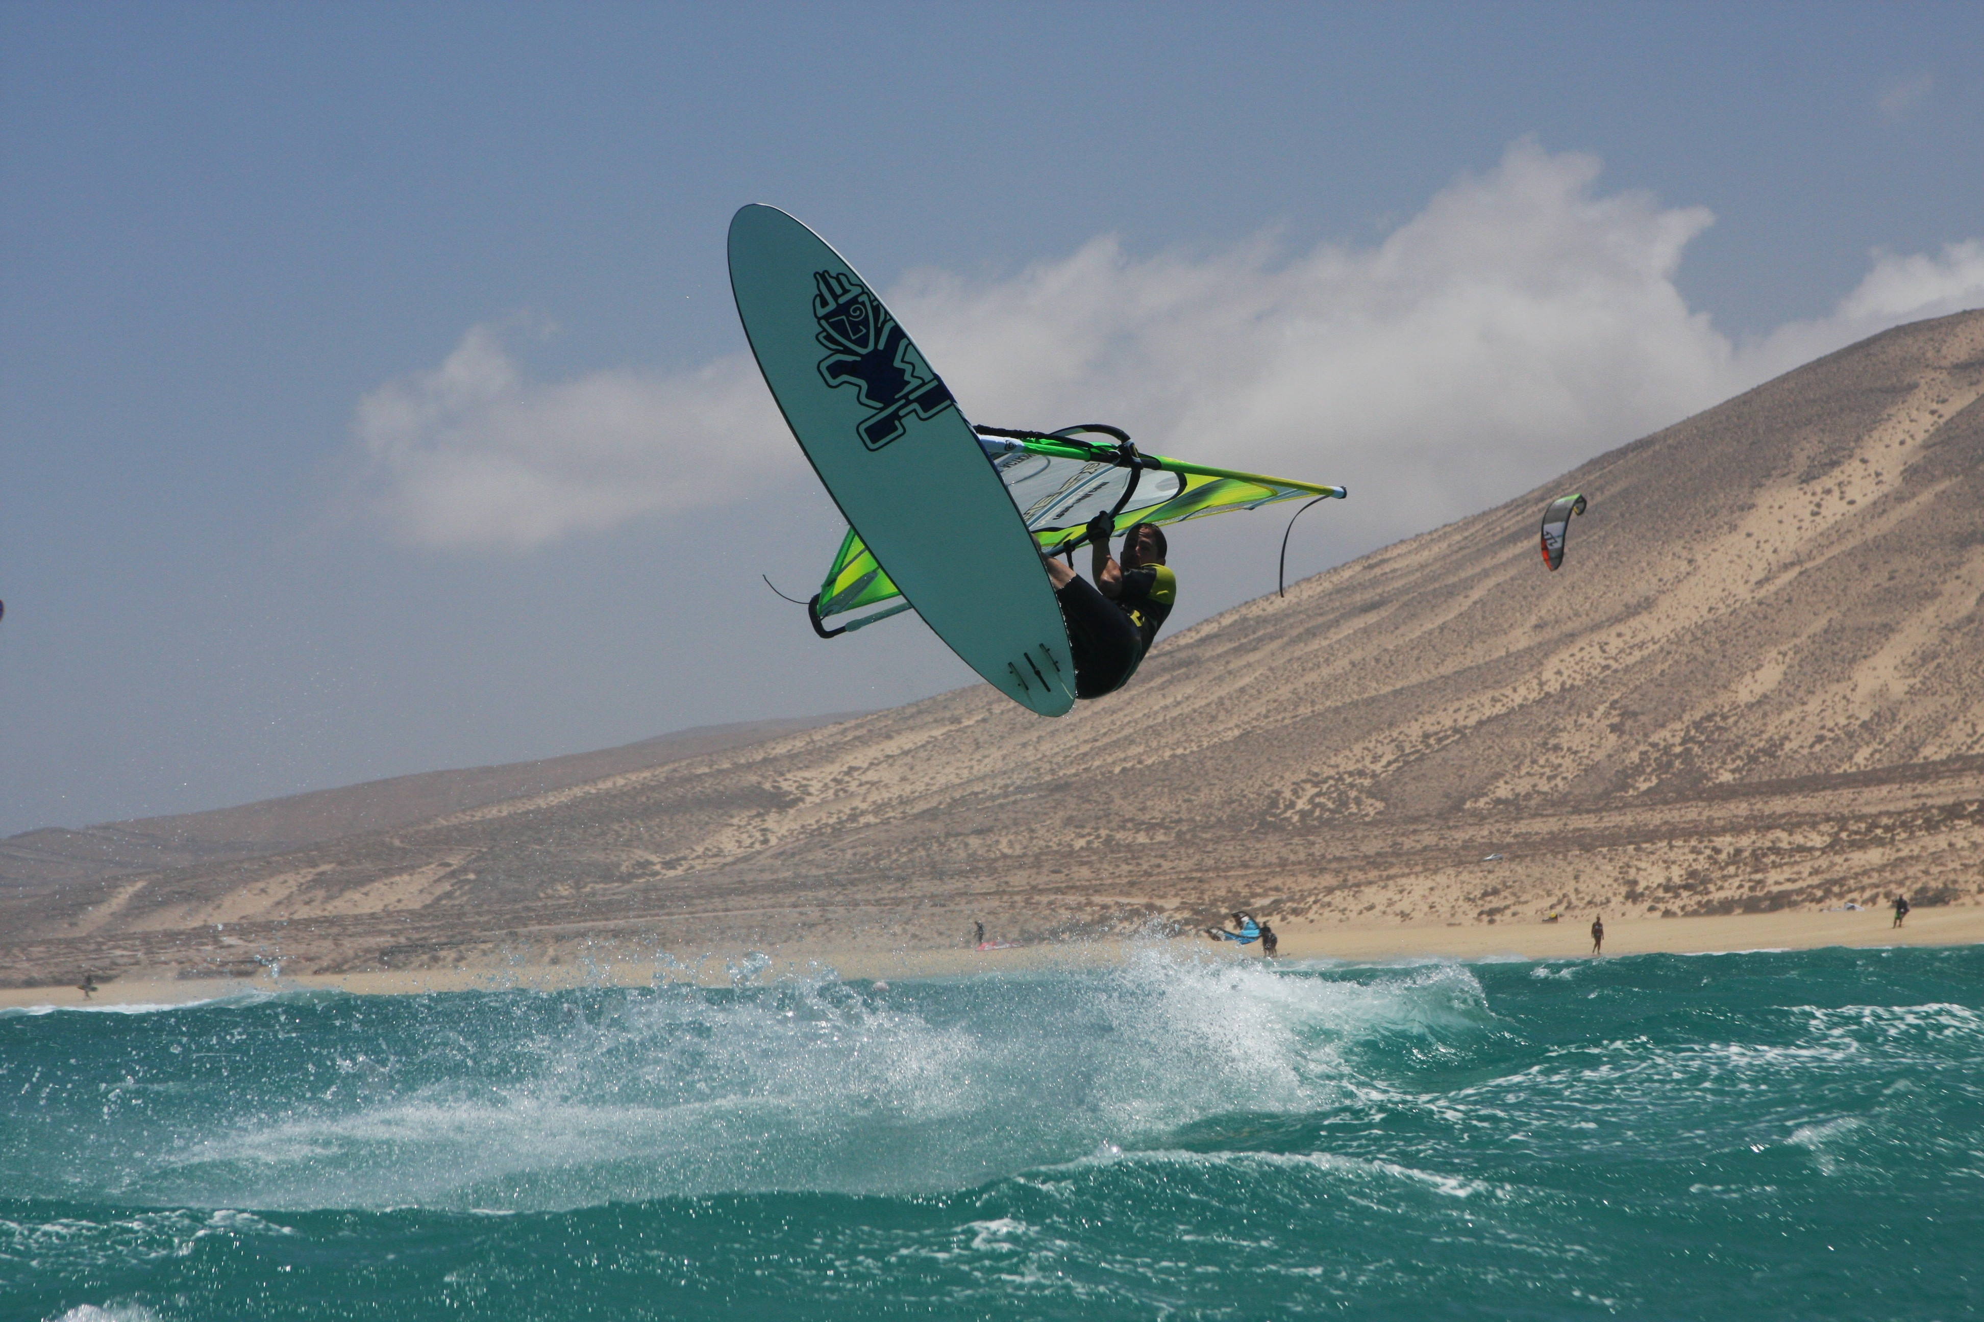
Figure 1 Windsurf action.

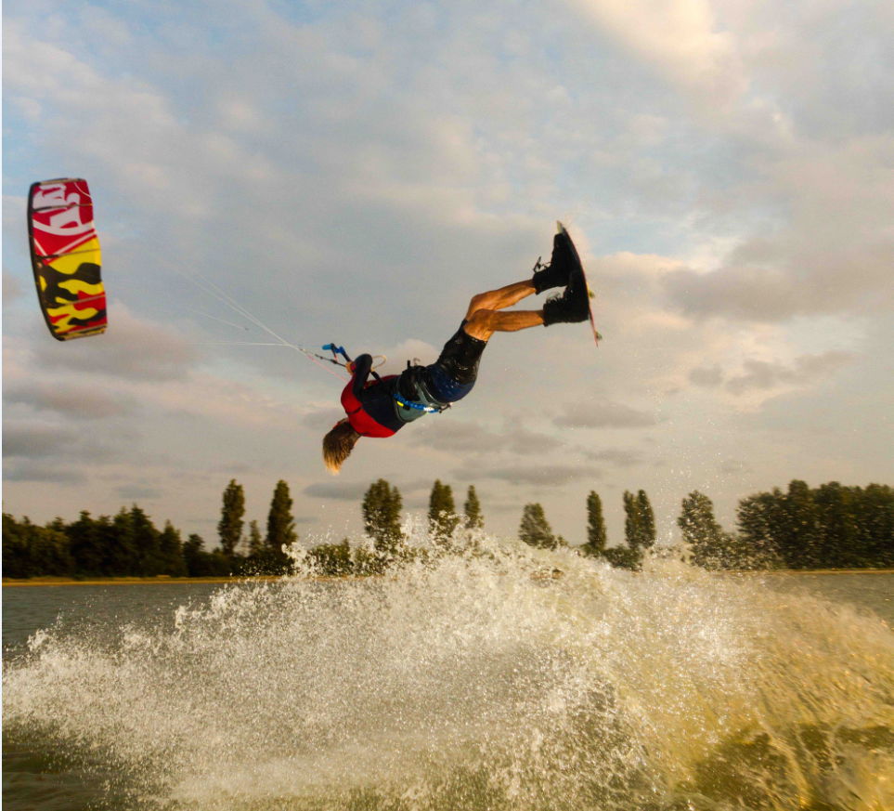
Figure 2 Kitesurf action.

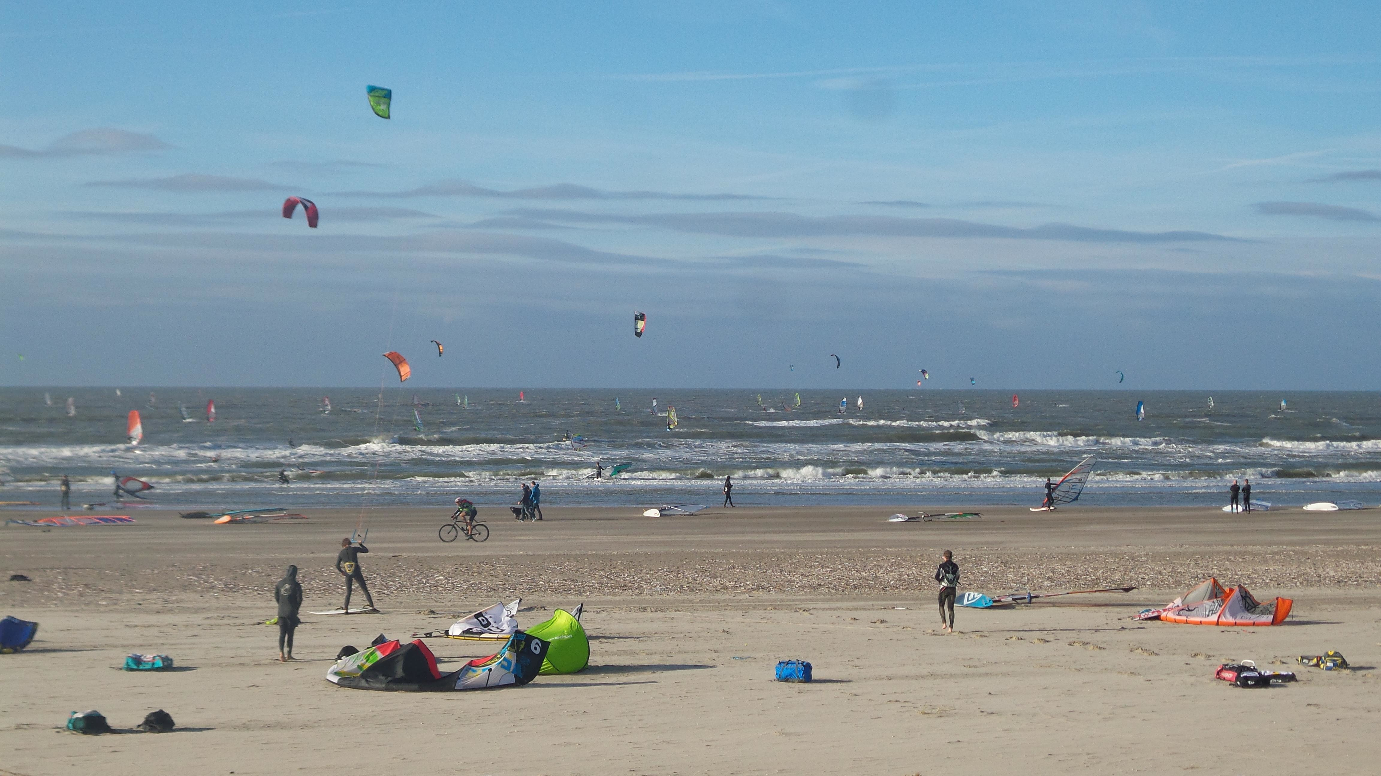
Figure 3 Picture of the popular spot at the North Sea on a typical day, showing windsurfers and kitesurfers mixed.

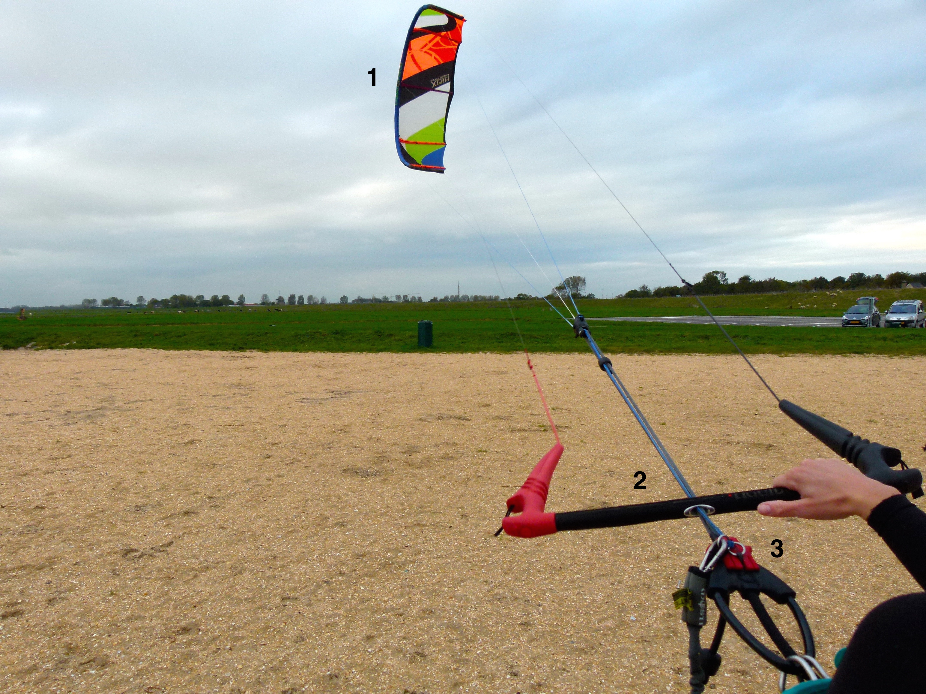
Figure 4 Picture showing (1) the kite, (2) the handlebar, and (3) the quick-release system.

