Name of Journal: World Journal of Clinical Cases
Manuscript NO: 52865
Manuscript Type: CASE REPORT

Esophageal tuberculosis complicated with intestinal tuberculosis: a case report

Mao L et al. Esophageal and intestinal tuberculosis

Lei Mao, Xue-Ting Zhou, Ji-Pin Li, Jun Li, Fang Wang, Hui-Min Ma, Xiao-Lu Su, Xiang Wang

Lei Mao, Xue-Ting Zhou, Ji-Pin Li, Jun Li, Fang Wang, Hui-Min Ma, Xiao-Lu Su, Xiang Wang, Department of Gastroenterology, The Second Hospital of Lanzhou University, Lanzhou 730000, Gansu Province, China

Author contributions: Wang X and Mao L were attending physicians for the patient, reviewed the literature and contributed to manuscript drafting; Zhou XT, Li JP and Li J reviewed the literature and contributed to manuscript drafting; Wang F and Ma HM performed the upper gastrointestinal endoscopy and colonoscopy, and contributed to manuscript drafting; Su XL analyzed and interpreted the histopathological findings; Wang X was responsible for the revision of the manuscript for important intellectual content; all authors issued final approval for the version to be submitted.

Corresponding author: Xiang Wang, MAMS, Associate Professor, Chief Physician, Department of Gastroenterology, The Second Hospital of Lanzhou University, No. 82 Cuiyingmen, Chengguan District, Lanzhou 730000, Gansu Province, China. wangxiang@lzu.edu.cn

Received: November 22, 2019
Revised: December 10, 2019
Accepted: December 14, 2019
Published online: February 6, 2020
Abstract
BACKGROUND
Although the overall incidence of tuberculosis in underdeveloped areas has increased in recent years, esophageal tuberculosis (ET) is still rare. Intestinal tuberculosis (ITB) is relatively more common, but there are few reports of ET complicated with ITB. We report a case of secondary ET complicated with ITB in a previously healthy patient.

CASE SUMMARY
A 27-year-old female was hospitalized for progressive dysphagia, retrosternal pain, acid regurgitation, belching, heartburn, and nausea. Upper gastrointestinal endoscopy showed a mid-esophageal ulcerative hyperplastic lesion. Endoscopic ultrasonography showed a homogeneous hypoechoic lesion, with adjacent enlarged lymph nodes. Biopsy histopathology showed inflammatory exudation, exfoliated epithelial cells and interstitial granulation tissue proliferation. Colonoscopy revealed a rat-bite ulcer in the terminal ileum and a superficial ulcer in the ascending colon, near the ileocecal region. The ileum lesion biopsy showed focal granulomas with caseous necrosis. Polymerase chain reaction for Mycobacterium tuberculosis was positive in the esophageal and ileum lesion biopsies. The T-cell spot tuberculosis test was also positive. The patient was diagnosed with secondary ET infiltrated by mediastinal lymphadenopathy and complicated with ITB, possibly from the Mycobacterium tuberculosis-infected esophageal lesion. After 2 mo of anti-tuberculosis therapy, her symptoms improved significantly, and upper gastrointestinal endoscopy showed healing ulcers.

CONCLUSION
When dysphagia or odynophagia occurs in patients at high-risk for tuberculosis, ET should be considered.

Key words: Esophageal tuberculosis; Intestinal tuberculosis; Dysphagia; Endoscopic ultrasonography; Tuberculosis drug therapy; Case report

Mao L, Zhou XT, Li JP, Li J, Wang F, Ma HM, Su XL, Wang X. Esophageal tuberculosis complicated with intestinal tuberculosis: a case report. World J Clin Cases 2020; 8(3): 645-651 URL: https://www.wjgnet.com/2307-8960/full/v8/i3/645.htm DOI: https://dx.doi.org/10.12998/wjcc.v8.i3.645

Core tip: Esophageal (ET) and intestinal tuberculosis are rare forms of tuberculosis, and there are few reports of ET complicated with intestinal tuberculosis. Our patient presented with progressive dysphagia, but no other significant medical history. Lesions in the esophagus and colon were found to be Mycobacterium tuberculosis positive. The patient responded well to anti-tuberculosis therapy. This case demonstrates that ET should be suspected when patients at high risk for tuberculosis present with dysphagia or odynophagia.

INTRODUCTION
Intestinal tuberculosis (ITB) is the sixth most common type of extrapulmonary tuberculosis, accounting for only 2% of tuberculosis cases^{[1]}. Esophageal tuberculosis (ET), which is usually associated with mediastinal lymphadenopathy, is an even rarer form of extrapulmonary tuberculosis, accounting for only 2.8% of gastrointestinal tuberculosis^{[2]}. There are few reports of ET complicated with ITB.

CASE PRESENTATION
Chief complaints
A 27-year-old woman presented to our hospital with a one-month history of progressive dysphagia, accompanied by post-sternal pain, belching, acid regurgitation, heartburn, and nausea, with no fever, cough, abdominal pain, gastrointestinal bleeding, night sweats or weight loss.

History of present illness
An upper gastrointestinal endoscopy performed in another hospital revealed a protruding lesion in the middle esophagus, which was considered an esophageal leiomyoma.

History of past illness
She had no significant past medical history.

Personal and family history
There was no pertinent family history.

Physical examination upon admission
There was no obvious abnormality in the patient’s physical examination.

Laboratory examinations
Routine blood tests were normal, including erythrocyte sedimentation rate and C-reactive protein. The liver and kidney functions were normal. The human immunodeficiency virus antibody was negative. The T-cell spot tuberculosis test was positive. Autoimmune-related antibodies such as ANA, ANCA, AMA, LMA, and ASMA were negative.

Imaging examinations
The enhanced chest computed tomography showed local thickening of the esophageal wall with moderate enhancement (Figure 1).

Further diagnostic work-up
An upper gastrointestinal endoscopy was repeated in our hospital and showed a 1.5 cm plate-shaped ulcerated hyperplastic lesion in the middle esophagus, about 26-30 cm from the incisors, with a central depression, erosion and slight bleeding (Figure 2). An endoscopic ultrasound (EUS) was performed and showed a homogeneous hypoechoic lesion protruding into the esophageal lumen, with mucosal layers that had disappeared and fused, and 17.5 mm × 21.3 mm enlarged lymph nodes adjacent to the esophageal lesion (Figure 3). Three biopsy specimens were taken from the esophageal lesion and pathologic results showed epithelial detachment and interstitial granulation tissue hyperplasia under inflammatory exudation (Figure 4). The polymerase chain reaction for Mycobacterium tuberculosis (TB–PCR) test was positive. A colonoscopy revealed an irregular ulcer in the terminal ileum, with a rat-bite border and a thin white moss covering at the bottom, and a shallow ulcer of about 0.5 cm × 0.6 cm in the ascending colon, near the ileocecal region, with an irregular border and congested edematous peripheral mucosa (Figure 5). Two biopsy specimens were taken from the lesion at the terminal ileum and pathologic results revealed that the mucosa was in an acute inflammatory activity period of chronic inflammation, with decreasing or disappearing crypts in some areas, and some small focal granulomas in the stroma, which were composed of epithelial cells. Some caseous necroses were observed in the center of the granulomas, and the granulomas were surrounded by numerous lymphocytes (Figure 6). TB-PCR of these specimens was also positive.

FINAL DIAGNOSIS
Based on the above evidence, the patient was diagnosed with ET, secondary to mediastinal lymphadenopathy, and complicated with ITB, which was caused by Mycobacterium tuberculosis infection from the esophageal lesion.

TREATMENT
The patient was treated with anti-tuberculosis therapy (ATT) (2HRZE) for 2 mo (isoniazid 300 mg QD, rifampicin 0.45 g QD, pyrazinamide 0.5 g TID and ethambutol 0.75 g QD).

OUTCOME AND FOLLOW-UP
After 2 mo of ATT, her symptoms improved significantly, and follow-up upper gastrointestinal endoscopy showed ulcer healing with scar tissue (Figure 7). Neither liver function impairment nor intolerance to antitubercular drugs was observed. ATT will be administered for another 4 mo (4HR, isoniazid, rifampicin), and we will continue to follow up on her condition.

DISCUSSION
ET is a rare form of extrapulmonary tuberculosis. Primary ET is defined as involvement of the esophagus only but without the involvement of any other body site. Secondary ET is often caused by direct infiltration from adjacent mediastinal lymph nodes and some cases may be transmitted by lung or spinal infection or blood. Due to esophageal self-defense mechanisms such as mucosal protecting factors, stratified squamous epithelium, esophageal peristalsis, mucus, saliva, and erect posture, primary ET is extremely rare and secondary ET is more common. In this case, the patient was considered to have secondary ET complicated with ITB.
According to existing case reports^{[3-7]}, ET is more common in middle-aged and elderly women, but a minority of patients are young^{[8]}. The onset of ET is often insidious, with few systemic manifestations of typical tuberculosis such as low fever, fatigue or night sweats. Dysphagia is the most common presentation, and is possibly related to factors such as lymph node mass compression, mediastinal fibrosis, esophageal ulcer, or decreased esophageal activity. In addition, some patients presented with swallowing pain, which may relate to ulcer lesions, and heartburn, swallowing cough, or other disorders^{[3]}. Few patients presented with gastrointestinal bleeding, perforation, esophagotracheal fistula, aspiration pneumonia, or esophageal stenosis^{[4,8,9]}. Our patient’s presentation was consistent with the characteristics of ET.
The most common area involved in ET is the middle third of the esophagus, due to the abundant lymphoid tissue in the region adjacent to the subcarina. ET is often classified by ulcerative or protruded lesions seen on endoscopy, which is easily misdiagnosed as esophageal leiomyoma or esophageal cancer,. Ulcerative lesions, which are more common, are usually superficial ulcers of different sizes and irregular margins, often involving the mucosa and submucosa. A small number of patients may have deep ulcers, even penetrating the esophagus wall and leading to complications such as esophagobronchial or esophago-mediastinal fistula. Ulcerative lesions usually tend to self-heal, but as a result, the formation of fibrous tissue hyperplasia and scar may lead to esophageal stenosis and diverticulum. Protruded lesions often present as mucosal nodular bulges or submucosal masses, which may lead to esophageal stenosis or esophageal obstruction^{[3,4,10,11]}. Our patient was initially presumed to have esophageal leiomyoma. ITB often involves the terminal ileum, ileocecal valve, and cecum. Characteristic endoscopic manifestations of ITB include a patulous ileocecal valve and rat-bite and transverse ulcers. These ulcers are usually characteristically shallow with an irregular geographic border just as in our case.
EUS assessment of morphological manifestation is a feasible method for the diagnosis of ET^{[4,12]}. Initially, due to the infiltration of adjacent mediastinal lymphadenopathy, the esophageal wall may thicken or form a surface-destroyed intramural mass, accompanied by the destruction of the typical anatomical hierarchy structure of the esophageal wall. Subsequent morphology varies according to the different pathological stages of tuberculosis. Sometimes, multiple pathological changes may be found simultaneously in one lesion. Homogenous, hypoechoic areas correspond to proliferative lymphadenitis, which is characterized by lymphocyte infiltration and capillary proliferation in the early stages of the disease. Heterogeneous, iso-hypoechoic regions are associated with caseous necrosis or enlarged lymph nodes, which are fused, and due to membrane disruption in the middle stage of tubercular pathology. Unevenly distributed hyperechogenic strands and foci on EUS images represent fibrosis and calcification^{[3,10]}. Our patient’s EUS showed a homogeneous hypoechoic lesion in the middle of the esophagus, with the destruction and fusion of the anatomical structure of the esophageal wall, and enlarged lymph nodes outside the lumen adjacent to the esophageal lesion. These manifestations are the diagnostic basis for secondary ET.
Histopathologic features, including caseating granulomas and caseating necrosis, have been considered the gold standard for the diagnosis of tuberculosis. For both ET and ITB, histopathology for caseous necrosis, acid-fast bacilli or epithelioid granuloma is required for a final diagnosis. In the report of Puri et al^{[10]}, 84.5% of the patients with ET were diagnosed by pathology. Endoscopic mucosal biopsy and EUS-guided fine needle aspiration (EUS-FNA) of the lymph nodes can provide important evidence for diagnosis. The acid-fast bacilli-positive rate is higher in EUS-FNA of the lymph nodes as compared to endoscopic ulcer biopsy. For patients, whose mucosal biopsies are inconclusive, a further EUS-FNA should be performed to confirm diagnosis. Some researchers have shown that combining these two methods can improve diagnostic efficiency^{[10]}. In addition, Microbiological findings, including acid-fast bacilli, TB-PCR, TB-culture and T-cell spot tuberculosis can also aid in diagnosis.
Imaging findings of ET are mostly nonspecific, including focal esophageal wall thickening, subcarinal mediastinal lymph node enlargement, ulcerated mucosa overlying the lesion, luminal stenosis, pseudotumor mass, sinus tract, and fistula. Enhanced computed tomography usually shows multiregional lymph nodes with clear margins, homogeneous or heterogeneous density, central low attenuation, or peripheral rim enhancement^{[3]}. The combined imaging and laboratory results in our case established a diagnosis of secondary ET complicated with ITB.
Generally, patients with ET or ITB have a good clinical responses to ATT. Early detection, diagnosis, and treatment are conducive to the healing of lesions, and improve the prognosis for tuberculouss tracheoesophageal fistula^{[13]}. Our patient responded well to ATT, which confirmed the diagnosis of ET complicated with ITB. After 2 mo of ATT, her clinical symptoms were markedly improved and repeated gastrointestinal endoscopy showed that an esophageal ulcer scar had formed.
It should be noted that ET patients complicated with pulmonary, bone, or other tuberculosis often have a poor prognosis. If medical treatment fails to close the fistula, surgery is required. Emergent surgery may be required in patients with arterial esophageal fistula complicated with acute hemorrhage. As for patients with esophageal stricture, endoscopic interventional therapy such as balloon dilatation or esophageal stent implantation can be performed^{[7-9]}. In addition, the increase of drug-resistant TB strains in recent years creates new challenges for effective ATT that require further research^{[14,15]}.

CONCLUSION
When dysphagia or odynophagia occurs in patients in high-risk areas for tuberculosis, ET should be considered. Differential diagnosis includes esophageal leiomyoma and esophageal cancer, and ET is also easily misdiagnosed as lymphoma, sarcoidosis, or esophageal Crohn’s disease. Misdiagnosis may lead to unnecessary surgery and delayed therapy. A comprehensive approach with multiple diagnostic tools should be utilized to increase the diagnostic yield^{[11]}. For patients with suspected ET but pending a confirmed diagnosis, it may be wise to administer ATT while closely observing symptoms and endoscopic changes.

REFERENCES
1 Miah AR, Sharma YR, Rahman MT, Raihan A, Roy PK, Hasan M. Clinicopathological profile of patients with abdominal tuberculosis. J Nepal Health Res Counc 2011; 9: 169-175 [PMID: 22929848]
2 Patel N, Amarapurkar D, Agal S, Baijal R, Kulshrestha P, Pramanik S, Gupte P. Gastrointestinal luminal tuberculosis: establishing the diagnosis. J Gastroenterol Hepatol 2004; 19: 1240-1246 [PMID: 15482529 DOI: 10.1111/j.1440-1746.2004.03485.x]
3 Tang Y, Shi W, Sun X, Xi W. Endoscopic ultrasound in diagnosis of esophageal tuberculosis: 10-year experience at a tertiary care center. Dis Esophagus 2017; 30: 1-6 [PMID: 28575247 DOI: 10.1093/dote/dox031]
4 Dahale AS, Kumar A, Srivastava S, Varakanahalli S, Sachdeva S, Puri AS. Esophageal tuberculosis: Uncommon of common. JGH Open 2018; 2: 34-38 [PMID: 30483561 DOI: 10.1002/jgh3.12043]
5 Li YX, Nian WD, Wang HH. A case of esophageal tuberculosis with unusual endoscopic feature. Clin Res Hepatol Gastroenterol 2018; 42: e5-e6 [PMID: 28578936 DOI: 10.1016/j.clinre.2017.04.010]
6 Elosua González A, Macías Mendizábal E, Saldaña Dueñas C, Fernández-Urién Sainz I, Vila Costas JJ. Esophageal tuberculosis: a cause of dysphagia we should be aware of. Gastrointest Endosc 2018; 88: 964-965 [PMID: 30036504 DOI: 10.1016/j.gie.2018.07.017]
7 Mbiine R, Kabuye R, Lekuya HM, Manyillirah W. Tuberculosis as a primary cause of oesophageal stricture: a case report. J Cardiothorac Surg 2018; 13: 58 [PMID: 29871658 DOI: 10.1186/s13019-018-0743-4]
8 Jain SS, Somani PO, Mahey RC, Shah DK, Contractor QQ, Rathi PM. Esophageal tuberculosis presenting with hematemesis. World J Gastrointest Endosc 2013; 5: 581-583 [PMID: 24255751 DOI: 10.4253/wjge.v5.i11.581]
9 Desai P, Mayenkar P, Northrup TF, Mallela V. Bronchoesophageal Fistula due to Esophageal Tuberculosis. Case Rep Infect Dis 2019; 2019: 6537437 [PMID: 31019816 DOI: 10.1155/2019/6537437]
10 Puri R, Khaliq A, Kumar M, Sud R, Vasdev N. Esophageal tuberculosis: role of endoscopic ultrasound in diagnosis. Dis Esophagus 2012; 25: 102-106 [PMID: 21777339 DOI: 10.1111/j.1442-2050.2011.01223.x]
11 Seo JH, Kim GH, Jhi JH, Park YJ, Jang YS, Lee BE, Song GA. Endosonographic features of esophageal tuberculosis presenting as a subepithelial lesion. J Dig Dis 2017; 18: 185-188 [PMID: 28139030 DOI: 10.1111/1751-2980.12454]
12 Sharma V, Rana SS, Chhabra P, Sharma R, Gupta N, Bhasin DK. Primary esophageal tuberculosis mimicking esophageal cancer with vascular involvement. Endosc Ultrasound 2016; 5: 61-62 [PMID: 26879170 DOI: 10.4103/2303-9027.175924]
13 Devarbhavi HC, Alvares JF, Radhikadevi M. Esophageal tuberculosis associated with esophagotracheal or esophagomediastinal fistula: report of 10 cases. Gastrointest Endosc 2003; 57: 588-592 [PMID: 12665778 DOI: 10.1067/mge.2003.140]
14 Garg R, Carter S, Barawi M. Dysphagia from esophageal tuberculosis in a patient with undiagnosed HIV infection. Endoscopy 2017; 49: E195-E196 [PMID: 28614889 DOI: 10.1055/s-0043-110667]
15 Park CS, Seo KW, Park CR, Nah YW, Suh JH. Case of bronchoesophageal fistula with gastric perforation due to multidrug-resistant tuberculosis. World J Gastrointest Surg 2014; 6: 253-258 [PMID: 25548611 DOI: 10.4240/wjgs.v6.i12.253]

Footnotes
Informed consent statement: Informed written consent was obtained from the patient for publication of this report and any accompanying images.

Conflict-of-interest statement: The authors declare that they have no conflict of interest.

CARE Checklist (2016) statement: The authors have read the CARE Checklist (2016), and the manuscript was prepared and revised according to the CARE Checklist (2016).

Open-Access: This article is an open-access article which was selected by an in-house editor and fully peer-reviewed by external reviewers. It is distributed in accordance with the Creative Commons Attribution Non Commercial (CC BY-NC 4.0) license, which permits others to distribute, remix, adapt, build upon this work non-commercially, and license their derivative works on different terms, provided the original work is properly cited and the use is non-commercial. See: http://creativecommons.org/licenses/by-nc/4.0/

Manuscript source: Unsolicited manuscript

Peer-review started: November 22, 2019
First decision: December 3, 2019
Article in press: December 14, 2019

Specialty type: Medicine, research and experimental
Country of origin: China
Peer-review report classification
Grade A (Excellent): 0
Grade B (Very good): B
Grade C (Good): C
Grade D (Fair): D
Grade E (Poor): 0

P-Reviewer: Garg R, Hashimoto N, Yan SL S-Editor: Zhang L L-Editor: MedE-Ma JY E-Editor: Liu MY

Figure Legends

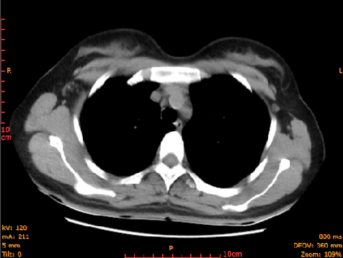
Figure 1 Enhanced chest computed tomography. Computed tomography shows local thickening of the esophageal wall with moderate enhancement.

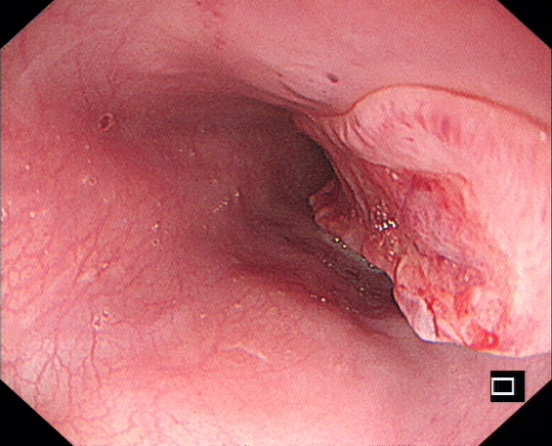
Figure 2 Upper gastrointestinal endoscopy. A 1.5 cm plate-shaped ulcerated hyperplastic lesion is seen in the middle esophagus, with a central depression, erosion, and slight bleeding.

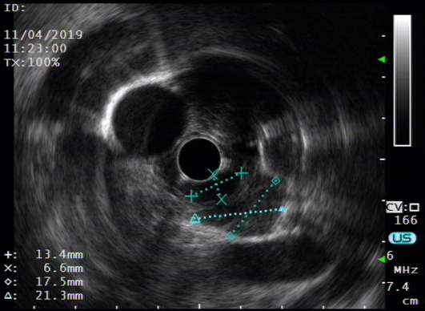
Figure 3 Endoscopic ultrasonography. A homogeneous hypoechoic lesion protrudes into the esophageal lumen, with disappearance and fusion of the mucosal layers, and 17.5 mm × 21.3 mm enlarged lymph nodes adjacent to the esophageal lesion.

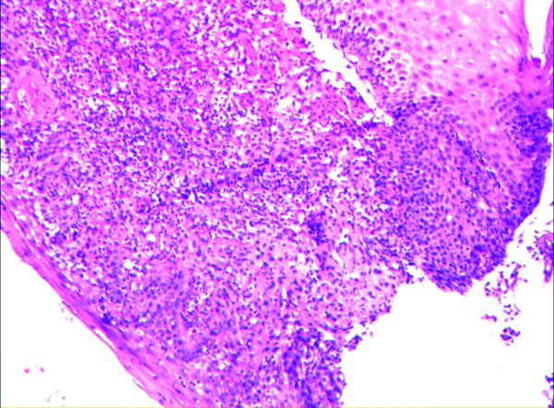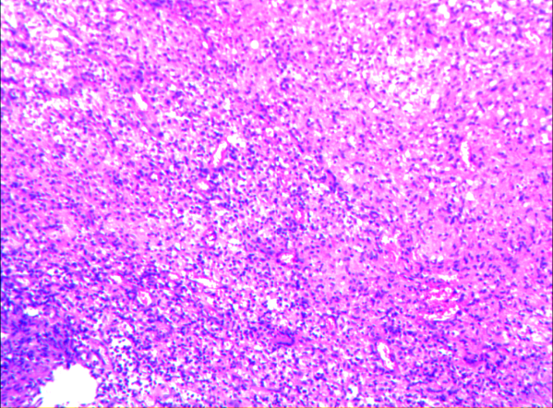
Figure 4 Pathologic biopsy of esophageal lesions. Hematoxylin-eosin staining, × 200 shows epithelial detachment and interstitial granulation tissue hyperplasia, under inflammatory exudation.

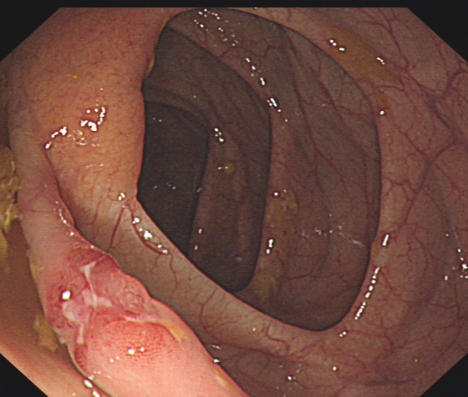
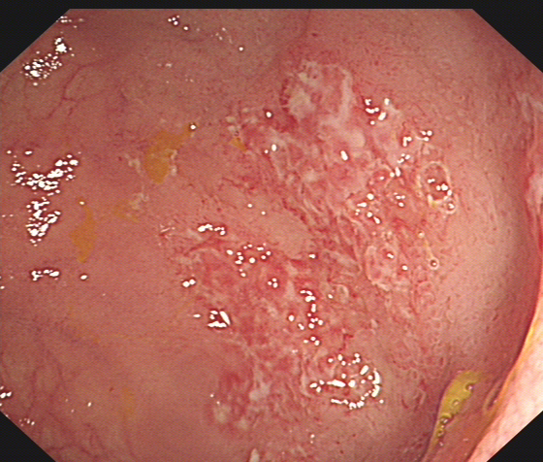
Figure 5 Colonoscopy. A: An irregular ulcer with a rat-bite border in the terminal ileum; B: A shallow ulcer with irregular border in the ascending colon.
A
B

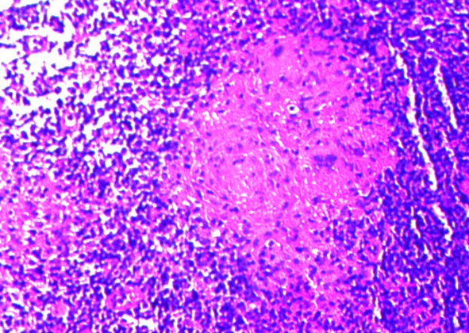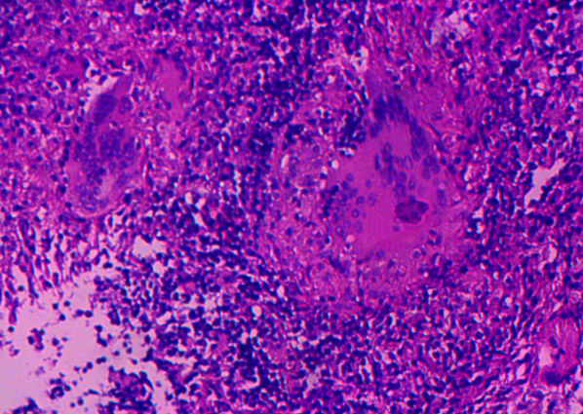
Figure 6 Pathologic biopsy of the terminal ileal lesion. Hematoxylin-eosin staining × 200 reveals that the mucosa was in an acute inflammatory activity period of chronic inflammation, with decreasing or disappearing crypts in some areas, and some small focal granulomas, with caseous necrosis and surrounded by numerous lymphocytes.

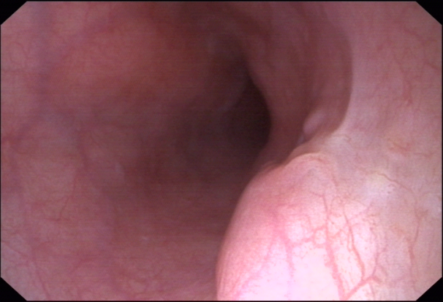
Figure 7 Follow-up upper gastrointestinal endoscopy. After 2 mo of anti-tuberculosis therapy, the endoscopy shows ulcer healing with scar tissue.

