Name of Journal: World Journal of Clinical Cases
Manuscript NO: 64295
Manuscript Type: ORIGINAL ARTICLE

Retrospective Study
Thoracoscopic segmentectomy and lobectomy assisted by three-dimensional computed-tomography bronchography and angiography for the treatment of primary lung cancer

Wu YJ et al. Thoracoscopic segmentectomy and lobectomy assisted by assisted by 3D-CTBA

Yun-Jiang Wu, Qing-Tong Shi, Yong Zhang, Ya-Li Wang

Yun-Jiang Wu, Qing-Tong Shi, Department of Thoracic Surgery, The Affiliated Hospital of Yangzhou University, Yangzhou University, Yangzhou 225009, Jiangsu Province, China

Yong Zhang, Department of Radiology, The Affiliated Hospital of Yangzhou University, Yangzhou University, Yangzhou 225009, Jiangsu Province, China

Ya-li Wang, Department of Respiratory Medicine, Renji Hospital, School of Medicine, Shanghai Jiao Tong University, Shanghai 200127, China

Author contributions: Wu YJ and Wang YL analyzed and interpreted the data and wrote the article; Zhang Y and Wang YL drafted the work and collected the data; Wu YJ and Qing TS designed the study and revised the article for important intellectual content.

Supported by National Natural Science Foundation of China, No. 81800050; Natural Science Fund of Yangzhou City, No. YZ2017119; and Science and Technology Innovation Cultivation Program of Yangzhou University, No. 2017CXJ122.

Corresponding author: Ya-li Wang, MA, MD, Attending Doctor, Chief Doctor, Doctor, Department of Respiratory Medicine, Renji Hospital, School of Medicine, Shanghai Jiao Tong University, Minhang District, Shanghai 200127, China. wyl1586135@126.com

Received: February 15, 2021
Revised: July 20, 2021
Accepted: September 14, 2021
Published online: December 6, 2021

Abstract
BACKGROUND
Anatomical segmentectomy has been proposed as a substitution for lobectomy for early-stage lung cancer. However, it requires technical meticulousness due to the complex anatomical variations of segmental vessels and bronchi.

AIM
To assess the safety and feasibility of three-dimensional computed-tomography bronchography and angiography (3D-CTBA) in performing video-assisted thoracoscopic surgery (VATS) for lung cancers.

METHODS
In this study, we enrolled 123 patients who consented to undergo thoracoscopic segmentectomy and lobectomy assisted by 3D-CTBA between May 2017 and June 2019. The image data of enhanced computed tomography (CT) scans was reconstructed three-dimensionally by the Mimics software. The results of preoperative 3D-CTBA, in combination with intraoperative navigation, guided the surgery.

RESULTS
A total of 59 women and 64 men were enrolled, of whom 57 (46.3%) underwent segmentectomy and 66 (53.7%) underwent lobectomy. The majority of tumor appearance on CT was part-solid ground-glass nodule (pGGN; 55.3%). The mean duration of chest tube placement was 3.5 ± 1.6 d, and the average length of postoperative hospital stay was 6.8 ± 1.8 d. Surgical complications included one case of pneumonia and four cases of prolonged air leak lasting > 5 d. Notably, there was no intraoperative massive hemorrhage, postoperative intensive-care unit stay, or 30-d mortality. Preoperative 3D-CTBA images can display clearly and vividly the targeted structure and the variations of vessels and bronchi. To reduce the risk of locoregional recurrence, the application of 3D-CTBA with a virtual 3D surgical margin help the VATS surgeon determine accurate distances and positional relations among the tumor, bronchial trees, and the intersegmental vessels. Three-dimensional navigation was performed to confirm the segmental structure, precisely cut off the targeted segment, and avoid intersegmental veins injury.

CONCLUSION
VATS and 3D-CTBA worked in harmony in our study. This combination also provided a new pattern of transition from lesion-directed location of tumors to computer-aided surgery for the management of early lung cancer.

Key Words: Thoracoscopy; Segmentectomy; Lobectomy; Three-dimensional computed tomography; Bronchography and angiography

©The Author(s) 2021. Published by Baishideng Publishing Group Inc. All rights reserved.

Citation: Wu YJ, Shi QT, Zhang Y, Wang YL. Thoracoscopic segmentectomy and lobectomy assisted by three-dimensional computed-tomography bronchography and angiography for the treatment of primary lung cancer. World J Clin Cases 2021; 9(34): 10494-10506 URL: https://www.wjgnet.com/2307-8960/full/v9/i34/10494.htm
DOI: https://dx.doi.org/10.12998/wjcc.v9.i34.10494

Core Tip: To evaluate the therapeutic effect of video-assisted thoracoscopic surgery segmentectomy and lobectomy assisted by three-dimensional computed-tomography bronchography and angiography (3D-CTBA) on 123 patients. Using this method, surgeons can accurately identify and label targeted structures on the 3D-CTBA video and design meticulously to perform minimal unit resection with sufficient surgical margin.
INTRODUCTION
The increased popularity of health checkups and recent advances in high-resolution computed-tomography (CT) imaging have improved the early detection of lung cancer^{[1]}, ushering in a new era of less-invasive surgery for this disease. Currently, video-assisted thoracoscopic surgery (VATS) is being assessed as an alternative to thoracotomy for primary lung cancers^{[2]}. However, a lack of stereoscopic vision and the existence of anatomical variations create problems for surgeons during VATS, which can lead to unexpected complications, such as atelectasis, bleeding, pulmonary infection, and inadequate surgical margin^{[3]}. Therefore, the surgeon must have an accurate understanding of the patient’s pulmonary anatomy before surgery, especially an inexperienced surgeon.
Anatomical segmentectomy has been proposed as a substitution for lobectomy for early-stage lung cancer, which could produce oncological results equivalent to those of lobectomy^{[4]}. However, there is an ongoing dispute over the safety and outcomes of VATS segmentectomy compared with those of lobectomy^{[5]}. The segmentectomy can retain a maximal proportion of healthy lung tissue, which is beneficial to protecting postoperative lung function and improving quality of life. However, it requires technical meticulousness due to the complex anatomical variations of segmental vessels and bronchi. In addition, it remains highly controversial due to concerns about increased locoregional recurrence of lung cancer, higher rates of complications, and inadequate surgical margin^{[6]}. Therefore, constructing a three-dimensional (3D) image that can provide stereoscopic vision and accurately map out targeted structures is desirable when planning for VATS segmentectomy^{[7]}.
Currently, the new 3D imaging software packages widely used across the world are not specifically designed for thoracic surgery. Vessel reconstruction by 3D computed tomography and angiography (3D-CTA) is now performed well, but reconstructions of the bronchus are influenced by multiple factors, and the distance from the lesion to the predetermined cutting margin is hard to measure accurately^{[8]}. Our center is exploring reconstruction of preoperative 3D computed-tomography bronchography and angiography (3D-CTBA) using Mimics software (Materialise, Leuven, Belgium), which offers powerful 3D construction capability and allows for better 3D visualization of pulmonary anatomy. Therefore, we designed this study to evaluate the efficacy of 3D-CTBA using Mimics in performing accurate VATS segmentectomy and lobectomy, employing a series of typical examples.

MATERIALS AND METHODS
Patient inclusion criteria and preoperative evaluation
The study protocol was approved and supervised by the Ethics Committee of the Affiliated Hospital of Yangzhou University, Yangzhou, China. All patients signed an informed-consent form. Between May 2017 and June 2019, we performed VATS segmentectomy and lobectomy via 3D-CTBA on 123 patients. Our inclusion criteria for VATS lobectomy in lung cancer were good lung reserve, clinical T₁–T₃ N₀ stage. Patients with multi-lobe resection, lymph node metastasis, or small-cell lung cancer were excluded. Based on United States National Comprehensive Cancer Network (NCCN) guidelines for lung cancer^{[9]}, indications for VATS segmentectomy were as follows: (1) poor lung reserve or other major comorbidity that contraindicated lobectomy; and (2) peripheral nodule ≤ 2 cm with at least 1 of the following: (a) pure adenocarcinoma in situ (AIS) histology; (b) nodule had ≥ 50% ground-glass appearance (GGO) on CT; and (c) radiological surveillance confirmed a long doubling time (≥ 400 d). Exclusion criteria included carcinoid tumor, small-cell lung cancer, lymph node metastasis, wedge resections, and multiple primary lung cancer. Data from patient medical records consisted of demographics, surgical technique, duration of surgery, blood loss, perioperative complications, length of postoperative hospital stay, tumor size, and histopathological subtype. The preoperative assessment included enhanced CT of chest and abdomen, flexible bronchoscopy, arterial blood gas analysis, spirometry, echocardiography (ECG), enhanced brain magnetic resonance imaging (EMRI), and positron emission tomography (PET). PET/CT for all patients showed N₀ stage, and the final pathological N₀-stage was confirmed by pathological examination. We obtained patients’ preoperative characteristics and surgical outcomes from the inpatient database for analysis. Mortality within 30 d was also recorded.

Preoperative 3D-CTBA imaging reconstruction
We performed preoperative enhanced-CT scans on all patients using a multidetector CT (MDCT) unit (Somatom Definition Flash; Siemens Healthcare, Erlangen, Germany). Scanning range was from the thoracic-inlet plane to the posterior costodiaphragmatic-angle plane. The thickness of the construction layer was 1.0 mm. Afterward, we transmitted the image data to the computer, saved it in Digital Imaging and Communications in Medicine (DICOM) format, and reconstructed it using Mimics software version 21. The pulmonary anatomy was reconstructed 3-dimensionally on the basis of the difference in CT values and the surgeon’s understanding. We distinguished the pulmonary bronchus, artery, and vein from one another and marked them out in distinct colors (Figure 1). Preoperative 3D-CTBA was performed to analyze anatomical variations, detect the exact location of the tumor, and ensure its relationship to the surrounding structure. The 3D-CTBA images were assessed and interpreted by at least 2 attending surgeons and 1 radiologist, who reached a consensus.

Preoperative surgical simulation
Multidimensional 3D-CTBA views synergistically display the size, shape, and location of the tumor and its relationship to the surrounding structure. Because the lung should be resected with sufficient surgical margin, corresponding arteries, veins, and bronchi should be identified on the 3D images. During the simulation, surgeons can accurately identify and label targeted structures on the 3D-CTBA video and design meticulous plans to perform minimal unit resection with sufficient surgical margin and optimal intersegmental borders to protect postoperative lung function. Meanwhile, the reconstructed 3D-CTBA image can be rotated and displayed horizontally or vertically in the operating room for accurate intraoperative navigation.

Surgical procedure oriented by 3D-CTBA
We precisely located pulmonary nodules using CT-guided hookwire combined with 3D images. Afterwards, we performed VATS assisted by 3D-CTBA with patients under general anesthesia in the lateral-decubitus position with 1-lung ventilation. We made a 1.5-cm incision for thoracoscopic observation in the 7th or 8th intercostal space (ICS) at the midaxillary line, through which we inserted a 30° thoracoscope. A second incision, about 4 cm long, was made through the 4th or 5th ICS between the anterior axillary and midclavicular lines as the main operating hole. Next, a 2-cm incision was made through the 7th or 8th ICS between the posterior scapular and posterior axillary lines as the auxiliary operating hole. The 3D-CTBA image enabled the surgeon to secure a sufficient surgical margin within which the involved structure could be meticulously resected. Oriented by 3D-CTBA, we maintained the intersegmental veins and defined intersectional boundaries using an improved inflation–deflation method^{[8]}. Anatomical resection of the pulmonary parenchyma was performed along inflation–deflation lines with 2–3 endoscopic staplers. During the procedure of VATS Lobectomy, systematic lymph node dissection was mandatory. The #10, #11, and #5-7 nodes of the left lung were all dissected, while the #10, #11, #2, #4, and #7 nodes of the right lung accepted routine dissection. In segmentectomy, the #10-12 lymph nodes should be dissected. Mediastinal lymph node sampling was performed for #5-7 nodes on the left, and #2, #4, and #7 nodes on the right. We incised the targeted structure using optimal surgical manipulation in order to reduce lung compression and air leakage and to preserve maximal postoperative lung function. At the end of surgery, we inserted a 28 French (28F) chest tube.

RESULTS
Patients’ characteristics and oncological features
The demographic and preoperative characteristics of patients enrolled in this study are listed in Table 1. Patients included a total of 59 women and 64 men, of whom 57 (46.3%) underwent VATS segmentectomy and 66 (53.7%) underwent lobectomy. One patient whose tumor size was 25 mm consented to a compromised segmentectomy due to poor pulmonary reserve. The median age was 61.4 ± 9.8 years (range: 39.0–80.0 years). Tumor appearance on CT was mostly part-solid ground-glass nodule (pGGN; 55.3%); solid nodules were second most common (34.1%), followed by pure ground glass nodule (GGN; 10.6%). Mean duration of chest tube placement was 3.5 ± 1.6 d and the average postoperative hospital stay was 6.8 ± 1.8 d without intensive-care unit (ICU) stay. We pathologically diagnosed 112 cases as adenocarcinoma, including minimally invasive adenocarcinoma (MIA; n = 21), invasive adenocarcinoma (IA; n = 80), and AIS (n = 11). All lymph nodes were pathological negative.

Preoperative confirmation of anatomical variations
Owing to the complex anatomical variations of segmental vessels and bronchi, thoracoscopic segmentectomy requires more technical meticulousness than lobectomy. Preoperative 3D-CTBA images can clearly and vividly display the targeted structure and variations of vessels and bronchi (Figure 2). One example is variation of the right upper-lobe artery. In the case shown in Figure 2B, the A³a originated from the distal end of the A¹, while the enlarged A³b coexisted with the proximal end of the A¹. Care should be taken to protect the A1 when dealing with the A³b during the surgery. The 3D image in Figure 2D shows variations of the B² and V² in the right upper lobe. The posterior bronchus (B²) branched out separately, but the apical bronchus (B¹) and the anterior bronchus (B³) originated from a common stem. When the B¹ is resected, the surgeon often accidentally resects the B³ as well. In the same case, the right superior posterior pulmonary vein (V²) merged into the right inferior pulmonary vein (RIPV). When the surgeon deals with the RIPV, the V² can be mistakenly cut off altogether, leading to postoperative hemoptysis. Confirming anatomical variations before surgery can enable careful surgeon performance and better accuracy and security during the operation.

Identification of sufficient surgical margin
To reduce the risk of locoregional recurrence, preoperative planning is critical to securing a sufficient margin and minimizing anatomical resection of the targeted structure. The safety margin is defined as a sphere extending at least 2 cm outside the lesion or 2 cm greater than tumor size. When the cutting line is beyond the intersegmental plane, extended or combined segmentectomies are required, especially for intersegmental pulmonary nodules. The application of 3D-CTBA with a virtual 3D surgical margin helps the VATS surgeon determine accurate distances and positional relations among the tumor, bronchial trees, and intersegmental vessels. As shown in Figure 3, we precisely identified sufficient surgical margin after calculating the distance from the lesion to the predetermined cutting margin on the 3D-CTBA image. The extent of targeted lung parenchyma was labeled in yellow to facilitate adequate and precise resection.

Intraoperative navigation
Surgery was conducted according to the designed surgical procedure and with accurate intraoperative guidance by 3D-CTBA. As illustrated in Figure 4, we carefully performed segmentectomy of the RS³b, navigating by 3D-CTBA. A series of techniques were involved in the thoracoscopic segmentectomy, including location of pulmonary nodules, resection of the targeted vessels and bronchi, preservation of intersegmental veins, and identification of the intersegmental demarcation. Images 4A–D (respectively the V³c, A³b, B³b and V³b) indicate the resection sequence for the targeted vessels and bronchi. We defined the intersegmental demarcation (yellow dotted line) using the improved inflation–deflation method, with assistance from 3D-CTBA. Finally, surgeons precisely identified, separated, and dissected the targeted segment based on the cone-shaped principle.

Surgical outcomes and complications
As shown in Table 1, we observed no conversion from segmentectomy or lobectomy to open thoracotomy. The predominant pathology was adenocarcinoma, representing 98.2% of segmentectomy cases and 84.8% of lobectomy cases. Surgical results for all 123 cases were as follows: duration of surgery, mean 113.4 ± 19.7 min (range: 20–150 min); blood loss, mean 65.3 ± 34.2 mL (range: 20–220 mL); duration of chest tube placement, mean 3.5 ± 1.6 d (range: 2–10 d); length of postoperative hospital stay, mean 6.8 ± 1.8 d (range: 5–15 d); and tumor diameter, mean 17.4 ± 11.4 mm (range: 5–60 mm). Surgical complications included one patient with pneumonia and4 patients with prolonged air leak lasting > 5 d, which prolonged their hospital stays. No other complications were observed. Notably, there was no intraoperative massive hemorrhages, postoperative ICU stays, or 30-d mortalities.
Table 2 shows the sites and VATS surgical procedures for the 123 patients who underwent segmentectomy and lobectomy. Anatomical resection of the right upper lobe (n = 20) was the most frequently performed lobectomy, followed by resection of the right lower (n = 12), left lower (n = 12), left upper (n = 12), and right middle (n = 10) lobes. The following segmentectomies were performed: single segmentectomy (n = 36), combined segmentectomy (n = 3), single subsegmentectomy (n = 9), segmentectomy combined with subsegmentectomy (n = 4), combined subsegmentectomy (n = 4), and sub-subsegmentectomy (n = 1). The top three single-segmentectomy sites were the RS² in the right upper lobe (n = 6), the RS⁶ in the right lower lobe (n = 5), and the LS⁴⁺⁵ in the left upper lobe (n = 5).

DISCUSSION
This study analyzed the safety and feasibility of 3D-CTBA in performing VATS segmentectomy and lobectomy for primary lung cancers, including preoperative confirmation of anatomical variations, identification of sufficient surgical margin and intraoperative navigation. The purpose of our study is to assess the use of Mimics software in 3D-CTBA to help surgeons determine accurate distances and positional relations among the tumor, bronchial trees, and intersegmental vessels.
The higher frequency of diagnosis for small lung abnormalities elicits multiple questions about the optimal surgical approach in these patients, which has led to segmentectomy’s reaffirmation as an alternative to traditional lobectomy^{[10]}. Many retrospective studies have shown that the efficacy of minimally invasive segmentectomy is consistent with that of lobectomy in early-stage lung cancer^{[11]}. However, there are several concerns when surgeons balance the pros and cons of thoracoscopic segmentectomy. First, some retrospective reports have revealed that segmentectomy for lung cancer might have a higher rate of local recurrence than lobectomy^{[12,13]}. In our study, preoperative segmentectomy simulation using 3D-CTBA enabled us to determine safe surgical margins and provide computer-aided support for surgical orientation and visualization to allow for more-secure execution. Another difficulty is segmental attribution of the tumor, especially when the nodule is near the boundary of pulmonary segments^{[14]}. If the nodule is not accurately attributed to the targeted segment, incomplete excision and local recurrence can occur. The 3D reconstruction technique can be used to detect the exact location of the nodule and permit 3D visualization of segmental anatomy, like a “surgical map”^{[15]}. After calculating the distance from the tumor to the predetermined cutting margin on 3D-CTBA images, thoracic surgeons can determine whether it is enough to resect a single segment or whether an extended or combined segmentectomy is required. Furthermore, the vascular architecture of pulmonary segments is remarkably complex and variable, and variations are often not detected by common 2D-CT. Nevertheless, as illustrated in Figure 2, any intrapulmonary vascular variation can be identified vividly on 3D images, which can help us plan precisely individualized surgeries for patients. With 3D-CTBA guidance, VATS segmentectomy in our study turned out to be as effective as lobectomy, with fewer complications.
The total mean tumor diameter in our study was 17.4 ± 11.4 mm (range: 5–60 mm). The mean tumor size was 10.5 ± 4.8 mm (range: 5–25 mm) in the segmentectomy group and 23.4 ± 12.1 mm (range: 8–60 mm) in the lobectomy groups. The majority of tumor appearance on CT was pGGN (55.3%) among all patients. The point of controversy is the best management policy for small tumors presenting as pure GGN and pGGN. First, many researchers worry that these small lesions are often overtreated. A recent article by Zhu et al^{[16]} revealed that patients with micro-sized lung adenocarcinomas (≤ 1 cm in diameter) had better 5-year overall and disease-specific survival rates than those with small lung adenocarcinomas (1.1–2.0 cm in diameter), and that a sublobar surgical procedure was feasible. Second, it is difficult to palpate and pinpoint small nodules, some as small as a few millimeters in diameter, due to their nonsolid composition and deep location within the parenchyma. A variety of methods have been used to confirm the location of pulmonary nodules, such as methylene blue and CT-guided hookwire; with these methods, surgeons can solve the problem of wedge resection and lobectomy, rather than segmentectomy and subsegmentectomy^{[17]}. Furthermore, surgeons are often confused by labyrinthine segment structures that cannot even be sufficiently mutually distinguished for segmentectomy or subsegmentectomy, resulting in high frequency of intraoperative and postoperative complications^{[18]}. With 3D-CTBA assistance, the surgeons at our center can ascertain pulmonary-segment anatomy and confirm the location of small nodules; therefore, a segmentectomy can be preoperatively planned and simulated, and then precisely navigated step by step during the operation. In our study, VATS segmentectomy was a meticulously performed procedure with fewer complications and better therapeutic benefit.
Despite the development of high-resolution 2D-CT, it is hard to achieve a vivid composition of the length, angle, dimensions, and direction of the targeted segment^{[19]}. The advent of 3D-CTBA provides more-accurate and detailed 3D imaging of the bronchi and pulmonary vessels of the regional anatomy, which consequently helps thoracic surgeons perfect anatomical orientation for VATS segmentectomy^{[8,14,15]}. The 3D-CTBA method is remarkable not only for its accuracy but also for its feasibility and visualization. Several studies have evaluated the feasibility of using different 3D-imaging software packages for thoracic surgery^{[8,14,15,20–22]}. She et al^{[15]} and Wu et al^{[14]} recommend DeepInsight software (Northeastern University, Shenyang, China). OsiriX is a powerful 3D reconstruction software with which surgeons can easily manipulate and process 2D-CT data into 3D images^{[15]}. Thanks to its stronger 3D reconstruction, Mimics provides a higher quality and completely realistic vision of the bronchi and the vessels, dramatically enhancing the dynamic range of 3D display and thus extending its ability to present images with a high degree of realism and a vivid stereoscopic feeling. This user-friendly software with its advanced image processing tools allows comprehensive information to be generated from images, meeting VATS requirements for surgeons worldwide.
With the application of 3D-CTBA, a series of thoracoscopic-surgery techniques have been gradually developed, such as location of pulmonary nodules, dissection of targeted vessels and bronchi, preservation of intersegmental veins, and identification of the intersegmental demarcation^{[23]}. First, we used CT-guided hookwire combined with 3D-CTBA images to precisely locate nodules before surgery. Combining different methods to accomplish this task is of vital importance, especially for small, deep nodules or pure GGO^{[24,25]}. Notably, we encountered no intraoperative massive hemorrhage, thanks to our accurate determination of pulmonary vascular anatomy and variations. Additionally, we defined the intersegmental demarcation using the improved inflation–deflation method assisted by 3D-CTBA^{[14]}. The inflation–deflation interface was anatomically separated from the hilum to the distal region along the intersegmental veins and dissected using an electrotome and/or endoscopic staplers. The intersegmental vein and the inflation–deflation demarcation were identified as the markers of the intersegmental plane. Finally, with the help of Dr. Liang Chen, our institution explored the technique called “cone-shaped segmentectomy,” with which surgeons could precisely identify, separate, and dissect the targeted segment based on the cone-shaped principle^{[8]}.
There are several limitations to the utility of 3D-CTBA for surgical guidance. First, nearly all 3D-reconstruction software packages are designed for general business and industrial use, not specifically for medical applications, let alone thoracic surgery. Therefore, the 3D reconstruction procedure for pulmonary vessels and bronchi is not fully automated and is time consuming^{[26]}. Second, designing surgical procedures using 3D-CTBA technology depends on computer processing ability and the operational technique of the image software. The thoracic surgeon must not only cooperate with the radiologist, but also master radiological knowledge and ability^{[27]}. In addition, lesions are often detected by preoperative CT with the lung fully inflated, but during surgery the lung is often deflated. Understanding how preoperative conditions correlate with interoperative conditions requires significant experience and the ability to accurately identify anatomical structures. Furthermore, the size of the cohort in our study is a bit small, and more cases need to be collected in future. A final limitation is that we need more time to observe the postoperative recurrence and mortality rates in future studies. In the future, new high-quality software packages will hopefully facilitate the utility and diffusion of 3D technology among thoracic surgeons.

CONCLUSION
The advent of 3D-CTBA could dramatically change the VATS procedure for lung cancers, leading to a simpler, shorter, and more-accurate surgical process. The 3D-CTBA method enables the surgeon to visualize the anatomical relationship between the pulmonary nodule and the surrounding structure, which is valuable for a thoracoscopic-surgery strategy. The combination of VATS and 3D-CTBA worked in harmony in our study, and it also provided a new pattern of transition from the lesion-directed location of tumors to computer-aided surgery for the management of early-stage lung cancer.

ARTICLE HIGHLIGHTS
Research background
Performance of video-assisted thoracoscopic surgery (VATS) segmentectomy and lobectomy for primary lung cancer has currently increased. For small lung lesions, identification of the anatomical variation and intersegmental line is often difficult, and ensuring a sufficient surgical margin is more likely to be uncertain.

Research motivation
A lack of stereoscopic vision and the existence of anatomical variations create problems for surgeons during VATS, which can lead to unexpected complications.

Research objectives
The purpose of this study was to evaluate the therapeutic effect of VATS segmentectomy and lobectomy assisted by three-dimensional computed-tomography bronchography and angiography (3D-CTBA) on 123 patients.

Research methods
The 3D-CTBA during VATS segmentectomy and lobectomy was used for identifying the location of lesions, confirming anatomical variations, and securing the resection margins.

Research results
There was no intraoperative massive hemorrhages, postoperative intensive-care unit stays or 30-d mortalities. Three-dimensional navigation was performed to confirm the segmental structure, precisely cut off the targeted segment, and avoid intersegmental veins injury.

Research conclusions
The combination of VATS and 3D-CTBA worked in harmony in our study. This combination also demonstrated a new pattern of transition from lesion-directed location of tumors to computer-aided surgery for the management of small lung lesions.

Research perspectives
Intraoperative 3D-CTBA navigation could enable a more definitive VATS segmentectomy and lobectomy for early lung cancer.

ACKNOWLEDGEMENTS
We thank Dr. Liang Chen from Jiangsu Province Hospital for his helpful support and surgical skills.

REFERENCES
1 Balata H, Fong KM, Hendriks LE, Lam S, Ostroff JS, Peled N, Wu N, Aggarwal C. Prevention and Early Detection for NSCLC: Advances in Thoracic Oncology 2018. J Thorac Oncol 2019; 14: 1513-1527 [PMID: 31228621 DOI: 10.1016/j.jtho.2019.06.011]
2 Handa Y, Tsutani Y, Mimae T, Miyata Y, Okada M. Complex segmentectomy in the treatment of stage IA non-small-cell lung cancer. Eur J Cardiothorac Surg 2020; 57: 114-121 [PMID: 31230086 DOI: 10.1093/ejcts/ezz185]
3 Akiba T. Utility of three-dimensional computed tomography in general thoracic surgery. Gen Thorac Cardiovasc Surg 2013; 61: 676-684 [PMID: 24158329 DOI: 10.1007/s11748-013-0336-z]
4 Qu X, Wang K, Zhang T, Shen H, Dong W, Liu Q, Du J. Long-term outcomes of stage I NSCLC (≤3 cm) patients following segmentectomy are equivalent to lobectomy under analogous extent of lymph node removal: a PSM based analysis. J Thorac Dis 2017; 9: 4561-4573 [PMID: 29268526 DOI: 10.21037/jtd.2017.10.129]
5 Dai C, Shen J, Ren Y, Zhong S, Zheng H, He J, Xie D, Fei K, Liang W, Jiang G, Yang P, Petersen RH, Ng CS, Liu CC, Rocco G, Brunelli A, Shen Y, Chen C, He J. Choice of Surgical Procedure for Patients With Non-Small-Cell Lung Cancer ≤ 1 cm or > 1 to 2 cm Among Lobectomy, Segmentectomy, and Wedge Resection: A Population-Based Study. J Clin Oncol 2016; 34: 3175-3182 [PMID: 27382092 DOI: 10.1200/JCO.2015.64.6729]
6 Roman M, Labbouz S, Valtzoglou V, Ciesla A, Hawari M, Addae-Boateng E, Thorpe JA, Duffy JP, Majewski A. Lobectomy vs. segmentectomy. A propensity score matched comparison of outcomes. Eur J Surg Oncol 2019; 45: 845-850 [PMID: 30409440 DOI: 10.1016/j.ejso.2018.10.534]
7 Le Moal J, Peillon C, Dacher JN, Baste JM. Three-dimensional computed tomography reconstruction for operative planning in robotic segmentectomy: a pilot study. J Thorac Dis 2018; 10: 196-201 [PMID: 29600049 DOI: 10.21037/jtd.2017.11.144]
8 Wu WB, Xu XF, Wen W, Xu J, Zhu Q, Pan XL, Xia Y, Chen L. Three-dimensional computed tomography bronchography and angiography in the preoperative evaluation of thoracoscopic segmentectomy and subsegmentectomy. J Thorac Dis 2016; 8: S710-S715 [PMID: 28066674 DOI: 10.21037/jtd.2016.09.43]
9 NCCN Clinical Practice Guidelines in Oncology (NCCN Guidelines). Non-Small Cell Lung Cancer (Version 6.2019). Available from: http://www.nccn.org/patients
10 Nakazawa S, Shimizu K, Mogi A, Kuwano H. VATS segmentectomy: past, present, and future. Gen Thorac Cardiovasc Surg 2018; 66: 81-90 [PMID: 29255967 DOI: 10.1007/s11748-017-0878-6]
11 Shapiro M, Weiser TS, Wisnivesky JP, Chin C, Arustamyan M, Swanson SJ. Thoracoscopic segmentectomy compares favorably with thoracoscopic lobectomy for patients with small stage I lung cancer. J Thorac Cardiovasc Surg 2009; 137: 1388-1393 [PMID: 19464454 DOI: 10.1016/j.jtcvs.2009.02.009]
12 Nomori H, Mori T, Ikeda K, Yoshimoto K, Iyama K, Suzuki M. Segmentectomy for selected cT1N0M0 non-small cell lung cancer: a prospective study at a single institute. J Thorac Cardiovasc Surg 2012; 144: 87-93 [PMID: 22502969 DOI: 10.1016/j.jtcvs.2012.03.034]
13 Ojanguren A, Recuero JL, Pardina M, Milla L, Santamaría M. Three dimensional computed tomography for preoperative assessment of the pulmonary artery in patients undergoing endoscopic lobectomy or segmentectomy. Cir Esp 2017; 95: 102-108 [PMID: 28213996 DOI: 10.1016/j.ciresp.2017.01.005]
14 Wu WB, Xia Y, Pan XL, Wang J, He ZC, Xu J, Wen W, Xu XF, Zhu Q, Chen L. Three-dimensional navigation-guided thoracoscopic combined subsegmentectomy for intersegmental pulmonary nodules. Thorac Cancer 2019; 10: 41-46 [PMID: 30390378 DOI: 10.1111/1759-7714.12897]
15 She XW, Gu YB, Xu C, Li C, Ding C, Chen J, Zhao J. Three-dimensional (3D)- computed tomography bronchography and angiography combined with 3D-video-assisted thoracic surgery (VATS) versus conventional 2D-VATS anatomic pulmonary segmentectomy for the treatment of non-small cell lung cancer. Thorac Cancer 2018; 9: 305-309 [PMID: 29297974 DOI: 10.1111/1759-7714.12585]
16 Zhu WY, Tan LL, Wang ZY, Wang SJ, Xu LY, Yu W, Chen ZJ, Zhang YK. Clinical characteristics and advantages of primary peripheral micro-sized lung adenocarcinoma over small-sized lung adenocarcinoma. Eur J Cardiothorac Surg 2016; 49: 1095-1102 [PMID: 26374872 DOI: 10.1093/ejcts/ezv327]
17 Klinkenberg TJ, Dinjens L, Wolf RFE, van der Wekken AJ, van de Wauwer C, de Bock GH, Timens W, Mariani MA, Groen HJM. CT-guided percutaneous hookwire localization increases the efficacy and safety of VATS for pulmonary nodules. J Surg Oncol 2017; 115: 898-904 [PMID: 28230245 DOI: 10.1002/jso.24589]
18 Ghaly G, Kamel M, Nasar A, Paul S, Lee PC, Port JL, Stiles BM, Altorki NK. Video-Assisted Thoracoscopic Surgery Is a Safe and Effective Alternative to Thoracotomy for Anatomical Segmentectomy in Patients With Clinical Stage I Non-Small Cell Lung Cancer. Ann Thorac Surg 2016; 101: 465-72; discussion 472 [PMID: 26391692 DOI: 10.1016/j.athoracsur.2015.06.112]
19 Nomura Y, Higaki T, Fujita M, Miki S, Awaya Y, Nakanishi T, Yoshikawa T, Hayashi N, Awai K. Effects of Iterative Reconstruction Algorithms on Computer-assisted Detection (CAD) Software for Lung Nodules in Ultra-low-dose CT for Lung Cancer Screening. Acad Radiol 2017; 24: 124-130 [PMID: 27986507 DOI: 10.1016/j.acra.2016.09.023]
20 Li X, Wang X, Dai Y, Zhang P. Supervised recursive segmentation of volumetric CT images for 3D reconstruction of lung and vessel tree. Comput Methods Programs Biomed 2015; 122: 316-329 [PMID: 26362225 DOI: 10.1016/j.cmpb.2015.08.014]
21 Coenen A, Honda O, van der Jagt EJ, Tomiyama N. Computer-assisted solid lung nodule 3D volumetry on CT: influence of scan mode and iterative reconstruction: a CT phantom study. Jpn J Radiol 2013; 31: 677-684 [PMID: 23955317 DOI: 10.1007/s11604-013-0235-3]
22 Yao F, Wang J, Yao J, Hang F, Lei X, Cao Y. Three-dimensional image reconstruction with free open-source OsiriX software in video-assisted thoracoscopic lobectomy and segmentectomy. Int J Surg 2017; 39: 16-22 [PMID: 28115296 DOI: 10.1016/j.ijsu.2017.01.079]
23 Mun M, Nakao M, Matsuura Y, Ichinose J, Nakagawa K, Okumura S. Novel techniques for video-assisted thoracoscopic surgery segmentectomy. J Thorac Dis 2018; 10: S1671-S1676 [PMID: 30034834 DOI: 10.21037/jtd.2018.05.207]
24 Kleedehn M, Kim DH, Lee FT, Lubner MG, Robbins JB, Ziemlewicz TJ, Hinshaw JL. Preoperative Pulmonary Nodule Localization: A Comparison of Methylene Blue and Hookwire Techniques. AJR Am J Roentgenol 2016; 207: 1334-1339 [PMID: 27657546 DOI: 10.2214/AJR.16.16272]
25 Nakajima J. Advances in techniques for identifying small pulmonary nodules. Surg Today 2019; 49: 311-315 [PMID: 30474752 DOI: 10.1007/s00595-018-1742-8]
26 Reeves AP, Xie Y, Jirapatnakul A. Automated pulmonary nodule CT image characterization in lung cancer screening. Int J Comput Assist Radiol Surg 2016; 11: 73-88 [PMID: 26122930 DOI: 10.1007/s11548-015-1245-7]
27 Shimizu K, Nakazawa S, Nagashima T, Kuwano H, Mogi A. 3D-CT anatomy for VATS segmentectomy. J Vis Surg 2017; 3: 88 [PMID: 29078650 DOI: 10.21037/jovs.2017.05.10]

Footnotes
Institutional review board statement: This study was reviewed and approved by the Ethics Committee of the Affiliated Hospital of Yangzhou University.

Informed consent statement: Patients were not required to give informed consent to the study because the analysis used anonymous clinical data that were obtained after each patient agreed to treatment by written consent.

Conflict-of-interest statement: All authors declare no conflicts of interest related to this article.

Data sharing statement: No additional data are available.

Open-Access: This article is an open-access article that was selected by an in-house editor and fully peer-reviewed by external reviewers. It is distributed in accordance with the Creative Commons Attribution NonCommercial (CC BY-NC 4.0) license, which permits others to distribute, remix, adapt, build upon this work non-commercially, and license their derivative works on different terms, provided the original work is properly cited and the use is non-commercial. See: http://creativecommons.org/Licenses/by-nc/4.0/

Provenance and peer review: Unsolicited article; Externally peer reviewed.

Peer-review started: February 15, 2021
First decision: July 16, 2021
Article in press: September 14, 2021

Specialty type: Surgery
Country/Territory of origin: China
Peer-review report’s scientific quality classification
Grade A (Excellent): 0
Grade B (Very good): 0
Grade C (Good): C
Grade D (Fair): 0
Grade E (Poor): 0

P-Reviewer: Yajima T S-Editor: Ma YJ L-Editor: Filipodia P-Editor: Yu HG
Figure Legends
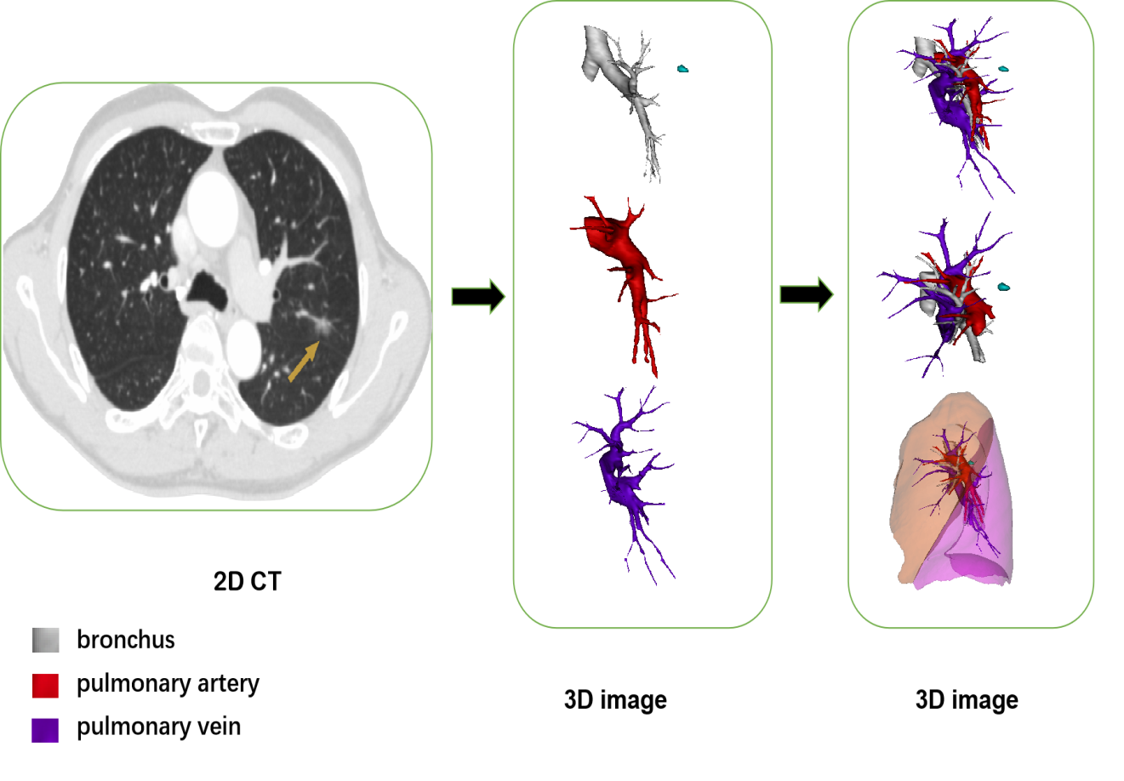
Figure 1 Preoperative flow diagram of three-dimensional reconstruction technique using Mimics software. The pulmonary bronchus, artery and vein were distinguished from one another and marked out with different colors: white, bronchus; red, pulmonary artery; purple, pulmonary vein. 3D: 3-dimensional; CT: computed-tomography.
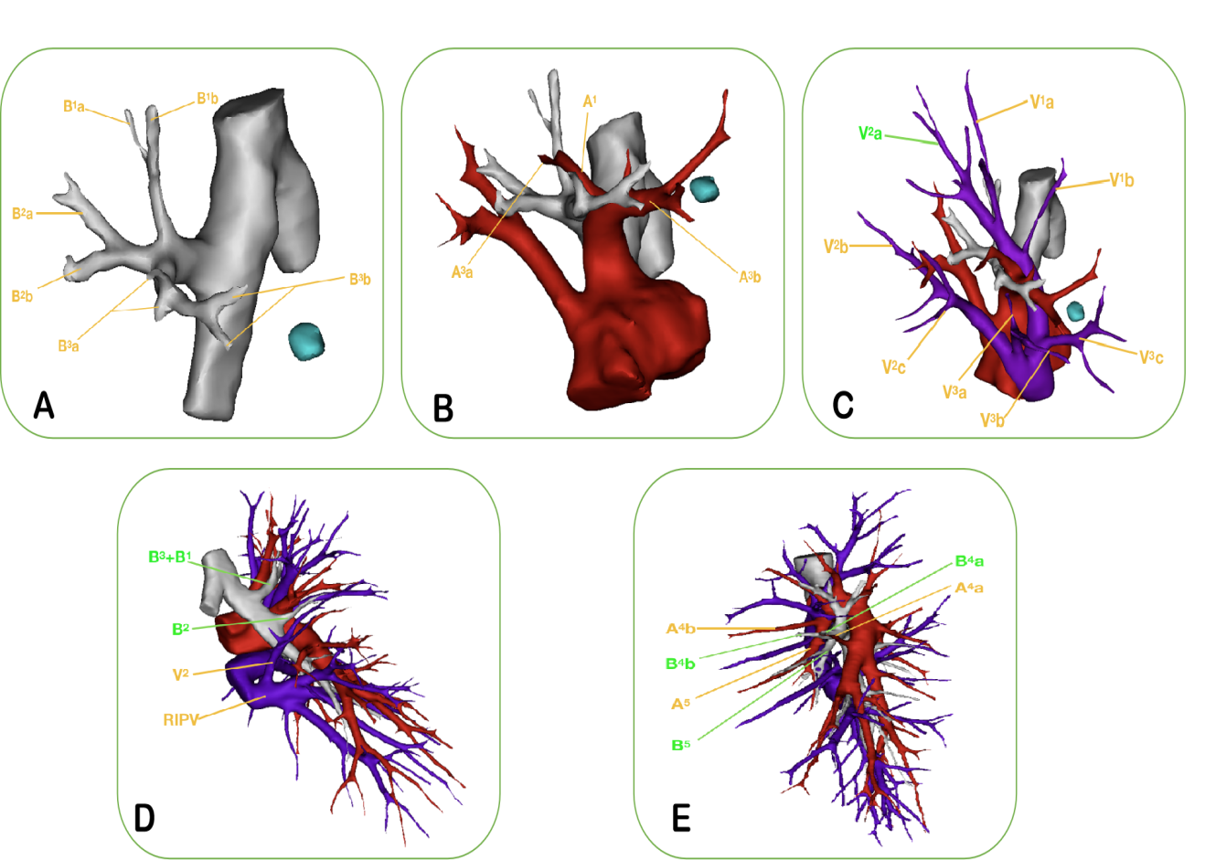
Figure 2 Presurgical confirmation of anatomical variations. Preoperative three-dimensional (3D) computed-tomography bronchography and angiography images can clearly and vividly display the targeted segmental structure and variations of vessels and bronchi. A: The bronchus of the right upper lobe is divided into the apical segmental bronchus (B¹), posterior segmental bronchus (B²), and anterior segmental bronchus (B³). The distance between the B³a and B³b of the anterior segmental bronchus is very great; B: The 3D image reveals the variations of the right upper-lobe artery: the A³a originates from the distal end of the A¹, while the enlarged A³b coexists with the proximal end of the A¹. Care should be taken to protect A¹ when dealing with the A³b during the surgery; C: The segmental and sub-segmental veins of the right upper lobe are labeled successively in the 3D image. There was no central vein, and the V² a flowed into the apex vein (V¹) through the upper pulmonary hilum; D: The 3D image reveals the variations of the B² and V² in the right upper lobe. The B² branched out separately, but the B¹ and B³ arose from a common stem. When the B¹ is resected, the surgeon often accidentally resects the B³ as well. Additionally, the right upper posterior pulmonary vein (V²) merged into the right inferior pulmonary vein (RIPV). When the surgeon deals with the right lower pulmonary vein, the V² could be mistakenly cut off altogether, leading to postoperative hemoptysis; E: The 3D image demonstrates the variation of the mediastinal lingual-segment artery (Med A⁴⁺⁵) in the left upper lobe. The A⁴b and A⁵ of the left upper lingual-segment artery originated from the upper pulmonary trunk, while the A⁴a originated from the interlobar-fissure artery separately. When left superior segmentectomy is performed, it is possible to cut off the A⁴b and A5 at the same time, resulting in decreased pulmonary blood flow to lingular-segment lung tissue and an imbalanced ventilation: blood flow ratio.
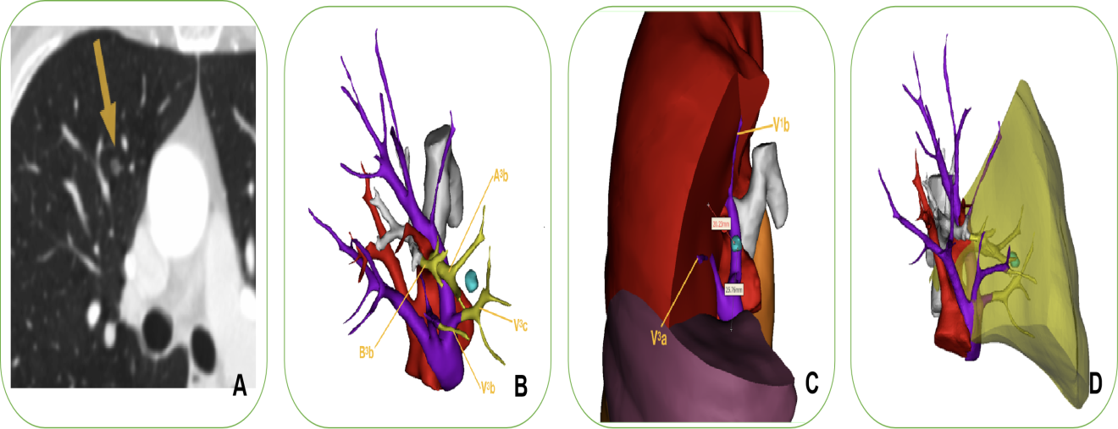
Figure 3 Identification of sufficient surgical margin and preoperative surgery simulation. A: Chest computed tomography (CT) scan showed pure ground-glass opacity in the right upper lobe; B: We simulated surgery preoperatively, guided by a three-dimensional computed-tomography bronchography and angiography (3D-CTBA) images. The image showed that the targeted segmental structures needing to be successively resected were the V³c, A³b, B³b, and V³b; C: We precisely identified sufficient surgical margin after calculating the distance from the lesion to the predetermined cutting margin on the 3D-CTBA image. The safety margin was defined as a sphere extending at least 2 cm outside the lesion or 2 cm greater than the tumor size; D: The yellow area denotes the extent of targeted lung parenchyma RS³b. Afterward, we meticulously performed segmentectomy of the RS³b, as illustrated in Figure 4.
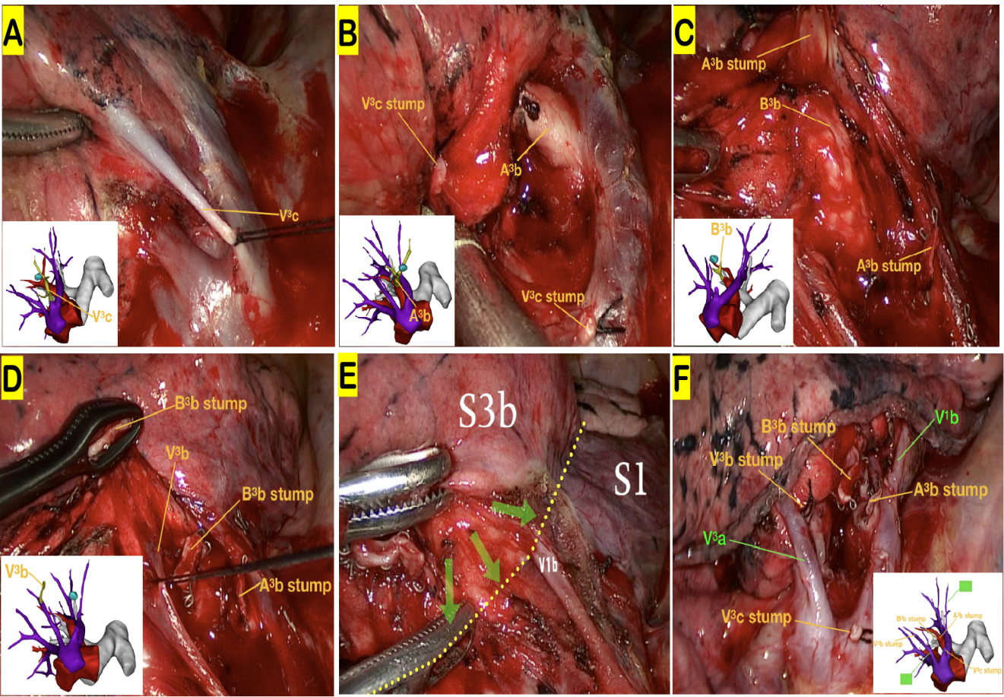
Figure 4 Illustration of the precise surgical procedure navigated by three-dimensional computed-tomography bronchography and angiography. With the assistance of three-dimensional computed-tomography bronchography and angiography (3D-CTBA), we meticulously performed thoracoscopic segmentectomy of the RS³b. A series of techniques were involved in this procedure, including location of the pulmonary nodules, resection of targeted vessels and bronchi, preservation of intersegmental veins, and identification of the intersegmental demarcation. A–D: Images showing the resection sequence for the targeted vessels and bronchi, including the V³c, A³b, B³b, and V³b, respectively. The intersegmental demarcation (yellow dotted line) was defined by the improved inflation–deflation method, assisted by 3D-CTBA. The intersegmental veins V¹b and V³a were carefully preserved. The surgeons precisely identified, separated, and dissected the targeted segment based on the cone-shaped principle; E, F: View of the hilum after RS³b removal reveals stumps of targeted vessels and bronchi, which was completely consistent with the preoperative 3D-CTBA images.
Table 1 Characteristics and postoperative complications of patients receiving video-assisted thoracoscopic surgery assisted by three-dimensional computed-tomography bronchography and angiography
Variable | Segmentectomy (n = 57) | Lobectomy  (n = 66) | Total (n = 123)
Age, mean (range), yr | 59.3 ± 10.8 (39.0-75.0) | 63.2 ± 8.5 (44.0-80.0) | 61.4 ± 9.8 (39.0-80.0)
Gender
Female | 31 (54.4%) | 28 (42.4%) | 59 (48.0%)
Male | 26 (45.6%) | 38 (57.6%) | 64 (52.0%)
Smoking history | 19 (33.3%) | 31 (47.0%) | 50 (40.7%)
Comorbidity
Hypertension | 14 (24.6%) | 11 (16.7%) | 25 (20.3%)
Diabetes mellitus | 6 (10.5%) | 4 (6.1%) | 10 (8.1%)
COPD | 5 (8.8%) | 7 (10.6%) | 12 (9.8%)
Arrhythmia | 1 (1.8%) | 2 (3.0%) | 3 (2.4%)
Operative time, mean (range), min | 129.8 ± 16.1 (105-180) | 125.2 ± 11.7 (105-160) | 113.4 ± 19.7 (20-150)
Blood loss, mean (range), ml | 48.8 ± 26.2 (20-150) | 79.5 ± 34.0 (20-220) | 65.3 ± 34.2 (20-220)
Duration of chest tube placement, mean (range), d | 3.1 ± 1.1 (2.0-9.0) | 3.8 ± 1.9 (2.0-10.0) | 3.5 ± 1.6 (2.0-10.0)
Postoperative hospital stay, mean (range), d | 6.4 ± 1.3 (5.0-12.0) | 7.1 ± 2.2 (5.0-15.0) | 6.8 ± 1.8 (5.0-15.0)
Tumor diameter, mean (range), mm | 10.5 ± 4.9 (5.0-25.0) | 23.4 ± 12.1 (8.0-60.0) | 17.4 ± 11.4 (5.0-60.0)
Appearance on CT
Pure GGO | 12 (21.1%) | 1 (1.5%) | 13 (10.6)
p GGO | 45 (78.9%) | 23 (34.8%) | 68 (55.3%)
Solid | 0 (0%) | 42 (63.6%) | 42 (34.1%)
Histological types
Adenocarcinoma | 56 (98.2%) | 56 (84.8%) | 112 (91.1%)
AIS | 8 (14.0%) | 3 (4.5%) | 11 (8.9%)
MIA | 20 (35.1%) | 1 (1.5%) | 21 (17.1%)
IA | 28 (49.1%) | 52 (78.8%) | 80 (65.0%)
Squamous cell | 1 (1.8%) | 7 (10.6%) | 8 (6.5%)
others | 0 (0%) | 3 (4.5%) | 3 (2.4%)
Postoperative complications | 2 (3.5%) | 8 (12.1%) | 10 (8.1%)
Pneumonia | 0 (0%) | 1 (1.5%) | 1 (0.8%)
Prolonged air leakage (> 5 d) | 2 (3.5%) | 1 (1.5%) | 3 (2.4%)
chylothorax | 0 (0%) | 6 (9.1%) | 6 (4.9%%)
Absent | 55 (96.5%) | 58 (87.9%) | 113 (91.9%)
Conversion rate | 0 (0%) | 0 (0%) | 0 (0%)
30-d mortality | 0 (0%) | 0 (0%) | 0 (0%)
Postoperative ICU stay | 0 (0%) | 0 (0%) | 0 (0%)

AIS: adenocarcinoma in situ; CT: computed tomography; GGO: ground-glass appearance; IA: invasive adenocarcinoma; ICU: intensive-care unit; MIA: minimally invasive adenocarcinoma.

Table 2 Sites of segmentectomy and lobectomy
Site | Segmentectomy (n = 57) |  |  |  |  |  | Lobectomy (n = 66)
 | Single seg. | Combined seg. | Single subseg. | Seg. combined with subseg. | Combined subseg. | Sub-subseg.
Left lung
Upper lobe |  |  |  |  |  |  | 12
LS¹⁺²b |  |  | 1
LS¹⁺²c |  |  | 2
LS¹⁺² | 1
LS¹⁺² + LS³a |  |  |  | 1
LS¹⁺²⁺³ | 3
LS² | 1
LS³a |  |  | 1
LS³a + LS⁴b |  |  |  |  | 1
LS³b |  |  | 1
LS³a+b |  |  |  |  | 1
LS³b+c |  |  |  |  | 2
LS³ | 2
LS⁴⁺⁵ | 5
Lower lobe |  |  |  |  |  |  | 12
LS⁶ | 4
LS⁸ | 2
LS⁸⁺⁹⁺¹⁰ | 1
Right lobe
Upper lobe |  |  |  |  |  |  | 20
RS¹b |  |  | 1
RS¹ + RS²a |  |  |  | 3
RS¹ + RS² |  | 2
RS² | 6
RS³ | 2
RS³b |  |  | 2
RS³b_{ii} |  |  |  |  |  | 1
Middle lobe |  |  |  |  |  |  | 10
RS⁵ | 1
Lower lobe |  |  |  |  |  |  | 12
RS⁶ | 5
RS⁶ + RS* |  | 1
RS⁸a |  |  | 1
RS⁸ | 2
RS⁷⁺⁸⁺⁹⁺¹⁰ | 1
Seg.: segmentectomy; Subseg.: subsegmentectomy; Sub-subseg.: sub-subsegmentectomy.

Published by Baishideng Publishing Group Inc
7041 Koll Center Parkway, Suite 160, Pleasanton, CA 94566, USA
Telephone: +1-925-3991568
E-mail: bpgoffice@wjgnet.com
Help Desk: https://www.f6publishing.com/helpdesk
https://www.wjgnet.com

© 2021 Baishideng Publishing Group Inc. All rights reserved.

