Name of Journal: World Journal of Gastroenterology
Manuscript NO: 56016
Manuscript Type: ORIGINAL ARTICLE

Basic Study
Herbal cake-partitioned moxibustion inhibits colonic autophagy in Crohn’s disease via signaling involving distinct classes of phosphatidylinositol 3-kinases

Wang SY et al. Moxibustion inhibits autophagy in Crohn’s disease

Shi-Yuan Wang, Ji-Meng Zhao, Ci-Li Zhou, Han-Dan Zheng, Yan Huang, Min Zhao, Zhi-Ying Zhang, Lu-Yi Wu, Huan-Gan Wu, Hui-Rong Liu

Shi-Yuan Wang, Ji-Meng Zhao, Ci-Li Zhou, Han-Dan Zheng, Yan Huang, Min Zhao, Zhi-Ying Zhang, Lu-Yi Wu, Huan-Gan Wu, Hui-Rong Liu, Key Laboratory of Acupuncture-Moxibustion and Immunology, Shanghai University of Traditional Chinese Medicine, Shanghai 201203, China

Shi-Yuan Wang, Ji-Meng Zhao, Ci-Li Zhou, Han-Dan Zheng, Yan Huang, Min Zhao, Zhi-Ying Zhang, Huan-Gan Wu, Hui-Rong Liu, Shanghai Research Institute of Acupuncture and Meridian, Shanghai 200030, China

Author contributions: Wang SY, Huang Y, Wu HG, and Liu HR designed the research; Wang SY, Zhao JM, Zhou CL, and Zheng HD performed the experiments; Wang SY, Zhao M, Zhang ZY, and Wu LY collected and analyzed the data; Wang SY wrote the manuscript; all authors reviewed the manuscript prior to its submission, and read and approved the final manuscript.

Supported by the Program of Shanghai Academic Research Leader, No. 17XD1403400; National Natural Sciences Foundation of China, No.81574079 and No. 81873374; Three-year Action Plan Project of Shanghai Traditional Chinese Medicine Development, No. ZY(2018-2020)-CCCX-2004-01; Chinese Medicine Inheritance and Innovation "100 Million" Talent Project, Qi Huang Scholar; and Shanghai Rising-Star Program, No. 16QA1403400.

Corresponding author: Hui-Rong Liu, MD, PhD, Doctor, Professor, Research Fellow, Key Laboratory of Acupuncture-Moxibustion and Immunology, Shanghai University of Traditional Chinese Medicine, No. 650 South Wanping Road, Xuhui District, Shanghai 201203, China. lhr_tcm@139.com

Received: April 16, 2020
Revised: July 14, 2020
Accepted: September 4, 2020
Published online:

Abstract
BACKGROUND
Autophagy is an evolutionarily conserved biological process in eukaryotic cells that involves lysosomal-mediated degradation and recycling of related cellular components. Recent studies have shown that autophagy plays an important role in the pathogenesis of Crohn’s disease (CD). Herbal cake-partitioned moxibustion (HM) has been historically practiced to treat CD. However, the mechanism by which HM regulates colonic autophagy in CD remains unclear.

AIM
To observe whether HM can alleviate CD by regulating colonic autophagy and to elucidate the underlying mechanism.

METHODS
Rats were randomly divided into a normal control (NC) group, a CD group, an HM group, an insulin + CD (I + CD) group, an insulin + HM (I + HM) group, a rapamycin + CD (RA + CD) group, and a rapamycin + HM (RA + HM) group. 2,4,6-trinitrobenzenesulfonic acid was administered to establish a CD model. The morphology of the colonic mucosa was observed by hematoxylin-eosin staining, and the formation of autophagosomes was observed by electron microscopy. The expression of autophagy marker microtubule-associated protein 1 light chain 3 beta (LC3B) was observed by immunofluorescence staining. Insulin and rapamycin were used to inhibit and activate colonic autophagy, respectively. The mRNA expression levels of phosphatidylinositol 3-kinase class I (PI3KC1), Akt1, LC3B, sequestosome 1 (p62), and mammalian target of rapamycin (mTOR) were evaluated by RT-qPCR. The protein expression levels of interleukin 18 (IL-18), tumor necrosis factor-α (TNF-α), nuclear factor κB/p65 (NF-κB p65), LC3B, p62, coiled-coil myosin-like BCL2-interacting protein (Beclin-1), p-mTOR, PI3KC1, class III phosphatidylinositol 3-kinase (PI3KC3/Vps34), and p-Akt were evaluated by Western blot analysis.

RESULTS
Compared with the NC group, the CD group showed severe damage to colon tissues and higher expression levels of IL-18 and NF-κB p65 in colon tissues (P < 0.01 for both). Compared with the CD group, the HM group showed significantly lower levels of these proteins (P_{IL-18} < 0.01 and P_{p65} < 0.05). There were no significant differences in the expression of TNF-α protein in colon tissue among the rat groups. Typical autophagic vesicles were found in both the CD and HM groups. The expression of the autophagy proteins LC3B and Beclin-1 was upregulated (P < 0.01 for both) in the colon tissues of rats in the CD group compared with the NC group, while the protein expression of p62 and p-mTOR was downregulated (P < 0.01 for both). However, these expression trends were significantly reversed in the HM group compared with the CD group (P_{LC3B} < 0.01, P_{Beclin-1} < 0.05, P_{p62} < 0.05, and P_{m-TOR} < 0.05). Compared with those in the RA + CD group, the mRNA expression levels of PI3KC1, Akt1, mTOR, and p62 in the RA + HM group were significantly higher (P_{PI3KC1} < 0.01 and P_{Akt1, mTOR, and p62} < 0.05), while those of LC3B were significantly lower (P < 0.05). Compared with the RA + CD group, the RA + HM group exhibited significantly higher PI3KC1, p-Akt1, and p-mTOR protein levels (P_{PI3KC1} < 0.01, P_{p-Akt1} < 0.05, and P_{p-mTOR} < 0.01), a higher p62 protein level (P = 0.057), and significantly lower LC3B and Vps34 protein levels (P < 0.01 for both) in colon tissue.

CONCLUSION
HM can activate PI3KC1/Akt1/mTOR signaling while inhibiting the PI3KC3 (Vps34)-Beclin-1 protein complex in the colon tissues of CD rats, thereby inhibiting overactivated autophagy and thus exerting a therapeutic effect.

Key Words: Crohn’s disease; Colon; Moxibustion; Macroautophagy; Immunity; Phosphatidylinositol 3-kinase signaling

Wang SY, Zhao JM, Zhou CL, Zheng HD, Huang Y, Zhao M, Zhang ZY, Wu LY, Wu HG, Liu HR. Herbal cake-partitioned moxibustion inhibits colonic autophagy in Crohn’s disease via signaling involving distinct classes of phosphatidylinositol 3-kinases. World J Gastroenterol 2020; In press

Core Tip: Here, we demonstrated that overactivation of colonic autophagy can be observed in a 2,4,6-trinitrobenzenesulfonic acid (TNBS)-induced rat Crohn’s Disease (CD) model. Herbal cake-partitioned moxibustion ameliorated TNBS-induced inflammation and colon damage, facilitated the repair of colonic epithelial cells, and inhibited colonic overactivated autophagy by activating the phosphatidylinositol 3-kinase class I/protein kinase B akt-1/mammalian target of rapamycin signaling pathway while inhibiting the class III phosphatidylinositol 3-kinase -coiled-coil myosin-like BCL2-interacting protein (Beclin-1) complex in CD rats.

INTRODUCTION
Crohn's disease (CD), a chronic inflammatory gastrointestinal disease, is a form of inflammatory bowel disease (IBD) characterized by abdominal pain, diarrhea, anal lesions, and systemic symptoms of varying degrees of severity. CD features recurrent and remitting changes that can affect all parts of the digestive tract, with the most common being the terminal ileum and colon^{[1]}. A population-based cohort study of diagnosed IBD patients from 13 countries in the Asia-Pacific region (2011-2013) has revealed that the overall incidence of IBD in Asia is 1.4/100000^{[2]}. A 2018 systematic review of the epidemiology of IBD in mainland China has shown that the current incidence of IBD is 1.80/1000000, of which CD accounts for 0.46/1000000 cases^{[3]}. The pathogenesis of CD has not been fully elucidated. At present, it is believed that CD onset is caused by abnormal factors such as genetic susceptibility, environmental factors, and intestinal flora imbalance that result in an abnormal intestinal mucosal immune response and impaired epithelial barrier function^{[4]}.
Macroautophagy (commonly shortened to “autophagy”) is an evolutionarily conserved biological process that occurs in eukaryotic cells and is mediated by lysosomal degradation and recycling of related cell components. Under normal conditions, autophagy occurs at a relatively low level, but it is activated when cells are stimulated by starvation, hypoxia, exposure to toxic molecules, or other stresses. Autophagy maintains intracellular homeostasis and promotes cell survival by decomposing related intracellular substrates^{[5]}. Increasing evidence suggests that dysregulation of autophagy is inextricably linked to the onset of CD^{[6,11]}. For example, autophagic dysfunction can reduce the restriction of intracellular replication of adherent-invasive E. coli (AIEC) and increase the secretion of proinflammatory factors such as tumor necrosis factor-α (TNF-α) and interleukin-6 (IL-6) in the intestine^{[12,13]}. Autophagy in intestinal epithelial cells (IECs) may play a protective role in preventing TNF-induced apoptosis of IECs and thus play a role in limiting intestinal inflammation^{[14]}. In-depth study of autophagy will help to further elucidate the pathogenesis of CD.
Mammalian target of rapamycin (mTOR) is a key mediator that regulates autophagy in response to cellular nutritional levels, hypoxia, and growth factors. As mTOR is a major regulator of autophagy, inhibiting mTOR is an important way to increase autophagy levels^{[15]}. As a direct downstream target of phosphatidylinositol 3-kinase (PI3K) and Akt, mTOR can be activated by neurotrophic factors and growth factor receptors, thereby promoting cell growth, differentiation, and survival and simultaneously downregulating related apoptosis signals. Studies have shown that insulin, insulin-like growth factor (IGF), and epithelial growth factor (EGF) can activate PI3K^{[16-18]}, which promotes Akt (site 473) phosphorylation, and increases in Akt phosphorylation can directly or indirectly lead to increases in the phosphorylation of specific sites on mTOR downstream (such as Ser2448). Therefore, activation of the PI3K/AKT/mTOR pathway should in principle play a role in autophagy inhibition. In contrast, induction of autophagy (inhibition of mTOR) may impair cell survival by causing continuous activation of autophagy^{[19]}. PI3K family members can be divided into 3 types; type I consists of regulatory and catalytic subunits (PI3Kα, β, γ, and δ), and its main pathway is the above mentioned PI3K/Akt/mTOR, whereas type III consists of only one member, the class III PI3K (PI3KC3/Vps34). Vps34 is also a major player in autophagy that mainly forms a complex with coiled-coil myosin-like BCL2-interacting protein (Beclin-1) to promote the formation of autophagosomes, and autophagy is inhibited when the formation of this complex is blocked. Therefore, the PI3K/Akt/mTOR pathway and the Vps34-Beclin-1 complex may play coregulatory roles in autophagy^{[20]}. For example, administration of the mTOR-specific inhibitor rapamycin can lead to downregulation of mTOR phosphorylation and directly activate autophagy, and mTOR inhibition can directly lead to activation of the autophagy-related protein unc-51-like kinase 1 (ULK1). When ULK1 is activated, Beclin-1 is phosphorylated, which enhances the activity of the Vps34-Beclin-1 complex and further enhances autophagic activity^{[21]}.
Herbal cake-partitioned moxibustion (HM), an important type of moxibustion, has the characteristics and advantages of moxibustion combined with traditional Chinese medicine, and its clinical application scope has exceeded that of conventional moxibustion. Our previous research has shown that HM improves intestinal epithelial morphology and epithelial cell structure and increases the expression of tight junction proteins to repair damage to the intestinal epithelial barrier by upregulating tumor necrosis factor alpha-induced protein 3 (A20) expression^{[22,23]}, alleviates colon tissue ulcers and relieves intestinal inflammation by downregulating IL-17 and IL-23 mRNA and protein expression in the colonic mucosa in CD model rats^{[24]}, alleviates colonic inflammation through regulation of Toll-like receptor 4 (TLR4), which induces nuclear factor κB (NF-κB) signal transduction^{[25]}, and ameliorates visceral pain and downregulates extracellular signal-regulated kinase, substance P, and neurokinin-1 protein and mRNA expression in the dorsal root ganglia in IBD^{[26]}. However, there have been few studies on the regulation of autophagy in CD, and the related mechanism is unclear. Therefore, this study was conducted to explore the regulatory effects and mechanism of HM in CD rats from the perspective of colonic autophagy to provide a scientific basis for research on related signal transduction mechanisms and clinical applications of moxibustion in the treatment of CD.

MATERIALS AND METHODS
Chemicals and reagents
2,4,6-trinitrobenzenesulfonic acid (TNBS; P2297, Sigma), anti-IL-18 (ab191860, Abcam), anti-TNF-α (ab6671, Abcam), anti-NF-κB p65 (ab16502, Abcam), anti-microtubule-associated protein 1 Light chain 3 beta (LC3B; #3868, Cell Signaling Technology, CST), anti-sequestosome 1 (p62; #23214, CST), anti-Beclin-1 (#3738, CST), anti-phospho-mTOR (p-mTOR; #2971, CST), Cy3-AffiniPure goat anti-mouse IgG (H + L) (111-165-003, Jackson), HRP-labeled goat anti-rabbit IgG (H + L) (A0208, Beyotime), HRP-labeled goat anti-mouse IgG (H + L) (A0216, Beyotime), insulin (P3376, Beyotime), rapamycin (LC R-5000, LC Laboratories), anti-PI3K p85 (#4292, CST), anti-Akt (#9272, CST), anti-p-Akt (#9271, CST), anti-Vps34 (V9764, sigma), and Antifade mounting medium (Beyotime, P0126) were used in this study.

Animals
Sprague-Dawley (SD) rats (male, clean grade, 180 ± 20 g) were provided by the Experimental Animal Center of Shanghai University of Traditional Chinese Medicine. The rats were housed indoors in clean conditions under a 12-h light/dark cycle, a room temperature of 20 ± 2 °C, and a humidity of 50%-70%. After 1 wk of adaptive feeding, the formal experiments began. All animal experiments in this study were approved and performed under the guidelines of the Animal Ethics Committee of the Shanghai University of Traditional Chinese Medicine (No. PZSHUTCM200403009). Seventy rats were randomly divided into a normal control (NC) group, a CD group, an HM group, an insulin + CD (I + CD) group, an insulin + HM (I + HM) group, a rapamycin + CD (RA + CD) group, and a rapamycin + HM (RA + HM) group, with ten rats in each group. A CD rat model was established by using 2,4,6-TNBS enema (10 mg/100 g). To perform the enema, each rat was lifted upside down to expose the anus, and then a 1 mL syringe was connected to a gastric perfusion needle. The gastric perfusion needle was dipped in liquid paraffin and then slowly inserted into the anus of the rat to a depth of approximately 6-8 cm. After the injection was finished, the rats were kept in the head-down position for 5 min. The injection was repeated every 7 d for five times.

Intervention and HM treatment
Traditional Chinese medicines such as Radix Aconiti Lateralis Preparata, Cortex Cinnamomi, and Radix Salviae Miltiorrhizae were made into powder. Yellow rice wine was poured into the powder and blended to make a paste. The paste was then made into an herbal cake with a special cake mold (0.5 cm in diameter and 1.0 cm in height). After the CD rat model was confirmed to be successfully established, the rats in the I + CD and RA + CD groups were given intraperitoneal injections of insulin and rapamycin, respectively, once daily for 7 d. The CD rats in the HM group were treated with moxa cones. The cones were made of refined mugwort floss (90 mg) placed on an herbal cake and were placed on the abdominal acupoints [Tianshu (ST25) and Qihai (CV6)] of the rats before being ignited. Two moxa cones were used for each acupoint once daily for 7 d. The CD rats in the I + HM and RA + HM groups underwent the same procedures as those in the HM group and were given intraperitoneal injections of insulin and rapamycin, respectively, once daily at the same time for 7 d.

Immunofluorescence
Rat colon samples were fixed in 40 g/L formaldehyde for 24 h, embedded in paraffin, cut into 5 μm sections, and then heated at 60 °C for 20 min. The sections were collected and soaked in dimethylbenzene for 15 min twice; soaked in 100%, 95% and 70% alcohol for 5 min each; and washed with water. Antigen repair was conducted using the microwave thermal repair method. Briefly, 0.01 mol/L citrate buffer (1000 mL with 3 g of trisodium citrate and 0.4 g of citric acid) was placed in a microwave oven and heated on a high setting. After the buffer began to boil, it was removed. Then, the sections were soaked in the buffer, put into the microwave oven, heated for 10 min, and cooled at room temperature for 1 h. The sections were then washed with phosphate buffer saline (PBS) for 5 min, blocked with goat serum for 30 min at room temperature, and incubated with a primary antibody (LC3B, 1:200) overnight at 4 °C. After the samples were incubated at 37 °C for 45 min and washed three times for 5 min with PBST, they were incubated with a secondary antibody (Cy3, 1:400) for 30 min at room temperature and then washed three times for 5 min with PBST. The samples were incubated with DAPI staining solution for 10 min and washed three times for 5 min with PBST. One drop of antifade mounting medium was added to each section, and laser confocal microscopy (Nikon, Japan) was used to detect the expression of LC3B.

Real-time qPCR
Total RNA was isolated using TRIzol reagent (Invitrogen), and cDNA was synthesized using a RevertAid First Strand cDNA Synthesis Kit (K1622, Invitrogen) according to the manufacturer’s protocol. Detection of mRNA was performed using a QuantityNova SYBR Green Kit (208052, Qiagen) and a Roche480II Real-Time PCR System (Roche). The mRNA expression levels were normalized to those of GAPDH and were calculated using the 2^{−ΔΔCt} method. The primers used for PCR ampliﬁcation are listed in Table 1.

Western blot analysis
Total proteins were extracted from colon tissues using RIPA buffer supplemented with protease and phosphatase inhibitors (P1046, Beyotime). Equal amounts of protein (50 µg) were separated by 8%-10% sodium dodecylsulphate polyacrylamide gel electrophoresis, and the separated proteins were transferred to polyvinylidene fluoride membranes. The membranes were blocked with 5% bovine serum albumin in Tris Buffered Saline with Tween-20 (TBST) and then incubated at 4 °C overnight with primary antibodies. Following several sequential washes, the membranes were incubated with secondary antibodies for 1 h at room temperature. The antibody concentrations/dilutions were prepared according to the instructions (IL-18 and p65, 0.5 µg/mL; Vps34, 2 µg/mL; TNF-α, LC3B, p62, Beclin-1, p-mTOR, p85, Akt, and p-Akt, 1:1000). The blots were then washed four times with TBST (10 min each time). The membranes were stained with enhanced chemiluminescence solution (Thermo) and visualized using an imager.

Transmission electron microscopy
Samples of the rat colonic mucosa were cut into 1 mm³ strips and placed in glutaraldehyde fixation solution. The samples were washed for three times for 15 min each with 0.1 mol/L PBS, fixed with 2% glutaraldehyde fixative at 4 °C for at least 2 h, washed three times for 15 min each with 0.1 mol/L PBS, fixed with 2% osmium acid for 2 h, and again washed three times for 15 min each with 0.1 mol/L PBS. The samples were then dehydrated in 30%, 50%, and 70% ethanol solutions for 20 min each at 4 °C; incubated in uranyl acetate dihydrate overnight at 4 °C; placed sequentially into 80% and 90% ethanol solutions; soaked in 90% acetone:embedding agent (1:1) for 20 min at 4 °C; soaked in 100% acetone three times for 20 min each at room temperature; soaked in 100% acetone:embedding agent (1:1) for 2 h at room temperature; and soaked in embedding agent two times for 1.5 h each at 37 °C. The samples were then heated in an oven at 37 °C for 12 h and at 60 °C for 48 h. For sectioning, the block of embedded sample was trimmed with a double-sided knife, and the top was cut into a pyramid shape. The top was flattened, and the tissue was exposed to facilitate slicing. A glass strip was fitted into an ultramicrotome knife-making machine to make the glass knife, which was fixed on the stage with sticking plaster. The block of sample in embedding agent was placed on the ultramicrotome and sliced at a thickness of 80 nm. The slices were removed and placed on a support membrane of copper mesh. Lead citrate staining solution was used to dye the slices for 15 min, after which the slices were washed with distilled water three times, dried naturally, and observed under a transmission electron microscope (Leica EMUC 7, Germany). The embedding agent consisted of 618 epoxy resin 40.5 g, dodeceny succinicanhydride 36 g, dibutyl phthalate 2.7 g, and 2,4,6-Tris(dimethylaminomethyl)phenol 0.675 mL.

Statistical analysis
SPSS 20.0 statistical software was used for statistical analyses. One-way ANOVA was used for data that met the assumptions of a normal distribution and homogeneity of variance. For data that did not meet the normal distribution or homogeneity of variance assumption, a nonparametric test was used. Continuous data are presented as the mean ± standard deviation or as medians (P25, P75) according to the distribution; P < 0.05 were considered to indicate statistical significance.

RESULTS
HM ameliorates TNBS-induced inflammation and colon damage in CD rats
We used the Morris method^{[27]} to establish a rat model of CD. After TNBS induction, the colon was shortened and exhibited megacolon or intestinal obstruction. Upon cutting of the intestine, wall thickening, mucosal surface roughness, and cobblestone-like changes were observed, accompanied by scattered edema, congestion, and ulceration, suggesting that the rat model had been successfully established (Figure 1A). After confirming the success of the modeling, we selected the Qihai (CV6) and bilateral Tianshu (ST25) acupoints for HM and performed pathological observation. In the NC group, the colon tissues showed clear and intact colonic epithelial structures, complete and continuous mucosae, and neatly arranged glands. In the CD group, considerable inflammatory cell infiltration, destruction of mucosal structure, partial mucosal shedding, disappearance or deformation of glands, and fissure-like ulcers were observed. Compared with rats in the CD group, the colon tissue of rats in the HM group showed relatively complete mucosal epithelial coverage, ulcer repair, and partial amelioration of gland abnormalities and lymphocyte infiltration (Figure 1B). Our previous research has demonstrated that HM at the Qihai (CV6) and Tianshu (ST25) acupoints in CD rats can relieve intestinal inflammation by downregulating IL-17 and IL-23^{[24]}. In the present study, we tested the expression levels of IL-18, TNF-α, and NF-κB in the colon tissues of the rats in each group. Compared with the NC group, the CD group exhibited significantly higher levels of IL-18 protein and NF-κB p65 in colon tissue (P < 0.01 for both). Compared with the CD group, the HM group exhibited significantly lower levels of these proteins (P_{IL-18} < 0.01 and P_{p65} < 0.05). There were no significant differences in the expression of TNF-α protein in colon tissue among the groups. However, compared with the NC group, the CD group exhibited a trend toward higher TNF-α protein expression, and compared with the CD group, the HM group exhibited a trend toward lower TNF-α protein expression (Figure 1C).

HM facilitates the repair of colonic epithelial cells
Since the intestinal mucosa is composed of a simple columnar epithelium that serves as a physical and chemical barrier and an absorptive surface^{[28]}, we next observed the damage, repair, and autophagosome formation of colon tissue epithelial cells in the rats in each group by electron microscopy (Figure 2). In the NC group, the colonic epithelial cell structure was intact, the organelles and microvilli were arranged neatly without damage, and no autophagosomes were present. In the CD group, injury, swelling, and deformation of organelles were observed. Typical autophagic vesicles were found that had double-layer membrane structures and contained damaged organelles. In the HM group, typical autophagic vesicles were still present, and organelle deformation and swelling could be observed, but these features were milder than those in the CD group, and repair of microvillus damage could be seen. These findings suggested that inflammation activated autophagy and that HM promoted the repair of colonic epithelial cells, but it remained unclear whether HM could regulate autophagy.

HM inhibits colonic autophagy in CD rats
Next, we observed the effect of HM on the colonic levels of autophagy proteins in each group of rats. As shown in Figure 3A, compared with the NC group, the CD group and the HM group exhibited significantly higher expression of LC3B protein in colon tissue (P < 0.01 for both). Compared with the CD group, the HM group exhibited significantly lower expression of LC3B protein in colon tissue (P < 0.01). Both p62 and LC3 are used to evaluate autophagy, and studies have shown that the expression levels of p62 decrease with increasing LC3 Levels^{[29]}. Therefore, we tested the expression levels of p62 protein in colon tissues. As expected, compared with the NC group, the CD group and the HM group exhibited significantly lower expression of p62 protein in colon tissue (P < 0.01 for both). In addition, compared with the CD group, the HM group exhibited significantly higher expression of p62 protein in colon tissue (P < 0.05). Compared with the NC group, the CD group exhibited significantly higher expression of Beclin-1 protein in colon tissue (P < 0.01). Compared with the CD group, the HM group exhibited significantly lower expression of Beclin-1 protein in colon tissue (P < 0.05). Furthermore, compared with the NC group, the CD group and the HM group exhibited significantly lower expression of p-mTOR (ser 2448) protein in colon tissue (P < 0.01 and P < 0.05, respectively). Compared with the CD group, the HM group exhibited significantly higher expression of p-mTOR protein in colon tissue (P < 0.05). Immunofluorescence showed that LC3B was expressed in different layers of the colon, especially in the lamina propria and submucosa. Only a few positive puncta were observed in the NC group, while strong positive staining was observed in the CD group. Compared with the CD group, the HM group had obviously weaker positive staining (Figure 3B). The above results suggested that HM may have exerted a therapeutic effect by inhibiting autophagy in colon tissue in CD rats, but the mechanism was still unclear.

HM regulates autophagy through PI3K signaling
The activation of the PI3K/Akt/mTOR signaling pathway by insulin has been confirmed^{[30]}. Specifically, insulin upregulates Akt phosphorylation and activates mTOR complex 1 (mTORC1), thereby inhibiting autophagy^{[31-33]}. The protein mTOR is downstream of the PI3K and AKT pathway^{[19]}, and studies have shown that rapamycin can inhibit cyclophosphamide-induced activation of the PI3K/Akt/mTOR signaling pathway, thus activating autophagy^{[34,35]}. In addition, rapamycin and its derivatives can not only inhibit mTORC1, but also inhibit the phosphorylation of Akt by inhibiting mTORC2 after long-term application^{[36,37]}. Thus, we used insulin to activate the PI3KC1/Akt1/mTOR pathway to inhibit autophagy and used rapamycin to inhibit the PI3KC1/Akt1/mTOR pathway to activate autophagy, and subsequently observed the changes in the PI3K signaling pathway in the colon tissues of the rats in each group. The hematoxylin-eosin staining results showed that the colon tissue structure was severely damaged and that the glands had disappeared in both the CD and RA + CD groups. In addition, fissure-like ulcers and granulomas were found. In the other groups, healing ulcers, epithelial hyperplasia, partial loss of glands, and lymphocyte infiltration were observed (Figure 4). Immunofluorescence showed that compared with the CD and RA + CD groups, the I + CD, I + HM, and RA + HM groups exhibited lower expression of LC3B (Figure 5). In addition, compared with the RA + CD group, the RA + HM group exhibited significantly higher expression of PI3KC1, Akt1, mTOR, and p62 mRNA (P_{PI3KC1} < 0.01 and P_{Akt1, mTOR, and p62} < 0.05) but significantly lower expression of LC3B mRNA (P < 0.05) (Figure 6A). Compared with the RA + CD group, colon tissue in the RA + HM group exhibited significantly higher expression of PI3KC1 protein (P < 0.01), significantly higher expression of p-Akt1 and p-mTOR proteins (P < 0.05 and P < 0.01, respectively), and higher expression of p62 protein (P = 0.057). LC3B protein expression was significantly downregulated in the RA + HM group (P < 0.01) (Figure 6B). Previous research has indicated that administration of the mTOR-specific inhibitor rapamycin can downregulate mTOR phosphorylation, directly activate autophagy, and cause phosphorylation of the autophagy-related protein Beclin-1, thus enhancing the activity of the Vps34-Beclin1 protein complex^{[21]} and further enhancing autophagic activity. In addition, studies have shown that insulin can inhibit the autophagy-related gene PI3KC3/Vps34^{[38]}. Since the expression of Beclin-1 could be inhibited by HM treatment (Figure 3A), thus, we observed the protein expression levels of Vps34 in the colon tissues of the rats in each group. The results showed that HM could significantly downregulate the expression of Vps34 protein in the colon tissues of CD rats. Compared with the CD group, the expression of Vps34 protein in RA + CD group was significantly upregulated (P < 0.01). Compared with the RA + CD group, Vps34 protein expression was significantly downregulated in the I + CD, I + HM, and RA + HM groups (P < 0.01 for all; Figure 6B).

DISCUSSION
At present, autophagy is broadly divided into three types: Macroautophagy, microautophagy, and molecular chaperone-mediated autophagy^{[39]}. Among them, macroautophagy (commonly shortened to “autophagy”) has received the most attention in research. This type of autophagy can be triggered by different stimuli, such as starvation, inflammation, oxidative stress, hypoxia, and toxic molecules. Studies have shown that dysregulation of autophagy is inextricably linked to the occurrence and development of CD^{[6,7]}. Thus, in the present study, we used the Morris method to establish a rat model of CD and observed the effects of TNBS on colonic autophagy in rats. The results showed that after TNBS stimulation, the colons of the rats showed severe inflammation and damage; they also showed significant activation of autophagy, as indicated by the upregulated protein expression of LC3B and Beclin-1 and the downregulated protein expression of p62 and p-mTOR and as further validated by transmission electron microscopy. In addition, treatment with rapamycin (a widely used autophagy activator) did not attenuate the pathological damage in the colon; however, HM and/or insulin treatment not only greatly ameliorated colon damage but also inhibited colonic autophagy, suggesting that under inflammatory conditions, overactivation of autophagy is harmful to colon tissues. This finding is consistent with the findings of previous studies^{[40,41]}.
Among the autophagy-related proteins, the kinase mTOR is a major regulator of autophagy. It can receive input from different signaling pathways and become inactivated under stress conditions, thereby activating ATG1 kinases (mammalian homologs of unc-51-like autophagy-activating kinases 1 and 2) and initiating autophagosome formation, thus activating autophagy^{[39]}. Our results showed that the expression of p-mTOR protein in colon tissues was significantly downregulated in the CD group but that HM treatment reversed this downregulation, suggesting that TNBS may activate autophagy through the mTOR pathway and that mTOR may be one of the targets of HM therapy.
mTOR is downstream of PI3K/Akt signaling^{[42]}, and studies have shown that inhibiting the PI3K/Akt/mTOR pathway enhances autophagy and induces apoptosis^{[31,43]}, while activation of the PI3K/Akt/mTOR pathway inhibits autophagy^{[44]}. PI3K is an enzyme that catalyzes the phosphorylation of inositol phospholipids at position 3 of the inositol ring. Its function is to generate specific molecular messengers on the cell membrane. There are eight types of PI3Ks in mammalian cells that are divided into three classes: Class I, which includes four isomers (PI3KC1α, β, γ, and δ); class II, which includes three isomers (PI3KC2α, β, and γ); and class III, which includes a single isomer (PI3KC3)^{[45,46]}. PI3KC1 is the main type involved in the PI3K/Akt signaling pathway, and phosphorylation and activation of the serine kinase PKB (also known as AKT) appears to be a general response to class I PI3K activation^{[47]}. Activation of the PI3K/Akt/mTOR pathway is initiated by interactions between PI3K and transmembrane G protein-coupled receptors or receptor tyrosine kinases such as IGF and fibroblast growth factor that lead to Akt phosphorylation; Akt phosphorylation then leads to activation of downstream mTOR^{[42]}. Therefore, activation of the PI3K/Akt pathway can promote mTOR activation and inhibit autophagy, which in turn may lead to upregulation of autophagy. Based on the relationship between the PI3K/Akt/mTOR signaling pathway and autophagy mentioned above, we used insulin to inhibit autophagy and used rapamycin to activate autophagy. The results showed that after administration of rapamycin to CD rats, the mRNA expression of PI3K, Akt, mTOR, and p62 and the protein expression of PI3K, p-Akt, p-mTOR, and p62 in colon tissues were further downregulated, while the mRNA and protein expression of LC3B was further upregulated. These changes indicated that autophagy in colon tissue was further upregulated. Notably, the changes in these indicators were reversed by HM or/and insulin treatment. These results suggest that HM can inhibit excessively activated autophagy during CD by activating the PI3K/Akt/mTOR signaling pathway.
PI3K class III currently contains only one member, PI3KC3, also known as Vps34^{[48]}, which is one of the main participants in autophagy^{[49]}. Vps34 complexes with Beclin-1 (an autophagy-related protein 6 homolog) and provides a PI3P-rich domain that mediates autophagosome membrane formation^{[20,39]}. Vps34-Beclin-1 complexes have been identified in mammals to play an important role in regulating autophagy^{[50]}. For example, acetylation of Vps34 can inhibit the formation of the Vps34-Beclin 1 complex, thereby suppressing autophagy^{[51]}. In contrast, phosphorylation of Beclin-1 can enhance the activity of the Vps34-Beclin1-ATG14L complex, thereby enhancing autophagy^{[52]}. Studies have shown that insulin has an inhibitory effect on Vps34^{[38]} and that inactivation of Vps34 enhances insulin-related effects^{[53]}. Rapamycin can directly activate ULK1 by inhibiting mTOR; after activation of ULK1, rapamycin phosphorylates Beclin-1 at the Ser14 site, thereby strengthening Vps34-Beclin1-ATG14 complex activity, which is essential for autophagic vesicle formation and initiation of autophagy^{[21,54]}. Based on the above findings, we observed the effect of HM on the Vps34-Beclin-1 complex core protein Vps34 in colon tissues. As expected, compared with the CD group, the CD + RA group exhibited further upregulation of VPS34 protein expression, and the Vps34 protein expression level was significantly downregulated after HM and/or insulin treatment. These results suggest that HM can inhibit overactivated autophagy by inhibiting the PI3KC3 (Vps34)-Beclin-1 protein complex.

CONCLUSION
In summary, our results suggest that HM can inhibit TNBS induced excessive autophagy in colon tissues of CD rats by activating PI3KC1/Akt1/mTOR signaling while inhibiting the PI3KC3 (Vps34)-Beclin-1 protein complex. Additionally, our findings raise the question of whether insulin has dual therapeutic effects on diabetic patients with CD. However, since the PI3KC signaling pathway may have different mechanisms between the two diseases, further clinical observations are needed to answer this question.

ARTICLE HIGHLIGHTS
Research background
Recent studies have shown that autophagy dysfunction plays an important role in the pathogenesis of Crohn's disease (CD). Our previous studies have indicated that herbal cake-partitioned moxibustion (HM) can attenuate inflammation and ameliorate pathological changes in colon tissue in CD. However, it is unclear whether HM can regulate colonic autophagy in CD.

Research motivation
The mechanism of HM in the treatment of CD has remained unclear. We sought to elucidate the relevant mechanism by which HM alleviates CD from the perspective of autophagy.

Research objectives
To observe the effect of HM on colonic autophagy in CD rats and further explore the underlying mechanism.

Research methods
2,4,6-trinitrobenzene sulfonic acid (TNBS) was used to establish a rat CD model. The morphology of the colonic mucosa, formation of autophagosomes, and expression of microtubule-associated protein 1 Light chain 3 beta (LC3B) were observed by hematoxylin-eosin staining, electron microscopy, and immunofluorescence staining, respectively. Insulin and rapamycin were used to inhibit and activate colonic autophagy, respectively. The mRNA expression levels of phosphatidylinositol 3-kinase class I (PI3KC1), Akt1, LC3B, sequestosome 1 (p62), and mammalian target of rapamycin (mTOR) and the protein expression levels of interleukin-18 (IL-18), tumor necrosis factor-α (TNF-α), nuclear factor κB/p65 (NF-κB p65), LC3B, p62, coiled-coil myosin-like BCL2-interacting protein (Beclin-1), p-mTOR, PI3KC1, class III phosphatidylinositol 3-kinase (PI3KC3/Vps34), and p-Akt1 were evaluated by RT-qPCR and Western blot analysis, respectively.

Research results
Our experiments revealed that TNBS-induced inflammation activated autophagy in rat colon tissues. HM at the Qihai (CV6) and bilateral Tianshu (ST25) acupoints reversed the expression changes in the autophagy proteins LC3B, p62, Beclin-1, and p-mTOR in colon tissues while ameliorating colonic inflammation (indicated by IL-18, TNF-α, and NF-κB p65 levels) and damage. Furthermore, HM facilitated the repair of colonic epithelial cells. We hypothesized that the mechanisms by which HM alleviates CD may involve the PI3KC1/Akt1/mTOR pathway and the PI3KC3 (VPS34)-Beclin-1 protein complex and confirmed this hypothesis through our experiments.

Research conclusions
HM can activate the PI3KC1/Akt1/mTOR signaling pathway while inhibiting the PI3KC3 (VPS34)-Beclin-1 protein complex, thereby inhibiting overactivated colonic autophagy in CD rats.

Research perspectives
Our findings provide insights into the molecular mechanism of HM and shed new light on a cost-effective and safe therapy for CD.

REFERENCES
1 Torres J, Mehandru S, Colombel JF, Peyrin-Biroulet L. Crohn's disease. Lancet 2017; 389: 1741-1755 [PMID: 27914655 DOI: 10.1016/S0140-6736(16)31711-1]
2 Ng SC, Tang W, Ching JY, Wong M, Chow CM, Hui AJ, Wong TC, Leung VK, Tsang SW, Yu HH, Li MF, Ng KK, Kamm MA, Studd C, Bell S, Leong R, de Silva HJ, Kasturiratne A, Mufeena MNF, Ling KL, Ooi CJ, Tan PS, Ong D, Goh KL, Hilmi I, Pisespongsa P, Manatsathit S, Rerknimitr R, Aniwan S, Wang YF, Ouyang Q, Zeng Z, Zhu Z, Chen MH, Hu PJ, Wu K, Wang X, Simadibrata M, Abdullah M, Wu JC, Sung JJY, Chan FKL; Asia–Pacific Crohn's and Colitis Epidemiologic Study (ACCESS) Study Group. Incidence and phenotype of inflammatory bowel disease based on results from the Asia-pacific Crohn's and colitis epidemiology study. Gastroenterology 2013; 145: 158-165.e2 [PMID: 23583432 DOI: 10.1053/j.gastro.2013.04.007]
3 Cui G, Yuan A. A Systematic Review of Epidemiology and Risk Factors Associated With Chinese Inflammatory Bowel Disease. Front Med (Lausanne) 2018; 5: 183 [PMID: 29971235 DOI: 10.3389/fmed.2018.00183]
4 Abraham C, Cho JH. Inflammatory bowel disease. N Engl J Med 2009; 361: 2066-2078 [PMID: 19923578 DOI: 10.1056/NEJMra0804647]
5 Bento CF, Renna M, Ghislat G, Puri C, Ashkenazi A, Vicinanza M, Menzies FM, Rubinsztein DC. Mammalian Autophagy: How Does It Work? Annu Rev Biochem 2016; 85: 685-713 [PMID: 26865532 DOI: 10.1146/annurev-biochem-060815-014556]
6 Kim S, Eun HS, Jo EK. Roles of Autophagy-Related Genes in the Pathogenesis of Inflammatory Bowel Disease. Cells 2019; 8: [PMID: 30669622 DOI: 10.3390/cells8010077]
7 Iida T, Yokoyama Y, Wagatsuma K, Hirayama D, Nakase H. Impact of Autophagy of Innate Immune Cells on Inflammatory Bowel Disease. Cells 2018; 8: [PMID: 30583538 DOI: 10.3390/cells8010007]
8 Haq S, Grondin J, Banskota S, Khan WI. Autophagy: roles in intestinal mucosal homeostasis and inflammation. J Biomed Sci 2019; 26: 19 [PMID: 30764829 DOI: 10.1186/s12929-019-0512-2]
9 Tschurtschenthaler M, Adolph TE. The Selective Autophagy Receptor Optineurin in Crohn's Disease. Front Immunol 2018; 9: 766 [PMID: 29692785 DOI: 10.3389/fimmu.2018.00766]
10 Baxt LA, Xavier RJ. Role of Autophagy in the Maintenance of Intestinal Homeostasis. Gastroenterology 2015; 149: 553-562 [PMID: 26170139 DOI: 10.1053/j.gastro.2015.06.046]
11 Plantinga TS, Joosten LA, van der Meer JW, Netea MG. Modulation of inflammation by autophagy: consequences for Crohn's disease. Curr Opin Pharmacol 2012; 12: 497-502 [PMID: 22342166 DOI: 10.1016/j.coph.2012.01.017]
12 Lapaquette P, Bringer MA, Darfeuille-Michaud A. Defects in autophagy favour adherent-invasive Escherichia coli persistence within macrophages leading to increased pro-inflammatory response. Cell Microbiol 2012; 14: 791-807 [PMID: 22309232 DOI: 10.1111/j.1462-5822.2012.01768.x]
13 Lapaquette P, Glasser AL, Huett A, Xavier RJ, Darfeuille-Michaud A. Crohn's disease-associated adherent-invasive E. coli are selectively favoured by impaired autophagy to replicate intracellularly. Cell Microbiol 2010; 12: 99-113 [PMID: 19747213 DOI: 10.1111/j.1462-5822.2009.01381.x]
14 Pott J, Maloy KJ. Epithelial autophagy controls chronic colitis by reducing TNF-induced apoptosis. Autophagy 2018; 14: 1460-1461 [PMID: 29799774 DOI: 10.1080/15548627.2018.1450021]
15 Lai SL, Mustafa MR, Wong PF. Panduratin A induces protective autophagy in melanoma via the AMPK and mTOR pathway. Phytomedicine 2018; 42: 144-151 [PMID: 29655680 DOI: 10.1016/j.phymed.2018.03.027]
16 Lee JH, Liu R, Li J, Wang Y, Tan L, Li XJ, Qian X, Zhang C, Xia Y, Xu D, Guo W, Ding Z, Du L, Zheng Y, Chen Q, Lorenzi PL, Mills GB, Jiang T, Lu Z. EGFR-Phosphorylated Platelet Isoform of Phosphofructokinase 1 Promotes PI3K Activation. Mol Cell 2018; 70: 197-210.e7 [PMID: 29677490 DOI: 10.1016/j.molcel.2018.03.018]
17 Zhu C, Yin Z, Tan B, Guo W. Insulin regulates titin pre-mRNA splicing through the PI3K-Akt-mTOR kinase axis in a RBM20-dependent manner. Biochim Biophys Acta Mol Basis Dis 2017; 1863: 2363-2371 [PMID: 28676430 DOI: 10.1016/j.bbadis.2017.06.023]
18 Wang G, Lu M, Yao Y, Wang J, Li J. Esculetin exerts antitumor effect on human gastric cancer cells through IGF-1/PI3K/Akt signaling pathway. Eur J Pharmacol 2017; 814: 207-215 [PMID: 28847482 DOI: 10.1016/j.ejphar.2017.08.025]
19 Heras-Sandoval D, Pérez-Rojas JM, Hernández-Damián J, Pedraza-Chaverri J. The role of PI3K/AKT/mTOR pathway in the modulation of autophagy and the clearance of protein aggregates in neurodegeneration. Cell Signal 2014; 26: 2694-2701 [PMID: 25173700 DOI: 10.1016/j.cellsig.2014.08.019]
20 Wang S, Li J, Du Y, Xu Y, Wang Y, Zhang Z, Xu Z, Zeng Y, Mao X, Cao B. The Class I PI3K inhibitor S14161 induces autophagy in malignant blood cells by modulating the Beclin 1/Vps34 complex. J Pharmacol Sci 2017; 134: 197-202 [PMID: 28779993 DOI: 10.1016/j.jphs.2017.07.001]
21 Russell RC, Tian Y, Yuan H, Park HW, Chang YY, Kim J, Kim H, Neufeld TP, Dillin A, Guan KL. ULK1 induces autophagy by phosphorylating Beclin-1 and activating VPS34 lipid kinase. Nat Cell Biol 2013; 15: 741-750 [PMID: 23685627 DOI: 10.1038/ncb2757]
22 Shi Y, Guo Y, Zhou J, Wu L, Chen L, Sun Y, Li T, Zhao J, Bao C, Wu H. Herbs-partitioned moxibustion improves intestinal epithelial tight junctions by upregulating A20 expression in a mouse model of Crohn's disease. Biomed Pharmacother 2019; 118: 109149 [PMID: 31302421 DOI: 10.1016/j.biopha.2019.109149]
23 Zhou J, Wu LY, Chen L, Guo YJ, Sun Y, Li T, Zhao JM, Bao CH, Wu HG, Shi Y. Herbs-partitioned moxibustion alleviates aberrant intestinal epithelial cell apoptosis by upregulating A20 expression in a mouse model of Crohn's disease. World J Gastroenterol 2019; 25: 2071-2085 [PMID: 31114134 DOI: 10.3748/wjg.v25.i17.2071]
24 Weng Zj, Wu Ly, Lü Tt, Zhang F, Xie Hr, Sun Ta, Liu Hr, Wu Hg. Regulatory effects of herbal cake-partitioned moxibustion on the expressions of IL-17, IL-23 and their mRNAs in the colon of rats with Crohn’s disease. J Acupunct Tuina Sci 2016; 14: 156-163 [DOI: 10.1007/s11726-016-0917-3]
25 Zhang D, Ma X, Wu H, Hong J, Zhang C, Wu L, Liu J, Zhu Y, Yang L, Wei K, Yan H. Efficacy of herb-partitioned moxibustion at Qihai (CV 6) and bilateral Tianshu (ST 25) on colonic damage and the TLR4/NF-κB signaling pathway in rats with Crohn's disease. J Tradit Chin Med 2018; 38: 218-226 [PMID: 32186061 DOI: 10.1016/j.jtcm.2018.04.004]
26 Li ZY, Yang YT, Hong J, Zhang D, Huang XF, Wu LJ, Wu HG, Shi Z, Liu J, Zhu Y, Ma XP. Extracellular signal-regulated kinase, substance P and neurokinin-1 are involved in the analgesic mechanism of herb-partitioned moxibustion. Neural Regen Res 2017; 12: 1472-1478 [PMID: 29089993 DOI: 10.4103/1673-5374.215259]
27 Morris GP, Beck PL, Herridge MS, Depew WT, Szewczuk MR, Wallace JL. Hapten-induced model of chronic inflammation and ulceration in the rat colon. Gastroenterology 1989; 96: 795-803 [PMID: 2914642]
28 Wosen JE, Mukhopadhyay D, Macaubas C, Mellins ED. Epithelial MHC Class II Expression and Its Role in Antigen Presentation in the Gastrointestinal and Respiratory Tracts. Front Immunol 2018; 9: 2144 [PMID: 30319613 DOI: 10.3389/fimmu.2018.02144]
29 Rodríguez-Arribas M, Yakhine-Diop SM, González-Polo RA, Niso-Santano M, Fuentes JM. Turnover of Lipidated LC3 and Autophagic Cargoes in Mammalian Cells. Methods Enzymol 2017; 587: 55-70 [PMID: 28253976 DOI: 10.1016/bs.mie.2016.09.053]
30 Yao H, Han X, Han X. The cardioprotection of the insulin-mediated PI3K/Akt/mTOR signaling pathway. Am J Cardiovasc Drugs 2014; 14: 433-442 [PMID: 25160498 DOI: 10.1007/s40256-014-0089-9]
31 Saiki S, Sasazawa Y, Imamichi Y, Kawajiri S, Fujimaki T, Tanida I, Kobayashi H, Sato F, Sato S, Ishikawa K, Imoto M, Hattori N. Caffeine induces apoptosis by enhancement of autophagy via PI3K/Akt/mTOR/p70S6K inhibition. Autophagy 2011; 7: 176-187 [PMID: 21081844 DOI: 10.4161/auto.7.2.14074]
32 Sancak Y, Thoreen CC, Peterson TR, Lindquist RA, Kang SA, Spooner E, Carr SA, Sabatini DM. PRAS40 is an insulin-regulated inhibitor of the mTORC1 protein kinase. Mol Cell 2007; 25: 903-915 [PMID: 17386266 DOI: 10.1016/j.molcel.2007.03.003]
33 Lee CC, Huang CC, Hsu KS. Insulin promotes dendritic spine and synapse formation by the PI3K/Akt/mTOR and Rac1 signaling pathways. Neuropharmacology 2011; 61: 867-879 [PMID: 21683721 DOI: 10.1016/j.neuropharm.2011.06.003]
34 Wang LQ, Cheng XS, Huang CH, Huang B, Liang Q. Rapamycin protects cardiomyocytes against anoxia/reoxygenation injury by inducing autophagy through the PI3k/Akt pathway. J Huazhong Univ Sci Technolog Med Sci 2015; 35: 10-15 [PMID: 25673186 DOI: 10.1007/s11596-015-1381-x]
35 Zhou L, Xie Y, Li S, Liang Y, Qiu Q, Lin H, Zhang Q. Rapamycin Prevents cyclophosphamide-induced Over-activation of Primordial Follicle pool through PI3K/Akt/mTOR Signaling Pathway in vivo. J Ovarian Res 2017; 10: 56 [PMID: 28814333 DOI: 10.1186/s13048-017-0350-3]
36 Zeng Z, Sarbassov dos D, Samudio IJ, Yee KW, Munsell MF, Ellen Jackson C, Giles FJ, Sabatini DM, Andreeff M, Konopleva M. Rapamycin derivatives reduce mTORC2 signaling and inhibit AKT activation in AML. Blood 2007; 109: 3509-3512 [PMID: 17179228 DOI: 10.1182/blood-2006-06-030833]
37 Sarbassov DD, Ali SM, Sengupta S, Sheen JH, Hsu PP, Bagley AF, Markhard AL, Sabatini DM. Prolonged rapamycin treatment inhibits mTORC2 assembly and Akt/PKB. Mol Cell 2006; 22: 159-168 [PMID: 16603397 DOI: 10.1016/j.molcel.2006.03.029]
38 Liu HY, Han J, Cao SY, Hong T, Zhuo D, Shi J, Liu Z, Cao W. Hepatic autophagy is suppressed in the presence of insulin resistance and hyperinsulinemia: inhibition of FoxO1-dependent expression of key autophagy genes by insulin. J Biol Chem 2009; 284: 31484-31492 [PMID: 19758991 DOI: 10.1074/jbc.M109.033936]
39 Saha S, Panigrahi DP, Patil S, Bhutia SK. Autophagy in health and disease: A comprehensive review. Biomed Pharmacother 2018; 104: 485-495 [PMID: 29800913 DOI: 10.1016/j.biopha.2018.05.007]
40 Zhang F, Wang W, Niu J, Yang G, Luo J, Lan D, Wu J, Li M, Sun Y, Wang K, Miao Y. Heat-shock transcription factor 2 promotes sodium butyrate-induced autophagy by inhibiting mTOR in ulcerative colitis. Exp Cell Res 2020; 388: 111820 [PMID: 31923427 DOI: 10.1016/j.yexcr.2020.111820]
41 Talero E, Alcaide A, Ávila-Román J, García-Mauriño S, Vendramini-Costa D, Motilva V. Expression patterns of sirtuin 1-AMPK-autophagy pathway in chronic colitis and inflammation-associated colon neoplasia in IL-10-deficient mice. Int Immunopharmacol 2016; 35: 248-256 [PMID: 27085036 DOI: 10.1016/j.intimp.2016.03.046]
42 McKenna M, McGarrigle S, Pidgeon GP. The next generation of PI3K-Akt-mTOR pathway inhibitors in breast cancer cohorts. Biochim Biophys Acta Rev Cancer 2018; 1870: 185-197 [PMID: 30318472 DOI: 10.1016/j.bbcan.2018.08.001]
43 Singh BN, Kumar D, Shankar S, Srivastava RK. Rottlerin induces autophagy which leads to apoptotic cell death through inhibition of PI3K/Akt/mTOR pathway in human pancreatic cancer stem cells. Biochem Pharmacol 2012; 84: 1154-1163 [PMID: 22902833 DOI: 10.1016/j.bcp.2012.08.007]
44 Wu YT, Tan HL, Huang Q, Ong CN, Shen HM. Activation of the PI3K-Akt-mTOR signaling pathway promotes necrotic cell death via suppression of autophagy. Autophagy 2009; 5: 824-834 [PMID: 19556857 DOI: 10.4161/auto.9099]
45 Hawkins PT, Stephens LR. PI3K signalling in inflammation. Biochim Biophys Acta 2015; 1851: 882-897 [PMID: 25514767 DOI: 10.1016/j.bbalip.2014.12.006]
46 Vanhaesebroeck B, Guillermet-Guibert J, Graupera M, Bilanges B. The emerging mechanisms of isoform-specific PI3K signalling. Nat Rev Mol Cell Biol 2010; 11: 329-341 [PMID: 20379207 DOI: 10.1038/nrm2882]
47 Manning BD, Cantley LC. AKT/PKB signaling: navigating downstream. Cell 2007; 129: 1261-1274 [PMID: 17604717 DOI: 10.1016/j.cell.2007.06.009]
48 Backer JM. The regulation and function of Class III PI3Ks: novel roles for Vps34. Biochem J 2008; 410: 1-17 [PMID: 18215151 DOI: 10.1042/BJ20071427]
49 Xie Z, Klionsky DJ. Autophagosome formation: core machinery and adaptations. Nat Cell Biol 2007; 9: 1102-1109 [PMID: 17909521 DOI: 10.1038/ncb1007-1102]
50 Funderburk SF, Wang QJ, Yue Z. The Beclin 1-VPS34 complex--at the crossroads of autophagy and beyond. Trends Cell Biol 2010; 20: 355-362 [PMID: 20356743 DOI: 10.1016/j.tcb.2010.03.002]
51 Su H, Yang F, Wang Q, Shen Q, Huang J, Peng C, Zhang Y, Wan W, Wong CCL, Sun Q, Wang F, Zhou T, Liu W. VPS34 Acetylation Controls Its Lipid Kinase Activity and the Initiation of Canonical and Non-canonical Autophagy. Mol Cell 2017; 67: 907-921.e7 [PMID: 28844862 DOI: 10.1016/j.molcel.2017.07.024]
52 Qian X, Li X, Cai Q, Zhang C, Yu Q, Jiang Y, Lee JH, Hawke D, Wang Y, Xia Y, Zheng Y, Jiang BH, Liu DX, Jiang T, Lu Z. Phosphoglycerate Kinase 1 Phosphorylates Beclin1 to Induce Autophagy. Mol Cell 2017; 65: 917-931.e6 [PMID: 28238651 DOI: 10.1016/j.molcel.2017.01.027]
53 Bilanges B, Alliouachene S, Pearce W, Morelli D, Szabadkai G, Chung YL, Chicanne G, Valet C, Hill JM, Voshol PJ, Collinson L, Peddie C, Ali K, Ghazaly E, Rajeeve V, Trichas G, Srinivas S, Chaussade C, Salamon RS, Backer JM, Scudamore CL, Whitehead MA, Keaney EP, Murphy LO, Semple RK, Payrastre B, Tooze SA, Vanhaesebroeck B. Vps34 PI 3-kinase inactivation enhances insulin sensitivity through reprogramming of mitochondrial metabolism. Nat Commun 2017; 8: 1804 [PMID: 29180704 DOI: 10.1038/s41467-017-01969-4]
54 Pyo KE, Kim CR, Lee M, Kim JS, Kim KI, Baek SH. ULK1 O-GlcNAcylation Is Crucial for Activating VPS34 via ATG14L during Autophagy Initiation. Cell Rep 2018; 25: 2878-2890.e4 [PMID: 30517873 DOI: 10.1016/j.celrep.2018.11.042]

Footnotes
Institutional review board statement: This study did not involve human subjects.

Institutional animal care and use committee statement: All animal experiments in this study were performed under guidelines approved by the Animal Ethics Committee of the Shanghai University of Traditional Chinese Medicine (No. PZSHUTCM200403009).

Conflict-of-interest statement: The authors declare no conflicts of interest.

Data sharing statement: No additional data are available.

ARRIVE guidelines statement: The authors have read the ARRIVE guidelines, and the manuscript was prepared and revised according to the ARRIVE guidelines.

Open-Access: This article is an open-access article that was selected by an in-house editor and fully peer-reviewed by external reviewers. It is distributed in accordance with the Creative Commons Attribution NonCommercial (CC BY-NC 4.0) license, which permits others to distribute, remix, adapt, build upon this work non-commercially, and license their derivative works on different terms, provided the original work is properly cited and the use is non-commercial. See: http://creativecommons.org/Licenses/by-nc/4.0/

Manuscript source: Unsolicited manuscript

Peer-review started: April 16, 2020
First decision: May 1, 2020
Article in press:

Specialty type: Integrative and complementary medicine
Country/Territory of origin: China
Peer-review report’s scientific quality classification
Grade A (Excellent): 0
Grade B (Very good): 0
Grade C (Good): C
Grade D (Fair): 0
Grade E (Poor): 0

P-Reviewer: Merigo F S-Editor: Zhang H L-Editor: Wang TQ P-Editor:
Figure legends
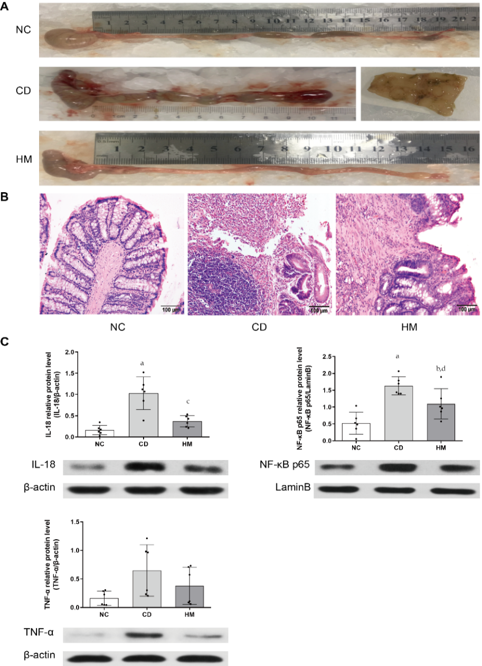
Figure 1 Herbal cake-partitioned moxibustion at the Qihai (CV6) and bilateral Tianshu (ST25) acupoints ameliorates colon damage and inflammation in Crohn’s disease rats. A: Megacolon and cobblestone-like changes; B: Histopathological observations of colon tissue by hematoxylin and eosin staining. Scale bar: 100 μm; C: Expression of the colonic inflammatory factors interleukin-18 (IL-18), nuclear factor κB/p65 (NF-κB p65), and tumor necrosis factor-α (TNF-α) proteins evaluated by Western blot. Six independent experiments were analyzed, and the data are presented as the mean ± SD. ªP < 0.01, ^{b}P < 0.05 vs NC group; ^{c}P < 0.01, ^{d}P < 0.05 vs CD group. NC: Normal control; CD: Crohn’s disease; HM: Herbal cake-partitioned moxibustion; IL-18: Interleukin 18; NF-κB p65: Nuclear factor κB p65; TNF-α: Tumor necrosis factor-α.
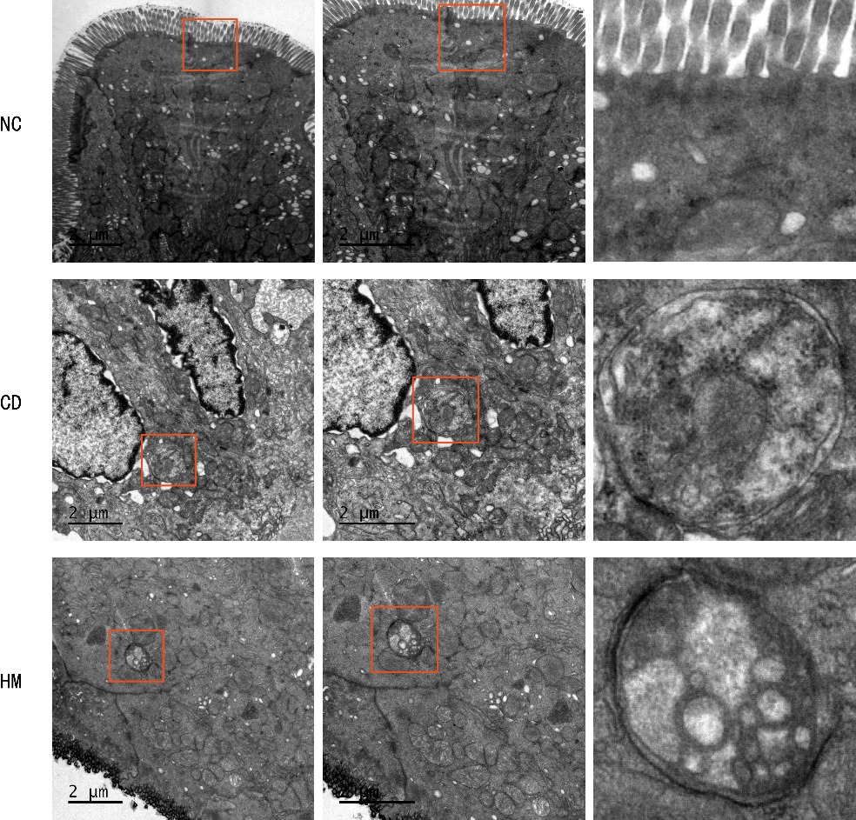
Figure 2 Ultrastructure of colonic epithelial tissue and autophagic vesicles in each group of rats. Scale bar: 2 μm. NC: Normal control; CD: Crohn’s disease; HM: Herbal cake-partitioned moxibustion.
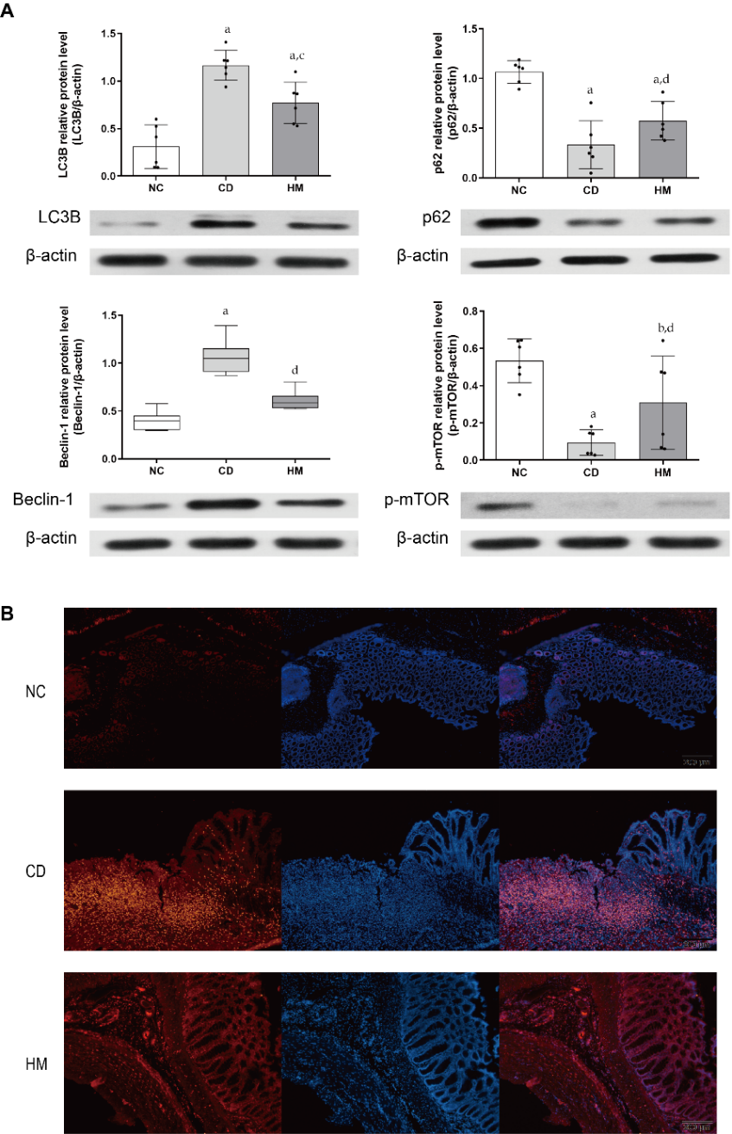
Figure 3 Herbal cake-partitioned moxibustion at the Qihai (CV6) and bilateral Tianshu (ST25) acupoints regulates the expression of autophagy proteins in the colon tissues of Crohn’s disease rats. A: Expression changes of the microtubule-associated protein 1 light chain 3 beta, sequestosome 1, coiled-coil myosin-like BCL2-interacting protein, and phospho-mammalian target of rapamycin proteins evaluated by Western blot. Six independent experiments were analyzed, and the data are presented as the mean ± SD or medians (P25, P75). ªP < 0.01, ^{b}P < 0.05 vs NC group; ^{c}P < 0.01, ^{d}P < 0.05 vs CD group; B: Immunofluorescence images for LC3B (Red) in each group. Scale bar: 200 μm. NC: Normal control; CD: Crohn’s disease; HM: Herbal cake-partitioned moxibustion; LC3B: Microtubule-associated protein 1 light chain 3 beta; p62: Sequestosome 1; Beclin-1: Coiled-coil myosin-like BCL2-interacting protein; p-mTOR: Phospho-mammalian target of rapamycin.

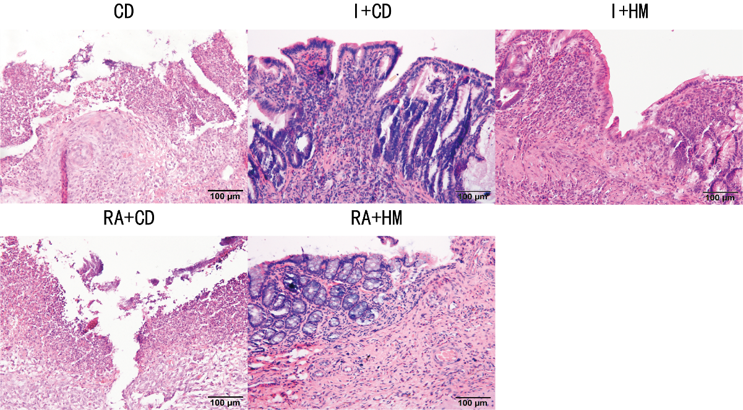
Figure 4 Histopathological observations of colon tissue from each group by hematoxylin and eosin staining. Scale bar: 100 μm. CD: Crohn’s disease; I + CD: Insulin + Crohn’s disease; I + HM: Insulin + herbal cake-partitioned moxibustion; RA + CD: Rapamycin + Crohn’s disease; RA + HM: Rapamycin + herbal cake-partitioned moxibustion.
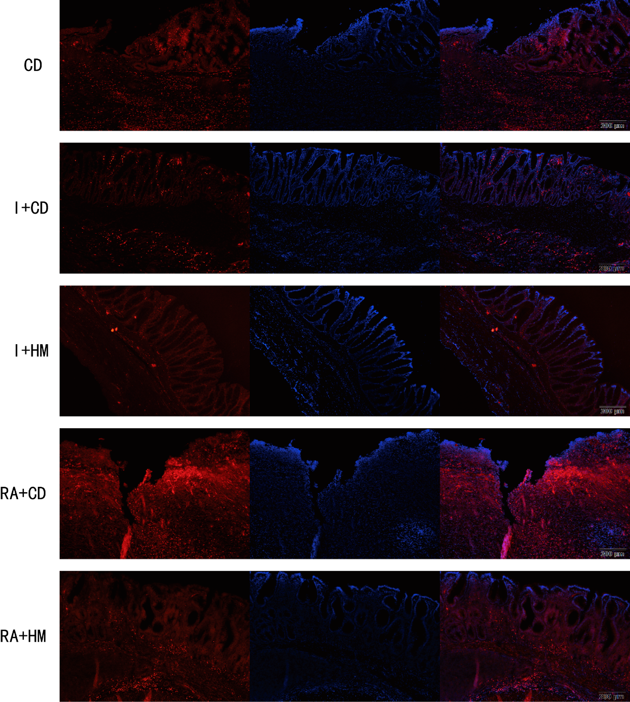
Figure 5 Immunofluorescence images for microtubule-associated protein 1 light chain 3 beta (Red) in each group. Scale bar: 200 μm. CD: Crohn’s disease; I + CD: Insulin + Crohn’s disease; I + HM: Insulin + herbal cake-partitioned moxibustion; RA+CD: Rapamycin + Crohn’s disease; RA + HM: Rapamycin + herbal cake-partitioned moxibustion; LC3B: Microtubule-associated protein 1 light chain 3 beta.

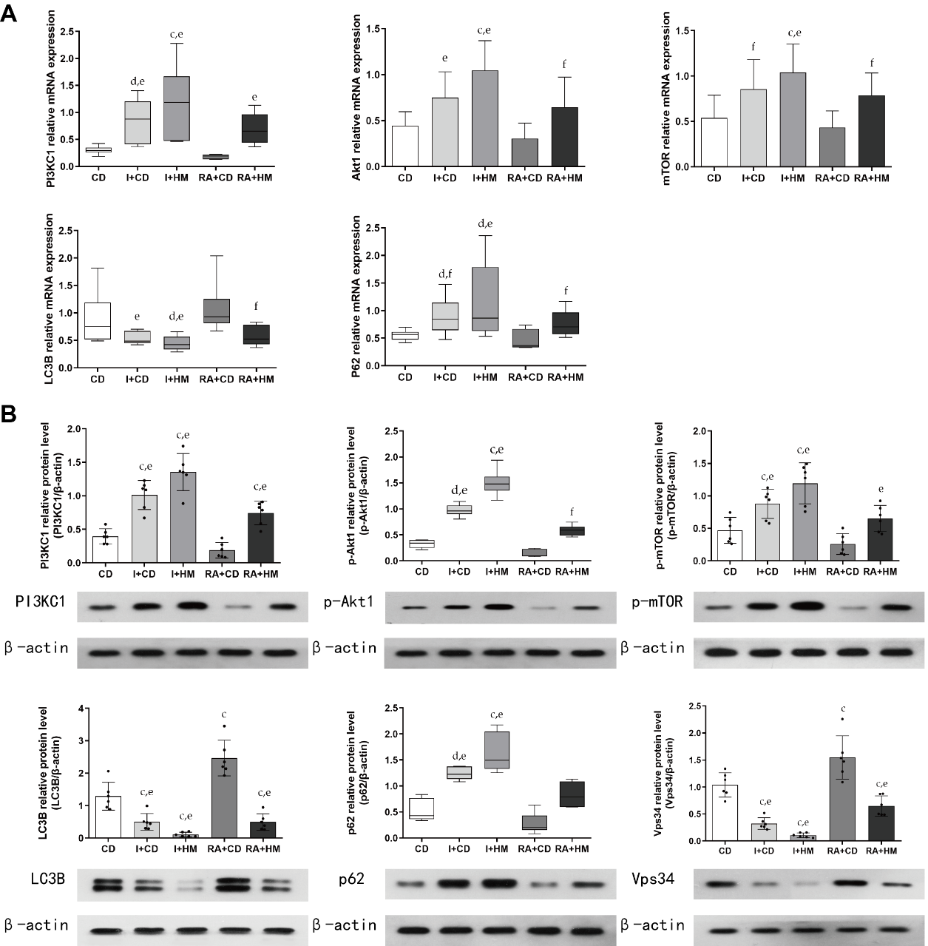
Figure 6 Herbal cake-partitioned moxibustion at the Qihai (CV6) and bilateral Tianshu (ST25) acupoints regulates the mRNA and protein expression of PI3KC signaling-related molecules in the colon tissues of Crohn’s disease rats. A: The mRNA levels of phosphatidylinositol 3-kinase class I (PI3KC1), Akt1, mammalian target of rapamycin (mTOR), microtubule-associated protein 1 light chain 3 beta (LC3B), and sequestosome 1 (p62) were determined by real-time PCR; B: Expression changes of the PI3KC1, p-Akt1, mTOR, LC3B, p62, and class III phosphatidylinositol 3-kinase proteins evaluated by Western blot. Six independent experiments were analyzed, and the data are presented as the mean ± SD or medians (P25, P75). ^{c}P < 0.01, ^{d}P < 0.05 vs CD group; ^{e}P < 0.01, ^{f}P < 0.05 vs RA+CD group. CD: Crohn’s disease; I + CD: Insulin + Crohn’s disease; I + HM: Insulin + herbal cake-partitioned moxibustion; RA+CD: Rapamycin + Crohn’s disease; RA + HM: Rapamycin + herbal cake-partitioned moxibustion; PI3KC1: Phosphatidylinositol 3-kinase class I; Akt1: Protein kinase B akt-1; p-Akt1: Phospho-protein kinase B akt-1; mTOR: Mammalian target of rapamycin; p-mTOR: Phospho-mammalian target of rapamycin; LC3B: Microtubule-associated protein 1 light chain 3 beta; p62: Sequestosome 1; Vps34: Class III phosphatidylinositol 3-kinase.
Table 1 Primers used for PCR
NM | Length | Primer NM | Sequence (5’-3’)
NM_017008.4 | 129 bp | Rat GAPDH F-primer | tgccactcagaagactgtgg
 |  | Rat GAPDH R-primer | ttcagctctgggatgacctt
NM_175843.4 | 188 bp | Rat p62 F-primer | agaagtggacccatccacag
 |  | Rat p62 R-primer | agaaacccatggacagcatc
NM_022867.2 | 114 bp | Rat Map1lc3b F-primer | ttcttcctcctggtgaatgg
 |  | Rat Map1lc3b R-primer | ctgggaggcatagaccatgt
NM_019906.1 | 153 bp | Rat mTOR Forward primer | ggcttctgaagatgctgtcc
 |  | Rat mTOR Reverse primer | gagttcgaagggcaagagtg
NM_013005.1 | 166 bp | Rat Pik3r1 F-primer | actactggggagaggggaga
 |  | Rat Pik3r1 R-primer | caggaagggtcaacactggt
NM_033230.2 | 176 bp | Rat Akt1 F-primer | actcattccagacccacgac
 |  | Rat Akt1 R-primer | ccggtacaccacgttcttct
GAPDH: Glyceraldehyde-3-phosphate dehydrogenase; p62: Sequestosome 1; Map1lc3b: Microtubule-associated protein 1 light chain 3 beta; mTOR: Mammalian target of rapamycin; Pik3r1: Phosphatidylinositol 3-kinase regulatory subunit alpha; Akt1: Protein kinase B akt-1.

