Name of Journal: World Journal of Gastrointestinal Oncology
Manuscript NO: 68218
Manuscript Type: ORIGINAL ARTICLE

Basic Study
STAT3-mediated activation of mitochondrial pathway contributes to antitumor effect of dihydrotanshinone I in esophageal squamous cell carcinoma cells

Qi MM et al. DHTS exerts antitumor effect in ESCC

Ming-Ming Qi, Peng-Zhan He, Lan Zhang, Wei-Guo Dong

Ming-Ming Qi, Peng-Zhan He, Lan Zhang, Wei-Guo Dong, Department of Gastroenterology, Renmin Hospital of Wuhan University, Wuhan 430060, Hubei Province, China

Ming-Ming Qi, Peng-Zhan He, Lan Zhang, Central Laboratory of Renmin Hospital, Renmin Hospital of Wuhan University, Wuhan 430060, Hubei Province, China

Author contributions: Qi MM and Dong WG designed the research; Qi MM and He PZ performed the research; Zhang L contributed new reagents/analytical tools; Qi MM and He PZ analyzed the data; Qi MM wrote the manuscript; all authors have read and approved the final manuscript.

Supported by the National Natural Science Foundation of China, No. 81572426, No. 81870392, and No. 82000521.

Corresponding author: Wei-Guo Dong, MD, PhD, Professor, Department of Gastroenterology, Renmin Hospital of Wuhan University, No. 238 Jiefang Road, Wuhan 430060, Hubei Province, China. dongweiguo@whu.edu.cn

Received: May 20, 2021
Revised: June 17, 2021
Accepted: July 5, 2021
Published online:
Abstract
BACKGROUND
Esophageal squamous cell carcinoma (ESCC) is one of the most common malignancies with a poor prognosis, and its treatment remains a great challenge. Dihydrotanshinone I (DHTS) has been reported to exert antitumor effect in many cancers. However, the role of DHTS in ESCC remains unclear.

AIM
To investigate the antitumor effect of DHTS in ESCC and the underlying mechanisms.

METHODS
CCK-8 assay and cell cycle analysis were used to detect proliferation and cell cycle in ESCC cells. Annexin V-PE/7-AAD double staining assay and Hoechst 33258 staining were used to detect apoptosis in ESCC cells. Western blot was used to detect the expression of proteins associated with the mitochondrial pathway. Immunofluorescence was used to detect the expression of phosphorylated STAT3 (pSTAT3) in DHTS-treated ESCC cells. ESCC cells with STAT3 knockdown and overexpression were constructed to verify the role of STAT3 in DHTS induced apoptosis. A xenograft tumor model in nude mice was used to evaluate the antitumor effect of DHTS in vivo.

RESULTS
After treatment with DHTS, the proliferation of ESCC cells was inhibited in a dose- and time-dependent manner. Moreover, DHTS induced cell cycle arrest in the G0/1 phase. Annexin V-PE/7-AAD double staining assay and Hoechst 33258 staining revealed that DHTS induced obvious apoptosis in KYSE30 and Eca109 cells. At the molecular level, DHTS treatment reduced the expression of pSTAT3 and anti-apoptotic proteins, while increasing the expression of pro-apoptotic proteins in ESCC cells. STAT3 knockdown in ESCC cells markedly promoted the activation of the mitochondrial pathway while STAT3 overexpression blocked the activation of the mitochondrial pathway. Additionally, DHTS inhibited tumor cell proliferation and induced apoptosis in a xenograft tumor mouse model.

CONCLUSION
DHTS exerts antitumor effect in ESCC via STAT3-mediated activation of the mitochondrial pathway. DHTS may be a novel therapeutic agent for ESCC.

Key Words: Esophageal squamous cell carcinoma; Dihydrotanshinone I; STAT3; Proliferation; Apoptosis

Qi MM, He PZ, Zhang L, Dong WG. STAT3-mediated activation of mitochondrial pathway contributes to antitumor effect of dihydrotanshinone I in esophageal squamous cell carcinoma cells. World J Gastrointest Oncol 2021; In press

Core Tip: Esophageal squamous cell carcinoma (ESCC) is one of the most common malignancies with a poor prognosis. Our research found that dihydrotanshinone I (DHTS) suppresses proliferation and induces apoptosis in ESCC cells. Besides, STAT3-mediated activation of the mitochondrial pathway plays a vital role in DHTS-induced apoptosis. DHTS may be a promising candidate for the treatment of ESCC.
INTRODUCTION
Esophageal cancer (EC) is one of the most common malignancies, ranking seventh in terms of incidence and sixth in terms of mortality worldwide. Esophageal squamous cell carcinoma (ESCC) is the main histologic subtype of EC in parts of Asia and Sub-Saharan Africa, and accounts for over 90% of all EC cases^{[1]}. Many patients with ESCC are diagnosed in the advanced stage of disease and have a great need for chemotherapy. Unfortunately, because of drug resistance and toxicity, clinical outcomes have been far from satisfactory^{[2,3]}. Thus, potent antitumor agents with excellent sensitivity and safety are urgently needed.
Studies have shown that traditional Chinese medicine has good preventive or therapeutic effect for various malignant tumors^{[4]}. Dihydrotanshinone I (DHTS) is a natural component isolated from the roots of a well-known traditional Chinese medicinal plant, Salvia miltiorrhiza^{[5]}. Previous studies have shown that DHTS has various biological functions, including cardiovascular protection, anti-inflammation, and anti-Alzheimer's disease, and several molecules, such as hypoxia-inducible factor-1α, human antigen R, and acetylcholinesterase, have been identified as potential targets for DHTS^{[6-9]}. Recently, DHTS has been reported to exert anti-tumor efficacy in breast cancer, osteosarcoma, and hemangiomas by exerting cytotoxic effect and inducing cell cycle arrest and apoptosis^{[6,10-12]}. However, the role of DHTS in ESCC and the underlying molecular mechanisms remain to be determined.
STAT3 is reported to be associated with cell proliferation, migration, and apoptosis, and is aberrantly hyperactivated in many types of cancer^{[13-15]}. The STAT3 cascade is associated with the promotion of tumor growth and immunosuppression^{[16]}. In the inactive state, STAT3 exists as a monomer found in the cytoplasm. Once activated, the phosphorylation of Tyr705 results in dimerization of the STAT3 protein and translocation of the STAT3 dimer to the nucleus. In the nucleus, phosphorylated STAT3 (pSTAT3) may mediate the induction of key target genes that regulate cellular proliferation and survival, suppress apoptosis, and promote angiogenesis, invasiveness, and/or metastasis^{[17,18]}. It has been proven that STAT3 is involved in the progression of many kinds of tumors, and treatments that target STAT3 promise therapeutic benefits for cancer patients^{[19]}.
In this study, we treated ESCC cells with DHTS to investigate whether DHTS could exert antitumor effect in ESCC cells, as well as the possible molecular mechanism involved, trying to provide a new strategy for the treatment of ESCC.

MATERIALS AND METHODS
Cell culture and reagents
The human ESCC cell lines KYSE30, Eca109, KYSE450, and KYSE510 and human normal esophageal epithelial cell line Het-1A were donated by the China Center for Type Culture Collection. The ESCC cells were cultured in Roswell Park Memorial Institute (RPMI)-1640 medium (Gibco, United States) with 10% fetal bovine serum (FBS) (Gibco, United States) while Het-1A cells in Dulbecco’s modified Eagle medium (DMEM) (Gibco, United States) with 10% FBS in a humidified incubator at 37 °C containing 5% CO₂. DHTS (Sigma-Aldrich, United States) was dissolved in dimethyl sulfoxide (DMSO) (Sigma-Aldrich, United States) at a stock concentration of 10 mmol/L and was diluted with RPMI-1640 medium or DMEM medium to perform assays. As a result, the final concentration of DMSO in the medium was no more than 10 μL/mL in all assays and would not show obvious toxicity to cells.

Cell viability assay
Cells were seeded in triplicate in 96-well plates at a density of 8000 cells per well. After overnight incubation, the cells were exposed to different concentrations of DHTS for 12 h, 24 h, or 36 h. Cell viability was assessed using a Cell Counting Kit-8 (CCK-8, Beyotime, China) according to the manufacturer’s protocol. The absorbance at 450 nm was measured using a microplate spectrophotometer (Victor3 1420 Multilabel Counter, Perkin Elmer, United States). RPMI 1640 medium or DMEM medium containing 5% CCK-8 was used as a control.

Cell cycle analysis
Cells were seeded at a density of 5 × 10⁵ per well in six-well plates and incubated at 37 °C overnight. After culturing in RPMI 1640 medium without fetal bovine serum for 24 h, the cells were cultured in RPMI 1640 medium with 10% FBS and treated with DHTS for 24 h and then collected after trypsinization and fixed in ice-cold 75% ethanol overnight at 4 °C. The cells were then washed with PBS and incubated with PI (50 μg/mL, Antgene, China) and RNAse (Yeasen, China) for 30 min. Cell cycle distribution was detected using the BD TM LSRΙΙ flow cytometer (BD Biosciences, San Jose, CA, United States). The resultant cell cycle profiles were analyzed using ModFit software (Verity Software House, Topshem, ME, United States).

Annexin V-PE/7-AAD double staining assay for apoptosis
The annexin V-PE/7-AAD kit (BD Pharmingen, United States) was used to quantify the percentage of apoptotic cells using flow cytometry (FACS Calibur, Becton Dickinson). Cells were seeded into a six-well plate and incubated at 37 °C overnight. Then the cells were treated with different concentrations of DHTS for 24 h. Adherent cells were collected and co-stained with 5 μL of annexin V-PE and 5 μL of 7-AAD before flow cytometric analysis. Live cells are PE- and 7-AAD-negative, and early apoptotic cells are PE-positive and 7-AAD-negative. Necrotic cells are both PE- and 7-AAD-positive, and late apoptotic and dead cells are PE-negative and 7-AAD-positive.

Hoechst 33258 staining for apoptosis
Cells were seeded into a six-well plate at a density of 2 × 10⁵ per well and incubated at 37 °C overnight. The cells were then treated with different concentrations of DHTS for 24 h. Cells were then fixed with 4% paraformaldehyde for 15 min at room temperature and then washed twice with PBS. After that, the cells were stained with 50 ng/mL Hoechst 33258 (Beyotime, China) for 10 min. Apoptotic morphological features (chromatin condensation and nuclear fragmentation) were observed and imaged using a fluorescence microscope (BX51, Olympus).

Transfection and lentiviral transduction
pLVX-Puro-STAT3-shRNA- and pLVX-Puro-STAT3-expressing lentiviruses were designed and provided by Genomeditech (Shanghai, China). KYSE30 cells and Eca109 cells were transfected with the lentiviral vectors, while control cells were transfected with empty vectors according to the manufacturer's instructions. To establish stable cell lines, 2 μg/mL puromycin dihydrochloride (Beyotime, China) was used daily for 1 wk after transfection with lentiviral vectors. Knockdown and overexpression efficiencies were validated using Western blot and real-time quantitative polymerase chain reaction (RT-qPCR).

RNA extraction and RT-PCR
Total RNA was extracted using TRIzol Reagent (Invitrogen, United States) as described by the manufacturer. cDNA was synthesized using the Hifair II 1st Strand cDNA Synthesis SuperMix for qPCR Kit (Yeasen, China) according to the manufacturer’s protocol. RT-qPCR was conducted using the Hieff qPCR SYBR Green Master Mix Kit (Yeasen, China) on an ABI7500 real-time PCR system (Applied Biosystems, Foster City, CA) following the recommended protocols. The expression level of the glyceraldehyde 3-phosphate dehydrogenase (GAPDH) gene was used as a loading control. Primer sequences are as follows: Forward sequence 5'-CAGCAGCTTGACACACGGTA-3' and reverse sequence 5'-AAACACCAAAGTGGCATGTGA-3' for STAT3; forward sequence 5'-AAATCCCATCACCATCTTCC-3' and reverse sequence 5'-TCACACCCATGACGAACA-3' for GAPDH.

Western blot analysis
ESCC cells treated with DHTS were used to isolate proteins. The proteins were separated on 10% SDS-PAGE and transferred to polyvinylidene difluoride (PVDF) membranes (Millipore, Bedford, MA, United States). PVDF membranes were blocked in 5% non-fat milk in TBS-Tween 20 (0.1%, v/v) at 25 °C for 1 h. The PVDF membranes were incubated in blocking solution with primary antibodies at 4 °C overnight. The membranes were washed with TBS-Tween 20 (0.1%, v/v) three times (10 min/time), further immunoblotted with secondary antibody for 1 h at 25 °C, washed three times with TBS-Tween 20 (0.1%, v/v) in the dark, and scanned using a two-color Odyssey infrared imaging system (LI-COR Biosciences). The specific protein expression levels were normalized to that of GAPDH on the same PVDF membranes. Antibodies against STAT3 (#9139), pSTAT3 (#4113), B-cell lymphoma 2 (Bcl 2) (#4223), Bcl 2-associated X (Bax) (#5023), cytochrome C (Cyt C) (#4280), Cyclin D1 (#2978), cleaved caspase 3 (#9664), cleaved caspase 7 (#8438), cleaved caspase 9 (#7237), survivin (#2808), and GAPDH (#2118) were obtained from Cell Signaling Technology (United States), and antibodies against cyclin A2 (#18202-1-AP) and cyclin E1 (#11554-1-AP) were obtained from Proteintech (China). The antibodies were used at the indicated concentrations. Secondary antibodies were purchased from LI-COR (Lincoln, United States) and used at a dilution ratio of 1:10000. Protein bands were quantified based on densitometry using Image J software (National Institutes of Health, Bethesda, MD, United States).

Immunofluorescence
KYSE30 and Eca109 cells were seeded onto glass coverslips in a 24-well plate overnight, and the cells were then treated with DHTS for 24 h. The cells were then washed with PBS and fixed with paraformaldehyde for 15 min at 25 °C. Next, the cells were permeabilized for 15 min with 0.3% Triton X-100 in PBS. The cells were then blocked with 5% BSA in PBS for 1 h at 25 °C and then incubated at 4 °C with the primary antibody against pSTAT3 (1:100 dilution; CST, #4113) overnight. The treated cells were then incubated with an FITC-labeled goat anti-mouse IgG (H + L) highly cross-adsorbed secondary antibody (Biosharp, China) in the dark for 1 h. The nuclei were visualized after staining with 2 μg/mL DAPI (Biosharp, China) for 10 min at 25 °C. The glass coverslips were sealed with antifade reagent (Biosharp, China) and examined under a fluorescence microscope (BX51, Olympus).

Xenograft tumor experiment using nude mice
All animal research procedures were approved by the Ethics Committee of Renmin Hospital of Wuhan University. All animal experiments were carried out in accordance with the National Institutes of Health Guide for the Care and Use of Laboratory Animals (NIH Publications No. 8023, revised in 1978). Male BALB/c nude mice (5 wk old) were purchased from Beijing Life River Experimental Animal Technology Co. Ltd. (China). The collected KYSE30 cells (1 × 10⁶) were washed in serum-free RPMI 1640, suspended in 200 μL of PBS, and subcutaneously implanted into the right flank in the dorsal region of nude mice. When the longest diameter of the tumor was about 5 mm, nude mice were randomly divided into the following four groups (n = 6 each group): Control (normal saline), 5 mg/kg DHTS, 10 mg/kg DHTS, and 15 mg/kg DHTS. Mice were injected intraperitoneally once every other day. There was no significant difference between these groups before treatment. Tumor size was measured using a Vernier caliper (3–4 times/wk). Tumor volume (TV) was calculated using the following formula: TV (cm³) = 0.5 × d² × D; where d and D are the shortest and longest diameters, respectively. All mice were weighed (3–4 times/wk). After treatment for 9 times, tumor specimens were collected and weighed.

TUNEL assay
Xenograft tumors from vehicle-treated and DHTS-treated mice were fixed in 10% neutral buffered formalin, embedded in paraffin, and used to prepare 4 μm-thick sections. Apoptotic cells were detected using a terminal deoxynucleotidyl transferase-mediated dUTP nick end labeling (TUNEL) assay performed with an in situ apoptosis detection kit (Roche Applied Science, Basel, Switzerland). An optical microscope (Olympus, BX51) was used to observe the specimens. Positive cells were identified, counted, and analyzed.

Immunohistochemistry
Immunohistochemistry staining was performed using an UltraSensitive TM SP kit and DAB kit (China Fuzhou Maixin Biotechnology) according to the manufacturer’s instructions. Sections (4 μm) were obtained from formalin-fixed paraffin-embedded xenograft tumors from vehicle-treated and DHTS-treated mice. Anti-Ki67 antibody (Abcam, #ab16667) was applied at 1:200 dilution. An optical microscope (Olympus, BX51) was used to observe the specimens. Positive cells were identified, counted, and analyzed.

Statistical analysis
SPSS software, version 25.0, was used for all analyses. Data are expressed as the mean ± SD. Analysis of variance was used to analyze differences between groups. A P-value of less than 0.05 was considered statistically significant.

RESULTS
DHTS inhibits proliferation in ESCC cells
To identify whether DHTS exerts antitumor effect in ESCC cells, CCK8 was used to detect the cell viability of ESCC cells. After treatment with different concentrations of DHTS for 12 h, 24 h, or 36 h, the proliferation of ESCC cells was inhibited in a dose- and time-dependent manner (Figure 1A-D). After treatment with DHTS for 24 h, the IC₅₀ of DHTS in KYSE30, Eca109, KYSE450, and KYSE510 cells was 0.697 (95% confidence interval [CI]: 0.438-0.961) μmol/L, 5.895 (95%CI: 3.766-9.633) μmol/L, 13.878 (95%CI: 10.287-20.148) μmol/L, and 9.943 (95%CI: 7.675-13.496) μmol/L, respectively. In addition, to explore whether DHTS inhibits the proliferation of normal esophageal epithelial cells, the viability of Het-1A cells treated with DHTS was detected, while no significant inhibition was detected even at a high concentration of DHTS (Figure 1E) and the IC₅₀ of DHTS at 24 h was 758.751 (95%CI: 238.424-20168.744) μmol/L, which is much higher than the IC₅₀ in ESCC cells. All IC₅₀ values for different treatment time are shown in Table 1. These data indicate that DHTS exerts an inhibitory effect on the proliferation of ESCC cells in a dose- and time-dependent manner, but shows no obvious proliferation inhibition in normal esophageal epithelial cells.

DHTS induces cell cycle arrest in the G0/1 phase in ESCC cells
To decipher the mechanisms underlying DHTS-mediated inhibition of proliferation, we analyzed the cell cycle distribution using flow cytometry. KYSE30 cells were treated with 0 μmol/L, 0.25 μmol/L, 0.5 μmol/L, or 1.0 μmol/L DHTS, while Eca109 cells were treated with 0 μmol/L, 2.5 μmol/L, 5 μmol/L, or 10 μmol/L DHTS. Following 24 h of DHTS treatment, the number of KYSE30 and Eca109 cells in the G0/1 phase significantly increased in a concentration-dependent manner, accompanied by a marked decrease in cells in the S and G2/M phases (Figure 2A and B) (P < 0.05).
Western blot analysis revealed that DHTS treatment significantly regulated the expression of proteins associated with the cell cycle. Cyclin A2, cyclin E1, and cyclin D1, which are involved in the transition from G1 to S phase, decreased significantly with an increase in DHTS concentration (Figure 2C and D) (P < 0.05). Meanwhile, the expression of P21 increased after DHTS treatment (Figure 2C and D) (P < 0.05). These data indicated that the number of cells in the G0/1 phase increased greatly while the number of cells in the S and G2/M phases decreased significantly after DHTS treatment, demonstrating that DHTS induces an obvious cell cycle arrest in the G0/1 phase in KYSE30 and Eca109 cells.

DHTS induces apoptosis in ESCC cells
To detect whether DHTS induces apoptosis in ESCC cells, annexin PE/7-AAD staining was used to detect cell apoptosis. The proportion of early and late apoptotic cells increased significantly for DHTS-treated KYSE30 cells and Eca109 cells with the increase in DHTS concentration (Figure 3A and B) (P < 0.05). Apoptosis of ESCC cells induced by DHTS was further confirmed by Hoechst 33258 staining. Both KYSE30 and Eca109 cells treated with DHTS had more bright-blue fluorescence and condensed nuclei than control cells, indicating many more apoptotic cells among the DHTS-treated cells (Figure 3C and D) (P < 0.05). Besides, annexin PE/7-AAD staining was used to detect whether DHTS induces apoptosis in normal esophageal epithelial cells. The results revealed that the proportion of early and late apoptotic cells of Het-1A cells showed no significant difference with the control group even when treated with DHTS at 64 μmol/L (Figure 4A and B). These results indicate that DHTS induces apoptosis in KYSE30 cells and Eca109 cells dose-dependently but does not induce obvious apoptosis in normal esophageal epithelial cells.

DHTS activates mitochondrial pathway in ESCC cells
The mitochondrial pathway plays an important role in the apoptosis of tumor cells^{[20]}. To test whether DHTS exerts antitumor effect through the mitochondrial pathway, we examined the expression of proteins associated with apoptosis in DHTS-treated ESCC cells. An imbalance of anti-apoptotic/pro-apoptotic proteins was found: DHTS treatment led to an obvious increase in pro-apoptotic Bax and a decrease in anti-apoptotic Bcl2 in both KYSE30 and Eca109 cells, and the ratio of Bax and Bcl2 increased significantly (Figure 5A and B). Additionally, cleaved caspase 3, cleaved caspase 7, cleaved caspase 9, and Cyt C, which could promote apoptosis, were significantly higher than those in the control group after exposure to DHTS for 24 h (Figure 5C and D). Meanwhile, survivin levels were lower in DHTS-treated cells, indicating that DHTS inhibited survival and promoted apoptosis in KYSE30 and Eca109 cells (Figure 5C and D). The above results demonstrate that DHTS activates the mitochondrial pathway and induces significant apoptosis in KYSE30 and Eca109 cells.

DHTS inhibits the phosphorylation of STAT3 in ESCC cells
Previous studies have demonstrated that STAT3 plays an essential role in the proliferation of ESCC cells^{[21]}. Hence, we speculated that DHTS may induce apoptosis through STAT3 in ESCC cells. After DHTS treatment for 24 h, the protein expression of STAT3 in both KYSE30 and Eca109 cells did not change significantly, but the expression of pSTAT3, the active form of STAT3 that functions in the nucleus, decreased significantly with an increase in DHTS concentration (Figure 6A and B). Immunofluorescence showed the same results; it was obvious that pSTAT3 mainly located in the nucleus, and the expression of pSTAT3 decreased with the increase in DHTS concentration (Figure 6C and D). These results suggest that DHTS inhibits the phosphorylation of STAT3.

STAT3 knockdown promotes the activation of mitochondrial pathway in DHTS-treated ESCC cells
To clarify the role of STAT3 in DHTS-induced apoptosis, we constructed STAT3-knockdown ESCC cell lines. Western blot and RT-qPCR were used to detect the efficiency of STAT3 knockdown (Figure 7A-C). Western blot analysis showed that the level of pSTAT3 was consistent with that of STAT3 (Figure 7A). To verify the role of STAT3 in ESCC cells, cell lines with the best STAT3 knockdown efficiency were used in the following experiments. Hoechst 33258 staining showed that STAT3 knockdown not only induced apoptosis but also showed synergy with DHTS in both KYSE30 and Eca109 cells; STAT3 knockdown and DHTS treatment showed a significant pro-apoptotic effect (Figure 7D and E). Annexin PE/7-AAD staining showed the same results (Figure 7F and G). In addition, the expression proteins associated with the mitochondrial pathway were detected in STAT3-knockdown ESCC cells. In both KYSE30 and Eca109 cells, STAT3 knockdown increased the expression of pro-apoptotic proteins such as Bax, Cyt C, cleaved caspase 3, cleaved caspase 7, and cleaved caspase 9, while proteins associated with anti-apoptosis and survival, including Bcl2 and survivin, decreased significantly (Figure 8A and B). Furthermore, STAT3 knockdown and DHTS treatment led to a greater increase in pro-apoptotic proteins and greater decrease of anti-apoptotic proteins (Figure 8A and B). These results indicate that STAT3 knockdown promotes the pro-apoptotic effect of DHTS in KYSE30 and Eca109 cells.

STAT3 overexpression blocks the activation of mitochondrial pathway in DHTS treated ESCC cells
Although STAT3 knockdown promotes the activation of the mitochondrial pathway, we still cannot determine whether DHTS exerts antitumor effect through STAT3 for other molecules that may play a role in the process. To prove that STAT3 is involved in DHTS-induced apoptosis, STAT3-overexpressing ESCC cell lines were used to detect apoptosis-associated proteins. STAT3 overexpression efficiency was verified by Western blot and RT-qPCR (Figure 9A-C). Western blot analysis showed that the level of pSTAT3 was consistent with that of STAT3 (Figure 9A). Compared with ESCC cells without any treatment, STAT3 overexpression decreased the levels of pro-apoptotic proteins such as Bax, Cyt C, cleaved caspase 3, cleaved caspase 7, and cleaved caspase 9, while increased the levels of Bcl2 and survivin (Figure 9D and E), which means that STAT3 overexpression inhibited apoptosis. Meanwhile, the expression of pro-apoptotic proteins in DHTS treated STAT3-overexpressing cells was lower while the expression of anti-apoptotic proteins was higher than that in DHTS-treated control cells (Figure 9D and E), indicating that the pro-apoptotic effect of DHTS was blocked by STAT3 overexpression. All the results indicate that DHTS induces apoptosis through STAT3 in KYSE30 and Eca109 cells.

DHTS exerts antitumor effect in ESCC in vivo
Based on the data in vitro above, we further investigated the antitumor effect of DHTS on xenograft tumors in vivo. The transplanted tumors grew rapidly in the control group (1.047 ± 0.143 cm³) but were suppressed in the treatment group in a dose-dependent manner (0.364 ± 0.042 cm³ in the 5 mg/kg group, 0.270 ± 0.012 cm³ in the 10 mg/kg group, and 0.150 ± 0.030 cm³ in the 15 mg/kg group) (Figure 10A and B) (P < 0.05). The weight of tumors in the DHTS treatment groups also decreased in a dose-dependent manner (Figure 10C) (P < 0.05), while the body weight of mice in the four groups showed no difference during the treatment of DHTS (Figure 10D). Immunohistochemistry staining of tumors showed that the expression of Ki67 decreased significantly with the increase in DHTS dose (Figure 10E), proving that DHTS inhibited the proliferation of ESCC dose-dependently in vivo at the molecular level. Additionally, TUNEL assay of the tumors revealed more brown spots (which represent DNA fragments) in the DHTS treatment groups, indicating that cell apoptosis in the tumor increased significantly with the increase in DHTS dose (Figure 10F and G) (P < 0.05). Taken together, DHTS exerts antitumor effect in ESCC in vivo in a dose-dependent manner.

DISCUSSION
ESCC is one of the most common cancers in south African countries and some Asian countries^{[22]}. Although early detection and treatment have been gradually popularized, ESCC remains a great threat to patients^{[23,24]}. For patients with advanced disease, chemotherapy is still needed. However, traditional fluoropyrimidine-based and platinum-based chemotherapies, as well as chemotherapies containing paclitaxel or docetaxel, are not perfect choices because of their severe adverse reactions and drug resistance^{[2]}, which leads to a poor clinical prognosis. Effective remedies are still urgently needed in the clinic.
DHTS, a natural lipophilic constituent, has been shown to exert antitumor effect in several cancers without obvious toxicity^{[10,11]}. In the present study, we demonstrated that DHTS significantly inhibited the proliferation of ESCC cells and induced cell cycle arrest in the G0/1 phase in a dose-dependent manner. We further demonstrated that DHTS induced apoptosis via STAT3-mediated activation of the mitochondrial apoptotic pathway. Additionally, DHTS exerted antitumor effect in a xenograft tumor mouse model without decreasing the body weight of tumor-bearing mice, which is consistent with an earlier finding that DHTS treatment for 3 mo showed no significant toxicity, even at a high concentration^{[25]}. All data suggest that DHTS is a promising novel agent for the treatment of ESCC.
Induction of cell cycle arrest has been proposed as an effective therapeutic approach for cancers^{[26,27]}. Progression through G1 and entry into S-phase is tightly regulated by cyclin A/cyclin E–CDK2 complexes^{[28,29]}. Cyclin D1 is also required for progression through the G1 phase of the cell cycle^{[30]}, while P21 may inhibit CDK activity through binding to the cyclin-CDK complex, inducing G1 phase arrest and blocking S phase entry^{[31]}. In the present study, the expression of cyclin D1, cyclin A2, and cyclin E1 decreased and that of P21 increased after exposure to DHTS; the proportion of cells in the G1 phase increased, while that of cells in the S and G2/M phases decreased after DHTS treatment, which explains the antitumor effect of DHTS.
As a programmed form of cell death, apoptosis plays a pivotal role in cancer and therapies inducing cancer cell apoptosis have been proven to be effective strategies^{[32]}. Apoptosis is induced through two main routes involving either the intrinsic mitochondrial pathway or the activation of death receptors (the extrinsic pathway)^{[33]}. In the current study, DHTS treatment increased the expression of Bax while decreasing the levels of Bcl2. The Bax/Bcl2 ratio plays a vital role in determining mitochondrial membrane permeability and activation, which mediates the cell apoptosis process^{[34,35]}. Activated Bax migrates to the outer membrane of mitochondria, which is the key step in initiating apoptosis. Moreover, Bax can also promote the release of Cyt C from mitochondria into the cytoplasm, while Cyt C is involved in the formation of apoptosomes^{[36]}. Apoptosomes promote the activation of caspase 9, which in turn activates effector caspases, such as caspase 3 and caspase 7, which collectively orchestrate the execution of apoptosis^{[37,38]}. Meanwhile, caspases may cause cell death by cleaving DNA repair enzymes such as PARP^{[39]}. This is in line with our data showing that DHTS treatment activated the mitochondrial pathway. Moreover, survivin directly inhibits the activity of the caspase family to block the process of apoptosis induced by various stimulants^{[40,41]}, and our results indicated that DHTS treatment inhibited survivin in a dose-dependent way, which promoted the pro-apoptotic effect of DHTS.
STAT3 has been reported as a key regulator of cell proliferation, survival, and apoptosis and is constitutively activated in many cancers^{[13,42,43]}. It is a cytoplasmic transcription factor characterized by six functionally conserved domains, including the amino-terminal domain, the coiled-coil domain, the DNA-binding domain, the linker domain, the SRC homology 2 domain, and the carboxyl-terminal transactivation domain^{[44]}. STAT3 maintains an inactive state in the cytoplasm in an unstimulated cell while becomes activated mainly by direct phosphorylation when there is stimulus. The phosphorylation induces dimerization of pSTAT3 and translocation of pSTAT3 dimer into the nucleus, and eventually execution of their nuclear functions^{[45]}. Under physiological conditions, transient activation of STAT3 mediates cell proliferation, differentiation, apoptosis, survival, immune function, angiogenesis, and other important cellular processes in response to transcriptional signals from cytokines and growth factor^{[46]}. However, STAT3 becomes hyperactivated in a variety of human cancers and is generally associated with a poor clinical prognosis^{[13,47,48]}. Gathered evidence suggests that STAT3 hyperactivation occurs not only in cancer cells but also in immune cells and cancer-associated fibroblasts within the tumor microenvironment^{[49,50]}. The hyperactivation of STAT3 in the tumor microenvironment may inhibit antitumor immunity through upregulation of immunosuppressive factors and downregulation of immune activation factors^{[51]}. Furthermore, persistent activation of STAT3 is associated with resistance to chemotherapy and poor prognosis. Therefore, therapeutic strategies targeting the STAT3 signaling pathway has long been recognized as a new way for long-lasting and multilayered tumor control. Coincidentally, DHTS has been reported to exert antitumor effect via multiple mechanisms^{[11,12,26]}. Therefore, we assumed that DHTS induced apoptosis in ESCC cells through STAT3. In this study, we found that DHTS inhibited the phosphorylation of STAT3 in a dose-dependent manner, which provides evidence for our hypothesis. To explore the relationship between DHTS and STAT3, cells with STAT3 knockdown and overexpression were constructed, and STAT3 knockdown significantly promoted the activation of the mitochondrial pathway induced by DHTS while STAT3 overexpression blocked the activation of the mitochondrial pathway induced by DHTS, which confirmed our hypothesis that DHTS may exert antitumor effect via STAT3-mediated activation of the mitochondrial pathway. Taken together, this study provides evidence that DHTS can exert antitumor effect via STAT3-mediated activation of the mitochondrial pathway, thus revealing the anticancer mechanism of the drug.

CONCLUSION
In summary, our data experimentally showed that DHTS has potent antitumor activity against ESCC by reducing cell proliferation and inducing apoptosis in vitro and in vivo. We further identified that STAT3-mediated activation of the mitochondrial pathway contributes to the antitumor effect of DHTS in ESCC cells. Overall, our results strongly suggest that DHTS is a promising candidate for the treatment of ESCC, which may build a foundation for the clinical trials of this novel therapeutic agent.

ARTICLE HIGHLIGHTS
Research background
Esophageal squamous cell carcinoma (ESCC) is one of the most common malignancies with a poor prognosis. Dihydrotanshinone I (DHTS) has been reported to exert antitumor effect in cancer. However, the role of DHTS in ESCC remains unclear.

Research motivation
This study investigated the role of DHTS in ESCC and the underlying mechanisms, and explored novel therapeutic agents for ESCC.

Research objectives
The aim of this study was to investigate the antitumor effect of DHTS in ESCC and the underlying mechanisms.

Research methods
CCK-8 assay was used to detect proliferation and cell cycle analysis was used to detect cell cycle in ESCC cells. Annexin V-PE/7-AAD double staining assay and Hoechst 33258 staining were used to detect apoptosis. Western blot was used to detect the expression of proteins associated with proliferation and the mitochondrial pathway. Immunofluorescence was used to detect the expression of phosphorylated STAT3 (pSTAT3) in DHTS-treated ESCC cells. ESCC cells with STAT3 knockdown and overexpression were constructed to verify the role of STAT3 in DHTS induced apoptosis. A xenograft tumor model in nude mice was used to evaluate the antitumor effect of DHTS in vivo.

Research results
After treatment with DHTS, the proliferation of ESCC cells was inhibited in a dose- and time-dependent manner. Moreover, DHTS induced cell cycle arrest in the G0/1 phase. Annexin V-PE/7-AAD double staining assay and Hoechst 33258 staining revealed that DHTS induced obvious apoptosis in KYSE30 and Eca109 cells. At the molecular level, DHTS treatment reduced the expression of pSTAT3 and anti-apoptotic proteins, while increasing the expression of pro-apoptotic proteins in ESCC cells. STAT3 knockdown in ESCC cells markedly promoted the activation of the mitochondrial pathway while STAT3 overexpression blocked the activation of the mitochondrial pathway. Additionally, DHTS exerted antitumor effect in a xenograft tumor mouse model.

Research conclusions
DHTS exerts antitumor effect in ESCC via STAT3-mediated activation of the mitochondrial pathway. DHTS may be a novel therapeutic agent for ESCC.

Research perspectives
In the future, additional research will be carried out to further explore the important role of DHTS and whether DHTS treatment can be employed to improve the prognosis of ESCC patients.

ACKNOWLEDGEMENTS
We are grateful to Mrs. Ming-Xia Fan from the Animal Laboratory Center and Mrs. Qiong Ding from the Central Laboratory of Renmin Hospital of Wuhan University for their support.

REFERENCES
1 Bray F, Ferlay J, Soerjomataram I, Siegel RL, Torre LA, Jemal A. Global cancer statistics 2018: GLOBOCAN estimates of incidence and mortality worldwide for 36 cancers in 185 countries. CA Cancer J Clin 2018; 68: 394-424 [PMID: 30207593 DOI: 10.3322/caac.21492]
2 Kato K, Cho BC, Takahashi M, Okada M, Lin CY, Chin K, Kadowaki S, Ahn MJ, Hamamoto Y, Doki Y, Yen CC, Kubota Y, Kim SB, Hsu CH, Holtved E, Xynos I, Kodani M, Kitagawa Y. Nivolumab versus chemotherapy in patients with advanced oesophageal squamous cell carcinoma refractory or intolerant to previous chemotherapy (ATTRACTION-3): a multicentre, randomised, open-label, phase 3 trial. Lancet Oncol 2019; 20: 1506-1517 [PMID: 31582355 DOI: 10.1016/S1470-2045(19)30626-6]
3 Hou S, Jin W, Xiao W, Deng B, Wu D, Zhi J, Wu K, Cao X, Chen S, Ding Y, Shi H. Integrin α5 promotes migration and cisplatin resistance in esophageal squamous cell carcinoma cells. Am J Cancer Res 2019; 9: 2774-2788 [PMID: 31911861]
4 Wang Y, Zhang Q, Chen Y, Liang CL, Liu H, Qiu F, Dai Z. Antitumor effects of immunity-enhancing traditional Chinese medicine. Biomed Pharmacother 2020; 121: 109570 [PMID: 31710893 DOI: 10.1016/j.biopha.2019.109570]
5 Li Y, Hou Z, Su F, Chen J, Zhang X, Xu L, Yang D, Liang Z. Quantitative Determination and Validation of Four Ketones in Salvia miltiorrhiza Bunge Using Quantitative Proton Nuclear Magnetic Resonance Spectroscopy. Molecules 2020; 25 [PMID: 32353926 DOI: 10.3390/molecules25092043]
6 Chen X, Yu J, Zhong B, Lu J, Lu JJ, Li S, Lu Y. Pharmacological activities of dihydrotanshinone I, a natural product from Salvia miltiorrhiza Bunge. Pharmacol Res 2019; 145: 104254 [PMID: 31054311 DOI: 10.1016/j.phrs.2019.104254]
7 Jiang L, Zeng H, Ni L, Qi L, Xu Y, Xia L, Yu Y, Liu B, Yang H, Hao H, Li P. HIF-1α Preconditioning Potentiates Antioxidant Activity in Ischemic Injury: The Role of Sequential Administration of Dihydrotanshinone I and Protocatechuic Aldehyde in Cardioprotection. Antioxid Redox Signal 2019; 31: 227-242 [PMID: 30799630 DOI: 10.1089/ars.2018.7624]
8 Yuan R, Huang L, Du LJ, Feng JF, Li J, Luo YY, Xu QM, Yang SL, Gao H, Feng YL. Dihydrotanshinone exhibits an anti-inflammatory effect in vitro and in vivo through blocking TLR4 dimerization. Pharmacol Res 2019; 142: 102-114 [PMID: 30794925 DOI: 10.1016/j.phrs.2019.02.017]
9 Zhang XZ, Qian SS, Zhang YJ, Wang RQ. Salvia miltiorrhiza: A source for anti-Alzheimer's disease drugs. Pharm Biol 2016; 54: 18-24 [PMID: 25857808 DOI: 10.3109/13880209.2015.1027408]
10 Kim SL, Choi HS, Kim JH, Jeong DK, Kim KS, Lee DS. Dihydrotanshinone-Induced NOX5 Activation Inhibits Breast Cancer Stem Cell through the ROS/Stat3 Signaling Pathway. Oxid Med Cell Longev 2019; 2019: 9296439 [PMID: 31019654 DOI: 10.1155/2019/9296439]
11 Tan T, Chen J, Hu Y, Wang N, Chen Y, Yu T, Lin D, Yang S, Luo J, Luo X. Dihydrotanshinone I inhibits the growth of osteosarcoma through the Wnt/β-catenin signaling pathway. Onco Targets Ther 2019; 12: 5111-5122 [PMID: 31308689 DOI: 10.2147/OTT.S204574]
12 Cai Y, Lv F, Kaldybayeva N, Zhamilya A, Wu Z, Wu Y. 15, 16-Dihydrotanshinone I Inhibits Hemangiomas through Inducing Pro-apoptotic and Anti-angiogenic Mechanisms in Vitro and in Vivo. Front Pharmacol 2018; 9: 25 [PMID: 29441017 DOI: 10.3389/fphar.2018.00025]
13 Laudisi F, Cherubini F, Di Grazia A, Dinallo V, Di Fusco D, Franzè E, Ortenzi A, Salvatori I, Scaricamazza S, Monteleone I, Sakamoto N, Monteleone G, Stolfi C. Progranulin sustains STAT3 hyper-activation and oncogenic function in colorectal cancer cells. Mol Oncol 2019; 13: 2142-2159 [PMID: 31361391 DOI: 10.1002/1878-0261.12552]
14 Yang Y, Fang E, Luo J, Wu H, Jiang Y, Liu Y, Tong S, Wang Z, Zhou R, Tong Q. The Antioxidant Alpha-Lipoic Acid Inhibits Proliferation and Invasion of Human Gastric Cancer Cells via Suppression of STAT3-Mediated MUC4 Gene Expression. Oxid Med Cell Longev 2019; 2019: 3643715 [PMID: 31915505 DOI: 10.1155/2019/3643715]
15 Sen M, Kindsfather A, Danilova L, Zhang F, Colombo R, LaPorte MG, Kurland BF, Huryn DM, Wipf P, Herman JG. PTPRT epigenetic silencing defines lung cancer with STAT3 activation and can direct STAT3 targeted therapies. Epigenetics 2020; 15: 604-617 [PMID: 31595832 DOI: 10.1080/15592294.2019.1676597]
16 Yu H, Pardoll D, Jove R. STATs in cancer inflammation and immunity: a leading role for STAT3. Nat Rev Cancer 2009; 9: 798-809 [PMID: 19851315 DOI: 10.1038/nrc2734]
17 Yu H, Jove R. The STATs of cancer--new molecular targets come of age. Nat Rev Cancer 2004; 4: 97-105 [PMID: 14964307 DOI: 10.1038/nrc1275]
18 Bournazou E, Bromberg J. Targeting the tumor microenvironment: JAK-STAT3 signaling. JAKSTAT 2013; 2: e23828 [PMID: 24058812 DOI: 10.4161/jkst.23828]
19 Johnson DE, O'Keefe RA, Grandis JR. Targeting the IL-6/JAK/STAT3 signalling axis in cancer. Nat Rev Clin Oncol 2018; 15: 234-248 [PMID: 29405201 DOI: 10.1038/nrclinonc.2018.8]
20 Kühn B, Brat C, Fettel J, Hellmuth N, Maucher IV, Bulut U, Hock KJ, Grimmer J, Manolikakes G, Rühl M, Kühn A, Zacharowski K, Matrone C, Urbschat A, Roos J, Steinhilber D, Maier TJ. Anti-inflammatory nitro-fatty acids suppress tumor growth by triggering mitochondrial dysfunction and activation of the intrinsic apoptotic pathway in colorectal cancer cells. Biochem Pharmacol 2018; 155: 48-60 [PMID: 29909078 DOI: 10.1016/j.bcp.2018.06.014]
21 Liu Y, Zhi Y, Song H, Zong M, Yi J, Mao G, Chen L, Huang G. S1PR1 promotes proliferation and inhibits apoptosis of esophageal squamous cell carcinoma through activating STAT3 pathway. J Exp Clin Cancer Res 2019; 38: 369 [PMID: 31438989 DOI: 10.1186/s13046-019-1369-7]
22 Siegel RL, Miller KD, Fuchs HE, Jemal A. Cancer Statistics, 2021. CA Cancer J Clin 2021; 71: 7-33 [PMID: 33433946 DOI: 10.3322/caac.21654]
23 Nakajo K, Abe S, Oda I, Ishihara R, Tanaka M, Yoshio T, Katada C, Yano T. Impact of the Charlson Comorbidity Index on the treatment strategy and survival in elderly patients after non-curative endoscopic submucosal dissection for esophageal squamous cell carcinoma: a multicenter retrospective study. J Gastroenterol 2019; 54: 871-880 [PMID: 31055660 DOI: 10.1007/s00535-019-01583-9]
24 Lin YH, Ou CY, Lee WT, Lee Y-, Chang T-, Yen YT. Treatment outcomes for one-stage concurrent surgical resection and reconstruction of synchronous esophageal and head and neck squamous cell carcinoma. Eur Arch Otorhinolaryngol 2019; 276: 2929-2940 [PMID: 31332550 DOI: 10.1007/s00405-019-05564-9]
25 Zhao W, Li C, Gao H, Wu Q, Shi J, Chen X. Dihydrotanshinone I Attenuates Atherosclerosis in ApoE-Deficient Mice: Role of NOX4/NF-κB Mediated Lectin-Like Oxidized LDL Receptor-1 (LOX-1) of the Endothelium. Front Pharmacol 2016; 7: 418 [PMID: 27891092 DOI: 10.3389/fphar.2016.00418]
26 Wang L, Hu T, Shen J, Zhang L, Chan RL, Lu L, Li M, Cho CH, Wu WK. Dihydrotanshinone I induced apoptosis and autophagy through caspase dependent pathway in colon cancer. Phytomedicine 2015; 22: 1079-1087 [PMID: 26547530 DOI: 10.1016/j.phymed.2015.08.009]
27 Luo J, Meng X, Su J, Ma H, Wang W, Fang L, Zheng H, Qin Y, Chen T. Biotin-Modified Polylactic- co-Glycolic Acid Nanoparticles with Improved Antiproliferative Activity of 15,16-Dihydrotanshinone I in Human Cervical Cancer Cells. J Agric Food Chem 2018; 66: 9219-9230 [PMID: 30102527 DOI: 10.1021/acs.jafc.8b02698]
28 Blomberg I, Hoffmann I. Ectopic expression of Cdc25A accelerates the G(1)/S transition and leads to premature activation of cyclin E- and cyclin A-dependent kinases. Mol Cell Biol 1999; 19: 6183-6194 [PMID: 10454565 DOI: 10.1128/mcb.19.9.6183]
29 Lacy S, Whyte P. Identification of a p130 domain mediating interactions with cyclin A/cdk 2 and cyclin E/cdk 2 complexes. Oncogene 1997; 14: 2395-2406 [PMID: 9188854 DOI: 10.1038/sj.onc.1201085]
30 E Hermosilla V, Salgado G, Riffo E, Escobar D, Hepp MI, Farkas C, Galindo M, Morín V, García-Robles MA, Castro AF, Pincheira R. SALL2 represses cyclins D1 and E1 expression and restrains G1/S cell cycle transition and cancer-related phenotypes. Mol Oncol 2018; 12: 1026-1046 [PMID: 29689621 DOI: 10.1002/1878-0261.12308]
31 Mansilla SF, de la Vega MB, Calzetta NL, Siri SO, Gottifredi V. CDK-Independent and PCNA-Dependent Functions of p21 in DNA Replication. Genes (Basel) 2020; 11 [PMID: 32481484 DOI: 10.3390/genes11060593]
32 Pistritto G, Trisciuoglio D, Ceci C, Garufi A, D'Orazi G. Apoptosis as anticancer mechanism: function and dysfunction of its modulators and targeted therapeutic strategies. Aging (Albany NY) 2016; 8: 603-619 [PMID: 27019364 DOI: 10.18632/aging.100934]
33 Wang C, Youle RJ. The role of mitochondria in apoptosis*. Annu Rev Genet 2009; 43: 95-118 [PMID: 19659442 DOI: 10.1146/annurev-genet-102108-134850]
34 Tan C, Dlugosz PJ, Peng J, Zhang Z, Lapolla SM, Plafker SM, Andrews DW, Lin J. Auto-activation of the apoptosis protein Bax increases mitochondrial membrane permeability and is inhibited by Bcl-2. J Biol Chem 2006; 281: 14764-14775 [PMID: 16571718 DOI: 10.1074/jbc.M602374200]
35 Yan X, Jiang Z, Bi L, Yang Y, Chen W. Salvianolic acid A attenuates TNF-α- and D-GalN-induced ER stress-mediated and mitochondrial-dependent apoptosis by modulating Bax/Bcl-2 ratio and calcium release in hepatocyte LO2 cells. Naunyn Schmiedebergs Arch Pharmacol 2015; 388: 817-830 [PMID: 25943027 DOI: 10.1007/s00210-015-1116-3]
36 Dorstyn L, Akey CW, Kumar S. New insights into apoptosome structure and function. Cell Death Differ 2018; 25: 1194-1208 [PMID: 29765111 DOI: 10.1038/s41418-017-0025-z]
37 Eldering E, Mackus WJ, Derks IA, Evers LM, Beuling E, Teeling P, Lens SM, van Oers MH, van Lier RA. Apoptosis via the B cell antigen receptor requires Bax translocation and involves mitochondrial depolarization, cytochrome C release, and caspase-9 activation. Eur J Immunol 2004; 34: 1950-1960 [PMID: 15214043 DOI: 10.1002/eji.200324817]
38 Wang Q, Zhang L, Yuan X, Ou Y, Zhu X, Cheng Z, Zhang P, Wu X, Meng Y, Zhang L. The Relationship between the Bcl-2/Bax Proteins and the Mitochondria-Mediated Apoptosis Pathway in the Differentiation of Adipose-Derived Stromal Cells into Neurons. PLoS One 2016; 11: e0163327 [PMID: 27706181 DOI: 10.1371/journal.pone.0163327]
39 Germain M, Affar EB, D'Amours D, Dixit VM, Salvesen GS, Poirier GG. Cleavage of automodified poly(ADP-ribose) polymerase during apoptosis. Evidence for involvement of caspase-7. J Biol Chem 1999; 274: 28379-28384 [PMID: 10497198 DOI: 10.1074/jbc.274.40.28379]
40 Nassar A, Lawson D, Cotsonis G, Cohen C. Survivin and caspase-3 expression in breast cancer: correlation with prognostic parameters, proliferation, angiogenesis, and outcome. Appl Immunohistochem Mol Morphol 2008; 16: 113-120 [PMID: 18227733 DOI: 10.1097/PAI.0b013e318032ea73]
41 Mikami D, Kobayashi M, Uwada J, Yazawa T, Kamiyama K, Nishimori K, Nishikawa Y, Nishikawa S, Yokoi S, Taniguchi T, Iwano M. β-Hydroxybutyrate enhances the cytotoxic effect of cisplatin via the inhibition of HDAC/survivin axis in human hepatocellular carcinoma cells. J Pharmacol Sci 2020; 142: 1-8 [PMID: 31757742 DOI: 10.1016/j.jphs.2019.10.007]
42 Siersbæk R, Scabia V, Nagarajan S, Chernukhin I, Papachristou EK, Broome R, Johnston SJ, Joosten SEP, Green AR, Kumar S, Jones J, Omarjee S, Alvarez-Fernandez R, Glont S, Aitken SJ, Kishore K, Cheeseman D, Rakha EA, D'Santos C, Zwart W, Russell A, Brisken C, Carroll JS. IL6/STAT3 Signaling Hijacks Estrogen Receptor α Enhancers to Drive Breast Cancer Metastasis. Cancer Cell 2020; 38: 412-423.e9 [PMID: 32679107 DOI: 10.1016/j.ccell.2020.06.007]
43 Zhou C, Ma J, Su M, Shao D, Zhao J, Zhao T, Song Z, Meng Y, Jiao P. Down-regulation of STAT3 induces the apoptosis and G1 cell cycle arrest in esophageal carcinoma ECA109 cells. Cancer Cell Int 2018; 18: 53 [PMID: 29636641 DOI: 10.1186/s12935-018-0549-4]
44 Gharibi T, Babaloo Z, Hosseini A, Abdollahpour-Alitappeh M, Hashemi V, Marofi F, Nejati K, Baradaran B. Targeting STAT3 in cancer and autoimmune diseases. Eur J Pharmacol 2020; 878: 173107 [PMID: 32278856 DOI: 10.1016/j.ejphar.2020.173107]
45 Ma JH, Qin L, Li X. Role of STAT3 signaling pathway in breast cancer. Cell Commun Signal 2020; 18: 33 [PMID: 32111215 DOI: 10.1186/s12964-020-0527-z]
46 Huang Q, Zhong Y, Dong H, Zheng Q, Shi S, Zhu K, Qu X, Hu W, Zhang X, Wang Y. Revisiting signal transducer and activator of transcription 3 (STAT3) as an anticancer target and its inhibitor discovery: Where are we and where should we go? Eur J Med Chem 2020; 187: 111922 [PMID: 31810784 DOI: 10.1016/j.ejmech.2019.111922]
47 Huang R, Wang S, Wang N, Zheng Y, Zhou J, Yang B, Wang X, Zhang J, Guo L, Wang S, Chen Z, Wang Z, Xiang S. CCL5 derived from tumor-associated macrophages promotes prostate cancer stem cells and metastasis via activating β-catenin/STAT3 signaling. Cell Death Dis 2020; 11: 234 [PMID: 32300100 DOI: 10.1038/s41419-020-2435-y]
48 Hindupur SV, Schmid SC, Koch JA, Youssef A, Baur EM, Wang D, Horn T, Slotta-Huspenina J, Gschwend JE, Holm PS, Nawroth R. STAT3/5 Inhibitors Suppress Proliferation in Bladder Cancer and Enhance Oncolytic Adenovirus Therapy. Int J Mol Sci 2020; 21 [PMID: 32046095 DOI: 10.3390/ijms21031106]
49 Jing B, Wang T, Sun B, Xu J, Xu D, Liao Y, Song H, Guo W, Li K, Hu M, Zhang S, Ling J, Kuang Y, Zhang T, Zhou BP, Yao F, Deng J. IL6/STAT3 Signaling Orchestrates Premetastatic Niche Formation and Immunosuppressive Traits in Lung. Cancer Res 2020; 80: 784-797 [PMID: 31848193 DOI: 10.1158/0008-5472.CAN-19-2013]
50 Herrmann A, Kortylewski M, Kujawski M, Zhang C, Reckamp K, Armstrong B, Wang L, Kowolik C, Deng J, Figlin R, Yu H. Targeting Stat3 in the myeloid compartment drastically improves the in vivo antitumor functions of adoptively transferred T cells. Cancer Res 2010; 70: 7455-7464 [PMID: 20841481 DOI: 10.1158/0008-5472.CAN-10-0736]
51 Zou S, Tong Q, Liu B, Huang W, Tian Y, Fu X. Targeting STAT3 in Cancer Immunotherapy. Mol Cancer 2020; 19: 145 [PMID: 32972405 DOI: 10.1186/s12943-020-01258-7]

Footnotes
Institutional review board statement: The Ethics Committee of Renmin Hospital of Wuhan University approved all procedures involving animals (WDRM#20181114).

Institutional animal care and use committee statement: All animal experiments were carried out in accordance with the National Institutes of Health Guide for the Care and Use of Laboratory Animals (NIH Publications No. 8023, revised in 1978).

Conflict-of-interest statement: The authors declare no conflicts of interest for this manuscript.

Data sharing statement: No additional data are available.

ARRIVE guidelines statement: The authors have read the ARRIVE Guidelines, and the manuscript was prepared and revised according to the ARRIVE Guidelines.

Open-Access: This article is an open-access article that was selected by an in-house editor and fully peer-reviewed by external reviewers. It is distributed in accordance with the Creative Commons Attribution NonCommercial (CC BY-NC 4.0) license, which permits others to distribute, remix, adapt, build upon this work non-commercially, and license their derivative works on different terms, provided the original work is properly cited and the use is non-commercial. See: http://creativecommons.org/Licenses/by-nc/4.0/

Manuscript source: Unsolicited manuscript

Peer-review started: May 20, 2021
First decision: June 12, 2021
Article in press:

Specialty type: Gastroenterology and hepatology
Country/Territory of origin: China
Peer-review report’s scientific quality classification
Grade A (Excellent): 0
Grade B (Very good): 0
Grade C (Good): C
Grade D (Fair): 0
Grade E (Poor): 0

P-Reviewer: Caba O S-Editor: Wang JL L-Editor: Wang TQ P-Editor:

Figure Legends
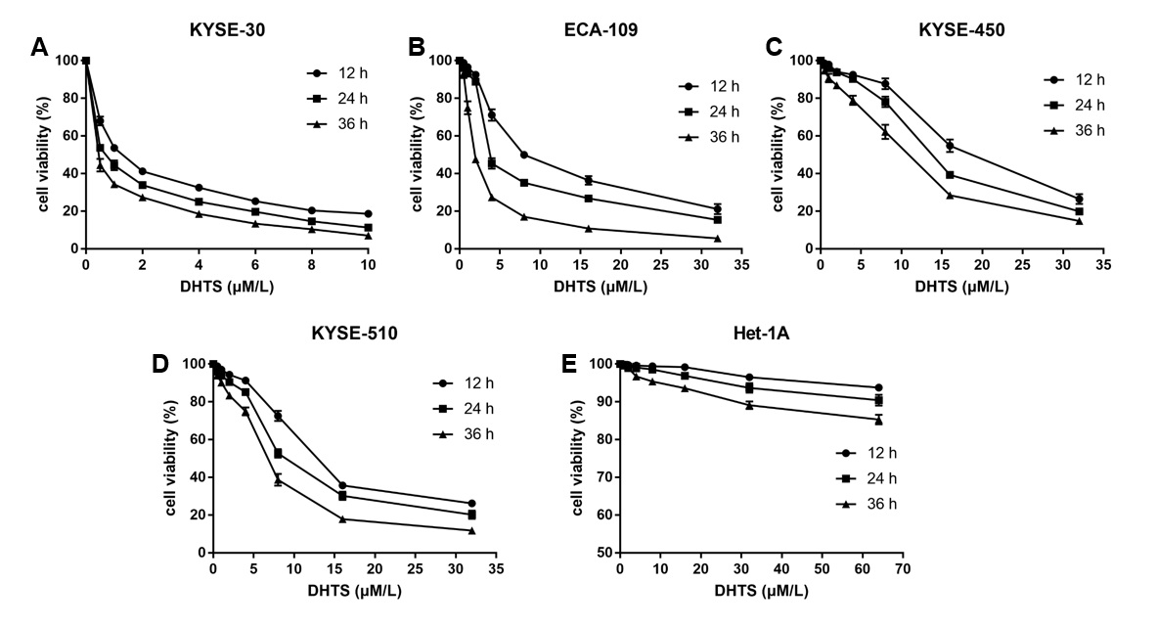
Figure 1 Dihydrotanshinone I inhibits proliferation of esophageal squamous cell carcinoma cells while showing no proliferation inhibition in normal esophageal epithelial cells. A-E: Cell viability of esophageal squamous cell carcinoma cells (KYSE30, Eca109, KYSE-450, and KYSE-510) and normal esophageal epithelial cells (Het-1A) after treatment with dihydrotanshinone I for 12 h, 24 h, and 36 h. DHTS: Dihydrotanshinone I.
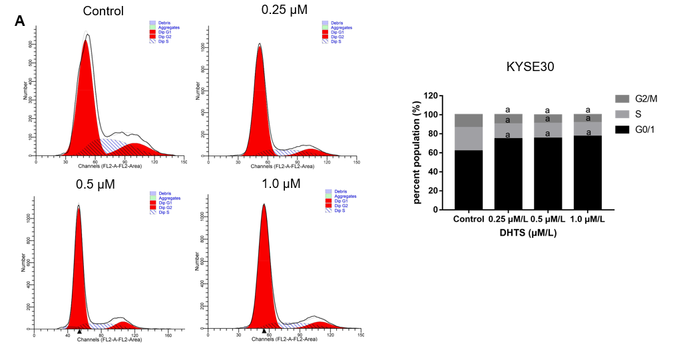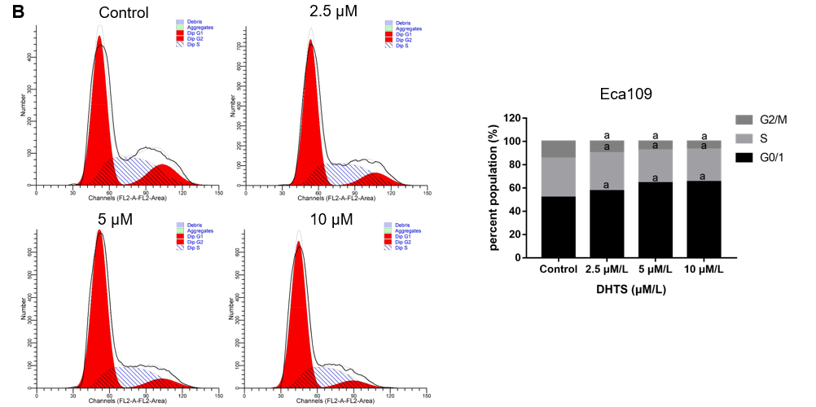
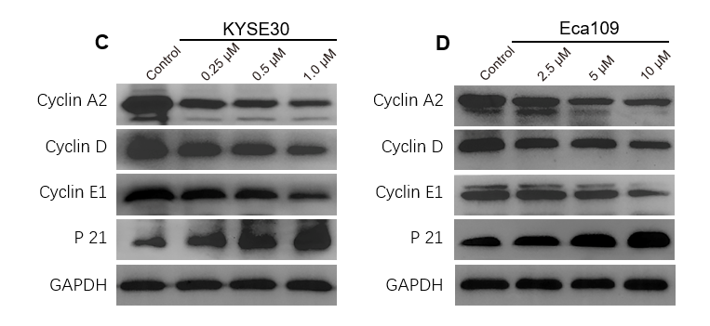
Figure 2 Dihydrotanshinone I induces cell cycle arrest in the G0/1 phase in esophageal squamous cell carcinoma cells. A and B: Cell cycle distribution after treatment with DHTS for 24 h in KYSE30 cells and Eca109 cells; C and D: Western blot analysis of proteins associated with the cell cycle in KYSE30 cells and Eca109 cells. ªP < 0.05 vs control. DHTS: Dihydrotanshinone I.

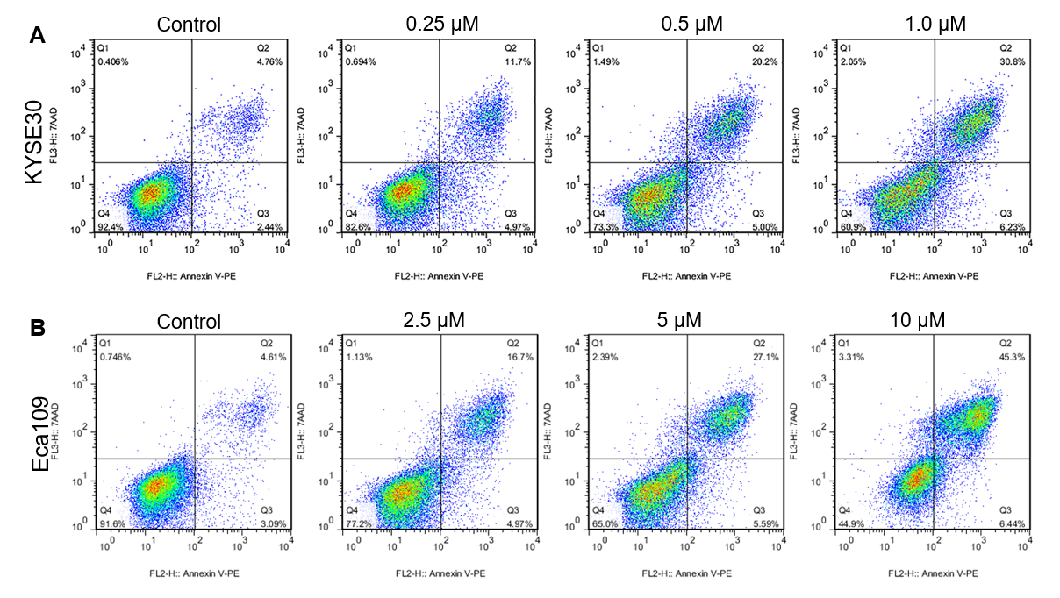
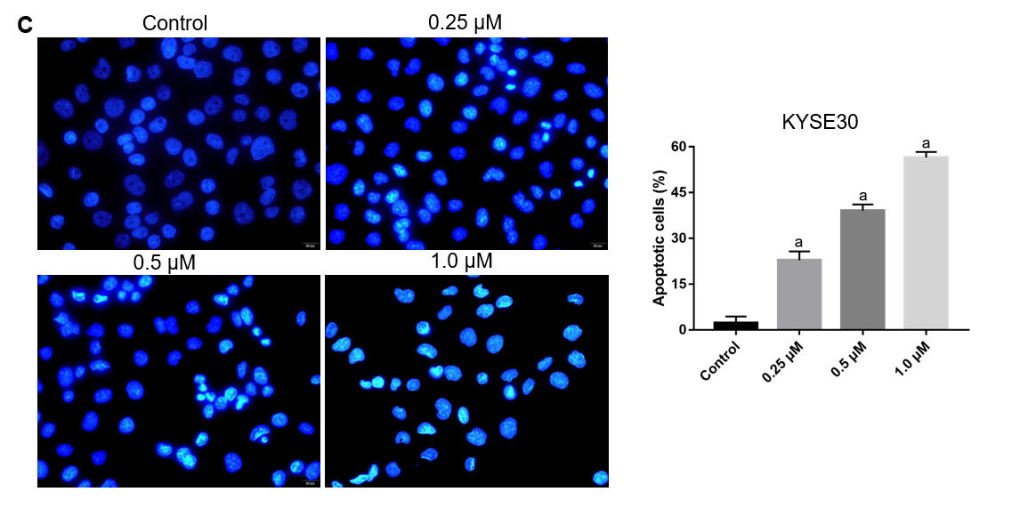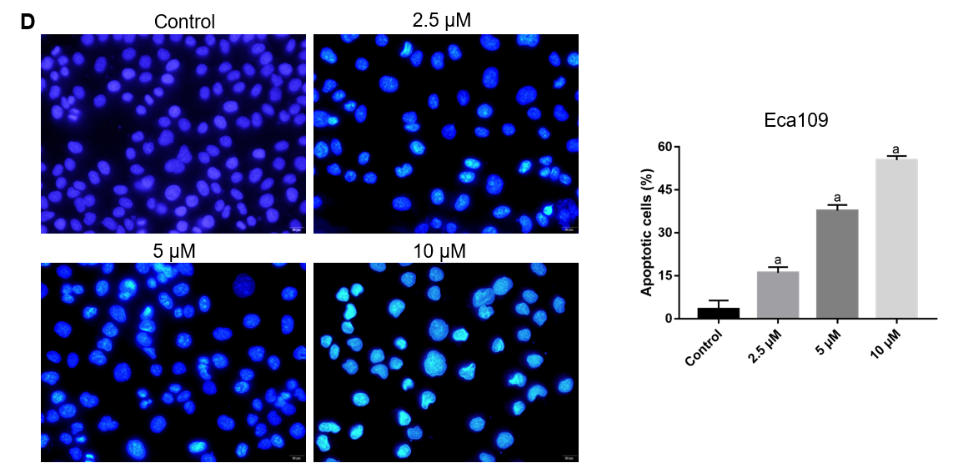
Figure 3 Dihydrotanshinone I induces apoptosis in esophageal squamous cell carcinoma cells. A and B: Cell apoptosis analyzed using flow cytometry with annexin V-PE/7-ADD double staining in KYSE30 cells and Eca109 cells; C and D: Apoptosis-related morphologic changes in the cells detected using Hoechst 33258 staining in KYSE30 cells and Eca109 cells. ªP < 0.05 vs control.

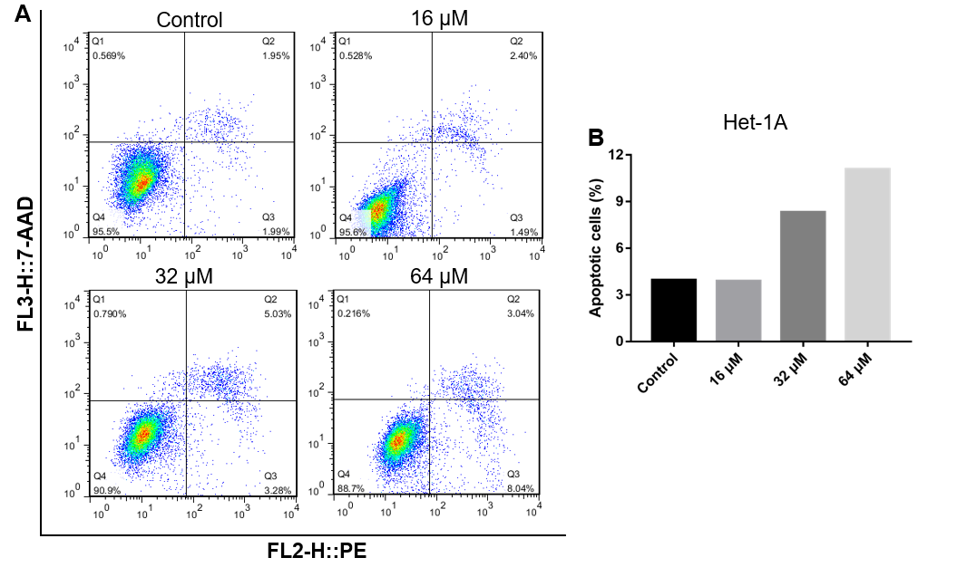
Figure 4 Dihydrotanshinone I does not induce apoptosis significantly in normal esophageal epithelial cells. A and B: Cell apoptosis analyzed using flow cytometry with annexin V-PE/7-ADD double staining in Het-1A cells. ªP < 0.05 vs control.

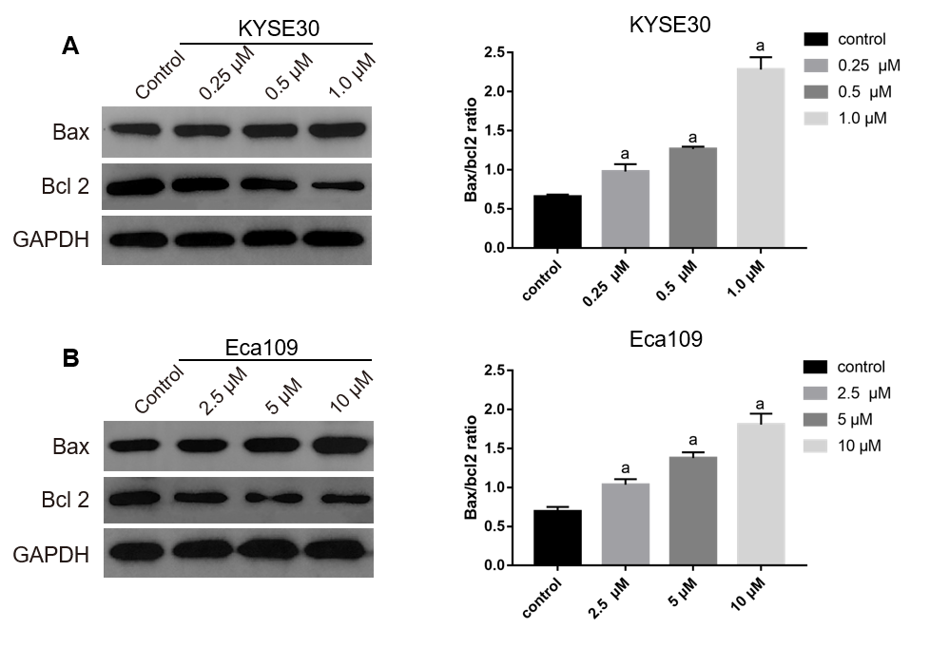

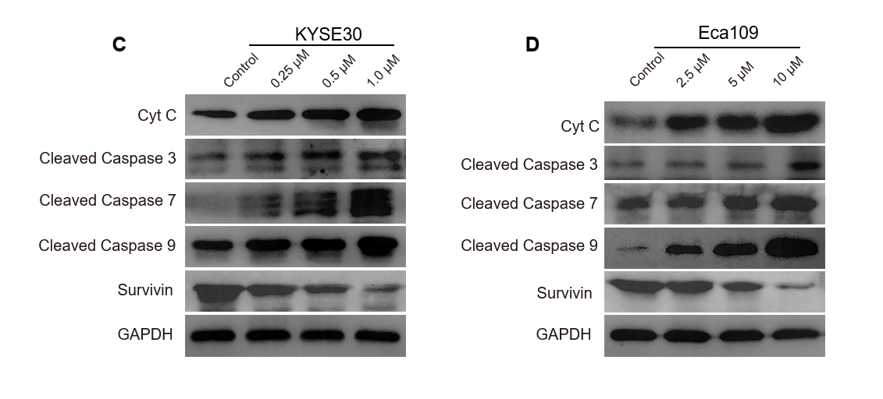
Figure 5 Dihydrotanshinone I activates the mitochondrial pathway in esophageal squamous cell carcinoma cells. A and B: Bax and Bcl2 levels detected using Western blot and the ratio of Bax and Bcl2 calculated in KYSE30 cells and Eca109 cells; C and D: Proteins associated with the mitochondrial pathway detected using Western blot in KYSE30 cells and Eca109 cells. ªP < 0.05 vs control.

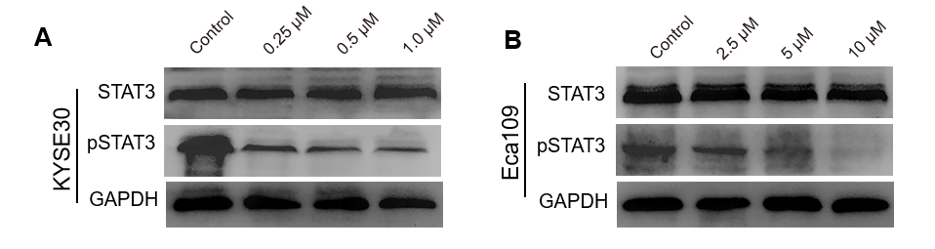
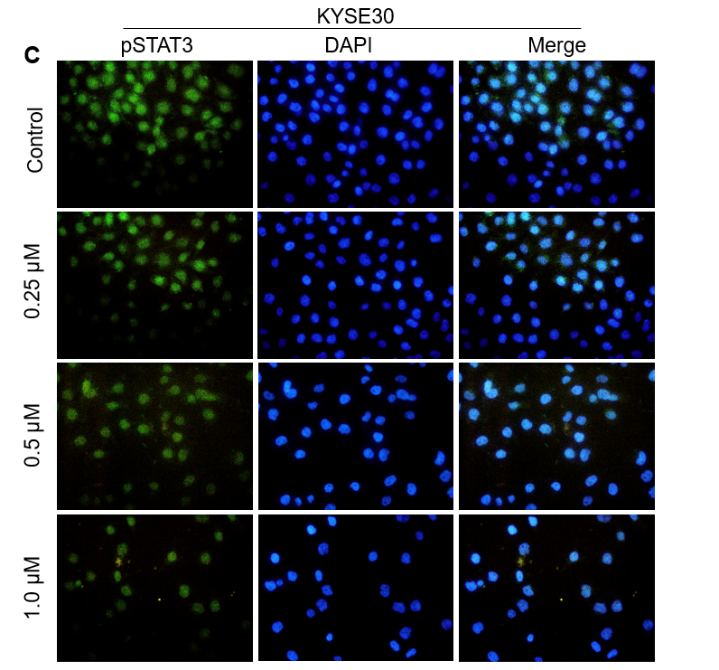
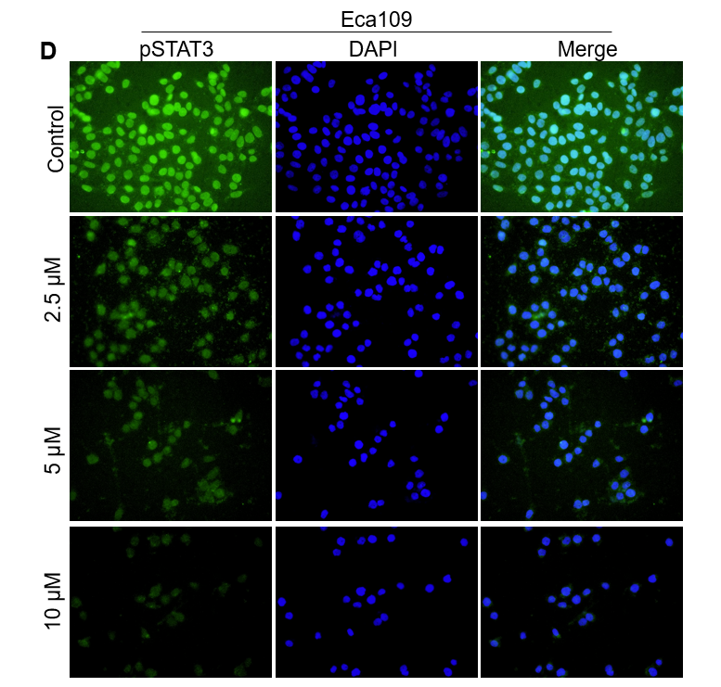
Figure 6 Dihydrotanshinone I inhibits the expression of phosphorylated STAT3 in esophageal squamous cell carcinoma cells. A and B: Levels of STAT3 and pSTAT3 detected using Western blot in KYSE30 cells and Eca109 cells; C and D: Expression and location of phosphorylated STAT3 detected by immunofluorescence in KYSE30 cells and Eca109 cells. pSTAT3: Phosphorylated STAT3.

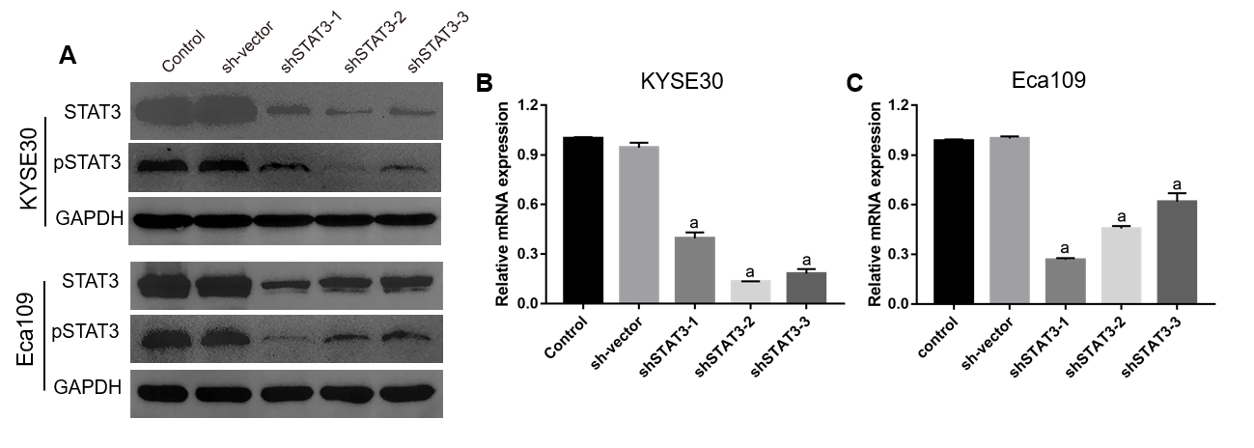
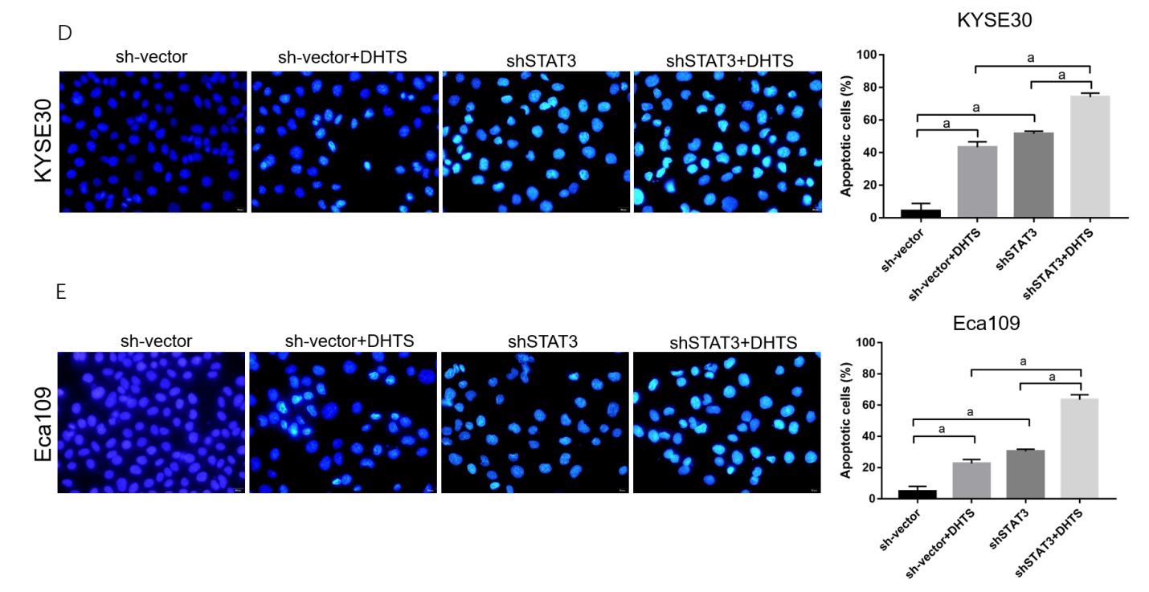
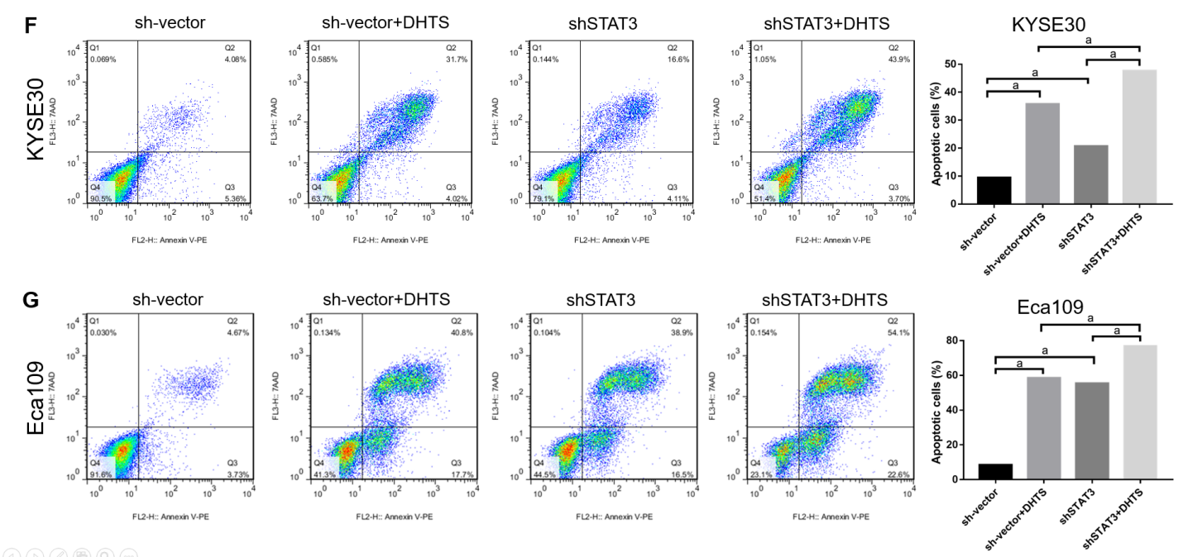
Figure 7 STAT3 knockdown promotes dihydrotanshinone I-induced apoptosis in esophageal squamous cell carcinoma cells. A: Knockdown efficiency of STAT3 and phosphorylated STAT3 identified using Western blot in esophageal squamous cell carcinoma cells; B and C: Knockdown efficiency of STAT3 identified using RT-qPCR in KYSE30 cells and Eca109 cells; D: Apoptosis-related morphological changes in STAT3 knockdown cells detected using Hoechst 33258 staining in KYSE30/sh-vector and KYSE30/shSTAT3 cells treated with 0.5 μmol/L DHTS; E: Apoptosis-related morphologic changes detected using Hoechst 33258 staining in Eca109/sh-vector and Eca109/shSTAT3 cells treated with 5 μmol/L DHTS; F: Cell apoptosis analyzed using flow cytometry with annexin V-PE/7-ADD double staining in KYSE30/sh-vector and KYSE30/shSTAT3 cells treated with 0.5 μmol/L DHTS; G: Cell apoptosis analyzed using flow cytometry with annexin V-PE/7-ADD double staining in Eca109/sh-vector and Eca109/shSTAT3 cells treated with 5 μmol/L. ªP < 0.05.

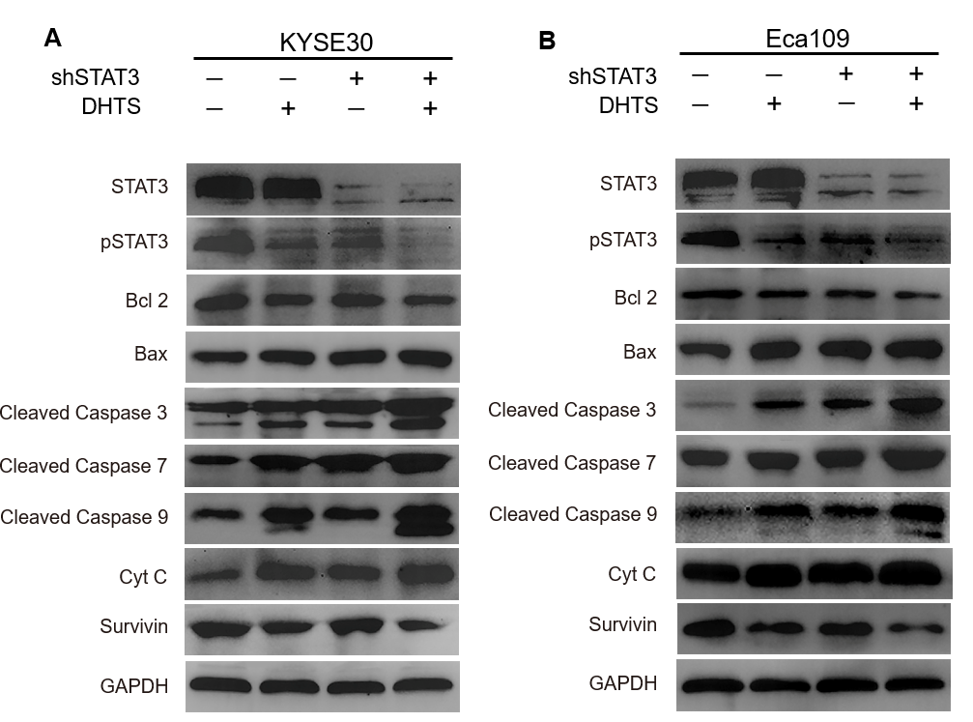
Figure 8 STAT3 knockdown synergizes with dihydrotanshinone I in the activation of the mitochondrial pathway in esophageal squamous cell carcinoma cells. A: KYSE30/sh-vector and KYSE30/shSTAT3 cells were treated with 0.5 μmol/L DHTS, and Western blot was performed to detect the levels of related proteins; B: Eca109/sh-vector and Eca109/shSTAT3 cells were treated with 5 μmol/L dihydrotanshinone I, and Western blot was performed to detect the levels of related proteins.

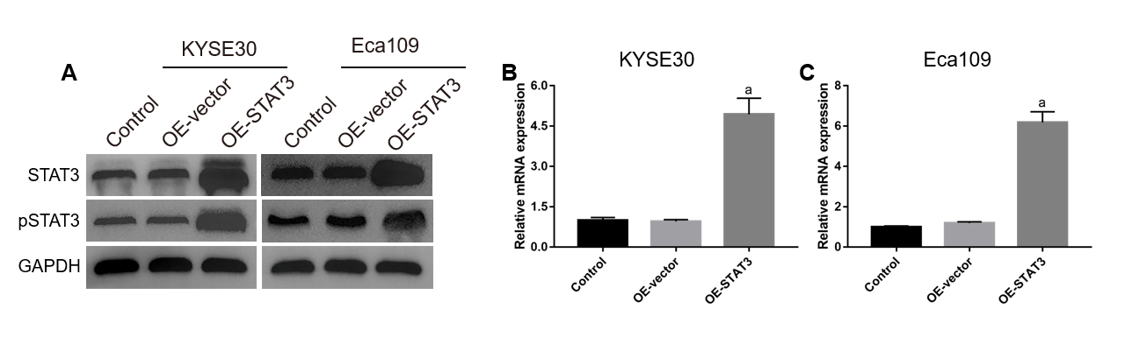
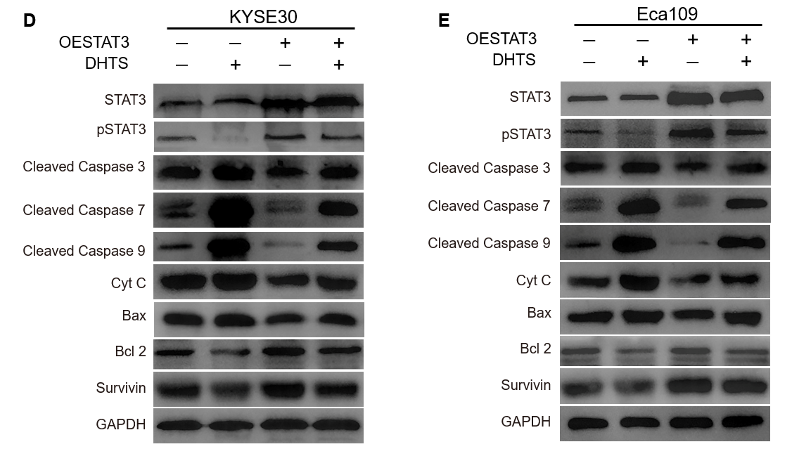
Figure 9 STAT3 overexpression blocks the mitochondrial pathway activated by dihydrotanshinone I in esophageal squamous cell carcinoma cells. A: Overexpression efficiency of STAT3 identified using Western blot in esophageal squamous cell carcinoma cells; B and C: Overexpression efficiency of STAT3 identified using RT-qPCR in KYSE30 cells and Eca109 cells; D: KYSE30/OE-vector and KYSE30/OE-STAT3 cells were treated with 0.5 μmol/L DHTS, and Western blot was performed to detect the levels of related proteins; E: Eca109/OE-vector and Eca109/OE-STAT3 cells were treated with 5 μmol/L DHTS, and Western blot was performed to detect the levels of related proteins. OE: Overexpression. ªP < 0.05 vs control.

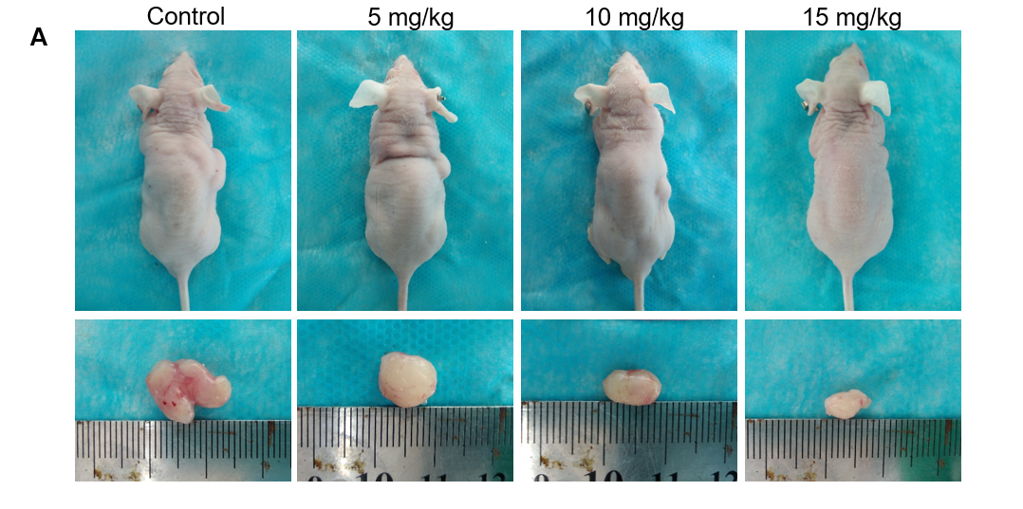
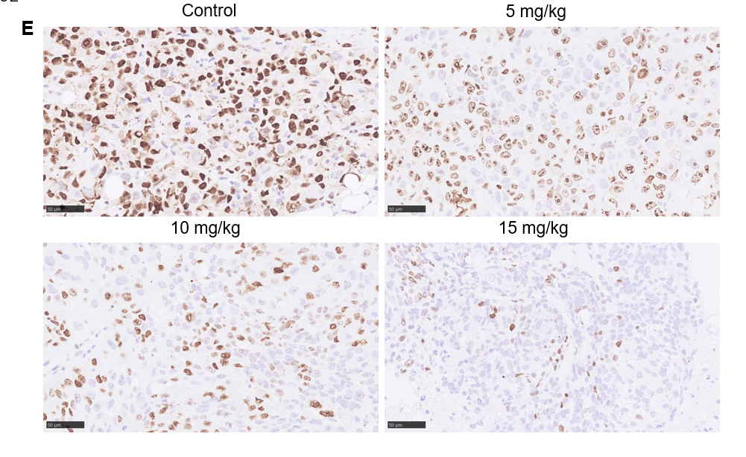
Figure 10 Dihydrotanshinone I inhibits proliferation and induces apoptosis in esophageal squamous cell carcinoma in vivo. A: Morphology of the subcutaneous implanted tumors; B: Mean tumor volume at each time point; C: Tumor weight obtained at the end of the experiment; D: Recorded body weight of the mice; E: Immunohistochemistry detection of the expression of Ki67 in the tumor tissue; F and G: A TUNEL assay was performed to detect apoptotic cells in the tumor tissue. ªP < 0.05 vs control.
Table 1 IC₅₀ of dihydrotanshinone I in esophageal squamous cell carcinoma cells and normal esophageal epithelial cells
 | Time of treatment | IC₅₀ (μmol/L) | 95 % CI (μmol/L)
KYSE30 | 12 h | 1.313 | 0.962-1.675
 | 24 h | 0.697 | 0.438-0.961
 | 36 h | 0.407 | 0.219-0.607
Eca109 | 12 h | 9.750 | 8.363-11.499
 | 24 h | 5.895 | 3.766-9.633
 | 36 h | 2.279 | 1.700-2.988
KYSE450 | 12 h | 18.890 | 13.967-28.640
 | 24 h | 13.878 | 10.287-20.148
 | 36 h | 9.196 | 6.849-12.921
KYSE510 | 12 h | 13.962 | 12.063-16.416
 | 24 h | 9.943 | 7.675-13.496
 | 36 h | 6.325 | 4.831-8.423
Het-1A | 12 h | 778.956 | 216.388-175793.136
 | 24 h | 758.751 | 238.424-20168.744
 | 36 h | 632.324 | 227.536-6313.869

