Name of journal: World Journal of Gastroenterology
ESPS Manunscript No.: 23917
Manuscript type: FIELD OF VISION

Advances in local ablation of malignant liver lesions

Eisele RM. Advances in local ablation

Robert M Eisele

Robert M Eisele, Department of General, Visceral, Vascular and Pediatric Surgery, Medical Faculty of the University of Saarland, 66421 Homburg, Germany

Author contributions: Eisele RM solely contributed to this paper.

Conflict-of-interest statement: There are no conflicts of interest to declare.

Open-Access: This article is an open-access article which was selected by an in-house editor and fully peer-reviewed by external reviewers. It is distributed in accordance with the Creative Commons Attribution Non Commercial (CC BY-NC 4.0) license, which permits others to distribute, remix, adapt, build upon this work non-commercially, and license their derivative works on different terms, provided the original work is properly cited and the use is non-commercial. See: http://creativecommons.org/licenses/by-nc/4.0/

Correspondence to: Robert M Eisele, MD, Department of General, Visceral, Vascular and Pediatric Surgery, Medical Faculty of the University of Saarland, Kirrberger Str. 100, 66421 Homburg, Germany. robert.eisele@uks.eu
Telephone: +49-6841-1631080
Fax: +49-6841-1631002

Received: December 24, 2015
Peer-review started: December 24, 2015
First decision: January 28, 2016
Revised: February 23, 2016
Accepted: March 14, 2016
Article in press:
Published online:

Abstract
Local ablation of liver tumors matured during the recent years and is now proven to be an effective tool in the treatment of malignant liver lesions. Advances focus on the improvement of local tumor control by technical innovations, individual selection of imaging modalities, more accurate needle placement and the free choice of access to the liver. The data found in the current literature for conventional local ablative treatment strategies, virtually no single technology is able to demonstrate an unequivocal superiority. Hints at better performance of microwave compared to radiofrequency ablation regarding local tumor control, duration of the procedure and potentially achievable larger size of ablation areas favour the comparably more recent treatment modality; image fusion enables more patients to undergo ultrasound guided local ablation; magnetic resonance guidance may improve primary success rates in selected patients; navigation and robotics accelerate the needle placement and reduces deviation of needle positions; laparoscopic thermoablation results in larger ablation areas and therefore hypothetically better local tumor control under acceptable complication rates, but seems to be limited to patients with no, mild or moderate adhesions following earlier surgical procedures. Apart from that, most techniques appear technically feasible, albeit demanding. Which technology will in the long run become accepted, is subject to future work.

Key words: Local ablation; Liver; Microwave ablation; Hepatocellular carcinoma; Colorectal liver metastases; Navigation

© The Author(s) 2016. Published by Baishideng Publishing Group Inc. All rights reserved.

Core tip: A wide variety of technical innovations enables us to use microwave as well as radiofrequency ablation, various image fusion technologies, magnetic resonance guidance for local ablation, navigation, robotics, and minimal invasive access to liver surgery in general in the 21st century. However, in comparison to data found in the current literature for conventional local ablative treatment strategies, virtually no single technology is able to demonstrate an unequivocal superiority. Most techniques appear technically feasible, albeit demanding. Which technology will in the long run become accepted, is subject to future work.

Eisele RM. Advances in local ablation of malignant liver lesions. World J Gastroenterol 2016; In press

Commentary on hot topics
Local ablation of liver tumors matured during the recent years and is now proven to be an effective tool in the treatment of malignant liver lesions. Advances focus on the improvement of local tumor control by technical innovations, individual selection of imaging modalities, more accurate needle placement and the free choice of access to the liver. Repeatedly, different elements of improving local ablation have been reported, including the use of microwaves instead of radiofrequency, magnetic resonance (MR) instead of computed tomography (CT) or ultrasound (US), navigation, robotics and minimal invasive surgical access routes instead of percutaneous or open surgical approaches. The following contribution is meant to illustrate some of the more recently envisioned developments with respect to the current literature.

Technical innovations
The most important single step was certainly the spread of microwave coagulation therapy (MCT) largely replacing radiofrequency ablation (RFA) during the recent years. MCT is no real novelty, as first reports were available as early as 1994^{[1]}. Microwaves emitted from a monopolar antenna lead to oscillation of water molecules in a dielectric surrounding such as liver tissue. Table 1 provides an overview displaying the cardinal characteristics of MCT in comparison to RFA, respectively. The renaissance of MCT is partly traced to better equipment with intelligent feedback controlled generators compared to the first devices^{[2]}, but as important seems to be, that MCT is meanwhile not considered yet another technique to generate heat in the same way like with RFA, but in contrast a complete distinct technology for thermal ablation with different and unique physical properties^{[3]}. This leads eventually to an experimentally confirmed less susceptibility to heat sink phenomena^{[4,5]}, shorter treatment duration^{[6]} and larger ablation areas^{[7]}. So far, no clinical evidence supports the superiority of MCT to RFA; the only published randomized controlled trial revealed no statistically significant difference, and among 14 comparative cohort studies, only three found a significantly lower local recurrence rate (LR) following MCT^{[8-10]}. The trend to shorter treatment times is however already clinically endorsed^{[11]}. In general, RFA is believed to be most effective in tumors with a maximum diameter not larger than 3 cm. MCT promises to be successful also in the treatment of larger tumors^{[2]}, most probably when combined with transarterial chemoembolization (TACE)^{[12,13]}. Sustained success may however also be achieved, if RFA is combined with TACE prior to or following the ablation^{[14]}. At date, MCT – albeit promising – has not yet been convincingly confirmed to be superior to RFA.

Imaging
Ultrasound (US) is presumably the most popular imaging modality in use for local ablation. Its value is undisputed; no differences to CT guidance are reported regarding success and time needed for needle placement. The widespread availability is considered a major advantage. In contrast, magnetic resonance (MR) imaging is limited by shortcomings in organisation, number and cost of the required MR machines. MR offers in return several theoretical advantages in comparison to extant imaging modalities, including MR thermometry (Figure 1), absence of ionizing radiation and an impression of better imaging quality for soft tissues. The latter accounts for a significantly increased primary success rate following MR-guided RFA in comparison to CT-guided RFA (only 4% incomplete ablations vs 21%, p = 0.04), whereas the secondary success rate following a redo-ablation was not significantly different (4% vs 10 %, p = 0.32)^{[15]}. The former has been shown to be associated with an evolution of the interventional MR scanners from lower (e.g., 0.2 T in 1997^{[16]}) towards high field machines (e.g., 1.5 T in 2008^{[17]}). Nowadays, MR thermometry allows for an accurate prediction of size and geometry of an ablation area with a sensitivity of uniformly reported 87% using a threshold of 60 °C^{[18,19]}. The spatial resolution is however disappointing, and displaying the microwave applicator is cumbersome unless optimized hardware recently became available (Figure 2). In addition, no study exists comparing MR-guided interventions to US guidance except for an experimental evaluation of MR imaging by Chopra et al^{[20]}. They found no differences in time to correct needle placement and number of required attempts. Dong et al^{[21]} recently report on MR-guided MCT. Both experimental studies have in common the use of an open MR scanner instead of a closed or double doughnut system formerly used. An introduction into a clinically applicable surgical environment is not intended so far.
In contrast, intraoperative US is a clinical reality in most operation theaters, albeit some nodules are invisible in B-mode US. Additionally, mistargeting belongs to the crucial risk factors for local treatment failure^{[22]}. A possible solution is registering the position of the US probe with a position tracking system and synchronizing the real-time US image with a previously recorded three-dimensional multiplanar imaging dataset derived from preoperatively obtained MR or CT scans (Figure 3), a method called Virtual Sonography or US Fusion Imaging (UFI). With UFI, technically successful RFA of hepatocellular carcinoma was achieved in 94.4%– 100%, and local tumor progression occurred in 0%–8.3%^{[23]}. In a recently published study from Japan^{[24]}, UFI was able to identify sonographically inconspicuous tumor nodules in 91.7% sufficiently for a successful RFA procedure, whereas by the application of US contrast media, the detection rate increased up to 96.7%. Local tumor control rate exceeded 90% after a follow-up of 3 years in nodules with a mean diameter of 14 mm (range 8 to 42 mm). The remaining tumors were treated by transarterial chemoembolization. The authors did not explain, why no other imaging modality was applied in order to perform a sufficient local ablation treatment.
So far, no evidence suggests superiority of one or the other imaging modality for guidance of local ablative therapies in the liver.

Targeting I: Navigation
Registration and tracking are both technologies of image processing already mentioned above. Both are prerequisites for successful navigation. Three-dimensional visualization and navigation in deformable soft tissues like liver and lung is difficult to accomplish, if free movements of the patient’s body due to breathing, intervention during mild sedation or comorbidities are not prevented. Stereotaxy was first evaluated and eventually introduced in neurosurgery, initially using a frame in order to limit the degree of freedom for movements of the target area in the central nervous system. Later, frameless navigation was available and evaluated in phantom experiments revealing deviations of 1.1 +/- 0.4 mm for accurate needle placement with one commercially available system^{[25]}, ranging from 1.67 to 2.91 mm with two others under MR guidance^{[26]}. Further research confirmed the high precision of yet another system with 1.1 +/- 0.5 mm deviation^{[27]}. Frameless stereotaxy opened the way for the application of navigation in the liver (Figure 4).
Navigation in liver directed surgery and interventions have been a subject of investigation for long. An overview is provided by Chopra et al^{[28]} 2010. The authors describe a few single center experiences with optical and electromagnetic tracking, which after all reveal the diappointing result, that three-dimensional navigation seems to be feasible, but to date not yet superior to conventional two-dimensional biopsy US probes. Despite all obstacles, there are currently computer-assisted navigational systems commercially available. Similarities and differences among them are exhaustively discussed in an up-to-date paper^{[29]} including a single center experience with one of the presented systems. The authors conclude, that working with the electromagnetic tracking system improved their performance compared to an ancient optical navigation device. Mean time to lesion acquisition was comparably short with only 3.5 min. Success rate with first-attempt passes was 93%. A direct comparison to conventional MCT procedures was not intended. The strategy for accurate liver intervention by an optical tracking system is outlined in a topical paper from Guangdong (China)^{[30]}. The group suggests the use of fiducial markers to deal with the imminent inaccuracies of soft tissue navigation. So far, no vendor distributes such a technology.

Targeting II: Robotics - a step further
If three-dimensional navigation increases the accuracy of the needle placement – at least under experimental ex vivo conditions, the complete elimination of the human component and probability for error by mechanical positioning will further improve the precision of an interventional treatment. Robotic surgery and ablation is emanating from this thesis. In phantom experiments, the use of a robot reduced Euklidic deviation from 2.2 to 1.9 mm and the mean standard distance from 1.8 to 1.6 mm^{[31]}. The time for needle placement was however approximately 30 min. in comparison to approximately 18 min. without the roboter. A clinical study endorses the impression^{[32]}: Robotic assistance required manual correction of the final needle position in more than 40% of all cases, resulting in a significantly decreased deviation of the active center of the microwave applicator from the tumor center (1.6 mm vs 3.3 mm). In addition, the exposure to radiation under fluoroscopy was significantly diminished in case of robotic needle placement. Methodological research with clinically appliable hard- and software was presented in 2010 by a group consisting in authors from the U.S. and China^{[33]}. The data for accuracy of needle placement was within the previously mentioned range (positioning error between 1 and 2 mm), and the estimation of the created ablation area was except for a relative mean error of 5.6% correct. The projection of the ablation area is indeed the crucial point in robotic ablation, since it acts on the assumption of an ideal symmetric geometrical shape of the ablation area. Cai et al^{[34]} describe nicely the mathematical functions and visualization backgrounds influencing the quality of predicting the ablation focus under conditions of unexpected soft tissue deformation, inhomogeneous heat conduction and undesired needle paths. The authors emphasize the demand for extensive training of the staff prior to the introduction of such techniques in a clinical environment. So far, no robotic application is set in clinical standard treatment protocols.

Minimal invasive treatment strategies
The goal of a local ablative treatment is complete tumor destruction with minimal side effects. In order to minimize adverse effects, miniaturization of the access to local ablation is intended. Occasionally, the least invasive, percutaneous way is unsound or even dangerous^{[35]}. In such cases, laparoscopic procedures are suggested³⁶. Advantages of laparoscopy for thermoablation are related to the direct visualization of the abdominal cavity, which offers diagnostic features like better tumor staging using laparoscopic ultrasound (LUS) as well as the opportunity of detecting extrahepatic intraabdominal tumor spread, and therapeutic implications in preventing thermal injury of abutting organs and structures, which are separated from the surface of the liver by the pneumoperitoneum itself or by distinct devices^{[36]}. In addition, the combination of a thermoablation with laparoscopy results in specific additive effects. LUS works usually with higher frequencies and thus displays a higher resolution enabling a more accurate and precise needle placement besides the above mentioned diagnostic property. The pneumoperitoneum in turn decreases tissue perfusion and reduces convective heat sink phenomena, leading to larger ablation areas^{[37]} and therefore preferably less local treatment failures. Clinical evidence for favourable outcome after laparoscopic RFA/MCT is scarce; a retrospective study recently presented a multivariate analysis of risk factors for local recurrence after US guided laparoscopic or percutaneous MCT^{[36]}. Laparoscopic MCT was a statistically significantly independant prognostic factor for better local tumor control. Since no randomized controlled trial is available, the conclusion of clinical superiority of laparoscopic compared to percutaneous MCT is drawn from this and other retrospective studies.
However, a large amount of indications to local ablation account for patients with recurrent disease following previous surgery. Adhesions frequently occurring after open surgery to a certain extent make laparoscopy difficult to accomplish if not impossible at all. Reluctance to offer open surgical access to local ablation in the liver is comprehensible. Hence, alternative approaches have been suggested including hand-assisted liver surgery (HALS, Figure 5)^{[38]} and transthoracic local ablation^{[39]}. Not a lot of experience is reported with both techniques worldwide. Besides technical remarks, no trial has ever been conducted showing superiority to more traditional procedures. Theoretic advantages encompass less risk of ascites and collateral injury to intraabdominal organs when comparing transthoracic ablation to open abdominal surgery, while local tumor control is reportedly superior to results obtained in percutaneous interventions, but no scientific evidence supports these postulations so far. With HALS, the advantages derived from the formation of pneumoperitoneum are preserved, albeit the open surgical part of the procedure imposes a similar risk to intraabdominal injury and consecutive morbidity upon the patient. In summary, except for proof of concepts, confirmation of improvements in local ablation using transthoracic approaches and/or HALS lacks.
Where are we now, and which prospects for the future may be drawn from the previous paragraphs? A wide variety of technical innovations enables us to use microwave as well as radiofrequency ablation, various image fusion technologies, MR guidance for local ablation, navigation, even robotics, and minimal invasive access to liver surgery in general in the 21st century. However, in comparison to data found in the current literature for conventional local ablative treatment strategies, virtually no single technology is able to demonstrate an unequivocal superiority. Hints at better performance of MCT compared to RFA regarding local tumor control, duration of the procedure and potentially achievable larger size of ablation areas favour the comparably more recent treatment modality; image fusion enables more patients to undergo ultrasound guided local ablation; MR guidance may improve primary success rates in selected patients; navigation and robotics accelerate the needle placement and reduces deviation of needle positions; laparoscopic thermoablation results in larger ablation areas and therefore hypothetically better local tumor control under acceptable complication rates, but seems to be limited to patients with no, mild or moderate adhesions following earlier surgical procedures. Apart from that, most techniques appear technically feasible, albeit demanding. It is a challenge to learn all novel treatment modalities and exhibit a satisfying command on it. So far, it remains an open question, which will eventually survive. In view of all mechanical and electronical support, there are some activities in our world, which are still best performed by humans, despite all highly sophisticated machines surrounding us.

References
1 Seki T, Wakabayashi M, Nakagawa T, Itho T, Shiro T, Kunieda K, Sato M, Uchiyama S, Inoue K. Ultrasonically guided percutaneous microwave coagulation therapy for small hepatocellular carcinoma. Cancer 1994; 74: 817-825 [PMID: 8039109 DOI: 10.1002/1097-0142(19940801)74:3<817::AID-CNCR2820740306>3.0.CO;2-8]
2 Liang PC, Lai HS, Shih TT, Wu CH, Huang KW. The pilot experience upon surgical ablation of large liver tumor by microwave system with tissue permittivity feedback control mechanism. BMC Surg 2014; 14: 82 [PMID: 25336074 DOI: 10.1186/1471-2482-14-82]
3 Brace CL. Microwave tissue ablation: biophysics, technology, and applications. Crit Rev Biomed Eng 2010; 38: 65-78 [PMID: 21175404 DOI: 10.1615/CritRevBiomedEng.v38.i1.60]
4 Wright AS, Sampson LA, Warner TF, Mahvi DM, Lee FT. Radiofrequency versus microwave ablation in a hepatic porcine model. Radiology 2005; 236: 132-139 [PMID: 15987969 DOI: 10.1148/radiol.2361031249]
5 Pillai K, Akhter J, Chua TC, Shehata M, Alzahrani N, Al-Alem I, Morris DL. Heat sink effect on tumor ablation characteristics as observed in monopolar radiofrequency, bipolar radiofrequency, and microwave, using ex vivo calf liver model. Medicine (Baltimore) 2015; 94: e580 [PMID: 25738477 DOI: 10.1097/MD.0000000000000580]
6 Fan W, Li X, Zhang L, Jiang H, Zhang J. Comparison of microwave ablation and multipolar radiofrequency ablation in vivo using two internally cooled probes. AJR Am J Roentgenol 2012; 198: W46-W50 [PMID: 22194514 DOI: 10.2214/AJR.11.6707]
7 Andreano A, Huang Y, Meloni MF, Lee FT, Brace C. Microwaves create larger ablations than radiofrequency when controlled for power in ex vivo tissue. Med Phys 2010; 37: 2967-2973 [PMID: 20632609 DOI: 10.1118/1.3432569]
8 Martin RC, Scoggins CR, McMasters KM. Safety and efficacy of microwave ablation of hepatic tumors: a prospective review of a 5-year experience. Ann Surg Oncol 2010; 17: 171-178 [PMID: 19707829 DOI: 10.1245/s10434-009-0686-z]
9 Correa-Gallego C, Fong Y, Gonen M, D'Angelica MI, Allen PJ, DeMatteo RP, Jarnagin WR, Kingham TP. A retrospective comparison of microwave ablation vs. radiofrequency ablation for colorectal cancer hepatic metastases. Ann Surg Oncol 2014; 21: 4278-4283 [PMID: 24889486 DOI: 10.1245/s10434-014-3817-0]
10 Abdelaziz A, Elbaz T, Shousha HI, Mahmoud S, Ibrahim M, Abdelmaksoud A, Nabeel M. Efficacy and survival analysis of percutaneous radiofrequency versus microwave ablation for hepatocellular carcinoma: an Egyptian multidisciplinary clinic experience. Surg Endosc 2014; 28: 3429-3434 [PMID: 24935203 DOI: 10.1007/s00464-014-3617-4]
11 Poulou LS, Botsa E, Thanou I, Ziakas PD, Thanos L. Percutaneous microwave ablation vs radiofrequency ablation in the treatment of hepatocellular carcinoma. World J Hepatol 2015; 7: 1054-1063 [PMID: 26052394 DOI: 10.4254/wjh.v7.i8.1054]
12 Ni JY, Sun HL, Chen YT, Luo JH, Chen D, Jiang XY, Xu LF. Prognostic factors for survival after transarterial chemoembolization combined with microwave ablation for hepatocellular carcinoma. World J Gastroenterol 2014; 20: 17483-17490 [PMID: 25516662 DOI: 10.3748/wjg.v20.i46.17483]
13 Xu LF, Sun HL, Chen YT, Ni JY, Chen D, Luo JH, Zhou JX, Hu RM, Tan QY. Large primary hepatocellular carcinoma: transarterial chemoembolization monotherapy versus combined transarterial chemoembolization-percutaneous microwave coagulation therapy. J Gastroenterol Hepatol 2013; 28: 456-463 [PMID: 23216261 DOI: 10.1111/jgh.12088]
14 Bharadwaz A, Bak-Fredslund KP, Villadsen GE, Nielsen JE, Simonsen K, Sandahl TD, Grønbæk H, Nielsen DT. Combination of radiofrequency ablation with transarterial chemoembolization for treatment of hepatocellular carcinoma: experience from a Danish tertiary liver center. Acta Radiol 2015; Epub ahead of print [PMID: 26342009 DOI: 10.1177/0284185115603246]
15 Clasen S, Rempp H, Hoffmann R, Graf H, Pereira PL, Claussen CD. Image-guided radiofrequency ablation of hepatocellular carcinoma (HCC): is MR guidance more effective than CT guidance? Eur J Radiol 2014; 83: 111-116 [PMID: 24161781 DOI: 10.1016/j.ejrad.2013.09.018]
16 Sinha S, Oshiro T, Sinha U, Lufkin R. Phase imaging on a .2-T MR scanner: application to temperature monitoring during ablation procedures. J Magn Reson Imaging 1997; 7: 918-928 [PMID: 9307920 DOI: 10.1002/jmri.1880070522]
17 Cernicanu A, Lepetit-Coiffe M, Roland J, Becker CD, Terraz S. Validation of fast MR thermometry at 1.5 T with gradient-echo echo planar imaging sequences: phantom and clinical feasibility studies. NMR Biomed 2008; 21: 849-858 [PMID: 18574794 DOI: 10.1002/nbm.1267]
18 Kickhefel A, Rosenberg C, Weiss CR, Rempp H, Roland J, Schick F, Hosten N. Clinical evaluation of MR temperature monitoring of laser-induced thermotherapy in human liver using the proton-resonance-frequency method and predictive models of cell death. J Magn Reson Imaging 2011; 33: 704-712 [PMID: 21563256 DOI: 10.1002/jmri.22499]
19 Rempp H, Hoffmann R, Roland J, Buck A, Kickhefel A, Claussen CD, Pereira PL, Schick F, Clasen S. Threshold-based prediction of the coagulation zone in sequential temperature mapping in MR-guided radiofrequency ablation of liver tumours. Eur Radiol 2012; 22: 1091-1100 [PMID: 22105843 DOI: 10.1007/s00330-011-2335-8]
20 Chopra SS, Schmidt SC, Wiltberger G, Denecke T, Streitparth F, Seebauer C, Teichgräber U, Schumacher G, Eisele RM. Laparoscopic radiofrequency ablation of liver tumors: comparison of MR guidance versus conventional laparoscopic ultrasound for needle positioning in a phantom model. Minim Invasive Ther Allied Technol 2011; 20: 212-217 [PMID: 21082902 DOI: 10.3109/13645706.2010.534864]
21 Dong J, Zhang L, Li W, Mao S, Wang Y, Wang D, Shen L, Dong A, Wu P. 1.0 T open-configuration magnetic resonance-guided microwave ablation of pig livers in real time. Sci Rep 2015; 5: 13551 [PMID: 26315365 DOI: 10.1038/srep13551]
22 Lee MW, Lim HK, Kim YJ, Choi D, Kim YS, Lee WJ, Cha DI, Park MJ, Rhim H. Percutaneous sonographically guided radio frequency ablation of hepatocellular carcinoma: causes of mistargeting and factors affecting the feasibility of a second ablation session. J Ultrasound Med 2011; 30: 607-615 [PMID: 21527608]
23 Minami Y, Kudo M. Ultrasound fusion imaging of hepatocellular carcinoma: a review of current evidence. Dig Dis 2014; 32: 690-695 [PMID: 25376285 DOI: 10.1159/000368001]
24 Toshikuni N, Takuma Y, Tomokuni J, Yamamoto H. Planning sonography using real-time virtual sonography and contrast-enhanced sonography for radiofrequency ablation of inconspicuous hepatocellular carcinoma nodules. Hepatogastroenterology 2015; 62: 661-666 [DOI: 10.5754/hge13649]
25 Meier-Meitinger M, Nagel M, Kalender W, Bautz WA, Baum U. [Computer-assisted navigation system for interventional CT-guided procedures: results of phantom and clinical studies]. Rofo 2008; 180: 310-317 [PMID: 18499907 DOI: 10.1055/s-2008-1027139]
26 Benardete EA, Leonard MA, Weiner HL. Comparison of frameless stereotactic systems: accuracy, precision, and applications. Neurosurgery 2001; 49: 1409-115; discussion 1409-115; [PMID: 11846941 DOI: 10.1097/00006123-200112000-00020]
27 Dorward NL, Alberti O, Palmer JD, Kitchen ND, Thomas DG. Accuracy of true frameless stereotaxy: in vivo measurement and laboratory phantom studies. Technical note. J Neurosurg 1999; 90: 160-168 [PMID: 10413173 DOI: 10.3171/2Fjns.1999.90.1.0160]
28 Chopra SS, Eisele RM, Denecke T, Stockmann M, Lange T, Eulenstein S, Schmidt SC, Neuhaus P. Advances in image guided conventional and minimal invasive liver surgery. Minerva Chir 2010; 65: 463-478 [PMID: 20802434]
29 Sindram D, Simo KA, Swan RZ, Razzaque S, Niemeyer DJ, Seshadri RM, Hanna E, McKillop IH, Iannitti DA, Martinie JB. Laparoscopic microwave ablation of human liver tumours using a novel three-dimensional magnetic guidance system. HPB (Oxford) 2015; 17: 87-93 [PMID: 25231167 DOI: 10.1111/hpb.12315]
30 Lin Q, Yang R, Cai K, Guan P, Xiao W, Wu X. Strategy for accurate liver intervention by an optical tracking system. Biomed Opt Express 2015; 6: 3287-3302 [PMID: 26417501 DOI: 10.1364/BOE.6.003287]
31 Stoffner R, Augschöll C, Widmann G, Böhler D, Bale R. Accuracy and feasibility of frameless stereotactic and robot-assisted CT-based puncture in interventional radiology: a comparative phantom study. Rofo 2009; 181: 851-858 [PMID: 19517342 DOI: 10.1055/s-0028-1109380]
32 Beyer LP, Pregler B, Niessen C, Dollinger M, Graf BM, Müller M, Schlitt HJ, Stroszczynski C, Wiggermann P. Robot-assisted microwave thermoablation of liver tumors: a single-center experience. Int J Comput Assist Radiol Surg 2016; 11: 253-259 [PMID: 26307269 DOI: 10.1007/s11548-015-1286-y]
33 Xu J, Jia ZZ, Song ZJ, Yang XD, Chen K, Liang P. Three-dimensional ultrasound image-guided robotic system for accurate microwave coagulation of malignant liver tumours. Int J Med Robot 2010; 6: 256-268 [PMID: 20564429 DOI: 10.1002/rcs.313]
34 Cai K, Yang R, Chen H, Ning H, Ma A, Zhou J, Huang W, Ou S. Simulation and Visualization of Liver Cancer Ablation Focus in Optical Surgical Navigation. J Med Syst 2016; 40: 19 [PMID: 26525057 DOI: 10.1007/s10916-015-0397-x]
35 Eisele RM, Schumacher G, Jonas S, Neuhaus P. Radiofrequency ablation prior to liver transplantation: focus on complications and on a rare but severe case. Clin Transplant 2008; 22: 20-28 [PMID: 18217901 DOI: 10.1111/j.1399-0012.2007.00725.x]
36 Eisele RM, Denecke T, Glanemann M, Chopra SS. [Minimal-invasive microwave coagulation therapy for liver tumours: laparoscopic and percutaneous access]. Zentralbl Chir 2014; 139: 235-243 [PMID: 24241949 DOI: 10.1055/s-0033-1350931]
37 Smith MK, Mutter D, Forbes LE, Mulier S, Marescaux J. The physiologic effect of the pneumoperitoneum on radiofrequency ablation. Surg Endosc 2004; 18: 35-38 [PMID: 14625745 DOI: 10.1007/s00464-001-8235-2]
38 Schumacher G, Eisele R, Spinelli A, Schmidt SC, Jacob D, Pratschke J, Neuhaus P. Indications for hand-assisted laparoscopic radiofrequency ablation for liver tumors. J Laparoendosc Adv Surg Tech A 2007; 17: 153-159 [PMID: 17484640 DOI: 10.1089/lap.2006.0001]
39 Mullen JT, Walsh GL, Abdalla EK, Loyer EM, Curley SA, Vauthey JN. Transdiaphragmatic radiofrequency ablation of liver tumors. J Am Coll Surg 2004; 199: 826-829 [PMID: 15501127 DOI: 10.1016/j.jamcollsurg.2004.07.010]

P-Reviewer: Sturesson C, Wu SL S-Editor: Ma YJ L-Editor: E-Editor:

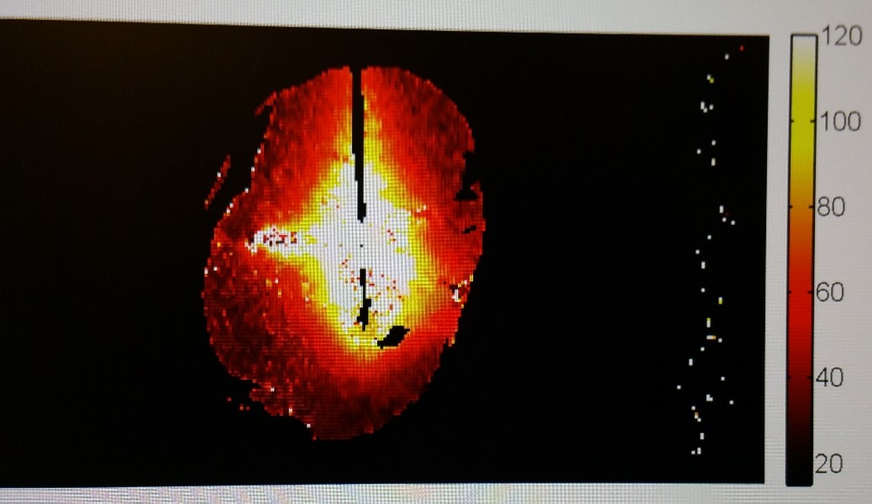
Figure 1 Thermal mapping using phase changes in magnetic resonance imaging, temperature code is depicted in the bar at the right margin of the image (values in degree Celsius). Courtesy of MedWaves Inc., San Diego, CA, United States.

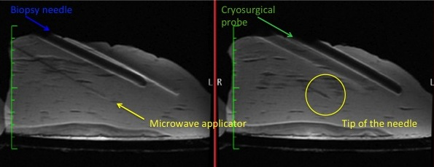
Figure 2 Magnetic resonance imaging of different devices for liver directed interventions. Of note is the inaccuracy in displaying the position of the needle shaft and tip with older devices and the complete absence of artifacts with the use of a novel microwave applicator. Courtesy of MedWaves Inc., San Diego, CA, United States.

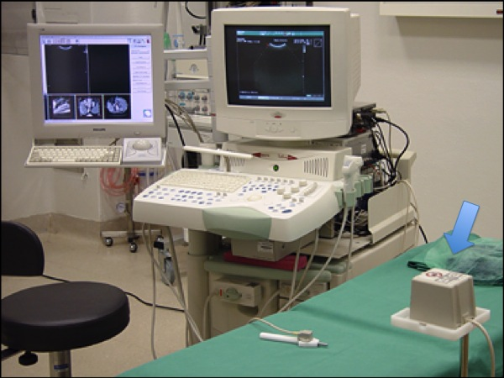
Figure 3 Clinical setup for ultrasound fusion imaging. The ultrasound machine is visible with an additional monitor for displaying the previously digitally acquired cross-sectional examination images. Meanwhile, there are also systems with a split screen. The arrow points at the electromagnetic reference point.

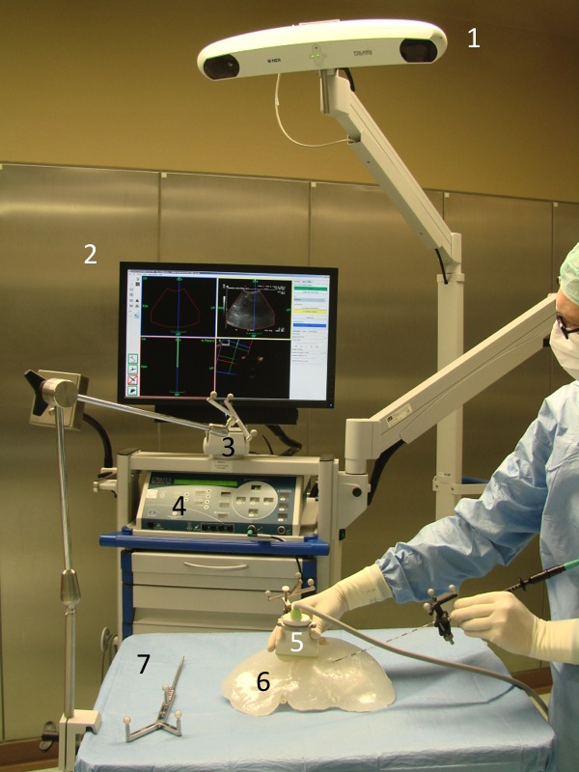
Figure 4 example for a navigation device using optical tracking. The crucial elements are shown under intraoperative conditions with a phantom liver model. 1: Stereooptic camera; 2: Monitor with a horizontally and vertically split screen; 3: Reference point; 4: Radiofrequency generator; 5: Ultrasound probe; 6: Liver phantom; 7: Pointer.

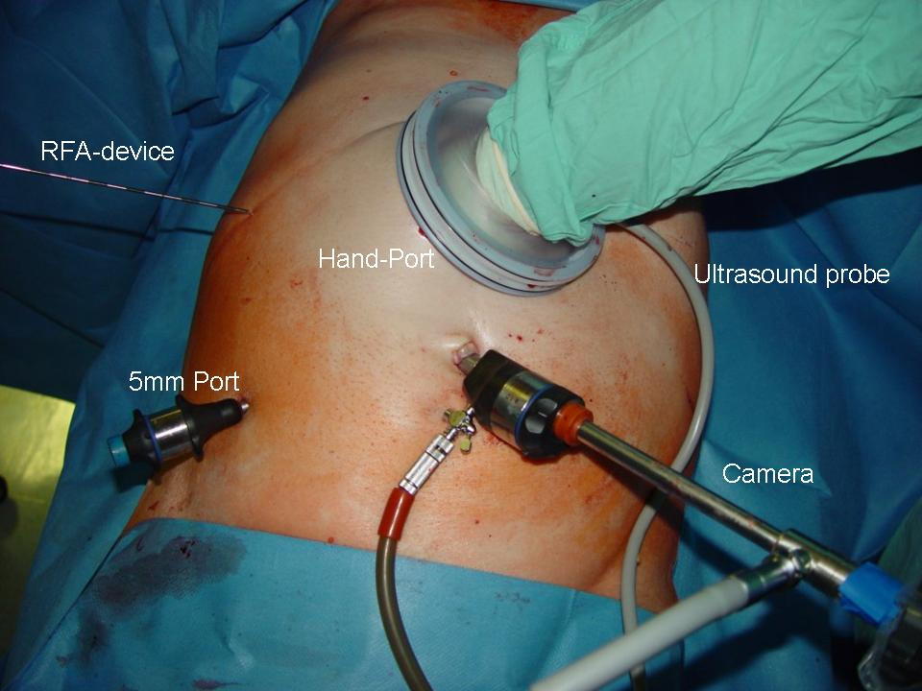
Figure 5 Clinical application of hand-assisted laparoscopic surgery. Intraoperative radiofrequency ablation using hand-assistance. The advantages of a minimal-invasive approach are preserved.

Table 1 Differences comparing radiofrequency ablation to microwave coagulation therapy with regard to physical properties
 | RFA | MCT
Electromagnetic waves | Radiowaves | Microwaves
Frequency | 0.3–0.5 MHz | 915–2450 MHz
Heating target | Ions | H₂O (approximately 50%)
Heat distribution | Convective | Direct heating (within field)
Alternating current | Closed circuit | Electromagnetic field
Applicator | Electrode | Antenna
Desiccation | Carbonization | Vaporization
Size of ablation area | Unaltered/slight increase | Marked shrinkage
RFA: radiofrequency ablation; MCT: microwave coagulation therapy.

