Name of journal: World Journal of Gastrointestinal Endoscopy
Manuscript NO: 38718
Manuscript Type: REVIEW

Clinical update on the management of pseudopapillary tumor of pancreas

Lanke G et al. Update on management of SPN

Gandhi Lanke, Faisal S Ali, Jeffrey H Lee

Gandhi Lanke, Faisal S Ali, Jeffrey H Lee, Department of Gastroenterology, Hepatology and Nutrition, University of Texas MD Anderson Cancer Center, Houston, TX 77030, United States

ORCID number: Gandhi Lanke (0000-0002-5577-2257); Faisal S Ali (0000-0001-7372-5158); Jeffrey H Lee (0000-0001-6740-3670),

Author contributions: Lanke G composed and drafted the paper; Ali SF provided the figures and edited the paper; Lee JH provided outlines, reviewed and edited the paper.

Conflict-of-interest statement: No potential conflicts of interest relevant to this article were reported.

Open-Access: This article is an open-access article which was selected by an in-house editor and fully peer-reviewed by external reviewers. It is distributed in accordance with the Creative Commons Attribution Non Commercial (CC BY-NC 4.0) license, which permits others to distribute, remix, adapt, build upon this work non-commercially, and license their derivative works on different terms, provided the original work is properly cited and the use is non-commercial. See: http://creativecommons.org/licenses/by-nc/4.0/

Manuscript source: Invited manuscript

Correspondence to: Jeffrey H Lee, MD, Professor, Department of Gastroenterology, Hepatology and Nutrition, University of Texas MD Anderson Cancer Center, 1515 Holcombe Blvd, Houston, TX 77030, United States. jefflee@mdanderson.org
Telephone: +1-713-7945073
Fax: +1-713-5634408

Received: March 14, 2018
Peer-review started: March 14, 2018
First decision: April 23, 2018
Revised: April 28, 2018
Accepted: June 8, 2018
Article in press:
Published online:

Abstract
Solid pseudopapillary neoplasm (SPN) is a rare tumor with malignant potential which is generally located in the tail of pancreas. The prevalence of SPN has increased with widespread use of cross sectional imaging. SPN is often misdiagnosed due to nonspecific clinical presentation and accurate diagnosis is essential for optimal management. Endoscopic ultrasound-FNA with immunohistochemistry can help in preoperative diagnosis. Surgery is the treatment of choice and a successful R0 resection is curative. Overall, SPN has a good prognosis. This review article focuses on pathogenesis, diagnosis and management of SPN.

Key words: Immunohistochemistry; Beta-catenin; Endoscopic ultrasound-fine needle aspiration; E-cadherin; Pancreatectomy; Pancreatic cysts

© The Author(s) 2018. Published by Baishideng Publishing Group Inc. All rights reserved.

Core tip: Solid pseudopapillary neoplasm (SPN) is a rare pancreatic tumor that predominantly affects young females. SPNs are usually indolent but they do have malignant potential. The pathogenesis of SPN is not entirely clear. Accurate diagnosis is essential in the management of SPN. Endoscopic ultrasound guided fine needle aspiration with immunohistochemistry can help distinguish SPNs from other aggressive pancreatic tumors preoperatively. Surgical resection with clear margins is curative and should be offered whenever feasible. The prognosis of SPN is good even in the presence of metastasis.

Lanke G, Ali FS, Lee JH. Clinical update on the management of pseudopapillary tumor of pancreas. World J Gastrointest Endosc 2018; In press

INTRODUCTION
Pancreatic cysts are diagnosed more frequently because of increasing use of computed tomography (CT) and magnetic resonance imaging (MRI). They are found incidentally in more than 2 percent on CT and MRI for unrelated reasons^{[1,2]}. According to World Health Organization (WHO) classification, pancreatic cysts are classified based on histology in to serous, mucinous cystic neoplasm, intraductal papillary mucinous neoplasm (IPMN) and solid pseudopapillary neoplasm (SPN)^{[3]}. SPN had various names in the past which include Frantz’s tumor, solid and papillary tumor, solid-cystic tumor, papillary cystic tumor and solid and papillary epithelial neoplasm^{[4]}. SPN accounts for about 3% of resected pancreatic cystic tumors^{[5]}. Among men it is reported in less than 10% of cases of SPN but in females it is more common in second or third decade^{[6]}. They are commonly found in the tail of pancreas^{[7,8]}.

PATHOGENESIS
The cellular origin of SPN is unclear. During normal pancreas development, beta-catenin signaling with in the beta-catenin/Wnt pathway is necessary and in the adult organ the pathway is usually downregulated^{[9]}. The majority (85%-90%) of SPN has exon-3 mutations and in 10%-15% mutations are present in other exons^{[10]}. The aberrant protein expression in SPN is strongly correlated with mutations in beta-catenin gene^{[10]}. Mutations in beta-catenin gene exon-3 lead to Wnt signaling activation which plays an important role in the development of SPN^{[11]}. Cell cycle-associated proteins like cyclin D1 and cyclin D3 are overexpressed in SPN because of deregulation of cell cycle^{[12,13]}. The role of genetic aberration of EWS/FLI-1 in SPN was studied. FLI-1 is identified in endothelial and mesodermal tissues^{[14]} and it is the earliest marker of blood vessels during embryogenesis^{[15]}. Although FLI-1 was expressed in SPN, it was not accompanied by CD 34 positivity or EWS/FLI-1 translocation^{[16]}. Hence, the diagnosis of SPN is less likely if EWS/FLI-1 translocation is positive. Chromosome 11 is vulnerable to specific genetic changes as it harbors several genes for proteins (cyclin D1, FLI-1, progesterone receptor and CD56) which are overexpressed in SPN^{[17]}. The low tumor growth rate in SPN is explained by the role of cyclin-dependent kinase inhibitors p²¹ and p²⁷ in controlling the activated Wnt/beta-catenin signaling pathway^{[17]}. SPNs are considered hormone sensitive because they express progesterone receptor^{[18]}. P²¹, P²⁷ and cyclin D1 expression is influenced by estradiol and progesterone^{[19,20]}. BCL9 and BCL9L play an important role in enhancing Wnt signaling by increasing beta-catenin transcriptional activity and tumorigenesis^{[21]}. BCL9L showed difference in expression among various pancreatic neoplasms [overexpressed in pancreatic ductal adenocarcinoma (PDAC) but decreased in SPN] but BCL9 did not show any difference^{[22]} (Figure 1).

HISTOLOGY AND MORPHOLOGY
Grossly SPN appear as solid and cystic components with areas of hemorrhage, fibrous capsule and calcification^{[23]}. They are encapsulated, well-demarcated and invasion of adjacent organs like spleen and duodenum is rare^{[4]}. Cut sections of SPN show alternate solid and yellow areas with cystic, necrotic and hemorrhagic zones. The solid portions of the tumor are usually composed of uniform, polygonal epithelioid cells with vascularized stroma and not cohesive in arrangement^{[24]}. Hyaline globules are periodic acid-shiff (PAS) intracytoplasmic inclusions that are immunoreactive for alpha1-antitrypsin. They are classically associated with SPN. However, hyaline globules are positive in about 5% of pancreatic neuroendocrine tumors (PanNETs)^{[25]}. Insidious pattern of invasion, clear cells and nuclear groove can help distinguish SPN from PanNETs^{[25]}. Electron microscopy shows abundant mitochondria in polygonal cells and sparse endoplasmic reticulum. Tumor cells have round to oval nucleus with occasional indentation of eccentrically located nucleolus and peripheral clumping of chromatin^{[26]}. Tumor cells contain corpuscles covered by membrane which are similar to zymogen granules about 8-1.2 micro meter in diameter^{[27]}.
Histological variants of SPN include clear cell, pleomorphic and oncocytic^{[24]}. Clear cell variant contains multiple cytoplasmic vacuoles with solid and diffuse growth pattern. Pleomorphic variant contains polymorphism (variation in nuclear size, shape, hyperchromasia and multinucleate) in more than 20% of total tumor area. Oncocytic variant contains mostly oncocytic cells. Histological features suggestive of aggressive behavior of SPN include extensive necrosis, nuclear atypia, high mitotic rate and sarcomatoid areas^{[24]}. Angioinvasion, perineural invasion and deep invasion of adjacent surrounding pancreatic parenchyma are considered potentially malignant SPN^{[4]} (Figures 2 and 3).

Immunohistochemistry
In general, the immunostaining of SPN is positive for beta-catenin (nuclear and cytoplasmic), vimentin, synaptophysin, progesterone receptor (nuclear), CD56, NSE (neuron-specific enolase), CD10, and E-cadherin (loss of membrane and nuclear)^{[10]}. Nuclear beta-catenin expression and membranous E-cadherin loss are important immunoprofiles useful in distinguishing SPN from other pancreatic neoplasms^{[28]}. E-cadherin is a transmembrane protein that mediates cell adhesion through interactions with catenins and it is linked to the actin skeleton. The exact mechanism for the loss of E-cadherin expression is not clear. Tang et al^{[29]} proposed that loss of E-cadherin is a result of promoter silencing and overexpression of transcription repressors such as Snail. Pseudopapillary pattern of SPN is explained from loss of cell cohesiveness by loss of E-cadherin^{[30]}. Enzyme histochemistry for trypsin, alpha-1 antitrypsin, chymotrypsin, amylase and lipase give inconsistent results and they are not useful in differentiating SPN from other pancreatic neoplasms. CD 10 is usually positive (80%) in the majority of SPN^{[10]}. CD 10 is an endopeptidase which reduces the local concentration of biologic modulators by catabolizing them^{[31]}. It is hypothesized that cell proliferation in SPN is from increased biologic modulators because of decreased CD10 expression^{[10]}.
CD 56 and CD10 are also positive in PanNET, acinar cell carcinoma (ACC), renal cell carcinoma (RCC) and malignant melanoma (MM). Progesterone receptor is positive in PanNET, ACC and MM. Synaptophysin is positive in PanNET and ACC. Yang et al^{[32]} showed in their systematic study that Ki-67 index ≥ 4% was significantly associated with decreased recurrence free survival (RFS) and disease specific survival (DSS) in SPN. Ki-67 is a cell-proliferation marker used for evaluation of proliferative activity in tumors. Ki-67 is expressed in all phases of the cell cycle (G1, S, G2 and M)^{[33]}. They concluded that Ki-67 should be routinely included in immunohistochemical staining of SPN.
Kim et al^{[34]} identified androgen receptor (AR), lymphoid enhancer-binding factor 1 (LEF-1) and transcription factor for immunoglobulin heavy-chain enhancer 3 (TFE3) as putative diagnostic markers of SPN in addition to beta-catenin. This study showed that the sensitivity and specificity of beta-catenin in SPN were 98.9% and 97% respectively. when beta-catenin, LEF-1 and TFE3 were combined, the sensitivity and specificity of SPN diagnosis increased to 100% and 91%, respectively^{[34]}. They concluded that when these markers are incorporated in to immunohistochemical panel, they can help differentiate SPN from pancreatic adenocarcinoma and neuroendocrine tumor. LEF-1 is a member of the lymphoid enhancer binding factor 1/T-cell factor (LEF1/TCF) complex and it acts as a regulator of the Wnt/CTNNB1 signaling pathway. When LEF-1 interacts with mutant CTNNB1 it leads to upregulation of LEF-1 in SPN. CTNNB1 is primarily located in the cytoplasmic plasma cell membrane and it plays a key role in the Wnt signal transduction pathway. Singhi et al^{[35]} analyzed the immunohistochemical staining for LEF-1 and CTNNB1 in pancreatic tumors. They concluded that abnormal CTNNB1 accumulation with nuclear LEF-1 expression was found in both SPN and pancreatoblastoma but with diffuse nuclear LEF-1 expression in SPN^{[35]}.
TFE3 is a member of the microphthalmia (MiT) family of transcription factors. MiT transcription factors regulate cellular proliferation, survival, motility, metabolism, melanocyte development by binding to target promoters^{[36]}. These are deregulated during oncogenic process. TFE3 is expressed in 74.7% of SPN^{[34]}. Park et al^{[37]} showed activation of androgen receptor signaling pathway in SPN and they demonstrated increased AR expression at transcriptional and translational levels. This study confirmed high level of nuclear androgen receptor expression in all SPN (14/14). Kim et al^{[34]} showed AR expression in 81.3% of SPN.
SOX-11 is a member of the SOX (SRY-related HMG-box) family of transcription factors. They play an important role in cell differentiation, sex determination, development of the central nervous system, hematopoietic, and other organ systems by regulating lineage and tissue-specific gene expression^{[38]}. SOX proteins have been shown to be key modulators of Wnt/beta-catenin signaling pathway. However, the interaction between SOX-11 and Wnt/beta-catenin signaling is not reported so far. Harrison et al^{[39]} showed a sensitivity and specificity of 100% and 84%, respectively in expression of SOX-11 in SPN. They concluded that immunohistochemistry with beta-catenin, SOX-11 and TFE3 should be combined to achieve optimal sensitivity and specificity in SPN. Foo et al^{[40]} evaluated the nuclear reactivity of SOX-11 in SPN and they showed that the sensitivity and specificity was 100%, respectively in EUS-FNA specimens.

CLINICAL PRESENTATION AND DIAGNOSIS
Symptoms are nonspecific. SPNs can present with palpable abdominal mass, indigestion, abdominal discomfort, epigastric pain, nausea, vomiting, asthenia, itching, weight loss, back pain, early satiety, bloating, jaundice and pancreatitis^{[23,27,41,42]}. SPN outside the pancreas can occur in retroperitoneum, liver, stomach, mesentery, duodenum, omentum, ovary or lung^{[43,44]}. The most common manifestation of malignancy of SPN is peripheral parenchymal infiltration^{[45]}. SPN can also be found in regional lymph nodes, portal vein, colon, spleen and blood vessels^{[24,46,47]}.
Differential diagnosis of SPN include cystic tumors like cyst adenoma, cystadenocarcinoma, microcystic adenoma, PanNET, lymphangioma, sarcoma, cystic islet cell tumors, acinar cell cystadenocarcinoma, discogenic cysts, pseudocysts and hydatid cysts^{[48]}.
Ultrasonographic (US) examination of SPN shows homogeneous, hypoechoic mass with hyperechoic rim and contrast enhanced ultrasound (CEUS) shows hyperenhancement of the rim in the arterial phase^{[49]}. CEUS can identify the cystic areas of the tumor and the peripheral rim of SPN better than US which improves the diagnosis of SPN^{[49]}. Contrast CT and MRI are superior to US in identifying capsule and intramural hemorrhage which are more specific characteristics for diagnosing SPN^{[50]}.
CT features of SPN include encapsulated mass with varying solid and cystic components secondary to hemorrhagic degeneration (Figure 4). At the periphery of the mass, calcification and solid areas can be identified^{[51]}. Small SPNs (less than 3 cm) on multiphasic CT scan have sharp border with solid pancreatic mass^{[52]}. During CT pancreatic phase, there is weak enhancement when compared to the surrounding pancreatic parenchyma and in hepatic venous phase there is gradual increase in enhancement of small SPNs^{[52]}. Typical SPN on CT has surrounding capsule with demarcation between solid and cystic components and hypoattenuation during pancreatic phase^{[50,51]}. Atypical SPNs on CT has no surrounding capsule, solid or cystic component with hyper attenuation during pancreatic phase and dense internal calcification with no defined margin^{[52]}. Park et al^{[53]} studied CT imaging features of SPNs in males and females. The results showed that lobulated shape is more common among males and oval shape in females^{[53]}.
MRI is considered superior to CT in terms of correlation of clinicopathological and radiological findings of SPN^{[54]}. It has advantage over CT especially when the patient has contrast allergy or renal insufficiency. SPN is identified on MRI as an encapsulated lesion with both solid and cystic component as well as hemorrhage without septation^{[54]}. Yu et al^{[54]} proposed three MRI features (Type 1, Type 2 and Type 3) that correlated with clinicopathological features. Type1 image in SPN is completely solid part. Type 1 image is homogeneously hypointense on T1W1 image and slightly hyperintense when compared to surrounding pancreatic parenchyma on T2W1 image. Type 2 image in SPN has both solid mass and hemorrhage. Type 2 image is hypointense with surrounding heterogeneously hyperintense area on T1W1 image and hyperintense areas on T1W1 appeared more hyperintense on T2W1 image. Type 3 image in SPN has massive hemorrhage. Type 3 image is mainly hyperintense with intermediate and hypointense area on T1W1 image and hyperintense areas on T1W1 appeared more hyperintense on T2W1 image.
The F-18 fluorodeoxy glucose (FDG) uptake of SPN on positron emission tomography (PET) is not well studied. Dong et al^{[55]} showed that FDG uptake of SPN on PET is related to tumor cellularity, proliferative index or histological malignancy. SPN with more solid component has more FDG uptake than with cystic or hemorrhagic component (Figure 5). Small SPN has more FDG uptake because they have less cystic component. Hence, increased FDG uptake does not necessarily correlate with malignancy. Sato et al^{[56]} suggested that high FDG uptake should be appropriately correlated by use of clinical, lab and other radiologic findings. Nakamoto et al^{[57]} evaluated the usefulness of delayed FDG-PET scanning in distinguishing between benign and malignant pancreatic lesions. False positives were seen in patients with acute pancreatitis and autoimmune pancreatitis, but clinical information helped distinguish benign from malignant. They concluded that delayed FDG-PET scanning at 2 h post injection can help differentiate benign from malignant pancreatic lesions when interpreted carefully^{[57]}.
SPN is characterized on EUS as well circumscribed, hypoechoic, heterogeneous solid mass with cystic, hemorrhagic and calcified components found predominantly on the body and tail of pancreas (Figure 6). EUS-Fine needle aspiration (EUS-FNA) can help in more definitive diagnosis of SPN (Figure 7). It is safe, reliable and can provide cytological specimens preoperatively which can guide targeted surgical approach^{[58]}. Stoita et al^{[58]} showed that a preoperative diagnosis of SPN was achieved from EUS-FNA cytology in 83% (5/6, 1/6 had insufficient sample) of cases. Jani et al^{[59]} conducted a multicenter study on the role of EUS-FNA in preoperative diagnosis of SPN. Results showed that EUS-FNA had 75% (21/28) accuracy. Two/28 had insufficient EUS-FNA sample or acellular for accurate diagnosis. Five/28 were preoperatively misdiagnosed as panNET because of immunostaining results. This study recommends immunohistochemical staining with vimentin, CD10 and beta-catenin for more definitive diagnosis of SPN. EUS-FNA sample with immunohistochemical staining can differentiate SPN, panNET and acinar cell carcinoma^{[60]}. SPN is positive for beta-catenin, vimentin, CD10 and CD56. PanNET is positive for chromogranin [50%-70% of PanNET (functioning and non-functioning)] and synaptophysin. Acinar cell carcinoma is positive for trypsin and chymotrypsin.
EUS-Fine needle biopsy (EUS-FNB) has advantage of providing adequate tissue sample for more accurate diagnosis of SPN. A. Maimone et al^{[61]} showed that preoperative diagnosis of SPN was achieved in all 5/5 patients. This study concluded that EUS-FNB with ProCore needle (biopsy needle with side fenestrations 19G or 22G) provides good quality and quantity of sample which can increase the yield of preoperative diagnosis of SPN. EUS-FNA can lead to tumor seeding along the needle tract especially in pancreatic adenocarcinoma^{[62]}. Micames et al^{[63]} evaluated the frequency of peritoneal carcinomatosis in non-metastatic pancreatic cancer patients diagnosed with percutaneous FNA vs EUS-FNA. Results showed that peritoneal carcinomatosis with EUS-FNA (1/46, 2.2%) and percutaneous FNA (7/43, 16.3%) respectively. EUS-FNA has lower likelihood of tract seeding compared to percutaneous FNA because of the shorter needle tract. They concluded that EUS-FNA should be the preferred method to obtain tissue sample for potentially resectable localized pancreatic cancer^{[63]}. However, no case reports of tumor seeding with EUS-FNA of SPN were published so far.
Hirooka et al^{[64]} described a case report of peritoneal dissemination after EUS-FNA of IPMN located in pancreatic body. They concluded that pancreatic lesions located in the body/tail have more risk because of needle passage through lesser sac. Kita et al^{[65]} described another case report of needle tract seeding (NTS) in posterior wall of stomach after EUS-FNA of pancreatic cancer located in pancreatic body. They concluded that NTS is rare in pancreatic head lesions as the needle passage is through duodenum and usually they undergo pancreaticoduodenectomy which includes needle tract (duodenal bulb). However, pancreatic lesions located in body/tail have higher risk of NTS as the needle passage is through transgastric (lesser sac) and they usually undergo distal pancreatectomy which doesn’t include needle tract (lesser sac)^{[65]}. Hence, there is more risk of peritoneal dissemination or NTS with transgastric than transduodenal approach.
Sakamoto et al^{[66]} described a case report of NTS after EUS-FNA of pancreatic adenocarcinoma located in pancreatic tail. They mentioned about slow-pull technique with/without side-hole. Slow-pull technique can increase cytological diagnostic accuracy with less blood contamination^{[67]}. Also, application of low suction during EUS-FNA decreases the blood contamination and increases the diagnostic accuracy^{[67]}. The technique involves the stylet where it is slowly withdrawn from the needle and in and out motion is performed with in the target lesion. When the needle is pulled out without suction, the tissue enters through the side hole thus replacing the existing tumor tissue inside the needle. After the strokes, when the needle is pulled out too far or because of difficult recognition of the side hole on EUS-images, the tissue collected can exit out of the needle hole and there is potential for NTS. Hence, they concluded that slow-pull technique with side-hole needle should be avoided in cases scheduled for resection of pancreatic body/tail cancer to prevent NTS^{[66]}.

MANAGEMENT
Surgical resection is the treatment of choice for SPN and organ preservation is advocated if feasible^{[68]}. Distal pancreatectomy with spleen preservation is recommended for SPN located in corpus and tail of the pancreas^{[69]}. Central pancreatectomy with distal pancreatojejunostomy or pancreaticogastrostomy is preferred for SPN located in the neck of the pancreas^{[70,71]}. However, central pancreatectomy is associated with pancreaticoenteric anastomotic leak because of the oversewn proximal pancreatic remnant and distal pancreaticoenteric anastomosis site yielding two potential sources of pancreatic leakage and hence it should be performed in only experienced centers^{[72]}. Pylorus preserving pancreaticoduodenectomy (PPD) is recommended for SPN located in head of pancreas to decrease dumping syndrome, diarrhea, delayed gastric emptying and marginal ulceration^{[73]}. Enucleation can be done for small SPN distant from pancreatic duct, but it is associated with high risk of pancreatic fistula^{[70,74]}. Spleen preservation is contraindicated if there is splenomegaly, vascular (splenic artery and vein) and hilar involvement^{[69]}. Incidence of lymph node metastasis is very rare in SPN and hence routine lymphadenectomy is not indicated^{[75]}. Enbloc resection with microscopic clear margins is advocated especially when SPN involves portal vein, superior mesenteric vein/artery, spleen, duodenum and for locally progressed^{[70,76]}.
Metastasectomy of the liver is advocated at the time of primary resection or even for the recurrences when feasible^{[68,70,74]}. The role of chemotherapy and radiation in SPN is not clear. Surgical treatment of metastasis in SPN is not standardized but debulking can be performed^{[77]}. Hah et al^{[78]} reported an unresectable SPN treated effectively by surgical resection of the primary tumor with preoperative chemotherapy (cisplatinum, ifosfamide, etoposide, and vincristine) followed by intraoperative radiofrequency ablation of metastatic liver lesions. Preoperative chemotherapy with fluorouracil and radiation followed by Gemcitabine can be attempted in unresectable SPN to decrease the size of the tumor before definitive surgery^{[79]}. Morikawa et al^{[80]} showed a patient treated with paclitaxel after she had recurrent liver and lymph node metastasis 3 mo after surgery. This patient was treated before with partial liver resection and chemotherapy with S-1 and gemcitabine. The patient was alive after 20 mo of follow up without disease progression^{[80]}. SPN is considered radiosensitive and radiotherapy can be attempted in tumors considered unresectable^{[81]}. Peritoneal carcinomatosis (PC) can occur with intra operative rupture of SPN. Honore et al^{[82]} showed that PC can be successfully treated with complete cytoreductive surgery (CCRS) and hyperthermic intraperitoneal chemotherapy (HIPEC) with irinotecan and oxaliplatin. Extensive liver metastasis from SPN can be treated with trans arterial chemoembolization (TACE). Prasad et al^{[83]} showed TACE with gemcitabine and lipoidal followed by gelfoam embolization is effective in treatment of multiple liver metastasis in SPN.
Postoperative complications include wound infection, bleeding, delayed gastric emptying, pseudomembranous colitis, pneumonitis, steatorrhea, Pseudocyst, intestinal obstruction, pancreatic fistula, abscess, portal vein thrombosis and recurrence of the tumor^{[70,71,75,84,85]}. Recurrence of SPN is not uncommon after surgery and it is variable. Papavramidis showed that 31/467 (6.6%) had recurrence after 1-10 years of follow up and the most common site of metastasis is liver and lymph nodes^{[47]}. Tipton et al^{[75]} showed 2/14 (14%) had recurrence after a median follow up of 3 mo to 20 years. Machado et al^{[70]} showed 2/34 (6%) had recurrence after a mean follow up of 84 mo. Tang et al^{[24]} showed that about 15% of SPN have metastasis most commonly to the liver and peritoneum.
Overall 5-year survival for SPN is about 97%, even in the presence of metastasis^{[24]}. Pathological features indicative of aggressive behavior includes diffuse growth pattern, high mitotic activity, nuclear atypia, tumor necrosis and component of sarcomatoid carcinoma^{[24]}. There are no specific guidelines for follow up after surgery but SPN with pathologic features indicative of aggressive behavior may require extended period of follow up. Estrella et al^{[86]} showed that muscular vessel invasion (tumor cells in the luminal spaces of blood vessels with circumferential smooth muscle layers), tumor (T) stage by European Neuroendocrine tumors society (ENETS) classification, ENETS stage grouping and stage grouping by the American joint committee on cancer (AJCC) were important predictors in disease specific survival of patients with SPN after surgical resection^{[86]}. Recurrence rate was 5/39 (13%) after a median follow up of 76 mo. Ten-year disease specific survival was 96% and metastatic/recurrent disease was significantly associated with large tumor size (P < 0.001)^{[86]}. Butte et al^{[7]} showed that tumor size at presentation in SPN is associated with malignancy. Kato et al^{[87]} showed that tumor doubling time of SPN according to the formula of Schwartz and coworkers is 765 d.
To our knowledge, we came across one review article from our literature search, which summarized the molecular pathogenesis and clinical features of SPN^{[88]}. In our review article, we proposed algorithms for pathogenesis and management in addition to histology and morphology, immunohistochemistry, clinical presentation and diagnosis of SPN using the existing current literature. We discussed about EUS-FNA and EUS-FNB in preoperative diagnosis of SPN. SOX11, LEF1, TFE3, and AR that can be putative diagnostic markers in SPNs are discussed. Overall, this review article is comprehensive and guides in the management of SPN (Figure 8).

CONCLUSION
Over the last decade, there has been a tremendous increase in the number of SPN cases reported in the literature. A diagnosis of SPN inferred from imaging studies can be adequate to guide surgical resection without preoperative pathological assessment. Nonetheless, EUS-FNA with immunohistochemistry helps in establishing a preoperative diagnosis. A multidisciplinary team approach involving the radiologist, endoscopist, pathologist, oncologist as well as the surgeon improves treatment accuracy and helps in effective management of SPN. Surgical resection should be offered when feasible. Referral to experienced centers for surgery can minimize complications. Future studies should standardize the follow up duration, and the frequency as well as type of diagnostic imaging for surveillance after surgical resection. Overall prognosis of SPN is excellent even in the presence of metastasis.

REFERENCES
1 Laffan TA, Horton KM, Klein AP, Berlanstein B, Siegelman SS, Kawamoto S, Johnson PT, Fishman EK, Hruban RH. Prevalence of unsuspected pancreatic cysts on MDCT. AJR Am J Roentgenol 2008; 191: 802-807 [PMID: 18716113 DOI: 10.2214/AJR.07.3340]
2 de Jong K, Nio CY, Hermans JJ, Dijkgraaf MG, Gouma DJ, van Eijck CH, van Heel E, Klass G, Fockens P, Bruno MJ. High prevalence of pancreatic cysts detected by screening magnetic resonance imaging examinations. Clin Gastroenterol Hepatol 2010; 8: 806-811 [PMID: 20621679 DOI: 10.1016/j.cgh.2010.05.017]
3 Spinelli KS, Fromwiller TE, Daniel RA, Kiely JM, Nakeeb A, Komorowski RA, Wilson SD, Pitt HA. Cystic pancreatic neoplasms: observe or operate. Ann Surg 2004; 239: 651-7; discussion 657-9 [PMID: 15082969 DOI: 10.1097/01.sla.0000124299.57430.ce]
4 Santini D, Poli F, Lega S. Solid-papillary tumors of the pancreas: histopathology. JOP 2006; 7: 131-136 [PMID: 16407635]
5 Valsangkar NP, Morales-Oyarvide V, Thayer SP, Ferrone CR, Wargo JA, Warshaw AL, Fernández-del Castillo C. 851 resected cystic tumors of the pancreas: a 33-year experience at the Massachusetts General Hospital. Surgery 2012; 152: S4-12 [PMID: 22770958 DOI: 10.1016/j.surg.2012.05.033]
6 Bouassida M, Mighri MM, Bacha D, Chtourou MF, Touinsi H, Azzouz MM, Sassi S. Solid pseudopapillary neoplasm of the pancreas in an old man: age does not matter. Pan Afr Med J 2012; 13: 8 [PMID: 23308315]
7 Butte JM, Brennan MF, Gönen M, Tang LH, D'Angelica MI, Fong Y, Dematteo RP, Jarnagin WR, Allen PJ. Solid pseudopapillary tumors of the pancreas. Clinical features, surgical outcomes, and long-term survival in 45 consecutive patients from a single center. J Gastrointest Surg 2011; 15: 350-357 [PMID: 20824369 DOI: 10.1007/s11605-010-1337-1]
8 Reddy S, Cameron JL, Scudiere J, Hruban RH, Fishman EK, Ahuja N, Pawlik TM, Edil BH, Schulick RD, Wolfgang CL. Surgical management of solid-pseudopapillary neoplasms of the pancreas (Franz or Hamoudi tumors): a large single-institutional series. J Am Coll Surg 2009; 208: 950-957; discussion 957-959 [PMID: 19476869 DOI: 10.1016/j.jamcollsurg.2009.01.044]
9 Heiser PW, Cano DA, Landsman L, Kim GE, Kench JG, Klimstra DS, Taketo MM, Biankin AV, Hebrok M. Stabilization of beta-catenin induces pancreas tumor formation. Gastroenterology 2008; 135: 1288-1300 [PMID: 18725219 DOI: 10.1053/j.gastro.2008.06.089]
10 Serra S, Chetty R. Revision 2: an immunohistochemical approach and evaluation of solid pseudopapillary tumour of the pancreas. J Clin Pathol 2008; 61: 1153-1159 [PMID: 18708424 DOI: 10.1136/jcp.2008.057828]
11 Tanaka Y, Kato K, Notohara K, Hojo H, Ijiri R, Miyake T, Nagahara N, Sasaki F, Kitagawa N, Nakatani Y, Kobayashi Y. Frequent beta-catenin mutation and cytoplasmic/nuclear accumulation in pancreatic solid-pseudopapillary neoplasm. Cancer Res 2001; 61: 8401-8404 [PMID: 11731417]
12 Müller-Höcker J, Zietz CH, Sendelhofert A. Deregulated expression of cell cycle-associated proteins in solid pseudopapillary tumor of the pancreas. Mod Pathol 2001; 14: 47-53 [PMID: 11235905 DOI: 10.1038/modpathol.3880255]
13 Abraham SC, Klimstra DS, Wilentz RE, Yeo CJ, Conlon K, Brennan M, Cameron JL, Wu TT, Hruban RH. Solid-pseudopapillary tumors of the pancreas are genetically distinct from pancreatic ductal adenocarcinomas and almost always harbor beta-catenin mutations. Am J Pathol 2002; 160: 1361-1369 [PMID: 11943721 DOI: 10.1016/S0002-9440(10)62563-1]
14 Vlaeminck-Guillem V, Carrere S, Dewitte F, Stehelin D, Desbiens X, Duterque-Coquillaud M. The Ets family member Erg gene is expressed in mesodermal tissues and neural crests at fundamental steps during mouse embryogenesis. Mech Dev 2000; 91: 331-335 [PMID: 10704859 DOI: 10.1016/S0925-4773(99)00272-5]
15 Mager AM, Grapin-Botton A, Ladjali K, Meyer D, Wolff CM, Stiegler P, Bonnin MA, Remy P. The avian fli gene is specifically expressed during embryogenesis in a subset of neural crest cells giving rise to mesenchyme. Int J Dev Biol 1998; 42: 561-572 [PMID: 9694627]
16 Tiemann K, Kosmahl M, Ohlendorf J, Krams M, Klöppel G. Solid pseudopapillary neoplasms of the pancreas are associated with FLI-1 expression, but not with EWS/FLI-1 translocation. Mod Pathol 2006; 19: 1409-1413 [PMID: 16941013 DOI: 10.1038/modpathol.3800664]
17 Tiemann K, Heitling U, Kosmahl M, Klöppel G. Solid pseudopapillary neoplasms of the pancreas show an interruption of the Wnt-signaling pathway and express gene products of 11q. Mod Pathol 2007; 20: 955-960 [PMID: 17632456 DOI: 10.1038/modpathol.3800902]
18 Kosmahl M, Seada LS, Jänig U, Harms D, Klöppel G. Solid-pseudopapillary tumor of the pancreas: its origin revisited. Virchows Arch 2000; 436: 473-480 [PMID: 10881741 DOI: 10.1007/s004280050475]
19 Groshong SD, Owen GI, Grimison B, Schauer IE, Todd MC, Langan TA, Sclafani RA, Lange CA, Horwitz KB. Biphasic regulation of breast cancer cell growth by progesterone: role of the cyclin-dependent kinase inhibitors, p21 and p27(Kip1). Mol Endocrinol 1997; 11: 1593-1607 [PMID: 9328342 DOI: 10.1210/mend.11.11.0006]
20 Said TK, Conneely OM, Medina D, O'Malley BW, Lydon JP. Progesterone, in addition to estrogen, induces cyclin D1 expression in the murine mammary epithelial cell, in vivo. Endocrinology 1997; 138: 3933-3939 [PMID: 9275084 DOI: 10.1210/endo.138.9.5436]
21 Adachi S, Jigami T, Yasui T, Nakano T, Ohwada S, Omori Y, Sugano S, Ohkawara B, Shibuya H, Nakamura T, Akiyama T. Role of a BCL9-related beta-catenin-binding protein, B9L, in tumorigenesis induced by aberrant activation of Wnt signaling. Cancer Res 2004; 64: 8496-8501 [PMID: 15574752 DOI: 10.1158/0008-5472.CAN-04-2254]
22 Hallas C, Phillipp J, Domanowsky L, Kah B, Tiemann K. BCL9L expression in pancreatic neoplasia with a focus on SPN: a possible explanation for the enigma of the benign neoplasia. BMC Cancer 2016; 16: 648 [PMID: 27539223 DOI: 10.1186/s12885-016-2707-1]
23 Cai H, Zhou M, Hu Y, He H, Chen J, Tian W, Deng Y. Solid-pseudopapillary neoplasms of the pancreas: clinical and pathological features of 33 cases. Surg Today 2013; 43: 148-154 [PMID: 22825652 DOI: 10.1007/s00595-012-0260-3]
24 Tang LH, Aydin H, Brennan MF, Klimstra DS. Clinically aggressive solid pseudopapillary tumors of the pancreas: a report of two cases with components of undifferentiated carcinoma and a comparative clinicopathologic analysis of 34 conventional cases. Am J Surg Pathol 2005; 29: 512-519 [PMID: 15767807 DOI: 10.1097/01.pas.0000155159.28530.88]
25 Meriden Z, Shi C, Edil BH, Ellison T, Wolfgang CL, Cornish TC, Schulick RD, Hruban RH. Hyaline globules in neuroendocrine and solid-pseudopapillary neoplasms of the pancreas: a clue to the diagnosis. Am J Surg Pathol 2011; 35: 981-988 [PMID: 21677537 DOI: 10.1097/PAS.0b013e31821a9a14]
26 Schlosnagle DC, Campbell WG Jr. The papillary and solid neoplasm of the pancreas: a report of two cases with electron microscopy, one containing neurosecretory granules. Cancer 1981; 47: 2603-2610 [PMID: 7260855 DOI: 10.1002/1097-0142(19810601)47:11<2603::AID-CNCR2820471115>3.0.CO;2-Z]
27 Ye J, Ma M, Cheng D, Yuan F, Deng X, Zhan Q, Shen B, Peng C. Solid-pseudopapillary tumor of the pancreas: clinical features, pathological characteristics, and origin. J Surg Oncol 2012; 106: 728-735 [PMID: 22688864 DOI: 10.1002/jso.23195]
28 Kim MJ, Jang SJ, Yu E. Loss of E-cadherin and cytoplasmic-nuclear expression of beta-catenin are the most useful immunoprofiles in the diagnosis of solid-pseudopapillary neoplasm of the pancreas. Hum Pathol 2008; 39: 251-258 [PMID: 17959228 DOI: 10.1016/j.humpath.2007.06.014]
29 Tang WW, Stelter AA, French S, Shen S, Qiu S, Venegas R, Wen J, Wang HQ, Xie J. Loss of cell-adhesion molecule complexes in solid pseudopapillary tumor of pancreas. Mod Pathol 2007; 20: 509-513 [PMID: 17334348 DOI: 10.1038/modpathol.3800764]
30 Ohara Y, Oda T, Hashimoto S, Akashi Y, Miyamoto R, Enomoto T, Satomi K, Morishita Y, Ohkohchi N. Pancreatic neuroendocrine tumor and solid-pseudopapillary neoplasm: Key immunohistochemical profiles for differential diagnosis. World J Gastroenterol 2016; 22: 8596-8604 [PMID: 27784972 DOI: 10.3748/wjg.v22.i38.8596]
31 Shipp MA, Look AT. Hematopoietic differentiation antigens that are membrane-associated enzymes: cutting is the key! Blood 1993; 82: 1052-1070 [PMID: 8102558]
32 Yang F, Yu X, Bao Y, Du Z, Jin C, Fu D. Prognostic value of Ki-67 in solid pseudopapillary tumor of the pancreas: Huashan experience and systematic review of the literature. Surgery 2016; 159: 1023-1031 [PMID: 26619927 DOI: 10.1016/j.surg.2015.10.018]
33 Vilar E, Salazar R, Pérez-García J, Cortes J, Oberg K, Tabernero J. Chemotherapy and role of the proliferation marker Ki-67 in digestive neuroendocrine tumors. Endocr Relat Cancer 2007; 14: 221-232 [PMID: 17639039 DOI: 10.1677/ERC-06-0074]
34 Kim EK, Jang M, Park M, Kim H. LEF1, TFE3, and AR are putative diagnostic markers of solid pseudopapillary neoplasms. Oncotarget 2017; 8: 93404-93413 [PMID: 29212159 DOI: 10.18632/oncotarget.21854]
35 Singhi AD, Lilo M, Hruban RH, Cressman KL, Fuhrer K, Seethala RR. Overexpression of lymphoid enhancer-binding factor 1 (LEF1) in solid-pseudopapillary neoplasms of the pancreas. Mod Pathol 2014; 27: 1355-1363 [PMID: 24658583 DOI: 10.1038/modpathol.2014.40]
36 Steingrímsson E, Copeland NG, Jenkins NA. Melanocytes and the microphthalmia transcription factor network. Annu Rev Genet 2004; 38: 365-411 [PMID: 15568981 DOI: 10.1146/annurev.genet.38.072902.092717]
37 Park M, Kim M, Hwang D, Park M, Kim WK, Kim SK, Shin J, Park ES, Kang CM, Paik YK, Kim H. Characterization of gene expression and activated signaling pathways in solid-pseudopapillary neoplasm of pancreas. Mod Pathol 2014; 27: 580-593 [PMID: 24072181 DOI: 10.1038/modpathol.2013.154]
38 Julian LM, McDonald AC, Stanford WL. Direct reprogramming with SOX factors: masters of cell fate. Curr Opin Genet Dev 2017; 46: 24-36 [PMID: 28662445 DOI: 10.1016/j.gde.2017.06.005]
39 Harrison G, Hemmerich A, Guy C, Perkinson K, Fleming D, McCall S, Cardona D, Zhang X. Overexpression of SOX11 and TFE3 in Solid-Pseudopapillary Neoplasms of the Pancreas. Am J Clin Pathol 2017; 149: 67-75 [PMID: 29272888 DOI: 10.1093/ajcp/aqx142]
40 Foo WC, Harrison G, Zhang X. Immunocytochemistry for SOX-11 and TFE3 as diagnostic markers for solid pseudopapillary neoplasms of the pancreas in FNA biopsies. Cancer Cytopathol 2017; 125: 831-837 [PMID: 29045075 DOI: 10.1002/cncy.21931]
41 Mirminachi B, Farrokhzad S, Sharifi AH, Nikfam S, Nikmanesh A, Malekzadeh R, Pourshams A. Solid Pseudopapillary Neoplasm of Pancreas; A Case Series and Review Literature. Middle East J Dig Dis 2016; 8: 102-108 [PMID: 27252816 DOI: 10.15171/mejdd.2016.14]
42 Belletrutti PJ, Allen PJ, Kurtz RC, DiMaio CJ. Education and imaging. Hepatobiliary and pancreatic: Recurrent pancreatitis caused by a solid pseudopapillary neoplasm of the pancreas. J Gastroenterol Hepatol 2011; 26: 787 [PMID: 21418308 DOI: 10.1111/j.1440-1746.2011.06711.x]
43 Zhu H, Xia D, Wang B, Meng H. Extrapancreatic solid pseudopapillary neoplasm: Report of a case of primary retroperitoneal origin and review of the literature. Oncol Lett 2013; 5: 1501-1504 [PMID: 23760027 DOI: 10.3892/ol.2013.1242]
44 Takahashi Y, Fukusato T, Aita K, Toida S, Fukushima J, Imamura T, Tanaka F, Amano H, Takada T, Mori S. Solid pseudopapillary tumor of the pancreas with metastases to the lung and liver. Pathol Int 2005; 55: 792-796 [PMID: 16287495]
45 Park JK, Cho EJ, Ryu JK, Kim YT, Yoon YB. Natural history and malignant risk factors of solid pseudopapillary tumors of the pancreas. Postgrad Med 2013; 125: 92-99 [PMID: 23816775 DOI: 10.3810/pgm.2013.03.2634]
46 Ng KH, Tan PH, Thng CH, Ooi LL. Solid pseudopapillary tumour of the pancreas. ANZ J Surg 2003; 73: 410-415 [PMID: 12801340 DOI: 10.1046/j.1445-2197.2003.t01-1-02634.x]
47 Papavramidis T, Papavramidis S. Solid pseudopapillary tumors of the pancreas: review of 718 patients reported in English literature. J Am Coll Surg 2005; 200: 965-972 [PMID: 15922212 DOI: 10.1016/j.jamcollsurg.2005.02.011]
48 Huang Y, Feng JF. Clinicopathologic characteristics and surgical treatment of solid pseudopapillary tumor of the pancreas. Hippokratia 2013; 17: 68-72 [PMID: 23935348]
49 Jiang L, Cui L, Wang J, Chen W, Miao L, Jia J. Solid pseudopapillary tumors of the pancreas: Findings from routine screening sonographic examination and the value of contrast-enhanced ultrasound. J Clin Ultrasound 2015; 43: 277-282 [PMID: 25502923 DOI: 10.1002/jcu.22259]
50 Choi JY, Kim MJ, Kim JH, Kim SH, Lim JS, Oh YT, Chung JJ, Yoo HS, Lee JT, Kim KW. Solid pseudopapillary tumor of the pancreas: typical and atypical manifestations. AJR Am J Roentgenol 2006; 187: W178-W186 [PMID: 16861508 DOI: 10.2214/AJR.05.0569]
51 Buetow PC, Buck JL, Pantongrag-Brown L, Beck KG, Ros PR, Adair CF. Solid and papillary epithelial neoplasm of the pancreas: imaging-pathologic correlation on 56 cases. Radiology 1996; 199: 707-711 [PMID: 8637992 DOI: 10.1148/radiology.199.3.8637992]
52 Baek JH, Lee JM, Kim SH, Kim SJ, Kim SH, Lee JY, Han JK, Choi BI. Small (&lt;or=3 cm) solid pseudopapillary tumors of the pancreas at multiphasic multidetector CT. Radiology 2010; 257: 97-106 [PMID: 20663966 DOI: 10.1148/radiol.10092089]
53 Park MJ, Lee JH, Kim JK, Kim YC, Park MS, Yu JS, Kim YB, Lee D. Multidetector CT imaging features of solid pseudopapillary tumours of the pancreas in male patients: distinctive imaging features with female patients. Br J Radiol 2014; 87: 20130513 [PMID: 24472726 DOI: 10.1259/bjr.20130513]
54 Yu CC, Tseng JH, Yeh CN, Hwang TL, Jan YY. Clinicopathological study of solid and pseudopapillary tumor of pancreas: emphasis on magnetic resonance imaging findings. World J Gastroenterol 2007; 13: 1811-1815 [PMID: 17465471 DOI: 10.3748/wjg.v13.i12.1811]
55 Dong A, Wang Y, Dong H, Zhang J, Cheng C, Zuo C. FDG PET/CT findings of solid pseudopapillary tumor of the pancreas with CT and MRI correlation. Clin Nucl Med 2013; 38: e118-e124 [PMID: 23354028 DOI: 10.1097/RLU.0b013e318270868a]
56 Sato M, Takasaka I, Okumura T, Shioyama Y, Kawasaki H, Mise Y, Asato Y, Yoshimi F, Imura J, Nakajima K. High F-18 fluorodeoxyglucose accumulation in solid pseudo-papillary tumors of the pancreas. Ann Nucl Med 2006; 20: 431-436 [PMID: 16922472 DOI: 10.1007/BF03027379]
57 Nakamoto Y, Higashi T, Sakahara H, Tamaki N, Kogire M, Doi R, Hosotani R, Imamura M, Konishi J. Delayed (18)F-fluoro-2-deoxy-D-glucose positron emission tomography scan for differentiation between malignant and benign lesions in the pancreas. Cancer 2000; 89: 2547-2554 [PMID: 11135214 DOI: 10.1002/1097-0142(20001215)89:12<2547::AID-CNCR5>3.0.CO;2-V]
58 Stoita A, Earls P, Williams D. Pancreatic solid pseudopapillary tumours - EUS FNA is the ideal tool for diagnosis. ANZ J Surg 2010; 80: 615-618 [PMID: 20840404 DOI: 10.1111/j.1445-2197.2010.05404.x]
59 Jani N, Dewitt J, Eloubeidi M, Varadarajulu S, Appalaneni V, Hoffman B, Brugge W, Lee K, Khalid A, McGrath K. Endoscopic ultrasound-guided fine-needle aspiration for diagnosis of solid pseudopapillary tumors of the pancreas: a multicenter experience. Endoscopy 2008; 40: 200-203 [PMID: 18067066 DOI: 10.1055/s-2007-995364]
60 Hosokawa I, Shimizu H, Ohtsuka M, Kato A, Yoshitomi H, Furukawa K, Takayashiki T, Ishihara T, Yokosuka O, Miyazaki M. Preoperative diagnosis and surgical management for solid pseudopapillary neoplasm of the pancreas. J Hepatobiliary Pancreat Sci 2014; 21: 573-578 [PMID: 24535774 DOI: 10.1002/jhbp.96]
61 Maimone A, Luigiano C, Baccarini P, Fornelli A, Cennamo V, Polifemo A, Fiscaletti M, de Biase D, Jaboli F, Virgilio C, Stelitano L, Zanini N, Masetti M, Jovine E, Fabbri C. Preoperative diagnosis of a solid pseudopapillary tumour of the pancreas by Endoscopic Ultrasound Fine Needle Biopsy: A retrospective case series. Dig Liver Dis 2013; 45: 957-960 [PMID: 23876743 DOI: 10.1016/j.dld.2013.06.005]
62 Paquin SC, Gariépy G, Lepanto L, Bourdages R, Raymond G, Sahai AV. A first report of tumor seeding because of EUS-guided FNA of a pancreatic adenocarcinoma. Gastrointest Endosc 2005; 61: 610-611 [PMID: 15812422 DOI: 10.1016/S0016-5107(05)00082-9]
63 Micames C, Jowell PS, White R, Paulson E, Nelson R, Morse M, Hurwitz H, Pappas T, Tyler D, McGrath K. Lower frequency of peritoneal carcinomatosis in patients with pancreatic cancer diagnosed by EUS-guided FNA vs. percutaneous FNA. Gastrointest Endosc 2003; 58: 690-695 [PMID: 14595302 DOI: 10.1016/S0016-5107(03)02009-1]
64 Hirooka Y, Goto H, Itoh A, Hashimoto S, Niwa K, Ishikawa H, Okada N, Itoh T, Kawashima H. Case of intraductal papillary mucinous tumor in which endosonography-guided fine-needle aspiration biopsy caused dissemination. J Gastroenterol Hepatol 2003; 18: 1323-1324 [PMID: 14535994 DOI: 10.1046/j.1440-1746.2003.03040.x]
65 Kita E, Yamaguchi T, Sudo K. A case of needle tract seeding after EUS-guided FNA in pancreatic cancer, detected by serial positron emission tomography/CT. Gastrointest Endosc 2016; 84: 869-870 [PMID: 26853299 DOI: 10.1016/j.gie.2016.01.060]
66 Sakamoto U, Fukuba N, Ishihara S, Sumi S, Okada M, Sonoyama H, Ohshima N, Moriyama I, Kawashima K, Kinoshita Y. Postoperative recurrence from tract seeding after use of EUS-FNA for preoperative diagnosis of cancer in pancreatic tail. Clin J Gastroenterol 2018; 11: 200-205 [PMID: 29392646 DOI: 10.1007/s12328-018-0822-z]
67 Chen JY, Ding QY, Lv Y, Guo W, Zhi FC, Liu SD, Cheng TM. Slow-pull and different conventional suction techniques in endoscopic ultrasound-guided fine-needle aspiration of pancreatic solid lesions using 22-gauge needles. World J Gastroenterol 2016; 22: 8790-8797 [PMID: 27818594 DOI: 10.3748/wjg.v22.i39.8790]
68 Romics L Jr, Oláh A, Belágyi T, Hajdú N, Gyurus P, Ruszinkó V. Solid pseudopapillary neoplasm of the pancreas--proposed algorithms for diagnosis and surgical treatment. Langenbecks Arch Surg 2010; 395: 747-755 [PMID: 20155425 DOI: 10.1007/s00423-010-0599-0]
69 de Castro SM, Singhal D, Aronson DC, Busch OR, van Gulik TM, Obertop H, Gouma DJ. Management of solid-pseudopapillary neoplasms of the pancreas: a comparison with standard pancreatic neoplasms. World J Surg 2007; 31: 1130-1135 [PMID: 17429567 DOI: 10.1007/s00268-006-0214-2]
70 Machado MC, Machado MA, Bacchella T, Jukemura J, Almeida JL, Cunha JE. Solid pseudopapillary neoplasm of the pancreas: distinct patterns of onset, diagnosis, and prognosis for male versus female patients. Surgery 2008; 143: 29-34 [PMID: 18154930 DOI: 10.1016/j.surg.2007.07.030]
71 Panieri E, Krige JE, Bornman PC, Graham SM, Terblanche J, Cruse JP. Operative management of papillary cystic neoplasms of the pancreas. J Am Coll Surg 1998; 186: 319-324 [PMID: 9510263 DOI: 10.1016/S1072-7515(98)00015-5]
72 Efron DT, Lillemoe KD, Cameron JL, Yeo CJ. Central pancreatectomy with pancreaticogastrostomy for benign pancreatic pathology. J Gastrointest Surg 2004; 8: 532-538 [PMID: 15239986 DOI: 10.1016/j.gassur.2004.03.004]
73 Grace PA, Pitt HA, Longmire WP. Pylorus preserving pancreatoduodenectomy: an overview. Br J Surg 1990; 77: 968-974 [PMID: 2207587 DOI: 10.1002/bjs.1800770906]
74 Lam KY, Lo CY, Fan ST. Pancreatic solid-cystic-papillary tumor: clinicopathologic features in eight patients from Hong Kong and review of the literature. World J Surg 1999; 23: 1045-1050 [PMID: 10512945 DOI: 10.1007/s002689900621]
75 Tipton SG, Smyrk TC, Sarr MG, Thompson GB. Malignant potential of solid pseudopapillary neoplasm of the pancreas. Br J Surg 2006; 93: 733-737 [PMID: 16609955 DOI: 10.1002/bjs.5334]
76 Vollmer CM Jr, Dixon E, Grant DR. Management of a solid pseudopapillary tumor of the pancreas with liver metastases. HPB (Oxford) 2003; 5: 264-267 [PMID: 18333000 DOI: 10.1080/13651820310001397]
77 Rebhandl W, Felberbauer FX, Puig S, Paya K, Hochschorner S, Barlan M, Horcher E. Solid-pseudopapillary tumor of the pancreas (Frantz tumor) in children: report of four cases and review of the literature. J Surg Oncol 2001; 76: 289-296 [PMID: 11320522 DOI: 10.1002/jso.1048]
78 Hah JO, Park WK, Lee NH, Choi JH. Preoperative chemotherapy and intraoperative radiofrequency ablation for unresectable solid pseudopapillary tumor of the pancreas. J Pediatr Hematol Oncol 2007; 29: 851-853 [PMID: 18090937 DOI: 10.1097/MPH.0b013e318158159c]
79 Maffuz A, Bustamante Fde T, Silva JA, Torres-Vargas S. Preoperative gemcitabine for unresectable, solid pseudopapillary tumour of the pancreas. Lancet Oncol 2005; 6: 185-186 [PMID: 15737835 DOI: 10.1016/S1470-2045(05)01770-5]
80 Morikawa T, Onogawa T, Maeda S, Takadate T, Shirasaki K, Yoshida H, Ishida K, Motoi F, Naitoh T, Rikiyama T, Katayose Y, Egawa S, Unno M. Solid pseudopapillary neoplasms of the pancreas: an 18-year experience at a single Japanese Institution. Surg Today 2013; 43: 26-32 [PMID: 23114787 DOI: 10.1007/s00595-012-0345-z]
81 Fried P, Cooper J, Balthazar E, Fazzini E, Newall J. A role for radiotherapy in the treatment of solid and papillary neoplasms of the pancreas. Cancer 1985; 56: 2783-2785 [PMID: 4052952]
82 Honore C, Goere D, Dartigues P, Burtin P, Dumont F, Elias D. Peritoneal carcinomatosis from solid pseudopapillary neoplasm (Frantz's tumour) of the pancreas treated with HIPEC. Anticancer Res 2012; 32: 1069-1073 [PMID: 22399634]
83 Prasad TV, Madhusudhan KS, Srivastava DN, Dash NR, Gupta AK. Transarterial chemoembolization for liver metastases from solid pseudopapillary epithelial neoplasm of pancreas: A case report. World J Radiol 2015; 7: 61-65 [PMID: 25825635 DOI: 10.4329/wjr.v7.i3.61]
84 Ren Z, Zhang P, Zhang X, Liu B. Solid pseudopapillary neoplasms of the pancreas: clinicopathologic features and surgical treatment of 19 cases. Int J Clin Exp Pathol 2014; 7: 6889-6897 [PMID: 25400772]
85 Kim MJ, Choi DW, Choi SH, Heo JS, Sung JY. Surgical treatment of solid pseudopapillary neoplasms of the pancreas and risk factors for malignancy. Br J Surg 2014; 101: 1266-1271 [PMID: 25052300 DOI: 10.1002/bjs.9577]
86 Estrella JS, Li L, Rashid A, Wang H, Katz MH, Fleming JB, Abbruzzese JL, Wang H. Solid pseudopapillary neoplasm of the pancreas: clinicopathologic and survival analyses of 64 cases from a single institution. Am J Surg Pathol 2014; 38: 147-157 [PMID: 24418850 DOI: 10.1097/PAS.0000000000000141]
87 Kato T, Egawa N, Kamisawa T, Tu Y, Sanaka M, Sakaki N, Okamoto A, Bando N, Funata N, Isoyama T. A case of solid pseudopapillary neoplasm of the pancreas and tumor doubling time. Pancreatology 2002; 2: 495-498 [PMID: 12378119 DOI: 10.1159/000064711]
88 Reddy S, Wolfgang CL. Solid pseudopapillary neoplasms of the pancreas. Adv Surg 2009; 43: 269-282 [PMID: 19845185 DOI: 10.1016/j.yasu.2009.02.011]

P-Reviewer: Fujino Y, Hanazaki K, Sakaguchi T, Tsolakis AV S-Editor: Ji FF L-Editor: E-Editor:

Specialty type: Gastroenterology and hepatology
Country of origin: United States
Peer-review report classification
Grade A (Excellent): 0
Grade B (Very good): B, B
Grade C (Good): 0
Grade D (Fair): D, D
Grade E (Poor): 0

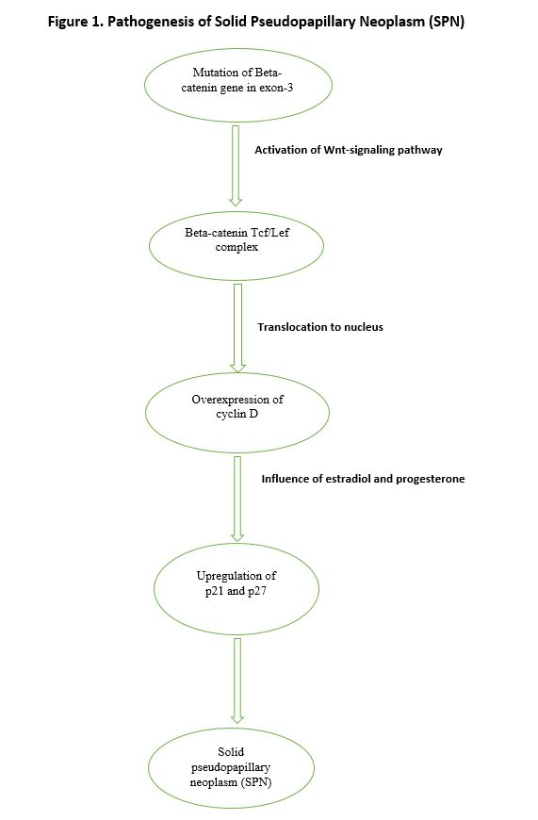
Figure 1 Pathogenesis of solid pseudopapillary neoplasm.

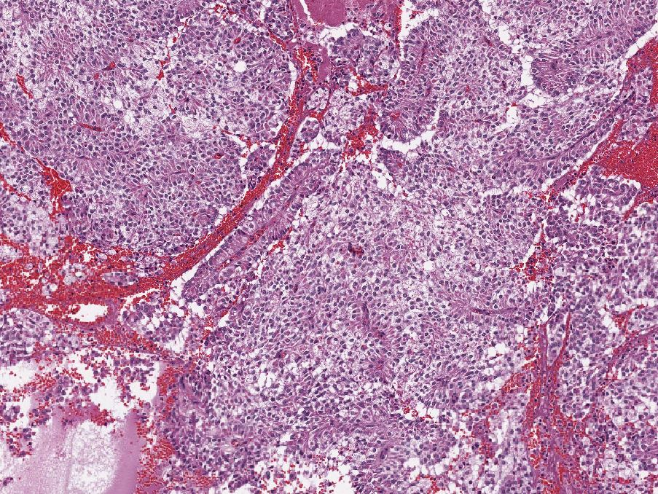

Figure 2 Histological appearance of solid pseudopapillary neoplasm. A hematoxylin and eosin (H and E) stain of a solid pseudopapillary neoplasm demonstrating eosinophilic neoplastic cells with vacuolated cytoplasm and pseudopapillary appearance.

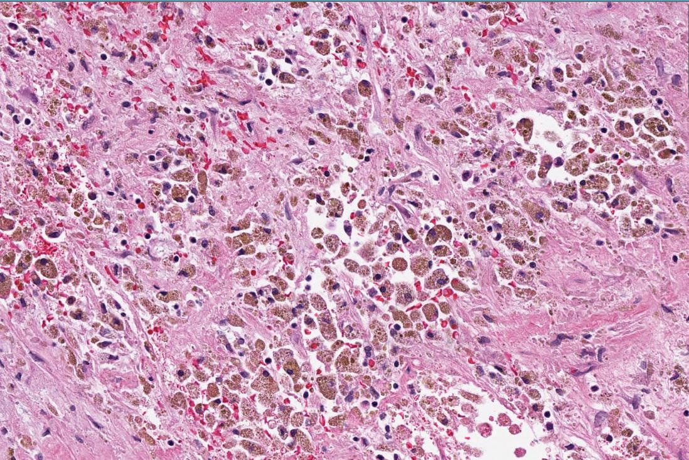

Figure 3 Cytoplasmic and nuclear staining of beta-catenin.

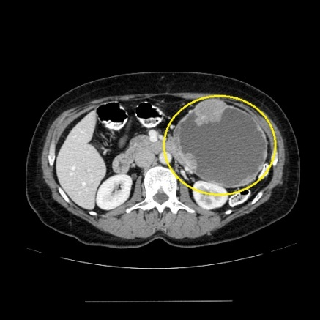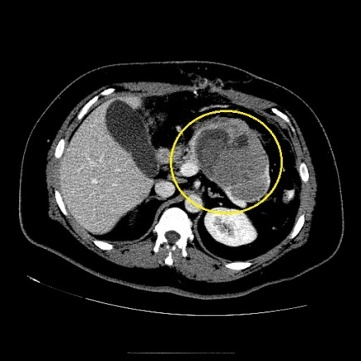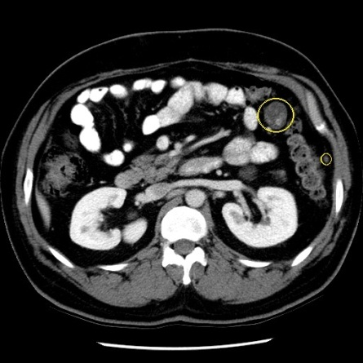
A
B
A B C
Figure 4 Computed tomography appearances. A: A pancreatic tail solid pseudopapillary neoplasm. Note the characteristic enhancing solid spaces at the periphery of an encapsulated SPN, accompanied by centrally located cystic space; B: Pancreatic tail solid pseudopapillary neoplasm with septation. The cystic component of SPN with degeneration is characterized by a heterogenous hypoattenuation on CT; C: Abdominal metastatic lesions of SPN. SPN: Solid pseudopapillary neoplasm; CT: Computed tomography.

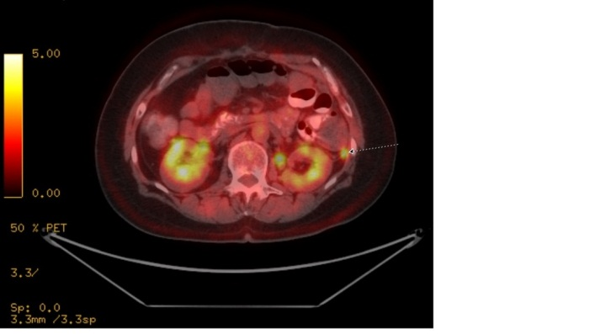
A B
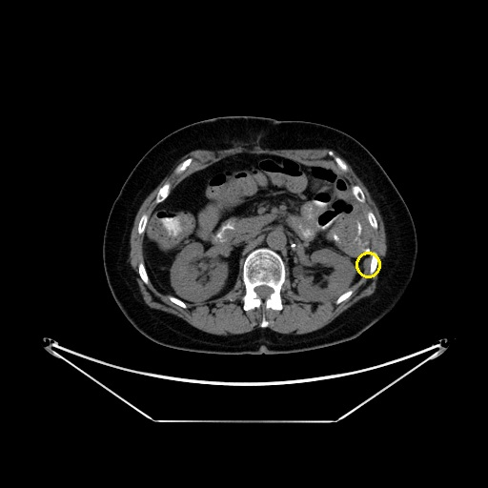
C
Figure 5 F-18 fluorodeoxy glucose avid solid pseudopapillary neoplasm metastases and metastatic solid pseudopapillary neoplasm to mesentery. A: FDG avid SPN metastases to mesentery; B: FDG avid metastatic SPN to mesentery; C: CT appearance of the FDG avid lesion. SPN: Solid pseudopapillary neoplasm; CT: Computed tomography; FDG: F-18 fluorodeoxy glucose.

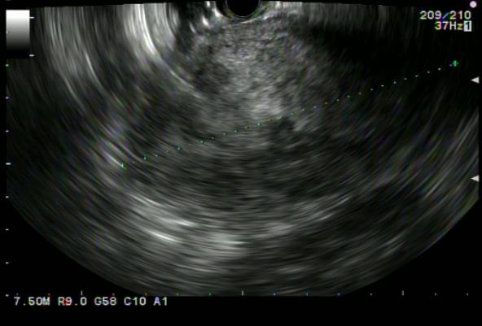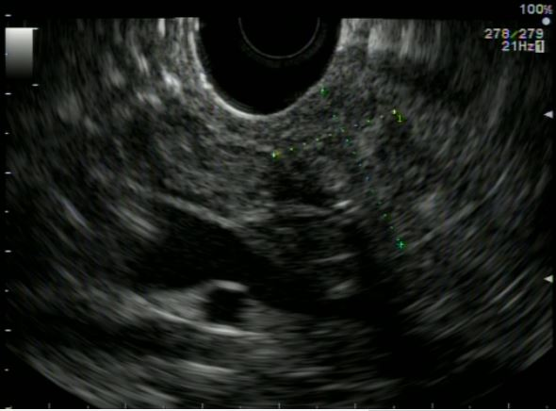

Figure 6 Endoscopic ultrasound appearances. A: SPN adjacent to the gastric wall. SPN demonstrates heterogenous echogenicity on EUS, with hyperechoic foci representing solid areas with surrounding hypoechoic cystic spaces; B: A pancreatic head SPN. EUS: Endoscopic ultrasound; SPN: Solid pseudopapillary neoplasm.

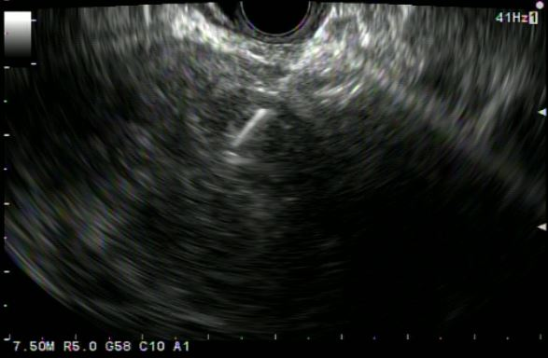

Figure 7 Endoscopic ultrasound guided fine needle aspiration of solid pseudopapillary neoplasm located in body/tail pancreas (Transgastric approach).

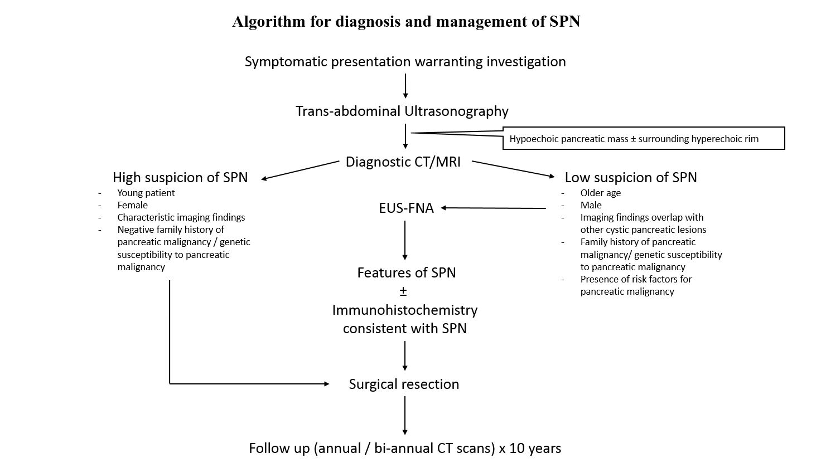
Figure 8 Proposed algorithm for the diagnosis and management of solid pseudopapillary neoplasm.

