Name of journal: World Journal of Respirology
ESPS Manuscript NO: 2420
Columns: ORIGINAL ARTICLES

High-frequency electrical stimulation of cervical vagi reduces airway response to methacholine

Zhuang JG et al. Neural control of airways

Jianguo Zhuang, Daniel Bailet , Robert Curtis, Fadi Xu

Jianguo Zhuang, Fadi Xu, Lovelace Respiratory Research Institute, Pathophysiology Program, Albuquerque, NM 87108, United States
Daniel Bailet, Robert Curtis, NeuroStimulation Technologies, Inc., Albuquerque, NM 87108, United States

Author contributions: Zhuang J and Xu F performed the majority of experiments, data analysis and statistics, manuscript preparation and revision; Bailet D, Curtis R, and Xu F involved in the study design and endeavored to obtain financial support.

Supported by RO1 HL107462 from the National Heart, Lung, and Blood Institute, Bethesda, MD, and NeuroStimulation Techologies, Inc. Albuquerque, NM

Correspondence to: Dr. Fadi Xu, Lovelace Respiratory Research Institute, Pathophysiology Program, 2425 Ridgecrest Dr. SE, Albuquerque, NM 87108, United States. fxu@lrri.org
Telephone: +1-505-3489565 Fax: +1-505-3488567

Received: February 20, 2013 Revised: May 31, 2013
Accepted: June 18, 2013

Published online:

Abstract
AIM: To test whether high-frequency electrical stimulation (HES) of the bilateral cervical vagus nerves reduces the airway responses to methacholine (MCh).

METHODS: Guinea pigs were pretreated with saline (Sal, n = 9) or ovalbumin (Ova, n = 10) aerosol for two weeks (5 min/d, 5 d/wk) and subsequently anesthetized, paralyzed, tracheotomized and artificially ventilated. Both total lung resistance (R_{L}) and dynamic pulmonary compliance (C_{dyn}) were recorded. In addition, the effects of vagal low-frequency electrical stimulation (LES, monophasic, 50 Hz) and HES (monophasic and biphasic, 1 and 2.5 kHz) for about 10 s or 2 min on the responses of R_{L} and C_{dyn} to MCh aerosol-induced bronchoconstriction were compared in both groups of guinea pigs. In a few guinea pigs, the impact of bivagotomy on the R_{L} responses to MCh was assessed.

RESULTS: Before MCh challenge, LES, but not HES, significantly increased R_{L} by about 30% (P < 0.01) and decreased C_{dyn} by about 20% (P < 0.01) similarly in both groups. MCh aerosol for 2 min elevated R_{L} and diminished C_{dyn} more in Ova- than Sal-treated animals (R_{L}: 313% ± 52% vs 113% ± 17%, P < 0.01; C_{dyn}: -56% ± 7% vs -21% ± 3%, P < 0.01). During MCh-induced airway constriction, LES further enhanced, but HES decreased R_{L} and this decrease was greater in Ova- (about 45%) than Sal-treated animals (about 34%, P < 0.01) with little change in cardiovascular activity. On the other hand, LES further reduced whereas HES increased C_{dyn} more in Ova- (about 20%) than Sal-treated animals (about 13%, P < 0.01). In addition, bivagotomy almost eliminated the R_{L} and C_{dyn} responses to MCh.

CONCLUSION: We conclude that vagal HES is able to alleviate the bronchoconstriction induced by MCh in anesthetized guinea pigs, likely via reversible inhibition/blockade of vagal conduction.

© 2013 Baishideng. All rights reserved.

Key words: Bronchodilation; Acetylcholine; Airway hyperreactivity; Ovalbumin; Asthma

Core tip: In summary, our study revealed that vagal high-frequency electrical stimulation (HES) significantly suppressed the airway response to methacholine (MCh) more greatly in the Ova- than Sal-treated animals, while vagal low-frequency electrical stimulation always increased airway resistance. Importantly, the HES-evoked bronchodilation during MCh challenge is concomitant with the on-and-off electrical stimulation and with no effect on cardiovascular activity. These, along with the greatly blunted airway resistance response to MCh after bivagotomy, suggest that vagal HES may be a potentially useful approach in alleviating asthmatic bronchoconstriction (likely via reversible inhibition or blockade of the vagal nerve conduction).

Zhuang J, Bailet D, Curtis R, Xu F. High-frequency electrical stimulation of cervical vagi reduces airway response to methacholine.

Available from: URL:
DOI:

INTRODUCTION
Airway hyperreactivity results predominantly from an increased acetylcholine release from parasympathetic nerves innervating the airways, leading to local smooth muscle contraction in asthmatic patients^{[1]} and in animal models of asthma^{[2, 3]}. It was assumed that cholinergic agonists, such as methacholine (MCh), produced bronchoconstriction only via their direct effect on airway smooth muscle. However, this opinion has been challenged by several recent studies. Vagal activation by conventional electrical stimulation at low frequency (< 20 Hz) augments the airway responsiveness to MCh in rats^{[4]}. Conversely, bivagotomy or vagal blockade by cooling profoundly decreases and even eliminates bronchoconstriction induced by application of cholinergic agonists into the respiratory tract in mice, rats, sheep, and dogs^{[5-8]}. These results strongly demonstrate the critical role basic vagal tone per se plays in generating the airway smooth muscle responses to acetylcholine.
Accumulating evidence has shown a blocking effect of electrical stimulation at high frequencies (HES ≥ 1 kHz) on mammal peripheral nerve fibers’ conduction, thereby diminishing or abolishing the nerve’s functions^{[9-11]}. For example, HES applied to the sciatic nerve of anesthetized cats substantially decreases the alpha motor neural discharges as shown by recording of the antidromic potentials of single fibers of L7 ventral root^{[11]}. Therefore, we hypothesized that vagal HES (similar to bivagotomy) would reduce the airway responses to MCh challenge in guinea pigs, especially those with ovalbumin (Ova)-sensitization as an established animal model of asthma^{[12, 13]}.

MATERIALS AND METHODS
Animals
Pathogen-free Hartley Duncan guinea pigs were purchased from Charles River Laboratories, Inc. (Wilmington, MA) and housed in the animal facility in filter top cages with ad libitum water and food access. The room was constantly ventilated and the temperature was kept at 23°C. The animals were quarantined for 2 wk before the experiments. The experimental protocols were approved by the Institutional Animal Care and Use Committee at Lovelace Respiratory Research Institute, Albuquerque, NM, which is accredited by the Association for Assessment and Accreditation of Laboratory Animal Care International, United States.

Ova-exposure
Nineteen male guinea pigs were used and divided into two groups with matched-litter and body weight (initial weight about 250 g). Each animal was placed in a whole-body plethysmograph (SN 117829; Buxco Electronic Inc., Sharon, CT) for 1 h per day for 3 d. Following the habituation, the animals as previously reported^{[14, 15]} were either exposed to aerosolized Ova (n = 10) daily for 5 min, 5 d per week, for 2 wk (Ova-treatment) or to saline (Sal) aerosol (n = 9) in an identical manner to serve as a control. During the exposure, the individual guinea pig was placed in a plethysmograph under a negative-pressure exhaust hood. The plethysmograph was connected to an Aeroneb Pro nebulizer (Mountain View, CA) by which Ova (1% wt/vol) or its vehicle solution was introduced at 0.7 mL/min with a mass median aerodynamic diameter of 3.7 µm similar to those reported previously^{[14,15]}. Diphenhydramine (8 mg) was injected intraperitoneally (ip) in both groups 1 h before each exposure in the second week to alleviate the bronchospasm caused by release of histamine during Ova-exposure^{[15]}. Before the first and the last aerosol exposure, the animal’s body weight was measured.

General animal preparation
One day after the last exposure with Ova or Sal, anesthesia was induced using a mixture of ketamine + xylazine (40 + 5 mg/kg; im). Supplementary anesthetics (4 + 0.5 mg/kg; im) were provided as needed to suppress corneal and withdrawal reflexes. The trachea was cannulated below the larynx and connected to a pneumotachograph (Frank’s Mfg. Co., Albuquerque, NM) to measure the respiratory flow via a differential pressure transducer (ML141, ADInstruments, Castle Hill, Australia). The pneumotachograph had a linear flow-pressure relationship in the range of 0–20 mL/s with a flow resistance of 0.046 cmH₂O s mL⁻¹ and a dead space of about 0.2 mL. The animals were exposed to a gas mixture of 30% oxygen in nitrogen throughout the experiment. The right femoral artery was cannulated for monitoring and recording arterial blood pressure (ABP) and heart rate (HR) through a blood pressure transducer (MLT0380, ADInstruments). The right femoral vein was cannulated for administration of agents. The cervical vagi were carefully isolated and placed on bipolar stimulating electrodes respectively. The guinea pigs were then paralyzed with pancuronium (0.1−0.3 mg kg⁻¹ for induction and 0.1 mg kg⁻¹ h⁻¹ for maintenance, iv) and ventilated at a constant frequency (f_{R}) of 70 breaths min⁻¹ with tidal volume (V_{T}) adjusted to keep end tidal pressure of CO₂ (P_{ET}CO₂) at about 40 torr^{[4, 16]}. Sudden spontaneous increases in arterial blood pressure (> 10 mmHg) and/or any irregular rhythm or increase in heart rate (> 15%) were indicators for supplementary anesthesia after paralysis.

Measurement of airway resistance
As we reported previously^{[17]}, total lung resistance (R_{L}) and pulmonary compliance (C_{dyn}) were measured and recorded on a breath-by-breath basis. Briefly, a catheter was inserted into the intrapleural cavity between the 5th and 6th ribs and the incision subsequently sutured and sealed airtight with silicone jelly in order to measure intrapleural pressure. The pneumothorax was corrected by briefly opening the intrapleural catheter to ambient air while holding hyperinflation (3 × V_{T}). Transpulmonary pressure was measured as the difference between the tracheal and intrapleural pressure.

Experimental procedures
In our pilot studies, the conventional stimulations (5, 10, 25, 50, and 100 Hz; 0.5 V; 0.2 ms; monophonic and biphasic square-waveform) were delivered from a biphasic stimulus isolator (BSI-950, Dagan Corporation Minneapolis, MN) and applied to stimulate the vagi. We found that among these stimulations, a stimulation at 50 Hz with monophonic square-waveform resulted in the reproducible and greatest R_{L} response, which was applied as the low-frequency stimulation (LES). In addition, HES at 1 kHz or 2.5 kHz with monophasic waveform (HESm1 and HESm2) or with biphasic waveform (HESb1 and HESb2) were also applied. Both types of HES are reportedly able to block nerve conduction in previous studies^{[11, 18-21]}. These stimulations were randomly applied with the ratio of LES vs HES equal to 1:3 in each MCh exposure, and each stimulus lasted for a 10-s with an approximately 30 s interveal or occationally for 2-min period (only HES). Thirty minutes after completion of these electrical stimulations, the animals were subsequently exposed to MCh aerosol (100 μg mL⁻¹ min⁻¹ for 2 min^{[4]}) delivered by the nebulizer into the intake port of the ventilator by using an airflow 20 mL s⁻¹ with a nebulizer output of 0.7 mL min⁻¹. The same patterns of electrical stimulations applied before MCh exposure were repeated with the first electrical stimulation applied at about 30th s of the plateau R_{L} response to MCh. After recovery from the MCh exposure, the animal received the same MCh exposure and electrical stimulations again once or twice to ensure the reproducibility of the R_{L} responses. The above procedures were performed in 9 Sal- and 8 Ova-treated animals. In the remaining two other Ova-treated guinea pigs, the R_{L} response to the same MCh challenge was measured before and after bivagotomy to determine whether bivagotomy would cause a similar inhibition of the R_{L} response to MCh.

Statistical analysis
Raw data of the airflow, tracheal and intrapleural pressures, P_{ET}CO₂, arterial blood pressure, and rectal temperature were digitized, monitored, and recorded by using a PowerLab/8sp (model ML 785; ADInstruments Inc., Colorado Springs, CO) connected to a computer employing the PowerLab Chart 5 software. Derived parameters, including the R_{L}, C_{dyn}, V_{E}, V_{T}, f_{R}, MABP, and HR, were calculated online using the functions of the software. After stabilization of these variables, the R_{L} baseline was determined by averaging R_{L} values for 30 s immediately before vagal electrical stimulation or MCh exposure. The electrical stimulation-evoked R_{L} responses before and after MCh aerosol were expressed as delta percent (Δ%) change from the baseline R_{L} values. The R_{L} responses to the 1st, 2nd, and 3rd MCh exposure were compared to determine the reproducibility. In our study, multiple trials of a given electrical stimulation in the individual animal were averaged to calculate our group data unless mentioned otherwise. All data were presented as means ± SE. Student t-test was applied to detect the significant differences in baseline values between the two groups (Ova- and Sal-treated). Two-way ANOVA was used to differentiate all responses evoked by the stimulations (chemical or electrical) between the two groups or among the R_{L} responses to different trials of MCh exposure. When an overall test was found to be significant, Fisher's post-hoc tests were followed for specific comparisons between individual groups. Differences were considered significant at a P value < 0.05.

RESULTS
Airway responses to vagal electrical stimulations before MCh challenge
After completion of the Sal- or Ova-pretreatment, animal body weights were not significantly different between the two groups (358 ± 12 g vs 363 ± 15 g). Following anesthesia and paralysis, animals’ baseline airway and cardiovascular activities and their responses to the electrical stimulations were compared. As listed in Table 1, all of these baseline values were not significantly different between the two groups, which are consistent with the previously reported data from guinea pigs^{[5,14]}. LES immediately increased the R_{L} by about 30% and decreased the C_{dyn} by approximately 18%; this is similarly associated with bradycardia in the Sal- and Ova-treated guinea pigs. The evoked responses disappeared rapidly after withdrawing the electrical stimulation. In sharp contrast, all HESs (HESm1, HESm2, HESb1, and HESb2) failed to significantly alter R_{L}, C_{dyn}, MABP, and HR. The typical experimental recordings and the corresponding group data are illustrated in Figures 1 and 2, respectively.

Airway responses to aerosol MCh
In both groups of guinea pigs, exposure to MCh aerosol for 2 min evoked significant bronchoconstrictive response as evidenced by an increase in R_{L} and decrease in C_{dyn} (Figure 1). The R_{L} response reached a plateau about 2 min after applying MCh, and the plateau lasted for 2.8 ± 0.2 min followed by a relatively rapid recovery to their pre-exposure baselines. The amplitudes and durations of evoked R_{L} responses to the 1st, 2nd, and 3rd MCh exposure in Sal-treated and Ova-treated animals are listed in Table 2. The lack of significant difference among the R_{L} amplitude and duration in response to the three MCh exposures strongly indicates that these evoked responses are reproducible. The MCh exposure caused a remarkable hypotension (phase I) and a hypertension subsequently (phase II) that gradually returned to its pre-exposure baseline level. In parallel to phase II, there was a tachycardia evoked by MCh aerosol without HR change during phase I. The group data (Figure 2) showed that the MCh-induced R_{L} increase and C_{dyn} decrease were significantly greater in the Ova- than Sal-treated animals (313% vs 113% and -57% vs -20% respectively; P < 0.01). The changes of MABP and HR, however, were not significantly different between the two animal groups. These data are consistent with previously reported airway and cardiovascular responses to MCh^{[22-25]}.

Airway responses to vagal electrical stimulations after exposure to aerosolized MCh
When the R_{L} response reached the plateau after MCh inhalation, the different electrical stimulations were randomly applied. Typical experimental recordings are exhibited in Figure 1, in which LES still enhanced R_{L} but HESs suppressed the R_{L} response to MCh challenge. Statistically, the amplitude of the suppression was greater in the Ova- (49%) than the Sal-treated animals (35%). Similar results were also observed in C_{dyn}. The breakdown of the responses to individual HESs is detailed in Figure 3. The inhibitory effects on the R_{L} responses to MCh aerosol were not markedly different between the stimulations at 1 and 2.5 kHz and between the stimulations with different waveforms. In addition, the HES-induced alteration in R_{L} was not associated with statistical changes in ABP and HR, although ABP fluctuated a bit (Figures 1 and 3). In this study, 4 electrical stimulations were applied during each R_{L} plateau response to MCh aerosol. The bronchodilation responses (R_{L}) evoked by the first and last HES (usually with about 1.5 min apart) were not significantly different in amplitude (in Sal-treated GPs: -37% ± 5% vs -33% ± 6% and in Ova-treated GPs: -51% ± 6% vs -48% ± 7%; P > 0.05). In addition, no remarkable fatigue of the bronchodilation in response HES was observed during continuously stimulating vagi for 2 min (Figure 4). These data support the notion that detectable fatigue and/or nerve damage is minimal in the experimental timeframe of this study.

airway responses to prolonged electrical stimulations after MCh challenge
We also tested whether prolongation of the vagal stimulation duration would produce similar bronchodilation after MCh exposure and whether the vagal nerve remained viable. As exhibited in Figure 4, the prolonged 2-min HES stimulation still produced a bronchodilation with a limited effect on both MABP and HR. Moreover, this response was reversible and repeatable.

Airway responses to MCh aerosol before and after bivagotomy
The objective of this study was to clarify whether, similar to vagal HES, bivagotomy would substantially diminish the airway responses to MCh aerosol in our experimental preparation. We found that as compared to the responses measured with intact vagi, bivagotomy did not significantly change the baseline R_{L} and C_{dyn} or the BP and HR in the Sal- and Ova-treated animals, which is similar to the previous reports in anesthetized rats^{[5,26]}. Most imporatantly, the R_{L} and C_{dyn} responses to MCh aeorsol were dramatically reduced by the bivagotomy (55% ± 11%) and the MCh-induced hypotension tended to be smaller (Figure 5).

DISCUSSION
Multiple mechanisms (parasympathetic nerve-dependent or -independent) are involved in generating airway hyperreactivity. In the present study, we addressed an essential issue as to whether HES reversibly impairs vagal conduction via blocking acetylcholine release from parasympathetic fibers, and thereby alleviates the MCh-produced bronchoconstriction. We found that, differing from an excitatory effect of LES, vagal HES greatly inhibited the airway constrictive responses to inhalation of MCh aerosol in anesthetized guinea pigs, especially in those sensitized by Ova. Actually, vagal LES-induced bronchoconstriction^{[22-24]} and reduce C_{dyn}^{[27]} have been observed in rats, rabbits, and guinea pigs. This excitatory response is achievable mainly via promoting release of acetylcholine from parasympathetic fibers innervating airway smooth muscle. Although vagal LES provoked a relatively greater R_{L} increase and lower C_{dyn} in Ova- than Sal-treated guinea pigs, these differences were not significant. There are four unique features of our HES-induced bronchodilation. First, vagal HES during the bronchoconstrictive response to MCh challenge evokes a rapid bronchodilation that is consistent with the rapid tracheal relaxation by electrical stimulation in vitro^{[28]}. Second, the electrical stimulation-evoked bronchodilation was reversible and reproducible, implying a minimal damage of vagal HES on the nerve in our study. This finding is consistent with the reported effects of HES characterized by its repeated and reversible blockade of nerve conduction regardless of the electrical parameters^{[20,29]}. Third, the vagal HES-evoked bronchodilation was not associated with remarkable changes in HR and ABP. Fourth, the HES-evoked bronchodilation after MCh challenge was significantly greater in Ova- than Sal-treated animals. Collectively, our data clearly suggest that vagal HES could substantially inhibit the bronchoconstrictive responses to cholinergic agonists. Asthma is a chronic disease; however, severe asthmatic attack is acute. In our study, the airway responses to MCh mimic the asthmatic attack, while HES-induced bronchodilation during the acute bronchoconstriction may provide a clue of alleviating the asthmatic attack.
A large body of evidence has shown multiple neural pathways responsible for regulating the airway smooth muscle tone^{[30]}. Of them, two neural pathways are excitatory. Acetylcholine released from parasympathetic postganglionic nerves innervating airway smooth muscles produces airway contraction via acting on muscarinic 3 cholinoceptors of smooth muscle. In addition, activation of vagal pulmonary afferent endings releases tachykinins, such as substance P (SP) and neurokinin A (NKA), causes smooth muscle contraction. The two others are inhibitory. Parasympathetic postganglionic fibers can release inhibitory nonadrenergic, noncholinergic (iNANC) neurotransmitters, such as nitric oxide (NO) and vasoactive intestinal peptide (VIP); and β₂ adrenoceptors mediate the muscle relaxation in response to circulating adrenaline. We assume that vagal HES leads to bronchodilation during MCh exposure via inhibiting or blocking vagal conduction to attenuate release of acetylcholine from parasympathetic fibers innervating airway smooth muscle for several reasons. Vagal HES-induced bronchodilation during MCh is similar to the blunted airway response to MCh after bivagotomy that was previously reported^{[5-8]} and confirmed in this study. The similarity of vagal HES and bivagotomy was further confirmed by the evidence that vagal HES (Figures 6 and 7) and bivagotomy^{[5,6]} failed to alter baseline R_{L} and C_{dyn}. These data suggest that R_{L} and C_{dyn} at rest state are largely determined by the mechanics of the airway and lung tissue independent of the basal cholinergic tone. In agreement with our data, the ability of HES to block nerve conduction was first found by Reboul^{[18]} and subsequently confirmed by other investigators^{[11,19-21]}. Particularly, a square-waveform HES, similar to that used in this study, has been shown to block the sciatic nerve in anesthetized cats^{[11]}. The possibility of the involvement of SP and NKA release from pulmonary afferents in the HES-induced bronchodilation is discussed later. The HES-induced bronchodilation unlikely results from activation of the two inhibitory neural pathways. The iNANC pathway-mediated relaxation was evoked by low stimulating frequency (< 35 Hz) and often required several minutes to research the plateau^{[31]}. Different from these, we used HES that induced a rapid bronchodilation. Electrical stimulation of airway sympathetic nerves could also evoke bronchodilation in the guinea pig^{[32,33]}. Thus, one may ask whether the HES current spread could stimulate the adjacent airway sympathetic nerves, leading to the bronchodilation observed in our study. This opinion is strongly argued by lacking any significant cardiovascular response to vagal HES in this study. Taken together, our results demonstrate that vagal LES causes bronchoconstriction and bradycardia via activating the vagus nerve, while vagal HES leads to bronchodilation during MCh aerosol independent of stimulating waveforms, likely through inhibiting or blocking vagal conduction.
There are several concerns and limitations in this study. First, although vagal HES and bivagotomy share a similarity in inhibiting airway contraction in response to MCh aerosol, our data are not conclusive in proving vagal blockade by the HES. Technically, recording vagal afferent fiber signals is doable, but distinguishing these signals from the artificial signals of vagal HES is very difficult. Second, the cervical vagal trunk consists of both afferent (myelinated and unmyelinated) and efferent (myelinated) fibers^{[34]}. Our data are unable to delineate which type(s) of vagal fibers are responsible for the HES-induced change. Previous results in cats have shown that A-fibers of the slow adapting receptors are not critical to the cholinergic-mediated airway responses because lung inflation has limited effects on the airway response to MCh administration^{[35]}. On the other hand, bronchopulmonary C-fibers may be involved in modulating the airway response to cholinergic activaton via the local axonal- and/or the central-mediated reflexes. Nicotinic cholinergic receptors exist in bronchopulmonary C-fibers^{[36]}. Degeneration of these fibers significantly diminishes the airway responsiveness to MCh aerosol in both rats and guinea pigs^{[37,38]}, while stimulation of these fibers causes airway constriction^{[34,39]}. Thus, it is possible that vagal HES can induce bronchodilation during MCh challenge, presumably in part via inhibiting the conduction of bronchopulmonary C-fibers. Third, though our data failed to show a detectable fatigue and/or nerve damage induced by our HES applied within 2 min, it remains unknown whether HES applied in a prolonged period (> 2 min) would produce such pathophysiological changes. Fourth, our data cannot deny the plausible that pre-exposure to the conventional treatments clinically used may interfere with the effectiveness of HES denoted in the present study. Fifth, our study was performed in anesthetized preparation. Therefore, further experiments in conscious asthmatic animals are needed to rule out the possible interference of anesthetics in the vagal HES-induced bronchodilation.

COMMENTS
Background
High-frequency electrical stimulation (HES) of peripheral nerve is reportedly able to inhibit or block the nerve conduction, and thereby to inactivate the nerve-mediated responses. Airway hyperreactivity results predominantly from an increased acetylcholine release from vagal nerves innervating the airways in asthmatic patients and in animal models of asthma. Authors tested whether HES of vagal nerves could inhibit acetylcholine-induced airway hyperreactivity.

Research frontiers
Our results showed that HES of vagus nerves greatly attenuated airway hyperreactivity in response to acetylcholine, suggesting an inhibitory effect of HES on vagus nerves.

Innovations and breakthroughs
The major innovation of authors’ data is to ensure an inhibitory effect of HES on vagus nerves that leads to an attenuation of acetylcholine-induced airway hyperreactivity.

Applications
An inhibitory effect of HES on vagus nerves, as presented in this study, may provide a therapeutical approach to alleviate airway hyperreactivity in asthmatic patients.

Terminology
HES: low-frequency electrical stimulation; methacholine; ovalbumin; total lung resistance and dynamic pulmonary compliance.

Peer review
This is a very good study in which the authors demonstrated that HES of vagus nerves in guinea pigs attenuated the acetylcholine-induced airway hyperreactivity. The results are interesting and potentially transnational from data to pre-clinical research.

REFERENCES
1 Cropp GJ. The role of the parasympathetic nervous system in the maintenance of chronic airway obstruction in asthmatic children. Am Rev Respir Dis 1975; 112: 599-605 [PMID: 1190614]
2 Drazen JM, Austen KF. Atropine modification of the pulmonary effects of chemical mediators in the guinea pig. J Appl Physiol 1975; 38: 834-838 [PMID: 1126892]
3 Fryer AD, Wills-Karp M. Dysfunction of M2-muscarinic receptors in pulmonary parasympathetic nerves after antigen challenge. J Appl Physiol 1991; 71: 2255-2261 [PMID: 1778920]
4 Sorkness R, Clough J, Lemanske RF. Effects of airway parasympathetic tone on responses to intravenous bronchoconstrictor agonists in rats. J Appl Physiol 1994; 77: 2698-2702 [PMID: 7896609]
5 Badier M, Soler M, Mallea M, Delpierre S, Orehek J. Cholinergic responsiveness of respiratory and vascular tissues in two different rat strains. J Appl Physiol 1988; 64: 323-328 [PMID: 3356652]
6 Card JW, Voltz JW, Ferguson CD, Carey MA, DeGraff LM, Peddada SD, Morgan DL, Zeldin DC. Male sex hormones promote vagally mediated reflex airway responsiveness to cholinergic stimulation. Am J Physiol Lung Cell Mol Physiol 2007; 292: L908-L914 [PMID: 17158599 DOI: 10.1152/ajplung.00407.2006]
7 Yanaura S, Goto K, Kitagawa H, Hosokawa T, Misawa M, Kobayashi N, Hayakawa H. [Role of vagus nerves in bronchoconstriction induced by chemical mediators]. Nihon Yakurigaku Zasshi 1982; 79: 571-579 [PMID: 6957363 DOI: 10.1254/fpj.79.571]
8 Wagner EM, Jacoby DB. Methacholine causes reflex bronchoconstriction. J Appl Physiol 1999; 86: 294-297 [PMID: 9887142]
9 Joseph L, Haeffele BD, Butera RJ. Conduction block induced by high frequency AC stimulation in unmyelinated nerves. Conf Proc IEEE Eng Med Biol Soc 2007; 2007: 1719-1722 [PMID: 18002307]
10 Bhadra N, Lahowetz EA, Foldes ST, Kilgore KL. Simulation of high-frequency sinusoidal electrical block of mammalian myelinated axons. J Comput Neurosci 2007; 22: 313-326 [PMID: 17200886 DOI: 10.1007/s10827-006-0015-5]
11 Bowman BR, McNeal DR. Response of single alpha motoneurons to high-frequency pulse trains. Firing behavior and conduction block phenomenon. Appl Neurophysiol 1986; 49: 121-138 [PMID: 3827239]
12 Cartier A, Thomson NC, Frith PA, Roberts R, Hargreave FE. Allergen-induced increase in bronchial responsiveness to histamine: relationship to the late asthmatic response and change in airway caliber. J Allergy Clin Immunol 1982; 70: 170-177 [PMID: 7108068 DOI: 10.1016/0091-6749(82)90038-0]
13 Cockcroft DW, Ruffin RE, Dolovich J, Hargreave FE. Allergen-induced increase in non-allergic bronchial reactivity. Clin Allergy 1977; 7: 503-513 [PMID: 589783 DOI: 10.1111/j.1365-2222.1977.tb01481.x]
14 Wu ZX, Zhou D, Chen G, Lee LY. Airway hyperresponsiveness to cigarette smoke in ovalbumin-sensitized guinea pigs. Am J Respir Crit Care Med 2000; 161: 73-80 [PMID: 10619800 DOI: 10.1164/ajrccm.161.1.9809121]
15 Xu F, Zhuang J, Zhou T, Lee LY. Ovalbumin sensitization alters the ventilatory responses to chemical challenges in guinea pigs. J Appl Physiol 2005; 99: 1782-1788 [PMID: 16024517 DOI: 10.1152/japplphysiol.00613.2005]
16 Zhang G, Lin RL, Wiggers ME, Lee LY. Sensitizing effects of chronic exposure and acute inhalation of ovalbumin aerosol on pulmonary C fibers in rats. J Appl Physiol 2008; 105: 128-138 [PMID: 18436692 DOI: 01367.2007]
17 Zhuang J, Xu J, Zhang C, Xu F. IL-1β acutely increases pulmonary SP and permeability without associated changes in airway resistance and ventilation in anesthetized rats. Respir Physiol Neurobiol 2011; 175: 12-19 [PMID: 20692381 DOI: S1569-9048(10)00306-X]
18 Reboul L, Rosenblueth A. The action of alternating currents upon the electrical excitability of nerve. Am J Physiol Lung Cell Mol Physiol 1939; 125: 205-215 PMID:
19 TANNER JA. Reversible blocking of nerve conduction by alternating-current excitation. Nature 1962; 195: 712-713 [PMID: 13919574 DOI: 10.1038/195712b0]
20 Kilgore KL, Bhadra N. Nerve conduction block utilising high-frequency alternating current. Med Biol Eng Comput 2004; 42: 394-406 [PMID: 15191086 DOI: 10.1007/BF02344716]
21 Elbasiouny SM, Mushahwar VK. Modulation of motoneuronal firing behavior after spinal cord injury using intraspinal microstimulation current pulses: a modeling study. J Appl Physiol 2007; 103: 276-286 [PMID: 17234800 DOI: 10.1152/japplphysiol.01222.2006]
22 Pendry YD, Maclagan J. Evidence for inhibition of sympathetic neurotransmission by endogenously released acetylcholine in the guinea-pig trachea. Br J Pharmacol 1991; 104: 817-822 [PMID: 1667287 DOI: 10.1111/j.1476-5381.1991.tb12512.x]
23 Abrahamsson C. Neuropeptide Y1- and Y2-receptor-mediated cardiovascular effects in the anesthetized guinea pig, rat, and rabbit. J Cardiovasc Pharmacol 2000; 36: 451-458 [PMID: 11026645 DOI: 10.1097/00005344-200010000-00006]
24 Rechtman M, Majewski H. A facilitatory effect of anti-angiotensin drugs on vagal bradycardia in the pithed rat and guinea-pig. Br J Pharmacol 1993; 110: 289-296 [PMID: 8220890 DOI: 10.1111/j.1476-5381.1993.tb13807.x]
25 Zhuang J, Xu F, Campen MJ, Zhang C, Pena-Philippides JC, Sopori ML. Inhalation of the nerve gas sarin impairs ventilatory responses to hypercapnia and hypoxia in rats. Toxicol Appl Pharmacol 2008; 232: 440-447 [PMID: 18706921 DOI: 10.1016/j.taap.2008.07.016]
26 Kelliher GJ, Conahan ST. Changes in vagal activity and response to muscarinic receptor agonists with age. J Gerontol 1980; 35: 842-849 [PMID: 7440925 DOI: 10.1093/geronj/35.6.842]
27 Matsumoto S. Effects of vagal stimulation on slowly adapting pulmonary stretch receptors and lung mechanics in anesthetized rabbits. Lung 1996; 174: 333-344 [PMID: 8843059 DOI: 10.1007/BF00176192]
28 Manzini S. Bronchodilatation by tachykinins and capsaicin in the mouse main bronchus. Br J Pharmacol 1992; 105: 968-972 [PMID: 1380376 DOI: 10.1111/j.1476-5381.1992.tb09086.x]
29 Bhadra N, Kilgore KL. High-frequency electrical conduction block of mammalian peripheral motor nerve. Muscle Nerve 2005; 32: 782-790 [PMID: 16124008 DOI: 10.1002/mus.20428]
30 Gu Q, Lee L-Y. Neural control of airway smooth muscle. In Encyclopedia of Respiratory Medicine. Volume (Invited chapter). Edited by Laurent GJ, Shapiro SD: Elsevier Press; 2006. 138-145 doi: 10.1016/B0-12-370879-6/00253-2
31 Mazzone SB, Canning BJ. Evidence for differential reflex regulation of cholinergic and noncholinergic parasympathetic nerves innervating the airways. Am J Respir Crit Care Med 2002; 165: 1076-1083 [PMID: 11956048 DOI: 10.1164/ajrccm.165.8.2001121270c]
32 Ainsworth GA, Garland LG, Payne AN. Modulation of bronchoconstrictor responses to histamine in pithed guinea-pigs by sympathetic nerve stimulation. Br J Pharmacol 1982; 77: 249-254 [PMID: 7139187 DOI: 10.1111/j.1476-5381.1982.tb09293.x]
33 Chesrown SE, Venugopalan CS, Gold WM, Drazen JM. In vivo demonstration of nonadrenergic inhibitory innervation of the guinea pig trachea. J Clin Invest 1980; 65: 314-320 [PMID: 7356681 DOI: 10.1172/JCI109674]
34 Lee LY, Pisarri TE. Afferent properties and reflex functions of bronchopulmonary C-fibers. Respir Physiol 2001; 125: 47-65 [PMID: 11240152 DOI: S0034568700002048]
35 Sly PD, Brown KA, Bates JH, Macklem PT, Milic-Emili J, Martin JG. Effect of lung volume on interrupter resistance in cats challenged with methacholine. J Appl Physiol 1988; 64: 360-366 [PMID: 3281928]
36 Xu J, Yang W, Zhang G, Gu Q, Lee LY. Calcium transient evoked by nicotine in isolated rat vagal pulmonary sensory neurons. Am J Physiol Lung Cell Mol Physiol 2007; 292: L54-L61 [PMID: 16920888 DOI: 00182.2006]
37 Sakae RS, Leme AS, Dolhnikoff M, Pereira PM, do Patrocínio M, Warth TN, Zin WA, Saldiva PH, Martins MA. Neonatal capsaicin treatment decreases airway and pulmonary tissue responsiveness to methacholine. Am J Physiol 1994; 266: L23-L29 [PMID: 7508200]
38 Mukaiyama O, Morimoto K, Nosaka E, Takahashi S, Yamashita M. Greater involvement of neurokinins found in Guinea pig models of severe asthma compared with mild asthma. Int Arch Allergy Immunol 2004; 134: 263-272 [PMID: 15205557 DOI: 10.1159/000079163]
39 Lee LY, Gu Q. Role of TRPV1 in inflammation-induced airway hypersensitivity. Curr Opin Pharmacol 2009; 9: 243-249 [PMID: 19269247 DOI: 10.1016/j.coph.2009.02.002]

P-Reviewers Hattori N, Pedro XE, Wu X S-Editor Wen LL L-Editor E-Editor

Figure 1 Cardiovascular and airway responses to 2 min vagal high-frequency electrical stimulation after exposure to methacholine aerosal (100 μg mL⁻¹ min⁻¹ for 2 min). A: HESm1-evoked responses in an Ova-treated guinea pig about 2 min after initiation of methacholine (MCh) challenge, in which the baseline values of total lung resistance (R_{L}) and pulmonary compliance (C_{dyn}) were 0.1 cmH₂O s mL⁻¹ and 0.4 mL cmH₂O⁻¹ respectively; B: The averaged data of MABP, HR, R_{L} and C_{dyn} from three guinea pigs (five trials) are illustrated in panel. In both panels, the traces are arterial blood pressure (ABP/MABP), heart rate (HR), R_{L}, and C_{dyn}. n = 5 trials (3 guinea pigs); Mean ± SE; ªP < 0.05, high-frequency electrical stimulation (HES)-evoked responses compared to the data before electrical stimulation presented as “0”.
Figure 2 Comparison of the cardiovascular and airway responses to methacholine aerosol (100 μg ml⁻¹ min⁻¹ for 2 min) before and after bivagotomy in an anesthetized and paralyzed Ova-treated guinea pig. The traces are arterial blood pressure (ABP), heart rate (HR), total lung resistance (R_{L}), and pulmonary compliance (C_{dyn}).

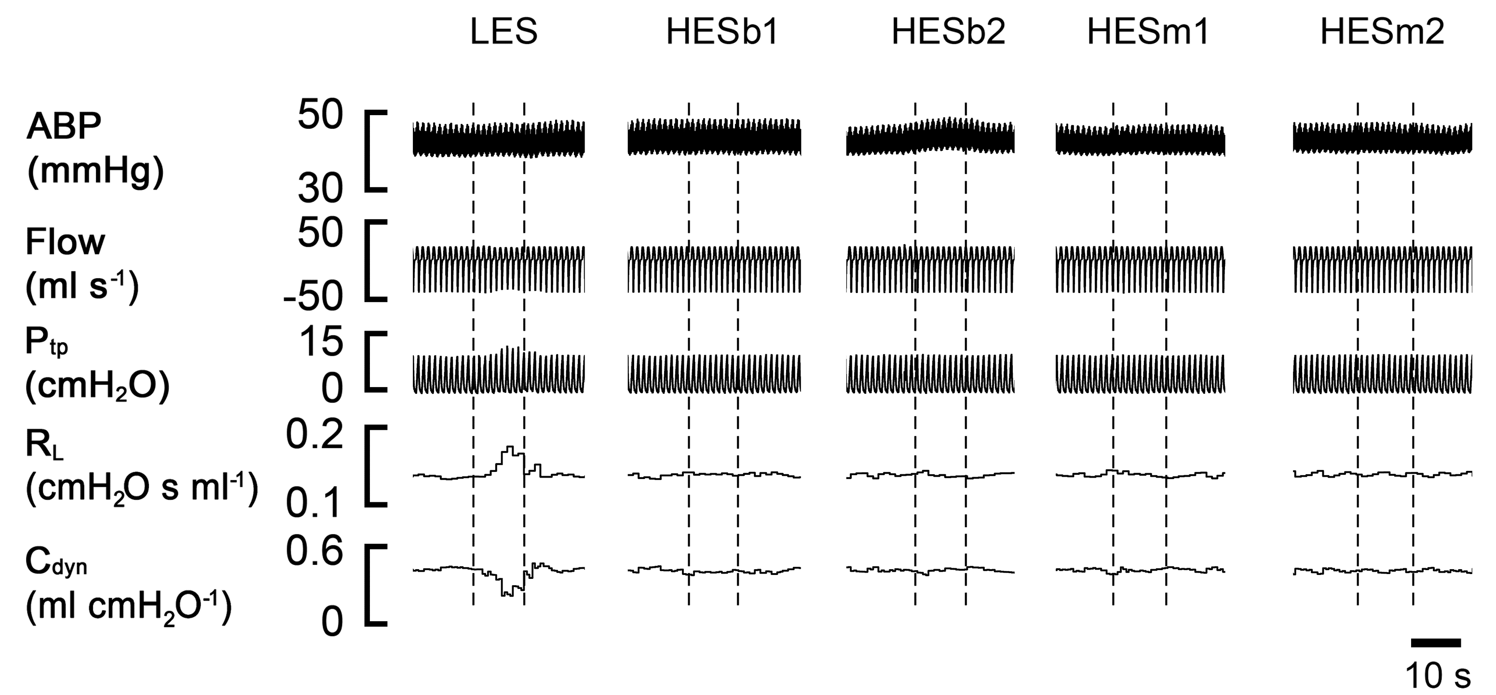
Figure 3 Typical total lung resistance and pulmonary compliance responses to electrical stimulations in an Ova-sensitized guinea pig. The traces from the top to bottom are arterial blood pressure (ABP), airflow (Flow), Trans-pulmonary pressure (P_{tp}), total lung resistance (R_{L}) and pulmonary compliance (C_{dyn}). The dashed lines in each column reflect the on- and off-set of a given electrical stimulation. Vagal electrical stimulation included low-frequency electrical stimulation (LES, monophasic stimulation at 50 Hz); HESb1 and HESb2 (biphasic waveform at 1 and 2.5 kHz); and HESm1 and HESm2 (monophasic waveform at 1 kHz and 2.5 kHz), which are the same for the following figures.

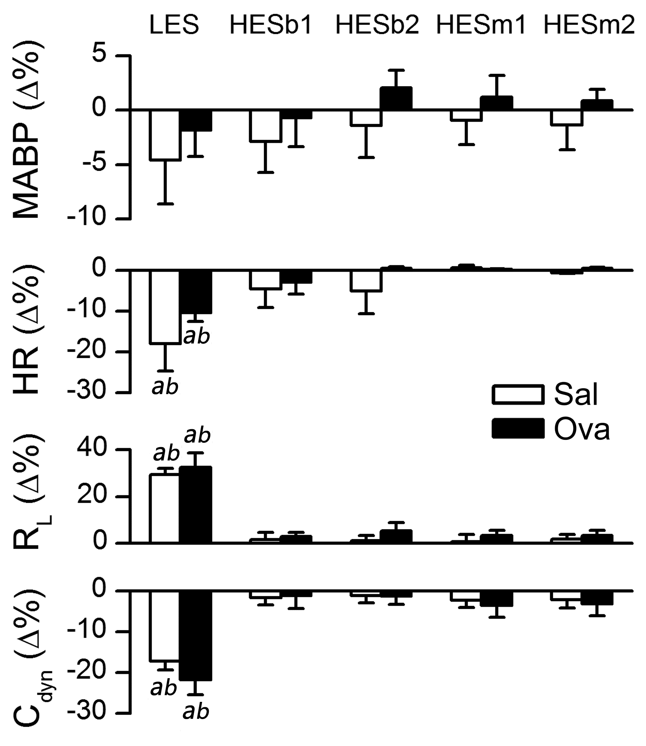

Figure 4 Group data showing the responses to vagal electrical stimulations. MABP: Mean arterial blood pressure; HR: Heart rate; R_{L}: Total lung resistance; C_{dyn}: Pulmonary compliance. n = 9 and 8 in the Sal- and Ova-pretreated guinea pigs; Mean ± SE. ªP < 0.01, vs the data immediately before electrical stimulation presented as “0”; ^{b}P < 0.01, low-frequency electrical stimulation (LES) vs high-frequency electrical stimulations (HESs).

Figure 5 Typical examples exhibiting cardiovascular and airway responses to methacholine aerosol (100 μg ml⁻¹ min⁻¹ for 2 min) and to vagal electrical stimulation in an anesthetized and paralyzed Ova-pretreated guinea pig. The traces from the top to bottom are arterial blood pressure (ABP), heart rate (HR), total lung resistance (R_{L}) and pulmonary compliance (C_{dyn}). The duration of the break is about 1 min. MCh: Methacholine.

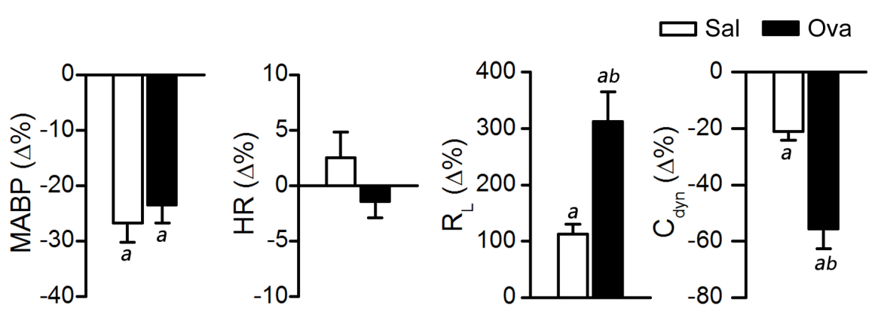

Figure 6 The peak airway responses to methacholine aerosol (100 μg ml⁻¹ min⁻¹ for 2 min) and the associated cardiovascular changes. MABP: Mean arterial blood pressure; HR: Heart rate; R_{L}: Total lung resistance; C_{dyn}: Pulmonary compliance, n = 9 and 8 in Sal- and Ova-treated guinea pigs respectively; mean ± SE. ªP < 0.01, vs the data of pre-methacholine (MCh) challenge presented as “0”; ^{b}P < 0.01 between Sal- and Ova-treated groups.

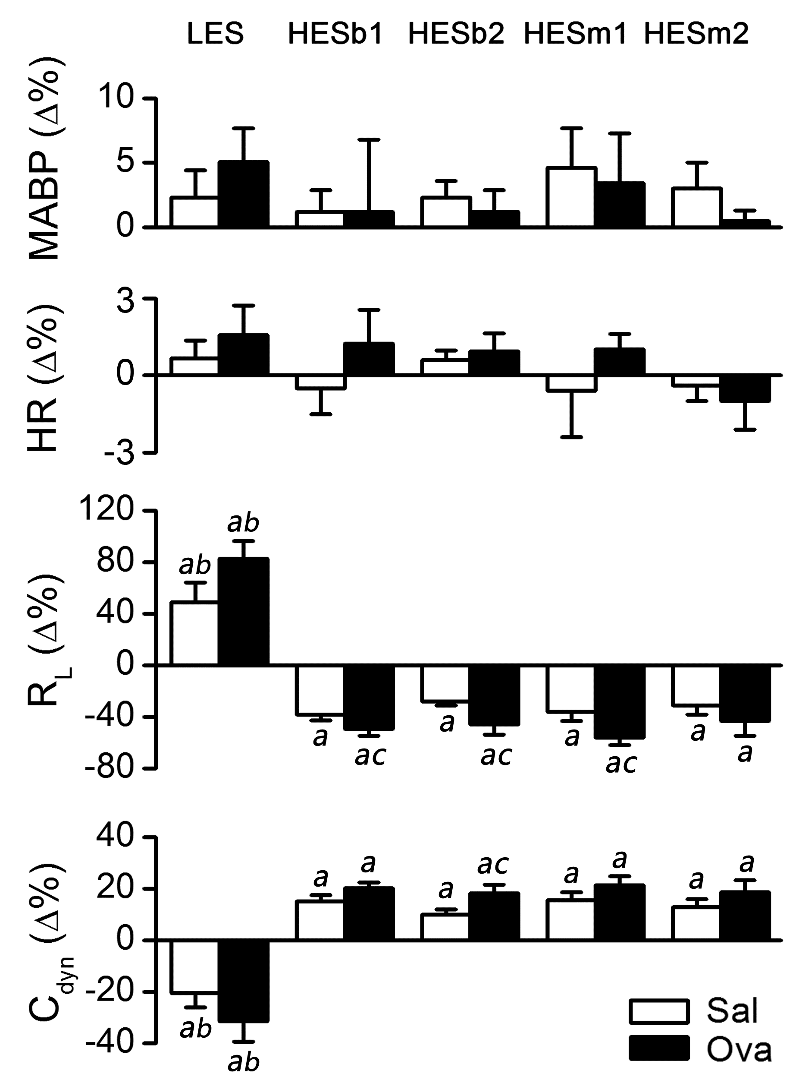
Figure 7 Airway and cardiovascular responses to the vagal electrical stimulations after exposure to methacholine aerosal (100 μg ml⁻¹ min⁻¹ for 2 min). MABP: Mean arterial blood pressure; HR: Heart rate; R_{L}: Total lung resistance; C_{dyn}: Pulmonary compliance. n = 8 and 9 in Sal- and Ova-treated guinea pigs; Mean ± SE. ªP < 0.01, compared to the data before methacholine (MCh) challenge; ^{b}P < 0.01 LES vs HESs; ^{c}P < 0.01 between Sal- and Ova-treated groups.

Table 1 Baseline parameters in the sal- and ova-treated guinea pigs
Animals | R_{L}  (cmH₂O s ml⁻¹) | C_{dyn}  (ml cmH₂O⁻¹) | MABP  (mmHg) | HR  (bpm)
Sal (n = 9) | 0.10 ± 0.02 | 0.35 ± 0.02 | 51.6 ± 1.6 | 327 ± 13
Ova (n = 8) | 0.12 ± 0.02 | 0.34 ± 0.03 | 55.2 ± 3.7 | 311 ± 9
No significant differences of total lung resistance (R_{L}), pulmonary compliance (C_{dyn}), mean arterial blood pressure (MABP), or heart rate (HR) were found between the two groups.

Table 2 The reproducibility of total lung resistance responses to methacholine exposure
Group | Amplitude (%) |  |  | Duration (min)
 | Trial 1 | Trial 2 | Trial 3 | Trial 1 | Trial 2 | Trial 3
Sal | 127 ± 25 | 136 ± 28 | 128 ± 30 | 7.9 ± 0.4 | 8.0 ± 0.5 | 7.5 ± 0.5
Ova | 355 ± 58 | 370 ± 68 | 351 ± 63 | 8.2 ± 0.5 | 8.4 ± 0.5 | 7.7 ± 0.6
n = 9 for saline- and Ova-treated guinea pigs for trial 1 and 2, and n = 5 for trial 3 for both groups; mean ± SE; No significant difference was found among the R_{L} amplitude and duration in response to the three methacholine exposures in both groups of animals.

