Name of Journal: World Journal of Clinical Cases
Manuscript NO: 58169
Manuscript Type: CASE REPORT

Gastroduodenal intussusception caused by gastric gastrointestinal stromal tumor: A case report and review of the literature

Hsieh YL et al. Gastroduodenal intussusception caused by gastric GIST

Yi-Lun Hsieh, Wen-Hung Hsu, Ching-Chun Lee, Chun-Chieh Wu, Deng-Chyang Wu, Jeng-Yih Wu

Yi-Lun Hsieh, Wen-Hung Hsu, Deng-Chyang Wu, Jeng-Yih Wu, Division of Gastroenterology, Department of Internal Medicine, Kaohsiung Medical University Hospital, Kaohsiung 807, Taiwan

Ching-Chun Lee, Division of Colorectal Surgery, Department of Surgery, Kaohsiung Medical University Hospital, Kaohsiung 807, Taiwan

Chun-Chieh Wu, Department of Pathology, Kaohsiung Medical University Hospital, Kaohsiung 807, Taiwan

Author contributions: Hsieh YL drafted the manuscript, Hsu WH, Lee CC, Wu CC, and Wu DC acquired and analyzed the data; Wu JY revised the manuscript critically for important intellectual content; all authors have read and approved the final manuscript.

Corresponding author: Jeng-Yih Wu, MD, Professor, Division of Gastroenterology, Department of Internal Medicine, Kaohsiung Medical University Hospital, No. 100 Tz-You 1st Road, Kaohsiung 807, Taiwan. joywu@kmu.edu.tw

Received: August 25, 2020
Revised: November 19, 2020
Accepted: December 10, 2020
Published online:

Abstract
BACKGROUND
Gastric gastrointestinal stromal tumor (GIST) is the most common etiology of gastroduodenal intussusception. Although gastroduodenal intussusception caused by gastric GIST is mostly treated by surgical resection, the first case of gastroduodenal intussusception caused by gastric GIST was treated by endoscopic submucosal dissection (ESD) in Japan in 2017.

CASE SUMMARY
An 84-year-old woman presented with symptoms of postprandial fullness with nausea and occasional vomiting for a month. Initially, she visited a local clinic for help, where abdominal sonography revealed a space-occupying lesion around the liver, so she was referred to our hospital for further confirmation. Abdominal sonography was repeated, which revealed a mass with an alternating concentric echogenic lesion. Esophagogastroduodenoscopy (EGD) was performed under the initial impression of gastric cancer with central necrosis and showed a tortuous distortion of gastric folds down from the lesser curvature side to the duodenal bulb with stenosis of the gastric outlet. EGD was barely passed through to the 2nd portion of the duodenum and a friable ulcerated mass was found. Several differential diagnoses were suspected, including gastroduodenal intussusception, gastric cancer invasion to the duodenum, or pancreatic cancer with adherence to the gastric antrum and duodenum. Abdominal computed tomography for further evaluation was arranged and showed gastroduodenal intussusception with a long stalk polypoid mass 5.9 cm in the duodenal bulb. Under the impression of gastroduodenal intussusception, ESD was performed at the base of the gastroduodenal intussusception; unfortunately, a gastric perforation was found after complete resection was accomplished, so gastrorrhaphy was performed for the perforation and retrieval of the huge polypoid lesion. The gastric tumor was pathologically proved to be a GIST. After the operation, there was no digestive disturbance and the patient was discharged uneventfully on the 10th day following the operation.

CONCLUSION
We present the second case of gastroduodenal intussusception caused by GIST treated by ESD. It is also the first case report of gastroduodenal intussusception by GIST in Taiwan, and endoscopic reduction or resection is an alternative treatment for elderly patients who are not candidates for surgery.

Key Words: Gastric gastrointestinal stromal tumor; Endoscopic submucosal dissection; Gastro-duodenal intussusception; Elderly; Esophagogastroduodenoscopy; Gastrointestinal obstruction; Case report

Hsieh YL, Hsu WH, Lee CC, Wu CC, Wu DC, Wu JY. Gastroduodenal intussusception caused by gastric gastrointestinal stromal tumor: A case report and review of the literature. World J Clin Cases 2020; In press

Core Tip: This is the first case report of gastroduodenal intussusception caused by gastrointestinal stromal tumor in Taiwan and endoscopic reduction or resection is an alternative treatment for elderly patients who are not candidates for surgery.
INTRODUCTION
Gastric outlet obstruction (GOO) is a clinical syndrome characterized by epigastric abdominal pain and postprandial vomiting due to mechanical obstruction. Benign disease such as peptic ulcer disease was responsible for 90% of cases until the late 1970s^{[1]}. With the decline in the incidence of peptic ulcer disease, it is estimated that 50-80% of all cases of GOO are attributable to malignancies. Distal gastric cancer remains a relatively common cause of malignant GOO, accounting for up to 35% of GOO cases^{[2]}. Gastro-duodenal intussusception is a rare cause of GOO in adults, and it is typically caused by a pathological leading point, malignant in over one half of cases^{[3]}. Herein, we report an 84-year-old woman with gastroduodenal intussusception caused by a gastric gastrointestinal stromal tumor (GIST).

CASE PRESENTATION
Chief complaints
An 84-year-old woman presented with symptoms of postprandial fullness with nausea and occasional vomiting for a month.

History of present illness
The patient suffered from persistent hematemesis and tarry stool complicated with orthostatic hypotension over the past 2-3 years. She complained about abdominal distress, abdominal fullness, nausea, and vomiting in recent one month. She first visited a local clinic, where abdominal sonography showed a liver tumor.

History of past illness
The patient had a history of hypertension, chronic kidney disease, and hepatitis B virus infection.

Personal and family history
The patient denied any personal history of alcohol, betel nuts, and cigarette consumption. She also denied travel, contact, and cluster history in recent 6 mo. As a housewife, she did not have any occupational history. Regarding her family history, she had one elder brother and four younger sisters. All of them did not have any malignancy history.

Physical examination
On the physical examination, the patient’s consciousness was alert (E4V5M6); her conjunctiva was not pale; she had anicteric sclera; her chest had symmetric movement with respiration; Her breath sound was bilaterally clear; and she had regular heart beat, flat abdomen, normoactive bowel sound, no muscle guarding, no tenderness, no rebound pain, and no pitting edema.

Laboratory examinations
The results of laboratory examinations are shown in Table 1.

Imaging examinations
Abdominal sonography was repeated, which revealed a mass with an alternating concentric echogenic lesion (Figure 1). EGD was performed under the initial impression of gastric cancer with central necrosis and showed a tortuous distortion of gastric folds down from the lesser curvature side to the duodenal bulb with stenosis of the gastric outlet (Figure 2A). EGD was barely passed through to the 2nd portion of the duodenum and a friable ulcerated mass was found (Figure 2B). Several differential diagnoses were suspected, including gastroduodenal intussusception, gastric cancer invasion to the duodenum, or pancreatic cancer with adherence to the gastric antrum and duodenum. Abdominal computed tomography for further evaluation was arranged and showed gastroduodenal intussusception with a long stalk polypoid mass (5.9 cm) in the duodenal bulb (Figure 3).

Further diagnostic work-up
Under the impression of gastroduodenal intussusception, endoscopic submucosal dissection (ESD) was performed at the base of the gastroduodenal intussusception; unfortunately, a gastric perforation was found after complete resection was accomplished, so gastrorrhaphy was performed for the perforation and retrieval of the huge polypoid lesion (Figure 4).

FINAL DIAGNOSIS
The gastric tumor was pathologically diagnosed as a GIST (Figure 5).

TREATMENT
Endoscopic resection and laparotomy were performed for gastric tumor removal and gastrorrhaphy.

OUTCOME AND FOLLOW-UP
The patient had a complete remission.

DISCUSSION
Regarding gastrointestinal obstruction in adults, symptoms are variable depending on the locations of obstruction, which range from small bowel obstruction followed by large intestine and gastric outlet complications^{[4]}. It is mostly caused by reasons such as adhesion, malignancy, and volvulus. In adults, intussusception accounts merely for 1% of mechanical gastrointestinal obstructions, representing a very rare cause^{[5]}. The symptoms of intussusception are nausea, vomiting, gastrointestinal bleeding, change in bowel habits, constipation, or abdominal pain^{[6]}. Ischemic change and peritonitis seldom occur but represent major critical complications of intussusception. In adults, intussusception is usually the result of lesions, including scar-like tissue in the intestine (adhesions) and prior surgery such as gastrointestinal bypass surgery for weight control, polyp, or tumor. The presenting case suffering from partial gastric outlet obstruction by gastroduodenal intussusception was managed by ESD and gastrorrhaphy proved that is was caused by a GIST.
GIST accounts for around 0.2% of all gastrointestinal tumors and occurs anywhere along the gastrointestinal tract, but most commonly in the stomach (40%-60%) and jejunum/ileum (25%-30%)^{[7]}. GIST is typically asymptomatic or has nonspecific symptoms (i.e., early satiety and bloating), unless they ulcerate, bleed, or grow large enough to cause pain or obstruction. Conceivably, gastroduodenal intussusception caused by GIST most commonly presents with nonspecific symptoms of acute or intermittent abdominal pain with vomiting lasting from days to several months^{[8]}. By reviewing the relevant literature, we found 41 cases of gastroduodenal intussusception within the past 20 years (Table 2)^{[9-44]}. Gastric GIST is the most common etiology and accounts for more than half of these cases, with the mean size of the GIST being 54.8 mm and the average age being 64.25 years (range, 29-95 years). Management of gastroduodenal intussusception included surgical intervention and endoscopic reduction in the past, and for the present case, endoscopic reduction of the invagination was tried but failed due to its large size (5.9 cm). Although gastroduodenal intussusception caused by gastric GIST is mostly treated by surgical resection, the first case of gastroduodenal intussusception caused by gastric GIST was treated by ESD in Japan in 2017^{[45]}, so ESD was also tried for this case with the result of complete resection although complicated with perforation. Finally, gastrorrhaphy repair and retrieval of the huge polypoid lesion were accomplished. Here we present the second case of gastroduodenal intussusception caused by GIST treated by ESD. It is also the first case report of gastroduodenal intussusception caused by GIST in Taiwan, and endoscopic reduction or resection is an alternative treatment for elderly patients who are not candidates for surgery.

CONCLUSION
We present the second case of gastroduodenal intussusception caused by GIST treated by endoscopic submucosal dissection. It is also the first case report of gastroduodenal intussusception caused by GIST in Taiwan, and endoscopic reduction or resection is an alternative treatment for elderly patients who are not candidates for surgery.

REFERENCES
1 Shone DN, Nikoomanesh P, Smith-Meek MM, Bender JS. Malignancy is the most common cause of gastric outlet obstruction in the era of H2 blockers. Am J Gastroenterol 1995; 90: 1769-1770 [PMID: 7572891]
2 Chowdhury A, Dhali GK, Banerjee PK. Etiology of gastric outlet obstruction. Am J Gastroenterol 1996; 91: 1679 [PMID: 8759707]
3 Marinis A, Yiallourou A, Samanides L, Dafnios N, Anastasopoulos G, Vassiliou I, Theodosopoulos T. Intussusception of the bowel in adults: a review. World J Gastroenterol 2009; 15: 407-411 [PMID: 19152443 DOI: 10.3748/wjg.15.407]
4 Markogiannakis H, Messaris E, Dardamanis D, Pararas N, Tzertzemelis D, Giannopoulos P, Larentzakis A, Lagoudianakis E, Manouras A, Bramis I. Acute mechanical bowel obstruction: clinical presentation, etiology, management and outcome. World J Gastroenterol 2007; 13: 432-437 [PMID: 17230614 DOI: 10.3748/wjg.v13.i3.432]
5 Azar T, Berger DL. Adult intussusception. Ann Surg 1997; 226: 134-138 [PMID: 9296505 DOI: 10.1097/00000658-199708000-00003]
6 Weilbaecher D, Bolin JA, Hearn D, Ogden W 2nd. Intussusception in adults. Review of 160 cases. Am J Surg 1971; 121: 531-535 [PMID: 5557762 DOI: 10.1016/0002-9610(71)90133-4]
7 Zakaria AH, Daradkeh S. Jejunojejunal intussusception induced by a gastrointestinal stromal tumor. Case Rep Surg 2012; 2012: 173680 [PMID: 23213593 DOI: 10.1155/2012/173680]
8 Đokić M, Novak J, Petrič M, Ranković B, Štabuc M, Trotovšek B. Case report and literature review: patient with gastroduodenal intussusception due to the gastrointestinal stromal tumor of the lesser curvature of the gastric body. BMC Surg 2019; 19: 158 [PMID: 31664984 DOI: 10.1186/s12893-019-0608-3]
9 Nakagawara M, Kajimura M, Hanai H, Shimizu S, Kobayashi H. Gastroduodenal intussusception secondary to a giant solitary gastric heterotopia: a case report. Gastrointest Endosc 2000; 52: 568-570 [PMID: 11023589 DOI: 10.1067/mge.2000.108923]
10 Sankaranunni B, Ooi DS, Sircar T, Smith RC, Barry J. Gastric lipoma causing gastroduodenal intussusception. Int J Clin Pract 2001; 55: 731-732 [PMID: 11777307]
11 Harrison JR, Ruchim M. Gastroduodenal intussusception. Gastrointest Endosc 2001; 53: 632 [PMID: 11323593 DOI: 10.1067/mge.2001.113586]
12 Mouës CM, Steenvoorde P, Viersma JH, van Groningen K, de Bruïne JF. Jejunal intussusception of a gastric lipoma: a review of literature. Dig Surg 2002; 19: 418-420 [PMID: 12435918 DOI: 10.1159/000065825]
13 Crowther KS, Wyld L, Yamani Q, Jacob G. Case report: gastroduodenal intussusception of a gastrointestinal stromal tumour. Br J Radiol 2002; 75: 987-989 [PMID: 12515708 DOI: 10.1259/bjr.75.900.750987]
14 Vinces FY, Ciacci J, Sperling DC, Epstein S. Gastroduodenal intussusception secondary to a gastric lipoma. Can J Gastroenterol 2005; 19: 107-108 [PMID: 15729430 DOI: 10.1155/2005/146149]
15 Juglard R, Rimbot A, Stéphant E, Paoletti H, Talarmin B, Arteaga C. [Gastroduodenal intussusception complicating Menetrier's disease]. J Radiol 2006; 87: 69-71 [PMID: 16415785 DOI: 10.1016/s0221-0363(06)73974-9]
16 Adjepong SE, Parameswaran R, Perry A, Mathews R, Jones R, Butterworth JR, Sigurdsson A. Gastroduodenal intussusception due to gastrointestinal stromal tumor (GIST) treated by laparoscopic billroth II distal gastrectomy. Surg Laparosc Endosc Percutan Tech 2006; 16: 245-247 [PMID: 16921305 DOI: 10.1097/00129689-200608000-00010]
17 Samamé J, Moreno JI, Maraschio MA. [Gastroduodenal intussusception due to gastrointestinal stromal tumor]. Cir Esp 2007; 82: 131 [PMID: 17785150 DOI: 10.1016/s0009-739x(07)71682-2]
18 Shum JS, Lo SS, Ka SY, Yeung CW, Ho JT. Gastroduodenal intussusception. Abdom Imaging 2007; 32: 698-700 [PMID: 17285402 DOI: 10.1007/s00261-007-9179-3]
19 Alamili M, Berg JO, Lindström C, Jensen CV, Wettergren A. [Gastroduodenal intussusception causing gastric retention]. Ugeskr Laeger 2008; 170: 753 [PMID: 18307965]
20 Siam FA, Siow SL. Stomach gastrointestinal stromal tumours (GIST) intussuscepted into duodenum: a case report. Malays J Med Sci 2008; 15: 68-70 [PMID: 22589640]
21 Su PY, Yen HH, Chen CJ. Clinical challenges and images in GI. Peutz-Jeghers syndrome with gastroduodenal intussusception secondary to gastric cancer. Gastroenterology 2009; 136: 774, 1125 [PMID: 19167388 DOI: 10.1053/j.gastro.2008.06.037]
22 Hillenbrand A, Waidner U, Henne-Bruns D, Maria Wolf A, Buttenschoen K. After 3 years of starvation: duodenum swallowed remaining stomach. Obes Surg 2009; 19: 664-666 [PMID: 19291339 DOI: 10.1007/s11695-009-9819-5]
23 Chan CT, Wong SK, Ping Tai Y, Li MK. Endo-laparoscopic reduction and resection of gastroduodenal intussuception of gastrointestinal stromal tumor (GIST): a synchronous endoscopic and laparoscopic treatment. Surg Laparosc Endosc Percutan Tech 2009; 19: e100-e103 [PMID: 19542829 DOI: 10.1097/SLE.0b013e3181a03f07]
24 Eom BW, Ryu KW, Lee JH, Lee JY, Lee JS, Kook MC, Kim YW. Gastrogastric intussusception secondary to a gastric carcinoma: Report of a case. Surg Today 2011; 41: 1424-1427 [PMID: 21922370 DOI: 10.1007/s00595-010-4439-1]
25 Euanorasetr C, Suwanthanma W. Transpyloric prolapse of a pedunculated polypoid gastric carcinoma: a case report and review of the literature. J Med Assoc Thai 2011; 94: 1008-1012 [PMID: 21863686]
26 Gyedu A, Reich SB, Hoyte-Williams PE. Gastrointestinal stromal tumour presenting acutely as gastroduodenal intussusception. Acta Chir Belg 2011; 111: 327-328 [PMID: 22191138]
27 Seok HS, Shon CI, Seo HI, Choi YG, Chung WG, Won HS. [Gastroduodenal intussusception due to pedunculated polypoid gastrointestinal stromal tumor]. Korean J Gastroenterol 2012; 59: 372-376 [PMID: 22617532 DOI: 10.4166/kjg.2012.59.5.372]
28 Wilson MH, Ayoub F, McGreal P, Collins C. Gastrointestinal stromal tumour presenting as gastroduodenal intussusception. BMJ Case Rep 2012; 2012: [PMID: 22927285 DOI: 10.1136/bcr-2012-006787]
29 Chen YY, Chen TW, Chen YF. Asymptomatic multiple gastric and duodenal tumors. Sporadic gastric hamartomatous polyps with gastroduodenal intussusception and adenocarcinoma transformation. Gastroenterology 2013; 145: e7-e8 [PMID: 23900102 DOI: 10.1053/j.gastro.2013.05.055]
30 Rittenhouse DW, Lim PW, Shirley LA, Chojnacki KA. Gastroduodenal intussusception of a gastrointestinal stromal tumor (GIST): case report and review of the literature. Surg Laparosc Endosc Percutan Tech 2013; 23: e70-e73 [PMID: 23579533 DOI: 10.1097/SLE.0b013e31826d72d4]
31 Chahla E, Kim MA, Beal BT, Alkaade S, Garrett RW, Omran L, Ogawa MT, Taylor JR. Gastroduodenal Intussusception, Intermittent Biliary Obstruction and Biochemical Pancreatitis due to a Gastric Hyperplastic Polyp. Case Rep Gastroenterol 2014; 8: 371-376 [PMID: 25685129 DOI: 10.1159/000369548]
32 Khanna M, Ramanathan S, Ahmed A, Kumar D. Gastroduodenal intussusception secondary to a pedunculated Brunner's gland hamartoma: CT and endoscopic features. J Gastrointest Cancer 2014; 45 Suppl 1: 257-260 [PMID: 25316097 DOI: 10.1007/s12029-014-9656-1]
33 Kadowaki Y, Nishimura T, Komoto S, Yuasa T, Tamura R, Okamoto T, Ishido N. Gastroduodenal intussusception caused by a gastric collision tumor consisting of adenocarcinoma and neuroendocrine carcinoma. Case Rep Gastroenterol 2014; 8: 89-94 [PMID: 24803892 DOI: 10.1159/000356818]
34 Yang JH, Zhang M, Zhao ZH, Shu Y, Hong J, Cao YJ. Gastroduodenal intussusception due to gastric schwannoma treated by Billroth II distal gastrectomy: one case report. World J Gastroenterol 2015; 21: 2225-2228 [PMID: 25717262 DOI: 10.3748/wjg.v21.i7.2225]
35 M S PB, Reddy CK, Augustine AJ, Sagari SG. Gastroduodenal intussusception due to pedunculated polypoid gastrointestinal stromal tumour (gist ): a rare case. J Clin Diagn Res 2015; 9: PD05-PD06 [PMID: 25738026 DOI: 10.7860/JCDR/2015/10457.5370]
36 Indiran V, Vinoth Kumar R, Maduraimuthu P. Gastrointestinal stromal tumor presenting as gastroduodenal intussusception. Indian J Gastroenterol 2015; 34: 347-348 [PMID: 26293600 DOI: 10.1007/s12664-015-0587-y]
37 Yildiz MS, Doğan A, Koparan IH, Adin ME. Acute Pancreatitis and Gastroduodenal Intussusception Induced by an Underlying Gastric Gastrointestinal Stromal Tumor: A Case Report. J Gastric Cancer 2016; 16: 54-57 [PMID: 27104028 DOI: 10.5230/jgc.2016.16.1.54]
38 Komatsubara T, Zuiki T, Lefor AK, Hirota N, Oki J. Unusual gastroduodenal intussusception secondary to a gastrointestinal stromal tumor of the gastric fundus. IJS Open 2016; 5: 33-36 [DOI: 10.1016/j.ijso.2016.10.002]
39 Jameel ARA, Segamalai D, Murugaiyan G, Shanmugasundaram R, Obla NB. Gastroduodenal Intussusception due to Gastrointestinal Stromal Tumour (GIST). J Clin Diagn Res 2017; 11: PD09-PD10 [PMID: 28969200 DOI: 10.7860/JCDR/2017/26292.10398]
40 Casimiro Pérez JA, Fernández Quesada C, Rodríguez Méndez Á, Sánchez Guedez I. Gastroduodenal invagination secondary to gastric submucosal lipoma treated by laparoscopic transgastric excision. Cir Esp 2018; 96: 235 [PMID: 29033072 DOI: 10.1016/j.ciresp.2017.09.003]
41 Zhou Y, Wu XD, Shi Q, Xu CH, Jia J. Gastroduodenal intussusception and pylorus obstruction induced by a c-KIT-negative gastric gastrointestinal stromal tumor: case report and review of the literature. Z Gastroenterol 2018; 56: 374-379 [PMID: 29346826 DOI: 10.1055/s-0043-122605]
42 Ssentongo P, Egan M, Arkorful TE, Dorvlo T, Scott O, Oh JS, Amponsah-Manu F. Adult Intussusception due to Gastrointestinal Stromal Tumor: A Rare Case Report, Comprehensive Literature Review, and Diagnostic Challenges in Low-Resource Countries. Case Rep Surg 2018; 2018: 1395230 [PMID: 30159192 DOI: 10.1155/2018/1395230]
43 De U, Basu S. Gastroduodenal intussusception due to gastrointestinal stromal tumor. Clin Case Rep 2018; 6: 2276-2278 [PMID: 30455936 DOI: 10.1002/ccr3.1786]
44 Suda T, Hodo Y, Shirota Y. Gastroduodenal intussusception of a gastric carcinoma. Dig Endosc 2019; 31: e38-e39 [PMID: 30536924 DOI: 10.1111/den.13313]
45 Yamauchi K, Iwamuro M, Ishii E, Narita M, Hirata N, Okada H. Gastroduodenal Intussusception with a Gastric Gastrointestinal Stromal Tumor Treated by Endoscopic Submucosal Dissection. Intern Med 2017; 56: 1515-1519 [PMID: 28626176 DOI: 10.2169/internalmedicine.56.8160]

Footnotes
Informed consent statement: The patient provided informed written consent for the publication of this case report.

Conflict-of-interest statement: The authors declare that they have no conflict of interest to report.

CARE Checklist (2016) statement: The authors have read the CARE Checklist (2016), and the manuscript was prepared and revised according to the CARE Checklist (2016).

Open-Access: This article is an open-access article that was selected by an in-house editor and fully peer-reviewed by external reviewers. It is distributed in accordance with the Creative Commons Attribution NonCommercial (CC BY-NC 4.0) license, which permits others to distribute, remix, adapt, build upon this work non-commercially, and license their derivative works on different terms, provided the original work is properly cited and the use is non-commercial. See: http://creativecommons.org/Licenses/by-nc/4.0/

Manuscript source: Unsolicited manuscript

Peer-review started: August 25, 2020
First decision: November 8, 2020
Article in press:

Specialty type: Gastroenterology and hepatology
Country/Territory of origin: Taiwan
Peer-review report’s scientific quality classification
Grade A (Excellent): 0
Grade B (Very good): B, B
Grade C (Good): C
Grade D (Fair): 0
Grade E (Poor): 0

P-Reviewer: D'Orazi V, Ozen H S-Editor: Zhang L L-Editor: Wang TQ P-Editor:
Figure legends
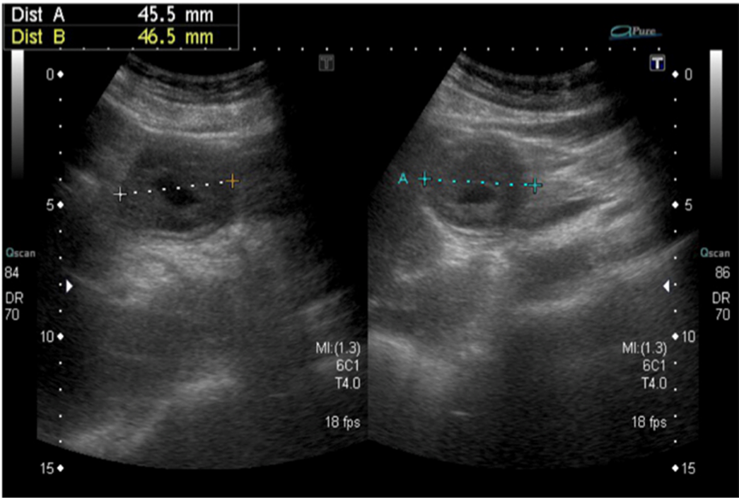
Figure 1 Abdominal ultrasound revealed the doughnut sign, measuring 4.5 cm × 4.6 cm.
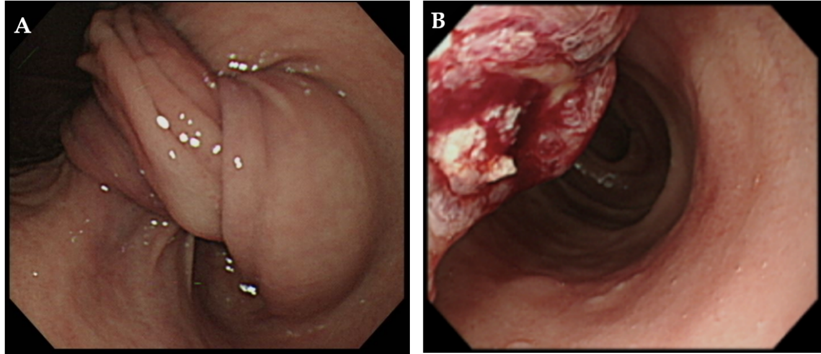
Figure 2 Esophagogastroduodenoscopy. A: Gastro-duodenal intussusception; B: Ulcerated polypoid lesion.
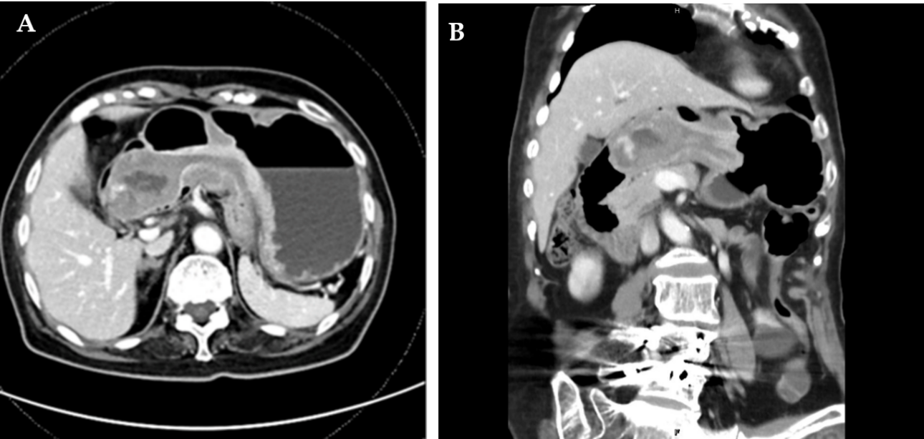
Figure 3 Abdominal computed tomography revealed intussusception with a long stalk polypoid mass 5.9 cm in the duodenal bulb. A: Axial view; B: Coronal view.
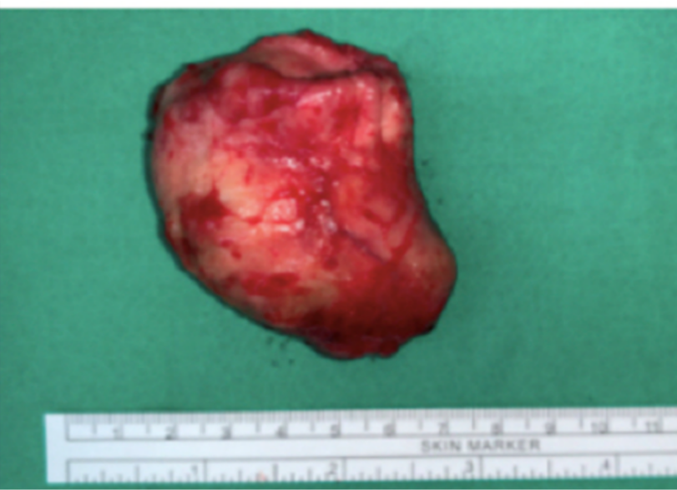
Figure 4 Cardia submucosal tumor measuring 5.6 cm × 4.5 cm × 3.5 cm.
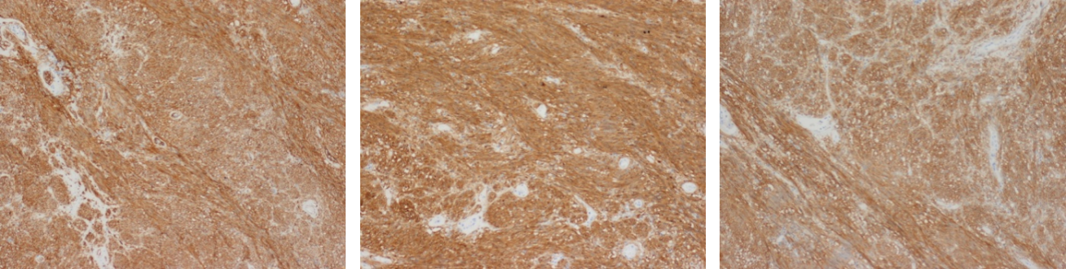
Figure 5 Microscopic examination.
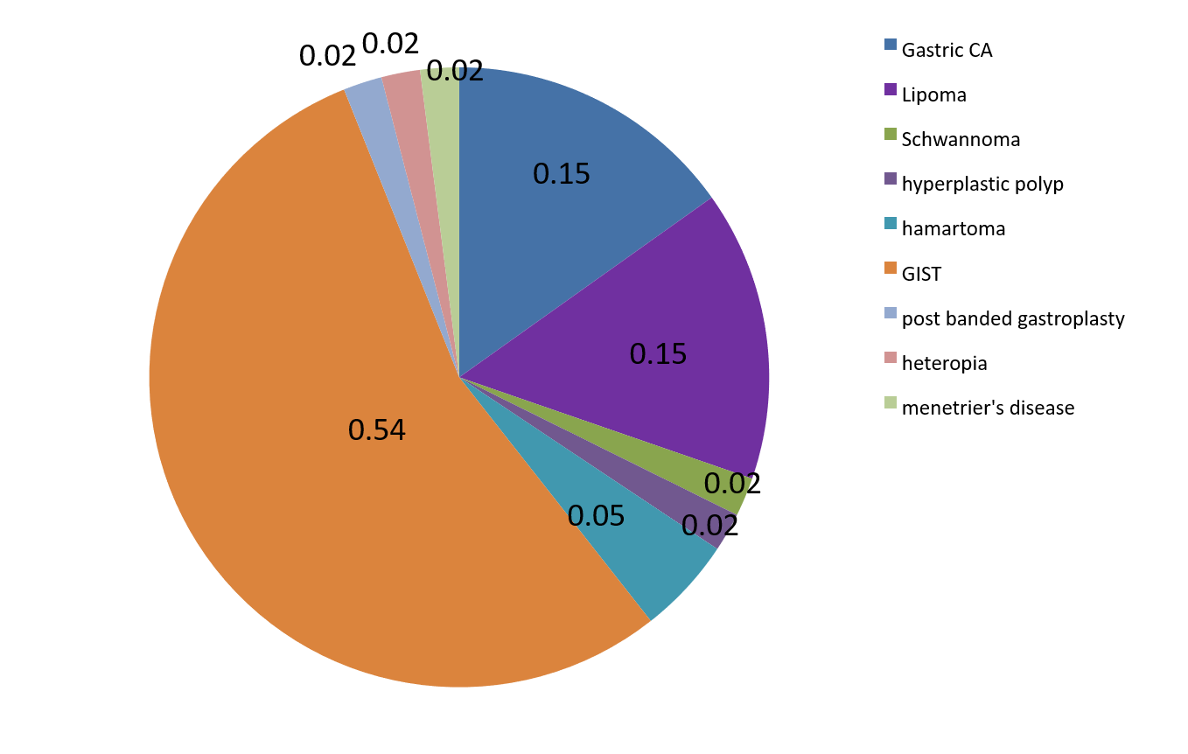
Figure 6 Etiologies. GIST: Gastrointestinal stromal tumor.
Table 1 Laboratory examinations
 | Result | Reference range
WBC | 9.37 | 4.4-11.3 × 10⁹ L
Hb | 9.1 | 12.3-15.3 g/dL
Plt | 302 | (160-370) × 1000/uL
CRP | 2.04 | mg/L
Crea | 1.53 | mg/dL
BUN | 25.9 | mg/dL
Na | 139 | mmol/L
K | 3.9 | mmol/L
GOT | 16 | IU/L
GPT | 11 | IU/L
INR | 0.97
PTT | 24.3 | sec
CEA | 3.58
WBC: White blood cells; Hb: Hemoglobin; Plt: Platelets; CRP: C reactive protein; Crea: Creatinine; BUN: Blood urea nitrogen; GOT: Glutamic oxalacetic transaminase; GPT: Glutamic pyruvic transaminase; CEA: Carcinoma embryonic antigen.
Table 2 Review of case reports on gastroduodenal intussusception
Ref. | Year | Age | Sex | Diagnosis | Pathology report | Management | Size
Nakagawara et al^{[9]} | 2000 | 50 | F | EGD | Gastric heterotopia | Endoscopic polypectomy | 30 mm × 36 mm
Sankaranunni et al^{[10]} | 2001 | 48 | M | CT | Gastric lipoma | Laparotomy | NA
Harrison et al^{[11]} | 2001 | 76 | M | EGD | Leiomyoma | Laparotomy | 50 mm × 42 mm
Mouës et al^{[12]} | 2002 |  |  | EGD and CT | Gastric lipoma | Laparotomy | 50 mm × 100 mm
Crowther et al^{[13]} | 2002 | 59 | F | CT | GIST | Partial gastrectomy | 60 mm
Vinces et al^{[14]} | 2005 | 72 | M | laparoscopy | Gastric lipoma | Exploratory laparotomy | NA
Vinces et al^{[14]} | 2006 |  |  |  | Gastric lipoma |  | NA
Juglard et al^{[15]} | 2006 |  |  |  | Ménétrier’s disease |  | NA
Adjepong et al^{[16]} | 2006 | 84 | M | CT | GIST | Laparoscopic Billroth II partial gastrectomy | 40 mm × 30 mm
Samamé et al^{[17]} | 2007 |  |  |  | GIST |  | NA
Shum et al^{[18]} | 2007 | 34 | F | CT | GIST | Partial gastrectomy | 50 mm × 50 mm
Shum et al^{[18]} | 2008 | 67 | M | Ultrasound and EGD | Gastric carcinoma | Surgical resection | 45 mm × 40 mm
Alamili et al^{[19]} | 2008 |  |  | CT | Duodenal lipoma | Surgical resection | NA
Siam et al^{[20]} | 2008 | 29 | M | EGD | GIST | Partial Gastrectomy | 60 mm × 60 mm
Su et al^{[21]} | 2009 | 24 | M | EGD | Gastric carcinoma (PJS) | Surgical resection | 30 mm
Hillenbrand et al^{[22]} | 2009 | 42 | F | CT | Post banded gastroplasty | Surgical reduction
Chan et al^{[23]} | 2009 | 34 | F | CT | GIST | Laparoscopic wedge resection | 65 mm × 44 mm
Eom et al^{[24]} | 2011 | 73 | F | CT and EGD | Gastric carcinoma | Subtotal gastrectomy | 78 mm × 75 mm
Euanorasetr et al^{[25]} | 2011 |  |  |  | Gastric carcinoma | Subtotal gastrectomy | NA
Gyedu et al^{[26]} | 2011 | 59 | F | CT and US | GIST | Partial gastrectomy | 70 mm × 60 mm
Seok et al^{[27]} | 2012 | 51 | M | CT and EGD | GIST | Gastric partial resection | 55 mm × 42 mm
Seok et al^{[27]} | 2012 | 62 | F | EGD and CT | GIST | Billroth II partial gastrectomy | 52 mm × 35 mm
Wilson et al^{[28]} | 2012 | 78 | F | CT | GIST | Laparoscopic wedge resection | 44 mm × 33 mm
Chen et al^{[29]} | 2013 | 63 | F | CT and EGD | Gastric hamartomatous polyp | Endoscopic mucosal resection | NA
Rittenhouse et al^{[30]} | 2013 | 52 | F | CT | GIST | Laparoscopic wedge resection | 50 mm × 50 mm
Chahla et al^{[31]} | 2014 | 76 | M | CT | Gastric hyperplastic polyp | Endoscopic resection | < 30 mm
Khanna et al^{[32]} | 2014 | 33 | M | CT and EGD | Brunner’s gland hamartoma | Duodenostomy and polypectomy | 35 mm × 70 mm
Kadowaki et al^{[33]} | 2014 | 77 | F | Laparotomy | Gastric collision tumor | Gastrotomy followed by duodenotomy | 120 mm
Yang et al^{[34]} | 2015 | 63 | M | CT | Gastric schwannoma | Conventional laparotomy | 55 mm × 48 mm
M S et al^{[35]} | 2015 | 74 | M | CT | GIST | Partial gastrectomy | NA
Indiran et al^{[36]} | 2015 |  |  |  | GIST |  | NA
Yildiz et al^{[37]} | 2016 | 85 | F | CT | GIST | Subtotal gastrectomy | 60 mm × 50 mm
Komatsubara et al^{[38]} | 2016 | 90 | F | EGD | GIST | Wedge resection | 50 mm × 45 mm
Yamauchi et al^{[9]} | 2017 | 95 | F | CT | GIST | Endoscopic submucosal  dissection | 42 mm × 39 mm
Jameel et al^{[39]} | 2017 | 65 | F | EGD and CT | GIST | Laparoscopic resection | 60 mm × 60 mm
Casimiro Pérez et al^{[40]} | 2018 | 55 | M | EGD and CT | Gastric submucosal lipoma | Laparoscopic transgastric excision | 63 mm × 55 mm
Zhou et al^{[41]} | 2018 | 69 | M | EGD and CT | GIST | Laparoscopic resection | 45 mm × 40 mm
Ssentongo et al^{[42]} | 2018 | 85 | F | CT | GIST | Wedge resection | 25 mm × 25 mm
De et al^{[43]} | 2018 | 42 | F | EGD | GIST | Surgical resection | 80 mm × 70 mm
Đokić et al^{[8]} | 2019 | 62 | M | CT and US | GIST | Laparotomy resection | 75 mm × 55 mm
Suda et al^{[44]} | 2019 | 81 | F | EGD and CT | Gastric carcinoma | Laparoscopic gastrectomy | 55 mm
Our case | 2020 | 84 | M | US and EGD and CT | GIST | Endoscopic submucosal  dissection and surgical repair | 59 mm
EGD: Esophagogastroduodenoscopy; F: Female; CT: Computed tomography; GIST: Gastrointestinal stromal tumor; M: Male; NA: Not available.

