Name of Journal: World Journal of Gastrointestinal Endoscopy
ESPS Manuscript NO: 22524
Manuscript Type: ORIGINAL ARTICLE

Observational Study
Cap assisted endoscopic sclerotherapy or hemorrhoids: Methods, feasibility and efficacy

Zhang T et al. Cap assisted endoscopic sclerotherapy for hemorrhoids

Ting Zhang, Li-Juan Xu, Jie Xiang, Zhi He, Zhao-Yuan Peng, Guang-Ming Huang, Guo-Zhong Ji, Fa-Ming Zhang

Ting Zhang, Li-Juan Xu, Jie Xiang, Zhi He, Zhao-Yuan Peng, Guang-Ming Huang, Guo-Zhong Ji, Fa-Ming Zhang, Medical Center for Digestive Diseases, the Second Affiliated Hospital of Nanjing Medical University, Nanjing 210011, Jiangsu Province, China

Ting Zhang, Li-Juan Xu, Jie Xiang, Zhi He, Zhao-Yuan Peng, Guang-Ming Huang, Guo-Zhong Ji, Fa-Ming Zhang, Key Lab of Holistic Integrative Enterology, Nanjing Medical University, Nanjing 210011, Jiangsu Province, China

Author contributions: Zhang T and Xu LJ contributed equally to this work; Zhang T, Xu LJ, Xiang J, He Z, Peng ZY, Huang GM, Ji GZ and Zhang FM designed the research; Xu LJ, Xiang J, Huang GM and Ji GZ peformed the research; He Z and Peng ZY analyzed the data; Zhang T and Zhang FM wrote the paper.

Supported by Intestine Initiative Foundation, Clinical Science and Technology Foundation of Jiangsu Province, No. BL2014097; the National Science and Technology Major Project, No. 2012BAI06B03; and National Gastroenterology Research Project, No. 2015BAI13B07.

Institutional review board statement: The study was reviewed and approved by the Second Affiliated Hospital of Nanjing Medical University Institutional Review Board.

Informed consent statement: All study participants, or their legal guardian, provided informed written consent prior to study enrollment.

Conflict-of-interest statement: We declare that there are no conflicts of interest to disclose.

Data sharing statement: No additional data are available.

Open-Access: This article is an open-access article which was selected by an in-house editor and fully peer-reviewed by external reviewers. It is distributed in accordance with the Creative Commons Attribution Non Commercial (CC BY-NC 4.0) license, which permits others to distribute, remix, adapt, build upon this work non-commercially, and license their derivative works on different terms, provided the original work is properly cited and the use is non-commercial. See: http://creativecommons.org/licenses/by-nc/4.0/

Correspondence to: Fa-Ming Zhang, MD, PhD, Medical Center for Digestive Diseases, the Second Affiliated Hospital of Nanjing Medical University, 121 Jiang Jiayuan, Nanjing 210011, Jiangsu Province, China. fzhang@njmu.edu.cn
Telephone: +86-25-58509883
Fax: +86-25-58509931

Received: September 1, 2015
Peer-review started: September 1, 2015
First decision: October 14, 2015
Revised: October 20, 2015
Accepted: December 3, 2015
Article in press:
Published online:

Abstract
AIM: To evaluate the methodology, feasibility, safety and efficacy of a novel method named cap assisted endoscopic sclerotherapy for internal hemorrhoids.

METHODS: A pilot study on cap assisted endoscopic sclerotherapy (CAES) for grade I to III internal hemorrhoids was performed. Colon and terminal ileum examination by colonoscopy was performed for all patients before starting CAES. Polypectomy and excision of anal papilla fibroma would be performed if polyps or anal papilla fibroma were found and assessed to be suitable for resection under endoscopy. CAES was performed based on the requirement of cap, endoscope, disposable endoscopic long injection needle, enough insufflated air and sclerosing agent.

RESULTS: Totally 30 patients with grade I to III internal hemorrhoids was included. The follow-up was more than four weeks. No bleeding was observed after CAES. One (3.33%) patient claimed mild tenesmus within four days after CAES in that an endoscopist performed this procedure for the first time. 100% of patients were satisfied with this novel procedure, especially for those patients who underwent CAES in junction with polypectomy or excision of anal papilla fibroma.

CONCLUSION: CAES as a novel endoscopic sclerotherapy, should be a convenient, safe and effective flexible endoscopic therapy for internal hemorrhoids.

Key words: Sclerotherapy; Hemorrhoids; Cap assisted endoscopic sclerotherapy; Colonoscopy; Colon; Papilla fibroma; Hemorrhoidal disease

© The Author(s) 2015. Published by Baishideng Publishing Group Inc. All rights reserved.

Core tip: Sclerotherapy is the most effective therapy for grade I or II internal hemorrhoids. Traditional sclerotherapy may cause iatrogenic risk due to misplaced injections. We designed a novel technique named cap assisted endoscopic sclerotherapy (CAES) for hemorrhoids by flexible endoscopy. Our study demonstrated CAES is a safe, effective and convenient endoscopic therapeutic strategy for grade I, grade II and partial grade III internal hemorrhoids. The colon preparation and colonoscopy before CAES brought more benefits for patients, including possible polypectomy and excision of anal papilla fibroma under colonoscopy. This study implies the future contribution of endoscopists on the hemorrhoidal disease.

Zhang T, Xu LJ, Xiang J, He Z, Peng ZY, Huang GM, Ji GZ, Zhang FM. Cap assisted endoscopic sclerotherapy or hemorrhoids: Methods, feasibility and efficacy. World J Gastrointest Endosc 2015; In press

INTRODUCTION
Hemorrhoidal disease is one of the most common anorectal disorders that affects mainly adults of any age and sex^{[1-4]}. The aetiology of hemorrhoids remains controversial. Nowadays, the most widely accepted theory is that hemorrhoidal disease is the abnormal dilatation and distortion of the vascular channel, together with destructive changes in the supporting connective tissue of the anal cushion^{[5]}. The submucosal vascular cushions are normal anatomical structure of the anal canal, and their existence with symptoms such as bleeding, prolapse, pain, thrombosis, mucus discharge, and pruritus indicates hemorrhoidal disease^{[6]}. The true incidence of hemorrhoids is difficult to estimate, as many patients are reluctant to seek medical suggestions for various personal, cultural, and socioeconomic reasons^{[7]}. Approximately 50 percent of the individuals require treatment of hemorrhoids in their 50’s or older, and 10-20% of the patients need surgical therapies^{[8]}.
Hemorrhoids have been well described for thousands of years. However, the treatment of hemorrhoids has only substantially evolved during the past few decades^{[1]}. The current therapies for hemorrhoids can be grouped into conservative management, office-based procedures and surgical treatment^{[8-10]}. Increased fiber intake, medical therapies as well as lifestyle changes are included in the conservative treatment options for nonthrombosed hemorrhoids^{[10]}. If conservative management is unsuccessful, several office-based modalities could be options, including rubber-band ligation, injection sclerotherapy, laser photocoagulation, bipolar diathermy, cryotherapy, doppler-guided hemorrhoidal artery ligation and infrared coagulation^{[8,9,11]}. When an office-based therapy is still ineffective, patients may consider further intervention, such as hemorrhoidectomy, thrombectomy of external hemorrhoid and stapled hemorrhoidectomy^{[7,9]}.
As an crucial component of many non-surgical practices, sclerotherapy is most effective for grade I and II internal hemorrhoids, especially for the patients who are accompanied with an increased risk of bleeding^{[2]}. However, traditional sclerotherapy is performed by physicians through anoscope. This method may cause iatrogenic risk and complications due to misplaced injections^{[2]}. Therefore, there is a scope for improvement in the field of sclerotherapy for hemorrhoids.
With the development of interventional flexible endoscopy, in order to solve the problems above, we designed a novel method named cap assisted endoscopic sclerotherapy (CAES) for internal hemorrhoids. This article presented our pilot study on the methodology, feasibility, safety and clinical findings using CAES for internal hemorrhoids.

MATERIALS AND METHODS
Patients inclusion and exclusion criteria
This observational study was carried out in the Second Affiliated Hospital of Nanjing Medical University. All eligible patients with symptoms and signs of grade I, grade II or grade III internal hemorrhoids requiring further interventional procedure after failure of conservative treatment were included in the study. Internal hemorrhoids are graded based on protrusion and reducibility (grade I, hemorrhoids characterized by prominent vasculature with engorgement but no prolapse; grade II, hemorrhoids prolapse only with straining but spontaneously reduce; grade III, hemorrhoids prolapse beyond the dentate line with straining and require manual reduction; grade IV, hemorrhoids prolapse beyond the dentate line with straining but cannot be reduced manually)^{[12,13]}. All included cases for analysis were followed up at least four weeks.
Acute thrombosed hemorrhoids with anal pain, stricture, fissure, fistula, fecal incontinence, ulcerative colitis, Crohn’s disease and any bleeding risk condition were excluded. Patients with acute diarrhea in the last 12 h, severe complications, cancer, stroke, pregnancy, puerperium, mental disorders as well as portal hypertension were also excluded. Colon and terminal ileum examination by colonoscopy was performed for all patients before starting CAES. Polypectomy would be performed if polyps were found and assessed to be suitable to be resected under endoscope. The informed consent was obtained from all participants.

Concept and methods of CAES
As shown in Figure 1, the regular cap used in endoscopic submucosal dissection was fixed on the top of the colonoscope. This cap is used to maximize visibility of endoscopic view with the enough insufflated air through channel within endoscope. A disposable endoscopic long injection needle (e.g., the special designed long needle: EN-123, 15 mm length, 22 g, Detian Medical, Changzhou, China) through operating channel is used for injection of sclerosing agent. The needle is advanced into submucosa of targeting area of hemorrhoids. The injecting points are above the dentate line. The sclerosing agent (Lauromacrogol Injection, Tianyu Pharmaceutical, Xi'an, China), 1-2 mL for each injecting point is injected while retracting the needle out slowly. During the procedure, enough air was given for exposure of endoscopic view. Before the complete retrieval of needle from tissue, as a suggestion, if you do not withdraw and stop the needle from moving for 5 seconds, it is found to be helpful to prevent bleeding. To perform the same procedure for each targeting site under endoscopic view. Before taking out the endoscope, enough suction of air in colon and visible rectal contents should be done for avoiding or relieving abdominal distention and the feeling of defecation after the procedure.

Preparation and education
Although it was suggested to have an antibiotic prophylaxis for predisposing valvular heart disease because of the possibility of bacteremia after sclerotherapy^{[14]}, antibiotics were not used before and after CAES in this study. Besides, for safety consideration and observational requirement in this study, patients were required to have rest in bed on the first night after the procedure. All individuals were required to follow the medical instructions for avoiding constipation and diarrhea. Medicines were prescribed to soften the stools after procedure if the patient had constipation.

Safety and satisfaction survey
The complications were recorded during and four weeks after CAES. Intensity of CAES and relationship between the complications and CAES were described using Common Terminology Criteria for Adverse Events (version 3.0). Intensity of complications was classified as mild, moderate, severe, and disabling. Relationship between the complications and CAES was categorized as unrelated, possible, probable, and definitely related to CAES. All patients were required to have a face to face communication at doctor’s office for the assessment of safety, efficacy and degree of satisfaction on the CAES. The level of satisfaction was classified into two degrees: positive, satisfied and pleased to introduce the CAES to other patients; negative, not satisfied and did not like this procedure. The second colonoscopy would be performed if the patient had bleeding or any other anorectal symptoms.

RESULTS
Patients’ characteristics
The Table 1 showed the characteristics of the patients, including gender, age, classification of the internal hemorrhoids, grade of prolapse, previous hemorrhoidectomy history and other related information. Totally 30 patients with grade I, grade II or grade III internal hemorrhoids were included for analysis in this study.

Clinical findings
Colon and terminal ileum examination by colonoscopy before CAES was performed among all patients for differential diagnosis of other possible diseases related to intestinal bleeding. No complications were observed during the procedure. However, we have to highlight that the needle couldn’t be retrieved immediately when the injection was finished. It is suggested to keep the needle stable within the tissue for 5 s. If the needle was taken out from the tissue too quickly, bleeding would occur and the endoscopic view would be affected by the blood. Figure 2 showed the procedures of CAES for internal hemorrhoids and the excision for anal papilla fibroma.
The patients were required to stay in hospital for 12 h after procedure for safety consideration in the present pilot observational study. No complications were observed during and after the procedure of polypectomy, CAES, excision of anal papilla fibroma and biopsy of polyps on the hemorrhoids lesion. All patients could return to normal activities after they were discharged from hospital. One (3.33%) patient claimed mild tenesmus within four days after CAES. This adverse event was finally confirmed as the reason that one injection site was chosen below dentate line by an endoscopist who performed this procedure for the first time. 100% of patients were satisfied with this novel procedure. Those patients who underwent CAES in junction with polypectomy or excision of anal papilla fibroma expressed strong feeling of satisfaction for the therapeutic strategy.

DISCUSSION
Sclerotherapy dates back at least one century^{[15]} and has been regarded as traditional therapy for grade I and II internal hemorrhoids. A variety of sclerosing agents including ethanolamine, quinine, hypertonic saline solution, 5% phenol in oil, as well as aluminum potassium sulfate and tannic acid have been used in injection sclerotherapy for treating hemorrhoids^{[16-19]}. Traditionally doctors had to use an anoscope during the sclerotherapy procedure. Misplacement of the sclerosing injection may result in potential complications including pain, impotence, prostatitis, mucosal ulceration or necrosis, and prostatic abscess^{[10]}. These complications emphasize the importance of precise placement of the injection with the sclerosing agent. In order to avoid the above complications, this prospective study was designed to evaluate the feasibility and efficacy of CAES for internal hemorrhoids under colonoscopy.
The preliminary results based on 30 cases demonstrated that CAES should be an effective interventional flexible endoscopic therapy for selected candidates with grade I to grade III internal hemorrhoids. After CAES, 100% of patients achieved expected clinical response. The follow-up within 4 weeks further showed the sustained clinical efficacy. No severe or obvious complications were observed, and none of the suffered complications were definitely related to CAES in the study. These results indicated that CAES was safe and helpful to prevent the iatrogenic risk from misplaced injections. The length of common commercial endoscopic injection needle was not suggested in CAES because of its short length (e.g., 4 or 5 mm), which seems to require more sites for injection and induce more mucosal injury and potential inflammation. Our special designed needle with 15 - 20 mm length should be an important tool for enough submucosal injection with sclerosing agent. Based on our experience, this CAES technique with the transparent cap is able to treat all hemorrhoids in a forward view fashion. There might be no need to have retroflection for the CAES procedure. Importantly, it is impossible for endoscopist to have retroflection in all cases.
In the present study, a high level of patients’ satisfaction (100%) and the convenience from adequate medical health or psychophysical protection for doctors also provide evidence for supporting the promising CAES in the future. Actually, the CAES brought additional benefits for patients, such as colonoscopy, possible polypectomy, excision of anal papilla fibroma and biopsy of polyps on hemorrhoids lesion under endoscopy.
Another advantage of doing an endoscopic procedure before CAES to that of using a plain disposable anoscope is that bleeding and other anorectal symptoms related to different colorectal diseases could be better differentiated^{[20]}. A population-based study in the United States^{[21]} reported in the hematochezia cohort showed significantly higher rates of diverticulosis, polyp or multiple polyps, mucosal abnormality/colitis, tumor, and solitary ulcer on colonoscopy findings. Anorectal diseases including hemorrhoids are frequent in patients with intestinal disease. Hemorrhoids have been reported to occur in 20% of patients with UC^{[22]} and approximately 7% of patients with CD^{[23]}. In these selected cases, lesions in colon and terminal ileum were observed during the examination by colonoscopy before CAES, which should be an effective way to have an early diagnosis of CD and UC with hemorrhoids. Therefore, it’s important to have a colon preparation and colonoscopy when dealing with hemorrhoids. It would save the related medical cost and colon preparation for patients.
The cap, endoscope, air, long needle, sclerosing agent and endoscopic view should be the key points for endoscopist to perform the CAES. This CASE technique is simple, but the possible risk should be considered for physicians. One patient claimed mild tenesmus within four days after CAES. This complication was finally confirmed as the reason that one injection site was chosen below dentate line by an endoscopist who performed this procedure for the first time. This lesson highlighted the importance of training for the CAES. With necessary training, the angle, direction and depth of injection under endoscopic view could be controlled very well, and it would be easy to avoid the risk of injuring deeper tissues or injecting outside of the hemorrhoid.
All cases were required to be hospitalized for bed rest on the first night after the procedure according to the design of this observational study. However, this hospitalization should not be required if the patient has no condition except hemorrhoids. For prevention of recurrence of hemorrhoids, medicines and health education are important for maintaining the soft defecation within the first week after CAES if necessary.
There are some limitations in the present study. The sample size of this pilot study was small, but a larger prospective study based on these preliminary results is ongoing. This was not a controlled study with the comparison of other traditional interventional therapies. Therefore a rigorous randomized clinical trial should be designed to provide more evidences for the practice of CAES. Though the CAES and the required preparation of colon and colonoscopy showed advantages and low medical cost on diagnosis and therapy of anorectal diseases related to hemorrhoidal disease, cost-effective analysis is needed in the further study.
In conclusion, CAES is an innovation of endoscopic sclerotherapy. It should be a convenient, safe and an effective flexible endoscopic therapy for internal hemorrhoids. Traditionally, hemorrhoids are commonly treated by surgeons. However, the present study implies the future contribution of endoscopists on the hemorrhoidal disease.

COMMENTS
Background
The current therapies for hemorrhoids can be grouped into conservative management, office-based procedures and surgical treatment. As an crucial component of many non-surgical practices, sclerotherapy is most effective for grade I and II internal hemorrhoids. However, traditional sclerotherapy is performed by physicians using an anoscope. This method may cause iatrogenic risk and complications due to misplaced injections. Additionally, anoscope has the limitation which could only be used within anus. Therefore, there is a scope for improvement in the field of sclerotherapy for hemorrhoids.

Research frontiers
With the development of interventional flexible endoscopy, we designed a novel method named cap assisted endoscopic sclerotherapy (CAES) for internal hemorrhoids. This article presented our pilot study on the methodology, feasibility, safety, clinical findings and our experience using CAES for internal hemorrhoids.

Innovations and breakthroughs
Our study demonstrated CAES was a safe, effective and convenient endoscopic therapeutic strategy for grade I, grade II and partial grade III internal hemorrhoids. The colon preparation and colonoscopy were the steps before the final sclerotherapy. The colon preparation and colonoscopy before CAES brought more benefits for patients, including possible polypectomy and excision of anal papilla fibroma under endoscopy. Besides, in these selected cases, lesions in colon and terminal ileum were observed before CAES during colonoscopy itself which should be an effective way to have early diagnosis of CD and UC with hemorrhoids. Therefore, it would save the related medical cost and colon preparation for patients. This study implies the future contribution of endoscopists on the hemorrhoidal disease.

Applications
This pilot study based on 30 cases demonstrated that CAES should be an effective interventional flexible endoscopic therapy for selected candidates with grade I to grade III internal hemorrhoids. After CAES, 100% of patients achieved expected clinical response. The follow-up within 4 wk further showed the sustained clinical efficacy. No severe or obvious complications were observed, and none of the suffered complications were definitely related to CAES in the study. These results indicated that CAES was safe and helpful to prevent the iatrogenic risk from misplaced injections. Our special designed needle with 15 - 20 mm length should be an important tool for enough submucosal injection with sclerosing agent. Based on our experience, this CAES technique with the transparent cap is able to treat all hemorrhoids in a forward view fashion. There might not need to have retroflection for the CAES procedure. Importantly, it is impossible for endoscopist to have retroflection in all cases.
In the present study, a high level of patients’ satisfaction (100%) and the convenience from adequate medical health or psychophysical protection for doctors also provide evidence for supporting the promising CAES in the future. Actually, the CAES brought additional benefits for patients, such as colonoscopy, possible polypectomy, excision of anal papilla fibroma and biopsy of polyps on hemorrhoids lesion under endoscopy.

Terminology
The concept and methods of CAES: The regular cap used in endoscopic submucosal dissection was fixed on the top of the colonoscope. This cap is used to maximize visibility of endoscopic view with the enough insufflated air through channel within endoscope. A disposable endoscopic long injection needle through operating channel is advanced into submucosa of targeting area of hemorrhoids. The injecting points are above the dentate line. The sclerosing agent for each injecting point is injected slowly while retracting the needle out slowly. During the procedure, enough air was given for exposure of endoscopic view. Before the complete retrieval of needle from tissue, as a suggestion, if you do not withdraw and stop the needle from moving for 5 s, it is found to be helpful to prevent bleeding. To perform the same procedure for each targeting site under endoscopic view.

Peer-review
The authors describe a modification of the band ligation technique of hemmorrhoid therapy by using ESD caps with sclerotherapy. The use of a cap mounted on the tip of an endoscope was useful to stabilize its position for precise injection of a sclerosing agent through a long needle. Overall, the model is elegant and the results seem to be promising. In addition to a novel technique their analysis is rigorous including the use of a post-procedure questionnaire. The images and diagram are also excellent.

REFERENCES
1 Altomare DF, Giuratrabocchetta S. Conservative and surgical treatment of haemorrhoids. Nat Rev Gastroenterol Hepatol 2013; 10: 513-521 [PMID: 23752820 DOI: 10.1038/nrgastro.2013.91]
2 Jacobs D. Clinical practice. Hemorrhoids. N Engl J Med 2014; 371: 944-951 [PMID: 25184866 DOI: 10.1056/NEJMcp1204188]
3 MacKay D. Hemorrhoids and varicose veins: a review of treatment options. Altern Med Rev 2001; 6: 126-140 [PMID: 11302778]
4 Riss S, Weiser FA, Schwameis K, Riss T, Mittlböck M, Steiner G, Stift A. The prevalence of hemorrhoids in adults. Int J Colorectal Dis 2012; 27: 215-220 [PMID: 21932016 DOI: 10.1007/s00384-011-1316-3]
5 Thomson WH. The nature of haemorrhoids. Br J Surg 1975; 62: 542-552 [PMID: 1174785]
6 Elshazly WG, Gazal AE, Madbouly K, Hussen A. Ligation anopexy versus hemorrhoidectomy in the treatment of second- and third-degree hemorrhoids. Tech Coloproctol 2015; 19: 29-34 [PMID: 25421703 DOI: 10.1007/s10151-014-1235-8]
7 Acheson AG, Scholefield JH. Management of haemorrhoids. BMJ 2008; 336: 380-383 [PMID: 18276714 DOI: 10.1136/bmj.39465.674745.80]
8 Johanson JF, Sonnenberg A. The prevalence of hemorrhoids and chronic constipation. An epidemiologic study. Gastroenterology 1990; 98: 380-386 [PMID: 2295392]
9 Nisar PJ, Scholefield JH. Managing haemorrhoids. BMJ 2003; 327: 847-851 [PMID: 14551102 DOI: 10.1136/bmj.327.7419.847]
10 Lohsiriwat V. Hemorrhoids: from basic pathophysiology to clinical management. World J Gastroenterol 2012; 18: 2009-2017 [PMID: 22563187 DOI: 10.3748/wjg.v18.i17.2009]
11 Siddiqui UD, Barth BA, Banerjee S, Bhat YM, Chauhan SS, Gottlieb KT, Konda V, Maple JT, Murad FM, Pfau P, Pleskow D, Tokar JL, Wang A, Rodriguez SA. Devices for the endoscopic treatment of hemorrhoids. Gastrointest Endosc 2014; 79: 8-14 [PMID: 24239254 DOI: 10.1016/j.gie.2013.07.021]
12 Cataldo P, Ellis CN, Gregorcyk S, Hyman N, Buie WD, Church J, Cohen J, Fleshner P, Kilkenny J, Ko C, Levien D, Nelson R, Newstead G, Orsay C, Perry WB, Rakinic J, Shellito P, Strong S, Ternent C, Tjandra J, Whiteford M. Practice parameters for the management of hemorrhoids (revised). Dis Colon Rectum 2005; 48: 189-194 [PMID: 15711856 DOI: 10.1007/s10350-004-0921-4]
13 Haas PA, Haas GP, Schmaltz S, Fox TA. The prevalence of hemorrhoids. Dis Colon Rectum 1983; 26: 435-439 [PMID: 6861574]
14 Adami B, Eckardt VF, Suermann RB, Karbach U, Ewe K. Bacteremia after proctoscopy and hemorrhoidal injection sclerotherapy. Dis Colon Rectum 1981; 24: 373-374 [PMID: 7261821]
15 Khoury GA, Lake SP, Lewis MC, Lewis AA. A randomized trial to compare single with multiple phenol injection treatment for haemorrhoids. Br J Surg 1985; 72: 741-742 [PMID: 3899248]
16 Hachiro Y, Kunimoto M, Abe T, Kitada M, Ebisawa Y. Aluminum potassium sulfate and tannic acid (ALTA) injection as the mainstay of treatment for internal hemorrhoids. Surg Today 2011; 41: 806-809 [PMID: 21626327 DOI: 10.1007/s00595-010-4386-x]
17 Kaidar-Person O, Person B, Wexner SD. Hemorrhoidal disease: A comprehensive review. J Am Coll Surg 2007; 204: 102-117 [PMID: 17189119 DOI: 10.1016/j.jamcollsurg.2006.08.022]
18 Graham-Stewart CW. Injection treatment of haemorrhoids. Br Med J 1962; 1: 213-216 [PMID: 13901043]
19 Santos G, Novell JR, Khoury G, Winslet MC, Lewis AA. Long-term results of large-dose, single-session phenol injection sclerotherapy for hemorrhoids. Dis Colon Rectum 1993; 36: 958-961 [PMID: 8404389]
20 Tarrant KM, Barclay ML, Frampton CM, Gearry RB. Perianal disease predicts changes in Crohn's disease phenotype-results of a population-based study of inflammatory bowel disease phenotype. Am J Gastroenterol 2008; 103: 3082-3093 [PMID: 19086959 DOI: 10.1111/j.1572-0241.2008.02212.x]
21 Gralnek IM, Ron-Tal Fisher O, Holub JL, Eisen GM. The role of colonoscopy in evaluating hematochezia: a population-based study in a large consortium of endoscopy practices. Gastrointest Endosc 2013; 77: 410-418 [PMID: 23294756 DOI: 10.1016/j.gie.2012.10.025]
22 Selvaggi F, Sciaudone G, Guadagni I, Pellino G. Ileal pouch-anal anastomosis after stapled haemorrhoidopexy for unrecognized ulcerative colitis. Colorectal Dis 2010; 12: e172 [PMID: 19604291 DOI: 10.1111/j.1463-1318.2009.02003.x]
23 Keighley MR, Allan RN. Current status and influence of operation on perianal Crohn's disease. Int J Colorectal Dis 1986; 1: 104-107 [PMID: 3611935]

P-Reviewer: Fusaroli P, Schneider E S-Editor: Qi Y
L-Editor: E-Editor:

Table 1 Patients’ geographics and clinical results
Patients’ geographics | n (%)
Total included cases | 30
Classification of internal hemorrhoids
Grade I | 7 (23.33)
Grade II | 21 (70.0)
Grade III | 2 (6.67)
Grade IV | 0
Male | 22 (73.33)
Age (mean ± SD) | 45.5 ± 4.2
With hemorrhoidectomy history | 6 (20.0)
With rectal mucosal prolapse | 4 (13.33)
With polyps on hemorrhoids lesion | 1 (3.33)
With external hemorrhoids | 0
Colon and terminal ileum examination before CAES | 30 (100)
Polypectomy during colonoscopy before CAES | 7 ( 23.33)
Excision of anal papilla fibroma after CAES | 1 (3.33)
Biopsy for the polyps on hemorrhoids before CAES | 1 (3.33)
Complications during and post-CAES | 0
Post-CAES rectal bleeding | 0
Post-CAES rectal mild pain or tenesmus | 1 (3.33)
Positive satisfaction on CAES | 30 (100)
Data are frequency counts (percentage of total) or the mean ± SD. CAES: Cap assisted endoscopic sclerotherapy.

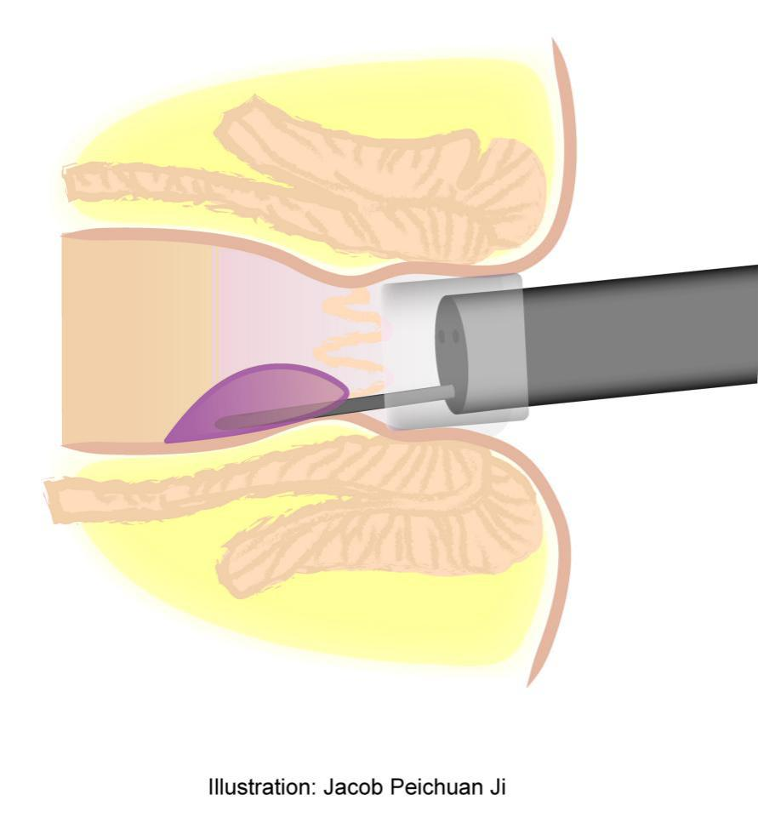
Figure 1 Illustration of cap assisted endoscopic sclerotherapy.

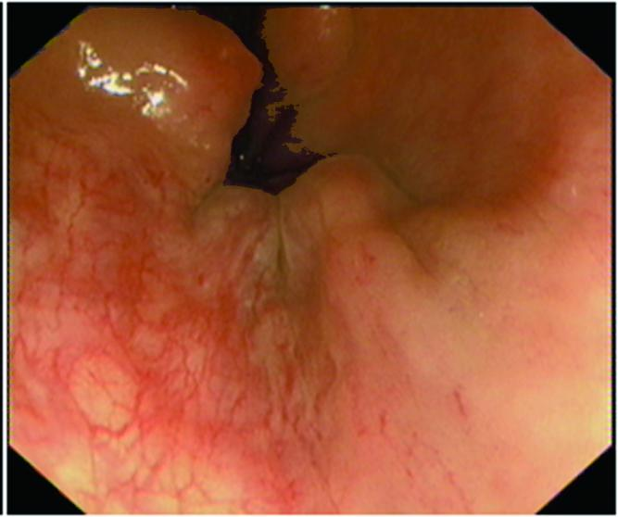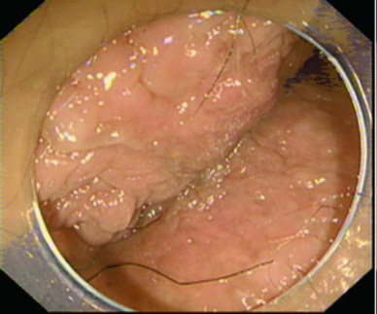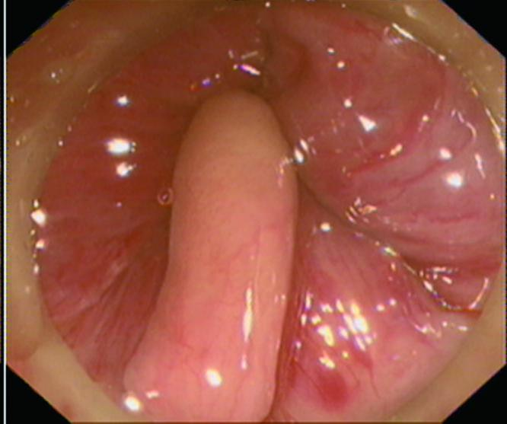
A B C
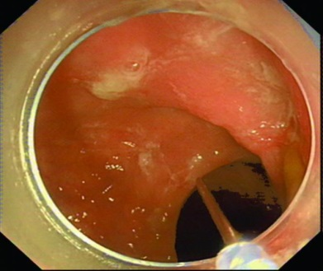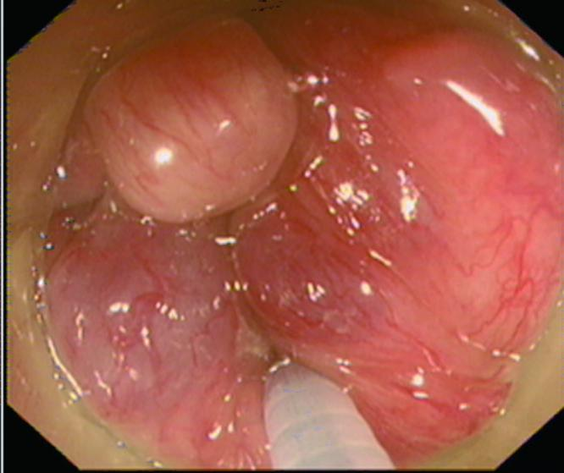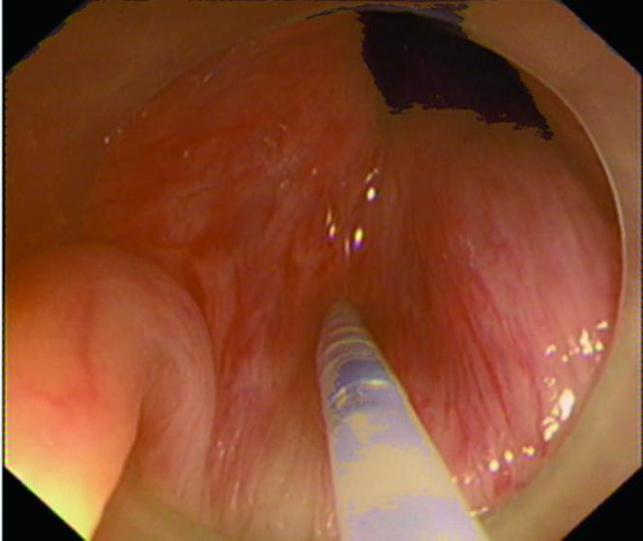
D E F
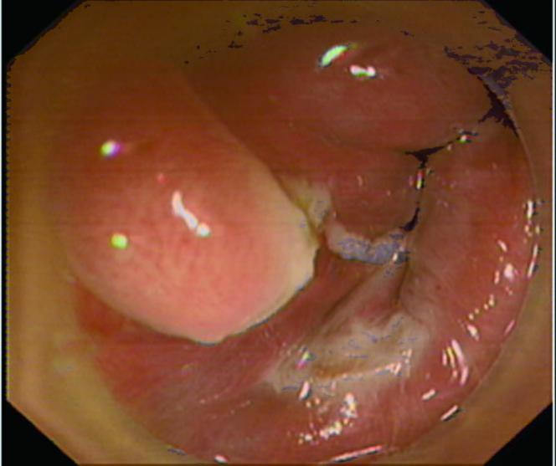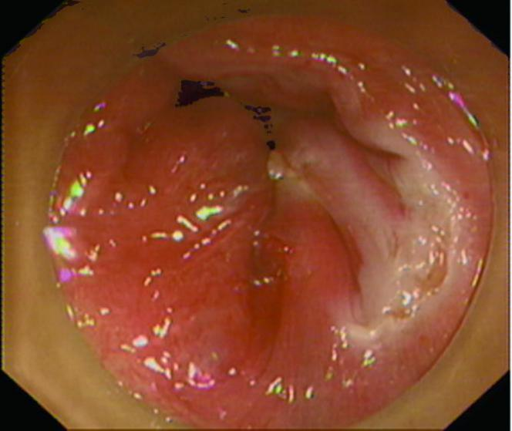
G H

Figure 2 Procedures of cap assisted endoscopic sclerotherapy for internal hemorrhoids and the excision for anal papilla fibroma. A: Internal hemorrhoids with retroflection of the endoscope; B: The anal region under cap assisted endoscopic view; C: Internal hemorrhoids and anal papilla fibroma under cap assisted endoscopic view with enough insufflated air; D: The disposable endoscopic long injection needle through operating channel; E: Injection of lauromacrogol into submucosa of internal hemorrhoids with the cap assisted endoscopic view; F: Injecting of lauromacrogol into submucosa of internal hemorrhoids close to papilla fibroma before dissection; G: Dissection of anal papilla fibroma (confirmed by the followed pathology) after cap assisted endoscopic sclerotherapy (CAES); H: No bleeding after CAES and dissection of anal papilla lesion before ending all procedures.

