Name of Journal: World Journal of Gastrointestinal Surgery
Manuscript NO: 82548
Manuscript Type: MINIREVIEWS

Initial management of suspected biliary injury after laparoscopic cholecystectomy

Siiki A et al. Management of biliary injuries after cholecystectomy

Antti Siiki, Reea Ahola, Yrjö Vaalavuo, Anne Antila, Johanna Laukkarinen

Antti Siiki, Reea Ahola, Yrjö Vaalavuo, Anne Antila, Johanna Laukkarinen, Department of Gastroenterology and Alimentary Tract Surgery, Tampere University Hospital, Tampere 33521, Finland

Johanna Laukkarinen, Faculty of Medicine and Health Technology, University of Tampere, Tampere 33521, Finland

Author contributions: Siiki A, Ahola R, Vaalavuo Y, Antila A and Laukkarinen J contributed to the manuscript drafting and revision.

Corresponding author: Antti Siiki, MD, PhD, Surgeon, Department of Gastroenterology and Alimentary Tract Surgery, Tampere University Hospital, Teiskontie 35, Tampere 33521, Finland. antti.siiki@fimnet.fi

Received: December 28, 2022
Revised: January 26, 2023
Accepted: March 15, 2023
Published online:

Abstract
Although rare, iatrogenic bile duct injury (BDI) after laparoscopic cholecystectomy may be devastating to the patient. The cornerstones for the initial management of BDI are early recognition, followed by modern imaging and evaluation of injury severity. Tertiary hepato-biliary centre care with a multi-disciplinary approach is crucial. The diagnostics of BDI commences with a multi-phase abdominal computed tomography scan, and when the biloma is drained or a surgical drain is put in place, the diagnosis is set with the help of bile drain output. To visualize the leak site and biliary anatomy, the diagnostics is supplemented with contrast enhanced magnetic resonance imaging. The location and severity of the bile duct lesion and concomitant injuries to the hepatic vascular system are evaluated. Most often, a combination of percutaneous and endoscopic methods is used for control of contamination and bile leak. Generally, the next step is endoscopic retrograde cholangiography (ERC) for downstream control of the bile leak. ERC with insertion of a stent is the treatment of choice in most mild bile leaks. The surgical option of re-operation and its timing should be discussed in cases where an endoscopic and percutaneous approach is not sufficient. The patient's failure to recover properly in the first days after laparoscopic cholecystectomy should immediately raise suspicion of BDI and this merits immediate investigation. Early consultation and referral to a dedicated hepato-biliary unit are essential for the best outcome.

Key Words: Cholecystectomy; Laparoscopy; Bile duct injury; Iatrogenic; Adverse event; Complication

Siiki A, Ahola R, Vaalavuo Y, Antila A, Laukkarinen J. Initial management of suspected biliary injury after laparoscopic cholecystectomy. World J Gastrointest Surg 2023; In press

Core Tip: A rare, but potentially disastrous bile duct injury (BDI) after laparoscopic cholecystectomy may easily go unnoticed at first. Thus, any unwell patient or anyone not recovering properly in the first post-operative days after surgery should be considered as having a surgical complication unless proven otherwise. The right initial management in suspected BDI is essential for prognosis. Early referral to a hepato-biliary unit, combination of modern imaging modalities and consequent evaluation of the severity grade of the injury are the foundations of management. The initial treatment options range from percutaneous and endoscopic methods to surgery, the timing and details of which need a multi-disciplinary hepato-biliary approach.

INTRODUCTION
Rare bile duct injury (BDI) after cholecystectomy should be recognized early to allow prompt diagnosis and treatment^{[1-3]}. As most cholecystectomies are operated on laparoscopically, BDI occurs in 0.2%-0.9% of patients; the variation depends on whether all bile leaks or only surgically reconstructed injuries are included^{[4-6]}. Commonly graded by Strasberg´s classification^{[7]}, bile duct injuries are graded from A to E, where A represents a simple cystic duct leak and C-E complex injuries to the hepatic ducts or common bile duct (CBD)^{[7-9]} (Figure 1). Most post-cholecystectomy bile leaks are mild type A-B lesions, where endoscopic treatment combined with external drainage is usually successful^{[10-12]}. More severe grades often require re-operation or even a combination of endoscopy, interventional radiology and surgery^{[4,13,14]}. Surgical repair of BDI should be avoided between two and six weeks after the cholecystectomy due to the elevated risk of postoperative morbidity and hepaticojejunostomy stricture compared to re-operation at some earlier or later time point^{[15]}. At worst, BDI may lead to morbidity and mortality^{[11]}, series of re-interventions, long hospitalization and substantial costs^{[1,16,17]}. BDI has a considerable impact on long-term quality-of-life; e.g. surgically repaired BDI may require re-interventions for strictured hepatico-jejunostomy anastomosis in 10%-20%^{[3,14,18]}.

Referral and diagnosis in suspected BDI
Most mild bile duct injuries are recognized a few days after the operation^{[6,10,19,20]}. Prompt referral and evaluation with modern imaging is crucial whenever a patient is not recovering properly after any type of cholecystectomy^{[2,11,19]}. The clinical symptoms of BDI are vague: symptoms such as abdominal pain, fever, sepsis and jaundice are not specific. Liver function tests and inflammatory markers may be normal in the early phase. Noteworthy, elevated liver function test results are associated with biliary obstruction or vascular damage, but in cases with bile leak these are usually normal. The only symptom of the most common iatrogenic injury, a leak from the cystic duct (Strasberg A), is often the patient’s unspecific deterioration early in the postoperative course. The key to correct diagnosis is high level of suspicion with consequent swift consultation or referral to a tertiary centre when the patient is unwell in the early days after cholecystectomy^{[2,10,19,21]}. It is known that severe BDIs, especially with concomitant vascular injury, are best treated by early referral to the unit with the most experience and extensive resources for interventional radiology, advanced endoscopy and complex reconstructive surgery^{[8,22-24]}.
In the emergency department, abdominal imaging should be performed urgently to rule out any post-operative complications (Figure 2). While transabdominal ultrasound may visualize a fluid collection or dilation of the intrahepatic biliary ducts, a multi-phase abdominal computed tomography (CT) scan is required for BDI diagnosis. The common findings are perihepatic fluid accumulation around the right perihepatic space, gallbladder fossa and inferiorly into the right paracolic gutter^{[25]}. Contrast enhanced CT with arterial phase is necessary to exclude the possibility of arterial injury with associated hypoperfusion of the liver due to damage typically to the right branch of the hepatic artery, occurring in up to 20% of BDIs^{[23]}. CT scan may be followed by hepato-biliary specific contrast media enhanced magnetic resonance imaging (MRI) to identify the leak site and accurately identify the biliary anatomy. When contrast enhanced MRI is not available, standard magnetic resonance cholangio-pancreatography (MRCP) without contrast allows evaluation of the fluid-filled bile ducts and provides indirect evidence of a leak^{[25]}. MRI may also reveal CBD stones predisposing to leak from the stump of the cystic duct.
In evaluating the extent of the BDI, it is often useful to consult the original notes from the time of the primary operation. Sometimes crucial information can be obtained on how the anatomy appeared during the cholecystectomy and ascertaining if the critical view of safety was obtained^{[26,27]}, how the intra-operative cholangiography (e.g., anatomy, stones, sludge) appeared^{[28]} and what the pre-operative MRI or CT looked like^{[29,30]}, or whether the gallbladder was acutely or chronically inflamed, thereby increasing the risks for BDI^{[4,20,31]}.

Containing the contamination
The first step in the initial management of BDI is to contain the contamination (Figures 2 and 3). The placement of a percutaneous drain in the biloma is often enough to control the infection combined with wide-spectrum antibiotic treatment. When a drain is placed in the accumulation or a surgical bile-producing drain is left in place in cholecystectomy, samples for bacterial culture and drain bilirubin should be obtained. In cases where interventional radiology is unavailable, especially in a septic patient, emergency laparoscopic lavation may be considered to contain the contamination followed by surgical drains^{[13]}. In these cases, drainage or laparoscopic lavation may be performed in the referring hospital to avoid delays. However, reconstructive surgery for BDI should not be attempted before the severity grade of BDI and possible associated vascular injury are properly evaluated. At the latest, the referral to or consultation with a tertiary hepato-biliary unit should be made at this point, even before any interventions^{[1,2,19,21,24]}.

Treatment: Controlling the leak
After proper imaging and external drainage, endoscopic retrograde cholangiography (ERC) is the preferred next step in most cases (Figures 2 and 3). When bile drain output continues for more than ca 24 h, ERC is often indicated. Endoscopy is used to locate the leak and determine its severity grade and also to treat the bile leak with sphincterotomy and stents. In ERC a leak is carefully visualized with fluoroscopy by injecting pressurized contrast medium over an occlusion balloon^{[32]}. Generally, the most common forms of mild BDI, type A leak from the cystic duct or aberrant duct from the gallbladder fossa, can be easily diagnosed and treated with standard ERC^{[12,33]}. It is often wise to have a hepato-biliary surgeon present in the endoscopy room to see live fluoroscopy findings when a complex BDI is suspected.
When a complete transection of CBD is not present, trans-papillary downstream control of the leak by ERC allows healing in more than 90% of biliary leaks^{[9,10,34]}. In ERC occult CBD stones obstructing the bile flow and predisposing to leak can also be easily removed. In the European guideline, it is recommended to insert a temporary plastic biliary stent rather than to decompress the CBD with sphincterotomy only: stenting provides faster leak resolution than sphincterotomy alone^{[34]}. Stents seem to be equally effective whether biliary sphincterotomy is performed or not. However, while biliary sphincterotomy may be associated with some complications, it is usually necessary for the removal of retained stones. In simple grade A leaks, without bile duct stones, a single plastic stent inserted for four to eight weeks is often enough without sphincterotomy^{[34]}. However, when a stent has been inserted, biliary sludge, stones, or occasionally even a persistent leak may be found at the time of stent removal. Thus, a stent may be preferable to sphincterotomy alone, which can be considered a mere secondary alternative when stone clearance is confirmed and second endoscopy for stent removal would be too risky^{[9,34]}. However, a recent randomised controlled trial proved that after appropriate patient selection in a simple Strasberg type A leak, endoscopic sphincterotomy may be a safe and cost-effective single procedure without stent insertion^{[12]}.
When biodegradable biliary stents are available, stent removal in second endoscopy may be avoided^{[35]}. However, in that case, an adequate sphincterotomy followed by careful cleansing of the CBD of stones and sludge should be performed at the index ERC.
In case of more complex BDI, ERC also gives more detailed information for locating the bile leak. It helps to assess the relation of the lesion to the hilum and the main biliary ducts even if the lesion itself may not eventually be treatable by endoscopy only^{[33]}. When only the right hepatic duct is injured or anomalous right segmental biliary branches draining to the cystic duct have been damaged, ERC may be misinterpreted as having no leak despite drain bile output^{[8]}. In this scenario, comparing ERC cholangiography to pre-operative MRI may be the way to diagnose this type of lesion correctly^{[29]}. A fistulography performed via the catheter drain may also help in determining the extent of the lesion^{[9]}. When the bile duct is disconnected or the main branches entirely transected, early surgery or a combination of external drainage of biloma and percutaneous transhepatic cholangiogram catheter (PTC) for proximal control may be necessary in the early phase in order to gain time for definitive treatment^{[8]}.
Instead of plastic stents, self-expanding large bore covered metal stents may be used in ERC in iatrogenic BDI^{[32,36,37]}. Correctly positioned, they may successfully bridge and seal even grade D injuries to the CBD and common hepatic duct^{[38]}. The benefits of self-expanding metal stents are their greater diameter and the sealing effect of the plastic or silicone covering of the stents^{[36]}. Large diameter stents with 8-10 mm bore may be associated with faster leak resolution than plastic stents with 3 mm (10F) calibre^{[35]}. However, care should be taken not to insert a stent with too large a diameter into a narrow normal CBD to prevent circumferential ischaemia and consequent biliary stricture due to stent expansion. Most importantly, before embarking on percutaneous or endoscopic treatment of complex lesions, all diagnostic methods should be undertaken with multi-disciplinary evaluation of the surgical or endoscopic options in a hepato-biliary centre^{[19,21,24]}.

Surgical options
Surgery is the mainstay treatment in cases not manageable by ERC^{[8]}. When BDI is identified during the cholecystectomy, immediate surgical repair should be attempted^{[16,31]}. In these cases, it is important to call a senior surgeon into the operation, carefully evaluate the anatomy and the extent of the lesion with cholangiography^{[21,28]} if this has not been done at an earlier phase of the operation. In the prevention of BDI, a bail-out strategy by stopping further dissection and performing e.g., partial cholecystectomy may be indicated^{[18,27,39]}. Open conversion with Kocher mobilisation or laparoscopic suture, placement of a T-tube with external drainage or even reconstruction with roux-Y hepaticojejunostomy may be considered, depending on the lesion (Figures 1-3), the condition of the patient and the expertise of the surgical team. In complex cases, the best solution may be to do nothing further but call a hepato-biliary specialist during the surgery or place drains and consequently transfer the patient to a centre providing definitive care^{[8]}. When CBD stones are present, it is important to remove them in the same procedure with repair by choledochoscopy via e.g., choledochotomy. Early or immediate repair may give a good prognosis when performed by experienced specialists only^{[8,19,40]}. In practice, the prerequisites for immediate or early reconstruction with roux-Y hepatico-jejunostomy are: an experienced hepato-biliary team present, the entire biliary tree well visualised in cholangiography, no sepsis or severe biliary peritonitis, no significant co-morbidities and no vascular injury.
According to the literature, the optimal timing of definite reconstructive re-operation varies^{[9,15]}. However, when a complex BDI unamenable to treatment by ERC is diagnosed after the operation, early surgical repair is generally not recommended, especially when diagnosis is delayed or sepsis, biliary peritonitis or arterial injury are concomitant^{[8,9]}. In these cases, the definitive reconstruction should preferably be delayed for up to a few months and preceded by e.g., PTC, multiple drains and also adequate nutritional support^{[8]}. Due to the high risk of morbidity and late stricture formation, surgical reconstruction should be avoided for at least from weeks two to six post-operatively^{[15]}. While the options for re-operation range from reconstruction with roux-Y hepaticojejunostomy^{[11]} to liver resections and even up to liver transplantation^{[22]}, any reconstructive late-phase surgery should be performed in an expert hepato-biliary centre^{[8,19,24]}.

CONCLUSION
Laparoscopic cholecystectomy is a safe procedure with low morbidity and mortality^{[4,5]}. Any unwell patient with abdominal problems in the immediate post-operative period after cholecystectomy should be managed and referred to specialist care by reason of suspected complication until this possibility can be excluded^{[1,2,6,19]}. Early recognition of BDI improves survival^{[28]}. In addition to BDI related morbidity and mortality^{[11,14]}, substantial cost stresses the importance of proper initial management^{[16,17]}.
In the surgical emergency department, evaluation starts with blood samples and multi-phase abdominal CT scan^{[25]}. The first step in the treatment of BDI is to contain contamination by percutaneous radiologic catheter drainage, which usually allows time for further decision-making as well as bacterial culture and bile analysis of the drain output^{[13]}. The second step is the evaluation of leak severity, which in practice means contrast-enhanced MRI or MRCP^{[25]} followed by ERC, cholangiography and placement of a temporary stent for down-stream control^{[33]}. The diagnostics of the severity of BDI thus requires a combination of modern imaging modalities. When endoscopic treatment is not sufficient, urgent multi-disciplinary evaluation for further interventional radiologic procedures or re-operation and their optimal timing are called for^{[8]}. While in complex lesions, surgery is the preferred treatment, immediate or early repair by non-specialists is not recommended^{[8,40]}. The long-term consequences of rare severe BDI may be devastating to the patient and the health care system^{[14,16,17]}. Any reconstructive surgery should be performed in an expert hepato-biliary centre^{[22,24,40]}.
Although BDI or bile leak may be inevitable when large numbers of patients are operated on^{[26]}, for the most common simple leaks prognosis after ERC is excellent^{[20,32,36]}. Additionally, the vast majority of complex BDIs can be successfully managed surgically in experienced hepato-biliary centres^{[4,19,24,40]}. However, for the prevention of BDIs, all guidelines stress the importance of proper surgical training, paying due attention to the critical view of safety, use of intraoperative cholangiography to ascertain the anatomy and understanding the role of bail-out strategy^{[18,21,27,30,39]}. In BDI, early recognition, diagnosis and referral are essential^{[2,19,24]}, thus a structured algorithm-based approach for the evaluation and referral pattern of complications of laparoscopic cholecystectomy could be useful, possibly similar to that developed for pancreatic surgery^{[41]}.

REFERENCES
1 Gouma DJ, Obertop H. Management of bile duct injuries: treatment and long-term results. Dig Surg 2002; 19: 117-122 [PMID: 11978998 DOI: 10.1159/000052024]
2 Wu YV, Linehan DC. Bile duct injuries in the era of laparoscopic cholecystectomies. Surg Clin North Am 2010; 90: 787-802 [PMID: 20637948 DOI: 10.1016/j.suc.2010.04.019]
3 Pucher PH, Brunt LM, Davies N, Linsk A, Munshi A, Rodriguez HA, Fingerhut A, Fanelli RD, Asbun H, Aggarwal R; SAGES Safe Cholecystectomy Task Force. Outcome trends and safety measures after 30 years of laparoscopic cholecystectomy: a systematic review and pooled data analysis. Surg Endosc 2018; 32: 2175-2183 [PMID: 29556977 DOI: 10.1007/s00464-017-5974-2]
4 Harboe KM, Bardram L. The quality of cholecystectomy in Denmark: outcome and risk factors for 20,307 patients from the national database. Surg Endosc 2011; 25: 1630-1641 [PMID: 21136118 DOI: 10.1007/s00464-010-1453-8]
5 Enochsson L, Thulin A, Osterberg J, Sandblom G, Persson G. The Swedish Registry of Gallstone Surgery and Endoscopic Retrograde Cholangiopancreatography (GallRiks): A nationwide registry for quality assurance of gallstone surgery. JAMA Surg 2013; 148: 471-478 [PMID: 23325144 DOI: 10.1001/jamasurg.2013.1221]
6 Barrett M, Asbun HJ, Chien HL, Brunt LM, Telem DA. Bile duct injury and morbidity following cholecystectomy: a need for improvement. Surg Endosc 2018; 32: 1683-1688 [PMID: 28916877 DOI: 10.1007/s00464-017-5847-8]
7 Strasberg SM, Hertl M, Soper NJ. An analysis of the problem of biliary injury during laparoscopic cholecystectomy. J Am Coll Surg 1995; 180: 101-125 [PMID: 8000648]
8 Connor S, Garden OJ. Bile duct injury in the era of laparoscopic cholecystectomy. Br J Surg 2006; 93: 158-168 [PMID: 16432812 DOI: 10.1002/bjs.5266]
9 Soper NJ, Santos BF. Laparoscopic Cholecystectomy: Complications and Management. In: Tichansky DS, Morton J, Jones DB. The SAGES Manual of Quality, Outcomes and Patient Safety. 1st ed. Boston: Springer, 2012
10 Karvonen J, Salminen P, Grönroos JM. Bile duct injuries during open and laparoscopic cholecystectomy in the laparoscopic era: alarming trends. Surg Endosc 2011; 25: 2906-2910 [PMID: 21432006 DOI: 10.1007/s00464-011-1641-1]
11 Viste A, Horn A, Øvrebø K, Christensen B, Angelsen JH, Hoem D. Bile duct injuries following laparoscopic cholecystectomy. Scand J Surg 2015; 104: 233-237 [PMID: 25700851 DOI: 10.1177/1457496915570088]
12 Rainio M, Lindström O, Udd M, Haapamäki C, Nordin A, Kylänpää L. Endoscopic Therapy of Biliary Injury After Cholecystectomy. Dig Dis Sci 2018; 63: 474-480 [PMID: 28948425 DOI: 10.1007/s10620-017-4768-7]
13 Eum YO, Park JK, Chun J, Lee SH, Ryu JK, Kim YT, Yoon YB, Yoon CJ, Han HS, Hwang JH. Non-surgical treatment of post-surgical bile duct injury: clinical implications and outcomes. World J Gastroenterol 2014; 20: 6924-6931 [PMID: 24944484 DOI: 10.3748/wjg.v20.i22.6924]
14 Schreuder AM, Busch OR, Besselink MG, Ignatavicius P, Gulbinas A, Barauskas G, Gouma DJ, van Gulik TM. Long-Term Impact of Iatrogenic Bile Duct Injury. Dig Surg 2020; 37: 10-21 [PMID: 30654363 DOI: 10.1159/000496432]
15 Schreuder AM, Nunez Vas BC, Booij KAC, van Dieren S, Besselink MG, Busch OR, van Gulik TM. Optimal timing for surgical reconstruction of bile duct injury: meta-analysis. BJS Open 2020; 4: 776-786 [PMID: 32852893 DOI: 10.1002/bjs5.50321]
16 Savader SJ, Lillemoe KD, Prescott CA, Winick AB, Venbrux AC, Lund GB, Mitchell SE, Cameron JL, Osterman FA Jr. Laparoscopic cholecystectomy-related bile duct injuries: a health and financial disaster. Ann Surg 1997; 225: 268-273 [PMID: 9060582 DOI: 10.1097/00000658-199703000-00005]
17 Andersson R, Eriksson K, Blind PJ, Tingstedt B. Iatrogenic bile duct injury--a cost analysis. HPB (Oxford) 2008; 10: 416-419 [PMID: 19088927 DOI: 10.1080/13651820802140745]
18 Gupta V, Jain G. Safe laparoscopic cholecystectomy: Adoption of universal culture of safety in cholecystectomy. World J Gastrointest Surg 2019; 11: 62-84 [PMID: 30842813 DOI: 10.4240/wjgs.v11.i2.62]
19 Nordin A, Grönroos JM, Mäkisalo H. Treatment of biliary complications after laparoscopic cholecystectomy. Scand J Surg 2011; 100: 42-48 [PMID: 21482504 DOI: 10.1177/145749691110000108]
20 Mangieri CW, Hendren BP, Strode MA, Bandera BC, Faler BJ. Bile duct injuries (BDI) in the advanced laparoscopic cholecystectomy era. Surg Endosc 2019; 33: 724-730 [PMID: 30006843 DOI: 10.1007/s00464-018-6333-7]
21 Brunt LM, Deziel DJ, Telem DA, Strasberg SM, Aggarwal R, Asbun H, Bonjer J, McDonald M, Alseidi A, Ujiki M, Riall TS, Hammill C, Moulton CA, Pucher PH, Parks RW, Ansari MT, Connor S, Dirks RC, Anderson B, Altieri MS, Tsamalaidze L, Stefanidis D; and the Prevention of Bile Duct Injury Consensus Work Group. Safe Cholecystectomy Multi-society Practice Guideline and State of the Art Consensus Conference on Prevention of Bile Duct Injury During Cholecystectomy. Ann Surg 2020; 272: 3-23 [PMID: 32404658 DOI: 10.1097/SLA.0000000000003791]
22 Vilatobá M, Chávez-Villa M, Figueroa-Méndez R, Domínguez-Rosado I, Cruz-Martínez R, Leal-Villalpando RP, García-Juárez I, Mercado MA. Liver Transplantation as Definitive Treatment of Post-cholecystectomy Bile Duct Injury: Experience in a High-volume Repair Center. Ann Surg 2022; 275: e729-e732 [PMID: 35084146 DOI: 10.1097/SLA.0000000000005245]
23 Schmidt SC, Settmacher U, Langrehr JM, Neuhaus P. Management and outcome of patients with combined bile duct and hepatic arterial injuries after laparoscopic cholecystectomy. Surgery 2004; 135: 613-618 [PMID: 15179367 DOI: 10.1016/j.surg.2003.11.018]
24 de Reuver PR, Grossmann I, Busch OR, Obertop H, van Gulik TM, Gouma DJ. Referral pattern and timing of repair are risk factors for complications after reconstructive surgery for bile duct injury. Ann Surg 2007; 245: 763-770 [PMID: 17457169 DOI: 10.1097/01.sla.0000252442.91839.44]
25 Patel N, Jensen KK, Shaaban AM, Korngold E, Foster BR. Multimodality Imaging of Cholecystectomy Complications. Radiographics 2022; 42: 1303-1319 [PMID: 35904983 DOI: 10.1148/rg.210106]
26 Terho P, Sallinen V, Lampela H, Harju J, Koskenvuo L, Mentula P. The Critical View of Safety in Laparoscopic Cholecystectomy: User Trends Among Residents and Consultants. Surg Laparosc Endosc Percutan Tech 2022; 32: 453-461 [PMID: 35881992 DOI: 10.1097/SLE.0000000000001077]
27 Iwashita Y, Hibi T, Ohyama T, Umezawa A, Takada T, Strasberg SM, Asbun HJ, Pitt HA, Han HS, Hwang TL, Suzuki K, Yoon YS, Choi IS, Yoon DS, Huang WS, Yoshida M, Wakabayashi G, Miura F, Okamoto K, Endo I, de Santibañes E, Giménez ME, Windsor JA, Garden OJ, Gouma DJ, Cherqui D, Belli G, Dervenis C, Deziel DJ, Jonas E, Jagannath P, Supe AN, Singh H, Liau KH, Chen XP, Chan ACW, Lau WY, Fan ST, Chen MF, Kim MH, Honda G, Sugioka A, Asai K, Wada K, Mori Y, Higuchi R, Misawa T, Watanabe M, Matsumura N, Rikiyama T, Sata N, Kano N, Tokumura H, Kimura T, Kitano S, Inomata M, Hirata K, Sumiyama Y, Inui K, Yamamoto M. Delphi consensus on bile duct injuries during laparoscopic cholecystectomy: an evolutionary cul-de-sac or the birth pangs of a new technical framework? J Hepatobiliary Pancreat Sci 2017; 24: 591-602 [PMID: 28884962 DOI: 10.1002/jhbp.503]
28 Törnqvist B, Strömberg C, Persson G, Nilsson M. Effect of intended intraoperative cholangiography and early detection of bile duct injury on survival after cholecystectomy: population based cohort study. BMJ 2012; 345: e6457 [PMID: 23060654 DOI: 10.1136/bmj.e6457]
29 Omiya K, Hiramatsu K, Kato T, Shibata Y, Yoshihara M, Aoba T, Arimoto A, Ito A. Preoperative MRI for predicting pathological changes associated with surgical difficulty during laparoscopic cholecystectomy for acute cholecystitis. BJS Open 2020; 4: 1137-1145 [PMID: 32894010 DOI: 10.1002/bjs5.50344]
30 Conrad C, Wakabayashi G, Asbun HJ, Dallemagne B, Demartines N, Diana M, Fuks D, Giménez ME, Goumard C, Kaneko H, Memeo R, Resende A, Scatton O, Schneck AS, Soubrane O, Tanabe M, van den Bos J, Weiss H, Yamamoto M, Marescaux J, Pessaux P. IRCAD recommendation on safe laparoscopic cholecystectomy. J Hepatobiliary Pancreat Sci 2017; 24: 603-615 [PMID: 29076265 DOI: 10.1002/jhbp.491]
31 Krähenbühl L, Sclabas G, Wente MN, Schäfer M, Schlumpf R, Büchler MW. Incidence, risk factors, and prevention of biliary tract injuries during laparoscopic cholecystectomy in Switzerland. World J Surg 2001; 25: 1325-1330 [PMID: 11596898 DOI: 10.1007/s00268-001-0118-0]
32 Rustagi T, Aslanian HR. Endoscopic management of biliary leaks after laparoscopic cholecystectomy. J Clin Gastroenterol 2014; 48: 674-678 [PMID: 24296422 DOI: 10.1097/MCG.0000000000000044]
33 Kaffes AJ, Hourigan L, De Luca N, Byth K, Williams SJ, Bourke MJ. Impact of endoscopic intervention in 100 patients with suspected postcholecystectomy bile leak. Gastrointest Endosc 2005; 61: 269-275 [PMID: 15729238 DOI: 10.1016/s0016-5107(04)02468-x]
34 Dumonceau JM, Tringali A, Papanikolaou IS, Blero D, Mangiavillano B, Schmidt A, Vanbiervliet G, Costamagna G, Devière J, García-Cano J, Gyökeres T, Hassan C, Prat F, Siersema PD, van Hooft JE. Endoscopic biliary stenting: indications, choice of stents, and results: European Society of Gastrointestinal Endoscopy (ESGE) Clinical Guideline - Updated October 2017. Endoscopy 2018; 50: 910-930 [PMID: 30086596 DOI: 10.1055/a-0659-9864]
35 Siiki A, Vaalavuo Y, Antila A, Ukkonen M, Rinta-Kiikka I, Sand J, Laukkarinen J. Biodegradable biliary stents preferable to plastic stent therapy in post-cholecystectomy bile leak and avoid second endoscopy. Scand J Gastroenterol 2018; 53: 1376-1380 [PMID: 30394150 DOI: 10.1080/00365521.2018.1518480]
36 Lam R, Muniraj T. Fully covered metal biliary stents: A review of the literature. World J Gastroenterol 2021; 27: 6357-6373 [PMID: 34720527 DOI: 10.3748/wjg.v27.i38.6357]
37 Luigiano C, Bassi M, Ferrara F, Fabbri C, Ghersi S, Morace C, Consolo P, Maimone A, Galluccio G, D'Imperio N, Cennamo V. Placement of a new fully covered self-expanding metal stent for postoperative biliary strictures and leaks not responding to plastic stenting. Surg Laparosc Endosc Percutan Tech 2013; 23: 159-162 [PMID: 23579510 DOI: 10.1097/SLE.0b013e318278c201]
38 Fukuda K, Nakai Y, Mizuno S, Sato T, Noguchi K, Kanai S, Suzuki T, Hakuta R, Ishigaki K, Saito K, Saito T, Takahara N, Hamada T, Kogure H, Fujishiro M. Endoscopic Bridge-and-Seal of Bile Leaks Using a Fully Covered Self-Expandable Metallic Stent above the Papilla. J Clin Med 2022; 11 [PMID: 36294340 DOI: 10.3390/jcm11206019]
39 Strasberg SM. A three-step conceptual roadmap for avoiding bile duct injury in laparoscopic cholecystectomy: an invited perspective review. J Hepatobiliary Pancreat Sci 2019; 26: 123-127 [PMID: 30828991 DOI: 10.1002/jhbp.616]
40 Perera MT, Silva MA, Hegab B, Muralidharan V, Bramhall SR, Mayer AD, Buckels JA, Mirza DF. Specialist early and immediate repair of post-laparoscopic cholecystectomy bile duct injuries is associated with an improved long-term outcome. Ann Surg 2011; 253: 553-560 [PMID: 21217507 DOI: 10.1097/SLA.0b013e318208fad3]
41 Smits FJ, Henry AC, Besselink MG, Busch OR, van Eijck CH, Arntz M, Bollen TL, van Delden OM, van den Heuvel D, van der Leij C, van Lienden KP, Moelker A, Bonsing BA, Borel Rinkes IH, Bosscha K, van Dam RM, Derksen WJM, den Dulk M, Festen S, Groot Koerkamp B, de Haas RJ, Hagendoorn J, van der Harst E, de Hingh IH, Kazemier G, van der Kolk M, Liem M, Lips DJ, Luyer MD, de Meijer VE, Mieog JS, Nieuwenhuijs VB, Patijn GA, Te Riele WW, Roos D, Schreinemakers JM, Stommel MWJ, Wit F, Zonderhuis BA, Daamen LA, van Werkhoven CH, Molenaar IQ, van Santvoort HC; Dutch Pancreatic Cancer Group. Algorithm-based care vs usual care for the early recognition and management of complications after pancreatic resection in the Netherlands: an open-label, nationwide, stepped-wedge cluster-randomised trial. Lancet 2022; 399: 1867-1875 [PMID: 35490691 DOI: 10.1016/S0140-6736(22)00182-9]

Footnotes
Conflict-of-interest statement: The authors declare no relevant conflict of interest. Authors Siiki and Laukkarinen have received lecture fees from Boston Scientific, Cook Medical and Olympus Europe.

Open-Access: This article is an open-access article that was selected by an in-house editor and fully peer-reviewed by external reviewers. It is distributed in accordance with the Creative Commons Attribution NonCommercial (CC BY-NC 4.0) license, which permits others to distribute, remix, adapt, build upon this work non-commercially, and license their derivative works on different terms, provided the original work is properly cited and the use is non-commercial. See: https://creativecommons.org/Licenses/by-nc/4.0/

Provenance and peer review: Invited article; Externally peer reviewed.
Peer-review model: Single blind
Corresponding Author's Membership in Professional Societies: Finnish Society of Gastrointestinal Surgery.

Peer-review started: December 28, 2022
First decision: January 12, 2023
Article in press:

Specialty type: Virology
Country/Territory of origin: Finland
Peer-review report’s scientific quality classification
Grade A (Excellent): 0
Grade B (Very good): B
Grade C (Good): C
Grade D (Fair): 0
Grade E (Poor): 0

P-Reviewer: Moshref L, Saudi Arabia; Thapar P, India S-Editor: Zhang H L-Editor: A P-Editor: Zhang H

Figure Legends
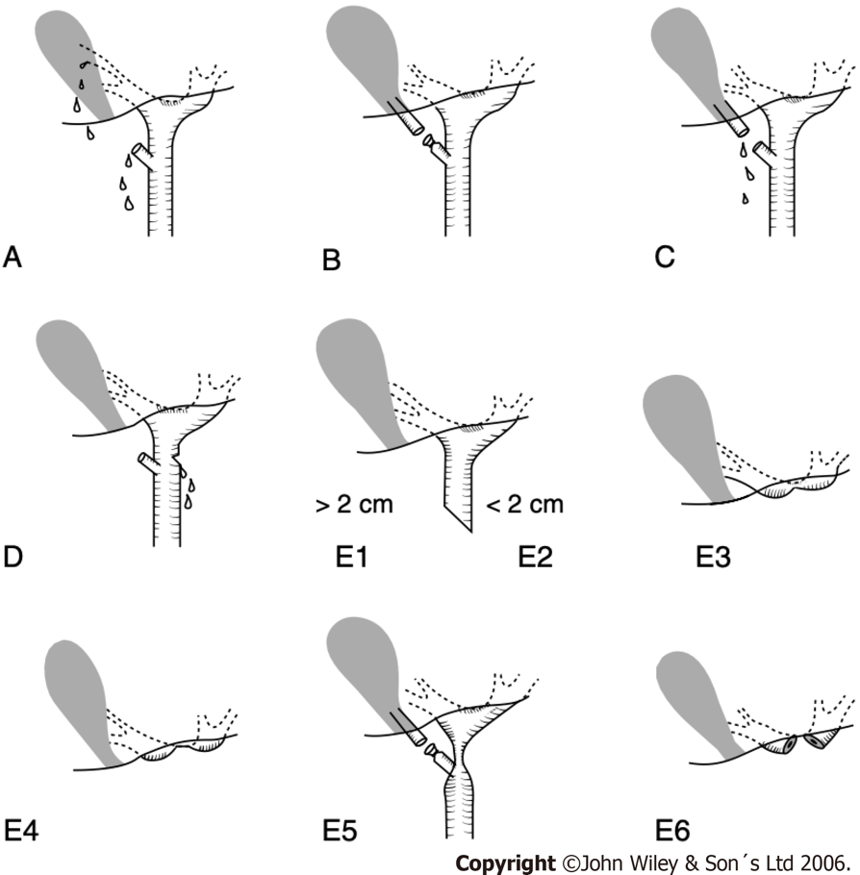
Figure 1 Classification of the bile duct injuries after cholecystectomy. A: Schematic classification of bile duct injuries in laparoscopic cholecystectomy. Originally developed by Strasberg et al in 1995^{[7]}. A bile leak from the cystic duct stump or minor biliary radical in the gallbladder fossa; B: Occluded right posterior sectoral duct; C: Bile leak from the divided right posterior sectoral duct; D: Bile leak from the main bile duct without major tissue loss; E1: Transected main bile duct with a stricture more than 2 cm from the hilus; E2: Transected main bile duct with a stricture less than 2 cm from the hilus; E3: Stricture of the hilus with right and left ducts in communication; E4: Stricture of the hilus with separation of right and left ducts; E5: Stricture of the main bile duct and the right posterior sectoral duct; E6: complete excision of the extrahepatic ducts involving the confluence (this injury is not described in Strasberg’s original classification). Citation: Connor S, Garden OJ. Bile duct injury in the era of laparoscopic cholecystectomy. Br J Surg 2006; 93(2): 158-168. Copyright ©John Wiley & Son´s Ltd 2006. Published by John Wiley & Son´s Ltd^{[8]}.
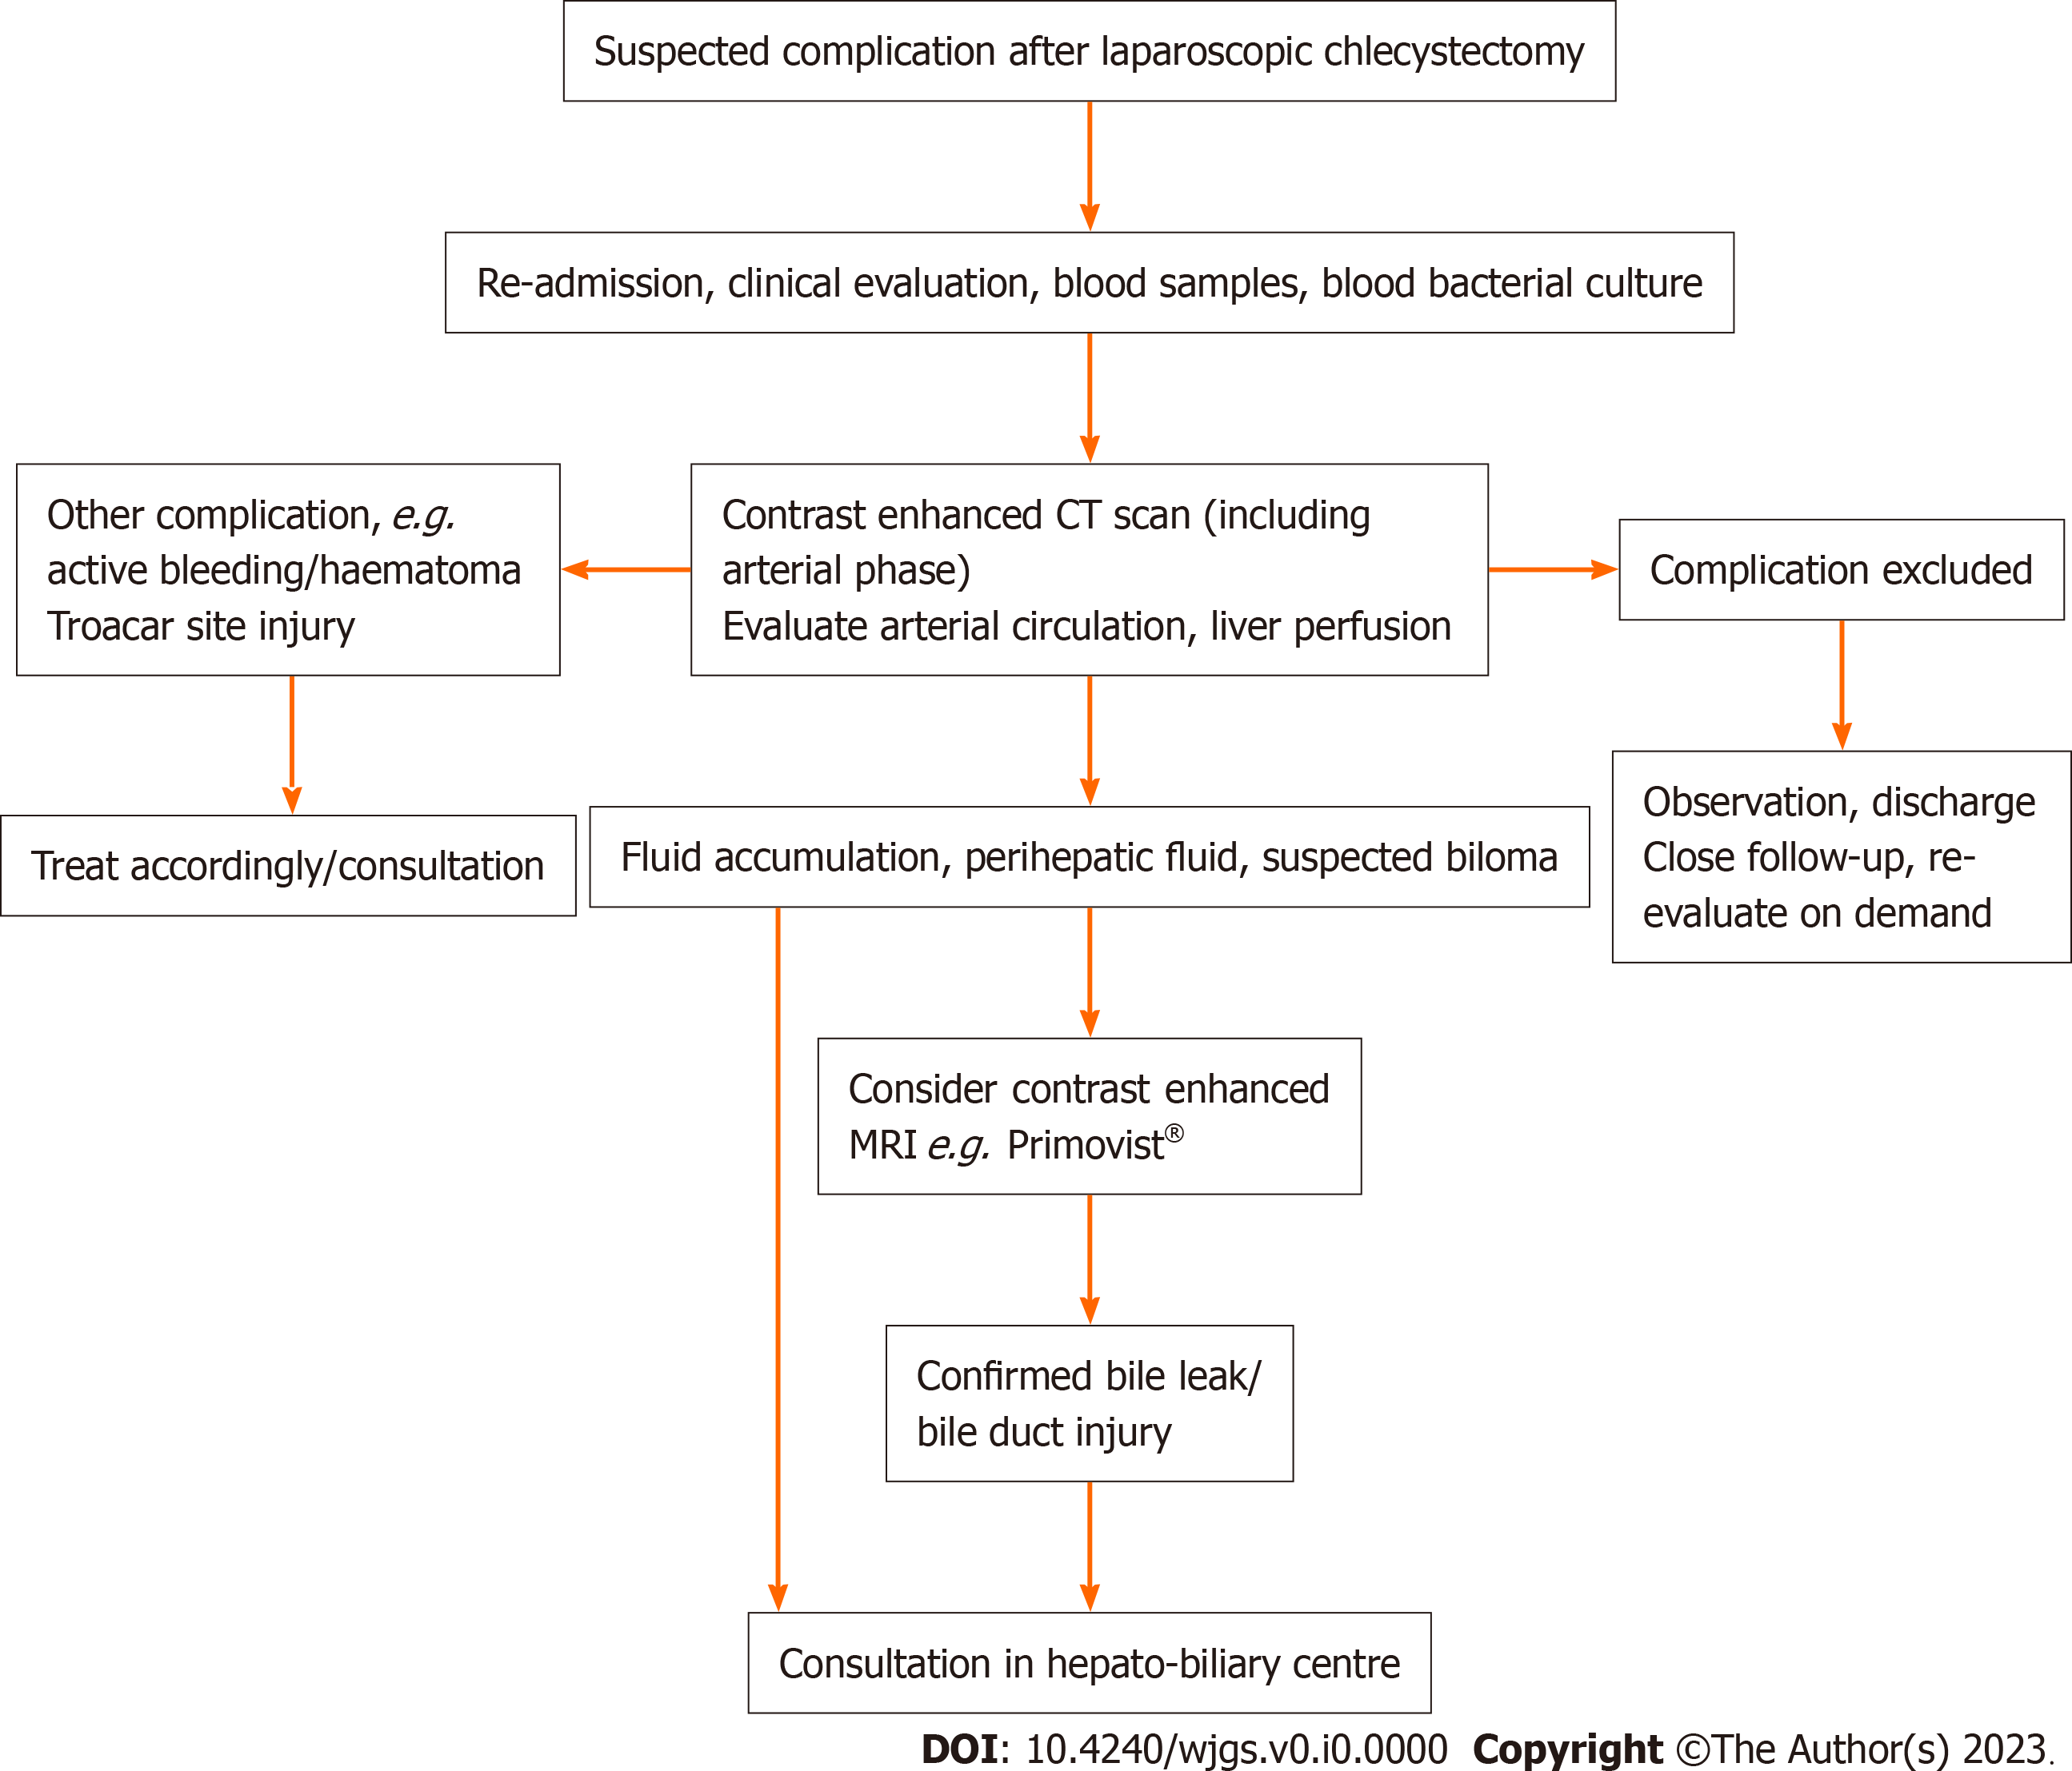
Figure 2 Initial diagnostic flowchart in suspected complication after laparoscopic cholecystectomy. Any patient not recovering correctly in the immediate post-operative phase should be referred and evaluated for the possibility of a complication. Early consultation with the hepato-biliary unit is recommended when bile duct injury or other severe complication of laparoscopic cholecystectomy is suspected. CT: Computed tomography; MRI: Magnetic resonance imaging; MRCP: Magnetic resonance cholangio-pancreatography. (Primovist: Bayer AG, Leverkusen, Germany).
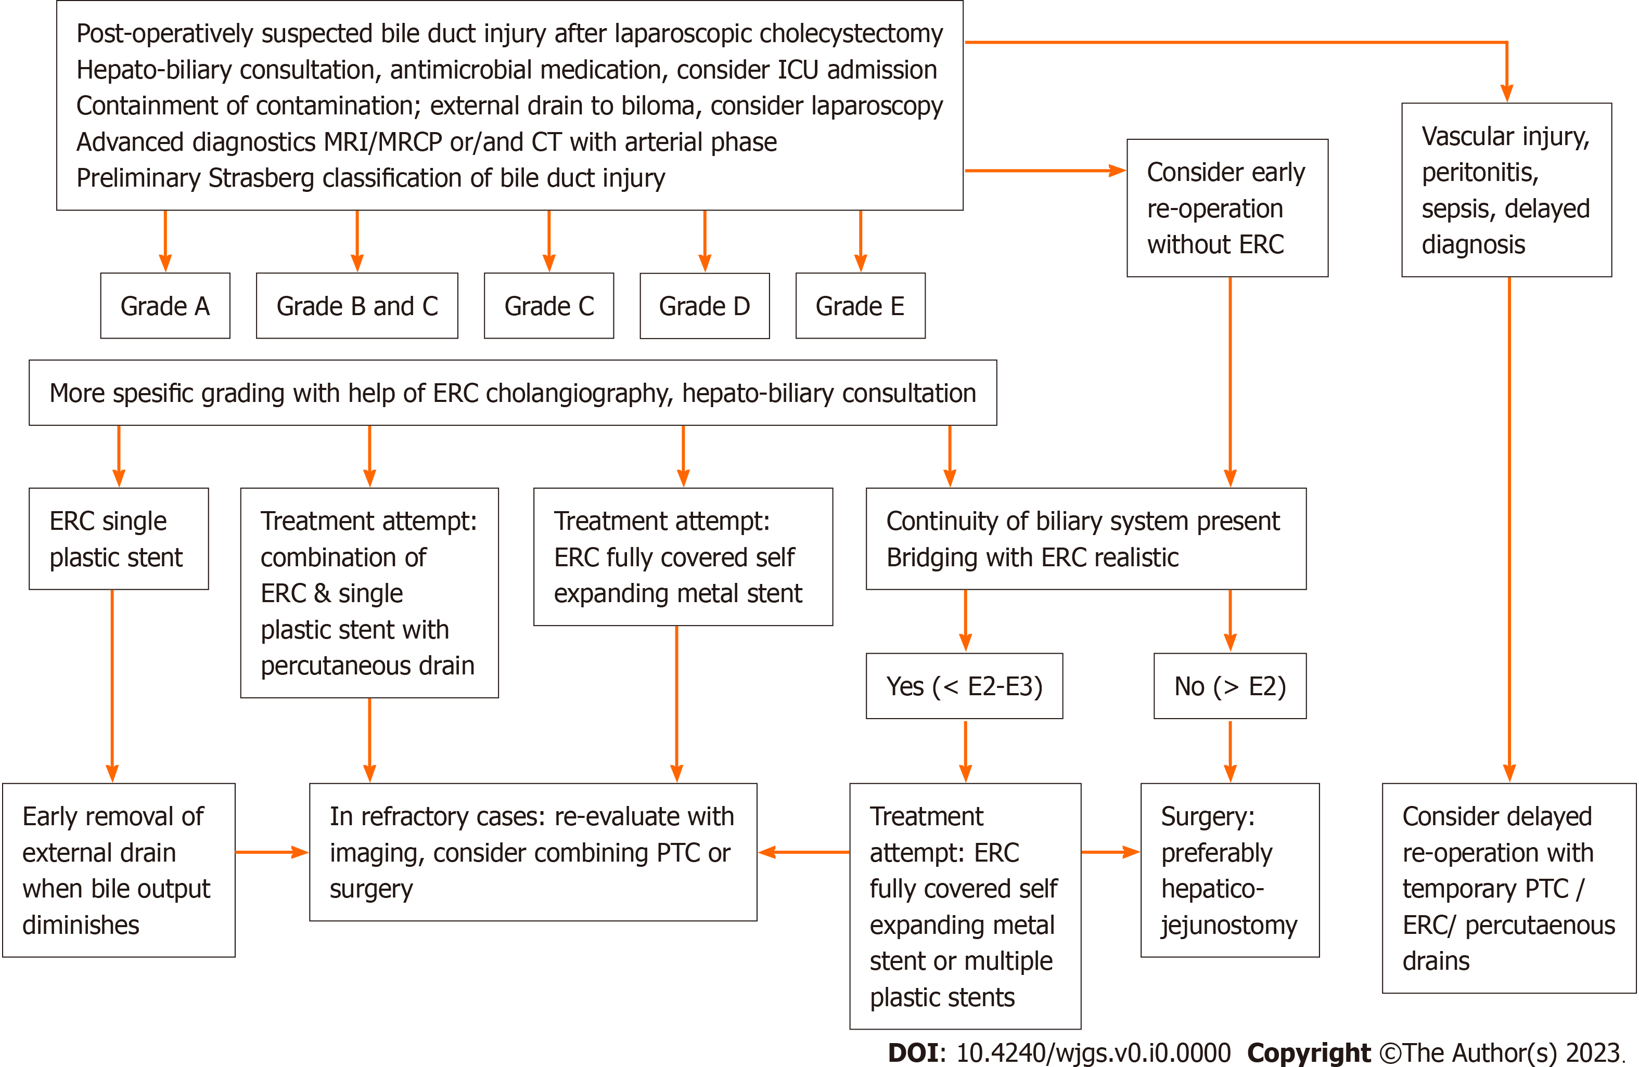
Figure 3 Flow chart of containment and initial treatment in bile leak or bile duct injury. Reconstructive surgery should be planned and performed by hepato-biliary specialists only. ICU: Intensive care unit; CT: Computed tomography; MRI: Magnetic resonance imaging; MRCP: Magnetic resonance cholangio-pancreatography; ERC: Endoscopic retrograde cholangiography; PTC: Percutaneous transhepatic cholangiography catheter drainage; FCSEMS: Fully covered self-expandable metal stent.

