Name of Journal: World Journal of Clinical Cases
Manuscript NO: 85544
Manuscript Type: ACADEMIC WRITING

Revitalizing case reports: Standardized guidelines and mentorship

Jeyaraman M et al. Revitalizing case reports in medical literature

Madhan Jeyaraman, Swaminathan Ramasubramanian, Naveen Jeyaraman, Arulkumar Nallakumarasamy, Shilpa Sharma

Madhan Jeyaraman, Department of Orthopaedics, ACS Medical College and Hospital, Chennai 600056, Tamil Nadu, India

Swaminathan Ramasubramanian, Department of General Medicine, Government Medical College, Omandurar Government Estate, Chennai 600018, Tamil Nadu, India

Naveen Jeyaraman, Department of Orthopaedics, Shri Sathya Sai Medical College and Research Institute, Sri Balaji Vidyapeeth, Chengalpet 603108, Tamil Nadu, India

Arulkumar Nallakumarasamy, Department of Orthopaedics, All Indian Institute of Medical Sciences, Bhubaneswar 751019, Odisha, India

Shilpa Sharma, Department of Paediatric Surgery, All India Institute of Medical Sciences, New Delhi 110029, India

Author contributions: All authors contributed equally to writing the manuscript.

Corresponding author: Madhan Jeyaraman, MS, PhD, Assistant Professor, Research Associate, Department of Orthopaedics, ACS Medical College and Hospital, Dr. MGR Educational and Research Institute, Chennai 600056, Tamil Nadu, India. madhanjeyaraman@gmail.com

Received: May 3, 2023
Revised: May 30, 2023
Accepted: June 9, 2023
Published online:

Abstract
Despite a decrease in publication, case reports remain essential in medical literature as they offer detailed descriptions of individual patient cases and valuable insights for future management. These reports adhere to a standardized structure comprising sections such as abstract, introduction, case report, discussion, and conclusion. Obtaining informed consent and adhering to guidelines is essential. Case reports contribute to evidence-based medicine by detecting new therapies and adverse events. They also facilitate clear reporting, guideline adherence, and mentorship programs. These reports are vital for documenting rare occurrences, assisting clinicians in timely management, and communicating novel information to busy medical professionals. Following case report guidelines ensures comprehensive and standardized reporting, enhancing the acceptance and quality of case reports, and advancing medical knowledge.

Key Words: Case report; Case report guidelines; Literature; Research

Jeyaraman M, Ramasubramanian S, Jeyaraman N, Nallakumarasamy A, Sharma S. Revitalizing case reports: Standardized guidelines and mentorship. World J Clin Cases 2023; In press

Core Tip: Despite occupying a lower tier within the evidence hierarchy, case reports serve as one of the foundational element for generating hypotheses that can be explored through more rigorous research methodologies. Adherence to the case report guidelines is crucial, alongside obtaining informed consent from patients, in order to maintain ethical standards and ensure the legitimacy of the case report. To guarantee the quality and rigor of the case report, it is essential to meticulously document the details in accordance with the specific requirements set forth by the target academic journal.

INTRODUCTION
Case reports have long been regarded as an essential component of medical literature. They provide detailed descriptions of individual patient symptoms, diagnoses, treatments, and follow-ups, offering valuable lessons and experiences that can guide future management of similar situations or cases. Although case reports may be at the bottom of the literature hierarchy, they can serve as the starting point for other evidence which builds on top of them, helping to identify new clinical conditions, observations, treatments, or complications^{[1]}. In recent years, however, the publication of case reports has drastically reduced due to a variety of factors, including a reduction in the impact factor of journals as case reports are less cited than original articles, plagiarism, and authorship conflicts. This paper aims to discuss the format of a case report, common reasons for rejection, and ways to improve acceptance. It focuses on improving writing skills for novice authors and emphasizes the importance of reporting rare or unusual clinical conditions, previously unreported diseases, unusual side effects of therapy, and the unique use of diagnostic tools.

STRUCTURE OF A CASE REPORT
A standardized case report generally adheres to a specific structure, encompassing five primary sections: Abstract, Introduction, Case Report, Discussion, and Conclusion. Each section plays a crucial role in the overall presentation and coherence of the case report.

Abstract: The abstract concisely summarizes the case, capturing its key elements within a limited word count. It includes the patient's demographics, clinical presentation, diagnostic investigations, treatment approach, and notable findings or outcomes, aiming to captivate readers and encourage further exploration of the paper's contents.

Introduction: The Introduction contextualizes the case by providing background information and its significance within the existing literature. It incorporates a comprehensive review of relevant published information, summarizing it coherently to set the stage for the presentation of the case. The Introduction establishes the case's context, existing knowledge, and highlights the unique contributions and novel information it offers to the medical community.

Case Report: The Case Report section provides essential information about the case, divided into several subsections:

Demographics: Covers patient's age, gender, and ethnicity while ensuring confidentiality.

History: Details the patient's medical history, including chief complaint, symptom duration, and relevant medical, surgical, and family history.

Clinical Examination: Describes the patient's vital signs, general appearance, and system-specific findings, emphasizing unique aspects and using concealed patient images with consent.

Investigations: Outlines diagnostic tests conducted, including laboratory tests and imaging studies, along with rationale and results.

Treatment: Discusses therapeutic interventions, including modality, dosage, duration, rationale, efficacy, side effects, and modifications.

Follow-up: Documents the patient's progress and outcomes during subsequent visits, especially for chronic conditions, including histopathologic examination results for surgical cases and relevant management.

Discussion: The Discussion section analyzes and interprets the case findings in relation to existing knowledge and similar reported cases. It incorporates a literature review and focuses on the unique aspects of the case, comparing and contrasting it with previous cases, and providing potential explanations for the observed findings. It addresses the strengths and limitations of the case, mentions encountered challenges or pitfalls, and discusses the implications for clinical practice and research.

Conclusion: The Conclusion section summarizes the key points and findings of the case report, highlighting its significance and unique features. It may include recommendations or suggestions for future research, clinical practice, or patient management. The specific content of this section can vary based on the target journal for submission.
In addition to the abovementioned sections, obtaining documented informed consent from the patient is an indispensable prerequisite before publishing a case report. Reporting a case without informed consent is deemed unethical. Authors should safeguard the patient's anonymity and secure consent for any images used in the report. By adhering to the structure and guidelines outlined above, authors can ensure a coherent and well-structured case report that may have a higher likelihood of acceptance in medical journals. Each section should be written in an academic tone, using clear and concise language that effectively conveys pertinent information while maintaining the reader's interest.

STRATEGIES FOR PUBLISHING A CASE REPORT
Figure 1 outlines the strategies involved in publishing a case report. The initial step in writing a case report involves finding a suitable mentor, as research has demonstrated that mentorship positively impacts the quality of case reports^{[1]}. Ensuring the novelty of the case is crucial, necessitating a comprehensive literature review. Subsequently, the report can be drafted in accordance with the provided guidelines and the case report guidelines (CARE guidelines). Once the report is written, it is important to select an appropriate journal that aligns with the specific case. During this process, potential pitfalls should be considered, and measures should be taken to maximize the chances of publication, which are explained below. Maintaining patient privacy is of paramount importance, and it should never be compromised. Professional ethics must be upheld throughout the publication process by keeping all relevant parties well-informed and providing appropriate acknowledgment in the final publication. Additionally, proofreading the manuscript and ensuring its adherence to the journal's guidelines are crucial steps before submission and publication.
Several pitfalls may be encountered during the publication process of case reports, such as poor manuscript quality, failure to conform to journal requirements, and rejection due to the low level of evidence provided by case reports in the literature hierarchy. To avoid these issues, authors can follow the CARE guidelines, which provide a 13-point checklist for writing case reports^{[1-3]}. Adherence to the submitting journal's requirements also improves the likelihood of acceptance. Furthermore, finding an experienced mentor is crucial for success in the academic realm, as they can guide authors through the process of selecting a case, writing the report, and finding an appropriate journal for publication.
Despite their limitations, case reports play a crucial role in medical research. Case reports, due to their narrow scope and limited readership, typically have limited generalizability and make minimal contributions to the scientific knowledge base, resulting in infrequent citations and potential negative impact on a journal's Impact Factor, while their specialized nature attracts a small number of readers with specific expertise in the field^{[4]}. Nonetheless, case reports serve as essential tools for medical progress by describing unusual or novel occurrences, and providing rapid communication between busy clinicians who may lack the time or resources for large-scale research^{[1]}. A well-written case report can demonstrate the coexistence of evidence-based medicine and the rare findings of an individual patient^{[5]}. Similarly, case reports and case series in dermatology and medicine can serve as the first line of evidence for new therapies and help detect rare adverse events^{[6]}. To improve the reporting of case reports and series, authors should provide a clear and concise title, fully describe the patient's history and intervention, report adverse events, discuss relevance to current medical knowledge, obtain informed consent, and follow the CARE guidelines. Workshops and mentorship programs can help trainees and academic faculty improve their skills in writing case reports^{[7]}. A retrospective pre-post survey has shown that participant confidence in identifying and writing case reports improves with mentorship^{[7]}. Writing and publishing case reports in the medical field remain vital, despite the challenges and limitations associated with them. Case reports are easy to write, relevant to daily clinical practice, and provide a foundation for further research. Reasons for case report rejection may include inadequate formatting, poor manuscript writing, plagiarism, data manipulation, or a low level of evidence. To overcome these issues, authors should follow the submitting journal's guidelines, edit their submissions, avoid plagiarism, ensure data integrity, and focus on novel techniques, unexpected outcomes, or therapeutic challenges^{[8]}.

CONCLUSION
Ultimately, the importance of case reports in medical research cannot be understated. Despite their limitations and the challenges associated with their publication, case reports offer valuable insights into rare clinical conditions, previously unreported diseases, unusual side effects of therapy, and the unique use of diagnostic tools. By adhering to the CARE guidelines, obtaining proper mentorship, and focusing on the quality and novelty of the case report, authors can increase the likelihood of acceptance and contribute to the advancement of medical knowledge.

REFERENCES
1 Sun Z. Tips for writing a case report for the novice author. J Med Radiat Sci 2013; 60: 108-113[PMID: 26229618 DOI: 10.1002/jmrs.18]
2 Riley DS, Barber MS, Kienle GS, Aronson JK, von Schoen-Angerer T, Tugwell P, Kiene H, Helfand M, Altman DG, Sox H, Werthmann PG, Moher D, Rison RA, Shamseer L, Koch CA, Sun GH, Hanaway P, Sudak NL, Kaszkin-Bettag M, Carpenter JE, Gagnier JJ. CARE guidelines for case reports: explanation and elaboration document. J Clin Epidemiol 2017; 89: 218-235[PMID: 28529185 DOI: 10.1016/j.jclinepi.2017.04.026]
3 CARE Case Report Guidelines. CARE Case Report Guidelines. [cited 3 June 2023]. Available from: https://www.care-statement.org
4 Khalil S, Mishra D. Sharing Clinical Experience with the Scientific Community: How to Write a Case Report? Indian Pediatr 2016; 53: 513-516[PMID: 27376606 DOI: 10.1007/s13312-016-0881-5]
5 Guidelines To Writing A Clinical Case Report. Heart Views 2017; 18: 104-105[PMID: 29184619 DOI: 10.4103/1995-705X.217857]
6 Albrecht J, Werth VP, Bigby M. The role of case reports in evidence-based practice, with suggestions for improving their reporting. J Am Acad Dermatol 2009; 60: 412-418[PMID: 19231639 DOI: 10.1016/j.jaad.2008.10.023]
7 Gupta S, Kimble A, Henry T, Burger A, Mhaskar R, Block L. A Case for Case Reports: How to Write One and Promote Mentorship, Scholarship and Faculty Development. Cureus 2023; 15: e33299[PMID: 36741651 DOI: 10.7759/cureus.33299]
8 Aneja K, Shyam A. Case Reports: The Art of Writing, the Importance of Publishing it and Avoiding Facing Rejection. J Orthop Case Rep 2022; 12: 106-107[PMID: 37065522 DOI: 10.13107/jocr.2021.v12.i06.2888]

Footnotes
Conflict-of-interest statement: All the authors report no relevant conflicts of interest for this article.

Open-Access: This article is an open-access article that was selected by an in-house editor and fully peer-reviewed by external reviewers. It is distributed in accordance with the Creative Commons Attribution NonCommercial (CC BY-NC 4.0) license, which permits others to distribute, remix, adapt, build upon this work non-commercially, and license their derivative works on different terms, provided the original work is properly cited and the use is non-commercial. See: https://creativecommons.org/Licenses/by-nc/4.0/

Provenance and peer review: Invited article; Externally peer reviewed.

Peer-review model: Single blind

Peer-review started: May 3, 2023
First decision: May 25, 2023
Article in press:

Specialty type: Medicine, research and experimental
Country/Territory of origin: India
Peer-review report’s scientific quality classification
Grade A (Excellent): 0
Grade B (Very good): B
Grade C (Good): C, C
Grade D (Fair): 0
Grade E (Poor): 0

P-Reviewer: Mahmoud MZ, Saudi Arabia; Watanabe T, Japan S-Editor: Li L L-Editor: A P-Editor:

Figure Legends
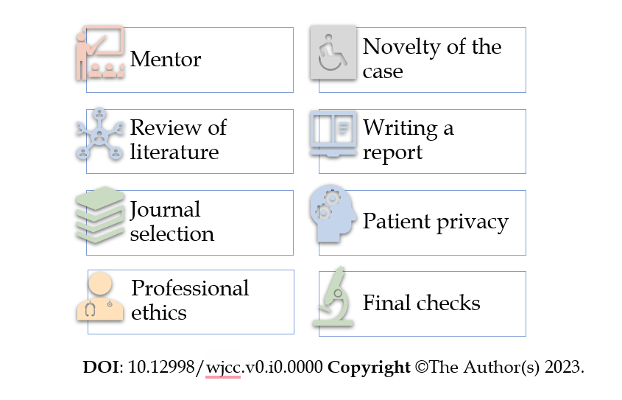
Figure 1 Strategies for publishing a case report.

