Name of journal: World Journal of Gastroenterology
ESPS Manuscript NO: 23576
Manuscript Type: ORIGINAL ARTICLE

Retrospective Study
Methylation of DAPK and THBS1 genes in esophageal gastric-type columnar metaplasia

Herrera-Goepfert R et al. Gene methylation in esophageal columnar metaplasia

Roberto Herrera-Goepfert, Luis F Oñate-Ocaña, José Luis Mosqueda-Vargas, Luis A Herrera, Clementina Castro, Julia Mendoza, Rodrigo González-Barrios

Roberto Herrera-Goepfert, José Luis Mosqueda-Vargas, Department of Pathology, Instituto Nacional de Cancerología (INCan), México 10480, DF, México

Luis F Oñate-Ocaña, Clinical Research Division, Instituto Nacional de Cancerología (INCan), México 10480, DF, México

Luis A Herrera, Clementina Castro, Julia Mendoza, Rodrigo González-Barrios, Unidad de Investigación Biomédica en Cáncer, Instituto Nacional de Cancerología (INCan)-Instituto de Investigaciones Biomédicas (IIB), Universidad Nacional Autónoma de México (UNAM), México 10480, DF, México

Author contributions: Herrera-Goepfert R contributed to study concept and design, acquisition of data, analysis and interpretation of data, drafting of the manuscript, critical revision of the manuscript for important intellectual content, statistical analysis, funding, and study supervision; Mosqueda-Vargas JL, Mendoza J, and González-Barrios R contributed to acquisition of data, drafted of the manuscript, and technical support; Herrera LA, Oñate-Ocaña LF, and Castro C contributed to analysis and interpretation of data, drafting of the manuscript, critical revision of the manuscript for important intellectual content, statistical analysis, and technical support; all authors have read and approved the final version to be published.

Institutional review board statement: The protocol study was approved by Research and Ethics on Research Committees at the Institute, and did not need ethical approval.

Conflict-of-interest statement: The authors declare no conflicts of interest.

Open-Access: This article is an open-access article which was selected by an in-house editor and fully peer-reviewed by external reviewers. It is distributed in accordance with the Creative Commons Attribution Non Commercial (CC BY-NC 4.0) license, which permits others to distribute, remix, adapt, build upon this work non-commercially, and license their derivative works on different terms, provided the original work is properly cited and the use is non-commercial. See: http://creativecommons.org/licenses/by-nc/4.0/

Correspondence to: Roberto Herrera-Goepfert, MD, Departamento de Patología, Instituto Nacional de Cancerología, México, Av. San Fernando 22, Colonia Sección XVI, Delegación Tlalpan, 10480 México, DF, México. rhgoepfert@gmail.com

Telephone: +52-55-47471020-11069

Received: December 2, 2015
Peer-review started: December 4, 2015
First decision: December 31, 2015
Revised: January 19, 2016
Accepted: January 30, 2016
Article in press:
Published online:

Abstract
AIM: To explore methylation of DAPK, THBS1, CDH-1, and p14 genes, and Helicobacter pylori (H. pylori) status in individuals harboring esophageal columnar metaplasia.

METHODS: Distal esophageal mucosal samples obtained by endoscopy and histologically diagnosed as gastric-type (non-specialized) columnar metaplasia, were studied thoroughly. DNA was extracted from paraffin blocks, and methylation status of death-associated protein kinase (DAPK), thrombospondin-1 (THBS1), cadherin-1 (CDH1), and p14 genes, was examined using a methyl-sensitive polymerase chain reaction (MS-PCR) and sodium bisulfite modification protocol. Helicobacter pylori (H. pylori) cagA status was determined by PCR.

RESULTS: In total, 68 subjects (33 females and 35 males), with a mean age of 52 years, were included. H. pylori cagA positive was present in the esophageal gastric-type metaplastic mucosa of 18 individuals. DAP kinase, THSB1, CDH1, and p14 gene promoters were methylated by MS-PCR in 40 (58.8%), 33 (48.5%), 46 (67.6%), and 23 (33.8%) cases of the 68 esophageal samples. Helicobacter pylori status was associated with methylation of DAPK (P = 0.003) and THBS1 (P = 0.019).

CONCLUSION: DNA methylation occurs in cases of gastric-type (non-specialized) columnar metaplasia of the esophagus, and this modification is associated with Helicobacter pylori cagA positive infection.

Key words: DNA methylation; Esophageal columnar metaplasia; DAPK; THBS1; Helicobacter pylori; cagA

© The Author(s) 2016. Published by Baishideng Publishing Group Inc. All rights reserved.

Core tip: Columnar metaplasia of the esophagus, whether specialized or not, is a hallmark of gastroesophageal reflux disease. Current information suggests that intestinal metaplasia in the esophagus arises from gastric-type metaplasia. In this study, we have demonstrated that Helicobacter pylori (H. pylori) cagA⁺ can colonize esophageal gastric-type metaplastic mucosa, and that DNA methylation of tumor suppressor genes could be related to H. pylori cagA⁺ infection, which in turn, may predispose to precancerous lesions, including intestinal metaplasia.

Herrera-Goepfert R, Oñate-Ocaña LF, Mosqueda-Vargas JL, Herrera LA, Castro C, Mendoza J, González-Barrios R. Methylation of DAPK and THBS1 genes in esophageal gastric-type columnar metaplasia. World J Gastroenterol 2016; In press

INTRODUCTION
Columnar metaplasia of the esophagus is defined as the replacement of the normal settled squamous epithelium in the distal portion of the esophagus with columnar epithelium, either with goblet cells [specialized columnar metaplasia, i.e., complete or incomplete intestinal metaplasia, Barrett esophagus (BE)], or without goblet cells (non-specialized columnar metaplasia or gastric-type metaplasia; i.e., oxyntocardiac and cardiac mucosa)^{[1]}. The importance of such a distinction is found in the higher risk of developing adenocarcinoma of the distal esophagus in patients harboring specialized columnar metaplasia; the incidence of adenocarcinoma originating in BE has been reported as approximately 0.5% per year, with higher risk when long-segment BE is present^{[2]}. However, it is now recognized that the presence of specialized columnar metaplastic cells (goblet cells) is not an essential requirement for the development of such adenocarcinomas^{[3]}. Columnar metaplasia of the esophagus, whether specialized or not, is a hallmark of gastroesophageal reflux disease (GERD), and current information suggests that intestinal metaplasia in the esophagus arises from gastric-type, oxyntocardiac and/or cardiac (non-specialized) metaplasia^{[4]}. Histologically, the non-specialized metaplastic mucosa of the esophagus may display any of the changes commonly observed in settled gastric mucosa, including the changes observed during Helicobacter pylori (H. pylori) infection^{[5]}.
Neoplastic transformation and progression in BE are related with genetic and epigenetic events that ultimately favor abnormal expression of the genes responsible for the intrinsic control mechanisms regulating cellular proliferation and/or apoptosis. DNA methylation is involved in the epigenetic regulation of gene expression (primarily through gene repression) when it occurs predominantly in regions containing CpG islands, which are often concentrated in the promoter regions of genes. In the case of esophageal adenocarcinoma, abnormal methylation patterns are not only detected in neoplastic tissue but also in premalignant Barrett mucosa. These results suggest that hypermethylation of DNA is an early epigenetic event in the multistep process of esophageal carcinogenesis^{[6]}.
Recent reports suggested that H. pylori is an initiator of the inflammatory microenvironment which might promote carcinogenesis and progression of gastric cancer^{[7]}; in gastric diseases, chronic inflammation and alterations in DNA and histone methylation, especially at promoter regions, are frequently associated with H. pylori infection^{[8,9]}. Such epigenetic alteration could be promoted in part by activation of NF-κB and PI3K/AKT-Sp1-RBP2-Cyclin D1 pathways triggered by H. pylori Cytotoxin-associated gene product (cagA) positive^{[7,9,10]}. In addition to aging, increased methylation of several genes has also been described in chronic gastritis and premalignant stages of gastric carcinoma, irrespective of H. pylori status^{[11]}. Moreover, H. pylori infection induces an overexpression of DNA methyltransferases (DNMTs), which has been associated with CpG island methylation of multiple gene promoters involved in cell growth, differentiation and tumor suppression, like Ndrg2, p14, DAPK and CDH1, as in chronic gastritis as in gastric cancer^{[7,12–14]}.
Consequently, the aim of this retrospective and descriptive study, was to explore the relationship between methylation of the death-associated protein kinase (DAPK), thrombospondin-1 (THBS1), cadherin-1 (CDH1), and p14 genes, and the presence of H. pylori cytotoxin-associated gene A (cagA) positive, in the non-specialized, gastric-type columnar metaplastic mucosa of the distal esophagus, in a group of Mexican patients.

MATERIAL AND METHODS

Patients
This is a retrospective and descriptive study of consecutive cases with the histopathological diagnosis of non-specialized (gastric-type), but not specialized (complete or incomplete intestinal metaplasia), columnar metaplasia of the distal esophagus. Biopsies of the distal esophagus, as well as gastric biopsies, were retrieved from the files of the Department of Pathology at the Instituto Nacional de Cancerología (INCan) in Mexico City during the period between January 2003 and December 2008. Inclusion criteria were females and males, aged > 18 years. All biopsies were obtained by means of the panendoscopy procedure at the Endoscopy Service outpatient clinic, in patients with upper gastrointestinal complaints and with endoscopic suspicion of columnar metaplasia. Relevant demographic and clinical data for each patient were retrospectively retrieved from their clinical records. Non-specialized columnar metaplasia of the esophagus was operationally defined as the presence of cardiac and/or oxyntocardiac gastric mucosa lacking goblet cells and intermingled with recognizable islets of non-keratinized squamous epithelium and/or immersed duct structures lined by multilayered epithelium. Slides stained with hematoxylin and eosin (HE) from each case were thoroughly reviewed, and histological criteria for gastritis (mononuclear cells and neutrophils) and H. pylori density were applied to grade the samples according to the Visual analog scales (VAS) proposed by the Updated Sydney System^{[15]}. Giemsa staining was also performed to confirm the presence of H. pylori. Finally, cases with sufficient tissue were selected for morphological and molecular analysis. DNA was extracted from paraffin-embedded tissue samples.

DNA extraction and bisulfite modification

DNA was extracted from histological sections of 20 µm in thickness by phenol/chloroform/isoamyl alcohol. One µg of genomic DNA extracted from samples was subjected to sodium bisulfite modification using a Zymo Kit (EZ DNA Methylation™ Kit; Zymo Research Co., USA) following manufacturer’s instructions for small samples. As a control, we employed human lymphocyte DNA, known to be unmethylated in the promoter regions of our genes-of-interest.

Methylation-specific polymerase chain reaction

Bisulfite-modified DNA was amplified with primers specific for either methylated or unmethylated sequences^{[11]} (Table 1). PCR products were subjected to electrophoresis on 3% agarose gels and were then visualized under ultraviolet (UV) illumination using ethidium bromide.

H. pylori detection by PCR

The presence of H. pylori was corroborated by PCR using the following primers from the conserved region of the cagA gene: forward, 5´ TT CAT GGG CGT GTT TGA TG 3´, and reverse, 5’-AGC GAC TCC CTC AAC ATC TAA 3’. The fragments were amplified with 30 cycles utilizing a 55°C annealing temperature.

Statistical analysis
Statistical review of the study was performed by a biomedical statistician. The association of tested variables with the presence of H. pylori infection was assessed using the χ² test. Odds ratios (OR) with their corresponding 95% confidence intervals (95%CIs) were calculated as a measure of association using logistic regression analysis. Two-sided statistics were used in all cases, and a probability (p) value of 0.05 was considered as significant. SPSS ver. 19 software (2010; IBM Corp., Armonk, NY, USA) was used for computations.

RESULTS
A total of 68 subjects (33 females and 35 males) with a mean age of 52 years (range, 25‒88 years) fulfilled the histological criteria and were thus eligible for the study. In 35 subjects, gastric mucosa samples were insufficient for the molecular study, and in the remaining 33 (48.5%) subjects, the gastric samples were processed for final analysis. Endoscopic findings at the distal esophagus included variable degrees of mucosal erosion, salmon-colored mucosal tongues and irregular Z line. Histologically, all cases showed chronic inflammation. In the esophageal samples, the intensity of the mononuclear infiltrate was moderate in 43 (63.2%) cases, mild in 18 (26.5%), and marked in 7 (10.3%). Forty (58.8%) of the cases displayed polymorphonuclear leukocyte activity in the gastric-type metaplastic mucosa, which was graded as mild in 33 (82.5%) cases, moderate in 5 (12.5%), and marked in 2 (5%) (Figures 1 and 2). In 22 (32.3%) cases, H. pylori microorganisms were identified at the luminal surface of the gastric-type metaplastic mucosa. H. pylori density was graded as mild in 17 (77.3%) cases, moderate in 3 (13.6%), and marked in 2 (9.1%) (Figure 3). Regarding the 33 gastric biopsies, mononuclear infiltrate intensity was moderate in 16 (48.5%) cases, mild in 14 (42.4%), and marked in 3 (9.1%). Polymorphonuclear leukocyte activity was present in 17 (51.5%) cases and graded as moderate in 8 (47%), mild in 7 (41.2%), and marked in two (11.8%). H. pylori microorganisms were found in 17 (51.5%) cases and graded according to density, as moderate in 10 (58.8%), mild in 5 (29.4%), and marked in two (11.8%). In addition, four (12.1%) and two (6%) of the 33 cases displayed mild and moderate complete intestinal metaplasia, respectively. In one (3%) case, there was also mild atrophy of the gastric mucosa.
CagA⁺ H. pylori was detected in the esophageal non-specialized metaplastic mucosa and in the gastric mucosa of 18 (26.5%) of 68 individuals, and in 10 (30.3%) of 33, respectively, by means of Polymerase chain reaction (PCR) (Figure 4A). DAP kinase, THSB1, CDH1, and p14 gene promoters were methylated by MS-PCR in 40 (58.8%), 33 (48.5%), 46 (67.6%), and 23 (33.8%) cases of the 68 esophageal samples and in 10 (30.3%), 14 (43.8%), 26 (78.8%), and 10 (31.3%) of the gastric biopsies, respectively. In the remaining cases, these genes were not methylated (Figure 4B). H. pylori cagA⁺ status was significantly associated with methylation of DAPK (P = 0.003) and THBS1 (P = 0.019) in the 68 esophageal samples (Table 2), and bivariate analysis confirmed the significance of this association (Table 3). In the comparative analysis between the 33 gastric and 33 esophageal paired samples, the trend for the association between H. pylori cagA⁺ and methylation of THBS1 and DAPK genes was maintained (Table 4). Methylation of the CDH1 and p14 gene promoters did not exhibit statistically significant differences between H. pylori cagA⁺ and cagA⁻ cases, in both the esophageal and the gastric biopsies. Among the esophageal biopsies, there were no significant differences regarding the age (P = 0.39) or gender (P = 0.34) of the subjects and H. pylori status by means of PCR; histopathological variables according to the Updated Sydney System for the classification and grading of gastritis were significantly associated with H. pylori cagA⁺ status (Table 5). On the other hand, H. pylori density, mononuclear cells, and neutrophils, as histologically graded according to the Updated Sidney System for the classification of gastritis, did not show correlation with methylation status of the genes-under-study (data not shown).

DISCUSSION
Allison et al^{[16,17]} first described and correctly interpreted the histopathological changes occurring in the distal esophagus of subjects suffering from GERD, and Paull et al^{[18]}, defined the histological subsets of the columnar lined esophagus. The subsets were then renamed the oxyntocardiac mucosa (formerly the fundic epithelium), cardiac mucosa (formerly the junctional epithelium), and intestinal metaplastic mucosa (formerly the specialized columnar epithelium) by Chandrasoma et al^{[19]}.
Although H. pylori infection of the gastric mucosa has been proposed as a beneficial factor for GERD and BE^{[20,21]}, nearly nothing has been published regarding the potential effects of H. pylori colonization on the esophageal non-specialized (gastric-type) metaplastic mucosa. To the best of our knowledge, this study is the first to examine the presence of H. pylori cagA⁺ in columnar metaplastic mucosa of the esophagus and to correlate such bacterial presence with the appearance of early epigenetic events. We selected cases with gastric-type (non-specialized) columnar metaplasia of the esophagus because, in addition to being considered an early morphological change in the evolution of Barrett’s esophagus^{[21]}, intestinal metaplastic cells are infrequently colonized by H. pylori^{[22]}. Given the limited and random sampling of the columnar esophagus, we cannot yet rule out the presence of specialized columnar epithelium in areas other than those analyzed in the present study. However, our goal was to explore the methylation status of select genes and the relationship of methylation with H. pylori cagA⁺ infection in gastric-type metaplastic mucosa of the esophagus.
The majority of these studies, however, have been planned and conducted employing normal settled esophageal mucosa or tissues displaying intestinal metaplasia and not considering non-specialized (gastric-type) metaplastic mucosa In this study, we explored the methylation status of four genes, DAPK (proapoptotic; tumor suppressor), THBS1 (angiogenesis inhibitor), CDH1 (cell adhesion), and p14ARF (cell cycle regulator; tumor suppressor), in patients harboring gastric-type (non-specialized) columnar metaplasia of the esophagus. Of these, DAPK and THBS1 methylation was significantly associated with H. pylori cagA⁺ infection of the esophageal gastric-type metaplastic mucosa, whereas CDH1 and p14 genes methylation was not. In specialized columnar metaplasia of the esophagus (BE), DAPK, CDH1, and p14 have been reported to be methylated in 50%, 8%, and 7%, respectively^{[23]}, whereas THBS1 is infrequently methylated^{[6]}. On the other hand, we did not find a statistically significant association between H. pylori cagA positive and methylation of any of these genes, in the gastric mucosa. Our findings could be interpreted as the result of the smaller sampling of the gastric mucosa than of the columnar lined esophagus, therefore, with a loss of any potential statistic association. Another plausible explanation is that metaplastic gastric mucosa, in the distal esophagus, is more susceptible to, or predisposes to, the methylation of certain genes than the normal settled gastric mucosa due to disturbances induced by the gastroesophageal reflux, in addition to the H. pylori infection.
It is widely recognized that H. pylori is able to colonize gastric mucosa along the entire gastrointestinal tract, including areas as proximal as the upper esophagus^{[24]} and as distal as the rectum^{[25]}, as well as all sites in between, such as the duodenum^{[26]} and Meckel’s diverticulum^{[27]}. Previously, colonization of gastric-type mucosa in BE was also described; however, its clinicopathological significance has been underestimated^{[5]} Recently, employing a rat experimental model of chronic gastroesophageal reflux, Liu et al^{[28]} demonstrated that severity of inflammation and incidence of Barrett esophagus and esophageal adenocarcinoma are increased when H. pylori colonizes the esophagus. In the gastric mucosa, H. pylori causes a complex immune and inflammatory process that is largely determined by the virulence of strains carrying the cytotoxin-associated gene (cag) pathogenicity island (PAI)^{[29]}. Thus, H. pylori is responsible for several molecular events that ultimately play a significant role in gastric carcinogenesis. Interestingly, H. pylori infection has been suggested as an initiator of gastric carcinogenesis by upregulation of DNA methyltransferase 3b (DNMT3b)^{[7]}, and it has been also reported to induce expression of DNMT1 and DNMT3A in gastrointestinal stromal tumors^{[30]}; therefore, H. pylori DNMT-induced de novo methylation could promote aberrant CpG island methylation, thus increasing the risk of gastric cancer^{[31,32]}.
Dysregulation of DAPK is implicated in the development and progression of cancer through gene silencing. DAP kinase function is closely related with the p53-dependent pathway for apoptosis^{[33]}. In the gastric mucosa, hypermethylation of the DAPK promoter has been associated with aging and chronic inflammation^{[11]}, as well as premalignant stages of gastric carcinoma^{[34]}. Hypermethylation of the DAPK gene in noncancerous gastric and chronic gastritis mucosa has been associated with the risk of gastric cancer and neutrophil infiltration activity, but not aging, in a H. pylori-infected population^{[10,12,35]}. In the esophageal mucosa, decreases in DAP kinase protein expression correlate with the severity of reflux esophagitis and tumor progression in Barrett carcinogenesis^{[36]}.
Moreover, a field effect of DAPK has been detected in normal esophageal mucosa of patients with adenocarcinoma and Barrett esophagus^{[37]}. Indeed, possible silencing of DAPK by methylation could be an early event in columnar metaplasia of the esophagus, and this silencing remains throughout the process of neoplastic transformation. The association between DAPK silencing and H. pylori infection has been previously reported in gastric mucosa^{[12]}. It is noteworthy that H. pylori infection of the columnar mucosa could be exerting an additive effect on DAPK gene promoter methylation, in addition to the reflux.
On the other hand, THBS1 is an inhibitor of angiogenesis and its expression is regulated by tumor-suppressor genes such as p53 and Rb. Additionally, THBS1 possesses tumor suppressive properties in vivo. It has been demonstrated that THBS1 methylation inactivates its expression in several normal and neoplastic cell lines^{[38]}.
DAPK and THBS1 have been found to be methylated in the gastric mucosa in patients with diseases ranging from chronic gastritis to carcinoma, with a rising frequency of DAPK methylation encountered in advanced stages of carcinogenesis^{[36]}. THBS1 promoter methylation has been associated with DAPK methylation from early-onset sporadic gastric carcinoma^{[39]}. In this way, our findings are in agreement with previous studies that demonstrated that the early steps of Barrett’s progression may involve DNA methylation of genes linked with apoptosis and tumor suppressor properties, particularly DAPK and THBS1. Our findings are also consistent with those reported by Ferrández et al^{[40]}, who performed a large case-control study and observed that H. pylori CagA⁺ infection does not reduce the risk of BE.
Finally, we are aware that our study has some limitations, regarding its retrospective design, the small number of patients under study, and the inevitable sampling bias
due to the varied and random distribution of the histological changes among the columnar lined esophagus. Further prospective studies are warranted to adequately identify patients with GERD with higher risks for developing severe disorders including BE as well as adenocarcinoma and its precursor lesions.
In this study, we showed that CpG methylation occurs in non-specialized, gastric-type columnar metaplasia of the esophagus and is closely related to H. pylori cagA⁺ infection. Given this effect on gastric-type metaplastic mucosa, a conscious search for H. pylori and its eradication may be essential for halting the early mechanisms potentially involved in BE development and BE-associated carcinogenesis, among subjects suffering from GERD.

COMMENTS
Background
Gastroesophageal reflux disease (GERD) is a highly prevalent condition among worldwide population, and gives rise to esophageal columnar metaplasia, among others. Nowadays, columnar metaplasia of the esophagus is classified into non-specialized (gastric-type) and specialized [intestinal-type; Barrett’s esophagus (BE)] neoplastic transformation and progression in BE, are related to genetic and epigenetic events that ultimately favor abnormal expression of the genes responsible for the intrinsic control mechanisms regulating cellular proliferation and/or apoptosis.

Research frontiers
Current information suggests that intestinal metaplasia arises from gastric-type, non-specialized metaplasia. In the stomach, Helicobacter pylori (H. pylori) infection has been associated with methylation of multiple gene promoters involved in cell growth, differentiation and tumor suppression, as in chronic gastritis as in gastric cancer. In this study, the authors report the methylation of two genes and its relation to H. pylori cagA status, in gastric- type columnar metaplasia of the esophagus.

Innovations and breakthroughs
DNA methylation of the promoter regions of genes containing CpG islands is involved in the epigenetic regulation of gene expression (predominantly through gene repression), and it is an early event in the multistep process of esophageal carcinogenesis. The authors performed the first study to assess the methylation of some genes involved in neoplastic transformation and progression in several organs, and its correlation with H. pylori cagA⁺ infection, in the esophageal gastric-type metaplastic mucosa.

Applications
This study provides evidence that CpG methylation occurs in non-specialized columnar metaplasia of the esophagus and is closely related to H. pylori cagA⁺ infection. Given this effect on gastric-type metaplastic mucosa, a conscious search for H. pylori and its eradication may be essential for halting the early mechanisms potentially involved in BE development and BE-associated carcinogenesis, among subjects suffering from GERD.

Peer-review
Herrera-Goepfert et al explored gene methylation in esophageal columnar metaplasia, and correlated these findings with the status of H. pylori cagA⁺. It is well written and contains information which readers may be interested. Because it is suggested that intestinal metaplasia in the esophagus arises from gastric-type metaplasia, authors should include intestinal metaplasia in the study.

REFERENCES
1 Spechler SJ, Souza RF. Barrett's esophagus. N Engl J Med 2014; 371: 836-845 [PMID: 25162890 DOI: 10.1056/NEJMra1314704]
2 Dias Pereira A, Suspiro A, Chaves P. Cancer risk in Barrett's oesophagus. Eur J Gastroenterol Hepatol 2007; 19: 915-918 [PMID: 18049157 DOI: 10.1097/MEG.0b013e3282c3a967]
3 Takubo K, Aida J, Naomoto Y, Sawabe M, Arai T, Shiraishi H, Matsuura M, Ell C, May A, Pech O, Stolte M, Vieth M. Cardiac rather than intestinal-type background in endoscopic resection specimens of minute Barrett adenocarcinoma. Hum Pathol 2009; 40: 65-74 [PMID: 18755496 DOI: 10.1016/j.humpath.2008.06.008]
4 Chandrasoma P, Wijetunge S, Demeester SR, Hagen J, Demeester TR. The histologic squamo-oxyntic gap: an accurate and reproducible diagnostic marker of gastroesophageal reflux disease. Am J Surg Pathol 2010; 34: 1574-1581 [PMID: 20871393 DOI: 10.1097/PAS.0b013e3181f06990]
5 Talley NJ, Cameron AJ, Shorter RG, Zinsmeister AR, Phillips SF. Campylobacter pylori and Barrett's esophagus. Mayo Clin Proc 1988; 63: 1176-1180 [PMID: 3199885]
6 Eads CA, Lord RV, Wickramasinghe K, Long TI, Kurumboor SK, Bernstein L, Peters JH, DeMeester SR, DeMeester TR, Skinner KA, Laird PW. Epigenetic patterns in the progression of esophageal adenocarcinoma. Cancer Res 2001; 61: 3410-3418 [PMID: 11309301]
7 Ling ZQ, Ge MH, Lu XX, Han J, Wu YC, Liu X, Zhu X, Hong LL. Ndrg2 promoter hypermethylation triggered by helicobacter pylori infection correlates with poor patients survival in human gastric carcinoma. Oncotarget 2015; 6: 8210-8225 [PMID: 25823664 DOI: 10.18632/oncotarget.3601]
8 Yoshida T, Kato J, Maekita T, Yamashita S, Enomoto S, Ando T, Niwa T, Deguchi H, Ueda K, Inoue I, Iguchi M, Tamai H, Ushijima T, Ichinose M. Altered mucosal DNA methylation in parallel with highly active Helicobacter pylori-related gastritis. Gastric Cancer 2013; 16: 488-497 [PMID: 23292007 DOI: 10.1007/s10120-012-0230-x]
9 Liang X, Zeng J, Wang L, Shen L, Li S, Ma L, Ci X, Yu J, Jia M, Sun Y, Liu Z, Liu S, Li W, Yu H, Chen C, Jia J. Histone demethylase RBP2 induced by Helicobactor Pylori CagA participates in the malignant transformation of gastric epithelial cells. Oncotarget 2014; 5: 5798-5807 [PMID: 25015565]
10 Shao Y, Sun K, Xu W, Li XL, Shen H, Sun WH. Helicobacter pylori infection, gastrin and cyclooxygenase-2 in gastric carcinogenesis. World J Gastroenterol 2014; 20: 12860-12873 [PMID: 25278683 DOI: 10.3748/wjg.v20.i36.12860]
11 Kang GH, Lee HJ, Hwang KS, Lee S, Kim JH, Kim JS. Aberrant CpG island hypermethylation of chronic gastritis, in relation to aging, gender, intestinal metaplasia, and chronic inflammation. Am J Pathol 2003; 163: 1551-1556 [PMID: 14507661]
12 Tahara T, Arisawa T, Shibata T, Nakamura M, Yoshioka D, Okubo M, Maruyama N, Kamano T, Kamiya Y, Fujita H, Nakagawa Y, Nagasaka M, Iwata M, Takahama K, Watanabe M, Yamashita H, Hirata I. Increased number of methylated CpG islands correlates with Helicobacter pylori infection, histological and serological severity of chronic gastritis. Eur J Gastroenterol Hepatol 2009; 21: 613-619 [PMID: 19307977 DOI: 10.1097/MEG.0b013e32830e28b2]
13 Chan AO, Peng JZ, Lam SK, Lai KC, Yuen MF, Cheung HK, Kwong YL, Rashid A, Chan CK, Wong BC. Eradication of Helicobacter pylori infection reverses E-cadherin promoter hypermethylation. Gut 2006; 55: 463-468 [PMID: 16428266 DOI: 10.1136/gut.2005.077776]
14 Wei J, Noto JM, Zaika E, Romero-Gallo J, Piazuelo MB, Schneider B, El-Rifai W, Correa P, Peek RM, Zaika AI. Bacterial CagA protein induces degradation of p53 protein in a p14ARF-dependent manner. Gut 2015; 64: 1040-1048 [PMID: 25080447 DOI: 10.1136/gutjnl-2014-307295]
15 Dixon MF, Genta RM, Yardley JH, Correa P. Classification and grading of gastritis. The updated Sydney System. International Workshop on the Histopathology of Gastritis, Houston 1994. Am J Surg Pathol 1996; 20: 1161-1181 [PMID: 8827022]
16 Allison PR. Peptic ulcer of the oesophagus. Thorax 1948; 3: 20-42 [PMID: 18904843]
17 Allison PR, Johnstone AS. The oesophagus lined with gastric mucous membrane. Thorax 1953; 8: 87-101 [PMID: 13077502]
18 Paull A, Trier JS, Dalton MD, Camp RC, Loeb P, Goyal RK. The histologic spectrum of Barrett's esophagus. N Engl J Med 1976; 295: 476-480 [PMID: 940579]
19 Chandrasoma PT, Lokuhetty DM, Demeester TR, Bremmer CG, Peters JH, Oberg S, Groshen S. Definition of histopathologic changes in gastroesophageal reflux disease. Am J Surg Pathol 2000; 24: 344-351 [PMID: 10716147]
20 Corley DA, Kubo A, Levin TR, Block G, Habel L, Rumore G, Quesenberry C, Buffler P, Parsonnet J. Helicobacter pylori and gastroesophageal reflux disease: a case-control study. Helicobacter 2008; 13: 352-360 [PMID: 19250510 DOI: 10.1111/j.1523-5378.2008.00624.x]
21 Corley DA, Kubo A, Levin TR, Block G, Habel L, Zhao W, Leighton P, Rumore G, Quesenberry C, Buffler P, Parsonnet J. Helicobacter pylori infection and the risk of Barrett's oesophagus: a community-based study. Gut 2008; 57: 727-733 [PMID: 17895354 DOI: 10.1136/gut.2007.132068]
22 Ota H, Katsuyama T, Nakajima S, El-Zimaity H, Kim JG, Graham DY, Genta RM. Intestinal metaplasia with adherent Helicobacter pylori: a hybrid epithelium with both gastric and intestinal features. Hum Pathol 1998; 29: 846-850 [PMID: 9712427]
23 Agarwal A, Polineni R, Hussein Z, Vigoda I, Bhagat TD, Bhattacharyya S, Maitra A, Verma A. Role of epigenetic alterations in the pathogenesis of Barrett's esophagus and esophageal adenocarcinoma. Int J Clin Exp Pathol 2012; 5: 382-396 [PMID: 22808291]
24 Gutierrez O, Akamatsu T, Cardona H, Graham DY, El-Zimaity HM. Helicobacter pylori and hetertopic gastric mucosa in the upper esophagus (the inlet patch). Am J Gastroenterol 2003; 98: 1266-1270 [PMID: 12818267 DOI: 10.1111/j.1572-0241.2003.07488.x]
25 Corrigan MA, Shields CJ, Keohane C, Kirwan WO. The immunohistochemical demonstration of Helicobacter pylori in rectal ectopia. Surg Laparosc Endosc Percutan Tech 2009; 19: e146-e148 [PMID: 19692868 DOI: 10.1097/SLE.0b013e3181ae534c]
26 Genta RM, Kinsey RS, Singhal A, Suterwala S. Gastric foveolar metaplasia and gastric heterotopia in the duodenum: no evidence of an etiologic role for Helicobacter pylori. Hum Pathol 2010; 41: 1593-1600 [PMID: 20656325 DOI: 10.1016/j.humpath.2010.04.010]
27 Ackerman Z, Peston D, Cohen P. Role of Helicobacter pylori infection in complications from Meckel's diverticulum. Dig Dis Sci 2003; 48: 1068-1072 [PMID: 12822864]
28 Liu FX, Wang WH, Wang J, Li J, Gao PP. Effect of Helicobacter pylori infection on Barrett's esophagus and esophageal adenocarcinoma formation in a rat model of chronic gastroesophageal reflux. Helicobacter 2011; 16: 66-77 [PMID: 21241415 DOI: 10.1111/j.1523-5378.2010.00811.x]
29 Amieva MR, El-Omar EM. Host-bacterial interactions in Helicobacter pylori infection. Gastroenterology 2008; 134: 306-323 [PMID: 18166359 DOI: 10.1053/j.gastro.2007.11.009]
30 He M, Fan J, Jiang R, Tang WX, Wang ZW. Expression of DNMTs and MBD2 in GIST. Biomed Rep 2013; 1: 223-227 [PMID: 24648923 DOI: 10.3892/br.2012.34]
31 He M, Fan J, Jiang R, Tang WX, Wang ZW. Expression of DNMTs and genomic DNA methylation in gastric signet ring cell carcinoma. Mol Med Rep 2013; 8: 942-948 [PMID: 23820855 DOI: 10.3892/mmr.2013.1566]
32 Enomoto S, Maekita T, Ohata H, Yanaoka K, Oka M, Ichinose M. Novel risk markers for gastric cancer screening: Present status and future prospects. World J Gastrointest Endosc 2010; 2: 381-387 [PMID: 21191511 DOI: 10.4253/wjge.v2.i12.381]
33 Michie AM, McCaig AM, Nakagawa R, Vukovic M. Death-associated protein kinase (DAPK) and signal transduction: regulation in cancer. FEBS J 2010; 277: 74-80 [PMID: 19878310 DOI: 10.1111/j.1742-4658.2009.07414.x]
34 Kang GH, Shim YH, Jung HY, Kim WH, Ro JY, Rhyu MG. CpG island methylation in premalignant stages of gastric carcinoma. Cancer Res 2001; 61: 2847-2851 [PMID: 11306456]
35 Kaise M, Yamasaki T, Yonezawa J, Miwa J, Ohta Y, Tajiri H. CpG island hypermethylation of tumor-suppressor genes in H. pylori-infected non-neoplastic gastric mucosa is linked with gastric cancer risk. Helicobacter 2008; 13: 35-41 [PMID: 18205664 DOI: 10.1111/j.1523-5378.2008.00572.x]
36 Kuester D, Dar AA, Moskaluk CC, Krueger S, Meyer F, Hartig R, Stolte M, Malfertheiner P, Lippert H, Roessner A, El-Rifai W, Schneider-Stock R. Early involvement of death-associated protein kinase promoter hypermethylation in the carcinogenesis of Barrett's esophageal adenocarcinoma and its association with clinical progression. Neoplasia 2007; 9: 236-245 [PMID: 17401463]
37 Brabender J, Marjoram P, Lord RV, Metzger R, Salonga D, Vallböhmer D, Schäfer H, Danenberg KD, Danenberg PV, Selaru FM, Baldus SE, Hölscher AH, Meltzer SJ, Schneider PM. The molecular signature of normal squamous esophageal epithelium identifies the presence of a field effect and can discriminate between patients with Barrett's esophagus and patients with Barrett's-associated adenocarcinoma. Cancer Epidemiol Biomarkers Prev 2005; 14: 2113-2117 [PMID: 16172218 DOI: 10.1158/1055-9965.EPI-05-0014]
38 Li Q, Ahuja N, Burger PC, Issa JP. Methylation and silencing of the Thrombospondin-1 promoter in human cancer. Oncogene 1999; 18: 3284-3289 [PMID: 10359534]
39 Kim HC, Kim JC, Roh SA, Yu CS, Yook JH, Oh ST, Kim BS, Park KC, Chang R. Aberrant CpG island methylation in early-onset sporadic gastric carcinoma. J Cancer Res Clin Oncol 2005; 131: 733-740 [PMID: 16075282]
40 Ferrández A, Benito R, Arenas J, García-González MA, Sopeña F, Alcedo J, Ortego J, Sainz R, Lanas A. CagA-positive Helicobacter pylori infection is not associated with decreased risk of Barrett's esophagus in a population with high H. pylori infection rate. BMC Gastroenterol 2006; 6: 7 [PMID: 16483364 DOI: 10.1186/1471-230X-6-7]
P-Reviewer: Hummel R, Su CC, Tepes B S-Editor: Yu J L-Editor: E-Editor:

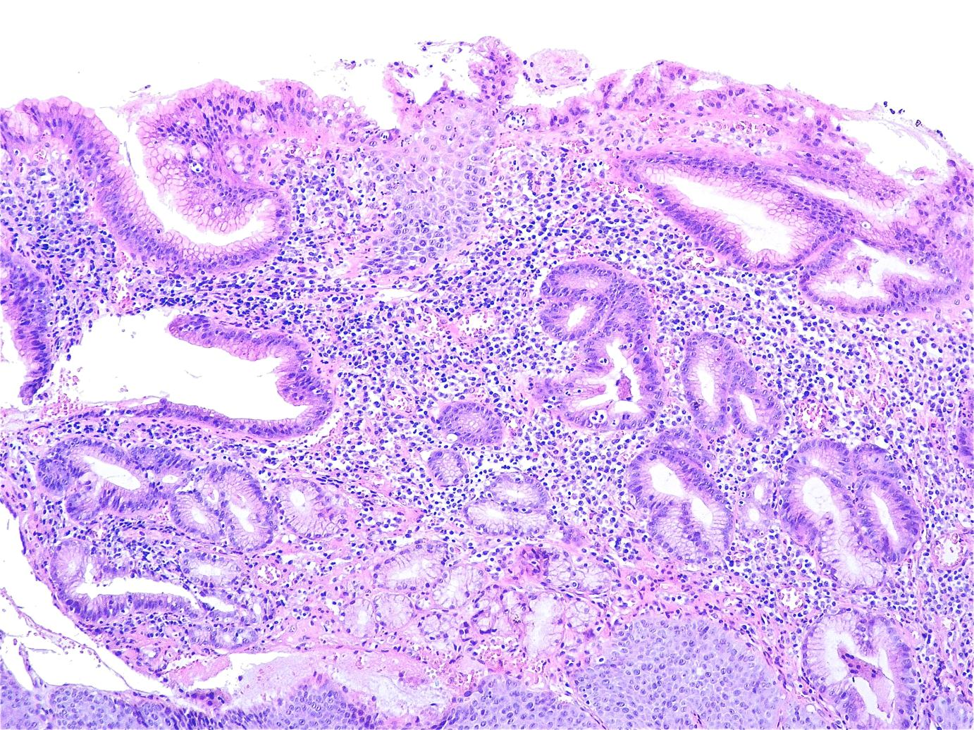

Figure 1 Islets of non-keratinized squamous epithelium can be observed intermingling with cardiac-type gastric mucosa. Superficial and glandular gastric epithelial linings demonstrate infiltration by polymorphonuclear leukocytes (Hematoxylin-eosin staining; original magnification × 10).

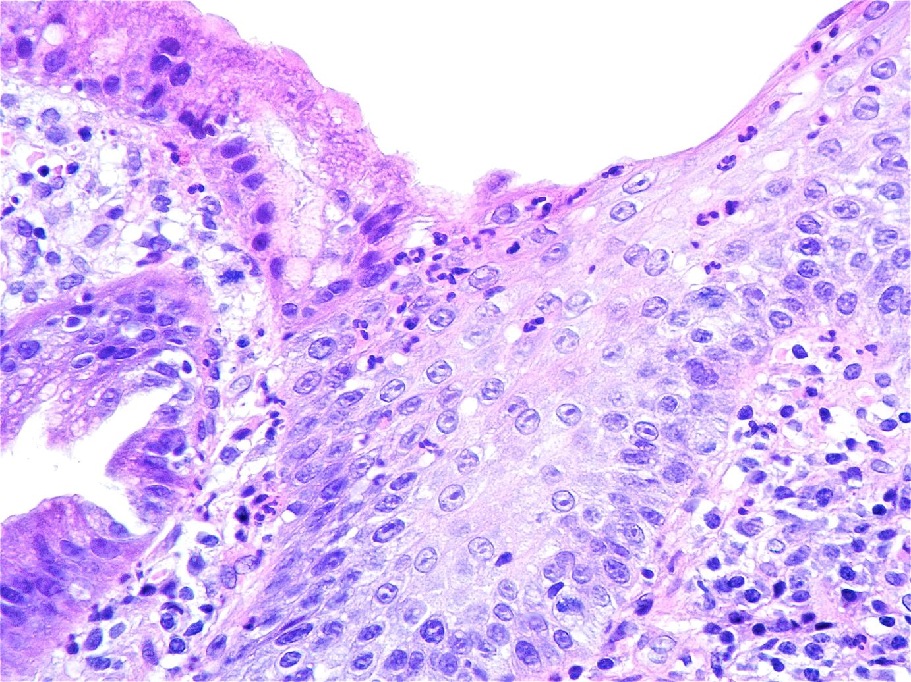
Figure 2 Histological section of gastric-type columnar mucosa of the esophagus. Moderate mononuclear infiltrate in the lamina propria and polymorphonuclear leukocytes infiltrating the mucosa layer can be observed (Hematoxylin-eosin staining stain; original magnification × 40).

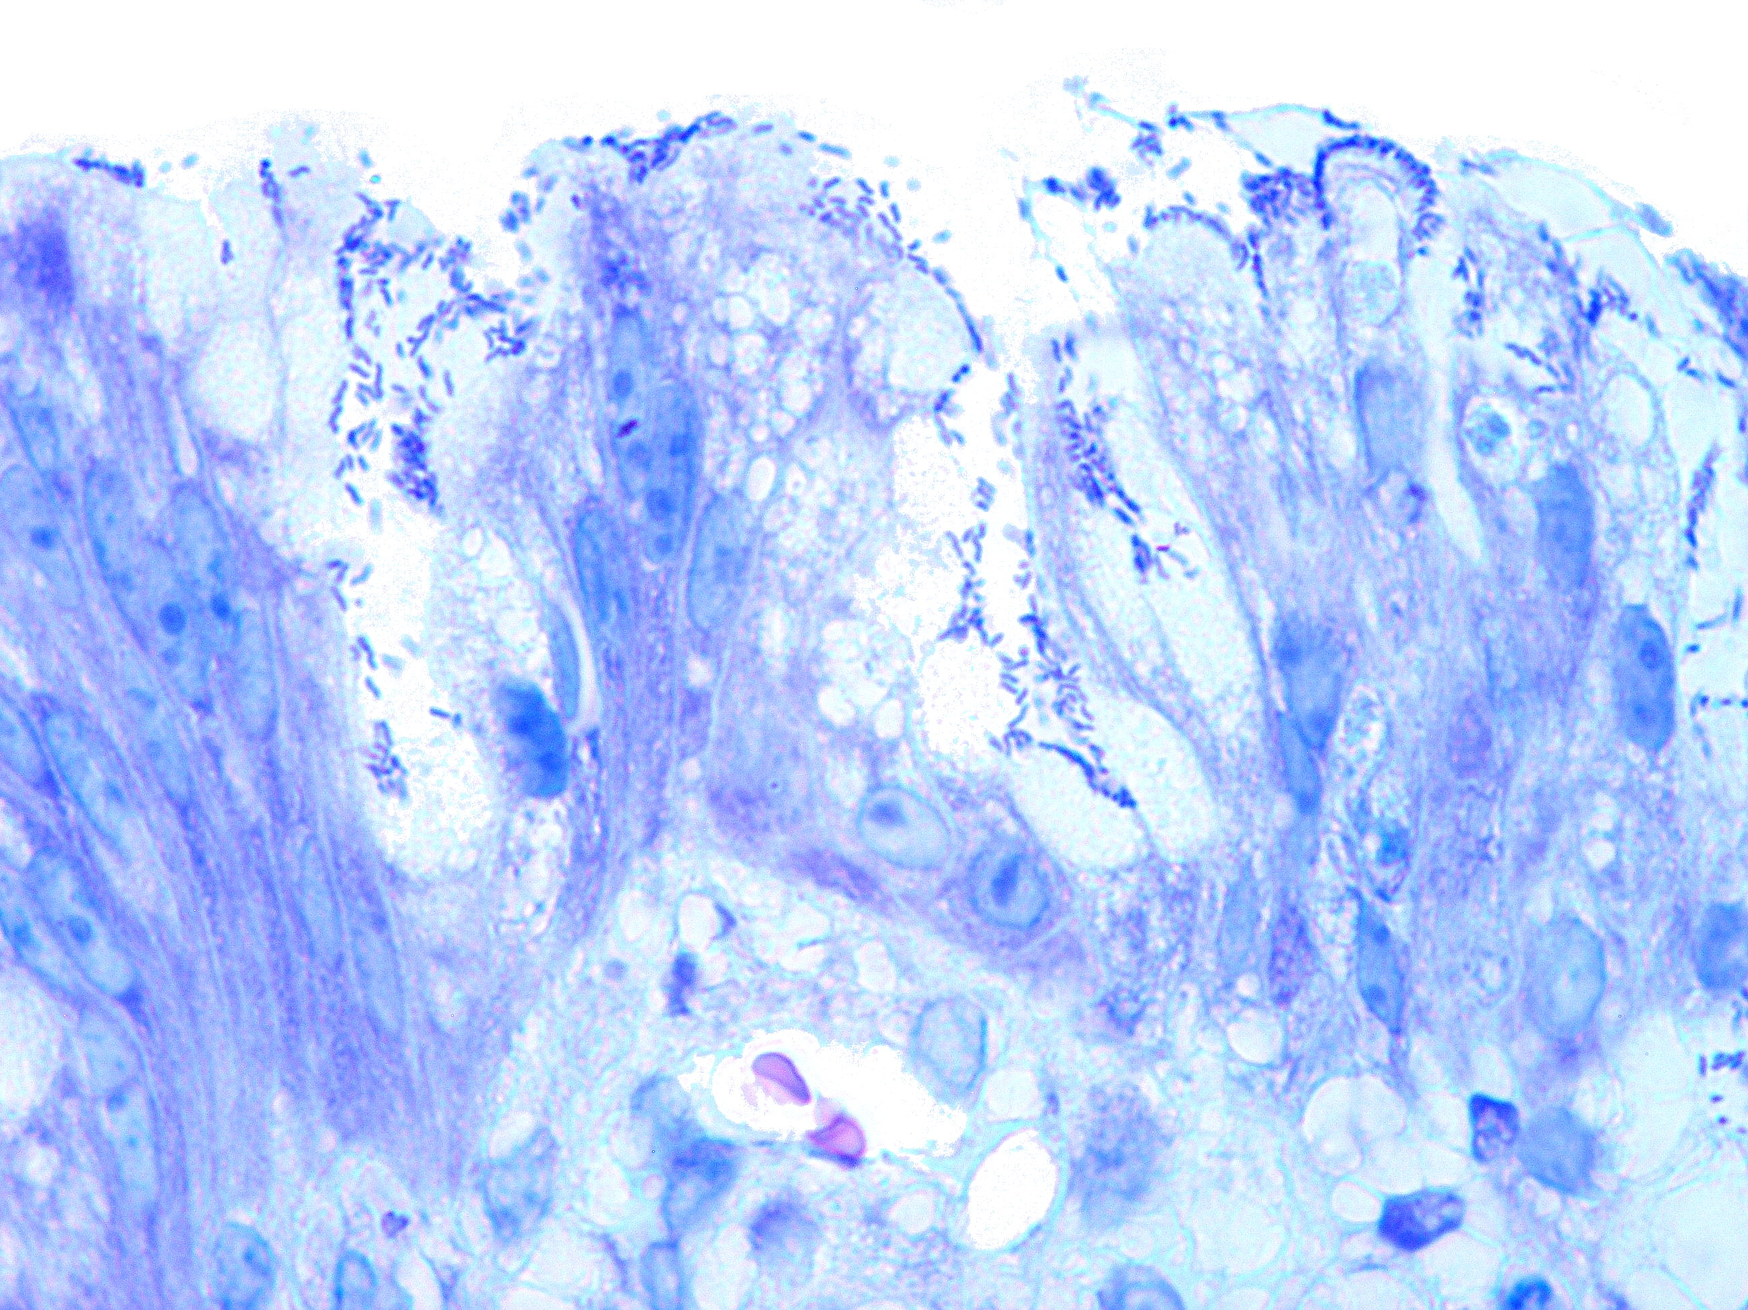
Figure 3 Numerous rod-shape bacilli can be seen attached to the gastric-type metaplastic columnar epithelium (Giemsa staining; original magnification × 100).

A
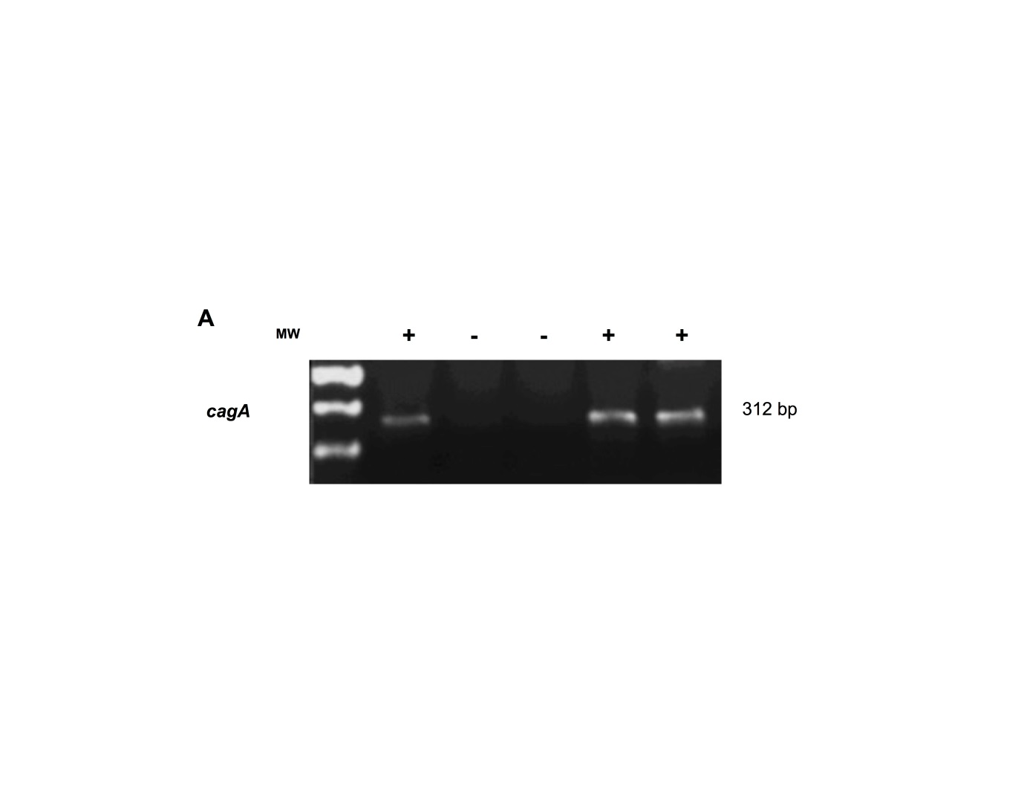
B
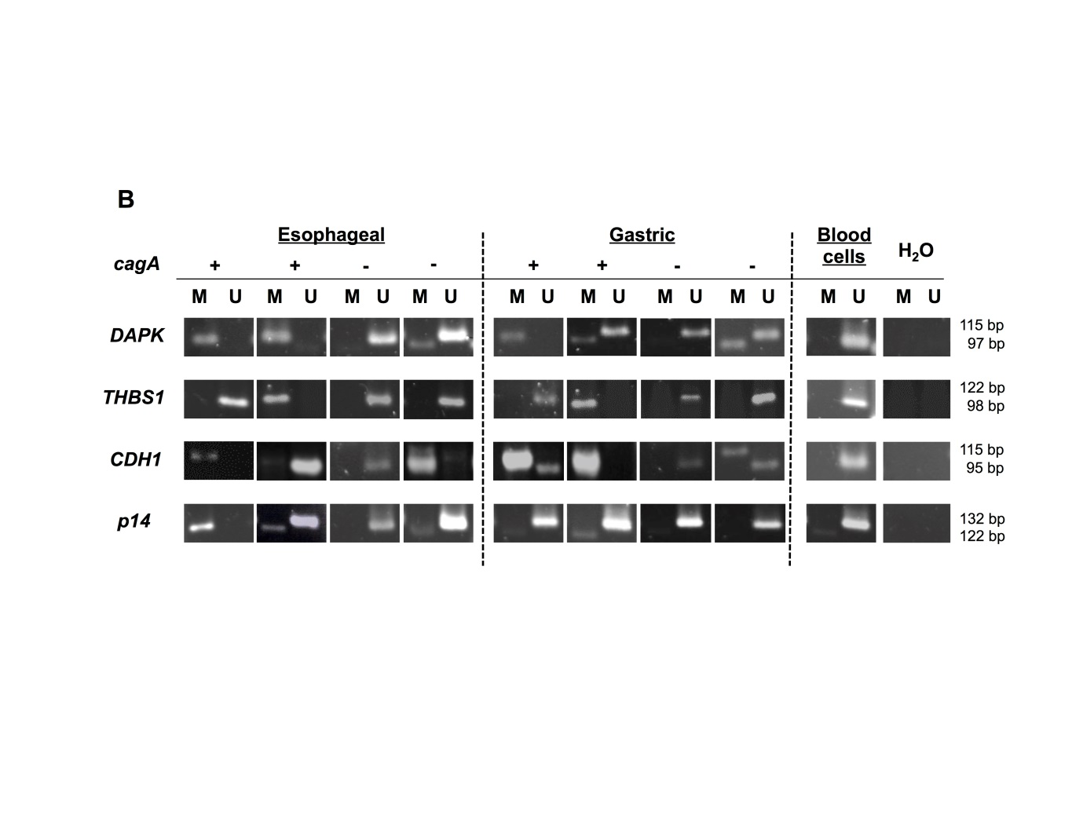
Figure 4 cagA detection and DNA promoter methylation status of DAPK, THBS1, CDH1 and p14 genes in esophageal and gastric mucosa tissue samples. A: Helicobacter pylori cagA⁺ detection by polymerase chain reaction (PCR) amplification in tissue samples, (⁺) positive and (⁻) negative; B: Analysis of methylation status of DAPK, THBS1, CDH1, and p14 genes promoters in esophageal mucosa and gastric biopsies tissue samples detected by methyl-sensitive PCR. Blood cells were used as control of unmethylated promoter regions. M represents methylated and U represent unmethylated; the status of Helicobacter pylori cagA is indicated as (⁺) positive and (⁻) negative.

Table 1 Sequences of specific primers used for determining gene methylation status
Primer  name |  | Forward primer sequence (5´-3´) | Reverse primer sequence (5´-3´) | Product  size  (bp) | AT  (°C) | No. of  cycles
DAPK | M | GGATAGTCGGATCGAGTTAACGTC | CCCTCCCAAACGCCGA | 98 | 60 | 35
 | U | GGAGGATAGTTGGATTGAGTTAATGTT | CAAATCCCTCCCAAACACCAA | 98 | 60 | 35
p14 | M | GTGTTAAAGGGCGGCGTAGC | AAAACCCTCACTCGCGACGA | 122 | 60 | 40
 | U | TTTTTGGTGTTAAAGGGTGGTGTAGT | CACAAAAACCCTCACTCACAACAA | 132 | 60 | 40
CDH1 | M | TTAGGTTAGAGGGTTATCGCGT | TAACTAAAAATTCACCTACCGAC | 115 | 53 | 35
 | U | TAATTTTAGGTTAGAGGGTTATTGT | CACAACCAATCAACAACACA | 97 | 57 | 35
THBS1 | M | TGCGAGCGTTTTTTTAAATGC | TAAACTCGCAAACCAACTCG | 74 | 62 | 40
 | U | GTTTGGTTGTTGTTTATTGGTTG | CCTAAACTCACAAACCAACTCA | 115 | 62 | 40
M: Methylated sequence; U: Unmethylated sequence; AT: Annealing temperature.

Table 2 Association of Helicobacter pylori cagA⁺ infection as detected by PCR, with DNA methylation of the promoter regions of target genes in the esophageal biopsies
 | Helicobacter pylori infection by PCR  Negative Positive |  | P value
DAPK Unmethylated  Methylated | 26  24 | 2  16 | 0.003¹
THBS1 Unmethylated  Methylated | 30  20 | 5  13 | 0.019¹
CDH1 Unmethylated  Methylated | 19  31 | 3  15 | 0.097
p14 Unmethylated  Methylated | 36  14 | 9  9 | 0.091
¹ Helicobacter pylori cagA⁺ status was significantly associated with methylation.

Table 3 Bivariate analysis of the association between molecular markers and the presence of Helicobacter pylori cagA⁺ infection in esophageal biopsies

 | Odds ratio | 95%CI | P value
DAPK | 8.67 | 1.8-41.7 | 0.007¹
THBS1 | 3.9 | 1.2-12.6 | 0.023¹
CDH1 | 3.06 | 0.78-11.9 | 0.11
p14 | 0.39 | 0.13-1.18 | 0.096

¹Statistically significant.

Table 4 Association of Helicobacter pylori cagA⁺ infection as detected by PCR with DNA methylation of the promoter regions of target genes in 33 esophageal and gastric biopsies

 | Helicobacter pylori infection by PCR  Negative Positive |  | P value
Esophageal biopsies
DAPK Unmethylated  Methylated | 14  10 | 0  9 | 0.004¹
THBS1 Unmethylated  Methylated | 15  9 | 2  7 | 0.057¹
CDH1 Unmethylated  Methylated | 11  13 | 1  8 | 0.107
p14 Unmethylated  Methylated | 18  6 | 5  4 | 0.4
Gastric biopsies
DAPK Unmethylated  Methylated | 17  6 | 6  4 | 0.444
THBS1 Unmethylated  Methylated | 15  7 | 3  7 | 0.062
CDH1 Unmethylated  Methylated | 6  17 | 1  9 | 0.397
p14 Unmethylated  Methylated | 14  8 | 8  2 | 0.44

¹Statistically significant.

Table 5 Clinical and histopathological data of patients depending on the presence of Helicobacter pylori cagA⁺ infection by PCR, in esophageal biopsies
 | Helicobacter pylori infection by PCR Negative Positive |  | P value
Age (yr) ≤ 40  41-65  > 65 | 16  14  20 | 9  4  5 | 0.39
Gender Feminine  Masculine | 26  24 | 7  11 | 0.34
H. pylori (HE) Negative  Positive | 38  12 | 8  10 | 0.014¹
Sydney Classification: Normal  H. pylori Mild  Moderate  Marked | 38  11  1  0 | 8  6  2  2 | 0.014¹
Sydney Classification: Normal Neutrophils Mild  Moderate  Marked | 23  25  1  1 | 5  8  4  1 | 0.028¹
Sydney Classification: Mild  Mononuclear cells Moderate  Marked | 17  30  3 | 1  13  4 | 0.021¹

¹Statistically significant. H. pylori: Helicobacter pylori; HE: Hematoxylin-eosin staining.

