Name of Journal: World Journal of Gastroenterology
Manuscript NO: 90452
Manuscript Type: ORIGINAL ARTICLE

Basic Study
Role of deubiquitinase JOSD2 in the pathogenesis of esophageal squamous cell carcinoma

Wang WP et al. Function of JOSD2 in ESCC development

Wen-Peng Wang, Dan Shi, Duo Yun, Jun Hu, Jie-Fu Wang, Jia Liu, Yan-Peng Yang, Ming-Rui Li, Jun-Feng Wang, Da-Lu Kong

Wen-Peng Wang, Jun Hu, Jie-Fu Wang, Jia Liu, Yan-Peng Yang, Jun-Feng Wang, Da-Lu Kong, Department of Colorectal Oncology, Tianjin Medical University Cancer Institute and Hospital, National Clinical Research Center for Cancer, Tianjin’s Clinical Research Center for Cancer, Key Laboratory of Cancer Prevention and Therapy, Tianjin 300060, China

Dan Shi, Department of Gastrointestinal Surgery, Tianjin Nan Kai Hospital, Tianjin Medical University, Tianjin Key Laboratory of Acute Abdomen Disease Associated Organ Injury and ITCWM Repair, Institute of Integrative Medicine for Acute Abdominal Diseases, Tianjin 300100, China

Duo Yun, Department of Oncology, The First Hospital of Hohhot, Hohhot 010000, Inner Mongolia Autonomous Region, China

Ming-Rui Li, Department of Endocrinology, Dazhou Central Hospital, Dazhou 635000, Sichuan Province, China

Co-first authors: Wen-Peng Wang and Dan Shi.

Co-corresponding authors: Jun-Feng Wang and Da-Lu Kong.

Author contributions: Wang WP and Shi D contributed equally to this work; Kong DL and Wang JF were co-corresponding authors; The study was conceptualized and designed by Kong DL, Wang JF, and Wang WP; Shi D and Yun D were in charge of acquiring public data; Bioinformatic and statistical analyses were conducted by Wang WP, Shi D, Yun D, Hu J, Wang JF, and Liu J; Wang WP, Shi D, Yun D, Yang YP, and Li MR carried out both in vitro and in vivo experiments; Figures and tables were prepared, and the initial draft of the manuscript was written by Wang WP, Shi D, Wang JF and Yun D; Manuscript revisions were performed by Kong DL, Wang JF, and Wang WP; All authors have reviewed and approved the final version of the manuscript for publication.

Supported by Tianjin Key Medical Discipline (Specialty) Construction Project, No. TJYXZDXK-009A; Tianjin Medical University Cancer Hospital National Natural Science Foundation Cultivation Program, No. 220108; National Natural Science Foundation of China, No. 82373134; Science and Technology Development Fund of Tianjin Education Commission for Higher Education, No. 2022KJ228; Chinese Anti-Cancer Association-Heng Rui Anti-angiogenesis Targeted Tumor Research Fund, No. 2021001045; and Scientific Research Translational Foundation of Wenzhou Safety (Emergency) Institute of Tianjin University, No. TJUWYY2022025.

Corresponding author: Da-Lu Kong, BMed, Chief Physician, Director, Doctor, Department of Colorectal Oncology, Tianjin Medical University Cancer Institute and Hospital, National Clinical Research Center for Cancer, Tianjin’s Clinical Research Center for Cancer, Key Laboratory of Cancer Prevention and Therapy, Huanhuxi Road, Hexi District, Tianjin 300060, China. kongdalu2021@126.com

Received: December 4, 2023
Revised: December 20, 2023
Accepted: January 16, 2024
Published online:

Abstract
BACKGROUND
Esophageal squamous cell carcinoma (ESCC) is a deadly malignancy with limited treatment options. Deubiquitinases (DUBs) have been confirmed to play a crucial role in the development of malignant tumors. JOSD2 is a DUB involved in controlling protein deubiquitination and influencing critical cellular processes in cancer.

AIM
To investigate the impact of JOSD2 on the progression of ESCC.

METHODS
Bioinformatic analyses were employed to explore the expression, prognosis, and enriched pathways associated with JOSD2 in ESCC. Lentiviral transduction was utilized to manipulate JOSD2 expression in ESCC cell lines (KYSE30 and KYSE150). Functional assays, including cell proliferation, colony formation, drug sensitivity, migration, and invasion, were performed, revealing the impact of JOSD2 on ESCC cell lines. JOSD2's role in xenograft tumor growth and drug sensitivity in vivo was also assessed. The proteins that interacted with JOSD2 were identified using mass spectrometry.

RESULTS
Preliminary research indicated that JOSD2 was highly expressed in ESCC tissues, which was associated with poor prognosis. Further analysis demonstrated that JOSD2 was upregulated in ESCC cell lines compared to normal esophageal cells. JOSD2 knockdown inhibited ESCC cell activity, including proliferation and colony-forming ability. Moreover, JOSD2 knockdown decreased the drug resistance and migration of ESCC cells, while JOSD2 overexpression enhanced these phenotypes. In vivo xenograft assays further confirmed that JOSD2 promoted tumor proliferation and drug resistance in ESCC. Mechanistically, JOSD2 appears to activate the MAPK/ERK and PI3K/AKT signaling pathways. Mass spectrometry was used to identify crucial substrate proteins that interact with JOSD2, which identified the four primary proteins that bind to JOSD2, namely USP47, IGKV2D-29, HSP90AB1, and PRMT5.

CONCLUSION
JOSD2 plays a crucial role in enhancing the proliferation, migration, and drug resistance of ESCC, suggesting that JOSD2 is a potential therapeutic target in ESCC.

Key Words: Esophageal squamous cell carcinoma; JOSD2; Ubiquitination; Biomarker; Targeted therapy; Drug resistance

Wang WP, Shi D, Yun D, Hu J, Wang JF, Liu J, Yang YP, Li MR, Wang JF, Kong DL. Role of deubiquitinase JOSD2 in the pathogenesis of esophageal squamous cell carcinoma. World J Gastroenterol 2024; In press

Core Tip: JOSD2, a deubiquitinating enzyme, is a key player in the aggressive pathogenesis of esophageal squamous cell carcinoma (ESCC). Elevated JOSD2 expression in ESCC tissues is associated with poor prognosis. Functional analyses, including in vivo xenograft assays, highlight JOSD2's role in promoting tumor proliferation and drug resistance. Mechanistically, JOSD2 activates the MAPK/ERK and PI3K/AKT signaling pathways. Mass spectrometry identified key interacting proteins, including USP47, IGKV2D-29, HSP90AB1, and PRMT5. This study underscores the potential role of JOSD2 as a therapeutic target in ESCC.

INTRODUCTION
Esophageal squamous cell carcinoma (ESCC) ranks among the deadliest malignancies worldwide, posing a significant public health concern^{[1]}. Despite advances in early detection and therapeutic interventions, ESCC remains a formidable challenge due to its mostly late-stage diagnosis and limited treatment options. To explore the potential therapeutic targets of ESCC, there has been an increasing focus on the genetic underpinnings of this aggressive cancer. Deubiquitinases (DUBs), responsible for cleaving ubiquitin chains from their protein targets, are crucial for controlling protein ubiquitination and preserving protein homeostasis. DUBs influence important cellular processes such as tumor cell proliferation, drug resistance, distant metastasis, and immune evasion by stabilizing the expression of key cancer proteins^{[2-6]}. The research on DUBs provides new avenues for developing treatment options for cancers lacking effective therapeutic strategies. However, the role of DUBs in malignant tumors is far from fully elucidated. Currently, an increasing number of small molecule inhibitors targeting DUBs are being developed and reported, with preclinical and clinical trials underway, demonstrating significant potential in this research field^{[7]}.
JOSD2, also known as Josephin domain-containing 2, is a member of the Machado-Joseph disease protein family. It consists of 188 amino acids and contains only one highly conserved catalytic Josephin domain, possessing enzymatic activity. Several recent studies have shed light on the involvement of JOSD2 in some malignant tumors^{[8-12]}. JOSD2 has been found to interact with key signaling pathways, such as the Hippo pathway, Wnt/β-catenin pathway, and DNA repair mechanisms^{[8,9,11]}. Dysregulation of JOSD2 expression has been implicated in cancer initiation, tumor growth, and resistance to chemotherapy^{[8,11]}. There is a lack of relevant research on the association between JOSD2 and ESCC. The elucidation of the function of JOSD2 in ESCC will be helpful to identify individuals at higher risk and devise personalized treatment strategies. Therefore, we aimed to explore the function of JOSD2 in ESCC, shedding light on its potential as a promising avenue for further investigation and clinical applications.

MATERIALS AND METHODS
Analyses of JOSD2 expression, prognosis and enriched pathways in ESCC tissue
The University of Alabama at Birmingham CANcer database (https://ualcan.path.uab.edu/) was used to analyze the differential expression of JOSD2 mRNA between ESCC and normal esophageal tissues^{[13,14]}. The online survival database Kaplan–Meier Plotter (https://kmplot.com/analysis/) was used to assess the impact of high vs low JOSD2 mRNA expression on the survival prognosis of patients with ESCC^{[15]}. Clinical and RNA-seq data from ESCC patients were downloaded from The Cancer Genome Atlas (TCGA) database (https://portal.gdc.cancer.gov/), and a nomogram predicting the 1-, 3- and 5-year survival probability of ESCC patients was constructed and visualized using the “survival” and “rms” packages in R (4.2.1).
The top 500 genes that have a similar expression pattern to JOSD2 in ESCC were downloaded from the Gene Expression Profiling Interactive Analysis 2 database (http://gepia2.cancer-pku.cn/#index) and listed in Supplementary Table 1. The Search Tool for the Retrieval of Interacting Genes/Proteins database (https://string-db.org/) was used to plot a protein-protein interaction (PPI) network of the top 100 genes associated with JOSD2.
Gene Ontology (GO) (Supplementary Table 2) and Kyoto Encyclopedia of Genes and Genomes (KEGG) (Supplementary Table 3) enrichment analyses of the top 500 genes that have a similar expression pattern to JOSD2 were conducted using the R packages “clusterProfiler”, “enrichplot”, and “ggplot2”. The differentially expressed genes between the high and low JOSD2 expression groups based on TCGA database were determined using the R package “DESeq2” and listed in Supplementary Table 4. A Gene Set Enrichment Analysis (GSEA) was then conducted using the R packages “clusterProfiler” and “ggplot2” (Supplementary Table 5), based on the C2. CP. KEGG.v7.2 gene sets from the Molecular Signatures Database (MSigDB). Single-cell sequencing data from GSE160269 dataset was also analyzed to determine JOSD2 expression of different cell types (including B cell, CD4 T cell, CD8 T cell, DC, endothelial cell, fibroblasts, malignant cell, mast cell, mono/macro cell, pericytes, plasma cell, T proliferation cell, and Treg cell) using the Tumor Immune Single-Cell Hub 2 online tool (http://tisch.comp-genomics.org/home/).

Cell culture
A normal esophageal epithelial cell line, Het-1A, was obtained from the American Type Culture Collection and cultured in Dulbecco's modified Eagle's medium (Thermo Fisher Scientific, United States) supplemented with 10% fetal bovine serum (FBS) (Sigma, United States), penicillin (100 U/mL) and streptomycin (0.1 mg/mL) (Sigma, United States). Four ESCC cell lines (KYSE30, KYSE140, KYSE150, and KYSE410) were obtained from the Chinese Academy of Sciences Cell Bank and cultured in Roswell Park Memorial Institute (RPMI)-1640 medium (Thermo Fisher Scientific, United States) supplemented with 10% FBS (Sigma, United States), penicillin (100 U/mL), and streptomycin (0.1 mg/mL) (Sigma, United States). These cells were cultured at 37°C in a 5% CO₂ incubator.

Lentiviral packaging and transduction
Two independent small hairpin RNA (shRNA) sequences targeting JOSD2 (sh1: CGATGAGATCTG-CAAGAGGTT; sh2: GTGTCTACTACAACCTGGACT) were designed, cloned into a PSIH1 vector (GenePharma, China), and used for lentivirus packaging in 293T cells. The lentiviral supernatant was collected. KYSE150 cells (which had the highest JOSD2 expression among the ESCC cell lines) were transduced with the lentivirus and selected with puromycin 72 h later.
The JOSD2 gene was cloned into the lentiviral expression vector pLVX-IRES-Neo to create the overexpression plasmid pLVX-G418 JOSD2-Flag (GenePharma, China). The lentivirus was packaged and used to infect KYSE30 cells (which had the lowest JOSD2 expression among the ESCC cell lines), which were then selected with G418 72 h later.

RNA extraction and real-time fluorescent quantitative polymerase chain reaction
The total RNA was extracted using an RNApure Tissue/Cell Kit (Cwbiotech, China). The isolated RNA was used as a template for reverse transcription reaction using a HiFiScript cDNA Synthesis Kit (Cwbiotech, China). Real-time fluorescent quantitative polymerase chain reaction (RT-qPCR) was performed using SYBR Fast qPCR Mix (TaKaRa, Japan) and a CFX96 Real-Time System (Bio-Rad, United States). The primer sequences for JOSD2 were as follows: Forward: 5’-CCCACCGTGTACCACGAAC-3’; reverse: 5’-CTCCTGGCTAAAGAGCTGCTG-3’. The primer sequences for GAPDH were as follows: Forward: 5’-GATTCCACCCATGGCAAATTC-3’; reverse: 5’-CTGGAAGATGGTGATGGGATT-3’.

Cell protein extraction and western blotting
Approximately 1 × 10⁶ cells were placed in each well of a 6-well culture plate. The cells were lysed by adding radioimmunoprecipitation assay buffer (10 μL) and a phosphatase inhibitor (1 μL) for every 100000 cells. The protein lysate was centrifuged at 17000g for 30 min to obtain the supernatant. The protein concentration was measured using a bicinchoninic acid assay. A mixture containing 10 μg of protein was then boiled at 95 °C for 10 min to denature the proteins.
Gel electrophoresis and transfer were carried out using a Mini Gel Tank chamber system (Thermo Fisher Scientific, United States) following the detailed procedures and reagents provided in the manufacturer's instructions. Gel electrophoresis was performed with constant voltage, starting at 70 V for 20 min, followed by an adjustment to 100 V for 50 min. The proteins were then transferred to a polyvinylidene fluoride membrane using a constant voltage of 10 V for 50 min.
The membrane was blocked with 5% skim milk for 1 h. The membrane was then incubated with one of the following primary antibodies overnight at 4 °C: JOSD2 antibody (sab2103354, 1:500, Sigma-Aldrich, United States), phosphorylated p44/42 MAPK (Erk1/2) (Thr202/Tyr204) antibody (9101, 1:1000, Cell Signaling Technology, United States), p44/42 MAPK (Erk1/2) (L34F12) antibody (4696, 1:1000, Cell Signaling Technology, United States), phosphorylated Akt (Ser473) (D9E) antibody (4060, 1:2000, Cell Signaling Technology, United States), phosphorylated Akt (Thr308) antibody (13038, 1:1000, Cell Signaling Technology, United States), or Akt (pan) (40D4) antibody (2920, 1:2000, Cell Signaling Technology, United States). The membrane was then incubated with one of the following secondary antibodies at room temperature for 1 h: Anti-rabbit (7074, 1:1000, Cell Signaling Technology, United States) or anti-mouse (7076, 1:1000, Cell Signaling Technology, United States) horseradish peroxidase-linked antibody. The membrane was subjected to enhanced chemiluminescence (ECL) detection using SignalFire ECL reagent (Cell Signaling Technology, United States), and images were captured and saved using an automated imaging system. Anti-β-actin antibody (4967, 1:1000, Cell Signaling Technology, United States) was then added and incubated at room temperature for 1 h, followed by detection and image capture.

Cell proliferation assays
The Cell Counting Kit-8 (CCK-8) assay (Solarbio, China) was performed according to the manufacturer's instructions. Cells were seeded in a 96-well culture plate with approximately 1000 cells per well, and incubated at 37 °C in a 5% CO₂ incubator for 24, 48, 72, or 96 h. Subsequently, 10 μL of CCK-8 reagent was added to the cells, and the absorbance at 450 nm was measured using a microplate reader.

Colony formation assay
After exposure to shRNA1, shRNA2, or negative control, 1000 cells in the logarithmic growth phase were suspended in RPMI-1640 medium with 10% FBS and seeded in each well of 6-well plates. Following a 12-d incubation, the cells were fixed with methanol for 15 min and then stained with 0.5% crystal violet for 3 min at room temperature. After three washes with distilled water, the plates were air-dried and the cell colonies were manually counted. A positive colony was defined as a cluster containing at least 50 cells.

Drug sensitivity assay
Cells in the logarithmic growth phase, with knocked-down or overexpressed JOSD2, and their respective control cells, were divided into different groups and seeded into 96-well plates with each well containing 1 × 10⁴ cells. After cell adhesion, cisplatin (Med-ChemExpress, United States) was added to each well at concentration gradients of 0, 10, 20, 40, 60, and 80 μg/mL in JOSD2 knock-down cell group. For the JOSD2 overexpression cell group, cisplatin was added at concentration gradients of 0, 20, 40, 60, 80, and 100 μg/mL. After 48 h, the sensitivity of the tumor cells to cisplatin was assessed using a 3-(4,5-dimethylthiazol-2-yl)-2,5-diphenyltetrazolium bromide assay kit (Sangon Biotech, China).

Migration assay
Transwell chambers (Corning, United States) were preloaded with 5 × 10⁴ cells suspended in 100 μL of RPMI-1640 medium without FBS. The chambers were then placed in a 24-well plate, with each well containing 500 μL of RPMI-1640 medium supplemented with 10% FBS, and incubated in a 37 °C, 5% CO₂ incubator. After 24 h, the medium in the chambers was removed, and the cells in the chambers were gently wiped away with a cotton swab. The cells on the chambers were fixed on a new 24-well plate with 4% paraformaldehyde for 20 min. Next, the chambers were removed, followed by crystal violet staining for 20 min. Excess crystal violet solution was washed off with phosphate-buffered saline (PBS), and cell images were captured using a microscope.

Invasion assay
Approximately 60 μL of diluted Matrigel (1:8, Becton, Dickinson and Company, United States) was added to Transwell chambers. The chambers were incubated in a 37 °C, 5% CO₂ incubator for 3 h, excess liquid was removed from the chambers, and 100 μL of RPMI-1640 medium without FBS was added. The chambers were then placed in the 37 °C, 5% CO₂ incubator for 30 min to hydrate the basement membrane. Subsequently, 100 μL of cell suspension comprising 5 × 10⁴ cells in FBS-free RPMI-1640 medium was added to the chambers. The chambers were then placed in a 24-well plate, with each well containing 500 μL of RPMI-1640 medium with 10% FBS, and incubated in the 37 °C, 5% CO₂ incubator. After 24 h, the medium in the chambers was removed, and the Matrigel and the cells in the chambers were gently wiped away with a cotton swab. As in the Transwell migration assays, a new 24-well plate with 4% paraformaldehyde was used to fix the cells on the chambers for 20 min, the chambers were removed, crystal violet staining was performed for 20 min, excess crystal violet solution was rinsed off with PBS, and cell images were captured using a microscope.

Xenograft and drug sensitivity assays
Xenograft assays were conducted by subcutaneously injecting JOSD2-knockdown KYSE150 cells and JOSD2-overexpressing KYSE30 cells under the armpits of BALB/c nude mice. Tumor dimensions, including length and width, were assessed using a vernier caliper every 3 d. Tumor volume was determined as 0.52 × length × width², and growth curves were plotted. From subcutaneous injection until tumor growth on the 19th day, the tumor tissues were harvested and their weights were recorded.
Additionally, the role of JOSD2 in cisplatin sensitivity in vivo was studied using xenograft and drug sensitivity assays. JOSD2-knockdown KYSE150 cells or JOSD2-overexpressing KYSE30 cells were injected under the armpits of BALB/c nude mice. When the tumor volume reached 10 mm³, cisplatin was intraperitoneally injected (6 mg/kg, every 3 d for 15 d) and the tumor volume was measured at the same time. At approximately 2 wk after the first administration of cisplatin, the tumor tissues were excised and weighed.

Mass spectrometry
To explore the proteins that interact with JOSD2, KYSE30 cells with Flag-tagged JOSD2 (Flag-JOSD2 sequence: GATTACAAGGATGACGACGATAAG) were lysed with protein lysis buffer to obtain the total proteins. Flag-JOSD2 was then enriched by immunoprecipitation. After obtaining the protein precipitate interacting with Flag-JOSD2, the protein complex was subjected to SDS-PAGE, followed by silver staining for band visualization. Specific bands were then subjected to mass spectrometry analysis (Beijing Protein Innovation Co., Ltd., China).

Statistical methods
ImageJ software was used to quantify the protein expression levels in Western blot analysis. Graphs were constructed and statistical analyses were performed using GraphPad Prism 10 software (GraphPad Software, Inc., United States). A P value less than 0.05 was considered statistically significant. Student's t-test was used to determine the significance of differences between two groups, while analysis of variance was employed to compare differences among more than two groups.

RESULTS
JOSD2 is highly expressed in ESCC tissues, which is associated with poor prognosis
JOSD2 expression was significantly higher in ESCC tissues than normal esophageal tissues (Figure 1A, P < 0.0001). Additionally, ESCC patients with high JOSD2 expression had a worse prognosis than those with low expression (P = 0.025), providing a basis for predicting the prognosis of ESCC (Figure 1B and C).
To determine the biological functions of JOSD2, GO and KEGG enrichment analyses were performed. The top five most enriched biological process, cellular component, and molecular function (MF) terms are shown in Figure 1D (only one MF term was enriched), and the top five most enriched KEGG pathways are shown in Figure 1E. The top five gene sets in the GSEA, comprising CROMER Tumorigenesis Up, UROSEVIC Response to Imiquimod, MOSERLE IFNA Response, GNATENKO Platelet Signature, and RADAEVA Response to IFNA1 Up, are shown in Figure 1F. A PPI diagram based on the top 100 genes associated with JOSD2 is depicted in Supplementary Figure 1.

JOSD2 expression in ESCC cells
To determine whether JOSD2 is expressed in ESCC cells, single-cell sequencing data in GSE160269 was utilized and JOSD2 was highly expressed in ESCC cells (Figure 2). Additionally, JOSD2 mRNA and protein expression in a normal esophageal epithelial cell line (Het-1A) and ESCC cell lines (KYSE30, KYSE140, KYSE150, and KYSE410) was assessed using RT-qPCR and western blotting, respectively. The results showed that both JOSD2 mRNA (Figure 3A) and protein (Figure 3B) expression were consistently upregulated in ESCC cell lines compared to the normal esophageal cell line.

JOSD2 knockdown inhibits activity of ESCC cells
To confirm the function of JOSD2 in ESCC cells, two shRNAs targeting JOSD2 were designed and knockdown assays in the KYSE150 cell line (which had the highest JOSD2 expression among the ESCC cell lines) were conducted. RT-qPCR results showed that both shRNAs achieved effective knockdown (Figure 4A).
Subsequently, CCK-8 cell viability assays were performed to study the influence of JOSD2 knockdown on cell proliferation. The results indicated that both shRNAs significantly inhibited the proliferation of KYSE150 cells (Figure 4B, P < 0.0001 for both). Colony formation assays were conducted to investigate the effect of JOSD2 knockdown on tumor-forming ability. JOSD2 knockdown significantly suppressed the colony-forming ability of KYSE150 cells (Figure 4C).

JOSD2 enhances ESCC cell proliferation, drug resistance, and migration in vitro
Chemoresistance and distant metastasis are major contributors to the poor prognosis of ESCC patients. Therefore, the next step was to investigate whether JOSD2 also affects the drug resistance and migratory ability of ESCC cells. JOSD2 knockdown increased the sensitivity of KYSE150 cells to 48-h treatment with various concentrations of cisplatin (Figure 5A, P < 0.0001 for both). Transwell migration and invasion assays also demonstrated that JOSD2 knockdown significantly inhibited the migratory (P < 0.01) and invasion (P < 0.0001) ability of KYSE150 cells (Figure 5B). To validate the promoting role of JOSD2 in the development of ESCC cells, exogenous JOSD2 was overexpressed in KYSE30 cells (which had the lowest JOSD2 expression among the ESCC cell lines). The results showed that JOSD2 overexpression significantly promoted the proliferation (P < 0.0001), drug resistance (P < 0.0001), migration (P < 0.01), and invasion (P < 0.001) capability of KYSE30 cells (Figure 5C-E).

JOSD2 promotes ESCC cell proliferation and drug resistance in vivo
Xenograft assays were conducted in nude mice using JOSD2-knockdown KYSE150 cells, JOSD2-overexpressing KYSE30 cells, and their respective control cells. The mice in each group were divided into subgroups with and without cisplatin treatment to study the effects of JOSD2 on ESCC cell proliferation and drug sensitivity in vivo. JOSD2-knockdown KYSE150 cells exhibited significantly slower tumor growth and a more pronounced reduction in tumor volume under cisplatin treatment compared to control cells (Figure 6A and B, P < 0.001 for tumor volume, P < 0.0001 for tumor weight). On the other hand, JOSD2-overexpressing KYSE30 cells not only had faster tumor growth but also exhibited significantly increased resistance to cisplatin (Figure 6C and D, P < 0.0001 for tumor volume, P < 0.0001 for tumor weight). These findings suggested that JOSD2 has a vital role in promoting the development of ESCC.

JOSD2 facilitates activation of cancer-related pathways in ESCC cells
To explore the molecular mechanisms by which JOSD2 promotes ESCC, the effects of JOSD2 on the phosphorylation pathways MAPK/ERK and PI3K/AKT, which play important roles in carcinogenesis, were assessed. Western blotting results showed that JOSD2 knockdown in ESCC cells inhibited the phosphorylation levels of ERK1/2 and AKT (Figure 7A), while JOSD2 overexpression in ESCC cells led to the activation of MAPK/ERK and PI3K/AKT signaling pathways (Figure 7B). These results indicated that the activation of the MAPK/ERK and PI3K/AKT signaling pathways serves as a pivotal downstream mechanism in facilitating the oncogenic function of JOSD2.

Proteins potentially binding to JOSD2 were identified by mass spectrometry
To identify key substrate proteins interacting with JOSD2, anti-Flag magnetic beads were used to enrich Flag-JOSD2 protein and its interacting proteins in KYSE30 cells with exogenous Flag-JOSD2 overexpression. As indicated by the blue arrows in Figure 8A, silver staining of the SDS-PAGE gel revealed numerous protein bands in the overexpression group but not in the control group, indicating that these proteins were specifically immunoprecipitated along with Flag-JOSD2. Mass spectrometry showed that JOSD2 had the highest score (validating the reliability of its enrichment) and the other top-ranked proteins were USP47, IGKV2D-29, HSP90AB1, and PRMT5 (Figure 8B), which indicated that these proteins may be the significant substrates that bind to JOSD2.

DISCUSSION
In recent years, an increasing number of studies have shown that DUBs play a crucial role in the development of malignant tumors^{[11,16]}. There has been a substantial amount of research on DUBs in five common malignant tumors, namely non-small cell lung cancer, hepatocellular cancer, gastric cancer, colorectal cancer, and breast cancer^{[8,17-20]}. For instance, USP9X, DUB3, and USP7 have been identified in these malignant tumors^{[21-23]}. There has been less research on DUBs in ESCC, and this research has mostly focused on the impact of the known DUBs on the metastatic process of ESCC^{[24-27]}. PSMD14, OTUB1, USP26, and EIF3H, by stabilizing Snail, promote the occurrence of metastasis^{[24-27]}. This redundancy in the regulatory mechanism makes using individual DUBs as effective therapeutic targets challenging.
This study is the first to report on the role of JOSD2 in ESCC. The preliminary findings indicated that JOSD2 is not only highly expressed in ESCC tissues, but its high expression is significantly associated with a poor prognosis. Subsequent analyses revealed that JOSD2 significantly enhanced the proliferation, migration, and drug resistance of ESCC cells. The in vivo results confirmed that altering JOSD2 expression, either by overexpression or knockdown, modulates the resistance of ESCC to the chemotherapy drug cisplatin (one of the primary chemotherapy drugs used to treat ESCC). This highlights the potential significance of using JOSD2 as a therapeutic target in order to overcome cisplatin resistance in ESCC.
Norberg et al^{[28]} reported the role of JOSD2 in lung adenocarcinoma. They analyzed the metabolic profile of lung adenocarcinoma and found that PHGDH, a critical rate-limiting enzyme in serine synthesis, was highly expressed in a subgroup with poor prognosis^{[28]}. Tumors with high PHGDH expression exhibited rapid proliferation and migration. Subsequently, the authors discovered that the protein expression of PHGDH is regulated by the ubiquitin proteasome system pathway. The authors screened for DUBs that stabilize PHGDH by using a siRNA library targeting 99 DUBs for transient knockdown. Targeting the DUB JOSD2, among these 99 DUBs, led to the largest significant reduction (> 80%) in PHGDH protein expression. Thus, JOSD2 affected the metabolism of lung adenocarcinoma by stabilizing PHGDH and promoting tumor growth. The same research team further explored and revealed the relationship between JOSD2 and metabolism^{[29]}. They found that both in vitro and in vivo, JOSD2 directly regulated the metabolic enzyme complex comprising aldolase A, phosphofructokinase 1, and PHGDH. Wild-type JOSD2, but not its enzymatic mutant, stabilized this complex via deubiquitination, enhancing its activity, and thereby increasing the glycolytic rate of cancer cells. The absence of JOSD2 inhibited various cancer cells (including non-small cell lung cancer, breast cancer, and ovarian cancer cells) and reduced glycolysis. In summary, JOSD2 effectively integrated glycometabolism and serine metabolism by stabilizing the metabolic enzyme complex. For cancer types that are highly reliant on glycolysis for their energy supply, increased JOSD2 expression significantly promoted cell proliferation and growth. This finding suggests that JOSD2 is a potential therapeutic target in cancer cells that are dependent on glycolytic metabolism.
Qian et al^{[11]} reported the role of JOSD2 in the progression of cholangiocarcinoma (CCA)^{[11]}. They identified JOSD2 as a crucial regulator that stabilizes Yes-associated protein/Transcriptional co-activator with PDZ-binding motif (YAP/TAZ), which are involved in the malignant progression of CCA. Depleting JOSD2 led to the degradation of YAP/TAZ and thereby significantly inhibited CCA proliferation both in vitro and in vivo. Additionally, there was a positive association between JOSD2 and YAP abundance in CCA patient samples, suggesting that JOSD2 is a potential target for treatment in patients with YAP/TAZ-related CCA. Moreover, Huang et al^{[9]} identified JOSD2 as a novel prognostic indicator for individuals with hepatocellular cancer and identified CTNNB1 as a significant collaborator and downstream protein targeted by JOSD2^{[9]}. However, Lei et al^{[10]} reported that, in acute myeloid leukemia, JOSD2 is a tumor suppressor and PKM2 is a newfound JOSD2-interacting partner, which suggests that JOSD2 has different functions and mechanisms in different malignant tumors^{[10]}.
The MAPK/ERK and PI3K/AKT signaling pathways are crucial for key cancer characteristics, including cell proliferation, differentiation, migration, and genomic stability^{[30,31]}. Therefore, we assessed the effects of JOSD2 on these pathways. The results revealed that the phosphorylation activation of MAPK/ERK and PI3K/AKT was a critical downstream event mediating the oncogenic function of JOSD2.
Regarding the key substrate proteins interacting with JOSD2, we found that USP47, IGKV2D-29, HSP90AB1, and PRMT5 were the top four binding proteins of JOSD2 and may also be substrates for JOSD2's activity. USP47, a DUB, can counteract the functions of E3 ubiquitin ligases, playing a role in cell growth and survival processes^{[32]}. Several studies have provided evidence that USP47 is involved in the advancement of diverse cancer types^{[33-35]}. There is limited research on the IGKV2D-29 gene, but polymorphism in this gene was shown to lower the recombination frequency in B cells and to be especially important for immune responses to Haemophilus influenzae type b polysaccharide^{[36]}. HSP90AB1 is a crucial participant in oncogene activity and the preservation of cancer cell viability^{[37]}. This is due to its chaperone mechanism in cancer cells, safeguarding significant amounts of mutated and excessively expressed oncogenic proteins from undergoing misfolding and degradation^{[37]}. Lastly, PRMT5 plays a crucial oncogenic role in various malignancies and has been a key target in recent cancer therapies^{[38,39]}. However, there have been no studies reporting its deubiquitination modification. PRMT5’s role in various malignancies implies that it is likely a key substrate protein for JOSD2's oncogenic function, and JOSD2's deubiquitination of PRMT5 may have significant implications for the treatment of ESCC.

CONCLUSION
In conclusion, this study reveals the tumorigenic role of JOSD2 in the advancement of ESCC. In terms of the mechanism, JOSD2 influences the phosphorylation activation of MAPK/ERK and PI3K/AKT. USP47, IGKV2D-29, HSP90AB1, and PRMT5 are the four primary proteins that interact with JOSD2 and may serve as substrates for JOSD2's functional activity, especially PRMT5. In 2019, Grasty et al^{[40]} elucidated the molecular structure of the JOSD2 protein, which will facilitate the development of molecular targeted inhibitors of JOSD2. However, there are currently no report on JOSD2 inhibitors. Consequently, there is a need for further exploration of the effects of specific and potent JOSD2 inhibitors on the clinical outlook for ESCC patients.

ARTICLE HIGHLIGHTS
Research background
Esophageal squamous cell carcinoma (ESCC) is a highly lethal malignancy with limited treatment options. Deubiquitinases (DUBs), crucial for maintaining protein homeostasis, are emerging as key players influencing vital cellular processes in ESCC, offering new treatment avenues. In addition, the ongoing development of small molecule inhibitors targeting DUBs shows significant promise, with several preclinical and clinical trials underway.

Research motivation
Recognizing the crucial involvement of DUBs in malignant tumor development, JOSD2, a specific DUB, has been identified as playing a pivotal role in controlling protein deubiquitination and impacting essential cellular processes in cancer. Nevertheless, the function of JOSD2 in ESCC remains uncertain.

Research objectives
The objective of this study was to explore the impact of JOSD2 on the progression of ESCC.

Research methods
Bioinformatics analyses were used to investigate the expression patterns, prognosis, and enriched pathways of JOSD2 in ESCC tissues. Manipulation of JOSD2 expression in ESCC cell lines (KYSE30 and KYSE150) was achieved through lentiviral transduction. Comprehensive functional assays, encompassing cell proliferation, colony formation, drug sensitivity, migration, and invasion assays, were conducted to unveil the influence of JOSD2 on ESCC cell lines. Additionally, the effects of JOSD2 on xenograft tumor growth and drug sensitivity in vivo were assessed. Proteins interacting with JOSD2 were determined by mass spectrometry.

Research results
The initial results suggested that JOSD2 was highly expressed in ESCC tissues and was associated with a poor prognosis. Subsequent investigations revealed upregulation of JOSD2 in ESCC cell lines compared to normal esophageal cells. JOSD2 knockdown inhibited various ESCC cell activities, including proliferation, colony formation, and migration, as well as reducing drug resistance. Conversely, JOSD2 overexpression enhanced these phenotypes. In vivo xenograft assays confirmed that JOSD2 promoted tumor proliferation and drug resistance in ESCC. Mechanistically, JOSD2 appears to activate the MAPK/ERK and PI3K/AKT signaling pathways. Mass spectrometry identified four primary proteins interacting with JOSD2: USP47, IGKV2D-29, HSP90AB1, and PRMT5.

Research conclusions
JOSD2 promotes cell proliferation, migration, and drug resistance in ESCC.

Research perspectives
JOSD2 is a promising therapeutic target for the treatment of ESCC.

REFERENCES
1 Zheng R, Zhang S, Zeng H, Wang S, Sun K, Chen R, Li L, Wei W, He J. Cancer incidence and mortality in China, 2016. J Nati Cancer Cent 2022; 2: 1-9 [DOI: 10.1016/j.jncc.2022.02.002]
2 Ge Z, Leighton JS, Wang Y, Peng X, Chen Z, Chen H, Sun Y, Yao F, Li J, Zhang H, Liu J, Shriver CD, Hu H; Cancer Genome Atlas Research Network, Piwnica-Worms H, Ma L, Liang H. Integrated Genomic Analysis of the Ubiquitin Pathway across Cancer Types. Cell Rep 2018; 23: 213-226.e3 [PMID: 29617661 DOI: 10.1016/j.celrep.2018.03.047]
3 Leznicki P, Kulathu Y. Mechanisms of regulation and diversification of deubiquitylating enzyme function. J Cell Sci 2017; 130: 1997-2006 [PMID: 28476940 DOI: 10.1242/jcs.201855]
4 Zhang X, Smits AH, van Tilburg GB, Jansen PW, Makowski MM, Ovaa H, Vermeulen M. An Interaction Landscape of Ubiquitin Signaling. Mol Cell 2017; 65: 941-955.e8 [PMID: 28190767 DOI: 10.1016/j.molcel.2017.01.004]
5 Zhang S, Zhang M, Jing Y, Yin X, Ma P, Zhang Z, Wang X, Di W, Zhuang G. Deubiquitinase USP13 dictates MCL1 stability and sensitivity to BH3 mimetic inhibitors. Nat Commun 2018; 9: 215 [PMID: 29335437 DOI: 10.1038/s41467-017-02693-9]
6 Lim SO, Li CW, Xia W, Cha JH, Chan LC, Wu Y, Chang SS, Lin WC, Hsu JM, Hsu YH, Kim T, Chang WC, Hsu JL, Yamaguchi H, Ding Q, Wang Y, Yang Y, Chen CH, Sahin AA, Yu D, Hortobagyi GN, Hung MC. Deubiquitination and Stabilization of PD-L1 by CSN5. Cancer Cell 2016; 30: 925-939 [PMID: 27866850 DOI: 10.1016/j.ccell.2016.10.010]
7 Harrigan JA, Jacq X, Martin NM, Jackson SP. Deubiquitylating enzymes and drug discovery: emerging opportunities. Nat Rev Drug Discov 2018; 17: 57-78 [PMID: 28959952 DOI: 10.1038/nrd.2017.152]
8 Ge F, Liu X, Zhang H, Yuan T, Zhu H, Yang B, He Q. Deubiquitinating enzyme JOSD2 affects susceptibility of non-small cell lung carcinoma cells to anti-cancer drugs through DNA damage repair. Zhejiang Da Xue Xue Bao Yi Xue Ban 2023; 52: 533-543 [PMID: 37899394 DOI: 10.3724/zdxbyxb-2023-0256]
9 Huang Y, Zeng J, Liu T, Xu Q, Song X, Zeng J. Deubiquitinating enzyme JOSD2 promotes hepatocellular carcinoma progression through interacting with and inhibiting CTNNB1 degradation. Cell Biol Int 2022; 46: 1089-1097 [PMID: 35568970 DOI: 10.1002/cbin.11812]
10 Lei H, Yang L, Wang Y, Zou Z, Liu M, Xu H, Wu Y. JOSD2 regulates PKM2 nuclear translocation and reduces acute myeloid leukemia progression. Exp Hematol Oncol 2022; 11: 42 [PMID: 35836282 DOI: 10.1186/s40164-022-00295-w]
11 Qian M, Yan F, Wang W, Du J, Yuan T, Wu R, Zhao C, Wang J, Lu J, Zhang B, Lin N, Dong X, Dai X, Dong X, Yang B, Zhu H, He Q. Deubiquitinase JOSD2 stabilizes YAP/TAZ to promote cholangiocarcinoma progression. Acta Pharm Sin B 2021; 11: 4008-4019 [PMID: 35024322 DOI: 10.1016/j.apsb.2021.04.003]
12 Wang Y, Li ZX, Wang JG, Li LH, Shen WL, Dang XW. Deubiquitinating enzyme Josephin-2 stabilizes PHGDH to promote a cancer stem cell phenotype in hepatocellular carcinoma. Genes Genomics 2023; 45: 215-224 [PMID: 36583817 DOI: 10.1007/s13258-022-01356-4]
13 Chandrashekar DS, Bashel B, Balasubramanya SAH, Creighton CJ, Ponce-Rodriguez I, Chakravarthi BVSK, Varambally S. UALCAN: A Portal for Facilitating Tumor Subgroup Gene Expression and Survival Analyses. Neoplasia 2017; 19: 649-658 [PMID: 28732212 DOI: 10.1016/j.neo.2017.05.002]
14 Chandrashekar DS, Karthikeyan SK, Korla PK, Patel H, Shovon AR, Athar M, Netto GJ, Qin ZS, Kumar S, Manne U, Creighton CJ, Varambally S. UALCAN: An update to the integrated cancer data analysis platform. Neoplasia 2022; 25: 18-27 [PMID: 35078134 DOI: 10.1016/j.neo.2022.01.001]
15 Győrffy B. Discovery and ranking of the most robust prognostic biomarkers in serous ovarian cancer. Geroscience 2023; 45: 1889-1898 [PMID: 36856946 DOI: 10.1007/s11357-023-00742-4]
16 Jin X, Yan Y, Wang D, Ding D, Ma T, Ye Z, Jimenez R, Wang L, Wu H, Huang H. DUB3 Promotes BET Inhibitor Resistance and Cancer Progression by Deubiquitinating BRD4. Mol Cell 2018; 71: 592-605.e4 [PMID: 30057199 DOI: 10.1016/j.molcel.2018.06.036]
17 Li L, Liu T, Li Y, Wu C, Luo K, Yin Y, Chen Y, Nowsheen S, Wu J, Lou Z, Yuan J. The deubiquitinase USP9X promotes tumor cell survival and confers chemoresistance through YAP1 stabilization. Oncogene 2018; 37: 2422-2431 [PMID: 29449692 DOI: 10.1038/s41388-018-0134-2]
18 Wang J, Liu R, Mo H, Xiao X, Xu Q, Zhao W. Deubiquitinase PSMD7 promotes the proliferation, invasion, and cisplatin resistance of gastric cancer cells by stabilizing RAD23B. Int J Biol Sci 2021; 17: 3331-3342 [PMID: 34512150 DOI: 10.7150/ijbs.61128]
19 Wu J, Liu C, Wang T, Liu H, Wei B. Deubiquitinase inhibitor PR-619 potentiates colon cancer immunotherapy by inducing ferroptosis. Immunology 2023; 170: 439-451 [PMID: 37526037 DOI: 10.1111/imm.13683]
20 Ning Z, Guo X, Liu X, Lu C, Wang A, Wang X, Wang W, Chen H, Qin W, Liu X, Zhou L, Ma C, Du J, Lin Z, Luo H, Otkur W, Qi H, Chen D, Xia T, Liu J, Tan G, Xu G, Piao HL. USP22 regulates lipidome accumulation by stabilizing PPARγ in hepatocellular carcinoma. Nat Commun 2022; 13: 2187 [PMID: 35449157 DOI: 10.1038/s41467-022-29846-9]
21 Zhang Q, Zhang ZY, Du H, Li SZ, Tu R, Jia YF, Zheng Z, Song XM, Du RL, Zhang XD. DUB3 deubiquitinates and stabilizes NRF2 in chemotherapy resistance of colorectal cancer. Cell Death Differ 2019; 26: 2300-2313 [PMID: 30778200 DOI: 10.1038/s41418-019-0303-z]
22 Zhang FK, Ni QZ, Wang K, Cao HJ, Guan DX, Zhang EB, Ma N, Wang YK, Zheng QW, Xu S, Zhu B, Chen TW, Xia J, Qiu XS, Ding XF, Jiang H, Qiu L, Wang X, Chen W, Cheng SQ, Xie D, Li JJ. Targeting USP9X-AMPK Axis in ARID1A-Deficient Hepatocellular Carcinoma. Cell Mol Gastroenterol Hepatol 2022; 14: 101-127 [PMID: 35390516 DOI: 10.1016/j.jcmgh.2022.03.009]
23 Dai X, Lu L, Deng S, Meng J, Wan C, Huang J, Sun Y, Hu Y, Wu B, Wu G, Lovell JF, Jin H, Yang K. USP7 targeting modulates anti-tumor immune response by reprogramming Tumor-associated Macrophages in Lung Cancer. Theranostics 2020; 10: 9332-9347 [PMID: 32802195 DOI: 10.7150/thno.47137]
24 Zhu R, Liu Y, Zhou H, Li L, Li Y, Ding F, Cao X, Liu Z. Deubiquitinating enzyme PSMD14 promotes tumor metastasis through stabilizing SNAIL in human esophageal squamous cell carcinoma. Cancer Lett 2018; 418: 125-134 [PMID: 29331416 DOI: 10.1016/j.canlet.2018.01.025]
25 Zhou H, Liu Y, Zhu R, Ding F, Cao X, Lin D, Liu Z. OTUB1 promotes esophageal squamous cell carcinoma metastasis through modulating Snail stability. Oncogene 2018; 37: 3356-3368 [PMID: 29559747 DOI: 10.1038/s41388-018-0224-1]
26 Li L, Zhou H, Zhu R, Liu Z. USP26 promotes esophageal squamous cell carcinoma metastasis through stabilizing Snail. Cancer Lett 2019; 448: 52-60 [PMID: 30763716 DOI: 10.1016/j.canlet.2019.02.007]
27 Guo X, Zhu R, Luo A, Zhou H, Ding F, Yang H, Liu Z. EIF3H promotes aggressiveness of esophageal squamous cell carcinoma by modulating Snail stability. J Exp Clin Cancer Res 2020; 39: 175 [PMID: 32867821 DOI: 10.1186/s13046-020-01678-9]
28 Zhang B, Zheng A, Hydbring P, Ambroise G, Ouchida AT, Goiny M, Vakifahmetoglu-Norberg H, Norberg E. PHGDH Defines a Metabolic Subtype in Lung Adenocarcinomas with Poor Prognosis. Cell Rep 2017; 19: 2289-2303 [PMID: 28614715 DOI: 10.1016/j.celrep.2017.05.067]
29 Krassikova L, Zhang B, Nagarajan D, Queiroz AL, Kacal M, Samakidis E, Vakifahmetoglu-Norberg H, Norberg E. The deubiquitinase JOSD2 is a positive regulator of glucose metabolism. Cell Death Differ 2021; 28: 1091-1109 [PMID: 33082514 DOI: 10.1038/s41418-020-00639-1]
30 Sun Y, Liu WZ, Liu T, Feng X, Yang N, Zhou HF. Signaling pathway of MAPK/ERK in cell proliferation, differentiation, migration, senescence and apoptosis. J Recept Signal Transduct Res 2015; 35: 600-604 [PMID: 26096166 DOI: 10.3109/10799893.2015.1030412]
31 Akbarzadeh M, Mihanfar A, Akbarzadeh S, Yousefi B, Majidinia M. Crosstalk between miRNA and PI3K/AKT/mTOR signaling pathway in cancer. Life Sci 2021; 285: 119984 [PMID: 34592229 DOI: 10.1016/j.lfs.2021.119984]
32 Shi J, Liu Y, Xu X, Zhang W, Yu T, Jia J, Liu C. Deubiquitinase USP47/UBP64E Regulates β-Catenin Ubiquitination and Degradation and Plays a Positive Role in Wnt Signaling. Mol Cell Biol 2015; 35: 3301-3311 [PMID: 26169834 DOI: 10.1128/MCB.00373-15]
33 Peng J, Li W, Tan N, Lai X, Jiang W, Chen G. USP47 stabilizes BACH1 to promote the Warburg effect and non-small cell lung cancer development via stimulating Hk2 and Gapdh transcription. Am J Cancer Res 2022; 12: 91-107 [PMID: 35141006]
34 Zhang S, Ju X, Yang Q, Zhu Y, Fan D, Su G, Kong L, Li Y. USP47 maintains the stemness of colorectal cancer cells and is inhibited by parthenolide. Biochem Biophys Res Commun 2021; 562: 21-28 [PMID: 34030041 DOI: 10.1016/j.bbrc.2021.05.017]
35 Lei H, Xu HZ, Shan HZ, Liu M, Lu Y, Fang ZX, Jin J, Jing B, Xiao XH, Gao SM, Gao FH, Xia L, Yang L, Liu LG, Wang WW, Liu CX, Tong Y, Wu YZ, Zheng JK, Chen GQ, Zhou L, Wu YL. Targeting USP47 overcomes tyrosine kinase inhibitor resistance and eradicates leukemia stem/progenitor cells in chronic myelogenous leukemia. Nat Commun 2021; 12: 51 [PMID: 33397955 DOI: 10.1038/s41467-020-20259-0]
36 Padyukov L, Hahn-Zoric M, Blomqvist SR, Ulanova M, Welch SG, Feeney AJ, Lau YL, Hanson LA. Distribution of human kappa locus IGKV2-29 and IGKV2D-29 alleles in Swedish Caucasians and Hong Kong Chinese. Immunogenetics 2001; 53: 22-30 [PMID: 11261927 DOI: 10.1007/s002510000291]
37 Haase M, Fitze G. HSP90AB1: Helping the good and the bad. Gene 2016; 575: 171-186 [PMID: 26358502 DOI: 10.1016/j.gene.2015.08.063]
38 Jarrold J, Davies CC. PRMTs and Arginine Methylation: Cancer's Best-Kept Secret? Trends Mol Med 2019; 25: 993-1009 [PMID: 31230909 DOI: 10.1016/j.molmed.2019.05.007]
39 Yang Y, Bedford MT. Protein arginine methyltransferases and cancer. Nat Rev Cancer 2013; 13: 37-50 [PMID: 23235912 DOI: 10.1038/nrc3409]
40 Grasty KC, Weeks SD, Loll PJ. Structural insights into the activity and regulation of human Josephin-2. J Struct Biol X 2019; 3: 100011 [PMID: 32647816 DOI: 10.1016/j.yjsbx.2019.100011]

Footnotes
Institutional review board statement: The study was reviewed and approved by the Institutional Review Board of Tianjin Medical University Cancer Institute and Hospital, No. Ek2023018.

Institutional animal care and use committee statement: All procedures involving animals were reviewed and approved by the Tianjin Cancer Institute Animal Ethics Committee, No. NSFC-AE-2023n2.

Informed consent statement: All study participants or their legal guardian provided informed written consent about personal and medical data collection prior to study enrolment.

Conflict-of-interest statement: The authors declare no conflict of interest.

Data sharing statement: The data used and/or analyzed during the current study are available from the corresponding author on reasonable request.

ARRIVE guidelines statement: The authors have read the ARRIVE guidelines, and the manuscript was prepared and revised according to the ARRIVE guidelines.

Open-Access: This article is an open-access article that was selected by an in-house editor and fully peer-reviewed by external reviewers. It is distributed in accordance with the Creative Commons Attribution NonCommercial (CC BY-NC 4.0) license, which permits others to distribute, remix, adapt, build upon this work non-commercially, and license their derivative works on different terms, provided the original work is properly cited and the use is non-commercial. See: https://creativecommons.org/Licenses/by-nc/4.0/

Provenance and peer review: Unsolicited article; Externally peer reviewed.

Peer-review model: Single blind

Peer-review started: December 4, 2023
First decision: December 8, 2023
Article in press:

Specialty type: Gastroenterology and hepatology
Country/Territory of origin: China
Peer-review report’s scientific quality classification
Grade A (Excellent): A
Grade B (Very good): 0
Grade C (Good): 0
Grade D (Fair): 0
Grade E (Poor): 0

P-Reviewer: Alcántara-Hernández R, Mexico S-Editor: Fan JR L-Editor: A P-Editor:
Figure legends
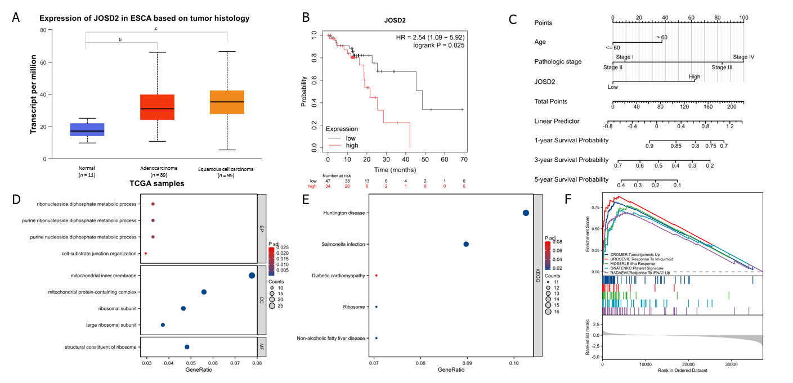
Figure 1 Expression level, survival analysis, and enrichment analyses of JOSD2 in esophageal squamous cell carcinoma tissues. A: Boxplots of JOSD2 expression in esophageal squamous cell carcinoma (ESCC) tissues and normal esophageal tissues based on University of Alabama at Birmingham CANcer database; B: Kaplan-Meier plot showing the survival difference between ESCC patients with high vs low JOSD2 expression based on the Kaplan-Meier Plotter database; C: Nomogram of JOSD2 expression predicting 1-, 3- and 5-year survival probability of ESCC patients; D-F: Gene Ontology (D), Kyoto Encyclopedia of Genes and Genomes (E) and Gene Set Enrichment Analysis (F) enrichment analyses of JOSD2. ^{b}P < 0.001; ^{c}P < 0.0001.

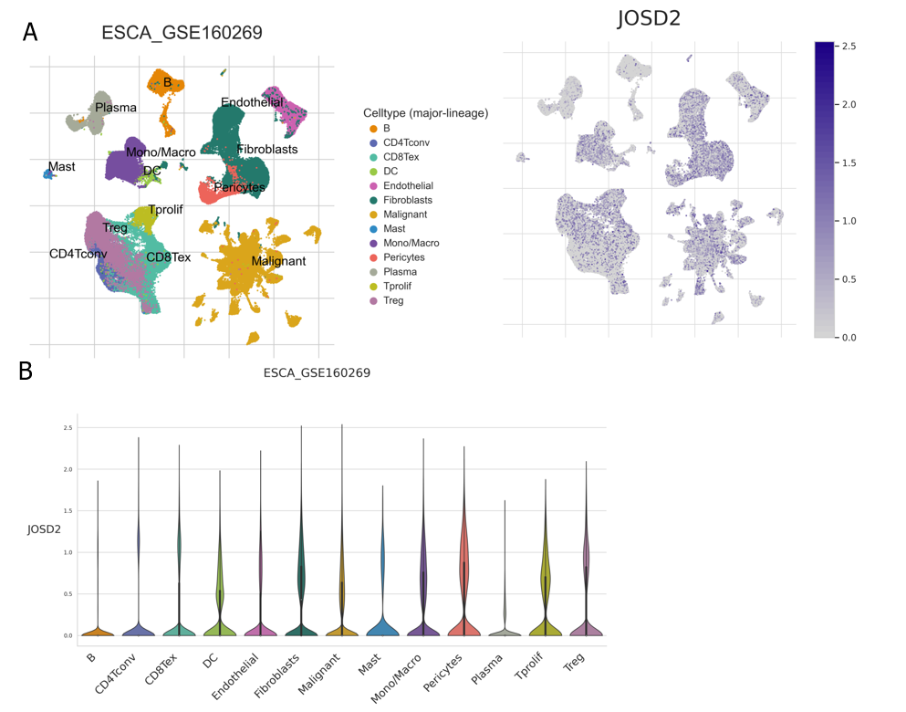
Figure 2 Single-cell sequencing data of esophageal squamous cell carcinoma in GSE160269. A: Uniform manifold approximation and projection plots showing the grouping of different cell types (left) and the expression profile of JOSD2 (right) in different cell types; B: Violin plots showing JOSD2 expression in different cell types.
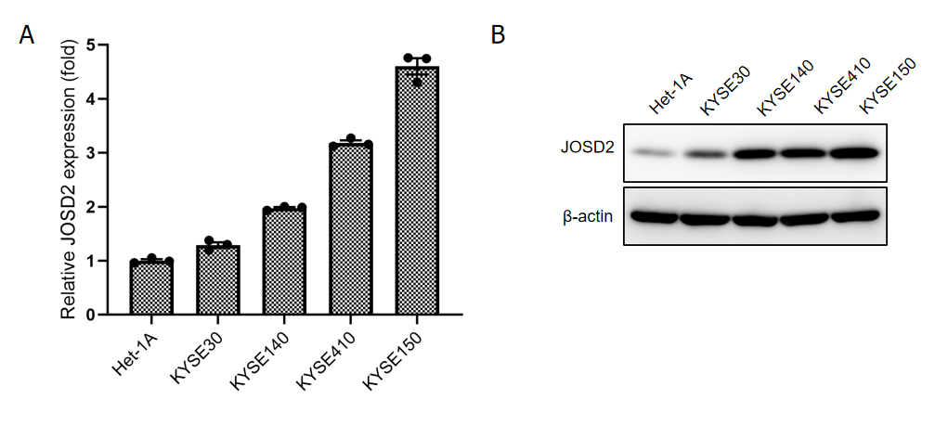
Figure 3 JOSD2 expression in esophageal squamous cell carcinoma cell lines. Real-time fluorescence quantitative polymerase chain reaction and western blotting results showing JOSD2 mRNA (A) and protein (B) expression in esophageal squamous cell carcinoma cell lines and a normal esophageal epithelial cell line. A: JOSD2 mRNA; B: Protein.

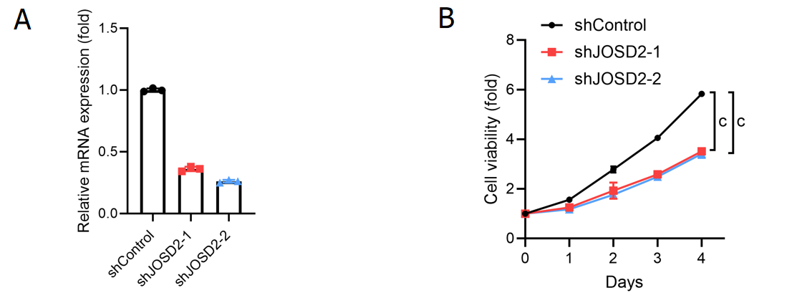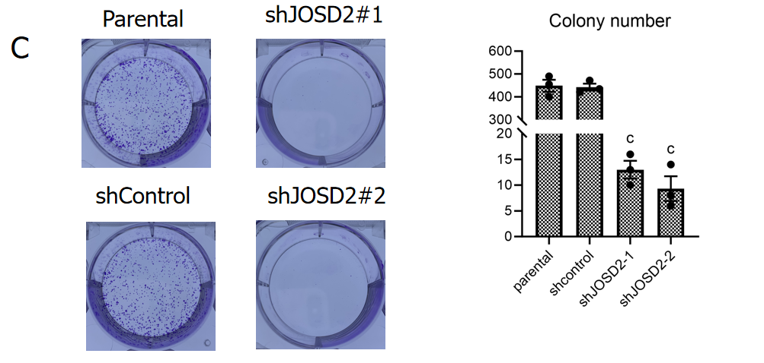
Figure 4 JOSD2 knockdown significantly suppresses the activity of esophageal squamous cell carcinoma cells. A: JOSD2 was successfully knocked down using shRNA1/2 directed against JOSD2 in KYSE150 cells; B: JOSD2 knockdown significantly inhibited cell proliferation; C: JOSD2 knockdown significantly inhibited the ability of the cells to form colonies. ^{c}P < 0.0001.

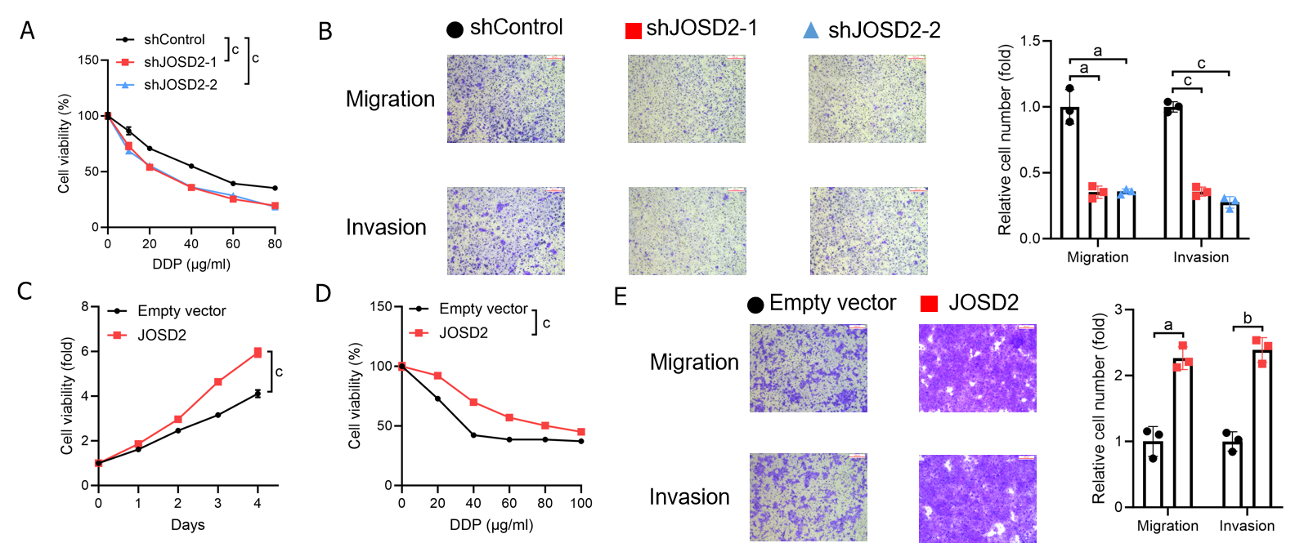
Figure 5 JOSD2 contributes to the proliferation, drug resistance, and metastatic capability of esophageal squamous cell carcinoma cells. A: JOSD2-knockdown KYSE150 cells exhibited increased sensitivity to 48-h treatment with various concentrations of cisplatin; B: JOSD2-knockdown KYSE150 cells exhibited significantly decreased migration and invasion in Transwell migration and invasion assays; C: JOSD2-overexpressing KYSE30 cells exhibited significantly increased cell growth in cell proliferation assays; D: JOSD2-overexpressing KYSE30 cells exhibited increased resistance to 48-h treatment with various concentrations of cisplatin; E: JOSD2-overexpressing KYSE30 cells exhibited significantly increased migration and invasion in Transwell migration and invasion assays. ªP < 0.01; ^{b}P < 0.001; ^{c}P < 0.0001.

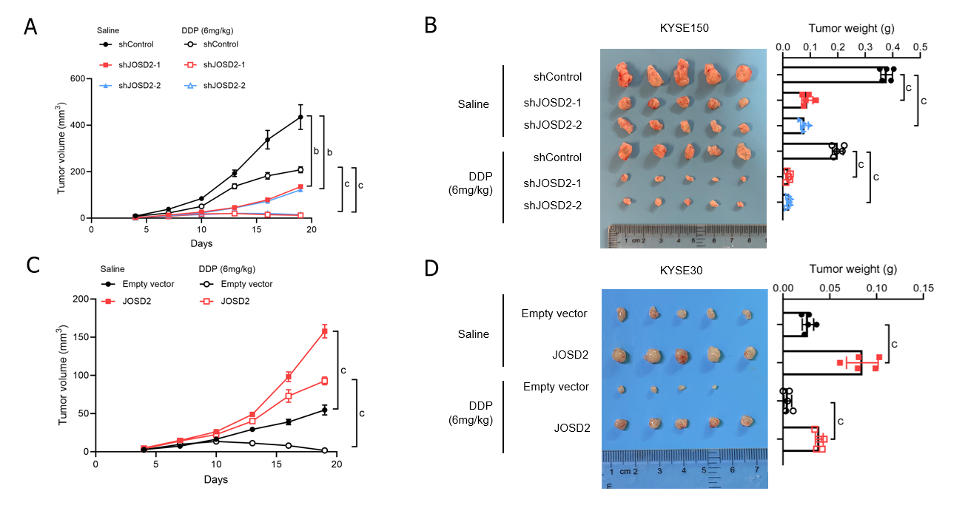
Figure 6 JOSD2 promotes in vivo esophageal squamous cell carcinoma cell proliferation and cisplatin resistance. A and B: JOSD2-knockdown cisplatin-treated KYSE150 cells exhibited significantly decreased tumor growth in both volume (A) and weight (B) compared to cisplatin-treated control cells; C and D: JOSD2-overexpressing cisplatin-treated KYSE30 cells exhibited significantly increased tumor growth in both volume (C) and weight (D) compared to cisplatin-treated control cells. ^{b}P < 0.001; ^{c}P < 0.0001.

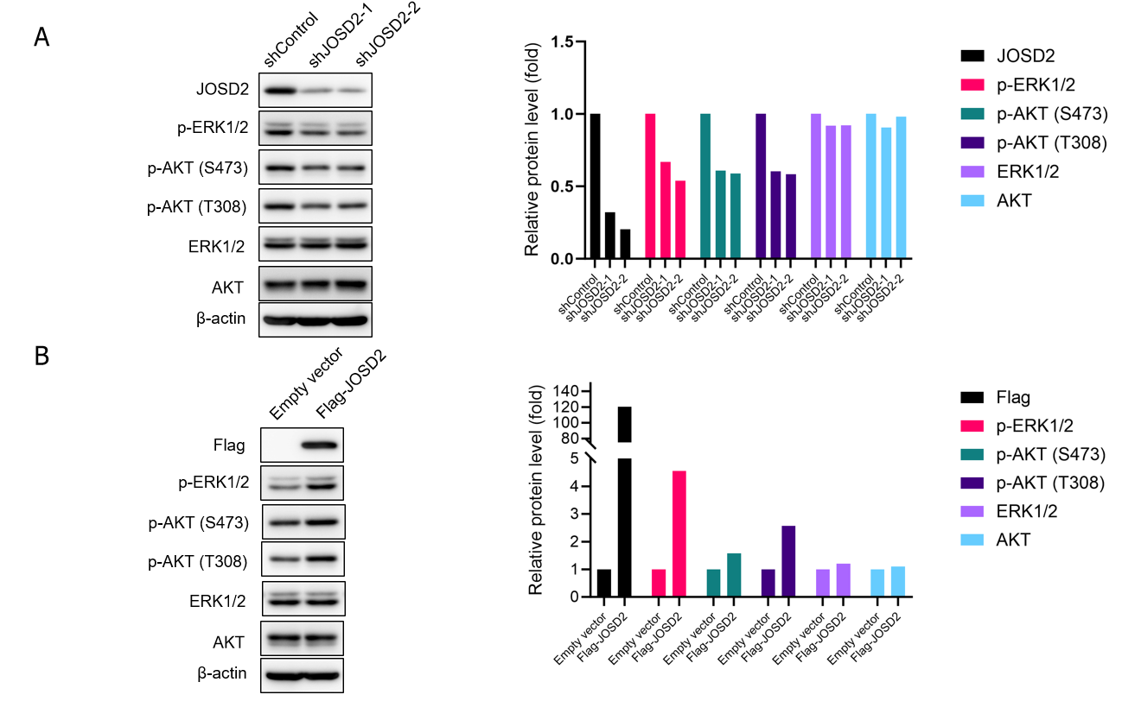
Figure 7 JOSD2 enhances the activation of phosphorylation pathways in esophageal squamous cell carcinoma. A: Western blotting showing that JOSD2 knockdown in esophageal squamous cell carcinoma (ESCC) cells decreased the phosphorylation of ERK1/2 and AKT; B: Western blotting showing that JOSD2 overexpression in ESCC cells activated the MAPK/ERK and PI3K/AKT signaling pathways.
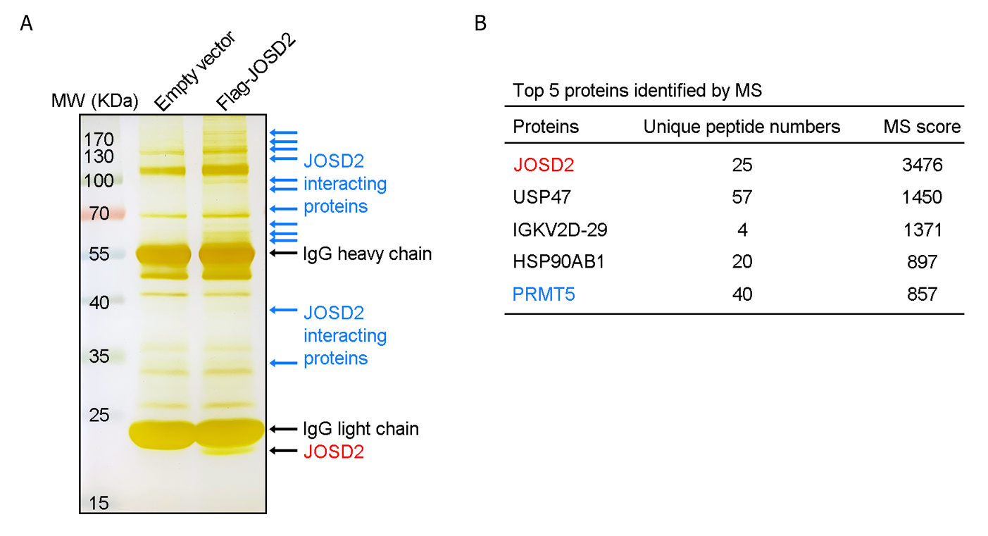
Figure 8 Mass spectrometry analysis of proteins that bind to JOSD2 protein. A: Protein bands after SDS-PAGE gel silver staining; B: Proteins that potentially interact with JOSD2.

