Name of Journal: World Journal of Clinical Cases
Manuscript NO: 77936
Manuscript Type: CASE REPORT

Subclavian brachial plexus metastasis from breast cancer: A case report

Zeng Z et al. Subclavian brachial plexus metastasis from breast cancer

Zeng Zeng, Nan Lin, Li-Tao Sun, Cong-Xian Chen

Zeng Zeng, Li-Tao Sun, Cong-Xian Chen, Cancer Center, Department of Ultrasound Medicine, Zhejiang Provincial People’s Hospital, Affiliated People’s Hospital, Hangzhou Medical College, Hangzhou 310000, Zhejiang Province, China

Nan Lin, Plastic Surgery Center, Department of Hand & Reconstruct Surgery, Zhejiang Provincial People’s Hospital, Affiliated People’s Hospital, Hangzhou Medical College, Hangzhou 310000, Zhejiang Province, China

Author contributions: Zeng Z, Lin N, Sun LT and Chen CX were responsible for substantial contributions to conception and design; Chen CX and Lin N was responsible for the acquisition of data; Zeng Z was responsible for drafting the article; Zeng Z, Lin N, Sun LT and Chen CX were responsible for the final approval of the version to be published.

Corresponding author: Cong-Xian Chen, Doctor, Cancer Center, Department of Ultrasound Medicine, Zhejiang Provincial People’s Hospital, Affiliated People’s Hospital, Hangzhou Medical College, No. 158 Shangtang Road, Gongshu District, Hangzhou 310000, Zhejiang Province, China. kema320@qq.com

Received: June 4, 2022
Revised: August 6, 2022
Accepted: October 26, 2022
Published online:

Abstract
BACKGROUND
The common area of breast cancer metastases are bone, lung and liver. Brachial plexus metastasis from breast cancer is extremely rare. We report a case of subclavian brachial plexus metastasis from breast cancer 6 years postoperative, which were detected by ultrasound, magnetic resonance imaging (MRI) and ¹⁸F-fluorodeoxyglucose positron emission tomography and computed tomography (FDG-PET/CT).

CASE SUMMARY
Our study reports a 64-year-old woman who had right breast cancer and underwent radical mastectomy 6 years before. Ultrasound first revealed a soft lesion measuring 38 mm × 37 mm which located on the right side of the clavicle to the armpit subcutaneously. The right subclavian brachial plexus (beam level) was significantly thickened, wrapped around by a hypoechoic lesion, the surrounded axillary artery and vein were pressed. MRI brachial plexus scan showed that the right side of brachial plexus was enlarged compared with the left side and brachial plexus bundle in the distance showed a flake shadow. FDG-PET/CT revealed that the right side of brachial plexus nodular appearance with increased FDG metabolism. These results supported brachial plexus metastasis from breast cancer. Ultrasound exam also found many lesions between pectoralis major, deltoid muscle and inner upper arm. The lesion puncture was performed under ultrasound guidance and the tissue was sent for pathology. Pathology showed large areas of tumor cells in fibroblast tissue. Immunohistochemistry showed the following results: A2-1: GATA3 (+), ER (+, strong, 90%), PR (+, moderate, 10%), HER-2 (3+), Ki67 (+15%), P120 (membrane+), P63 (-), E-cadherin (+), CK5/6 (-). These results were consistent with the primary right breast cancer characteristics, thus supporting lesion metastasis from breast cancer.

CONCLUSION
The brachial plexus metastasis from breast cancer is uncommon. Ultrasound has great value in detecting brachial plexus metastasis of breast cancer. It is an easy, non-invasive and affordable method. Close attention should be paid to new grown out lesions in those patients who had a history of breast cancer when doing ultrasound review.

Key Words: Brachial plexus; Metastasis; Breast Cancer; Ultrasound; Magnetic resonance imaging; 18F-fluorodeoxyglucose positron emission tomography/computed tomography; Case report

Zeng Z, Lin N, Sun LT, Chen CX. Subclavian brachial plexus metastasis from breast cancer: A case report. World J Clin Cases 2022; In press

Core Tip: Breast cancer metastases are commonly found in bone, lung and liver. Brachial plexus metastasis from breast cancer is extremely rare. We here report a 64-year-old woman who had brachial plexus metastasis from breast cancer. Ultrasound is an easy, non-invasive and affordable method for the detection of brachial plexus metastasis from breast cancer. Attention should be paid to new lesions in patients with a history of breast cancer when performing ultrasound review.

INTRODUCTION
Breast cancer is the most threatening cancer in women worldwide^{[1]}. Bones, lungs, liver and lymph nodes are common predilection sites of breast cancer metastasis^{[2]}. Brachial plexus metastasis from breast cancer is extremely rare. So diagnosing this metastasis shows great challenging. We report a case of a 64-year-old woman who had subclavian brachial plexus metastasis 6 years after radical mastectomy. Ultrasound was the first exam to find the metastasis lesion both at brachial plexus and muscles. Magnetic resonance imaging (MRI) and ¹⁸F-fluorodeoxyglucose positron emission tomography and computed tomography (FDG-PET/CT) gave further identification of brachial plexus metastasis. Pathology and immunohistochemistry results indicated lesions between pectoralis major and deltoid muscle as metastasis from breast cancer. The diagnosis has clinical importance for the next step of treatment whether by radiotherapy, chemotherapy or hormonal therapy.

CASE PRESENTATION
Chief complaints
A 64-year-old woman went to our ultrasound department with a lesion on the right side of the clavicle to the armpit subcutaneously. Her right upper arm was edema and accompanied by pain, numbness and discomfort in the right finger.

History of present illness
The patient was diagnosed with right breast cancer 6 years before. Her primary lesion was invasive breast cancer (T₂N₁M₀), immunohistochemistry showed ER (+), PR (+), HER-2 (+++). At that time she had right radical mastectomy and accepted both chemotherapy and radiotherapy.

History of past illness
There is no history of past illness.

Personal and family history
There is no personal and family history.

Physical examination
Scars were seen in the right chest area. The arm circumference was significantly widened. The upper part of the right forearm near to the proximal elbow was edema, with greater tension, accompanied by pain, numbness and discomfort at the end of the fingers. There was no difference in the remaining limbs, and the pathological signs were not elicited.

Laboratory examinations
Blood test showed an elevated tumor marker-cytokeratin (CK) (195.1 ng/mL).

Imaging examinations
Ultrasound found a soft lesion measuring 38 mm × 37 mm which located on the right side of the clavicle to the armpit subcutaneously (Figure 1). Then series of other imaging and blood tests were done. MRI brachial plexus scan showed that the right side of brachial plexus was enlarged compared with the left side and brachial plexus bundle in the distance showed a flake shadow (Figure 2). FDG-PET/CT revealed that the right side of brachial plexus nodular appearance with increased FDG metabolism, an SUVmax of 13.7 (Figure 3). Ultrasound exam also found many lesions between pectoralis major, deltoid muscle and inner upper arm.

FINAL DIAGNOSIS
All imaging examinations suggested brachial plexus metastasis from breast cancer. Pathology showed large areas of tumor cells in fibroblast tissue. Immunohistochemistry showed the following results: A2-1: GATA3 (+), ER (+, strong, 90%), PR (+, moderate, 10%), HER-2 (3+), Ki67 (+15%), P120 (membrane+), P63 (-), E-cadherin (+), CK5/6 (-) (Figure 4).

TREATMENT
The patient underwent lesion punctuation and the lesion was sent for pathology.

OUTCOME AND FOLLOW-UP
The patient abandoned treatment.

DISCUSSION
Breast cancer had the highest incidence rate of cancers in women worldwide^{[1]}. The common area of breast cancer metastases are bone, brain, lung and liver. Brachial plexus metastasis from breast cancer is extremely rare. In this case report, we described a patient of subclavian brachial plexus metastasis after breast cancer. Our patient had a soft lesion located on the right side of the clavicle to the armpit on the chest wall subcutaneously. Ultrasound with high frequency probe (> 10 MHz) is vital in detecting subcutaneous lesions. It can reveal the lesion’s size, shape, depth of tissue and the blood supply and give out a tendency diagnosis^{[3]}. In our department, assessment of breast and axilla is a routine for the breast cancer patients both pre-operation and post-operation in order to find and review breast lesions and metastasis lesions. In retrospect of this patient’s ultrasound images, many sonographic features suggested that the soft lesion which located on the right side of the clavicle to the armpit subcutaneously was not metastatic lymph node. First, lymph nodes have their own morphological characteristics. Metastatic lymph nodes are no exception, they have clear boundaries and regular shape. However, brachial plexus metastases do not have clear boundaries and regular shape. Second, lymph nodes have their fixed location, mostly within superficial soft tissues. While the brachial plexus nerve is located in the intermuscular space, associated brachial arteries and veins are always around them. Third, lymph nodes are often distributed in clusters and most lymph node metastasis is forward sentinel metastasis. Breast cancer mostly has axillary metastasis firstly^{[4]}. So in view of the above characteristics, this lesion was considered as the brachial plexus metastasis.
FDG-PET/CT revealed that the right side of brachial plexus nodular appearance with increased FDG metabolism, a SUVmax of 13.7. FDG-PET/CT is a noninvasive techniques which play a vital role in cancer with the aspects of staging, restaging and treatment monitoring^{[5]}. It is also a sensitive way to help with identifying the nature of lesions. In this case, we found brachial plexus metastasis after radical mastectomy of a breast cancer patient. This patient had right breast cancer 6 years before and also diagnosed brachial plexus metastasis on the right side this time. Increased uptake was found in right brachial plexus with an SUVmax of 13.7. The radioactivity uptake also increased in many lesions between pectoralis major and deltoid muscle, with an SUVmax of 16.8. Thus FDG-PET/CT confirming brachial plexus and chest wall metastases.
We reviewed the literature on some novel location metastases from breast cancer. We summarized many case reports of rare metastasis of breast cancer (Table 1)^{[6]}. It includes patients’ basic characterisitcs, tumors’ size and location. Liu et al^{[7]} reported a soft tissue nodule which was located on the top left side of the scalp subcutaneously in a woman who underwent a mastectomy after diagnosed as right breast cancer. They concluded that soft tissue lesions should be given special attention in those patients with malignant cancer history. KANEKO et al^{[8]} described a female patient of right invasive lobular breast carcinoma. This patient had a rare isolated gastric metastasis 7 years after right mastectomy and axillary lymph node dissection. Apodaca-Rueda et al^{[9]} reported a 64-year-old female who had pancreatic metastasis 2 years after neoadjuvant therapy, mastectomy and adjuvant radiation therapy. They concluded that although pancreatic metastasis from breast cancer was rare, when the patient was detected a pancreatic lesion with breast cancer history should be considered carefully. Bakraoui et al^{[10]} presented a rare case of a triple-negative breast cancer patient who was found orbital metastasis 2 mo after the end of adjuvant therapy. A case of bladder metastasis during treatment for recurrent breast cancer was reported by Yoneyama et al^{[11]}. Bladder metastasis usually originates from peripheral organs such as the colon and rectum, cervix and prostate. Cancer metastasis from distant organ such as breast to bladder is really rare^{[11]}. In these patients, early detect metastasis and treatment can help the clinical management thus influencing the prognosis and increasing patients survival. So we strongly recommend that women with breast cancer history should have a thorough examination of many organs not only breast but also armpits, subclavian area, abdomen, urinary system and so on once a year or more frequently.

Brachial plexus is the plexus of nerves which can supply the upper limb. It is made by the union of ventral rami of C5, C6, C7, C8 and T1 spinal nerves. Brachial plexus has roots, trunks, cords, divisions and branches. The roots and trunks variation of brachial plexus are rare, however, the origin and distribution of the branches of brachial plexus are very common^{[12,13]}. More attention should be paid to these variations which can mislead to the assessment of the metastasis. Another import thing we should pay attention is that in the absence of breast lesions, diagnosis of metastatic cancer will be challenging and even delayed. When we diagnose a disease, we need to think logically, including understanding the patient’s past and current disease history, because these are important basis for diagnosis. Physical examination and extensive investigations are needed when diagnosing metastatic carcinoma^{[14]}. Multidisciplinary team also shows great value in diagnosing.

CONCLUSION
Brachial plexus metastasis from breast cancer is extremely rare. When a healthy appearance patient who had breast cancer history complains about newly grown out lesion, ultrasound and further imaging tests such as MRI or FDG-PET/CT should be carefully applied. Ultrasound is an easy, non-invasive and affordable method in detecting metastasis lesions. FDG-PET/CT is an expensive method which can help to identify the nature of the lesion. Pathology is the golden standard to identify the metastasis lesion.

REFERENCES
1 Torre LA, Islami F, Siegel RL, Ward EM, Jemal A. Global Cancer in Women: Burden and Trends. Cancer Epidemiol Biomarkers Prev 2017; 26: 444-457 [PMID: 28223433 DOI: 10.1158/1055-9965.EPI-16-0858]
2 Siegel RL, Fedewa SA, Miller KD, Goding-Sauer A, Pinheiro PS, Martinez-Tyson D, Jemal A. Cancer statistics for Hispanics/Latinos, 2015. CA Cancer J Clin 2015; 65: 457-480 [PMID: 26375877 DOI: 10.3322/caac.21314]
3 Klimonda Z, Karwat P, Dobruch-Sobczak K, Piotrzkowska-Wróblewska H, Litniewski J. Breast-lesions characterization using Quantitative Ultrasound features of peritumoral tissue. Sci Rep 2019; 9: 7963 [PMID: 31138822 DOI: 10.1038/s41598-019-44376-z]
4 Kim J, Jeon JY, Choi YJ, Choi JK, Kim SB, Jung KH, Ahn JH, Kim JE, Seo S. Characteristics of metastatic brachial plexopathy in patients with breast cancer. Support Care Cancer 2020; 28: 1913-1918 [PMID: 31363905 DOI: 10.1007/s00520-019-04997-6]
5 Tasdemir B, Dostbil Z, Inal A, Unal K, Yildirim S, Simsek FS. Evaluation of clinical contributions provided by addition of the brain, calvarium, and scalp to the limited whole body imaging area in FDG-PET/CT tumor imaging. Biomed Res Int 2014; 2014: 129683 [PMID: 25025032 DOI: 10.1155/2014/129683]
6 Fu JX, Zou YN, Long-Li, Wang XJ. Widespread Metastasis to the Stomach 10 Years After Primary Breast Cancer: A case report and review of the literature. Medicine (Baltimore) 2020; 99: e22527 [PMID: 33235059 DOI: 10.1097/MD.0000000000022527]
7 Liu YF, Liu LY, Xia SL, Li T, Li J. An Unusual Case of Scalp Metastasis from Breast Cancer. World Neurosurg 2020; 137: 261-265 [PMID: 32035211 DOI: 10.1016/j.wneu.2020.01.230]
8 Kaneko Y, Koi Y, Kajitani K, Ohara M, Daimaru Y. Asymptomatic solitary metastasis to the stomach from breast cancer: A case report. Mol Clin Oncol 2020; 13: 75 [PMID: 33005409 DOI: 10.3892/mco.2020.2145]
9 Apodaca-Rueda M, Chaim FHM, Garcia MDS, Saito HPA, Gestic MA, Utrini MP, Callejas-Neto F, Chaim EA, Cazzo E. Solitary pancreatic metastasis from breast cancer: case report and review of literature. Sao Paulo Med J 2019; 137: 201-205 [PMID: 29116313 DOI: 10.1590/1516-3180.2017.0144260617]
10 El Bakraoui K, El Morabit B. Orbital Metastasis from Triple-Negative Breast Cancer: Case Report and Literature Review. Case Rep Oncol 2020; 13: 1042-1046 [PMID: 33082746 DOI: 10.1159/000509348]
11 Yoneyama K, Nakagawa M, Hara A. Bladder metastasis from primary breast cancer: a case report. Surg Case Rep 2018; 4: 73 [PMID: 29987656 DOI: 10.1186/s40792-018-0484-6]
12 Satheesha NAYAK, Nagabhooshana SOMAYAJI, Venkata Ramana VOLLALA. A rare variation in the formation of the upper trunk of the brachial plexus-A case report. Neuroanatomy 2005; 4: 37-38
13 Shetty SD, Nayak BS, Madahv V. A study on the variations in the formation of the trunks of brachial plexus. Int J Morphol 2011; 29: 555-558
14 Alfian Sulai DD, Krishnasamy T, Nik Mahmood NRK. Diagnostic challenge in silent metastatic invasive breast carcinoma: dysphagia as the only symptom. BMJ Case Rep 2021; 14 [PMID: 34290001 DOI: 10.1136/bcr-2020-239997]

Footnotes
Informed consent statement: All study participants, or their legal guardian, provided informed written consent prior to study enrollment.

Conflict-of-interest statement: All the authors report no relevant conflicts of interest for this article.

CARE Checklist (2016) statement: The authors have read the CARE Checklist (2016), and the manuscript was prepared and revised according to the CARE Checklist (2016).

Open-Access: This article is an open-access article that was selected by an in-house editor and fully peer-reviewed by external reviewers. It is distributed in accordance with the Creative Commons Attribution NonCommercial (CC BY-NC 4.0) license, which permits others to distribute, remix, adapt, build upon this work non-commercially, and license their derivative works on different terms, provided the original work is properly cited and the use is non-commercial. See: https://creativecommons.org/Licenses/by-nc/4.0/

Provenance and peer review: Unsolicited article; Externally peer reviewed.
Peer-review model: Single blind

Peer-review started: June 4, 2022
First decision: August 4, 2022
Article in press:

Specialty type: Oncology
Country/Territory of origin: China
Peer-review report’s scientific quality classification
Grade A (Excellent): 0
Grade B (Very good): 0
Grade C (Good): C, C
Grade D (Fair): 0
Grade E (Poor): 0

P-Reviewer: Hasan A, Egypt; Nayak S, India S-Editor: Xing YX L-Editor: A P-Editor: Xing YX
Figure Legends
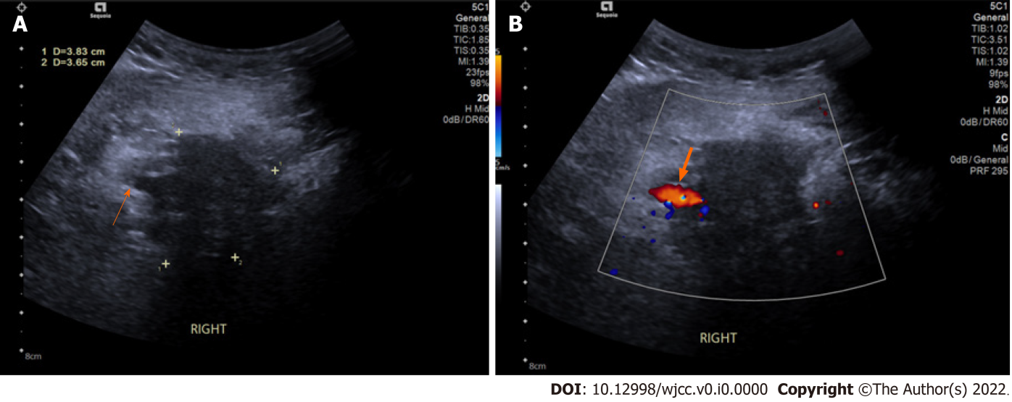
Figure 1 Ultrasound showed a soft lesion which located on the right side of the clavicle to the armpit subcutaneously. A: This soft lesion is 38 mm × 37 mm with blurred boundaries and uneven hypoechoic echogenicity. The lesion’s boundary with the brachial plexus (orange arrow) is not clear; B: Axillary artery (the thick arrow) can be seen beside this lesion.
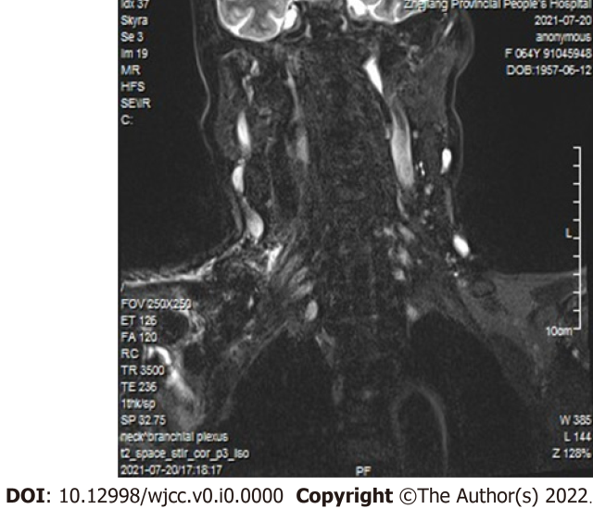
Figure 2 Magnetic resonance imaging brachial plexus scan showed the right side of brachial plexus was enlarged compared with the left side. Brachial plexus bundle in the distance showed a flake shadow.
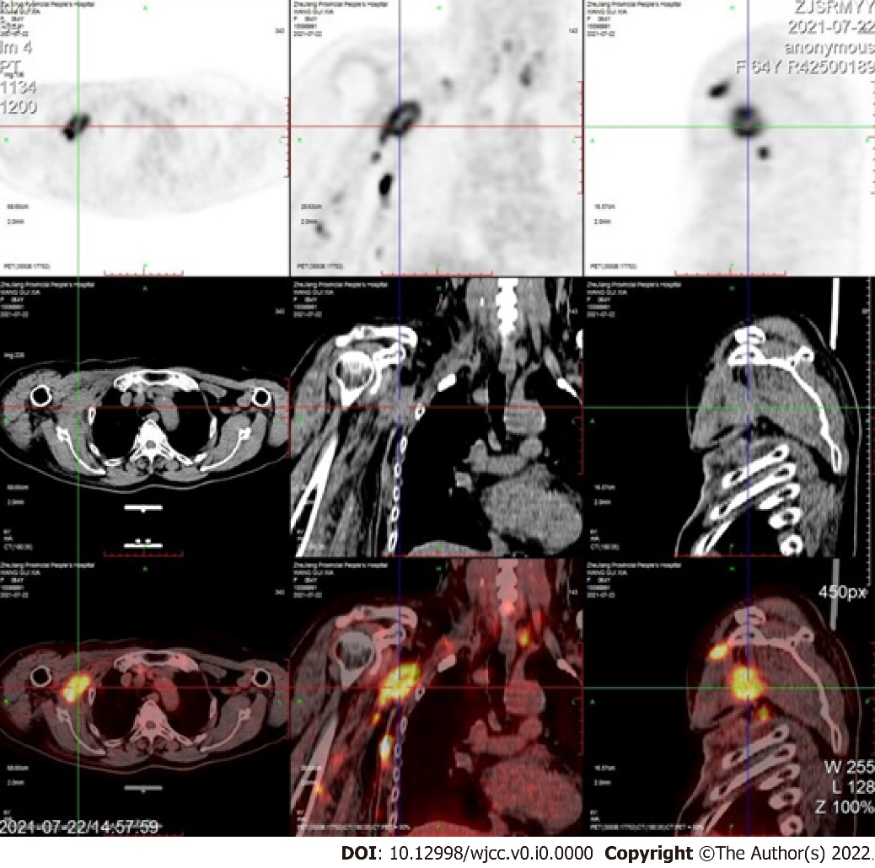
Figure 3 ¹⁸F-fluorodeoxyglucose positron emission tomography and computed tomography revealed that the right side of brachial plexus nodular appearance with increased ¹⁸F-fluorodeoxyglucose metabolism, a SUVmax of 13.7.
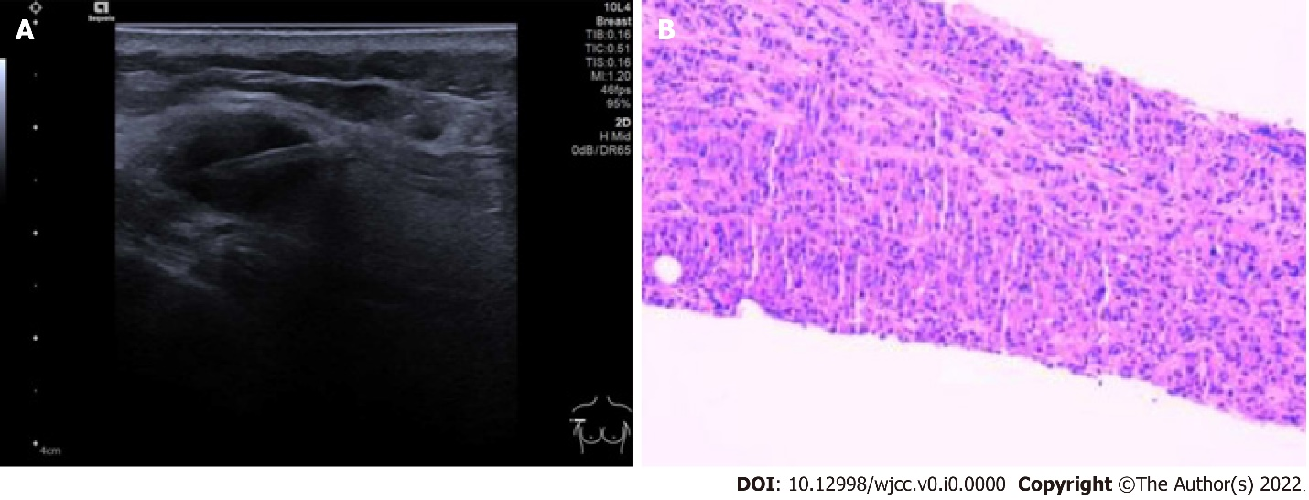
Figure 4 Brachial plexus metastasis from breast cancer. A: The patient underwent lesion punctuation under ultrasound guidance and the lesion was sent for pathology; B: Pathology showed large areas of tumor cells in fibroblast tissue. Immunohistochemistry showed the following results: A2-1: GATA3 (+), ER (+, strong, 90%), PR (+, moderate, 10%), HER-2 (3+), Ki67 (+15%), P120 (membrane+), P63 (-), E-cadherin (+), CK5/6 (-).
Table 1 Literature review of rare metastasis from breast cancer
Ref. | Age(year) | Gender | Size (cm) | Location
Liu et al^{[4]} | 52 | Female | 1.0 × 0.7 | Scalp
Kaneko et al^{[8]} | 45 | Female | — | Stomach
Fu et al^{[6]} | 63 | Female | — | Stomach
Apodaca-Rueda et al^{[9]} | 64 | Female | 6.6 × 6.0 × 7.0 | Pancreas
El Bakraoui et al^{[10]} | 43 | Female | — | Orbital
Yoneyama et al^{[11]} | 68 | Female | — | Bladder
Our case | 64 | Female | 3.8 × 3.7 | Brachial Plexus

