Name of Journal: World Journal of Gastrointestinal Oncology
Manuscript NO: 68538
Manuscript Type: ORIGINAL ARTICLE

Prospective Study
Anatomic resection improved the long-term outcome of hepatocellular carcinoma patients with microvascular invasion: a prospective cohort study

Zhou JM et al. AR and surgical margin

Jiang-min Zhou, Chen-yang Zhou, Xiao-Ping Chen, Zhi-wei Zhang

Jiang-min Zhou, Chen-yang Zhou, Zhi-wei Zhang, Hepatic Surgery Center, Tongji Hospital, Tongji Medical College, Huazhong University of Science and Technology, wuhan 430030, Hubei Province, China

Xiao-Ping Chen, Translational Medicine Center, Tongji Hospital, Tongji Medical College, Huazhong University of Science and Technology, wuhan 430030, Hubei Province, China

Author contributions: Zhou JM analyzed and interpreted the patient data and wrote the manuscript; Zhou CY managed the patients, including recruiting patients, performing operations, and following-up with the patients; Zhang ZW and Chen XP designed the experiment and modified the manuscript; All authors read and approved the final manuscript.

Supported by the National Key Research and Development Program of China, No. 2016YFC0106004.

Corresponding author: Zhi-wei Zhang, PhD, Professor, Hepatic Surgery Center, Tongji Hospital, Tongji Medical College, Huazhong University of Science and Technology, No. 1095 Jiefang Avenue, Wuhan 430030, Hubei Province, China. zhiweizhangtjh@163.com

Received: May 26, 2021
Revised: July 5, 2021
Accepted: September 15, 2021
Published online:

Abstract
BACKGROUND
The long-term effect of anatomic resection (AR) is better than that of non-anatomic resection (NAR). At present, there is no study on microvascular invasion (MVI) and liver resection types.

AIM
To explore whether AR improves long-term survival in patients with hepatocellular carcinoma (HCC) by removing the peritumoral MVI.

METHODS
A total of 217 patients diagnosed with HCC were enrolled in the study. The surgical margin was routinely measured. According to the stratification of different tumor diameters, patients were divided into the following groups: ≤ 2 cm group, 2-5 cm group, and > 5 cm group.

RESULTS
In the 2-5 cm diameter group, the overall survival (OS) of MVI positive patients was significantly better than that of MVI negative patients (P = 0.031). For the MVI positive patients, there was a statistically significant difference between AR and NAR (P = 0.027). AR leads to a wider surgical margin than NAR (2.0 ± 2.3 cm vs 0.7 ± 0.5 cm, P < 0.001). In the groups with tumor diameters < 2 cm, both AR and NAR can obtain a wide surgical margin, and the surgical margins of AR are wider than that of NAR (3.5 ± 5.8 cm vs 1.6 ± 0.5 cm, P = 0.048). In the groups with tumor diameters > 5 cm, both AR and NAR fail to obtain wide surgical margin (0.6 ± 1.0 cm vs 0.7 ± 0.4 cm, P = 0.491).

CONCLUSION
For patients with a tumor diameter of 2-5 cm, AR can achieve the removal of peritumoral MVI by obtaining a wide incision margin, reduce postoperative recurrence, and improve prognosis.

Key Words: microvascular invasion; hepatocellular carcinoma; anatomic resection; surgical margin; recurrence; surgery

Zhou JM, Zhou CY, Chen XP, Zhang ZW. Anatomic resection improved the long-term outcome of hepatocellular carcinoma patients with microvascular invasion: a prospective cohort study. World J Gastrointest Oncol 2021; In press

Core Tip: The prognosis of anatomic resection is better than that of non-anatomic resection with diameters from 2 to 5 cm. For tumor diameters smaller than 2 cm and larger than 5 cm, anatomic resection is not superior to non-anatomic resection. Anatomic resection can achieve the removal of peritumoral microvascular invasion by obtaining a wide incision margin. Both anatomic resection and non-anatomic resection can obtain wide surgical margins in the group with tumor diameters smaller than 2 cm. Both anatomic resection and non-anatomic resection failed to obtain wide surgical margins in the diameter larger than 5 cm group.

INTRODUCTION
Hepatocellular carcinoma (HCC) is one of the most common malignancies worldwide, and its high mortality makes it the second leading cause of cancer death^{[1]}. Although the poor prognosis of HCC has improved significantly over the last decade due to increased knowledge of HCC behavior, improvements in staging systems, and multiple therapeutic options compared with other malignancies, HCC still has a high mortality rate^{[2]}. The prognosis of HCC remains very poor due to the high incidence of recurrence and metastasis, and the 5-year recurrence rate after curative treatment remains high (70%), with 15% of HCC patients developing extrahepatic metastasis^{[3]}. One important reason is that tumor cells are able to penetrate the microvasculature, disseminate through the bloodstream to other sites, and form metastatic tumors. Studies have suggested that microvascular invasion (MVI) in HCC is one of the most significant risk factors for recurrence and metastasis in HCC following curative surgical resection^{[4]}. MVI is defined as clusters of cancer cells observed microscopically in vessels located in the tumor capsule and surrounding liver parenchyma^{[5]}. Previous research reported that the incidence of MVI ranged from 15% to 57% in HCC specimens and was associated with tumor size, levels of alpha fetoprotein (AFP), and typical image features^{[6]}. Even for patients with HCC, the presence of MVI increases the risk of recurrence and dramatically shortens long-term survival^{[7,8]}. The main reason for this is that the residual microthrombosis results in early recurrence. A safe surgical margin is a prerequisite for the complete removal of residual microtumor thrombosis. In HCC, invasion of the portal vein and intrahepatic and distant metastases are frequently observed. Resection of the portal vein invaded by the tumor is one method to decrease the risk of recurrence. Previous research has reported that both anatomic resection (AR) and non-anatomic resection (NAR), with a sufficient margin, can reduce the risk of early recurrence and improve the prognosis of HCC^{[9,10]}. A meta-analysis has shown that anatomical hepatectomy is more effective than non-anatomical hepatectomy^{[11]}. We defined AR as the complete removal of at least one Couinaud segment containing the focus and the portal vein in the drainage area of the lesion. A complete tumor plus the rim of non-neoplastic liver parenchyma was considered a non-anatomic resection^{[12]}. Studies have shown that although the width of the resection margin does not influence the postoperative recurrence rates after liver resection, a wide margin is associated with a lower recurrence risk in patients with venous invasion or microsatellites^{[12,13]}. Studies have shown that not all patients are suitable for AR, and controversy remains over the superiority of AR compared to NAR. In general, AR guarantees a wider surgical margin. However, a wider surgical margin means that more healthy liver tissue has to be removed. Almost all patients with HCC have liver cirrhosis, and the excessive removal of non-neoplastic liver parenchyma can lead to liver dysfunction and the morbidities of ascites, jaundice, and hypoalbuminemia. When the tumor is enormous and the remaining liver tissue is insufficient, AR may not be appropriate^{[14]}. When the liver volume is insufficient, a surgical margin of at least 5 mm should be secured by NAR whenever possible^{[15]}. Therefore, NAR still plays an important role in hepatectomy. Previous studies have shown that AR should be performed when the size of HCC ranges from 2 to 5 cm^{[10]}. However, whether AR should be recommended when the diameter is less than 2 cm or greater than 5 cm remains controversial. In addition, whether anatomical hepatectomy improves the prognosis of patients with hepatocellular carcinoma with microvascular invasion regardless of tumor size is unclear. Therefore, the aim of the study is to determine whether AR improves long-term survival in patients with hepatocellular carcinoma (HCC) by removing microvascular invasion (MVI).

MATERIALS AND METHODS
Patient selection
We consecutively enrolled 217 patients who underwent AR or NAR from November 2016 to November 2018 at the Hepatic Surgery Center, Tongji Hospital, Tongji Medical College, Huazhong University of Science and Technology. The surgical margin was routinely measured. A pathological specimen of each patient was promptly sent to the pathology department and a detailed pathology report was issued. The pathological characteristics of our data, such as MVI, were derived from the report. The flow diagram of the enrolled patients is displayed in Figure 1. According to the stratification of different tumor diameters, patients were divided into the following groups: ≤ 2 cm group, 2-5 cm group, and > 5 cm group.

Patient eligibility
The inclusion criteria were: (1) definitive pathological diagnosis of HCC based on the World Health Organization criteria; (2) curative resection, defined as complete macroscopic removal of the tumor with negative (R0) margins; (3) no prior anticancer treatment; and (4) aged between 18 and 80 years. The exclusion criteria were: (1) distant metastasis; (2) portal vein tumor thrombosis (PVTT); and (3) Child–Pugh C liver disease. The study was conducted in accordance with the Declaration of Helsinki (as revised in 2013). The study was approved by the Ethical Committee of Tongji Hospital of Tongji Medical College of Huazhong University of Science and Technology, and the number of the approval was TJ-IRB20181101. Informed consent was obtained from each patient included in the study.

Terminology
Completely removing at least one Couinaud segment containing the focus and portal vein in the drainage area of the lesion was defined as an AR. A complete tumor plus a rim of non-neoplastic liver parenchyma was considered an NAR.

Surgical procedure
All surgeries were accomplished by a team who was able to professionally implement a hepatectomy. Patients were placed in supine position and under general anesthesia. The surgical principles were followed according to the corresponding the Union for International Cancer Control TNM classification. Intraoperative ultrasonography was routinely used in all patients to assess the number and size of the tumors, and their relation to nearby vascular structures. Proper hepatic vascular control techniques, including the selective inflow occlusion (SIO) maneuver and intermittent Pringle maneuvers (IPs), were used to reduce bleeding during liver resection. The SIO maneuver is described by the following procedure: dissecting the portal vein, proper hepatic artery, right and left hepatic arteries, and bile ducts followed by continuously blocking the hepatic artery in the tumor bearing lobe with a bulldog clamp. IPs encircling the hepatoduodenal ligament were performed with cycles of clamping and unclamping times of 15 min and 5 min, respectively.

Follow-up and tumor recurrence
The patients were surveilled every 1 mo with ultrasonography and AFP during the first 6 mo after surgery and every 3 mo thereafter. Patients were scheduled to have a computerized tomography (CT) scan every 6 mo and a magnetic resonance imaging (MRI) every year. Recurrence was diagnosed by computed tomography scans, magnetic resonance imaging, digital subtraction angiography, and elevated serum AFP level. We reviewed the governmental death registration and performed telephone follow-ups. Patients were excluded if they were not followed up as required, or their governmental data were incomplete. Follow-up was terminated on May 31, 2021. Patients lost to follow-up and with missing data were prematurely excluded. Ultimately, 217 eligible patients were enrolled in the study. Death was the primary endpoint and the diagnosis of intrahepatic recurrence and/or extrahepatic metastasis was the secondary endpoint.

Study design
First, all patients were randomized to receive standard anatomic or non-anatomic resection. After surgery, we measured the surgical margin and identified microvascular invasion. We divided them into three groups based on tumor size to compare the effects of anatomic and nonanatomic hepatectomy in subgroups. In addition, the relationship between tumor size and surgical margin was further analyzed.

Statistical analysis
Data are presented as the mean ± SD. The overall survival (OS) was analyzed using Kaplan-Meier survival curves and a log-rank test. Student’s t-tests were used for comparison between groups where appropriate. A c² test was used for comparison between groups where appropriate. P < 0.05 was considered statistically significant. Statistical analyses were performed with SPSS version 19.0.

RESULTS
Patient characteristics
The mean follow-up time was 45.2 ± 6.3 mo (median: 46.0 mo; range: 30.6-53.4 mo). The cumulative survival rate for all patients was 90%, 57%, and 39% at 1, 3, and 5 years. All of the category boundaries were defined by the clinical guideline or recognized criterion when continuous variables were categorized. Table 1 demonstrates the clinical and tumor characteristics of the 217 patients with HCC. The mean patient age was 52.6 ± 12.4 years (range: 21–74 years). The patients were 90.8% (197/217) male and 9.2% (20/217) female. In total, 86.6% (178/217) were positive for hepatitis B virus (HBV) infection and 10 patients were positive for the hepatitis C virus (HCV). Overall, 42.4% (92/217) were Barcelona Clinic Liver Cancer (BCLC) 0+A, and 34.6% (75/217) were MVI positive. Eight patients (3.7%) had a hepatic function of Child-Pugh score B and received short-term liver protective therapy before surgery. The clinical and pathological characteristics of the AR and NAR groups are summarized in Table 2. There were no significant differences in age, sex, Child-Pugh class, etc. between the two groups.

Comparison of types of hepatectomy with prognosis in the 2-5 cm tumor diameter subgroup
The 217 included patients were divided into three groups: diameter ≤ 2 cm (84/217), 2-5 cm (87/217) and > 5 cm (46/217). In the diameter 2-5 cm group, there was a statistically significant difference between MVI positive and MVI negative patients (median OS 32.0 mo, 95% confidence interval (CI): 13.3-50.8 mo vs not reached, P = 0.031) (Figure 2a). For the MVI positive patients, there was a statistically significant difference between AR and NAR (median OS not reached vs 29.0 mo 95%CI: 8.0-43.9 mo, P = 0.027) (Figure 2b). However, for the MVI negative patients, there were no statistically significant differences between those who underwent AR and NAR (median OS not reached vs 44.2 mo, 95%CI: 27.0-61.5 mo, P = 0.206) (Figure 2c). This suggests that AR improved OS only in MVI positive patients, but not in MVI negative patients in the diameter 2-5 cm group. In addition, we compared the surgical margin of AR and NAR in the 2-5 cm diameter group. We found that AR led to a wider surgical margin than NAR (2.0 ± 2.3 cm vs 0.7 ± 0.5 cm, P < 0.001) (Table 3). We speculated that AR can achieve a wide enough surgical margin, which can remove MVI in advance, reducing the risk of postoperative recurrence and improving the prognosis.

Comparison of types of hepatectomy with prognosis in the subgroup with a tumor diameter less than 2 cm
Among patients with a diameter less than 2 cm, there was no statistically significant difference between MVI positive and MVI negative patients (median OS 34 mo 95%CI: 27.6-40.4 mo vs 45.0 mo 95%CI: 39.4-50.6 mo, P = 0.345) (Figure 2d). In addition, there was no statistically significant difference in overall survival between patients who received AR and NAR, whether MVI positive or MVI negative (median OS 32.4 mo 95%CI: 13.0-46.3 mo vs not reached, P = 0.097; median OS 46.6 mo, 95%CI: 32.8-60.4 mo vs 41.3 mo, 95%CI: 34.6-48.1 mo, P = 0.869) (Figure 3a and b). By comparing the surgical margins of AR and NAR patients, we found that although the AR margins were wider than those of NAR patients, the margins of both were greater than 1 cm (3.5 ± 5.8 cm vs 1.6 ± 0.5 cm, P = 0.048) (Table 3; Figure 4b). If a surgical margin of 1 cm is ensured, it can be clinically regarded as a R0 resection. Thus, for patients with a tumor of less than 2 cm in diameter, both AR and NAR can achieve a wide surgical margin to ensure the removal of MVI.

Comparison of types of hepatectomy with prognosis in the subgroup with a tumor diameter larger than 5 cm
In the group with a diameter > 5 cm, the prognosis of MVI positive patients was significantly worse than that of MVI negative patients (median OS 24.0 mo, 95%CI: 15.7-32.4 mo vs not reached, P = 0.004) (Figure 3c). However, there was no statistically significant difference in overall survival between patients who received AR and NAR, whether MVI positive or MVI negative, (median OS 27.2 mo, 95%CI: 21.9-32.5 mo vs 20.1 mo, 95%CI: 5.6-28.8 mo, P = 0.428; median OS not reached vs 38.3 mo, 95%CI: 19.5-60.5 mo, P = 0.714) (Figures 3d and 4a). In addition, there were no statistically significant differences between AR and NAR in surgical margins and the margins of both were less than 1cm (0.6 ± 1.0 cm vs 0.7 ± 0.4 cm, P = 0.491) (Table 3; Figure 4b). For patients with tumors larger than 5 cm in diameter, neither AR nor NAR could obtain a wide enough surgical margin to ensure the removal of MVI.

DISCUSSION
At present, surgeons consider hepatectomy and liver transplantation the optimal therapies to improve prognosis in HCC; however, tumor recurrence is still an important cause of death in patients^{[16]}. Previous research has demonstrated that microvascular invasion is a vital risk factor for the prognosis of HCC patients after curative hepatectomy^{[17]}. As long as a surgical margin of 1 cm is ensured, it can be clinically regarded as an R0 resection^{[18]}. The margin of microvascular invasion is generally no more than 1 cm. Therefore, an R0 resection enables the complete removal of the liver tissue invaded by the microvascular thrombosis. In contrast, positive margins were associated with a worse prognosis^{[19,20]}. Previous studies have shown that a wider surgical margin has been associated with a better prognosis among patients with HCC^{[21-23]}. In addition, a previous study has shown that AR led to a better OS than NAR. In a multivariable analysis, an AR was one of the prognostic factors^{[9]}. AR can reduce the risk of tumor residues and recurrence due to the elimination of venous tumor thrombosis within the resected domain, when at least one complete Couinaud segment and the portal vein in the drainage area of the lesion are removed^{[24,25]}. However, almost all patients with HCC have liver cirrhosis and excessive removal of non-neoplastic liver parenchyma can lead to liver dysfunction and the morbidities of ascites, jaundice, and hypoalbuminemia.
Our data indicated that AR improved OS only in MVI positive patients, but not in MVI negative patients in the 2-5 cm diameter group. We speculated that AR can achieve a wide enough surgical margin, which can remove MVI in advance, reduce the risk of postoperative recurrence, and improve the prognosis. For patients with a tumor diameter of less than 2 cm, both AR and NAR can obtain a wide surgical margin to ensure removal of MVI. Therefore, patients with a diameter less than 2 cm, both AR and NAR, can achieve a good prognosis. In other words, an R0 resection enabled the removal of the liver tissue invaded by the MVI regardless of whether AR or NAR was chosen by the surgeon. This suggests that AR is not necessary for tumors with a diameter of less than 2 cm, as long as sufficient surgical margin is ensured. However, in the > 5 cm group, both AR and NAR cannot guarantee sufficient surgical margin, which is one of the reasons why tumors with a diameter of more than 5 cm have a worse prognosis than tumors with a diameter of less than 2 cm. We believe that the surgeon needs to consider whether the residual liver volume and liver function reserve are sufficient when faced with a very large tumor. Therefore, for tumor diameters larger than 5 cm, the width of the resection margin should be increased appropriately when a sufficient liver volume and a good liver function can be ensured.

Limitations
The limitations of this study are the relatively small samples, short follow-up time, and a single study center cohort study. A multicenter clinical trial should be designed to further validate the prognostic significance of types of hepatectomy in HCC.

CONCLUSION
For patients with a tumor diameter of 2-5 cm, AR can achieve the removal of peritumoral MVI by obtaining a wide incision margin, reduce postoperative recurrence, and improve prognosis.

ARTICLE HIGHLIGHTS
Research background
At present, most studies suggest that anatomical resection is more effective than non-anatomical resection in the tumor diameter ranging from 2 cm to 5 cm. However, for tumors smaller than 2 cm and larger than 5 cm in diameter, the advantage of anatomic hepatectomy is not significant. Why is that? Does anatomic resection (AR) have an advantage over non-anatomic resection (NAR) in hepatocellular carcinoma (HCC) patients with microvascular invasion (MVI)?

Research motivation
Our study aimed to determine the effects of AR and NAR in different tumor diameter stratification. Further analysis shows that AR improves patient outcomes by obtaining a wider surgical margin.

Research objectives
This study compared the efficacy of AR and NAR in different tumor diameter subgroups in a prospective cohort study.

Research methods
First, all patients were randomized to receive standard anatomic or non-anatomic resection. After surgery, we measured the surgical margin and identified microvascular invasion. We divided them into three groups based on tumor size.

Research results
When the tumor is enormous and the remaining liver tissue is insufficient, AR may not be appropriate. For patients with a tumor diameter of 2-5 cm, AR can achieve the removal of peritumoral MVI by obtaining a wide incision margin, reducing postoperative recurrence and improving prognosis. For patients with a tumor of less than 2 cm in diameter, both AR and NAR can obtain a wide surgical margin to ensure the removal of MVI. AR should not be recommended for those patients. For patients with tumors larger than 5 cm in diameter, neither AR nor NAR could obtain a wide surgical margin to ensure removal of MVI.

Research conclusions
The doctor should ensure sufficient surgical margin on the premise of ensuring the safety of the operation. Therefore, for patients with a tumor diameter of 2-5 cm, AR should be strongly recommended.

Research perspectives
The study could guide doctors in their choice of surgical procedures. In general, AR guarantees a wider surgical margin. However, a wider surgical margin means that more healthy liver tissue has to be removed. Almost all patients with HCC have liver cirrhosis, and the excessive removal of non-neoplastic liver parenchyma can lead to liver dysfunction and the morbidities of ascites, jaundice, and hypoalbuminemia. When the tumor is enormous and the remaining liver tissue is insufficient, AR may not be appropriate.

ACKNOWLEDGEMENTS
The authors would like to thank Dr. Chang Shu who is a of statistics (Translational Medicine Center, Tongji Hospital, Tongji Medical College, Huazhong University of Science and Technology) for her technical assistance of statistical analysis.

REFERENCES
1 Sung H, Ferlay J, Siegel RL, Laversanne M, Soerjomataram I, Jemal A, Bray F. Global Cancer Statistics 2020: GLOBOCAN Estimates of Incidence and Mortality Worldwide for 36 Cancers in 185 Countries. CA Cancer J Clin 2021; 71: 209-249 [PMID: 33538338 DOI: 10.3322/caac.21660]
2 Njei B, Rotman Y, Ditah I, Lim JK. Emerging trends in hepatocellular carcinoma incidence and mortality. Hepatology 2015; 61: 191-199 [PMID: 25142309 DOI: 10.1002/hep.27388]
3 Tabrizian P, Jibara G, Shrager B, Schwartz M, Roayaie S. Recurrence of hepatocellular cancer after resection: patterns, treatments, and prognosis. Ann Surg 2015; 261: 947-955 [PMID: 25010665 DOI: 10.1097/SLA.0000000000000710]
4 Wang L, Jin YX, Ji YZ, Mu Y, Zhang SC, Pan SY. Development and validation of a prediction model for microvascular invasion in hepatocellular carcinoma. World J Gastroenterol 2020; 26: 1647-1659 [PMID: 32327913 DOI: 10.3748/wjg.v26.i14.1647]
5 Shirabe K, Toshima T, Kimura K, Yamashita Y, Ikeda T, Ikegami T, Yoshizumi T, Abe K, Aishima S, Maehara Y. New scoring system for prediction of microvascular invasion in patients with hepatocellular carcinoma. Liver Int 2014; 34: 937-941 [PMID: 24393295 DOI: 10.1111/liv.12459]
6 Renzulli M, Brocchi S, Cucchetti A, Mazzotti F, Mosconi C, Sportoletti C, Brandi G, Pinna AD, Golfieri R. Can Current Preoperative Imaging Be Used to Detect Microvascular Invasion of Hepatocellular Carcinoma? Radiology 2016; 279: 432-442 [PMID: 26653683 DOI: 10.1148/radiol.2015150998]
7 Zhou J, Sun HC, Wang Z, Cong WM, Wang JH, Zeng MS, Yang JM, Bie P, Liu LX, Wen TF, Han GH, Wang MQ, Liu RB, Lu LG, Ren ZG, Chen MS, Zeng ZC, Liang P, Liang CH, Chen M, Yan FH, Wang WP, Ji Y, Cheng WW, Dai CL, Jia WD, Li YM, Li YX, Liang J, Liu TS, Lv GY, Mao YL, Ren WX, Shi HC, Wang WT, Wang XY, Xing BC, Xu JM, Yang JY, Yang YF, Ye SL, Yin ZY, Zhang BH, Zhang SJ, Zhou WP, Zhu JY, Liu R, Shi YH, Xiao YS, Dai Z, Teng GJ, Cai JQ, Wang WL, Dong JH, Li Q, Shen F, Qin SK, Fan J. Guidelines for Diagnosis and Treatment of Primary Liver Cancer in China (2017 Edition). Liver Cancer 2018; 7: 235-260 [PMID: 30319983 DOI: 10.1159/000488035]
8 Erstad DJ, Tanabe KK. Prognostic and Therapeutic Implications of Microvascular Invasion in Hepatocellular Carcinoma. Ann Surg Oncol 2019; 26: 1474-1493 [PMID: 30788629 DOI: 10.1245/s10434-019-07227-9]
9 Hasegawa K, Kokudo N, Imamura H, Matsuyama Y, Aoki T, Minagawa M, Sano K, Sugawara Y, Takayama T, Makuuchi M. Prognostic impact of anatomic resection for hepatocellular carcinoma. Ann Surg 2005; 242: 252-259 [PMID: 16041216 DOI: 10.1097/01.sla.0000171307.37401.db]
10 Eguchi S, Kanematsu T, Arii S, Okazaki M, Okita K, Omata M, Ikai I, Kudo M, Kojiro M, Makuuchi M, Monden M, Matsuyama Y, Nakanuma Y, Takayasu K; Liver Cancer Study Group of Japan. Comparison of the outcomes between an anatomical subsegmentectomy and a non-anatomical minor hepatectomy for single hepatocellular carcinomas based on a Japanese nationwide survey. Surgery 2008; 143: 469-475 [PMID: 18374043 DOI: 10.1016/j.surg.2007.12.003]
11 Moris D, Tsilimigras DI, Kostakis ID, Ntanasis-Stathopoulos I, Shah KN, Felekouras E, Pawlik TM. Anatomic versus non-anatomic resection for hepatocellular carcinoma: A systematic review and meta-analysis. Eur J Surg Oncol 2018; 44: 927-938 [PMID: 29751946 DOI: 10.1016/j.ejso.2018.04.018]
12 Couinaud C. [Anatomic principles of left and right regulated hepatectomy: technics]. J Chir (Paris) 1954; 70: 933-966 [PMID: 13233306]
13 Moris D, Ronnekleiv-Kelly S, Rahnemai-Azar AA, Felekouras E, Dillhoff M, Schmidt C, Pawlik TM. Parenchymal-Sparing Versus Anatomic Liver Resection for Colorectal Liver Metastases: a Systematic Review. J Gastrointest Surg 2017; 21: 1076-1085 [PMID: 28364212 DOI: 10.1007/s11605-017-3397-y]
14 Viganò L, Procopio F, Mimmo A, Donadon M, Terrone A, Cimino M, Fabbro DD, Torzilli G. Oncologic superiority of anatomic resection of hepatocellular carcinoma by ultrasound-guided compression of the portal tributaries compared with nonanatomic resection: An analysis of patients matched for tumor characteristics and liver function. Surgery 2018; 164: 1006-1013 [PMID: 30195402 DOI: 10.1016/j.surg.2018.06.030]
15 Field WBS, Rostas JW, Philps P, Scoggins CR, McMasters KM, Martin RCG 2nd. Wide versus narrow margins after partial hepatectomy for hepatocellular carcinoma: Balancing recurrence risk and liver function. Am J Surg 2017; 214: 273-277 [PMID: 28615138 DOI: 10.1016/j.amjsurg.2017.06.002]
16 Lee MW, Lim HK. Management of sub-centimeter recurrent hepatocellular carcinoma after curative treatment: Current status and future. World J Gastroenterol 2018; 24: 5215-5222 [PMID: 30581270 DOI: 10.3748/wjg.v24.i46.5215]
17 Yamashita YI, Imai K, Yusa T, Nakao Y, Kitano Y, Nakagawa S, Okabe H, Chikamoto A, Ishiko T, Yoshizumi T, Aishima S, Maehara Y, Baba H. Microvascular invasion of single small hepatocellular carcinoma ≤3 cm: Predictors and optimal treatments. Ann Gastroenterol Surg 2018; 2: 197-203 [PMID: 29863190 DOI: 10.1002/ags3.12057]
18 Cherqui D, Tantawi B, Alon R, Piedbois P, Rahmouni A, Dhumeaux D, Julien M, Fagniez PL. Intrahepatic cholangiocarcinoma. Results of aggressive surgical management. Arch Surg 1995; 130: 1073-1078 [PMID: 7575119 DOI: 10.1001/archsurg.1995.01430100051011]
19 Lang H, Sotiropoulos GC, Sgourakis G, Schmitz KJ, Paul A, Hilgard P, Zöpf T, Trarbach T, Malagó M, Baba HA, Broelsch CE. Operations for intrahepatic cholangiocarcinoma: single-institution experience of 158 patients. J Am Coll Surg 2009; 208: 218-228 [PMID: 19228533 DOI: 10.1016/j.jamcollsurg.2008.10.017]
20 Xu X, Zhang HL, Liu QP, Sun SW, Zhang J, Zhu FP, Yang G, Yan X, Zhang YD, Liu XS. Radiomic analysis of contrast-enhanced CT predicts microvascular invasion and outcome in hepatocellular carcinoma. J Hepatol 2019; 70: 1133-1144 [PMID: 30876945 DOI: 10.1016/j.jhep.2019.02.023]
21 Kabir T, Syn NL, Tan ZZX, Tan HJ, Yen C, Koh YX, Kam JH, Teo JY, Lee SY, Cheow PC, Chow PKH, Chung AYF, Ooi LL, Chan CY, Goh BKP. Predictors of post-operative complications after surgical resection of hepatocellular carcinoma and their prognostic effects on outcome and survival: A propensity-score matched and structural equation modelling study. Eur J Surg Oncol 2020; 46: 1756-1765 [PMID: 32345496 DOI: 10.1016/j.ejso.2020.03.219]
22 Aoki T, Kubota K, Hasegawa K, Kubo S, Izumi N, Kokudo N, Sakamoto M, Shiina S, Takayama T, Nakashima O, Matsuyama Y, Murakami T, Kudo M; Liver Cancer Study Group of Japan. Significance of the surgical hepatic resection margin in patients with a single hepatocellular carcinoma. Br J Surg 2020; 107: 113-120 [PMID: 31654406 DOI: 10.1002/bjs.11329]
23 Tsilimigras DI, Sahara K, Moris D, Hyer JM, Paredes AZ, Bagante F, Merath K, Farooq AS, Ratti F, Marques HP, Soubrane O, Azoulay D, Lam V, Poultsides GA, Popescu I, Alexandrescu S, Martel G, Guglielmi A, Hugh T, Aldrighetti L, Endo I, Pawlik TM. Effect of Surgical Margin Width on Patterns of Recurrence among Patients Undergoing R0 Hepatectomy for T1 Hepatocellular Carcinoma: An International Multi-Institutional Analysis. J Gastrointest Surg 2020; 24: 1552-1560 [PMID: 31243714 DOI: 10.1007/s11605-019-04275-0]
24 Wakai T, Shirai Y, Sakata J, Kaneko K, Cruz PV, Akazawa K, Hatakeyama K. Anatomic resection independently improves long-term survival in patients with T1-T2 hepatocellular carcinoma. Ann Surg Oncol 2007; 14: 1356-1365 [PMID: 17252289 DOI: 10.1245/s10434-006-9318-z]
25 Regimbeau JM, Kianmanesh R, Farges O, Dondero F, Sauvanet A, Belghiti J. Extent of liver resection influences the outcome in patients with cirrhosis and small hepatocellular carcinoma. Surgery 2002; 131: 311-317 [PMID: 11894036 DOI: 10.1067/msy.2002.121892]

Footnotes
Institutional review board statement: The study was reviewed and approved for publication by Institutional Reviewer of Huazhong University of Science and Technology.

Informed consent statement: All study participants or their legal guardian provided informed written consent about personal and medical data collection prior to study enrolment.

Conflict-of-interest statement: All the authors have no conflict of interest related to the manuscript.

Data sharing statement: The original anonymous dataset is available on request from the corresponding author at zhiweizhangtjh@163.com.

CONSORT 2010 statement: The authors have read the CONSORT 2010 Statement, and the manuscript was prepared and revised according to the CONSORT 2010 Statement.

Open-Access: This article is an open-access article that was selected by an in-house editor and fully peer-reviewed by external reviewers. It is distributed in accordance with the Creative Commons Attribution NonCommercial (CC BY-NC 4.0) license, which permits others to distribute, remix, adapt, build upon this work non-commercially, and license their derivative works on different terms, provided the original work is properly cited and the use is non-commercial. See: http://creativecommons.org/Licenses/by-nc/4.0/

Manuscript source: Unsolicited manuscript

Peer-review started: May 26, 2021
First decision: June 24, 2021
Article in press:

Specialty type: Gastroenterology and hepatology
Country/Territory of origin: China
Peer-review report’s scientific quality classification
Grade A (Excellent): 0
Grade B (Very good): 0
Grade C (Good): C
Grade D (Fair): 0
Grade E (Poor): 0

P-Reviewer: Yagi H S-Editor: Gong ZM L-Editor: Filipodia P-Editor:
Figure Legends
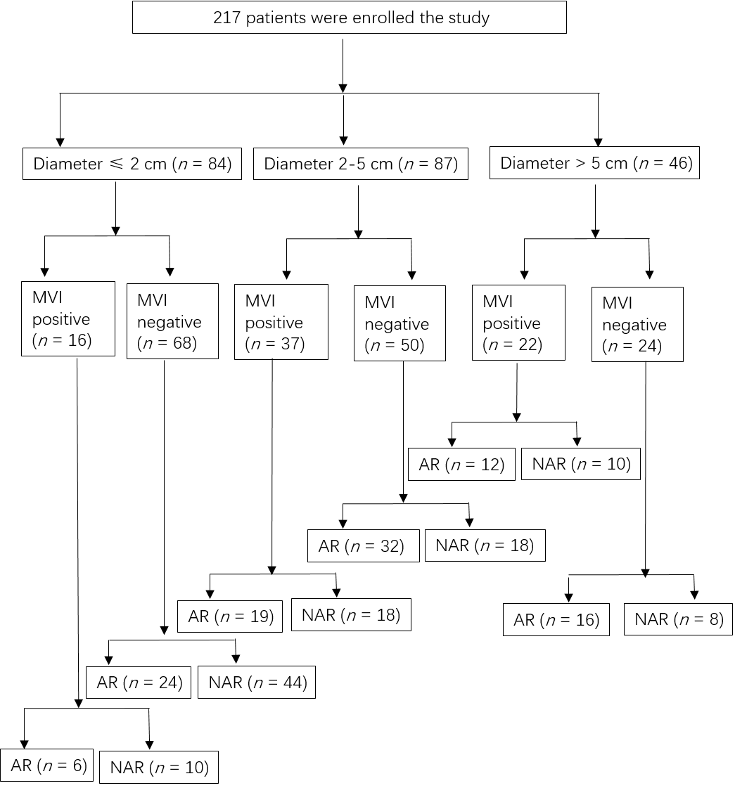
Figure 1 Flow diagram for the study. AR: anatomic resection; MVI: microvascular invasion; NAR: non-anatomic resection.
Figure 2 The long-term outcome of hepatocellular carcinoma with different tumor diameters. A: Kaplan-Meier analysis of the overall survival (OS) in microvascular invasion (MVI) positive and MVI negative patients with a tumor diameter 2-5 cm; b: In the group with a tumor diameter of 2-5 cm, Kaplan-Meier analysis of the OS in receiving MVI positive anatomic resection (AR) and non-anatomic resection (NAR) patients; C: In the group with a tumor diameter of 2-5 cm, Kaplan-Meier analysis of the OS in receiving AR and NAR patients with MVI negative. D: Kaplan-Meier analysis of the OS in MVI positive and MVI negative patients with a tumor diameter of less than 2 cm.

Figure 3 The long-term outcome of hepatocellular carcinoma with different tumor diameter. A: In the group with a tumor diameter of less than 2 cm, Kaplan-Meier analysis of the overall survival (OS) in receiving anatomic resection (AR) and non-anatomic resection (NAR) patients with microvascular invasion (MVI) positive; B: In the group with a tumor diameter of less than 2 cm, Kaplan-Meier analysis of the OS in patients receiving AR and NAR patients who were MVI negative; C: Kaplan-Meier analysis of the OS in MVI positive and MVI negative patients with tumor diameters larger than 5 cm; d: In the group with a tumor diameter of larger than 5 cm, Kaplan-Meier analysis of the OS in MVI positive patients receiving AR and NAR.

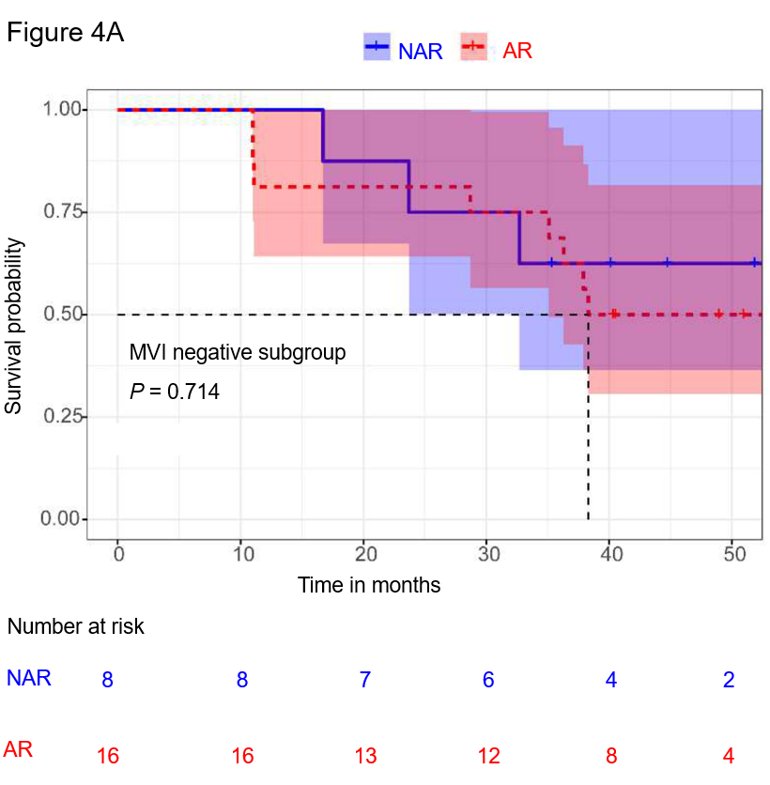
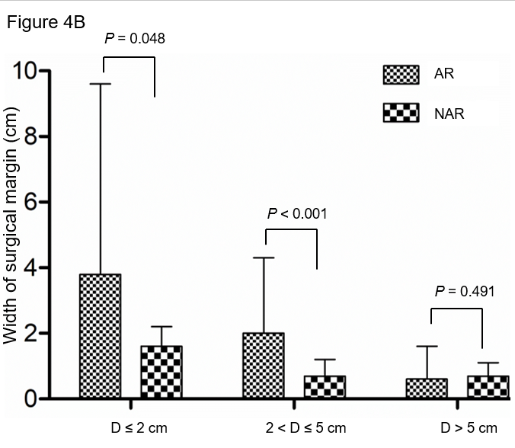
Figure 4 Kaplan-Meier analysis of the overall survival (A) and comparison of surgical margins in patients with different tumor diameters (B). a: In the group with a tumor diameter larger than 5 cm, Kaplan-Meier analysis of the overall survival in microvascular invasion negative patients receiving anatomic resection (AR) and non-anatomic resection (NAR); B: Comparison of surgical margins in patients receiving AR and NAR with different tumor diameters.
Table 1 Clinical characteristics of 217 patients
Clinical characteristics | Value
Age, yr, (mean ± SD) | 52.6 ± 12.4
Sex, n (%)
Male | 197 (90.8)
Female | 20 (9.2)
ALT (U/ml) | 30.2 ± 14.3
AST (U/ml) | 38.6 ± 32.0
TBiL (μmol/l) | 15.8 ± 9.6
Child-Pugh score, n (%)
A | 209 (96.3)
B | 8 (3.7)
Hepatitis virus, n (%)
HBV | 178 (82.0)
HCV | 10 (4.6)
No | 29 (13.4)
Liver cirrhosis, n (%)
No | 43 (19.8)
Yes | 174 (80.2)
ICG-R15 (%) | 6.6 ± 3.8
AFP (ng/mL), n (%)
≤ 400 | 144 (66.4)
> 400 | 73 (33.6)
Tumor diameter (cm) | 4.9 ± 3.5
No. of tumor, n (%)
Singe | 157(72.4)
Multiple | 60(27.6)
Microvascular invasion, n (%)
Yes | 75(34.6)
No | 142(65.4)
BCLC stage, n (%)
0+A | 92 (42.4)
B+C | 125 (57.6)
Operation method, n (%)
Open | 56 (25.8)
Laparoscopic | 161 (74.2)
Operation time (min) | 171 ± 40
Blood loss (mL) | 160 ± 180
Blood transfusion, n (%)
No | 189 (87.1)
Yes | 28 (12.9)
Hepatic vascular occlusion, n (%)
No | 64 (29.5)
Yes | 153 (70.5)
AFP: Alpha fetoprotein; ALT: Alanine transaminase; AST: Aspartate aminotransferase; BCLC: Barcelona Clinic Liver Cancer staging system; HBV: Hepatitis B virus; HCV: Hepatitis C virus; ICG R15 (%): Indocyanine green retention rate at 15 min; SD: Standard deviation; TBiL: Total bilirubin.
Table 2 Clinical characteristics of anatomic resection and non-anatomic resection
Clinical characteristics | AR (n = 103) | NAR (n = 114) | P value
Age, yr (mean ± SD) | 54.1 ± 12.5 | 51.3 ± 12.2 | 0.095
Sex, n (%) |  |  | 0.812
Male | 93 (90.3) | 104 (91.2)
Female | 10 (9.7) | 10 (8.8)
ALT (U/ml) | 30.5 ± 14.5 | 29.8 ± 14.2 | 0.721
AST (U/ml) | 36.3 ± 28.9 | 40.6 ± 34.6 | 0.332
TBiL(μmol/l) | 17.0 ± 10.5 | 15.9 ± 9.0 | 0.098
Child-Pugh score, n (%) |  |  | 0.154
A | 103 (100) | 106 (93.0)
B | 0 (0) | 2 (7.0)
HBsAg, n (%) |  |  | 0.622
Positive | 88 (85.4) | 100 (87.7)
Negative | 15 (14.6) | 14 (12.3)
Liver cirrhosis, n (%) |  |  | 0.841
No | 21 (20.4) | 22 (19.3)
Yes | 82 (79.6) | 92 (80.7)
AFP (ng/mL), n (%) |  |  | 0.446
< 400 | 71 (68.9) | 73 (64.0)
≥ 400 | 32 (31.1) | 41 (36.0)
ICG-R15 (%) | 5.9 ± 3.5 | 5.4 ± 3.1 | 0.578
BCLC stage, n (%) |  |  | 0.867
0+A | 46 (44.7) | 46 (40.4)
B+C | 57 (55.3) | 68 (59.6)
Operation method, n (%) |  |  | 0.423
Open | 24 (23.3) | 32 (28.1)
Laparoscopic | 79 (76.7) | 82 (71.9)
Operation time (min) | 171.4 ± 48.2 | 165.5 ± 45.3 | 0.335
Blood loss (mL) | 210 ± 233 | 170 ± 175 | 0.233
Blood transfusion, n (%) |  |  | 0.774
No | 89 (86.4) | 100 (87.7)
Yes | 14 (13.6) | 14 (12.3)
Hepatic vascular occlusion, n (%) |  |  | 0.314
No | 27 (26.2) | 37 (32.5)
Yes | 76 (73.8) | 77 (67.5)
Largest tumor size, (cm) | 5.1 ± 3.6 | 4.7 ± 3.3 | 0.507
No. of tumors, n (%) |  |  | 0.884
Single | 75 (72.8) | 82 (71.9)
Multiple | 28 (27.2) | 32 (28.1)
Tumor encapsulation, n (%) |  |  | 0.051
No | 57 (55.3) | 66 (57.9)
Yes | 46 (44.7) | 48 (42.1)
Satellite lesion, n (%) |  |  | 0.822
Yes | 9 (8.7) | 9 (7.9)
No | 94 (91.3) | 105 (92.1)
Tumor differentiation stage, n (%) |  |  | 0.943
Edmondson I II | 51 (49.5) | 57 (50.0)
Edmondson III IV | 52 (50.5) | 57 (50.0)
Microvascular invasion, n (%) |  |  | 0.845
Yes | 37 (35.9) | 38 (33.3)
No | 66 (64.1) | 76 (66.7)
AFP: alpha fetoprotein; ALT: alanine transaminase; AST: aspartate aminotransferase; AR: Anatomic resection; BCLC: Barcelona Clinic Liver Cancer staging system; HBsAg: hepatitis B surface antigen; ICG R15 (%): Indocyanine green retention rate at 15 min; NAR: non-anatomic resection; TBiL: total bilirubin.

Table 3 The surgical margin of different tumor diameter groups
Tumor diameter | Surgical margin (cm)
 | AR | NAR | P value
D ≤ 2 cm | 3.5 ± 5.8 | 1.6 ± 0.5 | 0.048
2 cm < D ≤ 5 cm | 2.0 ± 2.3 | 0.7 ± 0.5 | < 0.001
D > 5 cm | 0.6 ± 1.0 | 0.7 ± 0.4 | 0.491
AR: anatomic resection; D: diameter; NAR: non-anatomic resection.

