Name of Journal: World Journal of Dermatology
ESPS Manuscript NO: 24942
Manuscript Type: Case Report

Local hyperthermia cleared multiple cutaneous warts on a nephrotic syndrome patient

Zhang YJ et al. Heat clears warts in nephrotic syndrome

Yu-Jing Zhang, Rui-Qun Qi, Xing-Hua Gao

Yu-jing Zhang, Rui-qun Qi, Xing-hua Gao, Department of Dermatology, No. 1 Hospital of China Medical University, Shenyang 110001, Liaoning Province, China

Author contributions: Zhang YJ performed the treatment and wrote the report; Qi RQ and Gao XH designed the report.

Institutional review board statement: This study was reviewed and approved by the China Medical University Institutional Review Board.

Informed consent statement: The patient involved in the study gave her consent authorizing use and disclosure of her protected health information.

Conflict-of-interest statement: The authors declare that they have no conflict of interest.

Open-Access: This article is an open-access article which was selected by an in-house editor and fully peer-reviewed by external reviewers. It is distributed in accordance with the Creative Commons Attribution Non Commercial (CC BY-NC 4.0) license, which permits others to distribute, remix, adapt, build upon this work non-commercially, and license their derivative works on different terms, provided the original work is properly cited and the use is non-commercial. See: http://creativecommons.org/licenses/by-nc/4.0/

Manuscript source: Unsolicited manuscript

Correspondence to: Xing-Hua Gao, MD, PhD, Department of Dermatology, No.1 Hospital of China Medical University, 155 North Nanjing St, Heping District, Shenyang 110001, Liaoning Province, China. gaobarry@hotmail.com
Telephone: +86-24-83282326
Fax: +86-24-83282633

Received: February 16, 2016
Peer-review started: February 16, 2016
First decision: March 1, 2016
Revised: March 15, 2016
Accepted: May 10, 2016
Article in press:

Abstract
Cutaneous warts are caused by human papillomavirus infection. Immunosuppressive state is one of the risk factors of human papillomavirus infection. A girl diagnosed of nephrotic syndrome and on immunosuppressive therapy developed multiple common warts. We treated her on a single lesion by local hyperthermia therapy at 44 ℃ for 3 consecutive days, each therapy lasted for 30 min. 10 d later, the patient received another 2 consecutive therapy. All lesions are completely resolved at the 9th week after the treatment. No recurrent sign was observed in a 3-mo follow-up. Side effects included burning sensation, stabbing pain at the target site during treatment.

Key words: Hyperthermia; Warts; Nephrotic syndrome; Immunosuppression

© The Author(s) 2016. Published by Baishideng Publishing Group Inc. All rights reserved.

Core tip: Common warts on immunosuppressive patients are characterized by multiple lesions, long duration and hard to treat. Current treatment method includes laser therapy, cryotherapy, topical salicylic acid, etc. Scar formation and high recurrence rate are the most common disadvantages of these treatments. In this case report, we provide a noninvasive treatment method called hyperthermia treatment. Using this method we succeed to cure multiple warts on a nephrotic syndrome patient who received immunosuppressive treatment for years without any scar formation. And we did not see recurrence 3 mo after the treatment.

Zhang YJ, Qi RQ, Gao XH. Local hyperthermia cleared multiple cutaneous warts on a nephrotic syndrome patient. World J Dermatol 2016; In press

INTRODUCTION
Human papillomaviruses (HPVs) infection is associated with cutaneous warts and cervical cancer, depending on the virus subtypes. Smoking, a large number of lifetime sexual partners, and immunosuppressive state are the main factors that elevate the individual’s rate of infection^{[1]}. The former two factors are more related to individual’s unhealthy lifestyle than the latter one which is sometimes unpreventable, for instance, iatrogenic immunosuppressive agents for renal transplantation and autoimmune diseases^{[2]}. Multiple cutaneous lesions, long disease duration, and high recurrence rate – consequences of glucocorticoids and other immunosuppressive agents – are the challenges for the conventional treatment methods.
Controlled localized heating was proved successful to treat warts^{[3]}. Recently, we reported that the cure rate of cutaneous warts is over 50% using the intermittent local hyperthermia method. In these studies, we used a patented hyperthermia device (patent NO.: ZL 2007 2 01875403.3, Patent holder: The First Hospital of China Medical University, China). This device has an infrared emitting source. The heat generated by the device acted locally on skin surface without direct contact^{[4,5]}. Side effects were minimal except mild burning sensation and stabbing pain while receiving the treatment, and occasional heat-induced transit bullae. The recurrence rates were low. We treated an immunosuppressed patient with multiple warts by local hyperthermia at 44 ℃ for 30 min a day for 3 consecutive days plus 2 additional days 10 d later. The patient was followed-up weekly. The study was approved by the Ethics Committee of China Medical University (2009 no.22)

CASE REPORT
A 23-year-old girl presented with three slowly growing lesions on her left knee, and a similar one in the right nostril for 2 years. She did not receive any treatment. Months before developing the skin lesions, she experienced leg edema. Laboratory study revealed proteinuria (3+), occult urine blood (2+), serum albumin 19.9 g/L (normal range 40-55 g/L), serum total cholesterol 6.98 mmol/L (normal range 0-5.72 mmol/L), serum triglyceride 5.85 mmol/L (normal range 0-1.7 mmol/L), serum creatinine 48umol/L (normal range 59-104 μmol/L). She was clinically diagnosed with nephrotic syndrome, and membranous nephropathy by renal pathology. She received prednisone 50 mg/d and tacrolimus 3 mg/d. Her clinical symptoms disappeared in 10 d and laboratory tests turned close to normal. In the following two years, her prednisone dose was tapered from 50 mg/d to 25 mg/d. Oral tacrolimus was replaced by tripterygium wilfordii (20 mg/d). Physical examination of the skin showed three flesh or gray-colored papules over or at side of her left knee. The largest papule was 0.5 cm × 0.5 cm in size, and had a hyperkeratotic appearance. There was a pink colored papule at her right nostril. General exam revealed nothing particular. We initiated local hyperthermia on a papule at the extensor side of her knee (circled in Figure 1). The target received local hyperthermia at 44 ℃, once a day for 3 consecutive days, and each treatment lasted for 30 min. 10 d later, the patient received two more similar consecutive treatment. Then the patient was followed up once a week for next 3 mo. The lesions began to shrink at the 7th week after local hyperthermia therapy and completely resolved 9 wk after completion of the therapy (Figure 2). After the first treatment, the patient developed a tense blister adjacent to the target which resolved spontaneously within 3 d. It is noted that both treated and untreated sites over her knee had pigmentation left (Figure 2). The patient felt burning and stabbing pain at the targeted site while receiving treatment. We did not see any sign of recurrence during a 3 mo follow-up.

DISCUSSION
Chronic immunosuppression for various reasons can lead to persistent infection of human papillomavirus and HPV-associated diseases^{[6]}. This patient was diagnosed with nephrotic syndrome and she received glucocorticoids, tacrolimus, and tripterygium wilfordii (an immunosuppressive agent derived from plants). Glucocorticoids can interfere the function of both innate and adaptive immune system. Toll-like receptors are responsible for the microbial pathogen to elicit initial immune and inflammatory response. This reaction is normally limited by glucocorticoids to curb excess inflammation^{[7]}. Glucocorticoids-induced apoptosis in lymphocytes is mediated by the glucocorticoids receptor^{[8]}. Cell-mediated immunity is believed the main weapon against HPV virus. Antigen presenting cells, T helper cells, and cytotoxic lymphocytes may have the most significant role in clearing the critter. The use of glucocorticoids inhibits the effect of those cells, which is blamed to cause the long duration and multiple HPV induced lesions. Tacrolimus suppresses adaptive immune reaction through interfering the production of IL-2, which is an important cytokine for T cells development and proliferation. Besides, tripterygium wilfordii could reduce the cytokine secretion level of Th1 and Th2 cells^{[9]}. Common warts have a tendency to regress spontaneously: 23% cases within 2 mo, 30% within 3 mo and 65% to 78% within 2 years, however, warts are less likely to resolve in adults and in immunosuppressed patients^{[10]}. Topical salicylic acid therapy and cryotherapy are two first-line treatments for non-genital cutaneous warts^{[11]}. Both of the two treatments aim at eliminating signs and symptoms, and if the infectious areas are not removed thoroughly, the recurrence rate would be high. For this particular case, destructive options for the lesion over her nostril was not favored by the patient. We chose local hyperthermia therapy over a lesion on her knee, the resolution of which induced the spontaneous resolution of the untreated ones. The major advantages of the treatment include no scaring, high tolerability (especially for patients with multiple lesions as only one site is treated), easy accessibility and low recurrence rate^{[4,5]}. The full mechanism of local hyperthermia therapy is unclear. In our previous studies, we found that above fever range hyperthermia could increase influx of Langerhans cells to draining lymph node^{[12]} and could induce the IFN-induced antiviral activity and apoptosis of keratinocytes^{[13,14]}. These phenomenon suggest hyperthermia may help to setup an immune specific response against HPV infected keratinocytes, which could explain a single target treatment clears other untreated lesions.

ACKNOWLEDGMENTS
We thank Public Welfare Program, Ministry of Health, China, No. 201202013 and the National Natural Science Foundation of China, No. 81301368.

COMMENTS
Case characteristics
Hyperthermia-a new method succeed to treat multiple cutaneous warts in an immunosuppressive patient.

Clinical diagnosis
Verruca vulgaris and nephrotic syndrome.

Differential diagnosis
Molluscum contagiosm.

Treatment
Hyperthermia.

Experiences and lessons
Local hyperthermia provides with an effective, noninvasive, and low complication method to treat various warts.

Peer-review
It is an interesting case with a novel method and a good result.

REFERENCES
1 Brendle SA, Bywaters SM, Christensen ND. Pathogenesis of infection by human papillomavirus. Curr Probl Dermatol 2014; 45: 47-57 [PMID: 24643177 DOI: 10.1159/000355963]
2 Barba A, Tessari G, Talamini G, Chieregato GC. Analysis of risk factors for cutaneous warts in renal transplant recipients. Nephron 1997; 77: 422-426 [PMID: 9434064 DOI: 10.1159/000190319]
3 Stern P, Levine N. Controlled localized heat therapy in cutaneous warts. Arch Dermatol 1992; 128: 945-948 [PMID: 1626962 DOI: 10.1001/archderm.1992.01680170077010]
4 Gao XH, Gao D, Sun XP, Huo W, Hong YX, Li XD, Wang XQ, Qi RQ, Zhang L, Gu XC, Chen HD. Non-ablative controlled local hyperthermia for common warts. Chin Med J (Engl) 2009; 122: 2061-2063 [PMID: 19781396 DOI: 10.3760/cma.j.issn.0366-6999.2009.17.018]
5 Huo W, Gao XH, Sun XP, Qi RQ, Hong Y, Mchepange UO, Li XD, Xiao BH, Lin JP, Jiang Y, Zhang L, Li YH, Xiao T, Chen JZ, Chen HD. Local hyperthermia at 44 degrees C for the treatment of plantar warts: a randomized, patient-blinded, placebo-controlled trial. J Infect Dis 2010; 201: 1169-1172 [PMID: 20199243 DOI: 10.1086/651506]
6 Wieland U, Kreuter A, Pfister H. Human papillomavirus and immunosuppression. Curr Probl Dermatol 2014; 45: 154-165 [PMID: 24643184 DOI: 10.1159/000357907]
7 Chinenov Y, Rogatsky I. Glucocorticoids and the innate immune system: crosstalk with the toll-like receptor signaling network. Mol Cell Endocrinol 2007; 275: 30-42 [PMID: 17576036 DOI: 10.1016/j.mce.2007.04.014]
8 Planey SL, Litwack G. Glucocorticoid-induced apoptosis in lymphocytes. Biochem Biophys Res Commun 2000; 279: 307-312 [PMID: 11118283 DOI: 10.1006/bbrc.2000.3922]
9 Hu GH, Yi ZW, Wang JH, Yao JC. [Effect of triptergium wilfordii polyglycosidium on content of Th1 and Th2 in child recurrent nephrotic syndrome]. Zhongguo Zhong Yao Za Zhi 2008; 33: 441-443 [PMID: 18533507]
10 Sterling JC, Handfield-Jones S, Hudson PM. Guidelines for the management of cutaneous warts. Br J Dermatol 2001; 144: 4-11 [PMID: 11167676 DOI: 10.1046/j.1365-2133.2001.04066.x]
11 Bacelieri R, Johnson SM. Cutaneous warts: an evidence-based approach to therapy. Am Fam Physician 2005; 72: 647-652 [PMID: 16127954]
12 Li X, Gao XH, Jin L, Wang Y, Hong Y, McHepange UO, Wang X, Jiang Y, Wei H, Chen HD. Local hyperthermia could induce migrational maturation of Langerhans cells in condyloma acuminatum. J Dermatol Sci 2009; 54: 121-123 [PMID: 19155157 DOI: 10.1016/j.jdermsci.2008.12.004]
13 Zhu LL, Gao XH, Qi R, Hong Y, Li X, Wang X, McHepange UO, Zhang L, Wei H, Chen HD. Local hyperthermia could induce antiviral activity by endogenous interferon-dependent pathway in condyloma acuminata. Antiviral Res 2010; 88: 187-192 [PMID: 20797409 DOI: 10.1016/j.antiviral.2010.08.012]
14 Wang X, Gao XH, Li X, Hong Y, Qi R, Chen HD, Zhang L, Wei H. Local hyperthermia induces apoptosis of keratinocytes in both normal skin and condyloma acuminata via different pathways. Apoptosis 2009; 14: 721-728 [PMID: 19363704 DOI: 10.1007/s10495-009-0344-8]

P-Reviewer: Hu SCS, Husein-ElAhmed H, Kaliyadan F, Manolache L,
Torres-alvarez MB, Vasconcellos C S-Editor: Qiu S L-Editor: E-Editor:

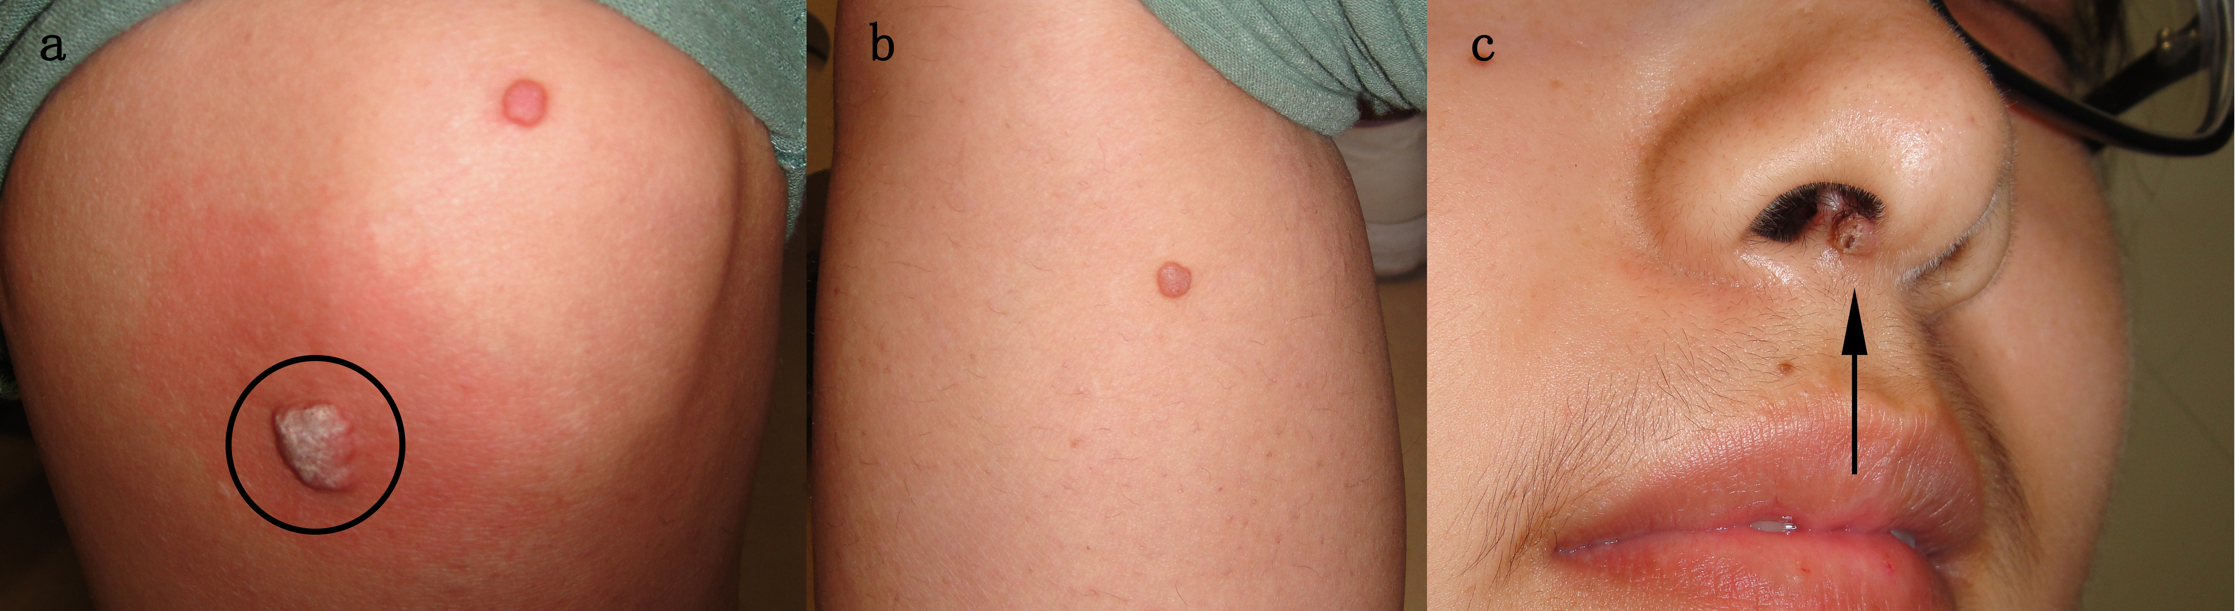
Figure 1 Local hyperthermia on a papule at the extensor side of knee. (A) lesion over left knee, target lesion is circled; (B) lateral side of left calf; (C) right nostril.

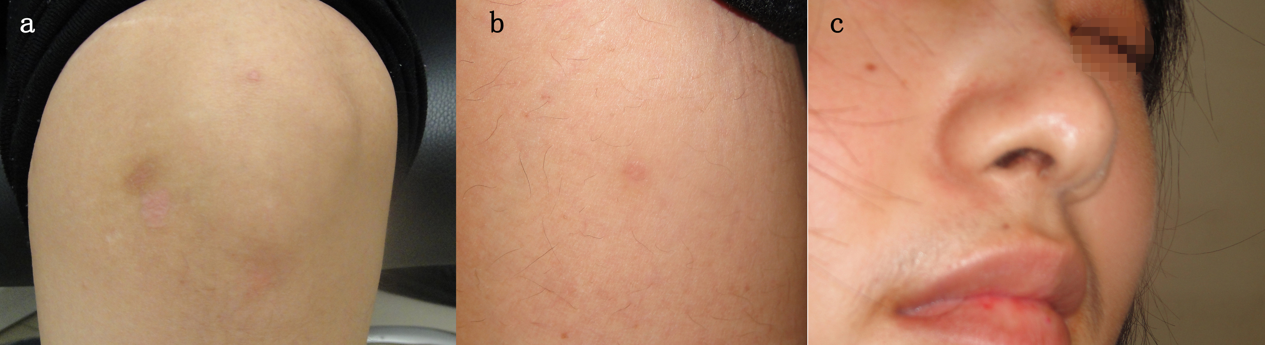
Figure 2 9th week after completion of five sessions of local hyperthermia treatment. (A) left knee; (B) lateral side of left calf; (C) right nostril.

