Name of Journal: World Journal of Clinical Cases
Manuscript NO: 60225
Manuscript Type: CASE REPORT

Epithelioid angiomyolipoma of the pancreas: A case report and review of the literature

Zhu QQ et al. Epithelioid angiomyolipoma

Qing-Qing Zhu, Zhong-Feng Niu, Fei-Dan Yu, Yan Wu, Guang-Bin Wang

Qing-Qing Zhu, Department of Radiology, Shandong Medical Imaging Research Institute, Cheeloo College of Medicine, Shandong University, Jinan 250021, Shandong Province, China

Qing-Qing Zhu, Zhong-Feng Niu, Fei-Dan Yu, Yan Wu, Department of Radiology, Sir Run Run Shaw Hospital, Zhejiang University School of Medicine, Hangzhou 310000, Zhejiang Province, China

Guang-Bin Wang, Department of Radiology, Shandong Medical Imaging Research Institue, Cheeloo College of Medicine, Shandong University, Jinan 250021, Shandong Province, China

Author contributions: Zhu QQ collected the clinical data of this patient and drafted the manuscript; Niu ZF reviewed the literature and drafted the manuscript; Yu FD and Wu Y performed the epithelioid angiomyolipoma consultation and reviewed the literature; Niu ZF and Wu Y were responsible for the revision of the manuscript for important intellectual content; Wu Y and Wang GB contributed equally to the manuscript polishing; all authors issued final approval for the version to be submitted.

Corresponding author: Guang-Bin Wang, MD, Chief Doctor, Department of Radiology, Shandong Medical Imaging Research Institute, Cheeloo College of Medicine, Shandong University, No. 324 Jinwu Road, Huaiyin District, Jinan 250021, Shandong Province, China. wgb7932596@hotmail.com

Received: November 10, 2020
Revised: December 25, 2020
Accepted: January 14, 2021
Published online:

Abstract
BACKGROUND
Angiomyolipomas (AMLs), belonging to the family of mesenchymal tumors, are considered benign lesions that occur mostly in the kidney or as a part of tuberous sclerosis. Epithelioid AML (EAML) is a rare type of AML that appears to have malignant potential. Extrarenal AMLs usually occur in the liver according to the retrieved literature reports. There have been only two previous reports of monofocal primary AML of the pancreas; however, no cases of primary monotypic EAML of the pancreas have been reported.

CASE SUMMARY
An asymptomatic 59-year-old woman incidentally revealed a tumor during abdominal ultrasound examination. Routine blood tests and physical examination were within normal limits. Abdominal ultrasound revealed a 1.9-cm hypoechogenic mass in the tail of the pancreas, clearly visualized by endoscopic ultrasound. However, contrast-enhanced abdominal computed tomography scans did not demonstrate the lesion. A subsequent gadolinium-enhanced magnetic resonance imaging scan showed that the lesion had some characteristic manifestations. The lesion was initially thought to be a neuroendocrine tumor (asymptomatic PanNET). After surgical resection, histopathology and immunohistochemistry confirmed the diagnosis of EAML. At the 6-mo follow-up, no recurrence, spread, or metastasis was identified on computed tomography or magnetic resonance imaging.

CONCLUSION
The preoperative diagnosis of pancreatic AML is extremely difficult. Imaging techniques are essential for providing valuable morphological features for differential diagnosis.

Key Words: Epithelioid angiomyolipoma; Pancreas; Ultrasound; Computed tomography; Magnetic resonance imaging; Case report

Zhu QQ, Niu ZF, Yu FD, Wu Y, Wang GB. Epithelioid angiomyolipoma of the pancreas: A case report and review of the literature. World J Clin Cases 2021; In press

Core Tip: We present a rare case of pancreatic epithelioid angiomyolipoma diagnosed after an anatomopathological examination. The patient was asymptomatic. Here are several findings from multiple modalities, including multidetector computed tomography, ultrasound, endoscopic ultrasound, magnetic resonance imaging, and providing a pathologic correlation. Awareness of the characteristic features, including immunoreactivity for the human melanoma black-45 marker, may help in the diagnosis of this rare entity. This report represents, to our knowledge, the first epithelioid angiomyolipoma arising in the pancreas.
INTRODUCTION
Angiomyolipoma (AML) is classified into two distinct histological subtypes: Classic triphasic AML and monotypic epithelioid AML (EAML). Classic AML is benign and characterized by proliferation of blood vessels, smooth muscle, and adipose tissue in variable proportions. EAML is composed of purely epithelioid cells with a paucity of adipose tissue components. The fact that immunohistochemical staining for melanocyte and smooth muscle cell markers in these tumors has standardized the histological diagnosis of this entity. The reported characteristics of renal EAML with malignant potential often resemble those of renal cell carcinoma on both radiology and histology^{[1-3]}. In the present report, we present an extrarenal EAML in the pancreas.

CASE PRESENTATION
Chief complaints
A 59-year-old asymptomatic woman underwent abdominal ultrasound (US) in the workflow of health examination, revealing a 1.9-cm hypoechogenic mass in the tail of the pancreas.

History of past illness
The patient used amlodipine besylate for 20 years for the treatment of hypertension. The remarkable medical history was thyroid cancer resection 5 mo prior and treatment with radionuclide therapy.

Personal and family history
Neither she nor anyone in her family had a history of tuberous sclerosis complex (TSC).

Physical examination
The patient’s vital signs and physical examination were likewise unremarkable.

Laboratory examinations
Laboratory findings indicated that the patient’s carbohydrate antigen 19-9 level, as well as her carcinoembryonic antigen level, was within the normal range.

Imaging examinations
Following abdominal US examination, the patient underwent enhanced multidetector computed tomography (MDCT), magnetic resonance imaging (MRI), and endoscopic US (EUS) for further evaluation. The size and morphology of the pancreas were nearly normal in all imaging examinations. US and EUS revealed a 1.9-cm hypoechogenic mass in the tail of the pancreas that did not display the typical expected adipose echogenicity. No hypervascularity was noted on the Doppler images (Figure 1A). Ultrasonic elastography showed a green-to-blue cold color, indicating soft conditions (Figure 1B). The soft tissue mass was occult on the computed tomography (CT) scan due to its homogeneous isodensity to the background pancreatic parenchyma in the unenhanced, arterial, portovenous, and delayed phases (Figure 2). No other lesions were detected on the abdominal and pelvic CT scan. On MRI, the mass demonstrated a long or equal signal intensity (SI) on LAVA-T1-weighted imaging and slightly long SI on FS-T2-weighted imaging. Chemical shift gradient-echo images demonstrated a slight loss of SI on out-of-phase imaging related to the small amount of microscopic lipid component within the mass (Figure 3A-C). DWI showed the mass-region of hyperintesity. ADC map was dark with an ADC value 0.707 × 10⁻³ mm²/s, consistent with reduced diffusivity (Figure 3 D). Additionally, contrast-enhanced MRI revealed that the mass was slightly hyperenhancing relative to surrounding pancreas on arterial phase imaging. Then, the mass washed out in the portal and delayed phases very quickly (Figure 3E-H).

MULTIDISCIPLINARY EXPERT CONSULTATION
Liu-Xin Cai, MD, Chief Doctor, Department of General Surgery, Zhejiang University School of Medicine
A neuroendocrine tumor (asymptomatic PanNET) was preoperatively diagnosed based on location and imaging findings. Considering the overall characteristics of the mass and the patients’ health condition, surgical resection should still be recommended due to the absence of available data on long-term follow-up.

FINAL DIAGNOSIS
Gross pathological examination revealed a well-defined, brown nodular tumor in the tail of the pancreas measuring 1.7 cm × 1.7 cm. The pathological diagnosis was based on pleomorphic perivascular epithelioid cells (PECs) (Figure 4) and immunohistochemical staining for melanoma and smooth muscle cell markers. While adipose tissue was scarcely observed, mitotic figures were rare, and atypical mitoses were not detected. The sections were immunostained using monoclonal anti-HMB-45, anti-desmin, anti-melan-A, and anti-SMA antibodies. Typical smooth muscle cells and epithelioid cells were immunoreactive for HMB-45 (Figure 5) and positive for melan-A and SMA. Accordingly, the final pathological diagnosis was primary EAML.

TREATMENT
The patient requested surgical intervention. During the operation, it was noted that the lesion was adjacent to splenic vessels. Subsequently, laparoscopic resection of the tail of the pancreas and spleen was performed.

OUTCOME AND FOLLOW-UP
The patient made an uneventful recovery and was discharged from the hospital on the 8th day after surgery. The patient was followed for 6 mo postoperatively, and no signs of recurrence or metastasis were observed on CT and MR examinations.

DISCUSSION
Etiology and demographics
AML was recognized as a mesenchymal tumor in the 2004 World Health Organization classification of renal tumors^{[4]} and a member of the family of PEComas^{[5]} that may occur sporadically or in association with TSC^{[6]}. Although AML is most common in the kidney, extrarenal sites can also be involved. The liver, with over 100 reported hepatic cases^{[7-9]}, is reported to be the most frequently involved extrarenal organ. Rare additional sites of reported AMLs include the lung^{[10,11]}, spleen^{[12,13]}, colon^{[14,15]}, heart^{[16]}, skin^{[17,18]}, parotid gland^{[19,20]}, mediastinum^{[21]}, spermatic cord^{[22]}, nasal cavity^{[23,24]}, and retroperitoneal soft tissue^{[25,26]}. The nature of most AMLs is benign, while examples of renal and extrarenal AMLs have described malignant potential^{[1-3,27]}. EAML is considered a potentially malignant neoplasm since one-third of patients develop metastatic lesions involving extension into the vena cava and metastasis^{[27]}. EAML can occur locally, metastasize, and result in death^{[28]}. No clear criteria have been developed to identify malignant tumors, but most reported examples did not exhibit increased mitotic activity^{[27,29]}. Our patient’s tumor exhibited benign historical characteristics, and follow-up information 6 mo after the operation indicated no evidence of recurrence. The patient remains in continuous follow-up.

Clinical and imaging findings
Clinical presentation varies and is nonspecific. Adding to the difficulty of a preoperative diagnosis, most extrarenal AMLs are asymptomatic and remain occult unless incidentally detected.
Renal AMLs involve the renal cortex and exhibit diffusely high echogenicity on US. Most renal AMLs demonstrate a fat density of less than -20 HU on a nonenhanced CT scan, although EAMLs show high attenuation. On a CT scan with contrast agent, they show a prolonged enhancement pattern homogeneous with peripheral kidney tissue. On MRI, the signal intensities of AMLs are decided by the fat content^{[30]}. Nevertheless, the majority of renal AMLs can be recognized easily under the technique of fat suppression or chemical shift, except for those with poor lipids. It may be challenging to achieve the accurate diagnosis of EAMLs because adipocytes are scarce in tumors. Renal EAMLs demonstrate a range of MR appearances, with non-specific DWI findings, hypointensity on T2-weighted MR images, and differing degree of enhancement depending on the components of the tumor. It must be recognized that renal EAML can appear adjacent or even within conventional AML and show high attenuation on CT and homogenous enhancement with a prolonged enhancement pattern^{[31]}.
Due to advances in US, MDCT, and MR imaging technologies, both symptomatic and asymptomatic extrarenal AMLs that can occur in various parts of the body have been noticed and reported frequently. So far, the most frequent location is the liver. One-half of AMLs occurring in the liver lack an appreciable fat content, which is unlike renal AMLs. Hepatic EAMLs on US appear as hyperechogenic lesions with clear boundaries. Relative hypervascularity may be found in the lesions. MDCT is useful for the evaluation of fat content within a mass, which can be helpful to differentiate lipid-rich and lipid-poor types. On CT scans, lipid-poor hepatic AMLs have a peripheral angiomyomatous component and soft tissue attenuation. On MRI scans, imaging findings of hepatic AMLs are consistent with those of renal AMLs^{[28]}. Fifty percent of hepatic AMLs lacking macroscopic fat content remain a diagnostic dilema^{[9,32,33]}.
The primary EAML in the pancreas that we reported in our patient appeared differently on CT and MRI when compared with primary hepatic and renal AMLs. The incidence and general radiographic features of primary EAML of the pancreas are not known. The pancreas can be involved by EAML, and as such, when faced with a pancreatic mass, doctors ought to include EAML in the differential diagnosis. Upon a review of the literature, there are a limited number of imaging studies on AML of the pancreas and no studies on EAML of the pancreas^{[34]}. Imaging features of pancreatic AML have been infrequently reported. The imaging findings associated with the mass in our case were partially similar to those of primary pancreatic AML but differed from those of reported EAMLs in the kidney and liver. The uncommon primary AML of the pancreas was reported for the first time by Heywood et al^{[34]} in 2004 with US and CT examination before surgery. The thick-walled cystic mass, measuring 4.5 cm × 3 cm × 2.5 cm, was located in the uncinate process of pancrease and was accompanied by hemorrhage. In 2017, Kim et al^{[35]} reported the second known case of monofocal primary AML. The mass, measuring 2 cm, was located in the body of the pancreas, suggesting a low-grade malignant or benign tumor. EUS revealed a hyperechogenic mass without hypervascularity. Isodense mass on unenhanced CT images and peripheral enhancement were observed during the arterial, parenchyma, and portovenous phases. On MRI, the mass, without diffusion restriction, displayed heterogeneous peripheral high SI on T2 imaging and homogenous low SI on T1 imaging. Additionally, dynamic MRI revealed that the central part of the mass was poorly enhanced, while the peripheral part was strongly enhanced.

Pathological features
Our case represents a pancreatic EAML whose epithelioid cell component is predominant. Histologically, EAML is composed of a group of PEC tumors with cells of epithelioid morphology, smooth muscle, and a partially melanocyte phenotype^{[3,5]}. These lesions can resemble melanoma or conventional renal tumors in the kidney that have a predominance of sarcomatous elements. Characteristic histology and an immunohistochemical phenotype should aid in the correct diagnosis.
Typical AMLs feature lobular structures and are colored gray-to-yellow on gross examination. Necrosis as well as intratumoral hemorrhage can be observed. Approximately 30% of patients are found to have multiple tumors, and in patients with TSC, the proportion is even higher. Multiple tumors are not equal to metastasis but the indication of multifocality^{[6,36]}.
Through microscopic examination, various proportions of components, including vessels with thick walls, smooth muscle, and mature adipose tissue, were observed in AML. Rare cases (i.e., monotypic EAML) with the predominant proportion of epithelioid cells can be extremely difficult to diagnose. In general, EAMLs are considered to originate from smooth muscle and are characterized by abundant eosinophilic cytoplasm as well as nuclear pleomorphism, atypia, and mitotic activity to varying degrees^{[37,38]}. Apits^{[39]} was the first to describe epithelioid features in renal AML, often arranged around vascular spaces, and increasing awareness of the lesion has led to the recognition of monotypic EAML^{[39]}. However, very subtle differences were observed between benign and malignant EAMLs, and there were no clear diagnostic criteria for malignancies. If there is no conclusive evidence of metastasis, the diagnosis of malignant AML is extremely difficult.
Some AMLs have an unusual morphology, including those with one predominant component, such as EAML, which may prompt a misdiagnosis of leiomyosarcoma, liposarcoma, and even carcinoma. Immunohistochemical staining reflects the distinctive cellular differentiation of the tumor. The most instructive finding is the smooth muscle or myoid cells in AMLs that coexpress muscle markers, such as SMA, and human melanocytic markers, such as HMB-45. In our patient, negative staining for cytokeratin, chromogranin A, and synaptophysin argued against carcinoma and neuroendocrine carcinoma, while positive staining for HMB-45, Melan-A, and SMA was added in the correct diagnosis.

Treatment and prognosis
In most cases, AMLs are benign in the clinical course, even those with multiple foci, a bizarre morphology, or local invasion. Surgical resection can reach the cure level. EAML, in contrast to classic AML (which is benign), may be associated with distant metastasis and local recurrence. Making a prognosis of malignant EAML is challenging for a limited number of cases. According to the literature, the survival of patients with malignant EAML ranges from several months to 3 years. Cibas et al^{[31]} reported a case of malignant EAML that was treated successfully with single-agent doxorubicin.

CONCLUSION
Our horizon about the occurrence sites and morphological features of AML has been enlarged to a great extent in recent years. Our report of primary pancreatic EAML prompts our awareness of AML. This report of primary EAML in the pancreas further widens this spectrum. To date, this is the first such case of only a few HMB-45-positive EAMLs outside the kidney and liver and is the first to describe relatively complete imaging findings of primary AML in the pancreas without hemorrhage. Further evaluation, including imaging modalities, imaging features, and prognosis, is urgently necessary to better characterize primary pancreatic AML.

REFERENCES
1 Christiano AP, Yang X, Gerber GS. Malignant transformation of renal angiomyolipoma. J Urol 1999; 161: 1900-1901 [PMID: 10332463 DOI: 10.1016/S0022-5347(05)68839-8]
2 El Jack AK, Tomaszewski JE, Haller DG, Siegelman ES. Metastatic PEComa arising from renal angiomyolipoma: MRI findings. J Magn Reson Imaging 2007; 26: 159-161 [PMID: 17659554 DOI: 10.1002/jmri.20947]
3 Lai HY, Chen CK, Lee YH, Tsai PP, Chen JH, Shen WC. Multicentric aggressive angiomyolipomas: a rare form of PEComas. AJR Am J Roentgenol 2006; 186: 837-840 [PMID: 16498117 DOI: 10.2214/AJR.04.1639]
4 Lopez-Beltran A, Scarpelli M, Montironi R, Kirkali Z. 2004 WHO classification of the renal tumors of the adults. Eur Urol 2006; 49: 798-805 [PMID: 16442207 DOI: 10.1016/j.eururo.2005.11.035]
5 Martignoni G, Pea M, Reghellin D, Zamboni G, Bonetti F. PEComas: the past, the present and the future. Virchows Arch 2008; 452: 119-132 [PMID: 18080139 DOI: 10.1007/s00428-007-0509-1]
6 Burgueño Gómez B, Lindo Ricce M, Mora Cuadrado N, González de Frutos C. Concurrent hepatic and renal angiomyolipomas in tuberous sclerosis complex. Rev Esp Enferm Dig 2020; 112: 412-413 [PMID: 32338028 DOI: 10.17235/reed.2020.6376/2019]
7 Yamasaki S, Tanaka S, Fujii H, Matsumoto T, Okuda C, Watanabe G, Suda K. Monotypic epithelioid angiomyolipoma of the liver. Histopathology 2000; 36: 451-456 [PMID: 10792487 DOI: 10.1046/j.1365-2559.2000.00848.x]
8 Ronen S, Prieto VG, Aung PP. Epithelioid angiomyolipoma mimicking metastatic melanoma in a liver tumor. J Cutan Pathol 2020; 47: 824-828 [PMID: 32274822 DOI: 10.1111/cup.13705]
9 Huang YM, Wei PL, Chen RJ. Epithelioid Angiomyolipoma of the Liver. J Gastrointest Surg 2018; 22: 175-176 [PMID: 29110191 DOI: 10.1007/s11605-017-3616-6]
10 Guinee DG Jr, Thornberry DS, Azumi N, Przygodzki RM, Koss MN, Travis WD. Unique pulmonary presentation of an angiomyolipoma. Analysis of clinical, radiographic, and histopathologic features. Am J Surg Pathol 1995; 19: 476-480 [PMID: 7694950 DOI: 10.1097/00000478-199504000-00010]
11 Ito M, Sugamura Y, Ikari H, Sekine I. Angiomyolipoma of the lung. Arch Pathol Lab Med 1998; 122: 1023-1025 [PMID: 9822133]
12 Hulbert JC, Graf R. Involvement of the spleen by renal angiomyolipoma: metastasis or multicentricity? J Urol 1983; 130: 328-329 [PMID: 6876283 DOI: 10.1016/s0022-5347(17)51134-9]
13 Asayama Y, Fukuya T, Honda H, Kaneko K, Kuroiwa T, Yoshimitsu K, Irie H, Shinokuma J, Yamaguchi K, Masuda K. Chronic expanding hematoma of the spleen caused by angiomyolipoma in a patient with tuberous sclerosis. Abdom Imaging 1998; 23: 527-530 [PMID: 9841068 DOI: 10.1007/s002619900392]
14 Maesawa C, Tamura G, Sawada H, Kamioki S, Nakajima Y, Satodate R. Angiomyolipoma arising in the colon. Am J Gastroenterol 1996; 91: 1852-1854 [PMID: 8792714]
15 Oishi K, Fukuda S, Sakimoto H, Eto T, Takahashi M, Nishida T. Angiomyolipoma of the colon: report of a case. Surg Today 2009; 39: 998-1001 [PMID: 19882325 DOI: 10.1007/s00595-009-3973-1]
16 Shimizu M, Manabe T, Tazelaar HD, Hirokawa M, Moriya T, Ito J, Hamanaka S, Hata T. Intramyocardial angiomyolipoma. Am J Surg Pathol 1994; 18: 1164-1169 [PMID: 7943538 DOI: 10.1097/00000478-199411000-00011]
17 Shim HS, Kim DH, Kwon H, Jung SN. Cutaneous angiomyolipoma in the forehead. J Craniofac Surg 2014; 25: 1120-1122 [PMID: 24769610 DOI: 10.1097/01.scs.0000436740.90536.f6]
18 Ammanagi AS, Dombale VD, Shindholimath VV. Cutaneous angiomyolipoma. Indian Dermatol Online J 2013; 4: 255-256 [PMID: 23984255 DOI: 10.4103/2229-5178.115543]
19 Rosado P, Villalain L, De Vicente JC, Vivanco B, Torre A. Angiomyolipoma of the parotid gland: report of a case and review of the literature. J Oral Maxillofac Surg 2010; 68: 2609-2612 [PMID: 20598415 DOI: 10.1016/j.joms.2009.10.018]
20 Guevara N, Lassalle S, Castillo L, Butori C, Santini J. [Angiomyolipoma of the parotid gland]. Ann Otolaryngol Chir Cervicofac 2008; 125: 90-93 [PMID: 18280455 DOI: 10.1016/j.aorl.2007.12.002]
21 Knight CS, Cerfolio RJ, Winokur TS. Angiomyolipoma of the anterior mediastinum. Ann Diagn Pathol 2008; 12: 293-295 [PMID: 18620999 DOI: 10.1016/j.anndiagpath.2006.12.007]
22 Giulianelli R, Albanesi L, Attisani F, Brunori S, Gentile BC, Mavilla L, Mirabile G, Pisanti F, Vincenti G, Shestani T, Schettini M. A case of angiomyolipoma of the spermatic cord and testicle. Arch Ital Urol Androl 2012; 84: 165-166 [PMID: 23210412]
23 Pandey V, Khatib Y, Gupte P, Pandey R, Khare MS. Monotypic angiomyolipoma of the nasal cavity: An extremely rare cause of nasal mass with recurrent epistaxis. Indian J Pathol Microbiol 2020; 63: 106-108 [PMID: 32031135 DOI: 10.4103/IJPM.IJPM_681_18]
24 Hao JY, Liu LP, Pan H, Wang C. [One case of nasal angiomyolipoma]. Zhonghua Er Bi Yan Hou Tou Jing Wai Ke Za Zhi 2018; 53: 697-698 [PMID: 30293266 DOI: 10.3760/cma.j.issn.1673-0860.2018.09.014]
25 Wroclawski ML, Baccaglini W, Pazeto CL, Carbajo C, Matushita C, Carneiro A, Pompeo A, Glina S, Pompeo ACL, Cavalcante LB. Extrarenal Angiomyolipoma: differential diagnosis of retroperitoneal masses. Int Braz J Urol 2018; 44: 639-641 [PMID: 29211401 DOI: 10.1590/S1677-5538.IBJU.2016.0670]
26 Ali AM, Rizvi SJ, Kanodia KV. Extrarenal retroperitoneal angiomyolipoma with oncocytoma. Indian J Urol 2018; 34: 82-84 [PMID: 29343920 DOI: 10.4103/iju.IJU_249_17]
27 Zhan R, Li YQ, Chen CY, Hu HY, Zhang C. Primary kidney malignant epithelioid angiomyolipoma: Two cases report and review of literature. Medicine (Baltimore) 2018; 97: e11805 [PMID: 30095646 DOI: 10.1097/MD.0000000000011805]
28 Lasri A, Touzani MA, Lahyani M, Karmouni T, Elkhader K, Koutani A, Andaloussi AA. [Malignant renal epithelioid angiomyolipoma (EAML): about a rare case]. Pan Afr Med J 2019; 33: 64 [PMID: 31448026 DOI: 10.11604/pamj.2019.33.64.11971]
29 Pea M, Bonetti F, Zamboni G, Martignoni G, Riva M, Colombari R, Mombello A, Bonzanini M, Scarpa A, Ghimenton C. Melanocyte-marker-HMB-45 is regularly expressed in angiomyolipoma of the kidney. Pathology 1991; 23: 185-188 [PMID: 1664078 DOI: 10.3109/00313029109063563]
30 Nguyen TTL, Terris B, Barat M. Hepatic epithelioid angiomyolipoma mimicking hepatocellular carcinoma. Diagn Interv Imaging 2020; 101: 501-503 [PMID: 32122801 DOI: 10.1016/j.diii.2020.01.016]
31 Cibas ES, Goss GA, Kulke MH, Demetri GD, Fletcher CD. Malignant epithelioid angiomyolipoma ('sarcoma ex angiomyolipoma') of the kidney: a case report and review of the literature. Am J Surg Pathol 2001; 25: 121-126 [PMID: 11145246 DOI: 10.1097/00000478-200101000-00014]
32 Sung CK, Kim SH, Woo S, Moon MH, Kim SY, Kim SH, Cho JY. Angiomyolipoma with minimal fat: differentiation of morphological and enhancement features from renal cell carcinoma at CT imaging. Acta Radiol 2016; 57: 1114-1122 [PMID: 26663389 DOI: 10.1177/0284185115618547]
33 Israel GM, Hindman N, Hecht E, Krinsky G. The use of opposed-phase chemical shift MRI in the diagnosis of renal angiomyolipomas. AJR Am J Roentgenol 2005; 184: 1868-1872 [PMID: 15908544 DOI: 10.2214/ajr.184.6.01841868]
34 Heywood G, Smyrk TC, Donohue JH. Primary angiomyolipoma of the pancreas. Pancreas 2004; 28: 443-445 [PMID: 15097863 DOI: 10.1097/00006676-200405000-00014]
35 Kim HH, Park DH. Imaging Findings of Primary Angiomyolipoma of the Pancreas: A Case Report. J Korean Soc Radiol 2017; 77: 9 [DOI: 10.3348/jksr.2017.77.1.9]
36 Aydin H, Magi-Galluzzi C, Lane BR, Sercia L, Lopez JI, Rini BI, Zhou M. Renal angiomyolipoma: clinicopathologic study of 194 cases with emphasis on the epithelioid histology and tuberous sclerosis association. Am J Surg Pathol 2009; 33: 289-297 [PMID: 18852677 DOI: 10.1097/PAS.0b013e31817ed7a6]
37 Lopater J, Daniel L, Akiki A, Boissier R, Lechevallier E, Coulange C. [Renal epithelioid angiomyolipoma]. Prog Urol 2009; 19: 457-461 [PMID: 19559375 DOI: 10.1016/j.purol.2009.01.010]
38 Smentkowski K, Kelly D. Epithelioid angiomyolipoma with tumor thrombus. Can J Urol 2019; 26: 9960-9962 [PMID: 31629448]
39 Apits K. Die Geschwulste und Gewebsmissbildungen der Nierenrinde; die adenoma. Virchows Arch 1943; 311: 328

Footnotes
Informed consent statement: The patient provided informed written consent for publication of this report and any accompanying images.

Conflict-of-interest statement: None declared.

CARE Checklist (2016) statement: The authors have read the CARE Checklist (2016), and the manuscript was prepared and revised according to the CARE Checklist (2016).

Open-Access: This article is an open-access article that was selected by an in-house editor and fully peer-reviewed by external reviewers. It is distributed in accordance with the Creative Commons Attribution NonCommercial (CC BY-NC 4.0) license, which permits others to distribute, remix, adapt, build upon this work non-commercially, and license their derivative works on different terms, provided the original work is properly cited and the use is non-commercial. See: http://creativecommons.org/Licenses/by-nc/4.0/

Manuscript source: Unsolicited manuscript

Peer-review started: November 10, 2020
First decision: December 13, 2020
Article in press:

Specialty type: Medicine, research and experimental
Country/Territory of origin: China
Peer-review report’s scientific quality classification
Grade A (Excellent): 0
Grade B (Very good): B
Grade C (Good): 0
Grade D (Fair): 0
Grade E (Poor): 0

P-Reviewer: Rajan R S-Editor: Gao CC L-Editor: Wang TQ P-Editor:

Figure Legends
A
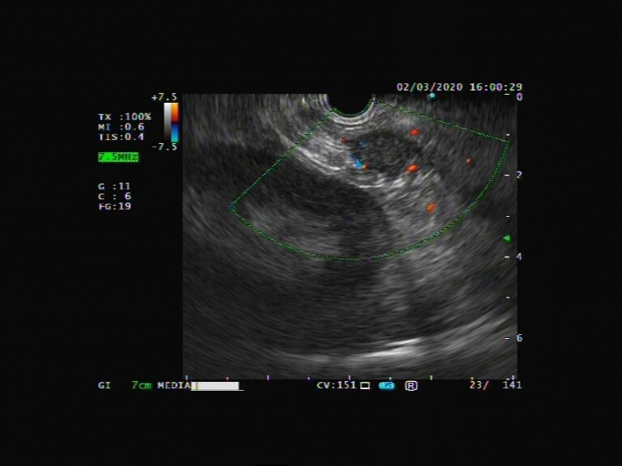
B
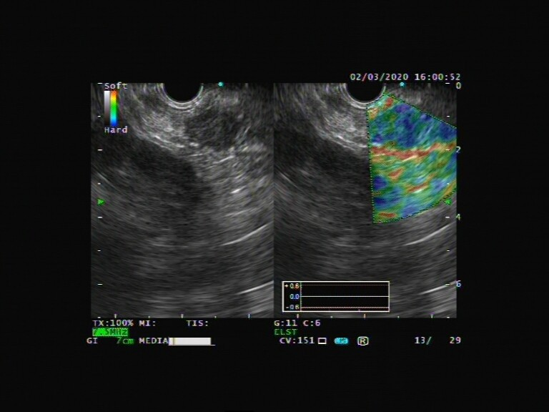
Figure 1 Endoscopic ultrasound images of the epithelioid angiomyolipoma. A: Endoscopic ultrasound showed a hypoechogenic mass in the tail of the pancreas, measuring 1.9 cm, without obvious blood flow on color doppler flow imaging; B: Elastography showed that the elastic properties of the mass were a little harder than the surrounding tissue.
A
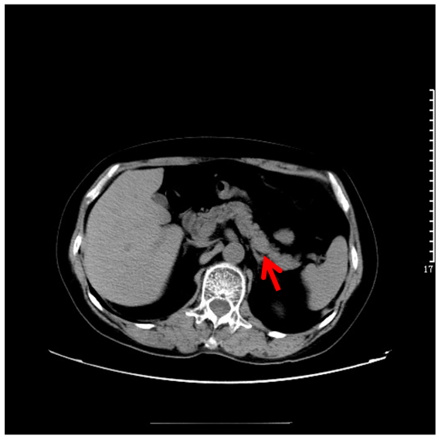
B
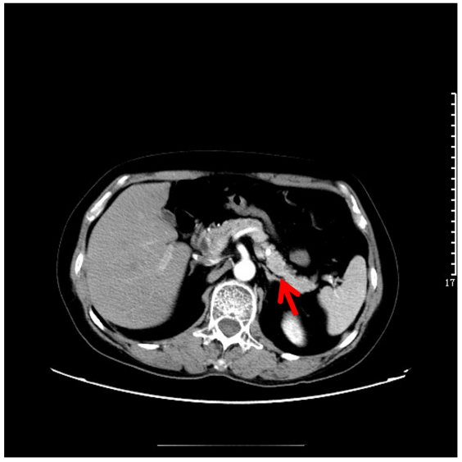
C
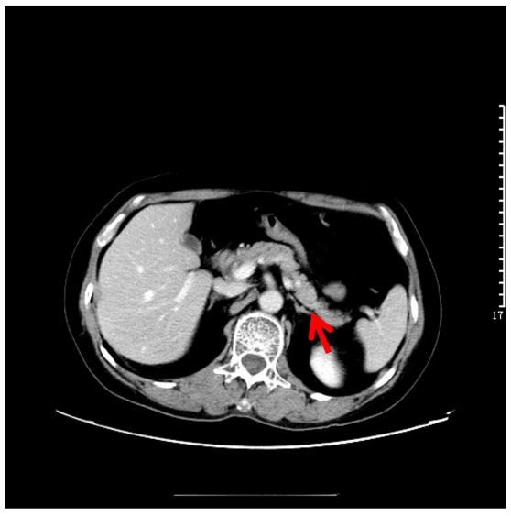
D
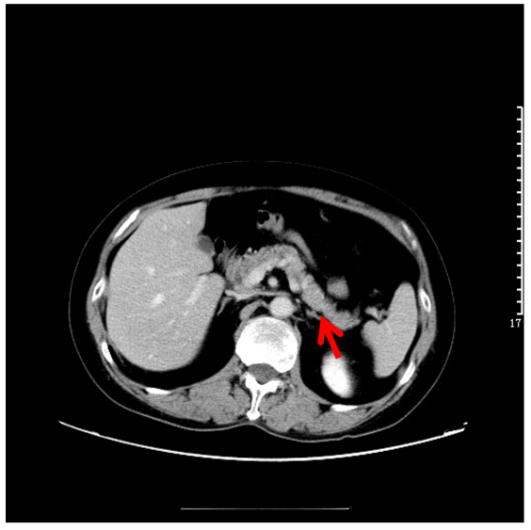
Figure 2 Contrast-enhanced computed tomography images of the epithelioid angiomyolipoma. A-D: Axial contrast-enhanced multidetector computed tomography scan series failed to demonstrate any mass.
A
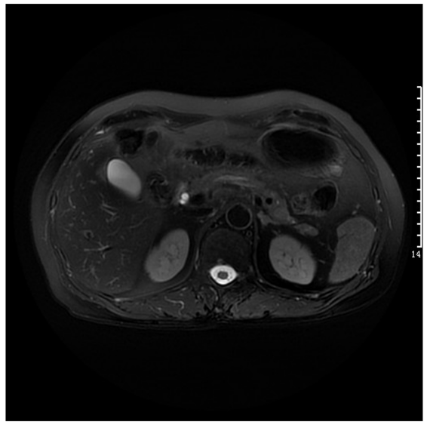
B
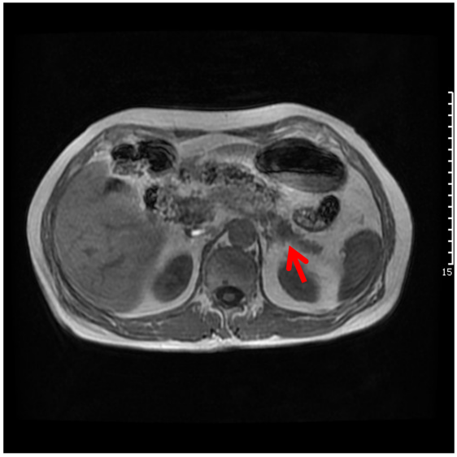
C
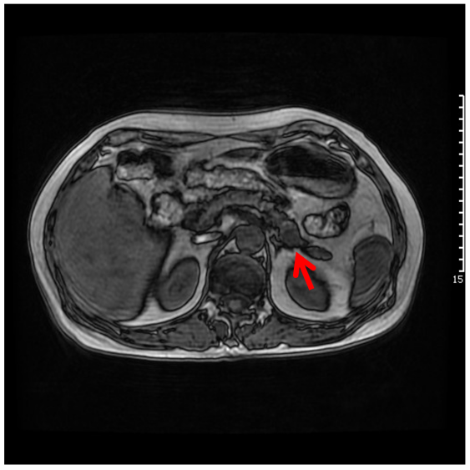
D
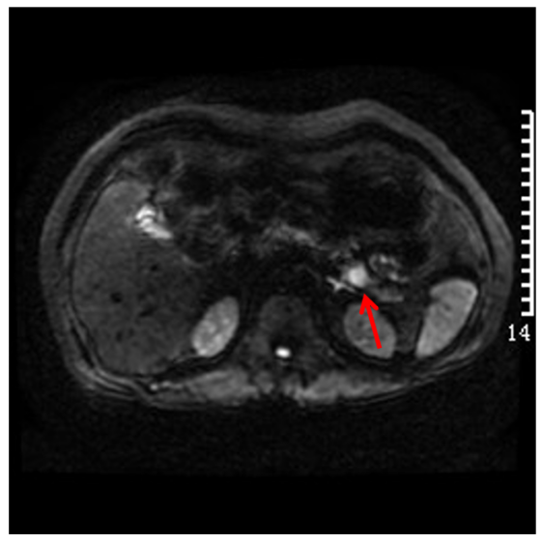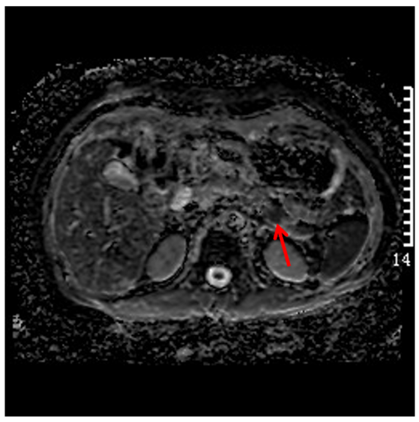
E
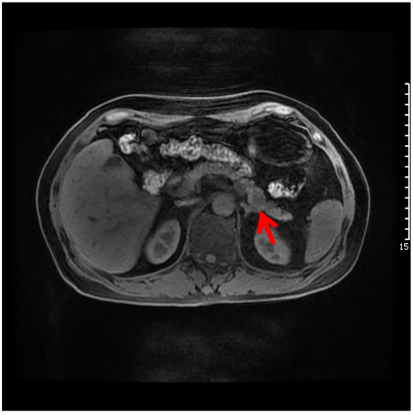
F
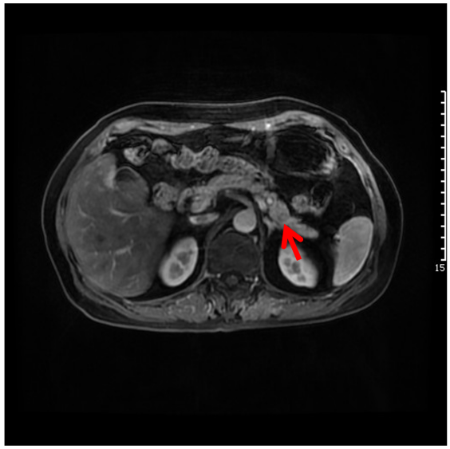
G
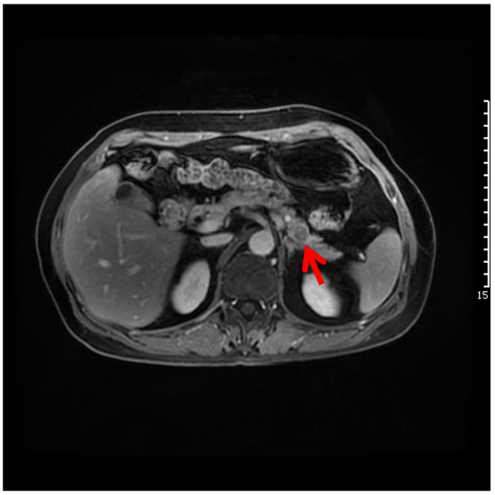
H
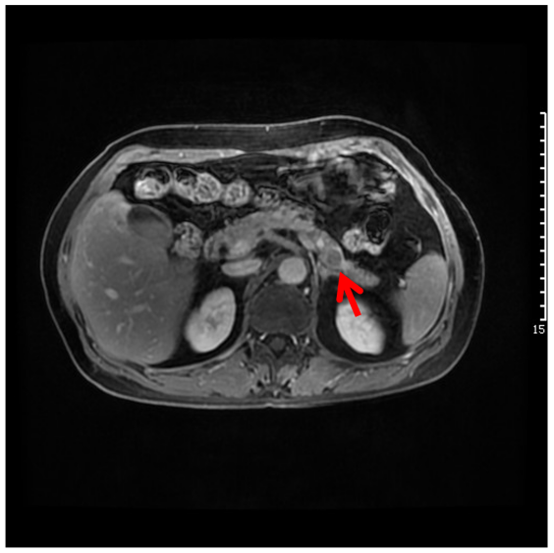
Figure 3 Gadolinium-enhanced magnetic resonance images of the epithelioid angiomyolipoma. A: Magnetic resonance (MR) imaging showed an isointensity to pancreatic parenchyma on fs-T2-weighted imaging; B and C: Axial T1-weighted in and out phase MR images, respectively, showing a slight loss of signal intensity (SI) related to microscopic lipid component; D: Diffusion-weighted image revealing a high SI area in the pancreas with corresponding low SI on the ADC map consistent with restricted diffusion; E-H: Axial T1-weighted fat saturated MR image before and after gadolinium administration, showing a mass with slightly intake of more contrast than surrounding pancreatic tissue, followed by rapid washout in the portal and delayed phases.
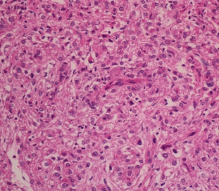
Figure 4 Photomicrograh (hematoxylin and eosin staining; magnification, × 200). Microscopically, the tumor was composed of large epithelioid cells, while adipose tissue was scarcely observed.
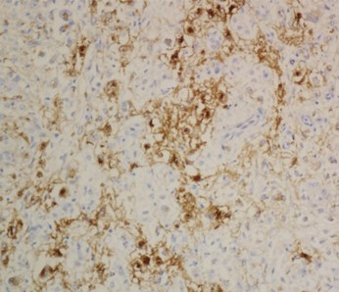
Figure 5 Immunohistochemical staining (magnification, × 200) demonstrated that the epithelioid cells and spindle smooth cells focally expressed human melanoma black-45.

