Name of Journal: World Journal of Gastrointestinal Surgery
Manuscript NO: 63135
Manuscript Type: ORIGINAL ARTICLE

Retrospective Study
Onodera’s Prognostic Nutritional Index is a novel and useful prognostic marker for gastrointestinal stromal tumors

Wang H et al. Prognostic marker for GISTs

Hao Wang, Ying-Ying Xu, Jun You, Wen-Qing Hu, Shao-Feng Wang, Ping Chen, Fan Yang, Lei Shi, Wei Zhao, Liang Zong

Hao Wang, Ping Chen, Lei Shi, Wei Zhao, Department of Gastrointestinal Surgery, Northern Jiangsu People’s Hospital, Clinical Medical College, Yangzhou University, Yangzhou 225001, Jiangsu Province, China

Ying-Ying Xu, Department of General Surgery, Yizheng People’s Hospital, Clinical Medical College, Yangzhou University, Yangzhou 211400, Jiangsu Province, China

Jun You, Department of Gastrointestinal Surgery, The First Affiliated Hospital of Xiamen University, Teaching Hospital of Fujian Medical University, Xiamen 361005, Fujian Province, China

Wen-Qing Hu, Liang Zong, Department of Gastrointestinal Surgery, Changzhi People’s Hospital, The Affiliated Hospital of Changzhi Medical College, Changzhi 046000, Shanxi Province, China

Shao-Feng Wang, Department of Digestive Internal Medicine, Changzhi People’s Hospital, The Affiliated Hospital of Changzhi Medical College, Changzhi 046000, Shanxi Province, China

Fan Yang, Department of Central Laboratory, Changzhi People’s Hospital, The Affiliated Hospital of Changzhi Medical College, Changzhi 046000, Shanxi Province, China

Author contributions: Xu YY, Wang H, and Zong L designed the research; Wang H, You J, Hu WQ, Wang SF, and Chen P performed the research; Shi L, Yang F, and Zhao W analyzed the data; Xu YY and Wang H wrote the paper and contributed equally to this study.

Supported by Health Commission of Shanxi Province, No. 2020130 and No. 2020TD27; and the Science and Technology Planning Project of Yangzhou City, No. YZ2018092.

Corresponding author: Liang Zong, MD, PhD, Professor, Research Associate, Department of Gastrointestinal Surgery, Changzhi People’s Hospital, The Affiliated Hospital of Changzhi Medical College, No. 502 Changxing Middle Road, Luzhou District, Changzhi 046000, Shanxi Province, China. 250537471@qq.com

Received: March 18, 2021
Revised: June 17, 2021
Accepted: August 13, 2021
Published online:

Abstract
BACKGROUND
Immunoinflammatory markers such as the peripheral blood neutrophil-to-lymphocyte ratio (NLR) and the platelet-to-lymphocyte ratio (PLR) have gained considerable attention as prognostic markers in gastrointestinal stromal tumors (GISTs).

AIM
To assess the prognostic value of Onodera’s Prognostic Nutritional Index (OPNI) for GISTs.

METHODS
All patients who had undergone surgical resection for a primary, localized GIST from 2009 to 2016 at our cancer center were initially and retrospectively identified. Recurrence-free survival (RFS) was calculated by the Kaplan-Meier method and compared by the log-rank test. We used univariate Cox proportional hazard regression models to identify associations with outcome variables.

RESULTS
A total of 235 GISTs were identified and included for analysis under our inclusion criteria. Univariate and multivariate analyses both identified the OPNI as an independent prognostic marker, and the OPNI was associated with the primary site, tumor size, mitotic index, tumor rupture, necrosis, and modified NIH risk classification. Low OPNI (< 51.30; hazard ratio = 5.852; 95% confidence interval: 1.072–31.964; P = 0.0414) was associated with worse RFS. The 2- and 5-year RFS rates of the patients with a low OPNI were 92.83% and 76.22%, respectively, whereas 100% and 98.41% were achieved by the patients with a high OPNI.

CONCLUSION
The preoperative OPNI is a novel and useful prognostic marker for GISTs.

Key Words: Gastrointestinal stromal tumor; Neutrophil-to-lymphocyte ratio; Platelet-to-lymphocyte ratio; Onodera’s Prognostic Nutritional Index; Prognostic marker

Wang H, Xu YY, You J, Hu WQ, Wang SF Chen P, Yang F, Shi L, Zhao W, Zong L. Onodera’s Prognostic Nutritional Index is a novel and useful prognostic marker for gastrointestinal stromal tumors. World J Gastrointest Surg 2021; In press

Core Tip: Immunoinflammatory markers such as the peripheral blood neutrophil-to-lymphocyte ratio and the platelet-to-lymphocyte ratio have gained considerable attention as prognostic markers in gastrointestinal stromal tumors (GISTs). Here we conducted the first investigation of the prognostic value of Onodera’s Prognostic Nutritional Index (OPNI) for GISTs. A total of 235 GISTs were identified and included for analysis under our inclusion criteria. Our study shown that the 2- and 5-year recurrence-free survival rates of the patients with a low OPNI were 92.83% and 76.22%, respectively, whereas 100% and 98.41% were achieved by the patients with a high OPNI, which demonstrated that the preoperative OPNI is a novel and useful prognostic marker for GISTs.
INTRODUCTION
Gastrointestinal stromal tumors (GISTs) are the most common mesenchymal neoplasms of the gastrointestinal (GI) tract; their estimated clinical incidence is nearly 1 per 100000 individuals per year^{[1,2]}. The driving force of GISTs is thought to be mutation in c-Kit and minimally in the PDGFRA oncogene (platelet derived growth factor receptor alpha)^{[3,4]}. GISTs can be malignant tumors arising anywhere in the GI tract or abdominal cavity^{[5]}. Surgery remains the standard treatment for primary GISTs, and it has been the only potentially curative therapy.
GIST relapse is common even when the tumor undergoes R0 resection. The disease-free survival (DFS) of patients with GISTs has been markedly improved by the use of the molecularly-specific oral anticancer agent imatinib mesylate (IM), but its adverse reaction and resistance have some hindrance in the treatment of GISTs. Systemic adjuvant IM therapy needs more assurance to be beneficial for target patients. The four most important prognostic factors for GISTs are the tumor location, tumor size, mitotic index, and presence/absence of tumor rupture as suggested by the U.S. famous institutes (NIH, AFIP)^{[6–8]}. Despite the use of these guidelines, even the latest risk stratification system should be improved^{[9–11]}.
One of the components of the tumor microenvironment is tumor-associated inflammatory cells. These cells have important roles in both tumor development and progression, which can promote the proliferation, invasion, and metastasis of tumor cells^{[12]}. Immunoinflammatory factors were shown to be associated with the oncogenesis, progression, and prognosis of GISTs. The peripheral blood neutrophil-to-lymphocyte ratio (NLR) and platelet-to-lymphocyte ratio (PLR; an easily measured, reproducible and cost-effective systemic inflammatory marker) have been investigated as prognostic markers in patients with multiple solid tumors such as non-small-cell lung cancer, colorectal cancer, and gastric cancer^{[13–15]}.
Onodera’s Prognostic Nutritional Index (OPNI) was useful for GI surgery patients to evaluate immune nutritional status^{[16]}. The OPNI has been reported to be a useful prognostic marker in esophageal cancer^{[17]}, gastric cancer^{[18]}, colorectal cancer^{[19]}, and pancreatic cancer^{[20]}, but the prognostic value of the OPNI for GISTs has not been determined. We conducted the present study to evaluate the prognostic value of the OPNI for GIST.

MATERIALS AND METHODS
Patients
We retrospectively retrieved the data of the patients with GISTs treated at Northern Jiangsu People’s Hospital (Yangzhou, China) from 2009 to 2016. The inclusion criteria were as follows: (1) R0 resection in GIST; (2) absence of coeval tumors; (3) no treatment or therapies (chemotherapy, radiotherapy, or imatinib); and (4) without signs of infection. A final total of 235 GISTs were included. This study was approved by the Ethics Committee of Northern Jiangsu People’s Hospital, and written informed consent for their data to be used was obtained from all the patients.

Preoperative peripheral blood routine tests and OPNI evaluation
All the patients’ preoperative peripheral blood routine tests had been performed within 7 d before surgery. The NLR value was calculated as the neutrophil count (10⁹/L) divided by the lymphocyte count (10⁹/L). The value of the PLR was calculated by the same method as the NLR. The OPNI was calculated as the serum albumin (g/L) + 5 × total lymphocyte count (10⁹/L).

Clinicopathological features
All specimens were diagnosed as GI mesenchymal (non-epithelial) tumors by hematoxylin and eosin (H&E) staining, and further confirmed by positive immunohistochemical staining for CD117 and discovered on GIST 1(DOG-1) with or without CD 34, desmin, SMA, and S-100 positive expression. If the result was negative for both staining, then c-Kit gene exons 9, 11, 13, and 17 or PDGFRA gene exons 12 and 18 were analyzed for DNA mutation.
We obtained the patients’ clinical data from their medical records: Age, gender, and basic clues like primary tumor location, tumor diameter, and rupture of tumor (preoperative/intraoperative). Pathologists measured tumor diameter before specimen fixation. The cell type, mitotic index, and necrosis of tumor were the histopathological markers for analysis. Tumor shape and size, mitotic index, tumor location, and rupture of tumor are four risk stratification factors. And the mitotic index was counted per 50 randomly selected high-power fields by two pathologists.

Follow-up
After their surgeries, the patients were followed by endoscopy and computed tomography examinations every 6 mo to evaluate the presence/absence of tumor recurrence and distant metastasis. We obtained the patients’ follow-up information from the hospital’s records and tumor registry, or by contacting directly with the patients or their family member.
Patients with GISTs can live with the tumor for a relatively long time even if they recur/metastasize. We speculated that the most suitable event for survival analysis was relapse or metastasis, and use of IM treatment for relapse and metastasis of GISTs can affect overall survival. We calculated the duration of a patient’s relapse free survival (RFS) from the surgery date for GIST, which was the study’s primary outcome. And the study’s secondary endpoints were receiver operator characteristic (ROC) analysis of NLR, PLR, OPNI, and Ki-67 index, and correlation between tumor size and NLR, PLR, OPNI, and Ki-67 index.

Statistical analysis
IBM SPSS Statistics were used to calculate all statistical analyses. Continuous variables are presented as the mean ± SD, and count data are summarized using frequencies and percentages. We calculated the correlation of continuous variables by obtaining the Pearson correlation coefficient, and we calculated the correlation of discrete variables by obtaining Spearman’s correlation coefficient. ROC analysis was used to determine the cut-off points of the NLR, PLR, OPNI, and Ki-67 index. Univariate analysis was performed using the Kaplan-Meier method, and the results were compared by the log-rank test. We conducted a multivariate analysis with the Cox proportional hazards model. A P-value < 0.05 was accepted as significant.

RESULTS
Clinicopathological parameters
The median age of the 235 patients (118 men and 117 women) was 62 years (range, 30–86 years), along with 125 patients (53%) aged more than 60 years. The basic symptoms of the GIST patients were abdominal discomfort/pain (n = 104), GI bleeding and obstruction (n = 63 and 8), rupture of tumor (n = 2), weight loss (n = 7), and being asymptomatic (n = 51). The GISTs can be found in the stomach (n = 183), small intestine (n = 41), colorectum (n = 10), and intraperitoneum with unknown etiology. The tumor sizes varied from 0.4 to 20 cm (median, 4.3 cm). Histologically, the spindle-cell type was most common (n = 206), followed by the epithelioid-cell type (n = 16) and the mixed type (n = 13). The mitotic index, necrosis, and more detailed clinicopathological variables are summarized in Table 1.

ROC analysis
We used the continuous variables of NLR, PLR, OPNI, and the Ki-67 index as test variables, and the RFS as the state variable. The areas under the ROC curves, cut-off points, sensitivities, specificities, and Youden indexes of the NLR, PLR, OPNI, and Ki-67 index are provided in Table 2 and Figure 1.

Correlation analyses
A lower OPNI was associated with the primary tumor location (P = 0.0004), tumor diameter (P < 0.0001), mitotic index (P < 0.0001), rupture of tumor (P = 0.0030), necrosis (P < 0.0001), and risk stratification by the modified NIH (P < 0.0001). A significant correlation was observed between the NLR and tumor size [Pearson correlation coefficient (r) = 0.2082, P = 0.0013]. Similarly, the PLR, OPNI, and Ki-67 index were each correlated strongly with tumor size (Table 3). There was a negative correlation between the OPNI and GIST tumor size, whereas the NLR, PLR, and Ki-67 index were positively correlated with GIST tumor size (Figure 2). Spearman’s correlation test revealed that the PLR (Rs =0.2045, P = 0.0016), OPNI (Rs = −3.048, P < 0.0001), and Ki-67 index (Rs =0.2551, P < 0.0001) were correlated with the mitotic index (Table 3). Correlation analysis of clinicopathologic parameters with OPNI, NLR, PLR, and Ki-67 index are shown in the Supplementary Tables 1-4, which showed no significance difference.

Follow-up
Patients were followed for a median of 35 mo (range 7–90 mo), and 9.79% (23/235) of the patients were lost to follow-up. The number of relapse patients was, including 5.96% (14/235) with local recurrence in the abdominopelvic cavity and 3.83% (9/235) with liver metastasis (n = 9), and lymph metastasis was not seen. The Kaplan-Meier 1-, 2-, and 5-year RFS rates were 99.15% (95%CI: 96.64–99.7), 96.61% (95%CI: 92.97–98.38), and 86.87% (95%CI: 78.73–92.04), respectively.

Univariate survival analysis
The results of our univariate survival analysis demonstrated that the primary site (log-rank P = 0.0093), tumor size (log-rank P = 0.0012), mitotic index (log-rank P < 0.0001), modified NIH risk stratification (log-rank P = 0.0007), NLR (log-rank P = 0.0224), PLR (log-rank P = 0.0069), and OPNI (log-rank P = 0.0002) were specific prognostic markers for RFS of our GIST patient series. The correlations of clinicopathological factors with the RFS are shown in Table 4 and Figure 3. The univariate survival analysis shows no significance association between recurrence and albumin and lymphocyte count. And the results of ROC analysis for albumin and lymphocyte count are shown in Supplementary Table 5.

Multivariate survival analysis
The collinearity diagnostics of all the explanatory variables was performed to exclude the internal correlation. We selected only the factors that showed a significant correlation with RFS in the univariate survival analysis for inclusion in the Cox proportional hazards model in entry strategies. The results of the study are listed in Table 5. The only significant independent negative prognostic indicators for RFS were high mitotic index (HR_{6–10/50 HPFs vs 5/50 HPFs} = 1.896, 95%CI: 0.518–6.949; HR_{> 10/50 HPFs vs 5/50 HPFs} = 6.791, 95%CI: 1.554–29.672; overall P = 0.0365) and low OPNI (HR = 5.852, 95%CI: 1.072–31.964; P = 0.0414) (Figure 4).

DISCUSSION
More precise risk classification criteria that can be used to predict the postoperative prognosis of patients with GIST - especially criteria that can be simply and feasibly measured and calculated by using clinicopathological data - have been required. Herein, we evaluated the prognostic value of the OPNI for patients with GISTs, and our analyses demonstrated that the OPNI was an independent prognostic marker that was associated with the GIST primary site, tumor size, mitotic index, tumor rupture, necrosis, and modified NIH risk classification in our patient series.
The AFIP criteria^{[7]} and the modified NIH consensus criteria^{[8]}, which encompass the four factors tumor diameter, mitotic index, location, and rupture of tumor, are the most widely used criteria to evaluate the post-surgery or intra-surgery risk in GIST cases, and the accuracy of these four factors is generally similar for prognosis. A nomogram that can be used to estimate the RFS at 2 and 5 years after surgery for a primary GIST was developed by the Memorial Sloan-Kettering Cancer Center sarcoma team^{[22]}. And more recently, a novel prognostic contour map was generated using the pooled data of 920 GIST patients who received no adjuvant therapy^{[21]}.
The OPNI, as a nutrition index, was initially established by Onodera and his colleagues in 1984. The OPNI has been used to divide patients with higher and lower OPNI values for prognostic evaluation, and it was reported that the prognoses of the patients with lower OPNI values were significantly worse than those of the patients with higher OPNI values^{[22]}. Similar results regarding gastric carcinoma have also been reported^{[23]}. In the present study, however, the cut-off value of the PNI was shown to be 51.30 in the ROC analysis. Our further analysis demonstrated that a lower OPNI was associated with the primary tumor site, tumor size, mitotic index, tumor rupture, necrosis, and the modified NIH risk classification. In the multivariate survival analysis, the OPNI was an independent prognostic indicator for GISTs.
A low OPNI may be the result of hypoproteinemia and/or lymphopenia, which can be explained by several potential phenomena: (1) The nutritional supplementation of branched-chain amino acids can improve a patient’s hypoproteinemia and reduce tumor recurrence^{[24]}; and (2) lymphocytes have an important role in the host immune response, counteracting tumor formation and progression^{[25]}.
Because OPNI consists of albumin and lymphocyte count levels, low OPNI means hypoalbuminemia and lymphocytopenia, which may contribute to tumor development and progression^{[24]}. Lower albumin levels in patients with lower OPNI reflect malnutrition and impaired protein synthesis ability especially those with large tumor size and high mitotic index. Lymphocytes have an important role in the host immune response, counteracting tumor formation and progression^{[25]}. The present study also examined lymphocyte-related markers, such as NLR and PLR, but these markers were not identified as independent prognostic factors in the multivariate analysis. OPNI predicted the prognosis of GIST patients more precisely than NLR and PLR because the OPNI contains albumin and lymphocyte levels as nutritional and immune factors.
Our study has several limitations to address. This was a single-center retrospective study, and a multicenter study is needed to expand the sample size to compensate for this deficiency. The best cut-off value was determined by the highest Youden index by plotting the ROC curve, but it is still unclear what cut-off value is the best for the clinical diagnosis of GISTs. An exploration of the best cut-off value and studies of its intrinsic molecular mechanism are future research topics.

CONCLUSION
In conclusion, our analyses demonstrated an association between immunoinflammatory and nutritional factors and the recurrence-free survival and clinicopathological features of patients with primary GISTs. The OPNI was shown to be an independent indicator for progression-free survival in GISTs, and it may be a valuable parameter for predicting a tumor’s biological behavior using peripheral blood samples.

ARTICLE HIGHLIGHTS
Research background
Prognostic markers have gained considerable attention in gastrointestinal stromal tumors (GISTs).

Research motivation
To improve the prognostic prediction of GISTs, we designed this study.

Research objectives
We conducted the first investigation of the prognostic value of Onodera’s Prognostic Nutritional Index (OPNI) for GISTs.

Research methods
In this study, the recurrence-free survival, and the receiver operator characteristic analysis of neutrophil-to-lymphocyte ratio (NLR) and the platelet-to-lymphocyte ratio (PLR), OPNI, and Ki-67 index, and the correlation between tumor size and NLR, PLR, OPNI and Ki-67 index were detected.

Research results
Univariate and multivariate analyses both identified the OPNI as an independent prognostic marker.

Research conclusions
The preoperative OPNI could be a prognostic marker for GISTs.

Research perspectives
We hope that we could find a valuable parameter for predicting the prognosis of GISTs using peripheral blood samples.

REFERENCES
1 Steigen SE, Eide TJ. Trends in incidence and survival of mesenchymal neoplasm of the digestive tract within a defined population of northern Norway. APMIS 2006; 114: 192-200 [PMID: 16643186 DOI: 10.1111/j.1600-0463.2006.apm_261.x]
2 Nishida T, Goto O, Raut CP, Yahagi N. Diagnostic and treatment strategy for small gastrointestinal stromal tumors. Cancer 2016; 122: 3110-3118 [PMID: 27478963 DOI: 10.1002/cncr.30239]
3 Hirota S, Isozaki K, Moriyama Y, Hashimoto K, Nishida T, Ishiguro S, Kawano K, Hanada M, Kurata A, Takeda M, Muhammad Tunio G, Matsuzawa Y, Kanakura Y, Shinomura Y, Kitamura Y. Gain-of-function mutations of c-kit in human gastrointestinal stromal tumors. Science 1998; 279: 577-580 [PMID: 9438854 DOI: 10.1126/science.279.5350.577]
4 Heinrich MC, Corless CL, Duensing A, McGreevey L, Chen CJ, Joseph N, Singer S, Griffith DJ, Haley A, Town A, Demetri GD, Fletcher CD, Fletcher JA. PDGFRA activating mutations in gastrointestinal stromal tumors. Science 2003; 299: 708-710 [PMID: 12522257 DOI: 10.1126/science.1079666]
5 Joensuu H, Hohenberger P, Corless CL. Gastrointestinal stromal tumour. Lancet 2013; 382: 973-983 [PMID: 23623056 DOI: 10.1016/S0140-6736(13)60106-3]
6 Fletcher CD, Berman JJ, Corless C, Gorstein F, Lasota J, Longley BJ, Miettinen M, O’Leary TJ, Remotti H, Rubin BP, Shmookler B, Sobin LH, Weiss SW. Diagnosis of gastrointestinal stromal tumors: A consensus approach. Hum Pathol 2002; 33: 459-465 [PMID: 12094370 DOI: 10.1053/hupa.2002.123545]
7 Miettinen M, Lasota J. Gastrointestinal stromal tumors: pathology and prognosis at different sites. Semin Diagn Pathol 2006; 23: 70-83 [PMID: 17193820 DOI: 10.1053/j.semdp.2006.09.001]
8 Joensuu H. Risk stratification of patients diagnosed with gastrointestinal stromal tumor. Hum Pathol 2008; 39: 1411-1419 [PMID: 18774375 DOI: 10.1016/j.humpath.2008.06.025]
9 Zhou Y, Hu W, Chen P, Abe M, Shi L, Tan SY, Li Y, Zong L. Ki67 is a biological marker of malignant risk of gastrointestinal stromal tumors: A systematic review and meta-analysis. Medicine (Baltimore) 2017; 96: e7911 [PMID: 28834915 DOI: 10.1097/MD.0000000000007911]
10 Zong L, Chen P, Jiang J, Wang L, Li QG. Predictive value of p53 expression in the risk of malignant gastrointestinal stromal tumors: Evidence from 19 studies. Exp Ther Med 2012; 3: 87-92 [PMID: 22969850 DOI: 10.3892/etm.2011.369]
11 Zong L, Chen P, Jiang J, Wang H, Wang L. Correlation between p16 expression and malignant risk of gastrointestinal stromal tumor: evidence from nine studies. Hepatogastroenterology 2012; 59: 1458-1463 [PMID: 22094995 DOI: 10.5754/hge11473]
12 Mantovani A, Allavena P, Sica A, Balkwill F. Cancer-related inflammation. Nature 2008; 454: 436-444 [PMID: 18650914 DOI: 10.1038/nature07205]
13 Yamanaka T, Matsumoto S, Teramukai S, Ishiwata R, Nagai Y, Fukushima M. The baseline ratio of neutrophils to lymphocytes is associated with patient prognosis in advanced gastric cancer. Oncology 2007; 73: 215-220 [PMID: 18424885 DOI: 10.1159/000127412]
14 Ying HQ, Deng QW, He BS, Pan YQ, Wang F, Sun HL, Chen J, Liu X, Wang SK. The prognostic value of preoperative NLR, d-NLR, PLR and LMR for predicting clinical outcome in surgical colorectal cancer patients. Med Oncol 2014; 31: 305 [PMID: 25355641 DOI: 10.1007/s12032-014-0305-0]
15 Sarraf KM, Belcher E, Raevsky E, Nicholson AG, Goldstraw P, Lim E. Neutrophil/lymphocyte ratio and its association with survival after complete resection in non-small cell lung cancer. J Thorac Cardiovasc Surg 2009; 137: 425-428 [PMID: 19185164 DOI: 10.1016/j.jtcvs.2008.05.046]
16 Onodera T, Goseki N, Kosaki G. [Prognostic nutritional index in gastrointestinal surgery of malnourished cancer patients]. Nihon Geka Gakkai Zasshi 1984; 85: 1001-1005 [PMID: 6438478]
17 Nozoe T, Kimura Y, Ishida M, Saeki H, Korenaga D, Sugimachi K. Correlation of pre-operative nutritional condition with post-operative complications in surgical treatment for oesophageal carcinoma. Eur J Surg Oncol 2002; 28: 396-400 [PMID: 12099649 DOI: 10.1053/ejso.2002.1257]
18 Migita K, Takayama T, Saeki K, Matsumoto S, Wakatsuki K, Enomoto K, Tanaka T, Ito M, Kurumatani N, Nakajima Y. The prognostic nutritional index predicts long-term outcomes of gastric cancer patients independent of tumor stage. Ann Surg Oncol 2013; 20: 2647-2654 [PMID: 23463091 DOI: 10.1245/s10434-013-2926-5]
19 Nozoe T, Kohno M, Iguchi T, Mori E, Maeda T, Matsukuma A, Ezaki T. The prognostic nutritional index can be a prognostic indicator in colorectal carcinoma. Surg Today 2012; 42: 532-535 [PMID: 22139087 DOI: 10.1007/s00595-011-0061-0]
20 Hubbard TJ, Lawson-McLean A, Fearon KC. Nutritional predictors of postoperative outcome in pancreatic cancer (Br J Surg 2011; 98: 268-274). Br J Surg 2011; 98: 1032; author reply 1032-1032; author reply 1033 [PMID: 21618489 DOI: 10.1002/bjs.7608]
21 Joensuu H, Vehtari A, Riihimäki J, Nishida T, Steigen SE, Brabec P, Plank L, Nilsson B, Cirilli C, Braconi C, Bordoni A, Magnusson MK, Linke Z, Sufliarsky J, Federico M, Jonasson JG, Dei Tos AP, Rutkowski P. Risk of recurrence of gastrointestinal stromal tumour after surgery: an analysis of pooled population-based cohorts. Lancet Oncol 2012; 13: 265-274 [PMID: 22153892 DOI: 10.1016/S1470-2045(11)70299-6]
22 Gold JS, Gönen M, Gutiérrez A, Broto JM, García-del-Muro X, Smyrk TC, Maki RG, Singer S, Brennan MF, Antonescu CR, Donohue JH, DeMatteo RP. Development and validation of a prognostic nomogram for recurrence-free survival after complete surgical resection of localised primary gastrointestinal stromal tumour: a retrospective analysis. Lancet Oncol 2009; 10: 1045-1052 [PMID: 19793678 DOI: 10.1016/S1470-2045(09)70242-6]
23 Nozoe T, Ninomiya M, Maeda T, Matsukuma A, Nakashima H, Ezaki T. Prognostic nutritional index: a tool to predict the biological aggressiveness of gastric carcinoma. Surg Today 2010; 40: 440-443 [PMID: 20425547 DOI: 10.1007/s00595-009-4065-y]
24 Nishikawa H, Osaki Y. Clinical significance of therapy using branched-chain amino acid granules in patients with liver cirrhosis and hepatocellular carcinoma. Hepatol Res 2014; 44: 149-158 [PMID: 23819582 DOI: 10.1111/hepr.12194]
25 Hanahan D, Weinberg RA. Hallmarks of cancer: the next generation. Cell 2011; 144: 646-674 [PMID: 21376230 DOI: 10.1016/j.cell.2011.02.013]

Footnotes
Institutional review board statement: This study was approved by the Ethics Committee of Northern Jiangsu People’s Hospital.

Informed consent statement: All study participants, or their legal guardian, provided informed written consent prior to study enrollment.

Conflict-of-interest statement: We have no financial relationships to disclose.

Data sharing statement: No additional data are available.

Open-Access: This article is an open-access article that was selected by an in-house editor and fully peer-reviewed by external reviewers. It is distributed in accordance with the Creative Commons Attribution NonCommercial (CC BY-NC 4.0) license, which permits others to distribute, remix, adapt, build upon this work non-commercially, and license their derivative works on different terms, provided the original work is properly cited and the use is non-commercial. See: http://creativecommons.org/Licenses/by-nc/4.0/

Manuscript source: Unsolicited manuscript

Peer-review started: March 18, 2021
First decision: June 3, 2021
Article in press:

Specialty type: Gastroenterology and hepatology
Country/Territory of origin: China
Peer-review report’s scientific quality classification
Grade A (Excellent): 0
Grade B (Very good): B
Grade C (Good): 0
Grade D (Fair): D
Grade E (Poor): 0

P-Reviewer: Palacios Huatuco RM, Takata T S-Editor: Wang JL L-Editor: Wang TQ P-Editor:

Figure Legends

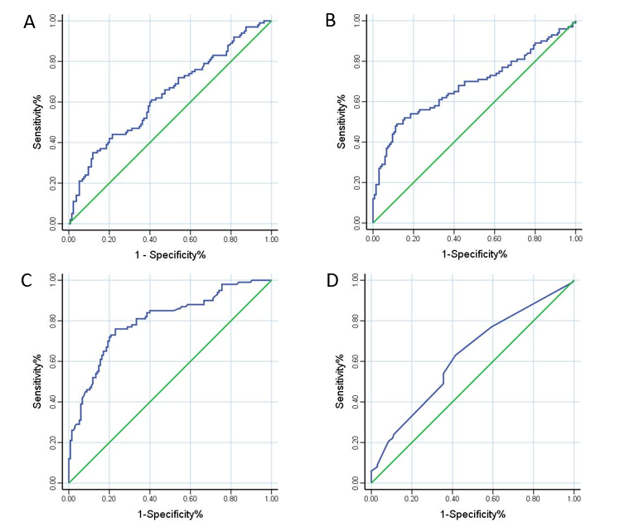
Figure 1 Receiver operator characteristic analysis of the neutrophil-to-lymphocyte ratio, platelet-to-lymphocyte ratio, Onodera’s Prognostic Nutritional Index, and Ki-67 index. A: Neutrophil-to-lymphocyte ratio; B: Platelet-to-lymphocyte ratio; C: Onodera’s Prognostic Nutritional Index; D: Ki-67 index.

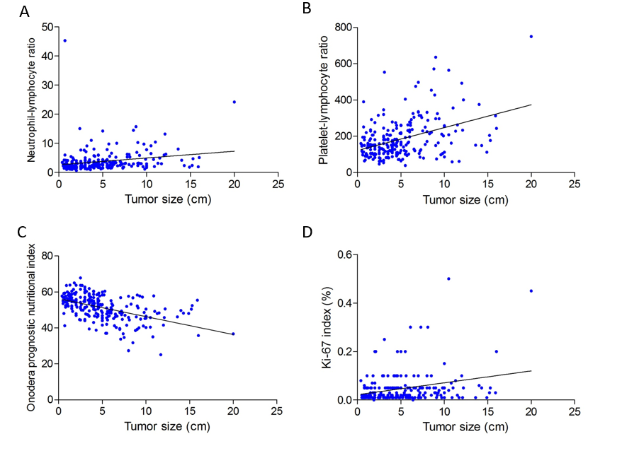
Figure 2 Correlation between gastrointestinal stromal gastrointestinal stromal tumor size and neutrophil-to-lymphocyte ratio, platelet-to-lymphocyte ratio, Onodera’s Prognostic Nutritional Index, and Ki-67 index. A: Neutrophil-to-lymphocyte ratio; B: Platelet-to-lymphocyte ratio; C: Onodera’s Prognostic Nutritional Index; D: Ki-67 index.

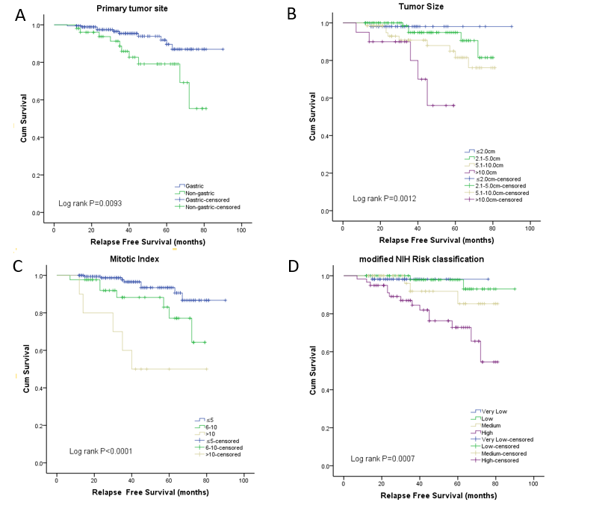
Figure 3 Recurrence-free survival analysis of 235 patients with primary gastrointestinal stromal tumors. The Kaplan-Meier curve analysis demonstrated worse recurrence-free survival rates for the patients presenting with (A) non-gastric origin, (B) larger tumor size, (C) higher mitotic index, or (D) high modified NIH risk.

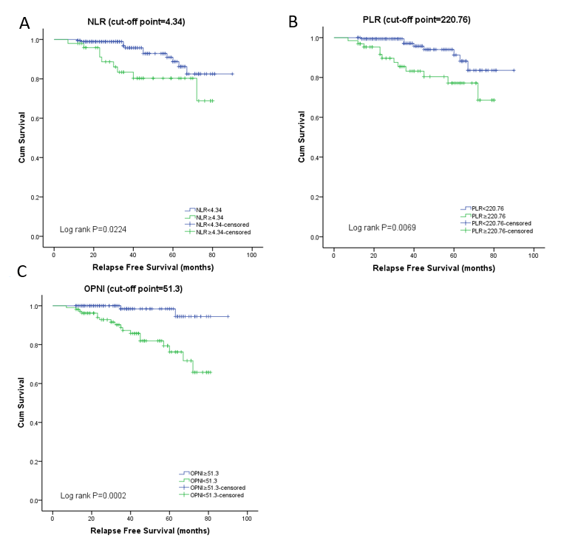
Figure 4 Recurrence-free survival analysis of 235 patients with primary gastrointestinal stromal tumors. The Kaplan-Meier curve analysis demonstrated worse recurrence-free survival rates for the patients presenting with (A) a higher neutrophil-to-lymphocyte ratio, (B) higher platelet-to-lymphocyte ratio, or (C) lower Onodera’s Prognostic Nutritional Index. NLR: Neutrophil-to-lymphocyte ratio; PLR: Platelet-to-lymphocyte ratio; OPNI: Onodera’s Prognostic Nutritional Index.
Table 1 Clinicopathological features of 235 patients with primary gastrointestinal stromal tumors
Characteristic | n (%)
Gender
Male | 118 (50.2)
Female | 117 (49.8)
Age (yr, mean ± SD) | 60.09 ± 10.12
≤ 60 | 110 (46.8)
> 60 | 125 (53.2)
Clinical manifestation
Abdominal discomfort or pain | 104 (44.3)
Gastrointestinal bleeding | 63 (26.8)
Obstruction | 8 (3.4)
Perforation or rupture | 2 (0.9)
Weight loss | 7 (3.0)
Asymptomatic | 51 (21.7)
Preoperative laboratory variables
Hemoglobin (g/L, mean ± SD) | 122.69 ± 29.94
White blood cell (10⁹ /L, mean ± SD) | 6.52 ± 2.70
Neutrophil count (10⁹ /L, mean ± SD) | 4.40 ± 2.35
Lymphocyte count (10⁹ /L, mean ± SD) | 1.42 ± 0.53
Platelet count (10⁹ /L, mean ± SD) | 230.11 ± 100.76
Albumin (g/L, mean ± SD) | 44.19 ± 6.66
NLR (mean ± SD) | 3.80 ± 3.95
PLR (mean ± SD) | 184.83 ± 109.06
OPNI (mean ± SD) | 51.27 ± 7.12
Primary tumor site
Stomach | 183 (77.9)
Small intestine | 41 (17.4)
Colorectum | 10 (4.3)
Intraperitoneally with unknown origin | 1 (0.4)
Tumor size (cm, mean ± SD) | 5.003 ± 3.5458
≤ 2.0 | 55 (23.4)
2.1-5.0 | 93 (39.6)
5.1-10.0 | 67 (28.5)
> 10.0 | 20 (8.5)
Predominant cell type
Spindle | 206 (87.7)
Epithelioid | 16 (6.8)
Mixed | 13 (5.5)
Mitotic index (per 50 HPFs)
≤ 5 | 182 (77.4)
6-10 | 43 (18.3)
> 10 | 10 (4.3)
Necrosis
Yes | 66 (28.1)
No | 169 (71.9)
Tumor rupture
Yes | 11 (4.7)
No | 224 (95.3)
Risk classification
Very low risk | 58 (24.7)
Low risk | 77 (32.8)
Intermediate risk | 41 (17.4)
High risk | 59 (25.1)
CD117
(–) | 4 (1.7)
(+) | 169 (71.9)
(++) | 18 (7.7)
(+++) | 44 (18.7)
CD34
(–) | 11 (4.7)
(+) | 165 (70.2)
(++) | 12 (5.1)
(+++) | 47 (20.0)
DOG-1
(–) | 3 (1.3)
(+) | 211 (89.8)
(++) | 12 (5.1)
(+++) | 9 (3.8)
Ki-67 index (%, mean ± SD) | 4.65 ± 6.37
Follow-up time (months, mean ± SD) | 40.20 ± 20.18
Follow-up status
Relapse-free survival | 215 (91.5)
Relapse | 15 (6.4)
Metastasis | 5 (2.1)
NLR: Neutrophil-to-lymphocyte ratio; PLR: Platelet-to-lymphocyte ratio; OPNI: Onodera’s Prognostic Nutritional Index.

Table 2 Receiver operator characteristic analyses for neutrophil-to-lymphocyte ratio, platelet-to-lymphocyte ratio, Onodera’s Prognostic Nutritional Index, and ki-67 index
 | NLR | PLR | OPNI | Ki-67 index
Cut-off point | 4.34 | 220.76 | 51.30 | 2.5%
Sensitivity% (95%CI) | 35.00 (25.73-45.19) | 49.00 (38.86-59.20) | 76.00 (66.43-83.98) | 63.00 (52.76-72.44)
Specificity% (95%CI) | 88.15 (81.47-93.07) | 88.15 (81.47-93.07) | 77.04 (69.02-83.83) | 58.52 (49.73-66.93)
Youden Index | 0.2315 | 0.3715 | 0.5304 | 0.2152
AUC (95%CI) | 0.6308 (0.5584-0.7031) | 0.6820 (0.6096-0.7545) | 0.7999 (0.7420-0.8578) | 0.6237 (0.5514-0.6960)
P value | 0.0006 | < 0.0001 | < 0.0001 | 0.0012
NLR: Neutrophil-to-lymphocyte ratio; PLR: Platelet-to-lymphocyte ratio; OPNI: Onodera’s Prognostic Nutritional Index; AUC: Area under the curve.
Table 3 Correlation analysis of tumor size and mitotic index with neutrophil-to-lymphocyte ratio, platelet-to-lymphocyte ratio, Onodera’s Prognostic Nutritional Index, and ki-67 index
 | Tumor size |  | Mitotic index
 | Pearson r | P value | R_{s} | P value
NLR | 0.2082 | 0.0013 | 0.1021 | 0.1185
PLR | 0.4098 | < 0.0001 | 0.2045 | 0.0016
OPNI | -0.4955 | < 0.0001 | -3.048 | < 0.0001
Ki-67 index | 0.2727 | < 0.0001 | 0.2551 | < 0.0001
NLR: Neutrophil-to-lymphocyte ratio; PLR: Platelet-to-lymphocyte ratio; OPNI: Onodera’s Prognostic Nutritional Index.
Table 4 Univariate analysis (Kaplan-Meier) of factors for recurrence-free survival in gastrointestinal stromal tumors
Factor | 1-year RFS rate (95%CI) | 2-year RFS rate (95%CI) | 5-year RFS rate (95%CI) | Log-rank P value
Age (yr) |  |  |  | 0.5441
≤ 60 | 99.09% (93.72-99.87) | 96.92% (90.66-99.01) | 91.20% (80.62-96.14)
> 60 | 99.20% (94.46-99.89) | 96.35% (90.49-98.62) | 82.93% (69.26-90.91)
Gender |  |  |  | 0.2889
Male | 98.31% (93.39-99.57) | 95.19% (88.74-97.99) | 84.07% (71.68-91.35)
Female | 100% | 98.03% (92.30-99.51) | 84.96% (66.88-93.61)
GI bleeding |  |  |  | 0.1877
Yes | 98.41% (89.26-99.77) | 98.41% (89.26-99.77) | 82.02% (63.00-91.85)
No | 99.42% (95.94-99.92) | 95.84% (90.90-98.12) | 89.37% (80.44-94.36)
Primary site |  |  |  | 0.0093
Gastric | 99.45% (96.18-99.92) | 97.47% (93.30-99.04) | 89.62% (79.32-94.94)
Non-gastric | 98.08% (87.12-99.73) | 93.75% (81.78-97.95) | 79.12% (61.86-89.21)
Tumor size |  |  |  | 0.0012
≤ 2.0 cm | 100% | 98.10% (87.12-99.73) | 98.10% (87.12-99.73)
2.1-5.0 cm | 100% | 100% | 94.90% (84.98-98.33)
5.1-10.0 cm | 98.51% (89.87-99.79) | 92.93% (82.17-97.30) | 81.55% (65.45-90.65)
> 10.0 cm | 95.00% (69.46-99.28) | 90.00% (65.59-97.40) | 56.00% (20.71-80.77)
Predominant cell type |  |  |  | 0.7759
Spindle | 99.51 % (96.60-99.93) | 97.22 % (93.41-98.84) | 88.47 % (79.83-93.55)
Epithelioid | 93.75 % (63.22-99.10) | 93.75 % (63.22-99.10) | 84.38 % (49.30-96.00)
Mixed | 100% | 100% | 76.39 % (30.91-94.01)
Mitotic index |  |  |  | < 0.0001
≤ 5 per 50 HPFs | 100% | 98.67% (94.75-99.67) | 93.47% (85.43-97.15)
6-10 per 50 HPFs | 97.67% (84.61-99.67) | 91.93% (76.88-97.34) | 77.13% (53.86-89.67)
>10 per 50 HPFs | 100% | 80.00% (40.86-94.59) | 50.00% (18.35-75.32)
Necrosis |  |  |  | 0.2676
Yes | 98.48% (89.72-99.79) | 98.48% (89.72-99.79) | 83.69% (66.12-92.63)
No | 100% | 95.79% (90.79-98.10) | 89.58% (81.22-94.34)
Tumor rupture |  |  |  | 0.0695
Yes | 100% | 100% | 63.49% (23.81-86.61)
No | 99.11% (96.48-99.78) | 96.43% (92.62-98.29) | 88.40% (79.94-93.44)
Risk classification |  |  |  | 0.0007
Very low risk | 100% | 98.18% (87.78-99.74) | 98.18% (87.78-99.74)
Low risk | 100% | 100% | 97.92% (86.11-99.70)
Intermediate risk | 100% | 100% | 85.27% (59.66-95.20)
High risk | 96.61% (87.11-99.14) | 89.10% (77.27-94.97) | 72.82% (56.21-83.98)
NLR |  |  |  | 0.0224
< 4.34 | 99.46% (96.22-99.92) | 98.89% (95.65-99.72) | 88.76% (78.31-94.35)
≥ 4.34 | 98.00% (86.63-99.72) | 88.68% (74.82-95.15) | 80.29% (64.11-89.73)
PLR |  |  |  | 0.0069
< 220.76 | 100% | 99.39% (95.75-99.91) | 91.24% (80.00-96.31)
≥ 220.76 | 96.92% (88.25-99.22) | 89.64% (78.27-95.23) | 77.17% (61.76-86.99)
OPNI |  |  |  | 0.0002
≥ 51.30 | 100% | 100% | 98.41% (89.26-99.77)
< 51.30 | 98.13% (92.73-99.53) | 92.83% (85.49-96.53) | 76.22% (62.51-85.48)
Ki-67 index |  |  |  | 0.0592
< 2.5% | 100% | 98.88% (92.29-99.84) | 88.03% (68.96-95.72)
≥ 2.5% | 98.29% (93.34-99.57) | 94.34% (87.79-97.43) | 84.39% (74.22-90.79)
Albumin |  |  |  | 0.0589
< 38.95 | 99.86% (96.42-99.91) | 98.79% (96.65-98.72) | 89.74% (76.31-93.35)
≥ 38.95 | 99.01% (89.63-99.82) | 90.68% (86.52-96.45) | 87.23% (75.11-89.63)
Lymphocyte count |  |  |  | 0.0524
< 0.975 | 99.46% (96.22-99.82) | 96.89% (95.15-99.02) | 88.76% (78.11-94.05)
≥ 0.975 | 98.70% (89.93-99.62) | 90.68% (86.82-95.15) | 87.29% (74.11-93.53)
GI: Gastrointestinal; RFS: Recurrence-free survival; NLR: Neutrophil-to-lymphocyte ratio; PLR: Platelet-to-lymphocyte ratio; OPNI: Onodera’s Prognostic Nutritional Index.
Table 5 Multivariate analysis [Cox regression analysis (Enter method)] for recurrence-free survival

Factor | Hazard ratio | 95%CI | P value
Primary tumor site |  |  | 0.0878
Gastric | 1.000 | - | -
Non-gastric | 2.641 | 0.866-8.053 | -
Tumor size (cm) |  |  | 0.4749
≤ 2.0 | 1.000 | - | -
2.1-5.0 | 1.318 | 0.006-292.720 | 0.9201
5.1-10.0 | 1.612 | 0.006-445.888 | 0.8678
> 10.0 | 4.765 | 0.015-1515.961 | 0.5953
Mitotic index (/50 HPFs) |  |  | 0.0365¹
≤ 5 | 1.000 | - | -
6-10 | 1.896 | 0.518-6.949 | 0.3341
>10 | 6.791 | 1.554-29.672 | 0.0109¹
Tumor rupture |  |  | 0.5202
No | 1.000 | - | -
Yes | 0.589 | 0.117-2.957 | -
NIH risk classification |  |  | 0.9763
Very low risk | 1.000 | - | -
Low risk | 0.283 | 0.001-64.779 | 0.6491
Intermediate risk | 0.282 | 0.001-91.515 | 0.6681
High risk | 0.277 | 0.001-101.508 | 0.6702
NLR |  |  | 0.7613
<4.34 | 1.000 | - | -
≥ 4.34 | 0.838 | 0.268-2.620 | -
PLR |  |  | 0.6958
< 220.76 | 1.000 | - | -
≥ 220.76 | 1.259 | 0.397-3.995 | -
OPNI |  |  | 0.0414¹
≥ 51.30 | 1.000 | - | -
< 51.30 | 5.852 | 1.072-31.964 | -
¹With statistical significance. NLR: Neutrophil-to-lymphocyte ratio; PLR: Platelet-to-lymphocyte ratio; OPNI: Onodera’s Prognostic Nutritional Index.

