Name of Journal: World Journal of Gastrointestinal Surgery
Manuscript NO: 76674
Manuscript Type: ORIGINAL ARTICLE

Retrospective Study
Individualized risk estimation for postoperative pulmonary complications after hepatectomy based on perioperative variables

Xu LN et al. Prediction of PPCs in liver surgery

Li-Ning Xu, Ying-Ying Xu, Gui-Ping Li, Bo Yang

Li-Ning Xu, Department of General Surgery, The Second Medical Center and National Clinical Research Center for Geriatric Diseases, Chinese PLA General Hospital, Beijing 100853, China

Ying-Ying Xu, Department of Internal Medicine, Henan Cancer Hospital, Zhengzhou 450003, Henan Province, China

Gui-Ping Li, Department of Radiology, Hubei Province Integrated Hospital of Chinese and Western Medicine, Wuhan 430015, Hubei Province, China

Bo Yang, Department of Radiology, Affiliated Union Hospital, Tongji Medical College, Huazhong University of Science and Technology, Wuhan 430022, Hubei Province, China

Author contributions: Xu LN, Xu YY and Li GP contributed equally to this work; Xu LN and Xu YY were the gastroenterologists; Li GP and Yang B performed the radiological diagnosis; Xu LN and Yang B analyzed the data and wrote the manuscript; Xu LN, Xu YY, Li GP and Yang B designed the research, performed the primary literature and data extraction, they were responsible for revising the manuscript for important intellectual content; and all authors read and approved the final version.

Corresponding author: Bo Yang, Doctor, Chief Doctor, Department of Radiology, Affiliated Union Hospital, Tongji Medical College, Huazhong University of Science and Technology, No. 1277 Jiefang Avenue, Wuhan 430022, Hubei Province, China. yangbo010027@163.com

Received: March 25, 2022
Revised: June 5, 2022
Accepted: July 5, 2022
Published online:

Abstract
BACKGROUND
At present, there is no perfect system to evaluate pulmonary complications of liver surgery using perioperative variables.

AIM
To design and verify a risk assessment system for predicting postoperative pulmonary complications (PPCs) after hepatectomy based on perioperative variables.

METHODS
A retrospective analysis was performed on 1633 patients who underwent liver surgery. The variables were screened using univariate and multivariate analyses, and graded scores were assigned to the selected variables. Logistic regression was used to develop the liver operation pulmonary complication scoring system (LOPCSS) for the prediction of PPCs. The LOPCSS was verified using the receiver operating characteristic curve.

RESULTS
According to the multivariate correlation analysis, the independent factors which influenced PPCs of liver surgery were age [≥ 65 years old/< 65 years old, odds ratio (OR) = 1.926, P = 0.011], medical diseases requiring drug treatment (yes/no, OR = 3.523, P < 0.001), number of liver segments to be removed (≥ 3/≤ 2, OR = 1.683, P = 0.002), operation duration (≥ 180 min/< 180 min, OR = 1.896, P = 0.004), and blood transfusion (yes/no, OR = 1.836, P = 0.003). The area under the curve (AUC) of the LOPCSS was 0.742. The cut-off value of the expected score for complications was 5. The incidence of complications in the group with ≤ 4 points was significantly lower than that in the group with ≥ 6 points (2.95% vs 33.40%, P < 0.001). Furthermore, in the validation dataset, the corresponding AUC of LOPCSS was 0.767.

CONCLUSION
As a novel and simplified assessment system, the LOPCSS can effectively predict PPCs of liver surgery through perioperative variables.

Key Words: Liver surgery; Complication; Pulmonary; Prediction

Xu LN, Xu YY, Li GP, Yang B. Individualized risk estimation for postoperative pulmonary complications after hepatectomy based on perioperative variables. World J Gastrointest Surg 2022; In press

Core Tip: In this study, a binomial logistic regression model was established to obtain the liver operation pulmonary complication scoring system (LOPCSS). The area under the curve of the LOPCSS was 0.742. As a novel and simplified assessment system, the LOPCSS can effectively predict postoperative pulmonary complications of liver surgery through perioperative factors; therefore, it can be used to evaluate the risk of liver surgical pulmonary complications.

INTRODUCTION
Compared to other surgical areas, liver surgery is still a relatively complex discipline that requires continuous theoretical exploration and accumulated experience^{[1,2]}. However, liver surgery technology has developed rapidly as a result of the development of information science and encouragement of liver allograft transplantation^{[3]}. The key reason hepatectomy is not applied globally is the high incidence of postoperative complications and high operative mortality^{[4]}. Appropriate preoperative prevention strategies should, therefore, be considered to reduce the risk of postoperative complications. Predicting, evaluating, and intervening in surgical risk and preventing complications of liver surgery have become major clinical problems^{[5-7]}. Postoperative pulmonary complications (PPCs) are important adverse events associated with surgery and anesthesia. The main PPCs include pulmonary insufflation, pneumonia, respiratory failure, and deterioration of potential pulmonary diseases. The treatment cost related to pulmonary complications is high and the average hospital stay is long. PPCs are a major cause of delayed recovery and worse outcomes after hepatectomy^{[8]}, their incidence is much higher than that of other important organ complications, and the associated complications can be life-threatening. Current clinical guidelines strongly recommend evaluation of the risk of PPCs. The prediction of PPCs enables individual application of preventive measures and perhaps even early treatment if a PPC eventually starts to develop^{[9]}. Appropriate perioperative prevention strategies should be considered to reduce the risk of PPCs where possible. Since the 1970s, many risk assessment systems have been established and applied; however, these risk assessment systems still have many problems in guiding clinical practice. Currently, there is no perfect prediction and evaluation system for pulmonary complications in liver surgery. Although many factors have been implicated as predictors, few models have been developed using the rigorous methodology required for clinically useful tools^{[10]}. Therefore, establishing a set of risk prediction and evaluation systems for perioperative pulmonary complications with strong clinical operability and improving the safety of liver surgery has become an urgent problem in the clinic.
In this study, perioperative risk factors for PPCs of liver surgery were screened and assessed according to the odds ratio (OR), and the total value of the perioperative risk factors for each patient was calculated. The results of the regression analysis will be used to create a scoring system for PPCs incidence and an associated cut-off value to make perioperative evaluation more intuitive.

MATERIALS AND METHODS
Case selection
Personal medical information files were established for patients undergoing perioperative liver surgery. The inclusion criteria were as follows: (1) Perioperative patients; (2) Complete medical records; and (3) Nonrecent secondary surgery. A total of 1633 cases were collected between January 1990 and December 2020 at the PLA General Hospital. Data were obtained from the medical records department of PLA General Hospital. Among these patients, 682 (41.76%) were diagnosed with benign hepatobiliary disease, including hepatolithiasis, and 951 (58.24%) were diagnosed with malignant hepatobiliary disease, mainly primary hepatocellular carcinoma and intrahepatic cholangiocarcinoma. The mean patient age was 47.80 ± 12.09 years old (range 2–83), with 1017 (62.28%) men and 616 (37.72%) women. After the evaluation formula was obtained, 100 consecutive patients were enrolled in the validation for verification.

Selection of indicators to be screened
Based on other commonly used surgical risk scoring systems and the project team's previous clinical research experience, the perioperative factors analyzed included the patient's basic information, diagnosis, laboratory examination, type of surgery, associated medical diseases, medication history, tumor position, and intraoperative variables (such as operative time, blood loss, blood transfusion). Postoperative conditions included complications and death.

The clinical risk factors were screened according to the occurrence of PPCs in liver surgery
The grouping variables were PPCs and the test variables were perioperative variables. The variables were set according to the grade for ordered classification variables, such as age and bilirubin level. The main risk factors and their relative risk values were determined using Pearson’s correlation analysis. All factors that were significantly correlated with postoperative adverse outcomes were included in the multivariate logistic regression analysis. A scoring system was introduced based on the OR values for these factors, which were rounded off to be clinically usable (the risk index was assigned according to the nearest integer for clinical application). The sum of the risk scores of all risk factors for a single patient was considered to be the patient’s total risk score for complications. The risk index for all patients with complications was calculated to establish the evaluation system for the risk of pulmonary complications: The liver operation pulmonary complication scoring system (LOPCSS). The cut-off value was used to determine the critical point of complications.

Method for verifying LOPCSS
Receiver operating characteristic (ROC) curves were used to evaluate the resolution of the LOPCSS. The area under the curve (AUC) and cut-off values were calculated.

Statistical analysis
Statistical software (SPSS 25.0) was used for the data analysis. The measurement data are expressed as mean ± SD. Pearson’s correlation analysis was used to analyze the relationship between the complications and preoperative factors. Regression analysis was used to conduct a multivariate analysis of the factors affecting surgical complications, and P < 0.05 was considered statistically significant.

RESULTS
Incidence of pulmonary complications after liver surgery
A total of 250 pulmonary complications were observed in 205 patients, of whom 26 patients had multiple complications, with an incidence of 12.55% (Table 1).

Screening the perioperative clinical risk factors for postoperative complications
According to the univariate correlation analysis, the preoperative clinical risk factors for different levels of postoperative liver complications were age (P < 0.001), medical diseases requiring drug treatment (P < 0.001), Child-Pugh grade (P < 0.001), number of total liver segments to be removed (P < 0.001), blood transfusion (P < 0.001), blood loss (P < 0.001), operation duration (P < 0.001), adjacent organ invasion (P = 0.007), and preoperative hospital stay (P < 0.001) (Table 2).
According to multivariate correlation analysis, the independent factors influencing postoperative complications of liver surgery were age, medical diseases requiring drug treatment, number of liver segments to be removed, operation duration, and blood transfusion, as shown in Table 3. A scoring system was introduced based on the OR values for these factors, which were rounded to improve the ease of applying the scale clinically, as shown in Table 4.

Predictive efficacy of the simplified scoring system
The ROC curves for each identified independent risk factors are plotted in Figure 1.
The ROC curves of the five combined variables are shown in Figure 2A. The AUC of the five combined variables was 0.742, and the corresponding standard error was 0.019. The cut-off value of the total score, calculated by adding the values of all risk factors, was 5. With this threshold, the incidence of pulmonary complications was 2.95% (33/1118) for patients with a score ≤ 4 and 33.40% (172/515) for patients with a score ≥ 6. The incidence of PPCs between patients with ≤ 4 points and ≥ 6 points was significantly different (χ² = 297.731, P < 0.001), as shown in Figure 2B.

Validation of the LOPCSS
One hundred consecutive patients were enrolled in the validation group to verify LOPCSS. We analyzed the discrimination ability using ROC curves. The AUC of LOPCSS is 0.767, as shown in Figure 3.

DISCUSSION
Hepatectomy has always been characterized by complexity and a high incidence of complications and mortality. However, in recent years, the safety of hepatectomy has been significantly improved by optimizing the selection of surgical patients, anesthesia, and perioperative management, and especially with the establishment of hepatobiliary surgery as a specialty. For the past fifty years, the safety of hepatectomy has always been at the forefront of liver surgery^{[11]}. With the rapid development of liver surgery, hepatectomy has changed from a risky procedure to a relatively safe one^{[12]}. However, there is still a high incidence of complications and mortality with liver surgery, and appropriate preoperative prevention strategies must be considered to reduce the risk of postoperative complications^{[13]}. However, a complete system for predicting complications of liver surgery based on perioperative factors remains unavailable^{[14]}. Therefore, establishing a set of clinically applicable preoperative risk prediction and evaluation systems for surgical liver complications has become an urgent clinical problem^{[15,16]}.
Among the complications of liver surgery, the incidence of pulmonary complications is high^{[17]}. This has a great impact on postoperative rehabilitation, so avoiding pulmonary complications should be considered as a priority by doctors. PPCs not only affect the recovery course and quality of life of patients, but also significantly increase the overall perioperative complication rate and mortality. Previous studies have reported that the incidence of PPCs was 2%–70%^{[18,19]}. PPCs mainly include atelectasis, bronchitis, pneumonia, respiratory failure (postoperative mechanical ventilation time exceeding 48 h or unplanned reintubation), hypoxemia, COPD, or asthma attack. Various risk factors can increase the incidence of PPCs^{[20]}. At present, the clear risk factors mainly include the operation site (such as the upper abdomen), emergency surgery, age > 65 years, duration of operation > 3 h, and poor overall health. Strengthening perioperative airway management, protecting pulmonary function, and reducing pulmonary complications are important to ensure the success of the operation and improve prognosis. In this study, a simplified prediction and evaluation system for PPCs of liver surgery which integrated multiple risk factors was established and verified, and is expected to provide new means for early intervention and treatment.
There are three major difficulties in performing surgery for elderly patients: (1) The decline in organ function and poor tolerance to the operation; (2) Elderly patients often have a variety of accompanying diseases; and (3) Elderly patients recover slowly after surgery. In this study, age was an independent risk factor for PPCs after liver surgery (≥ 65 years/< 65 years, OR = 1.926, P = 0.011). Elderly individuals are prone to pulmonary complications, such as pleural effusion and infection after surgery, and some elderly individuals also experience problems such as respiratory failure. This leads to high requirements for intraoperative and perioperative management. Therefore, perioperative management strategies should be improved.
Many patients who require surgery often have one or more other medical conditions or comorbidities^{[21]}, and this is more common in elderly patients^{[22]}. The physiological function of elderly people decreases with age, and is evidenced by: Decreases in height and body surface area; muscle atrophy; decreases in the total number of metabolically active cells; and decreased function of the heart, blood vessels, respiration, kidney, and other organs. These changes in physiological function lowers the reserve ability to maintain the stability of the internal environment under stress. The stress of surgery increases the burden on the organ systems and oxygen consumption of the body, and myocardial oxygen consumption^{[23]}. With the continuous breakthrough of the traditional surgical exclusion zone, a large number of high-risk surgery patients with liver, kidney, and lung insufficiency have been operated upon, and the number of surgical patients with diabetes, hypertension, heart disease, and other diseases has also increased rapidly. In these high-risk patients, perioperative comorbidities exist alone or in combination with several diseases, and are closely associated with postoperative complications and mortality. In this study, concomitant medical conditions requiring medication were independent risk factors for postoperative complications after liver surgery (yes/no, OR = 3.523, P < 0.001).
In recent years, due to the increasing maturity of liver surgery technology, the success rate of resection of giant liver tumors has increased^{[24]}, and postoperative complications and mortality have decreased greatly, such that large liver tumors that were considered inoperable in the past can now be safely resected. The main reasons for this are as follows: (1) The development of stereo positioning technology for liver tumors; (2) The development of liver bleeding, hemostasis, and blood transfusion technology; (3) More accurate liver and vascular surgery techniques; (4) Excellent anesthesia management; and (5) Advances in perioperative management. However, the amount of liver resected, and therefore the residual functional liver volume, remains the main factor affecting the curative effect of hepatectomy^{[25]}. This study showed that the number of liver segments removed was an independent risk factor for complications after liver surgery (≥ 3/≤ 2, OR = 1.683, P = 0.002).
However, there are some limitations to measuring the scope of resection based on the number of liver segments. The volume of the left lobe of the liver is smaller than that of the right lobe. Consequently, resection of the two segments of the left lobe is not equivalent to resection of segments 6-7 or 7-8. There are also differences in the surgical difficulty and scope of resection. In this study, considering the complexity of liver anatomy and the possible infiltration of liver tumors into adjacent organs, three indicators (lesion size, number of liver segments removed, and presence of adjacent organ infiltration) were used to evaluate the scope of liver resection. Even with all of these considerations taken into account, the results of this study showed that the removal of > 2 liver segments was an independent risk factor for pulmonary complications.
The surgical duration has long attracted the attention of doctors as an important factor affecting rehabilitation after general anesthesia. The surgical duration mainly reflects the complexity of the operation. With the development of modern surgical medicine, operation durations are shorter than ever before; however, under existing conditions, the operation duration is still one of the main factors hindering rehabilitation after general anesthesia. The extension of the operation duration has a great impact on postoperative respiration, digestion, physiological response, and the recovery of autonomic function, and affects the quality of postoperative rehabilitation. Additionally, the operation duration can affect the occurrence of PPCs^{[26]}. A longer duration of surgery has a significant impact on postoperative respiratory function. Owing to the residual effect of general anesthesia drugs, the respiratory center will be inhibited to varying degrees, resulting in a weakening of ventilation function, a reduction in tidal volume, and a change in respiratory rate. In addition, the residual effects of muscle relaxants can cause incomplete respiratory tract obstruction and insufficient ventilation. Simultaneously, long-term airway intubation can cause pulmonary infection, and the incidence of PPCs increases. Therefore, it is necessary to actively improve respiratory function. We should make preoperative and emergency plans, optimize the operation process, and shorten the operation time as much as possible. This study showed that the operation duration was an independent risk factor for complications after liver surgery (≥ 180 min/< 180 min, OR = 1.896, P = 0.004).
Blood transfusion is directly related to massive blood loss during surgery, which reflects a wider scope of resection. Because the estimation of intraoperative and postoperative acute bleeding is often inaccurate, the amount of blood transfused is often used as an alternative index of blood loss. As an effective treatment to correct intraoperative blood loss, blood transfusion is widely used in almost all hospitals; however, some negative effects can arise during its use, such as the spread of infectious diseases. In addition, blood transfusion also leads to some related complications^{[27]}, such as blood transfusion-related acute lung injury, blood transfusion-related graft-versus-host disease, blood transfusion-related circulatory overload, hemolytic reaction, and immunosuppression. Patients receiving blood transfusions tend to be older, have more complications, worse basic conditions, and more serious diseases. The adverse consequences of blood transfusion are related to factors such as blood transfusion-related immunosuppression, acute lung injury, changes in the coagulation cascade. Transfusion may cause infection and transfusion-related lung injury, which have an important impact on patient prognosis. Perioperative blood transfusions should be highly valued. Blood transfusions often lead to a significant increase in early mortality of the recipient and affects the prognosis. Attention should be paid to the risk factors for blood transfusions. For patients with risk factors, we should intervene as soon as possible, pay attention to the prevention and treatment of bleeding and blood transfusion-related complications, and prepare for blood transfusion when necessary. In this study, blood transfusion was an independent risk factor for PPCs after liver surgery (yes/no, OR = 1.836, P = 0.003).
Perioperative scoring systems have been developed to assess the risk of PPCs. An important example is the pulmonary complication risk score (PCRS) developed by the National Surgical Quality Improvement Program^{[28]}. However, the PCRS also has limitations. The PCRS is a real-time network calculator based on big data that can only be used after registration with the model software on the internet. Although the prediction model comes from a large multicenter study, it has not been fully validated in countries outside the United States. Moreover, the surgical risk is different in China and the United States, and should be adjusted according to the actual situation in China.
In this study, a binomial logistic regression model was established to obtain the LOPCSS. The AUC of LOPCSS was 0.742 and the cut-off value of the expected score for complications was 5. Furthermore, in the validation dataset, the corresponding AUC of LOPCSS was 0.767. The scoring system has only five parameters, and the values are all integers (0-4); therefore, the calculation is simple to perform. If the patient’s score is higher than the cut-off value, the lung function of the patient should be fully adjusted before surgery to achieve the optimum conditions; if the lung function is poor and surgery is necessary, the surgical method should be adjusted to shorten the operation time as much as possible and reduce trauma to the patient.
This study has some limitations. Due to the limited number of cases with pulmonary complications, only internal validation was used in this study. Before the beginning of this study, considering that open liver surgery had more pulmonary complications than laparoscopic liver surgery, it was of great practical significance to study open liver surgery. Therefore, only cases of open liver surgery were included in the present study. At present, with the rapid growth in the number of cases of laparoscopic liver surgeries performed, the significance of studying the risk factors for complications of laparoscopic liver surgery is more prominent, and we plan to study this in future.

CONCLUSION
As a novel and simplified assessment system, the LOPCSS can effectively predict the PPCs of liver surgery through perioperative factors and can be used to evaluate the risk of pulmonary complications associated with liver surgery.

ARTICLE HIGHLIGHTS
Research background
Predicting, evaluating, and intervening in surgical risk and preventing pulmonary complications of liver surgery have become major clinical problems.

Research motivation
Postoperative pulmonary complications (PPCs) are important adverse events associated with surgery and anesthesia. At present, there is no perfect system to evaluate the risk of pulmonary complications following liver surgery using perioperative variables.

Research objectives
This study aimed to design and verify a risk assessment system for predicting PPCs after hepatectomy based on perioperative variables.

Research methods
A retrospective analysis was performed on 1633 patients undergoing liver surgery. All factors that were significantly correlated with postoperative adverse outcomes were included in the multivariate logistic regression analysis. A scoring system [the liver operation pulmonary complication scoring system (LOPCSS)] was introduced based on the odds ratio (OR) values for these factors. The sum of the risk scores of all risk factors for a single patient was the total risk score of the patient’s complications. The cut-off value was used to determine the critical point of complications.

Research results
The independent factors influencing PPCs of liver surgery were age (≥ 65 years old/< 65 years old, OR = 1.926, P = 0.011), medical diseases requiring drug treatment (yes/no, OR = 3.523, P < 0.001), number of liver segments to be removed (≥ 3/≤ 2, OR = 1.683, P = 0.002), operation duration (≥ 180 min/< 180 min, OR = 1.896, P = 0.004), and blood transfusion (yes/no, OR = 1.836, P = 0.003). The cut-off value of the expected score for complications was 5.

Research conclusions
As a novel and simplified assessment system, the LOPCSS can effectively predict PPCs of liver surgery using perioperative variables.

Research perspectives
We screened for perioperative risk factors associated with pulmonary complications in liver surgery and established a scoring system to predict the occurrence of complications.

ACKNOWLEDGEMENTS
We thank Mrs. Ai-Qun Zhang for her assistance with the data collection.

REFERENCES
1 Agarwal V, Divatia JV. Enhanced recovery after surgery in liver resection: current concepts and controversies. Korean J Anesthesiol 2019; 72: 119-129 [PMID: 30841029 DOI: 10.4097/kja.d.19.00010]
2 Glantzounis GK, Karampa A, Peristeri DV, Pappas-Gogos G, Tepelenis K, Tzimas P, Cyrochristos DJ. Recent advances in the surgical management of hepatocellular carcinoma. Ann Gastroenterol 2021; 34: 453-465 [PMID: 34276183 DOI: 10.20524/aog.2021.0632]
3 Marques HP, Barros I, Li J, Murad SD, di Benedetto F. Current update in domino liver transplantation. Int J Surg 2020; 82S: 163-168 [PMID: 32244002 DOI: 10.1016/j.ijsu.2020.03.017]
4 Huang ZQ, Xu LN, Yang T, Zhang WZ, Huang XQ, Cai SW, Zhang AQ, Feng YQ, Zhou NX, Dong JH. Hepatic resection: an analysis of the impact of operative and perioperative factors on morbidity and mortality rates in 2008 consecutive hepatectomy cases. Chin Med J (Engl) 2009; 122: 2268-2277 [PMID: 20079125]
5 Nanashima A, Tobinaga S, Abo T, Nonaka T, Takeshita H, Hidaka S, Sawai T, Nagayasu T. Reducing the incidence of post-hepatectomy hepatic complications by preoperatively applying parameters predictive of liver function. J Hepatobiliary Pancreat Sci 2010; 17: 871-878 [PMID: 20734210 DOI: 10.1007/s00534-010-0281-5]
6 Chin KM, Allen JC, Teo JY, Kam JH, Tan EK, Koh Y, Goh KPB, Cheow PC, Raj P, Chow KHP, Chung YFA, Ooi LL, Chan CY, Lee SY. Predictors of post-hepatectomy liver failure in patients undergoing extensive liver resections for hepatocellular carcinoma. Ann Hepatobiliary Pancreat Surg 2018; 22: 185-196 [PMID: 30215040 DOI: 10.14701/ahbps.2018.22.3.185]
7 Xu LN, Yang B, Li GP, Gao DW. Assessment of complications after liver surgery: Two novel grading systems applied to patients undergoing hepatectomy. J Huazhong Univ Sci Technolog Med Sci 2017; 37: 352-356 [PMID: 28585138 DOI: 10.1007/s11596-017-1739-3]
8 Soufi M, Flick KF, Ceppa DP, Blackwell MM, Mararu R, Nguyen TK, Schmidt CM, Nakeeb A, Zyromski N, House MG, Moszczynski Z, Ceppa EP. Investigating the incidence, impact, and severity of pulmonary complications after hepatectomy: A single institution experience. Surgery 2022; 171: 643-649 [PMID: 35074169 DOI: 10.1016/j.surg.2021.12.016]
9 Nijbroek SG, Schultz MJ, Hemmes SNT. Prediction of postoperative pulmonary complications. Curr Opin Anaesthesiol 2019; 32: 443-451 [PMID: 30893115 DOI: 10.1097/ACO.0000000000000730]
10 Mazo V, Sabaté S, Canet J. How to optimize and use predictive models for postoperative pulmonary complications. Minerva Anestesiol 2016; 82: 332-342 [PMID: 25990430]
11 Jackson NR, Hauch A, Hu T, Buell JF, Slakey DP, Kandil E. The safety and efficacy of approaches to liver resection: a meta-analysis. JSLS 2015; 19: e2014.00186 [PMID: 25848191 DOI: 10.4293/JSLS.2014.00186]
12 Yamazaki S, Takayama T. Current topics in liver surgery. Ann Gastroenterol Surg 2019; 3: 146-159 [PMID: 30923784 DOI: 10.1002/ags3.12233]
13 Xu LN, Xu YY, Gao DW. Impact of operative and peri-operative factors on the long-term prognosis of primary liver cancer patients undergoing hepatectomy. J Huazhong Univ Sci Technolog Med Sci 2016; 36: 523-528 [PMID: 27465327 DOI: 10.1007/s11596-016-1619-2]
14 Chen L, Wang YB, Zhang YH, Gong JF, Li Y. Effective prediction of postoperative complications for patients after open hepatectomy: a simplified scoring system based on perioperative parameters. BMC Surg 2019; 19: 128 [PMID: 31488117 DOI: 10.1186/s12893-019-0597-2]
15 Wang YK, Bi XY, Li ZY, Zhao H, Zhao JJ, Zhou JG, Huang Z, Zhang YF, Li MX, Chen X, Wu XL, Mao R, Hu XH, Hu HJ, Liu JM, Cai JQ. [A new prognostic score system of hepatocellular carcinoma following hepatectomy]. Zhonghua Zhong Liu Za Zhi 2017; 39: 903-909 [PMID: 29262506 DOI: 10.3760/cma.j.issn.0253-3766.2017.12.005]
16 Donadon M, Fontana A, Palmisano A, Viganò L, Procopio F, Cimino M, Del Fabbro D, Torzilli G. Individualized risk estimation for postoperative morbidity after hepatectomy: the Humanitas score. HPB (Oxford) 2017; 19: 910-918 [PMID: 28743491 DOI: 10.1016/j.hpb.2017.06.009]
17 Jin S, Fu Q, Wuyun G, Wuyun T. Management of post-hepatectomy complications. World J Gastroenterol 2013; 19: 7983-7991 [PMID: 24307791 DOI: 10.3748/wjg.v19.i44.7983]
18 Yang CK, Teng A, Lee DY, Rose K. Pulmonary complications after major abdominal surgery: National Surgical Quality Improvement Program analysis. J Surg Res 2015; 198: 441-449 [PMID: 25930169 DOI: 10.1016/j.jss.2015.03.028]
19 Fernandez-Bustamante A, Frendl G, Sprung J, Kor DJ, Subramaniam B, Martinez Ruiz R, Lee JW, Henderson WG, Moss A, Mehdiratta N, Colwell MM, Bartels K, Kolodzie K, Giquel J, Vidal Melo MF. Postoperative Pulmonary Complications, Early Mortality, and Hospital Stay Following Noncardiothoracic Surgery: A Multicenter Study by the Perioperative Research Network Investigators. JAMA Surg 2017; 152: 157-166 [PMID: 27829093 DOI: 10.1001/jamasurg.2016.4065]
20 Miskovic A, Lumb AB. Postoperative pulmonary complications. Br J Anaesth 2017; 118: 317-334 [PMID: 28186222 DOI: 10.1093/bja/aex002]
21 Russell MC. Complications following hepatectomy. Surg Oncol Clin N Am 2015; 24: 73-96 [PMID: 25444470 DOI: 10.1016/j.soc.2014.09.008]
22 Aucoin S, McIsaac DI. Emergency General Surgery in Older Adults: A Review. Anesthesiol Clin 2019; 37: 493-505 [PMID: 31337480 DOI: 10.1016/j.anclin.2019.04.008]
23 Gillis C, Carli F. Promoting Perioperative Metabolic and Nutritional Care. Anesthesiology 2015; 123: 1455-1472 [PMID: 26248016 DOI: 10.1097/ALN.0000000000000795]
24 Liu X, Yang Z, Tan H, Liu L, Xu L, Sun Y, Si S, Huang J, Zhou W. Characteristics and operative treatment of extremely giant liver hemangioma >20 cm. Surgery 2017; 161: 1514-1524 [PMID: 28126252 DOI: 10.1016/j.surg.2016.12.015]
25 Khan AS, Garcia-Aroz S, Ansari MA, Atiq SM, Senter-Zapata M, Fowler K, Doyle MB, Chapman WC. Assessment and optimization of liver volume before major hepatic resection: Current guidelines and a narrative review. Int J Surg 2018; 52: 74-81 [PMID: 29425829 DOI: 10.1016/j.ijsu.2018.01.042]
26 Sameed M, Choi H, Auron M, Mireles-Cabodevila E. Preoperative Pulmonary Risk Assessment. Respir Care 2021; 66: 1150-1166 [PMID: 34210743 DOI: 10.4187/respcare.09154]
27 Kaufmann KB, Baar W, Glatz T, Hoeppner J, Buerkle H, Goebel U, Heinrich S. Epidural analgesia and avoidance of blood transfusion are associated with reduced mortality in patients with postoperative pulmonary complications following thoracotomic esophagectomy: a retrospective cohort study of 335 patients. BMC Anesthesiol 2019; 19: 162 [PMID: 31438866 DOI: 10.1186/s12871-019-0832-5]
28 Foster CA, Charles EJ, Turrentine FE, Sohn MW, Kron IL, Jones RS. Development and Validation of Procedure-Specific Risk Score for Predicting Postoperative Pulmonary Complication: A NSQIP Analysis. J Am Coll Surg 2019; 229: 355-365.e3 [PMID: 31226476 DOI: 10.1016/j.jamcollsurg.2019.05.028]

Footnotes
Institutional review board statement: The study was approved by the Medical Ethics Committee of the Chinese PLA General Hospital.

Informed consent statement: This is a retrospective study, so informed consent is not involved.

Conflict-of-interest statement: All the authors report no relevant conflicts of interest for this article.

Data sharing statement: Dataset available from the corresponding author at yangbo010027@163.com.

Open-Access: This article is an open-access article that was selected by an in-house editor and fully peer-reviewed by external reviewers. It is distributed in accordance with the Creative Commons Attribution NonCommercial (CC BY-NC 4.0) license, which permits others to distribute, remix, adapt, build upon this work non-commercially, and license their derivative works on different terms, provided the original work is properly cited and the use is non-commercial. See: https://creativecommons.org/Licenses/by-nc/4.0/

Provenance and peer review: Unsolicited article; Externally peer reviewed.

Peer-review model: Single blind

Peer-review started: March 25, 2022
First decision: May 29, 2022
Article in press:

Specialty type: Gastroenterology and hepatology
Country/Territory of origin: China
Peer-review report’s scientific quality classification
Grade A (Excellent): 0
Grade B (Very good): 0
Grade C (Good): C, C
Grade D (Fair): D
Grade E (Poor): 0

P-Reviewer: Cassese G, Italy; Karamarkovic AR, Serbia; Uhlmann D, Germany S-Editor: Fan JR L-Editor: A P-Editor: Fan JR

Figure Legends
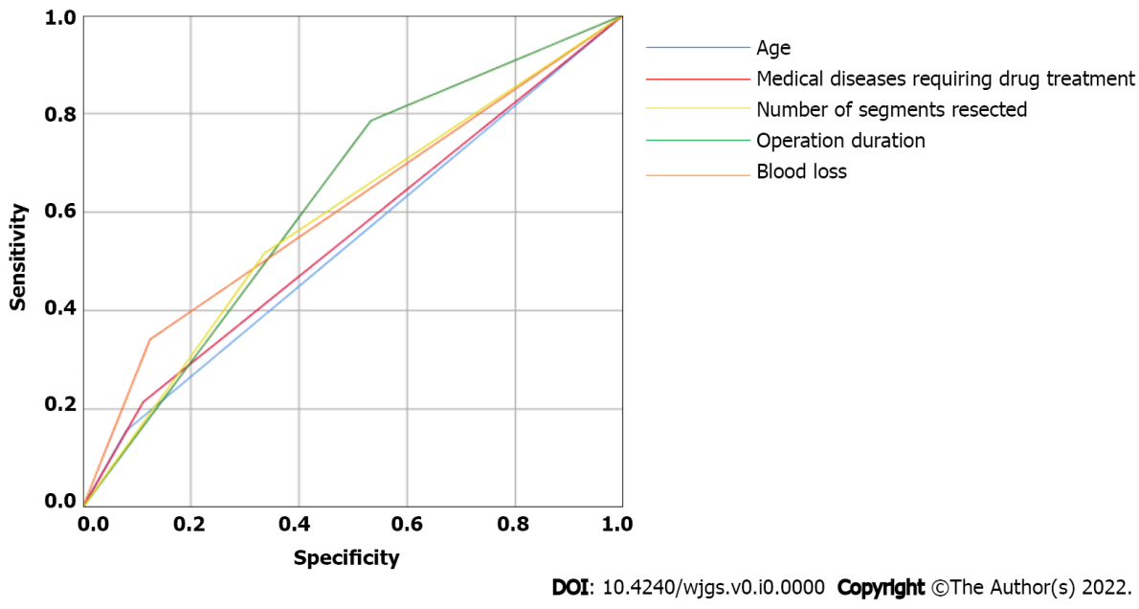
Figure 1 Predictive efficacy of the five variables. Predictive efficacy of the five variables: The area under the curves for diagnoses of postoperative complication were 0.538, 0.551, 0.626, 0608, and 0.590 for age, blood loss, operation duration, medical diseases requiring drug treatment, and number of segments resected, respectively.
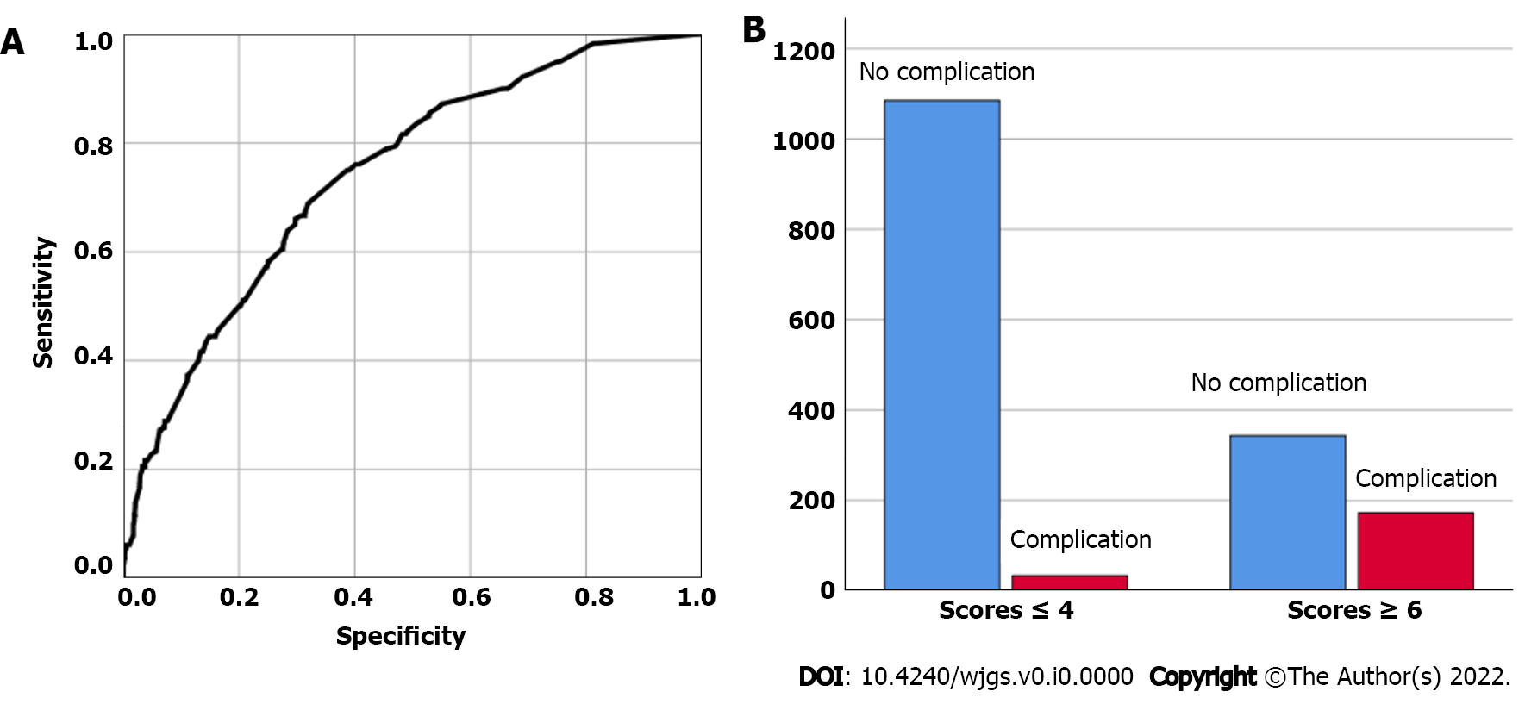
Figure 2 The predictive efficacy of the combined variables in the liver operation pulmonary complication scoring system. A: The area under the curve of the combined variables was 0.742; B: The incidence of complications in two groups divided based on liver operation pulmonary complication scoring system.
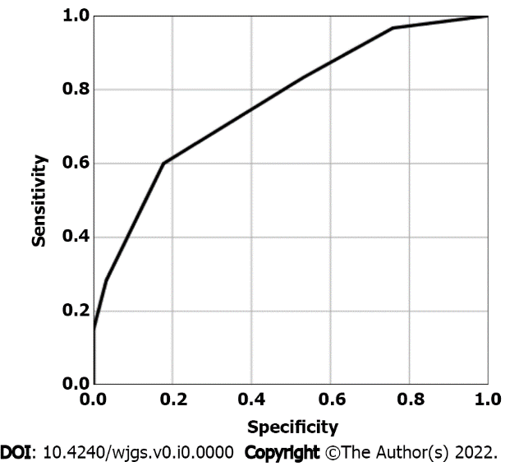
Figure 3 Validation of the liver operation pulmonary complication scoring system. The area under the curve of the liver operation pulmonary complication scoring system was 0.767.
Table 1 Post-surgical pulmonary complications
Complication-pulmonary | n | Ratio (n/total number of patients), %
Pleural cavity infection | 1 | 0.06
Respiratory tract infection | 3 | 0.18
Pneumothorax | 3 | 0.18
Respiratory insufficiency | 7 | 0.43
Atelectasis | 22 | 1.35
Pneumonia | 30 | 1.84
Pleural effussion | 184 | 11.27

Table 2 Univariate analysis of preoperative clinical risk factors related to pulmonary complications of hepatectomy
Variable | n | Pearson coefficient | P value¹
Age (years old) |  | 0.087 | 0.000
≥ 65 | 147
< 65 | 1486
Medical diseases requiring drug treatment |  | 0.200 | < 0.001
Yes | 248
No | 1385
Child-pugh grade |  | 0.093 | < 0.001
A | 1463
B, C | 170
Number of segments resected |  | 0.124 | < 0.001
≤ 2 segments resected | 1046
≥ 3 segments resected | 587
Blood transfusion |  | 0.182 | 0.000
Yes | 689
No | 944
Blood loss (mL) |  | 0.103 | < 0.001
≥ 800 | 204
< 800 | 1429
Operation duration (min) |  | 0.169 | 0.000
≥ 180 | 922
< 180 | 711
Adjacent organ invasion |  | 0.066 | 0.007
Yes | 18
No | 1615
Preoperative hospital stay (days) |  | 0.098 | 0.000
≤ 7 | 1142
> 7 | 491
¹Pearson’s correlation analysis.
Table 3 Multivariate analysis to screen and assign independent influencing factors of post-hepatectomy pulmonary complications
Variable | Odds ratio | P value¹
χ₁: Age (≥ 65 years old/< 65 years old) | 1.926 | 0.011
χ₂: Medical diseases requiring drug treatment (Yes/No) | 3.523 | < 0.001
χ₃: Number of segments resected (≥ 3/≤ 2) | 1.683 | 0.002
χ₄: Operation duration (≥ 180 min/< 180 min) | 1.896 | 0.004
χ₅: Blood transfusion (Yes/No) | 1.836 | 0.003
¹Logistic regression.
Table 4 New scoring system
Variable | Conditions | Scores
χ₁: Age | < 65 years old | 0
 | ≥ 65 years old | 2
χ₂: Medical diseases requiring drug treatment | No | 0
 | Yes | 4
χ₃: Number of segments resected | ≤ 2 | 0
 | ≥ 3 | 2
χ₄: Operation duration | < 180 min | 0
 | ≥ 180 min | 2
χ₅: Blood transfusion | No | 0
 | Yes | 2
Note: The total score was calculated as the sum of the five variables.

