Name of journal: World Journal of Gastroenterology
Manuscript NO: 36724
Manuscript Type: CASE REPORT

Mass forming chronic pancreatitis mimicking pancreatic cystic neoplasm: A case report

Jee KN et al. Mass-forming chronic pancreatitis

Keum Nahn Jee

Keum Nahn Jee, Department of Radiology, Dankook University Hospital, Chungcheongnam-do 330-715, South Korea

Keum Nahn Jee: (0000-0003-2669-4381).

Author contributions: Jee KN designed the report, collected the patient’s clinical data, drafting the article and reviewed the manuscript and approved the final manuscript as submitted.

Informed consent statement: This study was reviewed and approved the retrospective case review by Institutional Review Board of Dankook University Hospital, Cheonan, South Korea, with informed consent from the patient waived.

Conflict-of-interest statement: There are no potential conflicts (financial, professional, or personal) of interest relevant to this article to disclose by the author.

Open-Access: This article is an open-access article which was selected by an in-house editor and fully peer-reviewed by external reviewers. It is distributed in accordance with the Creative Commons Attribution Non Commercial (CC BY-NC 4.0) license, which permits others to distribute, remix, adapt, build upon this work non-commercially, and license their derivative works on different terms, provided the original work is properly cited and the use is non-commercial. See: http://creativecommons.org/licenses/by-nc/4.0/

Manuscript source: Unsolicited manuscript

Correspondence to: Keum Nahn Jee, MD, PhD, Professor, Department of Radiology, Dankook University Hospital, Mang-hyang Street 201, Anseo-dong, Dongnam-gu, Cheonan, Chungcheongnam-do 330-715, South Korea. jkn1303@dkuh.co.kr
Telephone: +82-41-5506921
Fax: +82-41-5529674

Received: October 19, 2017
Peer-review started: October 20, 2017
First decision: November 8, 2017
Revised: November 15, 2017
Accepted: November 22, 2017
Article in press:
Published online:

Abstract
Mass forming chronic pancreatitis is very rare. Diagnosis could be done by the pathologic findings of focal inflammatory fibrosis without evidence of tumor in pancreas. A 34-year-old man presented with right upper abdominal pain for a few weeks and slightly elevated bilirubin level on clinical findings. Radiological findings of multidetector-row computed tomography (CT), magnetic resonance (MR) imaging with MR cholangiopancreatography and endoscopic ultrasonography (EUS) revealed focal branch pancreatic duct dilatation with surrounding delayed enhancing solid component at uncinate process and head of pancreas, suggesting branch duct type intraductal papillary mucinous neoplasm (IPMN). Surgery was done and pathology revealed the focal chronic inflammation, fibrosis, and branch duct dilatation. Herein, I would like to report the first case report of mass-forming chronic pancreatitis mimicking pancreatic cystic neoplasm.

Key words: Chronic pancreatitis; Pseudotumor; Computed Tomography; Magnetic Resonance Imaging; Endoscopic ultrasound

© The Author(s) 2017. Published by Baishideng Publishing Group Inc. All rights reserved.

Core tip: Extremely unusual radiological manifestation of mass forming chronic pancreatitis mimicking pancreatic cystic neoplasm is the first case report in the English-written medical literature.

Jee KN. Mass forming chronic pancreatitis mimicking pancreatic cystic neoplasm: A case report. World J Gastroenterol 2017; In press

INTRODUCTION
Chronic pancreatitis represents a recurrent, prolonged inflammatory process and progressive fibrosis of the pancreas. These results in irreversible morphologic change of the pancreas, clinical symptoms of abdominal pain, and insufficiency of exocrine and endocrine function^{[1-3]}. On computed tomography (CT) and magnetic resonance (MR) image, dilatation of the main pancreatic duct, parenchymal atrophy, pancreatic calciﬁcation or stone, focal pancreatic enlargement or inflammatory pancreatic mass, bile duct dilatation, attenuation change of peripancreatic fat and ﬂuid collection are frequent ﬁndings^{[4-6]}.
Inflammatory mass in chronic pancreatitis retain a large degree of fibrosis like pancreatic carcinoma^{[7-9]}, and both lesions are shown as a gradual progressive enhancement on contrast-enhanced CT and dynamic MR imaging, making the discrimination of the two entities difficult^{[5,6,10]}.
In the case of mass forming chronic pancreatitis, diagnosis of inflammatory pancreatic mass could be almost impossible if associated radiological findings of chronic pancreatitis is not shown.
This paper presents a very unique case of mass-forming chronic pancreatitis mimicking pancreatic cystic neoplasm.

CASE REPORT
A 34-year-old man complained for right upper abdominal pain for a few days. His laboratory findings including white blood cell count, C-reactive protein, alkaline phosphatase, liver enzyme level and tumor markers of carbohydrate antigen 19-9 and carcinoembryonic antigen were within normal range except slight elevation of total bilirubin (1.3 mg/dL, normal range of 0.2-1.2), gamma-glutamyl transferase (108 IU/L, normal range of 8-60) and lipase (90 U/L, normal range of 30-60). The patient had past medical history of admission due to acute alcoholic pancreatitis 13 years ago and social history of daily alcohol consumption for 15 years and having smoked 20 pack years.
Unenhanced abdomen CT image showed slight low attenuating lesion involving pancreatic uncinate process and head (Figure 1A). Contrast-enhanced abdominal CT images showed a delayed enhancing solid portion surrounding a few tubular cystic attenuating lesion sized about 2.5 x 2.1 cm in pancreatic uncinate process and head, and mild dilatation of common bile duct (CBD) and gallbladder (Figure 1B and C). MR cholangiopancreatography showed branch pancreatic duct dilation in head and uncinate process causing extrinsic indentation and tapering of distal CBD, and mild dilatation of proximal CBD and gallbladder (Figure 2A). Fat-saturated T2-weighted MR image showed a slight high signal intensity solid component surrounding bright signal intensity branch duct dilatation in pancreatic uncinate process and head, with the lesion sized about 2.6 x 2.2 cm (Figure 1B). Fat-suppressed T1-weighted MR image showed a well-demarcated low signal intensity lesion in head and uncinate process of pancreas (Figure 2C), and delayed contrast-enhancing solid component surrounding low signal intensity branch-duct dilation in pancreatic uncinate process and head was shown on fat-suppressed T1-weighted dynamic gadolinium-enhanced MR images (Figure 2D and E). Diffusion-weighted MR images showed higher signal intensity on low b factor (b = 20 sec/mm2) image and low signal intensity on high b factor (b = 800 sec/mm2) image, suggesting no diffusion restriction on apparent diffusion coefficient map (Figure 2F), which reflecting the large area of cystic component of the lesion. Endoscopic ultrasonography (EUS) showed pruning pattern, anechoic branch duct dilatation containing a few small hyperechoic mural nodules (Figure 3A and B).
The lesion located in uncinate process and head of pancreas with indenting distal CBD and dilatation of proximal CBD, without dilatation of main pancreatic duct due to anatomic variation of pancreatic divisum which was detected on MR image (Figure 2B). Radiological diagnostic impression was branch duct type intraductal papillary mucinous neoplasm (IPMN) of pancreas. However, some worrisome features of delayed contrast-enhancing solid component around the wall of dilated branch duct on CT and MR images and small mural nodules in dilated branch ducts on EUS were shown. EUS guided fine needle aspiration (FNA) cytology was obtained from the solid component along the wall of dilated duct and suggested the possibility of intraductal-growing epithelial neoplasm.
The patient underwent pylorus-preserving pancreaticoduodenectomy, due to considering FNA finding, imaging findings of CT, MRI, and EUS and aggravated right upper abdominal pain and persistent mild elevation of bilirubin and gamma-glutamyl transferase levels without response to conservative medical treatment for four weeks. The gross pathology of resected specimen showed whitish hard infiltrating lesion in pancreatic uncinate process and head portion (Figure 4A). The histopathologic report revealed periductal inflammation with fibrosis and mild dilatation of branch pancreatic ducts and intralobular fibrosis, consistent with chronic pancreatitis (Figure 4B).

DISCUSSION
Chronic pancreatitis is defined as inflammatory and fibrotic disease of pancreatic tissue, characterized by irreversible functional and morphologic change. Alcohol abuse is the most common (70%-80%) cause of chronic pancreatitis in the developed countries^{[1,2,3,7]}. In addition, smoking, gene mutations, autoimmune syndromes, metabolic disturbances, environmental conditions and anatomical abnormalities are suggested as other associated factors with occurrence of the disease^{[3,11, 12]}.
The pathology of advanced alcoholic chronic pancreatitis revealed a firm consistency of pancreas with an irregular contour without the normal lobulation^{[13]}. The fibrosis may diffusely affect the entire gland, but occasionally it is unevenly distributed, with preserved normal lobular pattern in some areas. The severity of the duct changes depends on the extent of the surrounding fibrosis. Thus, the main duct may be focally or diffusely involved with obstruction, irregular dilatation and distortion^{[14,15]}. Fibrosis in the pancreas head may cause a tapering stenosis of CBD^{[16]}.
In this case, initial clinical symptom of right upper abdominal pain was developed due to dilatation of gallbladder by stenosis of distal CBD, and the causative lesion of CBD obstruction was a focal mass lesion, including branch duct dilatation with surrounding solid component in uncinate process and head of pancreas, detected on CT, MRI and EUS findings. The diagnostic impression based on radiological imaging findings was branch duct type IPMN most likely and serous cystadenoma as a possible differential diagnosis. In thinking of branch duct type IPMN, analyses of imaging findings included the “worrisome features” of contrast-enhancing ductal margin on CT and MRI and mural nodules in dilated duct on EUS^{[17-19]}. In addition, FNA suggested intraductal-growing epithelial neoplasm though scant cellularity. Surgery was the best choice at that time, considering aggravated clinical symptom, radiological findings, opinion of FNA, and patient’s young age. However, final pathologic result revealed interlobular and intralobular inflammation and fibrosis associated with branch duct dilatation, compatible with chronic pancreatitis. It was a totally unexpected one, even though considering patient’s past medical history of severe alcoholic pancreatitis and social history of frequent alcohol consumption and heavy smoking.
There have been many reports for the differentiation mass forming chronic pancreatitis from pancreatic adenocarcinoma such as dynamic enhancement of CT and MR imaging, Perfusion CT imaging, duel energy CT in spectral imaging mode, 18F fluorodeoxyglucose positron emission tomography/CT combined with carbohydrate antigen 19-9, and quantitative endoscopic ultrasound elastography, but still it is very difficult to distinguish accurately between the two^{[5,10,20-24]}. MRI is much better than CT for detection and characterization of focal pancreatic lesion, but it could not differentiate mass forming chronic pancreatitis from pancreatic carcinoma, even using diffusion-weighted functional MR imaging technique^{[5,10,25,26]}. In addition, none of the above mentioned papers included a case of a solid mass containing cystic lesion like this in their research of differentiation between mass forming pancreatitis and pancreatic carcinoma.
Among the papers on relationship between main pancreatic duct (MPD) and the mass, the “duct-penetrating” sign of MPD on MR cholangiopancreatography was reported to be helpful with relatively high sensitivity and specificity, and the result was smoothly stenotic or normal MPD penetrating a mass was seen more frequently in inflammatory pancreatic mass than in pancreatic carcinoma^{[27]}. However, in this peculiar case, inflammatory mass possessed dilated branch pancreatic duct without stenosis.
In this very unique case, it could be comprehended uneven fibrosis and inflammation developed in localized area of uncinate process and head of pancreas, focal severe perilobular and interlobular fibrosis caused stricture and dilatation of branch pancreatic duct in uncinate process, and the these outbreaks led to very distinctive and peculiar radiological features of mass forming chronic pancreatitis and clinical symptoms of bile duct obstruction.
There has been no literature about focal fibrotic mass forming chronic pancreatitis containing branch duct dilatation, and incidentally this lesion showed almost typical imaging findings of pancreatic cystic neoplasm.

ARTICLE HIGHLIGHTS
Case characteristics
A 34-year-old man was referred to our hospital with right upper abdominal pain, and a pancreatic solid and cystic lesion found on computed tomography (CT), magnetic resonance (MR) image with MR cholangiography, and endoscopic ultrasonography (EUS).

Clinical diagnosis
Branch duct type intraductal papillary mucinous neoplasm.

Differential diagnosis
Serous cystadenoma among solid and cystic pancreatic neoplasms.

Laboratory diagnosis
Abnormal laboratory results included slightly elevated level of total bilirubin (1.3 mg/dL, normal range of 0.2-1.2) and gamma-glutamyl transferase (108 IU/L, normal range of 8-60).

Imaging diagnosis
CT and MR imaging showed a delayed contrast-enhanced solid lesion containing pruning-pattern branch duct dilatation in uncinate process and head of pancreas, with small hyperechoic mural nodules in the dilated branch ducts on EUS.

Pathological diagnosis
Microscopic findings of resected specimen revealed mass forming chronic pancreatitis including branch duct dilatation.

Treatment
The patient was treated with pylorus-preserving pancreaticoduodenectomy.

Related reports
There have been many reports for the discrimination between mass forming chronic pancreatitis and pancreatic adenocarcinoma using various imaging modalities.

Term explanation
There are no non-standard medical terms used in this manuscript.

Experiences and lessons
The author presents this case to share the very unusual but important knowledge that mass forming chronic pancreatitis might include the branch duct dilatation.

ACKNOWLEDGEMENT
I wish to thank to Drs. Sung Ho Cho (Department of Surgery, Dankook University Hospital) and Won-Ae Lee (Department of Pathology, Dankook University Hospital) for their comments and discussions about the case.

REFERENCES
1 Steer ML, Waxman I, Freedman S. Chronic pancreatitis. N Engl J Med 1995; 332: 1482-1490 [PMID: 7739686 DOI: 10.1056/NEJM199506013322206]
2 Muniraj T, Aslanian HR, Farrell J, Jamidar PA. Chronic pancreatitis, a comprehensive review and update. Part I: epidemiology, etiology, risk factors, genetics, pathophysiology, and clinical features. Dis Mon 2014; 60: 530-550 [PMID: 25510320 DOI: 10.1016/j.disamonth.2014.11.002]
3 Etemad B, Whitcomb DC. Chronic pancreatitis: diagnosis, classification, and new genetic developments. Gastroenterology 2001; 120: 682-707 [PMID: 11179244]
4 Luetmer PH, Stephens DH, Ward EM. Chronic pancreatitis: reassessment with current CT. Radiology 1989; 171: 353-357 [PMID: 2704799 DOI: 10.1148/radiology.171.2.2704799]
5 Kim T, Murakami T, Takamura M, Hori M, Takahashi S, Nakamori S, Sakon M, Tanji Y, Wakasa K, Nakamura H. Pancreatic mass due to chronic pancreatitis: correlation of CT and MR imaging features with pathologic findings. AJR Am J Roentgenol 2001; 177: 367-371 [PMID: 11461864 DOI: 10.2214/ajr.177.2.1770367]
6 McNulty NJ, Francis IR, Platt JF, Cohan RH, Korobkin M, Gebremariam A. Multi--detector row helical CT of the pancreas: effect of contrast-enhanced multiphasic imaging on enhancement of the pancreas, peripancreatic vasculature, and pancreatic adenocarcinoma. Radiology 2001; 220: 97-102 [PMID: 11425979 DOI: 10.1148/radiology.220.1.r01jl1897]
7 Imamura T, Iguchi H, Manabe T, Ohshio G, Yoshimura T, Wang ZH, Suwa H, Ishigami S, Imamura M. Quantitative analysis of collagen and collagen subtypes I, III, and V in human pancreatic cancer, tumor-associated chronic pancreatitis, and alcoholic chronic pancreatitis. Pancreas 1995; 11: 357-364 [PMID: 8532652]
8 Longnecker DS. Pancreas. Anderson's Pathology. 10th ed. St. Louis: Mosby-Year Book; 1996; 1891-1916.
9 Ritchie AC. Pancreas. Boyd's textbook of pathology, 9th ed. Philadelphia: Lea & Febiger; 1990; 1202-1234.
10 Johnson PT, Outwater EK. Pancreatic carcinoma versus chronic pancreatitis: dynamic MR imaging. Radiology 1999; 212: 213-218 [PMID: 10405744 DOI: 10.1148/radiology.212.1.r99jl16213]
11 Maisonneuve P, Lowenfels AB, Müllhaupt B, Cavallini G, Lankisch PG, Andersen JR, Dimagno EP, Andrén-Sandberg A, Domellöf L, Frulloni L, Ammann RW. Cigarette smoking accelerates progression of alcoholic chronic pancreatitis. Gut 2005; 54: 510-514 [PMID: 15753536 DOI: 10.1136/gut.2004.039263]
12 Ammann RW. The natural history of alcoholic chronic pancreatitis. Intern Med 2001; 40: 368-375 [PMID: 11393404]
13 Klöppel G, Maillet B. The morphological basis for the evolution of acute pancreatitis into chronic pancreatitis. Virchows Arch A Pathol Anat Histopathol 1992; 420: 1-4 [PMID: 1539444]
14 Ammann RW, Heitz PU, Klöppel G. Course of alcoholic chronic pancreatitis: a prospective clinicomorphological long-term study. Gastroenterology 1996; 111: 224-231 [PMID: 8698203]
15 Klöppel G. Chronic pancreatitis of alcoholic and nonalcoholic origin. Semin Diagn Pathol 2004; 21: 227-236 [PMID: 16273941]
16 Yadegar J, Williams RA, Passaro E Jr, Wilson SE. Common duct stricture from chronic pancreatitis. Arch Surg 1980; 115: 582-586 [PMID: 7377960]
17 Tanaka M, Fernández-del Castillo C, Adsay V, Chari S, Falconi M, Jang JY, Kimura W, Levy P, Pitman MB, Schmidt CM, Shimizu M, Wolfgang CL, Yamaguchi K, Yamao K; International Association of Pancreatology. International consensus guidelines 2012 for the management of IPMN and MCN of the pancreas. Pancreatology 2012; 12: 183-197 [PMID: 22687371 DOI: 10.1016/j.pan.2012.04.004]
18 Goh BK, Tan DM, Ho MM, Lim TK, Chung AY, Ooi LL. Utility of the sendai consensus guidelines for branch-duct intraductal papillary mucinous neoplasms: a systematic review. J Gastrointest Surg 2014; 18: 1350-1357 [PMID: 24668367 DOI: 10.1007/s11605-014-2510-8]
19 Castellano-Megías VM, Andrés CI, López-Alonso G, Colina-Ruizdelgado F. Pathological features and diagnosis of intraductal papillary mucinous neoplasm of the pancreas. World J Gastrointest Oncol 2014; 6: 311-324 [PMID: 25232456 DOI: 10.4251/wjgo.v6.i9.311]
20 Yin Q, Zou X, Zai X, Wu Z, Wu Q, Jiang X, Chen H, Miao F. Pancreatic ductal adenocarcinoma and chronic mass-forming pancreatitis: Differentiation with dual-energy MDCT in spectral imaging mode. Eur J Radiol 2015; 84: 2470-2476 [PMID: 26481480 DOI: 10.1016/j.ejrad.2015.09.023]
21 Yadav AK, Sharma R, Kandasamy D, Pradhan RK, Garg PK, Bhalla AS, Gamanagatti S, Srivastava DN, Sahni P, Upadhyay AD. Perfusion CT - Can it resolve the pancreatic carcinoma versus mass forming chronic pancreatitis conundrum? Pancreatology 2016; 16: 979-987 [PMID: 27568845 DOI: 10.1016/j.pan.2016.08.011]
22 Lu N, Feng XY, Hao SJ, Liang ZH, Jin C, Qiang JW, Guo QY. 64-slice CT perfusion imaging of pancreatic adenocarcinoma and mass-forming chronic pancreatitis. Acad Radiol 2011; 18: 81-88 [PMID: 20951612 DOI: 10.1016/j.acra.2010.07.012]
23 Gu X, Liu R. Application of 18F-FDG PET/CT combined with carbohydrate antigen 19-9 for differentiating pancreatic carcinoma from chronic mass-forming pancreatitis in Chinese elderly. Clin Interv Aging 2016; 11: 1365-1370 [PMID: 27729779 DOI: 10.2147/CIA.S115254]
24 Kim SY, Cho JH, Kim YJ, Kim EJ, Park JY, Jeon TJ, Kim YS. Diagnostic efficacy of quantitative endoscopic ultrasound elastography for differentiating pancreatic disease. J Gastroenterol Hepatol 2017; 32: 1115-1122 [PMID: 27862278 DOI: 10.1111/jgh.13649]
25 Wang Y, Miller FH, Chen ZE, Merrick L, Mortele KJ, Hoff FL, Hammond NA, Yaghmai V, Nikolaidis P. Diffusion-weighted MR imaging of solid and cystic lesions of the pancreas. Radiographics 2011; 31: E47-E64 [PMID: 21721197 DOI: 10.1148/rg.313105174]
26 Barral M, Taouli B, Guiu B, Koh DM, Luciani A, Manfredi R, Vilgrain V, Hoeffel C, Kanematsu M, Soyer P. Diffusion-weighted MR imaging of the pancreas: current status and recommendations. Radiology 2015; 274: 45-63 [PMID: 25531479 DOI: 10.1148/radiol.14130778]
27 Ichikawa T, Sou H, Araki T, Arbab AS, Yoshikawa T, Ishigame K, Haradome H, Hachiya J. Duct-penetrating sign at MRCP: usefulness for differentiating inflammatory pancreatic mass from pancreatic carcinomas. Radiology 2001; 221: 107-116 [PMID: 11568327 DOI: 10.1148/radiol.2211001157]

P-Reviewer: Agrawal S, Tandon RK S-Editor: Chen K L-Editor: E-Editor:
Specialty type: Gastroenterology and hepatology
Country of origin: South Korea
Peer-review report classification
Grade A (Excellent): 0
Grade B (Very good): 0
Grade C (Good): C, C
Grade D (Fair): 0
Grade E (Poor): 0

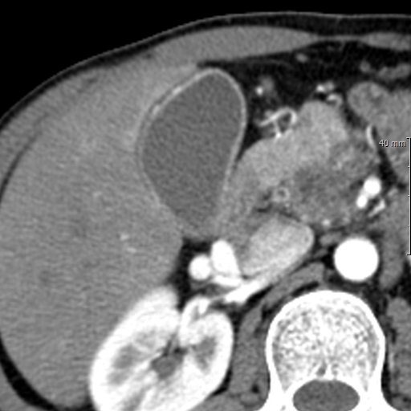
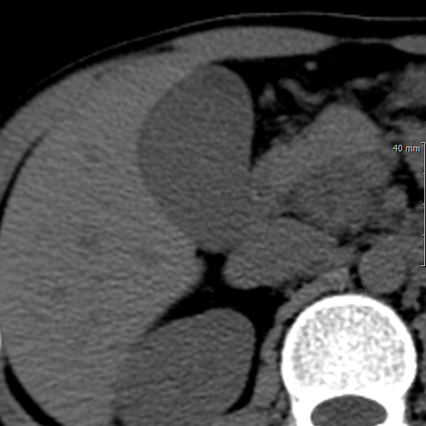
B
A

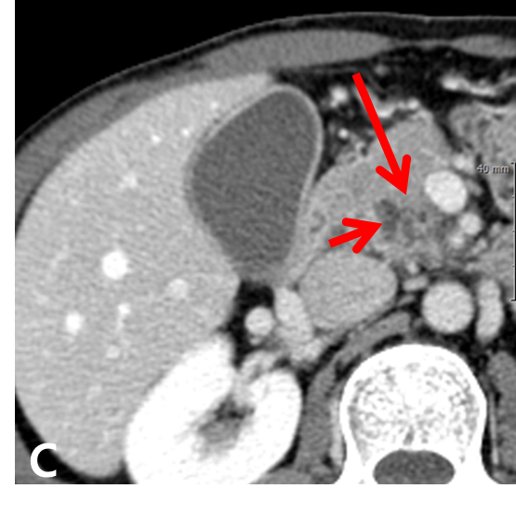
Figure 1 Findings from computed tomography. A: Unenhanced computed tomography (CT) image shows a slight low attenuating lesion (arrow) in pancreatic uncinated process and head and dilatation of gallbladder; B: Contrast–enhanced arterial phase CT image shows minimal enhancing low attenuating lesion (long arrow) surrounding a few tubular low cystic attenuating structures (short arrow), and homogenous highly enhancing normal pancreas (arrowhead); C: Contrast-enhanced portal venous phase CT image shows delayed enhancing lesion (long arrow) containing a few tubular cystic structures (short arrow).

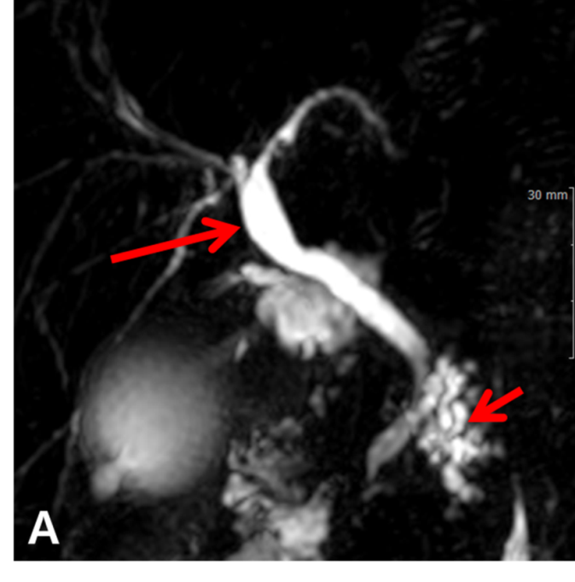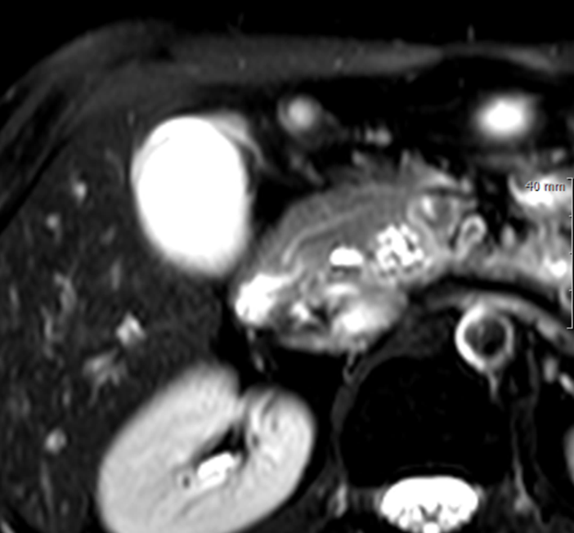
B
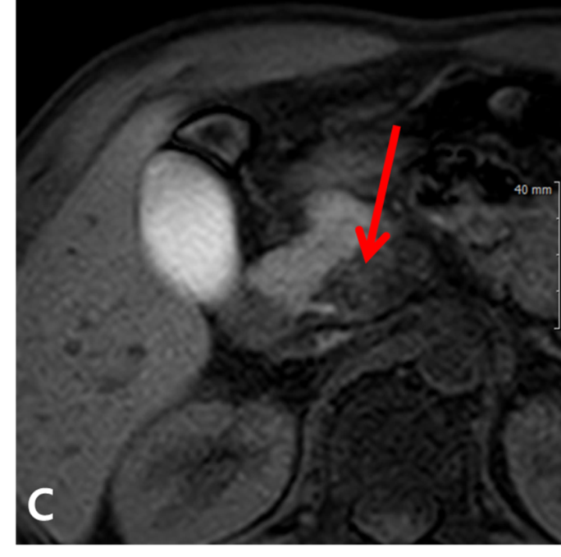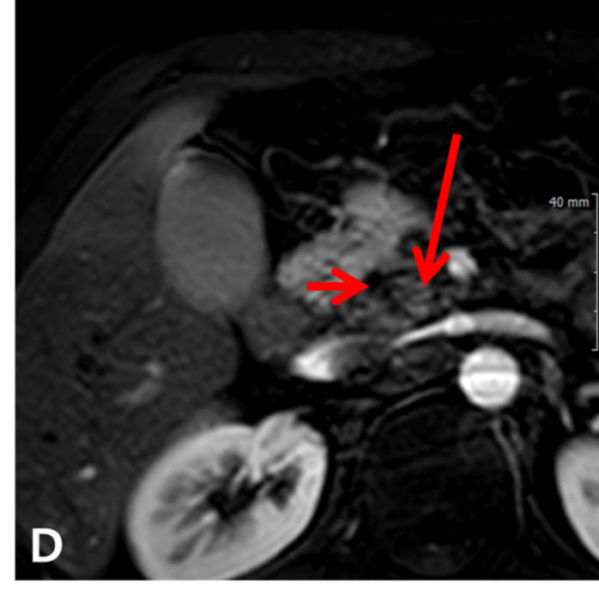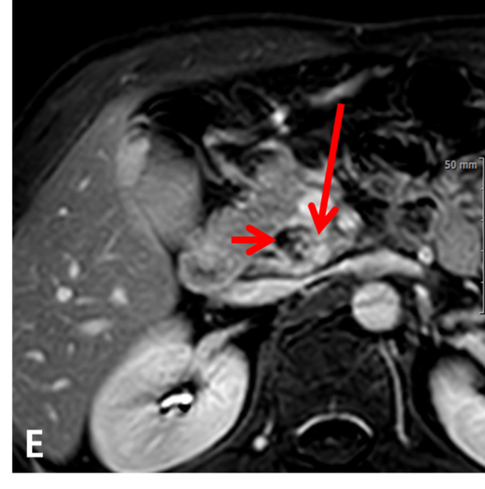

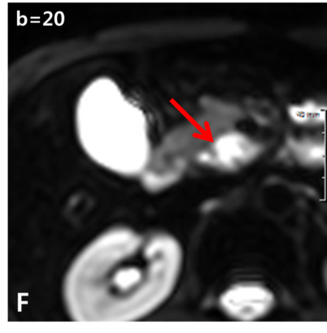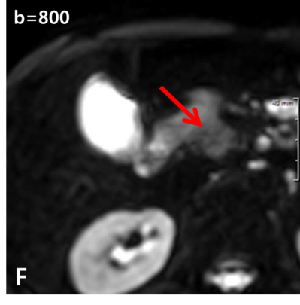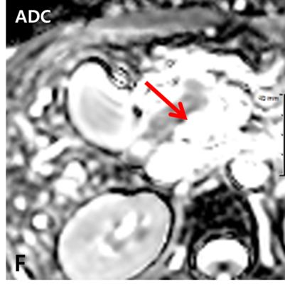
Figure 2 Findings from magnetic resonance image. A: Magnetic resonance (MR) cholangiopancreatography shows localized branch pancreatic duct dilatation (short arrow) in head of pancreas with tapering of distal common bile duct and dilatation of proximal common duct (long arrow); B: T2-weighted MR image shows slight high signal intensity lesion (long arrow) containing bright intensity branch duct dilatation (short arrow) in head and uncinate process of pancreas, and incidental finding of pancreatic divisum (arrowhead); C: Fat-suppressed T1-weighted MR image shows a well-demarcated low signal intensity lesion (long arrow) in uncinate process and head of pancreas; D-E: Fat-suppressed T1-weighted gadolinium-enhanced arterial- (D) and delayed-phase (E) MR images show delayed highly enhancing solid mass-like lesion (long arrows) containing non-enhancing dark intensity branch duct dilatation (short arrows) in pancreatic head; F: The higher signal intensity lesion (arrow) on diffusion-weighted image obtained with b=20 sec/mm² shows as low signal intensity (arrow) on diffusion-weighted image obtained with b=800 sec/mm² and as higher (arrow) apparent diffusion coefficient (ADC) without diffusion restriction.

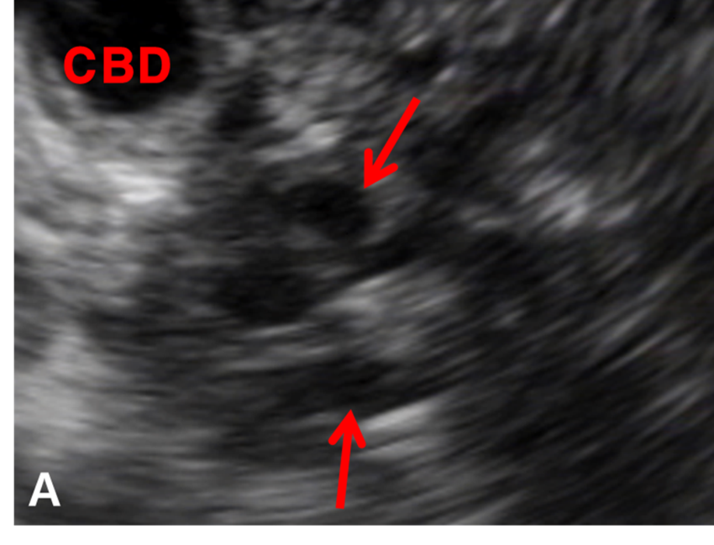
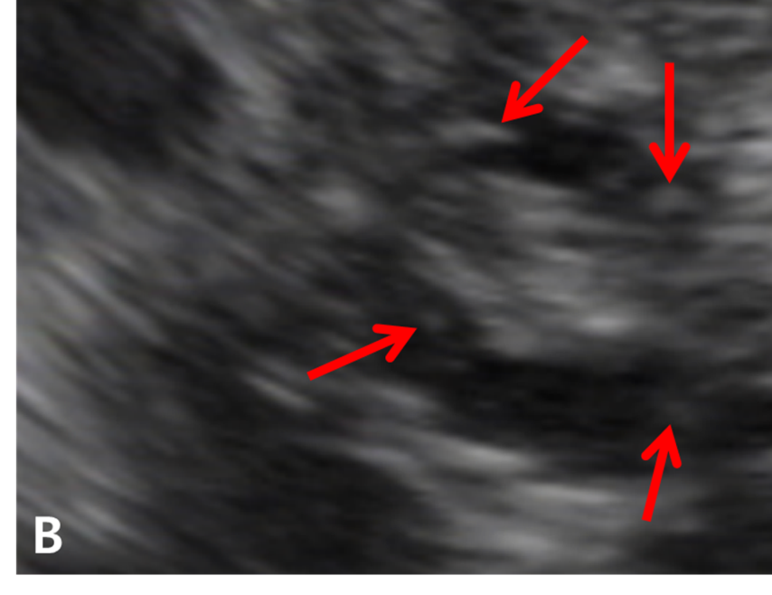
Figure 3 Findings from endoscopic ultrasound. A: EUS shows a few anechoic tubular structures (arrows), causing indentation of distal CBD and dilatation of proximal bile duct; B: EUS shows small hyperechoic mural nodules (short arrows) in the dilated branch pancreatic ducts. EUS: Endoscopic ultrasound; CBD: Common bile duct.

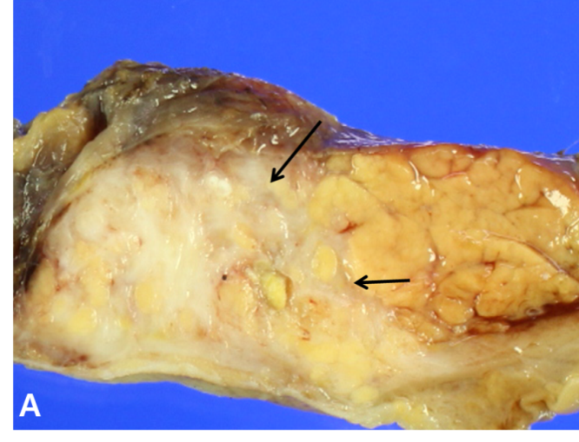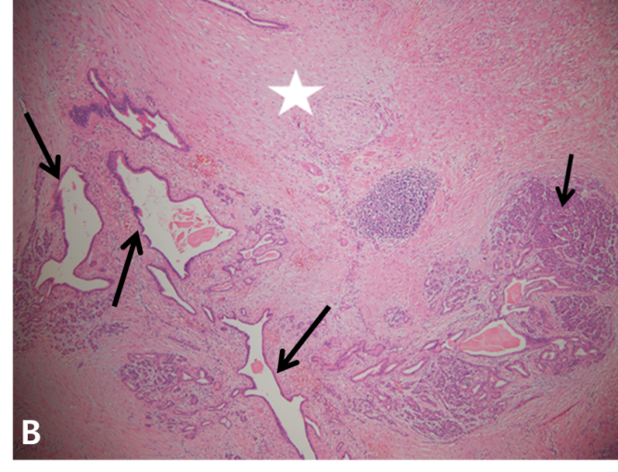
Figure 4 Macroscopic and microscopic findings of resected specimen. A: Gross specimen shows whitish hard infiltrating mass-like lesion (arrows) focally replaced head and uncinate process of pancreas; B: Microscopy (hematoxylin and eosin, x 40) shows perilobular and intralobular fibrosis (asterisk) replaces normal pancreatic acini with focal perivascular lymphocyte infiltration (short arrow) and dilated branch ducts (long arrows).

