Name of Journal: World Journal of Clinical Cases
Manuscript NO: 73765
Manuscript Type: CASE REPORT

Carotid blowout syndrome caused by chronic infection: A case report

Xie TB et al. CBS caused by chronic infection

Tian-Hao Xie, Wen-Jun Zhao, Xiao-Long Li, Yan Hou, Xiong Wang, Jing Zhang, Xiu-Hua An, Li-Tao Liu

Tian-Hao Xie, Jing Zhang, Li-Tao Liu, Department of General Surgery, Affiliated Hospital of Hebei University, Baoding 071000, Hebei Province, China

Wen-Jun Zhao, Department of Ophthalmology, MEM Yinghua Hospital, Baoding 071000, Hebei Province, China

Xiao-Long Li, Department of Traumatology, The First Hospital of Hebei Medical University, Shijiazhuang 050000, Hebei Province, China

Yan Hou, Department of Imaging, Affiliated Hospital of Hebei University, Baoding 071000, Hebei Province, China

Xiong Wang, Department of General Surgery, Li County Hospital, Baoding 071400, Hebei Province, China

Xiu-Hua An, Department of Internal Medicine, Wangdu County Chinese Medicine Hospital, Baoding 072450, Hebei Province, China

Author contributions: Xie TH and Liu LT contributed to the drafting of the manuscript and the revising the final draft; Zhao WJ, Li XL and Hou Y contributed to the acquisition of data and the revising the final draft; Wang X, Zhang J and An XH contributed to the investigation and interpretation of the descriptive; and All authors have read and approved the manuscript.

Supported by Medical Science Research Project of Hebei Provincial Health Commission, No. 20211642.

Corresponding author: Li-Tao Liu, PhD, Professor, Department of General Surgery, Affiliated Hospital of Hebei University, No. 212 East Yuhua Road, Baoding 071000, Hebei Province, China. squall.xth@163.com

Received: December 2, 2021
Revised: February 10, 2022
Accepted: March 26, 2022
Published online:

Abstract
BACKGROUND
Carotid blowout syndrome (CBS) refers to rupture of the extracranial carotid artery and its branches; as a severe complication, it usually occurs after surgery or radiotherapy for malignant tumours of the head and neck. We present a case of CBS caused by chronic infection of the external carotid artery (ECA). In this case, we did not find any evidence of head and neck tumours.

CASE SUMMARY
A 42-year-old man was referred to the Emergency Department with a complaint of a lump found on the left side of his neck with pain and fever for 4 d. We diagnosed the condition as neck infection with abscess formation based on physical examination, routine blood examination, ultrasound examination and plain computed tomography (CT) and decided to perform emergency surgery. During the operation, 30 mL of grey and smelly pus was drained from the deep surface of the sternocleidomastoid muscle. The second day after the operation, the patient suddenly exhibited a large amount of haemoptysis and incision bleeding. The enhanced CT showed distal occlusion of the left ECA and irregular thickening of the broken ends of the artery encased in an uneven enhancement of soft tissue density. Infected ECA occlusion and rupture were considered. The patient was transferred to a vascular unit for transcatheter ECA embolization and recovered well.

CONCLUSION
Surgeons need to pay attention to vascular lesions caused by chronic infection that may develop into acute CBS.

Key Words: Carotid blowout syndrome; Carotid arteries; Infection; surgery; Case report

Xie TH, Zhao WJ, Li XL, Hou Y, Wang X, Zhang J, An XH, Liu LT. Carotid blowout syndrome caused by chronic infection: A case report. World J Clin Cases 2022; In press

Core Tip: Carotid blowout syndrome (CBS) refers to rupture of the extracranial carotid artery and its branches; as a severe complication, it usually occurs after surgery or radiotherapy for malignant tumours of the head and neck. We present a case of CBS caused by chronic infection of the external carotid artery. In this case, we did not find any evidence of head and neck tumours. This suggested that surgeons need to pay attention to vascular lesions caused by chronic infection that may develop into acute CBS.
INTRODUCTION
Carotid blowout syndrome (CBS) refers to rupture of the extracranial carotid artery and its branches; as a severe complication, it usually occurs after surgery or radiotherapy for malignant tumours of the head and neck. CBS can lead to severe haemorrhage and life-threatening neurological complications of up to 60% and mortality of up to 40%^{[1]}. We present a case of CBS caused by chronic infection of the external carotid artery (ECA). In this case, we did not find any evidence of head and neck tumours.

CASE PRESENTATION
Chief complaints
A 42-year-old man was referred to the Emergency Department in July 2019 with a complaint of a lump found on the left side of his neck with pain and fever for 4 d.

History of present illness
He had a slight sore throat and difficulty swallowing.

History of past illness
He had no history of diabetes, hypertension, smoking or other underlying infectious source such as bad tooth, foreign body, etc.

Personal and family history
He had no obvious medical history, irradiation history or family history with regard to tumours in the head and neck. And he had no history of head and neck trauma.

Physical examination
A physical examination revealed a solid and hemispherical lump 6 cm in diameter located on the left side of the neck, and the lump was tender and fixed the underlying tissues. The boundary between the lump and surrounding tissue is unclear. The skin on the surface of the lump was swelling and red and had a high temperature. No jugular venous distention or abnormal carotid arterial pulse was observed.

Laboratory examinations
The routine blood examination was essentially normal except for elevations in white blood cell count, haemoglobin levels, neutrophil count and eutrophilic granulocyte percentage: 11.78 × 10⁹/L (reference limits, 3.50 × 10⁹/L to 9.50 × 10⁹/L), 120 g/L (130 g/L to 175 g/L), 9.81 × 10⁹/L (1.80 × 10⁹/L to 6.30 × 10⁹/L) and 83.2% (40.0% to 75.0%). The remaining laboratory blood tests, including assessments of tumour markers (alpha fetoprotein, carcinoembryonic antigen, carbohydrate antigen (CA) 125, CA15-3, CA19-9, and CA72-4), and coagulation function, did not reveal abnormalities.

Imaging examinations
Ultrasound examination showed an irregular hypoechoic mass (dimensions: 10.6 cm × 6.3 cm) in the left neck, which was considered an infectious lesion. Abundant blood flow signals were detected around and within the mass through colour Doppler flow imaging. The size and shape of the parotid, thyroid and submandibular glands were normal, and the echo of the parenchyma was uniform. Plain computed tomography (CT) revealed a soft tissue mass containing scattered air (dimensions: 9.9 cm × 7.3 cm × 4.6 cm; CT value: 22-34 HU) that had a vague boundary and an irregular shape on the left poststyloid parapharyngeal space, and the oropharynx and laryngeal left lateral wall were thickened (Figure 1).

Disease development: We diagnosed the condition as neck infection with abscess formation based on physical examination, routine blood examination, ultrasound examination and plain CT and decided to perform emergency surgery. During the operation, 30 mL of grey and smelly pus was drained from the deep surface of the sternocleidomastoid muscle. There was not any main artery was exposed in the operation field, and no suture or ligation. After the purulent cavity was cleared, iodophor gauze was stuffed into the space. The incision was not sutured. The bacterial culture of the pus was Gram-positive cocci.
The second day after the operation, the patient suddenly exhibited a large amount of haemoptysis and incision bleeding. After symptomatic treatment, the patient underwent enhanced CT examination of the neck. The enhanced CT showed distal occlusion of the left ECA and irregular thickening of the broken ends of the artery encased in an uneven enhancement of soft tissue density. Infected ECA occlusion and rupture were considered (Figure 2).

FINAL DIAGNOSIS
CBS caused by chronic infection of the left ECA was considered.

TREATMENT
The patient was transferred to a vascular unit for transcatheter ECA embolization. Under general anesthesia, the left ECA angiography indicated the significantly localized expanded ECA. Then, a Guglielmi detachable coil was used to occlude the initial part of ECA completely. Postoperative immediate angiography confirmed the complete occlusion of the left ECA. Bleeding stopped after the procedure without any complications.

OUTCOME AND FOLLOW-UP
The neck incision healed 3 wk after anti-infection treatment and dressing changes. No relapse of haemoptysis or stroke was found at the 1-year follow-up.

DISCUSSION
CBS can be defined as a rupture of the extracranial carotid arteries or one of their branches and occurs in 6% to 10% of advanced head and neck cancer cases^{[2,3]}. Risk factors for CBS include radiotherapy, necrosis of the skin flap, wound infection, fistula formation, radical neck dissection, and tumour recurrence^{[4]}. However, some patients often have multiple risk factors. In this case, the patient had no history of neck radiation or surgery and no evidence supporting head and neck tumours. We concluded that there was no significant relationship between the carotid lesion and the abscess drainage procedure. Instead, we determined that the initial lesion was an infection of the pharynx, followed by chronic inflammation spreading around the carotid sheath. Chronic inflammation corroded the ECA, leading to its distal occlusion, which may be why the patient did not have neurological complications. When the infection progressed into an acute phase, the broken end of the ECA was eroded and ruptured.
When CBS occurs, blood flow to the airway can cause asphyxia, and haemorrhage can lead to hypovolemic shock, which is a major risk factor for stroke. If the patient is not rescued in time, his condition will deteriorate rapidly. The basic principles for the treatment of CBS are local pressure for haemostasis, such as pushing the common carotid artery backward to the transverse process of the 6th cervical vertebra or compressing the wound with gauze filling for haemostasis, ensuring airway patency, and resuscitating using liquid or blood products^{[5]}. Tracheal intubation is important for some cases because an inflatable aerocyst can effectively prevent blood flow to the airway and keep the airway open. After the patient's condition is stabilised, the next step of treatment should be carried out as soon as possible, including endovascular interventional therapy or surgical treatment.
The traditional treatment for CBS is vessel ligation, which has been widely used in the past few decades as an effective method to prevent rebleeding. Upile et al^{[6]} reported that there was no significant change in the incidence of major complications after ligation of the ECA, but the incidence of major complications after ligation of the common carotid artery or internal carotid artery increased to 60%. This result may be related to the presence of many vascular anastomotic branches in the head and neck. Among them, the circle of Willis is considered to be the most important. If the circle of Willis is intact and supported by a sufficient bloodstream, the incidence of cerebrovascular complications after carotid artery ligation is relatively low.
Endovascular interventional therapy, including endovascular embolization and endovascular stent implantation, is another effective treatment for CBS^{[7]}. The technique can reduce the risk of surgery by reducing damage to surrounding tissue and bleeding. Coil embolization is considered to be a safe and effective alternative to vascular ligation, and it has been reported in the literature that coil embolization can control life-threatening haemorrhage caused by trauma, postoperative infection and radiotherapy^{[8]}. However, if the cause is infection easily leading to delayed wound healing, tissue necrosis, and vascular erosion, clinicians should be aware that interventional therapy may be delayed^{[2]}. The key point in this case was that the patient’s ECA had been completely blocked due to chronic infection, and the risk of complications in regard to interventional embolizationwas reduced after abscess incision and drainage.
CBS can be divided into three subtypes according to its clinical severity: (1) Threatened CBS, in which the carotid artery is exposed to the external circumstances and physical or radiologic examination are prompt messages for inevitable carotid haemorrhage in the immediate future if no treatment is carried out; (2) Upcoming CBS manifesting as sentinel haemorrhage that resolves spontaneously or with packing; and (3) Acute CBS presenting as a nonself-limited massive haemorrhage^{[5]}. In this case, this patient was in the second phase when he came to the hospital. According to plain CT, neck infection with abscess formation was diagnosed, and abscess incision and drainage were performed. Because the patient had no signs of bleeding or neurological symptoms, we did not perform radiologic examinationofblood vessels until a large amount of haemoptysis and incision bleeding suddenly appeared on the second day after the operation, which signalled the third phase.

CONCLUSION
Acute CBS is life-threatening and requires urgent intervention. Because chronic head and neck infections develop into acute episodes, we need to pay attention to vascular lesions to avoid CBS.

REFERENCES
1 Lesley WS, Chaloupka JC, Weigele JB, Mangla S, Dogar MA. Preliminary experience with endovascular reconstruction for the management of carotid blowout syndrome. AJNR Am J Neuroradiol 2003; 24: 975-981 [PMID: 12748106]
2 Roh JL, Suh DC, Kim MR, Lee JH, Choi JW, Choi SH, Nam SY, Kim SY. Endovascular management of carotid blowout syndrome in patients with head and neck cancers. Oral Oncol 2008; 44: 844-850 [PMID: 18218333 DOI: 10.1016/j.oraloncology.2007.11.003]
3 Lu HJ, Chen KW, Chen MH, Chu PY, Tai SK, Wang LW, Chang PM, Yang MH. Predisposing factors, management, and prognostic evaluation of acute carotid blowout syndrome. J Vasc Surg 2013; 58: 1226-1235 [PMID: 23958069 DOI: 10.1016/j.jvs.2013.04.056]
4 Pyun HW, Lee DH, Yoo HM, Lee JH, Choi CG, Kim SJ, Suh DC. Placement of covered stents for carotid blowout in patients with head and neck cancer: follow-up results after rescue treatments. AJNR Am J Neuroradiol 2007; 28: 1594-1598 [PMID: 17846218 DOI: 10.3174/ajnr.A0589]
5 Cohen J, Rad I. Contemporary management of carotid blowout. Curr Opin Otolaryngol Head Neck Surg 2004; 12: 110-115 [PMID: 15167047 DOI: 10.1097/00020840-200404000-00010]
6 Upile T, Triaridis S, Kirkland P, Archer D, Searle A, Irving C, Rhys Evans P. The management of carotid artery rupture. Eur Arch Otorhinolaryngol 2005; 262: 555-560 [PMID: 15772844 DOI: 10.1007/s00405-004-0775-3]
7 Jong MA, Candanedo C, Gross M, Cohen JE. Intervening in the Acute Phase of Postradiation Carotid Blowout Syndrome. Int Arch Otorhinolaryngol 2019; 23: 172-177 [PMID: 30956701 DOI: 10.1055/s-0038-1676660]
8 Hertz JA, Valentino J, Kwolek CJ, Endean ED. Carotid blowout with infection: management with endovascular and open vascular approaches--a case report. Vasc Endovascular Surg 2004; 38: 477-481 [PMID: 15490049 DOI: 10.1177/153857440403800515]

Footnotes
Informed consent statement: All study participants, or their legal guardian, provided informed written consent prior to study enrollment.

Conflict-of-interest statement: The authors declare that they have no competing interests.

CARE Checklist (2016) statement: The authors have read the CARE Checklist (2016), and the manuscript was prepared and revised according to the CARE Checklist (2016).

Open-Access: This article is an open-access article that was selected by an in-house editor and fully peer-reviewed by external reviewers. It is distributed in accordance with the Creative Commons Attribution NonCommercial (CC BY-NC 4.0) license, which permits others to distribute, remix, adapt, build upon this work non-commercially, and license their derivative works on different terms, provided the original work is properly cited and the use is non-commercial. See: https://creativecommons.org/Licenses/by-nc/4.0/

Provenance and peer review: Unsolicited article; Externally peer reviewed.
Peer-review model: Single blind

Peer-review started: December 2, 2021
First decision: December 27, 2021
Article in press:

Specialty type: Peripheral vascular disease
Country/Territory of origin: China
Peer-review report’s scientific quality classification
Grade A (Excellent): 0
Grade B (Very good): B, B
Grade C (Good): 0
Grade D (Fair): 0
Grade E (Poor): 0

P-Reviewer: Bendari M, Morocco; Malekzadegan A, Iran S-Editor: Ma YJ L-Editor: A P-Editor: Ma YJ

Figure Legends
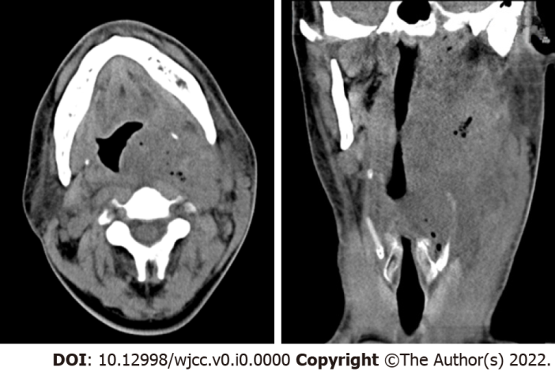
Figure 1 Plain computed tomography revealed a soft tissue mass containing scattered air (dimensions: 9.9 cm × 7.3 cm × 4.6 cm; computed tomography value: 22-34 HU) that had a vague boundary and an irregular shape on the left neck and submaxillary space, and the oropharynx and laryngeal left lateral wall were thickened.
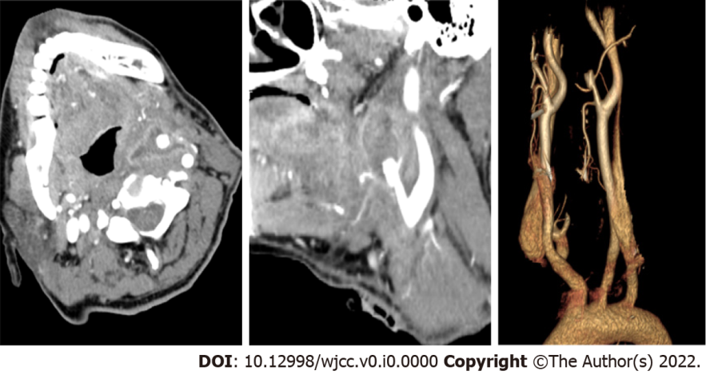
Figure 2 The enhanced computed tomography showed distal occlusion of the left external carotid artery and irregular thickening of the broken ends of the artery encased in an uneven enhancement of soft tissue density.

