Name of Journal: World Journal of Gastroenterology
Manuscript NO: 72588
Manuscript Type: REVIEW

New insights in diagnosis and treatment of gastroenteropancreatic neuroendocrine neoplasms

Yin F et al. Gastroenteropancreatic NENs

Feng Yin, Zi-Hao Wu, Jin-Ping Lai

Feng Yin, Department of Pathology and Anatomical Sciences, University of Missouri, Columbia, MO 65212, United States

Zi-Hao Wu, Department of Surgery, University of Missouri, Columbia, MO 65212, United States

Jin-Ping Lai, Department of Pathology, Kaiser Permanente Sacramento Medical Center, Sacramento, CA 95825, United States

Author contributions: Yin F wrote and finalized the manuscript; Wu ZH critically reviewed the manuscript; Lai JP collected and analyzed the data, made the figures, and finalized the manuscript; all authors have approved the final manuscript.

Corresponding author: Jin-Ping Lai, MD, PhD, Associate Professor, Doctor, Department of Pathology, Kaiser Permanente Sacramento Medical Center, 2025 Morse Ave, Sacramento, CA 95825, United States. jinping.x.lai@kp.org

Received: October 21, 2021
Revised: January 6, 2022
Accepted: April 4, 2022
Published online:

Abstract
Gastroenteropancreatic neuroendocrine neoplasms (GEP-NENs) are rare epithelial neoplasms derived from pluripotent endocrine cells along the gastrointestinal tract and pancreas. GEP-NENs are classified into well-differentiated neuroendocrine tumors and poorly differentiated neuroendocrine carcinomas. Despite overlapping morphological features, GEP-NENs vary in molecular biology, epigenetic, clinical behavior, treatment response, and prognosis features and remain an unmet clinical challenge. In this review, we introduce recent updates on the histopathologic classification, including the tumor grading and staging system, molecular genetics, and systemic evaluation of the diagnosis and treatment of GEP-NENs at different anatomic sites, together with some insights into the diagnosis of challenging and unusual cases. We also discuss the application of novel therapeutic approaches for GEP-NENs, including peptide receptor radionuclide therapy, targeted therapy, and immunotherapy with immune checkpoint inhibitors. These findings will help improve patient care with precise diagnosis and individualized treatment of patients with GEP-NENs.

Key Words: Gastroenteropancreatic neuroendocrine neoplasms; Neuroendocrine tumours; Neuroendocrine carcinoma; World Health Organization classification; Diagnosis; Treatment

Yin F, Wu ZH, Lai JP. New insights in diagnosis and treatment of gastroenteropancreatic neuroendocrine neoplasms. World J Gastroenterol 2022; In press

Core Tip: Gastroenteropancreatic neuroendocrine neoplasms (GEP-NENs) are rare tumors, but their incidence rates have been steadily increasing over the past 3 decades. GEP-NENs consist of a genetically heterogeneous group of tumors ranging from slow-growing well-differentiated neuroendocrine tumor to aggressive, poorly differentiated neuroendocrine carcinoma. Surgery is the cornerstone for the clinical management of localized tumors. However, GEP-NENs have frequently been diagnosed at a later stage and, therefore, remain an unmet clinical challenge. In this review, we discuss recent updates on the histopathologic classification, molecular genetics, and systemic evaluation of diagnosis and treatment of GEP-NENs at different anatomic sites.

INTRODUCTION
Gastroenteropancreatic neuroendocrine neoplasms (GEP-NENs) are epithelial neoplasms with neuroendocrine differentiation that occur inside the gastrointestinal (GI) tract and the pancreas^{[1]}. They are a group of tumors with significant heterogeneity and complex clinical behavior, ranging from slowly growing well-differentiated gastroenteropancreatic neuroendocrine tumors (GEP-NETs) to highly aggressive, poorly differentiated gastroenteropancreatic neuroendocrine carcinomas (GEP-NECs)^{[1-3]}. The traditional term for a NET is carcinoid, which has been largely discouraged in the updated disease classification published by the World Health Organization (WHO)^{[1]}.
GEN-NENs are relatively rare (1.0%-1.5% of all GEP neoplasms, 6.98 and 0.4 new cases per year per 100000 individuals in the United States for GEP-NETs and GEP-NECs, respectively)^{[4-7]}, although their incidence has significantly increased in the past 3 decades, largely due to the improved awareness and detection rate. The majority (> 95%) of GEP-NENs are sporadic, although some (approximately 5%) could be part of syndromic presentations, including multiple endocrine neoplasm type 1 (MEN1), neurofibromatosis type 1 (NF1), and von Hippel–Lindau syndrome (VHL)^{[1-4]}.
Based on the embryological development of the GI tract, GEP-NENs can be divided into foregut (the esophagus to the proximal duodenum and pancreas), midgut (the distal duodenum to proximal two thirds of the transverse colon), and hindgut NENs (distal third of the transverse colon to the rectum)^{[5,6]}, with the midgut (especially the small intestine) being the most common site for GEP-NENs. For example, Figure 1 shows the case of a 71-year-old Caucasian man who was initially identified to have multiple liver masses on computed tomography (CT) scans. CT-guided percutaneous liver needle core biopsy showed poorly differentiated neuroendocrine carcinoma and a small cell type, and the tumor cells were positive for neuroendocrine markers and GI tumor markers. A positron emission tomography (PET)/CT scan revealed the primary lesion in the ileum (Figure 1). In addition, compared with their foregut and hindgut counterparts, midgut NENs are more commonly associated with carcinoid syndrome^{[7]}. In this review, we will discuss anatomic origin and pathologic feature-based classification systems for GEP-NETs as well as the diagnosis and current update of therapy. Based on our practice, we will also share some experience in the work-up of some unusual and challenging cases with diagnostic pitfalls.

Histopathologic Classification
Tumor differentiation is closely associated with the clinical behavior of GEP-NENs and refers to how much the tumor tissue looks like the normal tissue that it was derived from. Based on tumor differentiation and histopathologic features, GEP-NENs can be classified into three major categories: Well-differentiated NETs, poorly differentiated NECs, and mixed neuroendocrine-nonneuroendocrine neoplasms (MiNENs)^{[8]}. Well-differentiated GEP-NETs commonly present with a uniform population of tumor cells with round nuclei and finely stippled “salt-and-pepper” chromatin^{[9]}. Their common growth patterns include nests, trabeculae, acini, and ribbons. On the other hand, poorly differentiated GEP-NECs could be further classified into small-cell NECs and large-cell NECs based on their cytological features and commonly grow in sheets or nests with frequent tumor necrosis^{[10]}. Small-cell NECs have features that include blue cells with scant cytoplasm, finely dispersed chromatin, nuclear molding, smudging, no distinct nucleoli, high mitotic rate, and patterns of rosettes and/or peripheral palisading (Figure 1). Large-cell NECs also have a neuroendocrine architecture and features of large cells with abundant cytoplasm, round and vesicular nuclei, and prominent nucleoli. Some NECs have a concurrent adenocarcinoma component and are categorized as MiNENs^{[11,12]}.
Tumor grade is another important factor closely correlated with the clinical behavior of GEP-NENs. It refers to how abnormal the tumor cells look under a microscope, and in the case of GEP-NENs, the tumor grade is usually determined by the proliferation rate of the tumor cells that could be reported by the mitotic rate (number of mitoses per 2 mm²) and/or the Ki-67 proliferation index (average nuclear immunolabeling based on at least 500 tumor cells) (Table 1). The current guidelines use a 3-tier tumor grading system: Low-grade (grade 1, G1) tumors with a mitotic rate up to 2 per 2 mm² or a Ki-67 proliferation index up to 3%, intermediate-grade (grade 2, G2) tumors with a mitotic rate from 2 to 20 per 2 mm² or a Ki-67 proliferation index from 3% to 20%, and high-grade (grade 3, G3) tumors with a mitotic rate greater than 20 per 2 mm² or a Ki-67 proliferation index greater than 20%^{[13]}. A suggestion has been made to use a Ki-67 proliferation index of 5% as the cutoff level, instead of 3% according to current guidelines, for better risk stratification in patients with G1 to G2 tumors^{[14]}, although additional large-scale studies are needed to validate this proposed cutoff value. Due to the heterogeneity among tumor tissues, a routine practice is to perform measurements in the most mitotically active tumor area. In cases with discrepancies between the mitotic rate and Ki-67 proliferation index, the tumor will be placed into the highest-grade category. A higher Ki-67 proliferation index is associated with a poorer prognosis^{[15]}. In fact, the Ki-67 proliferation index appears to be a better prognostic marker than the mitotic rate for metastatic pancreatic and midgut NENs^{[16]}. Of note, all NECs were high-grade carcinomas with a poorly differentiated morphology and a high Ki-67 proliferation index (> 20%, more than 50% in the majority of the cases) (Figure 1) and high mitotic count (> 20 per 2 mm²). Historically, all G3 GEP-NENs were conceptually equal to NECs before 2017. However, recent studies have clearly demonstrated that G3 GEP-NETs and GEP-NECs are genetically different entities^{[17]}. In general, G3 GEP-NETs are morphologically well differentiated and clinically less aggressive than GEP-NECs and have a poorer response to platinum-based chemotherapy^{[18]}.
All GEP-NENs are characterized by the expression of neuroendocrine markers, with or without secretion of biologically active substances. Immunohistochemical staining is often necessary, not only to confirm the diagnosis and to assign the tumor grade category but also to investigate the tumor origin in cases of metastasis. GEN-NENs are derived from the neuroendocrine epithelium and therefore normally express cytokeratin (CK), with CK8 and CK18 being the most common^{[19]}. The expression of CK could separate GEP-NENs from their great mimics pheochromocytoma/paraganglioma. General neuroendocrine markers are also frequently used in routine practice to establish the diagnosis. Well-differentiated NETs usually express somatostatin receptors. In fact, the expression of somatostatin receptor subtype 2A (SSTR2A) is the basis of functional imaging (such as gallium Ga 68 dotatate) and somatostatin analog (SSA) therapy, including octreotide acetate and peptide receptor radionuclide therapy (PRRT) (such as lutetium Lu 177 dotatate)^{[20]}. Some commonly used neuroendocrine immunohistochemical markers include chromograin A (CgA), synaptophysin (SYN), and CD56. Recent studies have demonstrated INSM1 (insulinoma-associated protein 1) as a novel and more specific marker of neuroendocrine differentiation. In the case of poorly differentiated NECs, INSM1 appears much more sensitive (95%) than CgA (83%) and SYN (82%)^{[21]}. Immunohistochemical staining could also be helpful to identify unknown primary tumors in cases of metastasis. Up to 20% of NETs originally present as liver or bone metastasis from unknown primary tumors, and identification of the primary tumor has significant therapeutic and prognostic implications. The jejunum, ileum, and pancreas appear to be the most common primary sites for patients with NET liver metastases of occult origin^{[22,23]}. CDX2 immunoreactivity is present in the majority of jejuno-ileal NETs, and up to 24% of metastases are primarily pancreatic NETs^{[24]}. The novel marker SATB2 (special AT-rich sequence-binding protein 2) is frequently and strongly expressed in NETs of the lower GI tract and has shown value in assigning NEC sites of origin^{[25]}. For metastatic GEP-NENs, additional immunohistochemical panels include PDX-1 (pancreatic and duodenal homeobox 1), PAX6 (paired Box 6), PAX8 (paired Box 8), ISL1 (islet 1), NESP55 (neuroendocrine secretory protein 55), PR (progesterone receptor), and PrAP (prostate acid phosphatase)^{[26,27]}. We performed PAX6 and PAX8 immunohistochemical staining on 178 NETs, including 110 primary NETs (26 pancreatic, 10 gastric, 12 duodenal, 22 jejuno-ileal, 10 rectal, and 30 pulmonary) and 68 NETs metastatic to the liver (24 pancreatic, 1 duodenal, 37 jejuno-ileal, 1 rectal, and 5 pulmonary). Among primary GEP-NETs, PAX6 and PAX8 were positive in 65% (17/26) and 73% (19/26) of pancreatic, 0% (0/10) and 10% (1/10) of gastric, 92% (11/12) and 92% (11/12) of duodenal, 0% (0/22) and 0% (0/22) of jejuno-ileal, and 90% (9/10) and 80% (8/10) of rectal NETs, respectively. PAX6 and PAX8 positivity was seen in 46% (11/24) and 50% (12/24) of metastatic pancreatic NETs to the liver, respectively. None of the nonpancreatic NETs metastatic to the liver were immunoreactive for either PAX6 or PAX8^{[27]}.

Molecular Genetics
GEP-NENs consist of a biologically distinct group of tumors with great genetic heterogeneity. Largely driven by high-throughput technologies and next-generation sequencing, significant progress has been made in recent years in understanding the key molecular drivers of tumorigenesis and progression, especially pancreatic and small bowel NENs^{[28-30]}. Approximately 10%-20% of pancreatic NETs (P-NETs) are associated with hereditary genetic syndromes, including MEN-1, NF1, VHL, and tuberous sclerosis^{[31]}. In cases with sporadic P-NETs, three types of major molecular alterations have been detected, including somatic mutations in MEN1 (44%), DAXX (death-domain associated protein)/ATRX (alpha thalassaemia/mental retardation syndrome X-linked mutations) (43%), and mammalian target of rapamycin (mTOR) pathway genes such as PTEN, TSC2, and PIK3CA (14%)^{[32]}. Identification of mTOR pathway gene alterations has clinical relevance due to the available targeted therapy. Germline mutations in DNA repair genes, including MUTYH, CHEK2, and BRCA2, have been reported in sporadic P-NETs^{[33]}. Chromosome 18 deletion is detected in 60%-90% of small intestinal NETs (SI-NETs), although its significance is still unclear at this time^{[34]}. Chromosome 14 gain is also frequently detected in advanced and metastatic disease^{[35]}. Approximately 8% of SI-NETs have somatic mutations in CDKN1B^{[36,37]}. A recent study demonstrated that, as epigenetically dysregulated tumors, SI-NETs could be divided into three subgroups: (1) Chromosome 18 deletion with CDKN1B mutations and CpG island methylator phenotype (CIMP) negativity, the largest subgroup (55%) with the most favorable prognosis; (2) The absence of arm-level copy-number variation (CNV) with a high level of CIMP positivity, the subgroup (19%) with intermediate prognosis; and (3) The presence of multiple CNVs, the subgroup (26%) with a young age at onset and the worst prognosis^{[38]}. In addition to P-NETs and SI-NETs, more studies are needed to understand the molecular genetics of GEP-NETs in other anatomic sites.
From a molecular genetics point of view, pancreatic NECs (P-NECs) are entirely biologically different entities from P-NETs. The most common molecular alterations in P-NECs are somatic mutations in TP53, RB1, CDKN2A, and KRAS^{[39]}. Notably, mutations in the TP53 and RB1 genes appear to be recurrent molecular events in GEP-NECs from different anatomic sites, including the stomach and colorectum^{[40]}. KRAS mutations have also been detected in gastric and colorectal NECs, although BRAF mutations have only been reported in colorectal NECs^{[30]}. Interestingly, somatic mutations in DAXX, ATRX, and MEN1 are almost exclusively detected in well-differentiated NETs but not poorly differentiated NECs^{[41]}.
The pathological diagnosis of grade-3 well-differentiated NETs and poorly differentiated NECs could be challenging in some cases because of the high mitotic rate (> 20 per 2 mm²) and high Ki-67 proliferation index (> 20%), particularly for the limited sample made from endoscopic ultrasound-guided fine-needle aspiration (EUS-FNA). The distinct molecular profile could help to separate these two entities. In practice, immunohistochemistry using antibodies against DAXX, ATXR, p53, and RB1 could be performed to surrogate for genetic status^{[42]}. Poorly differentiated NECs frequently have absent RB1 and aberrant p53 protein expression, together with normal expression of DAXX and ATRX. On the other hand, normal RB1 and p53 protein expression is normally found in well-differentiated NETs.

Clinical presentation, Diagnosis, and Treatment
Gastric NENs
Gastric NENs (G-NENs) originate from different neuroendocrine cell types in the gastric mucosa, including enterochromaffin (EC) cells (serotonin producing), enterochromaffin-like (ECL) cells (histamine producing), D-cells (somatostatin producing), and G-cells (gastrin producing)^{[43]}. The diagnosis of G-NENs is usually performed incidentally during upper GI endoscopy due to the lack of specific symptoms, although rare cases could be seen in systemic syndromes, especially Zollinger-Ellison syndrome. Gastric NETs (G-NETs) are commonly subclassified into three distinct types that are mostly derived from ECL cells (Table 2). NETs derived from D cells, G cells, and EC cells are extremely rare.
Type 1 G-NETs are the most common NETs (80%-90%) in the stomach and associated with advanced autoimmune metaplastic atrophic gastritis. It is more commonly seen in females that frequently have additional autoimmune disorders, such as type 1 diabetes mellites and Hashimoto’s thyroiditis. The presence of autoimmune antibodies, including anti-parietal cell antibodies and anti-intrinsic factor antibodies, leads to the destruction of parietal cells and achlorhydria^{[44]}. Laboratory testing shows elevated serum gastrin, decreased vitamin B12, and high gastric pH (> 7). Gastrin induces ECL cell hyperplasia (< 0.5 mm) and ultimately G-NETs when the lesions measure 0.5 mm or larger.
Type 1 G-NETs are usually diagnosed under upper GI endoscopy with biopsy. It usually presents with multiple small (< 1 cm) reddish polyps or nodules of the gastric body (Figure 2A) and fundus. Histologically, type 1 G-NETs show tumor cells with abundant eosinophilic cytoplasm, monotonous round nuclei, and characteristic chromatin arranged in trabecular or nested patterns (Figure 2B and C). Necrosis is not a feature for this type of tumor. The background gastric mucosa shows atrophic gastritis with frequent intestinal metaplasia (Figure 2B and C inset). In addition, the spindle cell morphology of type 1 G-NETs has been reported by us with histological features mimicking spindle cell gastrointestinal stromal tumors (GISTs) (Figure 2D)^{[45]} and therefore represents a potential diagnostic pitfall.
Most type 1 G-NETs are small G1 tumors and are limited to the mucosa and rarely the submucosa. Imaging study is usually unnecessary. However, EUS is likely warranted if the tumor is greater than 1-2 cm due to a higher risk for lymph node metastasis (2%-9%), muscularis propria invasion, and angioinvasion^{[46]}. The management of type 1 G-NET is generally conservative with endoscopic surveillance due to its favorable prognosis. Endoscopic resection could be performed on cases with larger lesions (> 5 mm) (Figure 3). Gastrectomy is only reserved for rare high-risk cases.
Type 2 G-NETs are rare and account for 5%-6% of G-NETs. They occur in Zollinger-Ellison syndrome in the setting of MEN-1 syndrome, and patients are younger. Type 2 G-NETs are usually caused by duodenal gastrinoma^{[47]}. The common clinical presentation includes abdominal pain and watery diarrhea. Laboratory testing shows elevated serum gastrin and low gastric pH (< 2). Additional genetic testing is recommended to confirm MEN-1 syndrome in suspicious cases. Endoscopically, type 2 G-NENs present with multiple gastric polyps or nodules. Multiple gastric peptic ulcers are common findings. These polypoid lesions are usually larger but typically less than 2 cm. The microscopic features of type 2 G-NENs are similar to those of type 1 G-NENs, presenting as low-grade tumors (G1 tumors being the most common) in a background of ECL hyperplasia. However, background gastric mucosa in type 2 G-NETS demonstrates parietal cell hypertrophy/hyperplasia. Type 2 G-NETs are mostly limited to the mucosa and submucosa. It has a higher risk of lymph node metastases (up to 30%) and therefore a slightly worse prognosis than type 1 G-NETs.
The clinical management of type 2 G-NETs also includes endoscopic surveillance, endoscopic resection, and rarely surgery. It is of clinical importance to locate and resect the primary gastrinoma. SSAs have been proposed in the treatment of type 2 G-NETs, although large-scale cohort studies are necessary for their validation.
Type 3 G-NETs are sporadic tumors and account for 10%-15% of all G-NETs. Laboratory testing showed normal serum gastrin and gastric pH. The clinical presentations are nonspecific, including abdominal pain, melena, and weight loss. Carcinoid syndrome could be seen in patients with liver metastases. Endoscopically, the tumor is usually a single large lesion (> 2 cm) arising in the normal background mucosa. These tumors commonly have aggressive clinical behavior, characterized by higher tumor grade, higher tumor stage, and frequent lymph node and distant metastases. The diagnosis involves upper GI endoscopy and biopsy. EUS is required to measure the depth of invasion and to evaluate lymph node status. Additional imaging studies, including computed tomography (CT), magnetic resonance imaging (MRI), and somatostatin receptor scintigraphy (SRS), are recommended for perioperative tumor staging.
Compared with the favorable prognosis in types 1 and 2 G-NETs, type 3 G-NETs frequently present as high-grade and deeply invasive tumors. Lymph node metastases are found in up to 71% of type 3 G-NETs measuring 2 cm or larger^{[48]}. Although endoscopic resection could be applied for small and superficial lesions, radical surgical resection (total or subtotal gastrectomy) with lymphadenectomy is often the treatment of choice for type 3 G-NETs.
Gastric NECs (G-NECs) are poorly differentiated carcinomas with high mitotic counts and frequent necrosis. They have been further subclassified into small cell NECs (SCNECs) and large cell NECs (LCNECs)^{[49]}. Histologically, SCNECs are similar to their counterparts in the lung, featuring small neoplastic cells with scant cytoplasm and hyperchromatic nuclei. Prominent nucleolus is uncommon. In contrast, LCNECs have large neoplastic cells with abundant eosinophilic cytoplasm, vesicular nuclei, and prominent nucleoli. G-NECs are high-grade neoplasms by definition, with a high Ki-67 proliferation index (> 20%, often more than 60%-70%) and a high mitotic rate (> 20 per 2 mm²). For G-NECs, surgical resection is often required, and postoperative chemotherapy is advised in cases with metastatic disease^{[50]}.

Small intestinal NENs
The incidence of small intestinal NENs (SI-NENs) has been increasing steadily over the past 3 decades to 1.05 new cases per 100000 individuals per year^{[51,52]}, and they are the most common GEP-NENs (29.5%) in the United States, followed by the rectum (29.2%) and pancreas (13.5%)^{[52]}. The clinical presentations include nonspecific abdominal pain, mass effects (small bowel obstruction), and symptoms related to excess hormone secretion. Ampullary NENs could cause jaundice and acute or chronic pancreatitis. Duodenal gastrinoma is a cause of Zollinger-Ellison syndrome. Despite relatively slow growth, the small intestine is the most common primary NET site for metastatic disease along the GI tract^{[53]}.
CT scans are the most common imaging modalities for the diagnosis of SI-NENs. Other imaging studies include ultrasound, MRI, and SRS. Endoscopy with biopsy is the gold standard for the diagnosis of SI-NENs. Endoscopic examination of SI-NENs includes capsule endoscopy, colonoscopy, and double-balloon enteroscopy. Duodenal and periampullary NETs are usually single small (< 2 cm) polypoid or nodular lesions limited to the mucosa and submucosa. NETs at the jejunum and ileum are usually large (> 2 cm) and multifocal, with frequent deep invasion and lymph node metastases^{[54]}.
SI-NENs are morphologically similar to NENs at other sites. A few relatively specific histological features include psammoma bodies in somatostatin-producing D-cell NETs and nested growth patterns with peripheral palisading in serotonin-producing EC-cell NETs. Gangliocytic paraganglioma is a rare NET that is typically encountered in the second part of the duodenum and is characterized by the presence of three distinct components: A neuroendocrine epithelioid component, a Schwannian spindle cell component, and a ganglion cell-like component^{[55]}.
For localized SI-NETs, the standard of care is complete surgical resection of the primary tumor, regional lymph nodes, and mesenteric fibrotic tissue. A consensus has not been reached with routine administration of octreotide preoperatively or intraoperatively^{[56]}. For metastatic disease, treatment options are surgical resection, liver-directed therapy (in cases predominantly with liver metastasis), and systemic therapy including SSA, PRRT, everolimus (mTOR inhibitor), and cytotoxic chemotherapy.

Appendiceal NENs
The appendix is a frequent primary site for GEP-NENs, with an incidence rate of approximately 0.15-0.6 new cases per 100000 individuals per year in the United States^{[52,57,58]}. They frequently occur in children and young adults with a slight female predominance^{[59]}. Appendiceal NENs (A-NENs) have the most favorable prognosis among all subgroups of GEP-NENs^{[52]}.
The common clinical presentations of A-NENs are similar to those of acute appendicitis. Carcinoid syndrome is extremely rare in A-NENs and is mostly associated with metastatic disease. Histopathologic evaluation is crucial to establish the diagnosis of A-NENs. The application of imaging studies, including CT and MRI, has limited value for the detection of small primary A-NENs. However, colonoscopy is recommended given that up to 18% of patients with A-NENs have concurrent GI neoplasms^{[60]}.
The majority (80%) of A-NENs are small and only incidentally found in appendectomy specimens^{[52]}. Most A-NENs (60%-75%) are located at the appendiceal tip; therefore, the appendiceal tip should be examined carefully on all appendectomy specimens. The histological features of A-NENs are similar to those of NENs of other primary sites, with the exception of tubular NETs. Tubular NETs are rare benign neoplasms with a predominant tubular growth pattern, so it is important not to misdiagnose them as adenocarcinomas^{[61]}. Of note, goblet cell adenocarcinoma (formerly goblet cell carcinoid) is no longer considered an A-NEN^{[62]}. Currently, we believe that this is an unusual type of adenocarcinoma with neuroendocrine differentiation.
The management of A-NENs depends on the stage of the disease determined by the tumor size, location, and tumor extension. Simple appendectomy is considered adequate for tumors less than 10 mm. Right hemicolectomy is indicated for tumors larger than 20 mm. The implication of right hemicolectomy in A-NETs with a size of 10-20 mm is still controversial, likely depending on the presence of high-risk features (positive margin after appendectomy, base location, Ki-67 index of 3% or higher, > 3 mm mesoappendiceal invasion, angioinvasion, and perineural invasion)^{[63,64]}. For patients with more advanced disease (stages III and IV), the treatment usually includes curative surgery and systemic therapy.

Colorectal NENs
The incidence rates of colonic and rectal NENs are 0.2 and 1.2 new cases per 100000 individuals per year in the United States, respectively^{[52]}. The mean age for colonic NENs is 65 years, which is significantly older than that for rectal NENs (56 years) due to late detection. The presentation of colorectal NENs is similar to that of colorectal adenocarcinoma with nonspecific mass-related effects, abdominal pain, and bleeding. Classic carcinoid symptoms could be seen in some cases, often with liver metastases.
The majority (70%) of colonic NETs (C-NETs) are located on the right side of the colon, especially the cecum^{[65]}. C-NETs are usually larger, with an average size of 4.9 cm^{[66]}. Approximately 30%-40% of C-NETs have local or distant metastasis at the time of presentation. Colonoscopy with biopsy is commonly performed to establish the diagnosis. C-NETs are usually derived from EC cells or Kulchitsky cells within the crypts of Lieburkuhn. Therefore, C-NETs typically show EC cell features, including insular growth patterns and CDX2 immunoreactivity. Necrosis is usually absent. The preferred treatment is colectomy with lymphadenectomy.
Rectal NETs (R-NETs) are relatively smaller (< 1 cm), smooth, round polypoid lesions and generally have a better prognosis than their counterparts in the colon. R-NETs are subgrouped into the L-cell (glucagon-like peptide and pancreatic polypeptide producing) type and non-L-cell type according to their origin^{[67]}, with the L-cell type being the dominant type. L-cell R-NETs typically present with trabecular or tubular growth patterns. Of note, non-L-cell-type rectal NETs usually present as larger masses and have an increased risk of lymphovascular invasion and worse prognosis^{[68]}.
For the purpose of tumor staging, it is recommended to use EUS and MRI of the pelvis to determine the depth of invasion and lymph node status and to use SRS-based scans to determine distant metastases. Endoscopic mucosal resection and endoscopic submucosal dissection are indicated for small (1 cm or smaller) and superficial R-NETs if there is no evidence of muscularis propria invasion or lymph node metastases^{[69]}. For R-NETs larger than 2 cm in size, low anterior resection or abdominal resection is recommended.

Pancreatic NENs
As rare neoplasms, the incidence rate for pancreatic NENs (P-NENs) is 1.0 new cases per 100000 individuals per year in the United States^{[70]} and accounts for 2%-4% of all pancreatic neoplasms^{[71]}. All P-NETs are considered to have malignant potential. These tumors are derived from pancreatic islet cells and could be subclassified into functioning and nonfunctioning subgroups. Functioning P-NETs, including insulinoma, gastrinoma, VIPoma, and glucogonoma, cause clinical hormone hypersecretion syndromes. The clinical presentations of functioning P-NETs are mostly related to hormone effects, such as hyperglycemia in insulinoma and large-volume secretory diarrhea in VIPoma. In contrast, nonfunctioning P-NETs are usually incidental findings on imaging studies for other causes or mass effects at late stages. With the increased use of imaging studies, nonfunctioning P-NENs have become more common, accounting for more than 60% of all P-NENs^{[72]}.
Insulinoma and gastrinoma are the two most common functioning P-NETs. In suspected cases of insulinoma, 72-h fasting tests for blood glucose, insulin, C-peptide, and proinsulin levels should be performed together with drug tests for sulfonylurea. In suspected cases of gastrinoma, laboratory testing includes fasting gastrin level and gastric pH. Laboratory testing for serum glucagon and VIP levels would be helpful for the diagnosis of glucagonoma and VIPoma. The circulating CgA level is also a sensitive and specific diagnostic marker for P-NETs, with the exception of insulinoma^{[73]}, and it has no added value for the diagnosis of nonfunctioning P-NETs.
The most common imaging studies for P-NENs include EUS, CT, MRI, and 68Ga-dotatate PET. Radiolabeled glucagon-like peptide-1 receptor (GLP-1R) scintigraphy is another sensitive tool to detect small insulinomas^{[74]}. Based on our experience, P-NETs could appear as thin-walled cystic lesions with no communication with the pancreatic duct (Figure 4) that clinically and radiologically may mimic mucinous cystic neoplasms. Clinicians and pathologists should be aware of this unusual presentation to avoid misdiagnosis.
Microscopically, P-NETs are well-differentiated neoplasms that do not differ from NETs from other primary sites (Figure 5). One or more neuroendocrine markers (CgA, SYN, CD56, and neuron-specific enolase) and one epithelial marker (cytokeratin AE1/AE3 and CAM5.2) are indicated for the diagnosis of P-NENs. Ki-67 immunoreactivity is warranted to assign tumor grade. Insulin immunoreactivity is necessary in the diagnosis of insulinoma in cases of multifocal tumors or insulinomatosis. In the cases of metastatic disease, some markers (Pax 6, Pax8, ISL-1, PDX-1, and CDX2) could be helpful to determine pancreatic origin^{[75]}.
Surgical resection is the preferred and only curative therapy for P-NENs. Conservative management was suggested for small (< 2 cm) low-grade nonfunctioning P-NETs due to their excellent prognosis^{[76,77]}. However, even for small-sized nonfunctioning P-NETs, surgical resection is indicated in cases with high-risk features (55 years or older, grade 3 tumor, and distant metastases)^{[78]}. Local resection or enucleation could be applied in localized and easily accessible disease to maximally reserve pancreatic tissue^{[79]}, especially if the tumor is located more than 2-3 mm from the pancreatic duct. Depending on the tumor location, surgical resection procedures for P-NENs include partial pancreaticoduodenectomy and distal pancreatectomy. Regional lymphadenectomy is recommended for surgical resection of P-NENs.
P-NENs commonly present with liver metastases. Surgical resection should be considered in metastatic disease for both nonfunctioning and functioning P-NENs. The presence of liver metastases is not a counterindication to surgical management for P-NEN patients^{[80]}. Efforts should be made if surgical removal is feasible for both primary pancreatic tumors and metastatic liver lesions. However, it is still under debate whether to resect the primary tumor in cases of unresectable metastatic liver lesions. Surgical resection of metastatic liver lesions should be avoided in cases with unresectable primary P-NENs^{[81]}.

Novel therapeutic Approaches
The treatment options for advanced and metastatic GEP-NENs have significantly expanded during the past two decades^{[82,83]}. Some important clinical studies, including the PROMID^{[84]} and CLARINET^{[85]} trials, have demonstrated a significant efficacy of SSA in the control of tumor growth in patients with metastatic GEP-NETs. A recent CLARINET FORTE phase 2 clinical trial further supports the clinical benefit of the SSA lanreotide autogel (LAN), which led to significantly improved progression-free survival (PFS) and disease control rate in patients with GEN-NETs, especially in cases with a Ki67 index ≤ 10%^{[86]}. In addition to SSA^{[87]}, novel therapeutic approaches, including PRRT, targeted therapy, and immunotherapy, have demonstrated promising clinical benefits^{[88-90]}.
PRRT is a type of systemic radiotherapy specifically targeting tumor cells expressing SSTR^{[91]}. In the phase 3 NETTER-1 trial, for patients with metastatic well-differentiated midgut NETs, treatment with ¹⁷⁷Lu-dotatate led to a significantly improved PFS (median PFS not reached vs 8.4 mo in the control group with high-dose octreotide alone) and an improved radiographic response rate (18% vs 3% in the control group)^{[92]}. The most common adverse effects for ¹⁷⁷Lu-dotatate are nausea and vomiting. Based on this trial, PRRT with ¹⁷⁷Lu-dotatate has been approved for patients with advanced GEP-NETs and SSTR expression on imaging.
Due to the hypervascularity in GEP-NETs, multiple clinical trials have investigated the therapeutic effects of targeted therapy against vascular endothelial growth factor (VEGF) receptors. In a phase 3 trial, patients with low- to intermediate-grade P-NETs received placebo vs sunitinib, a tyrosine kinase inhibitor targeting multiple receptors, including VEGF receptors-1, 2, and 3. Sunitinib led to a significantly longer median PFS [11.4 mo vs 5.5 mo in the control group; hazard ratio (HR) for progression or death, 0.42; P < 0.001]^{[93]}. Sunitinib has been approved for patients with advanced P-NETs.
mTOR is a multifunctional serine/threonine kinase related to NET growth. mTOR pathway genes, including PTEN, TSC2, and PIK3CA, are also frequently mutated in NETs. Multiple clinical trials have been conducted to test the treatment effect of the mTOR inhibitor everolimus in GEP-NETs. In the RADIANT-3 trial, for patients with advanced P-NETs, everolimus treatment led to a significantly longer median PFS (11 mo vs 4.6 mo in the control group; HR: 0.35)^{[94]}. In the RADIANT-4 trial, patients with advanced nonfunctioning GI and lung NETs had a longer median PFS in the everolimus arm (11 mo vs 3.9 mo in the control group; HR: 0.48)^{[95]}. Everolimus is approved for patients with advanced P-NETs and nonfunctioning GI NETs.
Immune checkpoint inhibitors and antibodies targeting programmed cell death protein-1 (PD-1), programmed cell death protein ligand-1 (PD-L1), or cytotoxic T lymphocyte-associated antigen 4 (CTLA-4), have demonstrated promising therapeutic responses in various types of cancers^{[96]}. Based on the durable antitumor efficacy and favorable safety profile in patients with advanced metastatic Merkel-cell carcinoma, a high-grade cutaneous NEC^{[97]}, immunotherapy has been proposed to be potentially effective for advanced NENs with microsatellite instability, high tumor burden, and/or mutational load^{[98]}. Multiple clinical trials have been conducted to test the efficacy of immunotherapy in GEP-NENs. Currently, these studies only showed very limited therapeutic effects for GEP-NENs^{[99-101]}. Interestingly, in a phase 1b trial on toripalimab (an anti-PD-1 antibody) for patients with high-grade NENs, patients with PD-L1 expression greater than 10% and/or high tumor mutational burden (TMB) had a better objective response rate (ORR) than low PD-L1 (< 10%) (50.0% vs 10.7%, P = 0.019) and low TMB patients (75.0% vs 16.1%, P = 0.03)^{[100]}. Therefore, PD-L1 expression is a potential therapeutic and prognostic biomarker for GEP-NENs.

CONCLUSION
GEP-NENs are relatively rare tumors, although the incidence rates have been steadily increasing over the past three decades. GEP-NENs consist of a genetically heterogeneous group of tumors ranging from slow-growing, well-differentiated NETs to aggressive, poorly differentiated NECs. Great progress has been made toward understanding their unique molecular genetics and combating advanced disease through improved diagnostic tools and effective therapeutic regimens. A multidisciplinary and personalized treatment approach would be crucial to achieve optimal clinical outcomes for patients with GEP-NENs.

REFERENCES
1 Klimstra DSKG, La Rosa S, Rindi G. Classification of neuroendocrine neoplasms of the digestive system. WHO Classification of Tumours Editorial Board, editor. WHO classification of tumours: Digestive system tumours. Lyon: IARC Press; 2019.
2 Jensen RT, Berna MJ, Bingham DB, Norton JA. Inherited pancreatic endocrine tumor syndromes: advances in molecular pathogenesis, diagnosis, management, and controversies. Cancer 2008; 113: 1807-1843 [PMID: 18798544 DOI: 10.1002/cncr.23648]
3 Kidd M, Modlin IM, Bodei L, Drozdov I. Decoding the Molecular and Mutational Ambiguities of Gastroenteropancreatic Neuroendocrine Neoplasm Pathobiology. Cell Mol Gastroenterol Hepatol 2015; 1: 131-153 [PMID: 28210673 DOI: 10.1016/j.jcmgh.2014.12.008]
4 Ito T, Masui T, Komoto I, Doi R, Osamura RY, Sakurai A, Ikeda M, Takano K, Igarashi H, Shimatsu A, Nakamura K, Nakamoto Y, Hijioka S, Morita K, Ishikawa Y, Ohike N, Kasajima A, Kushima R, Kojima M, Sasano H, Hirano S, Mizuno N, Aoki T, Aoki T, Ohtsuka T, Okumura T, Kimura Y, Kudo A, Konishi T, Matsumoto I, Kobayashi N, Fujimori N, Honma Y, Morizane C, Uchino S, Horiuchi K, Yamasaki M, Matsubayashi J, Sato Y, Sekiguchi M, Abe S, Okusaka T, Kida M, Kimura W, Tanaka M, Majima Y, Jensen RT, Hirata K, Imamura M, Uemoto S. JNETS clinical practice guidelines for gastroenteropancreatic neuroendocrine neoplasms: diagnosis, treatment, and follow-up: a synopsis. J Gastroenterol 2021; 56: 1033-1044 [PMID: 34586495 DOI: 10.1007/s00535-021-01827-7]
5 WILLIAMS ED, SANDLER M. The classification of carcinoid tum ours. Lancet 1963; 1: 238-239 [PMID: 14000847 DOI: 10.1016/s0140-6736(63)90951-6]
6 Capelli P, Fassan M, Scarpa A. Pathology - grading and staging of GEP-NETs. Best Pract Res Clin Gastroenterol 2012; 26: 705-717 [PMID: 23582914 DOI: 10.1016/j.bpg.2013.01.003]
7 Cheung VTF, Khan MS. A guide to midgut neuroendocrine tumours (NETs) and carcinoid syndrome. Frontline Gastroenterol 2015; 6: 264-269 [PMID: 28839822 DOI: 10.1136/flgastro-2014-100483]
8 Rindi G, Klimstra DS, Abedi-Ardekani B, Asa SL, Bosman FT, Brambilla E, Busam KJ, de Krijger RR, Dietel M, El-Naggar AK, Fernandez-Cuesta L, Klöppel G, McCluggage WG, Moch H, Ohgaki H, Rakha EA, Reed NS, Rous BA, Sasano H, Scarpa A, Scoazec JY, Travis WD, Tallini G, Trouillas J, van Krieken JH, Cree IA. A common classification framework for neuroendocrine neoplasms: an International Agency for Research on Cancer (IARC) and World Health Organization (WHO) expert consensus proposal. Mod Pathol 2018; 31: 1770-1786 [PMID: 30140036 DOI: 10.1038/s41379-018-0110-y]
9 Anlauf M. Neuroendocrine neoplasms of the gastroenteropancreatic system: pathology and classification. Horm Metab Res 2011; 43: 825-831 [PMID: 22105474 DOI: 10.1055/s-0031-1291307]
10 Ilett EE, Langer SW, Olsen IH, Federspiel B, Kjær A, Knigge U. Neuroendocrine Carcinomas of the Gastroenteropancreatic System: A Comprehensive Review. Diagnostics (Basel) 2015; 5: 119-176 [PMID: 26854147 DOI: 10.3390/diagnostics5020119]
11 La Rosa S, Marando A, Sessa F, Capella C. Mixed Adenoneuroendocrine Carcinomas (MANECs) of the Gastrointestinal Tract: An Update. Cancers (Basel) 2012; 4: 11-30 [PMID: 24213223 DOI: 10.3390/cancers4010011]
12 de Mestier L, Cros J. Digestive system mixed neuroendocrine-non-neuroendocrine neoplasms (MiNEN). Ann Endocrinol (Paris) 2019; 80: 172-173 [PMID: 31064662 DOI: 10.1016/j.ando.2019.04.006]
13 Inzani F, Petrone G, Rindi G. The New World Health Organization Classification for Pancreatic Neuroendocrine Neoplasia. Endocrinol Metab Clin North Am 2018; 47: 463-470 [PMID: 30098710 DOI: 10.1016/j.ecl.2018.04.008]
14 Scarpa A, Mantovani W, Capelli P, Beghelli S, Boninsegna L, Bettini R, Panzuto F, Pederzoli P, delle Fave G, Falconi M. Pancreatic endocrine tumors: improved TNM staging and histopathological grading permit a clinically efficient prognostic stratification of patients. Mod Pathol 2010; 23: 824-833 [PMID: 20305616 DOI: 10.1038/modpathol.2010.58]
15 Singh S, Hallet J, Rowsell C, Law CH. Variability of Ki67 labeling index in multiple neuroendocrine tumors specimens over the course of the disease. Eur J Surg Oncol 2014; 40: 1517-1522 [PMID: 25088936 DOI: 10.1016/j.ejso.2014.06.016]
16 Khan MS, Luong TV, Watkins J, Toumpanakis C, Caplin ME, Meyer T. A comparison of Ki-67 and mitotic count as prognostic markers for metastatic pancreatic and midgut neuroendocrine neoplasms. Br J Cancer 2013; 108: 1838-1845 [PMID: 23579216 DOI: 10.1038/bjc.2013.156]
17 Busico A, Maisonneuve P, Prinzi N, Pusceddu S, Centonze G, Garzone G, Pellegrinelli A, Giacomelli L, Mangogna A, Paolino C, Belfiore A, Kankava K, Perrone F, Tamborini E, Pruneri G, Fazio N, Milione M. Gastroenteropancreatic High-Grade Neuroendocrine Neoplasms: Histology and Molecular Analysis, Two Sides of the Same Coin. Neuroendocrinology 2020; 110: 616-629 [PMID: 31557757 DOI: 10.1159/000503722]
18 Rinke A, Gress TM. Neuroendocrine Cancer, Therapeutic Strategies in G3 Cancers. Digestion 2017; 95: 109-114 [PMID: 28161703 DOI: 10.1159/000454761]
19 Ordóñez NG. Broad-spectrum immunohistochemical epithelial markers: a review. Hum Pathol 2013; 44: 1195-1215 [PMID: 23427873 DOI: 10.1016/j.humpath.2012.11.016]
20 John M, Meyerhof W, Richter D, Waser B, Schaer JC, Scherübl H, Boese-Landgraf J, Neuhaus P, Ziske C, Mölling K, Riecken EO, Reubi JC, Wiedenmann B. Positive somatostatin receptor scintigraphy correlates with the presence of somatostatin receptor subtype 2. Gut 1996; 38: 33-39 [PMID: 8566856 DOI: 10.1136/gut.38.1.33]
21 Bellizzi AM. Immunohistochemistry in the diagnosis and classification of neuroendocrine neoplasms: what can brown do for you? Hum Pathol 2020; 96: 8-33 [PMID: 31857137 DOI: 10.1016/j.humpath.2019.12.002]
22 Wang SC, Parekh JR, Zuraek MB, Venook AP, Bergsland EK, Warren RS, Nakakura EK. Identification of unknown primary tumors in patients with neuroendocrine liver metastases. Arch Surg 2010; 145: 276-280 [PMID: 20231629 DOI: 10.1001/archsurg.2010.10]
23 Mayo SC, de Jong MC, Pulitano C, Clary BM, Reddy SK, Gamblin TC, Celinksi SA, Kooby DA, Staley CA, Stokes JB, Chu CK, Ferrero A, Schulick RD, Choti MA, Mentha G, Strub J, Bauer TW, Adams RB, Aldrighetti L, Capussotti L, Pawlik TM. Surgical management of hepatic neuroendocrine tumor metastasis: results from an international multi-institutional analysis. Ann Surg Oncol 2010; 17: 3129-3136 [PMID: 20585879 DOI: 10.1245/s10434-010-1154-5]
24 Zimmermann N, Lazar-Karsten P, Keck T, Billmann F, Schmid S, Brabant G, Thorns C. Expression Pattern of CDX2, Estrogen and Progesterone Receptors in Primary Gastroenteropancreatic Neuroendocrine Tumors and Metastases. Anticancer Res 2016; 36: 921-924 [PMID: 26976979]
25 Bellizzi AM. SATB2 in neuroendocrine neoplasms: strong expression is restricted to well-differentiated tumours of lower gastrointestinal tract origin and is most frequent in Merkel cell carcinoma among poorly differentiated carcinomas. Histopathology 2020; 76: 251-264 [PMID: 31233624 DOI: 10.1111/his.13943]
26 Maguire A, Brogi E. Sentinel lymph nodes for breast carcinoma: an update on current practice. Histopathology 2016; 68: 152-167 [PMID: 26768036 DOI: 10.1111/his.12853]
27 Lai JP, Mertens RB, Mirocha J, Koo J, Venturina M, Chung F, Mendez AB, Kahn M, Dhall D. Comparison of PAX6 and PAX8 as immunohistochemical markers for pancreatic neuroendocrine tumors. Endocr Pathol 2015; 26: 54-62 [PMID: 25433656 DOI: 10.1007/s12022-014-9346-3]
28 Asa SL, La Rosa S, Basturk O, Adsay V, Minnetti M, Grossman AB. Molecular Pathology of Well-Differentiated Gastro-entero-pancreatic Neuroendocrine Tumors. Endocr Pathol 2021; 32: 169-191 [PMID: 33459926 DOI: 10.1007/s12022-021-09662-5]
29 Mapelli P, Aboagye EO, Stebbing J, Sharma R. Epigenetic changes in gastroenteropancreatic neuroendocrine tumours. Oncogene 2015; 34: 4439-4447 [PMID: 25435371 DOI: 10.1038/onc.2014.379]
30 Mafficini A, Scarpa A. Genetics and Epigenetics of Gastroenteropancreatic Neuroendocrine Neoplasms. Endocr Rev 2019; 40: 506-536 [PMID: 30657883 DOI: 10.1210/er.2018-00160]
31 Esposito I, Segler A, Steiger K, Klöppel G. Pathology, genetics and precursors of human and experimental pancreatic neoplasms: An update. Pancreatology 2015; 15: 598-610 [PMID: 26365060 DOI: 10.1016/j.pan.2015.08.007]
32 Jiao Y, Shi C, Edil BH, de Wilde RF, Klimstra DS, Maitra A, Schulick RD, Tang LH, Wolfgang CL, Choti MA, Velculescu VE, Diaz LA Jr, Vogelstein B, Kinzler KW, Hruban RH, Papadopoulos N. DAXX/ATRX, MEN1, and mTOR pathway genes are frequently altered in pancreatic neuroendocrine tumors. Science 2011; 331: 1199-1203 [PMID: 21252315 DOI: 10.1126/science.1200609]
33 Scarpa A, Chang DK, Nones K, Corbo V, Patch AM, Bailey P, Lawlor RT, Johns AL, Miller DK, Mafficini A, Rusev B, Scardoni M, Antonello D, Barbi S, Sikora KO, Cingarlini S, Vicentini C, McKay S, Quinn MC, Bruxner TJ, Christ AN, Harliwong I, Idrisoglu S, McLean S, Nourse C, Nourbakhsh E, Wilson PJ, Anderson MJ, Fink JL, Newell F, Waddell N, Holmes O, Kazakoff SH, Leonard C, Wood S, Xu Q, Nagaraj SH, Amato E, Dalai I, Bersani S, Cataldo I, Dei Tos AP, Capelli P, Davì MV, Landoni L, Malpaga A, Miotto M, Whitehall VL, Leggett BA, Harris JL, Harris J, Jones MD, Humphris J, Chantrill LA, Chin V, Nagrial AM, Pajic M, Scarlett CJ, Pinho A, Rooman I, Toon C, Wu J, Pinese M, Cowley M, Barbour A, Mawson A, Humphrey ES, Colvin EK, Chou A, Lovell JA, Jamieson NB, Duthie F, Gingras MC, Fisher WE, Dagg RA, Lau LM, Lee M, Pickett HA, Reddel RR, Samra JS, Kench JG, Merrett ND, Epari K, Nguyen NQ, Zeps N, Falconi M, Simbolo M, Butturini G, Van Buren G, Partelli S, Fassan M; Australian Pancreatic Cancer Genome Initiative, Khanna KK, Gill AJ, Wheeler DA, Gibbs RA, Musgrove EA, Bassi C, Tortora G, Pederzoli P, Pearson JV, Waddell N, Biankin AV, Grimmond SM. Whole-genome landscape of pancreatic neuroendocrine tumours. Nature 2017; 543: 65-71 [PMID: 28199314 DOI: 10.1038/nature21063]
34 Kytölä S, Höög A, Nord B, Cedermark B, Frisk T, Larsson C, Kjellman M. Comparative genomic hybridization identifies loss of 18q22-qter as an early and specific event in tumorigenesis of midgut carcinoids. Am J Pathol 2001; 158: 1803-1808 [PMID: 11337378 DOI: 10.1016/S0002-9440(10)64136-3]
35 Andersson E, Swärd C, Stenman G, Ahlman H, Nilsson O. High-resolution genomic profiling reveals gain of chromosome 14 as a predictor of poor outcome in ileal carcinoids. Endocr Relat Cancer 2009; 16: 953-966 [PMID: 19458023 DOI: 10.1677/ERC-09-0052]
36 Crona J, Gustavsson T, Norlén O, Edfeldt K, Åkerström T, Westin G, Hellman P, Björklund P, Stålberg P. Somatic Mutations and Genetic Heterogeneity at the CDKN1B Locus in Small Intestinal Neuroendocrine Tumors. Ann Surg Oncol 2015; 22 Suppl 3: S1428-S1435 [PMID: 25586243 DOI: 10.1245/s10434-014-4351-9]
37 Francis JM, Kiezun A, Ramos AH, Serra S, Pedamallu CS, Qian ZR, Banck MS, Kanwar R, Kulkarni AA, Karpathakis A, Manzo V, Contractor T, Philips J, Nickerson E, Pho N, Hooshmand SM, Brais LK, Lawrence MS, Pugh T, McKenna A, Sivachenko A, Cibulskis K, Carter SL, Ojesina AI, Freeman S, Jones RT, Voet D, Saksena G, Auclair D, Onofrio R, Shefler E, Sougnez C, Grimsby J, Green L, Lennon N, Meyer T, Caplin M, Chung DC, Beutler AS, Ogino S, Thirlwell C, Shivdasani R, Asa SL, Harris CR, Getz G, Kulke M, Meyerson M. Somatic mutation of CDKN1B in small intestine neuroendocrine tumors. Nat Genet 2013; 45: 1483-1486 [PMID: 24185511 DOI: 10.1038/ng.2821]
38 Karpathakis A, Dibra H, Pipinikas C, Feber A, Morris T, Francis J, Oukrif D, Mandair D, Pericleous M, Mohmaduvesh M, Serra S, Ogunbiyi O, Novelli M, Luong T, Asa SL, Kulke M, Toumpanakis C, Meyer T, Caplin M, Meyerson M, Beck S, Thirlwell C. Prognostic Impact of Novel Molecular Subtypes of Small Intestinal Neuroendocrine Tumor. Clin Cancer Res 2016; 22: 250-258 [PMID: 26169971 DOI: 10.1158/1078-0432.CCR-15-0373]
39 Yachida S, Vakiani E, White CM, Zhong Y, Saunders T, Morgan R, de Wilde RF, Maitra A, Hicks J, Demarzo AM, Shi C, Sharma R, Laheru D, Edil BH, Wolfgang CL, Schulick RD, Hruban RH, Tang LH, Klimstra DS, Iacobuzio-Donahue CA. Small cell and large cell neuroendocrine carcinomas of the pancreas are genetically similar and distinct from well-differentiated pancreatic neuroendocrine tumors. Am J Surg Pathol 2012; 36: 173-184 [PMID: 22251937 DOI: 10.1097/PAS.0b013e3182417d36]
40 Makuuchi R, Terashima M, Kusuhara M, Nakajima T, Serizawa M, Hatakeyama K, Ohshima K, Urakami K, Yamaguchi K. Comprehensive analysis of gene mutation and expression profiles in neuroendocrine carcinomas of the stomach. Biomed Res 2017; 38: 19-27 [PMID: 28239029 DOI: 10.2220/biomedres.38.19]
41 Konukiewitz B, Jesinghaus M, Steiger K, Schlitter AM, Kasajima A, Sipos B, Zamboni G, Weichert W, Pfarr N, Klöppel G. Pancreatic neuroendocrine carcinomas reveal a closer relationship to ductal adenocarcinomas than to neuroendocrine tumors G3. Hum Pathol 2018; 77: 70-79 [PMID: 29596894 DOI: 10.1016/j.humpath.2018.03.018]
42 Tang LH, Basturk O, Sue JJ, Klimstra DS. A Practical Approach to the Classification of WHO Grade 3 (G3) Well-differentiated Neuroendocrine Tumor (WD-NET) and Poorly Differentiated Neuroendocrine Carcinoma (PD-NEC) of the Pancreas. Am J Surg Pathol 2016; 40: 1192-1202 [PMID: 27259015 DOI: 10.1097/PAS.0000000000000662]
43 La Rosa S, Vanoli A. Gastric neuroendocrine neoplasms and related precursor lesions. J Clin Pathol 2014; 67: 938-948 [PMID: 25053544 DOI: 10.1136/jclinpath-2014-202515]
44 Rindi G, Bordi C, Rappel S, La Rosa S, Stolte M, Solcia E. Gastric carcinoids and neuroendocrine carcinomas: pathogenesis, pathology, and behavior. World J Surg 1996; 20: 168-172 [PMID: 8661813 DOI: 10.1007/s002689900026]
45 Lee AA, Poddar N, Hammami MB, Veerapong J, Cao D, Lai JP. Gastric Spindle Cell Neuroendocrine Tumor Mimicking Gastrointestinal Stromal Tumor: Unique Morphology and Diagnostic Pitfall. Anticancer Res 2017; 37: 5893-5897 [PMID: 28982917 DOI: 10.21873/anticanres.12035]
46 Scherübl H, Cadiot G, Jensen RT, Rösch T, Stölzel U, Klöppel G. Neuroendocrine tumors of the stomach (gastric carcinoids) are on the rise: small tumors, small problems? Endoscopy 2010; 42: 664-671 [PMID: 20669078 DOI: 10.1055/s-0030-1255564]
47 Chin JL, O'Toole D. Diagnosis and Management of Upper Gastrointestinal Neuroendocrine Tumors. Clin Endosc 2017; 50: 520-529 [PMID: 29207862 DOI: 10.5946/ce.2017.181]
48 Rorstad O. Prognostic indicators for carcinoid neuroendocrine tumors of the gastrointestinal tract. J Surg Oncol 2005; 89: 151-160 [PMID: 15719376 DOI: 10.1002/jso.20179]
49 Gonzalez RS. Diagnosis and Management of Gastrointestinal Neuroendocrine Neoplasms. Surg Pathol Clin 2020; 13: 377-397 [PMID: 32773190 DOI: 10.1016/j.path.2020.04.002]
50 Liu DJ, Fu XL, Liu W, Zheng LY, Zhang JF, Huo YM, Li J, Hua R, Liu Q, Sun YW. Clinicopathological, treatment, and prognosis study of 43 gastric neuroendocrine carcinomas. World J Gastroenterol 2017; 23: 516-524 [PMID: 28210088 DOI: 10.3748/wjg.v23.i3.516]
51 Yao JC, Hassan M, Phan A, Dagohoy C, Leary C, Mares JE, Abdalla EK, Fleming JB, Vauthey JN, Rashid A, Evans DB. One hundred years after "carcinoid": epidemiology of and prognostic factors for neuroendocrine tumors in 35,825 cases in the United States. J Clin Oncol 2008; 26: 3063-3072 [PMID: 18565894 DOI: 10.1200/JCO.2007.15.4377]
52 Dasari A, Shen C, Halperin D, Zhao B, Zhou S, Xu Y, Shih T, Yao JC. Trends in the Incidence, Prevalence, and Survival Outcomes in Patients With Neuroendocrine Tumors in the United States. JAMA Oncol 2017; 3: 1335-1342 [PMID: 28448665 DOI: 10.1001/jamaoncol.2017.0589]
53 Hallet J, Law CH, Cukier M, Saskin R, Liu N, Singh S. Exploring the rising incidence of neuroendocrine tumors: a population-based analysis of epidemiology, metastatic presentation, and outcomes. Cancer 2015; 121: 589-597 [PMID: 25312765 DOI: 10.1002/cncr.29099]
54 Klöppel G, Perren A, Heitz PU. The gastroenteropancreatic neuroendocrine cell system and its tumors: the WHO classification. Ann N Y Acad Sci 2004; 1014: 13-27 [PMID: 15153416 DOI: 10.1196/annals.1294.002]
55 Witkiewicz A, Galler A, Yeo CJ, Gross SD. Gangliocytic paraganglioma: case report and review of the literature. J Gastrointest Surg 2007; 11: 1351-1354 [PMID: 17653595 DOI: 10.1007/s11605-007-0217-9]
56 Howe JR, Cardona K, Fraker DL, Kebebew E, Untch BR, Wang YZ, Law CH, Liu EH, Kim MK, Menda Y, Morse BG, Bergsland EK, Strosberg JR, Nakakura EK, Pommier RF. The Surgical Management of Small Bowel Neuroendocrine Tumors: Consensus Guidelines of the North American Neuroendocrine Tumor Society. Pancreas 2017; 46: 715-731 [PMID: 28609357 DOI: 10.1097/MPA.0000000000000846]
57 Mehrvarz Sarshekeh A, Advani S, Halperin DM, Conrad C, Shen C, Yao JC, Dasari A. Regional lymph node involvement and outcomes in appendiceal neuroendocrine tumors: a SEER database analysis. Oncotarget 2017; 8: 99541-99551 [PMID: 29245922 DOI: 10.18632/oncotarget.20362]
58 Moris D, Tsilimigras DI, Vagios S, Ntanasis-Stathopoulos I, Karachaliou GS, Papalampros A, Alexandrou A, Blazer DG 3RD, Felekouras E. Neuroendocrine Neoplasms of the Appendix: A Review of the Literature. Anticancer Res 2018; 38: 601-611 [PMID: 29374682 DOI: 10.21873/anticanres.12264]
59 Shaib W, Krishna K, Kim S, Goodman M, Rock J, Chen Z, Brutcher E, Staley CI, Maithel SK, Abdel-Missih S, El-Rayes BF, Bekaii-Saab T. Appendiceal Neuroendocrine, Goblet and Signet-Ring Cell Tumors: A Spectrum of Diseases with Different Patterns of Presentation and Outcome. Cancer Res Treat 2016; 48: 596-604 [PMID: 26044156 DOI: 10.4143/crt.2015.029]
60 Boudreaux JP, Klimstra DS, Hassan MM, Woltering EA, Jensen RT, Goldsmith SJ, Nutting C, Bushnell DL, Caplin ME, Yao JC; North American Neuroendocrine Tumor Society (NANETS). The NANETS consensus guideline for the diagnosis and management of neuroendocrine tumors: well-differentiated neuroendocrine tumors of the Jejunum, Ileum, Appendix, and Cecum. Pancreas 2010; 39: 753-766 [PMID: 20664473 DOI: 10.1097/MPA.0b013e3181ebb2a5]
61 Volante M, Grillo F, Massa F, Maletta F, Mastracci L, Campora M, Ferro J, Vanoli A, Papotti M. Neuroendocrine neoplasms of the appendix, colon and rectum. Pathologica 2021; 113: 19-27 [PMID: 33686307 DOI: 10.32074/1591-951X-230]
62 Popa O, Taban SM, Pantea S, Plopeanu AD, Barna RA, Cornianu M, Pascu AA, Dema ALC. The new WHO classification of gastrointestinal neuroendocrine tumors and immunohistochemical expression of somatostatin receptor 2 and 5. Exp Ther Med 2021; 22: 1179 [PMID: 34475969 DOI: 10.3892/etm.2021.10613]
63 Pawa N, Clift AK, Osmani H, Drymousis P, Cichocki A, Flora R, Goldin R, Patsouras D, Baird A, Malczewska A, Kinross J, Faiz O, Antoniou A, Wasan H, Kaltsas GA, Darzi A, Cwikla JB, Frilling A. Surgical Management of Patients with Neuroendocrine Neoplasms of the Appendix: Appendectomy or More. Neuroendocrinology 2018; 106: 242-251 [PMID: 28641291 DOI: 10.1159/000478742]
64 Liu E, Telem DA, Hwang J, Warner RR, Dikman A, Divino CM. The clinical utility of Ki-67 in assessing tumor biology and aggressiveness in patients with appendiceal carcinoids. J Surg Oncol 2010; 102: 338-341 [PMID: 20607756 DOI: 10.1002/jso.21634]
65 Anthony LB, Strosberg JR, Klimstra DS, Maples WJ, O'Dorisio TM, Warner RR, Wiseman GA, Benson AB 3rd, Pommier RF; North American Neuroendocrine Tumor Society (NANETS). The NANETS consensus guidelines for the diagnosis and management of gastrointestinal neuroendocrine tumors (nets): well-differentiated nets of the distal colon and rectum. Pancreas 2010; 39: 767-774 [PMID: 20664474 DOI: 10.1097/MPA.0b013e3181ec1261]
66 Berardi RS. Carcinoid tumors of the colon (exclusive of the rectum): review of the literature. Dis Colon Rectum 1972; 15: 383-391 [PMID: 4561188 DOI: 10.1007/BF02587418]
67 Lee SH, Kim BC, Chang HJ, Sohn DK, Han KS, Hong CW, Lee EJ, Lee JB, Lee DS, Lee IT, Youk EG. Rectal neuroendocrine and L-cell tumors: diagnostic dilemma and therapeutic strategy. Am J Surg Pathol 2013; 37: 1044-1052 [PMID: 23648459 DOI: 10.1097/PAS.0b013e3182819f0f]
68 Sugimoto S, Hotta K, Shimoda T, Imai K, Yamaguchi Y, Nakajima T, Oishi T, Mori K, Takizawa K, Kakushima N, Tanaka M, Kawata N, Matsubayashi H, Ono H. The Ki-67 labeling index and lymphatic/venous permeation predict the metastatic potential of rectal neuroendocrine tumors. Surg Endosc 2016; 30: 4239-4248 [PMID: 26718357 DOI: 10.1007/s00464-015-4735-3]
69 de Mestier L, Brixi H, Gincul R, Ponchon T, Cadiot G. Updating the management of patients with rectal neuroendocrine tumors. Endoscopy 2013; 45: 1039-1046 [PMID: 24163193 DOI: 10.1055/s-0033-1344794]
70 Milan SA, Yeo CJ. Neuroendocrine tumors of the pancreas. Curr Opin Oncol 2012; 24: 46-55 [PMID: 22080942 DOI: 10.1097/CCO.0b013e32834c554d]
71 D'Haese JG, Tosolini C, Ceyhan GO, Kong B, Esposito I, Michalski CW, Kleeff J. Update on surgical treatment of pancreatic neuroendocrine neoplasms. World J Gastroenterol 2014; 20: 13893-13898 [PMID: 25320524 DOI: 10.3748/wjg.v20.i38.13893]
72 Falconi M, Eriksson B, Kaltsas G, Bartsch DK, Capdevila J, Caplin M, Kos-Kudla B, Kwekkeboom D, Rindi G, Klöppel G, Reed N, Kianmanesh R, Jensen RT; Vienna Consensus Conference participants. ENETS Consensus Guidelines Update for the Management of Patients with Functional Pancreatic Neuroendocrine Tumors and Non-Functional Pancreatic Neuroendocrine Tumors. Neuroendocrinology 2016; 103: 153-171 [PMID: 26742109 DOI: 10.1159/000443171]
73 Qiao XW, Qiu L, Chen YJ, Meng CT, Sun Z, Bai CM, Zhao DC, Zhang TP, Zhao YP, Song YL, Wang YH, Chen J, Lu CM. Chromogranin A is a reliable serum diagnostic biomarker for pancreatic neuroendocrine tumors but not for insulinomas. BMC Endocr Disord 2014; 14: 64 [PMID: 25099181 DOI: 10.1186/1472-6823-14-64]
74 Christ E, Wild D, Forrer F, Brändle M, Sahli R, Clerici T, Gloor B, Martius F, Maecke H, Reubi JC. Glucagon-like peptide-1 receptor imaging for localization of insulinomas. J Clin Endocrinol Metab 2009; 94: 4398-4405 [PMID: 19820010 DOI: 10.1210/jc.2009-1082]
75 Koo J, Mertens RB, Mirocha JM, Wang HL, Dhall D. Value of Islet 1 and PAX8 in identifying metastatic neuroendocrine tumors of pancreatic origin. Mod Pathol 2012; 25: 893-901 [PMID: 22388755 DOI: 10.1038/modpathol.2012.34]
76 Bettini R, Partelli S, Boninsegna L, Capelli P, Crippa S, Pederzoli P, Scarpa A, Falconi M. Tumor size correlates with malignancy in nonfunctioning pancreatic endocrine tumor. Surgery 2011; 150: 75-82 [PMID: 21683859 DOI: 10.1016/j.surg.2011.02.022]
77 Lee LC, Grant CS, Salomao DR, Fletcher JG, Takahashi N, Fidler JL, Levy MJ, Huebner M. Small, nonfunctioning, asymptomatic pancreatic neuroendocrine tumors (PNETs): role for nonoperative management. Surgery 2012; 152: 965-974 [PMID: 23102679 DOI: 10.1016/j.surg.2012.08.038]
78 Cherenfant J, Stocker SJ, Gage MK, Du H, Thurow TA, Odeleye M, Schimpke SW, Kaul KL, Hall CR, Lamzabi I, Gattuso P, Winchester DJ, Marsh RW, Roggin KK, Bentrem DJ, Baker MS, Prinz RA, Talamonti MS. Predicting aggressive behavior in nonfunctioning pancreatic neuroendocrine tumors. Surgery 2013; 154: 785-91; discussion 791-3 [PMID: 24074416 DOI: 10.1016/j.surg.2013.07.004]
79 Cauley CE, Pitt HA, Ziegler KM, Nakeeb A, Schmidt CM, Zyromski NJ, House MG, Lillemoe KD. Pancreatic enucleation: improved outcomes compared to resection. J Gastrointest Surg 2012; 16: 1347-1353 [PMID: 22528577 DOI: 10.1007/s11605-012-1893-7]
80 Sarmiento JM, Heywood G, Rubin J, Ilstrup DM, Nagorney DM, Que FG. Surgical treatment of neuroendocrine metastases to the liver: a plea for resection to increase survival. J Am Coll Surg 2003; 197: 29-37 [PMID: 12831921 DOI: 10.1016/S1072-7515(03)00230-8]
81 Jin K, Xu J, Chen J, Chen M, Chen R, Chen Y, Chen Z, Cheng B, Chi Y, Feng ST, Fu D, Hou B, Huang D, Huang H, Huang Q, Li J, Li Y, Liang H, Lin R, Liu A, Liu J, Liu X, Lu M, Luo J, Mai G, Ni Q, Qiu M, Shao C, Shen B, Sheng W, Sun J, Tan C, Tan H, Tang Q, Tang Y, Tian X, Tong D, Wang X, Wang J, Wang J, Wang W, Wang W, Wang Y, Wu Z, Xue L, Yan Q, Yang N, Yang Y, Yang Z, Yin X, Yuan C, Zeng S, Zhang R, Yu X. Surgical management for non-functional pancreatic neuroendocrine neoplasms with synchronous liver metastasis: A consensus from the Chinese Study Group for Neuroendocrine Tumors (CSNET). Int J Oncol 2016; 49: 1991-2000 [PMID: 27826620 DOI: 10.3892/ijo.2016.3711]
82 Pavel M, Öberg K, Falconi M, Krenning EP, Sundin A, Perren A, Berruti A; ESMO Guidelines Committee. Electronic address: clinicalguidelines@esmo.org. Gastroenteropancreatic neuroendocrine neoplasms: ESMO Clinical Practice Guidelines for diagnosis, treatment and follow-up. Ann Oncol 2020; 31: 844-860 [PMID: 32272208 DOI: 10.1016/j.annonc.2020.03.304]
83 Dawod M, Gordoa TA, Cives M, De Mestier L, Crona J, Spada F, Oberg K, Pavel M, Lamarca A. Antiproliferative Systemic Therapies for Metastatic Small Bowel Neuroendocrine Tumours. Curr Treat Options Oncol 2021; 22: 73 [PMID: 34185197 DOI: 10.1007/s11864-021-00863-y]
84 Rinke A, Müller HH, Schade-Brittinger C, Klose KJ, Barth P, Wied M, Mayer C, Aminossadati B, Pape UF, Bläker M, Harder J, Arnold C, Gress T, Arnold R; PROMID Study Group. Placebo-controlled, double-blind, prospective, randomized study on the effect of octreotide LAR in the control of tumor growth in patients with metastatic neuroendocrine midgut tumors: a report from the PROMID Study Group. J Clin Oncol 2009; 27: 4656-4663 [PMID: 19704057 DOI: 10.1200/JCO.2009.22.8510]
85 Caplin ME, Pavel M, Ćwikła JB, Phan AT, Raderer M, Sedláčková E, Cadiot G, Wolin EM, Capdevila J, Wall L, Rindi G, Langley A, Martinez S, Blumberg J, Ruszniewski P; CLARINET Investigators. Lanreotide in metastatic enteropancreatic neuroendocrine tumors. N Engl J Med 2014; 371: 224-233 [PMID: 25014687 DOI: 10.1056/NEJMoa1316158]
86 Pavel M, Ćwikła JB, Lombard-Bohas C, Borbath I, Shah T, Pape UF, Capdevila J, Panzuto F, Truong Thanh XM, Houchard A, Ruszniewski P. Efficacy and safety of high-dose lanreotide autogel in patients with progressive pancreatic or midgut neuroendocrine tumours: CLARINET FORTE phase 2 study results. Eur J Cancer 2021; 157: 403-414 [PMID: 34597974 DOI: 10.1016/j.ejca.2021.06.056]
87 Massironi S, Conte D, Rossi RE. Somatostatin analogues in functioning gastroenteropancreatic neuroendocrine tumours: literature review, clinical recommendations and schedules. Scand J Gastroenterol 2016; 51: 513-523 [PMID: 26605828 DOI: 10.3109/00365521.2015.1115117]
88 Borga C, Businello G, Murgioni S, Bergamo F, Martini C, De Carlo E, Trevellin E, Vettor R, Fassan M. Treatment personalization in gastrointestinal neuroendocrine tumors. Curr Treat Options Oncol 2021; 22: 29 [PMID: 33641005 DOI: 10.1007/s11864-021-00825-4]
89 Cidon EU. New therapeutic approaches to metastatic gastroenteropancreatic neuroendocrine tumors: A glimpse into the future. World J Gastrointest Oncol 2017; 9: 4-20 [PMID: 28144395 DOI: 10.4251/wjgo.v9.i1.4]
90 Cives M, Pelle' E, Strosberg J. Emerging Treatment Options for Gastroenteropancreatic Neuroendocrine Tumors. J Clin Med 2020; 9 [PMID: 33202931 DOI: 10.3390/jcm9113655]
91 Hirmas N, Jadaan R, Al-Ibraheem A. Peptide Receptor Radionuclide Therapy and the Treatment of Gastroentero-pancreatic Neuroendocrine Tumors: Current Findings and Future Perspectives. Nucl Med Mol Imaging 2018; 52: 190-199 [PMID: 29942397 DOI: 10.1007/s13139-018-0517-x]
92 Strosberg J, El-Haddad G, Wolin E, Hendifar A, Yao J, Chasen B, Mittra E, Kunz PL, Kulke MH, Jacene H, Bushnell D, O'Dorisio TM, Baum RP, Kulkarni HR, Caplin M, Lebtahi R, Hobday T, Delpassand E, Van Cutsem E, Benson A, Srirajaskanthan R, Pavel M, Mora J, Berlin J, Grande E, Reed N, Seregni E, Öberg K, Lopera Sierra M, Santoro P, Thevenet T, Erion JL, Ruszniewski P, Kwekkeboom D, Krenning E; NETTER-1 Trial Investigators. Phase 3 Trial of ¹⁷⁷Lu-Dotatate for Midgut Neuroendocrine Tumors. N Engl J Med 2017; 376: 125-135 [PMID: 28076709 DOI: 10.1056/NEJMoa1607427]
93 Fazio N, Kulke M, Rosbrook B, Fernandez K, Raymond E. Updated Efficacy and Safety Outcomes for Patients with Well-Differentiated Pancreatic Neuroendocrine Tumors Treated with Sunitinib. Target Oncol 2021; 16: 27-35 [PMID: 33411058 DOI: 10.1007/s11523-020-00784-0]
94 Yao JC, Shah MH, Ito T, Bohas CL, Wolin EM, Van Cutsem E, Hobday TJ, Okusaka T, Capdevila J, de Vries EG, Tomassetti P, Pavel ME, Hoosen S, Haas T, Lincy J, Lebwohl D, Öberg K; RAD001 in Advanced Neuroendocrine Tumors, Third Trial (RADIANT-3) Study Group. Everolimus for advanced pancreatic neuroendocrine tumors. N Engl J Med 2011; 364: 514-523 [PMID: 21306238 DOI: 10.1056/NEJMoa1009290]
95 Yao JC, Fazio N, Singh S, Buzzoni R, Carnaghi C, Wolin E, Tomasek J, Raderer M, Lahner H, Voi M, Pacaud LB, Rouyrre N, Sachs C, Valle JW, Fave GD, Van Cutsem E, Tesselaar M, Shimada Y, Oh DY, Strosberg J, Kulke MH, Pavel ME; RAD001 in Advanced Neuroendocrine Tumours, Fourth Trial (RADIANT-4) Study Group. Everolimus for the treatment of advanced, non-functional neuroendocrine tumours of the lung or gastrointestinal tract (RADIANT-4): a randomised, placebo-controlled, phase 3 study. Lancet 2016; 387: 968-977 [PMID: 26703889 DOI: 10.1016/S0140-6736(15)00817-X]
96 Bagchi S, Yuan R, Engleman EG. Immune Checkpoint Inhibitors for the Treatment of Cancer: Clinical Impact and Mechanisms of Response and Resistance. Annu Rev Pathol 2021; 16: 223-249 [PMID: 33197221 DOI: 10.1146/annurev-pathol-042020-042741]
97 Kaufman HL, Russell J, Hamid O, Bhatia S, Terheyden P, D'Angelo SP, Shih KC, Lebbé C, Linette GP, Milella M, Brownell I, Lewis KD, Lorch JH, Chin K, Mahnke L, von Heydebreck A, Cuillerot JM, Nghiem P. Avelumab in patients with chemotherapy-refractory metastatic Merkel cell carcinoma: a multicentre, single-group, open-label, phase 2 trial. Lancet Oncol 2016; 17: 1374-1385 [PMID: 27592805 DOI: 10.1016/S1470-2045(16)30364-3]
98 Weber MM, Fottner C. Immune Checkpoint Inhibitors in the Treatment of Patients with Neuroendocrine Neoplasia. Oncol Res Treat 2018; 41: 306-312 [PMID: 29742518 DOI: 10.1159/000488996]
99 Mehnert JM, Bergsland E, O'Neil BH, Santoro A, Schellens JHM, Cohen RB, Doi T, Ott PA, Pishvaian MJ, Puzanov I, Aung KL, Hsu C, Le Tourneau C, Hollebecque A, Élez E, Tamura K, Gould M, Yang P, Stein K, Piha-Paul SA. Pembrolizumab for the treatment of programmed death-ligand 1-positive advanced carcinoid or pancreatic neuroendocrine tumors: Results from the KEYNOTE-028 study. Cancer 2020; 126: 3021-3030 [PMID: 32320048 DOI: 10.1002/cncr.32883]
100 Strosberg J, Mizuno N, Doi T, Grande E, Delord JP, Shapira-Frommer R, Bergsland E, Shah M, Fakih M, Takahashi S, Piha-Paul SA, O'Neil B, Thomas S, Lolkema MP, Chen M, Ibrahim N, Norwood K, Hadoux J. Efficacy and Safety of Pembrolizumab in Previously Treated Advanced Neuroendocrine Tumors: Results From the Phase II KEYNOTE-158 Study. Clin Cancer Res 2020; 26: 2124-2130 [PMID: 31980466 DOI: 10.1158/1078-0432.CCR-19-3014]
101 Vijayvergia N, Dasari A, Deng M, Litwin S, Al-Toubah T, Alpaugh RK, Dotan E, Hall MJ, Ross NM, Runyen MM, Denlinger CS, Halperin DM, Cohen SJ, Engstrom PF, Strosberg JR. Pembrolizumab monotherapy in patients with previously treated metastatic high-grade neuroendocrine neoplasms: joint analysis of two prospective, non-randomised trials. Br J Cancer 2020; 122: 1309-1314 [PMID: 32152503 DOI: 10.1038/s41416-020-0775-0]

Footnotes
Conflict-of-interest statement: The authors declare that they have no competing interests in this study.

Open-Access: This article is an open-access article that was selected by an in-house editor and fully peer-reviewed by external reviewers. It is distributed in accordance with the Creative Commons Attribution NonCommercial (CC BY-NC 4.0) license, which permits others to distribute, remix, adapt, build upon this work non-commercially, and license their derivative works on different terms, provided the original work is properly cited and the use is non-commercial. See: https://creativecommons.org/Licenses/by-nc/4.0/

Provenance and peer review: Invited article; Externally peer reviewed.

Peer-review model: Single blind

Peer-review started: October 21, 2021
First decision: December 27, 2021
Article in press:

Specialty type: Gastroenterology and hepatology
Country/Territory of origin: United States
Peer-review report’s scientific quality classification
Grade A (Excellent): 0
Grade B (Very good): B
Grade C (Good): 0
Grade D (Fair): D
Grade E (Poor): 0

P-Reviewer: Massironi S, Italy; Skrlec I, Croatia S-Editor: Fan JR L-Editor: Wang TQ P-Editor: Fan JR

Figure Legends
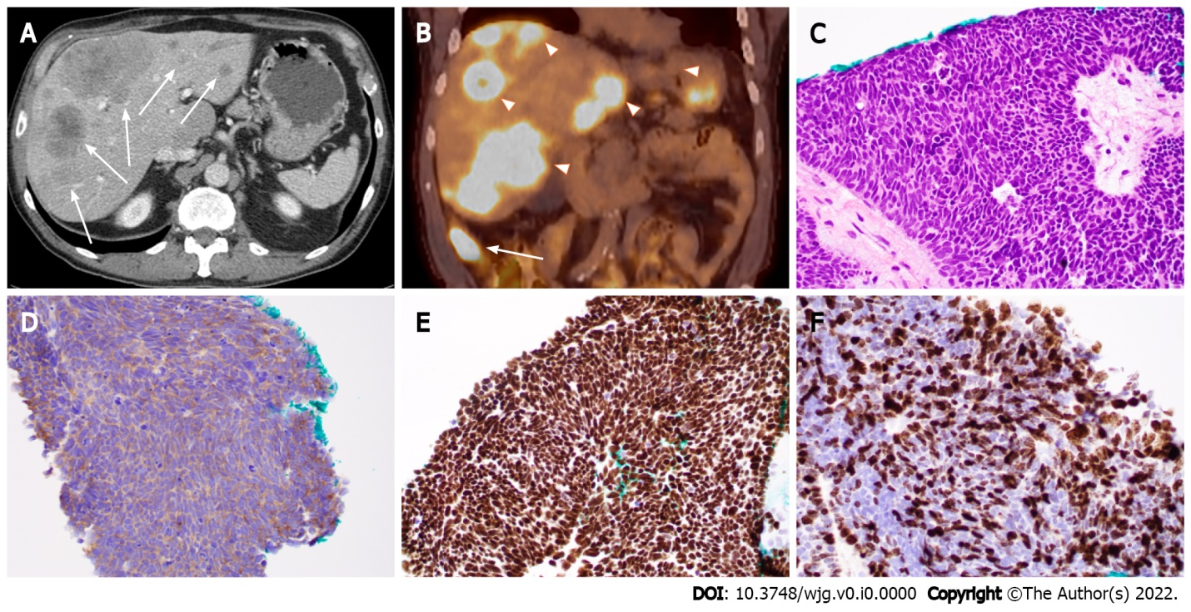
Figure 1 Ileal small cell neuroendocrine carcinoma with liver metastases in a 71-year-old man. A: Computed tomography (CT) image (axial) showing ileal and multifocal liver lesions (arrow); B: Positron emission tomography-CT image showing ileal (arrow) and liver lesions (arrowheads) with hypermetabolic activity; C: Histopathologic features of small cell neuroendocrine carcinoma. Note the tumor cells with peripheral palisading, rosetting, scant cytoplasm, nuclear molding, finely granular chromatin, and lack of prominent nucleoli; D-F: Tumor cells with positive immunoreactivity for synaptophysin (D) and CDX2 (E) as well as a high Ki-67 proliferation index (70%) (F). (C-F: 400 ×).
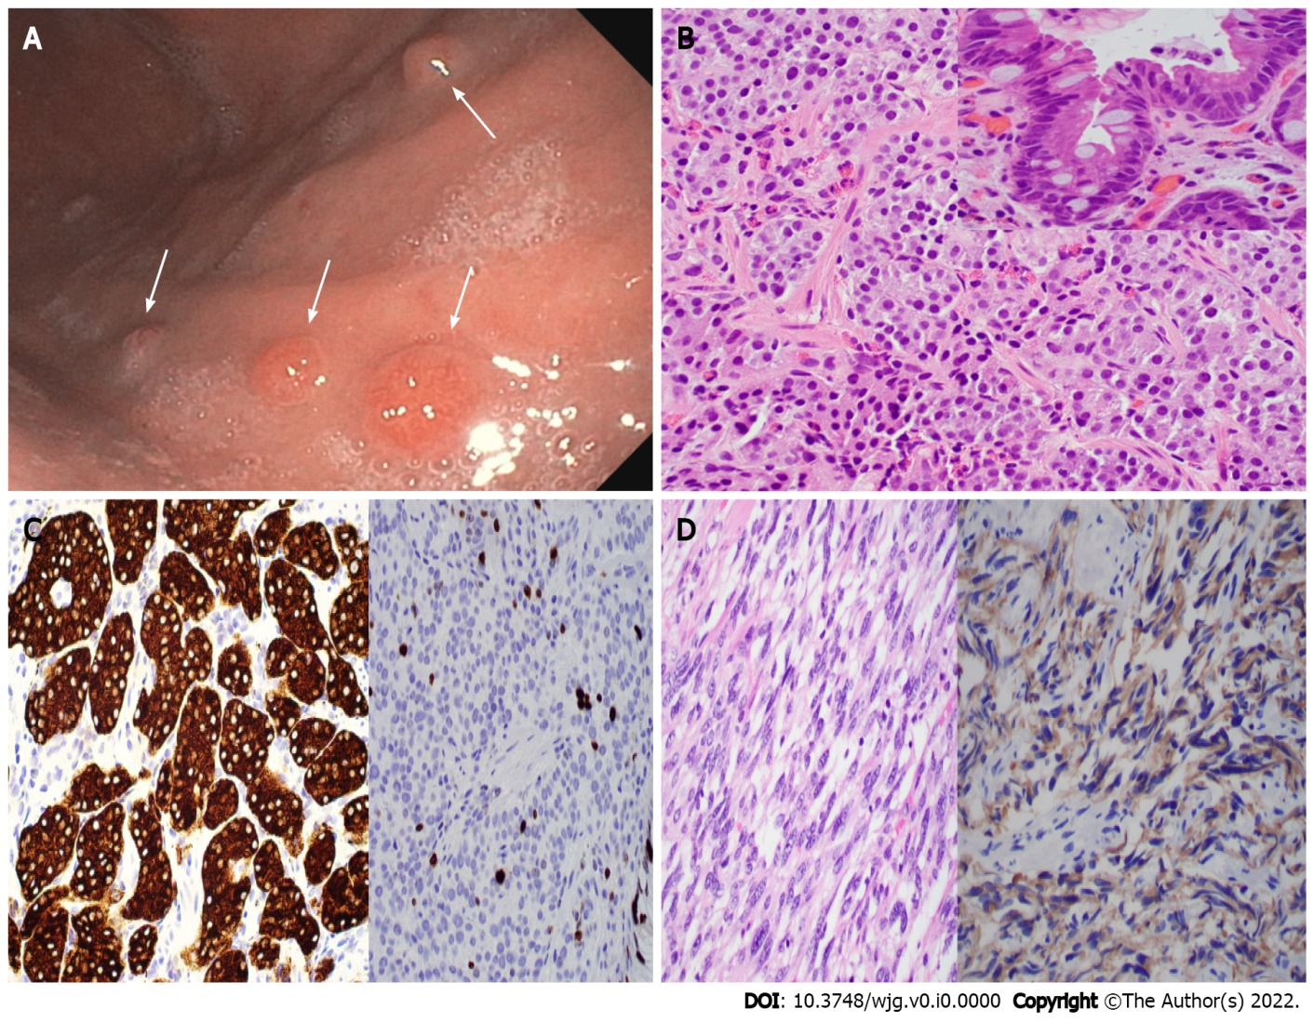
Figure 2 Type 1 gastric neuroendocrine tumor with usual and unusual histology. A: Endoscopic photo showing four nodules (arrows) in the gastric body of a 56-year-old woman with a history of autoimmune chronic atrophic gastritis (ACAG); B and C: Biopsy of the nodules showing well-differentiated neuroendocrine tumor (B, H&E stain, 400 ×) with intestinal metaplasia on the overlying mucosa (B inset), positivity for synaptophysin (C, left), and a 7% Ki67 index (C, right); D: Gastric biopsy in an 83-year-old woman with ACAG showing a neuroendocrine tumor with unusual spindle cell morphology mimicking gastrointestinal stromal tumor (GIST) (left, H&E stain), which is positive for synaptophysin (right) and negative for GIST markers.

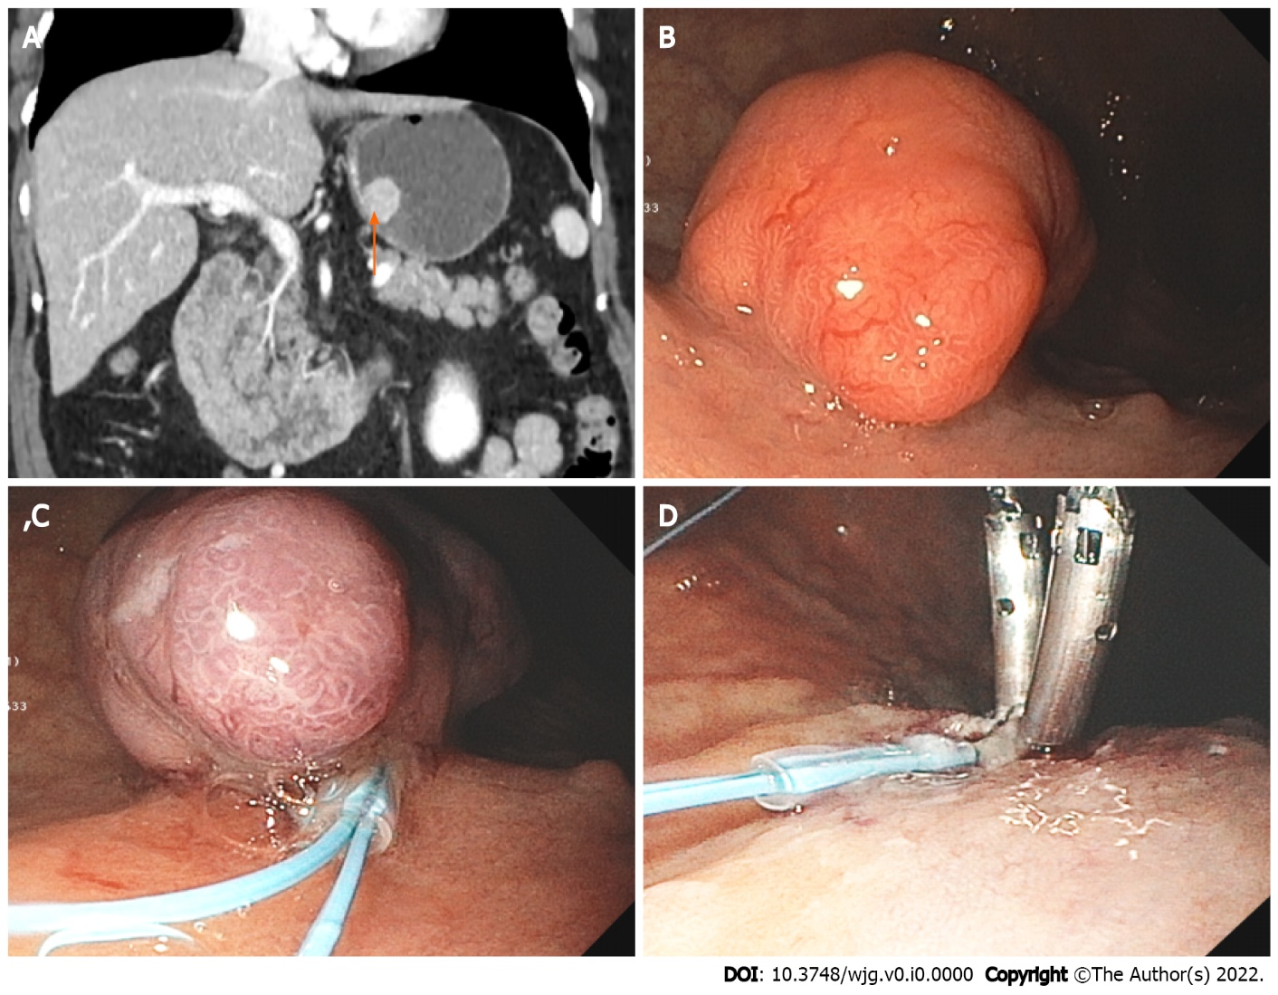
Figure 3 Large gastric neuroendocrine tumor. A: Computed tomography image showing a 2.3 cm mass (arrow) at the posterior wall of the body of a 74-year-old woman with a history of autoimmune chronic atrophic gastritis; B: Endoscopic image showing the large polypoid lesion in the gastric body; C and D: Endoscopic mucosal resection of the polypoid type 1 neuroendocrine tumor.

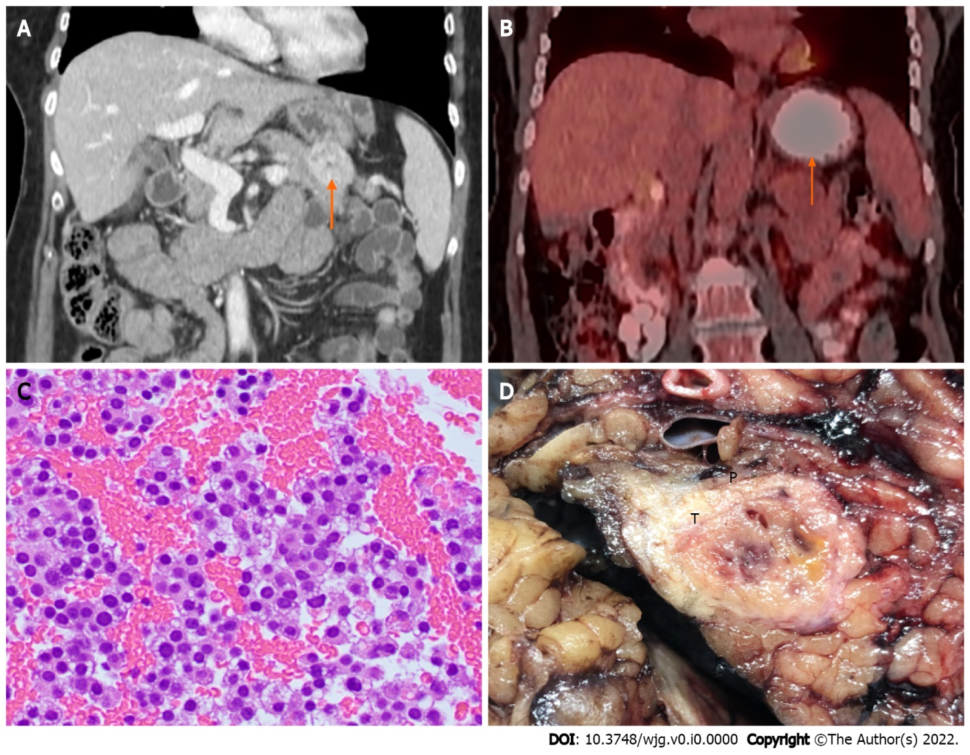
Figure 4 Pancreatic neuroendocrine tumor. A: Computed tomography (CT) image showing a 3.5 cm distal pancreatic mass (arrow); B: Positron emission tomography-CT image showing a pancreatic mass with hypermetabolic activity (SUVmax = 4.3) (arrow); C: Endoscopic ultrasound-guided fine-needle aspiration showing clusters of neuroendocrine tumor cells with round nuclei and fine stippled “salt-and-pepper” chromatin (H&E stain, 400 ×); D: Distal pancreatectomy showing the gross cut surface of a firm fibrotic pancreatic neuroendocrine tumor (T) with focal hemorrhage.

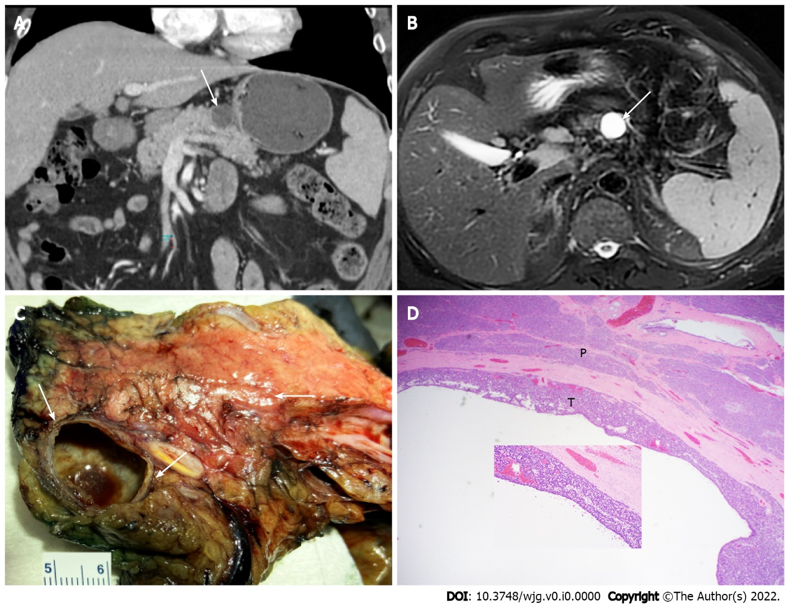
Figure 5 Pancreatic cystic neuroendocrine tumor mimicking mucinous cystic neoplasm. A: Computed tomography image (axial) showing a 2.2 cm cystic lesion (arrow) in the pancreatic body of a 68-year-old man; B: Magnetic resonance imaging (T2, axial) showing the cystic mass (arrow); C: Partial pancreatectomy specimen showing cut surface of the thin-walled cystic pancreatic neuroendocrine tumor mimicking mucinous cystic neoplasm with no communication with the pancreatic duct (arrows); D: Histopathologic features of cystic pancreatic neuroendocrine tumor with acinar and trabecular architecture (T) and surrounding pancreatic parenchyma (P) (H&E stain, 40 ×, inset 200 ×).
Table 1 World Health Organization classification for gastroenteropancreatic neuroendocrine neoplasms¹
 | Differentiation | Mitotic rate (%) | Ki-67 proliferation index (%)
G1 NET | Well-differentiated | < 2 | < 3
G2 NET | Well-differentiated | 2-20 | 3-20
G3 NET | Well-differentiated | > 20 | > 20
SCNEC | Poorly-differentiated | > 20 | > 20
LCNEC | Poorly-differentiated | > 20 | > 20
MiNEN | Well- or poorly-differentiated | Variable | Variable
NET: Neuroendocrine tumor; SCNEC: Small cell neuroendocrine carcinoma; LCNEC: Large cell neuroendocrine carcinoma; MiNEN: Mixed neuroendocrine-non-neuroendocrine neoplasm.
¹Data derived from Klimstra et al^{[1]}
Table 2 Clinicopathologic characteristics of gastric neuroendocrine tumor
 | Type 1 | Type 2 | Type 3
Relative frequency (%) | 70-80 | 5-6 | 10-15
Gender | F > M | F = M | M > F
Cell of origin | ECL | ECL | ECL, EC, etc
Associated disease | AMAG; Pernicious anemia | MEN1; ZES | None (Sporadic)
Site of tumors | Fundus and corpus | Fundus and corpus, occasionally antrum | Anywhere
Size of tumors | < 1 cm | < 2 cm | 2-5 cm
Number of tumors | Multiple | Multiple | Single
Plasma gastrin level | High | High | Normal
Gastric acid output | Low or absent | High | Normal
Metastatic rate (%) | 2-5 | 10-30 | 50-100
Tumor related death (%) | Approximately 0 | < 10 | 25-30
ECL: Enterochromaffin-like cell; EC: Enterochromaffin cell; F: Female; M: Male; AMAG: Autoimmune metaplastic atrophic gastritis; MEN1: Multiple endocrine neoplasm type 1; ZES: Zollinger-Ellison syndrome.

