Name of Journal: World Journal of Clinical Cases
Manuscript NO: 59691
Manuscript Type: CASE REPORT

Idiopathic adulthood ductopenia with elevated transaminase only: A case report

Zhang XC et al. IAD case report

Xiao-Chen Zhang, Di Wang, Xiang Li, Yu-Lin Hu, Chong Wang

Xiao-Chen Zhang, Di Wang, Xiang Li, Yu-Lin Hu, Chong Wang, Department of Hepatology, The First Hospital of Jilin University, Changchun 130021, Jilin Province, China

Author contributions: Zhang XC was the patient’s doctor in charge and was responsible for collecting medical history, reviewing the literature, and drafting the paper; Wang D and Li X were responsible for collecting medical history; Hu YL was the patient’s doctor in charge; Wang C was the patient’s doctor in charge, reviewed the literature and contributed to manuscript revision; All authors gave final approval for the version to be submitted.

Corresponding author: Chong Wang, MD, PhD, Attending Doctor, Department of Hepatology, The First Hospital of Jilin University, No. 71 Xinmin Street, Changchun 130021, Jilin Province, China. wangchong206@sina.com

Received: September 25, 2020
Revised: October 26, 2020
Accepted: November 2, 2020
Published online:

Abstract
BACKGROUND
Idiopathic adulthood ductopenia (IAD) is a chronic cholestatic liver disease of unknown etiology that usually presents as unexplained jaundice. It is characterized by adult onset, lack of autoantibodies, inflammatory bowel disease and loss of interlobular bile ducts.

CASE SUMMARY
This case presents a 27-year-old woman with elevation of transaminases and alkaline phosphatase without clinical symptoms. Five years ago, the patient had abnormal transaminases but no cholestasis. Three months before admission, physical examination revealed an increase in transaminases. Oral hepatoprotective drugs did not show any significant improvement, and she was admitted to hospital for further diagnosis and treatment. Liver biopsy confirmed IAD. After about 2 wk of ursodeoxycholic acid treatment, serological and histological examination showed a significant response.

CONCLUSION
IAD is a manifestation of cholestasis, but also may be an abnormal increase in transaminase in the early stage.

Key Words: Idiopathic adulthood ductopenia; Ductopenic diseases; Liver injury; Cholestasis; Ursodeoxycholic acid; Case report

Zhang XC, Wang D, Li X, Hu YL, Wang C. Idiopathic adulthood ductopenia with elevated transaminase only: A case report. World J Clin Cases 2020; In press

Core Tip: Idiopathic adulthood ductopenia (IAD) is a chronic cholestatic liver disease that has unclear etiology, usually manifested as cholestasis. We report a case with no cholestasis or obvious clinical symptoms, only an increase in transaminases. The diagnosis of IAD relies on liver tissue biopsy. However, this examination is invasive and thus not acceptable by all patients. Therefore, in the clinical diagnostic process, many cases of unexplained liver damage and jaundice are missed. Furthermore, this case proved that the application of ursodeoxycholic acid has an obvious positive effect in the treatment of IAD.
INTRODUCTION
Idiopathic adulthood ductopenia (IAD) is a rare chronic liver disease that is often misdiagnosed. IAD was first described in 1988 by Ludwig et al^{[1]}, with interlobular bile ducts disappearing without a clear origin^{[2]}. So far, less than 100 cases have been reported^{[3]}. In recent years, the pathology and pathogenesis of bile duct loss have been widely studied, and a number of hepatobiliary diseases have been added to the list of ductopenic diseases^{[4]}. IAD is a special type of ductopenic disease that is characterized by adult onset, autoantibodies negative, inflammatory bowel disease and absence of interlobular bile ducts^{[5]}.
This report presents a case that had no obvious clinical symptoms. The patient was diagnosed with IAD and was treated with ursodeoxycholic acid (UDCA).

CASE PRESENTATION
Chief complaints
A 27-year-old female was hospitalized for continuous elevation of transaminases and alkaline phosphatase without clinical symptoms or signs.

History of present illness
The patient had abnormally elevated transaminases at physical examination 5 years ago, but this was not concerning to her. The patient found abnormal transaminases again at physical examination 2 years ago, and was admitted to the hospital. After admission, the patient was tested for ceruloplasmin, which was negative. The patient had no viral hepatitis markers, and autoantibodies were absent. The patient was discharged from the hospital when her liver function improved after hepatoprotective treatment. In the past 2 years, liver function was rechecked three times, and it was still abnormal. Liver function test results 3 mo before the present admission were: aspartate transaminase (AST) 213.8 U/L (0-40 U/L), alanine transaminase (ALT) 321.8 U/L (0-40 U/L), alkaline phosphatase (ALP) 317 U/L (15-112 U/L) and γ-glutamyltransferase (GGT) 172.1 U/L (7-32 U/L). After oral bicyclol treatment (25 mg/d), liver function was rechecked 8 d before admission, showing the following results: AST 251 U/L (13-35 U/L), ALT 419 U/L (7-40 U/L), ALP 337 U/L (35-100 U/L) and GGT 232 U/L (7-45 U/L). There were no improvements, so the patient was admitted to the hospital again.

History of past illness
The patient had taken oral Chinese medicine to treat folliculitis 3 years ago.

Personal and family history
The patient did not have any family history.

Physical examination
The liver area was sensitive to light palpation, and there were no obvious positive signs.

Laboratory examinations
Her liver function results were as follows: AST 169.5 U/L, ALT 261.5 U/L, ALP 231.6 U/L and GGT 167.7 U/L; erythrocyte sedimentation rate: 24 mm/h (2-20 mm/h); five items of immunity: immunoglobulin G 21.50 g/L (6-16 g/L), complement C3 1.47 g/L (0.7-1.28 g/L) and antinuclear antibody normal. There were no abnormalities in hepatitis B and C markers, Treponema pallidum antibody, anti-human immunodeficiency virus antibody, antimitochondrial antibody M2 and tumor markers.

Imaging examinations
Multi-row computed tomography of the liver, gallbladder, spleen and pancreas demonstrated diffuse fatty liver or chronic liver injury.

Further diagnostic work-up
After 5 d of hepatoprotective treatment, the liver function was rechecked, with AST 130.4 U/L, ALT 84.8 U/L, ALP 236.9 U/L and GGT 194.4 U/L. AST and ALT decreased significantly, but ALP and GGT did not improve significantly. After that, liver biopsy was performed, and the pathological results suggested the following: (1) Local I with balloon-like degeneration of hepatocytes, mild expansion and fibrosis in some portal areas, infiltration of plasma cells and a few lymphocytes in the stroma. (2) Part of the inherent bile duct disappeared (> 50%), degeneration of the bile duct and mild hyperplasia of the thin bile duct (Figure 1). It was recommended to exclude vanishing bile duct syndrome. Pathological results at Beijing Youan Hospital were: (1) Vanishing bile duct syndrome; (2) more plasma cell infiltration and focal interfacial inflammation in portal areas and (3) lobular hepatitis in the recovery period that may have been related to recent medication.

FINAL DIAGNOSIS
IAD

TREATMENT
The patient was given UDCA (250 mg twice daily) after admission.

OUTCOME AND FOLLOW-UP
Re-examination of liver function after 2 wk of treatment showed that AST and ALT had returned to normal, and ALP was 146.1 U/L and GGT 114.8 U/L. According to the pathological results, the treatment was considered effective.

DISCUSSION
This patient was a young female without a clear cause of IAD. A retrospective medical history revealed that there were abnormal transaminases 5 years ago, but no cholestasis. There were no obvious clinical symptoms, but only mild percussion pain in the liver area. Imaging examinations after admission suggested chronic liver injury. The abnormal liver function was mainly due to elevated a-fetoprotein and GGT accompanied by mild cholestasis, so autoimmune liver disease was considered. Related laboratory tests excluded the possibility of autoimmune hepatitis and primary biliary cholangitis. Although the patient had a history of oral Chinese medicine, liver function tests showed abnormal transaminases before taking the medicine, so it is unlikely that IAD was caused by drug-induced liver injury. Therefore, the diagnosis depended on liver biopsy. The patient had a normal extrahepatic biliary tract and had no evidence of inflammatory bowel disease. A liver biopsy specimen presented loss of interlobular bile ducts from > 50% of the portal area. Combined with liver histological features, a diagnosis of IAD was made.
The diagnostic criteria for IAD include the following: (1) The patient must be an adult or at least an adolescent; (2) biopsy ought to show a reduction in intrahepatic bile ducts in at least 50% of the portal areas; and (3) there should be no identifiable causes of cholestasis^{[1]}. As for therapy, related research has shown that some patients have improvement in liver function tests with UDCA^{[6]}. Since the patient was admitted to hospital, she has been treated with UDCA. Liver biopsy can establish whether UDCA is effective for treatment of IAD. However, for patients with rapid disease progression, UDCA does not improve the condition, and they will ultimately require liver transplantation^{[7]}. Cirrhosis caused by IAD has been reported in some cases, and its progression is faster than other types of cirrhosis^{[8]}.

CONCLUSION
IAD is a manifestation of cholestasis, but also may be an abnormal increase in transaminase in the early stage. For liver injury of unknown cause, when we exclude primary biliary cholangitis, autoimmune hepatitis and drug-induced liver injury, liver biopsy can be performed to clarify the diagnosis. For patients who have been diagnosed, long-term UDCA treatment should be used to reduce liver cell damage and help with liver cell repair and bile duct regeneration and reconstruction. UDCA has a positive effect on the long-term prognosis of the disease. Further examinations are still necessary to evaluate the recovery of bile ducts and arrest the disease progress in a timely manner.

REFERENCES
1 Ludwig J. Idiopathic adulthood ductopenia: an update. Mayo Clin Proc 1998; 73: 285-291 [PMID: 9511789 DOI: 10.4065/73.3.285]
2 Ludwig J, Wiesner RH, LaRusso NF. Idiopathic adulthood ductopenia. A cause of chronic cholestatic liver disease and biliary cirrhosis. J Hepatol 1988; 7: 193-199 [PMID: 3057064 DOI: 10.1016/s0168-8278(88)80482-3]
3 Bilal M, Kazemi A, Babich M. Idiopathic Adulthood Ductopenia: 'It Is Out There'. Case Rep Gastroenterol 2016; 10: 95-98 [PMID: 27403109 DOI: 10.1159/000444443]
4 Nakanuma Y, Tsuneyama K, Harada K. Pathology and pathogenesis of intrahepatic bile duct loss. J Hepatobiliary Pancreat Surg 2001; 8: 303-315 [PMID: 11521175 DOI: 10.1007/s005340170002]
5 Park BC, Park SM, Choi EY, Chae HB, Yoon SJ, Sung R, Lee SK. A case of idiopathic adulthood ductopenia. Korean J Intern Med 2009; 24: 270-273 [PMID: 19721865 DOI: 10.3904/kjim.2009.24.3.270]
6 Moreno A, Carreño V, Cano A, González C. Idiopathic biliary ductopenia in adults without symptoms of liver disease. N Engl J Med 1997; 336: 835-838 [PMID: 9062092 DOI: 10.1056/nejm199703203361204]
7 Müller C, Ulrich W, Penner E. Manifestation late in life of idiopathic adulthood ductopenia. Liver 1995; 15: 213-218 [PMID: 8544645 DOI: 10.1111/j.1600-0676.1995.tb00673.x]
8 Douglass KM, Willner IR, Glenn DJ, Jones RM. Idiopathic Adulthood Ductopenia Causing Cirrhosis. ACG Case Rep J 2020; 7: e00349 [PMID: 32337312 DOI: 10.14309/crj.0000000000000349]

Footnotes
Informed consent statement: Informed consent was obtained from the patient in this report.

Conflict-of-interest statement: The authors declare that they have no conflict of interest.

CARE Checklist (2016) statement: The authors have read the CARE Checklist (2016), and the manuscript was prepared and revised according to the CARE Checklist (2016).

Open-Access: This article is an open-access article that was selected by an in-house editor and fully peer-reviewed by external reviewers. It is distributed in accordance with the Creative Commons Attribution NonCommercial (CC BY-NC 4.0) license, which permits others to distribute, remix, adapt, build upon this work non-commercially, and license their derivative works on different terms, provided the original work is properly cited and the use is non-commercial. See: http://creativecommons.org/Licenses/by-nc/4.0/

Manuscript source: Unsolicited manuscript

Peer-review started: September 25, 2020
First decision: October 18, 2020
Article in press:

Specialty type: Medicine, research and experimental
Country/Territory of origin: China
Peer-review report’s scientific quality classification
Grade A (Excellent): 0
Grade B (Very good): 0
Grade C (Good): C
Grade D (Fair): 0
Grade E (Poor): 0

P-Reviewer: Frascio M S-Editor: Gao CC L-Editor: Filipodia P-Editor:

Figure Legends
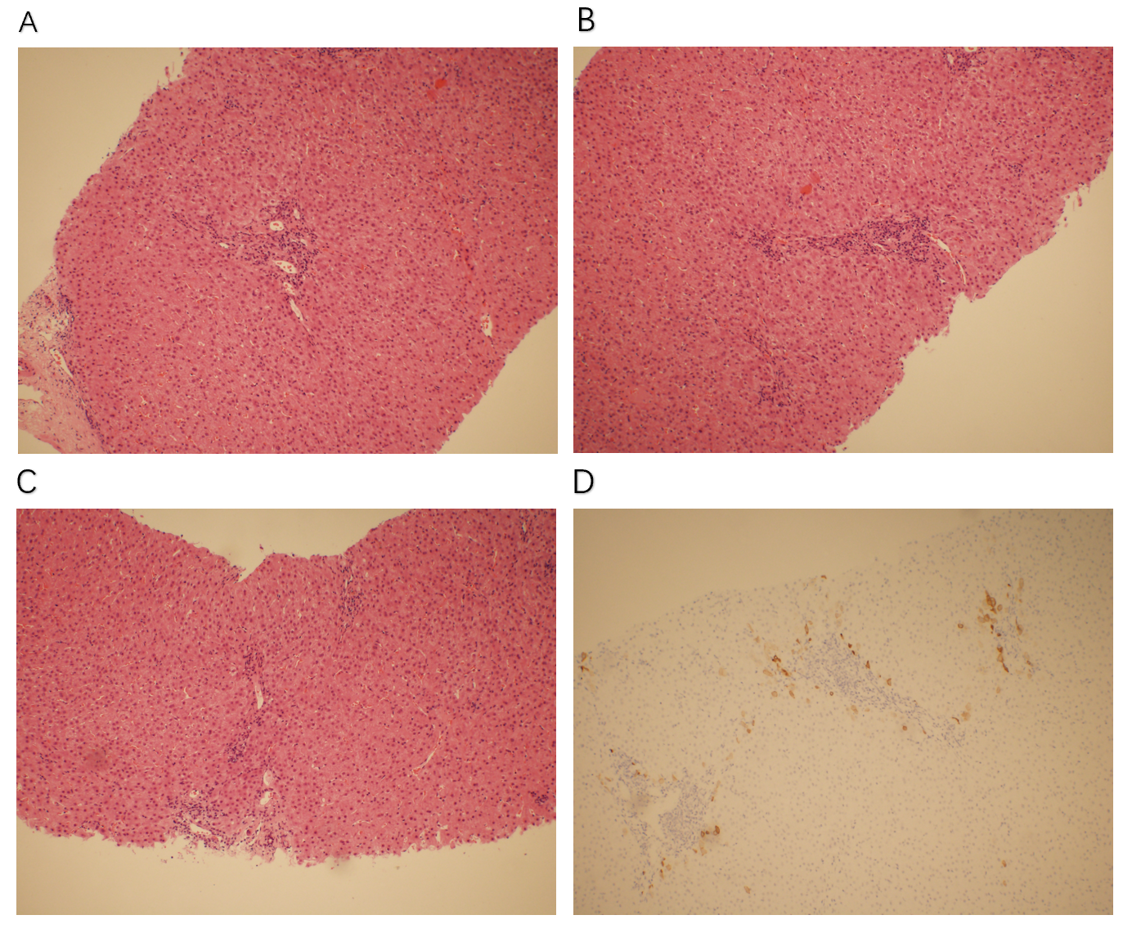
Figure 1 Pathology and immunohistochemical staining. A-C: Liver pathology staining showing plasma cell infiltration and focal interfacial inflammation in the confluence area and mild interfacial inflammation; D: Immunohistochemical staining of cytokeratin 7 showing that most of the intrahepatic bile ducts were missing (> 50%).

