Name of Journal: World Journal of Clinical Oncology
Manuscript NO: 87227
Manuscript Type: ORIGINAL ARTICLE

Basic Study
Comprehensive analysis of disulfidptosis related genes and prognosis of gastric cancer

Li Q et al. Relationship between DRGs and GC

Qian Li, Long-Kuan Yin

Qian Li, Department of Oncology, Fushun Hospital of Traditional Chinese Medicine, Zigong 643200, Sichuan Province, China

Long-Kuan Yin, Department of Gastrointestinal Surgery, Fushun People’s Hospital, Zigong 643200, Sichuan Province, China

Author contributions: Li Q contributed to this work; Yin LK and Li Q prepared for the figures and tables; and all authors have approved the final manuscript.

Corresponding author: Long-Kuan Yin, Doctor, Researcher, Department of Gastrointestinal Surgery, Fushun People’s Hospital, No. 490 Jixiang Road, Fushi Town, Zigong 643200, Sichuan Province, China. 782286066@qq.com

Received: July 30, 2023
Revised: September 7, 2023
Accepted: September 18, 2023
Published online: October 24, 2023

Abstract
BACKGROUND
Gastric cancer (GC) is a common malignant tumor of the digestive system. Disulfidptosis is a new programmed cell death mechanism, although its specific mechanism in GC is incompletely understood.

AIM
In this study, we used bioinformatics analysis to explore a disulfidptosis-based predictive model related to GC prognosis and to identify potential therapeutic targets and sensitive drugs for GC.

METHODS
We extracted GC-related data from The Cancer Genome Atlas and Gene Expression Omnibus databases. R software (version 4.2.1) was used for correlation analysis.

RESULTS
Through the above analysis, we found that the disulfidptosis related gene may be related to the prognosis of GC. Six genes, namely, PLS3, GRP, APOD, SGCE, COL8A1, and VAMP7, were found to constitute a predictive model for GC prognosis. APOD is a potential therapeutic target for treating GC. Bosutinib and other drugs are sensitive for the treatment of GC.

CONCLUSION
The results of this study indicate that disulfidptosis is related to the prognosis and treatment of GC, while APOD represents a potential therapeutic target for GC.

Key Words: Gastric cancer; Disulfidptosis; Drugs; Prognosis; Targets

©The Author(s) 2023. Published by Baishideng Publishing Group Inc. All rights reserved.

Citation: Li Q, Yin LK. Comprehensive analysis of disulfidptosis related genes and prognosis of gastric cancer. World J Clin Oncol 2023; 14(10): 373-399
URL: https://www.wjgnet.com/2218-4333/full/v14/i10/373.htm
DOI: https://dx.doi.org/10.5306/wjco.v14.i10.373

Core Tip: Gastric cancer (GC) is a common malignant tumor of the digestive system. Disulfidptosis is a new programmed cell death mechanism. The specific mechanism of disulfidptosis in GC is not fully understood. This study found that the disulfidptosis related gene may be related to the prognosis of gastric cancer. PLS3, GRP, APOD, SGCE, COL8A1, VAMP7, these six genes constitute a predictive model for gastric cancer prognosis. APOD is a potential therapeutic target. Bosutinib and other drugs are sensitive for the treatment of gastric cancer.

INTRODUCTION
Gastric cancer (GC) is a common cause of cancer-related death worldwide, with a particularly high incidence in East Asia, such as South Korea, China, and Japan^{[1-9]}. The early clinical symptoms of GC are not obvious and lack specificity^{[10-14]}, which leads to a low rate of early diagnosis^{[15-26]}. Most patients with GC are diagnosed late and have a poor prognosis^{[27-40]}. Although the diagnosis and treatment strategies for GC have gradually increased in recent decades, the prognosis of advanced GC remains poor^{[41-47]}. Therefore, there is an urgent need to find more biomarkers as novel therapeutic targets and to develop new drugs to improve diagnosis and treatment measures and, consequently, patient survival and prognosis.
GC is a heterogeneous disease^{[48]}, with previous studies suggesting that various cell programmed death mechanisms, including ferroptosis^{[49-54]} and cuproptosis^{[55-58]}, represent novel research directions for GC. In recent years, it has been found that disulfidptosis^{[59]}, a novel and poorly studied mechanism of programmed cell death, represents a previously uncharacterized form of cell death induced by abnormal accumulation of disulfide in cells under glucose starvation, which is different from copper death and iron death. However, its role in GC and its related mechanisms are still unclear and need to be further explored.
In this study, we analyzed the sequencing data of tumor tissues from databases such as The Cancer Genome Atlas (TCGA)^{[60]} and Gene Expression Omnibus (GEO) (Supplementary material)^{[61]} and 14 disulfidptosis-related gene (DRGs)^{[59]} (ACTN4, ACTB, CD2AP, CAPZB, DSTN, FLNA, FLNB, INF2, IQGAP1, MYH10, MYL6, MYH9, PDLIM1, and TLN1). We conducted differential analysis of DRGs, as well as analyses of the tumor mutation burden (TMB)^{[62,63]}, copy variations, gene ontology (GO)^{[64]}, and the kyoto encyclopedia of genes and genomes (KEGG)^{[65]}, among others. In this paper, the mechanism of DRGs involved in the occurrence and development of GC is discussed, and new therapeutic targets and drugs that may be related to the prognosis of GC are preliminarily analyzed and screened from a new perspective.

MATERIALS AND METHODS
Data downloading and processing
Expression data, clinical data, mutation data, and copy data related to GC were downloaded and organized from TCGA database. The GSE84433 and GSE26253 datasets and their platform annotation files were downloaded from the GEO database. Data were analyzed and processed using R software (version 4.2.1) and Perl software (version 5.30.0).

Differential and prognostic analyses
GC-related data were extracted from TCGA database and analyzed in combination with the disulfidptosis-related gene. Differential analysis, mutation load analysis, copy number variation frequency analysis, and survival analysis were performed using R software.

Disulfidptosis subtype analysis
R software was used to classify all samples related to the disulfidptosis-related gene in TCGA and GEO databases for survival analysis, heatmap clustering, gene set variation analysis (GSVA), immune cell differential analysis, subtype differential analysis, and GO and KEGG enrichment analyses.

Significant differential gene subtyping, prediction model construction, and analysis
We continued to perform survival analysis, heatmap clustering, and differential analysis of the DRGs on the samples classified by differential gene subtyping. Then, we randomly divided the significant differential samples into groups and performed least absolute shrinkage and selection operator (LASSO) regression analysis and univariate and multivariate Cox regression analyses and constructed a prognostic model. Using the prognostic model, we calculated the risk score for each patient sample using the following formula:.where Coef_{i} is the coefficient, and X_{i} is the expression level of the gene. We constructed a prognostic evaluation model for overall survival based on the risk score. We then constructed a Sankey diagram and analyzed the differences in risk scores between subtypes and the differential risk of the DRGs.

Prognostic model validation
The reliability of the prognostic model was verified by survival analysis, receiver operating characteristic (ROC) curve mapping, risk curve mapping, survival state map, and clustering heatmap of model genes in each subgroup.

Nomogram construction and analysis of the correlation between risk score and immunity, as well as drug susceptibility
Next, the independent prognostic factors of GC and potential therapeutic targets were sought by constructing the column diagram, and survival analysis of potential prognostic genes was performed by Gene Expression Profiling Interactive Analysis (GEPIA). Subsequently, immune cell correlation analysis, tumor microenvironment (TME) difference analysis, waterfall map construction, tumor mutation load analysis, microsatellite instability (MSI), stem cell correlation analysis, and drug sensitivity analysis were performed for the risk score.

Immunohistochemical analysis
We conducted immunohistochemical analysis of APOD using the human protein atlas (HPA) network database, comparing the differences in protein expression between GC tissues and adjacent normal tissues.

Statistical analysis
All statistical analyses were performed using R software (version 4.2.1). A P-value < 0.05 was considered statistically significant.

RESULTS
Difference analysis and prognosis analysis of DRGs
Difference analysis revealed that 10 DRGs, namely, ACTN4, ACTB, CD2AP, CAPZB, FLNB, INF2, IQGAP1, MYH10, MYH9, and PDLIM1, were significantly different in GC samples and adjacent normal tissue samples (Figure 1A). Through mutation load analysis, copy number variation frequency analysis, and a genosphere map, we found that CAPZB and MYL6 were not mutated, while MYH10 had the most mutations. It was also found that CAPZB had the most deletion mutations, while IQGAP1 had the most insertion mutations. Cyclic analysis led to the identification of disulfidptosis mutations in 14 chromosomes (Figure 1B-D). Moreover, survival analysis showed that patients with high expression of TLN1, MYL6, MYH10, MYH9, IQGAP1, INF2, FLNA, DSTN, and ACTB had a reduced survival time, while those with high expression of PDLIM1 had an increased survival time (Figure 2A–J). Prognostic network diagram analysis showed that disulfidptosis-related genes, including PDLIM1, FLNA, MYH10, MYL6, and DSTN, were significantly correlated with the prognosis of GC (P < 0.05), and DSTN, FLNA, MYH10, and MYL6 were risk factors for the prognosis of GC, while PDLIM1 was a favorable factor for the prognosis of GC (Figure 2K).

Subtyping of the DRGs and analysis through GSVA, single-sample gene set enrichment analysis, GO, and KEGG analyses
Through clustering analysis of the DRG samples, we found that the best way to divide the samples was into two subtypes, A and B (Figure 3A-D). Through survival analysis of the two subtypes, we found significant differences between the groups, P < 0.05 (Figure 3E), and through clustering heatmap analysis, we found that most DRGs were upregulated in cluster A and downregulated in cluster B (Figure 3F). Using the GSVA package in R software, we performed KEGG pathway enrichment analysis on the DRG subtyping samples and found that the significantly different pathways enriched in the two subtypes included glutamate and glutamine metabolism, extracellular matrix receptor interaction, the transforming growth factor-beta (TGF-β) signaling pathway, and the pentose phosphate pathway (Figure 4A). Through GO functional enrichment analysis of the DRG subtyping samples with the GSVA package in R, we found that the main enrichment was in the positive regulation of the transforming growth factor receptor and Wnt signaling pathways (Figure 4B). We also found significant differences in immune cells, such as activated CD4 T cells, and activated CD8 T cells, between subtypes A and B, according to the analysis of the differences in immune cells between the subtypes (Figure 5A). Subtype differential analysis led to the identification of 282 significantly different co-expressed genes between subtypes A and B (Figure 5B and C). Moreover, GO analysis of these differentially expressed genes revealed that the enriched functions of these differentially expressed genes were mainly in the extracellular matrix tissue and negative regulation of the typical Wnt signaling pathway (Figure 5D). KEGG analysis of these differentially expressed genes revealed that these genes were enriched in the TGF-β, Wnt, and MAPK signaling pathways, as well as in other pathways (Figure 5E).

Classification and correlation analysis of significant differentially expressed genes obtained from the disulfidptosis subtype samples
The related samples of differentially expressed genes were clustered into three subtypes (Figure 6A–D). Survival analysis showed that the prognosis of subtype C was different from that of subtypes A and B, with better prognosis for subtypes B and C (Figure 6E). Heatmap analysis showed that most samples in subtype C were upregulated, while most samples in subtype B were downregulated (Figure 6F). Differential expression analysis of the DRGs in the different gene subtypes showed that the expression of the DRGs was different in subtypes A, B, and C, with P < 0.05 (Figure 6G). We used the create data partition package to randomly divide the samples into two groups of equal size, the training and testing groups. Then, using LASSO regression and Cox regression, we analyzed the training group samples and constructed a six-gene risk model based on the DRG subtype: Risk score = (0.164102181511909* PLS3 expression) + (0.079055019007862* GRP expression) + (0.0649967121599996* APOD expression) + (0.0920219139298833* SGCE expression) + (0.107438278125729* COL8A1 expression) + (–0.0723643090076661* VAMP7 expression) (Figure 6H and I). The results of the risk model are shown in Supplementary Table 1. The Sankey diagram shows the distribution of samples among the different groups (Figure 7A). By evaluating the risk score for each group, we found significant differences in the risk between the groups (Figure 7B and C). By evaluating the risk score for the DRGs, we found that the expression levels of 13 DRGs differed significantly between the high and low risk groups, with nine genes showing higher expression in the high-risk group and four genes showing higher expression in the low-risk group (Figure 7D).

Validation results of the risk model
We next used the risk model to score the differential gene-related samples mentioned above and then divided them into high- and low-risk groups for the overall, test set, and training set samples. We then performed survival, ROC, and risk analyses on each group. Survival analysis of each group revealed that the high-risk group had poorer prognosis than the low-risk group (Figure 8A-C). Through ROC curve analysis of each group, we found that the area under the curve values of the overall, training set, and test set samples for 1, 3, and 5 years were all > 0.05, indicating the accuracy of the model in predicting survival prognosis (Figure 8D-F). Risk curve analysis of the total, training set, and test set samples showed an increase in the number of deaths with an increase in the risk score. We also found that VAMP7 was a low-risk gene, while PLS3, GRP, APOD, SGCE, and COL8A1 were high-risk genes through heatmap analysis (Figure 8G-O). Comparison of the results of survival, ROC, and risk analyses among various groups showed that the results were consistent, indicating the accuracy of this risk model in predicting the prognosis of patients with GC.

Identification of potential therapeutic targets by constructing column line graphs and immune and drug sensitivity analyses
We found that APOD, PLS3, age, sex, and N staging are independent factors that impact patient prognosis, all of which are risk factors for the prognosis of patients with GC. The odds of patients surviving for 1, 3, and 5 years are 0.806, 0.527, and 0.39, respectively (Figure 9A). The correction curve shows that the predicted value of the model is close to the actual value (Figure 9B). Through immune cell analysis, we found that resting mast cells and APOD were significantly positively correlated. Moreover, PLS3 was significantly positively correlated with resting mast cells (Figure 9C). We also conducted survival analysis on APOD and PLS3 by GEPIA, which were found to have independent effects on the prognosis of GC through column line graph analysis, and found that the survival analysis of APOD showed significant differences (P < 0.05) (Figure 9D), while the survival analysis of PLS3 did not indicate the presence of significant differences (P > 0.05) (Figure 9E). In the relationship analysis between immune cells and risk scores, we found that 13 types of immune cells were significantly correlated with risk scores (Figure 10). Through TME scoring, we found differences between high and low risk groups in terms of the Stromal Score and ESTIMATE Score, both of which were upregulated in the high-risk group (Figure 11A). The waterfall chart shows that the genes that undergo mutations in the high- and low-risk groups were consistent, while the probability of mutations occurring in the low-risk group was higher than that in the high-risk group (Figure 11B and C). Through TMB analysis, we found significant differences between the high- and low-risk groups, as well as a negative correlation between TMB and risk scores (Figure 11D and E). Through microsatellite instability analysis, we found significant differences between the microsatellite stability and MSI-high (MSI-H) groups, as well as between the MSI-H and MSI-low groups. The risk value of the MSI-H group is the lowest, and the proportion of stable samples in the high-risk group is as high as 71% (Figure 11F and G). Stem cell correlation analysis shows that RNA stemness scores (RNAss) is negatively correlated with risk scores (Figure 11H). Finally, drug analysis showed significant differences in the sensitivity of 89 drugs, including Bosutinib and Bryostatin (Figure 11I and J), between high- and low-risk groups.

Immunohistochemical analysis
Through the HPA network database, immunohistochemical analysis of APOD revealed that the protein expression level of APOD in GC tissues was significantly higher than that in normal tissues adjacent to GC (Figure 12).

DISCUSSION
The occurrence and development of GC are complex pathological processes involving the activation and alteration of multiple genes and signaling pathways^{[66]}. Previous studies have shown that the expression of certain genes in GC tissue and normal gastric tissue can vary^{[67]}. In this study, we analyzed the differential expression of 10 DRGs between GC tissue and adjacent normal tissue and found significant differences between the two. By analyzing the mutation waterfall plot and mutation frequency plot of DRGs, we observed that most DRGs were mutated in GC tissue, further indicating that DRGs are differentially expressed in cancer tissue. Previous studies have found that high expression of the disulfidptosis-related gene PDLIM1 may inhibit the proliferation, invasion, and migration of GC cells, promote apoptosis, and enhance their sensitivity to cisplatin^{[68]}. It has also been found that the high expression of FLNA can lead to low survival rate and migration and invasion energy of GC cells^{[69]}. Additionally, the disulfidptosis-related gene MYH10 may be related to the occurrence, development, and drug resistance of ovarian cancer^{[70]}, but its role in GC requires further exploration. Moreover, previous studies have revealed that DSTN increases the colony formation and migration ability of tumor cells when highly expressed^{[71]}, although its relationship with GC prognosis requires further study. Study on MYL6 revealed possible impacts on the migration of melanoma cells^{[72]}, but its relationship with GC needs further study. In this study, we found that PDLIM1, FLNA, MYH10, MYL6, and DSTN are significantly associated with GC prognosis (P < 0.05), among which, DSTN, FLNA, MYH10, and MYL6 are risk factors for GC prognosis, while PDLIM1 is a protective factor for GC prognosis. Our study further demonstrates the impact of DRGs on GC prognosis.
Our results revealed significant pathway and functional differences, as well as significantly different KEGG and GO pathways and functions between the two subtypes of disulfidptosis, mainly enriched in amino acid metabolism, TGF-β signaling pathway, pentose phosphate pathway, Wnt signaling pathway, and MAPK signaling pathway, among others. These functions and pathways may be related to the presence of GC. Indeed, previous studies have found that the TGF-β signaling pathway may be involved in the occurrence, invasion, proliferation, and metastasis of GC, affecting the prognosis of patients with GC^{[73-77]}. Furthermore, some studies have suggested that the pentose phosphate pathway may be related to the proliferation of GC cells^{[78]}. Previous studies have also found that the MAPK signaling pathway may also be involved in the occurrence, invasion, proliferation, and metastasis of GC, affecting the prognosis of GC^{[79-87]}. Additionally, some studies have found that the Wnt signaling pathway may be involved in the metastasis, migration, invasion, and progression of GC, affecting the prognosis of GC^{[88-94]}. In the current study, we also found differences in immune cell infiltration between the subgroups of disulfidptosis gene typing. Taken together, these findings and research suggest that DRGs affect various aspects of patients with GC, including amino acid metabolism, various signaling pathways, and immune cell infiltration, all of which may affect the survival or prognosis of patients with GC; however, the specific mechanisms and functions need to be further explored.
In this study, we used a risk model to score differentially expressed genes in overall, training set, and testing set samples, dividing them into high- and low-risk groups. Survival, ROC, and risk analyses were conducted for each group. The results showed that the high-risk group had a poorer prognosis than the low-risk group in all groups, and the result trend was consistent, further demonstrating the reliability of the model.
Through column line chart analysis, we revealed that APOD, PLS3, age, sex, and N stage represent independent risk factors affecting patient prognosis, all of which are risk factors for GC prognosis. Through column line chart analysis, we observed that the survival rates of patients at 1, 3, and 5 years gradually decreased, with rates of 0.806, 0.527, and 0.39, respectively; this is consistent with the trend of 1-, 3-, and 5-year survival rates in previous studies on GC, further confirming the reliability of the prognostic model^{[95]}. Additionally, we found that APOD represents an independent prognostic factor for GC in this model (P < 0.001). Previous studies on APOD have found that it may be involved in the construction of multiple GC prognostic and immune prediction models^{[96-103]}, which may be related to GC prognosis. In this study, we further analyzed the protein encoded by APOD in the HPA network database through immunohistochemical analysis and found that its protein expression level in GC tissues was significantly higher than that in adjacent normal tissues, further indicating significant differences in APOD between GC tissues and adjacent normal tissues. Overall, our results suggest that APOD may play an important role in the occurrence and development of GC, while its expression level may be related to the prognosis of patients with GC, further suggesting that APOD represents a potential therapeutic target for GC.
We also found that the genes constituting the GC prognosis model were related to various immune cells, indicating that the DRGs may affect the immunity of patients with GC. The heatmap of the correlation between the model genes and immune cells in this study showed a significant positive correlation between disulfidptosis PLS3 and resting mast cells (P < 0.001). Indeed, previous studies have found a correlation between resting mast cells and GC^{[104,105]}, and it has been suggested that PLS3^{[106]} may also be related to GC. Through the analysis of TME differences in the prognosis model, we found differences in the Stromal Score and ESTIMATE Score in the high- and low-risk groups, with both scores found to be upregulated in the high-risk group, indicating that the risk score of the prognosis model is related to the TME of GC. Through the analysis of the relationship between the risk score of the prognosis model and TMB, MSI, and stem cell correlation, we found that the risk score of the prognosis model was correlated with TMB, MSI, and RNAss. These results further indicate that the DRGs may be related to the immunity or immune therapy targets of TMB, MSI, and RNAss in patients with GC, which may affect the immune therapy effect and prognosis of patients with GC. Among them, MSI, an immune therapy target, has been found to affect the treatment and prognosis of patients with GC in previous studies^{[107-111]}, while the significant correlation between the GC risk prediction model established in this study and MSI indicates that MSI-targeted treatment may be meaningful for the treatment and prognosis of patients with GC. This further indicates the correlation between disulfidptosis and the immunity or immune therapy targets of patients with GC.
The results of our drug sensitivity analysis revealed that 89 drugs, including Bosutinib and Bryostatin, were significantly correlated with the sensitivity of GC treatment. Previous studies have found that Bryostatin can enhance the effect of paclitaxel in the treatment of GC^{[112]}, while others have found that Bosutinib may inhibit the migration of GC cells^{[113]}. These results suggest that Bosutinib may have therapeutic effects on GC. The high sensitivity of Bosutinib and Bryostatin to GC found in this study suggests that they may be useful drugs for the treatment of GC. Therefore, the 89 drugs represented by Bosutinib in this study may be potential drugs for the treatment of GC.

CONCLUSION
In conclusion, our findings suggest that the DRGs and their submolecules may have an impact on immunity, immunotherapy targets, signaling pathways, and drug sensitivity in patients with GC. DRGs, including PDLIM1, FLNA, MYH10, MYL6, and DSTN, may be related to the prognosis of GC. Six genes, namely, PLS3, GRP, APOD, SGCE, COL8A1, and VAMP7, constituted a prognostic model of GC associated with DRG. APOD may be a potential target for the treatment of GC, while 89 drugs, including Bosutinib and Bryostatin, may be potential drugs for the treatment of GC.

ARTICLE HIGHLIGHTS
Research background
Gastric cancer (GC) is one of the most common malignant tumors, although its pathogenesis remains unclear.

Research motivation
For the first time, in the current study, we constructed a new GC prognostic model based on the sub-group analysis of disulfidptosis-related genes (DRGs) and explored treatment targets and sensitive drugs.

Research objectives
The aims of this study were to explore a new GC prognostic model based on the sub-group analysis of DRGs and explore treatment targets and sensitive drugs.

Research methods
In this study, a bioinformatics strategy was used to extract GC-related data from The Cancer Genome Atlas and Gene Expression Omnibus databases, while R software (version 4.2.1) was used for correlation analysis.

Research results
Through the above analysis, we found that the disulfidptosis-related gene may be related to the prognosis of GC. Six genes, namely, PLS3, GRP, APOD, SGCE, COL8A1, and VAMP7, constitute a predictive model for GC prognosis. APOD is a potential therapeutic target. Bosutinib and other drugs are suitable for the treatment of GC.

Research conclusions
The results of this study indicate that disulfidptosis is related to the prognosis and treatment of GC. Additionally, APOD can be used as a potential therapeutic target for GC.

Research perspectives
Six genes, namely, PLS3, GRP, APOD, SGCE, COL8A1, and VAMP7, constitute a predictive model for GC prognosis. APOD is a potential therapeutic target for treating GC. Bosutinib and other drugs are suitable for the treatment of GC, although this requires further confirmation through molecular biology and clinical experiments.

REFERENCES
1 Li Y, Hu X, Lin R, Zhou G, Zhao L, Zhao D, Zhang Y, Li W, Zhang Y, Ma P, Ren H, Liao X, Niu P, Wang T, Zhang X, Wang W, Gao R, Li Q, Church G, He J, Chen Y. Single-cell landscape reveals active cell subtypes and their interaction in the tumor microenvironment of gastric cancer. Theranostics 2022; 12: 3818-3833 [PMID: 35664061 DOI: 10.7150/thno.71833]
2 Chang X, Ge X, Zhang Y, Xue X. The current management and biomarkers of immunotherapy in advanced gastric cancer. Medicine (Baltimore) 2022; 101: e29304 [PMID: 35623069 DOI: 10.1097/MD.0000000000029304]
3 Zhang Y, Yu J. The role of MRI in the diagnosis and treatment of gastric cancer. Diagn Interv Radiol 2020; 26: 176-182 [PMID: 32209504 DOI: 10.5152/dir.2019.19375]
4 Smyth EC, Nilsson M, Grabsch HI, van Grieken NC, Lordick F. Gastric cancer. Lancet 2020; 396: 635-648 [PMID: 32861308 DOI: 10.1016/S0140-6736(20)31288-5]
5 Machlowska J, Baj J, Sitarz M, Maciejewski R, Sitarz R. Gastric Cancer: Epidemiology, Risk Factors, Classification, Genomic Characteristics and Treatment Strategies. Int J Mol Sci 2020; 21 [PMID: 32512697 DOI: 10.3390/ijms21114012]
6 Zhao Q, Cao L, Guan L, Bie L, Wang S, Xie B, Chen X, Shen X, Cao F. Immunotherapy for gastric cancer: dilemmas and prospect. Brief Funct Genomics 2019; 18: 107-112 [PMID: 30388190 DOI: 10.1093/bfgp/ely019]
7 Wu SL, Zhang Y, Fu Y, Li J, Wang JS. Gastric cancer incidence, mortality and burden in adolescents and young adults: a time-trend analysis and comparison among China, South Korea, Japan and the USA. BMJ Open 2022; 12: e061038 [PMID: 35863834 DOI: 10.1136/bmjopen-2022-061038]
8 Yang X, Zhang T, Zhang H, Sang S, Chen H, Zuo X. Temporal trend of gastric cancer burden along with its risk factors in China from 1990 to 2019, and projections until 2030: comparison with Japan, South Korea, and Mongolia. Biomark Res 2021; 9: 84 [PMID: 34784961 DOI: 10.1186/s40364-021-00340-6]
9 Gao M, Yin H, Fei ZW. Clinical application of microRNA in gastric cancer in Eastern Asian area. World J Gastroenterol 2013; 19: 2019-2027 [PMID: 23599620 DOI: 10.3748/wjg.v19.i13.2019]
10 Tang D, Liu S, Shen H, Deng G, Zeng S. Extracellular Vesicles Promote the Formation of Pre-Metastasis Niche in Gastric Cancer. Front Immunol 2022; 13: 813015 [PMID: 35173726 DOI: 10.3389/fimmu.2022.813015]
11 Gu X, Zhang Y, Huang Y, Ju S. Comprehensive Evaluation of Serum tRF-17-WS7K092 as a Promising Biomarker for the Diagnosis of Gastric Cancer. J Oncol 2022; 2022: 8438726 [PMID: 36245992 DOI: 10.1155/2022/8438726]
12 Titov SE, Anishchenko VV, Poloz TL, Veryaskina YA, Arkhipova AA, Ustinov SN. [Differential diagnostics of gastric cancer and precancerous changes of the gastric mucosa using analysis of expression of six microRNAS.]. Klin Lab Diagn 2020; 65: 131-136 [PMID: 32159312 DOI: 10.18821/0869-2084-2020-65-2-131-136]
13 Tong H, Wang Y, Li Y, Liu S, Chi C, Liu D, Guo L, Li E, Wang C. Volatile organic metabolites identify patients with gastric carcinoma, gastric ulcer, or gastritis and control patients. Cancer Cell Int 2017; 17: 108 [PMID: 29200968 DOI: 10.1186/s12935-017-0475-x]
14 Zhao Y, Zhou T, Li A, Yao H, He F, Wang L, Si J. A potential role of collagens expression in distinguishing between premalignant and malignant lesions in stomach. Anat Rec (Hoboken) 2009; 292: 692-700 [PMID: 19306436 DOI: 10.1002/ar.20874]
15 Qi M, Liu D, Wang H, Bianba C, Ji W. Correlation of Single Nucleotide Gene Polymorphisms and Gastric Cancer Based on Magnetic Nanoparticles. J Nanosci Nanotechnol 2021; 21: 928-934 [PMID: 33183426 DOI: 10.1166/jnn.2021.18628]
16 Jiang L, Gong X, Liao W, Lv N, Yan R. Molecular targeted treatment and drug delivery system for gastric cancer. J Cancer Res Clin Oncol 2021; 147: 973-986 [PMID: 33550445 DOI: 10.1007/s00432-021-03520-x]
17 Jiang H, Hu K, Xia Y, Liang L, Zhu X. Long Noncoding RNA KLF3-AS1 Acts as an Endogenous RNA of miR-223 to Attenuate Gastric Cancer Progression and Chemoresistance. Front Oncol 2021; 11: 704339 [PMID: 34745937 DOI: 10.3389/fonc.2021.704339]
18 Guo XM, Zhao HY, Shi ZY, Wang Y, Jin ML. [Application and Progress of Convolutional Neural Network-based Pathological Diagnosis of Gastric Cancer]. Sichuan Da Xue Xue Bao Yi Xue Ban 2021; 52: 166-169 [PMID: 33829686 DOI: 10.12182/20210360501]
19 Chen R, Yang M, Huang W, Wang B. Cascades between miRNAs, lncRNAs and the NF-κB signaling pathway in gastric cancer (Review). Exp Ther Med 2021; 22: 769 [PMID: 34055068 DOI: 10.3892/etm.2021.10201]
20 Chen J, Liu Z, Gao G, Mo Y, Zhou H, Huang W, Wu L, He X, Ding J, Luo C, Long H, Feng J, Sun Y, Guan X. Efficacy of circulating microRNA-130b and blood routine parameters in the early diagnosis of gastric cancer. Oncol Lett 2021; 22: 725 [PMID: 34429765 DOI: 10.3892/ol.2021.12986]
21 Wang H, Li J. A systematic review and meta-analysis protocol of clinical characteristics and prognostic significance of mammalian target of rapamycin for gastric cancer patients. Medicine (Baltimore) 2020; 99: e21138 [PMID: 32769866 DOI: 10.1097/MD.0000000000021138]
22 Shafabakhsh R, Yousefi B, Asemi Z, Nikfar B, Mansournia MA, Hallajzadeh J. Chitosan: A compound for drug delivery system in gastric cancer-a review. Carbohydr Polym 2020; 242: 116403 [PMID: 32564837 DOI: 10.1016/j.carbpol.2020.116403]
23 Tan Z. Recent Advances in the Surgical Treatment of Advanced Gastric Cancer: A Review. Med Sci Monit 2019; 25: 3537-3541 [PMID: 31080234 DOI: 10.12659/MSM.916475]
24 Zou WB, Yang F, Li ZS. [How to improve the diagnosis rate of early gastric cancer in China]. Zhejiang Da Xue Xue Bao Yi Xue Ban 2015; 44: 9-14 [PMID: 25851969 DOI: 10.3785/j.issn.1008-9292.2015.01.002]
25 Mu YP, Sun WJ, Lu CW, Su XL. MicroRNAs May Serve as Emerging Molecular Biomarkers for Diagnosis and Prognostic Assessment or as Targets for Therapy in Gastric Cancer. Asian Pac J Cancer Prev 2015; 16: 4813-4820 [PMID: 26163596 DOI: 10.7314/apjcp.2015.16.12.4813]
26 Zheng G, Xiong Y, Xu W, Wang Y, Chen F, Wang Z, Yan Z. A two-microRNA signature as a potential biomarker for early gastric cancer. Oncol Lett 2014; 7: 679-684 [PMID: 24527072 DOI: 10.3892/ol.2014.1797]
27 Xiang Z, Zhou X, Mranda GM, Xue Y, Wang Y, Wei T, Liu J, Ding Y. Identification of the ferroptosis-related ceRNA network related to prognosis and tumor immunity for gastric cancer. Aging (Albany NY) 2022; 14: 5768-5782 [PMID: 35835721 DOI: 10.18632/aging.204176]
28 White JR, Banks M. Identifying the pre-malignant stomach: from guidelines to practice. Transl Gastroenterol Hepatol 2022; 7: 8 [PMID: 35243117 DOI: 10.21037/tgh.2020.03.03]
29 Sukri A, Hanafiah A, Kosai NR. The Roles of Immune Cells in Gastric Cancer: Anti-Cancer or Pro-Cancer? Cancers (Basel) 2022; 14 [PMID: 36010915 DOI: 10.3390/cancers14163922]
30 Niu X, Ren L, Hu A, Zhang S, Qi H. Identification of Potential Diagnostic and Prognostic Biomarkers for Gastric Cancer Based on Bioinformatic Analysis. Front Genet 2022; 13: 862105 [PMID: 35368700 DOI: 10.3389/fgene.2022.862105]
31 Koopaie M, Ghafourian M, Manifar S, Younespour S, Davoudi M, Kolahdooz S, Shirkhoda M. Evaluation of CSTB and DMBT1 expression in saliva of gastric cancer patients and controls. BMC Cancer 2022; 22: 473 [PMID: 35488257 DOI: 10.1186/s12885-022-09570-9]
32 Hassen G, Kasar A, Jain N, Berry S, Dave J, Zouetr M, Priyanka Ganapathiraju VLN, Kurapati T, Oshai S, Saad M, Pathan J, Kamat S, Tirupathi R, Patel UK, Rana RK. Programmed Death-Ligand 1 (PD-L1) Positivity and Factors Associated with Poor Prognosis in Patients with Gastric Cancer: An Umbrella Meta-Analysis. Cureus 2022; 14: e23845 [PMID: 35530821 DOI: 10.7759/cureus.23845]
33 Waddingham W, Nieuwenburg SAV, Carlson S, Rodriguez-Justo M, Spaander M, Kuipers EJ, Jansen M, Graham DG, Banks M. Recent advances in the detection and management of early gastric cancer and its precursors. Frontline Gastroenterol 2021; 12: 322-331 [PMID: 34249318 DOI: 10.1136/flgastro-2018-101089]
34 Feng H, Liu X. Interaction between ACOT7 and LncRNA NMRAL2P via Methylation Regulates Gastric Cancer Progression. Yonsei Med J 2020; 61: 471-481 [PMID: 32469171 DOI: 10.3349/ymj.2020.61.6.471]
35 Canale M, Casadei-Gardini A, Ulivi P, Arechederra M, Berasain C, Lollini PL, Fernández-Barrena MG, Avila MA. Epigenetic Mechanisms in Gastric Cancer: Potential New Therapeutic Opportunities. Int J Mol Sci 2020; 21 [PMID: 32752096 DOI: 10.3390/ijms21155500]
36 Negovan A, Iancu M, Fülöp E, Bănescu C. Helicobacter pylori and cytokine gene variants as predictors of premalignant gastric lesions. World J Gastroenterol 2019; 25: 4105-4124 [PMID: 31435167 DOI: 10.3748/wjg.v25.i30.4105]
37 Gu X, Zhang Q, Zhang W, Zhu L. Curcumin inhibits liver metastasis of gastric cancer through reducing circulating tumor cells. Aging (Albany NY) 2019; 11: 1501-1509 [PMID: 30844765 DOI: 10.18632/aging.101848]
38 Cen D, Huang H, Yang L, Guo K, Zhang J. Long noncoding RNA STXBP5-AS1 inhibits cell proliferation, migration, and invasion through inhibiting the PI3K/AKT signaling pathway in gastric cancer cells. Onco Targets Ther 2019; 12: 1929-1936 [PMID: 30881044 DOI: 10.2147/OTT.S194463]
39 Banks M, Graham D, Jansen M, Gotoda T, Coda S, di Pietro M, Uedo N, Bhandari P, Pritchard DM, Kuipers EJ, Rodriguez-Justo M, Novelli MR, Ragunath K, Shepherd N, Dinis-Ribeiro M. British Society of Gastroenterology guidelines on the diagnosis and management of patients at risk of gastric adenocarcinoma. Gut 2019; 68: 1545-1575 [PMID: 31278206 DOI: 10.1136/gutjnl-2018-318126]
40 Yang J, Bo L, Han T, Ding D, Nie M, Yin K. Pathway- and clinical-factor-based risk model predicts the prognosis of patients with gastric cancer. Mol Med Rep 2018; 17: 6345-6356 [PMID: 29532879 DOI: 10.3892/mmr.2018.8722]
41 Zhang Z, Wu H, Chong W, Shang L, Jing C, Li L. Liquid biopsy in gastric cancer: predictive and prognostic biomarkers. Cell Death Dis 2022; 13: 903 [PMID: 36302755 DOI: 10.1038/s41419-022-05350-2]
42 Jin X, Liu Z, Yang D, Yin K, Chang X. Recent Progress and Future Perspectives of Immunotherapy in Advanced Gastric Cancer. Front Immunol 2022; 13: 948647 [PMID: 35844558 DOI: 10.3389/fimmu.2022.948647]
43 Ajani JA, D'Amico TA, Bentrem DJ, Chao J, Cooke D, Corvera C, Das P, Enzinger PC, Enzler T, Fanta P, Farjah F, Gerdes H, Gibson MK, Hochwald S, Hofstetter WL, Ilson DH, Keswani RN, Kim S, Kleinberg LR, Klempner SJ, Lacy J, Ly QP, Matkowskyj KA, McNamara M, Mulcahy MF, Outlaw D, Park H, Perry KA, Pimiento J, Poultsides GA, Reznik S, Roses RE, Strong VE, Su S, Wang HL, Wiesner G, Willett CG, Yakoub D, Yoon H, McMillian N, Pluchino LA. Gastric Cancer, Version 2.2022, NCCN Clinical Practice Guidelines in Oncology. J Natl Compr Canc Netw 2022; 20: 167-192 [PMID: 35130500 DOI: 10.6004/jnccn.2022.0008]
44 Necula L, Matei L, Dragu D, Neagu AI, Mambet C, Nedeianu S, Bleotu C, Diaconu CC, Chivu-Economescu M. Recent advances in gastric cancer early diagnosis. World J Gastroenterol 2019; 25: 2029-2044 [PMID: 31114131 DOI: 10.3748/wjg.v25.i17.2029]
45 Coutzac C, Pernot S, Chaput N, Zaanan A. Immunotherapy in advanced gastric cancer, is it the future? Crit Rev Oncol Hematol 2019; 133: 25-32 [PMID: 30661655 DOI: 10.1016/j.critrevonc.2018.10.007]
46 Ratti M, Lampis A, Hahne JC, Passalacqua R, Valeri N. Microsatellite instability in gastric cancer: molecular bases, clinical perspectives, and new treatment approaches. Cell Mol Life Sci 2018; 75: 4151-4162 [PMID: 30173350 DOI: 10.1007/s00018-018-2906-9]
47 Alessandrini L, Manchi M, De Re V, Dolcetti R, Canzonieri V. Proposed Molecular and miRNA Classification of Gastric Cancer. Int J Mol Sci 2018; 19 [PMID: 29882766 DOI: 10.3390/ijms19061683]
48 Massarrat S, Stolte M. Development of gastric cancer and its prevention. Arch Iran Med 2014; 17: 514-520 [PMID: 24979566]
49 Song S, Shu P. Expression of ferroptosis-related gene correlates with immune microenvironment and predicts prognosis in gastric cancer. Sci Rep 2022; 12: 8785 [PMID: 35610340 DOI: 10.1038/s41598-022-12800-6]
50 Ouyang S, Li H, Lou L, Huang Q, Zhang Z, Mo J, Li M, Lu J, Zhu K, Chu Y, Ding W, Zhu J, Lin Z, Zhong L, Wang J, Yue P, Turkson J, Liu P, Wang Y, Zhang X. Inhibition of STAT3-ferroptosis negative regulatory axis suppresses tumor growth and alleviates chemoresistance in gastric cancer. Redox Biol 2022; 52: 102317 [PMID: 35483272 DOI: 10.1016/j.redox.2022.102317]
51 Yao F, Zhan Y, Pu Z, Lu Y, Chen J, Deng J, Wu Z, Chen B, Chen J, Tian K, Ni Y, Mou L. LncRNAs Target Ferroptosis-Related Genes and Impair Activation of CD4(+) T Cell in Gastric Cancer. Front Cell Dev Biol 2021; 9: 797339 [PMID: 34966745 DOI: 10.3389/fcell.2021.797339]
52 Xiao S, Liu X, Yuan L, Wang F. A Ferroptosis-Related lncRNAs Signature Predicts Prognosis and Therapeutic Response of Gastric Cancer. Front Cell Dev Biol 2021; 9: 736682 [PMID: 34926441 DOI: 10.3389/fcell.2021.736682]
53 Huo J, Wu L, Zang Y. Eight-gene prognostic signature associated with hypoxia and ferroptosis for gastric cancer with general applicability. Epigenomics 2021; 13: 875-890 [PMID: 33942671 DOI: 10.2217/epi-2020-0411]
54 Chen W, Feng Z, Huang J, Fu P, Xiong J, Cao Y, Liu Y, Tu Y, Li Z, Jie Z, Xiao T. Identification of Ferroptosis-Related Long Noncoding RNA and Construction of a Novel Prognostic Signature for Gastric Cancer. Dis Markers 2021; 2021: 7724997 [PMID: 34394774 DOI: 10.1155/2021/7724997]
55 Wang J, Qin D, Tao Z, Wang B, Xie Y, Wang Y, Li B, Cao J, Qiao X, Zhong S, Hu X. Identification of cuproptosis-related subtypes, construction of a prognosis model, and tumor microenvironment landscape in gastric cancer. Front Immunol 2022; 13: 1056932 [PMID: 36479114 DOI: 10.3389/fimmu.2022.1056932]
56 Song X, Hou L, Zhao Y, Guan Q, Li Z. Metal-dependent programmed cell death-related lncRNA prognostic signatures and natural drug sensitivity prediction for gastric cancer. Front Pharmacol 2022; 13: 1039499 [PMID: 36339625 DOI: 10.3389/fphar.2022.1039499]
57 Nie H, Wang H, Zhang M, Ning Y, Chen X, Zhang Z, Hu X, Zhao Q, Chen P, Fang J, Wang F. Comprehensive analysis of cuproptosis-related genes in prognosis, tumor microenvironment infiltration, and immunotherapy response in gastric cancer. J Cancer Res Clin Oncol 2023; 149: 5453-5468 [PMID: 36462036 DOI: 10.1007/s00432-022-04474-4]
58 Huang J, Chen M, Pei W, Xu Z, Ning J, Chen C. Distinct tumor microenvironment landscapes in gastric cancer classified by cuproptosis-related lncRNAs. J Cancer 2022; 13: 3687-3700 [PMID: 36606199 DOI: 10.7150/jca.79640]
59 Liu X, Nie L, Zhang Y, Yan Y, Wang C, Colic M, Olszewski K, Horbath A, Chen X, Lei G, Mao C, Wu S, Zhuang L, Poyurovsky MV, James You M, Hart T, Billadeau DD, Chen J, Gan B. Actin cytoskeleton vulnerability to disulfide stress mediates disulfidptosis. Nat Cell Biol 2023; 25: 404-414 [PMID: 36747082 DOI: 10.1038/s41556-023-01091-2]
60 Tomczak K, Czerwińska P, Wiznerowicz M. The Cancer Genome Atlas (TCGA): an immeasurable source of knowledge. Contemp Oncol (Pozn) 2015; 19: A68-A77 [PMID: 25691825 DOI: 10.5114/wo.2014.47136]
61 Barrett T, Wilhite SE, Ledoux P, Evangelista C, Kim IF, Tomashevsky M, Marshall KA, Phillippy KH, Sherman PM, Holko M, Yefanov A, Lee H, Zhang N, Robertson CL, Serova N, Davis S, Soboleva A. NCBI GEO: archive for functional genomics data sets--update. Nucleic Acids Res 2013; 41: D991-D995 [PMID: 23193258 DOI: 10.1093/nar/gks1193]
62 Addeo A, Friedlaender A, Banna GL, Weiss GJ. TMB or not TMB as a biomarker: That is the question. Crit Rev Oncol Hematol 2021; 163: 103374 [PMID: 34087341 DOI: 10.1016/j.critrevonc.2021.103374]
63 Liu L, Bai X, Wang J, Tang XR, Wu DH, Du SS, Du XJ, Zhang YW, Zhu HB, Fang Y, Guo ZQ, Zeng Q, Guo XJ, Liu Z, Dong ZY. Combination of TMB and CNA Stratifies Prognostic and Predictive Responses to Immunotherapy Across Metastatic Cancer. Clin Cancer Res 2019; 25: 7413-7423 [PMID: 31515453 DOI: 10.1158/1078-0432.CCR-19-0558]
64 Gene Ontology Consortium. Gene Ontology Consortium: going forward. Nucleic Acids Res 2015; 43: D1049-D1056 [PMID: 25428369 DOI: 10.1093/nar/gku1179]
65 Kanehisa M, Goto S. KEGG: kyoto encyclopedia of genes and genomes. Nucleic Acids Res 2000; 28: 27-30 [PMID: 10592173 DOI: 10.1093/nar/28.1.27]
66 Tao W, Li Y, Zhu M, Li C, Li P. LncRNA NORAD Promotes Proliferation And Inhibits Apoptosis Of Gastric Cancer By Regulating miR-214/Akt/mTOR Axis. Onco Targets Ther 2019; 12: 8841-8851 [PMID: 31802897 DOI: 10.2147/OTT.S216862]
67 Sung H, Hu N, Yang HH, Giffen CA, Zhu B, Song L, Su H, Wang C, Parisi DM, Goldstein AM, Taylor PR, Hyland PL. Association of high-evidence gastric cancer susceptibility loci and somatic gene expression levels with survival. Carcinogenesis 2017; 38: 1119-1128 [PMID: 29028942 DOI: 10.1093/carcin/bgx090]
68 Tan Y, Li Y, Zhu H, Wu X, Mei K, Li P, Yang Q. miR-187/PDLIM1 Gets Involved in Gastric Cancer Progression and Cisplatin Sensitivity of Cisplatin by Mediating the Hippo-YAP Signaling Pathway. J Oncol 2022; 2022: 5456016 [PMID: 36164345 DOI: 10.1155/2022/5456016]
69 Sun GG, Sheng SH, Jing SW, Hu WN. An antiproliferative gene FLNA regulates migration and invasion of gastric carcinoma cell in vitro and its clinical significance. Tumour Biol 2014; 35: 2641-2648 [PMID: 24241900 DOI: 10.1007/s13277-013-1347-1]
70 Liu L, Chen C, Liu P, Li J, Pang Z, Zhu J, Lin Z, Zhou H, Xie Y, Lan T, Chen ZS, Zeng Z, Fang W. MYH10 Combines with MYH9 to Recruit USP45 by Deubiquitinating Snail and Promotes Serous Ovarian Cancer Carcinogenesis, Progression, and Cisplatin Resistance. Adv Sci (Weinh) 2023; 10: e2203423 [PMID: 36929633 DOI: 10.1002/advs.202203423]
71 Yu J, Liang QY, Wang J, Cheng Y, Wang S, Poon TC, Go MY, Tao Q, Chang Z, Sung JJ. Zinc-finger protein 331, a novel putative tumor suppressor, suppresses growth and invasiveness of gastric cancer. Oncogene 2013; 32: 307-317 [PMID: 22370639 DOI: 10.1038/onc.2012.54]
72 Vierthaler M, Sun Q, Wang Y, Steinfass T, Poelchen J, Hielscher T, Novak D, Umansky V, Utikal J. ADCK2 Knockdown Affects the Migration of Melanoma Cells via MYL6. Cancers (Basel) 2022; 14 [PMID: 35205819 DOI: 10.3390/cancers14041071]
73 Kato S, Shiozaki A, Kudou M, Shimizu H, Kosuga T, Ohashi T, Arita T, Konishi H, Komatsu S, Kubota T, Fujiwara H, Okamoto K, Kishimoto M, Konishi E, Otsuji E. TRPV2 Promotes Cell Migration and Invasion in Gastric Cancer via the Transforming Growth Factor-β Signaling Pathway. Ann Surg Oncol 2022; 29: 2944-2956 [PMID: 34855064 DOI: 10.1245/s10434-021-11132-5]
74 Jiang H, Ma P, Duan Z, Liu Y, Shen S, Mi Y, Fan D. Ginsenoside Rh4 Suppresses Metastasis of Gastric Cancer via SIX1-Dependent TGF-β/Smad2/3 Signaling Pathway. Nutrients 2022; 14 [PMID: 35458126 DOI: 10.3390/nu14081564]
75 Zhang X, Wu J. LINC00665 promotes cell proliferation, invasion, and metastasis by activating the TGF-β pathway in gastric cancer. Pathol Res Pract 2021; 224: 153492 [PMID: 34091388 DOI: 10.1016/j.prp.2021.153492]
76 Xiong R, Yin T, Gao JL, Yuan YF. HOXD9 Activates the TGF-β/Smad Signaling Pathway to Promote Gastric Cancer. Onco Targets Ther 2020; 13: 2163-2172 [PMID: 32210582 DOI: 10.2147/OTT.S234829]
77 Xiong R, Gao JL, Yin T. G3BP1 activates the TGF-β/Smad signaling pathway to promote gastric cancer. Onco Targets Ther 2019; 12: 7149-7156 [PMID: 31564899 DOI: 10.2147/OTT.S213728]
78 Tao L, Yu H, Liang R, Jia R, Wang J, Jiang K, Wang Z. Rev-erbα inhibits proliferation by reducing glycolytic flux and pentose phosphate pathway in human gastric cancer cells. Oncogenesis 2019; 8: 57 [PMID: 31591390 DOI: 10.1038/s41389-019-0168-5]
79 Xia S, Ji L, Tang L, Zhang L, Zhang X, Tang Q, Feng Z, Lu L. Proteasome Subunit Alpha Type 7 Promotes Proliferation and Metastasis of Gastric Cancer Through MAPK Signaling Pathway. Dig Dis Sci 2022; 67: 880-891 [PMID: 33721161 DOI: 10.1007/s10620-021-06903-9]
80 Feng X, Song Z, Huang Q, Jia J, Zhang L, Zhu M, Qian J. AIM2 Promotes Gastric Cancer Cell Proliferation via the MAPK Signaling Pathway. J Healthc Eng 2022; 2022: 8756844 [PMID: 35432843 DOI: 10.1155/2022/8756844]
81 Xu W, Zhou B, Wang J, Tang L, Hu Q, Wang J, Chen H, Zheng J, Yan F, Chen H. tRNA-Derived Fragment tRF-Glu-TTC-027 Regulates the Progression of Gastric Carcinoma via MAPK Signaling Pathway. Front Oncol 2021; 11: 733763 [PMID: 34497772 DOI: 10.3389/fonc.2021.733763]
82 Wu S, Chen M, Huang J, Zhang F, Lv Z, Jia Y, Cui YZ, Sun LZ, Wang Y, Tang Y, Verhoeft KR, Li Y, Qin Y, Lin X, Guan XY, Lam KO. ORAI2 Promotes Gastric Cancer Tumorigenicity and Metastasis through PI3K/Akt Signaling and MAPK-Dependent Focal Adhesion Disassembly. Cancer Res 2021; 81: 986-1000 [PMID: 33310726 DOI: 10.1158/0008-5472.CAN-20-0049]
83 Wang JF, Zhao K, Chen YY, Qiu Y, Zhu JH, Li BP, Wang Z, Chen JQ. NKCC1 promotes proliferation, invasion and migration in human gastric cancer cells via activation of the MAPK-JNK/EMT signaling pathway. J Cancer 2021; 12: 253-263 [PMID: 33391422 DOI: 10.7150/jca.49709]
84 Zhang Q, Wang X, Cao S, Sun Y, He X, Jiang B, Yu Y, Duan J, Qiu F, Kang N. Berberine represses human gastric cancer cell growth in vitro and in vivo by inducing cytostatic autophagy via inhibition of MAPK/mTOR/p70S6K and Akt signaling pathways. Biomed Pharmacother 2020; 128: 110245 [PMID: 32454290 DOI: 10.1016/j.biopha.2020.110245]
85 Xu B, Li S, Fang Y, Zou Y, Song D, Zhang S, Cai Y. Proprotein Convertase Subtilisin/Kexin Type 9 Promotes Gastric Cancer Metastasis and Suppresses Apoptosis by Facilitating MAPK Signaling Pathway Through HSP70 Up-Regulation. Front Oncol 2020; 10: 609663 [PMID: 33489919 DOI: 10.3389/fonc.2020.609663]
86 Xiang Z, Li J, Song S, Wang J, Cai W, Hu W, Ji J, Zhu Z, Zang L, Yan R, Yu Y. A positive feedback between IDO1 metabolite and COL12A1 via MAPK pathway to promote gastric cancer metastasis. J Exp Clin Cancer Res 2019; 38: 314 [PMID: 31315643 DOI: 10.1186/s13046-019-1318-5]
87 Du F, Sun L, Chu Y, Li T, Lei C, Wang X, Jiang M, Min Y, Lu Y, Zhao X, Nie Y, Fan D. DDIT4 promotes gastric cancer proliferation and tumorigenesis through the p53 and MAPK pathways. Cancer Commun (Lond) 2018; 38: 45 [PMID: 29976242 DOI: 10.1186/s40880-018-0315-y]
88 Peng Y, Xu Y, Zhang X, Deng S, Yuan Y, Luo X, Hossain MT, Zhu X, Du K, Hu F, Chen Y, Chang S, Feng X, Fan X, Ashktorab H, Smoot D, Meltzer SJ, Hou G, Wei Y, Li S, Qin Y, Jin Z. A novel protein AXIN1-295aa encoded by circAXIN1 activates the Wnt/β-catenin signaling pathway to promote gastric cancer progression. Mol Cancer 2021; 20: 158 [PMID: 34863211 DOI: 10.1186/s12943-021-01457-w]
89 Liu H, Fredimoses M, Niu P, Liu T, Qiao Y, Tian X, Chen X, Kim DJ, Li X, Liu K, Dong Z. EPRS/GluRS promotes gastric cancer development via WNT/GSK-3β/β-catenin signaling pathway. Gastric Cancer 2021; 24: 1021-1036 [PMID: 33740160 DOI: 10.1007/s10120-021-01180-x]
90 Li H, Zhao J, Sun J, Tian C, Jiang Q, Ding C, Gan Q, Shu P, Wang X, Qin J, Sun Y. Demethylation of the SFRP4 Promoter Drives Gastric Cancer Progression via the Wnt Pathway. Mol Cancer Res 2021; 19: 1454-1464 [PMID: 34016745 DOI: 10.1158/1541-7786.MCR-20-0933]
91 Guo Q, Xu J, Huang Z, Yao Q, Chen F, Liu H, Zhang Z, Lin J. ADMA mediates gastric cancer cell migration and invasion via Wnt/β-catenin signaling pathway. Clin Transl Oncol 2021; 23: 325-334 [PMID: 32607811 DOI: 10.1007/s12094-020-02422-7]
92 Tian S, Peng P, Li J, Deng H, Zhan N, Zeng Z, Dong W. SERPINH1 regulates EMT and gastric cancer metastasis via the Wnt/β-catenin signaling pathway. Aging (Albany NY) 2020; 12: 3574-3593 [PMID: 32091407 DOI: 10.18632/aging.102831]
93 Yue B, Liu C, Sun H, Liu M, Song C, Cui R, Qiu S, Zhong M. A Positive Feed-Forward Loop between LncRNA-CYTOR and Wnt/β-Catenin Signaling Promotes Metastasis of Colon Cancer. Mol Ther 2018; 26: 1287-1298 [PMID: 29606502 DOI: 10.1016/j.ymthe.2018.02.024]
94 Yang XZ, Cheng TT, He QJ, Lei ZY, Chi J, Tang Z, Liao QX, Zhang H, Zeng LS, Cui SZ. LINC01133 as ceRNA inhibits gastric cancer progression by sponging miR-106a-3p to regulate APC expression and the Wnt/β-catenin pathway. Mol Cancer 2018; 17: 126 [PMID: 30134915 DOI: 10.1186/s12943-018-0874-1]
95 Xiaobin C, Zhaojun X, Tao L, Tianzeng D, Xuemei H, Fan Z, Chunyin H, Jianqiang H, Chen L. Analysis of Related Risk Factors and Prognostic Factors of Gastric Cancer with Bone Metastasis: A SEER-Based Study. J Immunol Res 2022; 2022: 3251051 [PMID: 35211630 DOI: 10.1155/2022/3251051]
96 Song L, Wang S, Li Q, Lu Y, Yang R, Feng X. Identification and Validation of a m5C RNA Modification-Related Gene Signature for Predicting Prognosis and Immunotherapeutic Efficiency of Gastric Cancer. J Oncol 2023; 2023: 9931419 [PMID: 36936373 DOI: 10.1155/2023/9931419]
97 Khan M, Lin J, Wang B, Chen C, Huang Z, Tian Y, Yuan Y, Bu J. A novel necroptosis-related gene index for predicting prognosis and a cold tumor immune microenvironment in stomach adenocarcinoma. Front Immunol 2022; 13: 968165 [PMID: 36389725 DOI: 10.3389/fimmu.2022.968165]
98 Huo J, Guan G, Cai J, Wu L. Integrated analysis of 1804 samples of six centers to construct and validate a robust immune-related prognostic signature associated with stromal cell abundance in tumor microenvironment for gastric cancer. World J Surg Oncol 2022; 20: 4 [PMID: 34983559 DOI: 10.1186/s12957-021-02485-y]
99 Dong R, Chen S, Lu F, Zheng N, Peng G, Li Y, Yang P, Wen H, Qiu Q, Wang Y, Wu H, Liu M. Models for Predicting Response to Immunotherapy and Prognosis in Patients with Gastric Cancer: DNA Damage Response Genes. Biomed Res Int 2022; 2022: 4909544 [PMID: 36578802 DOI: 10.1155/2022/4909544]
100 Sun Q, Guo D, Li S, Xu Y, Jiang M, Li Y, Duan H, Zhuo W, Liu W, Zhu S, Wang L, Zhou T. Combining gene expression signature with clinical features for survival stratification of gastric cancer. Genomics 2021; 113: 2683-2694 [PMID: 34129933 DOI: 10.1016/j.ygeno.2021.06.018]
101 Huo J, Wu L, Zang Y. Construction and Validation of a Universal Applicable Prognostic Signature for Gastric Cancer Based on Seven Immune-Related Gene Correlated With Tumor Associated Macrophages. Front Oncol 2021; 11: 635324 [PMID: 34178625 DOI: 10.3389/fonc.2021.635324]
102 Guo X, Liang X, Wang Y, Cheng A, Zhang H, Qin C, Wang Z. Significance of Tumor Mutation Burden Combined With Immune Infiltrates in the Progression and Prognosis of Advanced Gastric Cancer. Front Genet 2021; 12: 642608 [PMID: 34306002 DOI: 10.3389/fgene.2021.642608]
103 Hu C, Zhou Y, Liu C, Kang Y. A novel scoring system for gastric cancer risk assessment based on the expression of three CLIP4 DNA methylation-associated genes. Int J Oncol 2018; 53: 633-643 [PMID: 29901187 DOI: 10.3892/ijo.2018.4433]
104 Huang J, Song J, Li X, Liu S, Huang W, Shen Z, Cheng Y, Kou S, Gao Z, Tian Y, Hu J. Analysis and prognostic significance of tumour immune infiltrates and immune microenvironment of m6A-related lncRNAs in patients with gastric cancer. BMC Med Genomics 2022; 15: 164 [PMID: 35879790 DOI: 10.1186/s12920-022-01318-5]
105 Zhao Y, Hu S, Zhang J, Cai Z, Wang S, Liu M, Dai J, Gao Y. Glucoside xylosyltransferase 2 as a diagnostic and prognostic marker in gastric cancer via comprehensive analysis. Bioengineered 2021; 12: 5641-5654 [PMID: 34506251 DOI: 10.1080/21655979.2021.1967067]
106 Cao L, Wang S, Zhang Y, Wong KC, Nakatsu G, Wang X, Wong S, Ji J, Yu J. Zinc-finger protein 471 suppresses gastric cancer through transcriptionally repressing downstream oncogenic PLS3 and TFAP2A. Oncogene 2018; 37: 3601-3616 [PMID: 29610526 DOI: 10.1038/s41388-018-0220-5]
107 Yang Y, Shi Z, Bai R, Hu W. Heterogeneity of MSI-H gastric cancer identifies a subtype with worse survival. J Med Genet 2021; 58: 12-19 [PMID: 32170001 DOI: 10.1136/jmedgenet-2019-106609]
108 Pietrantonio F, Randon G, Di Bartolomeo M, Luciani A, Chao J, Smyth EC, Petrelli F. Predictive role of microsatellite instability for PD-1 blockade in patients with advanced gastric cancer: a meta-analysis of randomized clinical trials. ESMO Open 2021; 6: 100036 [PMID: 33460964 DOI: 10.1016/j.esmoop.2020.100036]
109 Kwon M, An M, Klempner SJ, Lee H, Kim KM, Sa JK, Cho HJ, Hong JY, Lee T, Min YW, Kim TJ, Min BH, Park WY, Kang WK, Kim KT, Kim ST, Lee J. Determinants of Response and Intrinsic Resistance to PD-1 Blockade in Microsatellite Instability-High Gastric Cancer. Cancer Discov 2021; 11: 2168-2185 [PMID: 33846173 DOI: 10.1158/2159-8290.CD-21-0219]
110 Chao J, Fuchs CS, Shitara K, Tabernero J, Muro K, Van Cutsem E, Bang YJ, De Vita F, Landers G, Yen CJ, Chau I, Elme A, Lee J, Özgüroglu M, Catenacci D, Yoon HH, Chen E, Adelberg D, Shih CS, Shah S, Bhagia P, Wainberg ZA. Assessment of Pembrolizumab Therapy for the Treatment of Microsatellite Instability-High Gastric or Gastroesophageal Junction Cancer Among Patients in the KEYNOTE-059, KEYNOTE-061, and KEYNOTE-062 Clinical Trials. JAMA Oncol 2021; 7: 895-902 [PMID: 33792646 DOI: 10.1001/jamaoncol.2021.0275]
111 Pietrantonio F, Miceli R, Raimondi A, Kim YW, Kang WK, Langley RE, Choi YY, Kim KM, Nankivell MG, Morano F, Wotherspoon A, Valeri N, Kook MC, An JY, Grabsch HI, Fucà G, Noh SH, Sohn TS, Kim S, Di Bartolomeo M, Cunningham D, Lee J, Cheong JH, Smyth EC. Individual Patient Data Meta-Analysis of the Value of Microsatellite Instability As a Biomarker in Gastric Cancer. J Clin Oncol 2019; 37: 3392-3400 [PMID: 31513484 DOI: 10.1200/JCO.19.01124]
112 Ajani JA, Jiang Y, Faust J, Chang BB, Ho L, Yao JC, Rousey S, Dakhil S, Cherny RC, Craig C, Bleyer A. A multi-center phase II study of sequential paclitaxel and bryostatin-1 (NSC 339555) in patients with untreated, advanced gastric or gastroesophageal junction adenocarcinoma. Invest New Drugs 2006; 24: 353-357 [PMID: 16683077 DOI: 10.1007/s10637-006-6452-1]
113 Tseng LL, Cheng HH, Yeh TS, Huang SC, Syu YY, Chuu CP, Yuh CH, Kung HJ, Wang WC. Targeting the histone demethylase PHF8-mediated PKCα-Src-PTEN axis in HER2-negative gastric cancer. Proc Natl Acad Sci U S A 2020; 117: 24859-24866 [PMID: 32958674 DOI: 10.1073/pnas.1919766117]

Footnotes
Institutional review board statement: The data supporting the results of this study are available from Gene Expression Omnibus database (GSE84433andGSE26253) and the expression data, clinical data, mutation data, and copy data related to gastric cancer from The Cancer Genome Atlas database.

Conflict-of-interest statement: The authors deny any conflict of interest.

Data sharing statement: No additional data are available.

Open-Access: This article is an open-access article that was selected by an in-house editor and fully peer-reviewed by external reviewers. It is distributed in accordance with the Creative Commons Attribution NonCommercial (CC BY-NC 4.0) license, which permits others to distribute, remix, adapt, build upon this work non-commercially, and license their derivative works on different terms, provided the original work is properly cited and the use is non-commercial. See: https://creativecommons.org/Licenses/by-nc/4.0/

Provenance and peer review: Unsolicited article; Externally peer reviewed.

Peer-review model: Single blind

Peer-review started: July 30, 2023
First decision: August 24, 2023
Article in press: September 18, 2023

Specialty type: Oncology
Country/Territory of origin: China
Peer-review report’s scientific quality classification
Grade A (Excellent): 0
Grade B (Very good): B, B
Grade C (Good): 0
Grade D (Fair): 0
Grade E (Poor): 0

P-Reviewer: Ozturk E, Turkey; Rhoden CRB, Brazil S-Editor: Qu XL L-Editor: A P-Editor: Zhang XD
Figure Legends
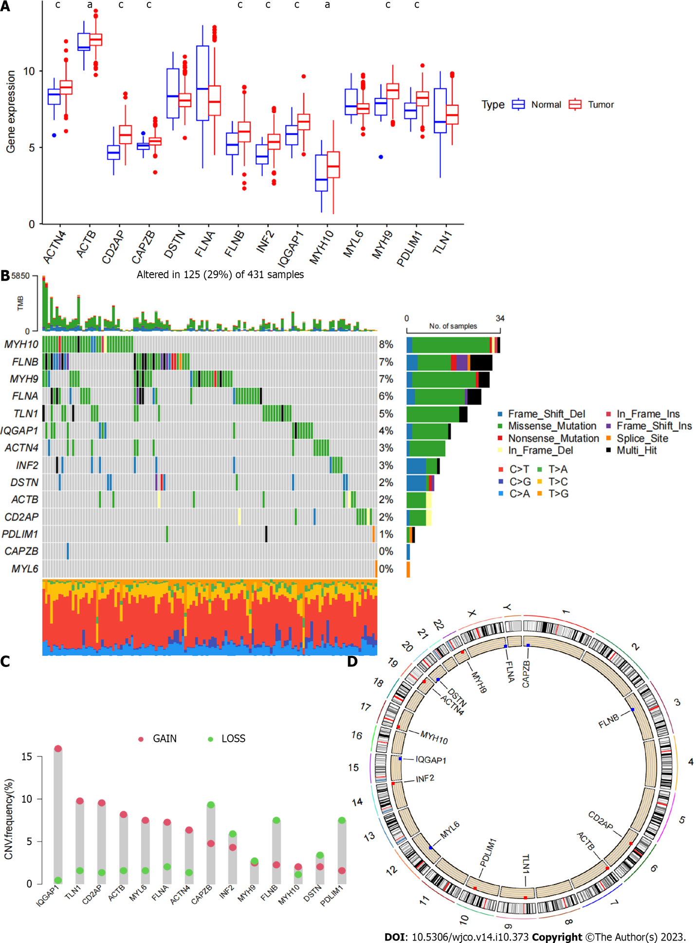
Figure 1 The results of the differential expression analysis of disulfidptosis related genes in gastric cancer and adjacent normal tissues are presented. A: Shows the difference analysis of disulfidptosis related genes in gastric cancer tissue samples and adjacent normal tissue samples; B: Shows the waterfall plot of disulfidptosis related genes mutations; C: Presents the mutation frequency of disulfidptosis related genes; D: Shows the mutation sites of disulfidptosis related genes. CNV: Copy number variation.
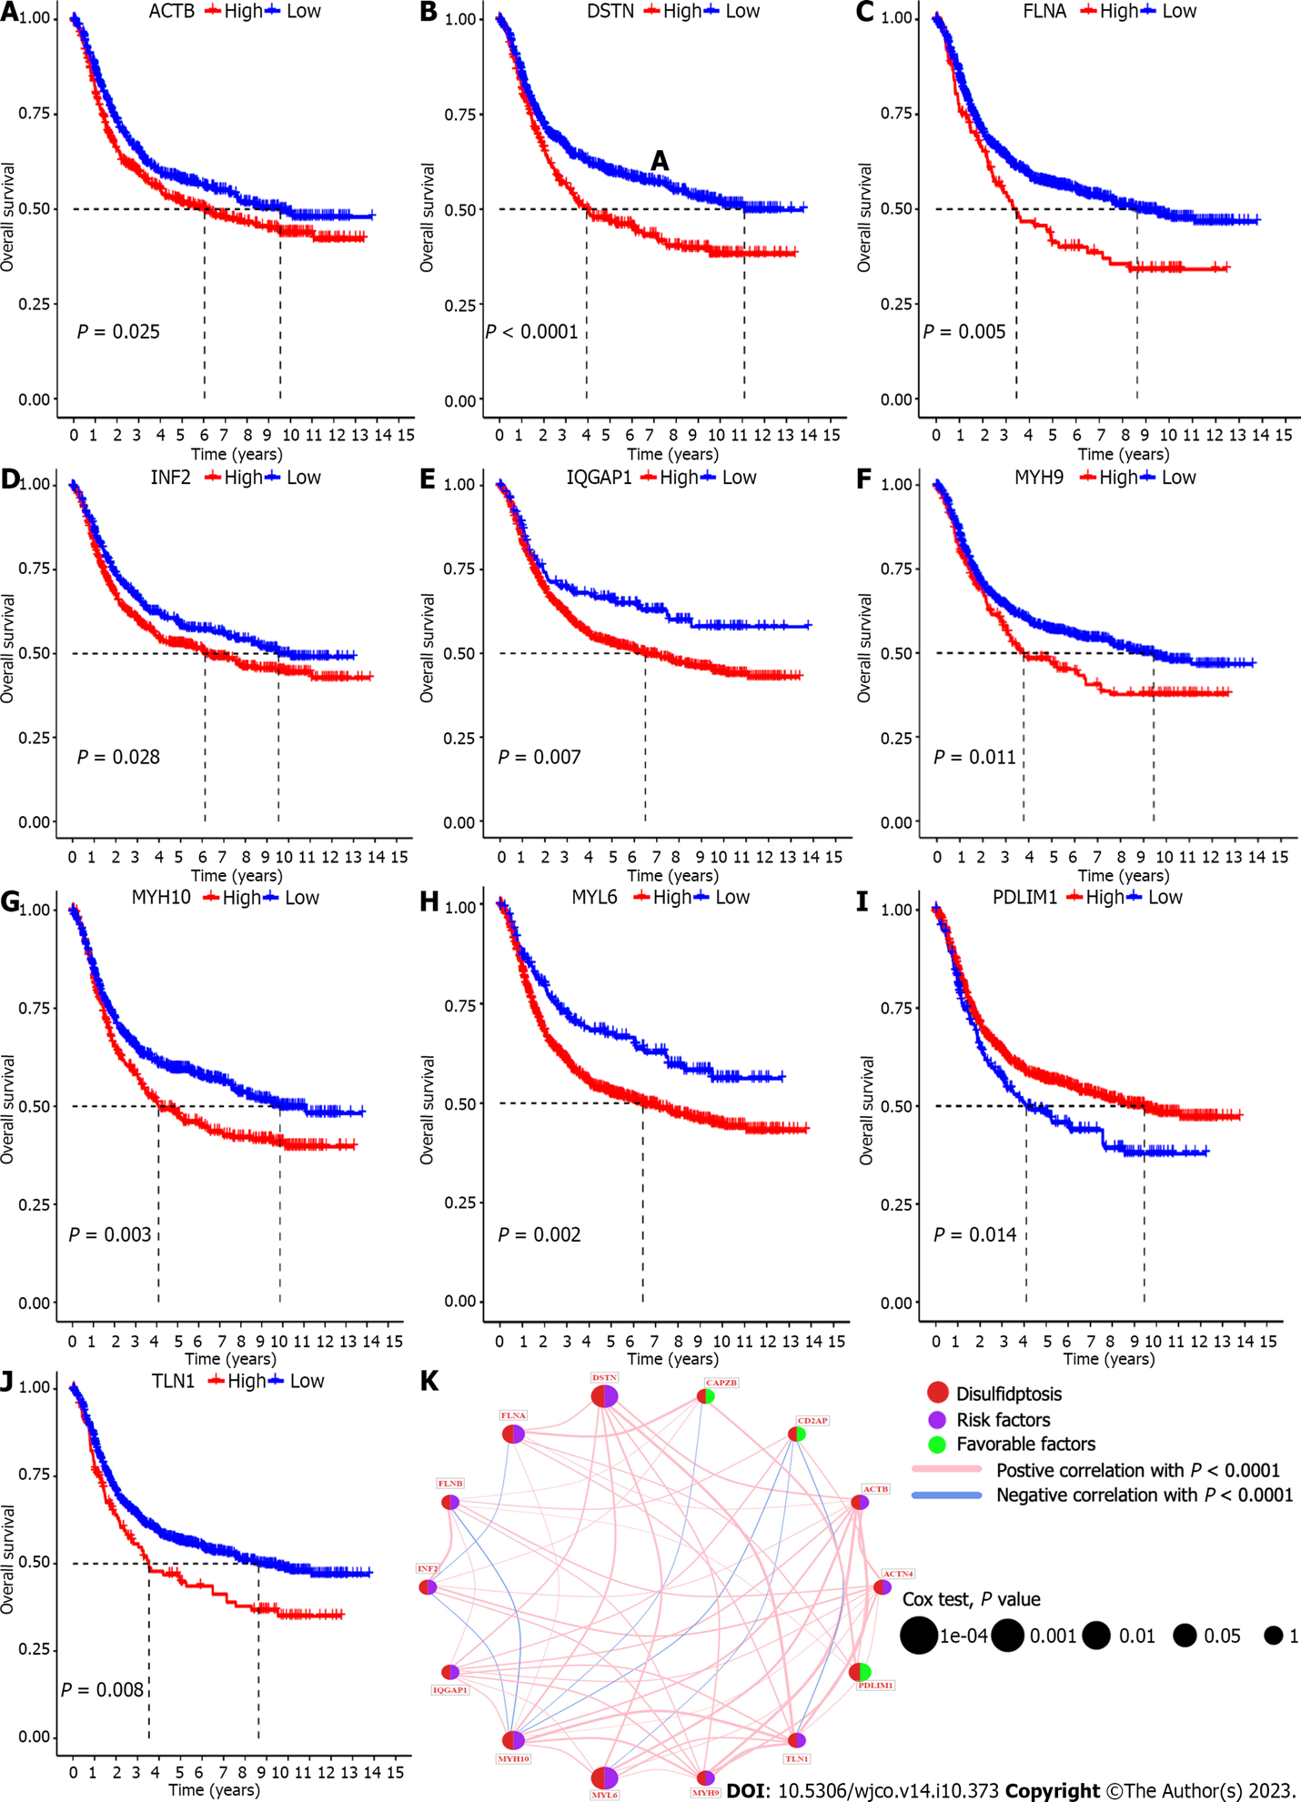

Figure 2 Screening disulfidptosis related genes related to the prognosis of gastric cancer. A-J: Show the Kaplan-Meier analysis of the survival curves of disulfidptosis related genes between high and low expression groups, and 10 disulfidptosis related genes related to gastric cancer prognosis were identified; K: Shows the COX analysis of the disulfidptosis related genes circle plot related to gastric cancer prognosis, and five significantly prognostic disulfidptosis related genes were identified.

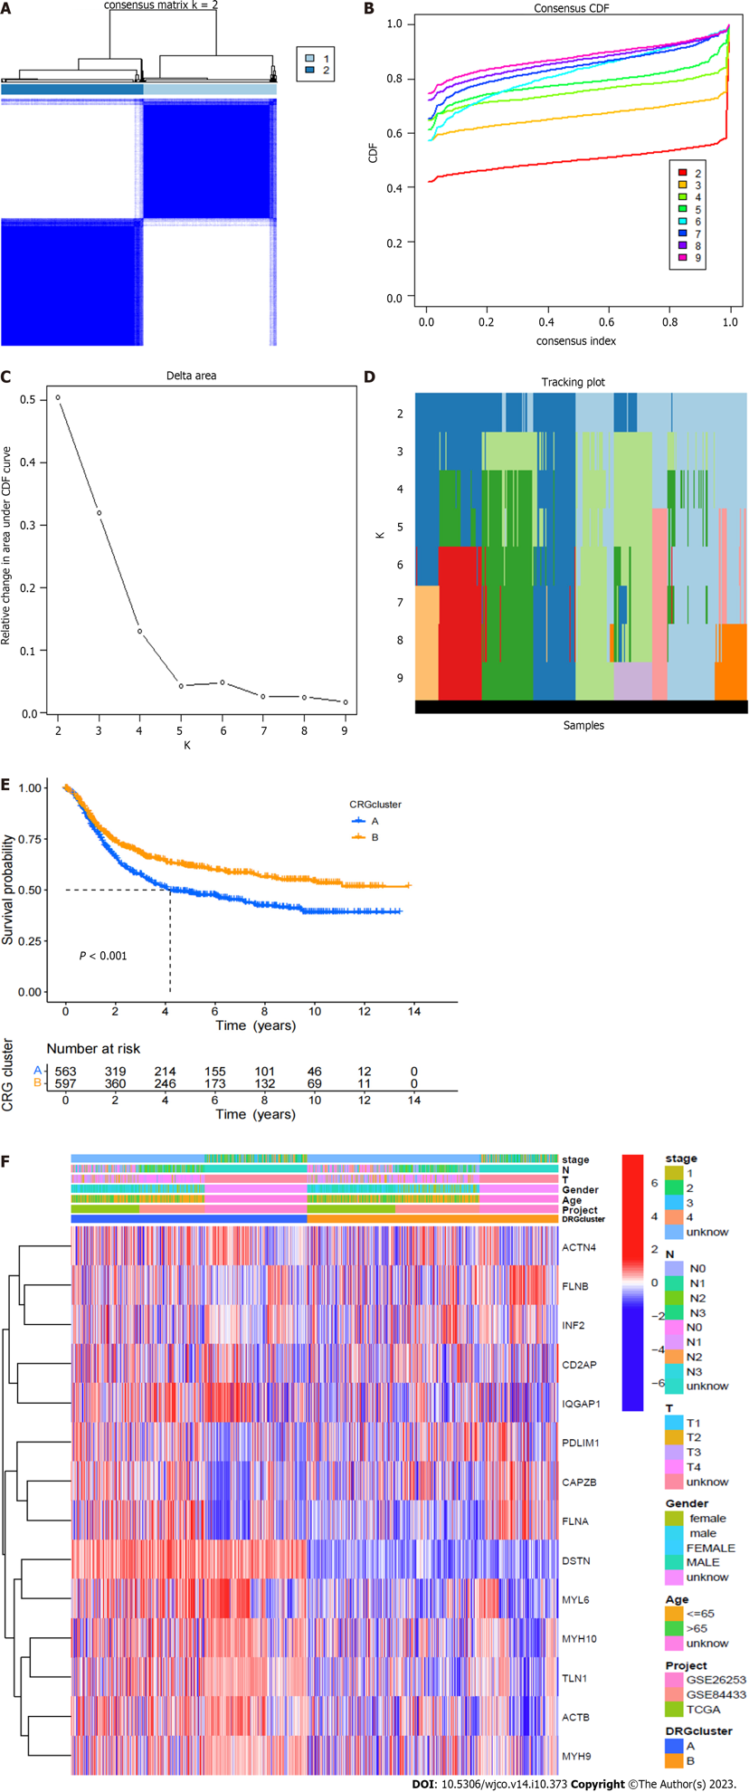
Figure 3 The sample classification, subgroup survival analysis, and differential gene heatmap related to disulfidptosis related genes are presented. A: Shows the clustering matrix plot of disulfidptosis related genes-related samples; B: Shows the clustering index plot of disulfidptosis related genes-related samples; C: Presents the relative change area under the cumulative distribution function curve; D: Shows the tracking plot of disulfidptosis related genes subgroup samples; E: Presents the survival analysis curves of disulfidptosis related genes subgroups; F: Shows the differential gene clustering heatmap between disulfidptosis related genes subgroups.

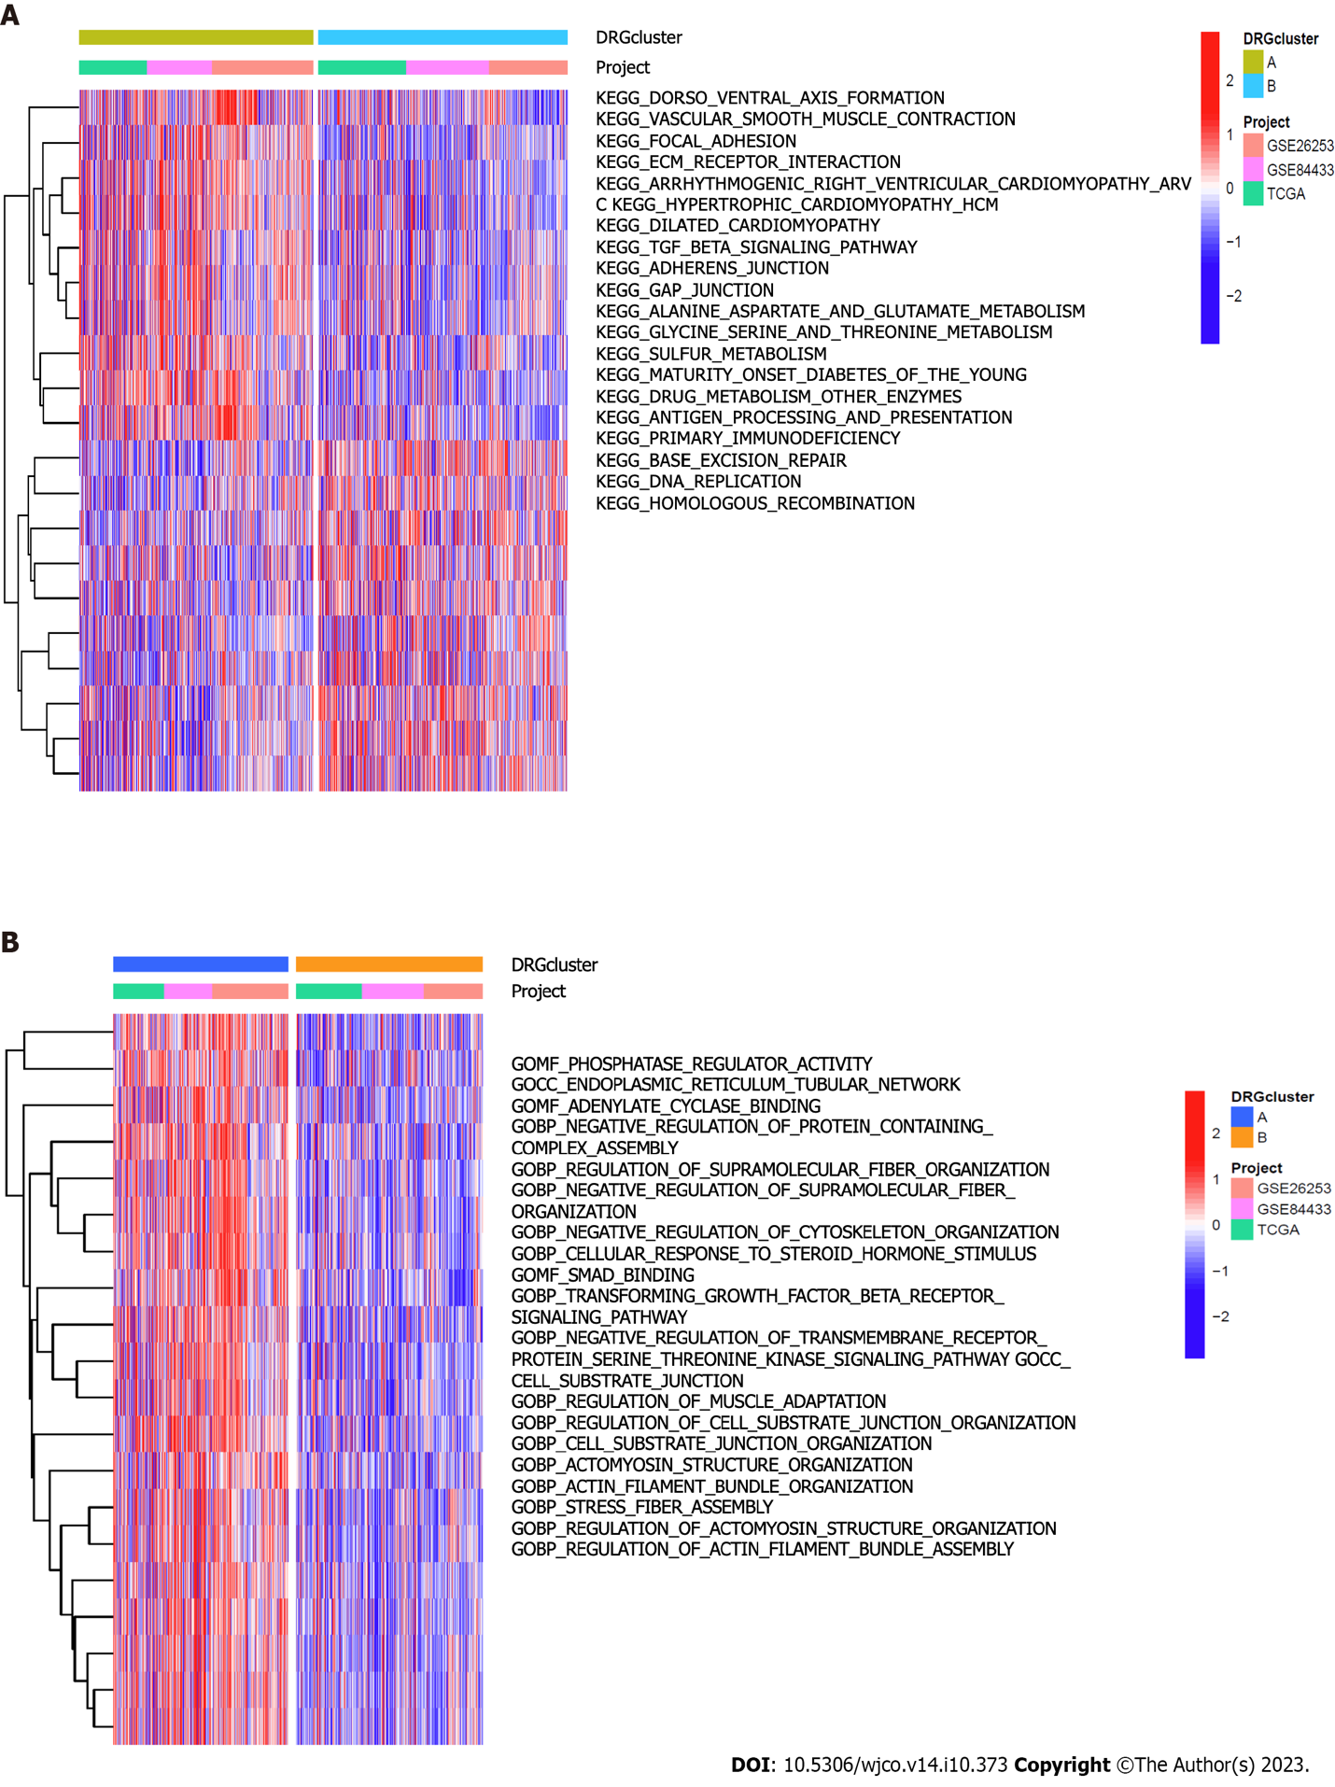
Figure 4 The significantly different kyoto encyclopedia of genes and genomes pathways and gene ontology functional analysis between disulfidptosis related genes subgroups are presented. A: Shows the significantly different kyoto encyclopedia of genes and genomes pathway enrichment analysis between disulfidptosis related genes subgroups; B: Shows the significantly different gene ontology pathway enrichment analysis between disulfidptosis related genes subgroups.

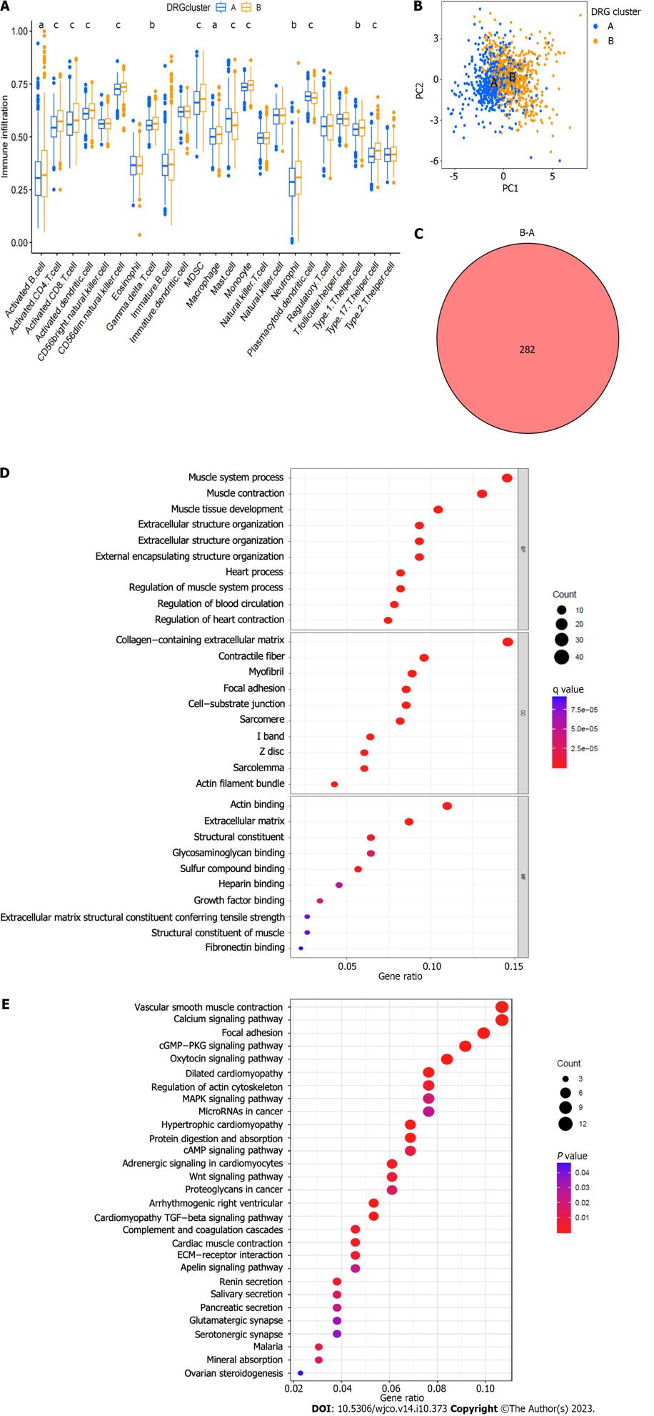
Figure 5 The immune cell differential analysis, principal component analysis analysis, significantly different genes, and gene ontology/kyoto encyclopedia of genes and genomes analysis between disulfidptosis related genes subgroups are presented. A: Shows the immune cell differential analysis between disulfidptosis related genes subgroups; B: Presents the principal component analysis analysis of disulfidptosis related genes subgroups; C: Shows the significantly different genes between disulfidptosis related genes subgroups; D: Presents the gene ontology analysis of significantly different genes between disulfidptosis related genes subgroups; E: Presents the kyoto encyclopedia of genes and genomes analysis of significantly different genes between disulfidptosis related genes subgroups.

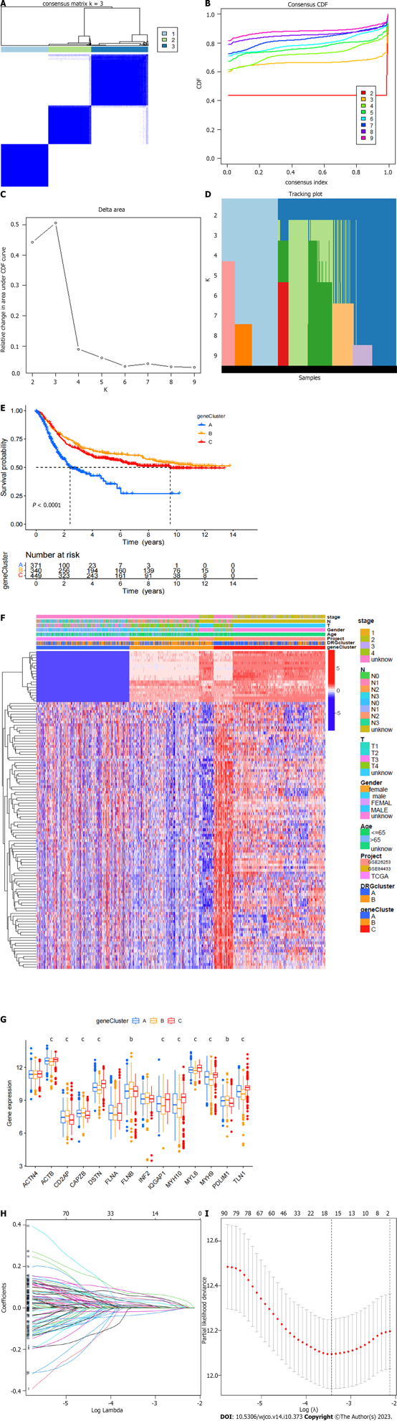
Figure 6 The differential gene-related sample clustering matrix, clustering index, cumulative distribution function curve, tracking plot, survival curve, heat map, differential analysis of disulfidptosis related genes, lasso regression plot, and cvfit plot are presented. A: Shows the clustering matrix of differential gene-related samples; B: Presents the clustering index of differential gene-related samples; C: Shows the relative change area of the cumulative distribution function curve of differential gene-related samples; D: Presents the tracking plot of differential gene subgroups; E: Shows the survival curve of differential gene-related samples; F: Presents the heat map of differential gene-related samples; G: Presents the differential analysis of disulfidptosis related genes between differential gene-related sample groups; H: Shows the lasso regression plot; I: Presents the cvfit plot of the lasso regression.

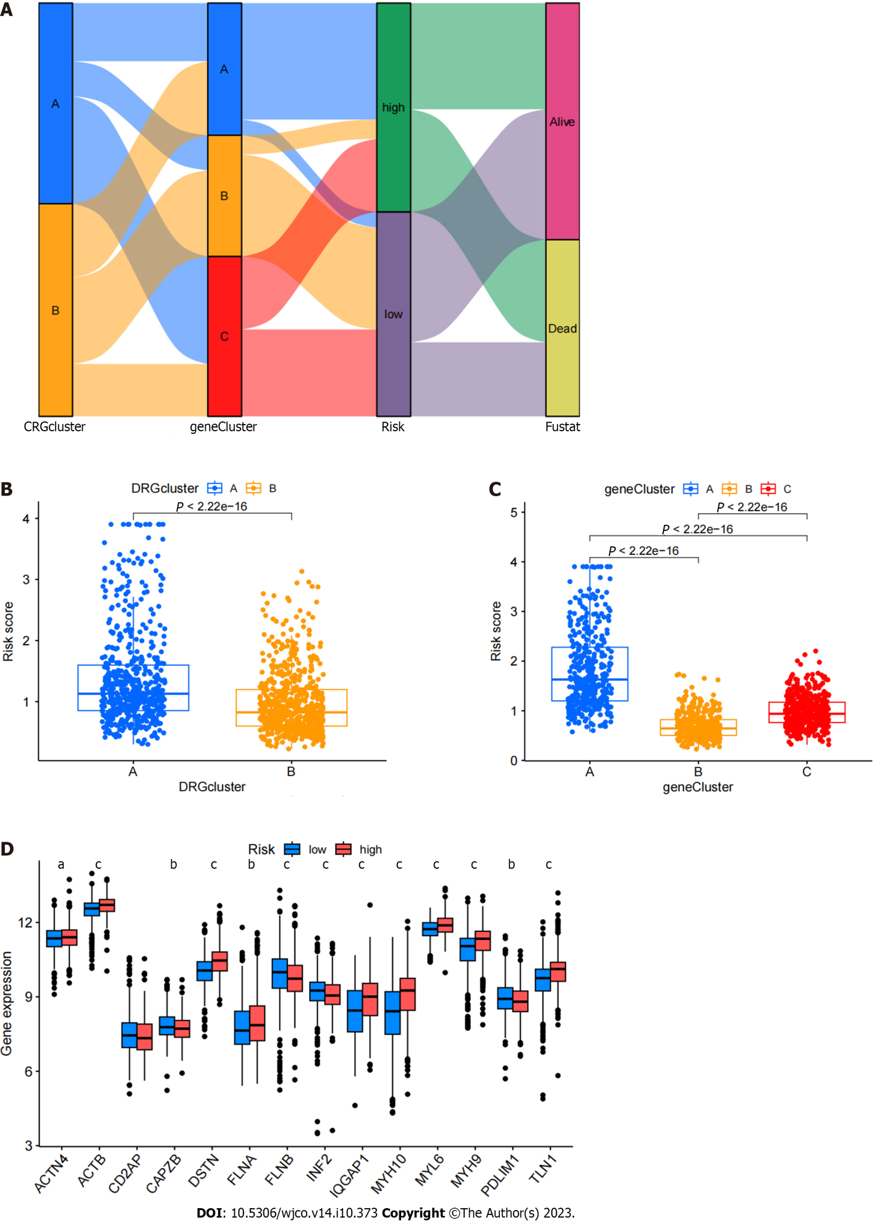
Figure 7 Testing the reliability of prognostic models. A: A Sankey diagram of the relationships between various data is presented; B: Shows a box plot of the disulfidptosis subtype; C: Presents a box plot of gene subtypes; D: Shows the differential analysis of disulfidptosis related genes between high and low-risk groups.

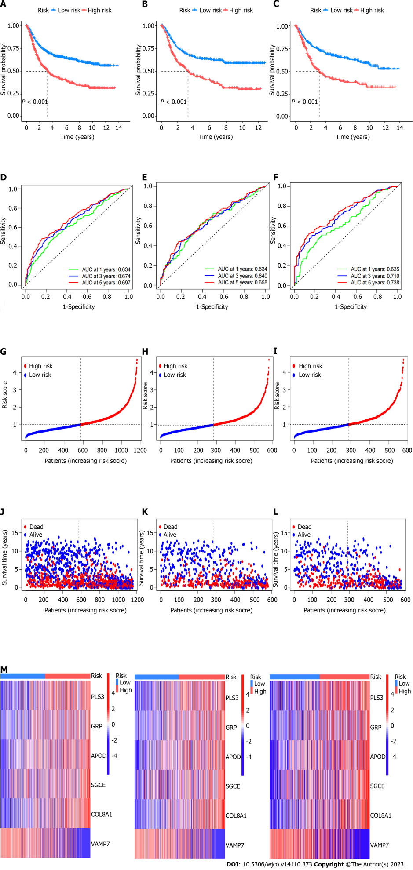
Figure 8 The accuracy of the prognostic model was verified by subgroup analysis. A-C: Survival curves between different groups are presented in panels; D-F: Show receiver operating characteristic curves between different groups; G-I: Risk curves for each group are presented; J-L: Show survival status plots for each group; M-O: Risk heat maps for each group are presented.
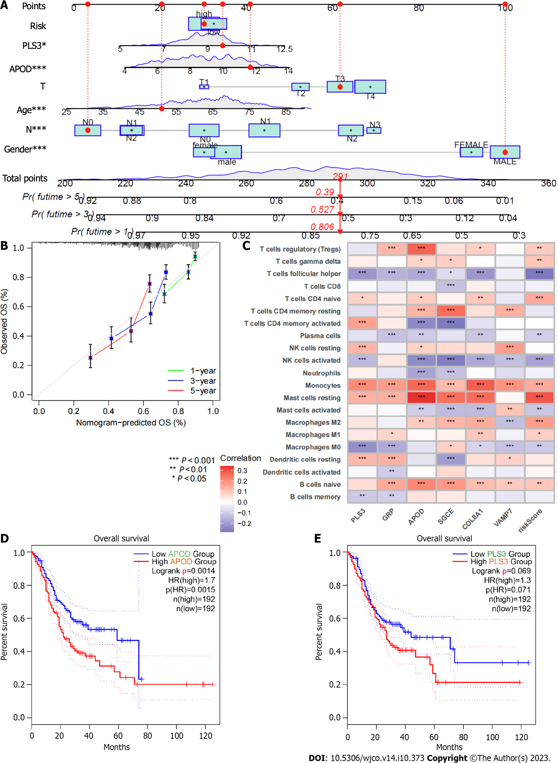
Figure 9 Further analysis of prognostic models to screen potential therapeutic targets. A: Presents a column line chart; B: Shows a calibration curve; C: Presents a heat map of the correlation between model genes and immune cells; D:The survival curve of APOD in gastric cancer was significantly different between high and low risk groups (P < 0.05); E: The survival curve of PLS3 in gastric cancer was shown between high and low risk groups, and the results suggested that the difference was not significant (P > 0.05).
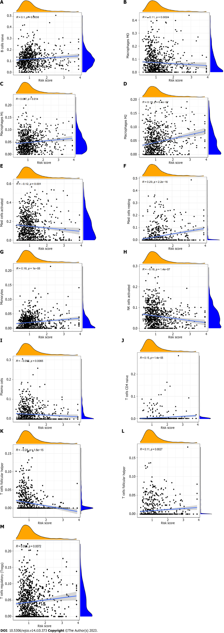
Figure 10 The correlation between immune cells and risk scores is analyzed. A: There was a positive correlation between B cells naive and risk score; B: The result shows that macrophages M0 is negatively correlated with risk score; C: The results showed that macrophages M1 was positively correlated with risk score; D: The results showed that macrophages M2 was positively correlated with risk score; E: There was a negative correlation between mast cells activated and risk score; F: The results showed that mast cells reting was positively correlated with risk score; G: There was a positive correlation between monocytes and risk score; H: There was a negative correlation between natural killer cells activated and risk score; I: There was a negative correlation between plasma cells and risk score; J: There was a positive correlation between T cells CD4 naive and risk score; K: It showed that T cells follicular helper was negatively correlated with risk score; L: There was a positive correlation between T cells gamma delta and risk score; M: There was a positive correlation between T cells regulation and risk score.

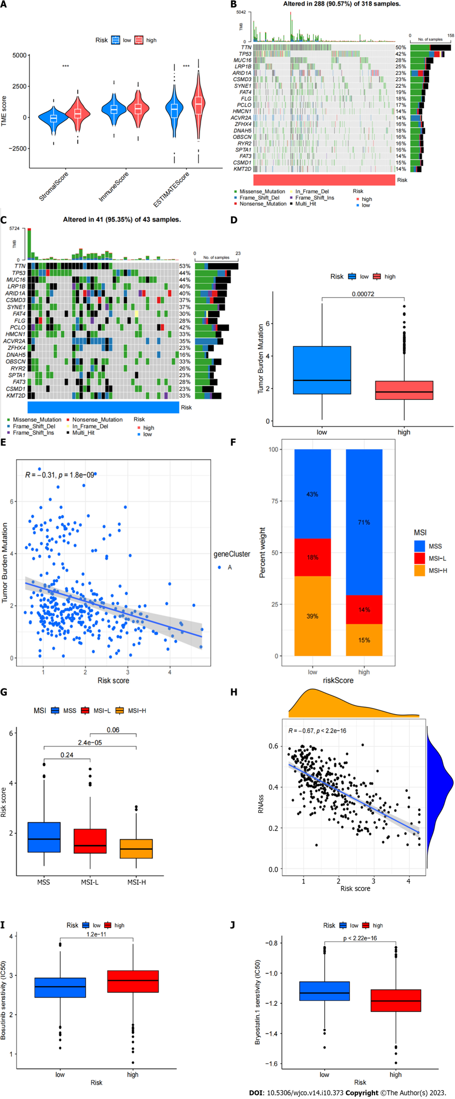
Figure 11 The correlation between the prognostic scoring model and tumor microenvironment, microsatellite instability, and RNAss, as well as drug sensitivity analysis, is presented. A: Shows the tumor microenvironment score for high and low-risk groups; B and C: Present waterfall plots of mutations for high and low-risk groups; D: Analyzes the differences in tumor mutation burden between high and low-risk groups; E: Shows the relationship between tumor mutation burden and risk score; F and G: Present microsatellite instability analysis for high and low-risk groups; H: Analyzes the correlation between stem cells and risk score; I and J: Present drug sensitivity analysis for drugs such as Bosutinib and Bryostatin.

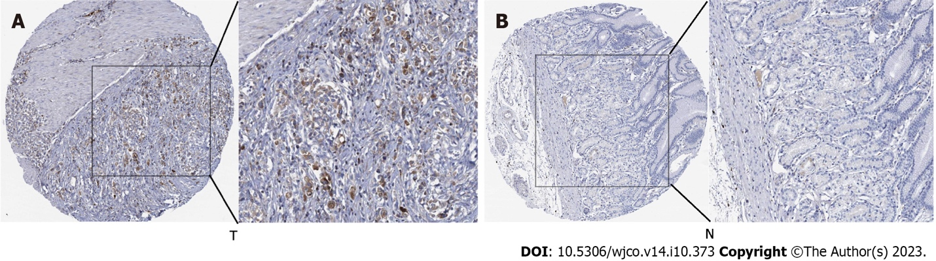
Figure 12 The immunohistochemical analysis of the APOD gene based on human protein atlas is presented. A: Tumor tissue; B: Normal tissue. T: Tumor tissue; B: Normal tissue.

Published by Baishideng Publishing Group Inc
7041 Koll Center Parkway, Suite 160, Pleasanton, CA 94566, USA
Telephone: +1-925-3991568
E-mail: bpgoffice@wjgnet.com
Help Desk: https://www.f6publishing.com/helpdesk
https://www.wjgnet.com

© 2023 Baishideng Publishing Group Inc. All rights reserved.

