Name of Journal: World Journal of Clinical Cases
Manuscript NO: 38083
Manuscript Type: ORIGINAL ARTICLE

Basic Study
Antiviral effects of hepatitis B virus S gene-specific anti-gene locked nucleic acid in transgenic mice

Xiao SR et al. Transgenic mice model of HBV

Shu-Rong Xiao, Gui-Dan Xu, Wu-Jun Wei, Bin Peng, Yi-Bin Deng

Shu-Rong Xiao, Gui-Dan Xu, Wu-Jun Wei, Bin Peng, Yi-Bin Deng, Department of Medical Laboratory Science, the Affiliated Hospital of Youjiang Medical College for Nationalities, Baise 533000, Guangxi Zhuang Autonomous Region, China

Yi-Bin Deng, Department of Hepatobiliary Disease Center, Guangxi Clinic Medicine Research, Baise 533000, Guangxi Zhuang Autonomous Region, China

ORCID number: Shu-Rong Xiao (0000-0002-7408-7060); Gui-Dan Xu (0000-0002-5388-6824); Wu-Jun Wei (0000-0002-3706-3895); Bin Peng (0000-0002-0081-5926); Yi-Bin Deng (0000-0002-0869-0400).

Author contributions: Xiao SR and Deng YB conceived the study, analyzed the data, drafted the manuscript; Xu GD and Wei WJ helped revise the manuscript critically for important intellectual content; Peng B collect the data; Deng YB helped design the study.

Supported by National Natural Science Foundation of China, No. 81460123; Guangxi Graduate Innovation Program, No. 201601005; and Guangxi Clinic Medicine Research Center of Hepatobiliary Disease, No. AD17129025.

Institutional review board statement: This study was approved by the Affiliated Hospital of Youjiang Medical College for Nationalities, Baise, China.

Institutional animal care and use committee statement: All procedures involving animals were reviewed and approved by the Animal Ethics and Welfare Committee of Affiliated Hospital of Youjiang Medical College for Nationalities.

Conflict-of-interest statement: The authors declare that they have no competing interests.

ARRIVE guidelines statement: The authors have read the ARRIVE guidelines, and the manuscript was prepared and revised according to the ARRIVE guidelines.

Open-Access: This article is an open-access article which was selected by an in-house editor and fully peer-reviewed by external reviewers. It is distributed in accordance with the Creative Commons Attribution Non Commercial (CC BY-NC 4.0) license, which permits others to distribute, remix, adapt, build upon this work non-commercially, and license their derivative works on different terms, provided the original work is properly cited and the use is non-commercial. See: http://creativecommons.org/licenses/by-nc/4.0/

Manuscript source: Unsolicited manuscript

Correspondence to: Yi-Bin Deng, PhD, Professor, Department of Medical Laboratory Science, the Affiliated Hospital of Youjiang Medical College for Nationalities, 18 Zhongshan 2nd Road, Baise 533000, Guangxi Zhuang Autonomous Region, China. enbin0776@sina.com
Telephone: +86-776-2852592
Fax: +86-776-2852592

Received: January 24, 2018
Peer-review started: February 2, 2018
First decision: March 7, 2018
Revised: March 29, 2018
Accepted: June 7, 2018
Article in press:
Published online:

Abstract
AIM
To assess the antiviral effects of hepatitis B virus (HBV) S gene-specific anti-gene locked nucleic acid (LNA) in transgenic mice.

METHODS
Thirty HBV transgenic mice were acclimatized to laboratory conditions and positive for serum HBV surface antigen (HBsAg) and HBV DNA, were randomly divided into 5 groups (n = 7), including negative control (blank control, unrelated sequence control), positive control (lamivudine, anti-sense-LNA), and anti-gene-LNA experimental group. LNA was injected into transgenic mice by tail vein while lamivudine was administered by gavage. Serum HBV DNA and HBsAg levels were determined by fluorescence-based PCR and enzyme-linked immune sorbent assay, respectively. HBV S gene expression amounts were assessed by reverse transcription polymerase chain reaction. Positive rates of HBsAg in liver cells were evaluated immunohistochemistry.

RESULTS
Average rate reductions of HBsAg after treatment on the 3rd, 5th, and 7th days were 32.34%, 45.96%, and 59.15%, respectively. The inhibitory effect of anti-gene-LNA on serum HBsAg peaked on day 7, with statistically significant differences compared with pre-treatment (0.96 ± 0.18 vs 2.35 ± 0.33, P < 0.05) and control values (P < 0.05 for all). Average reduction rates of HBV DNA on the 3rd, 5th, and 7th days were 38.55%, 50.95%, and 62.26%, respectively. This inhibitory effect peaked on the 7th day after treatment with anti-gene-LNA, with statistically significant differences compared with pre-treatment (4.17 ± 1.29 vs 11.05 ± 1.25, P < 0.05) and control values (P < 0.05 for all). The mRNA levels of the HBV S gene (P < 0.05 for all) and rates of HBsAg positive liver cells (P < 0.05 for all) were significantly reduced compared with the control groups. Liver and kidney function, and histology showed no abnormalities.

CONCLUSION
Anti-gene-LNA targeting the S gene of HBV displays strong inhibitory effects on HBV in transgenic mice, providing theoretical and experimental bases for gene therapy in HBV.

Key words: Anti-gene therapy; Hepatitis B virus; Locked nucleic acid; Hepatitis B; Transgenic mice; Anti-sense-therapy

© The Author(s) 2018. Published by Baishideng Publishing Group Inc. All rights reserved.

Core tip: We assess the antiviral effects of hepatitis B virus (HBV) S gene-specific anti-gene locked nucleic acid (LNA) in transgenic mice, to provide an experimental basis for gene therapy in patients with Chronic B-related Hepatitis. The inhibitory effect of anti-gene-LNA on serum HBV surface antigen (HBsAg) and HBV DNA peaked on day 7, with statistically significant differences compared with pre-treatment and control values. The mRNA levels of the HBV S gene and rates of HBsAg positive liver cells were significantly reduced compared with the control groups.

Xiao SR, Xu GD, Wei WJ, Peng B, Deng YB. Antiviral effects of hepatitis B virus S gene-specific anti-gene locked nucleic acid in transgenic mice. World J Clin Cases 2018; In press

INTRODUCTION
Hepatitis B virus (HBV) is one of the most severe human infectious virus in the world. According to estimates, 240 million individuals globally are chronically infected with HBV^{[1]}. In the past few years the prevalence of chronic HBV infection shows a declining trend throughout the world because of an anti-HBV vaccine and the implementation of successful immunization programs in enzootic zones. Despite improvement in global access to vaccination and treatment, mortality levels remain high^{[2,3]}. Chronic hepatitis B can be effectively and safely treated but a cure remains elusive.
The HBV genome is surrounded by an envelope containing HBV surface antigen (HBsAg) and HBV core antigen (HBcAg) and is a relaxed circular and partially double-stranded DNA^{[4]}. In the nuclei of infected hepatocytes, covalently closed circular DNA (cccDNA) is compounded and sustained at low replication levels are infected with HBV; cccDNA plays a role as the transcription template for all HBV RNAs^{[5]}. Due to cccDNA persistence in a stable form within the hepatocyte nucleus, it remains to a great extent unaffected by current therapies. One of the most important antiviral Drugs includes nucleus(t)ide analogues (NAs) and PEGylated/non-PEGylated interferon-alpha (IFN-α) are widely used to limit viral replication in chronic hepatitis B (CHB) infection^{[6]}. NAs therapy via a direct effect on DNA polymerase activity to some extent notably reduces viral load^{[7]}. Unfortunately, due to somewhat poor response and/or drug resistance, these therapies without achieve a therapeutic effect^{[8]}. Therefore, the development of a novel therapeutic strategy to repress HBV replication is of great significance in saving lives of CHB patients.
Recently, anti-sense-LNA was shown to effectively inhibit HBV replication and expression in in vitro models^{[9]}. However, anti-sense therapy cannot cut off the replication and transcription of viral genes from the source. It can only interfere with the synthesis of viral protein at the level of expression, and is prone to stop drug rebound. In anti-gene therapy, triplex-forming oligonucleotides (TFOs) provides a promising approach to bind in the major groove of duplex DNA at polypurine or polypyrimidine stretches in a sequence-specific manner^{[10]}. TFOs prevent the association of target DNA, polymerase, and transcription factors, down-regulating target genes^{[11-13]}. A recent and promising technological progress is the development of locked nucleic acid (LNA), which not only enhances binding to its target sequence while being resistant to nuclease degradation, but also shows minimal toxicity^{[14-16]}. Compared with anti-sense therapy, it has the advantage of blocking virus gene replication and transcription from the source.
The aim of this study was to design liposome based transport of a LNA modified oligonucleotide to inhibit HBV DNA express in transgenic mice, the final objective was to assess the antiviral effects of HBV S gene-specific anti-gene LNA in transgenic mice.

MATERIALS AND METHODS
Anti-gene-LNA synthesis and modification
According to the HBV S encoding chain, anti-gene-LNA was designed using the Walk function of the RNA structure software to select △G37 value of small fragments; by Blast analysis and homology sequence features, the synthesis and modification of anti-gene- LNA (5’-TaccTcTtgtA-3’; uppercase and lower case letters represent LNA and DNA, respectively) were performed by Shanghai biotechnology limited company.

Animals
HBV transgenic mice (n = 35; males and females in equal amounts) weighing 19-23 g were purchased from the Guangzhou Military Air Force Hospital of the People’s Liberation Army of China. All mice were positive for serum HBsAg and HBV DNA. They were bred and housed in pathogen-free conditions at 25 °C ± 2 °C under a 12 h:12 h light-dark cycle, with food and water provided ad libitum unless otherwise specified. All animal care and experimental procedures were approved by the Institutional Ethnics Committee of Youjiang Medical College for Nationalities.
Mice were randomly divided into five groups (n = 7 each), including negative control (blank control, unrelated sequence control), positive control (lamivudine, anti-sense-LNA), and anti-gene-LNA experimental group. The lamivudine control group was administered daily gavage of 2 mg/kg for 7 d; the remaining groups were injected (400 μL 5% glucose-liposome containing the corresponding drug) via the tail vein at 1, 3, and 5 d, respectively. Blood samples were collected from the orbital vein before and after injection on 3rd, 5th and 7th days, respectively, and centrifuged at 5000 r/min for 5 min. The resulting serum was stored at -20 °C until use. On the 7th day, all mice were sacrificed by cervical dislocation under anesthesia. Liver and kidney samples were obtained for histological assessments, ultrastructural examinations, and immunohistochemistry.

Measurement of serum HBsAg levels by enzyme-linked immune sorbent assay
Serum HBsAg levels were quantified with an enzyme-linked immune sorbent assay enzyme-linked immune sorbent assay (ELISA) kit according to the manufacturer’s protocol. ELISA kits were purchased from Lizhu Biology Company, Zhuhai, China.

Measurement of HBV DNA levels by Fluorescence based PCR
Serum HBV DNA levels were quantified with a diagnostic kit for the quantification of HBV DNA, according to the manufacturer’s protocol. HBV DNA diagnostic kits were purchased from Daan Gene Company, Guangzhou, China. Briefly, 30 μL serum was added to 70 μL DNA extract and oscillated for 15 s, incubated at 100 ℃ for 10 min, and centrifuged at 12000 r/min for 5 min. Then, DNA samples (20 μL) were added to 30 μL of PCR reaction mix and centrifuged at 8000 r/min for 5 s. PCR was performed as follows: 93 ℃for 2 min; 10 cycles of 93 ℃ for 45 s and 55 ℃ for 1 min; 30 cycles of 93 ℃for 30 s and 55 ℃ for 45 s; 40 ℃for 20 s. DNA levels were determined based on a standard curve for HBV.

Measurement of HBV S gene expression levels in the liver by reverse transcription polymerase chain reaction
Total RNA was extracted from liver samples with TRNzol Universal Reagent kit (TIANGEN), and concentrations were determined by spectrophotometry. Reverse transcription was performed with Fast Quant RT Kit (TIANGEN), according to the manufacturer’s instructions. Briefly, RT was carried out in a final volume of 20 μL containing 5 × g DNA buffer (2 μL), Total RNA (1 μL), RNase-free ddH₂O (7 μL) (incubated at 42 ℃for 3 min), 10×Fast RT buffer (2 μL), RT Enzyme Mix (1 μL), FQ-RT Primer Mix (2 μL), and RNase-Free ddH₂O (5 μL), total 20 μL. The mixture was incubated at 42 °C for 15 min and 95 °C for 3 min. PCR amplification of the S gene was performed with the following primers:
Forward, 5’-CTGCCTCTCCCTTATCGTCA-3’;
Reverse, primer5’-TGGCAAGGACCCATAACTTC-3’.
The following temperature protocol was used: 94 ℃ for 3 min; 30 cycles of 94 ℃ for 30 s, 55 ℃ for 30 s, and 72℃ for 1 min; 72 ℃ for 5 min. The amplicon was 830 bp. The glyceraldehyde phosphate dehydrogenase (GAPDH; reference gene) band in electrophoresis was used to determine the relative HBV S gene expression levels.

Immunohistochemistry
To detect HBsAg in liver cells, the sections were dewaxed in xylene and rehydrated in graded alcohol. The endogenous peroxidase activity was suppressed by 3% hydrogen peroxide for 15 min. After rinsing twice in phosphate-buffered saline (PBS), antigen retrieval was performed by immersing the sections in 10 mmol/L sodium citrate buffer (pH 6.0) and heated for 15 min in a microwave oven. The sections were then treated for 4 ℃for 18 h with mouse anti-HBsAg monoclonal antibody (1:100). PBS was used as a negative control. After three washes with PBS, the sections were subsequently treated with biotinylated goat anti-rabbit immunoglobulin for 15 min and horseradish peroxidase-streptavidin complex for 15 min. The slides were then washed three times with PBS and incubated in DAB for 5 min and counterstained with hematoxylin for 30 s. After dehydration with graded alcohol, the slides were mounted and analyzed under an Olympus BX53 inverted microscope (Olympus, Japan).

Histology
To assess the morphological changes of the liver and kidney, formalin-treated tissue samples were paraffin embedded. Serial sections with 4 mm thickness were obtained and stained with hematoxylin and eosin (H and E). Observation was performed under an Olympus BX53 inverted microscope (Olympus, Japan).

Statistical analysis
Quantitative data are mean ± SD, and were analyzed with the SPSS 13.0 software. Groups were compared by one-way analysis of variance (ANOVA) followed by the Tukey’s multiple range post hoc test. P < 0.05 was considered statistically significant.

RESULTS
Serum HBsAg levels
The inhibitory effect on serum HBsAg was assessed by ELISA on the 3rd, 5th, and 7th days, respectively, after treatment. Average rate reductions after treatment on the 3rd, 5th, and 7th days were 32.34%, 45.96%, and 59.15%, respectively. The inhibitory effect of anti-gene-LNA on serum HBsAg peaked on day 7, with statistically significant differences compared with pre-treatment and control values (P < 0.05). This suggests that anti-gene-LNA significantly inhibited HBsAg in mice in a time-dependent manner (Table 1 and Figure 1A).

HBV DNA levels
The inhibitory effect of anti-gene-LNA on HBV DNA was analyzed by fluorescence based PCR on the 3rd, 5th, and 7th days after treatment, respectively. Average reduction rates on the 3rd, 5th, and 7th days were 38.55%, 50.95%, and 62.26%, respectively. This inhibitory effect peaked on the 7th day after treatment with anti-gene-LNA, with statistically significant differences compared with pre-treatment and control values (P < 0.05). This suggests that anti-gene-LNA significantly inhibits HBV DAN in mice in a time-dependent manner (Table 2 and Figure 1B)

HBV S gene expression levels in the liver
The average grayscale values of lanes 1-5 for HBV S-DNA (with GAPDH set to 1) were 1, 0.96, 0.78, 0.51, and 0.32, respectively. Quantitation of HBV S gene expression levels in the liver after treatment with anti-gene-LNA revealed a significant decrease compared with pre-treatment (P < 0.05) or control (P < 0.05) values (Figure 2).

HBsAg positive cells in liver tissues
Figure 3 shows representative immunohistochemical staining data for HBsAg positive cells in liver tissues. No significant differences were observed in the rates of HBsAg positive liver cells among the blank control, unrelated sequence control and lamivudine control groups. Meanwhile, 47% of liver cells were positive for HBsAg after treatment with anti-sense- LNA verify, a rate significantly lower than those of the blank control, unrelated sequence control, and lamivudine control groups (P < 0.05); the positive expression rate of HBsAg in liver cells in the anti-gene-LNA treatment group was 31%, significantly lower than those of all control groups (P < 0.05)

Histological observations
H&E staining was used to assess the effects of anti-gene-LNA and liposomes on the histological features of the liver and kidney. Liver and kidney sections stained with H and E showed no significant differences between the anti-gene-LNA group and controls, suggesting that anti-gene-LNA had no obvious toxicity on liver and kidney at the histological level (Figures 4 and 5).

DISCUSSION
The present study assessed serum HBsAg, HBV DNA, and HBV S gene expression levels in transgenic mice. The results demonstrated that HBV amounts were significantly reduced after injection of anti-gene- LNA on 7th day, shows a significant difference compared with before treatment and control groups (P < 0.05). Significantly less positive HBsAg cells in liver tissues were obtained after treatment with anti-gene-LNA compared with the control groups, indicating that anti-gene-LNA transacted by cationic liposomes can effectively enter nucleolus in the liver of transgenic mice after tail vein injection and play a role in reducing HBV DNA replication and transcription.
We successfully used anti-sense-LNA to inhibit the translation and expression of HBV mRNA in vitro and in vivo models in previous study^{[15]}, due to the basic principle of anti-sense-LNA targeting specific mRNAs by annealing complementary oligonucleotides^{[17-20]}. In the simplest form, anti-sense-LNAs are introduced into the liver cell to down-regulate gene expression by interfering with the translation of mRNA instead of DNA transcription, i.e., they are involved in posttranscriptional rather than transcriptional gene regulation. Therefore, treatment with anti-sense-LNA does not achieve satisfactory effects. TFOs have emerged as potential regulators of biological activity for direct modifications of genomic DNA at selected sites through mutagenesis or homologous recombination and changing the anti-gene therapeutic method^{[21-23]}. In the present study, anti-gene-LNA was assessed for its antiviral effects in transgenic mice. The results showed that the inhibitory effect of anti-gene-LNA peaked on the 7th day, with a statistically significant difference compared with the anti-sense-LNA group (P < 0.05). However, compared with other nucleic acid-based approaches, TFOs faces challenges such as oligonucleotides (ONs) targeting ability and the stability of the TFOs in a genomic context. In order to efficient, ON should increase target DNA selectively, easily, stability, and with high affinity. Until now, due to the low of affinity of TFOs or their DNA targets, the method of anti-gene-DNA hampered to down-regulate and control the expression level of genomic DNA. The anti-gene-LNA sugar unit not only significantly enhances triplex stability but also partly relieves sequence restriction constraints^{[24-26]}. The present study provided evidence that once in the nucleus, an integrated HBV DNA sequence composed of LNA and DNA oligonucleotides (anti-gene-LNA) effectively targeted HBV, therefore inhibiting its replication at the transcription level.
HBV DNA is easily mutated compared to other DNA viruses during replication; one of the important reasons is that HBV DNA polymerase lacks a proofreading function^{[27]}, which can cause HBV mutations to occur at a 10-fold higher frequency^{[28]}. This results in decreased susceptibility or increased resistance in anti-HBV treatment. HBV contains 4 overlapping open reading frames (ORFs) encoding the polymerase (P), core (C), surface antigen (S), and X proteins^{[29]}. The S gene region is one of the most important open reading frames of the HBV genome, encoding a protein forming an important part of HbsAg^{[30,31]}. Thus, the S gene is not only closely associated with virus replication, transcription, assembly, and secretion processes, but also with cellular and humoral immune responses induced by the virus.
Taken together, this study showed an effective strategy that with liposome based transport of a LNA modified oligonucleotide to inhibit HBV DNA expression in transgenic mice. The new treatment strategy of repressing HBV DNA replication is usefulness and worth further studying. Based on the data presented herein highlight the usefulness of anti-gene-LNA mediated silencing HBV DNA replication and transcription bring forth innovative ideas and potentially viable tool for gene therapy.

ARTICLE HIGHLIGHTS
Research background
Hepatitis B virus (HBV) is one of the most severe human pathogens. It is reported that 240 million individuals globally are chronically infected with HBV and current antivirals cannot clear the infection or adequately suppress disease.

Research motivation
Despite improvement in global access to vaccination and treatment, mortality levels remain high. Chronic hepatitis B can be effectively and safely treated but a cure remains elusive.

Research objectives
The aim of this study is to inhibit HBV DNA expression with anti-gene locked nucleic acid (LNA) in transgenic mice.

Research methods
The aim of this study was to design liposome based transport of a LNA modified oligonucleotide to inhibit HBV DNA express in transgenic mice, the final objective was to assess the antiviral effects of HBV S gene-specific anti-gene LNA in transgenic mice.

Research results
Average rate reductions of HBsAg, HBV DNA, mRNA levels of the HBV S gene and the rate of HBsAg positive liver cells, with statistically significant differences compared with pre-treatment and control values (P < 0.05 for all). Liver and kidney function, and histology showed no abnormalities.

Research conclusions
Anti-gene-LNA transacted by cationic liposomes can effectively enter nucleolus in the liver of transgenic mice after tail vein injection and play a role in reducing HBV DNA replication and transcription.

Research perspectives
Based on the data presented herein highlight the usefulness of anti-gene-LNA mediated silencing HBV DNA replication and transcription bring forth innovative ideas and potentially viable tool for gene therapy.

REFERENCES
1 Schweitzer A, Horn J, Mikolajczyk RT, Krause G, Ott JJ. Estimations of worldwide prevalence of chronic hepatitis B virus infection: a systematic review of data published between 1965 and 2013. Lancet 2015; 386: 1546-1555 [PMID: 26231459 DOI: 10.1016/S0140-6736(15)61412-X]
2 Stanaway JD, Flaxman AD, Naghavi M, Fitzmaurice C, Vos T, Abubakar I, Abu-Raddad LJ, Assadi R, Bhala N, Cowie B, Forouzanfour MH, Groeger J, Hanafiah KM, Jacobsen KH, James SL, MacLachlan J, Malekzadeh R, Martin NK, Mokdad AA, Mokdad AH, Murray CJL, Plass D, Rana S, Rein DB, Richardus JH, Sanabria J, Saylan M, Shahraz S, So S, Vlassov VV, Weiderpass E, Wiersma ST, Younis M, Yu C, El Sayed Zaki M, Cooke GS. The global burden of viral hepatitis from 1990 to 2013: findings from the Global Burden of Disease Study 2013. Lancet 2016; 388: 1081-1088 [PMID: 27394647 DOI: 10.1016/S0140-6736(16)30579-7]
3 Wiktor SZ, Hutin YJ. The global burden of viral hepatitis: better estimates to guide hepatitis elimination efforts. Lancet 2016; 388: 1030-1031 [PMID: 27394646 DOI: 10.1016/S0140-6736(16)31018-2]
4 Samal J, Kandpal M, Vivekanandan P. Molecular mechanisms underlying occult hepatitis B virus infection. Clin Microbiol Rev 2012; 25: 142-163 [PMID: 22232374 DOI: 10.1128/CMR.00018-11]
5 Martinez MC, Kok CC, Baleriola C, Robertson P, Rawlinson WD. Investigation of occult hepatitis B virus infection in anti-hbc positive patients from a liver clinic. PLoS One 2015; 10: e0117275 [PMID: 25763579 DOI: 10.1371/journal.pone.0117275]
6 Tang CM, Yau TO, Yu J. Management of chronic hepatitis B infection: current treatment guidelines, challenges, and new developments. World J Gastroenterol 2014; 20: 6262-6278 [PMID: 24876747 DOI: 10.3748/wjg.v20.i20.6262]
7 Koumbi L. Current and future antiviral drug therapies of hepatitis B chronic infection. World J Hepatol 2015; 7: 1030-1040 [PMID: 26052392 DOI: 10.4254/wjh.v7.i8.1030]
8 Chang J, Guo F, Zhao X, Guo JT. Therapeutic strategies for a functional cure of chronic hepatitis B virus infection. Acta Pharm Sin B 2014; 4: 248-257 [PMID: 26579392 DOI: 10.1016/j.apsb.2014.05.002]
9 Deng YB, Qin HJ, Luo YH, Liang ZR, Zou JJ. Blocking the expression of the hepatitis B virus S gene in hepatocellular carcinoma cell lines with an anti-gene locked nucleic acid in vitro. Genet Mol Res 2015; 14: 5445-5451 [PMID: 26125740 DOI: 10.4238/2015.May.22.14]
10 Pabon-Martinez YV, Xu Y, Villa A, Lundin KE, Geny S, Nguyen CH, Pedersen EB, Jørgensen PT, Wengel J, Nilsson L, Smith CIE, Zain R. LNA effects on DNA binding and conformation: from single strand to duplex and triplex structures. Sci Rep 2017; 7: 11043 [PMID: 28887512 DOI: 10.1038/s41598-017-09147-8]
11 Besch R, Giovannangeli C, Degitz K. Triplex-forming oligonucleotides - sequence-specific DNA ligands as tools for gene inhibition and for modulation of DNA-associated functions. Curr Drug Targets 2004; 5: 691-703 [PMID: 15578950]
12 Rogers FA, Lloyd JA, Glazer PM. Triplex-forming oligonucleotides as potential tools for modulation of gene expression. Curr Med Chem Anticancer Agents 2005; 5: 319-326 [PMID: 16101484]
13 Simon P, Cannata F, Concordet JP, Giovannangeli C. Targeting DNA with triplex-forming oligonucleotides to modify gene sequence. Biochimie 2008; 90: 1109-1116 [PMID: 18460344 DOI: 10.1016/j.biochi.2008.04.004]
14 Rué L, Bañez-Coronel M, Creus-Muncunill J, Giralt A, Alcalá-Vida R, Mentxaka G, Kagerbauer B, Zomeño-Abellán MT, Aranda Z, Venturi V, Pérez-Navarro E, Estivill X, Martí E. Targeting CAG repeat RNAs reduces Huntington's disease phenotype independently of huntingtin levels. J Clin Invest 2016; 126: 4319-4330 [PMID: 27721240 DOI: 10.1172/JCI83185]
15 Barbaro V, Nasti AA, Del Vecchio C, Ferrari S, Migliorati A, Raffa P, Lariccia V, Nespeca P, Biasolo M, Willoughby CE, Ponzin D, Palù G, Parolin C, Di Iorio E. Correction of Mutant p63 in EEC Syndrome Using siRNA Mediated Allele-Specific Silencing Restores Defective Stem Cell Function. Stem Cells 2016; 34: 1588-1600 [PMID: 26891374 DOI: 10.1002/stem.2343]
16 Deng YB, Qin HJ, Luo YH, Liang ZR, Zou JJ. Antiviral effect of hepatitis B virus S/C gene loci antisense locked nucleic acid on transgenic mice in vivo. Genet Mol Res 2015; 14: 10087-10095 [PMID: 26345946 DOI: 10.4238/2015.August.21.16]
17 Pfeiffer N, Voykov B, Renieri G, Bell K, Richter P, Weigel M, Thieme H, Wilhelm B, Lorenz K, Feindor M, Wosikowski K, Janicot M, Päckert D, Römmich R, Mala C, Fettes P, Leo E. First-in-human phase I study of ISTH0036, an antisense oligonucleotide selectively targeting transforming growth factor beta 2 (TGF-β2), in subjects with open-angle glaucoma undergoing glaucoma filtration surgery. PLoS One 2017; 12: e0188899 [PMID: 29190672 DOI: 10.1371/journal.pone.0188899]
18 Marcovina SM, Viney NJ, Hughes SG, Xia S, Witztum JL, Tsimikas S. Temporal variability in lipoprotein(a) levels in patients enrolled in the placebo arms of IONIS-APO(a) and IONIS-APO antisense oligonucleotide clinical trials. J Clin Lipidol 2018; 12: 122-129.e2 [PMID: 29174389 DOI: 10.1016/j.jacl.2017.10.024]
19 Sun XC, Yan JY, Chen XL, Huang YP, Shen X, Ye XH. Depletion of telomerase RNA inhibits growth of gastrointestinal tumors transplanted in mice. World J Gastroenterol 2013; 19: 2340-2347 [PMID: 23613627 DOI: 10.3748/wjg.v19.i15.2340]
20 Xiu P, Dong XF, Li XP, Li J. Clusterin: Review of research progress and looking ahead to direction in hepatocellular carcinoma. World J Gastroenterol 2015; 21: 8262-8270 [PMID: 26217078 DOI: 10.3748/wjg.v21.i27.8262]
21 Mukherjee A, Vasquez KM. Triplex technology in studies of DNA damage, DNA repair, and mutagenesis. Biochimie 2011; 93: 1197-1208 [PMID: 21501652 DOI: 10.1016/j.biochi.2011.04.001]
22 Reza F, Glazer PM. Triplex-mediated genome targeting and editing. Methods Mol Biol 2014; 1114: 115-142 [PMID: 24557900 DOI: 10.1007/978-1-62703-761-7_8]
23 Reza F, Glazer PM. Therapeutic genome mutagenesis using synthetic donor DNA and triplex-forming molecules. Methods Mol Biol 2015; 1239: 39-73 [PMID: 25408401 DOI: 10.1007/978-1-4939-1862-1_4]
24 Kurreck J, Wyszko E, Gillen C, Erdmann VA. Design of antisense oligonucleotides stabilized by locked nucleic acids. Nucleic Acids Res 2002; 30: 1911-1918 [PMID: 11972327]
25 Mahato RI, Rolland A, Tomlinson E. Cationic lipid-based gene delivery systems: pharmaceutical perspectives. Pharm Res 1997; 14: 853-859 [PMID: 9244140]
26 Elmén J, Lindow M, Schütz S, Lawrence M, Petri A, Obad S, Lindholm M, Hedtjärn M, Hansen HF, Berger U, Gullans S, Kearney P, Sarnow P, Straarup EM, Kauppinen S. LNA-mediated microRNA silencing in non-human primates. Nature 2008; 452: 896-899 [PMID: 18368051 DOI: 10.1038/nature06783]
27 Tian Q, Jia J. Hepatitis B virus genotypes: epidemiological and clinical relevance in Asia. Hepatol Int 2016; 10: 854-860 [PMID: 27300749 DOI: 10.1007/s12072-016-9745-2]
28 Liu X, Xu Z, Hou C, Wang M, Chen X, Lin Q, Song R, Lou M, Zhu L, Qiu Y, Chen Z, Yang C, Zhu W, Shao J. Inhibition of hepatitis B virus replication by targeting ribonucleotide reductase M2 protein. Biochem Pharmacol 2016; 103: 118-128 [PMID: 26774458 DOI: 10.1016/j.bcp.2016.01.003]
29 Tian X, Zhao C, Ren J, Ma ZM, Xie YH, Wen YM. Gene-expression profiles of a hepatitis B small surface antigen-secreting cell line reveal upregulation of lymphoid enhancer-binding factor 1. J Gen Virol 2007; 88: 2966-2976 [PMID: 17947518 DOI: 10.1099/vir.0.83108-0]
30 Gao S, Joshi SS, Osiowy C, Chen Y, Coffin CS, Duan ZP. Chronic hepatitis B carriers with acute on chronic liver failure show increased HBV surface gene mutations, including immune escape variants. Virol J 2017; 14: 203 [PMID: 29065883 DOI: 10.1186/s12985-017-0870-x]
31 Qiao Y, Lu S, Xu Z, Li X, Zhang K, Liu Y, Zhao L, Chen R, Si L, Lin S, Xu D, Li J. Additional N-glycosylation mutation in the major hydrophilic region of hepatitis B virus S gene is a risk indicator for hepatocellular carcinoma occurrence in patients with coexistence of HBsAg/anti-HBs. Oncotarget 2017; 8: 61719-61730 [PMID: 28977899 DOI: 10.18632/oncotarget.18682]

P-Reviewer: Alexopoulou A, Shimizu Y, Takahashi T S-Editor: Ji FF L-Editor: E-Editor:

Specialty type: Medicine, research and experimental
Country of origin: China
Peer-review report classification
Grade A (Excellent): 0
Grade B (Very good): B
Grade C (Good): C
Grade D (Fair): D
Grade E (Poor): 0

Table 1 Serum hepatitis B surface antigen levels in transgenic mice (n = 7, mean ± SD)
Groups | Before treatment | After treatment
 |  | Day 1 | Day 3 | Day 5 | Day 7
Blank | 2.34 ± 0.22 | 2.33 ± 0.23 | 2.32 ± 0.31 | 2.37 ± 0.30 | 2.35 ± 0.21
USQ | 2.35 ± 0.36 | 2.34 ± 0.25 | 2.37 ± 0.31 | 2.31 ± 0.45 | 2.36 ± 0.38
LAM | 2.33 ± 0.28 | 2.31 ± 0.38 | 2.27 ± 0.24 | 2.21 ± 0.23 | 2.15 ± 0.19
Anti-S-LNA | 2.31 ± 0.27 | 2.03 ± 0.28 | 1.61 ± 0.11 | 1.55 ± 0.16 | 1.33 ± 0.26
Anti-G-LNA | 2.35 ± 0.33 | 1.92 ± 0.40 | 1.59 ± 0.32 ^{a,b} | 1.27 ± 0.29^{a,b} | 0.96 ± 0.18^{a,b,c}

ªIndicates significant differences between pre-treatment vs Anti-G-LNA (P < 0.05); ^{b}Indicates significant differences between Blank, USQ, LAM group vs Anti-G-LNA (P < 0.05); ^{c} Indicates significant differences between Anti-S-LNA vs Anti-G-LNA (P < 0.05). Values are mean ± SD. Blank: Blank control group, 5% glucose-liposome administered by tail vein injection; USQ: Unrelated sequence; LAM: Lamivudine; Anti-S-LNA: Anti-sense-LNA; Anti-G-LNA: Anti-gene-LNA; LNA: Locked nucleic acid.

Table 2 Effects of anti-gene-locked nucleic acid on hepatitis B virus deoxyribonucleic acid replication and expression in transgenic mice (n = 7, mean ± SD; × 10³ IU/mL)
Groups | Before treatment | After treatment
 |  | Day 1 | Day 3 | Day 5 | Day 7
Blank | 10.81 ± 1.15 | 10.80 ± 0.78 | 10.86 ± 1.85 | 10.80 ± 1.19 | 10.77 ± 1.25
USQ | 11.12 ± 0.87 | 11.25 ± 0.94 | 11.16 ± 0.96 | 11.06 ± 0.85 | 11.08 ± 0.89
LAM | 10.96 ± 1.08 | 10.93 ± 1.12 | 10.62 ± 0.89 | 10.07 ± 1.37 | 9.73 ± 1.17
Anti-S-LNA | 10.92 ± 1.09 | 8.94 ± 0.89 | 6.91 ± 1.26 | 5.48 ± 0.97 | 5.79 ± 0.92
Anti-G-LNA | 11.05 ± 1.25 | 9.12 ± 0.96 | 6.79 ± 1.16^{a,b} | 5.42 ± 1.12^{a,b} | 4.17 ± 1.29^{a,b,c}

ªIndicates significant differences between pre-treatment vs Anti-G-LNA (P < 0.05); ^{b}Indicates significant differences between Blank, USQ, LAM group vs Anti-G-LNA (P < 0.05); ^{c}Indicates significant differences between Anti-S-LNA vs Anti-G-LNA (P < 0.05). Values are mean ± SD. Blank: Blank control group, 5% glucose-liposome administered by tail vein injection; USQ: Unrelated sequence; LAM: Lamivudine; Anti-S-LNA: Anti-sense-LNA; Anti-G-LNA: Anti-gene-LNA; LNA: Locked nucleic acid.

The Inhibition rate of HBsAg (%)
A
a
The inhibition rate of HBV DNA (%)

B
a

Figure 1 Inhibition of hepatitis B virus deoxyribonucleic acid and hepatitis B surface antigen by anti-gene-locked nucleic acid, anti-sense-locked nucleic acid, and lamivudine. A: The inhibition rate of HBsAg; B: The inhibition rate of hepatitis B virus (HBV) deoxyribonucleic acid. ªSignificant (P < 0.05) HBsAg and HBV DNA expression alterations between lamivudine, anti-sense-LNA vs anti-gene-LNA. Values are mean ± SD. LNA: Locked nucleic acid; HBsAg: HBV surface antigen.

A
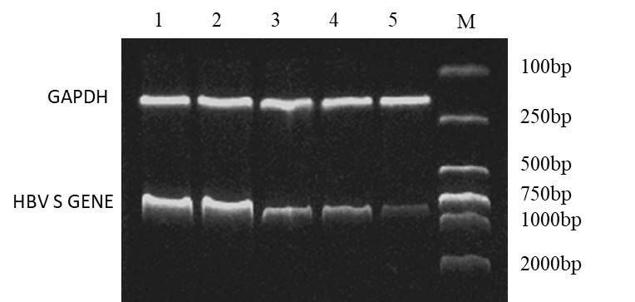
Electrophoresis of HBV S-mRNA
Relative expression of HBV S-mRNA
B
a
a
c
Figure 2 Hepatitis B virus S-mRNA expression levels in the liver of transgenic mice (mean ± SD, n = 7). A: Electrophoregram showing HBV S and GAPDH bands; B: Relative expression levels of HBV S-mRNA. ªSignificant (P < 0.05) S-mRNA expression alterations between blank (1), unrelated sequence (2), lamivudine (3) vs Anti-sense-LNA (4) and Anti-gene-LNA (5). ^{c}Significant (P < 0.05) S-mRNA expression alterations between Anti-sense-LNA (4) vs Anti-gene-LNA (5). Values are mean ± SD. M: DNA marker; LNA: Locked nucleic acid; HBV: Hepatitis B virus.
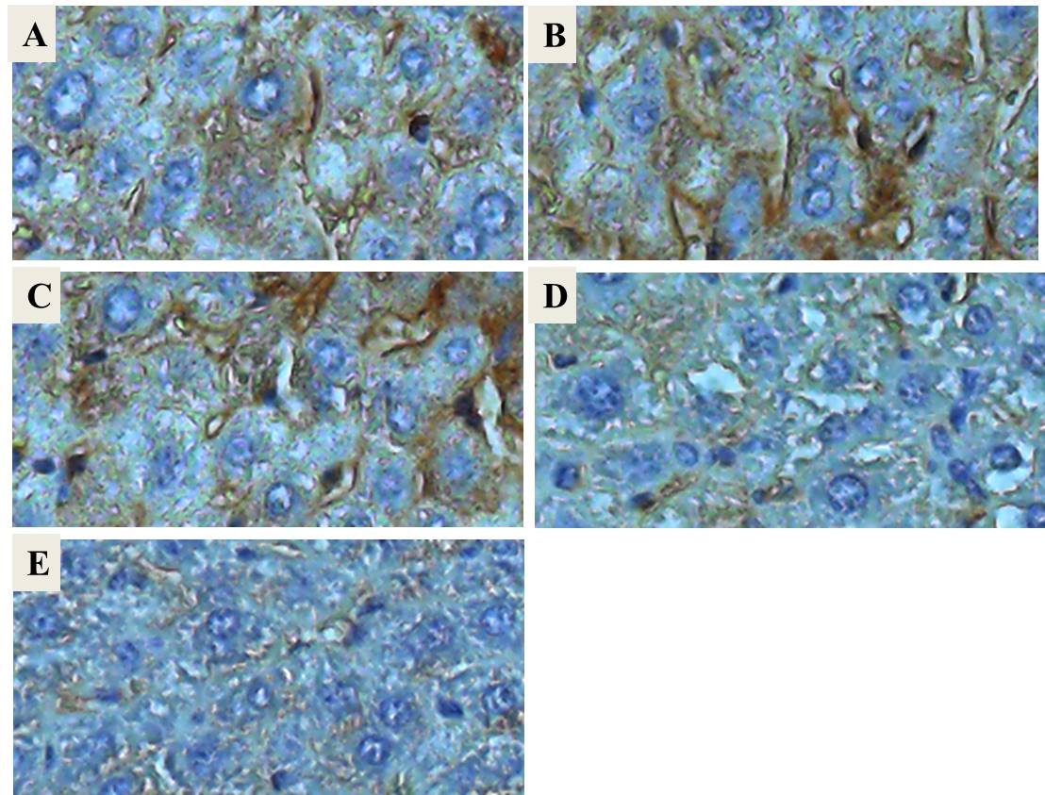
F
Positive cells of HBsAg(%)
a
c
a
Figure 3 Immunohistochemical detection (× 200) of hepatitis B surface antigen positive cells in liver tissues of transgenic mice. ªSignificant (P < 0.05) HBsAg positive cells expression alterations between blank (A),unrelated sequence (B), lamivudine (C) vs anti-sense-LNA (D) and anti-gene-LNA (E). ^{c}Significant (P < 0.05) HBsAg positive cells expression alterations between anti-sense-LNA (D) vs anti-gene-LNA (E). Values are mean ± SD; F: Positive HBsAg cells. LNA: Locked nucleic acid; HBV: Hepatitis B virus; HBsAg: HBV surface antigen.

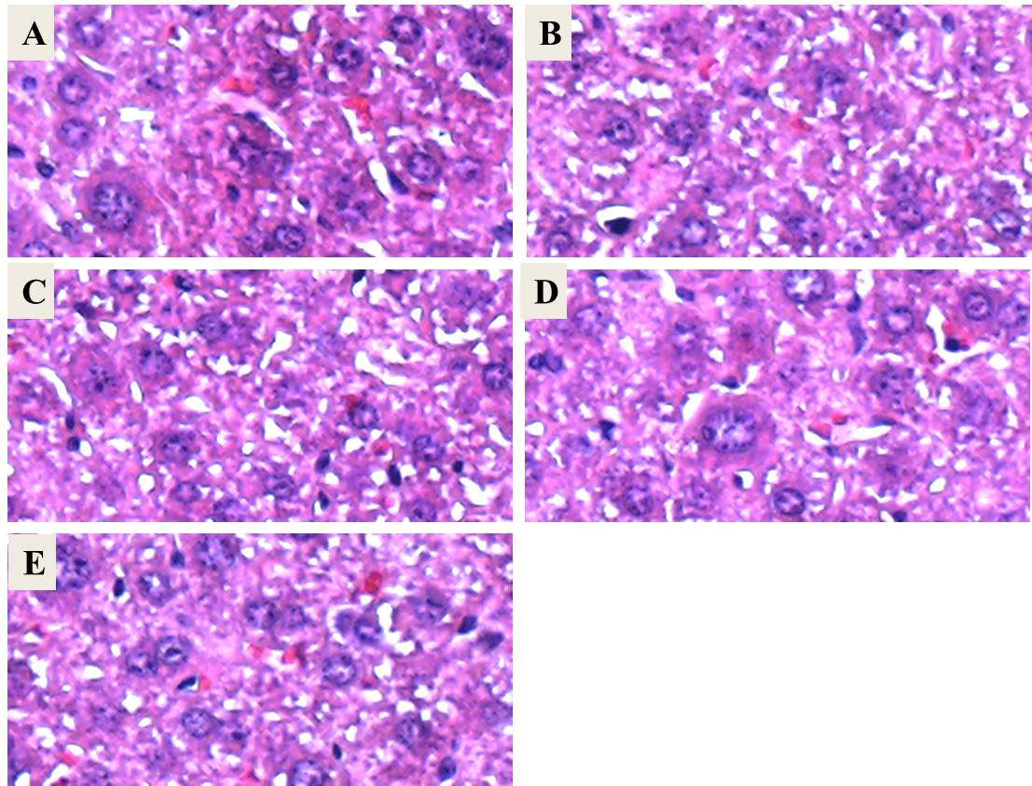

Figure 4 Morphological changes in liver sections obtained from transgenic mice infected with hepatitis B virus. Mice were sacrificed, and the livers were harvested and prepared for observation on the 7th d after treatment. A: Blank control group; B: Unrelated sequence control group; C: Lamivudine control group; D: Anti-sense-LNA treatment control group; E: Anti-gene-LNA treatment group. Liver sections were stained with hematoxylin and eosin (original magnification, × 200). There were no significant morphological changes in the liver among groups. LNA: Locked nucleic acid.

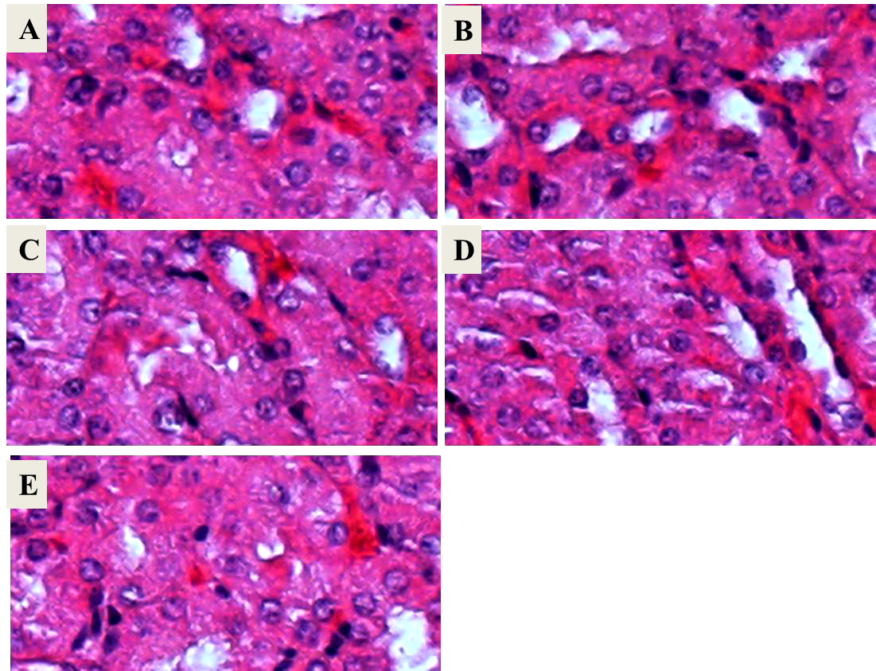

Figure 5 Morphological changes in kidney sections obtained from transgenic mice infected with hepatitis B virus. Mice were sacrificed, and the kidneys were harvested and prepared for observation on the 7th d after treatment. A: Blank control group; B: Unrelated sequence control group; C: Lamivudine control group; D: Anti-sense-LNA treatment control group; E: Anti-gene-LNA treatment group. Kidney sections were stained with hematoxylin and eosin (original magnification, × 200). There were no significant morphological changes in the kidney among groups. LNA: Locked nucleic acid.

