Tables and Images

Figure 1



Fig.1. Structure of BT (A). The Cα backbone is represented as ribbons with the LC in cyan, the HN in dark blue and the HC in a green to yellow gradient highlighting the HCN and HCC subdomains. The HN belt is in red.

BT (A)= Botulinum toxin A, HN+HC= ∼100 kDa heavy chain, HN=∼ 50 kDa amino terminus HC= ∼50 kDa carboxy terminal of the heavy chain, HCC= β-beta tree foil fold heavy chain subdomain , HCN= β-sheet jelly roll fold heavy chain subdomain, LC= light chain

Adapted with permission from Montal et al.[17]

Figure 2 Mechanism of action of botulinum neurotoxin

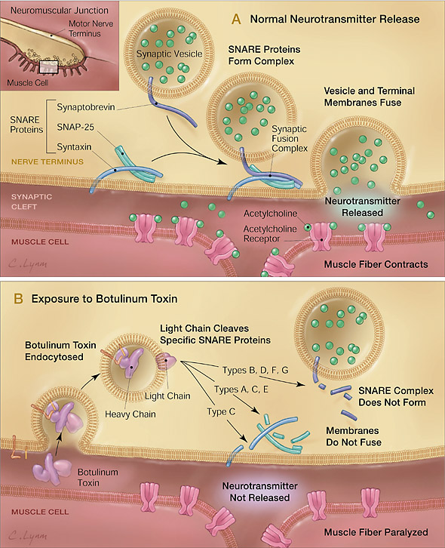

Reproduced with permission from Arnon et al [18]

A, Release of acetylcholine at the neuromuscular junction is mediated by the assembly of a synaptic fusion complex that allows the membrane of the synaptic vesicle containing acetylcholine to fuse with the neuronal cell membrane. The synaptic fusion complex is a set of SNARE proteins, which include synaptobrevin, SNAP-25, and syntaxin. After membrane fusion, acetylcholine is released into the synaptic cleft and then bound by receptors on the muscle cell.

B, Botulinum toxin binds to the neuronal cell membrane at the nerve terminus and enters the neuron by endocytosis. The light chain of botulinum toxin cleaves specific sites on the SNARE proteins, preventing complete assembly of the synaptic fusion complex and thereby blocking acetylcholine release. Botulinum toxins types B, D, F, and G cleave synaptobrevin; types A, C, and E cleave SNAP-25; and type C cleaves syntaxin. Without acetylcholine release, the muscle is unable to contract.

SNARE indicates soluble NSF-attachment protein receptor; NSF, N-ethylmaleimide-sensitive fusion protein; and SNAP-25, synaptosomal-associated protein of 25 kd.

(Table 1).

|  |  |  |  |  |  |
| --- | --- | --- | --- | --- | --- |
| Table 1. Properties of commercially available botulinum toxin drugs | | | | |  |
|  | **Botox®** | **Dysport®** | **Xeomin®** | **NeuroBloc® Myobloc ®** | |
| **Manufacturer** | Allergan Inc. Irvine, CA, USA | Ipsen Pharma Boulogne-Billancourt, France | Merz Pharmaceuticals Frankfurt/M, Germany | US WorldMeds Louisville, KY, USA | |
| **Pharmaceutical preparation** | Powder | Powder | Powder | Ready-to-use solution 5000 MU-E/ml | |
| **Storage conditions** | Below 8 °C | Below 8 °C | Below 25 °C | Below 8 °C | |
| **Shelf life** | 36 months | 24 months | 36 months | 24 months | |
| **Botulinum toxin type** | A | A | A | B | |
| ***Clostridium botulinum*strain** | Hall A | Ipsen strain | Hall A | Bean B | |
| **SNARE target** | SNAP25 | SNAP25 | SNAP25 | VAMP | |
| **Purification process** | Precipitation and chromatography | Precipitation and chromatography | Precipitation and chromatography | Precipitation and chromatography | |
| **pH-value of the reconstituted preparation** | 7.4 | 7.4 | 7.4 | 5.6 | |
| **Stabilisation** | Vacuum drying | Freeze-drying (lyophilisate) | Vacuum drying | pH-reduction | |
| **Excipients** | Human serum albumin 500 μg/100 MU-vial; NaCl 900 μg/100 MU-vial buffer system | Human serum albumin 125 μg/500 MU-vial; Lactose 2500 μg/100 MU-vial buffer system | Human serum albumin 1000 μg/100 MU-vial; Sucrose 4.7 mg/100 MU-vial buffer system | Human serum albumin 500 μg/ml; Disodium succinate 0.01 M; Sodium chloride 0.1 M; H2O; Hydrochloric acid | |
| **Biological activity** | 50/100 MU-A/vial | 500 MU-I/vial | 50/100 MU-M/vial | 1.0/2.5/10.0 kMU-E/vial | |
| **Biological activity in relation to Botox ®** | 1 | 1:2–1:3 | 1 | 1:40 | |
| **Specific biological activity** | 60 MU-EV/ngBNT | 100 MU-EV/ngBNT | 167 MU-EV/ngBNT | 5 MU-EV/ngBNT | |
| BNT: botulinum neurotoxin; MU-A: mouse unit in the Allergan mouse lethality assay; MU-E: mouse unit in the Solstice mouse lethality assay; MU-I: mouse unit in the Ipsen mouse lethality assay; MU-M: mouse unit in the Merz mouse lethality assay; MU-EV: equivalence mouse unit, 1 MU-EV = 1 MU-A = 1 MU-M = 3 MU-I = 40 MU-E. | | | | | |

Adapted with permission from Dressler et al [11]

**Figure 3. Neuronal Sprouting and Remodeling of the Neuromuscular Junction**

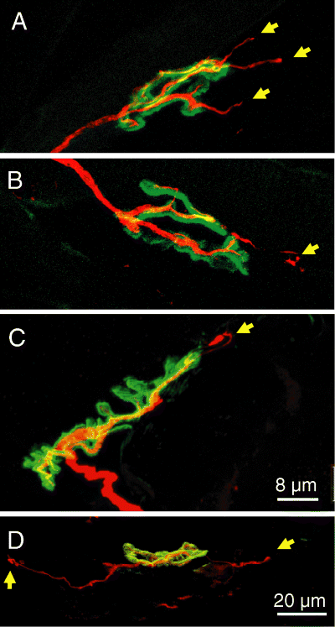

Fig 3. Remodelling of the neuromuscular junction in extensor digitorum longus muscle at 10 (A–C) and 21 days (D) after a single injection of botulinum neurotoxin type C. Axons and nerve terminals were immunolabelled (red) . To localize the junctions, nicotinic acetylcholine receptors were stained (green). Note the sprouts that emerge from the original motor endplate and project along muscle fibers (yellow arrows).

Reproduced with permission from Morbiato et al [42]