**Name of Journal:** *World Journal of Gastroenterology*

**Manuscript NO:** 46893

**Manuscript Type:** ORIGINAL ARTICLE

***Basic Study***

**Berberine prevents stress-induced gut inflammation, visceral hypersensitivity and reduces intestinal motility in rats**

Yu Z *et al*. Berberine prevents stress-induced gut inflammation

Zhi-Chao Yu, Yong-Xin Cen, Ben-Hua Wu, Cheng Wei, Feng Xiong, De-Feng Li, Ting-Ting Liu, Ming-Han Luo, Li-Liangzi Guo, Ying-Xue Li, Li-Sheng Wang, Jian-Yao Wang, Jun Yao

**Zhi-Chao Yu, Ben-Hua Wu, Cheng Wei, Feng Xiong, De-Feng Li, Ting-Ting Liu, Ming-Han Luo, Li-Liangzi Guo, Ying-Xue Li, Li-Sheng Wang, Jun Yao,** Department of Gastroenterology, Jinan University of Second Clinical Medical Sciences, Shenzhen Municipal People’s Hospital, Shenzhen 518020, Guangdong Province, China

**Yong-Xin Cen,** Department of Gastroenterology, Foshan Gaoming Affiliated Hospital of Guangdong Medical University, Foshan 528500, Guangdong Province, China

**Jian-Yao Wang,** Department of General Surgery, Shenzhen Children’s Hospital, Shenzhen 518026, Guangdong Province, China

**ORCID number:** Zhi-Chao Yu (0000-0001-5123-9191); Yong-Xin Cen (0000-0003-0793-7261); Ben-Hua Wu (0000-0002-9392-9470); Cheng Wei (0000-0002-6373-1826); Feng Xiong (0000-0002-4021-0817); De-Feng Li (0000-0003-3118-6840); Ting-Ting Liu (0000-0002-1533-5220); Ming-Han Luo (0000-0002-5056-3421); Li-Liangzi Guo (0000-0003-1521-6245); Ying-Xue Li (0000-0001-6350-612X); Li-Sheng Wang (0000-0002-7418-6114); Jian-Yao Wang (0000-0003-1568-4479); Jun Yao (0000-0002-3472-1602).

**Author contributions:** Yu ZC designed and wrote the report; Cen YX and Wu BH reviewed the manuscript for its intellectual content and revised the entire work; Wei C, Xiong F, Li DF, Liu TT, Luo MH, Guo LL and Li YX performed the histological assessments and evaluations; Wang LS, Wang JY and Yao J reviewed the manuscript for its intellectual content; all authors have read and approved the final manuscript.

**Supported by** the National Natural Science Foundation of China (No. 81800489), Three engineering training funds in Shenzhen (No. SYLY201718), and Technical Research and Development Project of Shenzhen (Nos. JCYJ20170307100538697, JCYJ20160429174927286, JCYJ20170307100911479).

**Institutional review board statement:** The research project entitled “Berberine prevents stress-induced gut inflammation, visceral hypersensitivity and reduces intestinal motility in rats” was reviewed and approved by the Animal Ethical and Welfare Committee of Shenzhen University.

**Institutional animal care and use committee statement:** The research project entitled “Berberine prevents stress-induced gut inflammation, visceral hypersensitivity and reduces intestinal motility in rats” was reviewed and approved by the Animal Ethical and Welfare Committee of Shenzhen University in January 12, 2016.

**Conflict-of-interest statement:** The authors of this manuscript have no conflicts of interest to disclose.

**ARRIVE guidelines statement:** The authors have read the ARRIVE guidelines, and the manuscript was prepared and revised according to the ARRIVE guidelines.

**Open-Access:** This article is an open-access article which was selected by an in-house editor and fully peer-reviewed by external reviewers. It is distributed in accordance with the Creative Commons Attribution Non Commercial (CC BY-NC 4.0) license, which permits others to distribute, remix, adapt, build upon this work non-commercially, and license their derivative works on different terms, provided the original work is properly cited and the use is non-commercial. See: http://creativecommons.org/licenses/by-nc/4.0/

**Manuscript source:** Unsolicited manuscript

**Corresponding author:** **Jun Yao, MD,** **PhD, Doctor,** Department of Gastroenterology, Jinan University of Second Clinical Medical Sciences, Shenzhen Municipal People’s Hospital, 1017 East Gate Road, Shenzhen 518020, Guangdong Province, China. [yj\_1108@126.com](mailto:YJ_1108@126.com)

**Telephone:** +86-755-25533497

**Fax:** +86-755-25533497

**Received:** February 27, 2019

**Peer-review started:** February 27, 2019

**First decision:** April 11, 2019

**Revised:** June 26, 2019

**Accepted:** July 5, 2019

**Article in press:**

**Published online:**

**Abstract**

***BACKGROUND***

Irritable bowel syndrome (IBS) is a common chronic non-organic disease of the digestive system. Berberine (BBR) is used to treat patients with IBS, but the underlying therapeutic mechanism is less understood. We believe that BBR may be used to treat IBS by preventing stress intestinal inflammation visceral allergy and reducing bowel motility

***AIM***

To test the hypothesis that BBR treats IBS by preventing subclinical inflammation of the intestinal mucosa and reducing visceral hypersensitivity and intestinal motility.

***METHODS***

IBS was induced in rats *via* water avoidance stress (WAS). Histological analyses and qRT-PCR were used to evaluate levels of cytokines and mucosal inflammation, respectively. Modified ELISA and qRT-PCR were used to evaluate nuclear factor kappa-B (NF-κB) signal transduction pathway. Colorectal distention, gastrointestinal transmission function, Western bolt and qRT-PCR were used to analyzed visceral sensitivity, intestinal motility, C-kit (marker of Cajal mesenchymal cells) and the expression of brain derived neurotrophic factor (BDNF) and its receptor TrkB.

***RESULTS***

WAS led to mucosal inflammation, visceral hyperalgesia and high intestinal motility. Oral administration of BBR inhibited NF-κB signal transduction pathway, reduced the expression of pro-inflammatory cytokines [interleukin (IL)-1β, IL-6, interferon-γ, Tumor necrosis factor α], promoted the expression of anti-inflammatory cytokines (IL-10, Transforming growth factor-β), and improved the terminal ileum tissue inflammation. BBR inhibited the expression of BDNF, TrkB and C-kit in IBS rats, leading to the reduction of intestinal motility and visceral hypersensitivity. The therapeutic effect of BBR at high dose (100 mg/kg) was superior to than that of the low-dose (25 mg/kg) group.

***CONCLUSION***

BBR reduces the intestinal mucosal inflammation by inhibiting the intestinal NF-κB signal pathway in the IBS rats. BBR reduces the expression of BDNF, its receptor TrkB, and C-kit. BBR also reduces intestinal motility and visceral sensitivity to achieve its therapeutic effect for IBS.

**Key words:** Irritable bowel syndrome; Visceral hypersensitivity; Berberine; Rifampicin; Nuclear factor kappa-B; Brain-derived neurotrophic factor; Cajal mesenchymal cells; C-kit

**© The Author(s) 2019.** Published by Baishideng Publishing Group Inc. All rights reserved.

**Core tip:** Irritable bowel syndrome (IBS) is a common chronic non-organic disease of the digestive system and the pathophysiology of IBS is still not completely understood. Berberine is used to treat patients with IBS, but little is known regarding to its therapeutic mechanism. This study aimed determine the therapeutic efficacy of berberine on IBS and its underlying mechanisms. The results demonstrate that the therapeutic efficacy of berberine is dose-dependent and maybe associated with inhibition of the intestinal nuclear factor kappa-B signal pathway, the expression of brain derived neurotrophic factor and its receptor TrkB, and the expression of C-kit to reduce intestinal motility and visceral sensitivity.

Yu Z, Cen YX, Wu BH, Wei C, Xiong F, Li DF, Liu TT, Luo MH, Guo LL, Li YX, Wang LS, Wang JY, Yao J. Berberine prevents stress-induced gut inflammation, visceral hypersensitivity and reduces intestinal motility in rats. *World J Gastroenterol* 2019; In press

**INTRODUCTION**

Berberine (BBR) is an isoquinoline alkaloid extracted from various Chinese medicinal herbs, *e.g.,* huanglian and scutellaria. BBR has abundant medicinal value, such as biological effects on the central nervous system, anti-tumor, anti-inflammatory, anti-Alzheimer’s disease and reducing blood fat. Large number of basic and clinical studies have also shown the efficacy of BBR in the treatment of irritable bowel syndrome (IBS). The common dosage of BBR for treating diarrhea in adults is 100-300 mg, three times a day[1-4].

The pathophysiology of IBS is still not completely understood. In the past decade, there has been increasing focuses on the possible connection of IBS with increased intestinal mucosal permeability, inflammation, intestinal bacterial overgrowth, dysfunction of the cerebral intestinal axis, and visceral hypersensitivity[[5](file:///C:\Users\Liansheng%20Ma\Desktop\Liansheng%20Ma\Dispose\2019-07-05-Final_Acceptance_WJG\46893\_ENREF_5)]. At present, the pathogenesis of IBS is accounted for the mechanism of environment-psycho-neuroendocrine-immunity[[6](file:///C:\Users\Liansheng%20Ma\Desktop\Liansheng%20Ma\Dispose\2019-07-05-Final_Acceptance_WJG\46893\_ENREF_6),[7](file:///C:\Users\Liansheng%20Ma\Desktop\Liansheng%20Ma\Dispose\2019-07-05-Final_Acceptance_WJG\46893\_ENREF_7)].

The immunologic disorder of the intestinal tract is closely associated with the pathogenesis of IBS, and the nuclear factor kappa-B (NF-κB) signal pathway plays a very important role in the immune response[8,9]. NF-κB can regulate the transcription of the genes related to inflammation and pain, activate the transcription of inflammatory factors, affect intestinal inflammation, and lead to abdominal pain[10]. Cytokines are an essential part of intestinal immune regulation. According to the performance of cytokines in the immune response, they can be divided into two categories: (1) Th1 cell-secreted pro-inflammatory cytokines, including interleukin-1β (IL-1β), IL-6, tumor necrosis factor-α (TNF-α) and interferon γ (IFN-γ); (2) Th2 cell-secreted anti-inflammatory cytokines, including IL-10, transforming growth factor-β (TGF-β). Immune response of IBS is not just limited to the intestine. Systemic immune activation characterized by the elevation of pro-inflammatory cytokines and the decrease of anti-inflammatory cytokines is also involved in IBS[11-14].

BBR can reduce the visceral hypersensitivity of IBS rats and regulate intestinal motility, but the underlying mechanism is not yet fully understood[[1](file:///C:\Users\Liansheng%20Ma\Desktop\Liansheng%20Ma\Dispose\2019-07-05-Final_Acceptance_WJG\46893\_ENREF_1)]. Brain derived neurotrophic factor (BDNF) plays an important role in the visceral hypersensitivity and intestinal hyperdynamic of IBS through the brain-gut axis. The increased expression of BDNF in colonic mucosa and central nervous system may contribute to the visceral hyperalgesia in IBS[[15](file:///C:\Users\Liansheng%20Ma\Desktop\Liansheng%20Ma\Dispose\2019-07-05-Final_Acceptance_WJG\46893\_ENREF_15),[16](file:///C:\Users\Liansheng%20Ma\Desktop\Liansheng%20Ma\Dispose\2019-07-05-Final_Acceptance_WJG\46893\_ENREF_16)]. Higher expression of BDNF in colonic mucosa and central nervous system would indicate the greater degree of abdominal pain on patient[[15](file:///C:\Users\Liansheng%20Ma\Desktop\Liansheng%20Ma\Dispose\2019-07-05-Final_Acceptance_WJG\46893\_ENREF_15)].

Cajal mesenchymal cells (ICC) can affect the intestinal motility and visceral sensitivity in IBS patients through the brain-gut axis. The corresponding receptors of many neurotransmitters are expressed on ICC, which is an important intermediary for the central nervous system to regulate visceral sensitivity and intestinal dynamics[[17](file:///C:\Users\Liansheng%20Ma\Desktop\Liansheng%20Ma\Dispose\2019-07-05-Final_Acceptance_WJG\46893\_ENREF_17)]. At the same time, some studies suggest that abnormalities in the structure and number of ICC in the intestinal tract of IBS patients can lead to abnormal electrophysiological activity in the intestinal tract[[18](file:///C:\Users\Liansheng%20Ma\Desktop\Liansheng%20Ma\Dispose\2019-07-05-Final_Acceptance_WJG\46893\_ENREF_18)]. C-Kit signaling plays a vital role in development and maintenance of ICC. Thus, C-kit has also been used as a cell marker of ICC[[19](file:///C:\Users\Liansheng%20Ma\Desktop\Liansheng%20Ma\Dispose\2019-07-05-Final_Acceptance_WJG\46893\_ENREF_19),[20](file:///C:\Users\Liansheng%20Ma\Desktop\Liansheng%20Ma\Dispose\2019-07-05-Final_Acceptance_WJG\46893\_ENREF_20)].

Rifaximin has achieved good therapeutic effect for IBS patients without constipation[[21](file:///C:\Users\Liansheng%20Ma\Desktop\Liansheng%20Ma\Dispose\2019-07-05-Final_Acceptance_WJG\46893\_ENREF_21)]. It has been shown that rifaximin relieves symptoms of IBS by reducing visceral hypersensitivity in rats[[22](file:///C:\Users\Liansheng%20Ma\Desktop\Liansheng%20Ma\Dispose\2019-07-05-Final_Acceptance_WJG\46893\_ENREF_22)]. However, rifaximin has disadvantages, *e.g*., high prices. Furthermore, long-term oral administration may lead to cross-resistance of similar antibiotics with rifampicin and rifabutin[[23](file:///C:\Users\Liansheng%20Ma\Desktop\Liansheng%20Ma\Dispose\2019-07-05-Final_Acceptance_WJG\46893\_ENREF_23),[24](file:///C:\Users\Liansheng%20Ma\Desktop\Liansheng%20Ma\Dispose\2019-07-05-Final_Acceptance_WJG\46893\_ENREF_24)]. This experiment intends to explore the possible mechanism of BBR in the treatment of IBS on the level of brain and intestinal axis through the study of the high visceral sensitivity and intestinal dynamic mechanism of BBR in rats with experimental diarrhea IBS.

**MATERIALS AND METHODS**

***Animals***

All experiments were performed on adult male Wistar rats (200-225 g). Rats were obtained from the Guangdong experimental animal center. Animals were housed in plastic cages, 3 per cage at room temperature (22 ± 1 °C) and 65%-70% humidity. Animals were maintained on a 12 h light:12 h dark cycle, with free access to water and feeds. External oblique muscle electrode implantation was implemented after 5-7 d. Surgical preparations involved anesthetization with a xylazine/ketamine mixture. Postoperative recovery of rats was 4-6 d. Experimental animals were maintained in accordance with internationally accepted principles for laboratory animal use.

***Chronic water avoidance stress protocol***

Chronic exposure of adult rats to water avoidance stress (WAS) was conducted as described previously[[25](file:///C:\Users\Liansheng%20Ma\Desktop\Liansheng%20Ma\Dispose\2019-07-05-Final_Acceptance_WJG\46893\_ENREF_25)]. Briefly, animals were placed on a block in the middle of a Plexiglas tank filled with sterile water (25 °C) (1 cm below the platform height). They were maintained on the block for 1 h daily for 10 consecutive days (Figure 1). Rats of control group were placed similarly in a tank without water for 1 h daily for 10 d. In separate studies, rats were treated with oral gavage of 3 mL rifaximin suspension (150 mg/kg, 2 times daily 6 h apart), 3 mL water once a day, 3 mL suspension of a small dose of BBR (25 mg/kg, once a day), 3 mL suspension of high dose of BBR (100 mg/kg, once a day) for 10 consecutive days. The rats were then submitted to daily sessions of WAS or sham WAS 3 h after each AM gavage for 10 d. Specific rifaximin and BBR doses were based on previous studies[[22](file:///C:\Users\Liansheng%20Ma\Desktop\Liansheng%20Ma\Dispose\2019-07-05-Final_Acceptance_WJG\46893\_ENREF_22),[26](file:///C:\Users\Liansheng%20Ma\Desktop\Liansheng%20Ma\Dispose\2019-07-05-Final_Acceptance_WJG\46893\_ENREF_26),[27](file:///C:\Users\Liansheng%20Ma\Desktop\Liansheng%20Ma\Dispose\2019-07-05-Final_Acceptance_WJG\46893\_ENREF_27)].

***Visceromotor response to colorectal distention***

The protocol for measuring electromyogram (EMG) to colorectal distention (CRD) has been previously described[[28](file:///C:\Users\Liansheng%20Ma\Desktop\Liansheng%20Ma\Dispose\2019-07-05-Final_Acceptance_WJG\46893\_ENREF_28)]. Briefly, rats with a surgery had 5 d for recovery, and fasted for 24 h before intracolonic infusion, CRD and EMG. EMG of rats were detected on day 0 and day 11 under different pressures. The baseline was the average of EMG amplitude measured by the Control group in the 0-day CRD pressure of 60 mmHg. The amplitude of EMG under different CRD pressure was compared with the baseline (% of control). We took the average EMG amplitude measured in day 11 subtracted by the average EMG amplitude detected in day 0, and expressed it as △EMG.

***Determination of gastrointestinal motility***

The protocol for detecting the gastrointestinal transit has been previously described[[29](file:///C:\Users\Liansheng%20Ma\Desktop\Liansheng%20Ma\Dispose\2019-07-05-Final_Acceptance_WJG\46893\_ENREF_29)]. For total gastrointestinal transi, after the animals were fasted overnight, activated carbon ink was orally administered at a dose of 10 mL/kg. The time that animals first defecated black feces was recorded. For small intestinal transit, after an overnight fast, activated carbon ink was orally administered at a dose of 10 mL/kg to each animal. After 30 min, the rats were sacrificed by cervical dislocation. The small intestine was immediately excised carefully without stretching and the distance traveled by ink was measured as well as the total length of the small intestine. Data are expressed as the proportion (%) of the distance traveled by the ink along the entire length of the small intestine.

***Evaluation of intestinal inflammatory response in rats***

Hematoxylin and eosin (HE) staining was carried out at rat distal ileum tissue, and the inflammatory changes were observed under the microscope.

***Enzyme-linked immunosorbent assay***

Distal ileum tissue (50 mg) was added to 2 mL cold saline and homogenized using a glass homogenizer. The homogenates were centrifuged at low temperature for 20 min at 3000 rpm. The protein concentration in the supernatant was quantified on a Nanodrop 2000 (Thermo Fisher Scientific, Waltham, MA, United States). The concentration of IL-1β, IL-6, TNF-α, IFN-γ, IL-10 and TGF-β was determined according to the manufacturer’s instruction.

***Modified enzyme-linked immunosorbent assay***

Cytoplasmic protein and nuclear protein were extracted from rat ileum. Expression of NF-κB (P65) DNA-binding protein were measured by a commercially available modified ELISA kit [Cayman NF-κB (P65) Transcription Factor Assay Kit].

***Western blotting***

Cytoplasmic protein and nuclear protein were extracted and quantified. Protein (20 μg) was separated in an SDS-PAGE gel and then electro-transferred onto a NC membrane (0.2 μm pore; WHATMAN, England). Membranes were incubated with primary antibodies overnight at 4 °C with subsequent incubation with secondary antibodies labeled with horseradish peroxidase. Signals were quantified using ImageJ. Primary antibodies included NF- kappa B P65 antibody (mouse, 1:1000, Santa Cruz, United States) C-kit antibodies (mouse, 1:1000, Santa Cruz, United States) Trkb Rabbit mAb (Rabbit 1:1000, Cell signaling Technology, United States) Technology; GAPDH (1:1000, Proteintech, United States); horseradish peroxidase-conjugated anti-rabbit/mouse secondary antibodies (1:10000, Zhongshan Gold Bridge, Beijing, China).

***Quantitative real-time polymerase chain reaction***

Total RNA was extracted from samples of distal ileum using TRIzol reagent (Thermo scientific, United States). cDNA was synthesized using a reverse transcription kit Thermo scientific, United States). Quantitative PCR for inflammatory cytokines and C-kit mRNA was performed with an iCycler IQ real-time detection system (Bio-Rad Laboratories, Hercules, CA, United States) and detected by SYBR Green in a fluorescence thermocycler (LightCycler; Roche Diagnostics, Mannheim, Germany). Primer sequences and Reverse sequences used for PCR were listed in Table 1. Double standard curve method was used to calculate the results

***Statistical analysis***

Changes of EMG under different CRD pressure before and after experiment were analyzed using SPSS13.0. The statistical data are represented by the mean with standard deviation. We conducted normal test and variance homogeneity test for each group of experimental data. If the variance is homogeneous, the one-factor ANOVA was adopted, and the Bonferroni test was used to compare the two groups for the overall difference. If the variance was not homogenous, Kruskal Wallis *H* test was adopted and the Mann Whitney *U* test was used to compare each group for the overall difference. *P* < 0.05 was considered to be statistically significant.

**RESULTS**

***Water avoidance stress induces intestinal inflammation in rats***

Compared with the control group, WAS group showed a low inflammatory response in the intestinal tract (Figure 2). The expression levels of p65 DNA binding protein and NF-κB (P65) were significantly increased in the WAS group (*P* < 0.05) (Figure 3). The levels of pro-inflammatory cytokines IL-1β, IL-6, TNF-α and IFN-γ were increased, while the levels of anti-inflammatory cytokines IL-10 and TGF-β were decreased (*P* < 0.05) in the WAS group compared with the control group (Figures 4 and 5).

***Chronic WAS induce visceral hyperalgesia and Intestinal hyperdynamic***

After 10 d WAS or sham WAS (control group), rats showed pressure-dependent increases in EMG amplitude to CRD. On day 11, chronic WAS induced greater increases in EMG amplitude to CRD compared to sham WAS. Such increase was significantly different at 40 mmHg (ΔEMG response after WAS over baseline: 46.14 ± 11.1 *vs* 3.8 ± 13.8 after sham WAS over baseline, *P* < 0.05), and 60 mmHg (ΔEMG response after WAS over baseline: 59.58 ± 17.8 *vs* 0.45 ± 9.6 after sham WAS over baseline, *P* < 0.05) (Figure 6). Gastrointestinal motility assay showed that the time to the first black feces in the WAS group was significantly shorter than that in the control group (457.47 ± 25.99 min *vs* 580.40 ± 40.44 min, *P* < 0.05). The proportion (%) of the distance traveled by the ink along the entire length of the small intestine in the WAS group was significantly lower than that in control group (63.77 ± 2.77% *vs* 49.03 ± 4.60%, *P* < 0.05) (Figure 7). Compared with the control group, BDNF and its receptor Trkb expression was significantly increased in the WAS group (*P* < 0.05) (Figure 8). C-kit expression levels in the WAS group were also significantly increased in the WAS group compared to the control group (*P* < 0.05) (Figure 9).

***Berberine prevents mucosal inflammation***

Compared with the WAS group, after oral administration of rifaximin, 25 mg/kg BBR or 100 mg/kg BBR, the tissues were intact, and there were no significant neutrophils at the distal ileum (Figure 2). In the treatment group, the expression level of DNA-binding protein and NF-κB (P65) in distal ileum tissues was significantly reduced compared to WAS group (*P* < 0.05). The therapeutic effect of oral administration of rifaximin or 100 mg/kg BBR was superior to 25 mg/kg BBR (*P* < 0.05) (Figure 3). The expression levels of pro-inflammatory cytokines in the treatment groups were lower than those in the WAS group (*P* < 0.05)，and the therapeutic effect of rifaximin or 100 mg/kg BBR was superior to 25 mg/kg BBR (*P* < 0.05). The expression levels of anti-inflammatory cytokines IL-10 and TGF-β in the treatment groups were higher than those in the WAS group (*P* < 0.05) (Figures 4 and 5).

***Berberine regulates the intestinal motility and visceral hypersensitivity***

On day 11, rifaximin, 25 mg/kg BBR or 100 mg/kg BBR treatment reduced the increased level of VMR to CRD induced by both forms of stress at 40 and 60 mmHg (*P* < 0.05. Furthermore, rifaximin or 100 mg/kg BBR makes the smaller △EMG compared to 25 mg/kg BBR (*P* < 0.05) (Figure 6). The time to the first black feces was significantly shorter in rifaximin and 100 mg/kg BBR groups than that in WAS and 25 mg/kg BBR group (*P* < 0.05). There is no significant difference between rifaximin group and 100 mg/kg BBR group. The proportion (%) of the distance traveled by the ink along the entire length of the small intestine in rifaximin and 100 mg/kg BBR group was significantly lower than that in WAS group and 25 mg/kg BBR group (*P* < 0.05). There is no significant difference between rifaximin and 100 mg/kg BBR group (Figure 7).

Compared with WAS group, the expression levels of BDNF and its receptor Trkb showed no significant difference in the 25 mg/kg BBR treatment group (*P* > 0.05). Compared with the WAS group, the expression levels of BDNF and its receptor Trkb were significantly decreased in the rifaximin group and 100 mg/kg BBR treatment group (*P* < 0.05). Compared with 25 mg/kg BBR group, the expression levels of BDNF and its receptor Trkb were significantly reduced in the rifaximin group and 100 mg/kg BBR group (*P* < 0.05). The expression levels of BDNF and its receptor Trkb were not significantly different between rifaximin group and 100 mg/kg BBR group (*P* > 0.05) (Figure 8).

Compared with the WAS group, C-kit expression were not significantly different in the 25 mg/kg BBR group (*P* > 0.05). Compared with the WAS group, the expression levels of C-kit were significantly decreased in the rifaximin and 100 mg/kg BBR groups (*P* < 0.05). Compared with the 25 mg/kg BBR group, the expression levels of C-kit were significantly decreased in the rifaximin and 100 mg/kg BBR group (*P* < 0.05). There was no significant difference in c-kit expression between rifaximin group and 100 mg/kg BBR group (*P* > 0.05) (Figure 9).

**DISCUSSION**

We used chronic exposure of adult rats to WAS to study the effects of BBR on mucosal inflammation, visceral hypersensitivity and intestinal motility. Similar to previous studies, chronic exposure of adult rats to WAS induced mucosal inflammation, and the amplitude of EMG induced by CRD in rats of WAS group was significantly enhanced, suggesting that the visceral sensitivity was enhanced. Further analysis also showed that intestinal motility was enhanced[[22](file:///C:\Users\Liansheng%20Ma\Desktop\Liansheng%20Ma\Dispose\2019-07-05-Final_Acceptance_WJG\46893\_ENREF_22),[30](file:///C:\Users\Liansheng%20Ma\Desktop\Liansheng%20Ma\Dispose\2019-07-05-Final_Acceptance_WJG\46893\_ENREF_30),[31](file:///C:\Users\Liansheng%20Ma\Desktop\Liansheng%20Ma\Dispose\2019-07-05-Final_Acceptance_WJG\46893\_ENREF_31)].

Our experiments showed that the mucosal inflammation occurred in the distal ileum in WAS group rats. Previous studies have shown that there is a positive feedback regulation between NF-κB signaling pathway and inflammatory cytokines. On the one hand, the activated NF-κB can promote the expression of pro-inflammatory cytokines. On the other hand, the released pro-inflammatory cytokines react to the activation state of the NF-κB, leading to a cascade of inflammatory response in the intestinal tract, and pro-inflammatory cytokines are further released[[10](file:///C:\Users\Liansheng%20Ma\Desktop\Liansheng%20Ma\Dispose\2019-07-05-Final_Acceptance_WJG\46893\_ENREF_10),[32-34](file:///C:\Users\Liansheng%20Ma\Desktop\Liansheng%20Ma\Dispose\2019-07-05-Final_Acceptance_WJG\46893\_ENREF_32)]. Thus, it is reasonable to consider that the activation of the NF-κB signaling pathway and the activation of inflammatory cytokines in IBS rats lead to low mucous mucosal inflammation in the distal ileum. Our experiments showed that high-dose oral administration of BBR or oral rifaximin can decrease the expression levels of NF-κB (p65) DNA- binding protein and NF-κB (p65) in IBS rats drop, Which may mean that it restrains the NF-κB signaling pathway, inhibit activation of pro-inflammatory cytokines, increase the anti-inflammatory cytokine expression, and reduce the inflammatory response of distal ileum in rats. As mentioned above, high-dose BBR effectively inhibited mucosal inflammation by interdicting the positive feedback between NF-κB signal pathway and inflammatory factors in IBS rats (Figure 10). Studies have shown that mucosal inflammation can lead to visceral hypersensitivity[[35](file:///C:\Users\Liansheng%20Ma\Desktop\Liansheng%20Ma\Dispose\2019-07-05-Final_Acceptance_WJG\46893\_ENREF_35)]. Therefore, oral high-dose BBR reduce visceral sensitivity by possibly controlling mucosal inflammation in intestine.

The expression levels of BDNF and its receptor TrkB were increased in WAS group rats. Previous studies have shown that BDNF plays an important regulatory role in IBS patients' visceral sensitivity and intestinal motility through the brain gut axis pathway. BDNF activates the signal transduction pathways of CaMK and MAPK after binding the high affinity receptor protein Trkb[[36](file:///C:\Users\Liansheng%20Ma\Desktop\Liansheng%20Ma\Dispose\2019-07-05-Final_Acceptance_WJG\46893\_ENREF_36),[37](file:///C:\Users\Liansheng%20Ma\Desktop\Liansheng%20Ma\Dispose\2019-07-05-Final_Acceptance_WJG\46893\_ENREF_37)]. High-dose BBR or rifaximin can reduce the visceral hypersensitivity and intestinal motility of IBS rats and decrease the expression levels of BDNF mRNA, Trkb mRNA and Trkb protein in distal ileum. BBR reduces visceral hypersensitivity and intestinal dynamics by reducing BDNF and its receptor Trkb expression, which may be associated with the following mechanisms. (1) The increased expression of BDNF may damage the ultrastructure of intestinal nerve fibers, and result in higher density of nerve fibers in the intestinal tract and the release of excitatory neurotransmitters, leading to the allergy of intestinal neurons[[38](file:///C:\Users\Liansheng%20Ma\Desktop\Liansheng%20Ma\Dispose\2019-07-05-Final_Acceptance_WJG\46893\_ENREF_38)]. BBR inhibits the expression of BDNF in the IBS rats to maintain the normal form of the enteric nervous system, keeps normal operation of the enteric nervous system, eventually, prevents the visceral hypersensitivity; (2) BDNF promotes the release of pain mediators in the intestinal tract[[38](file:///C:\Users\Liansheng%20Ma\Desktop\Liansheng%20Ma\Dispose\2019-07-05-Final_Acceptance_WJG\46893\_ENREF_38)], and BBR alleviates the pain of the IBS rats by reducing the expression of BDNF; and (3) BBR reduces the activity of serine protease by reducing the expression of BDNF in the intestinal tract, thereby improving the symptoms of diarrhea in IBS patients, as well as the severity and frequency of abdominal pain.

C-kit mRNA and protein expression levels increased in the distal ileum of WAS group rats, suggesting that the C-kit signaling pathway in rats was activated. C-kit activation may affect the regulatory effect of ICC cells on intestinal sensitivity and intestinal motility in rats. ICC can spontaneously produce rhythmic slow wave, transmit the intestinal nerve signals to the smooth muscle cells to ensure the normal movement of the intestinal tract and regulate the intestinal motility and visceral sensitivity of IBS patients through the brain gut axis[[20](file:///C:\Users\Liansheng%20Ma\Desktop\Liansheng%20Ma\Dispose\2019-07-05-Final_Acceptance_WJG\46893\_ENREF_20),[39](file:///C:\Users\Liansheng%20Ma\Desktop\Liansheng%20Ma\Dispose\2019-07-05-Final_Acceptance_WJG\46893\_ENREF_39),[40](file:///C:\Users\Liansheng%20Ma\Desktop\Liansheng%20Ma\Dispose\2019-07-05-Final_Acceptance_WJG\46893\_ENREF_40)]. C-kit signal pathway plays an important role in the proliferation and development of the ICC cells. Thus, c-kit protein expression is an important marker for the determination of ICC cells[[41](file:///C:\Users\Liansheng%20Ma\Desktop\Liansheng%20Ma\Dispose\2019-07-05-Final_Acceptance_WJG\46893\_ENREF_41),[42](file:///C:\Users\Liansheng%20Ma\Desktop\Liansheng%20Ma\Dispose\2019-07-05-Final_Acceptance_WJG\46893\_ENREF_42)]. Stem cell factor (SCF), an important ligand of c-kit, is one of the important cytokines that induce IBS[[19](file:///C:\Users\Liansheng%20Ma\Desktop\Liansheng%20Ma\Dispose\2019-07-05-Final_Acceptance_WJG\46893\_ENREF_19),[43](file:///C:\Users\Liansheng%20Ma\Desktop\Liansheng%20Ma\Dispose\2019-07-05-Final_Acceptance_WJG\46893\_ENREF_43)]. High-dose BBR or rifaximin can reduce the visceral hypersensitivity and intestinal motility of IBS rats, and reduce the expression levels of C-kit in distal ileum. BBR reduces visceral hypersensitivity and intestinal dynamics by reducing C-kit expression, which may be associated with the following mechanisms. (1) Through both SCF and C-kit, the JAK/STAT signaling pathway is activated, and STAT transfers into the nucleus, leading to the proliferation of ICC cells. Pathological changes occur in the new ICC, leading to abnormal intestinal electrophysiological pacing. BBR may inhibit the activation of the JAK/STAT signaling pathway by decreasing the expression of c-kit, reducing the abnormal regeneration of ICC, inhibiting the generation of abnormal electrical signals,and ultimately reducing the intestinal motility; (2) SCF and C-kit activate the P13K-AKT signaling pathway, which increases the expression of gap junction proteins in the intestinal smooth muscle cells. The electrical signals generated by the ICC are more likely to be transmitted to each other, which increases intestinal movement. Reduction in the expression level of C-kit can inhibit the activity of P13K-AKT signaling pathway, leading to decline of the expression level of gap junction proteins in the intestinal smooth muscle cells and transmission efficiency of abnormal electrical signals being reduced, which eventually causes reduction of the intestinal motility; and (3) Activation of the RAS - ERK signaling by SCF and C-kit increases the sensitivity of the neurotransmitter receptors on the ICC surface, making it easier to bind the neurotransmitter secreted by the central nervous system and the enteric nervous system. Thus, intestinal sensitivity and intestinal motility are increased. BBR inhibits RAS-ERK signaling pathway by reducing the expression of C-kit, decreases the sensitivity of neuron receptors on the surface of ICC cells decrease, and ultimately reduces visceral sensitivity and intestinal motility[[6](file:///C:\Users\Liansheng%20Ma\Desktop\Liansheng%20Ma\Dispose\2019-07-05-Final_Acceptance_WJG\46893\_ENREF_6),[44](file:///C:\Users\Liansheng%20Ma\Desktop\Liansheng%20Ma\Dispose\2019-07-05-Final_Acceptance_WJG\46893\_ENREF_44),[45](file:///C:\Users\Liansheng%20Ma\Desktop\Liansheng%20Ma\Dispose\2019-07-05-Final_Acceptance_WJG\46893\_ENREF_45)].

Our results showed that BBR can reduce inflammation of the distal ileum in IBS rats by inhibiting NF-κB signal pathways, regulate visceral sensitivity and intestinal motility in the treatment of IBS by reducing the expression of BDNF, its receptor TrkB and C-kit. Recent studies have shown that when patients experience the colon expansion test (CRD), IBS patients not only show increased abdominal withdrawal reflex, but also the increased range of brain activity reflex. These results suggest that IBS patients not only have visceral hypersensitivity, but also the increased sensitivity of the center. This interaction may be achieved through the axis of the brain. First, hormones and neurotransmitters secreted by neuroendocrine system act on immune cells and mast cells in the intestinal mucosa. Mast cells release the SCF and inflammatory medium by SCF and C–kit. Subsequently, inflammation reduces intestinal sensitivity and intestinal motivation *via* influencing the intestinal smooth muscle cells and neurons[[46-49](file:///C:\Users\Liansheng%20Ma\Desktop\Liansheng%20Ma\Dispose\2019-07-05-Final_Acceptance_WJG\46893\_ENREF_46)]. Secondly, in the stress state, the primary afferent neurons in the gastrointestinal tract are activated and the spinal cord is sensitized[[50](file:///C:\Users\Liansheng%20Ma\Desktop\Liansheng%20Ma\Dispose\2019-07-05-Final_Acceptance_WJG\46893\_ENREF_50)], which increases the permeability of the intestine[[51](file:///C:\Users\Liansheng%20Ma\Desktop\Liansheng%20Ma\Dispose\2019-07-05-Final_Acceptance_WJG\46893\_ENREF_51),[52](file:///C:\Users\Liansheng%20Ma\Desktop\Liansheng%20Ma\Dispose\2019-07-05-Final_Acceptance_WJG\46893\_ENREF_52)]. The increase of intestinal permeability leads to the defect of mucosal barrier, enhances bacterial adhesion, and infiltration into the gastrointestinal mucosa[[32](file:///C:\Users\Liansheng%20Ma\Desktop\Liansheng%20Ma\Dispose\2019-07-05-Final_Acceptance_WJG\46893\_ENREF_32),[48](file:///C:\Users\Liansheng%20Ma\Desktop\Liansheng%20Ma\Dispose\2019-07-05-Final_Acceptance_WJG\46893\_ENREF_48)]. DNA of these bacteria can interact with toll-like receptors[[53](file:///C:\Users\Liansheng%20Ma\Desktop\Liansheng%20Ma\Dispose\2019-07-05-Final_Acceptance_WJG\46893\_ENREF_53)] to regulate cytokines such as TNF and IFN[[54](file:///C:\Users\Liansheng%20Ma\Desktop\Liansheng%20Ma\Dispose\2019-07-05-Final_Acceptance_WJG\46893\_ENREF_54)] and activate intestinal mucosal immune response[[55](file:///C:\Users\Liansheng%20Ma\Desktop\Liansheng%20Ma\Dispose\2019-07-05-Final_Acceptance_WJG\46893\_ENREF_55)]. Thirdly, in anatomy, the gut immune cells are closely linked to the axons of the gut neurons. The inflammatory factors may change the structure of the nerve and increase the visceral sensation through the distal end of the afferent nerve and the activated spinal dorsal horn[[56](file:///C:\Users\Liansheng%20Ma\Desktop\Liansheng%20Ma\Dispose\2019-07-05-Final_Acceptance_WJG\46893\_ENREF_56),[57](file:///C:\Users\Liansheng%20Ma\Desktop\Liansheng%20Ma\Dispose\2019-07-05-Final_Acceptance_WJG\46893\_ENREF_57)]. Ultimately, the intestinal motility is enhanced[[58](file:///C:\Users\Liansheng%20Ma\Desktop\Liansheng%20Ma\Dispose\2019-07-05-Final_Acceptance_WJG\46893\_ENREF_58)]. The three pathways studied in this study were also connected through the brain-gut axis. The immune activation of IBS is not only limited to the intestinal wall, but also the whole body, which is manifested by the increase of the pro-inflammatory cytokines and the reduction of anti-inflammatory cytokines mediated by the NF-κB signal pathway[[13](file:///C:\Users\Liansheng%20Ma\Desktop\Liansheng%20Ma\Dispose\2019-07-05-Final_Acceptance_WJG\46893\_ENREF_13),[14](file:///C:\Users\Liansheng%20Ma\Desktop\Liansheng%20Ma\Dispose\2019-07-05-Final_Acceptance_WJG\46893\_ENREF_14)]. Cytokines are involved in the interaction of the brain-gut axis, and these inflammatory factors can act on smooth muscle cells and neurons in the gut, leading to the changes in intestinal motility and visceral sensitivity[[13](file:///C:\Users\Liansheng%20Ma\Desktop\Liansheng%20Ma\Dispose\2019-07-05-Final_Acceptance_WJG\46893\_ENREF_13),[59](file:///C:\Users\Liansheng%20Ma\Desktop\Liansheng%20Ma\Dispose\2019-07-05-Final_Acceptance_WJG\46893\_ENREF_59)]. Stress stimulates intestinal smooth muscle cells to release SCF. Combination of SCF and c-kit activates c-kit kinase, promotes the secretion of mast cells, and releases of a series of inflammatory mediators and inflammatory factors, leading to low inflammatory response in the intestinal tract. In the central nervous system, BDNF promotes the release of pro-inflammatory cytokines by activating nerve cells such as astrocytes, and the inflammatory response also causes BDNF to increase in dorsal root ganglia. Therefore, BDNF not only interacts with the intestinal nervous system, but also the intestinal immune system, which can affect the visceral sensitivity and intestinal dynamics of IBS rats[[60](file:///C:\Users\Liansheng%20Ma\Desktop\Liansheng%20Ma\Dispose\2019-07-05-Final_Acceptance_WJG\46893\_ENREF_60),[61](C:\\Users\\Liansheng Ma\\Desktop\\Liansheng Ma\\Dispose\\2019-07-05-Final_Acceptance_WJG\\46893\\_ENREF_61)]. These pathways reinforces each other through brain-gut axis, resulting in intestinal inflammation, visceral hypersensitivity, and increased intestinal motility in IBS patients. BBR can treat IBS patients by regulating these three pathways and blocking the interaction among them.

In conclusion, BBR inhibits the mucosal inflammation of the intestinal tract by inhibiting the intestinal NF-κB signal pathway in the IBS rats. BBR reduces the expression of BDNF and its receptor TrkB, and the expression of C-kit to reduce intestinal motility and visceral sensitivity and produce therapeutic effect on IBS. The therapeutic effect of 100 mg/kg BBR was superior to 25 mg/kg BBR.

**ARTICLE HIGHLIGHTS**

***Research background***

Irritable bowel syndrome (IBS) is a common chronic non-organic disease of the digestive system. Rifaximin has been used in clinical treatment of patients with IBS and has achieved good efficacy. However, rifaximin is expensive, and long-term oral administration may lead to cross-resistance with rifabutin and rifampicin. Large number of basic and clinical studies have also shown the efficacy of berberine in the treatment of IBS.

***Research motivation***

Many studies have demonstrated that the pathogenesis of patients with IBS may be related to the disorder of brain and intestinal axis, visceral hypersensitivity, intestinal immune abnormality, intestinal motility change, increased intestinal mucosal permeability and intestinal flora disorder. The treatment mechanism of berberine for IBS is still unclear. In this experiment, we tried to study the effect of berberine on intestinal inflammation, intestinal motility and intestinal sensitivity in rats with IBS and explore the therapeutic mechanism of berberine on IBS.

***Research objectives***

The purpose of this study was to investigate the effect of berberine on NF-κB signaling pathway in rats with IBS, which may improve intestinal inflammation in rats with IBS. And we studied the influence of berberine on the expression levels of brain-derived neurotrophic factor (BDNF) and c-kit in the intestinal tract of rats, which may affect the intestinal motility and visceral sensitivity of rats. Providing a theoretical basis for the clinical application of berberine in the treatment of IBS.

***Research methods***

Water avoidance stress (WAS) was used to establish the IBS rat model, and the rats were divided into control group, WAS group, Rifaximin group, 25 mg/kg BBR group and 100 mg/kg BBR group. We evaluated the histopathological changes of the terminal ileum in rats by hematoxylin and eosin (HE) staining. We measured the expression levels of NF-Κb (P65) DNA binding protein at the terminal tissues of ileum in rats of each group by modified ELISA and Western bolt. The expressions of IL-1β、IL-6、IFN-γ、TNF-a IL-10 and TGF-β mRNA levels were determined by qRT-PCR. ELISA was used to detect the inflammatory cytokines. Intestinal motility of rats in each group was detected by total gastrointestinal and small intestinal transmission functions. The mRNA expression levels of BDNF and its receptor TrkB were detected by qRT-PCR. Western bolt was used to detect the expression level of TrkB protein in the terminal tissues of ileum in each group of rats. mRNA expression levels of c-kit in ileum terminal tissues of rats in each group were detected by qRT-PCR. The expression level of Ckit protein in ileum terminal tissues of each group of rats was detected by Western bolt.

***Research results***

We successfully applied the WAS model to induce visceral hypersensitivity in rats, changes in intestinal inflammation and intestinal motility, which was consistent with the characteristics of IBS. Berberine can effectively improve the inflammation of IBS terminal tissues in HE staining. Berberine can inhibit the activated NF-κB signal pathway in the intestinal tract of IBS rats, significantly reducing the expression of inflammatory IL-1β、IL-6、IFN-γ、TNF-α in the terminal ileum tissues of IBS rats, and significantly increasing the expression levels of anti-inflammatory cytokines IL-10 and TGF-β. Berberine can effectively regulate the intestinal motility of IBS rats and inhibit the expression of BDNF and its receptor TrkB in ileum terminal tissues of IBS rats. Berberine can inhibit the expression levels of c-kit in ileum terminal tissues of IBS rats. The treatment effect of large dose (100 mg/kg) berberine group on IBS rats was significantly better than that of small dose (25 mg/kg) berberine group.

***Research conclusions***

This study found that BBR can inhibit the mucosal inflammation of the intestinal tract by inhibiting the intestinal NF-κB signal pathway in the IBS rats. BBR reduces the expression of BDNF and its receptor TrkB, and the expression of C-kit to reduce intestinal motility and visceral sensitivity and produce therapeutic effect on IBS. The therapeutic effect of 100 mg/kg BBR was superior to 25 mg/kg BBR.

***Research perspectives***

This study confirmed the exact therapeutic effect of berberine on IBS from the level of animal experiment, discussed the possible mechanism of its therapeutic effect, and provided theoretical basis for the clinical application of berberine in the treatment of IBS. However, the optimal dosage of berberine in the clinical treatment of IBS still needs further pharmacological and toxicological studies

**REFERENCES**

1 **Chen C**, Lu M, Pan Q, Fichna J, Zheng L, Wang K, Yu Z, Li Y, Li K, Song A, Liu Z, Song Z, Kreis M. Berberine Improves Intestinal Motility and Visceral Pain in the Mouse Models Mimicking Diarrhea-Predominant Irritable Bowel Syndrome (IBS-D) Symptoms in an Opioid-Receptor Dependent Manner. *PLoS One* 2015; **10**: e0145556 [PMID: 26700862 DOI: 10.1371/journal.pone.0145556]

2 **Chen FL**, Yang ZH, Liu Y, Li LX, Liang WC, Wang XC, Zhou WB, Yang YH, Hu RM. Berberine inhibits the expression of TNFalpha, MCP-1, and IL-6 in AcLDL-stimulated macrophages through PPARgamma pathway. *Endocrine* 2008; **33**: 331-337 [PMID: 19034703 DOI: 10.1007/s12020-008-9089-3]

3 **Kim S**, Kim Y, Kim JE, Cho KH, Chung JH. Berberine inhibits TPA-induced MMP-9 and IL-6 expression in normal human keratinocytes. *Phytomedicine* 2008; **15**: 340-347 [PMID: 17951041 DOI: 10.1016/j.phymed.2007.09.011]

4 **Tjong Y**, Ip S, Lao L, Fong HH, Sung JJ, Berman B, Che C. Analgesic effect of Coptis chinensis rhizomes (Coptidis Rhizoma) extract on rat model of irritable bowel syndrome. *J Ethnopharmacol* 2011; **135**: 754-761 [PMID: 21511022 DOI: 10.1016/j.jep.2011.04.007]

5 **Camilleri M**, Lasch K, Zhou W. Irritable bowel syndrome: Methods, mechanisms, and pathophysiology. The confluence of increased permeability, inflammation, and pain in irritable bowel syndrome. *Am J Physiol Gastrointest Liver Physiol* 2012; **303**: G775-G785 [PMID: 22837345 DOI: 10.1152/ajpgi.00155.2012]

6 **Ohman L**, Simrén M. Pathogenesis of IBS: Role of inflammation, immunity and neuroimmune interactions. *Nat Rev Gastroenterol Hepatol* 2010; **7**: 163-173 [PMID: 20101257 DOI: 10.1038/nrgastro.2010.4]

7 **Langhorst J**, Choi KE. The role of human defensins in gastrointestinal diseases. *Expert Rev Clin Immunol* 2011; **7**: 779-787 [PMID: 22014019 DOI: 10.1586/eci.11.62]

8 **Bradesi S**, McRoberts JA, Anton PA, Mayer EA. Inflammatory bowel disease and irritable bowel syndrome: Separate or unified? *Curr Opin Gastroenterol* 2003; **19**: 336-342 [PMID: 15703574 DOI: 10.1097/00001574-200307000-00003]

9 **Spiller RC**. Neuropathology of IBS? *Gastroenterology* 2002; **123**: 2144-2147 [PMID: 12454870 DOI: 10.1053/gast.2002.37287]

10 **Hartung JE**, Eskew O, Wong T, Tchivileva IE, Oladosu FA, O'Buckley SC, Nackley AG. Nuclear factor-kappa B regulates pain and COMT expression in a rodent model of inflammation. *Brain Behav Immun* 2015; **50**: 196-202 [PMID: 26187567 DOI: 10.1016/j.bbi.2015.07.014]

11 **Binshtok AM**, Wang H, Zimmermann K, Amaya F, Vardeh D, Shi L, Brenner GJ, Ji RR, Bean BP, Woolf CJ, Samad TA. Nociceptors are interleukin-1beta sensors. *J Neurosci* 2008; **28**: 14062-14073 [PMID: 19109489 DOI: 10.1523/JNEUROSCI.3795-08.2008]

12 **Gudes S**, Barkai O, Caspi Y, Katz B, Lev S, Binshtok AM. The role of slow and persistent TTX-resistant sodium currents in acute tumor necrosis factor-α-mediated increase in nociceptors excitability. *J Neurophysiol* 2015; **113**: 601-619 [PMID: 25355965 DOI: 10.1152/jn.00652.2014]

13 **Kindt S**, Van Oudenhove L, Broekaert D, Kasran A, Ceuppens JL, Bossuyt X, Fischler B, Tack J. Immune dysfunction in patients with functional gastrointestinal disorders. *Neurogastroenterol Motil* 2009; **21**: 389-398 [PMID: 19126184 DOI: 10.1111/j.1365-2982.2008.01220.x]

14 **Macsharry J**, O'Mahony L, Fanning A, Bairead E, Sherlock G, Tiesman J, Fulmer A, Kiely B, Dinan TG, Shanahan F, Quigley EM. Mucosal cytokine imbalance in irritable bowel syndrome. *Scand J Gastroenterol* 2008; **43**: 1467-1476 [PMID: 18752146 DOI: 10.1080/00365520802276127]

15 **Yu YB**, Zuo XL, Zhao QJ, Chen FX, Yang J, Dong YY, Wang P, Li YQ. Brain-derived neurotrophic factor contributes to abdominal pain in irritable bowel syndrome. *Gut* 2012; **61**: 685-694 [PMID: 21997550 DOI: 10.1136/gutjnl-2011-300265]

16 **O'Sullivan E**, Barrett E, Grenham S, Fitzgerald P, Stanton C, Ross RP, Quigley EM, Cryan JF, Dinan TG. BDNF expression in the hippocampus of maternally separated rats: Does Bifidobacterium breve 6330 alter BDNF levels? *Benef Microbes* 2011; **2**: 199-207 [PMID: 21986359 DOI: 10.3920/BM2011.0015]

17 **Koh SD**, Kim TW, Jun JY, Glasgow NJ, Ward SM, Sanders KM. Regulation of pacemaker currents in interstitial cells of Cajal from murine small intestine by cyclic nucleotides. *J Physiol* 2000; **527 Pt 1**: 149-162 [PMID: 10944178 DOI: 10.1111/j.1469-7793.2000.00149.x]

18 **Wang XY**, Vannucchi MG, Nieuwmeyer F, Ye J, Faussone-Pellegrini MS, Huizinga JD. Changes in interstitial cells of Cajal at the deep muscular plexus are associated with loss of distention-induced burst-type muscle activity in mice infected by Trichinella spiralis. *Am J Pathol* 2005; **167**: 437-453 [PMID: 16049330 DOI: 10.1016/S0002-9440(10)62988-4]

19 **Rich A**, Gordon S, Brown C, Gibbons SJ, Schaefer K, Hennig G, Farrugia G. Kit signaling is required for development of coordinated motility patterns in zebrafish gastrointestinal tract. *Zebrafish* 2013; **10**: 154-160 [PMID: 23297728 DOI: 10.1089/zeb.2012.0766]

20 **Eshraghian A**, Eshraghian H. Interstitial cells of Cajal: A novel hypothesis for the pathophysiology of irritable bowel syndrome. *Can J Gastroenterol* 2011; **25**: 277-279 [PMID: 21647464 DOI: 10.1155/2011/478370]

21 **Pimentel M**, Lembo A, Chey WD, Zakko S, Ringel Y, Yu J, Mareya SM, Shaw AL, Bortey E, Forbes WP; TARGET Study Group. Rifaximin therapy for patients with irritable bowel syndrome without constipation. *N Engl J Med* 2011; **364**: 22-32 [PMID: 21208106 DOI: 10.1056/NEJMoa1004409]

22 **Xu D**, Gao J, Gillilland M 3rd, Wu X, Song I, Kao JY, Owyang C. Rifaximin alters intestinal bacteria and prevents stress-induced gut inflammation and visceral hyperalgesia in rats. *Gastroenterology* 2014; **146**: 484-96.e4 [PMID: 24161699 DOI: 10.1053/j.gastro.2013.10.026]

23 **Farrell DJ**. Rifaximin in the treatment of irritable bowel syndrome: Is there a high risk for development of antimicrobial resistance? *J Clin Gastroenterol* 2013; **47**: 205-211 [PMID: 23340064 DOI: 10.1097/MCG.0b013e31827559a3]

24 **Senol G**, Erbaycu A, Ozsöz A. Incidence of cross resistance between rifampicin and rifabutin in Mycobacterium tuberculosis strains in Izmir, Turkey. *J Chemother* 2005; **17**: 380-384 [PMID: 16167516 DOI: 10.1179/joc.2005.17.4.380]

25 **Bradesi S**, Schwetz I, Ennes HS, Lamy CM, Ohning G, Fanselow M, Pothoulakis C, McRoberts JA, Mayer EA. Repeated exposure to water avoidance stress in rats: A new model for sustained visceral hyperalgesia. *Am J Physiol Gastrointest Liver Physiol* 2005; **289**: G42-G53 [PMID: 15746211 DOI: 10.1152/ajpgi.00500.2004]

26 **Gong Z**, Chen Y, Zhang R, Yang Q, Wang Y, Guo Y, Zhou B, Weng X, Liu X, Li Y, Zhu X, Dong Y. Pharmacokinetic difference of berberine between normal and chronic visceral hypersensitivity irritable bowel syndrome rats and its mechanism. *Arch Pharm Res* 2015; **38**: 1888-1896 [PMID: 25716428 DOI: 10.1007/s12272-015-0568-9]

27 **Tang QL**, Lai ML, Zhong YF, Wang AM, Su JK, Zhang MQ. Antinociceptive effect of berberine on visceral hypersensitivity in rats. *World J Gastroenterol* 2013; **19**: 4582-4589 [PMID: 23901236 DOI: 10.3748/wjg.v19.i28.4582]

28 **Wang P**, Chen FX, Du C, Li CQ, Yu YB, Zuo XL, Li YQ. Increased production of BDNF in colonic epithelial cells induced by fecal supernatants from diarrheic IBS patients. *Sci Rep* 2015; **5**: 10121 [PMID: 25998025 DOI: 10.1038/srep10121]

29 **Xie W**, Xing D, Zhao Y, Su H, Meng Z, Chen Y, Du L. A new tactic to treat postprandial hyperlipidemia in diabetic rats with gastroparesis by improving gastrointestinal transit. *Eur J Pharmacol* 2005; **510**: 113-120 [PMID: 15740731 DOI: 10.1016/j.ejphar.2005.01.019]

30 **Morteau O**, Hachet T, Caussette M, Bueno L. Experimental colitis alters visceromotor response to colorectal distension in awake rats. *Dig Dis Sci* 1994; **39**: 1239-1248 [PMID: 8200256 DOI: 10.1007/BF02093789]

31 **Davey KJ**, O'Mahony SM, Schellekens H, O'Sullivan O, Bienenstock J, Cotter PD, Dinan TG, Cryan JF. Gender-dependent consequences of chronic olanzapine in the rat: Effects on body weight, inflammatory, metabolic and microbiota parameters. *Psychopharmacology (Berl)* 2012; **221**: 155-169 [PMID: 22234378 DOI: 10.1007/s00213-011-2555-2]

32 **Gareau MG**, Jury J, Yang PC, MacQueen G, Perdue MH. Neonatal maternal separation causes colonic dysfunction in rat pups including impaired host resistance. *Pediatr Res* 2006; **59**: 83-88 [PMID: 16326990 DOI: 10.1203/01.pdr.0000190577.62426.45]

33 **Ogata H**, Hibi T. Cytokine and anti-cytokine therapies for inflammatory bowel disease. *Curr Pharm Des* 2003; **9**: 1107-1113 [PMID: 12769750 DOI: 10.2174/1381612033455035]

34 **Christianson JA**, Gebhart GF. Assessment of colon sensitivity by luminal distension in mice. *Nat Protoc* 2007; **2**: 2624-2631 [PMID: 17948005 DOI: 10.1038/nprot.2007.392]

35 **Dal Sasso M**, Culici M, Guffanti EE, Bianchi T, Fonti E, Braga PC. A combination of budesonide and the SH-metabolite I of erdosteine acts synergistically in reducing chemiluminescence during human neutrophil respiratory burst. *Pharmacology* 2005; **74**: 127-134 [PMID: 15753624 DOI: 10.1159/000084295]

36 **Wang P**, Du C, Chen FX, Li CQ, Yu YB, Han T, Akhtar S, Zuo XL, Tan XD, Li YQ. BDNF contributes to IBS-like colonic hypersensitivity via activating the enteroglia-nerve unit. *Sci Rep* 2016; **6**: 20320 [PMID: 26837784 DOI: 10.1038/srep20320]

37 **Andero R**, Choi DC, Ressler KJ. BDNF-TrkB receptor regulation of distributed adult neural plasticity, memory formation, and psychiatric disorders. *Prog Mol Biol Transl Sci* 2014; **122**: 169-192 [PMID: 24484701 DOI: 10.1016/B978-0-12-420170-5.00006-4]

38 **Boesmans W**, Gomes P, Janssens J, Tack J, Vanden Berghe P. Brain-derived neurotrophic factor amplifies neurotransmitter responses and promotes synaptic communication in the enteric nervous system. *Gut* 2008; **57**: 314-322 [PMID: 17965066 DOI: 10.1136/gut.2007.131839]

39 **Deng J**, He P, Zhong X, Wang Q, Li L, Song B. Identification of T-type calcium channels in the interstitial cells of Cajal in rat bladder. *Urology* 2012; **80**: 1389.e1-1389.e7 [PMID: 22995572 DOI: 10.1016/j.urology.2012.07.031]

40 **Jee SR**, Morales W, Low K, Chang C, Zhu A, Pokkunuri V, Chatterjee S, Soffer E, Conklin JL, Pimentel M. ICC density predicts bacterial overgrowth in a rat model of post-infectious IBS. *World J Gastroenterol* 2010; **16**: 3680-3686 [PMID: 20677340 DOI: 10.3748/wjg.v16.i29.3680]

41 **Abramovic M**, Radenkovic G, Velickov A. Appearance of interstitial cells of Cajal in the human midgut. *Cell Tissue Res* 2014; **356**: 9-14 [PMID: 24414177 DOI: 10.1007/s00441-013-1772-x]

42 **Li Z**, Zheng H, Li GB, Zhi H, Yuan WT. [Alterations of Cajal cells in the colon of slow transit constipation rats]. *Zhonghua Wei Chang Wai Ke Za Zhi* 2013; **16**: 777-779 [PMID: 23980052]

43 **Ghaith O**, El-Halabi M, Hashash JG, Sharara AI. Investigational agents for the irritable bowel syndrome. *Expert Opin Investig Drugs* 2010; **19**: 1161-1178 [PMID: 20836617 DOI: 10.1517/13543784.2010.513380]

44 **DiNitto JP**, Deshmukh GD, Zhang Y, Jacques SL, Coli R, Worrall JW, Diehl W, English JM, Wu JC. Function of activation loop tyrosine phosphorylation in the mechanism of c-Kit auto-activation and its implication in sunitinib resistance. *J Biochem* 2010; **147**: 601-609 [PMID: 20147452 DOI: 10.1093/jb/mvq015]

45 **Midrio P**, Vannucchi MG, Pieri L, Alaggio R, Faussone-Pellegrini MS. Delayed development of interstitial cells of Cajal in the ileum of a human case of gastroschisis. *J Cell Mol Med* 2008; **12**: 471-478 [PMID: 18266958 DOI: 10.1111/j.1582-4934.2008.00277.x]

46 **Mazzon E**, Sturniolo GC, Puzzolo D, Frisina N, Fries W. Effect of stress on the paracellular barrier in the rat ileum. *Gut* 2002; **51**: 507-513 [PMID: 12235072 DOI: 10.1136/gut.51.4.507]

47 **Barreau F**, Cartier C, Leveque M, Ferrier L, Moriez R, Laroute V, Rosztoczy A, Fioramonti J, Bueno L. Pathways involved in gut mucosal barrier dysfunction induced in adult rats by maternal deprivation: Corticotrophin-releasing factor and nerve growth factor interplay. *J Physiol* 2007; **580**: 347-356 [PMID: 17234701 DOI: 10.1113/jphysiol.2006.120907]

48 **Zareie M**, Johnson-Henry K, Jury J, Yang PC, Ngan BY, McKay DM, Soderholm JD, Perdue MH, Sherman PM. Probiotics prevent bacterial translocation and improve intestinal barrier function in rats following chronic psychological stress. *Gut* 2006; **55**: 1553-1560 [PMID: 16638791 DOI: 10.1136/gut.2005.080739]

49 **Róka R**, Ait-Belgnaoui A, Salvador-Cartier C, Garcia-Villar R, Fioramonti J, Eutamène H, Bueno L. Dexamethasone prevents visceral hyperalgesia but not colonic permeability increase induced by luminal protease-activated receptor-2 agonist in rats. *Gut* 2007; **56**: 1072-1078 [PMID: 17309885 DOI: 10.1136/gut.2006.115352]

50 **Seybold VS**. The role of peptides in central sensitization. *Handb Exp Pharmacol* 2009; **(194)**: 451-491 [PMID: 19655115 DOI: 10.1007/978-3-540-79090-7\_13]

51 **Dunlop SP**, Hebden J, Campbell E, Naesdal J, Olbe L, Perkins AC, Spiller RC. Abnormal intestinal permeability in subgroups of diarrhea-predominant irritable bowel syndromes. *Am J Gastroenterol* 2006; **101**: 1288-1294 [PMID: 16771951 DOI: 10.1111/j.1572-0241.2006.00672.x]

52 **Barau E**, Dupont C. Modifications of intestinal permeability during food provocation procedures in pediatric irritable bowel syndrome. *J Pediatr Gastroenterol Nutr* 1990; **11**: 72-77 [PMID: 2117653 DOI: 10.1097/00005176-199007000-00015]

53 **Rachmilewitz D**, Katakura K, Karmeli F, Hayashi T, Reinus C, Rudensky B, Akira S, Takeda K, Lee J, Takabayashi K, Raz E. Toll-like receptor 9 signaling mediates the anti-inflammatory effects of probiotics in murine experimental colitis. *Gastroenterology* 2004; **126**: 520-528 [PMID: 14762789 DOI: 10.1053/j.gastro.2004.05.052]

54 **Jijon H**, Backer J, Diaz H, Yeung H, Thiel D, McKaigney C, De Simone C, Madsen K. DNA from probiotic bacteria modulates murine and human epithelial and immune function. *Gastroenterology* 2004; **126**: 1358-1373 [PMID: 15131797 DOI: 10.1053/j.gastro.2004.02.003]

55 **Barbara G**. Mucosal barrier defects in irritable bowel syndrome. Who left the door open? *Am J Gastroenterol* 2006; **101**: 1295-1298 [PMID: 16771952 DOI: 10.1111/j.1572-0241.2006.00667.x]

56 **Cenac N**, Andrews CN, Holzhausen M, Chapman K, Cottrell G, Andrade-Gordon P, Steinhoff M, Barbara G, Beck P, Bunnett NW, Sharkey KA, Ferraz JG, Shaffer E, Vergnolle N. Role for protease activity in visceral pain in irritable bowel syndrome. *J Clin Invest* 2007; **117**: 636-647 [PMID: 17304351 DOI: 10.1172/jci29255]

57 **Bueno L**, Fioramonti J, Delvaux M, Frexinos J. Mediators and pharmacology of visceral sensitivity: From basic to clinical investigations. *Gastroenterology* 1997; **112**: 1714-1743 [PMID: 9136853 DOI: 10.1016/S0016-5085(97)70056-8]

58 **Drossman DA**, Camilleri M, Mayer EA, Whitehead WE. AGA technical review on irritable bowel syndrome. *Gastroenterology* 2002; **123**: 2108-2131 [PMID: 12454866 DOI: 10.1053/gast.2002.37095]

59 **Wouters MM**, Boeckxstaens GE. Neuroimmune mechanisms in functional bowel disorders. *Neth J Med* 2011; **69**: 55-61 [PMID: 21411840 DOI: 10.4065/mcp.2011.0031]

60 **Kleinschmidt S**, Nolte I, Hewicker-Trautwein M. Structural and functional changes of neuronal and glial components of the feline enteric nervous system in cats with chronic inflammatory and non-inflammatory diseases of the gastrointestinal tract. *Res Vet Sci* 2011; **91**: e129-e135 [PMID: 21349562 DOI: 10.1016/j.rvsc.2011.01.026]

61 **Jiang W**, Kirkup AJ, Grundy D. Mast cells drive mesenteric afferent signalling during acute intestinal ischaemia. *J Physiol* 2011; **589**: 3867-3882 [PMID: 21669977 DOI: 10.1113/jphysiol.2011.209478]

**P-Reviewer:** Bourgoin SG, Kamiya T **S-Editor:** Yan JP

**L-Editor:** **E-Editor:**

**Specialty type:** Gastroenterology and hepatology   
**Country of origin:** China   
**Peer-review report classification**  
**Grade A (Excellent):** 0  
**Grade B (Very good):** B  
**Grade C (Good):** C  
**Grade D (Fair):** 0 **Grade E (Poor):** 0



**Figure 1 The model of rats with irritable bowel syndrome was established by using water avoidance stress.**

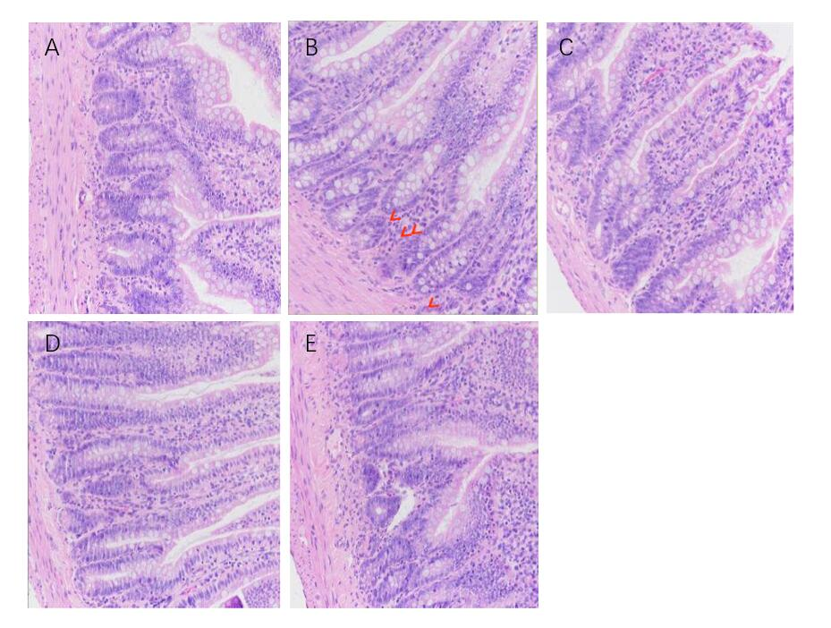

**Figure 2 The effects of berberine on histological score of distal intestine in rats (×200).** A: Control group; B: Water avoidance stress group; C: Rifaximin group; D: 25 mg/kg berberine (BBR) group; E: 100 mg/kg BBR group (the labeled cells are neutrophils). Compared with the Control group (A), rats in the water avoidance stress (WAS) group (B) showed low-grade intestinal inflammatory reaction. Microscopically, the tissues of the terminal ileum were intact, the mucosal structure and epithelium were intact, and the crypt WAS intact. Compared with WAS group, after the treatment of rifaximin (C), 25 mg/kg BBR (D) and 100 mg/kg BBR (E), the tissues of the terminal ileum of rats were intact, the mucosal structure and epithelium were intact, the crypt WAS intact, and no obvious neutrophil infiltration WAS observed. WAS: Water avoidance stress; BBR: Berberine.

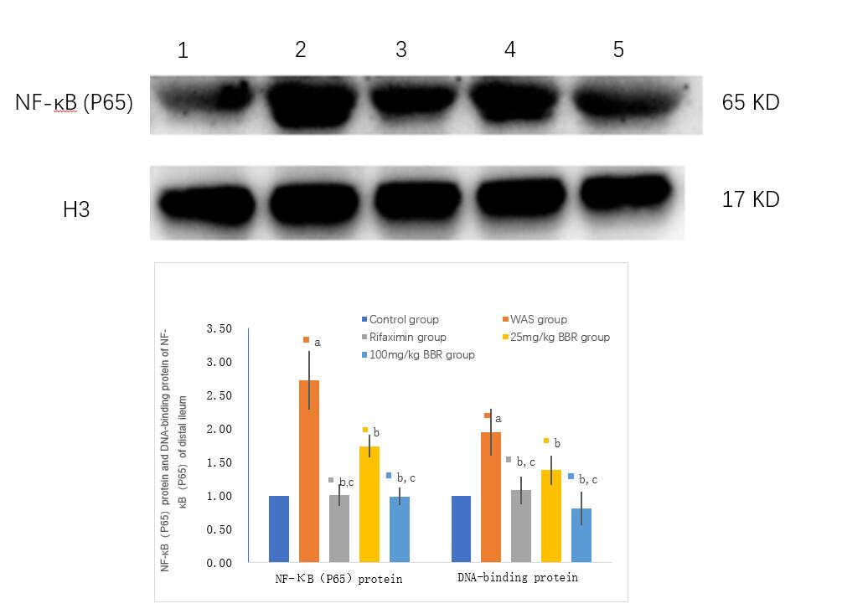

**Figure 3 The effects of berberine on NF-κB (P65) protein and NF-κB (P65) DNA-binding protein expression.** Expression of NF-κB (P65) protein and DNA-binding protein of NF-κB in 1: Control group; 2: Water avoidance stress (WAS) group; 3: Rifaximin group; 4: 25 mg/kg berberine (BBR) group; 5: 100 mg/kg BBR group. Letters a, b, c *P* < 0.05 compared with those in Control group, WAS group and 25 mg/kg BBR group, respectively. WAS: Water avoidance stress; BBR: Berberine.

**Figure 4 The effects of berberine on** **cytokines mRNA levels.** Cytokines mRNA levels in Control group, Water avoidance stress (WAS) group, Rifaximin group, 25 mg/kg berberine (BBR) group and 100 mg/kg BBR group. Letters a, b, c, d *P* < 0.05 compared with those in Control group, WAS group, 25 mg/kg BBR group and Rifaximin group, respectively. WAS: Water avoidance stress; BBR: Berberine; IL: Interleukin; IFN: Interferon; TNF-α: Tumor necrosis factor α; TGF-β: Transforming growth factor β.

**Figure 5 The effects of berberine on cytokines protein levels.** Cytokines protein levels in Control group, Water avoidance stress (WAS) group, Rifaximin group, 25 mg/kg berberine (BBR) group and 100 mg/kg BBR group. Letters a, b, c, d *P* < 0.05 compared with those in Control group, WAS group, 25 mg/kg BBR group and Rifaximin group, respectively. WAS: Water avoidance stress; BBR: Berberine; IL: Interleukin; IFN: Interferon; TNF-α: Tumor necrosis factor α; TGF-β: Transforming growth factor β.

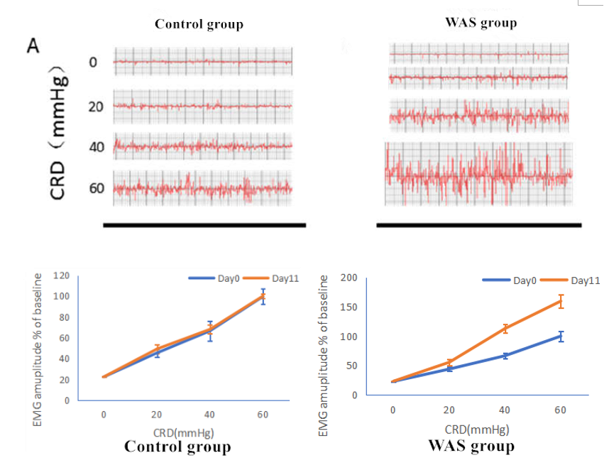

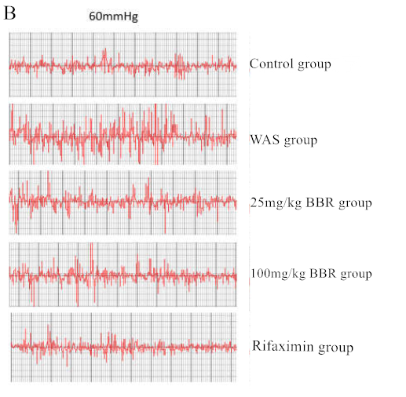 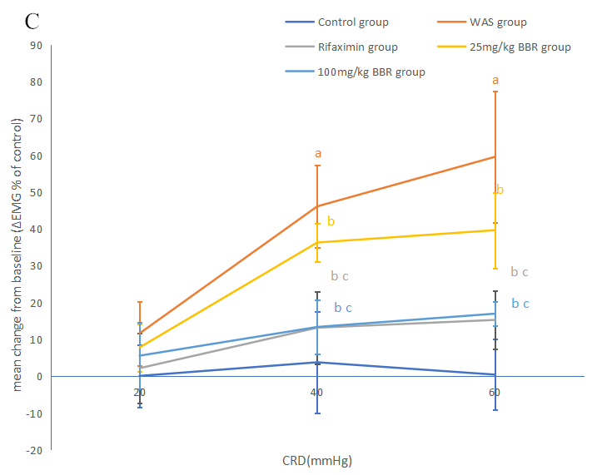

**Figure 6 The effects of berberine on visceromotor response to colorectal distention in rats.** We took the average EMG amplitude measured in day 11 subtracted by the average EMG amplitude detected in day 0, and expressed it as △EMG. A: The amplitude of electromyogram (EMG) was changed in the Control group and Water avoidance stress (WAS) group under different pressure colorectal distention(CRD); B: The amplitude of EMG in Control group, WAS group, Rifaximin group, 25 mg/kg berberine (BBR) group and 100 mg/kg BBR group under 60 mmHg CRD in day 11; C: △EMG of different group rats under different pressure CRD. Letters a, b, c *P* < 0.05 compared with those in Control group, WAS group and 25 mg/kg BBR group, respectively. WAS: Water avoidance stress; BBR: Berberine; CRD: Colorectal distention; EMG: Electromyogram.

**Figure 7 The effects of berberine on total gastrointestinal transit and Small intestinal transit.** Total gastrointestinal transit and Small intestinal transit in Control group, Water avoidance stress (WAS) group, Rifaximin group, 25 mg/kg berberine (BBR) group and 100 mg/kg BBR group. Letters a, b, c *P* < 0.05 compared with those in Control group, WAS group and 25 mg/kg BBR group, respectively. WAS: Water avoidance stress; BBR: Berberine.

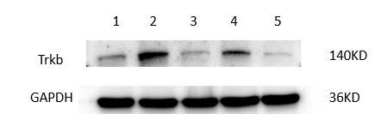

**Figure 8 The effects of berberine on brain derived neurotrophic** **factor and Trkb mRNA and Trkb protein expression.** Expression of brain derived neurotrophic factor and Trkb mRNA and Trkb protein in 1: Control group; 2: Water avoidance stress (WAS) group; 3: Rifaximin group; 4: 25 mg/kg berberine (BBR) group; 5: 100 mg/kg BBR group. Letters a, b, c *P* < 0.05 compared with those in Control group, WAS group and 25 mg/kg BBR group, respectively. BDNF: Brain derived neurotrophic factor; WAS: Water avoidance stress; BBR: Berberine.

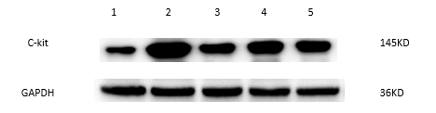

**Figure 9 The effects of berberine on C-kit mRNA and protein expression.** Expression of C-kit mRNA and protein in 1: Control group; 2: Water avoidance stress (WAS) group; 3: Rifaximin group; 4: 25 mg/kg berberine (BBR) group; 5: 100 mg/kg BBR group. Letters a, b, c P< 0.05 compared with those in Control group, WAS group and 25 mg/kg BBR group, respectively. WAS: Water avoidance stress; BBR: Berberine.

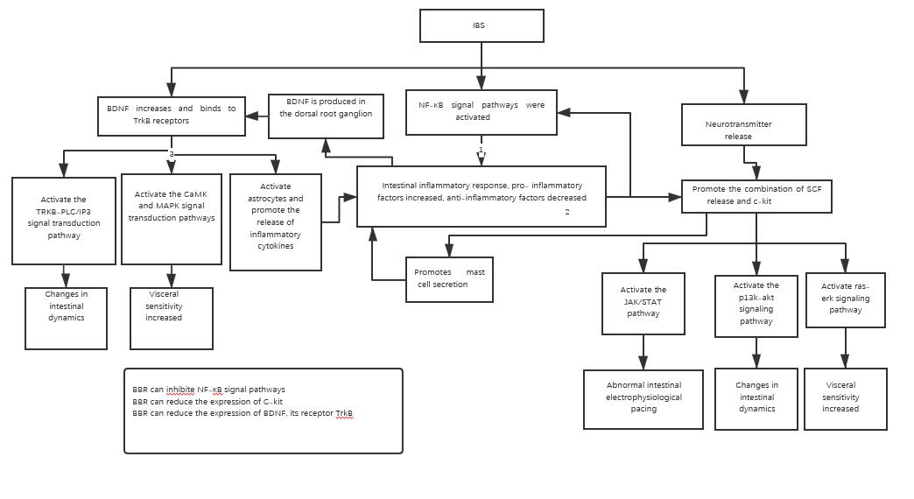

**Figure 10 Relationship between NF-kB signal, brain derived neurotrophic factor, C-kit and the underlying role of berberine.** IBS: Irritable bowel syndrome; BDNF: Brain derived neurotrophic factor; SCF: Stem cell factor.

**Table 1 Primer sequence of qRT-PCR**

|  |  |  |
| --- | --- | --- |
| **Gene** | **Forward sequence** | **Reverse sequence** |
| *IL-1β* | AGTCTGCACAGTTCCCCAAC | TTAGGAAGACACGGGTTCCA |  |
| *IL-6* | CCAACTTCCAATGCTCTCCT | GGTTTGCCGAGTAGACCTCA |
| *IL-10*  *TGF-β*  *IFN-γ*  *TNF-a*  *BDNF*  *Trkb*  *C-kit*  *Rats Β-actin* | GACTGCTATCTTGCCTGCTCTTAC  ATTCCTGGCGTTACCTTGG  TCTGTGGGTTGTTCACCTCG  CCTCCTCTCTGCCATCAACA  CTTGGAGAAGGAAACCGCCT  AGAGCTTCCCTGTCCCTCAG  AATCCGACAACCAAAGCAAC  TGTCACCAACTGGGACGATA | GGGTCTGGCTGACTGGGAAG  AGCCCTGTATTCCGTCTCCT  TATGGAAGGAAAGAGCCTCC  GCAATGACTCCAAAGTAGACCTG  GTCCACACAAAGCTCTCGGA  TTGGGAAGGTAACCAGATCG  TGTCACGGAAGCACTGACAT  GGGGTGTTGAAGGTCTCAAA |