# LPS_COL_strip

CRICOS Provider Code 00126G

# School of Biomedical, Biomolecular and Chemical Sciences DISCIPLINE OF BIOCHEMISTRY & MOLECULAR BIOLOGY

|  |  |  |  |  |
| --- | --- | --- | --- | --- |
| Delivery address: Ground Flr (Goods Receival) CMS Bldg Entry No. 4 Fairway Nedlands |  |  |  | **Postal address***:*  M310 The University of Western Australia  35 Stirling Highway  CRAWLEY  Western Australia 6009 |

**09 November 2012**

## The first author and the senior author wrote and edited the manuscript. Both authors are native English speakers and writers and have published numerous manuscripts in English language journals. Therefore the authors guarantee that the language of our manuscript “Desferrioxamine in warm reperfusion media decreases liver injury aggravated by cold storage” (ESPS Manuscript NO: 292) has reached or exceeded Grade B.

Sincerely,

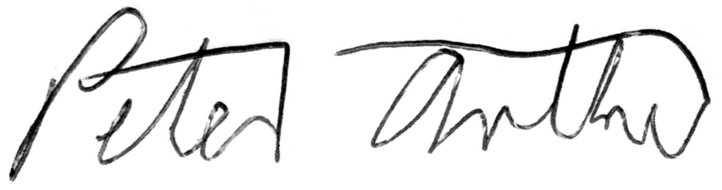

Dr. Peter G. Arthur email:   [peter.arthur@uwa.edu.au](mailto:peter.arthur@uwa.edu.au)  
The University of Western Australia Phone   +61 8 6488 1750