Name of Journal: World Journal of Gastrointestinal Endoscopy
Manuscript NO: 70878
Manuscript Type: MINIREVIEWS

Large polyps: Pearls for the referring and receiving endoscopist

Markarian E et al. Large polyps: Pearls for endoscopists

Eric Markarian, Brian M Fung, Mohit Girotra, James H Tabibian

Eric Markarian, Academy of Science and Medicine, Crescenta Valley High School, Los Angeles, CA 91214, United States

Brian M Fung, Division of Gastroenterology and Hepatology, Department of Internal Medicine, University of Arizona College of Medicine - Phoenix, Phoenix, AZ 85006, United States

Brian M Fung, Division of Gastroenterology, Banner - University Medical Center Phoenix, Phoenix, AZ 85006, United States

Mohit Girotra, Section of Gastroenterology and Therapeutic Endoscopy, Digestive Health Institute, Swedish Medical Center, Seattle, WA 98104, United States

James H Tabibian, Division of Gastroenterology, Department of Medicine, Olive View-UCLA Medical Center, Sylmar, CA 91342, United States

James H Tabibian, Vatche and Tamar Manoukian Division of Digestive Diseases, David Geffen School of Medicine at UCLA, Los Angeles, CA 90095, United States

Author contributions: Markarian E drafted the initial manuscript; Markarian E, Fung BM and Tabibian JH created the figures; Fung BM and Girotra M provided critical revisions; Tabibian JH provided supervision and critical revisions; all authors approved the submitted manuscript.

Corresponding author: James H Tabibian, FACP, MD, PhD, Associate Professor, Division of Gastroenterology, Department of Medicine, Olive View-UCLA Medical Center, 14445 Olive View Drive, 2B-182, Sylmar, CA 91342, United States. jtabibian@dhs.lacounty.gov

Received: August 19, 2021
Revised: October 4, 2021
Accepted: November 25, 2021
Published online:

Abstract
Polyps are precursors to colorectal cancer, the third most common cancer in the United States. Large polyps, i.e.,, those with a size ≥ 20 mm, are more likely to harbor cancer. Colonic polyps can be removed through various techniques, with the goal to completely resect and prevent colorectal cancer; however, the management of large polyps can be relatively complex and challenging. Such polyps are generally more difficult to remove en bloc with conventional methods, and depending on level of expertise, may consequently be resected piecemeal, leading to an increased rate of incomplete removal and thus polyp recurrence. To effectively manage large polyps, endoscopists should be able to: (1) Evaluate the polyp for characteristics which predict high difficulty of resection or incomplete removal; (2) Determine the optimal resection technique (e.g., snare polypectomy, endoscopic mucosal resection, endoscopic submucosal dissection, etc.); and (3) Recognize when to refer to colleagues with greater expertise. This review covers important considerations in this regard for referring and receiving endoscopists and methods to best manage large colonic polyps.

Key Words: Adenoma; Endoscopic mucosal resection; Endoscopic tattoo; Colorectal cancer; Polypectomy

Markarian E, Fung BM, Girotra M, Tabibian JH. Large polyps: Pearls for the referring and receiving endoscopist. World J Gastrointest Endosc 2021; In press

Core Tip: Large polyps, often defined as ≥ 20 mm in size, are generally more challenging to resect than smaller polyps with regard to both difficulty of complete removal and risk of adverse events. To effectively manage large polyps, endoscopists should be able to evaluate them for characteristics which may increase the difficulty of endoscopic resection, determine the optimal resection technique, and recognize when to refer to colleagues for more advanced approaches. Herein, we review important considerations and methods to best manage large colonic polyps.
INTRODUCTION
Colonic polyps have a risk of developing into colorectal cancer (CRC), the third most common cause of cancer-related deaths in the United States^{[1]}. Prior studies have demonstrated that the removal of adenomatous polyps during a colonoscopy is associated with a significant reduction in CRC-related death^{[2,3]}. However, achieving complete resection of a polyp can be challenging, especially with larger polyps. Previous studies have reported that 70%-90% of CRCs are preventable with routine screening colonoscopy and polypectomy^{[3]}; however, 7%-9% are reported to occur despite being up-to-date with colonoscopy^{[4]}. This subset of CRCs is thought to be likely due to either missed polyps or incompletely removed polyps.
The risk of incomplete polyp removal has been reported to increase with increasing polyp size^{[5]}. “Large polyps” are generally defined as being ≥ 20 mm in size (though other cut offs may also be used) and carry a greater likelihood of underlying advanced dysplasia and carcinoma^{[6]}. Indeed, the term “advanced adenoma”^{[7]} has been introduced to stress the clinical and histopathological significance of polyps ≥ 10 mm in size. With advances in polyp removal techniques, management of large polyps has shifted away from surgery and towards endoscopic resection, using novel methods like endoscopic submucosal dissection (ESD) and endoscopic mucosal resection (EMR). In this review, we expound key considerations and techniques to best manage large colonic polyps from the perspective of both the referring and the receiving endoscopist.

INITIAL EVALUATION OF A COLONIC POLYP
Inspection goals and components
When a polyp is detected, a decision must be made whether endoscopic resection is possible^{[8,9]}, and if so, what the best method of resection may be (Figure 1). Certain features, including large size, can pose a technical challenge for complete resection and may indicate a need for advanced endoscopic techniques, as discussed in forthcoming sections, or surgical resection^{[10]}. In addition to polyp size, features including morphology, location, and associated local features are all important determinants in gauging endoscopic resectability^{[10]}. For instance, pedunculated polyps tend to be, on average, easier to grasp (along the peduncle or “stalk”) and resect as opposed to sessile polyps^{[11,12]}. Polyp location also influences resectability, as right-sided lesions tend to be more difficult to resect due to the presence of colonic folds which can impede visualization and maneuverability, increasing the risk of incomplete removal, among other factors^{[13]}. Surface characteristics, discussed in the next section, can also predict submucosal invasion, which may prevent safe resection. Invasive cancers are associated with polyps that fail to lift with submucosal injection, a non-granular surface, depressed subtype, firmness, and redness^{[14-16]}. However, non-lifting does not always predict invasion, as a failure to lift can also be seen in previously biopsied or partially resected polyps with associated tissue fibrosis. Finally, associated local features can impact endoscopic resection; for instance, severe refractory colitis can impede large polyp resection and potentially result in the need for a colectomy^{[17]}. Endoscopic ultrasound (EUS) can be used to evaluate rectal polyps (in particular T stage) and determine feasibility of endoscopic resection when the endoscopic appearance is concerning for possible deep invasion.^{[18,19]} When EUS is not available or feasible (e.g., polyps proximal to the rectosigmoid), cross-sectional imaging such as magnetic resonance or computed tomography can be considered.
Size, morphology, site, access (SMSA) is a scoring system used to predict the difficulty encountered during polyp resection^{[20]}. The scoring is as follows: size (1-9 points), morphology (1-3 points), site (1-2 points), and access (1-3 points). Based on the total score, polyps are classified as Level 1 (4-5), Level 2 (6-9), Level 3 (10-12), or Level 4 (> 12). This system provides an objective assessment of the complexity of a polyp with higher scores suggesting increased complexity. Endoscopists should be aware of complex (and usually large) polyps scored under this system and consider the level of expertise needed to deal with these difficult polyps, referring the patient in necessary cases. Endoscopically unresectable polyps are generally referred to surgery, and are often managed with segmental colectomy, though studies have reported success using hybrid laparoendoscopic approaches i.e.,, combined endoscopic laparoscopic surgery (CELS), to avoid colon resection^{[21,22]}.

Polyp classifications systems
In addition to the features mentioned thus far, critically important here is determining whether a polyp is benign or premalignant, and within the latter, the degree of dysplasia that may be harbored within. There are several validated systems that can help to characterize and classify polyps in this regard, including the Paris classification^{[23]}, the narrow-band imaging international colorectal endoscopic (NICE) classification^{[24]}, and the Kudo pit pattern classification^{[25]}. The Paris classification classifies polyps as pedunculated (1p), sessile (1s), flat (IIa, IIb, IIc), or ulcerated (III)^{[24]}. It also classifies surface morphology as granular or non-granular for non-pedunculated polyps (1s and II). However, recent studies have questioned the validity of the Paris classification because of interobserver variability, recommending the system not be used for routine practice^{[26,27]}. The NICE classification classifies polyps as hyperplastic or sessile serrated polyps (SSP) (type 1), conventional adenomas (type 2), or deep submucosal invasive cancer (type 3) based on color, associated vessels, and surface patterns^{[24]}. The Kudo classification classifies polyps based on mucosal surface analysis. Also called the pit-pattern system, it requires magnification during colonoscopy to evaluate the pit pattern of polyps. This classification system classifies pit patterns as round (Type I), papillary/stellar (Type II), tubular or small round (Type III-S), large tubular or round (Type III-L), gyrus/branch-like (Type IV), non-structured/amorphous (Type V-I), and decrease of amorphous pits (Type V-N). Type I and II polyps are considered benign while types III-V are considered to show neoplastic and malignant changes^{[28]}. Despite the existence of the above classification systems, it is important to note that there is significant variability and agreement as to what the optimal method of classifying polyps should be.

Artificial intelligence and polyp detection
The emergence of artificial intelligence (AI) applications has direct implications in colonoscopy practices. The use of computer-aided detection (CADe) software has been demonstrated to decrease the polyp miss rate^{[29]}, especially for non-polypoid lesions in the right colon. AI has also been used to characterize polyps, also known as colonoscopy practice-polyp characterization (CADx). This can improve the accuracy of polyp diagnosis and reduce unnecessary resection of non-dysplastic polyps^{[29]}. Although data on the outcomes of AI for polyp detection are evolving rapidly, the few completed studies have demonstrated a significant increase in the detection of adenomas and polyps^{[30,31]}. However, the detection of more polyps does not necessarily improve outcomes; one study found that non-advanced adenomas were detected to a greater extent using AI-colonoscopies while identification of advanced adenomas was not substantially improved^{[32]}. More research is needed to determine the value of AI systems in polyp detection and characterization.

CONSIDERATIONS FOR THE REFERRING ENDOSCOPIST
Provider experience
Studies have shown that incomplete polyp removal in daily clinical practice, especially in the case of large polyps, can contribute to future interval cancers^{[33]}. Consequently, appropriate technique and complete resection of large colonic polyps is essential in preventing CRC (Figure 1). Incomplete removal renders future endoscopic resection more challenging; therefore, an endoscopist should aim for complete resection on the first attempt. For polyps ≥ 20 mm in size, the United States Multi-Society Task Force (USMSTF) recommends that an endoscopist be experienced in advanced polyp resection techniques to ensure complete resection^{[9]}. Although polyps that are endoscopically resectable are occasionally sent for surgery, studies show that only about 5-10% of patients subsequently require surgery if they undergo endoscopic resection first^{[34]}. Knowing your expertise and comfort level is particularly important on a variety of levels in the case of polyps that may be challenging to resect; for instance, it is relevant to ensuring the best outcome for the patient, peace of mind for the performing provider, and to avoid potential medical professional liability. Referring to a more experienced provider for a complete resection is thus generally recommended over attempting to complete a polypectomy but failing to achieve complete resection, especially if thermal energy is applied in the process and/or when the a priori probability of incomplete removal seems high. In addition, biopsies of the polyp should be performed with caution so as to avoid scarring and complicating future endoscopic resection. If a biopsy is needed, the biopsy should be performed cold and avoid flat areas of the lesion^{[35]}.

Tattoo placement
If a polyp is deemed unresectable by a provider, it is often advised to tattoo so it can be easily recognized by the receiving provider. Currently, India Ink, a compound known commercially as “Spot Ex,” is most commonly used for endoscopic tattooing^{[36]}. With respect to tattoo location and number of tattoos, best practice depends in large part on whether the polyp is planned for referral to a surgeon or to an advanced endoscopist, as shown in Figure 2^{[37,38]}. Generally speaking, a tattoo should be placed a) immediately distal to the polyp and circumferentially in multiple quadrants to facilitate intraoperative visualization when planning to refer for surgical resection or b) in one quadrant 3-5 cm distal to the polyp, with care to not inject into or under the polyp, when planning to refer for advanced endoscopic resection. Tattoo placement may not be necessary if the polyp is in the cecum or distal rectum, as these locations are typically easily identifiable on future examinations, but this may vary based on individual (e.g., anatomical) and institutional (e.g., surgeon or advanced endoscopist preference) factors^{[9]}. Irrespective of such factors, photodocumentation and clear description regarding tattoo placement are critical^{[39,40]}.
With respect to tattoo injection technique, a few options exist. The “bleb” method is one which is considered reliable for the placement of tattoos^{[41]}, wherein, 0.5 to 1.0 mL of saline is placed into the submucosa, followed by a needle inserted into the saline bleb to inject the tattoo agent. The bleb method ensures that the tattoo only enters the submucosal space and not into extracolonic tissue. A second method involves directly injecting the tattoo into the submucosa and lifting the needle toward the center of the lumen, although this technique requires greater expertise^{[36]}. Of note, analogous to polypectomy snares, different length and caliber injection needles are available, the appropriate choice of which may, depending on polyp location and other considerations, best facilitate tattoo placement^{[42-44]}; for instance, a shorter, smaller caliber needle may be opted for when tattooing a right colonic polyp in a coagulopathic patient (as opposed to a standard/larger length and caliber needle for a rectal polyp).

Adverse events with tattoo placement
Adverse events (AEs) associated with endoscopic tattooing, albeit rare, have been reported. For example, tattooing can cause submucosal fibrosis (Figure 3) and consequent muscle injury during future endoscopic resection if the tattoo ink spreads underneath the polyp, e.g., if injection is performed too close to or into the polyp or if an excess volume of ink is injected (which can later dissipate laterally to involve the submucosa below the polyp)^{[40]}. Thus, when a polyp is planned for referral for endoscopic resection, the closer the tattoo is to the polyp, the less tattoo volume should be used. Reports of inflammatory responses, localized necrosis from an inflammatory pseudotumor, and rectus muscle abscess have also been described^{[45-47]}. These potential AEs should be taken into account when placing an endoscopic tattoo and accordingly established techniques should be followed.

THE PERFORMING ENDOSCOPIST: RESECTION TECHNIQUES AND CONSIDERATIONS
The endoscopic resection technique that is used largely depends on the morphology of the polyp, in particular its size and whether it is pedunculated or not, as discussed below^{[9]}.

Pedunculated polyps
Large polyps can be pedunculated or non-pedunculated. For pedunculated polyps ≥ 10 mm in size, hot snare polypectomy (HSP), in which electrocoagulation is used for resection, is suggested^{[9]}. For larger pedunculated polyps, epinephrine injection into the head or stalk can also be considered to reduce the polyp size and make resection easier^{[48]}. Other strategies include using a detachable loop or placing clips at the polyp stalk before resection. Cold snare polypectomy (CSP) may also be used for resection and has been reported to have a lower rate of post-polypectomy bleeding^{[49]}; however, the rate of complete resection may be higher with HSP compared with CSP when resecting large pedunculated polyps^{[50]}.

Non-pedunculated polyps
Endoscopic mucosal resection: The majority of non-pedunculated (i.e., sessile) polyps can be removed by endoscopic mucosal resection (EMR). In this technique, fluid is injected submucosally to lift the polyp and facilitate resection. Many variations of this technique have been developed, such as hot snare EMR, cold snare EMR, and underwater EMR.
In the hot snare EMR (HS-EMR) technique, the underlying submucosa is first injected with a contrast dye, such as methylene blue, to achieve lifting of the polyp, which allows optimal placement of a snare to grab the polyp away from the mucosa, followed by resection with application of electrocautery. Polyps < 20 mm in size can be removed entirely (en bloc resection), while larger polyps can be removed in segments (piecemeal resection). Because HS-EMR utilizes electrocautery, it can minimize intraprocedural bleeding of cut tissue due to its coagulation effect and also destroy the polyp margins, thus leading to a lower recurrence rate^{[9]}. However, the use of electrocautery is also associated with a higher risk of post-procedural bleeding and perforation, compared to the cold snare technique^{[51]}.
Cold snare EMR (CS-EMR) allows for large polyp resection without use of electrocautery. In this variation of EMR, the submucosa may be injected to raise the polyp, similar to HS-EMR, after which the snare is then opened slightly larger than the area of the polyp (resecting some normal tissue margin) to remove it en bloc or piecemeal. As previously mentioned, this technique is associated with lower rates of post-procedural bleeding and perforation compared to HS-EMR. Studies of CS-EMR have shown low rates of polyp recurrence and AEs with excellent resection rates^{[52-54]}. Although HS-EMR is currently the standard of care in endoscopic resections, CS-EMR represents an equally effective and safe resection method for large polyps.
Given that complete en bloc resection rates decrease in polyps ≥ 10 mm using traditional EMR techniques (which in turn increases the rate of recurrence), underwater EMR (UEMR) has been proposed as an alternative effective strategy to resect large polyps^{[18,19]}. This method avoids the use of submucosal injection by aspirating gas and instilling water into the colonic lumen, which raises the mucosal pathology (polyp) away from the underlying submucosa, allowing safer and complete resection of the polyp. Especially useful in the case of large polyps, UEMR has shown significantly increased rates of R0 resections for polyps 10-20 mm in size without increasing the rate of AEs^{[55]}. This variant of EMR represents a viable alternative to traditional resection techniques for large polyps that are difficult to remove completely.

Endoscopic submucosal dissection: Endoscopic submucosal dissection (ESD) allows for the complete removal of polyps too large for EMR (≥ 20 mm in size) and/or that are strongly suspicious for cancer. ESD is also utilized in cases with suspected submucosal invasion, local early carcinoma, or laterally spreading polyps/tumors^{[56]}. Studies have demonstrated that ESD may have better outcomes for larger polyps, as EMR often requires piecemeal removal which has an increased rate of recurrence (about 20%)^{[57]}.
In the ESD technique, the area underneath the polyp is first injected to lift the polyp, followed by creation of an incision into the mucosa using an ESD knife. The submucosal edges are trimmed to allow access to the submucosal plane where the dissection is performed (Figure 4), resulting in an en bloc resection of large polyps/tumors. While ESD has excellent rates of en bloc resection, it has higher rates of AEs compared to EMR, including perforation, bleeding, and hospitalization related to the procedure^{[58]}. Low-voltage coagulation (“soft” ESD) can be performed after resecting the polyp to reduce the risk of post-resection bleeding^{[59]}.

Endoscopic full-thickness resection: Endoscopic full-thickness resection (EFTR) is a novel approach which enables all layers of the colon wall to be removed^{[60,61]}. This technique is often used for polyps < 30 mm in size which either fail to lift after submucosal injection or that are difficult to resect with conventional EMR techniques. Multiple studies have shown the efficacy and safety of EFTR^{[59]}, in both animal models and human patients, with excellent resection rates for non-lifting adenomas and low rates of AEs (about 14%)^{[62]}. The technique uses a full-thickness resection device (FTRD®), which has been shown to enable complete resection of polyps beneath the mucosa^{[63]}. At this time, EFTR is not widely practiced as few endoscopists are trained in this technique.

Post-resection elements
Endoscopic clipping: Bleeding, the most common AE after EMR, is more likely to occur in patients undergoing resection of large polyps, polyps ≥ 10 mm with a thick stalk, right-sided polyps, and in patients on anticoagulation/antiplatelet agents or with comorbid conditions that increase the risk of bleeding^{[64,65]}. Clipping can be used to effectively stop or prevent bleeding through mechanical pressure. In one study, endoscopic clipping significantly reduced the risk of bleeding after resection of large polyps (≥ 20 mm), with 7.6% of subjects without clipping having bleeding compared to 4.3% with clipping^{[66]}. In addition, clip placement is often utilized to close post-polypectomy mucosal defects^{[67]}.

Surveillance: After complete resection of large polyps, close surveillance is recommended to detect disease recurrence and/or metachronous colorectal polyps. Surveillance is important for early detection of asymptomatic and resectable recurrences, which increases patients’ chances for curative therapy^{[68]}. The USMSTF recommends that colonoscopy should be performed within 1 year after resection to look for metachronous polyps. If this examination is normal, a subsequent examination should be performed after 3 years, and then 5 years (if the second examination is also normal). However, shorter examination intervals may also be used if additional polyps are found^{[68]}. Shorter examinations are also favored in the case of piecemeal resection of a large polyp because of the significantly increased risk of residual polyp tissue and recurrence. Thus, a period of 2-6 mo is typically the recommended interval for surveillance colonoscopy in such cases^{[69]}.

CONCLUSION
As endoscopic resection techniques have evolved, there has been a shift in the management of large colonic polyps from being referred for colon surgery to endoscopic resection. Effective resection of these large polyps can be complex, but success has been documented using methods like EMR and ESD. Endoscopists should be comfortable at recognizing large colonic polyps through classification systems such as the NICE or Paris classification, and these polyps should be resected by endoscopists experienced with advanced resection techniques. Standardized practices coupled with clear communication can help ensure optimal outcomes.

REFERENCES
1 Siegel RL, Miller KD, Goding Sauer A, Fedewa SA, Butterly LF, Anderson JC, Cercek A, Smith RA, Jemal A. Colorectal cancer statistics, 2020. CA Cancer J Clin 2020; 70: 145-164 [PMID: 32133645 DOI: 10.3322/caac.21601]
2 Winawer SJ, Zauber AG, Ho MN, O'Brien MJ, Gottlieb LS, Sternberg SS, Waye JD, Schapiro M, Bond JH, Panish JF. Prevention of colorectal cancer by colonoscopic polypectomy. The National Polyp Study Workgroup. N Engl J Med 1993; 329: 1977-1981 [PMID: 8247072 DOI: 10.1056/NEJM199312303292701]
3 Zauber AG, Winawer SJ, O'Brien MJ, Lansdorp-Vogelaar I, van Ballegooijen M, Hankey BF, Shi W, Bond JH, Schapiro M, Panish JF, Stewart ET, Waye JD. Colonoscopic polypectomy and long-term prevention of colorectal-cancer deaths. N Engl J Med 2012; 366: 687-696 [PMID: 22356322 DOI: 10.1056/NEJMoa1100370]
4 Pohl H, Robertson DJ. Colorectal cancers detected after colonoscopy frequently result from missed lesions. Clin Gastroenterol Hepatol 2010; 8: 858-864 [PMID: 20655393 DOI: 10.1016/j.cgh.2010.06.028]
5 Pohl H, Srivastava A, Bensen SP, Anderson P, Rothstein RI, Gordon SR, Levy LC, Toor A, Mackenzie TA, Rosch T, Robertson DJ. Incomplete polyp resection during colonoscopy-results of the complete adenoma resection (CARE) study. Gastroenterology 2013; 144: 74-80.e1 [PMID: 23022496 DOI: 10.1053/j.gastro.2012.09.043]
6 De Ceglie A, Hassan C, Mangiavillano B, Matsuda T, Saito Y, Ridola L, Bhandari P, Boeri F, Conio M. Endoscopic mucosal resection and endoscopic submucosal dissection for colorectal lesions: A systematic review. Crit Rev Oncol Hematol 2016; 104: 138-155 [PMID: 27370173 DOI: 10.1016/j.critrevonc.2016.06.008]
7 Rex DK, Boland CR, Dominitz JA, Giardiello FM, Johnson DA, Kaltenbach T, Levin TR, Lieberman D, Robertson DJ. Colorectal Cancer Screening: Recommendations for Physicians and Patients From the U.S. Multi-Society Task Force on Colorectal Cancer. Gastroenterology 2017; 153: 307-323 [PMID: 28600072 DOI: 10.1053/j.gastro.2017.05.013]
8 Kaltenbach T, Anderson JC, Burke CA, Dominitz JA, Gupta S, Lieberman D, Robertson DJ, Shaukat A, Syngal S, Rex DK. Endoscopic Removal of Colorectal Lesions: Recommendations by the US Multi-Society Task Force on Colorectal Cancer. Am J Gastroenterol 2020; 115: 435-464 [PMID: 32058340 DOI: 10.14309/ajg.0000000000000555]
9 Shaukat A, Kaltenbach T, Dominitz JA, Robertson DJ, Anderson JC, Cruise M, Burke CA, Gupta S, Lieberman D, Syngal S, Rex DK. Endoscopic Recognition and Management Strategies for Malignant Colorectal Polyps: Recommendations of the US Multi-Society Task Force on Colorectal Cancer. Gastrointest Endosc 2020; 92: 997-1015.e1 [PMID: 33160507 DOI: 10.1016/j.gie.2020.09.039]
10 Aarons CB, Shanmugan S, Bleier JI. Management of malignant colon polyps: current status and controversies. World J Gastroenterol 2014; 20: 16178-16183 [PMID: 25473171 DOI: 10.3748/wjg.v20.i43.16178]
11 Pickhardt PJ, Pooler BD, Kim DH, Hassan C, Matkowskyj KA, Halberg RB. The Natural History of Colorectal Polyps: Overview of Predictive Static and Dynamic Features. Gastroenterol Clin North Am 2018; 47: 515-536 [PMID: 30115435 DOI: 10.1016/j.gtc.2018.04.004]
12 Tholoor S, Tsagkournis O, Basford P, Bhandari P. Managing difficult polyps: techniques and pitfalls. Ann Gastroenterol 2013; 26: 114-121 [PMID: 24714799]
13 Rex DK. Maximizing detection of adenomas and cancers during colonoscopy. Am J Gastroenterol 2006; 101: 2866-2877 [PMID: 17227527 DOI: 10.1111/j.1572-0241.2006.00905.x]
14 Matsuda T, Parra-Blanco A, Saito Y, Sakamoto T, Nakajima T. Assessment of likelihood of submucosal invasion in non-polypoid colorectal neoplasms. Gastrointest Endosc Clin N Am 2010; 20: 487-496 [PMID: 20656246 DOI: 10.1016/j.giec.2010.03.007]
15 Uno Y, Munakata A. The non-lifting sign of invasive colon cancer. Gastrointest Endosc 1994; 40: 485-489 [PMID: 7926542 DOI: 10.1016/s0016-5107(94)70216-0]
16 Ishiguro A, Uno Y, Ishiguro Y, Munakata A, Morita T. Correlation of lifting vs non-lifting and microscopic depth of invasion in early colorectal cancer. Gastrointest Endosc 1999; 50: 329-333 [PMID: 10462651 DOI: 10.1053/ge.1999.v50.98591]
17 Rubin PH, Friedman S, Harpaz N, Goldstein E, Weiser J, Schiller J, Waye JD, Present DH. Colonoscopic polypectomy in chronic colitis: conservative management after endoscopic resection of dysplastic polyps. Gastroenterology 1999; 117: 1295-1300 [PMID: 10579970 DOI: 10.1016/s0016-5085(99)70279-9]
18 Binmoeller KF, Weilert F, Shah J, Bhat Y, Kane S. "Underwater" EMR without submucosal injection for large sessile colorectal polyps (with video). Gastrointest Endosc 2012; 75: 1086-1091 [PMID: 22365184 DOI: 10.1016/j.gie.2011.12.022]
19 Binmoeller KF, Hamerski CM, Shah JN, Bhat YM, Kane SD, Garcia-Kennedy R. Attempted underwater en bloc resection for large (2-4 cm) colorectal laterally spreading tumors (with video). Gastrointest Endosc 2015; 81: 713-718 [PMID: 25708759 DOI: 10.1016/j.gie.2014.10.044]
20 Gupta S, Miskovic D, Bhandari P, Dolwani S, McKaig B, Pullan R, Rembacken B, Rutter MD, Riley S, Valori R, Vance ME, Faiz OD, Saunders BP, Thomas-Gibson S. The ‘SMSA’ Scoring System for Determining the Complexity of a Polyp. Gut 2011; 60: A129-A129 [DOI: 10.1136/gut.2011.239301.273]
21 Mal F, Perniceni T, Levard H, Boudet MJ, Levy P, Gayet B. [Colonic polyps considered unresectable by endoscopy. Removal by combinations of laparoscopy and endoscopy in 65 patients]. Endoscopy 2006; 38: A1433 [DOI: 10.1055/s-2006-934173]
22 Aslani N, Alkhamesi NA, Schlachta CM. Hybrid Laparoendoscopic Approaches to Endoscopically Unresectable Colon Polyps. J Laparoendosc Adv Surg Tech A 2016; 26: 581-590 [PMID: 27058749 DOI: 10.1089/Lap.2015.0290]
23 . The Paris endoscopic classification of superficial neoplastic lesions: esophagus, stomach, and colon: November 30 to December 1, 2002. Gastrointest Endosc 2003; 58: S3-43 [PMID: 14652541 DOI: 10.1016/s0016-5107(03)02159-x]
24 Hewett DG, Kaltenbach T, Sano Y, Tanaka S, Saunders BP, Ponchon T, Soetikno R, Rex DK. Validation of a simple classification system for endoscopic diagnosis of small colorectal polyps using narrow-band imaging. Gastroenterology 2012; 143: 599-607.e1 [PMID: 22609383 DOI: 10.1053/j.gastro.2012.05.006]
25 Kudo S, Tamura S, Nakajima T, Yamano H, Kusaka H, Watanabe H. Diagnosis of colorectal tumorous lesions by magnifying endoscopy. Gastrointest Endosc 1996; 44: 8-14 [PMID: 8836710 DOI: 10.1016/s0016-5107(96)70222-5]
26 van Doorn SC, Hazewinkel Y, East JE, van Leerdam ME, Rastogi A, Pellisé M, Sanduleanu-Dascalescu S, Bastiaansen BA, Fockens P, Dekker E. Polyp morphology: an interobserver evaluation for the Paris classification among international experts. Am J Gastroenterol 2015; 110: 180-187 [PMID: 25331346 DOI: 10.1038/ajg.2014.326]
27 Gupta S. Trouble in Paris (classification): polyp morphology is in the eye of the beholder. Am J Gastroenterol 2015; 110: 188-191 [PMID: 25567171 DOI: 10.1038/ajg.2014.411]
28 Patino-Barrientos S, Sierra-Sosa D, Garcia-Zapirain B, Castillo-Olea C, Elmaghraby A. Kudo’s Classification for Colon Polyps Assessment Using a Deep Learning Approach. Appl Sci 2020; 10: 501 [DOI: 10.3390/app10020501]
29 Vinsard DG, Mori Y, Misawa M, Kudo SE, Rastogi A, Bagci U, Rex DK, Wallace MB. Quality assurance of computer-aided detection and diagnosis in colonoscopy. Gastrointest Endosc 2019; 90: 55-63 [PMID: 30926431 DOI: 10.1016/j.gie.2019.03.019]
30 Wang P, Berzin TM, Glissen Brown JR, Bharadwaj S, Becq A, Xiao X, Liu P, Li L, Song Y, Zhang D, Li Y, Xu G, Tu M, Liu X. Real-time automatic detection system increases colonoscopic polyp and adenoma detection rates: a prospective randomised controlled study. Gut 2019; 68: 1813-1819 [PMID: 30814121 DOI: 10.1136/gutjnl-2018-317500]
31 Aziz M, Fatima R, Dong C, Lee-Smith W, Nawras A. The impact of deep convolutional neural network-based artificial intelligence on colonoscopy outcomes: A systematic review with meta-analysis. J Gastroenterol Hepatol 2020; 35: 1676-1683 [PMID: 32267558 DOI: 10.1111/jgh.15070]
32 Barua I, Vinsard DG, Jodal HC, Løberg M, Kalager M, Holme Ø, Misawa M, Bretthauer M, Mori Y. Artificial intelligence for polyp detection during colonoscopy: a systematic review and meta-analysis. Endoscopy 2021; 53: 277-284 [PMID: 32557490 DOI: 10.1055/a-1201-7165]
33 Bronzwaer MES, Koens L, Bemelman WA, Dekker E, Fockens P; COPOS study group. Volume of surgery for benign colorectal polyps in the last 11 years. Gastrointest Endosc 2018; 87: 552-561.e1 [PMID: 29108978 DOI: 10.1016/j.gie.2017.10.032]
34 Moss A, Williams SJ, Hourigan LF, Brown G, Tam W, Singh R, Zanati S, Burgess NG, Sonson R, Byth K, Bourke MJ. Long-term adenoma recurrence following wide-field endoscopic mucosal resection (WF-EMR) for advanced colonic mucosal neoplasia is infrequent: results and risk factors in 1000 cases from the Australian Colonic EMR (ACE) study. Gut 2015; 64: 57-65 [PMID: 24986245 DOI: 10.1136/gutjnl-2013-305516]
35 Rutter MD, Chattree A, Barbour JA, Thomas-Gibson S, Bhandari P, Saunders BP, Veitch AM, Anderson J, Rembacken BJ, Loughrey MB, Pullan R, Garrett WV, Lewis G, Dolwani S. British Society of Gastroenterology/Association of Coloproctologists of Great Britain and Ireland guidelines for the management of large non-pedunculated colorectal polyps. Gut 2015; 64: 1847-1873 [PMID: 26104751 DOI: 10.1136/gutjnl-2015-309576]
36 Rex DK. The Appropriate Use and Techniques of Tattooing in the Colon. Gastroenterol Hepatol (N Y) 2018; 14: 314-317 [PMID: 29991940]
37 Grimm IS, McGill SK. Look, but don't touch: what not to do in managing large colorectal polyps. Gastrointest Endosc 2019; 89: 479-481 [PMID: 30784495 DOI: 10.1016/j.gie.2018.10.008]
38 Kim HG, Thosani N, Banerjee S, Chen A, Friedland S. Effect of prior biopsy sampling, tattoo placement, and snare sampling on endoscopic resection of large nonpedunculated colorectal lesions. Gastrointest Endosc 2015; 81: 204-213 [PMID: 25440686 DOI: 10.1016/j.gie.2014.08.038]
39 Nahid M, Shrestha AK, Imtiaz MR, Basnyat PS. Endoscopic tattooing for colorectal lesions: impact on quality of care and patient outcomes. Ann R Coll Surg Engl 2020; 102: 594-597 [PMID: 32538104 DOI: 10.1308/rcsann.2020.0104]
40 Yang M, Pepe D, Schlachta CM, Alkhamesi NA. Endoscopic tattoo: the importance and need for standardised guidelines and protocol. J R Soc Med 2017; 110: 287-291 [PMID: 28537104 DOI: 10.1177/0141076817712244]
41 Barquero D, González V, García O, Fernández A, Blasco A, Navarro M, Bargalló García A, Martín M, Erice E, Ariza X, Hernández C, Vascónez C, Martín M, Castellví J, Mata A. Ways to perform an endoscopic tattoo. Prospective and randomized study in patients with colorectal neoplasm. Rev Esp Enferm Dig 2021; 113: 519-523 [PMID: 33256420 DOI: 10.17235/reed.2020.7310/2020]
42 NeedleMaster Injection Needles. Olympus America. [cited 20 February 2021]. Available from: https://medical.olympusamerica.com/products/needlemaster-injection-needles
43 AcuJect® Variable Injection Needle. Cook Medical. [cited 20 February 2021]. Available from: https://www.cookmedical.com/products/esc_vin_webds/
44 InterjectTM Sclerotherapy Needles. Boston Scientific. [cited 20 February 2021]. Available from: https://www.bostonscientific.com/en-US/products/needles/interject-sclerotherapy-needles.html
45 Coman E, Brandt LJ, Brenner S, Frank M, Sablay B, Bennett B. Fat necrosis and inflammatory pseudotumor due to endoscopic tattooing of the colon with india ink. Gastrointest Endosc 1991; 37: 65-68 [PMID: 1706285 DOI: 10.1016/s0016-5107(91)70626-3]
46 Gianom D, Hollinger A, Wirth HP. [Intestinal perforation after preoperative colonic tattooing with India ink]. Swiss Surg 2003; 9: 307-310 [PMID: 14725100 DOI: 10.1024/1023-9332.9.6.307]
47 Alba LM, Pandya PK, Clarkston WK. Rectus muscle abscess associated with endoscopic tattooing of the colon with India ink. Gastrointest Endosc 2000; 52: 557-558 [PMID: 11023584 DOI: 10.1067/mge.2000.108660]
48 Tanaka S, Oka S, Kaneko I, Hirata M, Mouri R, Kanao H, Yoshida S, Chayama K. Endoscopic submucosal dissection for colorectal neoplasia: possibility of standardization. Gastrointest Endosc 2007; 66: 100-107 [PMID: 17591481 DOI: 10.1016/j.gie.2007.02.032]
49 Kawamura T, Takeuchi Y, Asai S, Yokota I, Akamine E, Kato M, Akamatsu T, Tada K, Komeda Y, Iwatate M, Kawakami K, Nishikawa M, Watanabe D, Yamauchi A, Fukata N, Shimatani M, Ooi M, Fujita K, Sano Y, Kashida H, Hirose S, Iwagami H, Uedo N, Teramukai S, Tanaka K. A comparison of the resection rate for cold and hot snare polypectomy for 4-9 mm colorectal polyps: a multicentre randomised controlled trial (CRESCENT study). Gut 2018; 67: 1950-1957 [PMID: 28970290 DOI: 10.1136/gutjnl-2017-314215]
50 Yamamoto T, Suzuki S, Kusano C, Yakabe K, Iwamoto M, Ikehara H, Gotoda T, Moriyama M. Histological outcomes between hot and cold snare polypectomy for small colorectal polyps. Saudi J Gastroenterol 2017; 23: 246-252 [PMID: 28721979 DOI: 10.4103/sjg.SJG_598_16]
51 Lorenzo-Zúñiga V, Boix J, Moreno-de-Vega V, de-la-Ossa ND, Òdena G, Bartolí R. Microperforation of the colon: animal model in rats to reproduce mucosal thermal damage. J Surg Res 2014; 188: 415-418 [PMID: 24560429 DOI: 10.1016/j.jss.2014.01.039]
52 Choksi N, Elmunzer BJ, Stidham RW, Shuster D, Piraka C. Cold snare piecemeal resection of colonic and duodenal polyps ≥1 cm. Endosc Int Open 2015; 3: E508-E513 [PMID: 26528509 DOI: 10.1055/s-0034-1392214]
53 Piraka C, Saeed A, Waljee AK, Pillai A, Stidham R, Elmunzer BJ. Cold snare polypectomy for non-pedunculated colon polyps greater than 1 cm. Endosc Int Open 2017; 5: E184-E189 [PMID: 28331902 DOI: 10.1055/s-0043-101696]
54 Tutticci NJ, Hewett DG. Cold EMR of large sessile serrated polyps at colonoscopy (with video). Gastrointest Endosc 2018; 87: 837-842 [PMID: 29133196 DOI: 10.1016/j.gie.2017.11.002]
55 Yamashina T, Uedo N, Akasaka T, Iwatsubo T, Nakatani Y, Akamatsu T, Kawamura T, Takeuchi Y, Fujii S, Kusaka T, Shimokawa T. Comparison of Underwater vs Conventional Endoscopic Mucosal Resection of Intermediate-Size Colorectal Polyps. Gastroenterology 2019; 157: 451-461.e2 [PMID: 30981791 DOI: 10.1053/j.gastro.2019.04.005]
56 Tanaka S, Saitoh Y, Matsuda T, Igarashi M, Matsumoto T, Iwao Y, Suzuki Y, Nishida H, Watanabe T, Sugai T, Sugihara K, Tsuruta O, Hirata I, Hiwatashi N, Saito H, Watanabe M, Sugano K, Shimosegawa T; Japanese Society of Gastroenterology. Evidence-based clinical practice guidelines for management of colorectal polyps. J Gastroenterol 2015; 50: 252-260 [PMID: 25559129 DOI: 10.1007/s00535-014-1021-4]
57 Draganov PV, Wang AY, Othman MO, Fukami N. AGA Institute Clinical Practice Update: Endoscopic Submucosal Dissection in the United States. Clin Gastroenterol Hepatol 2019; 17: 16-25.e1 [PMID: 30077787 DOI: 10.1016/j.cgh.2018.07.041]
58 Fujiya M, Tanaka K, Dokoshi T, Tominaga M, Ueno N, Inaba Y, Ito T, Moriichi K, Kohgo Y. Efficacy and adverse events of EMR and endoscopic submucosal dissection for the treatment of colon neoplasms: a meta-analysis of studies comparing EMR and endoscopic submucosal dissection. Gastrointest Endosc 2015; 81: 583-595 [PMID: 25592748 DOI: 10.1016/j.gie.2014.07.034]
59 Yoshida N, Yagi N, Naito Y, Yoshikawa T. Safe procedure in endoscopic submucosal dissection for colorectal tumors focused on preventing complications. World J Gastroenterol 2010; 16: 1688-1695 [PMID: 20379999 DOI: 10.3748/wjg.v16.i14.1688]
60 Schmidt A, Bauerfeind P, Gubler C, Damm M, Bauder M, Caca K. Endoscopic full-thickness resection in the colorectum with a novel over-the-scope device: first experience. Endoscopy 2015; 47: 719-725 [PMID: 25763833 DOI: 10.1055/s-0034-1391781]
61 Vitali F, Naegel A, Siebler J, Neurath MF, Rath T. Endoscopic full-thickness resection with an over-the-scope clip device (FTRD) in the colorectum: results from a university tertiary referral center. Endosc Int Open 2018; 6: E98-E103 [PMID: 29344569 DOI: 10.1055/s-0043-124079]
62 Kuellmer A, Mueller J, Caca K, Aepli P, Albers D, Schumacher B, Glitsch A, Schäfer C, Wallstabe I, Hofmann C, Erhardt A, Meier B, Bettinger D, Thimme R, Schmidt A; FTRD study group. Endoscopic full-thickness resection for early colorectal cancer. Gastrointest Endosc 2019; 89: 1180-1189.e1 [PMID: 30653939 DOI: 10.1016/j.gie.2018.12.025]
63 Albrecht H, Raithel M, Braun A, Nagel A, Stegmaier A, Utpatel K, Schäfer C. Endoscopic full-thickness resection (EFTR) in the lower gastrointestinal tract. Tech Coloproctol 2019; 23: 957-963 [PMID: 31368009 DOI: 10.1007/s10151-019-02043-5]
64 Buddingh KT, Herngreen T, Haringsma J, van der Zwet WC, Vleggaar FP, Breumelhof R, Ter Borg F. Location in the right hemi-colon is an independent risk factor for delayed post-polypectomy hemorrhage: a multi-center case-control study. Am J Gastroenterol 2011; 106: 1119-1124 [PMID: 21266961 DOI: 10.1038/ajg.2010.507]
65 Kim HS, Kim TI, Kim WH, Kim YH, Kim HJ, Yang SK, Myung SJ, Byeon JS, Lee MS, Chung IK, Jung SA, Jeen YT, Choi JH, Choi KY, Choi H, Han DS, Song JS. Risk factors for immediate postpolypectomy bleeding of the colon: a multicenter study. Am J Gastroenterol 2006; 101: 1333-1341 [PMID: 16771958 DOI: 10.1111/j.1572-0241.2006.00638.x]
66 Luba D, Raphael M, Zimmerman D, Luba J, Detka J, DiSario J. Clipping prevents perforation in large, flat polyps. World J Gastrointest Endosc 2017; 9: 133-138 [PMID: 28360975 DOI: 10.4253/wjge.v9.i3.133]
67 Cereatti F, Grassia R, Drago A, Conti CB, Donatelli G. Endoscopic management of gastrointestinal leaks and fistulae: What option do we have? World J Gastroenterol 2020; 26: 4198-4217 [PMID: 32848329 DOI: 10.3748/wjg.v26.i29.4198]
68 Kahi CJ, Boland CR, Dominitz JA, Giardiello FM, Johnson DA, Kaltenbach T, Lieberman D, Levin TR, Robertson DJ, Rex DK. Colonoscopy Surveillance after Colorectal Cancer Resection: Recommendations of the US Multi-Society Task Force on Colorectal Cancer. Am J Gastroenterol 2016; 111: 337-46; quiz 347 [PMID: 26871541 DOI: 10.1038/ajg.2016.22]
69 Rex DK, Kahi CJ, Levin B, Smith RA, Bond JH, Brooks D, Burt RW, Byers T, Fletcher RH, Hyman N, Johnson D, Kirk L, Lieberman DA, Levin TR, O'Brien MJ, Simmang C, Thorson AG, Winawer SJ; American Cancer Society; US Multi-Society Task Force on Colorectal Cancer. Guidelines for colonoscopy surveillance after cancer resection: a consensus update by the American Cancer Society and the US Multi-Society Task Force on Colorectal Cancer. Gastroenterology 2006; 130: 1865-1871 [PMID: 16697749 DOI: 10.1053/j.gastro.2006.03.013]

Footnotes
Conflict-of-interest statement: The authors have no conflicts of interest to disclose.

Open-Access: This article is an open-access article that was selected by an in-house editor and fully peer-reviewed by external reviewers. It is distributed in accordance with the Creative Commons Attribution NonCommercial (CC BY-NC 4.0) license, which permits others to distribute, remix, adapt, build upon this work non-commercially, and license their derivative works on different terms, provided the original work is properly cited and the use is non-commercial. See: http://creativecommons.org/Licenses/by-nc/4.0/

Provenance and peer review: Invited article; Externally peer reviewed.
Peer-review model: Single blind

Peer-review started: August 19, 2021
First decision: September 29, 2021
Article in press:

Specialty type: Gastroenterology and hepatology
Country/Territory of origin: United States
Peer-review report’s scientific quality classification
Grade A (Excellent): 0
Grade B (Very good): 0
Grade C (Good): C
Grade D (Fair): 0
Grade E (Poor): 0

P-Reviewer: Gao W S-Editor: Wang LL L-Editor: A P-Editor: Wang LL

Figure Legends
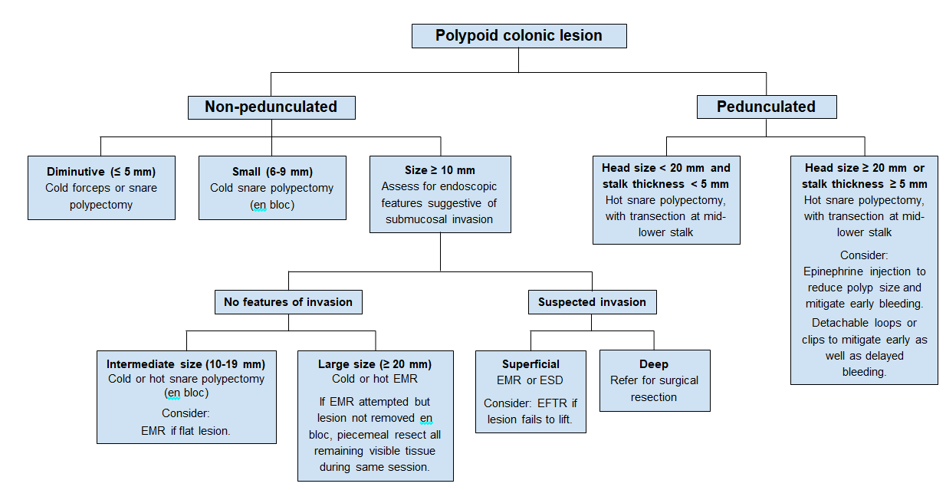
Figure 1 Polyp management algorithm based on morphology, size, and suspicion of submucosal invasion.
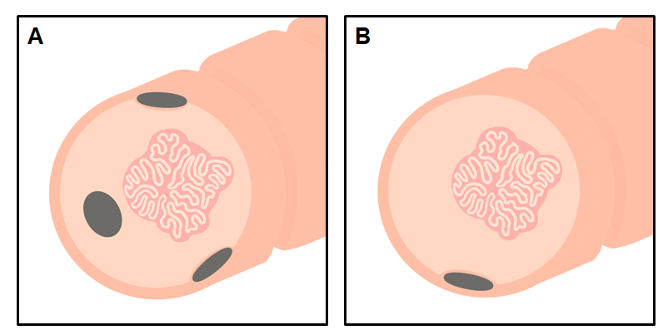
Figure 2 Guidelines for placing an endoscopic tattoo prior to resection. As an overarching principle, the location of the tattoo relative to a polyp should be guided by anatomical factors and institutional practices in addition to being well-described and photodocumented in the procedure report. A: When tattooing with the intent of referral for surgical resection, the tattoo should generally be placed immediately distal to the polyp and circumferentially in multiple quadrants to facilitate intraoperative visualization; B: When tattooing with the intent of referral for advanced endoscopic resection, tattoo should not be injected into or under the polyp, and care should be taken to not inject an excess volume of ink, as this may spread submucosally toward the polyp and subsequently complicate resection; a single tattoo, 3-5 cm distal to the polyp (or one haustral fold distal), is generally appropriate.
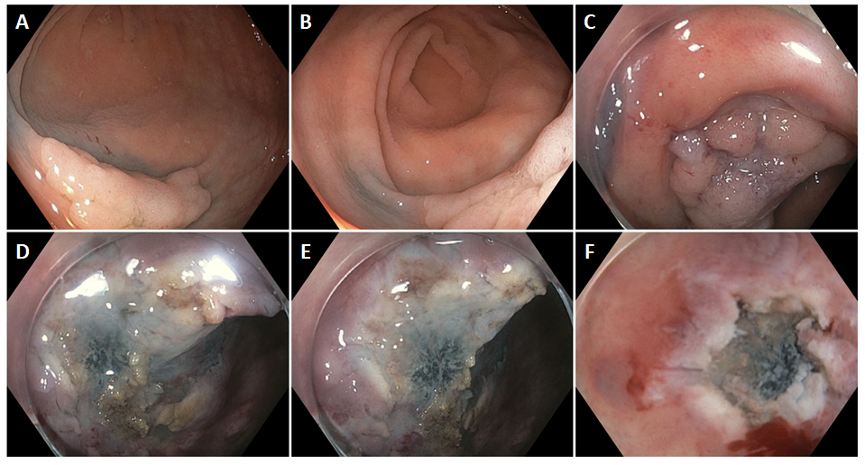
Figure 3 Endoscopic mucosal resection complicated by prior endoscopic tattooing. A and B: Presence of previously placed tattoo ink proximal and lateral to a large (25 mm) sessile polyp, suggestive of injection being made too close to (or under) the polyp and/or an excess volume of ink injected; C: Suboptimal lifting after 10 cc of saline and 13 cc of submucosal injectable composition as a result of submucosal fibrosis from the prior tattoo, complicating en bloc endoscopic mucosal resection; D, E and F: Tattoo ink and associated tissue fibrosis can be seen infiltrating the submucosa directly under the polyp.
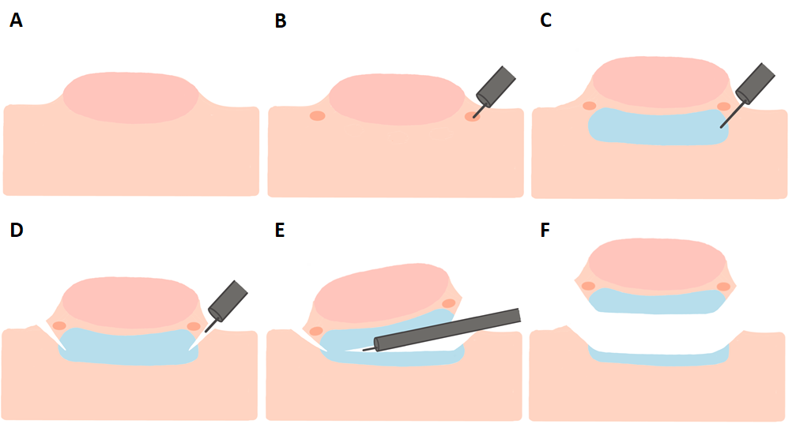
Figure 4 Key steps in performing endoscopic submucosal dissection. A: A large polyp is encountered and deemed to be endoscopically resectable; B: Markings are made around the polyp to delineate the borders; C: The polyp is raised with a submucosal injection solution; D: Incision is made into the submucosa using an endoscopic submucosal dissection (ESD) knife; E: The ESD knife is subsequently used to dissect the polyp in conjunction with serial additional injections; F: The polyp is removed en bloc.

