

**A**



**B**



**C**

**D**



**E**

**F**

**G**

**H**



**Supplementary Figure 1. Progression of metabolic deficits in DIO-NASH mice.** *p<0.05, **p<0.01, ***p<0.001 (vs. week 0).

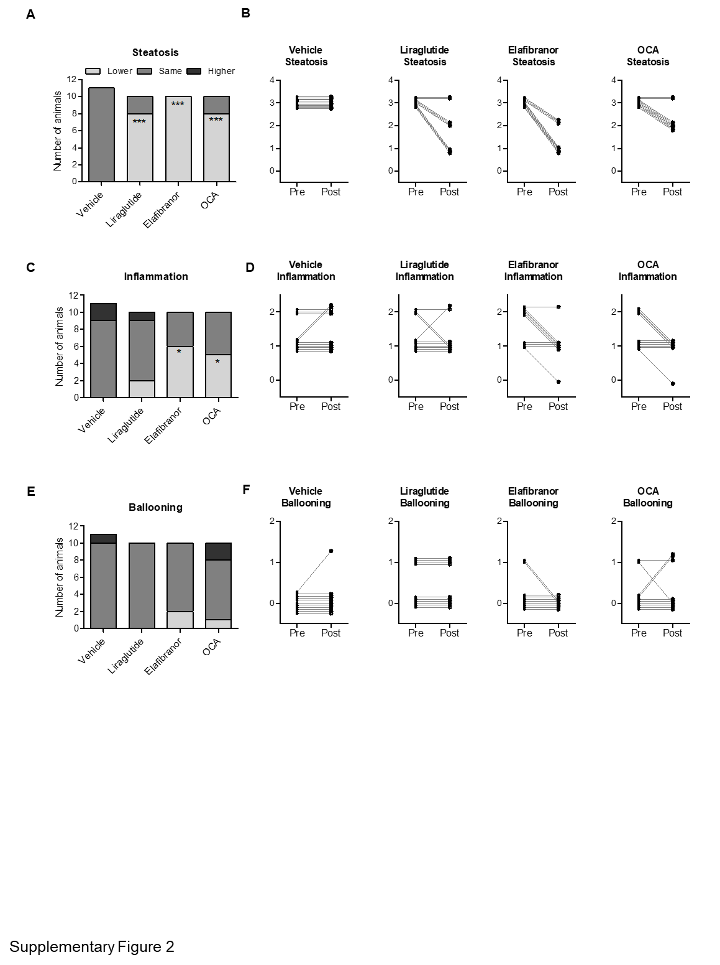

**Supplementary Figure 2. Histomorphological effects of liraglutide, obeticholic acid (OCA), and elafibranor treatment in DIO-NASH mice.** Individual steatosis, inflammation and ballooning scores. *p<0.05, ***p<0.001 (vs. vehicle controls).

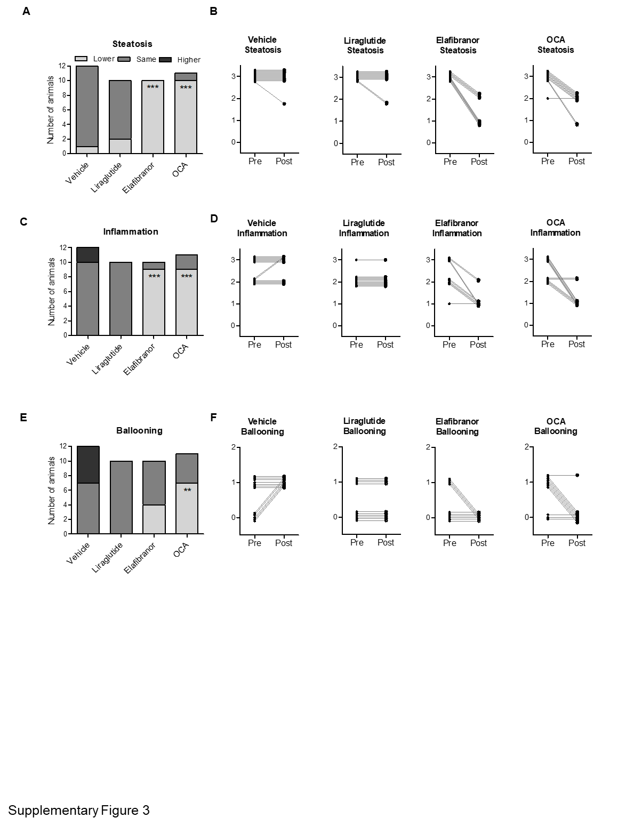

**Supplementary Figure 3. Histomorphological effects of liraglutide, obeticholic acid (OCA), and elafibranor in *ob/ob*-NASH mice.** Individual steatosis, inflammation and ballooning scores. **p<0.01, ***p<0.001 (vs. vehicle controls).