**Name of journal:** **World Journal of Gastrointestinal Endoscopy**

**ESPS Manuscript NO: 5395**

**Columns: ORIGINAL ARTICLE**

**Intraductal endoscopic radio-frequency ablation for the treatment of hilar non-resectable malignant bile duct obstruction**

Tal **AO *et al*.** Endoscopic RFA for malignant bile duct obstruction

Andrea Oliver Tal, Johannes Vermehren, Mireen Friedrich-Rust, Jörg Bojunga, Christoph Sarrazin, Stefan Zeuzem, Jörg Trojan, Jörg Gerhard Albert

**Andrea Oliver Tal, Johannes Vermehren, Mireen Friedrich-Rust, Jörg Bojunga, Christoph Sarrazin, Stefan Zeuzem, Jörg Trojan, Jörg Gerhard Albert,** Medizinische Klinik 1, Universitätsklinikum Frankfurt, 60590 Frankfurt am Main, Germany

**Author contributions:** Tal AO and Albert JG designed and performed the research; Friedrich-Rust M, Bojunga J, Sarrazin C, Trojan J and Albert JG performed the interventions and obtained clinical data; Tal AO, Vermehren J, Zeuzem S and Albert JG analysed the data and wrote the paper.

**Correspondence to: Jörg Gerhard Albert, MD,** Medizinische Klinik 1, Universitätsklinikum Frankfurt, Theodor-Stern-Kai 7, 60590 Frankfurt am Main, Germany. j.albert@med.uni-frankfurt.de

**Telephone:** +49-69-63015297 **Fax:** +49-69-63016247

**Received:** September 4, 2013 **Revised:** November 11, 2013

**Accepted:** December 9, 2013

**Published online:**

**Abstract**

**Aim:** To evaluate the safety and technical success of endoscopic radio frequency ablation (RFA) for palliative treatment of malignant hilar bile duct obstruction.

**METHODS:** In this study, a recently CE and FDA-approved endoscopic RFA catheter was first tested in an *ex vivo* pig liver model to study the effect of electrosurgical variables on the extent of the area of induced necrosis. Subsequently, a retrospective analysis was conducted of all patients treated with endoscopic RFA for malignant biliary obstruction at our center between February 2012 and April 2013. All patients had received an additional plastic stent implantation into the biliary tree following RFA.

**Results:** In the pig model ablation time of 60-90 s using the bipolar soft coagulation mode, at 8-10 Watts with an effect of 8 was found to be the most feasible setting. Twelve patients (5 females, 7 males; mean age, 70 years) underwent 19 endoscopic RFA (range, 1-5) sessions. Deployment of RFA was successful in all patients. Systemic chemotherapy was administered in four patients. We observed biliary bleeding 4-6 wk after the intervention in three cases and two of these patients died: In one patient, spontaneous hemobilia occurred whereas bleeding started during stent extraction in the other. In the third patient, bleeding was stopped by insertion of a non-covered self-expanding metal stent. Another three patients developed cholangitis during follow-up. Seven patients died during follow up and median survival was 6.4 months (95%CI: 0.05-12.7) from the time of the first RFA.

**Conclusion:** Endoscopic RFA is an easy to perform and technically highly successful procedure. However, hemobilia possibly associated with RFA occurred in three of our patients. Therefore, larger prospective studies are needed to further evaluate the safety and efficacy of this promising new method.

© 2013 Baishideng Publishing Group Co., Limited. All rights reserved.

**Key words:** Radio frequency ablation; Endoscopic retrograde cholangiopancreatography; Endoscopy; Cholangiography; Bile duct cancer; Cholangiocarcinoma

**Core tip:** Radio frequency ablation (RFA) is a promising tool for the treatment of patients with perihilar and intrahepatic bile duct cancer. While RFA is easy to perform and technical success rates are high, the outcome of patients remains unclear. Therefore, the long-term efficacy of this treatment approach needs to be studied in randomized trials.

Tal AO, Vermehren J, Friedrich-Rust M, Bojunga J, Sarrazin C, Zeuzem S, Trojan J, Albert JG. Intraductal endoscopic radio-frequency ablation for the treatment of hilar non-resectable malignant bile duct obstruction. World J Gastrointest Endosc 2013;

**Available from:**

**DOI:**

**Introduction**

Hilar cholangiocarcinoma (CCA) accounts for about 70% of biliary tumours[1] and is not amenable to curative surgical resection in more than two thirds of cases at the time of diagnosis[1]. Palliative chemotherapy may increase median survival when a combination of chemotherapeutic agents is used[2]. In addition, endoscopic insertion of plastic endoprostheses or self-expanding metal stents (SEMS) plays an important role in the palliative treatment of biliary tract cancer[3,4].

Randomized controlled trials have indicated that endoscopic local ablation of intraductal CCAs by use of photodynamic therapy (PDT) significantly improves survival in non-resectable tumors[5,6] and these findings are also supported by non-randomized studies[7-10]. However, PDT is complex and expensive requiring highly specialized equipment. Recently, ablation of intraductal tumors has been simplified by the introduction of a radio frequency ablation (RFA) probe, the Habib EndoHBP probe (EMcision UK, London, United Kingdom), that is inserted through the working-channel of a side-viewing endoscope during endoscopic retrograde cholangiopancreatography (ERCP) into the extra- and/or intrahepatic biliary tract[11].

To date, few data exist on the clinical applicability of this new device. We therefore performed a retrospective analysis of all consecutive patients treated with endoscopic RFA for malignant biliary obstruction at our center with a special emphasis on technical success rates, safety, and patient survival.

**Materials and Methods**

***Pre-clinical study***

Before the start of RFA treatments in patients, we performed an experimental pre-clinical study in an *ex-vivo* pig liver model to investigate the effect of electrosurgical variables on the extent of the area of RFA-induced necrosis. All procedures were performed using an RFA probe for bipolar cautery intended to use in endoscopic surgical procedures as described below (Habib EndoHPB; EMcision UK, London, United Kingdom; Figure 1).

In total, five consecutive freshly resected livers from adult pigs were obtained. All experiments were started within eight hours after the pigs had been euthanized and were performed at room temperature. The probe was advanced into the center of the liver over a guidewire and radio frequency ablation was performed using different variations of power (Watt), mode (effect), and ablation time. Ablations were performed with each technical setting three times in a row and the probe was inserted at least three centimeters apart from other ablation sites. Immediately after each application, the liver was cut along the guidewire with a scalpel to identify the ablation extent. The maximum diameter and length of the ablated area was measured separately for each application (Figure 2).

***Clinical study***

RFA was performed in patients with unresectable malignant biliary duct obstruction after the most feasible (8 to 10 Watt, effect 8, 60-90 s) probe settings for optimal radio frequency ablation had been identified in the pre-clinical study at our center starting in February 2012. All patients treated with endoscopic RFA for malignancy of an intra-hepatic or peri-hilar bile duct were eligible for inclusion in this study and the study protocol was approved by the ethics committee of the Medical School of the University of Frankfurt, Germany. None of the patients had been eligible for curative surgery or had undergone a previous explorative laparotomy due to locally advanced disease or comorbidities. However, all patients reported symptoms such as painless jaundice or weight loss. Histological diagnoses were obtained by percutaneous needle biopsy or intraductal endoscopically operated biopsy during ERCP. All endoscopic RFA procedures were ascertained in an interdisciplinary conference of consultant physicians from the departments of surgery, gastroenterology and medical oncology and treatment recommendations were given in consent.

All endoscopic procedures (ERCP) were performed by an experienced pancreatobiliary endoscopist under standard operating conditions with a commercially available duodenoscope (TJF-160 VR or TJF Q180V, Olympus medical, Tokyo, Japan). Previously inserted plastic endoprostheses were removed before cholangiography, which was then used to confirm biliary length, diameter, and localization of the tumor stenosis.

For endoscopic RFA a recently FDA-approved and CE-certified[12] catheter was used. This probe (Habib EndoHPB; EMcision UK, London, United Kingdom) features two ring electrodes at the tip lying 8 mm apart from each other (Figure 1). The catheter measures 8 French (2.6 mm) in diameter and 1.8 m in length. The RFA catheter can be connected to a bipolar electrosurgical generator to produce a cylindrical necrosis around the ring electrodes. The extent of the necrotic area depends on the mode of the electrosurgical generator, the power, and ablation time. For the present study, the VIO 200D generator (Erbe Elektromedizin, Tübingen, Germany) with the “bipolar soft coagulation” mode, effect 8, 8 to 10 Watts, for 90 s for treatment of the patients. Power was applied with 8 Watts for the left or right intrahepatic biliary ducts and 10 Watts for the subhilar section of the common hepatic or common bile duct, respectively. The RFA catheter was placed under fluoroscopic visualization of the biliary system after having visualized the tumor stenosis by injecting contrast medium (Iomeprol, Imeron® 300M, Bracco Imaging Deutschland, Konstanz, Germany) into the bile duct system *via* a standard ERCP-sonde. Positioning of the RFA catheter was performed exactly within the tumor stricture by using a guidewire. In case of a stenosis with more than 15 mm in length, repeated applications of RFA were carefully applied without overlapping the treated segments (1-4 applications per intervention). Thus, the RFA catheter was positioned into the right and/or the left intrahepatic bile ducts and we aimed to treat all segments involved in each specific tumor-dependent setting (Figure 1). After RFA treatment, plastic endoprosthesis (Gastrosoft; Optimed, Ettlingen, Germany) were inserted according to standard protocols. The technical success of RFA was defined as positioning the RFA catheter at the region of interest and applying coagulation current as intended with consecutive successful insertion of an endoprosthesis.

***Statistical analysis***

The clinical part of this study is a retrospective cohort study. Data were analyzed from patients who underwent endoscopic RFA between February 2012 and April 2013 at our study center. The primary endpoint was the technical feasibility of endoscopic RFA. Secondary outcome measures included peri-interventional complications and overall survival.

Descriptive statistics are shown as mean ± SD or median and range, as appropriate. Survival was assessed using Kaplan-Meier statistics. All analyses were performed using the SPSS statistics software package for Mac (Version 20.0; IBM, Somers, NY, United States).

**Results**

***Pre-clinical study***

In the *ex-vivo* pig liver model, significant differences in length and diameter of RFA-induced necrosis with variation of the electrosurgical parameters time, power and effect were observed. With an ablation time of 60-90 s using the bipolar soft coagulation mode, at 10 Watts, effect 8 (equivalent to the recommendation of the manufacturer) a mean necrotic area of 22 mm × 9 mm (length x diameter) could be induced. Power seemed to have a more pronounced effect on tissue destruction when compared to time or mode. A power of 7 Watts or less did not seem to produce a significant necrosis. Applying power in the range of 8-10 Watts seemed to be most appropriate for intraductal biliary use and higher power was associated with deep tissue destruction (Figures 2, 3).

***Clinical study***

In total, 19 RFA treatment cycles were performed in twelve patients (5 females, 7 males) with mean age of 70 years (median, 75; range, 33-85); table 1, figure 4.

All patients presented with malignant bile duct obstruction of the hepatic hilus (Klatskin like tumors). Final diagnosis included intrahepatic CCA in 2 patients, Bismuth stage IV in 8 patients, carcinoma of the gall bladder in two patients and metastases of gastric small cell carcinoma in one patient. Patients underwent either one (*n* = 9), two (*n* = 2) or five (*n* = 1) intraductal RFA applications that were considered technically successful during all applications. The ablations were applied to the left (*n* = 6), right (*n* = 9) or the main bile duct (*n* = 5) and RFA applications within one intervention ranged from 1 to 4 according to stricture length and/or bilateral vs. unilateral tumor stenosis. Four of the patients who had been diagnosed with CCA were also treated with systemic chemotherapy (cisplatin plus gemcitabine).

We observed biliary bleeding 4 to 6 wk after the intervention in three patients and two of these patients died of haemorrhagic shock. While one of these patients developed spontaneous hemobilia, bleeding started during stent extraction in the other patients that could be successfully stopped in one patient by insertion of a non-covered self-expanding metal stent (SEMS). None of the three patients had undergone chemotherapy concomitantly to endoscopic treatment. Of the remaining patients, four patients developed recurrent cholangitis during follow-up that could be successfully managed with stent exchange and antibiotic therapy.

From the time of the first RFA in each patient, the 30- and 90-d mortality of the entire cohort was 8.3% and 50%, respectively; figure 5. The extrapolated median survival from the first RFA and the time of diagnosis were 6.4 (95%CI: 0.05-12.7) mo and 8.5 (95%CI: 4.6-12.4) mo, respectively.

**Discussion**

Successful stenting of the biliary tree with prior or additive photodynamic therapy has been demonstrated to show the longest overall survival and has been referred to as the “gold standard” for endoscopic treatment of malignant biliary obstruction[5,13]. However, the management of patients treated with PDT is expensive and time comsuming and more feasible endoscopic options with equal survival benefit are warranted. Endoscopically applicable RFA represents a novel expansion of a method that is well known from its percutaneous applications, which has shown promising results in recently published case series. However, the safety of endoscopic RFA for biliary malignancy has not yet been clearly defined. Clinical data on intrahepatic treatment of CCA are scarce and many of the published studies included mostly extrahepatic tumors (Table 2). We here report our own experience on performing endoscopic RFA in 12 patients with malignant bile duct obstruction (mostly Klatskin Bismuth IV) due to hilar tumors of different etiologies. In our study, the technical applicability of RFA procedures was found to be excellent being successful in all patients and this is in line with previously published studies. Indeed, in the largest study published so far, the technical success rate was reported to be 95%[12].

Despite this, we did observe three cases of hemobilia that occurred 4-6 wk after RFA application. Two out of these three patients died from the consequences of hemorrhagic shock while bleeding could be successfully stopped in one patient by immediate SEMS insertion into the bleeding bile duct.

Although bleeding occurred several weeks after the RFA procedure in all three patients, a possible direct relationship to RFA may be assumed. In the two patients in whom bleeding occurred during stent extraction, deep necrosis induced by RFA may have been discarded from the perihilar tissue when necrotic material was removed while extracting the plastic endoprosthesis, thereby resulting in injury of a major blood vessel. Another possible explanation could be a strong necrotic effect induced by RFA that may have led to an increased angiogenic response within the tumor causing the recruitment of new vessel branches within the treated tissue. However, either of these hypotheses requires confirmation by analysis of immunohistochemical staining and biochemical processing of the treated tissues. Possible preemptive strategies to avoid biliary bleeding complications could include pre-interventional investigation with intraductal ultrasound (IDUS) to rule out large blood vessels in the vicinity of the ablation site. For the prevention of late bleeding complications, insertion of a SEMS directly after the RFA procedure seems to be feasible[12]. Severe complications associated with endoscopic RFA treatment have also been reported from most other published studies. For example, Dolak *et al*[14] reported that severe bleeding occurred in two of their patients and liver infarction in another patient, while Steel *et al*[12]reported that two of their patients required percutaneous gallbladder drainage for empyem.

Another secondary outcome measure of our study was overall survival following RFA therapy, which was shown to be 6.4 mo. In the above-mentioned Austrian multicenter study, the overall survival following RFA application was 10.6 mo. However, this was a multicenter cohort, involving 58 patients in total[14]. Other reported outcome measures included the increase of the diameter of tumor strictures[12] or stent patency at follow-up[12,14].

Taken together, our study shows that endoscopic RFA for malignant bile obstruction is a technically feasible and easy-to-apply procedure. However, based on the current experience, RFA should not be applied outside of study protocols given the risk of potentially fatal bleeding. Thus, randomized studies comparing PDT plus stenting *vs* RFA plus stenting, both with or without chemotherapy are clearly desired.

**COMMENTS**

***Background***

Treatment with curative intent may be offered only for a minority of patients with cholangiocarcinoma. We evaluated the technical feasibility and safety of endoscopic radiofrequency ablation (RFA) for palliative treatment of malignant biliary obstruction.

***Research frontiers***

A new endoscopic RFA probe (Habib EndoHPB, EMcision United Kingdom, London, United Kingdom) has recently been CE and FDA-approved, thereby offering a new palliative treatment option for the therapy of malignant biliary strictures. The catheter can be positioned and applied during endoscopic retrograde cholangiopancreatography using a specific guidewire.

***Innovations and breakthroughs***

This study demonstrates that endoscopic RFA is easy to perform and a technically highly successful tool for the endoscopic treatment of biliary malignancies. However, severe bleeding occurred in three of our patients that may have been directly associated with RFA although it occurred several weeks after the respective RFA applications.

***Applications***

This study evaluates a new therapeutic approach in the palliative treatment of patients with malignant biliary obstruction.

***Peer review***

The authors showed in their retrospective study that endoscopic RFA is technically highly feasible for the treatment of malignant biliary strictures. However, severe complications such as biliary bleeding may occur and larger, prosective studies are warranted.

**References**

|  |
| --- |
| 1 **Nakeeb A**, Pitt HA, Sohn TA, Coleman J, Abrams RA, Piantadosi S, Hruban RH, Lillemoe KD, Yeo CJ, Cameron JL. Cholangiocarcinoma. A spectrum of intrahepatic, perihilar, and distal tumors. *Ann Surg* 1996; **224**: 463-73; discussion 473-5 [PMID: 8857851 DOI: 10.1097/00000658-199610000-00005]  2 **Valle J**, Wasan H, Palmer DH, Cunningham D, Anthoney A, Maraveyas A, Madhusudan S, Iveson T, Hughes S, Pereira SP, Roughton M, Bridgewater J. Cisplatin plus gemcitabine versus gemcitabine for biliary tract cancer. *N Engl J Med* 2010; **362**: 1273-1281 [PMID: 20375404 DOI: 10.1056/NEJMoa0908721]  3 **Patel T**. Cholangiocarcinoma--controversies and challenges. *Nat Rev Gastroenterol Hepatol* 2011; **8**: 189-200 [PMID: 21460876 DOI: 10.1038/nrgastro.2011.20]  4 **Demols A**, Maréchal R, Devière J, Van Laethem JL. The multidisciplinary management of gastrointestinal cancer. Biliary tract cancers: from pathogenesis to endoscopic treatment. *Best Pract Res Clin Gastroenterol* 2007; **21**: 1015-1029 [PMID: 18070701 DOI: 10.1016/j.bpg.2007.09.005]Available]  5 **Ortner ME**, Caca K, Berr F, Liebetruth J, Mansmann U, Huster D, Voderholzer W, Schachschal G, Mössner J, Lochs H. Successful photodynamic therapy for nonresectable cholangiocarcinoma: a randomized prospective study. *Gastroenterology* 2003; **125**: 1355-1363 [PMID: 14598251 DOI: 10.1016/j.gastro.2003.07.015]  6 **Zoepf T**, Jakobs R, Arnold JC, Apel D, Riemann JF. Palliation of nonresectable bile duct cancer: improved survival after photodynamic therapy. *Am J Gastroenterol* 2005; **100**: 2426-2430 [PMID: 16279895 DOI: 10.1111/j.1572-0241.2005.00318.x]  7 **Kahaleh M**, Mishra R, Shami VM, Northup PG, Berg CL, Bashlor P, Jones P, Ellen K, Weiss GR, Brenin CM, Kurth BE, Rich TA, Adams RB, Yeaton P. Unresectable cholangiocarcinoma: comparison of survival in biliary stenting alone versus stenting with photodynamic therapy. *Clin Gastroenterol Hepatol* 2008; **6**: 290-297 [PMID: 18255347 DOI: 10.1016/j.cgh.2007.12.004]  8 **Witzigmann H**, Berr F, Ringel U, Caca K, Uhlmann D, Schoppmeyer K, Tannapfel A, Wittekind C, Mossner J, Hauss J, Wiedmann M. Surgical and palliative management and outcome in 184 patients with hilar cholangiocarcinoma: palliative photodynamic therapy plus stenting is comparable to r1/r2 resection. *Ann Surg* 2006; **244**: 230-239 [PMID: 16858185 DOI: 10.1097/01.sla.0000217639.10331.47]  9 **Dechene A**, Hilgard P, Maldonado-Lopez EJ, Riemann JF, Gerken G, Zoepf T. Dechene A, Hilgard P, Maldonado-Lopez EJ, Riemann JF, Gerken G, Zoepf T. Survival Difference in Patients with Photodynamic Therapy of Nonresectable Bile Duct Cancer Using Different Hematoporphyrins. *Gastrointest Endosc* 2007; **65**: AB227 [DOI: 10.1016/j.gie.2007.03.488]  10 **Prasad GA**, Wang KK, Baron TH, Buttar NS, Wongkeesong LM, Roberts LR, LeRoy AJ, Lutzke LS, Borkenhagen LS. Factors associated with increased survival after photodynamic therapy for cholangiocarcinoma. *Clin Gastroenterol Hepatol* 2007; **5**: 743-748 [PMID: 17545000 DOI: 10.1016/j.cgh.2007.02.021]  11 **Itoi T**, Isayama H, Sofuni A, Itokawa F, Tamura M, Watanabe Y, Moriyasu F, Kahaleh M, Habib N, Nagao T, Yokoyama T, Kasuya K, Kawakami H. Evaluation of effects of a novel endoscopically applied radiofrequency ablation biliary catheter using an ex-vivo pig liver. *J Hepatobiliary Pancreat Sci* 2012; **19**: 543-547 [PMID: 22038500 DOI: 10.1007/s00534-011-0465-7]  12 **Steel AW**, Postgate AJ, Khorsandi S, Nicholls J, Jiao L, Vlavianos P, Habib N, Westaby D. Endoscopically applied radiofrequency ablation appears to be safe in the treatment of malignant biliary obstruction. *Gastrointest Endosc* 2011; **73**: 149-153 [PMID: 21184881 DOI: 10.1016/j.gie.2010.09.031]  13 **Lee TY**, Cheon YK, Shim CS, Cho YD. Photodynamic therapy prolongs metal stent patency in patients with unresectable hilar cholangiocarcinoma. *World J Gastroenterol* 2012; **18**: 5589–5594 [PMID: 23112552 DOI: 10.3748/wjg.v18.i39.5589]  14 **Dolak W**, Schreiber F, Schwaighofer H, Gschwantler M, Plieschnegger W, Ziachehabi A, Mayer A, Kramer L, Kopecky A, Schrutka-Kölbl C, Wolkersdörfer G, Madl C, Berr F, Trauner M, Püspök A. Endoscopic radiofrequency ablation for malignant biliary obstruction: a nationwide retrospective study of 84 consecutive applications. *Surg Endosc* 2013; Epub ahead of print [PMID: 24196547 DOI: 10.1007/s00464-013-3232-9]  15 **Figueroa-Barojas P**, Bakhru MR, Habib NA, Ellen K, Millman J, Jamal-Kabani A, Gaidhane M, Kahaleh M. Safety and efficacy of radiofrequency ablation in the management of unresectable bile duct and pancreatic cancer: a novel palliation technique. *J Oncol* 2013; **2013**: 910897 [PMID: 23690775 DOI: 10.1155/2013/910897]  16 **Dolak W**, Tribl B, Schwaighofer H, Vogel W, Plieschnegger W, Siebert F, Hellmich B, Holzäpfel A, Wasilewski M, Gschwantler M, Mayer A, Decristoforo B, Dam K Z. ENDOSCOPIC RADIOFREQUENCY ABLATION FOR MALIGNANT BILIARY OBSTRUCTION: RESULTS OF 43 PROCEDURES AT 9 AUSTRIAN REFERRAL CENTERS. *Endoscopy* 2012; **44**: A14  17 **Mizandari M**, Pai M, Xi F, Valek V, Tomas A, Quaretti P, Golfieri R, Mosconi C, Guokun A, Kyriakides C, Dickinson R, Nicholls J, Habib N. Percutaneous intraductal radiofrequency ablation is a safe treatment for malignant biliary obstruction: feasibility and early results. *Cardiovasc Intervent Radiol* 2013; **36**: 814-819 [PMID: 23232859 DOI: 10.1007/s00270-012-0529-3] |

**P- Reviewers:** Anthony YBT, Konstantinos T, Wehrmann T **S- Editor:** Ma YJ

**L- Editor:** **E- Editor:**

**Table 1 Overview of all patients treated with radio frequency ablation for hilar malignancies included in our study**

|  |  |  |  |  |  |
| --- | --- | --- | --- | --- | --- |
| Patient | Patient gender/ age | Tumor location | Number of RFA treatment cycles | Follow-up (mo) | Outcome |
| 1 | F/78 | CCA Bismuth IV | 2 | 6.4 | Dead |
| 2 | F/73 | Intrahepatic CCA | 1 | 0.3 | Dead |
| 3 | M/72 | CCA Bismuth IV | 5 | 19.8 | Alive |
| 4 | M/85 | CCA Bismuth IV | 2 | 6.2 | Dead |
| 5 | M/81 | CCA Bismuth IV | 1 | 1.1 | Dead |
| 6 | M/33 | Gastric Carcinoma | 1 | Lost to follow up | - |
| 7 | F/77 | Gallbladder cancer | 1 | 6.6 | Dead |
| 8 | F/78 | CCA Bismuth IV | 1 | 1.3 | Dead |
| 9 | M/47 | CCA Bismuth IV | 1 | 14.1 | Alive |
| 10 | F/78 | CCA Bismuth IV | 1 | 1.2 | Dead |
| 11 | M/61 | Gallbladder cancer | 1 | 4.0 | Alive |
| 12 | M/72 | Intrahepatic CCA | 1 | 2.9 | Alive |

The number of RFAs denotes the number of treatment cycles during follow-up. The number of follow-up months denotes the months from the first RFA in each patient. CCA: cholangiocarcinoma; RFA: radio frequency ablation; F: female; M: male.

**Table 2 Literature overview of studies investigating the use of endoscopically-guided intraductal radio frequency ablation in malignant biliary obstruction, localisation of included tumors and complications are also listed for each study**

|  |  |  |  |  |
| --- | --- | --- | --- | --- |
| Ref. | Year | *n* | Localization of the tumor | Complications |
| Figueroa-Barojas *et al*[15] | 2011 | 8 | Intra- and extrahepatic | Pain: 4 |
| Pancreatitis and Cholecystitis: 1 |
| Steel *et al*[12] | 2011 | 21 | extrahepatic | Empyema of the gallbladder: 1 |
| Dolak *et al*[16] | 2012 | 43 | intrahepatic | Hemobilia: 2 |
| Liver infarction: 1 |
| Empyema of the gallbladder: 1 |
| Cholangitis: 1 |
| Mizandari *et al*[17] | 2012 | 39 | Intra- and extrahepatic | Pain: 15 |
| Own experience | 2013 | 12 | intrahepatic | Hemobilia: 3 (2 deaths) |

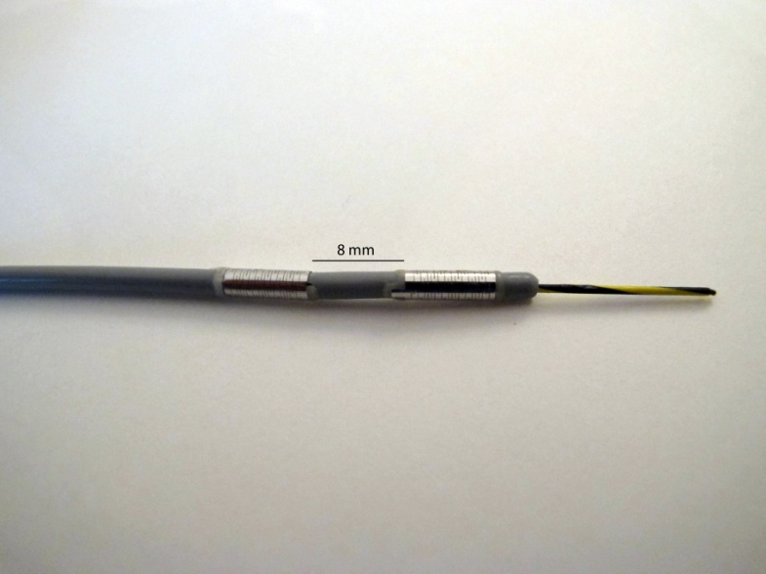

**Figure 1 The radio frequency ablation probe Habib EndoHPB (EMcision United Kingdom, London, United Kingdom) features two ring electrodes at the tip that are 8 mm apart. The probe is designed to perform bipolar cautery in endoscopic surgical procedures.**

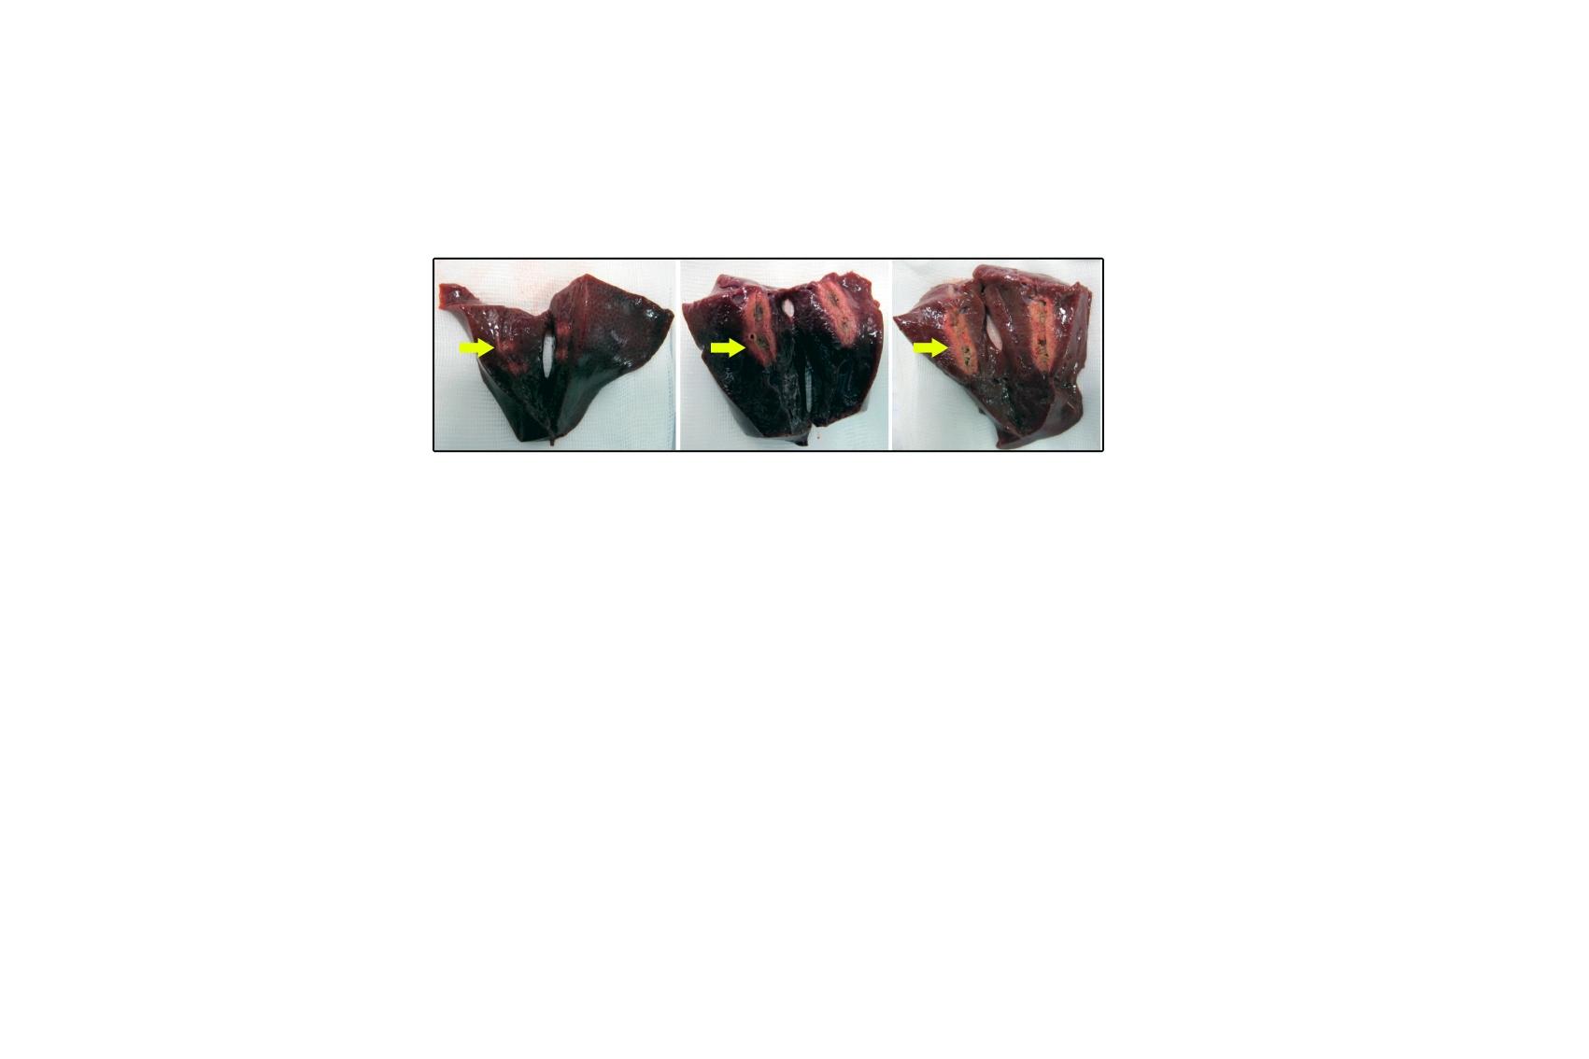

**Figure 2 Exemplary results from the *ex vivo* pig liver model.** From left to right, higher Watt variables were used. Necrotic areas are marked by a yellow arrow.



**Figure 3 Results from the *ex-vivo* pig liver model.** A: Length; B: Width.Varying electrosurgical variables revealed distinct differences in the extent of necrotic area. The used combinations are explained in the legend. *e.g.* the blue column shows length and width of the necrosis caused by RFA with 14 Watt, effect 8 with an ablation time of 90 s. RFA: radio frequency ablation.

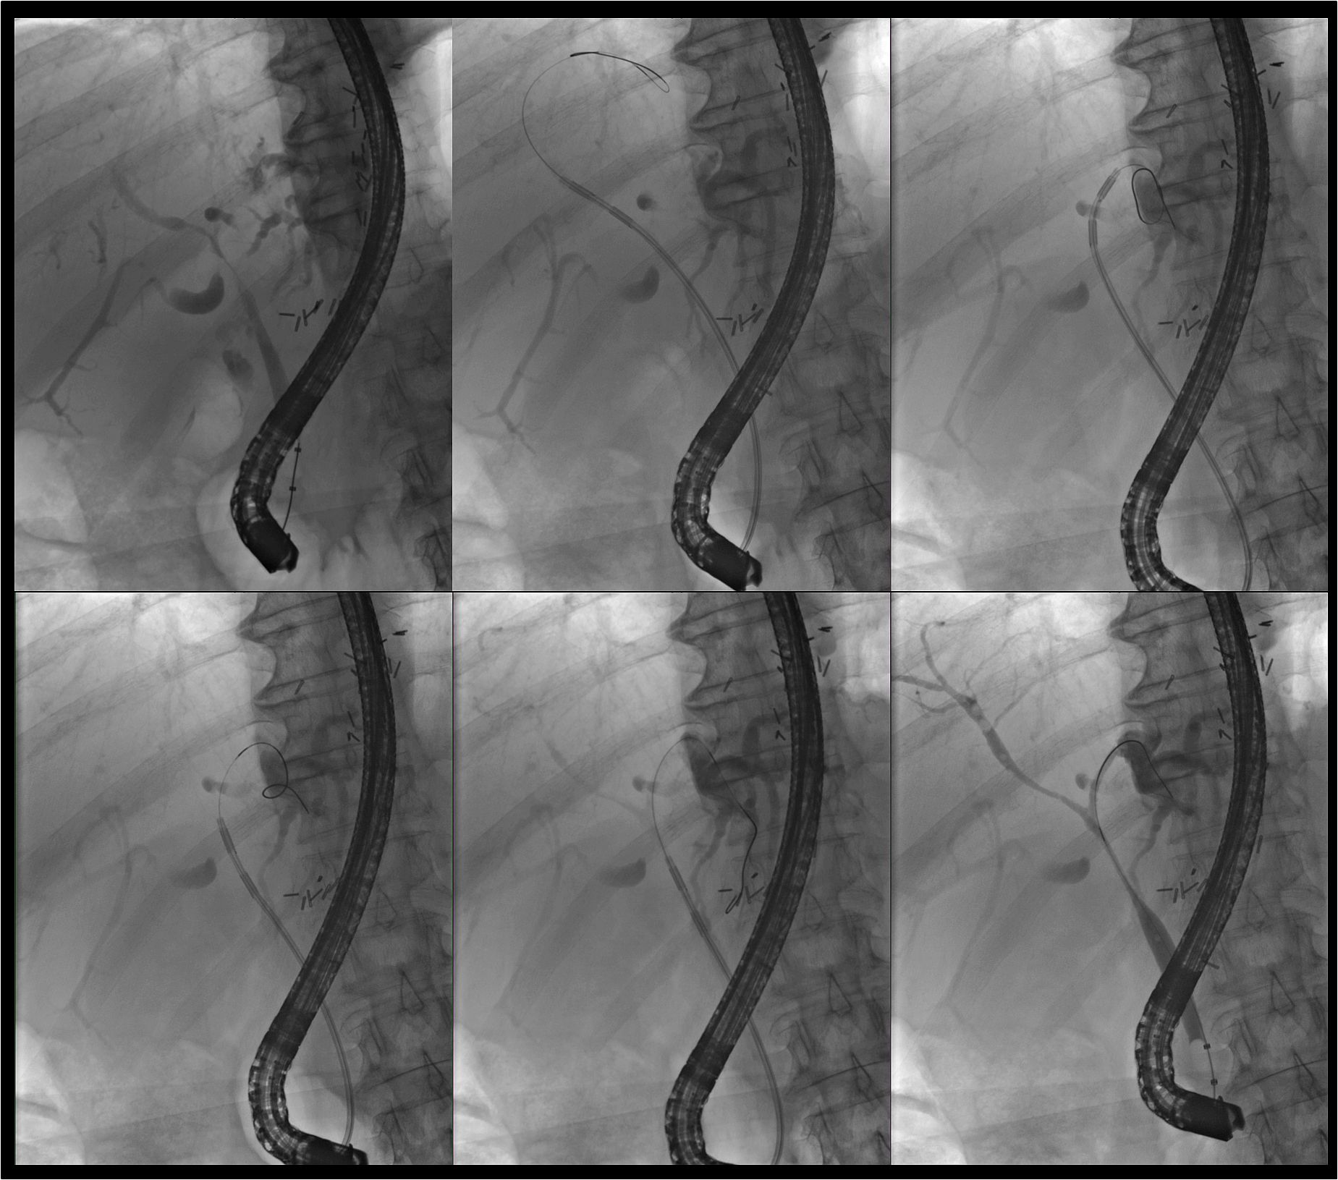

**Figure 4 Application of endoscopically guided, intraductal** **radio frequency ablation in a 72-year-old patient with an extended perihilar cholangiocarcinoma (Klatskin tumor, stage Bismuth IV, histologically proven) involving all subsegments.** Multisegmental radio frequency ablation (RFA) applications were performed (from left above to lower right). The patient experienced no treatment-associated complications and was doing well 15 mo after the initiation of endoscopic RFA treatment.

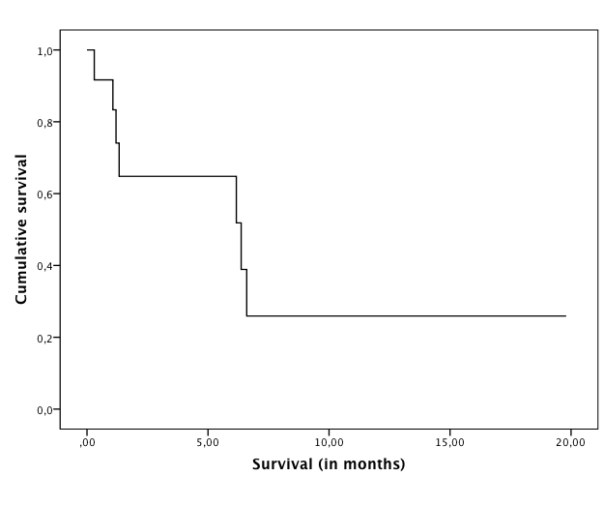**Figure 5 Kaplan-Meier survival curve of all study patients (*n* = 12).** Calculation of survival started at the time of the first endoscopic radio frequency ablation treatment in each patient.