Name of Journal: World Journal of Clinical Cases
Manuscript NO: 52920
Manuscript Type: CASE REPORT

Utility of multiple endoscopic techniques in differential diagnosis of gallbladder adenomyomatosis from gallbladder malignancy with bile duct invasion: A case report

Wen LJ et al. Multiple endoscopic techniques in differential diagnosis of GAM

Li-Jia Wen, Jun-Hong Chen, Yong-Jin Chen, Kai Liu

Li-Jia Wen, Jun-Hong Chen, Yong-Jin Chen, Kai Liu, Department of Hepatopancreatobiliary Surgery, The First Hospital of Jilin University, Changchun 130021, Jilin Province, China

Author contributions: Wen LJ and Liu K were involved in the patient’s medical treatment and wrote the paper; Chen JH and Chen YJ gathered detailed clinical information and contributed to preparing the figures; and all authors have read and approved the final manuscript.

Supported by the Jilin Province Science and Technology Development Program, No. 20191102031YY.

Corresponding author: Kai Liu, PhD, Chief Doctor, Department of Hepatopancreatobiliary Surgery, The First Hospital of Jilin University, No. 71, Xinmin Street, Changchun 130021, Jilin Province, China. 6kai@163.com

Received: December 2, 2019
Revised: December 19, 2019
Accepted: December 22, 2019
Published online: January 26, 2020
Abstract
BACKGROUND
Gallbladder adenomyomatosis (GAM) is a benign lesion, characterized by thickening of the gallbladder wall and a focal mass, which overlap with the features of gallbladder malignancy. Consequently, differential diagnosis of GAM from gallbladder cancer is difficult and approximately 20% of suspected malignant biliary strictures are postoperatively confirmed as benign lesions. Herein, we report a case in which a preoperative diagnosis of GAM was made by a combination of endoscopic and imaging techniques.

CASE SUMMARY
A 40-year-old man was referred to our hospital chiefly for a fever and right upper abdominal pain with dark urine. Enhanced computed tomography showed thickening of the gallbladder wall and a mass in the gallbladder neck with involvement of the hepatic bile ducts, which was suspected to be malignant. Gallbladder malignancy with bile duct invasion was ruled out by subsequent endoscopic examinations, including endoscopic retrograde cholangio-pancreatography, intraductal ultrasound, and SpyGlass. Endoscopic examinations showed a homogeneous hyperechoic lesion with smooth margins of benign bile duct stricture suggestive of inflammatory stenosis of the bile duct. The patient underwent laparoscopic cholecystectomy. GAM was postoperatively diagnosed and confirmed based on the histopathology results, which are consistent with the preoperative diagnosis. Notably, no malignant event occurred in the patient during a 12-mo follow-up period.

CONCLUSION
A combination of endoscopic techniques may help in the differential diagnosis of GAM from gallbladder cancer.

Key words: Gallbladder adenomyomatosis; Differential diagnosis; Endoscopic retrograde cholangio-pancreatography; Intraductal ultrasound; SpyGlass; Case report

Citation: Wen LJ, Chen JH, Chen YL, Liu K. Utility of multiple endoscopic techniques in differential diagnosis of gallbladder adenomyomatosis from gallbladder malignancy with bile duct invasion: A case report. World J Clin Cases 2020; 8(2): 464-470
URL: https://www.wjgnet.com/2307-8960/full/v8/i2/464.htm
DOI: https://dx.doi.org/10.12998/wjcc.v8.i2.464

Core tips: It remains a challenge to make an accurate preoperative diagnosis of gallbladder adenomyomatosis (GAM) mainly due to the overlapping features between GAM and gallbladder cancer. In this case report, enhanced computed tomography findings were initially indicative of a malignant gallbladder lesions, which were subsequently diagnosed as GAM by a combination of endoscopic techniques. Our findings suggest that multiple endoscopies can improve the accuracy of GAM diagnosis and help in differential diagnosis between GAM and gallbladder cancer.
INTRODUCTION
Gallbladder adenomyomatosis (GAM) is a benign tumor, and the imaging characteristics, such as thickening of the gallbladder wall and a focal mass, usually overlap with the findings in gallbladder malignancy. These similarities have posed considerable difficulties in making an accurate diagnosis of GAM, in particular, distinguishing GAM from gallbladder cancer. It has been reported that approximately 20% of suspected malignant biliary strictures were postoperatively confirmed as benign lesions^{[1]}. Computed tomography (CT) is widely used in the preoperative assessment of gallbladder lesions^{[2]}. However, CT imaging alone has been shown to reach an overall accuracy of only 70%-80% for biliary stenosis^{[3]}. Until now, there has been no definite consensus on the optimal clinical approaches for indeterminate biliary strictures. As such, it is necessary to improve the accuracy of GAM diagnosis and differential diagnosis between GAM and gallbladder cancer. In the present paper, we illustrate a case in which a preoperative diagnosis of GAM was made by a combination of endoscopic and imaging techniques.

CASE PRESENTATION
Chief complaints
A 40-year-old man was referred to our hospital chiefly for a fever and right upper abdominal pain with dark urine.

History of present illness
The patient’s symptoms started 7 d ago with right upper pain and fever, which had worsened over the last 72 h.

History of past illness
He had no special medical history.

Personal and family history
None.

Physical examination upon admission
The patient had upper abdominal pain without abdominal distension or vomiting, as well as yellow sclera and film. He had a body temperature of 37.5 ℃, heart rate of 72 bpm, blood pressure of 116/68 mmHg, and respiratory rate of 15.

Laboratory examinations
Total bilirubin was 138.8 µmol/L, direct bilirubin was 117.3 µmol/L, CA19-9 was 161.3 U/mL, CA-125 was 15.76 U/mL, AFP was 1.77 ng/mL, carcinoembryonic antigen was 1.29 ng/mL, C-reaction protein was 81.3 mg/L, neutrophil granulocyte percentage was 0.83, and IgG4 was 0.2 g/L.

Imaging examinations
An enhanced CT scan revealed a mass at the neck of the gallbladder involving the bile ducts (Figure 1A) and a shadow was visualized at the end of the common bile duct (Figure 1B). Endoscopic retrograde cholangio-pancreatography (ERCP) showed bile duct dilatation (Figure 2A) and gallstones at the end of the common bile duct (Figure 2B), intraductal ultrasound (IDUS) suggested a benign bile duct stricture (Figure 3), inflammatory change in the bile duct mucosa was visualized by SpyGlass Direct Visualization System imaging (Figure 4), and final pathological examination revealed GAM with chronic cholecystitis and acute suppurative inflammation (Figure 5).

FINAL DIAGNOSIS
GAM and choledocholithiasis.

TREATMENT
The patient underwent laparoscopic cholecystectomy.

OUTCOME AND FOLLOW-UP
Fortunately, neither recurrent GAM nor malignant tumor was observed in the patient during a 12-mo follow-up period.

DISCUSSION
Gallbladder carcinoma is the most common malignant tumor in the biliary system^{[4]}. Some benign gallbladder diseases are misdiagnosed as gallbladder carcinoma, resulting in unnecessary surgery. For instance, GAM is an excessively proliferative disease of the gallbladder epithelium with intramural diverticula (Rokitanskye Aschoff sinuses) extending into the thickened muscular layer^{[2]} and its imaging features have some overlaps with those of gallbladder carcinoma when it presents as focal thickening at the body and fundus and a mass with irregularly soft tissue density in the gallbladder, which may simulate a malignancy, resulting in a false-positive diagnosis of gallbladder carcinoma^{[5]}. On the contrary, patients who suffer from gallbladder cancer may present with acute cholecystitis, misdiagnosed as a benign lesion. It has been reported that the hidden incidence of gallbladder cancer combined with cholecystitis ranges from 1%-9%^{[4]}. Gallbladder carcinoma originating from the neck can invade the cystic and extrahepatic bile duct, making it difficult to distinguish from extrahepatic cholangiocarcinoma^{[6,7]}. When a stricture of the mid-portion of the extrahepatic bile duct is found in patients presenting with obstructive jaundice, careful evaluation of the cystic duct and gallbladder neck is necessary to rule out gallbladder cancer with metastasis.
With recently developed novel biomarkers and endoscopic techniques, unnecessary surgeries on benign strictures of the bile duct have been greatly reduced. However, no single approach has been reliable in the differential diagnosis of benign and malignant lesions in the gallbladder mainly due to insufficient sensitivity, low specificity, and inaccuracy. By reviewing the published systematic reviews and meta-analysis (Table 1), we identified the diagnostic indices for the evaluation of suspected malignant biliary strictures (Table 1)^{[1,8-14]}. We found that the clinical approach of various endoscopies in combination could significantly improve the diagnostic accuracy of indeterminate biliary stricture. It is worth noting in particular that contrast-enhanced ultrasound is very reliable in the differential diagnosis of gallbladder cancer with broad prospects^{[15,16]}. CA19-9 should be used cautiously for patients with biliary obstruction because of the potential for a pseudo increase^{[17]}. In this case report and review of the literature, we propose a strategy for the evaluation and preoperative diagnosis of gallbladder-occupying lesions with bile duct invasion (Figure 6), which may have great preoperative diagnostic utility. First, a detailed medical history should be obtained, with physical and laboratory examinations, along with abdominal ultrasound to provide the initial evidence for a non-invasive imaging method such as CT or magnetic resonance cholangiopancreatography. These imaging modalities can reveal both the hilar bile duct and gall bladder, which can guide future treatment. Second, an invasive method such as ERCP with IDUS/SpyGlass/probe-based confocal laser endomicroscopy/fluorescence in situ hybridization or pathology can be used as the primary measure. If endoscopy and laparoscopic cholecystectomy are positive, radical resection of hilar cholangiocarcinoma must be undertaken. If lymphatic metastasis or vascular invasion is found, ERCP stent implantation and radiofrequency ablation can be performed. Otherwise, 12 mo of follow-up is usually necessary.

CONCLUSION
In summary, preoperative diagnosis of GAM is challenging, particularly when it presents imaging features similar to those of gallbladder carcinoma. The findings in this case study suggest that the use of multiple endoscopic techniques in combination may improve the accuracy of GAM diagnosis and benefit the differential diagnosis of GAM from gallbladder cancer.

REFERENCES
1 Bowlus CL, Olson KA, Gershwin ME. Evaluation of indeterminate biliary strictures. Nat Rev Gastroenterol Hepatol 2016; 13: 28-37 [PMID: 26526122 DOI: 10.1038/nrgastro.2015.182]
2 Heinzow HS, Kammerer S, Rammes C, Wessling J, Domagk D, Meister T. Comparative analysis of ERCP, IDUS, EUS and CT in predicting malignant bile duct strictures. World J Gastroenterol 2014; 20: 10495-10503 [PMID: 25132767 DOI: 10.3748/wjg.v20.i30.10495]
3 Saluja SS, Sharma R, Pal S, Sahni P, Chattopadhyay TK. Differentiation between benign and malignant hilar obstructions using laboratory and radiological investigations: a prospective study. HPB (Oxford) 2007; 9: 373-382 [PMID: 18345322 DOI: 10.1080/13651820701504207]
4 Yoshimitsu K, Irie H, Aibe H, Tajima T, Nishie A, Asayama Y, Matake K, Yamaguchi K, Matsuura S, Honda H. Well-differentiated adenocarcinoma of the gallbladder with intratumoral cystic components due to abundant mucin production: a mimicker of adenomyomatosis. Eur Radiol 2005; 15: 229-233 [PMID: 15662477 DOI: 10.1007/s00330-004-2516-9]
5 Kim SW, Kim HC, Yang DM, Ryu JK, Won KY. Gallbladder carcinoma: causes of misdiagnosis at CT. Clin Radiol 2016; 71: e96-109 [PMID: 26602932 DOI: 10.1016/j.crad.2015.10.016]
6 Nakata T, Kobayashi A, Miwa S, Soeda J, Miyagawa S. Impact of tumor spread to the cystic duct on the prognosis of patients with gallbladder carcinoma. World J Surg 2007; 31: 155-61; discussion 162-3 [PMID: 17180477 DOI: 10.1007/s00268-006-0118-1]
7 Shukla PJ, Barreto SG, Shrikhande SV, Ramadwar MR, Deodhar KK, Mehta S, Patil P, Mohandas KM. Simultaneous gallbladder and bile duct cancers: revisiting the pathological possibilities. HPB (Oxford) 2008; 10: 48-53 [PMID: 18695759 DOI: 10.1080/13651820701867802]
8 Clemente G, Nuzzo G, De Rose AM, Giovannini I, La Torre G, Ardito F, Giuliante F. Unexpected gallbladder cancer after laparoscopic cholecystectomy for acute cholecystitis: a worrisome picture. J Gastrointest Surg 2012; 16: 1462-1468 [PMID: 22653330 DOI: 10.1007/s11605-012-1915-5]
9 Cui XY, Chen HW. Role of diffusion-weighted magnetic resonance imaging in the diagnosis of extrahepatic cholangiocarcinoma. World J Gastroenterol 2010; 16: 3196-3201 [PMID: 20593506 DOI: 10.3748/wjg.v16.i25.3196]
10 Gonda TA, Glick MP, Sethi A, Poneros JM, Palmas W, Iqbal S, Gonzalez S, Nandula SV, Emond JC, Brown RS, Murty VV, Stevens PD. Polysomy and p16 deletion by fluorescence in situ hybridization in the diagnosis of indeterminate biliary strictures. Gastrointest Endosc 2012; 75: 74-79 [PMID: 22100297 DOI: 10.1016/j.gie.2011.08.022]
11 Mohamadnejad M, DeWitt JM, Sherman S, LeBlanc JK, Pitt HA, House MG, Jones KJ, Fogel EL, McHenry L, Watkins JL, Cote GA, Lehman GA, Al-Haddad MA. Role of EUS for preoperative evaluation of cholangiocarcinoma: a large single-center experience. Gastrointest Endosc 2011; 73: 71-78 [PMID: 21067747 DOI: 10.1016/j.gie.2010.08.050]
12 Xie C, Aloreidi K, Patel B, Ridgway T, Thambi-Pillai T, Timmerman G, Khan A, Atiq M. Indeterminate biliary strictures: a simplified approach. Expert Rev Gastroenterol Hepatol 2018; 12: 189-199 [PMID: 29034764 DOI: 10.1080/17474124.2018.1391090]
13 Fugazza A, Gaiani F, Carra MC, Brunetti F, Lévy M, Sobhani I, Azoulay D, Catena F, de'Angelis GL, de'Angelis N. Confocal Laser Endomicroscopy in Gastrointestinal and Pancreatobiliary Diseases: A Systematic Review and Meta-Analysis. Biomed Res Int 2016; 2016: 4638683 [PMID: 26989684 DOI: 10.1155/2016/4638683]
14 Park HJ, Kim SH, Jang KM, Choi SY, Lee SJ, Choi D. The role of diffusion-weighted MR imaging for differentiating benign from malignant bile duct strictures. Eur Radiol 2014; 24: 947-958 [PMID: 24487774 DOI: 10.1007/s00330-014-3097-x]
15 Serra C, Felicani C, Mazzotta E, Gabusi V, Grasso V, De Cinque A, Giannitrapani L, Soresi M. CEUS in the differential diagnosis between biliary sludge, benign lesions and malignant lesions. J Ultrasound 2018; 21: 119-126 [PMID: 29476456 DOI: 10.1007/s40477-018-0286-5]
16 Sidhu PS, Cantisani V, Dietrich CF, Gilja OH, Saftoiu A, Bartels E, Bertolotto M, Calliada F, Clevert DA, Cosgrove D, Deganello A, D'Onofrio M, Drudi FM, Freeman S, Harvey C, Jenssen C, Jung EM, Klauser AS, Lassau N, Meloni MF, Leen E, Nicolau C, Nolsoe C, Piscaglia F, Prada F, Prosch H, Radzina M, Savelli L, Weskott HP, Wijkstra H. The EFSUMB Guidelines and Recommendations for the Clinical Practice of Contrast-Enhanced Ultrasound (CEUS) in Non-Hepatic Applications: Update 2017 (Long Version). Ultraschall Med 2018; 39: e2-e44 [PMID: 29510439 DOI: 10.1055/a-0586-1107]
17 Pearce S, Thornes H, Carr D, Tanner A. Diagnostic pitfall; interpretation of CA 19-9 concentrations in the presence of hepatic dysfunction. Gut 1994; 35: 707-708 [PMID: 8200572 DOI: 10.1136/gut.35.5.707]
Footnotes
Informed consent statement: Written informed consent was obtained from the patient for publication of this report and any accompanying images.

Conflict-of-interest statement: All authors declare no conflict of interest.

CARE Checklist (2016) statement: The authors have read the CARE Checklist (2016), and the manuscript was prepared and revised according to the CARE Checklist (2016).

Open-Access: This article is an open-access article which was selected by an in-house editor and fully peer-reviewed by external reviewers. It is distributed in accordance with the Creative Commons Attribution Non Commercial (CC BY-NC 4.0) license, which permits others to distribute, remix, adapt, build upon this work non-commercially, and license their derivative works on different terms, provided the original work is properly cited and the use is non-commercial. See: http://creativecommons.org/licenses/by-nc/4.0/

Manuscript source: Unsolicited manuscript

Peer-review started: December 2, 2019
First decision: December 11, 2019
Article in press: December 22, 2019

Specialty type: Medicine, research and experimental
Country of origin: China
Peer-review report classification
Grade A (Excellent): 0
Grade B (Very good): B
Grade C (Good): 0
Grade D (Fair): 0
Grade E (Poor): 0

P-Reviewer: Soresi M S-Editor: Dou Y L-Editor: Wang TQ E-Editor: Liu JH
Figure Legends
A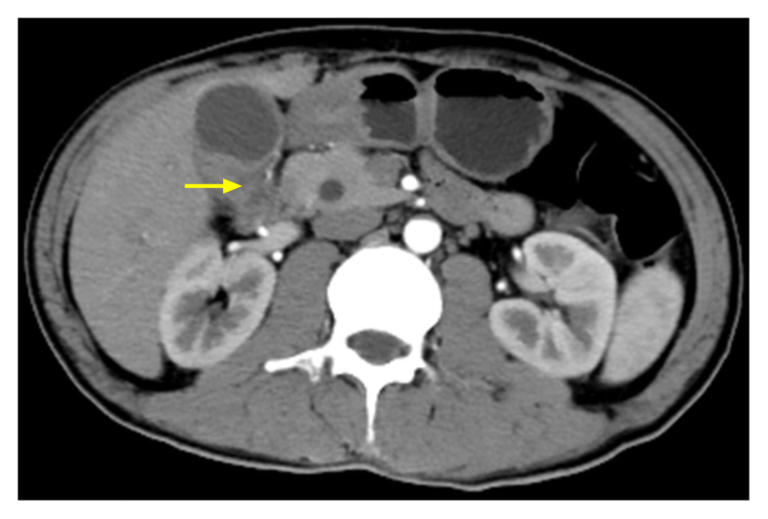
B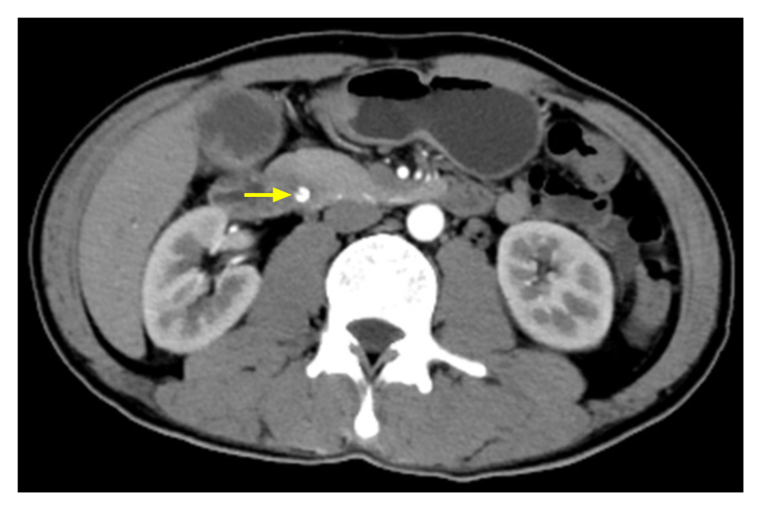
Figure 1 Enhanced computed tomography imaging. A: Thickening of the gallbladder wall and irregular density soft tissue extending from the neck and invading into the cavity and intrahepatic bile ducts with intrahepatic bile duct dilatation by approximately 2.5 cm × 1.3 cm; B: The cystic duct lumen was narrowed and a circular calcification-like high-density shadow was visualized at the end of the common bile duct at approximately 0.8 cm.
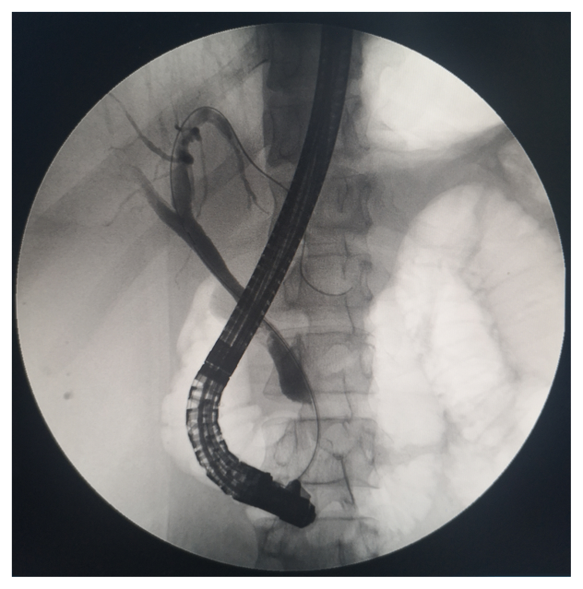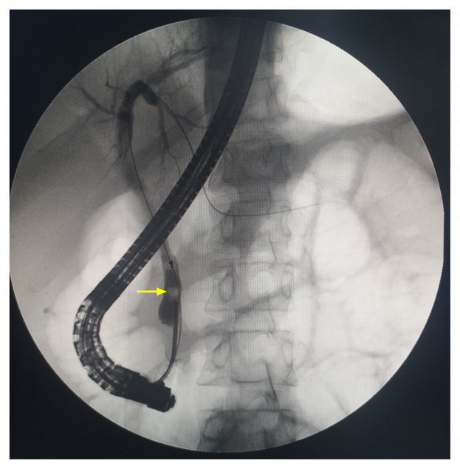
Figure 2 Endoscopic retrograde cholangio-pancreatography. A: Bile duct dilatation; B: Gallstones at the end of the common bile duct.
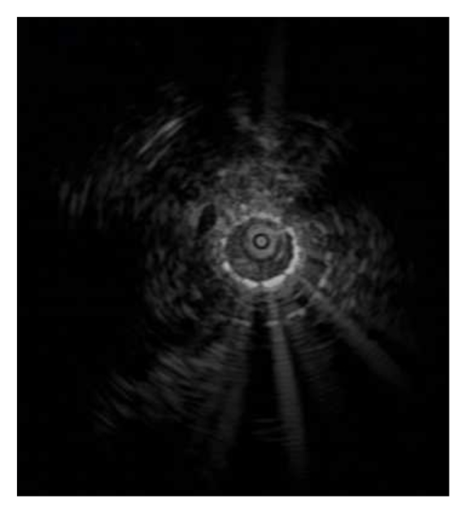
Figure 3 Intraductal ultrasound imaging. Homogeneous hyperechoic lesions with smooth margins of benign bile duct stricture were visualized.
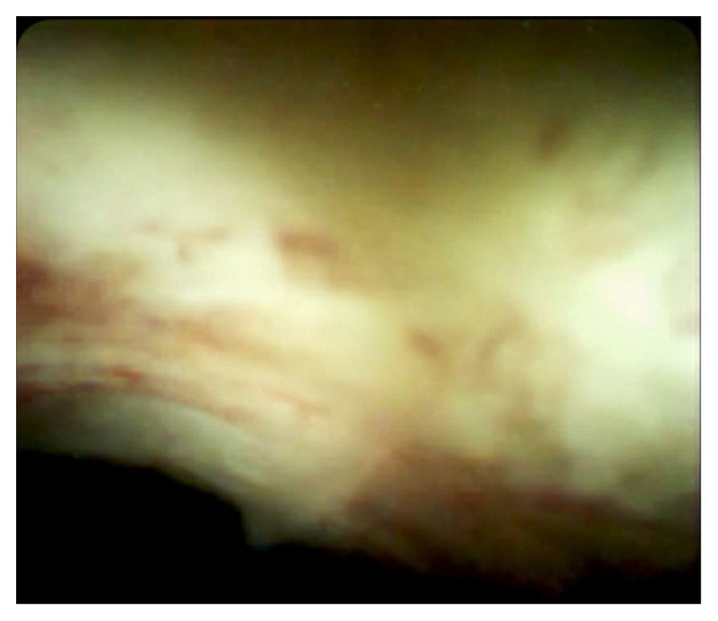
Figure 4 SpyGlass Direct Visualization System imaging. Inflammatory change in the bile duct mucosa was observed.
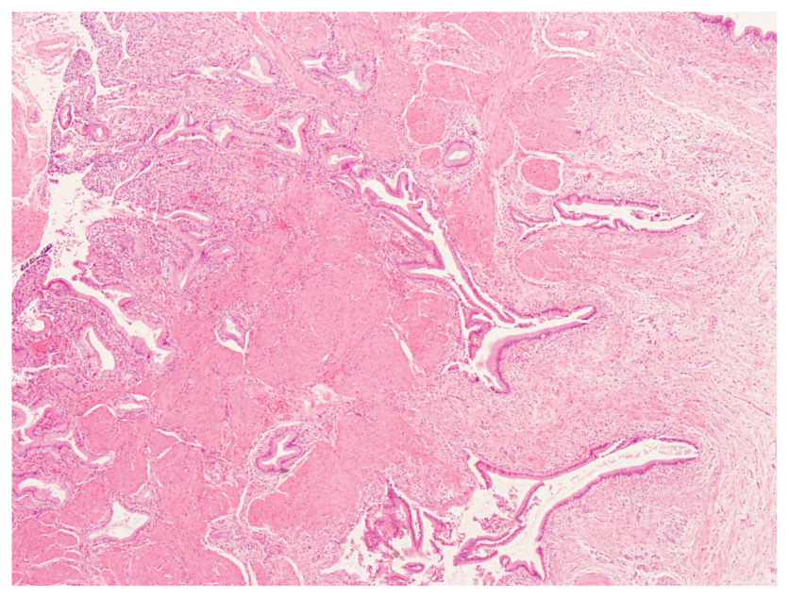
Figure 5 Pathological examination. Gallbladder adenomyomatosis with chronic cholecystitis and acute suppurative inflammation was present without signs of gallbladder carcinomas at the incisal margin of the liver and neck of the gallbladder (×40).
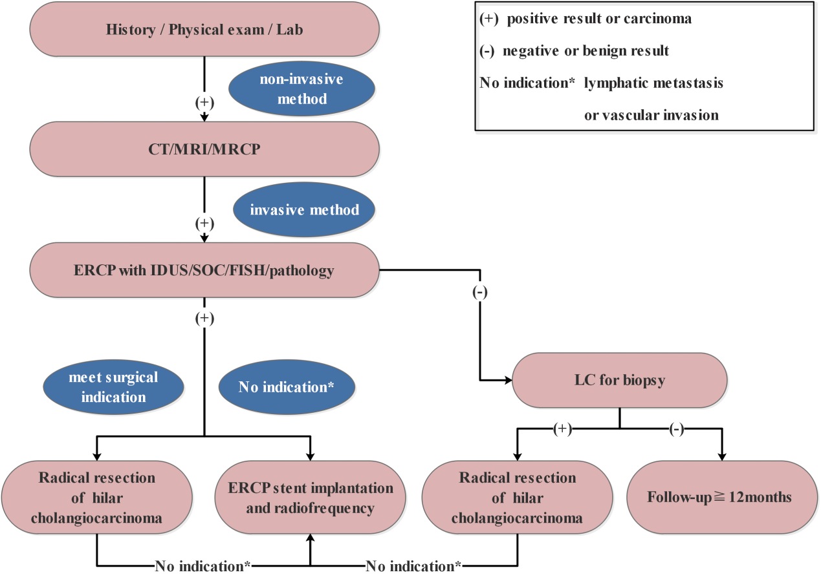Figure 6 Various endoscopic and radiological imaging modalities for evaluation and preoperative diagnosis of gallbladder occupying lesions with bile duct invasion. ERCP: Endoscopic retrograde cholangio-pancreatography.

Table 1 Various diagnostic techniques for evaluation of suspected malignant biliary strictures
Diagnostic modality | Sensitivity (%) | Specificity (%) | Accuracy (%)
ERCP brush cytology + biopsy | 59 | 100 | 73
CT/MDCT | 77 | 63 | 75
MRI/MRCP | 88 | 95 | 80
CA 19-9 > 100 | 75 | 80 | 78
SOC-biopsy | 60 | 98 | 79
FISH | 70 | 89 | 87
EUS | 88 | 90 | 74
ERCP + CLE | 90 | 72 | 81
ERCP + IDUS | 93 | 89 | 91
CT: Computed tomography; SOC-biopsy: Single-operator cholangioscopy-guided biopsy; FISH: Fluorescence in situ hybridization; EUS: Endoscopic ultrasound; IDUS: Intraductal endoscopic ultrasound; CLE: Confocal laser endomicroscopy; MRCP: Magnetic resonance cholangiopancreatography; ERCP: Endoscopic retrograde cholangio-pancreatography.

