**Name of journal:** *World Journal of Gastrointestinal Oncology*

**Manuscript NO:** 54339

**Manuscript type:** META-ANALYSIS

**Timing of surgery after neoadjuvant chemoradiotherapy affects oncologic outcomes in patients with esophageal cancer**

Shang QX *et al*. Timing of esophagectomy after nCRT

Qi-Xin Shang, Yu-Shang Yang, Yi-Min Gu, Xiao-Xi Zeng, Han-Lu Zhang, Wei-Peng Hu, Wen-Ping Wang, Long-Qi Chen, Yong Yuan

**Qi-Xin Shang, Yu-Shang Yang, Yi-Min Gu, Han-Lu Zhang, Wei-Peng Hu, Wen-Ping Wang, Long-Qi Chen, Yong Yuan,** Department of Thoracic Surgery, West China Hospital of Sichuan University, Chengdu 610041, Sichuan Province, China

**Xiao-Xi Zeng,** West China Biomedical Big Data Center, West China Hospital of Sichuan University, Chengdu 610041, Sichuan Province, China

**Author contributions:** Shang QX, Chen LQ and Yuan Y designed research; Shang QX, Yang YS, Gu YM, and Zhang HL performed research; Zeng XX and Hu WP contributed new reagents or analytic tools; Shang QX, Gu YM and Wang WP analyzed data; Shang QX wrote the paper; all authors approved the final version; Shang QX and Yang YS contributed equally to this work.

**Supported by** the National Natural Science Foundation of China, No. 81970481; Sichuan Science and Technology Program, No. 2018HH0150 and Chengdu Science and Technology Bureau, No. 2016GH0200020HZ.

**Corresponding author: Yong Yuan, MD, PhD, Associate Professor,** Department of Thoracic Surgery, West China Hospital of Sichuan University, No. 37 Guoxue Alley, Chengdu 610041, Sichuan Province, China.

yongyuan@scu.edu.cn

**Received:** January 23, 2020

**Revised:** April 9, 2020

**Accepted:** April 28, 2020

**Published online:** June 15, 2020

**Abstract**

BACKGROUND

The optimal time interval between neoadjuvant chemoradiotherapy (nCRT) and esophagectomy in esophageal cancer has not been defined.

AIM

To evaluate whether a prolonged time interval between the end of nCRT and surgery has an effect on survival outcome in esophageal cancer patients.

Methods

We searched PubMed, Embase, Web of Science, the Cochrane Library, Wanfang and China National Knowledge Infrastructure databases for relevant articles published before November 16, 2019, to identify potential studies that evaluated the prognostic role of different time intervals between nCRT and surgery in esophageal cancer. The hazard ratios and 95% confidence intervals (95%CI) were merged to estimate the correlation between the time intervals and survival outcomes in esophageal cancer, esophageal squamous cell carcinoma and adenocarcinoma using fixed- and random-effect models.

Results

This meta-analysis included 12 621 patients from 16 studies. The results demonstrated that esophageal cancer patients with a prolonged time interval between the end of nCRT and surgery had significantly worse overall survival (OS) [hazard ratio (HR): 1.107, 95%CI: 1.014-1.208, *P* = 0.023] than those with a shorter time interval. Subgroup analysis showed that poor OS with a prolonged interval was observed based on both the sample size and HRs. There was also significant association between a prolonged time interval and decreased OS in Asian, but not Caucasian patients. In addition, a longer wait time indicated worse OS (HR: 1.385, 95%CI: 1.186-1.616, *P* < 0.001) in patients with adenocarcinoma.

Conclusion

A prolonged time interval from the completion of nCRT to surgery is associated with a significant decrease in OS. Thus, esophagectomy should be performed within 7-8 wk after nCRT.

**Key words:** Esophageal cancer; Neoadjuvant chemoradiotherapy; Esophagectomy; Time interval; Survival outcome; Meta-Analysis

**Citation:** Shang QX, Yang YS, Gu YM, Zeng XX, Zhang HL, Hu WP, Wang WP, Chen LQ, Yuan Y.Timing of surgery after neoadjuvant chemoradiotherapy affects oncologic outcomes in patients with esophageal cancer. *World J Gastrointest Oncol* 2020; 12(6): 687-698

URL: <https://www.wjgnet.com/1948-5204/full/v12/i6/687.htm>

DOI: https://dx.doi.org/10.4251/wjgo.v12.i6.687

**Core tip:** Esophageal cancer is one of the most common malignant tumors worldwide. Neoadjuvant chemoradiotherapy (nCRT) is increasingly used as the standard treatment for most esophageal cancer patients. However, the optimal time interval for esophagectomy after nCRT in patients with esophageal cancer has not been defined. Therefore, we conducted a meta-analysis on 12 621 patients from 16 studies to evaluate whether a prolonged time interval from the end of nCRT to surgery has an effect on survival outcome in esophageal cancer patients.

**INTRODUCTION**

Esophageal cancer is the sixth leading cause of cancer-related death worldwide[1]. In China, esophageal cancer led to 375 000 deaths annually[2]. High-level evidence suggests that neoadjuvant chemoradiotherapy (nCRT) plus surgery compared with surgery alone improves survival in patients with local advanced esophageal squamous cell carcinoma (SCC) and adenocarcinoma (AC), and pathological complete response (pCR) after nCRT may have a potential impact on survival outcome[3,4]. However, there are many unclear factors which influence outcome in esophageal cancer patients.

The optimal time interval for esophagectomy after nCRT in patients with esophageal cancer has not been defined. According to current clinical practice, in most centers, patients usually undergo esophagectomy within 6 to 8 wk after completion of nCRT when they have fully recovered[5]. In rectal cancer patients, evidence[6] suggests that a longer waiting interval (more than 6-8 wk) significantly increases the rate of pCR without a detrimental outcome. Similarly, other studies[7,8] have revealed that a prolonged interval between nCRT (> 8 wk) and esophagectomy is associated with a higher pCR,which may improve survival in esophageal cancer patients. However, Ranney *et al*[9] and others[10,11] have indicated that the prognostic role of the time interval in esophageal cancer is still controversial. For these reasons, it is necessary to perform a meta-analysis to systematically and comprehensively investigate the impact of different intervals on survival outcome. In the present study, a pooled analysis of relevant studies was undertaken to evaluate whether a prolonged time interval from the end of nCRT to surgery has an effect on survival outcome in esophageal cancer patients.

**MATERIALS AND METHODS**

***Literature search***

We performed a systematic literature review in accordance with the Preferred Reporting Items for Systematic Reviews and Meta-Analyses. We searched PubMed, Embase, Web of Science, the Cochrane Library, Wanfang and China National Knowledge Infrastructure databases for relevant studies published before November 16, 2019. We identified articles using Medical Subject Heading and Test-word search strategy. Keywords included “esophageal neoplasms”, “neoadjuvant therapy”, “esophagectomy”, and “time interval”. In addition, the references listed in the articles were also checked.

***Study selection***

The included studies satisfied the following criteria: (1) comparisons were performed between longer time intervals and shorter time intervals from the completion of nCRT to surgery in esophageal cancer patients; (2) survival-related outcomes were reported, such as overall survival (OS), progression-free survival (PFS) and disease-free survival; (3) studies included human subjects; and (4) articles were published in any language. The exclusion criteria were as follows: (1) article types such as abstracts, letters, review articles, case reports and unpublished studies; (2) studies with insufficient data to evaluate hazard ratio (HR) and 95% confidence interval (95%CI); and (3) for studies already reported or containing duplicate data, we included only the latest studies.

***Data extraction, endpoints and quality assessment***

Two reviewers (Yi-Min Gu, Qi-Xin Shang) evaluated all potential eligible studies. Then, another two investigators (Han-Lu Zhang, Xiang-Yu Zhang) completed the full-text review independently. If disagreement occurred, a third investigator (Yu-Shang Yang) joined the discussion until a consensus was reached. The following information was extracted from the selected articles: first author, study year, study region, study design, ethnicity, sample size, age, nCRT regimen, cut-off value, outcome, follow-up, clinical stage, histological type and HR with 95% confidence intervals (95%CI). The time interval was defined as the period of time from the completion of nCRT to surgery. When several time interval groups were included in the study, the subgroup events were combined at the cut-off value of 7-8 wk in order to compare the longer interval with the shorter time interval. Some studies have suggested an interval of 7-8 wk for esophageal cancer patients (Table 1); and a similar classification was used in a previously published meta-analysis of esophageal cancer[34]. OS was selected as the primary end point, while PFS and disease-free survival were secondary end points. The included studies quality was rated according to the Newcastle-Ottawa Scale (NOS) by two independent investigators (Yi-Min Gu, Wei-Peng Hu). Studies with NOS scores of 6 or higher were considered to be of high quality.

***Statistical analysis***

HRs) and 95%CIs were extracted from each article and combined to estimate the prognostic value. HR > 1 indicated a worse oncologic outcome in esophageal cancer patients with a longer time interval between nCRT therapy and surgery. If the study did not provide HRs and 95%CIs directly but a Kaplan-Meier curve instead, Engauge-Digitizer version 12 (http://markummitchell.github.io/engauge-digitizer/) was used to derive estimates from survival curves according to the method proposed by Parmar *et al*[12]. Cochran’s *Q* test and Higgins I-squared statistic were used to assess the heterogeneity of the included studies. Pooled estimates of HR and 95%CI were calculated initially with a fixed-effect model (Mantel–Haenszel method). If significant heterogeneity existed (*Q*-test, *P* < 0.10 or *I*2 > 50% was defined as statistically significant heterogeneity), a certified analysis using the random-effect model (DerSimonian–Laird method) was performed. Begg’s funnel plot and Egger's linear regression test were carried out to detect publication bias. All *P*-values were two-sided and significant publication bias was defined as *P* < 0.05. Multivariate models were chosen for a more accurate estimate of the effect of time interval on survival outcomes when both univariate and multivariate Cox regression analyses were performed. Subgroup analyses were performed on the basis of variables including histology, study design, ethnicity, sample size, and HR type. All statistical analyses were performed with Stata/SE 12.0 software (Stata Corp LLC, version 12.0 4905 Lakeway Drive College Station, TX, United States).

**RESULTS**

***Identification of relevant studies***

We screened 2308 eligible studies and identified 19 studies including two relevant articles from the same study by Franko *et al*[13,14] and two studies[15,16] without sufficient data to calculate HR and 95%CI. Sixteen studies were finally selected for the meta-analysis to determine whether the time interval from completion of nCRT to surgery has an effect on survival outcome[5,7-11,14,17-25]. Of these studies, HRs and 95%CIs were directly provided in three studies, while the other 13 studies all provided Kaplan-Meier curves; thus, we were able to obtain estimated HRs and 95%CIs indirectly. Moreover, in 13 studies, HRs were evaluated by univariate analysis and in three by multivariate analysis. The included articles were assessed to be of high quality, with a median quality score of 7.3 (range, 6-8). The identification of relevant studies is summarized in the flowchart (Figure 1).

***Study characteristics***

The included studies were carried out in seven countries (United States, China, France, Italy, Netherlands, Japan, and Sweden) and published between 2010 and 2019. Of these studies, seven were retrospective and nine were prospective. The participants were Caucasian in 12 studies and were Asian in four studies. The median number of patients in each study was 789 (range, 88-5393), with a total of 12 621 patients, consisting of 7522 patients with a shorter time interval, and 5099 patients with a longer time interval between nCRT and surgery. The sample size in five studies was < 200 patients and was ≥ 200 patients in 11 studies. In addition, 1029, 219 and 189 patients underwent esophagectomy via Ivor-Lewis, Mckeown and transhiatal approaches, respectively, while six studies[5,8,11,20-22] did not provide the method of esophagectomy. The cut-off values in each study were not consistent and ranged from 45 d to 64 d. Six articles applied a cut-off value of 8 wk and five studies used 7 wk. Seven studies included whole stages, and three studies included advanced stage. Additional comprehensive characteristics of the relevant studies are shown in Table 1.

***Time interval and OS, PFS in esophageal cancer***

Sixteen studies were included in the meta-analysis on the effect of the time interval between nCRT and surgery on the OS of esophageal cancer patients. Notable heterogeneity was detected among the studies (*I*2 = 48.8%, *P* = 0.015; Figure 2); thus, a random-effect model was used. The results of our meta-analysis showed that esophageal cancer patients with a shorter wait time correlated with prolonged OS compared with an extended wait time, with a poor HR of 1.107 (95%CI: 1.014-1.208, *P* = 0.023; Table 2). Three studies which included 590 patients demonstrated that a longer time interval was related to shorter PFS (HR: 1.263, 95%CI: 0.976-1.633, *P* = 0.075; Table 2) without obvious heterogeneity (*I*2 = 48.4%, Ph = 0.144; Figure 2).

***Time interval and OS in AC***

Two studies with 2634 patients reported data on a longer time interval and OS in AC patients. Pooled data from the two studies demonstrated that a prolonged time interval was significantly associated with worse OS with a HR estimate of 1.385 (95%CI: 1.186-1.616, *P* < 0.001; Table 2) without apparent heterogeneity (*I*2 = 22.00%, Ph = 0.257; Figure 3).

***Time interval and OS in SCC***

Meta-analysis of six studies revealed that SCC patients with a longer time interval had poor OS (HR: 1.096, 95%CI: 0.896-1.341, *P* = 0.371; Table 2) with significant heterogeneity (*I*2 = 57.2%, Ph = 0.039; Figure 3).

***Subgroup analysis***

Subgroup analyses were conducted to investigate potential sources of heterogeneity across studies and to evaluate the consistency of the conclusions among different subpopulations of patients. Subgroup analyses based on study design, demonstrated that the merged HR was 1.073 (95%CI: 0.964-1.194, *P* = 0.064) for prospective cohort studies and 1.094 (95%CI: 1.034-1.158, *P* = 0.001) for retrospective analyses (Table 2).

Based on classifications by sample size, the merged HR was 1.254 (95%CI: 0.985-1.579, *P* = 0.067) for a sample size < 200 and 1.089 (95%CI: 0.995-1.190, *P* = 0.063) for a sample size ≥ 200. Stratification by ethnicity, revealed a combined HR of 1.091 (95%CI: 0.995-1.197, *P* = 0.150) in Caucasian populations and 1.251 (95%CI: 0.922-1.696, *P* = 0.023) in Asian cases. In addition, subgroup analysis was performed by univariate analysis (HR: 1.029, 95%CI: 0.949-1.115, *P* = 0.492) and multivariate analysis (HR: 1.194, 95 %CI: 1.010-1.411, *P* = 0.037). The results demonstrated that sample size (< 200 and ≥ 200) and statistical analysis approach (univariate and multivariate analyses) were both potential causes of significant heterogeneity (Table 2).

***Sensitivity analysis***

Due to the conspicuous heterogeneity among the studies, a sensitivity analysis was performed. We found that the combined results were still stable after the exclusion of any single study (Figure 4).

***Publication bias***

Investigations using Begg’s funnel plot (Figure 5) and Egger’s linear regression test did not indicate publication bias in the meta-analyses on the association between time to surgery and OS (Pr >|z| = 0.344 for Begg’s test and *P* >|t|= 0.432 for Egger’s test).

**DISCUSSION**

The role of preoperative chemoradiotherapy in improving survival among patients with potentially curable esophageal cancer is recognized in many randomized controlled studies[3,4]. However, esophagectomy cannot be performed immediately, as patients need to recover from the side effects of chemoradiotherapy, and an appropriate interval can induce the maximal radiotherapy response[26]. A strong relationship between the time interval and survival outcome has been reported for pancreatic tumor[27], rectal cancer[28], and non-small cell lung cancer[29].

Similarly, several studies have shown an association between time interval and survival in esophageal cancer patients. Shapiro *et al*[7] found that a prolonged interval after nCRT increased the pCR rate and may improve survival. However, the findings in some current studies do not support those of previous research. Ranney *et al*[9] found that OS was worse in the long-interval subgroup (HR: 1.44, 95%CI: 1.22-1.71, *P* < 0.001). This result is consistent with that of Chiu *et al*[10] who revealed that survival outcome did not improve following a long-term wait. In contrast, subgroup analysis showed that later resection may be hazardous, especially in patients who had a good response to nCRT.

This meta-analysis included 12 621 esophageal cancer patients from 16 cohort studies, and demonstrated that patients with a longer time interval between nCRT and esophagectomy had significantly worse OS (HR: 1.107, 95%CI: 1.014-1.208, *P* = 0.023; Figure 2) than those with a shorter time interval. Subgroup analysis showed that OS with a prolonged interval was poor based on both the sample size and the HRs. There was also a significant association between a prolonged interval and worse OS in Asian, but not Caucasian patients. In addition, we found that a prolonged interval indicated worse OS (HR: 1.385, 95%CI: 1.186-1.616, *P* < 0.001; Table 2) in patients with AC. In contrast, a prolonged interval resulted in shorter OS without statistical significance (HR: 1.096, 95%CI: 0.896-1.341, *P* > 0.05; Table 2) in SCC patients. Taking all of these findings into consideration, worse OS was noted in the longer time interval group. There are several possible explanations for this result. One possible explanation may be the disproportionate number of medically complex patients between the two groups, which could have decreased the OS[5]. Patients need to optimize medical comorbidities during see-and-wait follow-up. As a result, disease-specific survival may be closer to the real evaluation rather than OS. Another possible explanation is that the longer wait time was not due to preference or chance in the patients, but due to their poor physical condition after nCRT, which may have put them at an inherent disadvantage in terms of survival.

Some studies have shown that radiation-induced fibrosis may also make surgical dissection technically demanding with delayed surgery leading to higher complication rates[2]. In contrast, Haisley *et al*[5] found no effect on mortality and no increase in complications in the longer time interval group. Another source of uncertainty is cancer stage; however, no significant difference in initial clinical stage was observed between the longer time interval and shorter time interval groups[14,23]. In addition, due to the heterogeneity of genotype and phenotype in esophageal cancer as well as constitutive resistance to individual cytotoxic drugs[30], chemotherapy is rarely beneficial in all patients, and some researchers have reported that the pCR rate following preoperative chemoradiation for esophageal cancer could reach 20%-35%[31]. Further well-designed and large-scale studies are needed to determine whether the time interval from the end of nCRT to surgery has an effect on survival outcome and to assess whether disease-specific survival differs by type of pathological response.

The strength of our study is that this is the first meta-analysis to investigate whether the time interval between nCRT and surgery affects survival outcome using pooled HRs. The total sample size in the 16 included studies was 12 621 patients with a survival of five or more years. Moreover, the larger number of included studies ensured the inclusion of subgroup analyses. To date, three similar meta-analyses have been published. The earliest meta-analysis by Lin *et al*[32] included only five eligible studies and found that a longer time interval did not impact the five-year OS and pCR rates. The next meta-analysis was performed by Tie *et al*[33], but did not reveal if a prolonged time interval had a significant impact on the five-year OS and pCR rates. Moreover, this study included conference abstracts, which may have introduced potential bias. The third study by Qin *et al*[34] found that a prolonged interval between nCRT and surgery was significantly correlated with higher pCR and surgical mortality rate in esophageal cancer patients. Their study included only nine articles containing 5830 patients with a five-year survival, which were less than half of the sample size in our study. In addition, they did not investigate the association between time interval and survival outcomes.

Several limitations in our studies should be carefully addressed. The most important limitation was the fact that most of the studies included were retrospective. An additional uncontrolled factor is that heterogeneity was a potential factor that may have affected interpretation of the results. The source of heterogeneity in this study could be age, nCRT regimen, cut-off value, and ypTNM stage.

In conclusion, despite these limitations, this meta-analysis confirmed that a prolonged time interval between the completion of nCRT and surgery is related to decreased OS of esophageal cancer patients. It is suggested that esophagectomy should be performed within 7-8 wk after nCRT in view of OS, especially in patients with good recovery and response to nCRT. As some potential biases were hardly adjusted, our results still require further confirmation.

**ARTICLE HIGHLIGHTS**

***Research background***

The optimal time interval for esophagectomy after neoadjuvant chemoradiotherapy (nCRT) in patients with esophageal cancer has not been defined.

***Research motivation***

Some studies have revealed that a prolonged interval (> 8 wk) between nCRT and esophagectomy is associated with a higher pathological complete response,which may improve survival in esophageal cancer patients. However, othershave indicated that the prognostic role of the time interval in esophageal cancer is still controversial. For these reasons, it is necessary to perform a meta-analysis to systematically and comprehensively investigate the impact of different intervals on survival outcome in these patients.

***Research objectives***

To evaluate whether a prolonged time interval between the end of nCRT and surgery has an effect on survival outcome through meta-analysis.

***Research methods***

The research methods meta-analysis that were adopted to realize the objectives.

***Research results***

The results demonstrated that esophageal cancer patients with a prolonged time interval between the end of nCRT and surgery had significantly worse overall survival (OS) (HR: 1.107, 95%CI: 1.014-1.208, *P* = 0.023) than those with a shorter time interval. Subgroup analysis showed that poor OS with a prolonged interval was observed based on both the sample size and HRs. There was also significant association between a prolonged time interval and decreased OS in Asian, but not Caucasian patients. In addition, a longer waiting time resulted in worse OS (HR: 1.385, 95%CI: 1.186-1.616, *P* < 0.001) in patients with adenocarcinoma.

***Research conclusions***

This meta-analysis confirmed that a prolonged time interval between the completion of nCRT and surgery is related to decreased OS of esophageal cancer patients. It is suggested that esophagectomy should be performed within 7-8 wk after nCRT in view of OS, especially in patients with good recovery and response to nCRT.

***Research perspectives***

Several limitations in this analysis should be carefully addressed. The most important limitation was the fact that most of the studies included were retrospective. An additional uncontrolled factor is that heterogeneity was a potential factor that may have affected interpretation of the results. The source of heterogeneity in this study could be age, nCRT regimen, cut-off value, and ypTNM stage. As some potential biases were hardly adjusted, further well-designed and large-scale studies are needed to determine whether the time interval from the end of nCRT to surgery has an effect on survival outcome and to assess whether disease-specific survival differs by type of pathological response.

**REFERENCES**

1 **Torre LA**, Bray F, Siegel RL, Ferlay J, Lortet-Tieulent J, Jemal A. Global cancer statistics, 2012. *CA Cancer J Clin* 2015; **65**: 87-108 [PMID: 25651787 DOI: 10.3322/caac.21262]

2 **Chen W**, Zheng R, Baade PD, Zhang S, Zeng H, Bray F, Jemal A, Yu XQ, He J. Cancer statistics in China, 2015. *CA Cancer J Clin* 2016; **66**: 115-132 [PMID: 26808342 DOI: 10.3322/caac.21338]

3 **van Hagen P**, Hulshof MC, van Lanschot JJ, Steyerberg EW, van Berge Henegouwen MI, Wijnhoven BP, Richel DJ, Nieuwenhuijzen GA, Hospers GA, Bonenkamp JJ, Cuesta MA, Blaisse RJ, Busch OR, ten Kate FJ, Creemers GJ, Punt CJ, Plukker JT, Verheul HM, Spillenaar Bilgen EJ, van Dekken H, van der Sangen MJ, Rozema T, Biermann K, Beukema JC, Piet AH, van Rij CM, Reinders JG, Tilanus HW, van der Gaast A; CROSS Group. Preoperative chemoradiotherapy for esophageal or junctional cancer. *N Engl J Med* 2012; **366**: 2074-2084 [PMID: 22646630 DOI: 10.1056/NEJMoa1112088]

4 **Yang H**, Liu H, Chen Y, Zhu C, Fang W, Yu Z, Mao W, Xiang J, Han Y, Chen Z, Yang H, Wang J, Pang Q, Zheng X, Yang H, Li T, Lordick F, D'Journo XB, Cerfolio RJ, Korst RJ, Novoa NM, Swanson SJ, Brunelli A, Ismail M, Fernando HC, Zhang X, Li Q, Wang G, Chen B, Mao T, Kong M, Guo X, Lin T, Liu M, Fu J; AME Thoracic Surgery Collaborative Group. Neoadjuvant Chemoradiotherapy Followed by Surgery Versus Surgery Alone for Locally Advanced Squamous Cell Carcinoma of the Esophagus (NEOCRTEC5010): A Phase III Multicenter, Randomized, Open-Label Clinical Trial. *J Clin Oncol* 2018; **36**: 2796-2803 [PMID: 30089078 DOI: 10.1200/JCO.2018.79.1483]

5 **Haisley KR**, Laird AE, Nabavizadeh N, Gatter KM, Holland JM, Vaccaro GM, Thomas CR Jr, Schipper PH, Hunter JG, Dolan JP. Association of Intervals Between Neoadjuvant Chemoradiation and Surgical Resection With Pathologic Complete Response and Survival in Patients With Esophageal Cancer. *JAMA Surg* 2016; **151**: e162743 [PMID: 27627765 DOI: 10.1001/jamasurg.2016.2743]

6 **Petrelli F**, Sgroi G, Sarti E, Barni S. Increasing the Interval Between Neoadjuvant Chemoradiotherapy and Surgery in Rectal Cancer: A Meta-analysis of Published Studies. *Ann Surg* 2016; **263**: 458-464 [PMID: 24263329 DOI: 10.1097/SLA.0000000000000368]

7 **Shapiro J**, van Hagen P, Lingsma HF, Wijnhoven BP, Biermann K, ten Kate FJ, Steyerberg EW, van der Gaast A, van Lanschot JJ; CROSS Study Group. Prolonged time to surgery after neoadjuvant chemoradiotherapy increases histopathological response without affecting survival in patients with esophageal or junctional cancer. *Ann Surg* 2014; **260**: 807-813; discussion 813-814 [PMID: 25379852 DOI: 10.1097/SLA.0000000000000966]

8 **Klevebro F**, Nilsson K, Lindblad M, Ekman S, Johansson J, Lundell L, Ndegwa N, Hedberg J, Nilsson M. Association between time interval from neoadjuvant chemoradiotherapy to surgery and complete histological tumor response in esophageal and gastroesophageal junction cancer: a national cohort study. *Dis Esophagus* 2019 [PMID: 31676895 DOI: 10.1093/dote/doz078]

9 **Ranney DN**, Mulvihill MS, Yerokun BA, Fitch Z, Sun Z, Yang CF, D'Amico TA, Hartwig MG. Surgical resection after neoadjuvant chemoradiation for oesophageal adenocarcinoma: what is the optimal timing? *Eur J Cardiothorac Surg* 2017; **52**: 543-551 [PMID: 28498967 DOI: 10.1093/ejcts/ezx132]

10 **Chiu CH**, Chao YK, Chang HK, Tseng CK, Chan SC, Liu YH, Chen WH. Interval between neoadjuvant chemoradiotherapy and surgery for esophageal squamous cell carcinoma: does delayed surgery impact outcome? *Ann Surg Oncol* 2013; **20**: 4245-4251 [PMID: 23959050 DOI: 10.1245/s10434-013-3139-7]

11 **Lee A**, Wong AT, Schwartz D, Weiner JP, Osborn VW, Schreiber D. Is There a Benefit to Prolonging the Interval Between Neoadjuvant Chemoradiation and Esophagectomy in Esophageal Cancer? *Ann Thorac Surg* 2016; **102**: 433-438 [PMID: 27154156 DOI: 10.1016/j.athoracsur.2016.02.058]

12 **Parmar MK**, Torri V, Stewart L. Extracting summary statistics to perform meta-analyses of the published literature for survival endpoints. *Stat Med* 1998; **17**: 2815-2834 [PMID: 9921604 DOI: 10.1002/(SICI)1097-0258(19981230)17:24<2815::AID-SIM110>3.0.CO;2-8]

13 **Franko J**, Voynov G, Goldman CD. Esophagectomy Timing After Neoadjuvant Therapy for Distal Esophageal Adenocarcinoma. *Ann Thorac Surg* 2016; **101**: 1123-1130 [PMID: 26652139 DOI: 10.1016/j.athoracsur.2015.09.044]

14 **Franko J**, McAvoy S. Timing of esophagectomy after neoadjuvant chemoradiation treatment in squamous cell carcinoma. *Surgery* 2018; **164**: 455-459 [PMID: 29903507 DOI: 10.1016/j.surg.2018.04.026]

15 **Müller AK**, Lenschow C, Palmes D, Senninger N, Hummel R, Lindner K. [Timing of esophagectomy in multimodal therapy of esophageal cancer: Impact of time interval between neoadjuvant therapy and surgery on outcome and response]. *Chirurg* 2015; **86**: 874-880 [PMID: 25662991 DOI: 10.1007/s00104-014-2916-6]

16 **van der Werf LR**, Dikken JL, van der Willik EM, van Berge Henegouwen MI, Nieuwenhuijzen GAP, Wijnhoven BPL; Dutch Upper Gastrointestinal Cancer Audit (DUCA) group. Time interval between neoadjuvant chemoradiotherapy and surgery for oesophageal or junctional cancer: A nationwide study. *Eur J Cancer* 2018; **91**: 76-85 [PMID: 29353163 DOI: 10.1016/j.ejca.2017.12.009]

17 **Ruol A**, Rizzetto C, Castoro C, Cagol M, Alfieri R, Zanchettin G, Cavallin F, Michieletto S, Da Dalt G, Sileni VC, Corti L, Mantoan S, Zaninotto G, Ancona E. Interval between neoadjuvant chemoradiotherapy and surgery for squamous cell carcinoma of the thoracic esophagus: does delayed surgery have an impact on outcome? *Ann Surg* 2010; **252**: 788-796 [PMID: 21037434 DOI: 10.1097/SLA.0b013e3181fc7f86]

18 **Kim JY**, Correa AM, Vaporciyan AA, Roth JA, Mehran RJ, Walsh GL, Rice DC, Ajani JA, Maru DM, Bhutani MS, Welsh J, Marom EM, Swisher SG, Hofstetter WL. Does the timing of esophagectomy after chemoradiation affect outcome? *Ann Thorac Surg* 2012; **93**: 207-212 [PMID: 21962263 DOI: 10.1016/j.athoracsur.2011.05.021]

19 **Tessier W**, Gronnier C, Messager M, Hec F, Mirabel X, Robb WB, Piessen G, Mariette C. Does timing of surgical procedure after neoadjuvant chemoradiation affect outcomes in esophageal cancer? *Ann Thorac Surg* 2014; **97**: 1181-1189 [PMID: 24529482 DOI: 10.1016/j.athoracsur.2013.12.026]

20 **Shaikh T**, Ruth K, Scott WJ, Burtness BA, Cohen SJ, Konski AA, Cooper HS, Astsaturov I, Meyer JE. Increased time from neoadjuvant chemoradiation to surgery is associated with higher pathologic complete response rates in esophageal cancer. *Ann Thorac Surg* 2015; **99**: 270-276 [PMID: 25440267 DOI: 10.1016/j.athoracsur.2014.08.033]

21 **Wang BY**, Chen HS, Hsu PK, Shih CS, Liu CY, Liu CC, Wu SC. Clinical impact of the interval between chemoradiotherapy and esophagectomy in esophageal squamous cell carcinoma patients. *Ann Thorac Surg* 2015; **99**: 947-955 [PMID: 25620588 DOI: 10.1016/j.athoracsur.2014.10.037]

22 **Kathiravetpillai N**, Koëter M, van der Sangen MJ, Creemers GJ, Luyer MD, Rutten HJ, Nieuwenhuijzen GA. Delaying surgery after neoadjuvant chemoradiotherapy does not significantly influence postoperative morbidity or oncological outcome in patients with oesophageal adenocarcinoma. *Eur J Surg Oncol* 2016; **42**: 1183-1190 [PMID: 27134188 DOI: 10.1016/j.ejso.2016.03.033]

23 **Tsang JS**, Tong DKH, Lam KO, Law BTT, Wong IYH, Chan DKK, Chan FSY, Kwong D, Law S. Appropriate timing for surgery after neoadjuvant chemoradiation for esophageal cancer. *Dis Esophagus* 2017; **30**: 1-8 [PMID: 28859363 DOI: 10.1093/dote/dox062]

24 **Furukawa T**, Hamai Y, Hihara J, Emi M, Yamakita I, Ibuki Y, Kurokawa T, Okada M. Impact of Interval Between Neoadjuvant Chemoradiation and Surgery Upon Morbidity and Survival of Patients with Squamous Cell Carcinoma of Thoracic Esophagus. *Anticancer Res* 2018; **38**: 5239-5245 [PMID: 30194173 DOI: 10.21873/anticanres.12848]

25 **Singla S**, Gabriel E, Alnaji R, Du W, Attwood K, Nava H, Hochwald SN, Kukar M. Complete pathologic response is independent of the timing of esophagectomy following neoadjuvant chemoradiation for esophageal cancer. *J Gastrointest Oncol* 2018; **9**: 73-79 [PMID: 29564173 DOI: 10.21037/jgo.2017.09.11]

26 **Huang J**, Barbera L, Brouwers M, Browman G, Mackillop WJ. Does delay in starting treatment affect the outcomes of radiotherapy? A systematic review. *J Clin Oncol* 2003; **21**: 555-563 [PMID: 12560449 DOI: 10.1200/JCO.2003.04.171]

27 **Chen KT**, Devarajan K, Milestone BN, Cooper HS, Denlinger C, Cohen SJ, Meyer JE, Hoffman JP. Neoadjuvant chemoradiation and duration of chemotherapy before surgical resection for pancreatic cancer: does time interval between radiotherapy and surgery matter? *Ann Surg Oncol* 2014; **21**: 662-669 [PMID: 24276638 DOI: 10.1245/s10434-013-3396-5]

28 **Lefevre JH**, Mineur L, Kotti S, Rullier E, Rouanet P, de Chaisemartin C, Meunier B, Mehrdad J, Cotte E, Desrame J, Karoui M, Benoist S, Kirzin S, Berger A, Panis Y, Piessen G, Saudemont A, Prudhomme M, Peschaud F, Dubois A, Loriau J, Tuech JJ, Meurette G, Lupinacci R, Goasgen N, Parc Y, Simon T, Tiret E. Effect of Interval (7 or 11 weeks) Between Neoadjuvant Radiochemotherapy and Surgery on Complete Pathologic Response in Rectal Cancer: A Multicenter, Randomized, Controlled Trial (GRECCAR-6). *J Clin Oncol* 2016; **34**: 3773-3780 [PMID: 27432930 DOI: 10.1200/JCO.2016.67.6049]

29 **Gao SJ**, Corso CD, Wang EH, Blasberg JD, Detterbeck FC, Boffa DJ, Decker RH, Kim AW. Timing of Surgery after Neoadjuvant Chemoradiation in Locally Advanced Non-Small Cell Lung Cancer. *J Thorac Oncol* 2017; **12**: 314-322 [PMID: 27720827 DOI: 10.1016/j.jtho.2016.09.122]

30 **Ling ZQ**, Qi CJ, Lu XX, Qian LJ, Gu LH, Zheng ZG, Zhao Q, Wang S, Fang XH, Yang ZX, Yin J, Mao WM. Heterogeneity of chemosensitivity in esophageal cancer using ATP-tumor chemosensitivity assay. *Acta Pharmacol Sin* 2012; **33**: 401-406 [PMID: 22286916 DOI: 10.1038/aps.2011.195]

31 **Berger AC**, Farma J, Scott WJ, Freedman G, Weiner L, Cheng JD, Wang H, Goldberg M. Complete response to neoadjuvant chemoradiotherapy in esophageal carcinoma is associated with significantly improved survival. *J Clin Oncol* 2005; **23**: 4330-4337 [PMID: 15781882 DOI: 10.1200/JCO.2005.05.017]

32 **Lin G**, Han SY, Xu YP, Mao WM. Increasing the interval between neoadjuvant chemoradiotherapy and surgery in esophageal cancer: a meta-analysis of published studies. *Dis Esophagus* 2016; **29**: 1107-1114 [PMID: 26542065 DOI: 10.1111/dote.12432]

33 **Tie H**, He F, Shen J, Zhang B, Ye M, Chen B, Wu Q. Prolonged interval between neoadjuvant chemoradiotherapy and esophagectomy does not benefit the outcome in esophageal cancer: a systematic review and meta-analysis. *Dis Esophagus* 2018; **31**: 1-9 [PMID: 29087451 DOI: 10.1093/dote/dox116]

34 **Qin Q**, Xu H, Liu J, Zhang C, Xu L, Di X, Zhang X, Sun X. Does timing of esophagectomy following neoadjuvant chemoradiation affect outcomes? A meta-analysis. *Int J Surg* 2018; **59**: 11-18 [PMID: 30261331 DOI: 10.1016/j.ijsu.2018.09.013]

**Footnotes**

**Conflict-of-interest statement:** The authors deny any conflict of interest.

**PRISMA 2009 Checklist statement:** The authors have read the PRISMA 2009 Checklist, and the manuscript was prepared and revised according to the PRISMA 2009 Checklist.

**Open-Access:** This article is an open-access article that was selected by an in-house editor and fully peer-reviewed by external reviewers. It is distributed in accordance with the Creative Commons Attribution NonCommercial (CC BY-NC 4.0) license, which permits others to distribute, remix, adapt, build upon this work non-commercially, and license their derivative works on different terms, provided the original work is properly cited and the use is non-commercial. See: http://creativecommons.org/licenses/by-nc/4.0/

**Manuscript source:** Invited Manuscript

**Peer-review started:** January 23, 2020

**First decision:** March 24, 2020

**Article in press:** April 28, 2020

**Specialty type:** Oncology

**Country/Territory of origin:** China

**Peer-review report’s scientific quality classification**

Grade A (Excellent): 0

Grade B (Very good): 0

Grade C (Good): C, C, C

Grade D (Fair): 0

Grade E (Poor): 0

**P-Reviewer:** Okamoto H, Ono T, Petrucciani N **S-Editor:** Wang J **L-Editor:** MedE-Ma JY **E-Editor:** Qi LL

**Figure Legends**

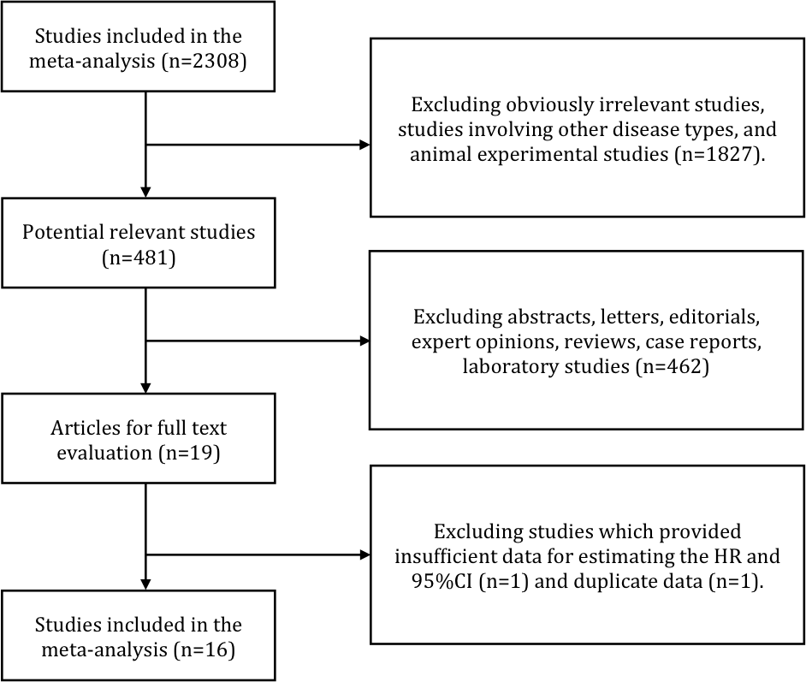

**Figure 1 Flow chart of study selection.**

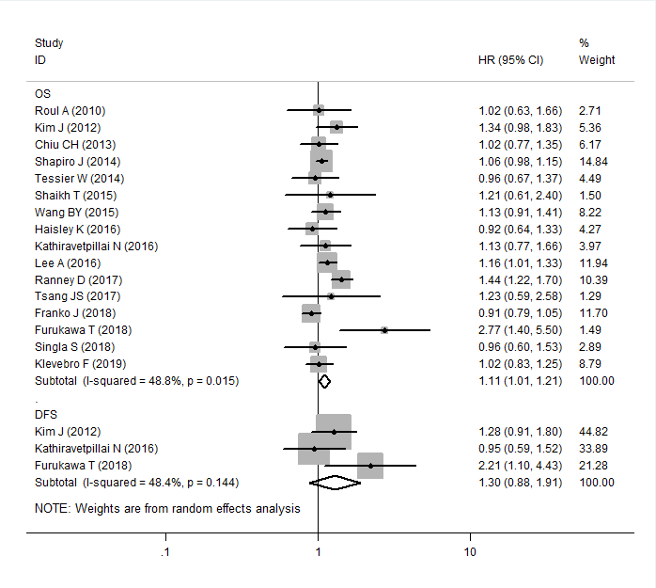

**Figure 2 Forest plot of the association between time interval and overall survival/progression-free survival of esophageal cancer patients.**

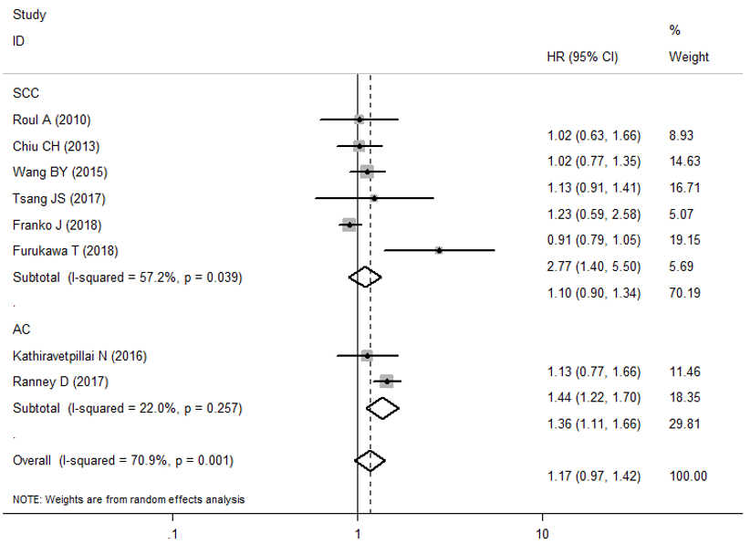

**Figure 3 Forest plot of the association between time interval and overall survival of patients with squamous cell carcinoma and adenocarcinoma.**

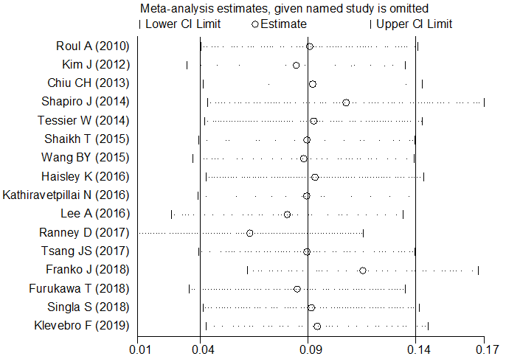

**Figure 4 Sensitivity analysis of the association between time interval and overall survival.** Combined results were still stable after the exclusion of any single study.



**Figure 5 Begg’s funnel plot of the association between time interval and overall survival.** The Begg’s funnel plot did not indicate publication bias in the meta-analyses on the association between time to surgery and overall survival (Pr >|z| = 0.344 for Begg’s test).

**Table 1 Characteristics of studies included in the meta-analysis**

|  |  |  |  |  |  |  |  |  |  |  |  |  |  |  |
| --- | --- | --- | --- | --- | --- | --- | --- | --- | --- | --- | --- | --- | --- | --- |
| **Ref.** | **Year** | **Study region** | **Ethnicity** | **Study design** | **No. (M/F)** | **Age (yr)** | **NCRT regimen** | **Cut-off (d)** | **Outcome** | **Follow-up (mo)** | **Clinical stage** | **Histology** | **HR type** | **NOS score** |
| Ruol *et al*[17] | 2010 | Italy | Caucasian | Prospective | 129 (99/30) | 60.8 | DDP+5FU ci/DDP+PTX/OXA+5FU ci+CF RT 45-50.4 Gy | 46 | OS | 60 | I-IV1 | SCC | U | 8 |
| Kim *et al*[18] | 2012 | United States | Caucasian | Prospective | 266 (235/31) | SI, 57; LI, 60 | Platinum-based RT 45Gy | 56 | OS/DFS | 99 | II-IVa1 | AC and SCC | U | 8 |
| Chiu *et al*[10] | 2013 | China | Asian | Retrospective | 276 (268/8) | SI, 56.8; LI, 53.5 | 5FU ci+DDP RT 30 Gy | 56 | OS | 60 | II-IV1 | SCC | U | 7 |
| Shapiro *et al*[7] | 2014 | United States | Caucasian | Retrospective | 325 (253/72) | 60 | PTX+CBP RT 41.4 Gy | 45 | OS/DFS | 60 | cT1-42, N0-11 | AC and SCC | U/M | 8 |
| Tessier *et al*[19] | 2014 | France | Caucasian | Prospective | 257 (227/30) | NR | 5FU ci+DDP RT 45 Gy | 49 | OS | 135 | I-III1 | AC and SCC | U | 8 |
| Shaikh *et al*[20] | 2015 | United States | Caucasian | Retrospective | 88 (62/26) | 61 | 5FU-based/PTX-based RT 45-60 Gy | 50 | OS | 87.7 | I-IV2 | AC and SCC | U | 7 |
| Wang *et al*[21] | 2015 | China | Asian | Prospective | 665 (636/29) | 53 | NA | 59 | OS | 60 | I-III2 | SCC | U | 7 |
| Haisley *et al*[5] | 2016 | United States | Caucasian | Prospective | 234 (191/43) | 64 | PTX+CBP/5FU ci+DDP NA | 56 | OS | 152 | I-IV2 | AC and SCC | U | 8 |
| Kathiravetpillai *et al*[22] | 2016 | Netherlands | Caucasian | Prospective | 190 (169/21) | NR | PTX+CBP/PTX+CBP+5FU RT41.4 Gy | 56 | OS/DFS | 60 | cT1-32, N0-32 | AC | U | 7 |
| Lee *et al*[11] | 2016 | United States | Caucasian | Retrospective | 5393 (4533/860) | 62 | NA RT 39.6-64.8 Gy | 64 | OS | 96 | I-IV2 | AC and SCC | M | 8 |
| Ranney *et al*[9] | 2017 | United States | Caucasian | Retrospective | 2444 (2193/251) | 61 | NA RT 40.4-50.4 Gy | 56 | OS | 60 | II-III2 | AC | M | 8 |
| Tsang *et al*[23] | 2017 | China | Asian | Prospective | 107(91/16) | 63 | 5FU ci+DDP RT 40 Gy | 64 | OS | 60 | I-III2 | SCC | U | 7 |
| Franko *et al*[14] | 2018 | United States | Caucasian | Retrospective | 1244 (810/434) | 60.5 | NA RT 45 Gy | 49 | OS | 75 | NR | SCC | U | 6 |
| Furukawa *et al*[24] | 2018 | Japan | Asian | Retrospective | 134 (116/18) | NR | 5FU+DTX/5FU+DDP/NDP RT 40 Gy | 56 | OS/DFS | 60 | I-IV2 | SCC | U | 7 |
| Singla *et al*[25] | 2018 | United States | Caucasian | Prospective | 226 (210/16) | 61 | DDP+Irinotecan/CBP+PTX/OXA+CAPE/5-FU+DDP RT 50.4 Gy | 49 | OS/PFS | 110 | I-IV2 | AC and SCC | U | 6 |
| Klevebro *et al*[8] | 2019 | Sweden | Caucasian | Prospective | 643 (536/107) | SI, 64; LI, 65 | DDP+5FU RT 40 Gy | 49 | OS | 60 | I-IVa2 | AC and SCC | U | 7 |

NCRT: Neoadjuvant chemoradiotherapy; NR: Not reported; LI: Longer time interval; SI: Shorter time interval; DDP: Cisplatin; 5FU: Fluorouracil; PTX: Paclitaxel; OXA: Oxaliplatin; CBP: Carboplatin; NDP: Nedaplatin; DTX: Docetaxel; RT: Radiotherapy; NA: None; OS: Overall survival; DFS: Disease-free survival; PFS: Progression-free survival; HR: Hazard ratio; M: Multivariate analysis; U: Univariate analysis; SCC: Squamous cell carcinoma; AC: Adenocarcinoma; 16th AJCC/UICC classification; 27th AJCC/UICC classification; NOS: Newcastle-Ottawa Quality Assessment Scale.

**Table 2 Meta-analysis and subgroup analyses**

|  |  |  |  |  |  |  |  |  |
| --- | --- | --- | --- | --- | --- | --- | --- | --- |
| **Analysis** | ***n*** | **Ref.** | **Random-effects model** | | **Fixed-effects model** | | **Heterogeneity** | |
| **HR (95%CI)** | ***P* value** | **HR (95%CI)** | ***P* value** | ***I*2** | **Ph** |
| Esophageal cancer OS | 16 | [5,7-11,13,16-24] | 1.107 (1.014-1.208) | 0.023 | 1.089 (1.036-1.145) | 0.001a | 48.80% | 0.015 |
| DFS | 3 | [17,21,23] | 1.300 (0.883-1.913) | 0.184 | 1.263 (0.976-1.633) | 0.075 | 48.40% | 0.144 |
| Subgroup 1: Study design | 16 | [5,7-11,13,16-24] | 1.107 (1.014-1.208) | 0.196 | 1.089 (1.036-1.145) | 0.196 | 0.00 | 0.865 |
| Prospective | 9 | [5,8,16-18,20-22,24] | 1.073 (0.964-1.194) | 0.064 | 1.073 (0.964-1.194) | 0.002a | 76.30% | 0.000 |
| Retrospective | 7 | [7,9-11,13,19,23] | 1.150 (0.992-1.332) | 0.023a | 1.094 (1.034-1.158) | 0.001a | 48.80% | 0.015 |
| Subgroup 2: Samplesize | 16 | [5,7-11,13,16-24] | 1.107 (1.014-1.208) | 0.023a | 1.089 (1.036-1.145) | 0.001a | 48.80% | 0.015 |
| < 200 | 5 | [16,19,21-23] | 1.294 (0.946-1.771) | 0.107 | 1.254 (0.985-1.597) | 0.067 | 34.70% | 0.190 |
| ≥ 200 | 11 | [5,7-11,13,17,18,20,24] | 1.089 (0.995-1.190) | 0.063 | 1.082 (1.028-1.139) | 0.002a | 54.20% | 0.016 |
| Subgroup 3: Ethnicity | 16 | [5,7-11,13,16-24] | 1.107 (1.014-1.208) | 0.064 | 1.107 (1.014-1.208) | 0.064 | 48.80% | 0.015 |
| Caucasian | 12 | [5,7-9,11,13,16-19,21,24] | 1.091 (0.995-1.197) | 0.150 | 1.091 (0.995-1.197) | 0.150 | 49.30% | 0.027 |
| Asian | 4 | [10,20,22,23] | 1.251 (0.922-1.696) | 0.023a | 1.251 (0.922-1.696) | 0.023a | 57.60% | 0.069 |
| Subgroup 4: HR type | 16 | [5,7-11,13,16-24] | 1.107 (1.014-1.208) | 0.023a | 1.089 (1.036-1.145) | 0.001a | 48.80% | 0.015 |
| Univariate | 13 | [5,8,10,13,16-24] | 1.053 (0.952-1.166) | 0.314 | 1.029 (0.949-1.115) | 0.492 | 23.20% | 0.209 |
| Multivariate | 3 | [7,9,11] | 1.194 (1.010-1.411) | 0.037a | 1.130 (1.059-1.204) | 0.000a | 81.00% | 0.005 |
| Squamous cell carcinoma OS | 6 | [10,13,16,20,22,23] | 1.096 (0.896-1.341) | 0.371 | 1.009 (0.908-1.120) | 0.874 | 57.20% | 0.039 |
| Adenocarcinoma OS | 2 | [9,21] | 1.360 (1.111-1.664) | 0.003a | 1.385 (1.186-1.616) | 0.000a | 22.00% | 0.257 |

astatistical significance. *n*: Number of studies; HR: Hazard ratio; 95%CI: 95% confidence interval; Ph: *P* values of *Q* test for heterogeneity test; OS: Overall survival; DFS: Disease free survival.