**Name of Journal:** *World Journal of Clinical Cases*

**Manuscript NO:** 46613

**Manuscript Type:** META-ANALYSIS

**Relationship between circulating irisin levels and overweight/obesity: A meta-analysis**

Jia J *et al.* Irisin levels and overweight/obesity

Jue Jia, Fan Yu, Wei-Ping Wei, Ping Yang, Ren Zhang, Yue Sheng, Yong-Qin Shi

**Jue Jia, Fan Yu, Wei-Ping Wei, Ping Yang, Yue Sheng, Yong-Qin Shi,** Affiliated Hospital of Jiangsu University, Zhenjiang 212001, Jiangsu Province, China

**Ren Zhang,** Department ofLibrary of Jiangsu University, Zhenjiang 212001, Jiangsu Province, China

**ORCID number:** Jue Jia (0000-0003-1871-5015); Fan Yu (0000-0003-2009-3702); Wei-Ping Wei (0000-0002-2774-0354); Ping Yang (0000-0003-3555-847X); Ren Zhang (0000-0003-4783-5243); Yue Sheng (0000-0002-4001-6993); Yong-Qin Shi (0000-0002-7334-3130).

**Author contributions:** Jia J conceived and designed the study; Jia J, Yu F, and Zhang R searched the related articles; Yang P, Wei WP, Sheng Y, and Shi YQ analyzed the data; Jia J and Yu F wrote the manuscript; all authors read and approved the final manuscript.

**Supported by** the National Natural Science Foundation of China, No. 81500351; the Youth Medical Talent Project of Jiangsu Province, No. QNRC2016842; the Jiangsu University Affiliated Hospital “5123” Talent Plan, No. 51232017305; and the 169 Talent Project of Zhenjiang.

**Conflict-of-interest statement:** The authors deny any conflict of interest.

**PRISMA 2009 Checklist statement:** The authors have read the PRISMA 2009 Checklist, and the manuscript was prepared and revised according to the PRISMA 2009 Checklist.

**Open-Access:** This article is an open-access article which was selected by an in-house editor and fully peer-reviewed by external reviewers. It is distributed in accordance with the Creative Commons Attribution Non Commercial (CC BY-NC 4.0) license, which permits others to distribute, remix, adapt, build upon this work non-commercially, and license their derivative works on different terms, provided the original work is properly cited and the use is non-commercial. See: <http://creativecommons.org/licenses/by-nc/4.0/>

**Manuscript source:** Invited manuscript

**Corresponding author: Jue Jia, MD, Lecturer, Associate Chief Physician,** Affiliated Hospital of Jiangsu University, No. 438, Jiefang North Road, Jingkou District, Zhenjiang 212001, Jiangsu Province, China. 1000011436@ujs.edu.cn

**Telephone:** +86-511-85031120

**Fax:** +86-511-85019237

**Received:** February 25, 2019

**Peer-review started:** February 26, 2019

**First decision:** April 18, 2019

**Revised:** April 27, 2019

**Accepted:** May 2, 2019

**Article in press:** May 2, 2019

**Published online:** June 26, 2019

**Abstract**

***BACKGROUND***

Currently, the findings about irisin as a novel myokine related to obesity are inconsistent in overweight/obese people. To our knowledge, no systematic analysis has been conducted to evaluate the relationship between irisin levels and overweight/obesity.

***AIM***

To evaluate the association between circulating irisin levels and overweight/obesity.

***METHODS***

The Cochrane Library, MEDLINE, SCOPUS, and the ISI Web of Science were searched to retrieve all of the studies associated with circulating irisin levels and overweight/obesity. Standard mean difference values and 95% confidence intervals (CI) were estimated and pooled using meta-analysis methodology.

***RESULTS***

A total of 18 studies were included in our meta-analysis containing 1005 cases and 1242 controls. Our analysis showed that the circulating irisin level in overweight/obese people was higher than that in overall healthy controls (random effects MD = 0.63; 95%CI: 0.22-1.05; *P* = 0.003). In the subgroup analysis by ethnicity, the irisin level was higher in overweight/obesity people than that in controls in Africa (random effects MD =3.41; 95%CI: 1.23-5.59; *P* < 0.05) but not in European, Asian, or American populations. In addition, in a subgroup analysis by age, the results showed that obese children exhibited a higher irisin level than controls (random effects MD = 0.86; 95%CI: 0.28-1.43; *P* < 0.05).

***CONCLUSION***

This meta-analysis provides evidence that circulating irisin is higher in obese individuals compared to healthy controls and it is important to identify the relationship between circulating irisin levels and overweight/obesity in predicting overweight/obesity.

**Key words:** Irisin; Overweight/obesity; Myokines; Body mass index

**© The Author(s) 2019.** Published by Baishideng Publishing Group Inc. All rights reserved.

**Core tip:** This study is the first meta-analysis that systematically assessed circulating irisin in overweight/obese people. This meta-analysis showed that circulating irisin levels were higher in obese individuals than in healthy controls. It also suggested that circulating irisin levels were higher in obese people in Africa than in controls. This meta-analysis further suggested that obese children exhibited a higher irisin level than controls.

**Citation:** Jia J, Yu F, Wei WP, Yang P, Zhang R, Sheng Y, Shi YQ. Relationship between circulating irisin levels and overweight/obesity: A meta-analysis. *World J Clin Cases* 2019; 7(12): 1444-1455

**URL:** https://www.wjgnet.com/2307-8960/full/v7/i12/1444.htm

**DOI:** https://dx.doi.org/10.12998/wjcc.v7.i12.1444

**INTRODUCTION**

The definition of obesity is the increase of fat mass which could cause serious health problems[1]. Guidelines of obesity treatment defined that body mass index (BMI) ≥ 25 is overweight and greater than 30 is obesity in adults. For children, age needs to be considered when defining overweight and obesity[2]. Over the past three decades, obesity has been a worldwide epidemic and a serious threat to human health for the steady rising of global obesity rate as well as no-declined prevalence rates[3].Accumulating evidence suggests that overweight/obesity has been identified as an independent risk factor for chronic diseases, including metabolic syndrome, cardiovascular disease, and diabetes mellitus, leading to a negative effect on health-related quality of life and a heavy pressure on the health care system[4-6]. Hence, identification of overweight/obesity-oriented factors that are potential biomarkers that could be used to predict obesity and related complications is important.

It is well known that muscle tissues can secrete some cytokines and other peptides named myokines that are essential for maintaining metabolic homeostasis[7]. Irisin is a novel myokine produced by proteolytical cleavage of fibronectin type III domain-containing 5 (FNDC5) both in mice and humans, and it can also be secreted by adipose tissue and the liver in a small amounts[8]. Recent meta-analysis reported that circulating irisin levels were associated with polycystic ovary syndrome and coronary artery diseases[9,10], and it was considered a critical myokine related to body metabolism. Interestingly, irisin can promote white adipose tissue browning, which dissipates energy to produce heat and decreases the appearance of cellulite[11].Recently, a growing number of studies suggested that circulating irisin levels in plasma or serum may be related to overweight/obesity in different groups of people[7]; however, this relationship remains controversial due to conflicting results that have been reported[12-18]. A clinical study involving 94 obese patients who participated in a weight loss program showed that obese subjects had a higher circulating irisin level than controls[12]. These findings are consistent with other studies[13-16].Puzzlingly, although most studies support a role for irisin in forecasting obesity, several studies do not have a consistent trend and concluded that circulating irisin levels were lower in the obese group compared to the control group[17-19]. Moreover, in obese *vs* healthy children, boys, or girls, results regarding circulating irisin were also incompatible[20-22].

To our knowledge, no systematic analysis has been conducted to evaluate the relationship between irisin levels and overweight/obesity. As a result, the objective of this study was to analyze all of the available data to perform a quantitative assessment of the association and deepen our understanding of the role of circulating irisin levels in the development of obesity via a meta-analysis.

**MATERIALS AND METHODS**

***Search strategies***

Databases including the Cochrane Library, PUBMED, and the ISI Web of Science were searched in English to identify studies published up to April 1, 2018, which addressed both irisin and overweight/obesity. Our overall search terms were irisin OR frcp2 OR fibronectin type III domain containing protein 5 OR fndc5 AND fat OR MS OR metabolic syndrome OR overweight/obesity. The reference lists of identiﬁed articles were also reviewed for more studies.

***Selection criteria***

To be considered for the meta-analysis, the studies had to be case-control or cohort studies that reported irisin levels in overweight/obese patients compared with healthy controls regardless of age or gender. We incorporated overweight into the obese group. Conference abstracts were also included if they contained sufﬁcient information to extract effect estimates. Literature reviews, articles of research on the drug, articles in which the mean and standard deviation (SD) could not be calculated, and studies with no healthy control group were excluded.

***Data extraction***

The titles and abstracts of all eligible studies were reviewed by two authors independently. To settle disagreements, a third author was consulted. The following information was collected from each study: The ﬁrst author, publication year, study design, study location, numbers of cases and controls, age, BMI, types of blood sample, assays for irisin measurement, study quality, and circulating irisin levels (means and standard deviations).

***Data synthesis and analysis***

The primary variables, circulating irisin levels in patients with obesity, were reported as standard mean differences (SMD) and the corresponding 95% conﬁdence intervals (CIs). The SMD for circulating irisin levels were calculated for all of the studies that were identiﬁed for the meta-analysis, and the results were combined using fixed- or random-effects modeling, as appropriate. Publication bias was assessed using Begg’s funnel plot and Egger’s test[22,23]. Heterogeneity in the results of the different studies was examined using *χ*2 tests for significance (a *P*-value < 0.1 was considered statistically significant) and the *I*2 test (*I*2 > 50%: significant heterogeneity; *I*2 < 25%: insignificant heterogeneity), which can be interpreted as the percentage of total variation across several studies owing to heterogeneity[24,25]. A sensitivity analysis was performed to assess whether the summary results had been significantly influenced by removing one study that investigated the association between circulating irisin levels and obesity. Subgroup analyses were conducted by geographic area and age. All statistical analyses were performed with Review Manager 5.2 and Stata version 11.0. *P* < 0.05 was considered statistically signiﬁcant.

**RESULTS**

***Description of the studies***

The literature search identified 1295 possible relevant articles. From these, 507 were duplicates, 788 were excluded after reading the title or abstract for obvious irrelevance, and 51 were finally included for further full-text evaluation. Of the 51 articles, five were excluded because they were reviews. Fifteen articles were excluded because they did not include healthy controls. Eight articles were excluded because data were represented by the median. Five articles were excluded because they did not contain detailed data. Finally, a total of 18 studies (1005 cases and 1242 controls) were included in our meta-analysis.

Figure 1 displays the flow chart describing the process of study inclusion/exclusion. Among the 18 studies, six were conducted in Europe, six in Asia, four in America, and two in Africa. The main characteristics of the included studies are presented in Table 1. Serum samples were used in 11 studies for irisin measurement, while plasma samples were used in the others. The sample size for each study ranged from 10 to 618. All of the irisin levels were measured with ELISA kits.

There were nine studies utilizing irisin ELISA kits from Phoenix Pharmaceuticals (Burlingame, CA, United States), three from BioVendor (Brno, Czech Republic), two from Bio Vision (Milpitas, United States), and one each from CUSABIO Life Science (Wuhan, China), Bioscience (Santa Clara, California, United States), Mercodia AB (Uppsala, Sweden), and MyBioSource (San Diego, United States). The details of characteristics related to the included studies are shown in Table 1.

***Main analysis***

A meta-analysis of 18 studies involving a total of 2247 subjects (1005 cases and 1242 controls) was performed. Among them, four studies showed that obese individuals expressed lower irisin levels than healthy controls[7,17-19], while nine articles observed the opposite outcome where significantly higher irisin levels were exhibited in obese individuals compared to healthy controls. The results of the remaining four studies had no significance. Data were all described as the means ± SD. The *P*-value of heterogeneity between studies was significant (*P* < 0.05, Figure 2), so we used the random effects model and found that the overall effect was sig­nificant (random effects MD = 0.63; 95%CI: 0.22- 1.05; *P* = 0.003). The effect size revealed that the irisin level was higher in obese people compared to healthy people.

In the subgroup analysis by ethnicity, the irisin level was higher in obese people in Africa than in controls and the test for overall effect was sig­nificant (*I*2 = 91%; random effects MD = 3.41; 95%CI: 1.23-5.59; *P* < 0.05). While the irisin levels in European (*I*2 = 90%, random effects MD = 0.57; 95%CI: -0.02-1.15), Asian (*I*2 = 93%; random effects MD = -0.05; 95%CI: -0.67-0.58), and American populations (*I*2 = 91%; random effects MD =0.61; 95%CI: -0.38-1.61) were not higher in obese individuals than in healthy controls, and the test for overall effect was not sig­nificant (*P* = 0.06, 0.89, and 0.31, respectively) (Figure 3).

Furthermore, we performed a subgroup analysis by age. Five studies included children. Three of these studies suggested that obese children exhibited a higher irisin level than controls, and another two studies showed different outcomes. The *P*-value of heterogeneity between studies was significant (*P* < 0.05, Figure 4), then we used the random effects model and found that the overall effect was sig­nificant (random effects MD = 0.86; 95%CI: 0.28-1.43; *P* = 0.004). The effect size revealed that the irisin levels were higher in obese children than in controls. Conversely, the irisin levels in adult patients were not sig­nificantly different from controls and the total effect was not sig­nificant (*I*2 = 95%; random effects MD = 0.57; 95%CI: -0.03-1.18; *P* = 0.06) (Figure 4).

We omitted one study at a time and calculated the pooled SMD for the remainder of the studies to conduct a sensitivity analysis. There was no considerable change in the direction of the effect when omitting each of the studies.

We also conducted analyses by the Begg’s test and Egger’s test. Begg’s funnel plot had the expected funnel shape (Figure 5). Begg’s test (*Z =* 0.61*, P =* 0.544) and Egger’s test for publication bias (*t* = 0.46, *P* = 0.65) indicated that there was no publication bias in our analysis.

**DISCUSSION**

This meta-analysis showed that circulating irisin levels in obese individuals were higher than those in overall healthy controls. It also suggested that circulating irisin levels were higher in obese people than in healthy controls in Africa, while studies in other regions showed a negative result. This meta-analysis further suggested that obese children exhibited higher irisin levels than controls.

First, the overall result of this meta-analysis is positive that circulating irisin levels increased in obesity compared with health controls, although some studies did not draw the same conclusion. When it comes to underlying mechanisms, it is speculated that the rising circulating irisin level in obesity is an accommodative compensatory response to obesity-induced metabolic dysfunction, such as a decline of insulin levels or “irisin resistance”[32] as has already been established for leptin or insulin in obesity. Second, the results suggest that age may be a factor for the increasing circulating irisin levels in obese children compared to controls. It is deduced that diet habits and lifestyle are also related factors. Due to their growth and development needs, children differ from adults in the above-mentioned factors. In addition, there are other differences such as exercise and underlying diseases[33-37]. Recent studies explored that baseline irisin levels were lower in the old compared to the young participants for age-related decline in muscle function[38,39]. Third, in the subgroup analysis by ethnicity, the irisin level was only higher in obese individuals than in controls in Africa, while there were no sig­nificant differences in European, Asian, or American populations. These results indicate that genetic differences can influence specific hormone levels such as those of irisin. Weight stratification in the Asian population based on different BMI criteria from other regions may also lead to no significance of the subgroup analysis. Besides the above, gender is another interesting aspect. Murawska-Cialowicz *et al* found that the level of irisin at baseline was higher in men than in women and after a 3-mo CrossFit training program, the changes of irisin level between women and men did not have a uniform trend[38], while in obese children, there was no evidence for differences of irisin levels between genders[37].

To our knowledge, this study is the first meta-analysis that systematically assessed circulating irisin in obese people, yet some limitations should be noted. First, in the above articles, how to choose the criteria to judge obesity is still in question. Although most studies chose to use BMI as the criterion of obesity, Mehrabian *et al*[27] suggested that body fat percentage is a better indicator of total adiposity compared to BMI for some individuals with normal weight obesity. Second, due to different methods, we cannot analyze whether the quality of serum or plasma samples has a decisive impact on the test results. For human FNDC5 does not have a canonical ATA translation start and some reports questioned that many human irisin antibodies used in commercial ELISA kits may lack necessary specificity[40], it is hard to determine the reliability of the results detected with the kits of many brands, although mass spectrometry has clearly demonstrated the existence of human irisin. Third, there were differences in the number of research subjects in different regions or countries; the majority of those surveyed were in Asia and Europe, while relatively few were in Africa. A larger sample survey is needed in the future for a more reliable result. Additionally, influences of the intensity and time of exercise on circulating irisin levels are also of interest, since irisin is a myokine associated with exercise. Future studies are required to investigate whether circulating irisin could predict the risk of obesity. Moreover, studies on the effects of exercise, lifestyle, and weight loss on the irisin level and related prospective studies are also needed.

In conclusion, our meta-analysis provides evidence that circulating irisin is higher in obese individuals compared to healthy controls and that circulating irisin levels seem to be affected by ethnicity and age. More investigations are necessary to clarify the association between the circulating irisin levels and overweight/obesity.

**ARTICLE HIGHLIGHTS**

***Research background***

Overweight/obesity has been a global health challenge and irisin as a novel myokine is reported to play an important role in the development of metabolism dysfunction and obesity, however, the exact relationship between irisin and overweight/obesity remains unclear.

***Research motivation***

Many studies on the results of circulating irisin levels in overweight/obesity people are inconsistent, which has puzzled us in confirming the role of irisin in overweight/obesity, thus, it is necessary to do such an analysis to clarify the relationship between them.

***Research objectives***

The main objective was to extract available data from studies and clarify the relationship between irisin and overweight/obesity.

***Research methods***

We searched Cochrane Library, MEDLINE, SCOPUS, and the ISI Web of Science to retrieve all of the studies associated with circulating irisin levels and overweight/obesity. We estimated standard mean difference values and 95% confidence intervals and used meta-analysis methodology to get final results.

***Research results***

A total of 18 studies were included in this meta-analysis containing 1005 cases and 1242 controls. The overall analysis showed that the circulating irisin level in overweight/obese people was higher than that in overall healthy controls. In the subgroup analysis by ethnicity, the irisin level was higher in overweight/obese people than that in controls in Africa. In addition, in a subgroup analysis by age, the results showed that obese children exhibited a higher irisin level than controls. Studies of larger population samples are needed to better explore the relationship between irisin and overweight/obesity.

***Research conclusions***

This study integrated the existing data to show that the circulating irisin levels in overweight/obese people was higher than those in healthy controls overall, and explored the potential of irisin as a predictive factor for overweight/obesity.

***Research perspectives***

More studies on the effects of exercise, lifestyle, and weight loss on the irisin level and related prospective studies are needed.

**REFERENCES**

1 **van der Klaauw AA**, Farooqi IS. The hunger genes: pathways to obesity. *Cell* 2015; **161**: 119-132 [PMID: 25815990 DOI: 10.1016/j.cell.2015.03.008]

2 **Ryan DH**, Kahan S. Guideline Recommendations for Obesity Management. *Med Clin North Am* 2018; **102**: 49-63 [PMID: 29156187 DOI: 10.1016/j.mcna.2017.08.006]

3 **Kushner RF**, Kahan S. Introduction: The State of Obesity in 2017. *Med Clin North Am* 2018; **102**: 1-11 [PMID: 29156178 DOI: 10.1016/j.mcna.2017.08.003]

4 **El-Lebedy DH**, Ibrahim AA, Ashmawy IO. Novel adipokines vaspin and irisin as risk biomarkers for cardiovascular diseases in type 2 diabetes mellitus. *Diabetes Metab Syndr* 2018; **12**: 643-648 [PMID: 29673927 DOI: 10.1016/j.dsx.2018.04.025]

5 **Polyzos SA**, Anastasilakis AD, Efstathiadou ZA, Makras P, Perakakis N, Kountouras J, Mantzoros CS. Irisin in metabolic diseases. *Endocrine* 2018; **59**: 260-274 [PMID: 29170905 DOI: 10.1007/s12020-017-1476-1]

6 **Park KH**, Zaichenko L, Brinkoetter M, Thakkar B, Sahin-Efe A, Joung KE, Tsoukas MA, Geladari EV, Huh JY, Dincer F, Davis CR, Crowell JA, Mantzoros CS. Circulating irisin in relation to insulin resistance and the metabolic syndrome. *J Clin Endocrinol Metab* 2013; **98**: 4899-4907 [PMID: 24057291 DOI: 10.1210/jc.2013-2373]

7 **Moreno-Navarrete JM**, Ortega F, Serrano M, Guerra E, Pardo G, Tinahones F, Ricart W, Fernández-Real JM. Irisin is expressed and produced by human muscle and adipose tissue in association with obesity and insulin resistance. *J Clin Endocrinol Metab* 2013; **98**: E769-E778 [PMID: 23436919 DOI: 10.1210/jc.2012-2749]

8 **Polyzos SA**, Kountouras J, Anastasilakis AD, Geladari EV, Mantzoros CS. Irisin in patients with nonalcoholic fatty liver disease. *Metabolism* 2014; **63**: 207-217 [PMID: 24140091 DOI: 10.1016/j.metabol.2013.09.013]

9 **Cai X**, Qiu S, Li L, Zügel M, Steinacker JM, Schumann U. Circulating irisin in patients with polycystic ovary syndrome: a meta-analysis. *Reprod Biomed Online* 2018; **36**: 172-180 [PMID: 29217128 DOI: 10.1016/j.rbmo.2017.10.114]

10 **Guo W**, Zhang B, Wang X. Lower irisin levels in coronary artery disease: a meta-analysis. *Minerva Endocrinol* 2017 [PMID: 29160049 DOI: 10.23736/S0391-1977.17.02663-3]

11 **Boström P**, Wu J, Jedrychowski MP, Korde A, Ye L, Lo JC, Rasbach KA, Boström EA, Choi JH, Long JZ, Kajimura S, Zingaretti MC, Vind BF, Tu H, Cinti S, Højlund K, Gygi SP, Spiegelman BM. A PGC1-α-dependent myokine that drives brown-fat-like development of white fat and thermogenesis. *Nature* 2012; **481**: 463-468 [PMID: 22237023 DOI: 10.1038/nature10777]

12 **Crujeiras AB**, Pardo M, Arturo RR, Navas-Carretero S, Zulet MA, Martínez JA, Casanueva FF. Longitudinal variation of circulating irisin after an energy restriction-induced weight loss and following weight regain in obese men and women. *Am J Hum Biol* 2014; **26**: 198-207 [PMID: 24375850 DOI: 10.1002/ajhb.22493]

13 **Stengel A**, Hofmann T, Goebel-Stengel M, Elbelt U, Kobelt P, Klapp BF. Circulating levels of irisin in patients with anorexia nervosa and different stages of obesity--correlation with body mass index. *Peptides* 2013; **39**: 125-130 [PMID: 23219488 DOI: 10.1016/j.peptides.2012.11.014]

14 **Chen JQ**, Fang LJ, Song KX, Wang XC, Huang YY, Chai SY, Bu L, Qu S. Serum Irisin Level is Higher and Related with Insulin in Acanthosis Nigricans-related Obesity. *Exp Clin Endocrinol Diabetes* 2016; **124**: 203-207 [PMID: 26588491 DOI: 10.1055/s-0035-1565060]

15 **Fagundo AB**, Jiménez-Murcia S, Giner-Bartolomé C, Agüera Z, Sauchelli S, Pardo M, Crujeiras AB, Granero R, Baños R, Botella C, de la Torre R, Fernández-Real JM, Fernández-García JC, Frühbeck G, Rodríguez A, Mallorquí-Bagué N, Tárrega S, Tinahones FJ, Rodriguez R, Ortega F, Menchón JM, Casanueva FF, Fernández-Aranda F. Modulation of Irisin and Physical Activity on Executive Functions in Obesity and Morbid obesity. *Sci Rep* 2016; **6**: 30820 [PMID: 27476477 DOI: 10.1038/srep30820]

16 **Tibana RA**, da Cunha Nascimento D, Frade de Souza NM, de Souza VC, de Sousa Neto IV, Voltarelli FA, Pereira GB, Navalta JW, Prestes J. Irisin Levels Are not Associated to Resistance Training-Induced Alterations in Body Mass Composition in Older Untrained Women with and without Obesity. *J Nutr Health Aging* 2017; **21**: 241-246 [PMID: 28244561 DOI: 10.1007/s12603-016-0748-4]

17 **Belviranli M**, Okudan N, Çelik F. Association of Circulating Irisin with Insulin Resistance and Oxidative Stress in Obese Women. *Horm Metab Res* 2016; **48**: 653-657 [PMID: 27632149 DOI: 10.1055/s-0042-116155]

18 **Hou N**, Han F, Sun X. The relationship between circulating irisin levels and endothelial function in lean and obese subjects. *Clin Endocrinol* (Oxf) 2015; **83**: 339-343 [PMID: 25382211 DOI: 10.1111/cen.12658]

19 **Liu BW**, Yin FZ, Qi XM, Fan DM, Zhang Y. The Levels of Serum Irisin as a Predictor of Insulin Resistance in Han Chinese Adults with Metabolically Healthy Obesity. *Clin Lab* 2017; **63**: 881-886 [PMID: 28627815 DOI: 10.7754/Clin.Lab.2016.160805]

20 **Palacios-González B**, Vadillo-Ortega F, Polo-Oteyza E, Sánchez T, Ancira-Moreno M, Romero-Hidalgo S, Meráz N, Antuna-Puente B. Irisin levels before and after physical activity among school-age children with different BMI: a direct relation with leptin. *Obesity (Silver Spring)* 2015; **23**: 729-732 [PMID: 25820255 DOI: 10.1002/oby.21029]

21 **Elizondo-Montemayor L**, Silva-Platas C, Torres-Quintanilla A, Rodríguez-López C, Ruiz-Esparza GU, Reyes-Mendoza E, Garcia-Rivas G. Association of Irisin Plasma Levels with Anthropometric Parameters in Children with Underweight, Normal Weight, Overweight, and Obesity. *Biomed Res Int* 2017; **2017**: 2628968 [PMID: 28553647 DOI: 10.1155/2017/2628968]

22 **Nigro E**, Scudiero O, Ludovica Monaco M, Polito R, Schettino P, Grandone A, Perrone L, Miraglia Del Giudice E, Daniele A. Adiponectin profile and Irisin expression in Italian obese children: Association with insulin-resistance. *Cytokine* 2017; **94**: 8-13 [PMID: 28385328 DOI: 10.1016/j.cyto.2016.12.018]

23 **Begg CB**, Mazumdar M. Operating characteristics of a rank correlation test for publication bias. *Biometrics* 1994; **50**: 1088-1101 [PMID: 7786990 DOI: 10.2307/2533446]

24 **Egger M**, Davey Smith G, Schneider M, Minder C. Bias in meta-analysis detected by a simple, graphical test. *BMJ* 1997; **315**: 629-634 [PMID: 9310563 DOI: 10.1136/bmj.315.7109.629]

25 **Higgins JP**, Thompson SG, Deeks JJ, Altman DG. Measuring inconsistency in meta-analyses. *BMJ* 2003; **327**: 557-560 [PMID: 12958120 DOI: 10.1136/bmj.327.7414.557]

26 **Viitasalo A**, Ågren J, Venäläinen T, Pihlajamäki J, Jääskeläinen J, Korkmaz A, Atalay M, Lakka TA. Association of plasma fatty acid composition with plasma irisin levels in normal weight and overweight/obese children. *Pediatr Obes* 2016; **11**: 299-305 [PMID: 26305484 DOI: 10.1111/ijpo.12062]

27 **Mehrabian S**, Taheri E, Karkhaneh M, Qorbani M, Hosseini S. Association of circulating irisin levels with normal weight obesity, glycemic and lipid profile. *J Diabetes Metab Disord* 2016; **15**: 17 [PMID: 27354972 DOI: 10.1186/s40200-016-0239-5]

28 **Rizk FH**, Elshweikh SA, Abd El-Naby AY. Irisin levels in relation to metabolic and liver functions in Egyptian patients with metabolic syndrome. *Can J Physiol Pharmacol* 2016; **94**: 359-362 [PMID: 26695389 DOI: 10.1139/cjpp-2015-0371]

29 **Shoukry A**, Shalaby SM, El-Arabi Bdeer S, Mahmoud AA, Mousa MM, Khalifa A. Circulating serum irisin levels in obesity and type 2 diabetes mellitus. *IUBMB Life* 2016; **68**: 544-556 [PMID: 27220658 DOI: 10.1002/iub.1511]

30 **Jang HB**, Kim HJ, Kang JH, Park SI, Park KH, Lee HJ. Association of circulating irisin levels with metabolic and metabolite profiles of Korean adolescents. *Metabolism* 2017; **73**: 100-108 [PMID: 28732566 DOI: 10.1016/j.metabol.2017.05.007]

31 **Sahin-Efe A**, Upadhyay J, Ko BJ, Dincer F, Park KH, Migdal A, Vokonas P, Mantzoros C. Irisin and leptin concentrations in relation to obesity, and developing type 2 diabetes: A cross sectional and a prospective case-control study nested in the Normative Aging Study. *Metabolism* 2018; **79**: 24-32 [PMID: 29108900 DOI: 10.1016/j.metabol.2017.10.011]

32 **Perakakis N**, Triantafyllou GA, Fernández-Real JM, Huh JY, Park KH, Seufert J, Mantzoros CS. Physiology and role of irisin in glucose homeostasis. *Nat Rev Endocrinol* 2017; **13**: 324-337 [PMID: 28211512 DOI: 10.1038/nrendo.2016.221]

33 **Kim HJ**, Lee HJ, So B, Son JS, Yoon D, Song W. Effect of aerobic training and resistance training on circulating irisin level and their association with change of body composition in overweight/obese adults: a pilot study. *Physiol Res* 2016; **65**: 271-279 [PMID: 26447516]

34 **Pathak K**, Woodman RJ, James AP, Soares MJ. Fasting and glucose induced thermogenesis in response to three ambient temperatures: a randomized crossover trial in the metabolic syndrome. *Eur J Clin Nutr* 2018; **72**: 1421-1430 [PMID: 29326420 DOI: 10.1038/s41430-017-0058-x]

35 **Daneshi-Maskooni M**, Keshavarz SA, Mansouri S, Qorbani M, Alavian SM, Badri-Fariman M, Jazayeri-Tehrani SA, Sotoudeh G. The effects of green cardamom on blood glucose indices, lipids, inflammatory factors, paraxonase-1, sirtuin-1, and irisin in patients with nonalcoholic fatty liver disease and obesity: study protocol for a randomized controlled trial. *Trials* 2017; **18**: 260 [PMID: 28592311 DOI: 10.1186/s13063-017-1979-3]

36 **Hron BM**, Ebbeling CB, Feldman HA, Ludwig DS. Hepatic, adipocyte, enteric and pancreatic hormones: response to dietary macronutrient composition and relationship with metabolism. *Nutr Metab* (Lond) 2017; **14**: 44 [PMID: 28694840 DOI: 10.1186/s12986-017-0198-y]

37 **Blüher S**, Panagiotou G, Petroff D, Markert J, Wagner A, Klemm T, Filippaios A, Keller A, Mantzoros CS. Effects of a 1-year exercise and lifestyle intervention on irisin, adipokines, and inflammatory markers in obese children. *Obesity (Silver Spring)* 2014; **22**: 1701-1708 [PMID: 24644099 DOI: 10.1002/oby.20739]

38 **Murawska-Cialowicz E**, Wojna J, Zuwala-Jagiello J. Crossfit training changes brain-derived neurotrophic factor and irisin levels at rest, after wingate and progressive tests, and improves aerobic capacity and body composition of young physically active men and women. *J Physiol Pharmacol* 2015; **66**: 811-821 [PMID: 26769830]

39 **Kim HJ**, So B, Choi M, Kang D, Song W. Resistance exercise training increases the expression of irisin concomitant with improvement of muscle function in aging mice and humans. *Exp Gerontol* 2015; **70**: 11-17 [PMID: 26183690 DOI: 10.1016/j.exger.2015.07.006]

40 **Jedrychowski MP**, Wrann CD, Paulo JA, Gerber KK, Szpyt J, Robinson MM, Nair KS, Gygi SP, Spiegelman BM. Detection and Quantitation of Circulating Human Irisin by Tandem Mass Spectrometry. *Cell Metab* 2015; **22**: 734-740 [PMID: 26278051 DOI: 10.1016/j.cmet.2015.08.001]

**P-Reviewer:** Avtanski D, Hosseinpour-Niazi S **S-Editor:** Ji FF **L-Editor:** Wang TQ **E-Editor:** Liu JH

**Specialty type:** Medicine, research and experimental

**Country of origin:** China

**Peer-review report classification**

Grade A (Excellent): 0

Grade B (Very good): B

Grade C (Good): 0

Grade D (Fair): D

Grade E (Poor): 0

**Table 1 Characteristics of included studies**

|  |  |  |  |  |  |  |  |
| --- | --- | --- | --- | --- | --- | --- | --- |
| Ref. | Country | Blood sample | Participants’ age, years (case-control) | Cases/controls, *n* | Irisin  assay | BMI (kg/m2) (case-control) | ELISA kit |
| Moreno-Navarrete *et al*[7], 2013 | Spain | Plasma | 52.41 ± 10.99-47.28 ± 10.15 | 51/18 | ELISA | 28.98±3.17-23.33±1.2 | SK00170-01; Aviscera  Bioscience Inc, Santa Clara, California |
| Stengel *et al*[13], 2013 | Germany | Plasma | 47.17 ± 11.91-48.5 ± 12.16 | 24/8 | ELISA | 50.63 ± 15.27-22.6 ± 2.55 | Phoenix Pharmaceuticals, Inc., Burlingame, CA, United States |
| Crujeiras *et al*[12], 2014 | Spain | Plasma | 49.4±9.4-35.71±8.8 | 94/48 | ELISA | 35.6±4.5-22.9±2.2 | Mercodia, AB (Uppsala, Sweden) |
| Hou *et al*[18], 2015 | China | Serum | 33 ±9-31 ± 7 | 41/40 | ELISA | 30.8±3.8-21.3±1.8 | Phoenix Pharmaceuticals, Inc., Burlingame, CA, United States |
| Palacios-González *et al*[20], 2015 | Mexico | Serum | 9.07 ± 0.88-9.0 ± 0.86 | 60/25 | ELISA | -0.25±0.67-2.11±0.77**1** | CUSA-BIO BIOTECH |
| Viitasalo *et al*[26], 2016[26] | Finland | Plasma | 7.71 ± 0.4-7.6 ± 0.4 | 55/388 | ELISA | 20.21 ± 1.52-15.5 ± 1.3 | Phoenix Pharmaceuticals, Inc., Burlingame, CA, United States |
| Belviranli *et al*[17], 2016 | Turkey | Plasma | 34.40 ± 10.60-28.70 ± 6.82 | 10/10 | ELISA | 32.65 ± 3.04-23.00 ± 2.23 | BioVendor, Czech Republic |
| Chen *et al*[14], 2016 | China | Serum | 34.4 ± 7.6-32.8 ± 7.8 | 30/20 | ELISA | 33.3 ± 4.2-21.1 ± 2.0 | Phoenix Pharmaceutical |
| Fagundo *et al*[15], 2016 | Spain | Plasma | 44.49 ± 11.50-29.04 ± 6.22 | 65/49 | ELISA | 42.83 ± 6.63-21.61 ± 1.54 | EK-067-52; Phoenix Pharmaceuticals, INC, CA |
| Mehrabian *et al*[27], 2016 | Iran | Serum | 28.76 ± 4.67-29.23 ± 4.50 | 38/26 | ELISA | 22.26 ± 1.23-20.88 ± 1.28 | Biovendor, Laboratory Medicine, Modrice Czech Republic |
| Rizk *et al*[28], 2016 | Egypt | Serum | 45.45 ± 8.30- 44.25 ± 10.46 | 20/20 | ELISA | 32.54 ± 1.80-22.85 ± 1.68 | BioVendor, Bmo, Czechrepublic (cat. No. RAG018R) |
| Shoukry *et al*[29], 2016 | Egypt | Serum | 47.06 ± 4.76-45.12 ± 4.72 | 119/31 | ELISA | 34.72 ± 5.68-23.27 ± 0.50 | BioVision, Milpitas, CA |
| Elizondo-Montemayor *et al*[21], 2017 | Mexico | Plasma | 8.0 (6–11)-8.5 (6-12) | 5/5 | ELISA | 98 (98-99)-66 (35-73) | Phoenix Pharmaceuticals, Inc., Burlingame, CA, United States |
| Jang *et al*[30], 2017 | South Korea | Serum | 13.7 ± 0.7- 13.5 ± 0.5 | 248/370 | ELISA | 31.4 ± 3.8-19.4 ± 1.5 | Cat#EK-067-52; Phoenix, Pharmaceuticals, Belmont, CA |
| Liu *et al*[19], 2017 | China | Serum | 35.20 ± 6.51-35.01 ± 7.09 | 51/75 | ELISA | 27.80 ± 3.04-22.62 ± 2.52- | Bio Vision, Milpitas, CA95035, United States |
| Nigro *et al*[22], 2017 | Italy | Serum | 9.7 ± 2.7- 8 ± 2.4 | 27/13 | ELISA | 2.7 ± 0.5-—0.46 ± 1.2 | Phoenix Pharmaceuticals, Belmont, CA, United States |
| Tibana *et al*[16], 2017 | Brazil | Serum | 66.5 ± 5.0- 68.0 ± 6.2 | 26/23 | ELISA | 30.9 ± 3.1-24.3 ± 3.6 | MyBioSource Inc., San Diego, CA, United States |
| Sahin-Efe *et al*[31], 2018 | United States | Serum | 69.4 ± 8.6-69.5 ± 9.2 | 41/73 | ELISA | 30.5 (29.6–31.5)-24.0 (23.3–24.7) | CAT#EK-067-52; Phoenix  Pharmaceuticals, Burlingame, CA |

1BMI z-score. Data are presented as the mean ± SD for continuous parametric variables or median (interquartile range) for continuous nonparametric variables. ELISA: Enzyme-linked immunosorbent assay.

1295 Potential relevant articles identified in database search

42 The Cochrane Library

322 PubMed

376 Scopus

555 ISI Web of Science

507 Duplicates removed

788 Titles and abstracts reviewed

737 Not relevant to review topic

51 Evaluated in detail

5 Reviews

15 No healthy controls

8 Data represented by the median

5 No detailed data

18 Articles included in meta-analysis

**Figure 1 Flow chart of article selection for meta-analysis.**

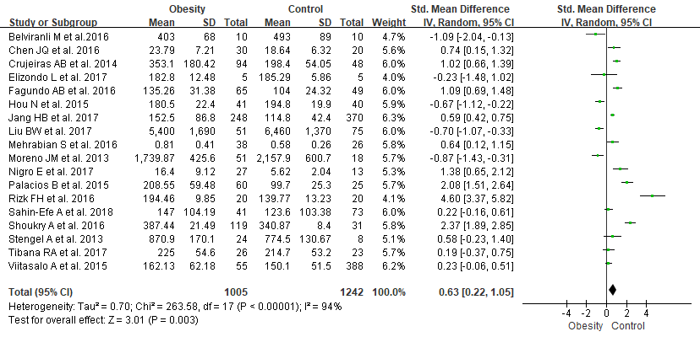

**Figure 2 Forest plot of meta-analysis of the association between irisin and obesity.**

A

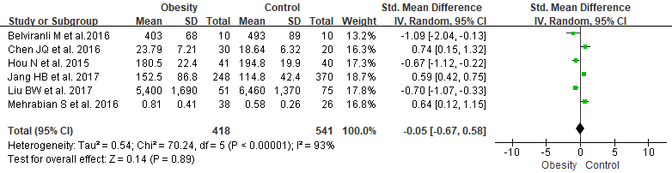

B

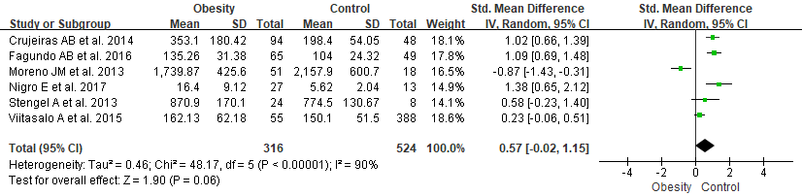

C

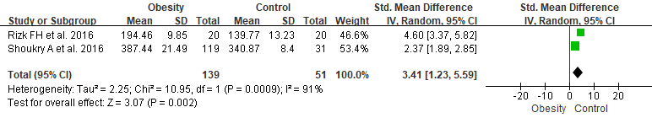

D

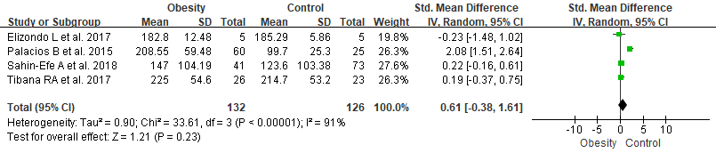

**Figure 3 Forest plot of irisin in obese patients in different racial groups.** A: Forest plot of irisin in obese patients in Asia; B: Forest plot of irisin in obese patients in Europe; C: Forest plot of irisin in obese patients in Africa; D: Forest plot of irisin in obese patients in America.

A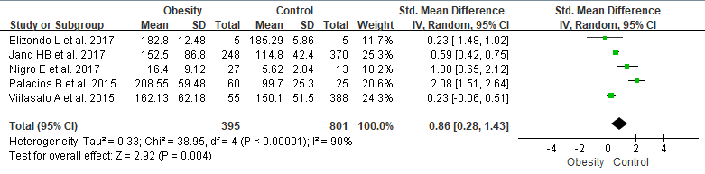

B

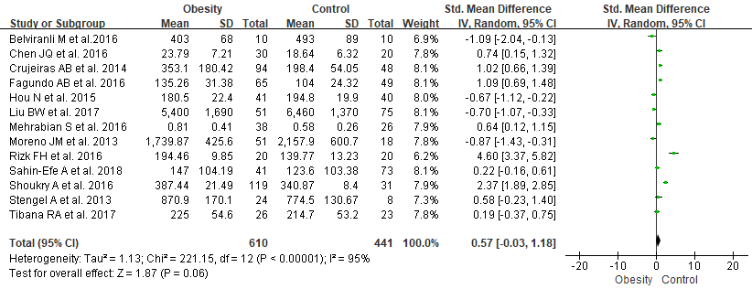

**Figure 4 Forest plot of irisin in obese patients in children and adults.** A: Forest plot of irisin in obese children *vs* nonobese children; B: Forest plot of irisin in obese adults *vs* nonobese adults.

**A****B**



**Figure 5 Analysis of publication bias.** A: Begg’s funnel plot had the expected funnel shape (Begg’s test *P* = 0.544); B: Egger’s publication bias plot (Egger’s test *P* = 0.65).