August 05, 2013

Dear Editor,

The following contains the recommendation letter and editing certificate issued by the English language editing company recommended, American Journal Experts.

Sincerely yours,

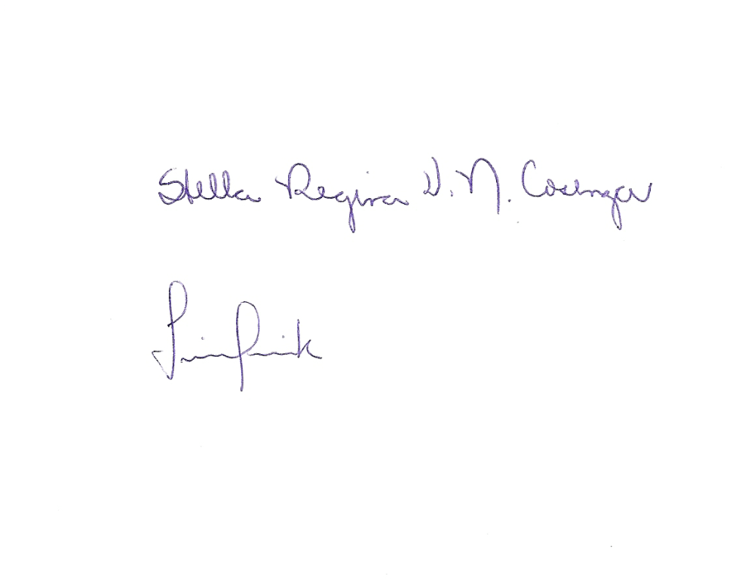

Fernanda Wisnieski, M.Sc.

Genetics Division, Department of Morphology and Genetic

Federal University of São Paulo, São Paulo, 04023900, Brazil

[fernandawis@yahoo.com.br](mailto:fernandawis@yahoo.com.br)

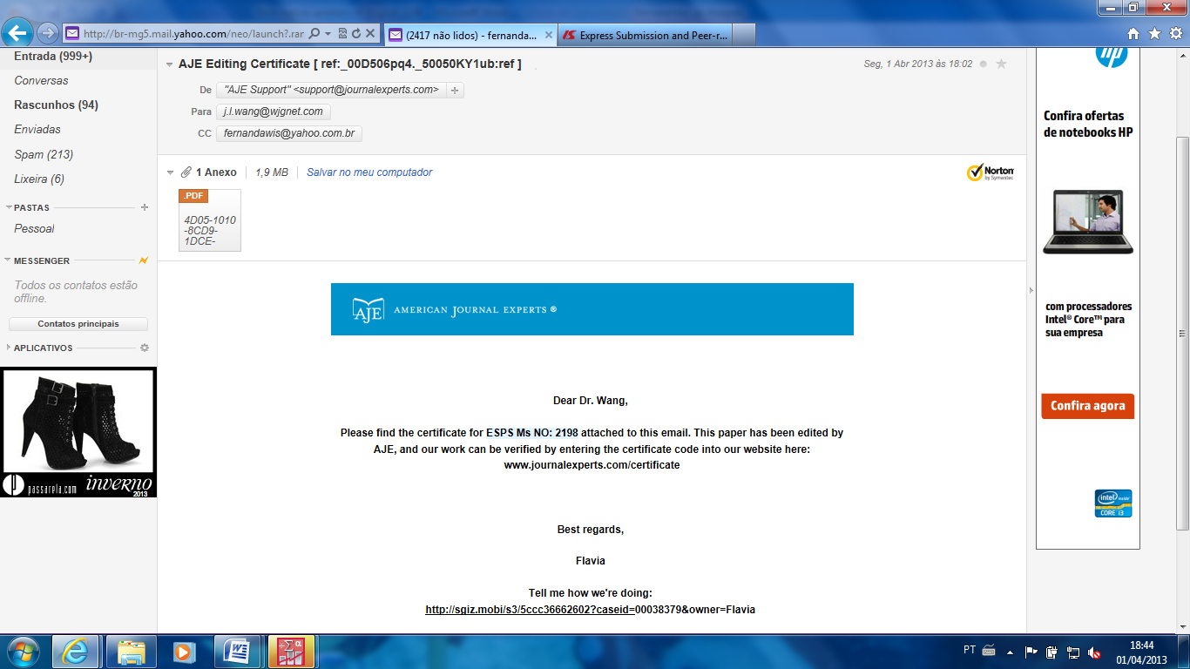



are all native English

American Journal Experts provides a range of editing, translation and manuscript services for researchers and publishers around the world