**Name of journal:** *World Journal of Gastroenterology*

**ESPS Manuscript NO: 20261**

**Manuscript Type**: **REVIEW**

**Clinical approach to incidental pancreatic cysts**

Chiang AL *et al*. Clinical approach to incidental pancreatic cysts

Austin L Chiang, Linda S Lee

**Austin L Chiang, Linda S Lee,** Division of Gastroenterology, Hepatology and Endoscopy at Brigham and Women’s Hospital, Boston, MA 02115, United States

**Author contributions:** Chiang AL and Lee LS solely contributed to this paper.

**Conflict-of-interest statement**: The authors declare no conflict-of-interest.

**Open-Access:** This article is an open-access article which was selected by an in-house editor and fully peer-reviewed by external reviewers. It is distributed in accordance with the Creative Commons Attribution Non Commercial (CC BY-NC 4.0) license, which permits others to distribute, remix, adapt, build upon this work non-commercially, and license their derivative works on different terms, provided the original work is properly cited and the use is non-commercial. See: <http://creativecommons.org/licenses/by-nc/4.0/>

**Correspondence to:** **Linda S Lee*,* MD,** Division of Gastroenterology, Hepatology and Endoscopy at Brigham and Women’s Hospital, 75 Francis St., Boston, MA 02115, United States. lslee@partners.org

**Telephone:** +1-617-7326389

**Received:** May 30, 2015

**Peer-review started:** June 4, 2015

**First decision:** July 20, 2015

**Revised:** August 8, 2015

**Accepted:** October 12, 2015

**Article in press:**

**Published online:**

**Abstract**

The approach to incidentally noted pancreatic cysts is constantly evolving. While surgical resection is indicated for malignant or higher risk cysts, correctly identifying these highest risk pancreatic cystic lesions remains difficult. Using parameters including cyst size, presence of solid components, and pancreatic duct involvement, the 2012 International Association of Pancreatology (IAP) and the 2015 American Gastroenterological Association (AGA) guidelines have sought to identify the higher risk patients who would benefit from further evaluation using endoscopic ultrasound (EUS). Not only can EUS help further assess the presence of solid component and nodules, but also fine needle aspiration of cyst fluid aids in diagnosis by obtaining cellular, molecular, and genetic data. The impact of new endoscopic innovations with novel methods of direct visualization including confocal endomicroscopy require further validation. This review also highlights the differences between the 2012 IAP and 2015 AGA guidelines, which include the thresholds for sending patients for EUS and surgery and methods, interval, and duration of surveillance for unresected cysts.

**Key words:** Pancreatic cysts; Intraductal papillary mucinous neoplasms; Pancreatic cystic neoplasms; Endoscopic ultrasound; Mucinous cystic neoplasm; Serous cystadenoma

**© The Author(s) 2015.** Published by Baishideng Publishing Group Inc. All rights reserved.

**Core tip:** The approach to incidentally noted pancreatic cysts is constantly evolving. While surgical resection is indicated for malignant or higher risk cysts, correctly identifying these highest risk pancreatic cystic lesions remains difficult. Using parameters including cyst size, presence of solid components, and pancreatic duct involvement, the 2012 International Association of Pancreatology and the 2015 American Gastroenterological Association guidelines have sought to identify the higher risk patients who would benefit from further evaluation using endoscopic ultrasound.

Chiang AL, Lee LS. Clinical approach to incidental pancreatic cysts. *World J Gastroenterol* 2015; In press

**INTRODUCTION**

Pancreatic cysts are identified in up to 20% of magnetic resonance imaging (MRI) and 3% of computed tomography (CT) scans[1,2]. The greater detection of incidental pancreatic cysts is likely in part due to increasing use of CT and MRI from less than 10 to over 30 per 100 persons in recent years and improved resolution of imaging studies[3]. Not only have more incidental cysts been discovered over the past decade, but when identified, they are also smaller[4]. Given the malignant potential of some pancreatic cystic lesions, these incidental findings should be considered carefully. In fact, incidental pancreatic cysts on CT or MRI demonstrated a hazard ratio (HR) of 1.40 [confidence interval (CI): 1.13-1.74] for mortality in patients less than 65 years old compared with a HR of 0.97 in those without cysts; pancreatic adenocarcinoma (not including non-adenocarcinoma neoplasms) conferred a hazard ratio of 3.0[5]. A recent American Gastroenterological Association (AGA) technical review reported the estimated incident risk of malignancy of incidental pancreatic cysts at 0.24% per year with a prevalent malignant risk of 0.25% at the time of cyst diagnosis[6].

Cystic lesions in the pancreas can range from entirely non-neoplastic (*e.g*., pseudocysts, retention cysts, benign epithelial cysts, mucinous non-neoplastic cysts, lymphoepithelial cysts) to necrotic degeneration of solid tumors. This review focuses on pancreatic cystic neoplasms, some of which carry malignant potential. Most pancreatic cystic neoplasms are asymptomatic though some lesions may present with pancreatitis [especially if there is invasion into or mucus plugging of the pancreatic duct as with intraductal papillary mucinous neoplasms (IPMN)], abdominal pain, nausea, vomiting, and/or jaundice.

The 2000 WHO histological classification of pancreatic cystic neoplasms outlines four general categories: serous cystic tumor, mucinous cystic neoplasm (MCN), IPMN, and solid pseudopapillary neoplasm (SPEN)[7]. Serous cystic tumors include serous cystadenomas (SCAs), which often have a microcystic or honeycomb appearance on imaging with the pathognomonic central scar or sunburst calcification occurring in up to 20% of these lesions (Figure 1). Serous cystadenomas consist of cuboidal epithelial cells that stain positive for glycogen (Figure 2), and more importantly only very rarely carry malignant potential. CT is only 23% accurate, but diffusion-weighted MRI has 100% sensitivity and 97% specificity in differentiating SCA from mucinous cysts[8,9].

On the other hand, MCN and IPMN are premalignant mucinous lesions. Main duct IPMNs (MD-IPMN), defined as diffuse or segmental dilatation of the main pancreatic duct (MPD) to > 5 mm from a cystic tumor producing mucus within the duct (Figure 3), has a reported 62% frequency of malignancy[10]. Branch duct IPMNs (BD-IPMN) are cysts arising within the side branches of the pancreatic duct with a nondilated MPD (Figure 4) and carry up to 26% frequency of malignancy[10]. The recent AGA review reported an approximately 3% risk of developing malignancy during surveillance of BD-IPMN[6]. MD-IPMNs more commonly present as the intestinal histologic type whereas BD-IPMNs demonstrate more gastric differentiation[11]. Mixed type IPMNs have features of both MD-IPMN and BD-IPMN with approximately 20% to 30% of BD-IPMN ultimately proven to be mixed type IPMN on surgical pathology[12]. The malignant potential of mixed type IPMN is more comparable to MD-IPMN although different subtypes of mixed type IPMN may carry different malignant potential[13]. Risk factors for malignant IPMNs include solid component, main pancreatic duct dilation > 3 cm, cyst size > 3 cm, and nodule[6]. MCNs are also mucinous cysts, but are defined by the presence of ovarian-like stroma and thus almost exclusively occur in women. On imaging, MCNs are usually characterized by unilocular cysts in the body and/or tail (Figure 5). Approximately 15% of resected MCNs contain invasive cancer with risk factors for malignancy including size > 6 cm and nodule[6]. Less than 0.4% of MCNs that are smaller than 3 cm without a nodule harbor high-grade dysplasia or invasive cancer[14]. Solid pseudopapillary neoplasms also carry malignant potential with characteristic pseudopapillae and cystic spaces containing hemorrhage and cholesterol clefts in myxoid stroma alternating with solid tissue. Thus these lesions appear as solid and cystic masses, typically in young women (Figure 6).

**APPROACHING THE INCIDENTAL PANCREATIC CYST**

The key questions to consider when evaluating incidental pancreatic cysts include the following: (1) What type of cyst is it as malignant potential varies with different cysts. In particular, is the cyst mucinous or nonmucinous given the malignant potential of mucinous cysts; (2) Is the cyst currently malignant; (3) If not, what is the malignant potential of the cyst[15,16]? The latter issue is most relevant to young, surgically fit patients with long life expectancies while the risk of prevalent cancer is most concerning to the elderly or those with multiple comorbidities with more limited longevity. Defining the best approach to managing incidental pancreatic cysts could potentially spare patients unnecessary testing, radiation, and surgery and also confer global cost benefit. Currently, the diagnosis of pancreatic cystic neoplasms is based upon both radiologic imaging and cyst fluid analyses. All patients with pancreatic cysts should undergo a good quality MRI of the pancreas with magnetic resonance cholangiopancreatography (MRCP) in 1.5 or 3 tesla with T1, T2, 3-D, fat-saturated, gradient-echo T1 gadolinium-enhanced sequences[10,17]. MRI is most accurate for diagnosing malignant and mucinous cysts (76%-91% and 80%, respectively) while it is only 50% accurate for diagnosing the specific type of cyst[16,18]. If MRI cannot be performed, pancreatic protocol CT with contrast-enhanced images during the pancreatic and portal venous phases allowing 3D analysis should be obtained. The findings on MRI or CT will guide the decision to pursue endoscopic ultrasound-guided fine needle aspiration (EUS-FNA), surgery, or surveillance.

To date three consensus guidelines have been proposed to manage pancreatic cystic lesions beginning with the original 2006 Sendai guideline which was revised in 2012 by the International Association of Pancreatology (IAP) in Fukuoka and the recent AGA guideline (Table 1)[10,19,20]. The Sendai guideline was updated in 2012 to improve its positive predictive value while maintaining its negative predictive value, however, the revised guideline still suffers from low positive predictive value (21%-63%)[21,22]. The AGA guideline increased the threshold for sending a patient to EUS-FNA as well as surgery from one to at least two risk factors. While this may be expected to decrease the unnecessary resection of benign, albeit larger cysts, the impact on the negative predictive value remains to be determined. In addition, while the IAP guideline supports surveillance intervals based on cyst size without an explicit recommendation to stop surveillance, the AGA guideline endorses a simplified surveillance regimen for 5 years followed by stopping if the cyst remains stable without developing any high risk features and in nonsurgical candidates. The impact of these recommendations to stop surveillance after 5 years in stable cysts as well as a ‘one size fits all’ approach to surveillance intervals is controversial and remains to be evaluated.

**ENDOSCOPIC DIAGNOSTIC MODALITIES**

***EUS***

EUS may allow diagnosis of malignant cysts and identification of cysts at high risk for becoming malignant. The IAP and AGA guidelines offer guidance on whom to select for EUS-FNA. The 2012 IAP guideline for suspected MCN and IPMN recommends EUS for patients with any one of these clinical or radiologic “worrisome features” (pancreatitis, size ≥ 3 cm, thickened enhanced cyst wall, nodule, MPD 5-9 mm, abrupt change in MPD diameter with upstream parenchymal atrophy, or lymphadenopathy). The goal of EUS would be to confirm presence of nodules, detect features of main duct involvement (thickened wall, intraductal mucin or nodule), and identify suspicious or positive cytology[10]. On the other hand, the AGA guideline suggests EUS-FNA only for cysts with two of the following high risk imaging features (size ≥ 3 cm, solid component, or dilated MPD) or if significant changes develop in the cyst during surveillance[20]. However, it seems reasonable to perform EUS-FNA in certain situations even with a single risk factor such as a solid component or significantly dilated MPD given the relatively high risk of malignancy associated with these features. Furthermore, the implications of the greater dependence on MRI findings in the AGA guideline need further evaluation as the interobserver agreement between EUS and MRI has been reported as poor to fair[23]. EUS-FNA is also helpful in differentiating mucinous from nonmucinous cysts when imaging is indeterminate and in diagnosing suspected cystic neuroendocrine tumors and SPENs[18].

In addition to identification of nodules or ductal involvement, EUS also allows further evaluation of cyst size, septations, cyst contour (lobular *vs* smooth), wall thickness, communication of cyst with the pancreatic duct, and pancreatic duct caliber (< 5 mm defined as normal, 5-9 mm considered a “worrisome feature” and ≥ 10 mm a “high-risk stigma” per IAP)[10,18]. Endoscopists can predict the presence of nodules and mucus by comparing the echogenicity relative to adjacent tissue and assessing the mobility of structures with patient repositioning and probing with the needle[24]. Nodules appear as iso- or hypoechoic structures without a smooth edge or hyperechoic rim compared with mucus which have a smooth-edge hyperechoic rim around a hypoechoic center. EUS can further aid in diagnosis with direct visualization using Spyglass technology (Boston Scientific, Marlborough, MA) and needle confocal laser endomicroscopy (Mauna Kea Technologies, Paris, France), which involves passing a probe through a 19 gauge needle to obtain real-time microscopic imaging of the cyst wall[25,26]. Identifying a vascular network pattern representing subepithelial capillary vascularization using endomicroscopy could help discern a serous cystadenoma with reported accuracy, sensitivity, specificity, positive predictive value, and negative predictive value of 87%, 69%, 100%, 100%, 82% respectively[25]. Further validation studies are necessary to assess the value of these diagnostic tools.

The utility of EUS was suggested by a study of 154 surgically resected cysts, where the sensitivity for neoplastic disease was 76% with EUS, as compared to 48% and 34% for CT and MRI, respectively. However, there may be bias toward EUS (with or without FNA) given that only surgically resected cysts were studied[27]. Some limitations to EUS imaging alone include lower sensitivity, specificity, and accuracy (56%, 45%, 51%, respectively) for the diagnosis of mucinous cysts[28]. Moreover, among expert endosonographers there remains wide variation in interobserver agreement of neoplastic features[29,30]. Agreement is reportedly best for nodules, moderate for solid component and cystic communication with PD, and fair for suspicion of malignancy[29].

***Cyst fluid analysis***

EUS allows sampling of cyst fluid from cysts greater than 1 cm typically using a 22 or 25 gauge needle, though larger bore 19 gauge needles may be useful for bigger cysts with thicker fluid. FNA is performed with the goal of aspirating the cyst to complete collapse and sampling solid components or nodules. Although EUS-FNA of pancreatic cysts has proven to be safe, a single dose of an intravenous fluoroquinolone antibiotic is recommended with a short course of oral antibiotics thereafter for prophylaxis[31,32].

Before sending fluid for analysis (Table 2), it should be evaluated for string sign, defined as cyst fluid extending from the tip of the needle for at least 1 cm and 1 second. This can also be assessed by placing a drop of fluid between two fingers and separating them. The string sign is highly specific (95%) for a mucinous cyst[33].

Cyst fluid for cytology typically has low diagnostic yield with less than 50% sensitivity for mucinous lesions, however, it is helpful when positive for a specific diagnosis. Cytology is useful if malignancy is detected with its high positive predictive value and 90% specificity. Cyst fluid cytology is only 60% sensitive for malignancy[20,34]. Fluid cytology carries 70%-75% accuracy for SPEN and 71% diagnostic yield for cystic neuroendocrine tumors[35-38]. Cyst fluid from a pancreatic lymphangioma has a characteristic chylous appearance, elevated triglyceride levels, and numerous benign lymphocytes[39]. Improved diagnostic yield for mucinous or malignant cysts by 29% has been reported with cyst wall cytology, obtained by repeatedly passing the needle back and forth through the collapsed cyst wall[40]. Therefore, cyst wall cytology may be preferred over fluid alone, unless copious fluid is available for cytology.

Tumor markers from cyst aspirates may help diagnose certain pancreatic cystic neoplasms. While carcinoembryonic antigen (CEA) is not predictive of malignancy, it remains the most widely used and accurate tumor marker for differentiating mucinous from non-mucinous pancreatic cysts[41]. However, it does not distinguish IPMN from MCN. The threshold of CEA elevation to suggest a mucinous lesion is debated, but CEA values greater than 192 ng/mL confer a 73% sensitivity and 84% specificity for mucinous cysts[28]. A low CEA of < 5 ng/mL yields 50% sensitivity and 95% specificity for SCA, pseudocyst, or cystic neuroendocrine tumor[42]. An existent challenge is that CEA assays are validated for serum but not for cyst fluid, and there could be significant CEA variation among different assays[43]. Other markers such as amylase is helpful in excluding pseudocysts if less than 250 U/L[42].  
 DNA analysis of cyst aspirates may be helpful especially when less than 0.5cc of fluid is available as this precludes the usual chemistry and tumor marker analyses. Identification of KRAS mutations has 54% sensitivity and 100% specificity for mucinous differentiation in a study of 142 surgically resected cysts[44]. The presence of both elevated CEA and KRAS mutation increased sensitivity to 83% but specificity dropped to 85% for mucinous cysts[45]. Presence of both KRAS mutations and loss of heterozygosity mutations is highly specific (94%-96%) for malignant cysts with 25%-37% sensitivity[21,46,47]. The addition of DNA analysis does not appear to improve diagnostic yield for malignant cysts beyond the 2012 IAP guideline[47].

Given that most cyst fluid markers suffer from poor sensitivity, tremendous efforts in translational research have attempted to identify more accurate biomarkers. Of the numerous DNA, RNA, and protein- based studies, guanine nucleotide binding protein alpha stimulating activity polypeptide 1 (GNAS) is one of the more promising. Mutation of either KRAS or GNAS was found in 95% of IPMNs[48]. Similarly, targeted sequencing also showed 96% of IPMNs having either the KRAS or GNAS mutation, with frequency of either at 79% and 50% of lesions, respectively[49]. GNAS mutations have been associated with IPMN in not only cyst fluid, but also tissue pathology and pancreatic juice[50]. Our own pathology-based study found GNAS mutations in 42% of IPMNs compared with 10% in SCA and none in MCN and pancreatic ductal adenocarcinoma[21]. Whole-exome sequencing of mucinous pancreatic cysts has also found that IPMNs are more commonly characterized by mutations in KRAS, GNAS, RNF43, TP53, p16/ CDKN2A, and SMAD4 genes whereas MCNs demonstrate KRAS, RNF43, TP53, p16/CDKN2A, and SMAD4 gene mutation profile[48]. Similarly, microRNA (miRNA) profiles have been explored to differentiate mucinous from non-mucinous lesions and MCN from BD-IPMN with a reported 85%-100% sensitivity and 100% specificity[51].

More investigational methods to interpret cyst fluid include a proteomic approach, analyzing the mucin for certain glycoproteins to discern premalignant from malignant lesions. Some have argued superiority of this method compared to CEA and cytology to detect malignant lesions, and expression of certain markers has been studied to define specific IPMN histologic subtypes (gastric, intestinal, or pancreaticobiliary) and ascertain the degree of dysplasia[52,53]. Higher expression of specific cytokines such as IL-1beta, IL5, and IL8 has also been linked to high-grade dysplasia or malignancy[54]. Various cytokines may help differentiate mixed type from BD-IPMN as well as BD-IPMN from inflammatory cysts[55,56]. Elevated cyst fluid vascular endothelial growth factor-A (VEGF-A) > 8500 pg/mL has 100% sensitivity and 97% specificity for SCA[57]. In addition, a reduction in certain metabolites such as glucose and kynurenine has been seen in mucinous as opposed to non-mucinous cysts[58]. While all these biomarkers appear promising, they require further validation as well as delineation of their role within the currently accepted cyst fluid markers.

**SURGICAL RESECTION**

The recommendation to resect certain pancreatic cystic neoplasms largely rests on the malignant potential of the lesion. Serous cystadenomas carry the least malignant potential (1% rate of malignancy) and therefore are not recommended to undergo resection unless symptomatic or large[59,60]. How large remains to be clarified with some suggesting a 4 cm threshold[16]. SPENs are considered premalignant with 2%-15% incidence of local invasion or metastatic disease[36]. Although there are no concrete guidelines about SPENs, given their malignant potential and favorable post-resection outcomes, referral for surgical resection is also appropriate. MCNs have invasive cancer in 15% of surgically resected cysts with 3 and 5 year survival rates of 44% and 26%, respectively[6,61]. MD-IPMN and mixed-type IPMN have the greatest malignant potential of all pancreatic cystic neoplasms at 40%-70%. As a result, the 2012 IAP guidelines recommend surgical resection for MCNs and MD-IPMNs. Resection is recommended for BD-IPMN if any one of the “high-risk stigmata” or “worrisome features” is present. High-risk stigmata include: obstructive jaundice with a cyst in the head of the pancreas, a solid component, or MPD ≥1 cm[10]. In addition, presence of nodules, features of main duct involvement (thickened wall, intraductal mucin or nodule), and suspicious or positive cytology on EUS-FNA are also deemed indications for surgery[10].

The AGA technical review identified the following as the greatest risk factors for malignancy in incidental pancreatic cysts: solid component with the highest odds ratio (OR) 7.7, cyst size > 3cm (OR = 3), and dilated MPD (OR = 2.4); presence of a solid component in the cyst was also the most specific feature with a specificity of 91%[20,62].One caveat is that the included studies used various definitions for dilated MPD ranging from ≥ 3 mm to > 6 mm, and others suggested that the degree of MPD dilation may portend varying risks of malignancy[63]. Regarding cyst size, a study including 563 resected and radiologically diagnosed BD-IPMN noted that 18% of cysts > 3 cm had high-grade dysplasia or invasive cancer, while no malignancy was detected in cysts < 2 cm and no high-grade dysplasia was noted in lesions < 1 cm[64]. The assessment of cyst size and nodules may vary depending on the imaging modality[65]. EUS was more sensitive for detecting nodules than CT (75% *vs* 24%, respectively) although this disparity is expected to diminish when compared with MRI[24].

In the AGA review, invasive malignancy was present in 15% of resected pancreatic cyst specimens while prevalence of high-grade dysplasia was not evaluated[6]. Of surgically resected IPMNs, 25% had invasive malignancy while 42% carried either high-grade dysplasia and/or invasive malignancy[6]. Whether resecting benign lesions or IPMN with low-grade dysplasia in 58% of cases is acceptable can be debated, but to improve the positive predictive value for resecting potentially malignant pancreatic cysts, the AGA guideline increased the threshold for surgery to presence of both solid component and dilated MPD and/or concerning features on EUS-FNA[20]. This will likely be most helpful when assessing the risk and benefits of surgery in patients who are elderly and/or with multiple comorbidities. In young healthy patients with longer life expectancies, the more relevant issue is the risk of malignancy over their lifetime, which may require adjusting the threshold for sending a patient to surgery. Any decision to pursue surgical resection should take into account not only cyst characteristics but also the patient’s comorbidities and other risks associated with surgery. The ongoing challenge remains identifying signs predictive of malignancy to allow early referral for resection in the hope of improving long-term survival while sparing low risk patients the morbidity and mortality of pancreatic surgery.

The decision of how much pancreas to resect must take into consideration the type of lesion in relation to the patient’s life expectancy from their other medical conditions. This is of particular relevance to patients with MD-IPMN where before proceeding with total pancreatectomy, it is paramount to consider how well the patient will tolerate brittle diabetes or exocrine insufficiency postoperatively. The goal of surgery is to resect the entire tumor with negative margins although whether this includes low and moderate-grade dysplasia is debated[10]. The extent of disease or invasion can be assessed intraoperatively with frozen sections as well as novel preoperative methods including pancreatoscopy, intraductal ultrasound (IDUS), or irrigation cytology (aspiration of saline injected into pancreatic duct). Irrigation cytology was shown in 17 patients with IPMNs to have 100% sensitivity and specificity for malignancy[62]. Small Japanese case series have suggested the utility of pancreatoscopy with IDUS in mapping IPMNs preoperatively[66-68].

**SURVEILLANCE**

Patients with low risk for malignancy and following resection of certain cysts should undergo surveillance. This includes patients with cysts < 3 cm, nondilated MPD, and no nodule, solid component, or concerning EUS-FNA findings. MRI is the preferred imaging modality over CT for surveillance to reduce radiation exposure. Even without gadolinium, non-contrast MRI scans have demonstrated similar efficacy to contrast-enhanced MRI in discerning benign from malignant disease[69]. Surveillance is recommended at various intervals for unresected pancreatic cystic neoplasms depending on size by the 2012 IAP guideline (Table 3)[10,20]. The interval of surveillance can be lengthened if there are no concerning features or changes found over repeated testing. According to the AGA guideline, surveillance recommendations were simplified to repeating MRI in 1 year followed by every 2 years thereafter for 5 years if no changes were demonstrated in the cyst[20]. While the IAP guideline does not explicitly recommend stopping surveillance, the AGA guideline supports this in surgically unfit patients and after 5 years of surveillance without any significant changes to the cyst[10,20]. This is perhaps the most controversial aspect of the AGA guideline which requires further evaluation.

After surgical resection of SCA or MCN without invasive features, surveillance is not necessary as resection is considered curative. This is because no recurrence of MCN without invasive cancer was noted in patients after nearly 5 years[61]. For IPMNs with negative surgical margins, the 2012 IAP guideline recommends repeat imaging at 2 and 5 years after resection and every 6 mo if dysplasia was noted[10]. Those with resected invasive cancer should continue surveillance as per patients with pancreatic ductal adenocarcinoma. The AGA guideline supports postoperative surveillance only following resection of high-grade dysplasia or invasive cancer with MRI every 2 years[20]. A concern with this recommendation is that early recurrences, especially in patients with invasive cancer, may be missed.

Several questions remain with regards to surveillance including the optimal surveillance interval and duration in unresected cysts. How to perform surveillance of IPMNs in those at higher risk with a family history of pancreatic adenocarcinoma remains unclear. Moreover, the need to screen for extrapancreatic malignancies in those with IPMNs is also not fully defined.

**CONCLUSION**

Approaching the incidental pancreatic cyst begins with performing good quality MRI imaging of the pancreas to identify malignant and mucinous cysts. Both the 2012 IAP and the 2015 AGA guidelines strive to identify patients with higher risk cysts for EUS-FNA and surgical resection. Based on the relatively low risk of prevalent and incident malignancy in these incidental pancreatic cysts, the AGA guideline overall raises the threshold for sending patients to further procedures, increases the surveillance interval, and even proposes stopping surveillance. While the huge economic burden of providing serial MRI imaging to all patients with pancreatic cysts must be appreciated, this also needs to be weighed against the individual patient. Further high quality studies are necessary to uncover better diagnostic markers, to improve risk stratification of patients, and to evaluate the impact of the AGA guideline.

**REFERENCES**

1 **Megibow AJ**, Baker ME, Gore RM, Taylor A. The incidental pancreatic cyst. *Radiol Clin North Am* 2011; **49**: 349-359 [PMID: 21333781 DOI: 10.1016/j.rcl.2010.10.008]

2 **Lee KS**, Sekhar A, Rofsky NM, Pedrosa I. Prevalence of incidental pancreatic cysts in the adult population on MR imaging. *Am J Gastroenterol* 2010; **105**: 2079-2084 [PMID: 20354507 DOI: 10.1038/ajg.2010.122]

3 **National Center for Health Statistics (US).** Health, United States, 2009: With Special Feature on Medical Technology. Hyattsville (MD): National Center for Health Statistics (US); 2010 Jan. Report No.: 2010-1232[PMID: 20698070]

4 **Chung JW**, Chung MJ, Park JY, Bang S, Song SY, Chung JB, Park SW. Clinicopathologic features and outcomes of pancreatic cysts during a 12-year period. *Pancreas* 2013; **42**: 230-238 [PMID: 23146922 DOI: 10.1097/MPA.0b013e31826ae31a]

5 **Chernyak V**, Flusberg M, Haramati LB, Rozenblit AM, Bellin E. Incidental pancreatic cystic lesions: is there a relationship with the development of pancreatic adenocarcinoma and all-cause mortality? *Radiology* 2015; **274**: 161-169 [PMID: 25117591 DOI: 10.1148/radiol.14140796]

6 **Scheiman JM**, Hwang JH, Moayyedi P. American gastroenterological association technical review on the diagnosis and management of asymptomatic neoplastic pancreatic cysts. *Gastroenterology* 2015; **148**: 824-48.e22 [PMID: 25805376 DOI: 10.1053/j.gastro.2015.01.014]

7 **Zamboni G**, Kloeppel G, Hruban RH, et al. Mucinous cystic neoplasms of the pancreas. In: Aaltonen LA, Hamilton SR, editors. World health organization classification of tumours. pathology and genetics of tumours of the digestive system. Lyon, France: IARC Press, 2000: 234

8 **Khashab MA**, Shin EJ, Amateau S, Canto MI, Hruban RH, Fishman EK, Cameron JL, Edil BH, Wolfgang CL, Schulick RD, Giday S. Tumor size and location correlate with behavior of pancreatic serous cystic neoplasms. *Am J Gastroenterol* 2011; **106**: 1521-1526 [PMID: 21468008 DOI: 10.1038/ajg.2011.117]

9 **Schraibman V**, Goldman SM, Ardengh JC, Goldenberg A, Lobo E, Linhares MM, Gonzales AM, Abdala N, Abud TG, Ajzen SA, Jackowsky A, Szejnfeld J. New trends in diffusion-weighted magnetic resonance imaging as a tool in differentiation of serous cystadenoma and mucinous cystic tumor: a prospective study. *Pancreatology* 2011; **11**: 43-51 [PMID: 21412024 DOI: 10.1159/000324565]

10 **Tanaka M**, Fernández-del Castillo C, Adsay V, Chari S, Falconi M, Jang JY, Kimura W, Levy P, Pitman MB, Schmidt CM, Shimizu M, Wolfgang CL, Yamaguchi K, Yamao K. International consensus guidelines 2012 for the management of IPMN and MCN of the pancreas. *Pancreatology* 2012; **12**: 183-197 [PMID: 22687371 DOI: 10.1016/j.pan.2012.04.004]

11 **Yamada S**, Fujii T, Shimoyama Y, Kanda M, Nakayama G, Sugimoto H, Koike M, Nomoto S, Fujiwara M, Nakao A, Kodera Y. Clinical implication of morphological subtypes in management of intraductal papillary mucinous neoplasm. *Ann Surg Oncol* 2014; **21**: 2444-2452 [PMID: 24562937 DOI: 10.1245/s10434-014-3565-1]

12 **Fritz S**, Werner J, Büchler MW. Reply to letter: "Liberal resection for (presumed) Sendai negative branch-duct IPMN--also not harmless". *Ann Surg* 2014; **259**: e46 [PMID: 23979285 DOI: 10.1097/SLA.0b013e3182a59c54]

13 **Sahora K**, Fernández-del Castillo C, Dong F, Marchegiani G, Thayer SP, Ferrone CR, Sahani DV, Brugge WR, Warshaw AL, Lillemoe KD, Mino-Kenudson M. Not all mixed-type intraductal papillary mucinous neoplasms behave like main-duct lesions: implications of minimal involvement of the main pancreatic duct. *Surgery* 2014; **156**: 611-621 [PMID: 25081232 DOI: 10.1016/j.surg.2014.04.023]

14 **Nguyen D**, Dawson DW, Hines OJ, Reber HA, Donahue TR. Mucinous cystic neoplasms of the pancreas: are we overestimating malignant potential? *Am Surg* 2014; **80**: 915-919 [PMID: 25264629]

15 **Lee LS**. Diagnostic approach to pancreatic cysts. *Curr Opin Gastroenterol* 2014; **30**: 511-517 [PMID: 25003604 DOI: 10.1097/MOG.0000000000000098]

16 **Lee LS**. Incidental Cystic Lesions in the Pancreas: Resect? EUS? Follow? *Curr Treat Options Gastroenterol* 2014; **12**: 333-349 [PMID: 24903582 DOI: 10.1007/s11938-014-0019-6]

17 **Berland LL**. The American College of Radiology strategy for managing incidental findings on abdominal computed tomography. *Radiol Clin North Am* 2011; **49**: 237-243 [PMID: 21333775 DOI: 10.1016/j.rcl.2010.10.003]

18 **Kadiyala V**, Lee LS. Endosonography in the diagnosis and management of pancreatic cysts. *World J Gastrointest Endosc* 2015; **7**: 213-223 [PMID: 25789091 DOI: 10.4253/wjge.v7.i3.213]

19 **Tanaka M**, Chari S, Adsay V, Fernandez-del Castillo C, Falconi M, Shimizu M, Yamaguchi K, Yamao K, Matsuno S. International consensus guidelines for management of intraductal papillary mucinous neoplasms and mucinous cystic neoplasms of the pancreas. *Pancreatology* 2006; **6**: 17-32 [PMID: 16327281]

20 **Vege SS**, Ziring B, Jain R, Moayyedi P. American gastroenterological association institute guideline on the diagnosis and management of asymptomatic neoplastic pancreatic cysts. *Gastroenterology* 2015; **148**: 819-22; quize12-3 [PMID: 25805375 DOI: 10.1053/j.gastro.2015.01.015]

21 **Lee LS**, Doyle LA, Houghton J, Sah S, Bellizzi AM, Szafranska-Schwarzbach AE, Conner JR, Kadiyala V, Suleiman SL, Banks PA, Andruss BF, Conwell DL. Differential expression of GNAS and KRAS mutations in pancreatic cysts. *JOP* 2014; **15**: 581-586 [PMID: 25435574 DOI: 10.6092/1590-8577/2432]

22 **Goh BK**, Thng CH, Tan DM, Low AS, Wong JS, Cheow PC, Chow PK, Chung AY, Wong WK, Ooi LL. Evaluation of the Sendai and 2012 International Consensus Guidelines based on cross-sectional imaging findings performed for the initial triage of mucinous cystic lesions of the pancreas: a single institution experience with 114 surgically treated patients. *Am J Surg* 2014; **208**: 202-209 [PMID: 24530043 DOI: 10.1016/j.amjsurg.2013.09.031]

23 **de Jong K**, van Hooft JE, Nio CY, Gouma DJ, Dijkgraaf MG, Bruno MJ, Fockens P. Accuracy of preoperative workup in a prospective series of surgically resected cystic pancreatic lesions. *Scand J Gastroenterol* 2012; **47**: 1056-1063 [PMID: 22571417 DOI: 10.3109/00365521.2012.674970]

24 **Zhong N**, Zhang L, Takahashi N, Shalmiyev V, Canto MI, Clain JE, Deutsch JC, DeWitt J, Eloubeidi MA, Gleeson FC, Levy MJ, Mallery S, Raimondo M, Rajan E, Stevens T, Topazian M. Histologic and imaging features of mural nodules in mucinous pancreatic cysts. *Clin Gastroenterol Hepatol* 2012; **10**: 192-18, 192-18, [PMID: 21982970 DOI: 10.1016/j.cgh.2011.09.029]

25 **Napoléon B**, Lemaistre AI, Pujol B, Caillol F, Lucidarme D, Bourdariat R, Morellon-Mialhe B, Fumex F, Lefort C, Lepilliez V, Palazzo L, Monges G, Filoche B, Giovannini M. A novel approach to the diagnosis of pancreatic serous cystadenoma: needle-based confocal laser endomicroscopy. *Endoscopy* 2015; **47**: 26-32 [PMID: 25325684 DOI: 10.1055/s-0034-1390693]

26 **Nakai Y**, Iwashita T, Park do H, Samarasena JB, Lee JG, Chang KJ. Diagnosis of pancreatic cysts: EUS-guided, through-the-needle confocal laser-induced endomicroscopy and cystoscopy trial: DETECT study. *Gastrointest Endosc* 2015; **81**: 1204-1214 [PMID: 25634486 DOI: 10.1016/j.gie.2014.10.025]

27 **Khashab MA**, Valeshabad AK, Afghani E, Singh VK, Kumbhari V, Messallam A, Saxena P, El Zein M, Lennon AM, Canto MI, Kalloo AN. A comparative evaluation of EUS-guided biliary drainage and percutaneous drainage in patients with distal malignant biliary obstruction and failed ERCP. *Dig Dis Sci* 2015; **60**: 557-565 [PMID: 25081224 DOI: 10.1007/s10620-014-3300-6]

28 **Brugge WR**, Lewandrowski K, Lee-Lewandrowski E, Centeno BA, Szydlo T, Regan S, del Castillo CF, Warshaw AL. Diagnosis of pancreatic cystic neoplasms: a report of the cooperative pancreatic cyst study. *Gastroenterology* 2004; **126**: 1330-1336 [PMID: 15131794]

29 **Ahmad NA**, Kochman ML, Brensinger C, Brugge WR, Faigel DO, Gress FG, Kimmey MB, Nickl NJ, Savides TJ, Wallace MB, Wiersema MJ, Ginsberg GG. Interobserver agreement among endosonographers for the diagnosis of neoplastic versus non-neoplastic pancreatic cystic lesions. *Gastrointest Endosc* 2003; **58**: 59-64 [PMID: 12838222]

30 **de Jong K**, Verlaan T, Dijkgraaf MG, Poley JW, van Dullemen H, Bruno MJ, Fockens P. Interobserver agreement for endosonography in the diagnosis of pancreatic cysts. *Endoscopy* 2011; **43**: 579-584 [PMID: 21717378 DOI: 10.1055/s-0030-1256434]

31 **Lee LS**, Saltzman JR, Bounds BC, Poneros JM, Brugge WR, Thompson CC. EUS-guided fine needle aspiration of pancreatic cysts: a retrospective analysis of complications and their predictors. *Clin Gastroenterol Hepatol* 2005; **3**: 231-236 [PMID: 15765442]

32 **Khashab MA**, Chithadi KV, Acosta RD, Bruining DH, Chandrasekhara V, Eloubeidi MA, Fanelli RD, Faulx AL, Fonkalsrud L, Lightdale JR, Muthusamy VR, Pasha SF, Saltzman JR, Shaukat A, Wang A, Cash BD. Antibiotic prophylaxis for GI endoscopy. *Gastrointest Endosc* 2015; **81**: 81-89 [PMID: 25442089 DOI: 10.1016/j.gie.2014.08.008]

33 **Bick BL**, Enders FT, Levy MJ, Zhang L, Henry MR, Abu Dayyeh BK, Chari ST, Clain JE, Farnell MB, Gleeson FC, Kendrick ML, Pearson RK, Petersen BT, Rajan E, Vege SS, Topazian M. The string sign for diagnosis of mucinous pancreatic cysts. *Endoscopy* 2015; **47**: 626-631 [PMID: 25730281 DOI: 10.1055/s-0034-1391484]

34 **Maker AV**, Lee LS, Raut CP, Clancy TE, Swanson RS. Cytology from pancreatic cysts has marginal utility in surgical decision-making. *Ann Surg Oncol* 2008; **15**: 3187-3192 [PMID: 18766406 DOI: 10.1245/s10434-008-0110-0]

35 **Jani N**, Dewitt J, Eloubeidi M, Varadarajulu S, Appalaneni V, Hoffman B, Brugge W, Lee K, Khalid A, McGrath K. Endoscopic ultrasound-guided fine-needle aspiration for diagnosis of solid pseudopapillary tumors of the pancreas: a multicenter experience. *Endoscopy* 2008; **40**: 200-203 [PMID: 18067066]

36 **Law JK**, Ahmed A, Singh VK, Akshintala VS, Olson MT, Raman SP, Ali SZ, Fishman EK, Kamel I, Canto MI, Dal Molin M, Moran RA, Khashab MA, Ahuja N, Goggins M, Hruban RH, Wolfgang CL, Lennon AM. A systematic review of solid-pseudopapillary neoplasms: are these rare lesions? *Pancreas* 2014; **43**: 331-337 [PMID: 24622060 DOI: 10.1097/MPA.0000000000000061]

37 **Morales-Oyarvide V**, Yoon WJ, Ingkakul T, Forcione DG, Casey BW, Brugge WR, Fernández-del Castillo C, Pitman MB. Cystic pancreatic neuroendocrine tumors: the value of cytology in preoperative diagnosis. *Cancer Cytopathol* 2014; **122**: 435-444 [PMID: 24591417 DOI: 10.1002/cncy.21403]

38 **Lee LS**. Diagnosis of pancreatic neuroendocrine tumors and the role of endoscopic ultrasound. *Gastroenterol Hepatol (N Y)* 2010; **6**: 520-522 [PMID: 20978556]

39 **Barnes EL**, Lee LS. Got milk? An unusual cause of abdominal pain. *Gastroenterology* 2015; **148**: e1-e2 [PMID: 25637836 DOI: 10.1053/j.gastro.2014.09.035]

40 **Hong SK**, Loren DE, Rogart JN, Siddiqui AA, Sendecki JA, Bibbo M, Coben RM, Meckes DP, Kowalski TE. Targeted cyst wall puncture and aspiration during EUS-FNA increases the diagnostic yield of premalignant and malignant pancreatic cysts. *Gastrointest Endosc* 2012; **75**: 775-782 [PMID: 22317883 DOI: 10.1016/j.gie.2011.12.015]

41 **Ngamruengphong S**, Bartel MJ, Raimondo M. Cyst carcinoembryonic antigen in differentiating pancreatic cysts: a meta-analysis. *Dig Liver Dis* 2013; **45**: 920-926 [PMID: 23790480 DOI: 10.1016/j.dld.2013.05.002]

42 **van der Waaij LA**, van Dullemen HM, Porte RJ. Cyst fluid analysis in the differential diagnosis of pancreatic cystic lesions: a pooled analysis. *Gastrointest Endosc* 2005; **62**: 383-389 [PMID: 16111956]

43 **Boot C**. A review of pancreatic cyst fluid analysis in the differential diagnosis of pancreatic cyst lesions. *Ann Clin Biochem* 2014; **51**: 151-166 [PMID: 24097809 DOI: 10.1177/0004563213503819]

44 **Nikiforova MN**, Khalid A, Fasanella KE, McGrath KM, Brand RE, Chennat JS, Slivka A, Zeh HJ, Zureikat AH, Krasinskas AM, Ohori NP, Schoedel KE, Navina S, Mantha GS, Pai RK, Singhi AD. Integration of KRAS testing in the diagnosis of pancreatic cystic lesions: a clinical experience of 618 pancreatic cysts. *Mod Pathol* 2013; **26**: 1478-1487 [PMID: 23743931 DOI: 10.1038/modpathol.2013.91]

45 **Al-Haddad M**, DeWitt J, Sherman S, Schmidt CM, LeBlanc JK, McHenry L, Coté G, El Chafic AH, Luz L, Stuart JS, Johnson CS, Klochan C, Imperiale TF. Performance characteristics of molecular (DNA) analysis for the diagnosis of mucinous pancreatic cysts. *Gastrointest Endosc* 2014; **79**: 79-87 [PMID: 23845445 DOI: 10.1016/j.gie.2013.05.026]

46 **Khalid A**, Zahid M, Finkelstein SD, LeBlanc JK, Kaushik N, Ahmad N, Brugge WR, Edmundowicz SA, Hawes RH, McGrath KM. Pancreatic cyst fluid DNA analysis in evaluating pancreatic cysts: a report of the PANDA study. *Gastrointest Endosc* 2009; **69**: 1095-1102 [PMID: 19152896 DOI: 10.1016/j.gie.2008.07.033]

47 **Lee LS**, Wu BU, Banks PA, Kadiyala V, Mehta S, Saltzman JR, Thompson CC, Bellizzi AM. Utility of commercial DNA analysis in detecting malignancy within pancreatic cysts. *JOP* 2014; **15**: 182-188 [PMID: 24618422 DOI: 10.6092/1590-8577/2004]

48 **Wu J**, Jiao Y, Dal Molin M, Maitra A, de Wilde RF, Wood LD, Eshleman JR, Goggins MG, Wolfgang CL, Canto MI, Schulick RD, Edil BH, Choti MA, Adsay V, Klimstra DS, Offerhaus GJ, Klein AP, Kopelovich L, Carter H, Karchin R, Allen PJ, Schmidt CM, Naito Y, Diaz LA, Kinzler KW, Papadopoulos N, Hruban RH, Vogelstein B. Whole-exome sequencing of neoplastic cysts of the pancreas reveals recurrent mutations in components of ubiquitin-dependent pathways. *Proc Natl Acad Sci U S A* 2011; **108**: 21188-21193 [PMID: 22158988 DOI: 10.1073/pnas.1118046108]

49 **Amato E**, Molin MD, Mafficini A, Yu J, Malleo G, Rusev B, Fassan M, Antonello D, Sadakari Y, Castelli P, Zamboni G, Maitra A, Salvia R, Hruban RH, Bassi C, Capelli P, Lawlor RT, Goggins M, Scarpa A. Targeted next-generation sequencing of cancer genes dissects the molecular profiles of intraductal papillary neoplasms of the pancreas. *J Pathol* 2014; **233**: 217-227 [PMID: 24604757 DOI: 10.1002/path.4344]

50 **Kanda M**, Knight S, Topazian M, Syngal S, Farrell J, Lee J, Kamel I, Lennon AM, Borges M, Young A, Fujiwara S, Seike J, Eshleman J, Hruban RH, Canto MI, Goggins M. Mutant GNAS detected in duodenal collections of secretin-stimulated pancreatic juice indicates the presence or emergence of pancreatic cysts. *Gut* 2013; **62**: 1024-1033 [PMID: 22859495 DOI: 10.1136/gutjnl-2012-302823]

51 **Lee LS**, Szafranska-Schwarzbach AE, Wylie D, Doyle LA, Bellizzi AM, Kadiyala V, Suleiman S, Banks PA, Andruss BF, Conwell DL. Investigating MicroRNA Expression Profiles in Pancreatic Cystic Neoplasms. *Clin Transl Gastroenterol* 2014; **5**: e47 [PMID: 24476997 DOI: 10.1038/ctg.2013.18]

52 **Jabbar KS**, Verbeke C, Hyltander AG, Sjövall H, Hansson GC, Sadik R. Proteomic mucin profiling for the identification of cystic precursors of pancreatic cancer. *J Natl Cancer Inst* 2014; **106**: djt439 [PMID: 24523528 DOI: 10.1093/jnci/djt439]

53 **Maker AV**, Carrara S, Jamieson NB, Pelaez-Luna M, Lennon AM, Dal Molin M, Scarpa A, Frulloni L, Brugge WR. Cyst fluid biomarkers for intraductal papillary mucinous neoplasms of the pancreas: a critical review from the international expert meeting on pancreatic branch-duct-intraductal papillary mucinous neoplasms. *J Am Coll Surg* 2015; **220**: 243-253 [PMID: 25592469 DOI: 10.1016/j.jamcollsurg.2014.11.001]

54 **Maker AV**, Katabi N, Qin LX, Klimstra DS, Schattner M, Brennan MF, Jarnagin WR, Allen PJ. Cyst fluid interleukin-1beta (IL1beta) levels predict the risk of carcinoma in intraductal papillary mucinous neoplasms of the pancreas. *Clin Cancer Res* 2011; **17**: 1502-1508 [PMID: 21266527 DOI: 10.1158/1078-0432.CCR-10-1561]

55 **Lee LS**, Clancy T, Kadiyala V, Suleiman S, Conwell DL. Interdisciplinary management of cystic neoplasms of the pancreas. *Gastroenterol Res Pract* 2012; **2012**: 513163 [PMID: 23133446 DOI: 10.1155/2012/513163]

56 **Lee LS**, Banks PA, Bellizzi AM, Sainani NI, Kadiyala V, Suleiman S, Conwell DL, Paulo JA. Inflammatory protein profiling of pancreatic cyst fluid using EUS-FNA in tandem with cytokine microarray differentiates between branch duct IPMN and inflammatory cysts. *J Immunol Methods* 2012; **382**: 142-149 [PMID: 22683544 DOI: 10.1016/j.jim.2012.05.018]

57 **Reid MD**, Choi H, Balci S, Akkas G, Adsay V. Serous cystic neoplasms of the pancreas: clinicopathologic and molecular characteristics. *Semin Diagn Pathol* 2014; **31**: 475-483 [PMID: 25441309 DOI: 10.1053/j.semdp.2014.08.009]

58 **Park WG**, Wu M, Bowen R, Zheng M, Fitch WL, Pai RK, Wodziak D, Visser BC, Poultsides GA, Norton JA, Banerjee S, Chen AM, Friedland S, Scott BA, Pasricha PJ, Lowe AW, Peltz G. Metabolomic-derived novel cyst fluid biomarkers for pancreatic cysts: glucose and kynurenine. *Gastrointest Endosc* 2013; **78**: 295-302.e2 [PMID: 23566642 DOI: 10.1016/j.gie.2013.02.037]

59 **Kimura W**, Moriya T, Hirai I, Hanada K, Abe H, Yanagisawa A, Fukushima N, Ohike N, Shimizu M, Hatori T, Fujita N, Maguchi H, Shimizu Y, Yamao K, Sasaki T, Naito Y, Tanno S, Tobita K, Tanaka M. Multicenter study of serous cystic neoplasm of the Japan pancreas society. *Pancreas* 2012; **41**: 380-387 [PMID: 22415666 DOI: 10.1097/MPA.0b013e31822a27db]

60 **Galanis C**, Zamani A, Cameron JL, Campbell KA, Lillemoe KD, Caparrelli D, Chang D, Hruban RH, Yeo CJ. Resected serous cystic neoplasms of the pancreas: a review of 158 patients with recommendations for treatment. *J Gastrointest Surg* 2007; **11**: 820-826 [PMID: 17440789]

61 **Gil E**, Choi SH, Choi DW, Heo JS, Kim MJ. Mucinous cystic neoplasms of the pancreas with ovarian stroma. *ANZ J Surg* 2013; **83**: 985-990 [PMID: 23072713 DOI: 10.1111/j.1445-2197.2012.06295.x]

62 **Nagayoshi Y**, Aso T, Ohtsuka T, Kono H, Ideno N, Igarashi H, Takahata S, Oda Y, Ito T, Tanaka M. Peroral pancreatoscopy using the SpyGlass system for the assessment of intraductal papillary mucinous neoplasm of the pancreas. *J Hepatobiliary Pancreat Sci* 2014; **21**: 410-417 [PMID: 24123930 DOI: 10.1002/jhbp.44]

63 **Abdeljawad K**, Vemulapalli KC, Schmidt CM, Dewitt J, Sherman S, Imperiale TF, Al-Haddad M. Prevalence of malignancy in patients with pure main duct intraductal papillary mucinous neoplasms. *Gastrointest Endosc* 2014; **79**: 623-629 [PMID: 24094923 DOI: 10.1016/j.gie.2013.08.024]

64 **Sahora K**, Mino-Kenudson M, Brugge W, Thayer SP, Ferrone CR, Sahani D, Pitman MB, Warshaw AL, Lillemoe KD, Fernandez-del Castillo CF. Branch duct intraductal papillary mucinous neoplasms: does cyst size change the tip of the scale? A critical analysis of the revised international consensus guidelines in a large single-institutional series. *Ann Surg* 2013; **258**: 466-475 [PMID: 24022439 DOI: 10.1097/SLA.0b013e3182a18f48]

65 **Maimone S**, Agrawal D, Pollack MJ, Wong RC, Willis J, Faulx AL, Isenberg GA, Chak A. Variability in measurements of pancreatic cyst size among EUS, CT, and magnetic resonance imaging modalities. *Gastrointest Endosc* 2010; **71**: 945-950 [PMID: 20231021 DOI: 10.1016/j.gie.2009.11.046]

66 **Yasuda K**, Sakata M, Ueda M, Uno K, Nakajima M. The use of pancreatoscopy in the diagnosis of intraductal papillary mucinous tumor lesions of the pancreas. *Clin Gastroenterol Hepatol* 2005; **3**: S53-S57 [PMID: 16012998]

67 **Cheon YK**, Cho YD, Jeon SR, Moon JH, Jeong SW, Hur KY, Jin SY, Lee JS. Pancreatic resection guided by preoperative intraductal ultrasonography for intraductal papillary mucinous neoplasm. *Am J Gastroenterol* 2010; **105**: 1963-1969 [PMID: 20407429 DOI: 10.1038/ajg.2010.169]

68 **Itoi T**, Sofuni A, Itokawa F, Kurihara T, Tsuchiya T, Ishii K, Tsuji S, Ikeuchi N, Arisaka Y, Moriyasu F. Initial experience of peroral pancreatoscopy combined with narrow-band imaging in the diagnosis of intraductal papillary mucinous neoplasms of the pancreas (with videos). *Gastrointest Endosc* 2007; **66**: 793-797 [PMID: 17905024]

69 **Nougaret S**, Reinhold C, Chong J, Escal L, Mercier G, Fabre JM, Guiu B, Molinari N. Incidental pancreatic cysts: natural history and diagnostic accuracy of a limited serial pancreatic cyst MRI protocol. *Eur Radiol* 2014; **24**: 1020-1029 [PMID: 24569848 DOI: 10.1007/s00330-014-3112-2]

**P-Reviewer:** Tada M **S-Editor:** Yu J **L-Editor:** **E-Editor:**

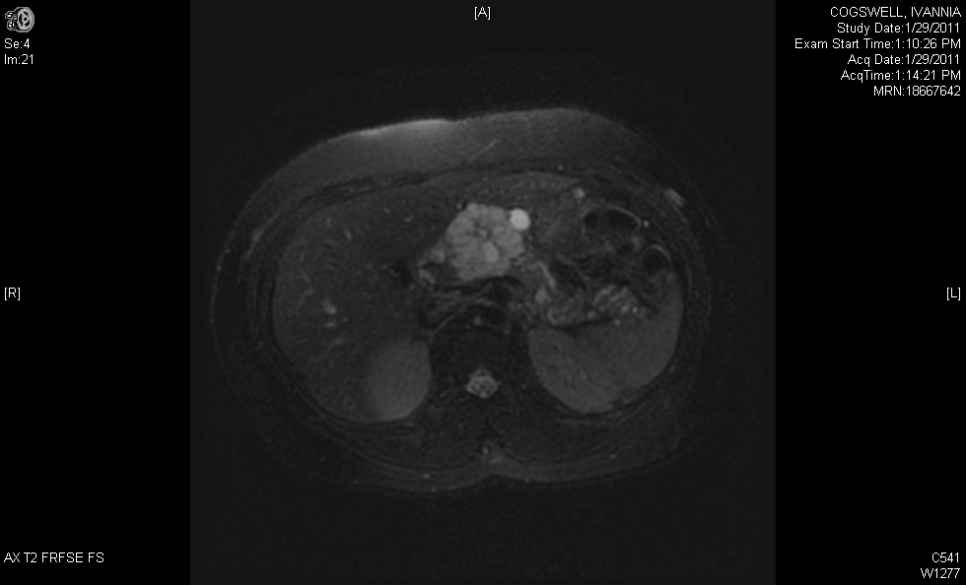

**Figure 1 Magnetic resonance imaging of microcystic serous cystadenoma in body of pancreas.**

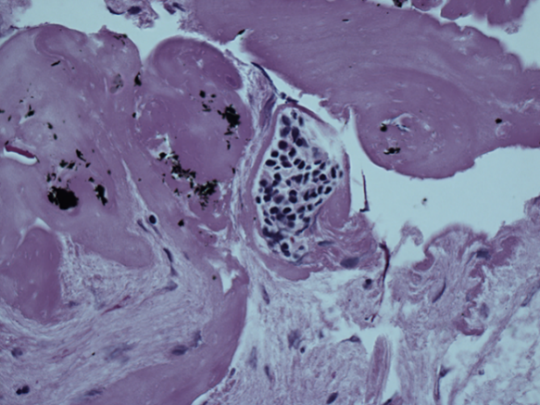

**Figure 2 Cytology of serous cystadenoma with cuboidal epithelial cells containing glycogen staining for periodic acid-Schiff.**

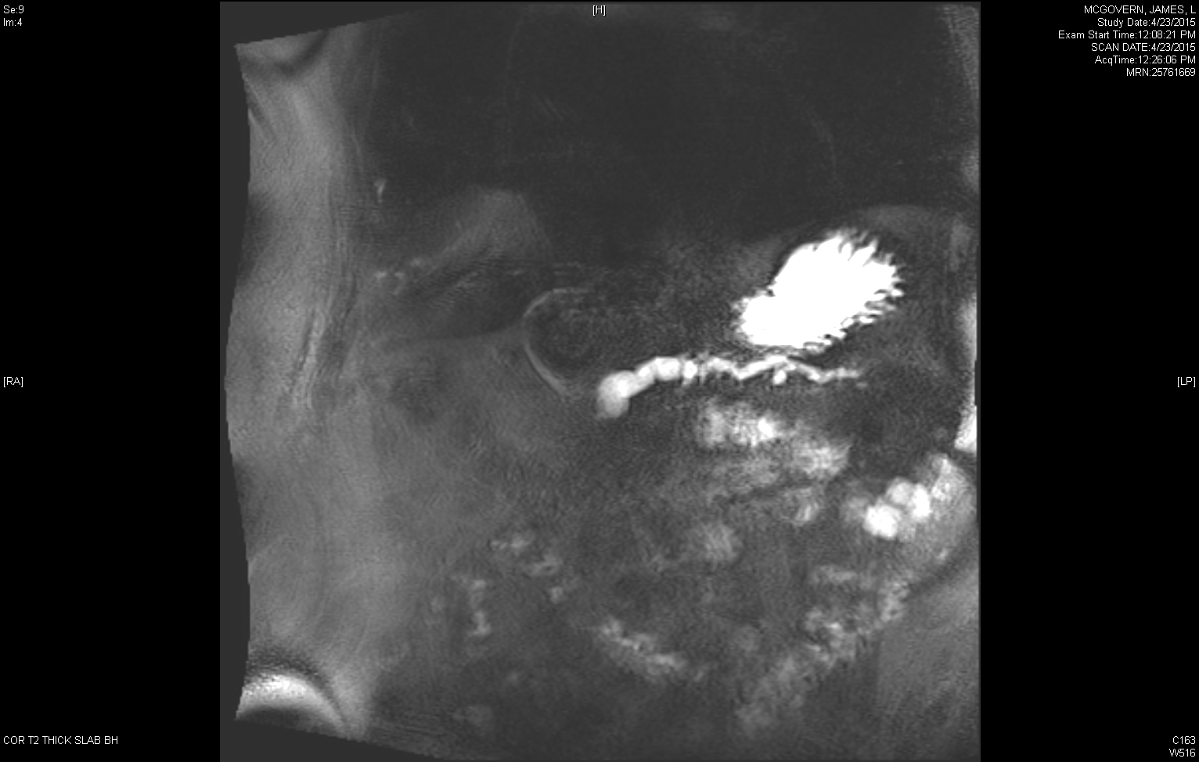

**Figure 3 Magnetic resonance cholangiopancreatography of main duct intraductal papillary mucinous neoplasms.**

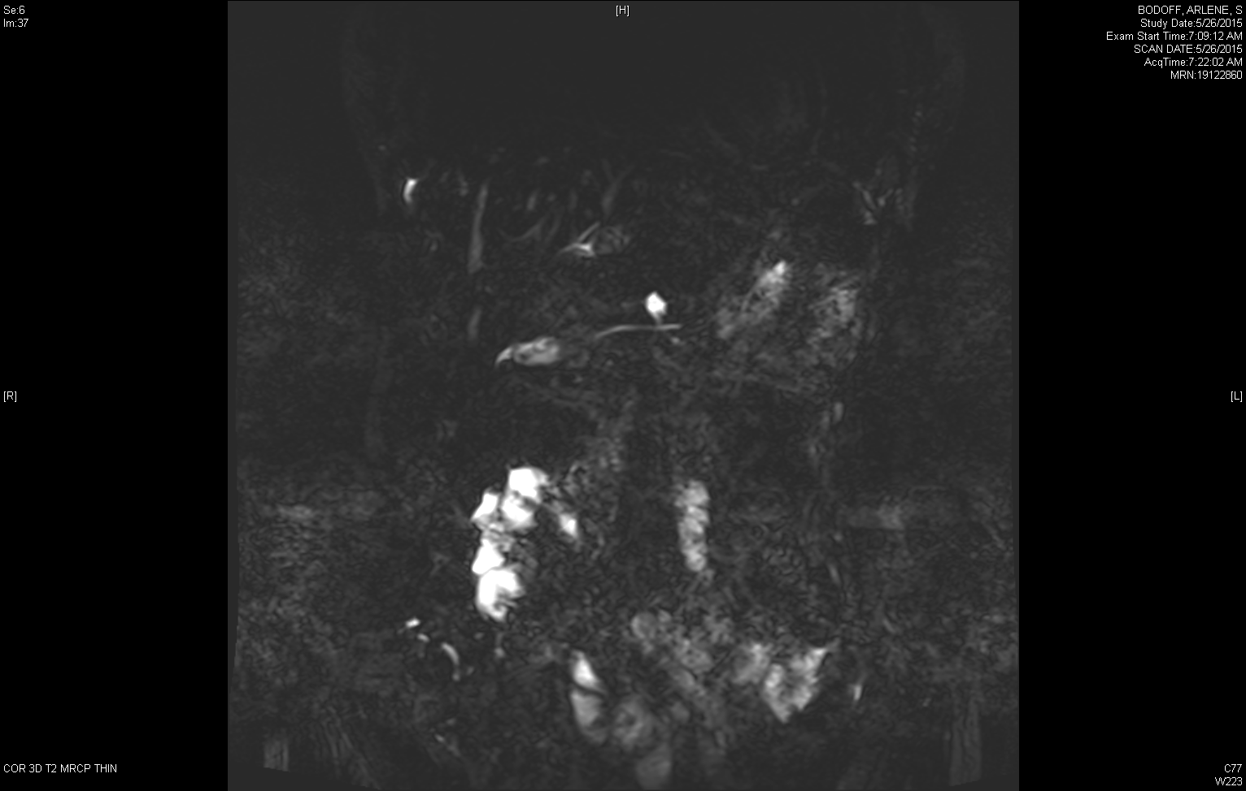

**Figure 4 Magnetic resonance cholangiopancreatography of branch duct intraductal papillary mucinous neoplasms communicating with nondilated main pancreatic duct.**

A B

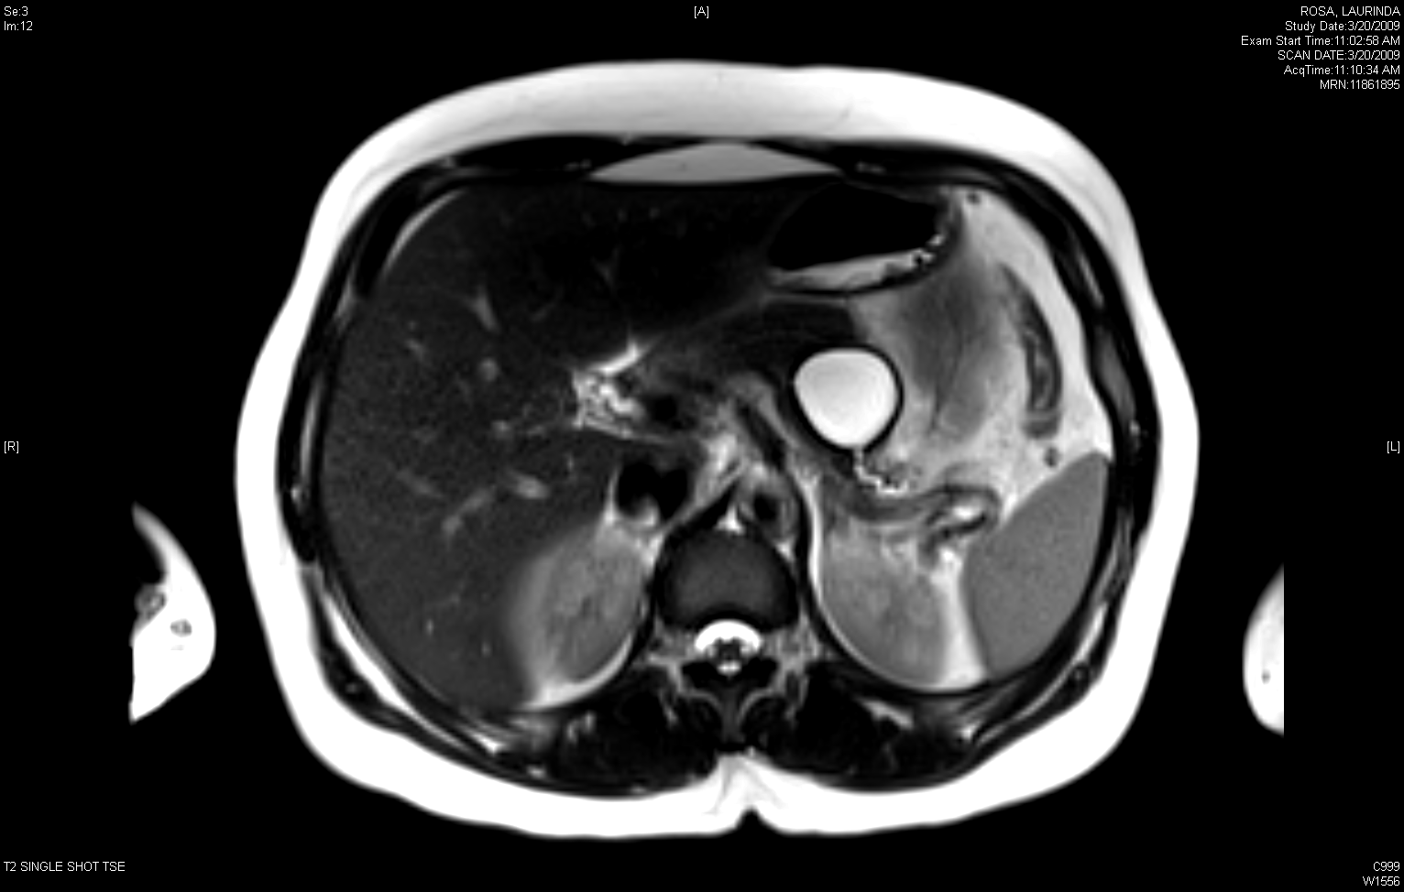

**Figure 5 Magnetic resonance imaging (A) and endoscopic ultrasound (B) of mucinous cystic neoplasm appearing unilocular with a thick wall.**

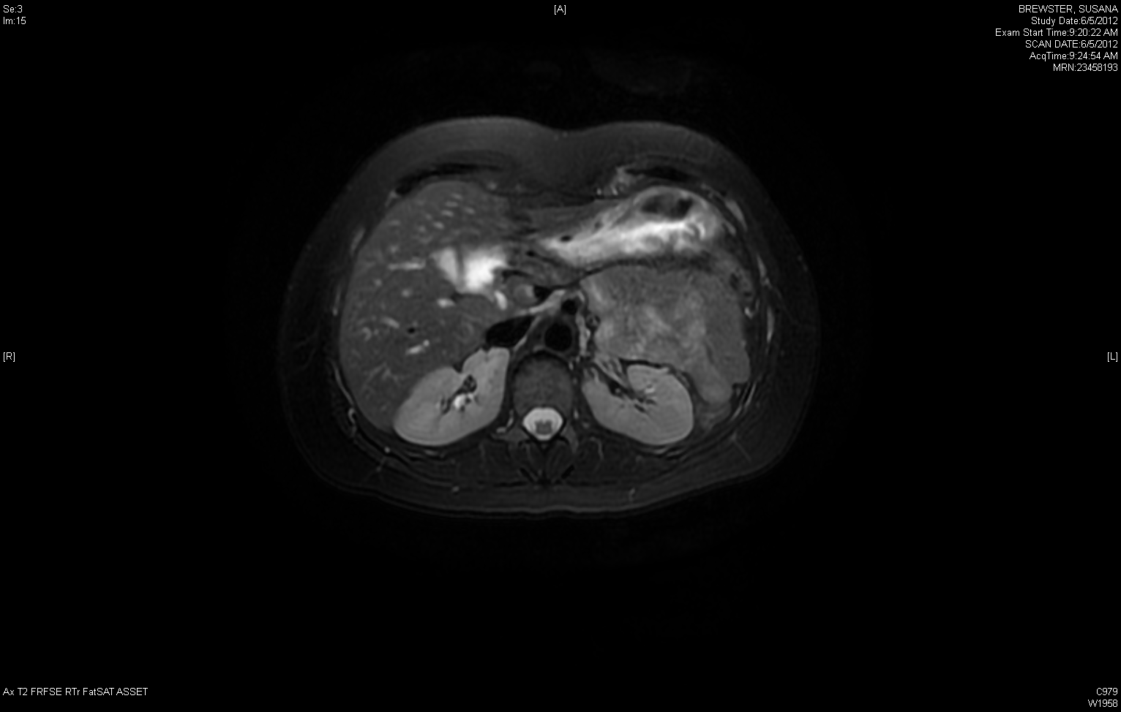

**Figure 6 Magnetic resonance imaging of solid pseudopapillary neoplasm.**

**Table 1Key differences between 2012 International Association of Pancreatology and 2015 American Gastroenterological Association guidelines for the management of pancreatic cysts**[10,20**]**

|  |  |  |
| --- | --- | --- |
| **Specifics of guidelines** | **2012 IAP** | **2015 AGA** |
| Patient population targeted by guideline | Suspected MCN and IPMN | All incidental pancreatic cysts |
| Recommended imaging modality | Pancreatic protocol CT or MRI | MRI pancreas with MRCP |
| Threshold for recommending EUS and/or surgery | 1 risk factor | At least 2 risk factors |
| Surveillance recommendations in unresected cysts | Frequent surveillance based on cyst size | MRI in 1 year and then every 2 years |
| Stopping surveillance | No explicit recommendation to stop in unresected cysts  Following resection of serous cystadenoma and MCN without invasive cancer | After 5 years of stable unresected cyst without development of high risk features.  Surgically unfit patients  Select resected cysts including BD-IPMN with no, low or moderate-grade dysplasia |

IAP: International Association of Pancreatology; AGA: American Gastroenterological Association; MRI: Magnetic resonance imaging; EUS: Endoscopic ultrasound; MCN: Mucinous cystic neoplasm; IPMN: Intraductal papillary mucinous neoplasms; MRCP: Magnetic resonance cholangiopancreatography.

**Table 2Recommended cyst fluid studies[**28,33,34,40**]**

|  |  |  |
| --- | --- | --- |
| **Cyst fluid test** | **Test characteristics** | **Diagnosis** |
| String sign ≥ 1 cm, ≥ 1 sec | 95% specificity, 94% positive predictive value | Mucinous |
| Cyst fluid cytology | 63% sensitivity | Mucinous or malignant |
| Cyst wall cytology | 29% increased diagnostic yield | Mucinous or malignant |
| CEA > 192 ng/mL | 75% sensitivity, 84% specificity | Mucinous |
| CEA < 5 ng/mL | 50% sensitivity, 95% specificity | Serous cystadenoma, pseudocyst, cystic neuroendocrine tumor |
| Amylase < 250 U/L | 44% sensitivity, 98% specificity | Excludes pseudocyst |
|  |  |  |

**Table 3Recommended surveillance modalities and intervals for unresected pancreatic cysts according to 2012 International Association of Pancreatology guideline[**10**]**

|  |  |  |
| --- | --- | --- |
| **Size** | **Modality** | **Interval** |
| < 1 cm | CT/MRI | 2-3 years |
| 1-2 cm | CT/MRI | 1 year (lengthen if no change after 2 years) |
| 2-3 cm | EUS, MRI | EUS in 3-6 mo, then lengthen interval thereafter alternating MRI and EUS |
| > 3 cm | EUS, MRI | Alternate MRI and EUS every 3-6 mo. |

MRI: Magnetic resonance imaging; EUS: Endoscopic ultrasound; CT: Computed tomography.