**Name of journal:** ***World Journal of*** ***Gastroenterology***

**Manuscript NO:** **36554**

**Manuscript Type: ORIGINAL ARTICLE**

***Basic Study***

**Overexpression of CREPT confers colorectal cancer sensitivity to fluorouracil**

Y Kuang *et al*. CREPT’s role in CRC drug resistance

Yan-Shen Kuang, Yi Wang, Li-Dan Ding, Liu Yang, Ying Wang, Si-Han Liu, Bing-Tao Zhu, Xu-Ning Wang, Hong-Yi Liu, Jun Li, Zhi-Jie Chang, Ying-Yin Wang, Bao-Qing Jia

**Yan-Shen Kuang, Xu-Ning Wang, Hong-Yi Liu, Bao-Qing Jia,** General Surgery II Department, Chinese PLA General Hospital, Beijing 100853, China

**Yi Wang, Li-Dan Ding, Liu Yang, Ying-Yin Wang, Si-Han Liu, Bing-Tao Zhu****, Zhi-Jie Chang,** State Key Laboratory of Membrane Biology, Department of Basic Medical Sciences, School of Medicine, Tsinghua University, Beijing 100084, China

**Jun Li,** Institute of Immunology, PLA, The Third Military Medical University, Chongqing 400038, China

**ORCID number:** Yan-Shen Kuang (0000-0001-9849-4667); Yi Wang (0000-0003-4028-2471); Li-Dan Ding (0000-0003-1094-6775); Liu Yang (0000-0001-8305-4554); Ying Wang (0000-0002-0346-376X); Si-Han Liu (0000-0001-9880-2949); Bing-Tao Zhu (0000-0003-3356-506X); Xu-Ning Wang (0000-0002-5979-0508); Hong-Yi Liu (0000-0002-0903-5205); Jun Li (0000-0001-7194-1180); Zhi-Jie Chang (0000-0003-1567-3227); Ying-Yin Wang (0000-0002-7449-3843); Bao-Qing Jia (0000-0002-7006-0741).

**Author contributions:** YS Kuang and Y Wang contribute equally to this work. YS Kuang preformed the majority of experiments and analyze data; Y Wang contributed significantly in the staining and analyzing IHC experiment; LD Ding and L Yang helped perform the analysis with constructive discussions; Y Wang, BT Zhu and Jun Li helped preformed the cell apoptosis detection; XN Wang and HY Liu contributed patients’ data; BQ Jia，ZJ Chang and YY Wang contributed to the conception and coordination of the study.

**Supported by** The Key Project Grant from the National Natural Science Foundation of China, No. 81372167, No. 81572729, No. 81402293, No. 81372372 and No. 81230044; and The National Key Research and Development Program of China, No. 2016YFA0500301.

**Institutional review board statement:** All patients involved in this study gave their informed consent. The study was carried out under the ethics committee approval from the PLA General Hospital (Beijing China).

**Conflict-of-interest statement:** We declare that we have no financial and personal relationships with other people or organizations that can inappropriately influence our work, there is no professional or other personal interest of any nature or kind in any product, service and/or company that could be construed as influencing the position presented in, or the review of, the manuscript entitled “Overexpression of CREPT confers colorectal cancer sensitivity to Fluorouracil”.

**Data sharing statement:** No additional data was available.

**Open-Access:** This article is an open-access article which was selected by an in-house editor and fully peer-reviewed by external reviewers. It is distributed in accordance with the Creative Commons Attribution Non Commercial (CC BY-NC 4.0) license, which permits others to distribute, remix, adapt, build upon this work non-commercially, and license their derivative works on different terms, provided the original work is properly cited and the use is non-commercial. See: http://creativecommons.org/licenses/by-nc/4.0/

**Manuscript source:** Unsolicited manuscript

**Correspondence to:** **Bao-Qing Jia, MD, PhD, Chief Doctor, Professor,** General Surgery II Department, Chinese PLA General Hospital, 28th, Haidian Dist., Beijing 100853, China.jiabaoqing@301hospital.com.cn

**Telephone:** +86-18910566719

**Fax:** +86-10-66937533

**Received:** October 22, 2017

**Peer-review started:** October 25, 2017

**First decision:** November 14, 2017

**Revised:** November 23, 2017

**Accepted:** November 28, 2017

**Article in press:**

**Published online:**

**Abstract**

***AIM***

To investigate the expression pattern of cell cycle-related and expression elevated protein in tumor (CREPT) in colorectal cancer (CRC) and determine its prognostic value in response to 5-Fluorouracil (5-FU) treatment.

***METHODS***

The relative expression of CREPT in CRC tumor samples was determined using immunohistochemistry. The protein content in cell lines was analyzed by immunoblotting. Cell viability was measured with CCK-8 assay. Cell cycle and apoptosis analysis were performed with flow cytometry.

***RESULTS***

CREPT is overexpressed in CRC tissuesand correlates with histological grade. Clinicopathological analyses indicate that CREPT positively relates to tumor progression. Exogenous expression of CREPT stimulates cell proliferation and accelerates cell cycle. More importantly, high expression of CREPT sensitizes CRC cells to 5-FU treatment. Furthermore, we demonstrated that 5-FU elicited significant apoptosis in CREPT-positive cells.

***CONCLUSION***

Aberrant overexpression of CREPT contributes to the tumorigenesis of CRC via promoting cell proliferation and accelerating cell cycle, whereas confers sensitivity to 5-FU treatment concurrently. Our data indicates that CREPT is the potential prognostic biomarker for 5-FU in CRC.

**Key words:** Cell cycle-related and expression elevated protein in tumor; Colorectal cancer; 5-Fluorouracil; Apoptosis; Proliferation

**© The Author(s) 2017.** Published by Baishideng Publishing Group Inc. All rights reserved.

**Core tip:** Cell cycle-related and expression elevated protein in tumor (CREPT) is an oncogene preferentially expressed in diverse human tumors. Overexpression of CREPT promotes cell proliferation and tumorigenesis. However, the expression and mechanistic involvement of CREPT in colorectal cancer is not fully investigated. Despite tremendous advances in exploitations and clinical applications of 5-Fluorouracil has been achieved in the past decades, drug resistance remains a significant limitation to the clinical use. In another word, the prognostic biomarker for administration of this drug is still in urgent need.

Kuang YS, Wang Y, Ding LD, Yang L, Wang Y, Liu SH, Zhu BT, Wang XN, Liu HY, Li J, Chang ZJ, Wang YY, Jia BQ. Overexpression of CREPT confers colorectal cancer sensitivity to fluorouracil. *World J Gastroenterol* 2017; In press

**INTRODUCTION**

Colorectal cancer (CRC) is a malignant disease with apparent signs or symptoms such as blood in the stool, aberrance in bowel movement and weight loss[1]. Globally, colorectal cancer is the third most common malignancy, accounting for approximate 10% of all cases. In China, there are 376300 newly diagnosed CRC cases and 191000 CRC caused deaths in 2015[2]. With advance in early diagnosis and clinical therapeutics, the average 5-year survival rate is approaching 70% in the United States. The diagnosis of CRC majorly relies on pathological examination on tissues collected via enteroscope, and evaluation of disease stage heavily depends on imaging technologies like CT scan, PET and MRI[3]. Fluorouracil-based chemotherapy is still the mainstay for clinical management of CRC[4]. 5-Fluorouracil (5-FU) is an antimetabolite drug that inhibits the biosynthesis of DNA and thus induce tumor cells apoptosis[5]. The clinical application of 5-FU base adjuvant chemotherapy in the treatment of late stage CRC patients improves overall and disease-free survival in 10%-15% of patients[5]. However, the provoked resistance in response to 5-FU seriously compromised its therapeutic efficiency. Therefore, identification and characterization of prognostic biomarker for screening the potential sensitive population for this drug is crucial at this point.

Cell cycle-related and expression elevated protein in tumor (CREPT, also named RPR1B) was first identified as an oncoprotein which is highly expressed in most of tumors[6]. Principally, CREPT functions as a transcriptional regulator in CCND1 expression in two distinct ways: promoting direct binding of RNA polymerase Ⅱ on the promoter region to activate transcription, or on the termination region before poly-A site to prevent release from transcript and allow for recycling[7]. CREPT was later on identified to function on the human RNA polymerase Ⅱ C-terminal domain scaffold and participated in phosphorylation of the C-terminal heptapeptide repeat domain[7]. In addition, CREPT induced the transcription of a number of other cell cycle-related genes including CDK2, CDK4, CDK6 and cyclin-E, which eventually accelerates cell cycle and stimulates proliferation[8]. Notably, the accumulative evidence suggested the crucial role of CREPT in tumor biology in a range of human cancers[9]. However, either the expression pattern or the mechanistic involvement of CREPT in CRC has not been fully investigated. Here we suggested that fundamental role of CREPT in tumorigenesis of CRC via inducing proliferation and stimulating cell cycle. Contradictorily, the over-expression of CREPT rendered cell sensitivity to chemotherapeutic drug 5-FU as well, which reinforced the apoptotic response. We proposed the prognostic biomarker function of CREPT for clinical application of 5-FU in addition to its conventional view as an oncogene.

**MATERIALS AND METHODS**

***Plasmids and antibodies***

Expression plasmids for human CREPT are pCDH/HA-CREPT which is constructed in our lab. The plasmid pBS/U6/CREPT-si was constructed according to a previous protocol. The target sequence by an siRNA (CREPT-si), GGACCTGAATTCACTAGAGA is identical in human and mouse. Antibodies against PARP (5625S) was purchased from Cell Signaling Technology, Danvers, MA, United States, Anti-Actin (AC-15) antibodies was obtained from Sigma-Aldrich. Anti-CREPT antibody (3E10) was raised in our lab.

***Patient specimens and staining***

203 primary CRC patients and 13 adenoma patients who underwent surgical treatment were selected for our study. Their formalin-fixed, paraffin-embedded tissue blocks tissues were cut into paraffin sections followed by analyzing with immunohistochemistry. Formalin-fixed, paraffin-embedded tissue blocks tissues were cut into paraffin sections (4 μm thick). The slides were heated in tissue-drying oven for 40 min at 65 °C followed by deparaffinized in xylene and rehydrated in a graded alcohol series. Then the slides are incubated in sodium citrate solution (pH = 6.0) and heated on the boiling water bath for 20 min for antigen retrieval. After endogenous peroxidases are blocked by soaking slides in 3% H2O2, the slides were incubated with anti-CREPT primary antibody (1:20) in a humidity chamber at 4 °C overnight. Then, we wash the slides with phosphate-buffered saline (PBS) for 3 times, and apply the EnVision Kit (Dako) to the sections on the slides and incubate in a humidified chamber at room temperature for 30 min. The signal dictation was performed using DAB in the EnVision Kit (Dako). Then, all slides were detected under microscope by two blinded pathologists. The proportion of positive cancer cell staining was classified on a scale of 4 grades: 1st grade: (-) = no positive cells; 2nd grade (1+) < 25%; 3rd grade 25%-75%, 4th grade > 75%. All patients gave informed consent for the participation in the research. The tissue collection procedure with informed consent was approved by the Ethic Affair Committee of Chinese PLA General Hospital.

***Construction of lentivirus***

Human CREPT gene were sub-cloned into pCDH-vector with HA-tag. ShRNA was designed to down-regulate the expression of CREPT. Non-overlapped sequences were designed (shRNA, 5’-GCAAGAACGAAGUGUUAUTT-3’). The shRNA targeting CREPT was selectively sub-cloned into lentiviral vector pLVX-IRWS-ZsGreen1. And pCDH-HA-CREPT was also subsequently cloned into pLVX-IRWS-ZsGreen1. Lentivirus was produced and the titration of purified virus was determined according to our previous report. The virus was stored at -80 ℃ until use.

***Cell culture***

Human colorectal adenocarcinoma cell lines DLD1 and SW620 were purchased from ATCC (Manassas, VA, United States). DLD1 were cultured in RPMI 1640 Medium (Life technologies, Carlsbad, CA, United States) and SW620 cells were cultured in L-15 supplemented with 10% FBS (Biological Industries), penicillin 100 U/mL and streptomycin 100 mg/mL. DLD1 cells were maintained at 37 °C in a 5% CO2-containing atmosphere and SW620 were kept at 37 °C with 100% air.

***Western blotting***

Cells were harvested and homogenized in RIPA buffer (Cell Signaling Technology, Danvers, MA, United States), followed by determination of protein concentrate by BCA kit (Life technologies, Carlsbad, CA, United States). 10% SDS-PAGE gel was applied to resolve protein, and then transferred to 0.45 mm PVDF membranes. Then, the membrane was blocked in 5% skim milk in TBS buffer with Tween 20 (TBST) in 37 ℃ for 1hour and incubated with indicated primary antibody at 4℃ overnight. The PVDF membrane was rigorously washed with TBST and subjected to secondary antibody hybridization. The protein bands were visualized using commercial enhanced chemiluminescence method (Millipore, CA, United States).

***CCK proliferation assay***

Cells were counted by hemocytometer and then seeded into 96-well plate at a density of 1 ×/well and 5-FU (50 μm/mL) were added 12 h later. CCK-8 (Dojindo) buffer were diluted as protocol indicated and added to the wells at indicated time. Then the absorbance at 450 nm was recorded with a reference filter of 570 nm using a microplate reader (Molecular Device)

***Flow cytometry analysis***

Cells were seeded in 6-well plate 12 h before 5-FU were add. After incubating for 48 h, cells were harvested and subjected to apoptosis detection by FITC-Annexin V Apoptosis Detection Kit with PI (BioLegend, San Diego, CA, United States) as protocol indicated. The cells were then analyzed by BD FACS Calibur (BD, United States).

***Statistical analysis***

Parameter data were expressed as mean ± standard deviation and were analyzed with unpaired *t*-test and analysis of variance (ANOVA) followed by a post-hoc *t*-test. Differences between proportions were assessed by the c2 test. The survival analysis was performed by Kaplan-Meier method. All the analyses were conducted using SPSS 17.0 software. Statistical significance was defined as P < 0.05.

**RESULT**

***The over-expression of cell cycle-related and expression elevated protein in tumor correlated with*** ***clinicopathological features in colorectal cancer***

To determine the expression pattern of CREPT in CRC clinical samples, totally 203 CRC tissue slides and 13 benign adenoma tissues for control were collected for IHC studies. A significant increase of CREPT was detected in the CRC tissues in comparison with benign tissues (77% *vs* 46%, Figure 1A and B, Table 1). Abundant expression of CREPT is observed in well differentiation tumors compared to moderately and poorly differentiation tumors (Figure 2A and Table 2). The intensive staining signal was enriched in the malignant region in contrast to the margin (the benign stromal tissue at the tumor periphery) and normal counterparts in the same slide (Figure 1C). We further analyzed the expression of CREPT in the common CRC cell lines by western blotting (Figure 1D). The NCM460, a normal human colon mucosal epithelial cell, was employed for comparative purpose. We did not detect CREPT protein in NCM460. In contrast, the CREPT protein levels were aberrantly up-regulated in all of the four CRC cell lines examined, including DLD1, HCT116, SW480 and SW620. Our in vitro expression analysis consolidated the observations from clinical samples. Next, we attempted to analyze if CREPT has any correlation with clinicopathological features. As shown in Figure 2A and Table 1 and 2, our data unambiguously demonstrated the positive association of high CREPT expression with pathologic type (*P <* 0.05) and histological grade (*P <* 0.005). Our data suggested that CREPT expression was up-regulated with CRC progression, which implicated a crucial role of CREPT in this disease.

***Cell cycle-related and expression elevated protein in tumor stimulated cell proliferation and cell cycle in colorectal cancer cells***

Our previous results characterized the aberrant high expression of CREPT in CRC both in vitro and *in vivo*. In view of the essential physiological role of CREPT in cell cycle modulation, we sought to investigate whether CREPT involved in cell proliferation and cell cycle regulation in CRC. To investigate whether CREPT has any influence on the viability of CRC cells, we constructed recombinant lentivirus, lenti-HA-CREPT, to generate stable overexpression cell lines and the lentivirus, lenti-sh-CREPT to knockdown the endogenous expression of CREPT. The SW620 and DLD1 cells were infected with indicated lentivirus, respectively. Both the ectopic expression of CREPT and knockdown efficiency was evaluated by immunoblotting (Figure 3A). Our results confirmed the success in establishment of the stable cell lines for further analysis.

The cell viability was determined using CCK-8 assay. As shown in Figure 3B, the forced expression of CREPT in SW620 significantly promoted cell growth while the cell viability was remarkably suppressed by CREPT depletion in DLD1 cells (Figure 3C). The previous studies indicated that CREPT fundamentally affected the G1 to S phase transition[10]. In line with this notion, our cell cycle analysis by flow cytometry clearly demonstrated an increase of S and decrease of G phase cells upon exogenous expression of CREPT in DLD1 cells (Figure 3D). All the results suggested that CREPT overexpression played critical role in stimulation of cell proliferation and cell cycle in CRC cell lines, which might underlie its oncogenic potential in this disease.

***Overexpression of cell cycle-related and expression elevated protein in tumor sensitized colorectal cancer cells to 5-FU-induced apoptosis***

The aforementioned data demonstrated the aberrant overexpression and oncogenic activity of CREPT via promoting cell proliferation and cell cycle. Next, we attempted to address whether high expression of CREPT linked to chemotherapy resistance, especially for 5-FU. Noteworthily, we have retrieved the relevant data from TCGA database, and a little to our surprise, despite there is no statistical difference, the analysis results revealed a trend that abundance of CREPT was a favorable indicator for those CRC patients who received 5-FU-based chemotherapy (Figure 2B). Therefore, we set out to experimentally validate this observation in our in vitro system.

We measured the cytotoxic effect of 5-FU in CREPT silenced DLD1 using CCK-8 method. The knockdown of CREPT markedly suppressed cell proliferation. However, the cell viability of CREPT-silenced DLD1 was significantly increased in comparison with control cells in response to 5-FU (50 μg/mL) treatment, implicating the provoked drug resistance by CREPT deficiency (Figure 4A). Furthermore, our cell apoptosis analysis showed that 5-FU elicited dramatic apoptosis in DLD1 cells, while this cytotoxic effect was significantly compromised upon CREPT knockdown (Figure 4B and D). All these results implied a close linkage between CREPT expression and 5-FU sensitivity in the CRC cells. This observation was further consolidated through apoptotic pathway analysis in CREPT-manipulated SW620 and DLD cells. 5-FU treatment stimulated significant higher level of PARP in CREPT expressing SW620 cells than in the control ones. Consistently, the PARP level was remarkably decreased in CREPT-silenced DLD cells upon 5-FU treatment (Figure 4C). All the results clearly demonstrated that CREPT conferred cells the sensitivity to 5-FU in vitro.

**DISCUSSION**

The CREPT protein is essentially a transcription regulator via modulation the expression of multiple cell cycle-related factors[8]. For example, our previous study indicated that CREPT enhanced the expression of Cyclin D1 by promoting RNAPII recycling during transcription of this gene[6]. Later study showed that CREPT promoted transcriptional activity of the β-catenin·TCF4 and in turn enhanced Wnt signaling pathway as well[7]. Wnt pathway consequently regulated diverse biological processes, including cell proliferation, survival, migration and polarity[7]. Assembling evidence implied the oncogenic activity associated with aberrant overexpression of CREPT in variety of human malignances. For instance, Wang *et al*[8] demonstrated that CREPT promoted tumor growth by accelerating the cell cycle in endometrial cancer. Zhang *et al*[7] reported that CREPT was highly expressed in tumor and enhanced the β-catenin·TCF4 transcriptional activity in response to Wnt signaling. She *et al*[10] suggested that CREPT expression correlated with poor prognosis in patients with retroperitoneal leiomyosarcoma. Similarly, high expression of CREPT in colorectal cancer promoted tumor growth and correlated with poor prognosis[11]. Moreover, Liu *et al*[12] demonstrated that inhibition CREPT reduced the proliferation and migration of non-small cell lung cancer cells by down-regulating cell cycle related proteins. Consistent with all these reports, here we demonstrated that CREPT is highly expressed in both colorectal tumor and CRC cell lines and intimately linked to the pathologic stages. Although there was no correlation between overall survival and CREPT expression identified in all CRC cases, stratification into non- and 5-FU treatment groups brought forth significant difference in respect to the CREPT status. In line with its well-established role in modulation of cell cycle, we further elucidated that CREPT promoted cell growth and accelerated cell cycle in both CRC cell lines. Consistent with the results from TCGA database analysis, our in vitro experiments consolidated that CREPT level positively associated with sensitivity to 5-FU.

5-FU is the mainstay chemotherapy drug for clinical treatment of CRC. However, only 5%-10% of all CRC patients manifested favorable response to 5-FU based regimen, whereas the majority with apparent drug resistance[5]. A number of mechanisms underlying the refractory effect have been elucidated. For example, the elevated expression of DNA repair gene ERCC6 was shown to confer resistance to 5-FU and associated with poor patient survival in CRC[13]. Liu *et al*[14] demonstrated that epigenetic silencing of ASPP1 conferred 5-FU resistance in clear cell renal carcinoma by preventing p53 activation. In addition, the overexpression of long non-coding RNA UCA1 was related to multidrug resistance including 5-FU and cisplatin[15]. The microRNA miR-1290 was shown functioning as a biomarker in DNA-mismatch-repair-deficient colon cancer and promoted resistance to 5-FU by directly targeting hMSH2[16]. Several strategies have been exploited to surmount the resistance developed in response to clinical use of 5-FU. The synthesized peptide of SPARC interfered with the interaction between caspase 8 and Bcl2 to re-sensitize chemo-resistant tumors and enhanced their regression *in vivo*[17]. In respect to microRNAs, overexpression of miR-122 re-sensitized 5-FU-resistant colon cancer cells through inhibition of PKM2 in vitro and *in vivo*[18]. Moreover, the chemotherapy response was reported associating with subsets of tumor-infiltrating lymphocytes in gastric cancer[19]. Together with all these efforts, here we provided novel evidence that overexpression of CREPT apparently conferred CRC cells the sensitivity to 5-FU, which hold the great potential as a prognostic biomarker for clinical application of this drug. Therefore, we proposed that relative expression of CREPT in CRC tissues should be determined during biopsy and which could serve as prerequisite for decision of clinical use of 5-FU.

Although 5-FU exerts the maximum therapy outcome is in CRC, it is a broad-spectrum anti-tumor drug. In the first line chemotherapy of breast cancer and gastric cancer, 5-FU plays an irreplaceable role. According to our previous study, CREPT has similar effect on colorectal cancer, breast cancer and gastric cancer. This might suggest that CREPT is a potential chemotherapy sensitivity indicator in these cancers and further research to verify these hypotheses is needed.

Despite of the well-acknowledged oncogenic role of CREPT in range of human cancers, here we indicated the highly-expressed CREPT was favorable in respect to 5-FU administration. However, the molecular events underlying the conveyed drug sensitivity by CREPT was still elusive. In view of its nature as a transcription regulator of multiple cell cycle-related factors, we hypothesized that CREPT accelerated cell cycle and exacerbated thymineless death in CRC cells in response to 5-FU challenge. Beyond this study, the intrinsic issue still to be addressed was how CREPT was up-regulated in CRC. Cui *et al*[20] reported that miR-1188 at the imprinted Dlk1-Dio3 domain acted as a tumor suppressor in hepatoma cells and suppressed CREPT expression, which threw some light on the regulatory mechanism underlying the overexpression of CREPT in CRC.

**ARTICLE** **HIGHLIGHTS**

***Research background***

Colorectal cancer (CRC) is the third leading cancer and the third most frequent cancer-related death in the United States. Cell cycle-related and expression elevated protein in tumor (CREPT) is preferentially expressed in many kinds of carcinomas. However, the correlation between CREPT and CRC clinicopathological patterns remains unclear. And the study on the impacts of CREPT expression to the anti-cancer drug 5-Fluorouracil (5-FU) resistance in CRC is limited.

***Research motivation***

Our research aims to investigate the expression pattern of CREPT in CRC and explore if CREPT rendered CRC cells sensitivity to 5-FU.

***Research objectives***

In this study, we investigated the expression pattern of CREPT in CRC. To our knowledge, we firstly conferred the correlation between CREPT and CRC cells sensitivity to 5-FU. This finding provokes us to consider CREPT as a potential chemotherapy predictive biomarker. Moreover, further study on CREPT’s impact on chemotherapy outcome among other cancers and anti-tumor drugs is needed.

***Research methods***

203 primary CRC patients and 13 benign adenoma patients’ sections are analyzed with immunohistochemistry by anti-CREPT antibody. Then, they were detected pathologists.

CREPT over-expressed/ knock-down cell lines were established by lenti-virus infection. Then, the expression of CREPT in these cell lines were analyzed by western blot and the cell viability was measured by CCK-8 assay.

Then, these cell lines are subjected to 5-FU treatment. The cytotoxic effect of 5-FU is measured by CCK-8 assay and PARP/flow cytometry analysis.

***Research results***

CREPT expression correlates with clinicopathological features in CRC, CREPT was abundantly expressed in CRC tissues compared with benign tissues. A significant increase of CREPT was detected in higher differentiation tumors. The intensive staining signal was enriched in the malignant region in contrast to the margin and normal counterparts in the same slide. CREPT stimulated cell proliferation and cell cycle in CRC cells, Cell growth was significantly enhanced when CREPT is overexpressed via exogenous transfected while CREPT depletion remarkably suppresses cell viability.

Overexpression of CREPT sensitized CRC cells to 5-FU-induced apoptosis.

The knockdown of CREPT markedly suppressed cell proliferation. However, the cell viability of CREPT-silenced DLD1 was significantly increased in comparison with control cells in response to 5-FU treatment, implicating the provoked drug resistance by CREPT deficiency. Furthermore, our cell apoptosis analysis showed that 5-FU elicited dramatic apoptosis in DLD1 cells.

***Research conclusions***

In this research, the impact of CREPT on CRC cells response to 5-FU was identified for the first time. We hypothesized that this phenomenon is attributed to accelerated cell cycle induced by high expression of CREPT. However, the mechanism of this interesting finding requires further study. Clinically, biomarkers for chemotherapy efficacy prediction is in urgent need and this research provides a candidate.

***Research perspectives***

Despite our research team endeavored to present a perfect research, we cannot denial that there are a few rough edges in this study. For example, compared to public database, first-hand follow-up data of patients is more convincing. As for future plan, we are working on animal experiments to verify our finding *in vivo*. Then we will embark on mechanism exploration and investigate the possibility of clinical application of CREPT as a prognostic indicator.

**REFERENCES**

1 **Brenner H**, Kloor M, Pox CP. Colorectal cancer. *Lancet* 2014; **383**: 1490-1502 [PMID: 24225001 DOI: 10.1016/S0140-6736(13)61649-9]

2 **Chen W**, Zheng R, Baade PD, Zhang S, Zeng H, Bray F, Jemal A, Yu XQ, He J. Cancer statistics in China, 2015. *CA Cancer J Clin* 2016; **66**: 115-132 [PMID: 26808342 DOI: 10.3322/caac.21338]

3 **Kekelidze M**, D'Errico L, Pansini M, Tyndall A, Hohmann J. Colorectal cancer: current imaging methods and future perspectives for the diagnosis, staging and therapeutic response evaluation. *World J Gastroenterol* 2013; **19**: 8502-8514 [PMID: 24379567 DOI: 10.3748/wjg.v19.i46.8502]

4 **Gustavsson B**, Carlsson G, Machover D, Petrelli N, Roth A, Schmoll HJ, Tveit KM, Gibson F. A review of the evolution of systemic chemotherapy in the management of colorectal cancer. *Clin Colorectal Cancer* 2015; **14**: 1-10 [PMID: 25579803 DOI: 10.1016/j.clcc.2014.11.002]

5 **Longley DB**, Harkin DP, Johnston PG. 5-fluorouracil: mechanisms of action and clinical strategies. *Nat Rev Cancer* 2003; **3**: 330-338 [PMID: 12724731 DOI: 10.1038/nrc1074]

6 **Ma J**, Ren Y, Zhang L, Kong X, Wang T, Shi Y, Bu R. Knocking-down of CREPT prohibits the progression of oral squamous cell carcinoma and suppresses cyclin D1 and c-Myc expression. *PLoS One* 2017; **12**: e0174309 [PMID: 28369091 DOI: 10.1371/journal.pone.0174309]

7 **Zhang Y**, Liu C, Duan X, Ren F, Li S, Jin Z, Wang Y, Feng Y, Liu Z, Chang Z. CREPT/RPRD1B, a recently identified novel protein highly expressed in tumors, enhances the β-catenin·TCF4 transcriptional activity in response to Wnt signaling. *J Biol Chem* 2014; **289**: 22589-22599 [PMID: 24982424 DOI: 10.1074/jbc.M114.560979]

8 **Wang Y**, Qiu H, Hu W, Li S, Yu J. RPRD1B promotes tumor growth by accelerating the cell cycle in endometrial cancer. *Oncol Rep* 2014; **31**: 1389-1395 [PMID: 24452636 DOI: 10.3892/or.2014.2990]

9 **Lu D**, Wu Y, Wang Y, Ren F, Wang D, Su F, Zhang Y, Yang X, Jin G, Hao X, He D, Zhai Y, Irwin DM, Hu J, Sung JJ, Yu J, Jia B, Chang Z. CREPT accelerates tumorigenesis by regulating the transcription of cell-cycle-related genes. *Cancer Cell* 2012; **21**: 92-104 [PMID: 22264791 DOI: 10.1016/j.ccr.2011.12.016]

10 **She Y**, Liang J, Chen L, Qiu Y, Liu N, Zhao X, Huang X, Wang Y, Ren F, Chang Z, Li P. CREPT expression correlates with poor prognosis in patients with retroperitoneal leiomyosarcoma. *Int J Clin Exp Pathol* 2014; **7**: 6596-6605 [PMID: 25400738]

11 **Zheng G**, Li W, Zuo B, Guo Z, Xi W, Wei M, Chen P, Wen W, Yang AG. High expression of CREPT promotes tumor growth and is correlated with poor prognosis in colorectal cancer. *Biochem Biophys Res Commun* 2016; **480**: 436-442 [PMID: 27773816 DOI: 10.1016/j.bbrc.2016.10.067]

12 **Liu T**, Li WM, Wang WP, Sun Y, Ni YF, Xing H, Xia JH, Wang XJ, Zhang ZP, Li XF. Inhibiting CREPT reduces the proliferation and migration of non-small cell lung cancer cells by down-regulating cell cycle related protein. *Am J Transl Res* 2016; **8**: 2097-2113 [PMID: 27347318]

13 **Zhao Z**, Zhang G, Li W. Elevated Expression of ERCC6 Confers Resistance to 5-Fluorouracil and Is Associated with Poor Patient Survival in Colorectal Cancer. *DNA Cell Biol* 2017; **36**: 781-786 [PMID: 28665687 DOI: 10.1089/dna.2017.3768]

14 **Wang X**, Cheng Y, Zhu Y, Li H, Ge W, Wu X, Zhao K, Yuan J, Li Z, Jiang S, Han Z, Jiang Q, Wu Q, Liu T, Zhang C, Yu M, Hu Y. Epigenetic silencing of ASPP1 confers 5-FU resistance in clear cell renal cell carcinoma by preventing p53 activation. *Int J Cancer* 2017; **141**: 1422-1433 [PMID: 28656647 DOI: 10.1002/ijc.30852]

15 **Wang H,** Guan Z, He K, Qian J, Cao J, Teng L. LncRNA UCA1 in anti-cancer drug resistance. *Oncotarget* 2017 [PMID: 28607207 DOI: 10.18632/oncotarget.18344]

16 **Ye L**, Jiang T, Shao H, Zhong L, Wang Z, Liu Y, Tang H, Qin B, Zhang X, Fan J. miR-1290 Is a Biomarker in DNA-Mismatch-Repair-Deficient Colon Cancer and Promotes Resistance to 5-Fluorouracil by Directly Targeting hMSH2. *Mol Ther Nucleic Acids* 2017; **7**: 453-464 [PMID: 28624221 DOI: 10.1016/j.omtn.2017.05.006]

17 **Rahman M**, Chan AP, Tang M, Tai IT. A peptide of SPARC interferes with the interaction between caspase8 and Bcl2 to resensitize chemoresistant tumors and enhance their regression in vivo. *PLoS One* 2011; **6**: e26390 [PMID: 22069448 DOI: 10.1371/journal.pone.0026390]

18 **He J**, Xie G, Tong J, Peng Y, Huang H, Li J, Wang N, Liang H. Overexpression of microRNA-122 re-sensitizes 5-FU-resistant colon cancer cells to 5-FU through the inhibition of PKM2 in vitro and in vivo. *Cell Biochem Biophys* 2014; **70**: 1343-1350 [PMID: 24898807 DOI: 10.1007/s12013-014-0062-x]

19 **Lee JY**, Son T, Cheong JH, Hyung WJ, Noh SH, Kim CB, Park CG, Kim HI. Association between Chemotherapy-Response Assays and Subsets of Tumor-Infiltrating Lymphocytes in Gastric Cancer: A Pilot Study. *J Gastric Cancer* 2015; **15**: 223-230 [PMID: 26819801 DOI: 10.5230/jgc.2015.15.4.223]

20 **Cui W**, Huang Z, He H, Gu N, Qin G, Lv J, Zheng T, Sugimoto K, Wu Q. MiR-1188 at the imprinted Dlk1-Dio3 domain acts as a tumor suppressor in hepatoma cells. *Mol Biol Cell* 2015; **26**: 1416-1427 [PMID: 25694452 DOI: 10.1091/mbc.E14-11-1576]

**P-Reviewer:** Jeong KY, Kir G, Luchini C **S-Editor:** Chen K **L-Editor: E-Editor:**

**Specialty type:** Gastroenterology and hepatology

**Country of origin:** China

**Peer-review report classification**

Grade A (Excellent): 0

Grade B (Very good): B

Grade C (Good): C

Grade D (Fair): D

Grade E (Poor): 0

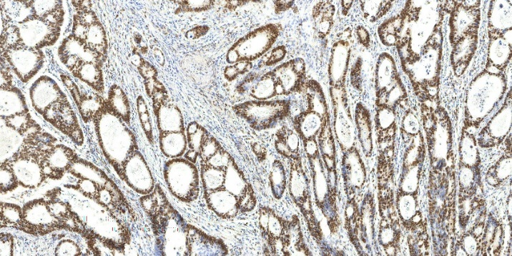

**B**

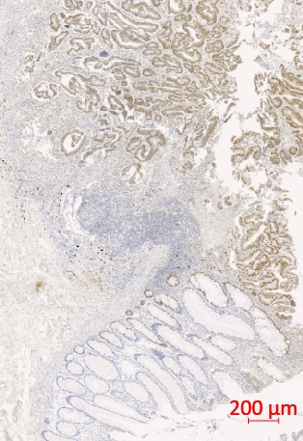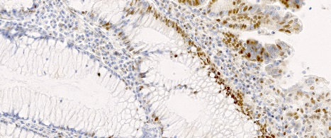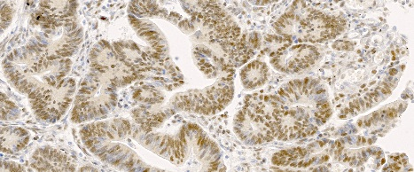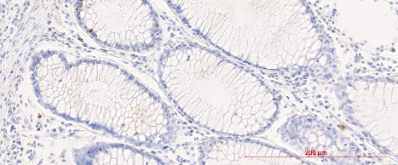

**Tumor**

**Margin**

**Normal**

**C**

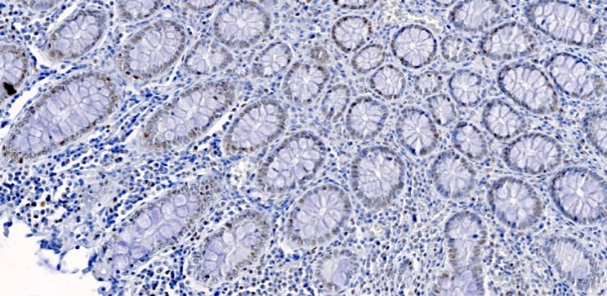

**A**

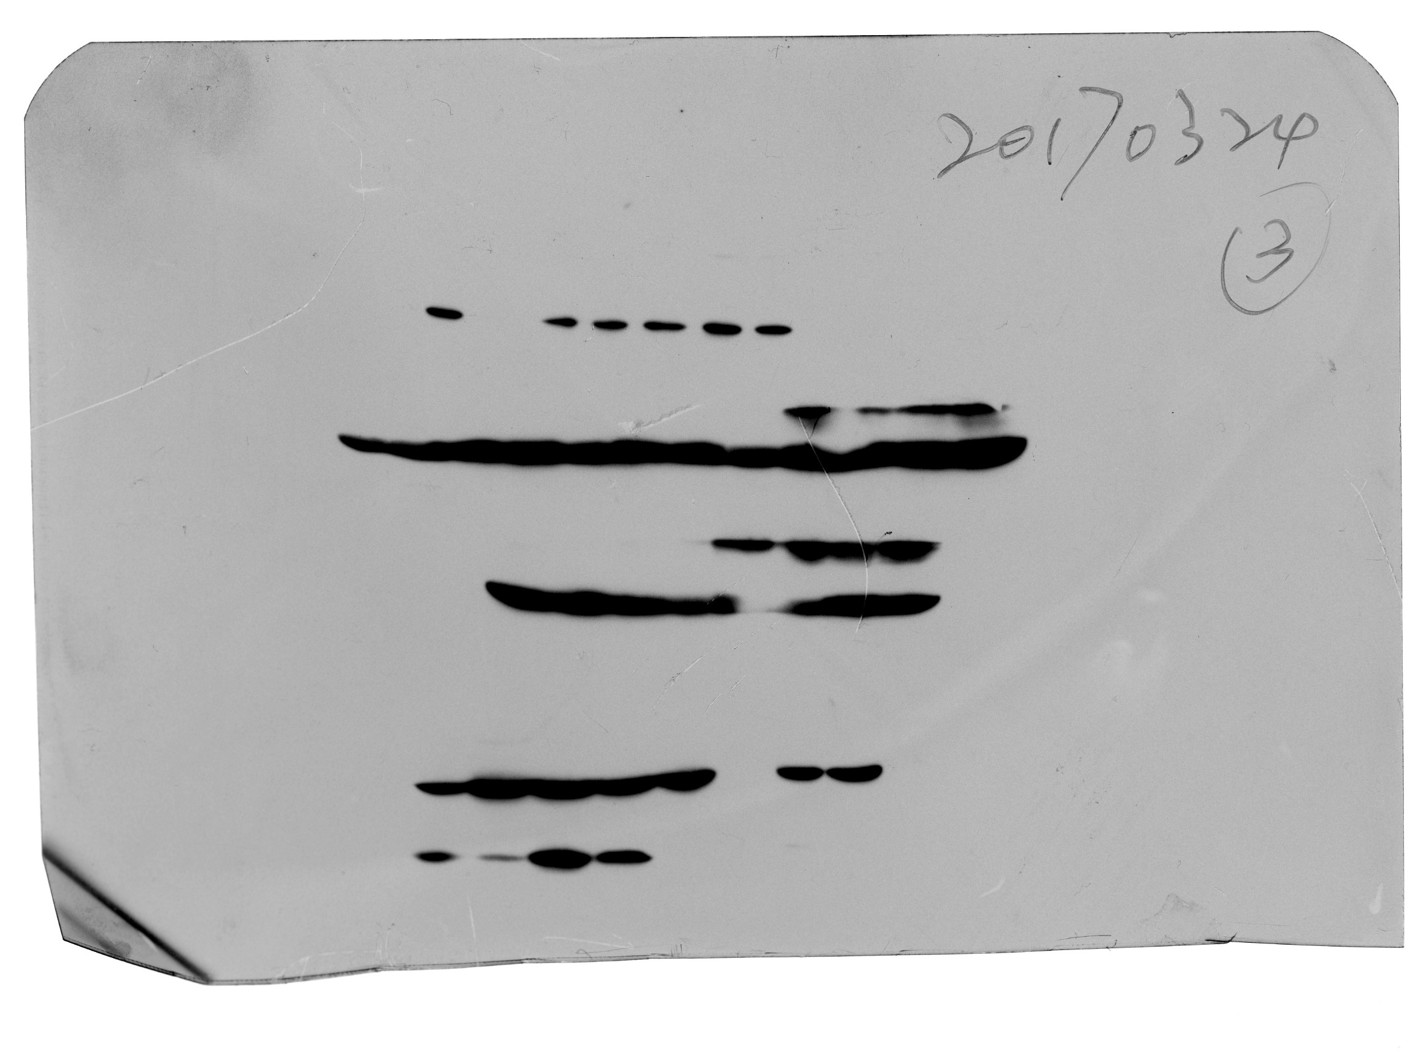

**D**

CREPT

β-Actin

DLD1

HCT116

SW480

SW620

NCM460

**Figure 1 Cell cycle-related and expression elevated protein in tumor expression in tumor and adenoma tissues.** A: Negative CREPT IHC staining in colorectal adenoma tissue; B: Positive CREPT IHC staining in CRC tissue; C: CREPT expression pattern in CRC sample; D: CREPT protein was determined by immunoblotting in CRC cell lines.

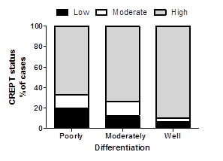 

“low” “moderate” “high” has been corrected as “poorly”” moderately” and “well”



B

**A**

**Figure 2 Cell cycle-related and expression elevated protein in tumor expression in colorectal cancer correlates with clinicopathological characteristics.** A: CREPT expression level correlates with pathologic type and tumor differentiation; B: Survival curve of CRC patients shows significant difference between patients with or without 5-FU-base adjuvant chemotherapy.

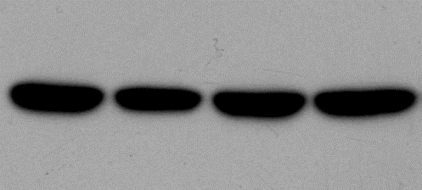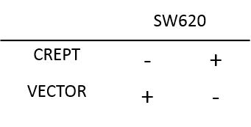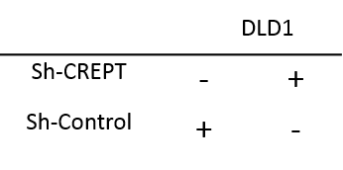

B

D

C

A

β-Actin

CREPT

**Figure 3 The alternation of cell cycle-related and expression elevated protein in tumor expression in colorectal cancer cells affects cell proliferation.** A: Western blot analyze show that the expression of CREPT in SW620 and DLD1 changed after exposed to indicated virus for 48 h; B and C: SW620 and DLD1 cells were incubated in 96-well plate, and CCK-8 assay was applied to determined cell viability at indicated time point; D: Cell cycle was detected by flow cytometry and indicated that CREPT facilitate cells went through G1/S check point.

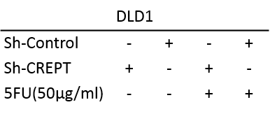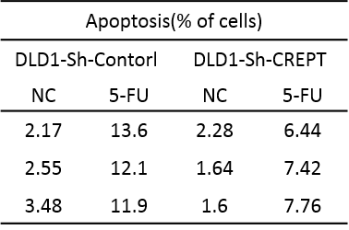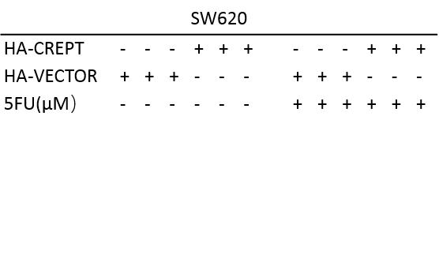

**B**

β-Actin

CREPT

PARP

**C**

**A**

**Figure 4 CR** **EPT facilitate colorectal cancer cells response to 5-Fluorouracil chemotherapy.** A: Cells were treated with 5-FU (50 μg/mL), and CCK-8 assay was applied to estimated their viability; B: Annexin V-PI apoptosis detection show that DLD1 cells are less sensitive to 5-FU chemotherapy when CREPT is knock down; C: SW620 and DLD1 cells were harvest after exposed to 5-FU (50 μg/mL) for 48 h, western blot analyze show that PARP is highly expressed in cells that express more CREPT.

**Table 1 Distribution of cell cycle-related and expression elevated protein in tumor status in colorectal benign tumor and malignant tumor**

|  |  |  |  |  |  |  |  |
| --- | --- | --- | --- | --- | --- | --- | --- |
| **Correlation between crept expression and pathologic type** | | | | | | | |
|  | **CREPT expression** | | | | | ***P-*value** | |
|  | **Low** | **Intermediate** | | **High** | |
| Benign tumor | 1 | | 6 | | 6 | | 0.035a |
| Malignant tumor | 25 | | 21 | | 157 | |

a*P* < 0.05.

**Table 2 Distribution of cell cycle-related and expression elevated protein in tumor status in colorectal carcinoma according to clinicopathological parameters**

|  |  |  |  |  |
| --- | --- | --- | --- | --- |
|  | **CREPT expression** | | | ***P-*value** |
|  | **Low** | **Intermediate** | **High** |
| Tumor | | | |  |
| T1 | 2 | 0 | 4 | 0.770 |
| T2 | 3 | 2 | 25 |
| T3 | 6 | 2 | 20 |
| T4 | 14 | 17 | 108 |
| Stage | | | |  |
| I | 4 | 2 | 23 | 0.700 |
| II | 11 | 12 | 64 |
| III | 8 | 3 | 56 |
| IV | 2 | 4 | 14 |
| Histological grade | | | |  |
| Poorly | 9 | 6 | 31 | 0.004b |
| Mediate | 12 | 13 | 71 |
| Well | 4 | 2 | 55 |
| Lymph node metastasis | | | |  |
| Negative | 15 | 15 | 92 | 0.487 |
| Positive | 10 | 6 | 65 |

b*P* < 0.05.