Dear Sirs,
I certify that the article entitled “Sorafenib and entecavir: the dioscuri of treatment for advanced hepatocellular carcinoma?” (ms code 874), submitted to World Journal of Gastroenterology, has been carefully revised in terms of language and English style by a Native English Speaker.
I therefore believe – in accordance also with reviewer’s judgment (Language Evaluation: Grade B) – that the manuscript has reached an acceptable level of English language.

Kind regards,
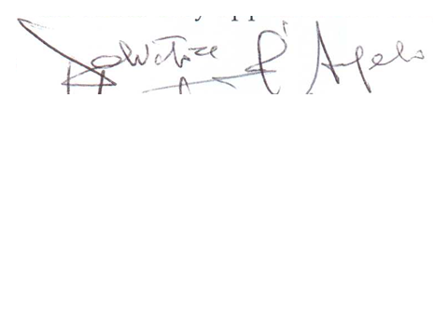
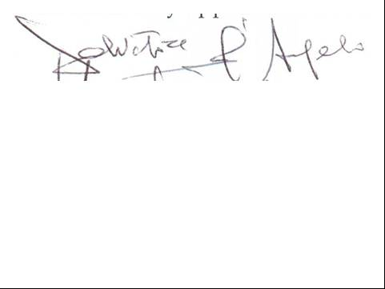

Salvatore D’Angelo

Salvatore D’Angelo, M.D.
Liver Unit, Clinical and Experimental Hepatology, S.G. Moscati Hospital, Avellino
Avellino Contrada Amoretta 83100.
Email: sadangelo@aosgmoscati.av.it; salvatore.dangelo45@tin.it

