Name of Journal: World Journal of Gastroenterology
Manuscript NO: 79530
Manuscript Type: ORIGINAL ARTICLE

Basic Study
Salvia miltiorrhiza extract may exert an anti-obesity effect in rats with high-fat diet-induced obesity by modulating gut microbiome and lipid metabolism

Ai ZL et al. Sal regulates gut microbiome and lipid metabolism

Zi-Li Ai, Xian Zhang, Wei Ge, You-Bao Zhong, Hai-Yan Wang, Zheng-Yun Zuo, Duan-Yong Liu

Zi-Li Ai, Xian Zhang, Department of Postgraduate, Jiangxi University of Chinese Medicine, Nanchang 330004, Jiangxi Province, China

Wei Ge, Department of Proctology, Affiliated Hospital of Jiangxi University of Chinese Medicine, Nanchang 330006, Jiangxi Province, China

You-Bao Zhong, Laboratory Animal Research Center for Science and Technology, Jiangxi University of Chinese Medicine, Nanchang 330004, Jiangxi Province, China

Hai-Yan Wang, Zheng-Yun Zuo, Duan-Yong Liu, Formula-Pattern Research Center, Jiangxi University of Chinese Medicine, Nanchang 330004, Jiangxi Province, China

Author contributions: Ai ZL and Zhang X contributed equally to this work; Zhong YB and Ge W performed the experiments; Liu DY, Wang HY, and Zuo ZY contributed reagents/materials/analytical tools; Liu DY and Ge W analyzed the data; Ai ZL and Liu DY wrote the paper; Zuo ZY and Wang HY conceived and designed the experiments.

Supported by the National Natural Science Foundation of China, No. 82060836; Jiangxi Province Graduate Student Innovation Special Fund Project, No. YC2021-B146; and Jiangxi University of Chinese Medicine Science and Technology Innovation Team Development Program, No. CXTD22008.

Corresponding author: Hai-Yan Wang, PhD, Associate Professor, Formula-Pattern Research Center, Jiangxi University of Chinese Medicine, Meiling Avenue 1688, Nanchang 330004, Jiangxi Province, China. 378278287@qq.com

Received: August 25, 2022
Revised: September 21, 2022
Accepted: October 31, 2022
Published online: November 21, 2022

Abstract
BACKGROUND
Studies have shown that a high-fat diet (HFD) can alter gut microbiota (GM) homeostasis and participate in lipid metabolism disorders associated with obesity. Therefore, regulating the construction of GM with the balance of lipid metabolism has become essential for treating obesity. Salvia miltiorrhiza extract (Sal), a common traditional Chinese medicine, has been proven effective against atherosclerosis, hyperlipidemia, obesity, and other dyslipidemia-related diseases.

AIM
To investigate the anti-obesity effects of Sal in rats with HFD-induced obesity, and explore the underlying mechanism by focusing on GM and lipid metabolism.

METHODS
Obesity was induced in rats with an HFD for 7 wk, and Sal (0.675 g/1.35 g/2.70 g/kg/d) was administered to treat obese rats for 8 wk. The therapeutic effect was evaluated by body weight, body fat index, waistline, and serum lipid level. Lipid factors (cAMP, PKA, and HSL) in liver and fat homogenates were analyzed by ELISA. The effect of Sal on GM and lipid metabolism was assessed by 16S rRNA-based microbiota analysis and untargeted lipidomic analysis (LC-MS/MS), respectively.

RESULTS
Sal treatment markedly reduced weight, body fat index, serum triglycerides (TG), total cholesterol (TC), low-density lipoprotein, glucose, free fatty acid, hepatic lipid accumulation, and adipocyte vacuolation, and increased serum high-density lipoprotein (HDL-C) in rats with HFD-induced obesity. These effects were associated with increased concentrations of lipid factors such as cAMP, PKA, and HSL in the liver and adipose tissues, enhanced gut integrity, and improved lipid metabolism. GM analysis revealed that Sal could reverse HFD-induced dysbacteriosis by promoting the abundance of Actinobacteriota and Proteobacteria, and decreasing the growth of Firmicutes and Desulfobacterita. Furthermore, LC-MS/MS analysis indicated that Sal decreased TGs (TG18:2/18:2/20:4, TG16:0/18:2/22:6), DGs (DG14:0/22:6, DG22:6/22:6), CL (18:2/18:1/18:1/20:0), and increased ceramides (Cers; Cer d16:0/21:0, Cer d16:1/24:1), (O-acyl)-ω-hydroxy fatty acids (OAHFAs; OAHFA18:0/14:0) in the feces of rats. Spearman’s correlation analysis further indicated that TGs, DGs, and CL were negatively related to the abundance of Facklamia and Dubosiella, and positively correlated with Blautia and Quinella, while OAHFAs and Cers were the opposite.

CONCLUSION
Sal has an anti-obesity effect by regulating the GM and lipid metabolism.

Key Words: Salvia miltiorrhiza extract; Obesity; Gut microbiota; Lipid metabolism; High fat diet

©The Author(s) 2022. Published by Baishideng Publishing Group Inc. All rights reserved.

Citation: Ai ZL, Zhang X, Ge W, Zhong YB, Wang HY, Zuo ZY, Liu DY. Salvia miltiorrhiza extract may exert an anti-obesity effect in rats with high-fat diet-induced obesity by modulating gut microbiome and lipid metabolism. World J Gastroenterol 2022; 28(43): 6131-6156
URL: https://www.wjgnet.com/1007-9327/full/v28/i43/6131.htm
DOI: https://dx.doi.org/10.3748/wjg.v28.i43.6131

Core Tip: Obesity is a major public health issue today and an obesity-related change in gut microbiota composition and its metabolite profile has been demonstrated. As a commonly used traditional Chinese medicine, Salvia miltiorrhiza extract (Sal) has many pharmacological effects, including anticoagulant, anti-inflammation, antioxidation, anti-fibrosis, anti-tumor, and organ protection. Although it has not been documented, Sal has a regulatory effect on obesity, which may be related to the gut microbiota. In the present study, we found that Sal plays a role in weight loss, lowering serum lipid levels, regulating the gut microbiota, and improving intestinal fecal metabolites in obese rats.

INTRODUCTION
Obesity, a condition whose incidence increases yearly, can lead to several chronic metabolic syndromes such as diabetes, hyperlipidemia, and atherosclerosis. According to 2016 epidemiological statistics, more than 1.9 billion adults worldwide suffer from obesity, and its prevalence reaches 70% in the United States^{[1]}. According to the WHO, adults with a body mass index (BMI) > 25 are considered overweight, while adults with a BMI > 30 are considered obese^{[2]}.
Gut microbiota (GM) is among the key regulators of metabolism^{[3]}. Dysregulation of the GM is closely connected with obesity and its complications^{[4]}. Under physiological circumstances, there is a symbiotic relationship between the GM and the host, which keeps the intestinal dynamic equilibrium of the body and metabolism^{[5]}. On the other hand, the GM-host imbalance^{[6]} has been associated with the occurrence of many diseases, such as obesity, enteritis, and colitis. Recent data indicated that there are significant differences in the structural composition of the GM of obese patients and that of non-obese people. For example, fewer Bacteroides (beneficial bacteria which metabolize oligosaccharides and polysaccharides, providing nutrition to the host) and more Pachyderma were found in the intestinal tract of obese patients^{[7]}. Consistent findings suggest that obesity is associated with decreased abundance in some taxa, such as Bifidobacterium, Christensenella, and Ackermannia, which are considered beneficial microbes. Moreover, as a key regulator of host metabolism, the GM can influence lipid metabolism and blood and tissue lipid levels in humans and rats^{[8]}. The GM has a major role in the fermentation of carbohydrates, fermenting carbohydrates and producing short-chain fatty acids (SCFAs), such as acetic acid, propionic acid, and butyric acid, to prevent and treat obesity and its complications. As a result, mounting evidence suggests treating obesity or obesity-related disease by improving the structure of the GM balance to regulate metabolism, particularly lipid metabolism.
Currently, bioactive substances of natural drugs are becoming increasingly popular as a new safe and effective approach to prevent and treat obesity. Salvia miltiorrhiza extract (Sal) is a traditional Chinese medicine that includes water-soluble components such as salyanolic acid, tanshinaldehyde, and comfrey acid that can inhibit early adipogenesis^{[9]} and alleviate lipid metabolism disorders^{[10]}. Moreover, its fat-soluble components, such as dihydrodanhinone I, tanshinone IIA and IIB, and cryptosanthoxylinone can reduce glycerol release^{[11]}, promote adipocyte differentiation, and reduce the contents of triglycerides (TG) and cholesterol^{[12]} to treat fatty liver or coronary atherosclerosis^{[13]}. The main pharmacological effects of Sal include restraining the activation of IκB-α and NF-κB, inhibiting the oxidation of low-density lipoprotein (LDL-C) from regulating lipid metabolism processes and antioxidant effects, and improving the body’s sensitivity to insulin by activating the AMPK pathway^{[14]}. Sal is also used to treat atherosclerosis^{[15]}, hyperlipidemia, obesity, and other dyslipidemia-related diseases. Furthermore, Wang et al^{[16]} found that the effect of Sal in regulating hepatic steatosis may be related to the intestinal flora. Hence, this study further investigated the anti-obesity effects of Sal in rats with high-fat diet (HFD)-induced obesity and explored the underlying mechanism by focusing on the GM and lipid metabolism.

MATERIALS AND METHODS
Animals
Male Sprague-Dawley rats (aged 7-8 wk, weighing 160 g ± 20 g) were provided by the Hunan Silaike Jingda Experimental Animal Co. Ltd. (Changsha, China; Animal Certificate Number: SCXK (Xiang) 2019-0004) and housed in specific pathogen-free conditions (23.0 °C ± 2.0 °C ambient temperature, 50%-60% relative humidity, and 12/12 h light/dark cycle) in Laboratory Animal Science and Technology Center of Jiangxi University of Traditional Chinese Medicine (Animal use license SYXK 2021-0007). The rats had free access to food and water throughout the experiment. The protocol (Permit Number: JZLLSC2021-236) was approved by the Jiangxi University of Chinese Medicine Animal Care and Use Committee and performed according to the guidelines prescribed by the committee. Experimental manipulation was performed after 7 d of acclimatization.

Drug
Salvia miltiorrhiza (batch number: 200701) was supplied by Baishixin Chinese Herbal Pieces Co., Ltd. (Millizhou, China). Preparation of Salvia miltiorrhiza extract was prepared as follows: The radix Salvia miltiorrhiza bunge was crushed into powder, dried at 58 °C, placed in 5000 mL round bottom flask, mixed with 75% ethanol (material-liquid ratio 1:10), soaked for 18 h, and placed in a water bath temperature 90 °C. A reflux extraction device was used to heat the reflux for 3 h, after which the filtrate was collected with four layers of gauze and left for 18 h after hot filtration.
The prepared Sal was freeze-dried with a vacuum freeze-dryer (Scientz-100F) and then smashed with zirconia beads using a mixer mill (MM 400, Retsch) at 30 Hz for 1.5 min. Then, 100 mg was dissolved with 1.2 mL of 70% methanol solution and vortexed for 30 s every 30 min 6 times, and the samples were placed in a refrigerator at 4 °C overnight. After centrifugation at 15984 g for 10 min, the extracts were filtered and then analyzed by ultra-performance liquid-chromatography tandem mass spectrometry (UPLC-MS/MS). Analytical conditions and mass spectrometry data were based on Wang et al^{[17]} and Chen et al^{[18]}, respectively. Linear ion trap and triple quadrupole scans were acquired on a triple quadrupole-linear ion trap mass spectrometer (QTRAP) with the AB4500 QTRAP UPLC/MS/MS System operating in positive and negative ion mode (Figure 1A and B). For each period, a particular set of MRM transitions was observed by the metabolites eluted during this period (Figure 1C and D). Table 1 shows some of the metabolites identified in this study along with their metabolite numbers, integral values, and names.

Experimental design
According to previous studies^{[19-23]}, an HFD with purified ingredients and a total caloric value of 475 Kcal/100 g, with lard as the main source of fat (D12451, Research Diets Inc.) was used to induce obesity. The experiment scheme for the modeling of HFD-induced obesity in rats and drug administration is shown in Figure 2. At the initial phase, all the rats were divided into either a control group (given normal diet; n = 8) or an HFD group (given HFD; n = 40) for 7 wk and housed at an ambient temperature of 22.0 °C ± 1.0 °C. Then, the HFD groups were randomly subdivided into five groups: Control (HFD + normal saline), Sal_L (HFD + 0.675 g/kg/d Sal), Sal_M (HFD + 1.35 g/kg/d Sal), Sal_H (HFD + 2.70 g/kg/d Sal), and orlistat (HFD + 32.4 mg/kg/d). All the treatments lasted for 8 wk. The body weight was measured every 3 d and intake of food was measured per cage daily. After deducting the residual food from the initially supplied, the food intake (g/rat/wk) was determined. Rats were randomly selected from multiple cages, and cages were changed every 2 wk to control for potential cage effects and sex/age differences.

Macroscopic observation
On the final day of the trial, all rats were euthanized with pentobarbital sodium (40 mg/kg intraperitoneally) and weighed, and the liver and fat were quickly removed and weighed after blood was drawn from the abdominal aorta. The body fat index (BFI) was calculated as follows: BFI = Total weight of fat/Body weight of rat × 100%.

Histological analysis
Fresh liver and adipose tissues were fixed with 4% polyformaldehyde (PFA) at 4 °C, embedded in paraffin, and then cut into 4-μm thick slices. Samples were then stained with hematoxylin-eosin (H&E) and observed under a light microscope to examine the histopathology according to the published criteria by Yerian et al^{[24]} and Liew et al^{[25]}.

Determination of serum biochemical parameters
The serum was centrifuged for 15 min at 999 g at room temperature. Serum TG, total cholesterol (TC), high-density lipoprotein (HDL-C), LDL-C, glucose (GLU), and free fatty acids (FFAs) were measured with a Beckmann COULTERAU480 automatic biochemical analyzer.

Enzyme-linked immunosorbent assay (ELISA)
To detect the contents of cAMP in liver tissue, and hormone-sensitive lipase (HSL) and PKA in adipose tissue, parts of the liver and adipose tissue were homogenized under slow rotation (4 °C, 30 min) in 300 µL of RIPA buffer. The supernatant was obtained by centrifugation at 18759 g for 30 min. The concentrations of cAMP, HSL, and PKA were determined with commercial ELISA kits (Thermo Fisher Scientific, Waltham city, MA, United States), and the absorbance was measured at 450 nm with a microplate reader (Thermo, Varioskan, MA, United States).

Microbial diversity analysis
Intestinal contents of all rats were collected in cryopreservation tubes and preserved at -80 °C. The microbial diversity analysis was conducted using I-sanger (Majorbio Bio-Pharm Technology Co. Ltd., Shanghai, China; www.i-s anger.com). Microbial community genomic DNA was extracted from intestinal contents using the E.Z.N.A.® soil DNA Kit (Omega Bio-Tek, Norcross, GA, United States). The DNA extract was tested on a 1% agarose gel, and the concentration and purity of the DNA were determined using a NanoDrop 2000 UV-vis spectrophotometer (Thermo Scientific, Wilmington, United States). PCR reactions were run in triplicate.
PCR products were extracted from 2% agarose gel, purified using the AxyPrep DNA Gel Extraction Kit (Axygen Biosciences, Union City, CA, United States) according to the manufacturer’s instructions, and quantified using a Quantus™ Fluorometer (Promega, United States). Purified amplicons were equimolar and end-to-end sequenced on the MiSeq PE300 platform/NovaSeq PE250 (United States) under the standard protocols of Majorbio Bio-Pharm Technology Co. Ltd. (Shanghai, China). The raw reads were uploaded to the NCBI Sequence Read Archive (SRA).
Multiplexing of raw 16S rRNA gene sequencing reads was performed, followed by quality filtering achieved with Fast version 0.20.0 and merging with FLASH version 1.2.7. UPARSE version 7.1 was used for clustering operational taxonomic units (OTUs) with a 97 percent similarity cutoff. The RDP classifier version 2.2 was used for classification analysis of the 16S rRNA database with a confidence threshold of 70%. Calculation of the Shannon index and Sobs diversity was performed, and principal coordinates analysis (PCoA) was used to assess alpha diversity using Mothur (version v.1.30.1). The Kruskal-Wallis H test and the Wilcoxon rank-sum test were used to identify taxa that significantly differed (biomarkers) between groups (P < 0.05). I-sanger was used to perform community bar plot and heatmap analysis, correlation analysis, and co-occurrence network analysis.

LC-MS/MS analysis
A total of 50 mg of rat feces were mixed with 80 µL of methanol and 400 µL of methyl-tert-butyl ether for lipid extraction. The mixtures were vortexed for 30 s, followed by sonication for 30 min, and then precipitated at -20 °C for 30 min. The organic phase was separated by centrifugation at 18759 g for 15 min at 4 °C. Then, 350 µL of lipid extracts contained in the upper phase were transferred to EP vials and dried in a vacuum concentrator. Consequently, the lipid extract was re-dissolved in 100 µL of isopropanol:acetonitrile (1:1, v/v) solution, followed by 2 min vortexing and 5 min ultrasonication on an ice water bath. Finally, 80 µL of supernatant was transferred carefully to sample vials for LC-MS/MS analysis.
Mass spectral data were collected using a Thermo Q-Exactive Mass Spectrometer equipped with an electrospray ionization^{[26]} source that can operate in either positive or negative ion mode. The raw data from the LC-MS analyses were imported into Lipid Search (Thermo, CA, United States) for peak detection, alignment, and identification. MS/MS fragments were used to identify the lipids. At least 80% of the lipidomic features detected in any set of samples were retained. After filtering, minimum lipid values were performed for specific samples with lipid levels below the lower limit of quantification, and each lipid profile was summed and pooled. After pooling procedures and imputation, log-transformed data were statistically analyzed to determine significant differences in metabolite levels between comparable groups.

Statistical analysis
Most of the data were statistically analyzed and figures produced using GraphPad Prism 7.0 software (San Diego, CA, United States). One-way ANOVA was performed on multiple groups, followed by Duncan’s test to analyze statistical differences. For the data on the GM, we used the online platform of the Majorbio Cloud. The Wilcoxon rank-sum test was used to analyze alpha diversity. Weighted UniFrac distances were used to generate the PCoA plots. Kruskal-Wallis rank sum tests were used to analyze species differences between groups. All results are represented as the mean ± SE. P < 0.05 was considered statistically significant.

RESULTS
Effects of Sal on body weight gain and fat accumulation in obese rats
After 8 wk of feeding, the body weight of HFD-induced obese rats was significantly higher (P < 0.05) compared to the control group (n = 8) (Figure 3A). However, the body weight decreased significantly in the Sal_H group (n = 8) from the 9th wk, and in Sal_L (n = 8) and Sal_M (n = 8) groups from the 10th wk compared with the HFD group (P < 0.05 for all). On the last day, the final body weight (Figure 3B), waistline (Figure 3C), and body fat index (Figure 3D) in the HFD group were observably increased compared with those of the control group, while Sal supplementation significantly reduced these indices without dose dependence (P < 0.05 for all). No significant difference was found among these groups in food intake (Figure 3E) (P > 0.05). The above results suggest that Sal can reduce the indices of HFD-induced obesity without affecting appetite intake.

Effects of Sal on serum lipid profiles, liver tissue, and adipose histopathology in HFD group rats
A long-time HFD intake often results in abnormal lipid metabolism^{[27]}. Serum lipid content can reflect the lipid metabolism in the body, among which TG, TC, LDL-C, and HDL-C are the most critical indicators to measure lipid metabolism. In our study, HFD feeding led to a significant increase in serum TG (Figure 4A), TC (Figure 4B), LDL-C (Figure 4C), GLU (Figure 4E), and FFAs (Figure 4F) levels and a significant decrease in the HDL-C (Figure 4D) level (P < 0.05 for all), while Sal_L, Sal_M, and orlistat significantly reduced TG and LDL-C levels without a dose-dependent relationship compared with the HFD group (P < 0.05 for all). However, Sal_H had no significant effect on TC or HDL-C (P > 0.05).
To assess the pathological injury in liver and fat tissues, pathological samples were prepared and stained using H&E. In the liver tissue in the control group, the hepatic lobule structure was ordered and tight (Figure 4G and H). By contrast, the sample in the HFD group exhibited pitting necrosis with balloon-like changes in hepatocytes, which revealed obvious accumulation of lipid droplets in the liver of HFD-induced obese rats. However, Sal and orlistat treatment alleviated these pathological changes. These data further suggest that the HFD intervention for 7 wk can lead to obesity, while Sal administration can effectively reduce dyslipidemia and hepatic lipid accumulation caused by HFD.
H&E-stained fat tissue was observed under a microscope, which showed that the outline of fat cells and volume became larger and the arrangement was loose in the HFD group (Figure 4I and J) compared with the control group. After treatment with Sal and orlistat, both the outline and volume of fat cells were reduced. The results showed that Sal alleviates hepatic steatosis and adipocyte hyperplasia in HFD-induced obese rats.

Sal increases the activities of cAMP, PKA, and HSL in HFD rats
The PKA and HSL signaling system is involved in promoting lipolysis and has a central role in regulating metabolism in all organ systems affected by obesity. In the present study, the levels of cAMP (Figure 5A) in liver tissue, and HSL (Figure 5B) and PKA (Figure 5C) in adipose tissue of the HFD group were significantly lower than those of the control group (P < 0.05 for all); contrarily, these levels were significantly increased in HFD-induced obese rats treated with Sal and orlistat (P < 0.05 vs HFD group for all). The results indicate that Sal regulates lipid metabolism by enhancing lipolysis in obese rats induced with an HFD.

Sal improves the composition of gut microbiome in HFD rats
Many studies have shown that GM dysbiosis has an essential role in the pathogenetic process of human obesity and animal obesity induced by an HFD. Fecal samples from various groups were analyzed by 16S rRNA sequencing to investigate the regulatory effect of Sal on the GM composition in HFD-induced obese rats. Twenty-four samples yielded a total of 1224808 sequencing reads. The Shannon index curve (Figure 6A), reflecting the alpha diversity of the intestinal flora, shows an adequate amount of sample sequencing data; the Venn diagram (Figure 6B) shows the overlap among the six groups at the OTU level. A total of 856, 810, 862, 889, 853, and 738 OTUs were identified in the control, HFD, Sal_L, Sal_M, Sal_H and orlistat groups, respectively. Statistical analysis of bioinformatics for OTUs at 97% similar levels found that 502 OTUs overlapped among groups. Compared with the control group, the number of OTUs in the GM was reduced in the HFD group, while Sal reversed the change. We think the main reason for the invalid effect of orlistat on OTUs of GM is that there was an anomalous sample in the orlistat group.
To determine which bacteria were improved through Sal and thus intervened in the disease progression of obesity, we analyzed the composition of GM in different groups. The community barplot analysis at the phylum level (Figure 6C) showed that the relative abundances of Proteobacteria and Actinobacteriota decreased in the HFD group, and that of Desulfobacterota increased compared with those in the control, Sal, and orlistat groups. Compared with the control group at the genus level (Figure 6D), the relative abundances of Aerococcus, Dubosiella, Psychrobacter, and norank_f_Lachnospiraceae were significantly decreased, and those of Quinella and Turicibacter were increased in the HFD group. The community heatmap analysis at the genus level (Figure 6E) showed that the relative abundance of Blautia was increased in the HFD group than in the control, Sal, and orlistat groups, while those of Facklamia, Jeotgalicoccus, NK4A214_group, and Corynebacterium were decreased.
Furthermore, β-diversity analysis, including non-metric multidimensional scaling (NMDS) and partial least squares discrimination analysis (PLS-DA), was used to assess the diversity variance among these six groups. NMDS (stress = 0.15) (Figure 6F) revealed that the GM composition of the HFD group was completely separated from that of the control group. Although the aggregation of the Sal_L group was similar to that of the HFD group, the two groups were significantly separated, and the aggregation of the control group was significantly enhanced as the dose of Sal increased.
PLS-DA (Figure 6G) was further used to analyze the similarity and differences among the grouped samples. It demonstrated that the species distribution of the HFD group was separated from that of each dose group of Sal and the control and orlistat groups, while the distance between Sal_M and the control group was shorter than that between the HFD and control groups. These findings suggest that Sal effectively improves GM composition in obese rats.
To further discover the regulatory effect of Sal on specific GM in obese rats, we analyzed species differences among the control, HFD, Sal_L, Sal_M, Sal_H, and orlistat groups. The genus-level Kruskal-Wallis H test bar plot (Figure 7A) showed that Sal and orlistat treatment markedly decreased the relative abundances of Quinella and Blautia in obese rats and significantly increased the abundances of Facklamia, Corynebacterium, Psychrobacte, and norank_f_Ruminococcaceae. In addition, the Wilcoxon rank-sum test at the genus level showed that compared with the control, Sal_L, Sal_M, Sal_H, and orlistat groups, the relative abundances of these species in the HFD group were significantly decreased, including Facklamia, Jeotgalicoccus, Aerococcus, and Dubosiella, while those of Lactobacillus, Turicibacter, and Quinella were increased significantly (Figure 7B-F). These findings suggest that Sal is important in treating obesity by regulating the GM composition in obese rats.

Correlation analysis of gut microbiota
To further clarify the distribution between groups and species, we analyzed the correlation of species abundance information among different samples through network analysis to obtain the coexistence relationship of species in environmental factors. The association and model prediction by network analysis at the genus level (Figure 7G) showed that the top species were most closely related to these six groups according to the degree of weighting (Table 2): Romboutsia, Aerococcus, Turicibacter, Quinella, Facklamia, Corynebacterium and Desulfobacterota. The evolution analysis by the phylogenetic tree at the genus level (Figure 7H) indicated that the top species of the closest consanguinity relation were Romboutsia, Lactobacillus, unclassified_Lachnospiraceae, Aerococcus, Turicibacter, and Quinella, which is consistent with the conclusion of community bar plot analysis, indicating that Sal exerts an anti-obesity role by regulating the above bacterial flora structure.
Finally, the functional prediction analysis (Figure 7I) revealed that these bacteria were primarily concentrated in energy production and conversion, amino acid transport and metabolism, carbohydrate transport and metabolism, biosynthesis, transport, and catabolism of secondary metabolites, lipid transport, and lipid oxidation, according to COG and KEGG orthology information and abundance. These findings suggest that the mechanism of Sal in obesity treatment involves energy and lipid metabolism.

Sal regulates lipid metabolism in obese rats
Lipid metabolism disorders are closely related to obesity and metabolic syndrome^{[28]}. Here, non-targeted lipidomic studies of intestinal contents in rats were conducted to explore the effects of Sal on lipid metabolism. The number of differential metabolites between the control and HFD groups and between the HFD and the Sal groups is visualized in Figure 8A. In a statistically significant analysis, different metabolites were identified where P < 0.05 and VIP > 1 were used to identify the different metabolites. In order to understand the metabolic differences between the control, Sal, and HFD groups, the significant lipid data were analyzed using a heatmap of metabolite cluster analysis, which showed the variation of each lipid in each group directly and illustrated the relative increase (red) or decrease (blue) tendency in the HFD group compared with the control and Sal groups (Figure 8B). Interesting, the expression of the control group and the HFD group showed opposite trends; the Sal_M group was the closest to the control group trend in each Sal group, while the low and high dose groups of Sal showed the opposite trend when compared to the control group, which could be explained by the dose-response curve. Therefore, the Sal_M group was selected to make further comparisons of differential metabolites. Relative contents of identified lipids and fold changes in metabolites in the control and Sal_M groups compared with those in the HFD group were calculated to further investigate the magnitude of change in the significant lipids (Table 3). Increased TGs (TG18:2/18:2/20:4, TG16:0/18:2/22:6, TG16:0/14:0/22:6), DGs (DG14:0/22:6, DG22:6/22:6), and CL (18:2/18:1/18:1/20:0) were observed in the HFD rats. In contrast, the lipids including ceramides (Cers; Cer d18:0/20:4, Cer d16:0/21:0, Cer d16:1/24:1), (O-acyl)-ω-hydroxy fatty acids (OAHFAs; OAHFA18:0/14:0), and Hex1Cers (Hex1Cer d18:0/16:0 + O, Hex1Cer d18:1/18:2 + 2O, Hex1Cer t18:0/16:0 + O, Hex1Cer t18:1/18:1 + 2O) showed a decreasing tendency in HFD-induced obese rats. These results identified the up-regulated and down-regulated lipids in the obesity rat induced by an HFD.
In order to further obtain the variation of the expression trend of the different metabolites among the control, HFD, and Sal_M groups, we performed VIP value analysis (Figure 8C and D). TG (16:0/14:0/22:6), TG (16:0/18:2/22:6), TG (18:2/18:2/20:4), Cer (d16:0/21:0), and DG (22:6/22:6) were the most significant metabolites among these groups. These metabolites are closely related to the development of obesity and might have an important role in the metabolism dysfunction in HFD-induced obesity.
In pathway analysis, matched metabolic pathways were displayed based on the P value and KEGG pathway enrichment analysis (Figure 8E). A total of 7 pathways were found with P < 0.05, five of which were closely associated with obesity, including regulation of lipolysis in adipocytes, insulin resistance, glycerolipid metabolism, fat digestion and absorption, and cholesterol metabolism. In general, these results demonstrate that Sal may exert an anti-obese effect by regulating lipid metabolism in obese rats.
The above results show that Sal can effectively regulate the blood lipid level and GM composition of obese rats. The distance-based redundancy analysis (db-RDA analysis) and Spearman correlation heatmap were used further to investigate the correlation between lipid metabolism and the GM. Three sets of environmental factors were selected to establish the correlation between lipid metabolism and GM, including the physiological and biochemical indexes (FFAs, weight, BFI, and GLU), the key factors of lipid metabolism (cAMP, PKA, and HSL), and the lipid molecules screened by lipidomics. According to the db-RDA analysis, the levels of FFAs, weight, BFI, and GLU of obese rats in the HFD group were opposite to the GM abundance in the control, Sal_L, Sal_M, and Sal_H groups at the genus level (Figure 8G). Analysis of the Spearman-related heatmap (Figure 8F) at the genus level found that TGs, DGs, and Cers were positively correlated with Quinella, Desulfovibrio, Blautia, and Turicibacter, and negatively correlated with Aerocuccus, Dubosiella, Facklamia, and Jeotgalicoccus; cAMP, PKA, and HSL were positively correlated with Corynebacterium, Aerocuccus, Dubosiella, and Facklamia and negatively correlated with Desulfovibrio and Blautia (Figure 8H), which agreed with our previous findings about the structure of the microbiome. The above analysis hints that Sal participates in the regulation of the microbial community structure and environmental characteristics, as well as the regulation of lipid metabolism, which helps to promote lipolysis and prevent adipogenesis.

DISCUSSION
In the present study, the weight losing effect of Sal on HFD-induced obese rats is evident, which was proven by the decrease in weight and BFI without changing food intake compared to the HFD groups with increased weight, obesity indexes, and lipid profiles. Moreover, we observed that Sal significantly down-regulated the levels of TG, TC, LDL-C, GLU, and FFAs in the serum of obese rats. Additionally, H&E analysis revealed that the liver tissue from HFD-induced obese rats treated with Sal displayed reduced mean adipocyte size, increased smaller adipocytes, and alleviated hepatic steatosis. Sal can improve dyslipidemia and reduce obesity by preventing the buildup of excess lipid compositions in the liver that can cause fatty liver and dyslipidemia in obese people. Similarly, after Sal intervention, smaller adipocytes were observed in adipose tissue. These results suggest that Sal has promising anti-obesity effects associated with reducing HFD-induced body weight independent of food intake.
Sal has been proven to have anti-inflammation^{[29]} and antioxidation effects, which is widely used to treat cardiovascular disease^{[30]}, diabetes^{[31]}, fatty liver disease^{[32]}, and other dyslipidemia diseases^{[33]}. Jung et al^{[9]} reported that tanshinone, an ingredient in the Sal, can inhibit HFD-induced obesity by preventing early adipogenesis and improving lipid metabolism. Importantly, we found that Sal exerts anti-HFD-induced obesity effects by improving blood lipid levels, and regulating GM and metabolites, thus further suggesting the potential of Sal for clinical treatment of obesity.
As an environmental factor, the GM interaction with the host^{[34]} has an essential role in the occurrence and development of obesity^{[35]}. Previous studies reported lower GM diversity in obese mice than in the control group, and obese mice showed a decrease in Bacteroides and an increase in Firmicutes^{[36,37]}. Armougom et al^{[38]} found more Methanobacter, Bacteroidetes, and Lactobacillus in anorexic patients. GM imbalance is one of the pathogeneses of obesity. In this study, we found that obese rats had a different gut flora composition than lean rats, with higher abundances of Desulfobacterota, Quinella, and Turicibacter and lower abundances of Jeotgalicoccus, NK4A214, Aerococcus, Dubosiella, Psychrobactor, norank_f_Lachnospiraceae, and norank_f_Erysipelotrichaceae at the genus level and Proteobacteria and Actinomycetes at the phylum level. Studies have suggested that Firmicutes, including Lachnoaceae, Erysipelotrichaceae, Oscillospiraceae, and Ruminococcaceae, can promote energy absorption in obese and diabetic rats^{[39]}. In this study, we found that Sal decreased the abundance of Firmicutes, including norank_f_Lachnospiraceae and Dubosiella, in HFD-induced obese rats. Similar results were observed in HFD-induced obese rats treated with polyphenols and procyanidins^{[40,41]}. Bacteroidetes, a beneficial bacterium, have been reported to be negatively associated with obesity and hyperlipidemia. Previous studies have suggested that the proportion of Bacteroidetes and Proteobacteria is slightly higher than that of the control population^{[27]}. Interestingly, when HFD was used to successfully induce obesity in rats, we found an increased abundance of Bacteroidetes at the phylum level. Our results are consistent with Schwiertz’s evidence of a significant increase in Bacteroidetes in overweight and obese subjects^{[42]}. We believe that this is because factors, such as heredity, diet, and environment, may have similar or even opposite effects on the flora. Lipid factors involved in metabolism may also interfere with the structure of GM through various mechanisms. Studies have shown that FXR agonists regulate lipid metabolism and GM by increasing the presence of Ackermann and decreasing the presence of Desulfuricans in obese mice^{[43]}, which is consistent with our findings.
One of the consequences of dyslipidemia is inefficient lipid metabolism, which in turn accelerates the development of obesity and dyslipidemia^{[44,45]}. Lipid metabolism disorders provide the “first hit” in the progression of metabolic diseases such as obesity^{[46]}. Hence, this study applied lipidomics to analyze the composition of lipid metabolites in obesity and observed the alteration of lipid metabolites by increasing the treatment of Sal to analyze the molecular mechanism of the anti-obesity and cholesterol-lowering effects of Sal, thus providing new insights into the treatment of obesity. A range of significant changes occurred in the lipidome with progressive obesity. Most notably, the contents of DGs, TGs, and CLs were increased in the HFD group compared to the control group, which was similar to previous studies^{[47]}. Contrary, Sal decreased the levels of these lipid species in the lipidome profile, suggesting that Sal could improve the imbalance between HFD-induced lipid synthesis and catabolism. The concentration of FFAs in serum is related to lipid metabolism and glucose metabolism, and diseases such as diabetes and obesity can increase the concentration of FFAs. When energy metabolism is abnormal, FFAs will accelerate the accumulation of TG in hepatocytes or convert to lipid intermediates such as DGs, CLs, and Cer, depleting cellular functions and, in turn, leading to obesity and other metabolic disorder diseases^{[48]}. Interestingly, we found that the supplementation of Sal effectively decreases the hepatic accumulation of TGs, DGs, and CLs. Evidence suggests that Cer is involved in obesity-induced metabolic disorders by various mechanisms, including inflammation, apoptosis, and autophagy. However, in our study, Cer was not entirely increased in the HFD-induced obese rats. We wondered whether Cer might interfere with obesity by participating in other pathways or whether the balance of sphingolipid (SP) metabolism, rather than Cer accumulation, is correlated with the development of obesity^{[49]}. SP species are not only increased in obese patients but are also associated with hepatic oxidative stress, suggesting that these lipids may participate in the progression of obesity^{[50]}. In general, TG accumulation is a sign of obesity and is positively correlated with hexosylceramide (HexCer); yet, in our experiment, Hex1Cer, which acts as a SP, was reduced in the HFD-induced obese rats and negatively correlated with TG. Part of that has to do with the small number of animals analyzed, and the role of Hex1Cer in obesity is not quite clear yet. Our results were consistent with Eisinger’s study^{[51]}. Some researchers also believe that pharmacological blockage of glucosylceramide prevents obesity and liver steatosis^{[3,52,53]}. In addition, we found that a few fatty acids, such as OAHFA, a novel lipid in structure with functions such as stimulating insulin secretion and improving glycolipid transport in vivo^{[54,55]}, were increased in HFD-induced obese rats treated with Sal. These lipids are structurally novel lipids that are provided. It is worth mentioning that some beneficial lipids are important to the development of obesity, such as phosphatidylcholines^{[56]}, which can regulate lipid and cholesterol metabolism^{[57]}. Although it did not appear in our study, it is also one of the focuses of our future research.
Pathway enrichment analysis can assess the biochemical pathways involved in significantly different metabolites and their functional classification. Significant pathways enriched by KEGG, including lipolysis in adipocytes, insulin resistance, glycerolipid metabolism, fat digestion and absorption, and cholesterol metabolism, have been shown to be closely associated with the development of obesity, among which metabolism of cholesterol had the greatest significance, with a P-value of 0.0016. Moreover, the dysfunction of glycerolipid metabolism may disturb the energy metabolism of hepatocytes and adipocytes. Furthermore, obese patients are often accompanied by hormonal dysregulation, which aggravates lipid metabolic disorders. For example, as one of the anti-lipolysis hormones, insulin has an important role in reducing lipolysis by reducing cAMP concentration in adipocytes. The increase of cAMP catalyzes the hydrolysis of triacylglycerol to fatty acids and glycerol and then completes the lipolysis process, and PKA with HSL is involved^{[2]}. Similarly, increases in FFAs can also cause insulin-mediated decreases in glucose oxidation and utilization, increase insulin resistance, and cause hyperinsulinemia and obesity. In our study, the levels of cAMP, PKA, and HSL were decreased in the HFD group compared to the control group, while GLU and FFA were increased. Spearman-related heatmap analysis further showed that cAMP, PKA, and HSL had a negative correlation with the structure of the GM in the HFD group, while FFAs, weight, BFI, and GLU were positively correlated with GM.
It is widely believed that the regulatory effect of intestinal microbiota on lipid metabolism is closely related to bile acids and short-chain fatty acids (SCFAs). According to Zhang et al^{[58]}, increasing the SCFA-producing genera Blautia and Allobaculum could enhance intestinal integrity and reduce the body weight in obese mice^{[59]}, thus rivaling obesity. Allobaculum is a member of Lachnospiraceae, Ruminococcaceae, and Erysipelotrichaceae, a family that affects host metabolism^{[60]} and protects body weight gain from HFD. Allobaculum can produce butyric acid and propionic acid^{[61,62]}. In our research, analysis of the Spearman-related heatmap showed that lipids including TGs, DGs, and CL that increased in the HFD group were inversely associated with Allobaculum and positively related to Blautia, which suggests that Sal may improve Allobaculum but not Blautia to produce SCFAs and then regulate the GM and lipid metabolism. Acetate, propionate, and butyrate are examples of SCFAs produced by bacteria, and research showed that SCFA-induced activation of the PPAR pathway could modulate lipid metabolism by increasing energy consumption^{[63]}, reducing body weight, and decreasing liver TG accumulation^{[64]}. It should be noted that the genus Blautia, as a member of the Lachnospiraceae family, could produce SCFAs, which can regulate inflammation and metabolism^{[65]}. Consequently, the observation in our research that Sal promoted a decrease in Lachnospiraceae and Allobaculum indicated that Sal likely confers beneficial effects via modulating the GM composition and host lipid metabolism with SCFAs, which is consistent with previous reports^{[66,67]}. However, whether Lachnospiraceae has a key role in the regulation of obesity and lipids still needs to be confirmed by accurate tests.
Desulfovibrio has been reported to be positively correlated with metabolism^{[68,69]} and may increase after an HFD^{[70,71]}. Similar to our findings, Desulfovibrio was reported to be decreased by the intervention of Sal. We also found that the improvement of gut microecology resulting in the increase of SCFAs may be responsible for the cholesterol-lowering effects of obesity. There is a reciprocal relationship between bile acids and cholesterol metabolism, which is closely related to intestinal flora. Bile acids are synthesized from cholesterol in the liver and have a role in maintaining cholesterol homeostasis and promoting lipid absorption^{[72]}. Intestinal flora regulates lipid metabolism in the host by affecting bile acid composition. GM could influence bile acid metabolism by performing structural modifications, including oxidation, deconjugation, or hydroxylation^{[73]}. It has been confirmed that bile acids and bile acid signaling pathways are involved in the control of plasma lipid and lipoprotein levels and that hepatic bile acid synthesis has an important role in the regulation of plasma TG levels in obese individuals^{[74]}, which is consistent with the present study that the cholesterol metabolism was most concentrated in KEGG pathway with the elevated cholesterol and TG in the serum and the significant elevation of TGs in lipidomics, while Sal may regulate the relationship between bile acids and cholesterol metabolism by reducing cholesterol accumulation and regulating lipid metabolism.
The above experimental results suggest that HFD-induced obesity causes dyslipidemia and dysregulation of GM and metabolites, accompanied by weight gain, hepatic steatosis, and abdominal fat accumulation. Importantly, we found that Sal effectively improved blood lipids and reshaped the balance of GM and lipid metabolism in obese rats (Figure 9), reversing weight gain and fat accumulation. Correlation analysis further demonstrated that Sal exerted anti-obesity effects through lipid metabolites of intestinal flora, which laid a good foundation for the subsequent study. In the following study, the key components of Sal’s anti-obesity effects will be further investigated by pharmacokinetic and high-performance liquid chromatography techniques. The key flora and metabolites of Sal’s anti-obesity effects will be further demonstrated by intestinal flora transplantation and lipid metabolite supplementation, and the key targets of Sal’s anti-obesity effects will be further explored by molecular docking or protein interaction and gene enrichment and editing techniques, which will become a promising way to find new targets for obesity.

CONCLUSION
Our results showed that Sal reduces body weight, body fat index, serum lipid level, hepatic lipid accumulation, and adipocyte vacuolation in HFD-induced obese rats, which may be associated with enhanced gut integrity and improved lipid metabolism. 16s RNA sequence analysis revealed that Sal could reverse HFD-induced dysbacteriosis while LC-MS/MS analysis indicated that Sal could improve the lipid composition of HFD rats, which provides research basis and evidence to study the mechanism of Sal in the treatment of obesity.

ARTICLE HIGHLIGHTS
Research background
Obesity is a world health problem. A growing number of studies have suggested that gut microbiota is an important regulator of host metabolism, and the dysregulation or imbalance of gut microbiota (GM) is closely related to obesity and its complications. Mounting evidence suggests that improving the structure of the GM balance to regulate metabolism, particularly lipid metabolism, is a viable strategy for treating obesity or obesity-related disease.

Research motivation
Salvia miltiorrhiza extract (Sal) has shown good efficacy in experimental obese rats induced by a high-fat diet (HFD). Also, disturbances in gut microbiota have been observed in various diseases, including metabolic disease. However, few studies have explored the role of Sal on gut microbiota and lipid metabolism when treating obesity.

Research objectives
To investigate whether Sal can alleviate obesity induced by an HFD by regulating gut microbiome and lipid metabolism.

Research methods
Rats were given an HFD (with purified ingredients and a total caloric value of 475 Kcal/100 g, with lard as the main source of fat) for 7 wk, while Sal (0.675 g/1.35 g/2.70 g/kg/d) was administered for 8 wk. Serum lipid test, liver and fat tissue histopathologic examination, ELISA, 16S RNA sequencing, and LC-MS/MS analysis were used to evaluate the efficacy of Sal on obesity.

Research results
Sal effectively improved blood lipids and reshaped the balance of gut microbiota and lipid metabolism in obese rats, reversing weight gain and fat accumulation caused by HFD. Correlation analysis further demonstrated that Sal exerted anti-obesity effects through lipid metabolites of intestinal flora, which laid a good foundation for the subsequent study.

Research conclusions
Sal may exert an anti-obesity effect in HFD-induced obese rats by modulating the gut microbiome and lipid metabolism.

Research perspectives
This study addressed an important topic of the development of obesity, i.e., the role of gut microbiota and lipid metabolism in the development of obesity, using an extract from a Chinese herb that has been found to have anti-obesity effects in various diseases.

REFERENCES
1 Acín-Pérez R, Iborra S, Martí-Mateos Y, Cook ECL, Conde-Garrosa R, Petcherski A, Muñoz MDM, Martínez de Mena R, Krishnan KC, Jiménez C, Bolaños JP, Laakso M, Lusis AJ, Shirihai OS, Sancho D, Enríquez JA. Fgr kinase is required for proinflammatory macrophage activation during diet-induced obesity. Nat Metab 2020; 2: 974-988 [PMID: 32943786 DOI: 10.1038/s42255-020-00273-8]
2 Esser N, Legrand-Poels S, Piette J, Scheen AJ, Paquot N. Inflammation as a link between obesity, metabolic syndrome and type 2 diabetes. Diabetes Res Clin Pract 2014; 105: 141-150 [PMID: 24798950 DOI: 10.1016/j.diabres.2014.04.006]
3 Zigmond E, Zangen SW, Pappo O, Sklair-Levy M, Lalazar G, Zolotaryova L, Raz I, Ilan Y. Beta-glycosphingolipids improve glucose intolerance and hepatic steatosis of the Cohen diabetic rat. Am J Physiol Endocrinol Metab 2009; 296: E72-E78 [PMID: 18940939 DOI: 10.1152/ajpendo.90634.2008]
4 Li Z, Yang P, Liang Y, Xia N, Li Y, Su H, Pan H. Effects of liraglutide on lipolysis and the AC3/PKA/HSL pathway. Diabetes Metab Syndr Obes 2019; 12: 1697-1703 [PMID: 31564937 DOI: 10.2147/DMSO.S216455]
5 Neish AS. Microbes in gastrointestinal health and disease. Gastroenterology 2009; 136: 65-80 [PMID: 19026645 DOI: 10.1053/j.gastro.2008.10.080]
6 Eckburg PB, Bik EM, Bernstein CN, Purdom E, Dethlefsen L, Sargent M, Gill SR, Nelson KE, Relman DA. Diversity of the human intestinal microbial flora. Science 2005; 308: 1635-1638 [PMID: 15831718 DOI: 10.1126/science.1110591]
7 Sommer F, Bäckhed F. The gut microbiota--masters of host development and physiology. Nat Rev Microbiol 2013; 11: 227-238 [PMID: 23435359 DOI: 10.1038/nrmicro2974]
8 Schoeler M, Caesar R. Dietary lipids, gut microbiota and lipid metabolism. Rev Endocr Metab Disord 2019; 20: 461-472 [PMID: 31707624 DOI: 10.1007/s11154-019-09512-0]
9 Jung DY, Kim JH, Jung MH. Anti-Obesity Effects of Tanshinone I from Salvia miltiorrhiza Bunge in Mice Fed a High-Fat Diet through Inhibition of Early Adipogenesis. Nutrients 2020; 12 [PMID: 32349456 DOI: 10.3390/nu12051242]
10 Chen J, Yue J, Liu J, Liu Y, Jiao KL, Teng MY, Hu CY, Zhen J, Wu MX, Zhou M, Li Z, Li Y. Salvianolic acids improve liver lipid metabolism in ovariectomized rats via blocking STAT-3/SREBP1 signaling. Chin J Nat Med 2018; 16: 838-845 [PMID: 30502765 DOI: 10.1016/S1875-5364(18)30125-0]
11 Pan Y, Zhao W, Zhao D, Wang C, Yu N, An T, Mo F, Liu J, Miao J, Lv B, Gu Y, Gao S, Jiang G. Salvianolic Acid B Improves Mitochondrial Function in 3T3-L1 Adipocytes Through a Pathway Involving PPARγ Coactivator-1α (PGC-1α). Front Pharmacol 2018; 9: 671 [PMID: 30072891 DOI: 10.3389/fphar.2018.00671]
12 An T, Zhang J, Lv B, Liu Y, Huang J, Lian J, Wu Y, Gao S, Jiang G. Salvianolic acid B plays an anti-obesity role in high fat diet-induced obese mice by regulating the expression of mRNA, circRNA, and lncRNA. PeerJ 2019; 7: e6506 [PMID: 30842902 DOI: 10.7717/peerj.6506]
13 Guo R, Li L, Su J, Li S, Duncan SE, Liu Z, Fan G. Pharmacological Activity and Mechanism of Tanshinone IIA in Related Diseases. Drug Des Devel Ther 2020; 14: 4735-4748 [PMID: 33192051 DOI: 10.2147/DDDT.S266911]
14 Jia Q, Zhu R, Tian Y, Chen B, Li R, Li L, Wang L, Che Y, Zhao D, Mo F, Gao S, Zhang D. Salvia miltiorrhiza in diabetes: A review of its pharmacology, phytochemistry, and safety. Phytomedicine 2019; 58: 152871 [PMID: 30851580 DOI: 10.1016/j.phymed.2019.152871]
15 Zhang Y, Gu Y, Chen Y, Huang Z, Li M, Jiang W, Chen J, Rao W, Luo S, Chen Y, Chen J, Li L, Jia Y, Liu M, Zhou F. Dingxin Recipe IV attenuates atherosclerosis by regulating lipid metabolism through LXR-α/SREBP1 pathway and modulating the gut microbiota in ApoE^{-/-} mice fed with HFD. J Ethnopharmacol 2021; 266: 113436 [PMID: 33011372 DOI: 10.1016/j.jep.2020.113436]
16 Wang W, Xu AL, Li ZC, Li Y, Xu SF, Sang HC, Zhi F. Combination of Probiotics and Salvia miltiorrhiza Polysaccharide Alleviates Hepatic Steatosis via Gut Microbiota Modulation and Insulin Resistance Improvement in High Fat-Induced NAFLD Mice. Diabetes Metab J 2020; 44: 336-348 [PMID: 31950772 DOI: 10.4093/dmj.2019.0042]
17 Wang A, Li R, Ren L, Gao X, Zhang Y, Ma Z, Ma D, Luo Y. A comparative metabolomics study of flavonoids in sweet potato with different flesh colors (Ipomoea batatas (L.) Lam). Food Chem 2018; 260: 124-134 [PMID: 29699652 DOI: 10.1016/j.foodchem.2018.03.125]
18 Chen W, Gong L, Guo Z, Wang W, Zhang H, Liu X, Yu S, Xiong L, Luo J. A novel integrated method for large-scale detection, identification, and quantification of widely targeted metabolites: application in the study of rice metabolomics. Mol Plant 2013; 6: 1769-1780 [PMID: 23702596 DOI: 10.1093/mp/sst080]
19 Church C, Moir L, McMurray F, Girard C, Banks GT, Teboul L, Wells S, Brüning JC, Nolan PM, Ashcroft FM, Cox RD. Overexpression of Fto leads to increased food intake and results in obesity. Nat Genet 2010; 42: 1086-1092 [PMID: 21076408 DOI: 10.1038/ng.713]
20 Coppey L, Davidson E, Lu B, Gerard C, Yorek M. Vasopeptidase inhibitor ilepatril (AVE7688) prevents obesity- and diabetes-induced neuropathy in C57Bl/6J mice. Neuropharmacology 2011; 60: 259-266 [PMID: 20849865 DOI: 10.1016/j.neuropharm.2010.09.008]
21 Deiuliis J, Shah Z, Shah N, Needleman B, Mikami D, Narula V, Perry K, Hazey J, Kampfrath T, Kollengode M, Sun Q, Satoskar AR, Lumeng C, Moffatt-Bruce S, Rajagopalan S. Visceral adipose inflammation in obesity is associated with critical alterations in tregulatory cell numbers. PLoS One 2011; 6: e16376 [PMID: 21298111 DOI: 10.1371/journal.pone.0016376]
22 Jiang T, Wang Z, Proctor G, Moskowitz S, Liebman SE, Rogers T, Lucia MS, Li J, Levi M. Diet-induced obesity in C57BL/6J mice causes increased renal lipid accumulation and glomerulosclerosis via a sterol regulatory element-binding protein-1c-dependent pathway. J Biol Chem 2005; 280: 32317-32325 [PMID: 16046411 DOI: 10.1074/jbc.M500801200]
23 Sutton GM, Trevaskis JL, Hulver MW, McMillan RP, Markward NJ, Babin MJ, Meyer EA, Butler AA. Diet-genotype interactions in the development of the obese, insulin-resistant phenotype of C57BL/6J mice lacking melanocortin-3 or -4 receptors. Endocrinology 2006; 147: 2183-2196 [PMID: 16469808 DOI: 10.1210/en.2005-1209]
24 Yerian L. Histopathological evaluation of fatty and alcoholic liver diseases. J Dig Dis 2011; 12: 17-24 [PMID: 21091934 DOI: 10.1111/j.1751-2980.2010.00472.x]
25 Liew PL, Lee WJ, Lee YC, Wang HH, Wang W, Lin YC. Hepatic histopathology of morbid obesity: concurrence of other forms of chronic liver disease. Obes Surg 2006; 16: 1584-1593 [PMID: 17217634 DOI: 10.1381/096089206779319392]
26 Pedersen HK, Gudmundsdottir V, Nielsen HB, Hyotylainen T, Nielsen T, Jensen BA, Forslund K, Hildebrand F, Prifti E, Falony G, Le Chatelier E, Levenez F, Doré J, Mattila I, Plichta DR, Pöhö P, Hellgren LI, Arumugam M, Sunagawa S, Vieira-Silva S, Jørgensen T, Holm JB, Trošt K; MetaHIT Consortium, Kristiansen K, Brix S, Raes J, Wang J, Hansen T, Bork P, Brunak S, Oresic M, Ehrlich SD, Pedersen O. Human gut microbes impact host serum metabolome and insulin sensitivity. Nature 2016; 535: 376-381 [PMID: 27409811 DOI: 10.1038/nature18646]
27 Du YX, Chen SN, Zhu HL, Niu X, Li J, Fan YW, Deng ZY. Consumption of Interesterified Medium- and Long-Chain Triacylglycerols Improves Lipid Metabolism and Reduces Inflammation in High-Fat Diet-Induced Obese Rats. J Agric Food Chem 2020; 68: 8255-8262 [PMID: 32643946 DOI: 10.1021/acs.jafc.0c03103]
28 Ramón-Arbués E, Martínez-Abadía B, Gracia-Tabuenca T, Yuste-Gran C, Pellicer-García B, Juárez-Vela R, Guerrero-Portillo S, Sáez-Guinoa M. [Prevalence of overweight/obesity and its association with diabetes, hypertension, dyslipidemia and metabolic syndrome: a cross-sectional study of a sample of workers in Aragón, Spain]. Nutr Hosp 2019; 36: 51-59 [PMID: 30834762 DOI: 10.20960/nh.1980]
29 Raisi A, Dezfoulian O, Davoodi F, Taheri S, Ghahremani SA. Salvia miltiorrhiza hydroalcoholic extract inhibits postoperative peritoneal adhesions in rats. BMC Complement Med Ther 2021; 21: 126 [PMID: 33879143 DOI: 10.1186/s12906-021-03300-7]
30 Wang XP, Wang PF, Bai JQ, Gao S, Wang YH, Quan LN, Wang F, Wang XT, Wang J, Xie YD. Investigating the effects and possible mechanisms of danshen- honghua herb pair on acute myocardial ischemia induced by isoproterenol in rats. Biomed Pharmacother 2019; 118: 109268 [PMID: 31545239 DOI: 10.1016/j.biopha.2019.109268]
31 Wu YL, Lin H, Li HF, Don MJ, King PC, Chen HH. Salvia miltiorrhiza Extract and Individual Synthesized Component Derivatives Induce Activating-Transcription-Factor-3-Mediated Anti-Obesity Effects and Attenuate Obesity-Induced Metabolic Disorder by Suppressing C/EBPα in High-Fat-Induced Obese Mice. Cells 2022; 11 [PMID: 35326476 DOI: 10.3390/cells11061022]
32 Nan JX, Park EJ, Kang HC, Park PH, Kim JY, Sohn DH. Anti-fibrotic effects of a hot-water extract from Salvia miltiorrhiza roots on liver fibrosis induced by biliary obstruction in rats. J Pharm Pharmacol 2001; 53: 197-204 [PMID: 11273016 DOI: 10.1211/0022357011775406]
33 Fan Y, Pedersen O. Gut microbiota in human metabolic health and disease. Nat Rev Microbiol 2021; 19: 55-71 [PMID: 32887946 DOI: 10.1038/s41579-020-0433-9]
34 Stanislawski MA, Dabelea D, Lange LA, Wagner BD, Lozupone CA. Gut microbiota phenotypes of obesity. NPJ Biofilms Microbiomes 2019; 5: 18 [PMID: 31285833 DOI: 10.1038/s41522-019-0091-8]
35 Hoffman DJ, Powell TL, Barrett ES, Hardy DB. Developmental origins of metabolic diseases. Physiol Rev 2021; 101: 739-795 [PMID: 33270534 DOI: 10.1152/physrev.00002.2020]
36 Turnbaugh PJ, Hamady M, Yatsunenko T, Cantarel BL, Duncan A, Ley RE, Sogin ML, Jones WJ, Roe BA, Affourtit JP, Egholm M, Henrissat B, Heath AC, Knight R, Gordon JI. A core gut microbiome in obese and lean twins. Nature 2009; 457: 480-484 [PMID: 19043404 DOI: 10.1038/nature07540]
37 Ley RE, Bäckhed F, Turnbaugh P, Lozupone CA, Knight RD, Gordon JI. Obesity alters gut microbial ecology. Proc Natl Acad Sci U S A 2005; 102: 11070-11075 [PMID: 16033867 DOI: 10.1073/pnas.0504978102]
38 Armougom F, Henry M, Vialettes B, Raccah D, Raoult D. Monitoring bacterial community of human gut microbiota reveals an increase in Lactobacillus in obese patients and Methanogens in anorexic patients. PLoS One 2009; 4: e7125 [PMID: 19774074 DOI: 10.1371/journal.pone.0007125]
39 Kameyama K, Itoh K. Intestinal colonization by a Lachnospiraceae bacterium contributes to the development of diabetes in obese mice. Microbes Environ 2014; 29: 427-430 [PMID: 25283478 DOI: 10.1264/jsme2.ME14054]
40 Li X, Yang L, Xu M, Qiao G, Li C, Lin L, Zheng GJJoFF. Smilax china L. Polyphenols alleviates obesity and inflammation by modulating gut microbiota in high fat/high sucrose diet-fed C57BL/6J mice. Journal of Functional Foods 2021; 77: 104332 [DOI: 10.1016/j.jff.2020.104332]
41 Zheng S, Huang K, Zhao C, Xu W, Sheng Y, Luo Y, He XJJoFF. Procyanidin attenuates weight gain and modifies the gut microbiota in high fat diet induced obese mice. Journal of Functional Foods 2018; 49: 362-368 [DOI: 10.1016/j.jff.2018.09.007]
42 Schwiertz A, Taras D, Schäfer K, Beijer S, Bos NA, Donus C, Hardt PD. Microbiota and SCFA in lean and overweight healthy subjects. Obesity (Silver Spring) 2010; 18: 190-195 [PMID: 19498350 DOI: 10.1038/oby.2009.167]
43 He K, Hu Y, Ma H, Zou Z, Xiao Y, Yang Y, Feng M, Li X, Ye X. Rhizoma Coptidis alkaloids alleviate hyperlipidemia in B6 mice by modulating gut microbiota and bile acid pathways. Biochim Biophys Acta 2016; 1862: 1696-1709 [PMID: 27287254 DOI: 10.1016/j.bbadis.2016.06.006]
44 Wang L, Li C, Huang Q, Fu X. Polysaccharide from Rosa roxburghii Tratt Fruit Attenuates Hyperglycemia and Hyperlipidemia and Regulates Colon Microbiota in Diabetic db/db Mice. J Agric Food Chem 2020; 68: 147-159 [PMID: 31826616 DOI: 10.1021/acs.jafc.9b06247]
45 Preuss C, Jelenik T, Bódis K, Müssig K, Burkart V, Szendroedi J, Roden M, Markgraf DF. A New Targeted Lipidomics Approach Reveals Lipid Droplets in Liver, Muscle and Heart as a Repository for Diacylglycerol and Ceramide Species in Non-Alcoholic Fatty Liver. Cells 2019; 8 [PMID: 30909521 DOI: 10.3390/cells8030277]
46 Yang Y, Sun Q, Xu X, Yang X, Gao Y, Sun X, Zhao Y, Ding Z, Ge W, Cheng R, Zhang J. Oral Administration of Succinoglycan Riclin Improves Diet-Induced Hypercholesterolemia in Mice. J Agric Food Chem 2019; 67: 13307-13317 [PMID: 31679333 DOI: 10.1021/acs.jafc.9b06034]
47 Feng S, Dai Z, Liu AB, Huang J, Narsipur N, Guo G, Kong B, Reuhl K, Lu W, Luo Z, Yang CS. Intake of stigmasterol and β-sitosterol alters lipid metabolism and alleviates NAFLD in mice fed a high-fat western-style diet. Biochim Biophys Acta Mol Cell Biol Lipids 2018; 1863: 1274-1284 [PMID: 30305244 DOI: 10.1016/j.bbalip.2018.08.004]
48 Neuschwander-Tetri BA. Hepatic lipotoxicity and the pathogenesis of nonalcoholic steatohepatitis: the central role of nontriglyceride fatty acid metabolites. Hepatology 2010; 52: 774-788 [PMID: 20683968 DOI: 10.1002/hep.23719]
49 Chew WS, Torta F, Ji S, Choi H, Begum H, Sim X, Khoo CM, Khoo EYH, Ong WY, Van Dam RM, Wenk MR, Tai ES, Herr DR. Large-scale lipidomics identifies associations between plasma sphingolipids and T2DM incidence. JCI Insight 2019; 5 [PMID: 31162145 DOI: 10.1172/jci.insight.126925]
50 Apostolopoulou M, Gordillo R, Koliaki C, Gancheva S, Jelenik T, De Filippo E, Herder C, Markgraf D, Jankowiak F, Esposito I, Schlensak M, Scherer PE, Roden M. Specific Hepatic Sphingolipids Relate to Insulin Resistance, Oxidative Stress, and Inflammation in Nonalcoholic Steatohepatitis. Diabetes Care 2018; 41: 1235-1243 [PMID: 29602794 DOI: 10.2337/dc17-1318]
51 Eisinger K, Krautbauer S, Hebel T, Schmitz G, Aslanidis C, Liebisch G, Buechler C. Lipidomic analysis of the liver from high-fat diet induced obese mice identifies changes in multiple lipid classes. Exp Mol Pathol 2014; 97: 37-43 [PMID: 24830603 DOI: 10.1016/j.yexmp.2014.05.002]
52 Zhao H, Przybylska M, Wu IH, Zhang J, Maniatis P, Pacheco J, Piepenhagen P, Copeland D, Arbeeny C, Shayman JA, Aerts JM, Jiang C, Cheng SH, Yew NS. Inhibiting glycosphingolipid synthesis ameliorates hepatic steatosis in obese mice. Hepatology 2009; 50: 85-93 [PMID: 19444873 DOI: 10.1002/hep.22970]
53 Jennemann R, Rothermel U, Wang S, Sandhoff R, Kaden S, Out R, van Berkel TJ, Aerts JM, Ghauharali K, Sticht C, Gröne HJ. Hepatic glycosphingolipid deficiency and liver function in mice. Hepatology 2010; 51: 1799-1809 [PMID: 20432257 DOI: 10.1002/hep.23545]
54 Yore MM, Syed I, Moraes-Vieira PM, Zhang T, Herman MA, Homan EA, Patel RT, Lee J, Chen S, Peroni OD, Dhaneshwar AS, Hammarstedt A, Smith U, McGraw TE, Saghatelian A, Kahn BB. Discovery of a class of endogenous mammalian lipids with anti-diabetic and anti-inflammatory effects. Cell 2014; 159: 318-332 [PMID: 25303528 DOI: 10.1016/j.cell.2014.09.035]
55 Yang Q, Vijayakumar A, Kahn BB. Metabolites as regulators of insulin sensitivity and metabolism. Nat Rev Mol Cell Biol 2018; 19: 654-672 [PMID: 30104701 DOI: 10.1038/s41580-018-0044-8]
56 Cui H, Li Y, Wang Y, Jin L, Yang L, Wang L, Liao J, Wang H, Peng Y, Zhang Z, Wang H, Liu X. Da-Chai-Hu Decoction Ameliorates High Fat Diet-Induced Nonalcoholic Fatty Liver Disease Through Remodeling the Gut Microbiota and Modulating the Serum Metabolism. Front Pharmacol 2020; 11: 584090 [PMID: 33328987 DOI: 10.3389/fphar.2020.584090]
57 Nie Q, Chen H, Hu J, Gao H, Fan L, Long Z, Nie S. Arabinoxylan Attenuates Type 2 Diabetes by Improvement of Carbohydrate, Lipid, and Amino Acid Metabolism. Mol Nutr Food Res 2018; 62: e1800222 [PMID: 30211972 DOI: 10.1002/mnfr.201800222]
58 Zhang X, Zhao Y, Zhang M, Pang X, Xu J, Kang C, Li M, Zhang C, Zhang Z, Zhang Y, Li X, Ning G, Zhao L. Structural changes of gut microbiota during berberine-mediated prevention of obesity and insulin resistance in high-fat diet-fed rats. PLoS One 2012; 7: e42529 [PMID: 22880019 DOI: 10.1371/journal.pone.0042529]
59 Everard A, Lazarevic V, Gaïa N, Johansson M, Ståhlman M, Backhed F, Delzenne NM, Schrenzel J, François P, Cani PD. Microbiome of prebiotic-treated mice reveals novel targets involved in host response during obesity. ISME J 2014; 8: 2116-2130 [PMID: 24694712 DOI: 10.1038/ismej.2014.45]
60 Yang J, Chen W, Xia P, Zhang W. Dynamic comparison of gut microbiota of mice infected with Shigella flexneri via two different infective routes. Exp Ther Med 2020; 19: 2273-2281 [PMID: 32104294 DOI: 10.3892/etm.2020.8469]
61 Louis P, Flint HJ. Formation of propionate and butyrate by the human colonic microbiota. Environ Microbiol 2017; 19: 29-41 [PMID: 27928878 DOI: 10.1111/1462-2920.13589]
62 Greetham HL, Gibson GR, Giffard C, Hippe H, Merkhoffer B, Steiner U, Falsen E, Collins MD. Allobaculum stercoricanis gen. nov., sp. nov., isolated from canine feces. Anaerobe 2004; 10: 301-307 [PMID: 16701531 DOI: 10.1016/j.anaerobe.2004.06.004]
63 Gao Z, Yin J, Zhang J, Ward RE, Martin RJ, Lefevre M, Cefalu WT, Ye J. Butyrate improves insulin sensitivity and increases energy expenditure in mice. Diabetes 2009; 58: 1509-1517 [PMID: 19366864 DOI: 10.2337/db08-1637]
64 den Besten G, Bleeker A, Gerding A, van Eunen K, Havinga R, van Dijk TH, Oosterveer MH, Jonker JW, Groen AK, Reijngoud DJ, Bakker BM. Short-Chain Fatty Acids Protect Against High-Fat Diet-Induced Obesity via a PPARγ-Dependent Switch From Lipogenesis to Fat Oxidation. Diabetes 2015; 64: 2398-2408 [PMID: 25695945 DOI: 10.2337/db14-1213]
65 Blaak EE, Canfora EE, Theis S, Frost G, Groen AK, Mithieux G, Nauta A, Scott K, Stahl B, van Harsselaar J, van Tol R, Vaughan EE, Verbeke K. Short chain fatty acids in human gut and metabolic health. Benef Microbes 2020; 11: 411-455 [PMID: 32865024 DOI: 10.3920/BM2020.0057]
66 Roopchand DE, Carmody RN, Kuhn P, Moskal K, Rojas-Silva P, Turnbaugh PJ, Raskin I. Dietary Polyphenols Promote Growth of the Gut Bacterium Akkermansia muciniphila and Attenuate High-Fat Diet-Induced Metabolic Syndrome. Diabetes 2015; 64: 2847-2858 [PMID: 25845659 DOI: 10.2337/db14-1916]
67 Anhê FF, Roy D, Pilon G, Dudonné S, Matamoros S, Varin TV, Garofalo C, Moine Q, Desjardins Y, Levy E, Marette A. A polyphenol-rich cranberry extract protects from diet-induced obesity, insulin resistance and intestinal inflammation in association with increased Akkermansia spp. population in the gut microbiota of mice. Gut 2015; 64: 872-883 [PMID: 25080446 DOI: 10.1136/gutjnl-2014-307142]
68 Zhang-Sun W, Augusto LA, Zhao L, Caroff M. Desulfovibrio desulfuricans isolates from the gut of a single individual: structural and biological lipid A characterization. FEBS Lett 2015; 589: 165-171 [PMID: 25479086 DOI: 10.1016/j.febslet.2014.11.042]
69 Rabus R, Venceslau SS, Wöhlbrand L, Voordouw G, Wall JD, Pereira IA. A Post-Genomic View of the Ecophysiology, Catabolism and Biotechnological Relevance of Sulphate-Reducing Prokaryotes. Adv Microb Physiol 2015; 66: 55-321 [PMID: 26210106 DOI: 10.1016/bs.ampbs.2015.05.002]
70 Ziętak M, Kovatcheva-Datchary P, Markiewicz LH, Ståhlman M, Kozak LP, Bäckhed F. Altered Microbiota Contributes to Reduced Diet-Induced Obesity upon Cold Exposure. Cell Metab 2016; 23: 1216-1223 [PMID: 27304513 DOI: 10.1016/j.cmet.2016.05.001]
71 Caesar R, Tremaroli V, Kovatcheva-Datchary P, Cani PD, Bäckhed F. Crosstalk between Gut Microbiota and Dietary Lipids Aggravates WAT Inflammation through TLR Signaling. Cell Metab 2015; 22: 658-668 [PMID: 26321659 DOI: 10.1016/j.cmet.2015.07.026]
72 Chávez-Talavera O, Tailleux A, Lefebvre P, Staels B. Bile Acid Control of Metabolism and Inflammation in Obesity, Type 2 Diabetes, Dyslipidemia, and Nonalcoholic Fatty Liver Disease. Gastroenterology 2017; 152: 1679-1694.e3 [PMID: 28214524 DOI: 10.1053/j.gastro.2017.01.055]
73 Wewalka M, Patti ME, Barbato C, Houten SM, Goldfine AB. Fasting serum taurine-conjugated bile acids are elevated in type 2 diabetes and do not change with intensification of insulin. J Clin Endocrinol Metab 2014; 99: 1442-1451 [PMID: 24432996 DOI: 10.1210/jc.2013-3367]
74 Chen L, van den Munckhof ICL, Schraa K, Ter Horst R, Koehorst M, van Faassen M, van der Ley C, Doestzada M, Zhernakova DV, Kurilshikov A, Bloks VW, Groen AK; Human Functional Genomics Project, Riksen NP, Rutten JHW, Joosten LAB, Wijmenga C, Zhernakova A, Netea MG, Fu J, Kuipers F. Genetic and Microbial Associations to Plasma and Fecal Bile Acids in Obesity Relate to Plasma Lipids and Liver Fat Content. Cell Rep 2020; 33: 108212 [PMID: 33027657 DOI: 10.1016/j.celrep.2020.108212]

Footnotes
Institutional review board statement: The study was reviewed and approved by the Jiangxi University of Chinese Medicine (Formula-Pattern Research Center).

Institutional animal care and use committee statement: All procedures involving animals were reviewed and approved by the Jiangxi University of Chinese Medicine Animal Care and Use Committee (Approval No. JZLLSC2021-236).

Conflict-of-interest statement: There are no conflicts of interest to report.

Data sharing statement: No additional unpublished data are available.

ARRIVE guidelines statement: The authors have read the ARRIVE Guidelines, and the manuscript was prepared and revised according to the ARRIVE Guidelines.

Open-Access: This article is an open-access article that was selected by an in-house editor and fully peer-reviewed by external reviewers. It is distributed in accordance with the Creative Commons Attribution NonCommercial (CC BY-NC 4.0) license, which permits others to distribute, remix, adapt, build upon this work non-commercially, and license their derivative works on different terms, provided the original work is properly cited and the use is non-commercial. See: https://creativecommons.org/Licenses/by-nc/4.0/

Provenance and peer review: Unsolicited article; Externally peer reviewed.
Peer-review model: Single blind

Peer-review started: August 25, 2022
First decision: September 2, 2022
Article in press: October 31, 2022

Specialty type: Gastroenterology and hepatology
Country/Territory of origin: China
Peer-review report’s scientific quality classification
Grade A (Excellent): 0
Grade B (Very good): B, B
Grade C (Good): 0
Grade D (Fair): 0
Grade E (Poor): 0

P-Reviewer: Liao Z, Singapore; Nath L, India S-Editor: Chen YL L-Editor: Wang TQ P-Editor: Yu HG
Figure Legends
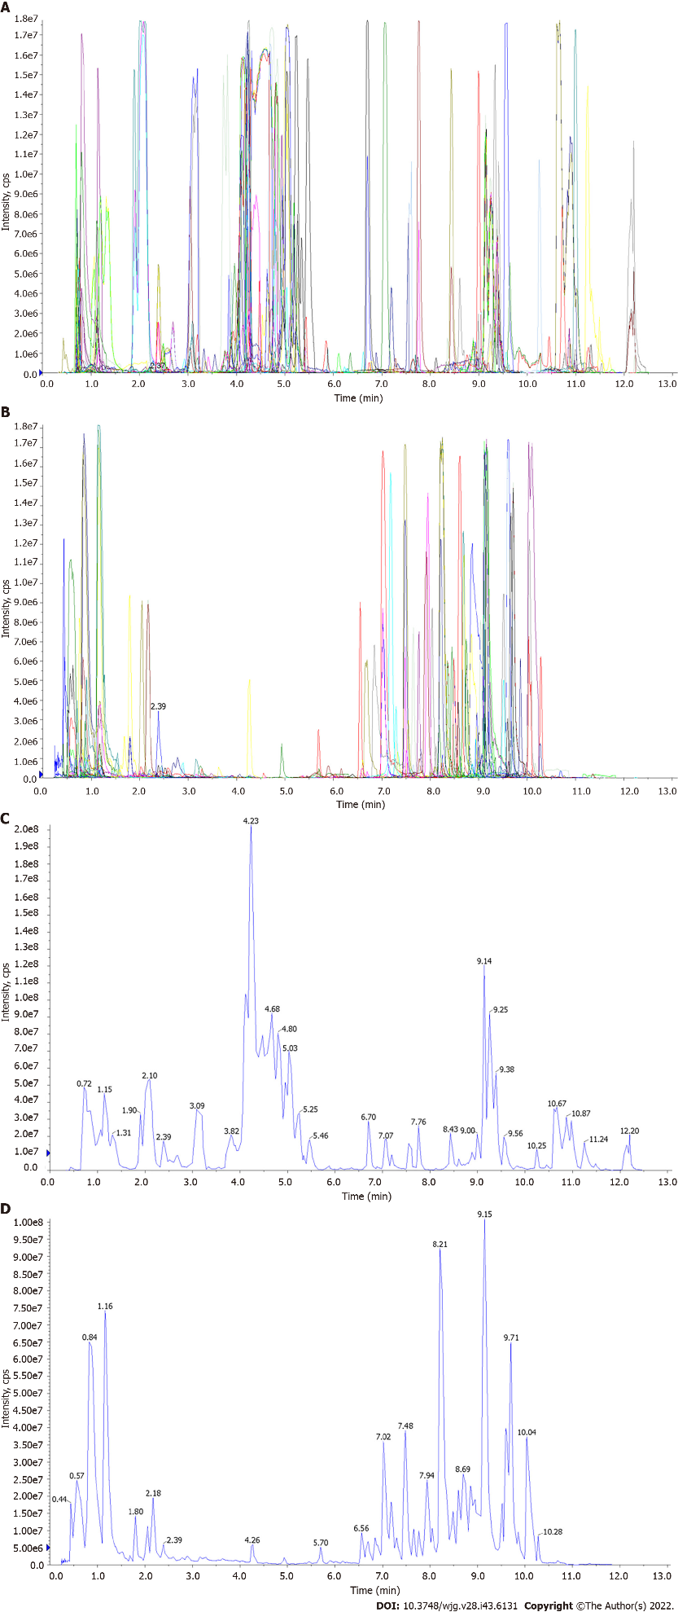
Figure 1 UPLC-MS/MS analysis of Salvia miltiorrhiza extract. A: Total ions Current-N of QC_MS; B: Total ions Current-P of QC_MS; C: MRM detection of multimodal maps-N; D: MRM detection of multimodal maps-P.

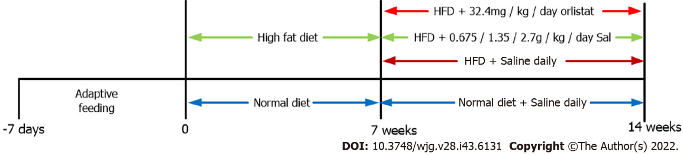
Figure 2 In vivo experiment scheme. Sal: Salvia miltiorrhiza.

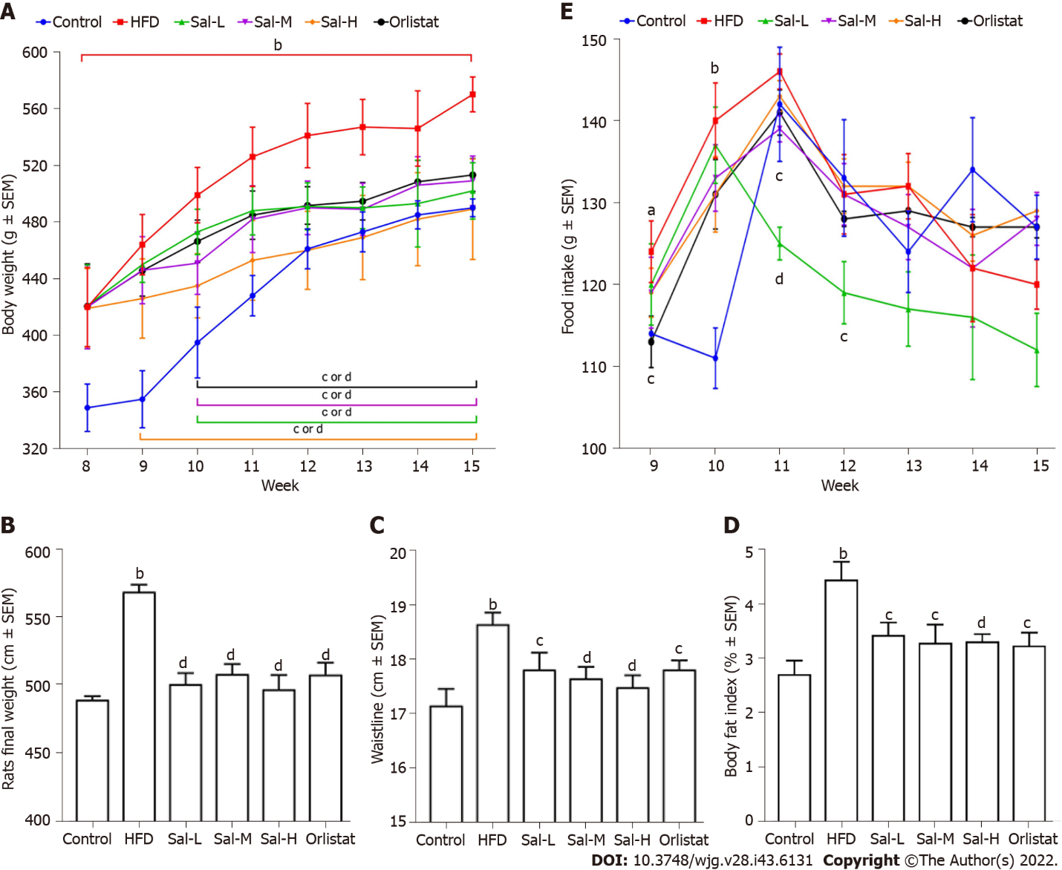
Figure 3 Therapeutic evaluation of Salvia miltiorrhiza in ameliorating high-fat diet-induced obesity in rats. A: Body weight change; B: Final weight; C: Waistline; D: Body fat index; E: Food intake. Values are expressed as the mean ± SE and analyzed by one-way ANOVA followed by Duncan’s multiple comparison test, n = 8. HFD: High-fat diet. ªP < 0.05, ^{b}P < 0.01 vs control group; ^{c}P < 0.05, ^{d}P < 0.01 vs HFD group.

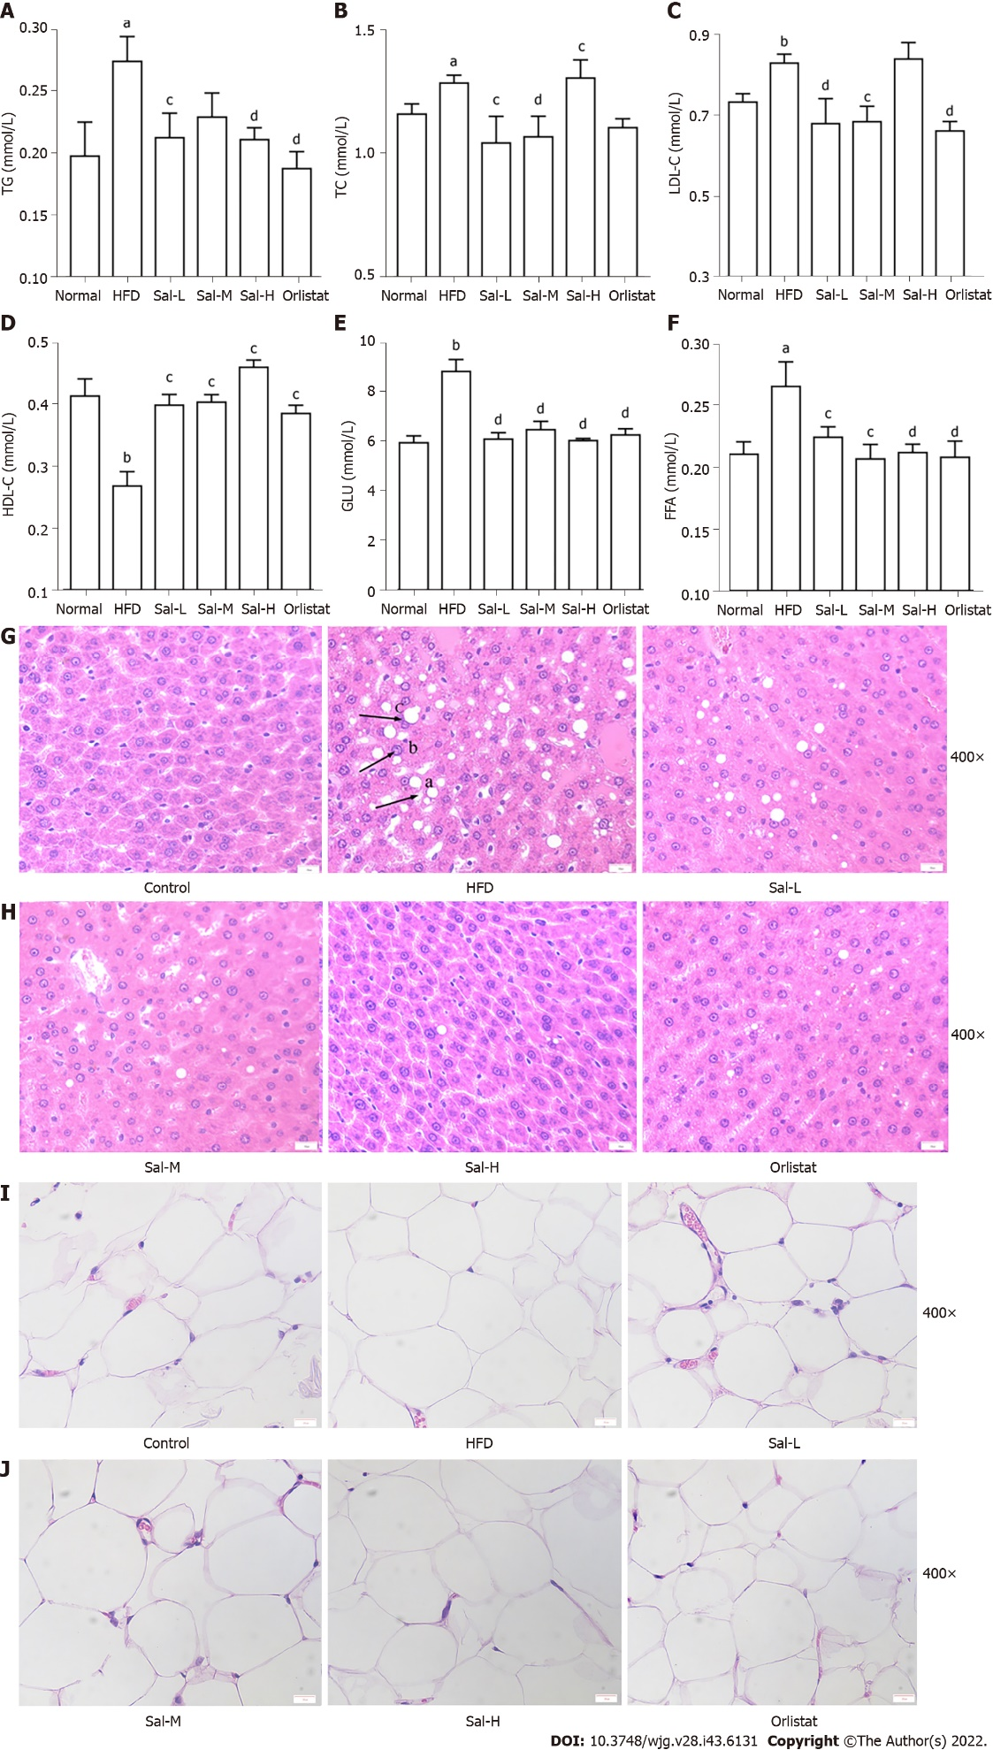
Figure 4 Effects of Salvia miltiorrhiza on serum lipid profiles, glucose, free fatty acid levels, and histopathological changes of the liver and adipose tissue in HFD-fed rats. A-D: Serum triglyceride, total cholesterol, low-density lipoprotein, and high-density lipoprotein levels; E: Serum glucose level; F: Serum free fatty acid level; G and H: Representative images of hematoxylin-and eosin-stained (H&E) sections of liver tissue (400 ×) in the six groups (a: Lipid droplet accumulation; b: Punctate necrosis of hepatocytes with inflammatory cell infiltration; c: Balloon-like changes) (Scale bars: 20 µm); I and J: Representative images of H&E sections of adipose tissue (400 ×) in the six groups (Scale bars: 20 µm). Significance between groups was calculated using one-way ANOVA followed by Duncan’s multiple comparison test. Data are shown as the mean ± SE. ªP < 0.05, ^{b}P < 0.01 vs control group; ^{c}P < 0.05, ^{d}P < 0.01 vs HFD group. Error bars represent standard error.

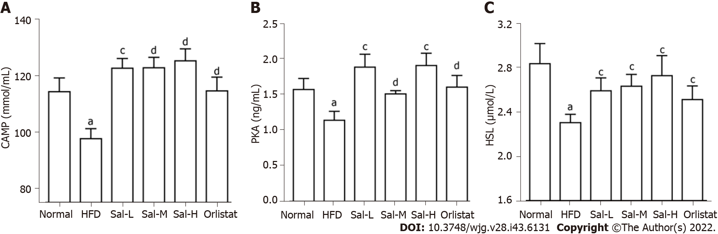
Figure 5 Levels of cAMP in liver tissue and HSL and PKA in adipose tissue of high-fat diet-fed rats. A: cAMP; B: PKA; C: HSL. Data are presented as the mean ± SE (n = 8). HFD: High-fat diet. ªP < 0.05, ^{b}P < 0.01 vs control group; ^{c}P < 0.05, ^{d}P < 0.01 vs HFD group.

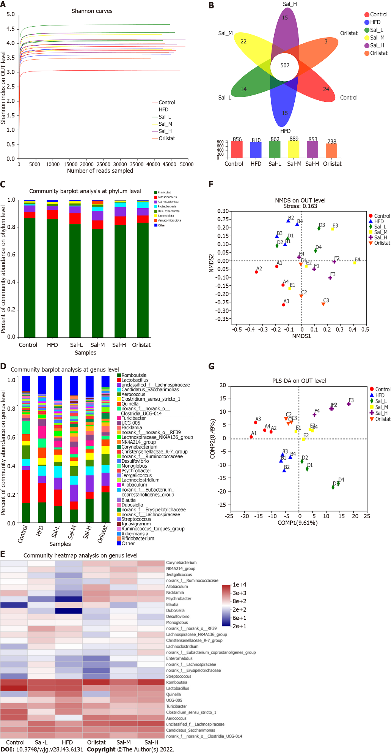
Figure 6 Beneficial effects of Salvia miltiorrhiza are associated with improved gut microbiome composition in high-fat diet-fed rats. A: α-diversity analysis: Shannon curves at the operational taxonomic unit (OTU) level; B: Venn diagram; C: Community bar plot analysis at the phylum level; D: Community bar plot analysis at the genus level; E: Community heatmap analysis of 30 species at the genus level; F: Non-metric multidimensional scaling (NMDS) at the OTU level; G: Partial least squares discriminant analysis (PLS-DA) score at the OTU level.

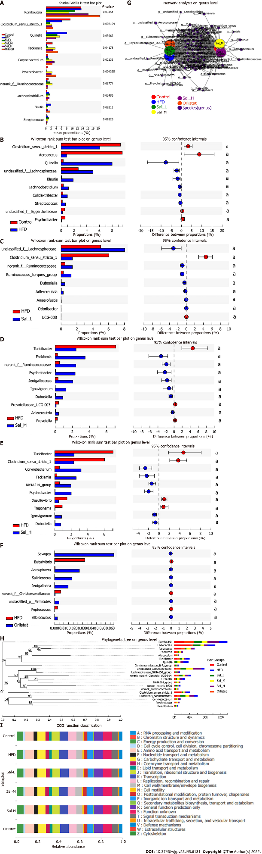
Figure 7 Effect of Salvia miltiorrhiza on intestinal microbiota composition in six groups of rats. A: Differential analysis among these six groups at the genus level; B-F: Differential analysis between control and high-fat diet (HFD) groups, HFD and Sal_L groups, HFD and Sal_M groups, HFD and Sal_H groups, and HFD and orlistat groups at the genus level (ªP < 0.05, ^{b}P < 0.01); G: Network analysis at the genus level; H: Phylogenetic tree at the genus level; I: COG functional classification.

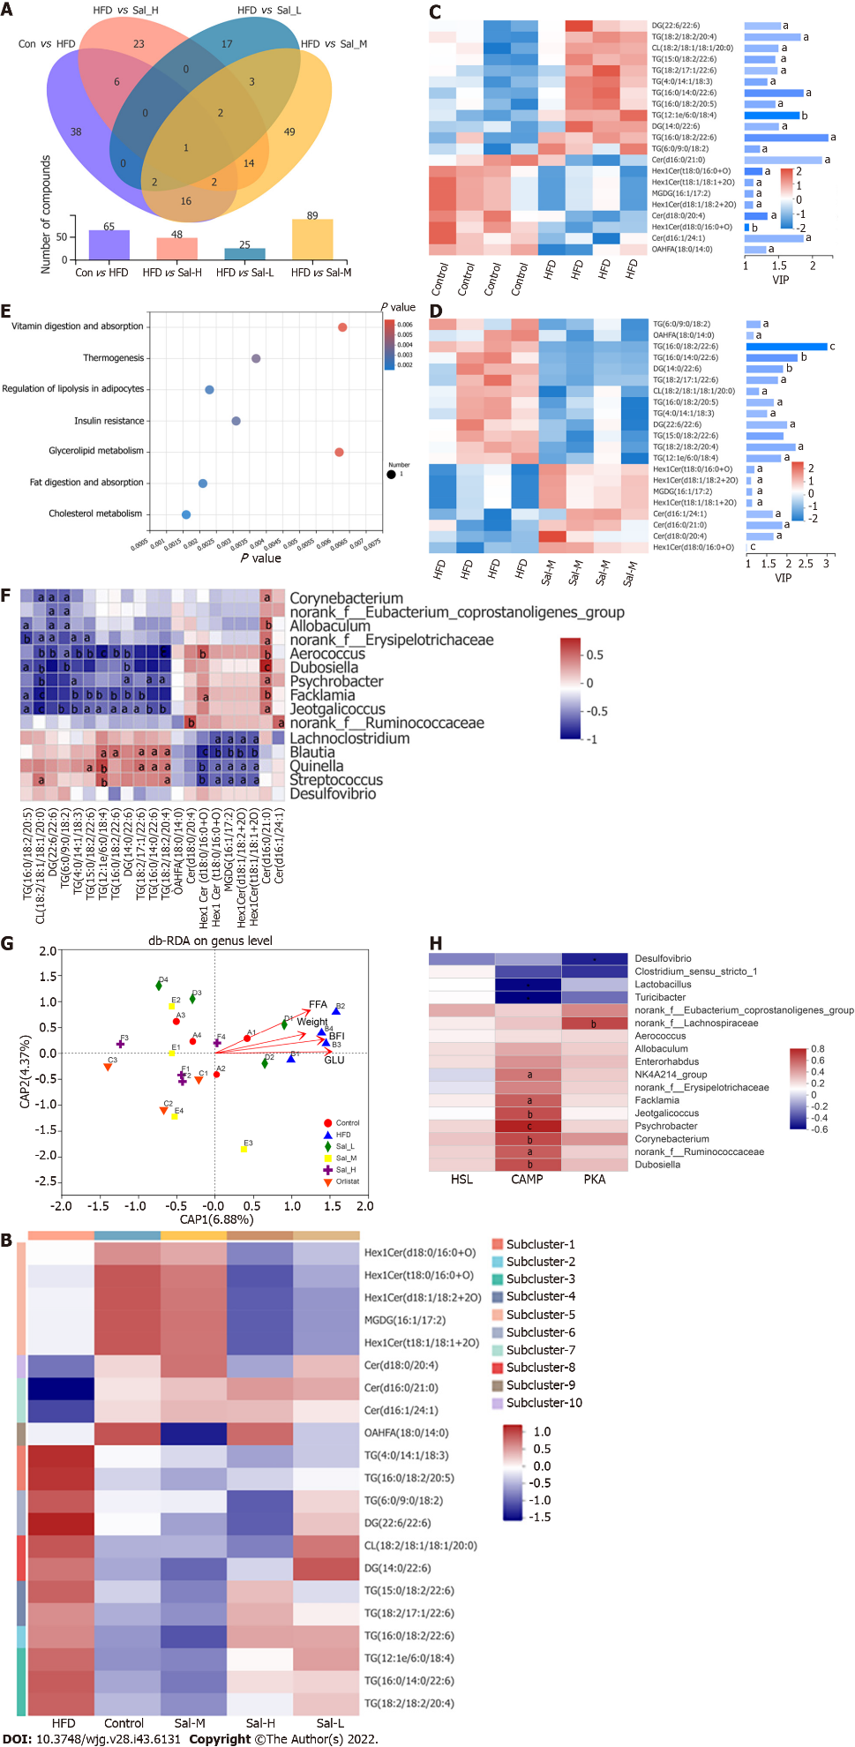
Figure 8 Lipidomics analysis and associations of gut microbial species with environmental factors. A: Numbers of differential metabolites between the control and high-fat diet (HFD) groups, HFD and Sal_L groups, HFD and Sal_M groups, and HFD and Sal_H groups (Venn diagram); B: Hierarchical clustering of metabolites in Control, HFD, Sal_L, Sal_M, and Sal_H groups; C: Heatmap of the VIP expression profile of the metabolites between control and HFD groups; D: Heatmap of the VIP expression profile of the metabolites between HFD and Sal_M groups; E: KEGG pathway enrichment; F: Spearman’s correlation between metabolites and gut microbiota; G: Correlation between free fatty acids, weight, body fat index, glucose, and microbial flora structure displayed by distance-based redundancy analysis (db-RDA analysis); H: Spearman’s correlation between cAMP, PKA, HSL, and gut microbiota. ªP < 0.05, ^{b}P < 0.01, or ^{c}P < 0.001.

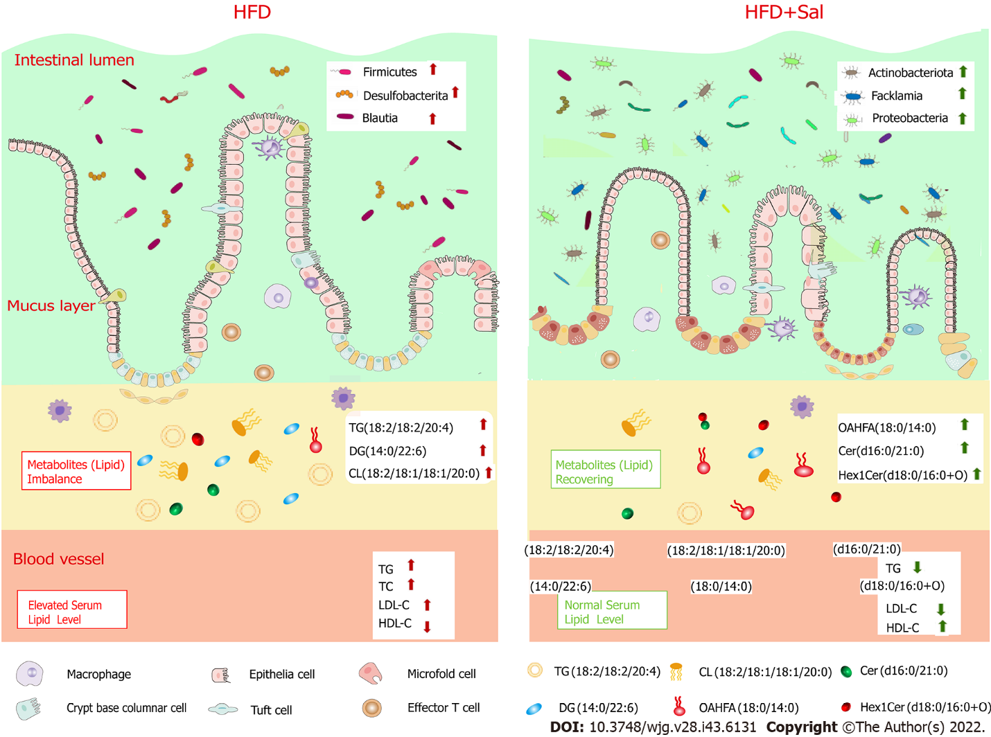
Figure 9 Graphical illustration of mechanism of action of Salvia miltiorrhiza to alleviate obesity. Salvia miltiorrhiza ameliorated obesity by reshaping the balance of gut microbiota, modulating the lipid metabolites, and improving blood lipids. Sal: Salvia miltiorrhiza extract; HFD: High-fat diet; TG: Triglycerides; TC: Total cholesterol; HDL-C: High-density lipoprotein; LDL-C: Low-density lipoprotein; GLU: Glucose; FFA: Free fatty acids.

Table 1 Some metabolites detected in Salvia miltiorrhiza extract
Index | Compounds | Class I
pme2292 | Putrescine | Alkaloids
pmf0096 | Oxalic acid | Organic acids
Zmyn000268 | 2,3-Dihydroxypropanal | Others
pme2601 | 3-Hydroxypropanoic acid | Organic acids
MWS1787 | 2-Picoline; 2-Methylpyridine | Alkaloids
pma6298 | 3-Hydroxypyridine | Alkaloids
MWSmce460 | 2-Piperidone | Alkaloids
MWS1990 | 4-Pentenoic acid | Organic acids
MWSmce461 | L-Azetidine-2-carboxylic acid | Alkaloids
MWStz073 | 5-Hydroxy-2-pyrrolidinone | Alkaloids

Table 2 Species nodes
Node name | Degree | Weighted degree
g_Romboutsia | 6 | 36385.41667
g_Aerococcus | 6 | 13881.41667
g_Turicibacter | 6 | 10477.08333
g_Quinella | 6 | 269.16667
g_Facklamia | 6 | 6077.25000
g_Corynebacterium | 6 | 4418.00000
g_Desulfovibrio | 6 | 2716.58333
Node name represent species nodes. Degree is the degree of the node. Weighted degree, which means the degree weight of the node, is the number of species sequences corresponding to the node.
Table 3 Differential metabolites in feces after Sal treatment
NO | Metabolite | Rt (mi) | m/z | Formula | VIP |  | FC |  | Trend
 |  |  |  |  | H vs C | S vs H | H vs C | S vs H | H vs C | S vs H
1 | Cer (d18:0/20:4) | 6.72 | 588.54 | C₃₈ H₇₀ O₃ N₁ | 1.34 | 1.67 | 1.07 | 0.90 | ↓ª | ↑^{c}  ↑*
2 | DG (14:0/22:6) | 6.62 | 630.51 | C₃₉ H₆₈ O₅ N₁ | 1.51 | 1.91 | 0.91 | 1.14 | ↑ª | ↓^{d}  ↑**
3 | DG (22:6/22:6) | 6.56 | 730.54 | C₄₇ H₇₂ O₅ N₁ | 1.54 | 2.01 | 0.91 | 1.15 | ↑ª | ↓^{c}  ↑**
4 | Hex1Cer (d18:0/16:0 + O) | 6.01 | 718.58 | C₄₀ H₈₀ O₉ N₁ | 1.07 | 1.01 | 1.03 | 1.01 | ↓ª | ↑^{c}  ↓**
5 | Hex1Cer (d18:1/18:2 + 2O) | 5.76 | 756.56 | C₄₂ H₇₈ O₁₀ N₁ | 1.13 | 1.12 | 1.04 | 1.12 | ↓ª | ↑^{c}  -  -
6 | Hex1Cer (t18:0/16:0 + O) | 5.79 | 734.58 | C₄₀ H₈₀ O₁₀ N₁ | 1.26 | 1.20 | 1.05 | 1.20 | ↓ª | ↑^{c}  ↑*  ↑**
7 | Hex1Cer (t18:1/18:1 + 2O) | 5.80 | 756.56 | C₄₇ H₇₂ O₅ N₁ | 1.13 | 1.14 | 1.04 | 1.14 | ↓ª | ↑^{c}
8 | MGDG (16:1/17:2) | 5.70 | 756.56 | C₄₇ H₇₂ O₅ N₁ | 1.13 | 1.14 | 1.04 | 0.96 | ↓ª | ↑^{c}
9 | TG (6:0/9:0/18:2) | 4.39 | 615.46 | C₃₆ H₆₄ O₆ Na₁ | 1.23 | 1.36 | 0.95 | 1.06 | ↑ª | ↓^{c}
10 | TG (4:0/14:1/18:3) | 6.29 | 631.49 | C₃₉ H₆₇ O₆ | 1.34 | 1.52 | 0.93 | 1.08 | ↑ª | ↓^{c}
11 | TG (12:1e/6:0/18:4) | 5.82 | 615.50 | C₃₉ H₆₇ O₅ | 1.82 | 1.86 | 0.90 | 1.12 | ↑^{b} | ↓^{c}
12 | TG (16:0/14:0/22:6) | 12.21 | 868.74 | C₅₅ H₉₈ O₆ N₁ | 1.87 | 2.27 | 0.87 | 1.18 | ↑ª | ↓^{d}
13 | TG (16:0/18:2/20:5) | 12.82 | 877.73 | C₅₇ H₉₇ O₆ | 1.46 | 1.68 | 0.94 | 1.08 | ↑ª | ↓^{c}
14 | TG (15:0/18:2/22:6) | 11.72 | 895.74 | C₅₈ H₉₆ O₆ Li₁ | 1.45 | 1.92 | 0.92 | 1.13 | ↑ª | ↓^{d}
15 | TG (18:2/18:2/20:4) | 11.79 | 920.77 | C₅₉ H₁₀₂ O₆ N₁ | 1.83 | 2.22 | 0.87 | 1.19 | ↑ª | ↓^{c}
16 | TG (16:0/18:2/22:6) | 12.36 | 925.73 | C₅₉ H₉₈ O₆ Na₁ | 2.24 | 3.01 | 0.80 | 1.36 | ↑ª | ↓^{e}
17 | TG (18:2/17:1/22:6) | 11.60 | 921.75 | C₆₀ H₉₈ O₆ Li₁ | 1.49 | 1.78 | 0.91 | 1.12 | ↑ª | ↓^{c}
18 | CL (18:2/18:1/18:1/20:0) | 5.57 | 741.53 | C₈₃ H₁₅₂ O₁₇ P₂ | 1.50 | 1.31 | 0.95 | 1.05 | ↑ª | ↓^{c}
19 | Cer (d16:0/21:0) | 8.47 | 626.57 | C₃₈ H₇₆ O₅ N₁ | 2.14 | 1.89 | 1.12 | 0.88 | ↓ª | ↑^{c}
20 | Cer (d16:1/24:1) | 9.02 | 664.59 | C₄₁ H₇₈ O₅ N₁ | 1.87 | 1.66 | 1.11 | 0.89 | ↓ª | ↑^{c}
21 | OAHFA (18:0/14:0) | 5.70 | 756.56 | C₄₇ H₇₂ O₅ N₁ | 1.32 | 1.18 | 0.95 | 0.94 | ↓ª | ↑^{c}
ªP < 0.05.
^{b}P < 0.01 vs control group.
^{c}P < 0.05.
^{d}P < 0.01.
^{e}P < 0.001 vs high-fat diet (HFD) group.
Control, HFD, and Sal_M (n = 8 per group) groups. ↑, metabolite content increased; ↓, metabolite content decreased; C: Control group; H: High-fat diet group; S: Sal_M group.

Published by Baishideng Publishing Group Inc
7041 Koll Center Parkway, Suite 160, Pleasanton, CA 94566, USA
Telephone: +1-925-3991568
E-mail: bpgoffice@wjgnet.com
Help Desk: https://www.f6publishing.com/helpdesk
https://www.wjgnet.com

© 2022 Baishideng Publishing Group Inc. All rights reserved.

