Name of journal: World Journal of Gastroenterology
ESPS Manuscript NO: 9534
Columns: CLINICAL TRIALS STUDY

Magnifying endoscopy of gastric epithelial dysplasia based on the morphologic characteristics

Kang et al. Magnifying endoscopy of gastric epithelial dysplasia

Hwa Mi Kang, Gwang Ha Kim, Do Youn Park, Hong Ryeol Cheong, Dong Hoon Baek, Bong Eun Lee, Geun Am Song

Hwa Mi Kang, Department of Internal Medicine, Busan Adeventist Hospital, Busan 602-819, South Korea

Gwang Ha Kim, Hong Ryeol Cheong, Dong Hoon Baek, Bong Eun Lee, Geun Am Song, Department of Internal Medicine, Pusan National University School of Medicine, Busan 602-739, South Korea

Do Youn Park, Department of Pathology, Pusan National University School of Medicine, Busan 602-739, South Korea

Author contributions: Kim GH and Park DY designed the study; Cheong HY and Baek DH analyzed the data; Kim GH and Lee BE performed the study; Kang HM and Kim GH collected the data; Song GA reviewed the data of study population; and Kang HM and Kim GH wrote the paper.

Supported by Grant from the Korea Healthcare technology R&D Project, Ministry of Health and Welfare, Republic of Korea, No. A121994

Correspondence to: Gwang Ha Kim, MD, PhD, Department of Internal Medicine, Pusan National University School of Medicine, 1-10 Ami-dong, Seo-gu, Busan 602-739, South Korea. doc0224@pusan.ac.kr

Telephone: +82-51-2407869 Fax: +82-51-2448180

Received: February 16, 2014 Revised: June 4, 2014
Accepted: June 25, 2014
Published online:

Abstract
AIM: To investigate the difference in magnifying endoscopic findings of gastric epithelial dysplasias (GEDs) according to the morphologic characteristics.

METHODS: This study included 46 GED lesions in 45 patients who underwent magnifying endoscopy using narrow band imaging (ME-NBI) before endoscopic resection. During ME-NBI, the microvascular (MV) and microsurface (MS) patterns and the presence of light blue crest (LBC) and white opaque substance (WOS) were investigated. GEDs were categorized as adenomatous, foveolar, and hybrid types, and their mucin phenotype was evaluated.

RESULTS: Of the 46 lesions, 27 (59%) were categorized as adenomatous, 15 (32%) as hybrid, and the remaining 4 (9%) as foveolar. All adenomatous GEDs showed the round pit and/or tubular MS patterns, all foveolar GEDs showed the papillary pattern, and hybrid GEDs showed mixed patterns (P < 0.001). LBC was more frequently observed in adenomatous GEDs than in hybrid or foveolar GEDs (52%, 33%, 0%, respectively), although this difference was not significant (P = 0.127). The papillary MS pattern was associated with MUC5AC and MUC6 expression, and the round pit and/or tubular MS patterns were associated with CD10 expression.

CONCLUSION: The MS pattern in ME-NBI findings is useful for predicting the morphologic category and mucin phenotype of GEDs, and ME-NBI findings may guide decisions regarding GED treatment.

© 2014 Baishideng Publishing Group Inc. All rights reserved.

Key words: Stomach; Dysplasia; Narrow band imaging; Magnifying endoscopy; Mucin

Core tip: Microsurface patterns in the magnifying endoscopy using narrow band imaging (ME-NBI) are different according to the morphologic category and mucin phenotype in gastric epithelial dysplasias (GEDs). Considering that foveolar GEDs tend to be associated with high-grade morphology, ME-NBI findings such as the papillary microsurface pattern may guide decisions regarding GED treatment.

Kang HM, Kim GH, Park DY, Cheong HR, Baek DH, Lee BE, Song GA. Magnifying endoscopy of gastric epithelial dysplasia based on the morphologic characteristics. World J Gastroenterol 2014; In press

INTRODUCTION
Gastric epithelial dysplasia (GED) is generally accepted as a neoplastic lesion to gastric adenocarcinoma^{[1]}. GED has traditionally been categorized into the adenomatous (or intestinal) and foveolar (or gastric) types on the basis of morphologic features^{[2,3]}, but the clinical relevance of this GED classification has not been extensively studied thus far. Western studies have shown that most foveolar GEDs are low grade, while adenomatous GEDs tend to be associated with intestinal metaplasia and high grade, and tend to have an increased risk of malignant transformation^{[4,5]}. In contrast, East Asian studies have shown that foveolar GEDs are more commonly high grade and are associated with the development of secondary dysplastic lesion^{[6,7]}. Recent developments in mucin immunohistochemistry have supported efforts to categorize gastric neoplasms on the basis of the pattern of mucin expression. Previous studies have reported that the pattern of mucin expression in gastric cancer is clinically significant, suggesting biologic differences in pre-neoplastic lesions and/or the process of malignant transformation^{[8-11]}.
Magnifying endoscopy (ME) has been used clinically because it enables visualization of the mucosa in great detail. Many studies have been reported on the clinical application of ME, particularly for the colon and esophagus^{[12-14]}. Additionally, the application of ME using narrow band imaging (ME-NBI) is becoming increasingly common, and it has been reported to be useful for the diagnosis of gastrointestinal tumors^{[15-17]} as well as histologic gastritis^{[18-20]}. In fact, the characteristic ME-NBI findings for gastric carcinoma are well demonstrated^{[9,10,12]}. However, only a few studies have investigated the usefulness of ME-NBI for GEDs^{[4,8,21]}, and to our knowledge, no study has examined the ME-NBI findings of GEDs depending on the morphologic category and pattern of mucin expression. Therefore, the present study aimed to investigate the difference in ME-NBI findings between adenomatous and foveolar GEDs, and to analyze the association between ME-NBI findings and the mucin expression pattern.

MATERIALS AND METHODS
Study population
A total of 46 GEDs in 45 patients (28 men and 17 women; age range, 45-82 yr; mean age, 62 yr) who underwent ME-NBI and were diagnosed with GED by endoscopic resection were enrolled between June 2012 and May 2013. All patients underwent upper endoscopy for various indications, including health check-ups and complaints of abdominal discomfort or dyspepsia. The following patients were excluded from the study: patients who had severe systemic diseases or advanced chronic liver diseases; those on histamine-2 receptor antagonists, proton-pump inhibitors, or non-steroidal anti-inflammatory drugs; those who had received Helicobacter pylori (H. pylori) eradication therapy; and those with a history of gastric surgery. The study protocol was reviewed and approved by the Institutional Review Board of the Pusan National University Hospital.

Magnifying endoscopy using narrow band imaging
The EVIS-LUCERA SPECTRUM system (Olympus Medical Systems Corp., Tokyo, Japan), comprising a light source (CLV-260SL), a processor (CV-260SL), and a magnifying video endoscope (GIF-H260Z), was used as the video endoscopy system. This system was equipped with both white light and NBI modes, which could be toggles within one minute, using a button on the control head of the video endoscope. The system can reach zoom magnifications of 80 ×. To obtain a clear view with ME-NBI, a soft black hood (MB-46; Olympus Medical Systems) was fitted on the distal tip of the endoscope in order to maintain the focal distance.
ME-NBI was performed by a single experienced endoscopist (Kim GH) who had previously performed over 100 ME-NBI examinations. All with conventional endoscopy, all examinations were performed under conscious sedation with 2-5 mg of midazolam. After routine observation, ME-NBI examinations of GED areas were performed to evaluate the microvascular (MV) pattern, microsurface (MS) pattern, and the presence or absence of light blue crest (LBC) and white opaque substance (WOS) (Figures 1, 2). MV patterns were categorized as regular or irregular, while MS patterns were classified as (1) round pit, (2) tubular, (3) mixed (both round pit and tubular), (4) papillary, or (5) absent. LBC was defined as a fine, blue-white line on the crest of the epithelial surface/gyri^{[19,20]}. and WOS was defined as a whitish substance that obscured the MV pattern within a neoplastic lesion^{[22,23]}. LBC or WOS was considered positive when these features were present in ≥ 10% of the dysplastic area.

Endoscopic resection
Endoscopic resection was performed by 2 experienced endoscopists (Kim GH and Song GA), using a single-channel endoscope (GIF-H260 or GIF-Q260; Olympus Co., Ltd., Tokyo, Japan). Endoscopic resection was performed under conscious sedation, with cardio-respiratory monitoring. For sedation, 5-10 mg of midazolam and 25 mg of meperidine were administered intravenously; propofol was administered as needed during the procedure. Two methods were used: endoscopic mucosal resection (EMR) and endoscopic submucosal dissection (ESD). In EMR, the saline solution (0.9% saline with small amount of epinephrine and indigo carmine) was injected into the submucosal layer to separate the superficial layers from the muscularis propria, thereby reducing the risk of perforation. The lesion was then resected using a snare. In ESD, marking outside the lesion, identified by conventional endoscopy or chromoendoscopy with indigo carmine solution, was made with argon plasma coagulation. After marking, the saline solution was injected submucosally around the lesion to lift it off the muscular layer. And then, a circumferential mucosal incision was performed outside the marking dots using the IT knife (Olympus Optical Co., Ltd., Tokyo, Japan) and/or Flex knife (Olympus Optical Co., Ltd.). Next, submucosal dissection was carried out with the above mentioned knives for complete removal of the lesion. If necessary during the procedure, a submucosal injection was repeated and endoscopic hemostasis was achieved. A high-frequency electrosurgical current generator (Erbotom VIO 300D; ERBE, Tübingen, Germany) was used during marking, mucosal incision, submucosal dissection and hemostasis.

Histological assessment
Endoscopic resection was performed within 2 wk after ME-NBI. The resected specimens were fixed in 10% buffered formalin. GEDs with adjacent non-GED mucosa were serially cut into 2-mm slices in parallel, embedded in paraffin, sectioned, and stained with hematoxylin-eosin for histologic examination. All histologic samples were examined by an expert pathologist (Park DY) who was blinded to the ME-NBI findings. Each lesion was categorized as adenomatous, foveolar, or hybrid on the basis of morphologic features as described previously^{[3,4,6]}. Adenomatous GED was characterized by tubules or glands lined by columnar cells with hyperchromatic, pencillate nuclei with pseudostratification, similar to the colonic adenomatous epithelium (Figure 1). In contrast, foveolar GED featured columnar cells with a pale cytoplasm and basally located round to oval nuclei, resembling the gastric foveolar epithelium (Figure 2). Hyperplasia of the foveolar region with irregular glandular branching and epithelial folding was also frequently noted in foveolar GED. When GED showed at least 10% of the second phenotype, it was classified as hybrid. Each GED was also classified as low or high grade depending on architectural complexity and cytologic atypia^{[3,24]}.

Mucin phenotype
We immunohistochemistry examined the expression of MUC2 (Ccp58, 1:500; Novocastra Laboratories, Newcastle, UK), MUC5AC (CLH2, 1:500; Novocastra Laboratories), MUC6 (CLH5, 1:500; Novocastra Laboratories), and CD10 (56C6, 1:100; Novocastra Laboratories) in the dysplastic epithelium as described previously^{[6]}. Briefly, 5-µm-thick consecutive sections were deparaffinized and hydrated through a graded series of alcohol. After inhibition of endogenous peroxidase activity by immersion in 3% H₂O₂/methanol solution, antigen retrieval was conducted by treatment with 10 mmol/L citrate buffer (pH 6.0) in a microwave oven for 10 min. Next, the sections were thoroughly washed in phosphate-buffered solution and incubated first with biotinylated secondary antibody and then with avidin-biotinylated horseradish peroxidase complex (Vectastain Elite ABC kit; Vector Laboratories, Burlingame, CA, USA). Finally, the immune complexes were visualized by incubation with 0.01% H₂O₂ and 0.05% 3,3’-diaminobenzidine tetrachloride. Nuclear counterstaining was accomplished using Mayer’s hematoxylin. Immunostaining was considered positive if at least 10% of the dysplastic cells were immunoreactive^{[6,10]}. Mucin phenotypes were divided into 4 types, namely, gastric (G-type), intestinal (I-type), gastrointestinal (GI-type), and unclassified (N-type), depending on the combination of immunohistochemical markers expressed for gastric mucin (MUC5AC and MUC6) and intestinal mucin (MUC2 and CD10) (Figures 1, 2). MUC5AC, MUC6, MUC2, and CD10 have been found to be specifically expressed in the gastric foveolar epithelium, pyloric gland cells, goblet cells, and brush border, respectively^{[25]}.

Statistical analysis
Differences in clinicopathologic and ME-NBI findings among the 3 GED types were evaluated using the one-way analysis of variance (ANOVA) test for continuous data and the χ² test for categorical variables. The association between mucin expression and ME-NBI findings was assessed using the χ² test or Fisher’s exact test. Statistical calculations were performed using the SPSS version 21.0 software for Windows (SPSS, Chicago, USA). Results were considered statistically significant when the P value was < 0.05.

RESULTS
Clinicopathologic characteristics of GEDs
Of the 46 GED lesions, 27 (59%) were categorized as adenomatous, 15 (32%) as hybrid, and the remaining 4 (9%) as foveolar on the basis of their morphologic features (Table 1). Patients with adenomatous GEDs were younger than those with hybrid or foveolar GEDs (P = 0.023). No significant difference was found in the tumor size, location, color, gross shape, and histologic grade among the 3 GED types. However, the prevalence of H. pylori infection was higher in cases of adenomatous GEDs than in those of hybrid and foveolar GEDs (85%, 47%, 50%, respectively; P = 0.020). In terms of the mucin phenotype, adenomatous GEDs mainly showed the I-type (82%), hybrid GEDs mainly showed the G-type (53%) and GI-type (40%), and all foveolar GEDs showed the G-type (100%) (P < 0.001).

ME-NBI findings of GEDs
The irregular MV pattern was observed in 56% of the adenomatous GEDs, 73% of the hybrid GEDs, and 75% of the foveolar GEDs (P = 0.517) (Table 2). All adenomatous GEDs showed the round pit and/or tubular patterns. All 4 foveolar GEDs showed the papillary pattern (100%), while the hybrid GEDs mainly showed the mixed (33%) and papillary (33%) patterns. Thus, the MS patterns differed significantly depending on the morphologic category (P < 0.001). LBC was observed more commonly in adenomatous GEDs than in hybrid and foveolar GEDs (52%, 33%, 0%, respectively), but this difference was not statistically significant (P = 0.127). Further, no difference in the presence of WOS was observed among the 3 GED types.

Association between mucin expression and ME-NBI findings
The round pit and/or tubular patterns, which were the main MS patterns exhibited by adenomatous GEDs, were associated with CD10 expression (P < 0.001). In contrast, the papillary MS pattern mainly shown by foveolar GEDs was associated with MUC5AC and MUC6 expression (P = 0.001 and P = 0.014, respectively) (Table 3). The MV pattern was not associated with the expression of any mucin marker. The presence of LBC was associated with CD10 expression (P = 0.002), but the presence of WOS was not associated with the expression of any mucin marker (Table 4).

DISCUSSION
GED is an unusual neoplasm that could be a direct precursor to gastric carcinoma^{[5]}, but there is no consensus on the management of this lesion when it is diagnosed by pre-treatment biopsy^{[21]}. In our previous study, we found that adenomatous and foveolar GEDs show distinct clinicopathologic features: foveolar GEDs tend to be associated with high-grade morphology^{[6]}. Therefore, we hypothesized that treatment plans could be devised more effectively if the morphologic category of GEDs could be predicted. Although some studies have examined ME-NBI findings for GEDs^{[15,21,26-28]}, to our knowledge, no study has investigated the ME-NBI findings of GEDs categorized morphologically. The results of the present study showed a clear difference in the MS pattern between adenomatous and foveolar GEDs. The former showed the round pit and/or tubular patterns, whole the latter predominantly showed the papillary pattern. In addition, the round pit and/or tubular patterns were associated with CD10 expression, whereas the papillary pattern was associated with MUC5AC and MUC6 expression.
ME-NBI enables clearly visualization of the MS structure as well as the MV structure of an organ. Therefore, the MS pattern on ME-NBI may have reflected the histologic characteristics of the GEDs. In fact, because pathologic examination shows that adenomatous GEDs are composed of large tubules on pathology, they exhibited round pit and/or tubular patterns on ME-NBI. On the other hand, because hyperplasia of the foveolar region with irregular glandular branching and epithelial folding is usually seen in foveolar GEDs, they exhibited a papillary pattern on ME-NBI, like ikra. Hybrid GEDs exhibited a mix of the MS patterns of adenomatous and foveolar GEDs. However, the MV pattern did not differ between adenomatous and foveolar GEDs. Therefore, the morphologic category of GEDs can be predicted only from the MS pattern on ME-NBI before endoscopic resection.
We previously found that in terms of mucin phenotype exhibited, the foveolar GEDs were more often positive for MUC5AC, while adenomatous GEDs were more often positive for CD10^{[6]}. Similarly, in the present study, adenomatous GEDs mainly exhibited the I-type; foveolar GEDs, the G-type; and hybrid GEDs, the G- and GI-types. We also investigated the ME-NBI findings of the GEDs according to the mucin expression and found that although the MV pattern was not associated with mucin expression, the MS pattern differed significantly depending on the mucin phenotype expressed. The round pit and/or tubular patterns, the main MS patterns shown by adenomatous GEDs, were associated with CD10 expression, while the papillary pattern, the main MS pattern of foveolar GEDs, was associated with MUC5AC and MUC6 expression. These results suggest that the mucin phenotype influences morphogenetic differences in the surface glandular structure^{[25]}.
LBC is thought to be an accurate predictor of intestinal metaplasia of the stomach^{[19,20]}. It is speculated that LBC results from differences in the reflectance of the light at the surface of the brush border and that LBC is associated with cells positive for CD10^{[19]}. The present study, too, found that LBC was associated with CD10 expression. Further, LBC was found more often with adenomatous GEDs than foveolar GEDs, although this difference was not statistically significant. In our previous study, we found that foveolar GEDs were associated more often with background intestinal metaplasia showing retained expression of G-type mucin^{[6]}. In contrast, adenomatous GEDs were significantly associated with background intestinal metaplasia showing a complete I-type mucin phenotype (CD10). This difference in mucin expression in the background intestinal metaplasia could explain the biologic difference in mucin expression between the morphologically distinct GEDs, which in turn explains why LBC is seen more often in adenomatous GEDs than in foveolar GEDs.
WOS is known to result from the accumulation of lipid droplets in the neoplastic GED cells, which suggests that GEDs with WOS may have the ability to absorb lipids^{[29]}. The frequency of occurrence of WOS remains poorly elucidated. In a Japanese study, 26 (53%) of 49 GEDs showed WOS, which was observed in GI- and I-type GEDs^{[22]}. In the present study, the frequency of WOS was 33% (15/46), and it did not differ depending on morphologic category or mucin phenotype expressed.
This study has some limitations, which must be acknowledged. First, this was a retrospective study that evaluated the difference in ME-NBI findings between adenomatous and foveolar GEDs. Therefore, some bias may have been introduced when the ME-NBI images were retrospectively reviewed. However, we capture at least 8-15 images per GED during ME-NBI, and this comprehensive collection of images may compensate for the retrospective nature of this study to some degree. Second, we could not exactly match each portion of the ME-NBI image to its corresponding portion in the histologic specimens, especially those stained immunohistochemically. Third, the number of foveolar GEDs was relatively lower than that of adenomatous GEDs. In our experience, foveolar GEDs constitute about 15%-20% of all GEDs (unpublished data). The number of hybrid GEDs, which are a mixed form of adenomatous and foveolar GEDs, however, was quite high, and these GEDs showed characteristic ME-NBI findings of both adenomatous and foveolar GEDs. Therefore, we believe that the small number of foveolar GEDs could not have influenced the interpretation of our results. Lastly, since the ME-NBI findings were interpreted by a single experienced endoscopist, inter-observer variation was not evaluated. Although the reliability of ME-NBI findings has been reported recently^{[30,31]}, inter-observer variability in assessing these findings must be evaluated before clinical application. Furthermore, computer-assisted automatic analysis for ME-NBI images would be considered for quantitative examinations going beyond qualitative observation^{[32,33]}.
In conclusion, MS pattern in the ME-NBI findings is useful for predicting the morphologic category and mucin phenotype in GEDs. Considering that foveolar GEDs tend to be associated with high-grade morphology, ME-NBI findings such as the papillary MS pattern may guide decisions regarding GED treatment.

COMMENTS
Background
Gastric epithelial dysplasia (GED) has traditionally been categorized into the adenomatous and foveolar types based on the morphologic characteristics. Magnifying endoscopy using narrow band imaging (ME-NBI) has been used clinically because it enables visualization of the mucosa in great detail. There has been no study about the ME-NBI findings of GEDs depending on the morphologic category.
Research frontiers
In this study, the authors investigated the difference in ME-NBI findings between adenomatous and foveolar GEDs, and analyzed the association between ME-NBI findings and the mucin expression pattern.
Innovations and breakthroughs
All adenomatous GEDs showed the round pit and/or tubular microsurface (MS) patterns, all foveolar GEDs showed the papillary pattern, and hybrid GEDs showed mixed patterns. Light blue crest was more frequently observed in adenomatous GEDs than in hybrid or foveolar GEDs. The papillary MS pattern was associated with MUC5AC and MUC6 expression, and the round pit and/or tubular MS patterns were associated with CD10 expression.
Applications
The MS pattern in the ME-NBI findings is useful for predicting the morphologic category and mucin phenotype in GEDs. Considering that foveolar GEDs tend to be associated with high-grade morphology, ME-NBI findings such as the papillary MS pattern may guide decisions regarding GED treatment.
Peer review
This is an interesting descriptive paper on use of magnifying endoscopy of gastric epithelial dysplasia based on the morphologic characteristics. As such there is little to criticize and overall quality of the paper is good.

REFERENCES
1 Lewin KJ, Appleman HD. Carcinoma of the stomach. In: Rosai J ed. Atlas of Tumor Pathology. Tumors of the Esophagus and Stomach (3rd Series Fascicle 18). Washington, DC: AFIP. 1996: 245-330
2 Lauwers GY. Defining the pathologic diagnosis of metaplasia, atrophy, dysplasia, and gastric adenocarcinoma. J Clin Gastroenterol 2003; 36: S37-S43; discussion S61-S62 [PMID: 12702964 DOI: 10.1097/00004836-200305001-00007]
3 Lauwers GY, Riddell RH. Gastric epithelial dysplasia. Gut 1999; 45: 784-790 [PMID: 10517922 DOI: 10.1136/gut.45.5.784]
4 Abraham SC, Montgomery EA, Singh VK, Yardley JH, Wu TT. Gastric adenomas: intestinal-type and gastric-type adenomas differ in the risk of adenocarcinoma and presence of background mucosal pathology. Am J Surg Pathol 2002; 26: 1276-1285 [PMID: 12360042 DOI: 10.1097/00000478-200210000-00004]
5 Abraham SC, Park SJ, Lee JH, Mugartegui L, Wu TT. Genetic alterations in gastric adenomas of intestinal and foveolar phenotypes. Mod Pathol 2003; 16: 786-795 [PMID: 12920223 DOI: 10.1097/01.MP.0000080349.37658.5E]
6 Park do Y, Srivastava A, Kim GH, Mino-Kenudson M, Deshpande V, Zukerberg LR, Song GA, Lauwers GY. Adenomatous and foveolar gastric dysplasia: distinct patterns of mucin expression and background intestinal metaplasia. Am J Surg Pathol 2008; 32: 524-533 [PMID: 18300795 DOI: 10.1097/PAS.0b013e31815b890e]
7 Tsukashita S, Kushima R, Bamba M, Sugihara H, Hattori T. MUC gene expression and histogenesis of adenocarcinoma of the stomach. Int J Cancer 2001; 94: 166-170 [PMID: 11668493 DOI: 10.1002/ijc.1460]
8 Koseki K, Takizawa T, Koike M, Ito M, Nihei Z, Sugihara K. Distinction of differentiated type early gastric carcinoma with gastric type mucin expression. Cancer 2000; 89: 724-732 [PMID: 10951333 DOI: 10.1002/1097-0142(20000815)89:4<724::AID-CNCR2>3.3.CO;2-W]
9 Yamazaki K, Tajima Y, Makino R, Nishino N, Aoki S, Kato M, Sakamoto M, Morohara K, Kaetsu T, Kusano M. Tumor differentiation phenotype in gastric differentiated-type tumors and its relation to tumor invasion and genetic alterations. World J Gastroenterol 2006; 12: 3803-3809 [PMID: 16804962]
10 Ha Kim G, Am Song G, Youn Park D, Han Lee S, Hyun Lee D, Oh Kim T, Jae Jo H, Heo J, Hwan Kang D, Cho M. CDX2 expression is increased in gastric cancers with less invasiveness and intestinal mucin phenotype. Scand J Gastroenterol 2006; 41: 880-886 [PMID: 16803685 DOI: 10.1080/00365520500497140]
11 Kim DH, Shin N, Kim GH, Song GA, Jeon TY, Kim DH, Lauwers GY, Park do Y. Mucin expression in gastric cancer: reappraisal of its clinicopathologic and prognostic significance. Arch Pathol Lab Med 2013; 137: 1047-1053 [PMID: 23899060 DOI: 10.5858/arpa.2012-0193-OA]
12 Kudo S, Tamura S, Nakajima T, Yamano H, Kusaka H, Watanabe H. Diagnosis of colorectal tumorous lesions by magnifying endoscopy. Gastrointest Endosc 1996; 44: 8-14 [PMID: 8836710 DOI: 10.1016/S0016-5107(96)70222-5]
13 Arima M. [Early detection of esophageal neoplasms by magnifying endoscopy]. Gan To Kagaku Ryoho 2011; 38: 1417-1420 [PMID: 22007354]
14 Yao K. How is the VS (vessel plus surface) classification system applicable to magnifying narrow-band imaging examinations of gastric neoplasias initially diagnosed as low-grade adenomas? Gastric Cancer 2012; 15: 118-120 [PMID: 22407063 DOI: 10.1007/s10120-011-0132-3]
15 Maki S, Yao K, Nagahama T, Beppu T, Hisabe T, Takaki Y, Hirai F, Matsui T, Tanabe H, Iwashita A. Magnifying endoscopy with narrow-band imaging is useful in the differential diagnosis between low-grade adenoma and early cancer of superficial elevated gastric lesions. Gastric Cancer 2013; 16: 140-146 [PMID: 22592604 DOI: 10.1007/s10120-012-0160-7]
16 Nagahama T, Yao K, Maki S, Yasaka M, Takaki Y, Matsui T, Tanabe H, Iwashita A, Ota A. Usefulness of magnifying endoscopy with narrow-band imaging for determining the horizontal extent of early gastric cancer when there is an unclear margin by chromoendoscopy (with video). Gastrointest Endosc 2011; 74: 1259-1267 [PMID: 22136775 DOI: 10.1016/j.gie.2011.09.005]
17 Ezoe Y, Muto M, Uedo N, Doyama H, Yao K, Oda I, Kaneko K, Kawahara Y, Yokoi C, Sugiura Y, Ishikawa H, Takeuchi Y, Kaneko Y, Saito Y. Magnifying narrowband imaging is more accurate than conventional white-light imaging in diagnosis of gastric mucosal cancer. Gastroenterology 2011; 141: 2017-2025.e3 [PMID: 21856268 DOI: 10.1053/j.gastro.2011.08.007]
18 Yagi K, Honda H, Yang JM, Nakagawa S. Magnifying endoscopy in gastritis of the corpus. Endoscopy 2005; 37: 660-666 [PMID: 16010611 DOI: 10.1055/s-2005-861423]
19 Uedo N, Ishihara R, Iishi H, Yamamoto S, Yamamoto S, Yamada T, Imanaka K, Takeuchi Y, Higashino K, Ishiguro S, Tatsuta M. A new method of diagnosing gastric intestinal metaplasia: narrow-band imaging with magnifying endoscopy. Endoscopy 2006; 38: 819-824 [PMID: 17001572 DOI: 10.1055/s-2006-944632]
20 An JK, Song GA, Kim GH, Park do Y, Shin NR, Lee BE, Woo HY, Ryu DY, Kim DU, Heo J. Marginal turbid band and light blue crest, signs observed in magnifying narrow-band imaging endoscopy, are indicative of gastric intestinal metaplasia. BMC Gastroenterol 2012; 12: 169 [PMID: 23185997 DOI: 10.1186/1471-230X-12-169]
21 Tsuji Y, Ohata K, Sekiguchi M, Ohno A, Ito T, Chiba H, Gunji T, Fukushima J, Yamamichi N, Fujishiro M, Matsuhashi N, Koike K. Magnifying endoscopy with narrow-band imaging helps determine the management of gastric adenomas. Gastric Cancer 2012; 15: 414-418 [PMID: 22252155 DOI: 10.1007/s10120-011-0133-2]
22 Yao K, Iwashita A, Nambu M, Tanabe H, Nagahama T, Maki S, Ishikawa H, Matsui T, Enjoji M. Nature of white opaque substance in gastric epithelial neoplasia as visualized by magnifying endoscopy with narrow-band imaging. Dig Endosc 2012; 24: 419-425 [PMID: 23078433 DOI: 10.1111/j.1443-1661.2012.01314.x]
23 Yao K, Iwashita A, Tanabe H, Nishimata N, Nagahama T, Maki S, Takaki Y, Hirai F, Hisabe T, Nishimura T, Matsui T. White opaque substance within superficial elevated gastric neoplasia as visualized by magnification endoscopy with narrow-band imaging: a new optical sign for differentiating between adenoma and carcinoma. Gastrointest Endosc 2008; 68: 574-580 [PMID: 18656862 DOI: 10.1016/j.gie.2008.04.011]
24 Schlemper RJ, Riddell RH, Kato Y, Borchard F, Cooper HS, Dawsey SM, Dixon MF, Fenoglio-Preiser CM, Fléjou JF, Geboes K, Hattori T, Hirota T, Itabashi M, Iwafuchi M, Iwashita A, Kim YI, Kirchner T, Klimpfinger M, Koike M, Lauwers GY, Lewin KJ, Oberhuber G, Offner F, Price AB, Rubio CA, Shimizu M, Shimoda T, Sipponen P, Solcia E, Stolte M, Watanabe H, Yamabe H. The Vienna classification of gastrointestinal epithelial neoplasia. Gut 2000; 47: 251-255 [PMID: 10896917 DOI: 10.1136/gut.47.2.251]
25 Kobayashi M, Takeuchi M, Ajioka Y, Hashimoto S, Sato A, Narisawa R, Aoyagi Y. Mucin phenotype and narrow-band imaging with magnifying endoscopy for differentiated-type mucosal gastric cancer. J Gastroenterol 2011; 46: 1064-1070 [PMID: 21667151 DOI: 10.1007/s00535-011-0418-6]
26 Miwa K, Doyama H, Ito R, Nakanishi H, Hirano K, Inagaki S, Tominaga K, Yoshida N, Takemura K, Yamada S, Kaneko Y, Katayanagi K, Kurumaya H, Okada T, Yamagishi M. Can magnifying endoscopy with narrow band imaging be useful for low grade adenomas in preoperative biopsy specimens? Gastric Cancer 2012; 15: 170-178 [PMID: 22407064 DOI: 10.1007/s10120-011-0093-6]
27 Nakamura M, Shibata T, Tahara T, Yoshioka D, Okubo M, Mizoguchi Y, Kuroda M, Arisawa T, Hirata I. The usefulness of magnifying endoscopy with narrow-band imaging to distinguish carcinoma in flat elevated lesions in the stomach diagnosed as adenoma by using biopsy samples. Gastrointest Endosc 2010; 71: 1070-1075 [PMID: 20438898 DOI: 10.1016/j.gie.2009.12.032]
28 Nonaka K, Arai S, Ban S, Kitada H, Namoto M, Nagata K, Ochiai Y, Togawa O, Nakao M, Nishimura M, Ishikawa K, Sasaki Y, Kita H. Prospective study of the evaluation of the usefulness of tumor typing by narrow band imaging for the differential diagnosis of gastric adenoma and well-differentiated adenocarcinoma. Dig Endosc 2011; 23: 146-152 [PMID: 21429020 DOI: 10.1111/j.1443-1661.2010.01070.x]
29 Ueo T, Yonemasu H, Yada N, Yano S, Ishida T, Urabe M, Takahashi K, Nagamatsu H, Narita R, Yao K, Daa T, Yokoyama S. White opaque substance represents an intracytoplasmic accumulation of lipid droplets: immunohistochemical and immunoelectron microscopic investigation of 26 cases. Dig Endosc 2013; 25: 147-155 [PMID: 23368762 DOI: 10.1111/j.1443-1661.2012.01364.x]
30 Anagnostopoulos GK, Yao K, Kaye P, Fogden E, Fortun P, Shonde A, Foley S, Sunil S, Atherton JJ, Hawkey C, Ragunath K. High-resolution magnification endoscopy can reliably identify normal gastric mucosa, Helicobacter pylori-associated gastritis, and gastric atrophy. Endoscopy 2007; 39: 202-207 [PMID: 17273960 DOI: 10.1055/s-2006-945056]
31 Pimentel-Nunes P, Dinis-Ribeiro M, Soares JB, Marcos-Pinto R, Santos C, Rolanda C, Bastos RP, Areia M, Afonso L, Bergman J, Sharma P, Gotoda T, Henrique R, Moreira-Dias L. A multicenter validation of an endoscopic classification with narrow band imaging for gastric precancerous and cancerous lesions. Endoscopy 2012; 44: 236-246 [PMID: 22294194 DOI: 10.1055/s-0031-1291537]
32 Riaz F, Silva FB, Ribeiro MD, Coimbra MT. Impact of visual features on the segmentation of gastroenterology images using normalized cuts. IEEE Trans Biomed Eng 2013; 60: 1191-1201 [PMID: 23204269 DOI: 10.1109/TBME.2012.2230174]
33 Massoptier L, Casciaro S. A new fully automatic and robust algorithm for fast segmentation of liver tissue and tumors from CT scans. Eur Radiol 2008; 18: 1658-1665 [PMID: 18369633 DOI: 10.1007/s00330-008-0924-y]

P- Reviewers: Amornyotin S, Casciaro S, Larentzakis A, Tsai HH
S- Editor: Nan J L- Editor: E- Editor:

Table 1 Baseline clinicopathologic characteristics of gastric epithelial dysplasias according to the morphologic type n (%)
 | Morphologic type |  |  | P value
 | Adenomatous  (n = 27) | Hybrid  (n = 15) | Foveolar  (n = 4)
Age (yr, mean ± SD) | 59.4 ± 7.3 | 67.1 ± 9.0 | 64.3 ± 7.5 | 0.023
Sex |  |  |  | 0.413
Male | 16 (59) | 9 (60) | 4 (100)
Female | 11 (41) | 6 (40) | 0 (0)
Tumor size (cm, mean ± SD) | 1.3 ± 0.5 | 1.7 ± 1.1 | 1.9 ± 1.1 | 0.242
Location |  |  |  | 0.251
Body/fundus | 17 (63) | 6 (40) | 1 (25)
Antrum | 10 (37) | 9 (60) | 3 (75)
Color |  |  |  | 0.172
Discolored | 13 (48) | 3 (20) | 1 (25)
Norma/reddish | 14 (52) | 12 (80) | 3 (75)
Gross shape |  |  |  | 0.328
Elevated/protruded | 24 (89) | 11 (73) | 3 (75)
Flat/depressed | 3 (11) | 4 (27) | 1 (25)
Histologic grade |  |  |  | 0.328
Low | 24 (89) | 11 (73) | 3 (75)
High | 3 (11) | 4 (27) | 1 (25)
H. pylori infection |  |  |  | 0.020
Present | 23 (85) | 7 (47) | 2 (50)
Absent | 4 (15) | 8 (53) | 2 (50)
Mucin phenotype |  |  |  | < 0.001
G-type | 1 (4) | 8 (53) | 4 (100)
I-type | 22 (82) | 0 (0) | 0 (0)
GI-type | 2 (7) | 6 (40) | 0 (0)
N-type | 2 (7) | 1 (7) | 0 (0)
H. pylori: Helicobacter pylori; G-type: Gastric-type; I-type: Intestinal-type; GI-type: Gastrointestinal-type; N-type: Unclassified-type.
Table 2 Magnifying endoscopy using narrow band imaging of gastric epithelial dysplasias according to the morphologic type n (%)
 | Morphologic type |  |  |  | P value
 | Adenomatous  (n = 27) | Hybrid  (n = 15) | Foveolar  (n = 4)
Microsurface pattern |  |  |  |  | < 0.001
Round pit | 2 (7) | 1 (7) |  | 0 (0)
Tubular | 15 (56) | 2 (13) |  | 0 (0)
Mixed | 10 (37) | 5 (33) |  | 0 (0)
Papillary | 0 (0) | 5 (33) |  | 4 (100)
Absent | 0 (0) | 2 (13) |  | 0 (0)
Microvascular pattern |  |  |  |  | 0.517
Regular | 12 (44) | 4 (27) |  | 1 (25)
Irregular | 15 (56) | 11 (73) |  | 3 (75)
Light blue crest |  |  |  |  | 0.127
Present | 14 (52) | 5 (33) |  | 0 (0)
Absent | 13 (48) | 10 (67) |  | 4 (100)
White opaque substance |  |  |  |  | 1.000
Present | 9 (33) | 5 (33) |  | 1 (25)
Absent | 18 (67) | 10 (67) |  | 3 (75)

Table 3 Mcrosurface and microvascular patterns according to mucin expression in gastric epithelial dysplasias n (%)
 |  | Microsurface pattern |  |  | P value | Microvasulcar pattern |  | P value
 | Round pit and/or tubular  (n = 35) |  | Papillary  (n = 9) | Absent  (n = 2) |  | Regular  (n = 17) | Irregular  (n = 29)
MUC2 expression |  |  |  |  | 0.569 |  |  | 0.545
Negative (< 10%) | 33 (94) |  | 8 (89) | 2 (100) |  | 15 (88) | 28 (97)
Positive (≥ 10%) | 2 (6) |  | 1 (11) | 0 (0) |  | 2 (12) | 1 (3)
MUC5AC expression |  |  |  |  | 0.001 |  |  | 0.301
Negative (< 10%) | 26 (74) |  | 1 (11) | 1 (50) |  | 12 (71) | 16 (55)
Positive (≥ 10%) | 9 (26) |  | 8 (89) | 1 (50) |  | 5 (29) | 13 (45)
MUC6 expression |  |  |  |  | 0.014 |  |  | 0.149
Negative (< 10%) | 28 (80) |  | 3 (33) | 1 (50) |  | 14 (82) | 18 (62)
Positive (≥ 10%) | 7 (20) |  | 6 (67) | 1 (50) |  | 3 (18) | 11 (38)
CD10 expression |  |  |  |  | < 0.001 |  |  | 0.417
Negative (< 10%) | 7 (20) |  | 8 (89) | 2 (100) |  | 5 (29) | 12 (41)
Positive (≥ 10%) | 28 (80) |  | 1 (11) | 0 (0) |  | 12 (71) | 17 (59)

Table 4 Presence or absence of light blue crest and white opaque substance according to mucin expression in gastric epithelial dysplasias n (%)
 |  | Light blue crest |  | P value | White opaque substance |  | P value
 | Absent  (n = 27) |  | Present  (n = 19) |  | Absent  (n = 31) | Present  (n = 15)
MUC2 expression |  |  |  | 1.000 |  |  | 1.000
Negative (< 10%) | 25 (93) |  | 18 (95) |  | 29 (94) | 14 (93)
Positive (≥ 10%) | 2 (7) |  | 1 (5) |  | 2 (6) | 1 (7)
MUC5AC expression |  |  |  | 0.220 |  |  | 0.575
Negative (< 10%) | 14 (52) |  | 14 (74) |  | 18 (58) | 10 (67)
Positive (≥ 10%) | 13 (48) |  | 5 (26) |  | 13 (42) | 5 (33)
MUC6 expression |  |  |  | 0.106 |  |  | 0.495
Negative (< 10%) | 16 (59) |  | 16 (84) |  | 23 (74) | 9 (60)
Positive (≥ 10%) | 11 (41) |  | 3 (16) |  | 8 (26) | 6 (40)
CD10 expression |  |  |  | 0.002 |  |  | 0.723
Negative (< 10%) | 15 (56) |  | 2 (11) |  | 12 (39) | 5 (33)
Positive (≥ 10%) | 12 (44) |  | 17 (89) |  | 19 (61) | 10 (67)

Figure 1 Endoscopic and histologic findings of adenomatous gastric epithelial dysplasia. A: An elevated lesion with nodular changes is seen at the antrum; B: Magnifying endoscopy using narrow band imaging shows a mixed (tubular and round pit) microsurface and regular microvascular pattern. Light blue crests are also seen (arrow); C: Histologic examination shows that the dysplasia is composed of tubules lined by columnar cells with hyperchromatic, pencillate nuclei with pseudostratification (Haematoxylin-Eosin stain, × 10). The dysplastic epithelium is strongly positive for CD10 (G) and negative for MUC2 (D), MUC5AC (E) and MUC6 (F)(Immunohistochemistry, × 10).

(A) 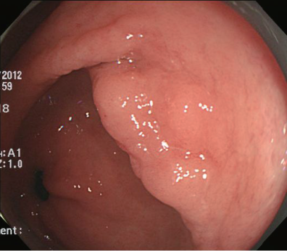 (B) 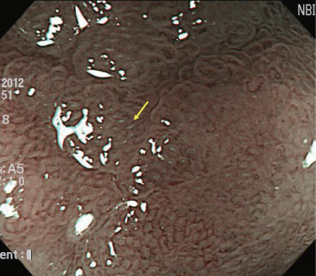
(C) 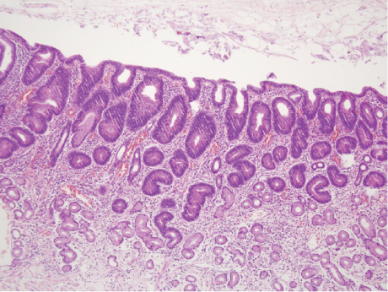 (D) 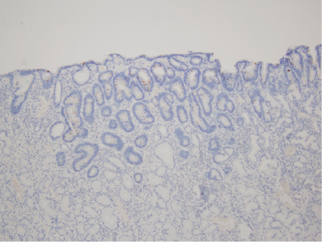
(E) 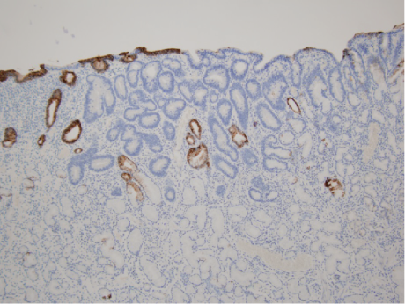 (F) 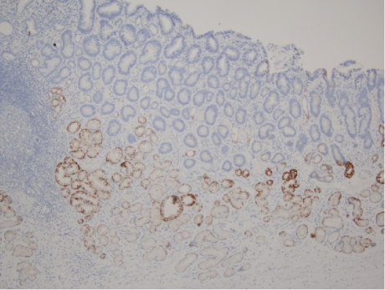
(G) 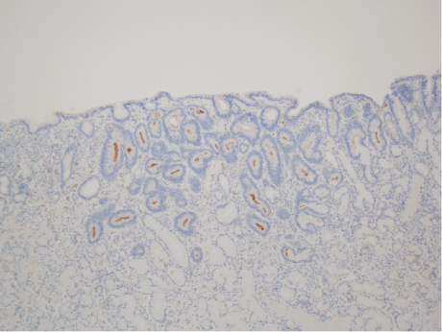

Figure 2 Endoscopic and histologic findings of foveolar gastric epithelial dysplasia. A: A slightly depressed lesion is seen at the antrum; B: Magnifying endoscopy using narrow band imaging shows a papillary microsurface and slightly irregular microvascular pattern; C: Histologic examination shows that the dysplasia is composed of cuboidal to columnar cells with a pale cytoplasm and basally located ovoid nuclei. Hyperplasia of the foveolar region with irregular glandular branching and epithelial folding are also seen (Haematoxylin-Eosin stain, × 10). The dysplastic epithelium is strongly positive for MUC5AC (E) and negative for MUC2 (D), MUC5AC (F) and CD10 (G)(Immunohistochemistry, × 10).

(A) 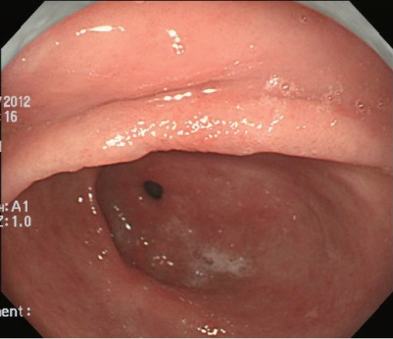 (B) 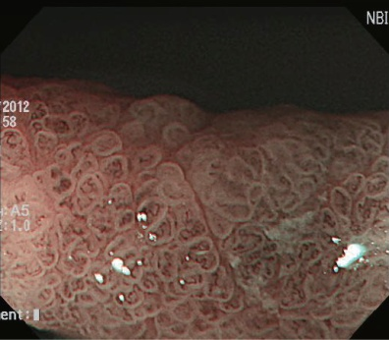
(C) 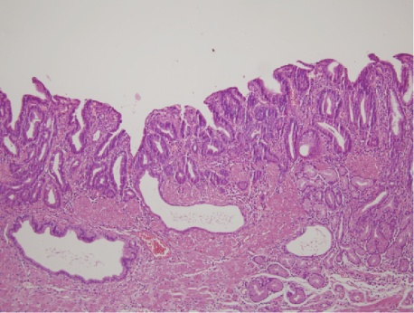 (D) 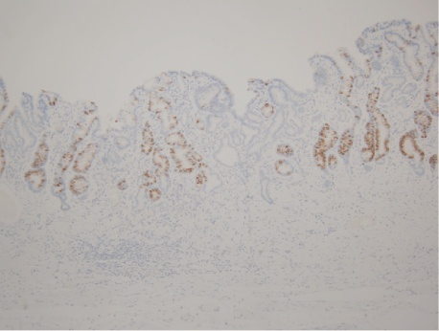
(E) 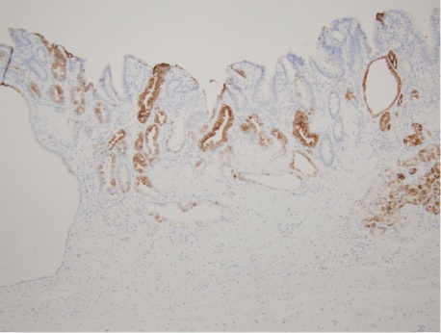 (F) 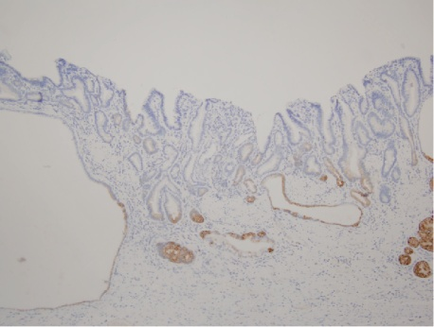
(G) 