Name of Journal: World Journal of Clinical Cases
Manuscript NO: 75894
Manuscript Type: CASE REPORT

Rare giant corneal keloid presenting 26 years after trauma: A case report

Li S et al. Traumatic giant corneal keloid

Shang Li, Jiang Lei, Ying-Hui Wang, Xiao-Lin Xu, Ke Yang, Ying Jie

Shang Li, Ying-Hui Wang, Xiao-Lin Xu, Ke Yang, Ying Jie, Beijing Institute of Ophthalmology, Beijing Tongren Eye Center, Beijing Tongren Hospital, Capital Medical University, Beijing Ophthalmology and Visual Sciences Key Lab, Beijing 100005, China

Jiang Lei, Department of Ophthalmology, The First People's Hospital of Lanzhou City, Lanzhou 730050, Henan Province, China

Author contributions: Jiang L collected and assembled the patient data; Li S and Wang YH wrote the paper; Jie Y and Yang K operated on the patient; Xu XL performed a biopsy of the tumor; all authors read and approved the final manuscript.

Corresponding author: Ying Jie, PhD, Chief Doctor, Professor, Beijing Institute of Ophthalmology, Beijing Tongren Eye Center, Beijing Tongren Hospital, Capital Medical University, Beijing Ophthalmology and Visual Sciences Key Lab, No. 1 Dongjiaominxiang Alley, Dongcheng District, Beijing 100005, China. jie_yingcn@aliyun.com

Received: March 10, 2022
Revised: April 22, 2022
Accepted: July 25, 2022
Published online:

Abstract
BACKGROUND
Corneal keloid is a rare clinical disease with an unknown etiology, which is easily misdiagnosed. Surgery is the most effective treatment but is rarely reported in the literature. Herein, we report the clinical features, histopathology, and surgical outcome of a giant corneal keloid with trophoblastic vessels and discuss the genesis of the mass.

CASE SUMMARY
A 36-year-old young man was admitted to the hospital because of a large mass on the surface of the left cornea. The patient had suffered an injury to his left eye at the age of 6-years-old; however, as the injury did not cause cornea perforation, he did not undergo treatment. Slit lamp exam showed a large, elevated, opaque lesion that covered the entire cornea and protruded from the surface of the eyeball. Anterior segment optical coherence tomography (AS-OCT) revealed a lesion of irregular density involving the anterior stroma. We suspected a secondary corneal fibroproliferative mass based on the clinical history, and slit lamp and AS-OCT findings. The patient subsequently underwent a superficial keratectomy and keratoplasty, and the final diagnosis of corneal keloid was confirmed by intraoperative histopathological examination.

CONCLUSION
Non-penetrating corneal trauma damages corneal epithelium basement membrane, initiating stromal fibrosis and causing corneal keloids. AS-OCT and biopsy confirm diagnosis.

Key Words: Corneal keloid; Histopathology; Immunohistochemical staining; Anterior segment ocular coherence tomography; Deep anterior lamellar keratoplasty; Case report

Li S, Lei J, Wang YH, Xu XL, Yang K, Jie Y. Rare giant corneal keloid presenting 26 years after trauma: A case report . World J Clin Cases 2022; In press

Core Tip: Corneal keloid is a benign proliferation of fibrous or fibrovascular tissue in the corneal stroma, and is rarely encountered in the clinic. The onset of secondary corneal keloids can occur months to years after the surgery or trauma, and the depth of corneal infiltration varies. Histopathology is the gold standard for diagnosis, but the cause of the disease is not yet clear. Here, we report a case of a giant corneal keloid that occurred 26 years after trauma and discuss the cause in detail.

INTRODUCTION
Corneal keloid is a rare type of ophthalmic disease that presents as a white, painless, enlarged vascular or avascular solitary nodule. It can also involve the entire corneal stroma, with a smooth surface^{[1]}. The diagnosis of corneal keloid can be challenging. It is often referred to as corneal fibroma, myofibroma, and hypertrophic scars, and is easily misdiagnosed as corneal dermatoid tumor, ocular surface squamous neoplasia, and corneal inclusion cyst^{[2-5]}. Corneal keloid can appear primary or secondary to trauma and surgery; secondary keloid, in particular, can occur anytime from months to years after the corneal injury and is commonly treated with surgery^{[6-8]}. Since the morphology and time of onset of corneal keloid are highly variable, biopsy and histopathology are essential for a definitive diagnosis.
Herein, we report the clinical features, histopathology, and anterior segment optical coherence tomography (AS-OCT) features in a case of giant corneal keloid presenting approximately 26 years after corneal trauma.

CASE PRESENTATION
Chief complaints
A 36-year-old man was referred to our hospital in December 2019 to address a corneal swelling found in his left eye 4 years prior. Over the past 2 years, the mass had rapidly increased until it protruded from the surface of the eye, preventing the eyelid from closing properly.

History of present illness
The patient reported having suffered an injury to the left eye at the age of 6-years-old; as the injury had not caused a corneal perforation, treatment was foregone. Since then, however, he had suffered from recurrent redness and a foreign body sensation, which led him to rub his eyes often.

History of past illness
The patient’s medical history was unremarkable.

Personal and family history
Not available at this time.

Physical examination
On initial examination, the best-corrected visual acuity (BCVA) was light perception/30 cm for the left eye and 20/20 for the right eye. Slit lamp showed conjunctival congestion with a thick nutrient vessel in the inferior temporal quadrant extending to the corneal limbal epithelium (Figure 1A). A white, tough, round, raised mass, 7 mm high and 9 mm in diameter, with numerous tiny vessels on the surface, localized in the center of the cornea, covered almost the entire cornea surface, preventing the eyelid from closing properly (Figure 1B). Anterior chamber details could not be visualized.

Laboratory examinations
Not available at this time.

Imaging examinations
Ultrasonographic evaluation of the posterior segment yielded normal findings. AS-OCT showed irregular epithelial tissue and dense subepithelial tissue with a low density of blood vessel invasion, similar to a honeycomb-like structure (Figure 1C).

Further diagnostic work-up
Detailed history-taking of the patient’s birth revealed that his mother had a spontaneous full-term delivery and no history of medications taken during pregnancy. No swelling was observed in any parts of the patient’s body other than the cornea. The results of routine blood, urine, and immunological examinations were negative.

PRELIMINARY DIAGNOSIS
Secondary corneal fibroproliferative mass.

FINAL DIAGNOSIS
Corneal keloid due to pathological examination.

TREATMENT
The lesion was removed via superficial keratectomy. Based on the depth of infiltration of the nodule, a deep anterior lamellar keratoplasty was performed (Figure 2). The excised mass was dissected, soaked in formalin, and sent for pathological examination.
Histopathological examination revealed irregular epithelial hyperplasia without Bowman's layer and abundant subepithelial collagen fibers with irregular proliferation and degenerative changes, which were lined with fibroblasts and vascular cavities (Figures 3A and B). Immunohistochemical staining of the keloid showed diffuse positivity for vimentin and smooth muscle actin (SMA), highlighting the smooth muscle wall of the vasculature and myofibroblasts (Figures 3C and D).

OUTCOME AND FOLLOW-UP
Postoperatively, the patient was prescribed topical steroids, antibiotics, and lubricants. On the first day after surgery, the BCVA was 20/100, and epithelialization of the ocular surface was completed 1 wk later (Figure 4A). There was no recurrence of swelling or post-operative complications during the 4 mo follow-up, and the patient reported satisfaction with the postoperative visual acuity and appearance (Figure 4B). AS-OCT showed that the corneal graft was closely attached to the bed, and the residual stroma thinness was about 100 μm (Figure 4C).

DISCUSSION
Corneal keloid is a rare clinical disease, classified as congenital, primary, or secondary depending on the etiology^{[1]}. The earliest case of corneal keloid was reported by Szokalski in 1865^{[9]}, and since then approximately 80 cases of corneal keloid have been reported in the literature^{[2]}. Most of the reported cases have occurred secondary to trauma, inflammation, or surgery, and the duration of onset has varied from a few months to several years. Herein, we reported a case of giant corneal keloid presenting approximately 26 years after corneal trauma.
There is no uniformity in the pathogenesis of corneal keloid, according to the collective cases reported. Some scholars believe that keloids result from the replacement of embedded iris and inflammatory exudate by fibrovascular tissue^{[9]}. However, in our case, the patient had no history of penetrating corneal injury, so we believe that the keloid originated from the injury and persistent eye rubbing, which led to excessive corneal repair.
Under normal conditions, an intact corneal epithelial basement membrane (EBM) protects the corneal stroma from the presence of myofibroblasts. Once the EBM is damaged, cytokines such as transforming growth factor beta-1, TGFβ2, and platelet-derived growth factor of corneal epithelial origin enter the stroma layer, contributing to the proliferation and differentiation of myofibroblast precursors^{[10]}. If the EBM is repaired within 1-3 wk, the fibroblast precursors do not mature^{[11]}. We assumed that the EBM could not repair the damage in this patient due to frequent eye rubbing and cytokines that were continuously secreted to stimulate myofibroblast activation. As this persisted for years, secretion of large amounts of extracellular matrix, in turn, led to the formation of a giant corneal keloid. Thus, both vimentin and SMA staining within the keloid were positive.
The enlargement of the swelling also depends on the blood vessel supply. The growth of neovascularization into the cornea is a complex process, in which multiple mediators such as inflammatory regulators, cytokines, growth factors, and matrix metalloproteinases interact. The neovascularization itself can assist dendritic cell (DC) migration into the central area^{[12]}. DCs promote keloid proliferation by secreting a series of cytokines that activate inflammatory pathways in the cornea^{[13]}.
After being diagnosed with corneal keloids, 82.6% of patients underwent surgery, these include superficial keratectomy (SK), lamellar excision/keratoplasty, penetrating keratoplasty (PK), sclerokeratoplasty, and enucleation^{[6, 14-16]}. SK remains the preferred choice of most physicians, with 70% of patients undergoing the procedure receiving SK. However, according to the literature, a non-dissected mass leads to recurrence in 40% of patients^{[3]}. Bakhtiari performed SK in 1 patient, after which the corneal opacification recurred, so he had to undergo 2 SK procedures combining PK and mitomycin C, followed by a femtosecond laser–assisted deep anterior lamellar keratoplasty^{[15]}. Therefore, we recommend choosing surgery based on the depth of the infiltrated mass, with the aim of complete removal of the mass from the corneal stroma. For lesions located in the corneal stroma that do not breach the Descemet's membrane, SK combined with amniotic membrane graft or deep lamellar corneal graft may be an option. For lesions that infiltrate into the endothelium or do not reach the endothelium but cause corneal endothelial edema, PK surgery is an option. In our case, the corneal keloid and neovascularization infiltrated the deep stromal layer of the cornea without breaking through the Descemet’s membrane; thus, the deep anterior lamellar keratoplasty procedure was selected.

CONCLUSION
Corneal keloids can occur up to 26 years secondary to non-penetrating corneal trauma. The genesis of such keloids may be related to EBM injury with cytokine clustering. AS-OCT plays an important role in early diagnosis of the disease, but confirmation of the diagnosis still relies on histopathological examination. Surgery is the treatment modality of choice for corneal keloid, and the operator should choose the procedure based on depth of infiltration.

REFERENCES
1 Vanathi M, Panda A, Kai S, Sen S. Corneal keloid. Ocul Surf 2008; 6: 186-197 [PMID: 18827951 DOI: 10.1016/s1542-0124(12)70179-9]
2 Gupta J, Gantyala SP, Kashyap S, Tandon R. Diagnosis, Management, and Histopathological Characteristics of Corneal Keloid: A Case Series and Literature Review. Asia Pac J Ophthalmol (Phila) 2016; 5: 354-359 [PMID: 27003732 DOI: 10.1097/APO.0000000000000154]
3 Palko JR, Arfeen S, Farooq AV, Reppa C, Harocopos GJ. Corneal keloid presenting forty years after penetrating injury: Case report and literature review. Surv Ophthalmol 2019; 64: 700-706 [PMID: 30849427 DOI: 10.1016/j.survophthal.2019.02.010]
4 Nair AG, Kenia H, Gopinathan I, Mehta SV, Mehta VC. Corneal fibroma: An uncommon stromal tumor. Indian J Ophthalmol 2018; 66: 699-701 [PMID: 29676322 DOI: 10.4103/ijo.IJO_936_17]
5 Zimmermann L, Reinhard T, Lange C, Heegaard S, Auw-Haedrich C. Corneal Myofibroma (Keloid) in a Young Patient with Neurofibromatosis Type 2. Ocul Oncol Pathol 2017; 3: 247-249 [PMID: 29344474 DOI: 10.1159/000457959]
6 Lee HK, Choi HJ, Kim MK, Wee WR, Oh JY. Corneal keloid: four case reports of clinicopathological features and surgical outcome. BMC Ophthalmol 2016; 16: 198 [PMID: 27829382 DOI: 10.1186/s12886-016-0372-4]
7 Alkatan HM, Al-Arfaj KM, Hantera M, Al-Kharashi S. Healed corneal ulcer with keloid formation. Saudi J Ophthalmol 2012; 26: 245-248 [PMID: 23961000 DOI: 10.1016/j.sjopt.2011.10.005]
8 Miyamoto R, Sakimoto T, Homma T, Tanaka Y, Sugiura T, Yamagami S. A rare case of corneal keloid occurred 30 years after pterygium surgery and 3 years after cataract surgery. Am J Ophthalmol Case Rep 2020; 20: 100901 [PMID: 32984646 DOI: 10.1016/j.ajoc.2020.100901]
9 Smith HC. Keloid of the Cornea. Trans Am Ophthalmol Soc 1940; 38: 519-538 [PMID: 16693235]
10 Medeiros CS, Marino GK, Santhiago MR, Wilson SE. The Corneal Basement Membranes and Stromal Fibrosis. Invest Ophthalmol Vis Sci 2018; 59: 4044-4053 [PMID: 30098200 DOI: 10.1167/iovs.18-24428]
11 Lassance L, Marino GK, Medeiros CS, Thangavadivel S, Wilson SE. Fibrocyte migration, differentiation and apoptosis during the corneal wound healing response to injury. Exp Eye Res 2018; 170: 177-187 [PMID: 29481786 DOI: 10.1016/j.exer.2018.02.018]
12 Narumi M, Kashiwagi Y, Namba H, Ohe R, Yamakawa M, Yamashita H. Contribution of corneal neovascularization to dendritic cell migration into the central area during human corneal infection. PLoS One 2014; 9: e109859 [PMID: 25299318 DOI: 10.1371/journal.pone.0109859]
13 Forrester JV, Xu H, Kuffová L, Dick AD, McMenamin PG. Dendritic cell physiology and function in the eye. Immunol Rev 2010; 234: 282-304 [PMID: 20193026 DOI: 10.1111/j.0105-2896.2009.00873.x]
14 Mejía LF, Acosta C, Santamaría JP. Clinical, surgical, and histopathologic characteristics of corneal keloid. Cornea 2001; 20: 421-424 [PMID: 11333333 DOI: 10.1097/00003226-200105000-00017]
15 Bakhtiari P, Agarwal DR, Fernandez AA, Milman T, Glasgow B, Starr CE, Aldave AJ. Corneal keloid: report of natural history and outcome of surgical management in two cases. Cornea 2013; 32: 1621-1624 [PMID: 24113371 DOI: 10.1097/ICO.0b013e3182a73a10]
16 Jung JJ, Wojno TH, Grossniklaus HE. Giant corneal keloid: case report and review of the literature. Cornea 2010; 29: 1455-1458 [PMID: 20856108 DOI: 10.1097/ICO.0b013e3181d83858]

Footnotes
Informed consent statement: Informed written consent was obtained from the patient for publication of this report and any accompanying images.

Conflict-of-interest statement: All authors declare that they have no conflicts of interest.

CARE Checklist (2016) statement: The authors have read the CARE Checklist (2016), and the manuscript was prepared and revised according to the CARE Checklist (2016).

Open-Access: This article is an open-access article that was selected by an in-house editor and fully peer-reviewed by external reviewers. It is distributed in accordance with the Creative Commons Attribution NonCommercial (CC BY-NC 4.0) license, which permits others to distribute, remix, adapt, build upon this work non-commercially, and license their derivative works on different terms, provided the original work is properly cited and the use is non-commercial. See: https://creativecommons.org/Licenses/by-nc/4.0/

Provenance and peer review: Unsolicited article; Externally peer reviewed.
Peer-review model: Single blind

Peer-review started: March 10, 2022
First decision: April 13, 2022
Article in press:

Specialty type: Medicine, research and experimental
Country/Territory of origin: China
Peer-review report’s scientific quality classification
Grade A (Excellent): A
Grade B (Very good): B
Grade C (Good): 0
Grade D (Fair): 0
Grade E (Poor): 0

P-Reviewer: Hegazy AA, Egypt; Shekouhi R, Iran S-Editor: Wang LL L-Editor: A P-Editor: Wang LL

Figure Legends
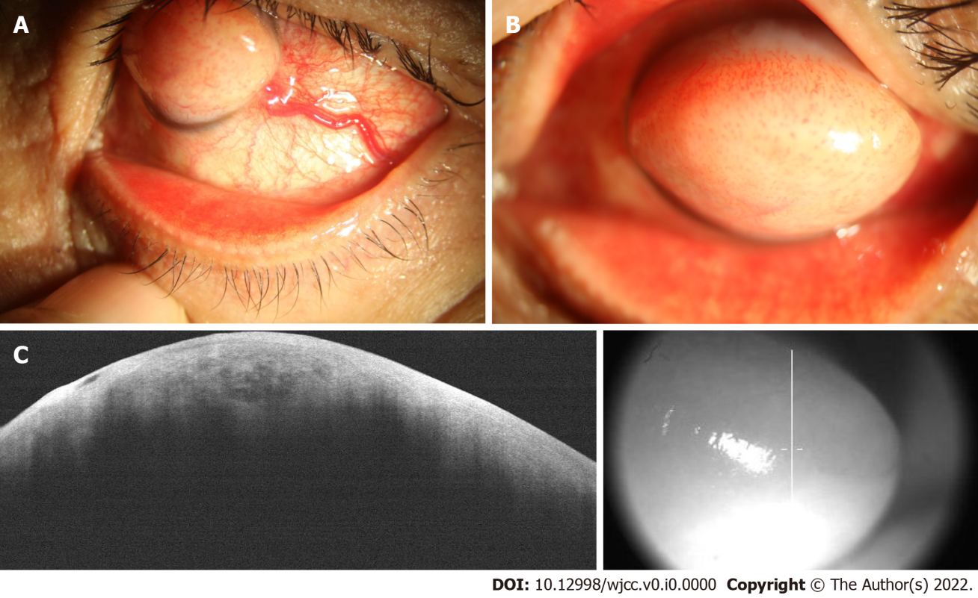
Figure 1 Preoperative clinical appearance and anterior segment optical coherence tomography images. A and B: Slit lamp microscope images; C: Anterior segment optical coherence tomography images.
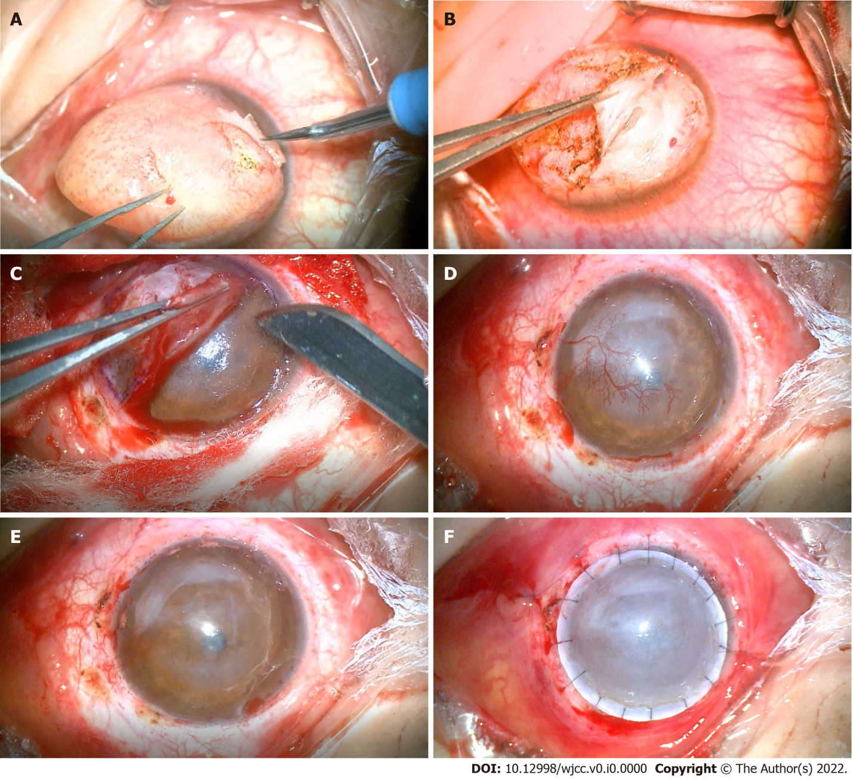
Figure 2 Surgery procedure. A: Electrocoagulation of the neovascularization on the surface of the swollen tissue; B-C: The hyperplastic fibrous connective tissue was removed, and the corneal stroma was exposed; D: The temporal nutrient vessels were seen in the stroma, with many branches crossing the pupil; E: The corneal stroma was dissected layer-by-layer until the Descemet’s membrane was approached, and the corneal endothelium was transparent; F: A 9.25-mm implant and implant bed were made, and the two were aligned and sutured.

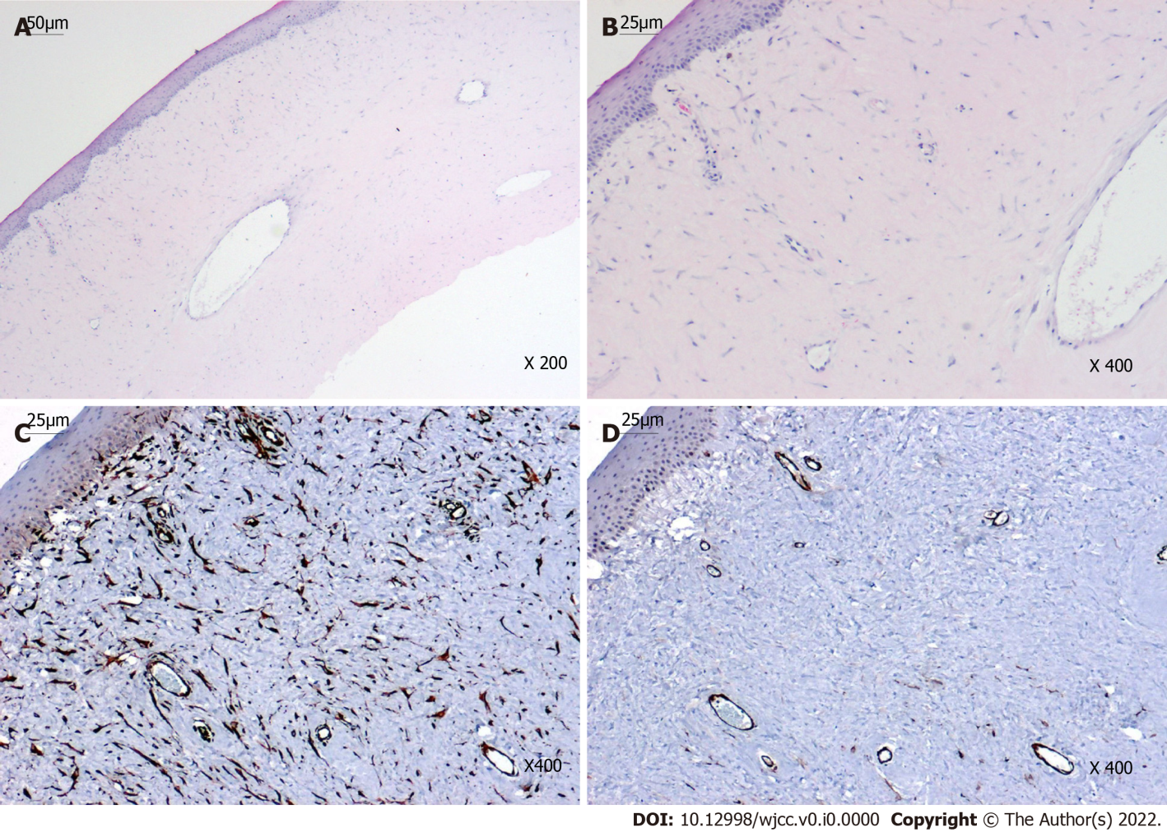
Figure 3 Histopathological and immunohistochemical results. A-B: Hematoxylin and eosin staining showed the irregular surface of the swelling, non-keratinized epithelium without Bowman’s layer, and dense fibrous connective tissue with blood vessels beneath the epithelium; C: Vimentin staining was diffusely positive within the parenchyma of the mass; D: Smooth muscle actin staining was positive in the smooth muscle walls of the vasculature and myofibroblasts.
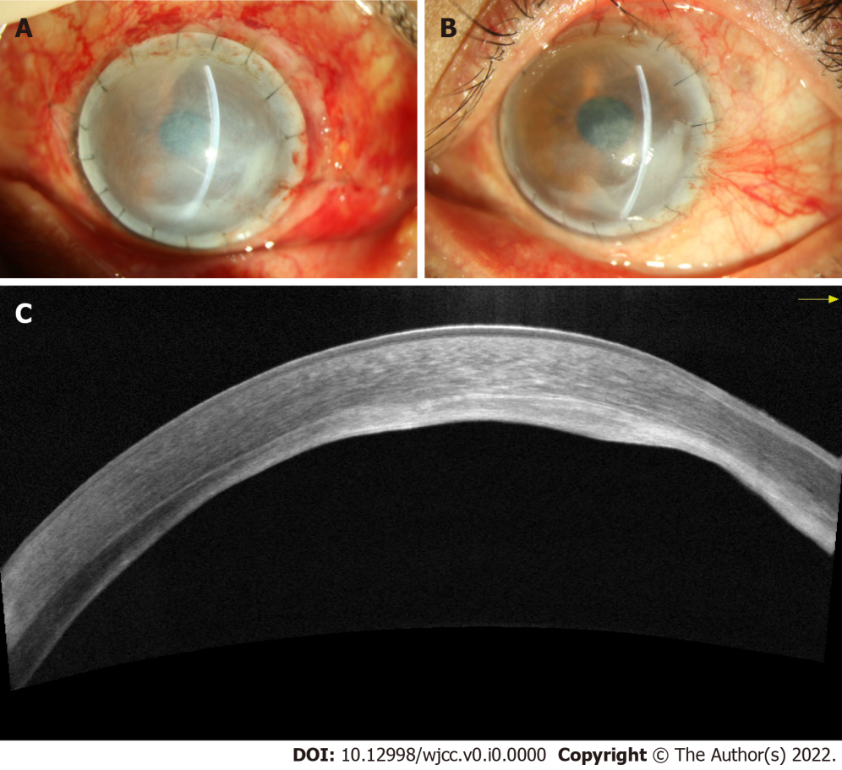
Figure 4 Postoperative ocular surface and anterior segment optical coherence tomography images. A: Slit lamp image 1 wk after surgery; B: Slit lamp image 4 mo after surgery; C: Anterior segment optical coherence tomography images 4 mo after surgery.

