Name of Journal: World Journal of Clinical Oncology
Manuscript NO: 54690
Manuscript Type: CASE REPORT

Mechanisms and anatomical risk factors of pneumothorax after Bevacizumab use: A case report

Ozaki Y et al. Pneumothorax after Bevacizumab use

Yuri Ozaki1, Akiyo Yoshimura, Masataka Sawaki, Masaya Hattori, Naomi Gondo, Haruru Kotani, Yayoi Adachi, Ayumi Kataoka, Kayoko Sugino, Nanae Horisawa, Yuka Endo, Kazuki Nozawa, Shoko Sakamoto, Hiroji Iwata

Yuri Ozaki1, Akiyo Yoshimura, Masataka Sawaki, Masaya Hattori, Naomi Gondo, Haruru Kotani, Yayoi Adachi, Ayumi Kataoka, Kayoko Sugino, Nanae Horisawa, Yuka Endo, Kazuki Nozawa, Shoko Sakamoto, Hiroji Iwata, Department of Breast Oncology, Aichi Cancer Center Hospital, Nagoya 464-8681, Japan

Author contributions: Ozaki Y contributed to study conception, data collection, and manuscript writing; Yoshimura A and Iwata H supervised the study and revised the manuscript before submission; all authors read and approved the final manuscript.

Corresponding author: Yuri Ozaki, MD, Surgical Oncologist, Department of Breast Oncology, Aichi Cancer Center Hospital, 1-1 kanoko-den chikusa-ku Nagoya City, Aichi, Nagoya 464-8681, Japan. yozaki@aichi-cc.jp

Received: February 14, 2020
Revised: June 2, 2020
Accepted: June 10, 2020
Published online: July 24, 2020

Abstract
Background
Bevacizumab is an antiangiogenic agent, and that synergizes with chemotherapeutic drugs. When used in combination therapies, Bevacizumab is associated with adverse events such as hemorrhage, gastrointestinal perforation, delayed wound healing, and pneumothorax. However, the molecular mechanisms underlying these adverse events are not fully understood.

Case summary
A 45-year-old female with multiple lung metastases that were derived from primary breast cancer, was placed on Bevacizumab + paclitaxel therapy, since this combination has a potent antitumor effect. She reported dyspnea before cycle 3, day 1 and we therefore ran a chest X-ray, which detected a right pneumothorax. The coronal plane computed tomography revealed that one solid mass rapidly necrosed and was replaced by a cavity that passed through the bronchus in the right lower lobe. The cavity eventually ruptured the pleura and made the bronchopleural fistula that led to this pneumothorax. Thoracic cavity drainage using an intercostal catheter was performed. On the 7th day of drainage, the patient was discharged from our hospital on recovery. Recurrence of pneumothorax was not reported, and continuation of chemotherapy was made possible by changing the regimen.

Conclusion
Patients with lung metastases surrounding the bronchi and on the pleura should be monitored for pneumothorax by Bevacizumab-containing chemotherapies.

Key words: Breast cancer; Lung metastasis; Bevacizumab; Adverse event; Pneumothorax; Case report

Citation: Ozaki Y, Yoshimura A, Sawaki M, Hattori M, Gondo N, Kotani H, Adachi Y, Kataoka A, Sugino K, Horisawa N, Endo Y, Nozawa K, Sakamoto S, Iwata H. Mechanisms and anatomical risk factors of pneumothorax after Bevacizumab use: A case report. World J Clin Oncol 2020; 11(7): 504-509
URL: https://www.wjgnet.com/2218-4333/full/v11/i7/504.htm
DOI: https://dx.doi.org/10.5306/wjco.v11.i7.504

Core tip: Combination therapy with Bevacizumab and chemotherapy is used to expect its high antitumor effect. However, Bevacizumab-containing combination therapies can induce severe adverse events. Mechanisms and risk factors that underlie the onset of pneumothorax are not clear. Here, we report a case of pneumothorax associated with a combination therapy of Bevacizumab with chemotherapy, and discuss the mechanisms and risk factors. Patients with multiple lung metastases surrounding the bronchi and on the pleura, should be monitored for pneumothorax, an adverse event that can be induced by the rapid necrosis due to Bevacizumab-containing combination chemotherapies.

INTRODUCTION
Bevacizumab (BV) is a monoclonal humanized antibody targeting vascular endothelial growth factor (VEGF). BV exerts its high antitumor effect by suppressing tumor angiogenesis and improving the delivery of chemotherapeutic drugs through normalization of the vascular plexus in tumors^{[1-4]}. BV also synergizes with chemotherapeutic agents to promote tumor regression. However, BV-containing combination therapies can induce severe adverse events such as gastrointestinal perforation^{[5-7]}, hemorrhage^{[8,9]}, delayed wound healing^{[10]}, and pneumothorax^{[11-14]}. Although there have been few reports of pneumothorax, the risk factors and molecular mechanisms that underlie the onset of pneumothorax are not clear^{[11,14]}. Here, we report a case of pneumothorax associated with a combination therapy of BV with chemotherapy, and discuss the molecular mechanisms and risk factors that were associated with this serious adverse event.

CASE PRESENTATION
Chief complaints
A 45-year-old female who was diagnosed with lung metastases of breast cancer and received combination therapy with Bevacizumab and chemotherapy developed dyspnea.

History of present illness
The case is a 45-year-old female. She visited our hospital because of an abnormality in her mammography and was diagnosed with left breast cancer (cStageT3N1M0). Pathological analysis of a core needle biopsy sample indicated a triple negative subtype (estrogen receptor-negative, progesterone receptor-negative and human epidermal growth factor receptor 2-negative). We planned 4 cycles of 5-fluorouracil + epirubicin + cyclophosphamide (FEC) followed by weekly paclitaxel (PTX) given 12 times as neoadjuvant chemotherapy. However neoadjuvant chemotherapy was stopped because of progression during weekly PTX; a left mastectomy and axillary lymph node dissection was then performed. The patient received postoperative chemotherapy (2 cycles of FEC followed by 8 cycles of capecitabine), but bilateral lung metastases were detected after the 5th cycle of capecitabine following a chest computed tomography (CT) that was performed due to her complaint of a persistent cough.
Some masses were on the pleura and one of the masses developed surrounding a bronchus at the right lower lobe (Figures 1 and 2). We made a diagnosis of multiple lung metastases of breast cancer. BV + PTX therapy was started due to its expected high antitumor effect. One cycle was 28 days, and BV was administered at 10 mg/kg on days 1 and 8 and PTX was administered at 80 mg/m² on days 1, 8 and 15. The patient noticed dyspnea before cycle 3, day 1.

Physical examination upon admission
She was tachypnea. The oxygen saturation at atmospheric pressure was 95%.

Laboratory examinations
There were no noticeable abnormalities.

Imaging examination
A right pneumothorax was diagnosed following a chest X-ray. The coronal plane CT revealed one solid mass replaced by a cavity that passed through the bronchus in the right lower lobe (Figure 3). The cavity eventually ruptured the pleura and made the bronchopleural fistula that led to this pneumothorax (Figure 4).

FINAL DIAGNOSIS
We diagnosed pneumothorax due to bronchopleural fistula that is associated with rapid necrosis of the lung metastasis.

Treatment
The patient was admitted to our hospital for management of the pneumothorax. Thoracic cavity drainage using an intercostal catheter was performed. Supplemental oxygen was not required. On the 2nd day, the leakage disappeared. On the 4th, the right lung was fully expanded on the X-ray and the drain was clamped. On the 6th, the drain was withdrawn. On the 7th, the patient was discharged from our hospital on recovery.

Outcome and follow-up
No recurrence of pneumothorax was observed following release from hospital. The continuance of chemotherapy was made possible by changing the regimen (irinotecan, gemcitabine + carboplatin). The patient died due to breast cancer 23 months after her first treatment, which was 9 months from the occurrence of the pneumothorax.

Discussion
BV is associated with the occurrence of several adverse events, such as gastrointestinal perforation^{[5-7]}, hemorrhage^{[8,9]}, delayed wound healing^{[10]} and pneumothorax^{[11-14]}. Although there have been few reports of pneumothorax, the risk factors and molecular mechanisms that underlie the onset of pneumothorax are not clear^{[11,14]}.
A more effective delivery of chemotherapeutic agents during BV treatment may explain the onset of gastrointestinal perforation in colon cancer^{[5]}. This is because the drugs induced rapid necrosis in the tumor, which infiltrates the serosa. Fatal hemoptysis in patients with lung squamous carcinoma has been reported in a phase Ⅱ trial^{[9]}. This suggests that centrally located lung tumors close to major blood vessels might be linked to severe pulmonary hemorrhage, since they may lead to collapsed vessels. And, as for breast cancer, a case was reported in which axillary arterial bleeding occurred after BV chemotherapy induced axillary metastatic lymph node necrosis^{[8]}.
BV promotes tumor regression by normalizing the vascular plexus in tumors, which is associated with improved delivery of chemotherapeutic drugs. This causes necrosis of tumors that lie close to important organs, and leads to severe adverse events^{[1-4]}. Another adverse effect associated with BV is delayed wound healing, as it inhibits the physiological endothelial repair processes mediated by VEGF^{[10]}.
The response of tumors to BV chemotherapy can to some extent explain why the solid mass in this case developed a cavity. The tumor surrounded the bronchi, and therefore induction of rapid necrosis and discharge of breakdown products via the bronchi would lead to cavity formation. This may be unique to this particular case, where only one solid mass surrounded the bronchi and became cavitary.
Another anatomical feature of this case is that the mass was on the pleura, and was therefore also susceptible to necrosis in this location. The cavity most likely ruptured the pleura, creating the bronchopleural fistula that led to this pneumothorax. The delayed wound healing caused by BV may also be associated with fistula formation.

Conclusion
Patients with multiple lung metastases surrounding the bronchi and on the pleura, should be monitored for pneumothorax, an adverse event that can be induced by the rapid necrosis due to Bevacizumab-containing combination chemotherapies.

References
1 Gray J, Murren J, Sharma A, Kelley S, Detterbeck F, Bepler G. Perforated viscus in a patient with non-small cell lung cancer receiving bevacizumab. J Thorac Oncol 2007; 2: 571-573 [PMID: 17545855 DOI: 10.1097/JTO.0b013e31805fea51]
2 Ferrara N. Vascular endothelial growth factor: basic science and clinical progress. Endocr Rev 2004; 25: 581-611 [PMID: 15294883 DOI: 10.1210/er.2003-0027]
3 Hicklin DJ, Ellis LM. Role of the vascular endothelial growth factor pathway in tumor growth and angiogenesis. J Clin Oncol 2005; 23: 1011-1027 [PMID: 15585754 DOI: 10.1200/jco.2005.06.081]
4 Jain RK. Normalization of tumor vasculature: an emerging concept in antiangiogenic therapy. Science 2005; 307: 58-62 [PMID: 15637262 DOI: 10.1126/science.1104819]
5 Hapani S, Chu D, Wu S. Risk of gastrointestinal perforation in patients with cancer treated with bevacizumab: a meta-analysis. Lancet Oncol 2009; 10: 559-568 [PMID: 19482548 DOI: 10.1016/s1470-2045(09)70112-3]
6 Van Cutsem E, Rivera F, Berry S, Kretzschmar A, Michael M, DiBartolomeo M, Mazier MA, Canon JL, Georgoulias V, Peeters M, Bridgewater J, Cunningham D; First BEAT investigators. Safety and efficacy of first-line bevacizumab with FOLFOX, XELOX, FOLFIRI and fluoropyrimidines in metastatic colorectal cancer: the BEAT study. Ann Oncol 2009; 20: 1842-1847 [PMID: 19406901 DOI: 10.1093/annonc/mdp233]
7 Shord SS, Bressler LR, Tierney LA, Cuellar S, George A. Understanding and managing the possible adverse effects associated with bevacizumab. Am J Health Syst Pharm 2009; 66: 999-1013 [PMID: 19451611 DOI: 10.2146/ajhp080455]
8 Abe N, Ohtake T, Abe S, Aoto K, Okano M, Tachibana K, Yoshida S, Yasuda M, Kimijima I, Takenoshita S. [A Case of Axillary Arterial Bleeding after Axillary Metastatic Lymph Node Necrosis during Treatment with Paclitaxel and Bevacizumabfor Breast Cancer]. Gan To Kagaku Ryoho 2016; 43: 2062-2064 [PMID: 28133222]
9 Johnson DH, Fehrenbacher L, Novotny WF, Herbst RS, Nemunaitis JJ, Jablons DM, Langer CJ, DeVore RF 3rd, Gaudreault J, Damico LA, Holmgren E, Kabbinavar F. Randomized phase II trial comparing bevacizumab plus carboplatin and paclitaxel with carboplatin and paclitaxel alone in previously untreated locally advanced or metastatic non-small-cell lung cancer. J Clin Oncol 2004; 22: 2184-2191 [PMID: 15169807 DOI: 10.1200/jco.2004.11.022]
10 Sharma K, Marcus JR. Bevacizumab and wound-healing complications: mechanisms of action, clinical evidence, and management recommendations for the plastic surgeon. Ann Plast Surg 2013; 71: 434-440 [PMID: 22868316 DOI: 10.1097/SAP.0b013e31824e5e57]
11 Iida T, Yabana T, Nakagaki S, Adachi T, Kondo Y. A Rupture of a Lung Metastatic Lesion of Colon Cancer, Leading to Pneumothorax Caused by Bevacizumab. Intern Med 2016; 55: 3125-3129 [PMID: 27803405 DOI: 10.2169/internalmedicine.55.7155]
12 Upadya A, Amoateng-Adjepong Y, Haddad RG. Recurrent bilateral spontaneous pneumothorax complicating chemotherapy for metastatic sarcoma. South Med J 2003; 96: 821-823 [PMID: 14515929 DOI: 10.1097/01.smj.0000047624.10190.3d]
13 Interiano RB, McCarville MB, Wu J, Davidoff AM, Sandoval J, Navid F. Pneumothorax as a complication of combination antiangiogenic therapy in children and young adults with refractory/recurrent solid tumors. J Pediatr Surg 2015; 50: 1484-1489 [PMID: 25783402 DOI: 10.1016/j.jpedsurg.2015.01.005]
14 Yang SH, Lin JK, Chen WS, Lin TC, Yang SH, Jiang JK, Chang SC, Lan YT, Chao TC, Yen CC, Tzeng CH, Teng HW. Pneumothorax after bevacizumab-containing chemotherapy: a case report. Jpn J Clin Oncol 2011; 41: 269-271 [PMID: 21030401 DOI: 10.1093/jjco/hyq195]

Footnotes
Informed consent statement: Written informed consent was obtained from the patient for the publication of personal details and accompanying images in this manuscript.

Conflict-of-interest statement: The authors declare that they have no competing interests in relation to the present work.

CARE Checklist (2016) statement: The authors have read the CARE Checklist (2016), and the manuscript was prepared and revised according to the CARE Checklist (2016).

Open-Access: This article is an open-access article that was selected by an in-house editor and fully peer-reviewed by external reviewers. It is distributed in accordance with the Creative Commons Attribution NonCommercial (CC BY-NC 4.0) license, which permits others to distribute, remix, adapt, build upon this work non-commercially, and license their derivative works on different terms, provided the original work is properly cited and the use is non-commercial. See: http://creativecommons.org/licenses/by-nc/4.0/

Manuscript source: Unsolicited manuscript

Peer-review started: February 14, 2020
First decision: May 28, 2020
Article in press:

Specialty type: Oncology
Country/Territory of origin: Japan
Peer-review report’s scientific quality classification
Grade A (Excellent): 0
Grade B (Very good): B
Grade C (Good): 0
Grade D (Fair): 0
Grade E (Poor): 0

P-Reviewer: Aykan NF S-Editor: Gong ZM L-Editor: E-Editor:

Figure Legends
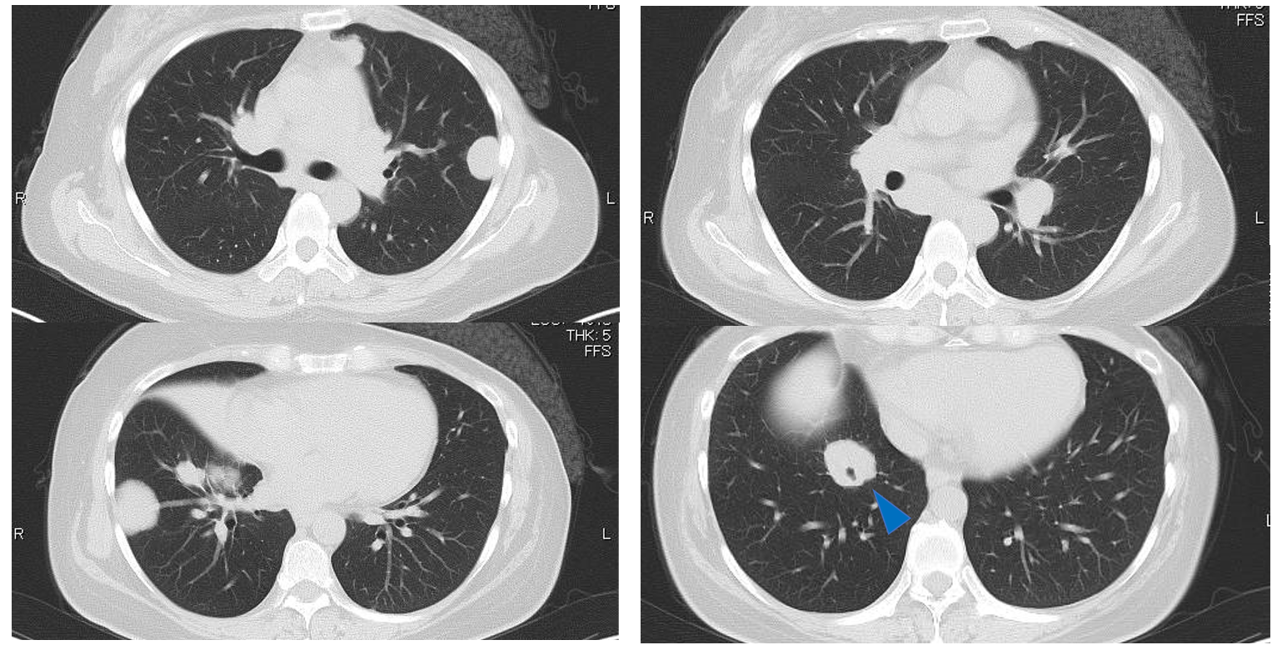Figure 1 Chest computed tomography showing multiple bilateral masses. Some masses bordered on the pleura and one of the masses developed around a bronchus (arrow).

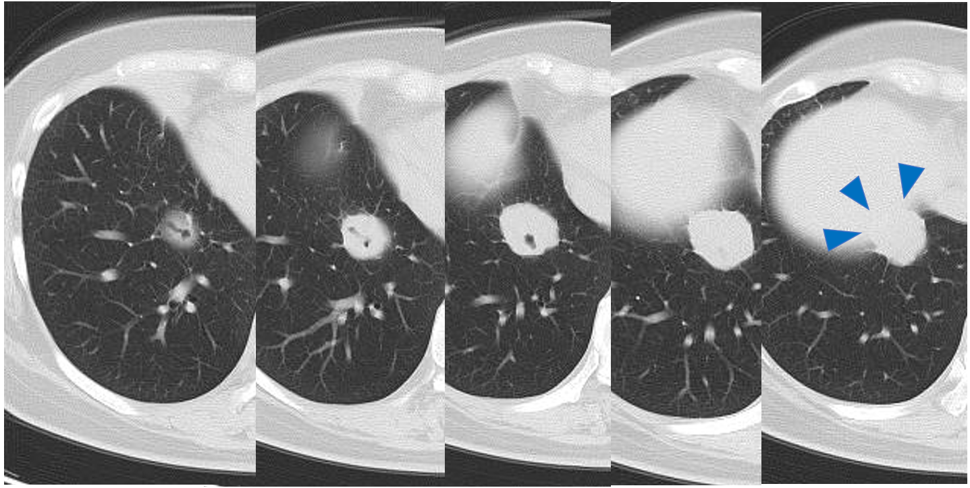
Figure 2 The mass around the bronchi is on the pleura above the diaphragm (arrows).

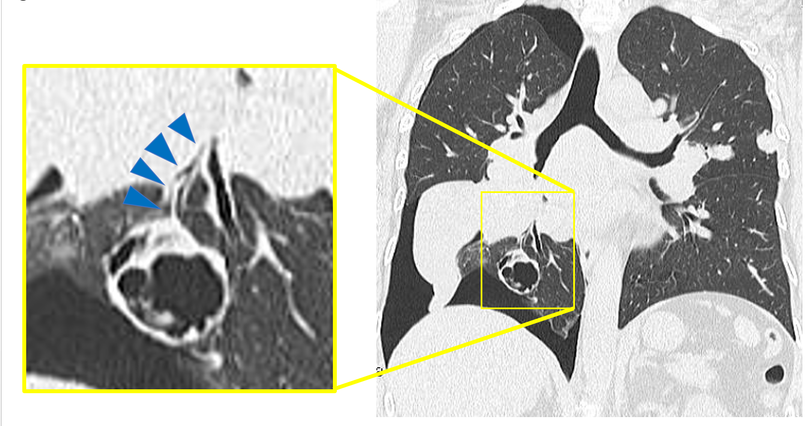
Figure 3 Coronal plane chest computed tomography showing a cavity replaced by a solid mass which was connected to the bronchi in the right lower lobe.

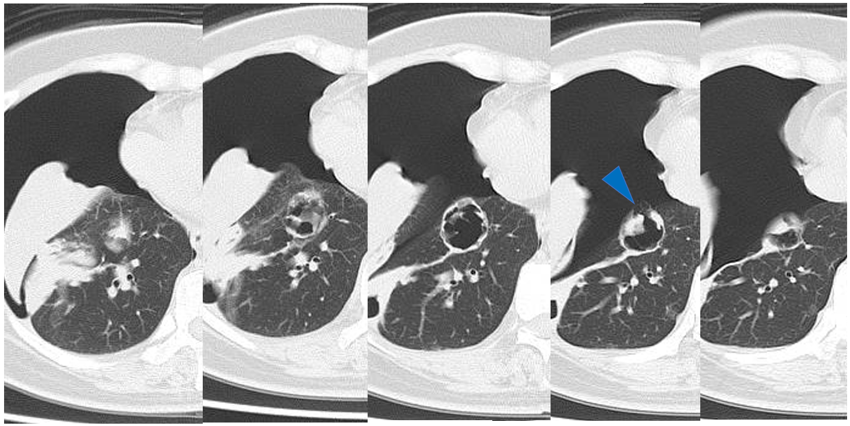
Figure 4 Chest computed tomography showing the right pneumothorax. The cavity wall ruptured into the pleura (arrow).

