Name of Journal: World Journal of Gastrointestinal Endoscopy
Manuscript NO: 39790
Manuscript Type: original article

Prospective Study
Submucosal injection of platelet-rich plasma in endoscopic resection of large sessile lesions

Lorenzo-Zúñiga V et al. Submucosal injection of PRP

Vicente Lorenzo-Zúñiga, Vicente Moreno de Vega, Ramón Bartolí, Ingrid Marín, Noemí Caballero, Ignacio Bon, Jaume Boix

Vicente Lorenzo-Zúñiga, Vicente Moreno de Vega, Ramón Bartolí, Ingrid Marín, Noemí Caballero, Ignacio Bon, Jaume Boix, Department of Gastrointestinal Endoscopy, University Hospital Germans Trias/CIBERehd, Barcelona 08916, Spain

ORCID number: Vicente Lorenzo-Zúñiga (0000-0002-4072-3241); Vicente Moreno de Vega (0000-0002-7077-0284); Ramon Bartolí (0000-0002-0636-0942); Ingrid Marín (0000-0002-1788-3861); Noemí Caballero (0000-0003-1000-0672); Ignacio Bon (0000-0002-5457-8436); Jaume Boix (0000-0003-4511-5090).

Author contributions: Lorenzo-Zúñiga V, Moreno de Vega V and Boix J contributed to the design of the study and performed the colonoscopies; Lorenzo-Zúñiga V and Bartolí R performed the data analysis and wrote the document; Marín I, Caballero N, and Bon I have revised the manuscript.

Institutional review board statement: The study was reviewed and approved by the institutional review board and Ethics Committee of University Hospital Germans Trias.

Informed consent statement: All study participants provided written consent prior to study enrolment.

Clinical trial registration: Study registered at ClinicalTrials.gov: NCT02931149.

Conflict-of-interest statement: The authors of this manuscript having no conflicts of interest to disclose.

CONSORT 2010 statement: The authors have read the CONSORT 2010 statement, and the manuscript was prepared and revised according to the CONSORT 2010 Statement.

Open-Access: This article is an open-access article which was selected by an in-house editor and fully peer-reviewed by external reviewers. It is distributed in accordance with the Creative Commons Attribution Non Commercial (CC BY-NC 4.0) license, which permits others to distribute, remix, adapt, build upon this work non-commercially, and license their derivative works on different terms, provided the original work is properly cited and the use is non-commercial. See: http://creativecommons.org/licenses/by-nc/4.0/

Manuscript source: Unsolicited Manuscript

Correspondence to: Vicente Lorenzo-Zúñiga, MD, Professor, Department of Gastrointestinal Endoscopy, University Hospital Germans Trias, Carretera del Canyet s/n, Badalona 08916, Spain. vlorenzo.germanstrias@gencat.cat

Received: May 12, 2018
Peer-review started: May 12, 2018
First decision: July 9, 2018
Revised: August 8, 2018
Accepted: October 8, 2018
Article in press:
Published online:

Abstract
AIM
To prospectively evaluate the efficacy of submucosal injection of platelet-rich plasma (PRP) on endoscopic resection of large sessile lesions.

METHODS
Eleven patients were submitted to endoscopic mucosal resection (EMR) with prior injection of PRP, obtained at the time of endoscopy. Patients were followed during 1 month. The incidence of adverse events (delayed bleeding or perforation) and the percentage of mucosal healing (MHR) after 4 wk were registered.

RESULTS
EMR was performed in 11 lesions (46.4 mm± 4 mm, range 40-70 mm). Delayed bleeding or perforation was not observed in any patient. Mean ulcerated area at baseline was 22.7 cm²± 11.7 cm² whereas at week 4 were 2.9 cm²±1.5 cm². Patients treated with PRP showed a very high MHR after 4 wk (87.5%).

CONCLUSION
PRP is an easy-to-obtain solution with proven and favourable biological activities that could be used in advanced endoscopic resection.

Key words: Platelet-rich plasma; endoscopic mucosal resection; submucosal injection; large lesions

© The Author(s) 2018. Published by Baishideng Publishing Group Inc. All rights reserved.

Core tip: This was a prospective single-center study to evaluate the efficacy of submucosal injection of platelet-rich plasma (PRP) on 11 patients submitted to endoscopic resection of large lesions. PRP as lifting solution proved absence of delayed bleeding or perforation and strong healing activity.

Lorenzo-Zúñiga V, Moreno de Vega V, Bartolí R, Marín I, Caballero N, Bon I, Boix J. Submucosal injection of platelet-rich plasma in endoscopic resection of large sessile lesions. World J Gastroenterol Endosc 2018; In press

INTRODUCTION
Submucosal injection of fluid solutions is crucial to prevent of delayed perforation (DP) in advanced resection techniques, endoscopic mucosal resection (EMR) or endoscopic submucosal dissection (ESD), by avoiding deep thermal injury. The perforation rate is traditionally considered as a quality of standard practice. It has a rate of 0.03%-0.8% during diagnostic procedures and 0.15%-3% during therapeutic procedures^{[1]}. Otherwise, delayed bleeding (DB) is a well-known and the most frequent adverse event after these resections, with an incidence of 2.6%–9.7%, not prevented by adding adrenaline to the submucosal fluid cushion or applying argon plasma coagulation, because these methods only decrease the incidence of early bleeding^{[2-4]}. There is no scientific evidence to recommend the systematic closure of the eschars with hemostatic clips to prevent DB because they are ineffective in large mucosal defects and increase procedure costs^{[5]}.
The ideal submucosal solution should provide a sustained lift, facilitate en-bloc or oligopiecemeal resection, be inexpensive, widely available and have few adverse effects^{[1]}. The optimal fluid to lift the lesion is still a matter of debate. Platelet-rich plasma (PRP), as autologous concentrated in plasma, has demonstrated strong healing properties as a shield over the eschars after EMR in preclinical models^{[6,7]}. PRP solution has showed the best electrical and rheological properties to perform safety endoscopic resections^{[8]}.
Therefore, we aim to evaluate the efficacy of submucosal injection of PRP on EMR of large sessile lesions.

MATERIALS AND METHODS
Subjects
This study was registered at ClinicalTrials.gov under the identifier NCT02931149 (EndoPRP study), was conducted from August 2016 to March 2017. Subjects eligible for the study were men and women aged 18 and older who were submitted for EMR of sessile lesions larger than 35 mm. We obtained a written informed consent in all participants. The Healthcare Ethics Committee of our institution (University Hospital Germans Trias i Pujol) approved the study protocol (IRB approval PT-16-002 on July 8, 2016), and was performed in accordance with the Declaration of Helsinki.

Study design
This was a non-randomized prospective single-center study. We performed an expanded access study (compassionate use) of PRP outside of a clinical trial because we wanted to generate information with a small number of individual patients. Patients were allocated to receive PRP as submucosal injection of PRP prior to EMR (Figure 1). After the procedure, all patients were followed during 4 wk. EMR was performed with blended current controlled by a microprocessor (ME 402 maxium KLS martin, Tuttlingen. Germany). The device used in all patients was a circular polyfilament snare 25 mm in diameter (SnareMaster, Olympus. Tokyo). After the procedure coagulation of the base with APC was performed in all cases.
We obtained PRP with OLIN-1 kit (a single-use sterile product), that comes in both a 20 ml and 40 ml format, from a sample of patient’s blood (18-36 mL) drawn at our Endoscopy Unit prior to perform the EMR (Figure 2). Peripheral blood was centrifuged (2500 rpm/8 min at room temperature). Depending on the size of the lesions, smaller or larger than 40 mm, we used 18 or 36 mL of blood (1 or 2 kits). A 20-mL syringe prefilled with 2 mL acid citrate dextrose (15% vol./vol.) was used for the standardized blood draw. Syringes were centrifuged obtaining two different layers; erythrocytes (±45% of volume) placed at the bottom, and PRP (55% vol., around 8 mL) on the top. PRP was activated with the addition of 20 mmol/L CaCl₂ just before the administration. A sample of 10 μL of blood and plasma were used to take a measurement of baseline blood platelet count and platelet count in PRP.

Assessments
The primary outcome was the assessment of the incidence of adverse events (DB or DP). Secondary objective was the evaluation of mucosal healing rate (MHR), calculated as a percentage of mucosal restoration after 1 month. Measurement of mucosal lesion and mucosal defect was carried out as comparison with opened forceps (7 mm) or by direct measurement with the specimen before pinning the specimen. We calculated the mean ulcerated and mucosal healing rate by the use of ImageJ public software (Image Processing and Analysis in Java; https://imagej.nih.gov/ij/)(Figure 3).

Statistical analysis
Unless otherwise indicated, results are expressed as mean ± SE or proportions as required. Statistical analyses were carried out with SPSS for Windows version 14.0 (SPSS Inc., Chicago, IL, United States).

RESULTS
Patient characteristics
A total of 11 EMRs large colorectal or gastric lesions were performed in 11 patients (Table 1). There were 6 (54.5%) females and their mean age was 68.3 years (range 53 to 84 years). More than half were located in rectum or in left colon, mean basal platelet count was of 175×10⁹/L, whereas obtained PRP was 2 times the basal value. The mean lesion size was 46.4 mm (SD, 11.4 mm; range 40-70 mm). Oligopiecemeal technique with complete resection was reached in all cases. Histology showed absence of deep submucosal involvement in all patients.

Assessments
Patient outcomes are summarized in Table 2. DP or DB was not observed in any case. PRP does not prolong EMR time. No evidence of stricture was found during the follow-up. Mean ulcerated area at baseline was 22.7 cm² ±11.7 cm² whereas after 4 wk was 2.9 cm²± 1.5 cm². The percentage of mucosal healing at week 4 was of 87.5% (Figure 4).

DISCUSSION
In this prospective study, we found that submucosal injection of PRP has proven efficacy in EMR of lesions larger than 35 mm, showing strong healing activity. Otherwise, the use of a submucosal fluid cushion rich in platelets prevents the incidence of DB or DP.
EMR and ESD as resection techniques can produce adverse events, such as perforation or bleeding. Post-EMR bleeding occurs in 5%-7% lesions ≥ 20 mm, whereas perforation is an uncommon event with an incident of 1.4%-1.5%^{[1]}. Mucosal elevation through the injection of a solution into the submucosal space can reduce the incidence of these events and improve the technical feasibility of the procedure^{[9]}. Normal saline is the most widely used solution but is not the most convenient for large lesions due to the maintenance of the fluid cushion. According to this, we should use other biocompatible lifting solutions easy to prepare and to administrate.
Use of PRP involves taking a sample of a patient’s blood prior to the endoscopic procedure and concentrating autologous platelets by centrifugation. PRP fluid contains at least 2 times peripheral blood platelets value and high levels of growth factors essential for mucosal healing, which are released from the alpha granules of activated platelets^{[10,11]}. The rationale for use PRP as solution to perform submucosal injection in endoscopic resection techniques lies in the exponential release of multiple bioactive factors, and subsequently, enhances the natural healing process, as well as in its haemostatic properties, with very low risk of fibrotic healing or strictures. In gastrointestinal disorders PRP has demonstrated efficacy in the prevention of DP^{[7]} and wound healing in primary colonic anastomosis^{[12]}. Previous reports have confirmed that surgical sites enhanced with PRP heal at rates two to three times those of untreated surgical sites and anabolic effects are directly correlated to platelet number^{[13]}.
Our study has tested the efficacy to use PRP in EMR of lesions large lesions, obtained through an inexpensive kit, showing strong anabolic effects. Otherwise, PRP has favourable biological and rheological properties as compared with other solutions as hyaluronic acid^{[14]}. This faster and stronger healing activity acts as mechanical defense that prevents the appearance of delayed adverse events. Regarding DB, PRP by mimicking the last step of the coagulation cascade, the formation of a fibrin clot, submucosal injection develops a more stable shield than prevent this complication.
Our study has some limitations because with this small number of patients we need larger studies to validate these findings and to perform a comparison study with other lifting solutions. PRP is an easy-to-obtain solution with proven favourable biological activities that could be applied as submucosal injection prior to endoscopic resection of large lesions. These data emphasize the need for continuing research in this topic.

ARTICLE HIGHLIGHTS
Research background
Submucosal injection of fluid solutions is crucial to prevent of adverse events in endoscopic resections. Platelet-rich plasma (PRP) has demonstrated strong healing properties in preclinical models.

Research motivation
PRP solution proved excellent electrical and rheological properties to perform safety endoscopic resections. PRP could be an ideal lifting solution in therapeutic endoscopy.

Research objectives
The primary outcome was the assessment of the incidence of adverse events (delayed bleeding or delayed perforation). Secondary objective was the evaluation of mucosal healing rate (MHR), calculated as a percentage of mucosal restoration after 1 mo.

Research methods
This was a non-randomized prospective single-center study (ClinicalTrials.gov NCT02931149). Subjects eligible for the study were men and women aged 18 and older who were submitted for endoscopic resection (EMR) of sessile lesions larger than 35 mm. Patients were allocated to receive PRP as submucosal injection of PRP prior to EMR.

Research results
EMR was performed in 11 lesions (46.4 mm± 4 mm, range 40-70 mm). Delayed bleeding or perforation was not observed in any patient. Mean ulcerated area at baseline was 22.7 cm²± 11.7 cm² whereas at week 4 were 2.9 cm² ±1.5 cm². Patients treated with PRP showed a very high MHR after 4 wk (87.5%).

Research conclusions
The new finding of this study is that PRP is lifting solution with proven and favourable biological activities that could be used in advanced endoscopic resection.

Research perspectives
We need larger studies to validate these findings and to perform a comparison study with other lifting solutions

REFERENCES
1 Ferlitsch M, Moss A, Hassan C, Bhandari P, Dumonceau JM, Paspatis G, Jover R, Langner C, Bronzwaer M, Nalankilli K, Fockens P, Hazzan R, Gralnek IM, Gschwantler M, Waldmann E, Jeschek P, Penz D, Heresbach D, Moons L, Lemmers A, Paraskeva K, Pohl J, Ponchon T, Regula J, Repici A, Rutter MD, Burgess NG, Bourke MJ. Colorectal polypectomy and endoscopic mucosal resection (EMR): European Society of Gastrointestinal Endoscopy (ESGE) Clinical Guideline. Endoscopy 2017; 49: 270-297 [PMID: 28212588 DOI: 10.1055/s-0043-102569]
2 Burgess NG, Metz AJ, Williams SJ, Singh R, Tam W, Hourigan LF, Zanati SA, Brown GJ, Sonson R, Bourke MJ. Risk factors for intraprocedural and clinically significant delayed bleeding after wide-field endoscopic mucosal resection of large colonic lesions. Clin Gastroenterol Hepatol 2014; 12: 651-61.e1-3 [PMID: 24090728 DOI: 10.1016/j.cgh.2013.09.049]
3 Hassan C, Repici A, Sharma P, et al. Efficacy and safety of endoscopic resection of large colorectal polyps: a systematic review and meta-analysis. Gut 2016; 65:806–820. PMID: 256581402. DOI: 10.1136/gutjnl-2014-308481.
4 Albéniz E, Fraile M, Ibáñez B, Alonso-Aguirre P, Martínez-Ares D, Soto S, Gargallo CJ, Ramos Zabala F, Álvarez MA, Rodríguez-Sánchez J, Múgica F, Nogales Ó, Herreros de Tejada A, Redondo E, Guarner-Argente C, Pin N, León-Brito H, Pardeiro R, López-Roses L, Rodríguez-Téllez M, Jiménez A, Martínez-Alcalá F, García O, de la Peña J, Ono A, Alberca de Las Parras F, Pellisé M, Rivero L, Saperas E, Pérez-Roldán F, Pueyo Royo A, Eguaras Ros J, Zúñiga Ripa A, Concepción-Martín M, Huelin-Álvarez P, Colán-Hernández J, Cubiella J, Remedios D, Bessa I Caserras X, López-Viedma B, Cobian J, González-Haba M, Santiago J, Martínez-Cara JG, Valdivielso E; Endoscopic Mucosal Resection Endoscopic Spanish Society Group. A Scoring System to Determine Risk of Delayed Bleeding After Endoscopic Mucosal Resection of Large Colorectal Lesions. Clin Gastroenterol Hepatol 2016; 14: 1140-1147 [PMID: 27033428 DOI: 10.1016/j.cgh.2016.03.021]
5 Liaquat H, Rohn E, Rex DK. Prophylactic clip closure reduced the risk of delayed postpolypectomy hemorrhage: experience in 277 clipped large sessile or flat colorectal lesions and 247 control lesions. Gastrointest Endosc 2013; 77: 401-407 [PMID: 23317580 DOI: 10.1016/j.gie.2012.10.024]
6 Bon I, Bartolí R, Lorenzo-Zúñiga V. Endoscopic shielding technique, a new method in therapeutic endoscopy. World J Gastroenterol 2017; 23: 3761-3764 [PMID: 28638215 DOI: 10.3748/wjg.v23.i21.3761]
7 Lorenzo-Zúñiga V, Boix J, Moreno de Vega V, Bon I, Marín I, Bartolí R. Efficacy of platelet-rich plasma as a shielding technique after endoscopic mucosal resection in rat and porcine models. Endosc Int Open 2016; 4: E859-E864 [PMID: 27540573 DOI: 10.1055/s-0042-109170]
8 Bon I, Lorenzo-Zúñiga V, Moreno de Vega V, Rodríguez A, De la Ossa N.D., Marín I, Boix J, Bartolí R. Comparative study of electrical and rheological properties of different solution to perform submucosal injection. UEG j 2017; 5: A454
9 Ferreira AO, Moleiro J, Torres J, Dinis-Ribeiro M. Solutions for submucosal injection in endoscopic resection: a systematic review and meta-analysis. Endosc Int Open 2016; 4: E1-E16 [PMID: 26793777 DOI: 10.1055/s-0034-1393079]
10 Kazakos K, Lyras DN, Verettas D, Tilkeridis K, Tryfonidis M. The use of autologous PRP gel as an aid in the management of acute trauma wounds. Injury 2009; 40: 801-805 [PMID: 18703188 DOI: 10.1016/j.injury.2008.05.002]
11 Mishra A, Harmon K, Woodall J, Vieira A. Sports medicine applications of platelet rich plasma. Curr Pharm Biotechnol 2012; 13: 1185-1195 [PMID: 21740373 DOI: 10.2174/138920112800624283]
12 Zhou B, Ren J, Ding C, Wu Y, Chen J, Wang G, Gu G, Li J. Protection of colonic anastomosis with platelet-rich plasma gel in the open abdomen. Injury 2014; 45: 864-868 [PMID: 24552769 DOI: 10.1016/j.injury.2014.01.018]
13 Kumar KA, Rao JB, Pavan Kumar B, Mohan AP, Patil K, Parimala K. A prospective study involving the use of platelet rich plasma in enhancing the uptake of bone grafts in the oral and maxillofacial region. J Maxillofac Oral Surg 2013; 12: 387-394 [PMID: 24431876 DOI: 10.1007/s12663-012-0466-3]
14 Russo F, D'Este M, Vadalà G, Cattani C, Papalia R, Alini M, Denaro V. Platelet Rich Plasma and Hyaluronic Acid Blend for the Treatment of Osteoarthritis: Rheological and Biological Evaluation. PLoS One 2016; 11: e0157048 [PMID: 27310019 DOI: 10.1371/journal.pone.0157048]
P-Reviewer: Chow WK, Gkekas I, Roy PK, Zhang QS S-Editor: Ma YJ L-Editor: E-Editor:

Specialty type: Gastroenterology and Hepatology
Country of origin: Spain
Peer-review report classification
Grade A (Excellent): 0
Grade B (Very good): B
Grade C (Good): C, c
Grade D (Fair): D
Grade E (Poor): 0

Table 1 Patient characteristics
 | EMR with PRP
No. of patients | 11
Mean age (yr) | 68.3 ± 9.48
Men/women | 5/6
Mean size of lesions (mm) | 46.4 ± 11.4
Basal platelet count (10⁹/L) | 175.4 ± 47.2
PRP count (10⁹/L) | 362.8 ± 98.7
Site, n (%)  Antrum  Rectum  Left colon  Right colon/cecum | 2 (18.2)  4 (36.4)  3 (27.2)  2 (18.2)
Histology, n (%)  Tubular adenoma  Tubulovillous adenoma  Villous adenoma  Serrated adenoma  Intramucosal adenocarcinoma | 3 (27.3)  1 (9.1)  0 (0)  4 (36.3)  3 (27.3)
EMR: endoscopic mucosal resection; PRP: platelet-rich plasma.

Table 2 Patient outcomes
 | EMR with PRP
Delayed perforation, n (%) | 0 (0)
Delayed bleeding, n (%) | 0 (0)
Mean ulcerated area at baseline (cm²) | 22.7 ± 11.7
Mean ulcerated area at 4 wk (cm²) | 2.9 ± 1.5
Mucosal healing rate (%) | 87.5
EMR: endoscopic mucosal resection; PRP: platelet-rich plasma.

Large lesions submitted for EMR
(n=11)
↓

Written informed consent
↓

EMR with PRP submucosal injection
↓

Endoscopic follow-up at week 4

Figure 1 Patient flow-chart. EMR: endoscopic mucosal resection; PRP: platelet-rich plasma.

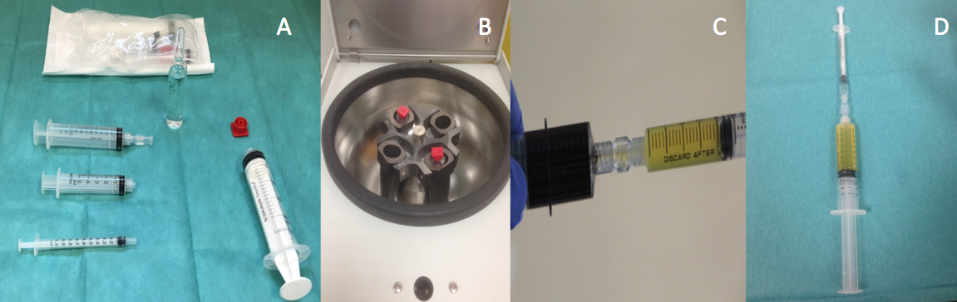
Figure 2 Preparation of platelet-rich plasma. A: Olin-1 Kit; B: Centrifugation of peripheral blood; C: PRP; D: Activation of PRP. PRP: platelet-rich plasma.

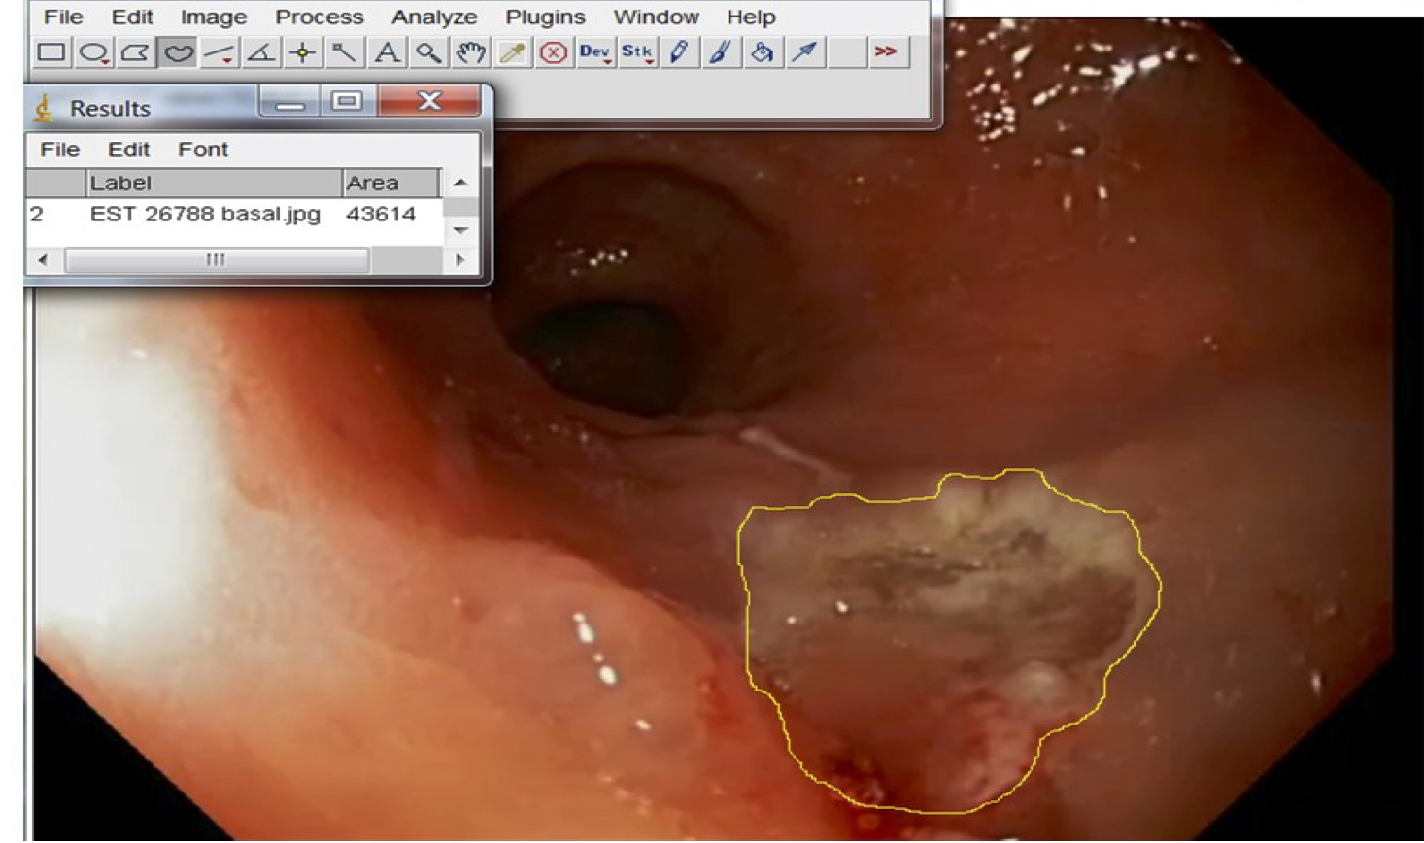
Figure 3 Mean ulcerated area and mucosal healing rate were calculated by the use of ImageJ public software (Image Processing and Analysis in Java. https://imagej.nih.gov/ij).

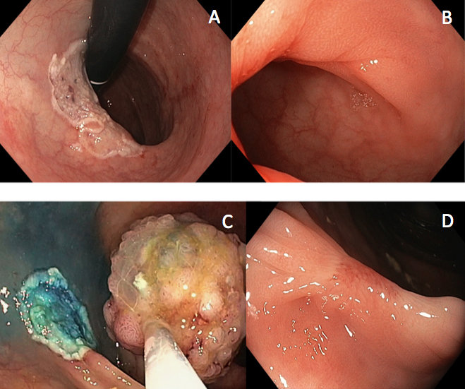
Figure 4 Mucosal healing after endoscopic resection in two patients treated with submucosal injection of platelet-rich plasma at baseline and after 4 wk. A: Patient 1 at baseline; B: Patient 1 at week 4; C: Patient 2 at baseline; D: Patient 2 at week 4.

