Name of Journal: World Journal of Hepatology
Manuscript NO: 61760
Manuscript Type: MINIREVIEWS

Lymphatic dysfunction in advanced cirrhosis: Contextual perspective and clinical implications

Kumar R et al. Lymphatic dysfunction in cirrhosis

Ramesh Kumar, Utpal Anand, Rajeev Nayan Priyadarshi

Ramesh Kumar, Department of Gastroenterology, All India Institute of Medical Sciences, Patna 801507, Bihar, India

Utpal Anand, Department of Surgical Gastroenterology, All India Institute of Medical Sciences, Patna 801507, Bihar, India

Rajeev Nayan Priyadarshi, Department of Radiodiagnosis, All India Institute of Medical Sciences, Patna 801507, Bihar, India

Author contributions: Kumar R designed and wrote the manuscript, and collected relevant data; Anand U and Priyadarshi RN contributed in data collection and manuscript writing; all authors have read and approve the final manuscript.

Corresponding author: Ramesh Kumar, MD, Associate Professor, Department of Gastroenterology, All India Institute of Medical Sciences, Ansari Nagar, Patna 801507, Bihar, India. docrameshkr@gmail.com

Received: December 17, 2020
Revised: January 31, 2021
Accepted: March 10, 2021
Published online: March 27, 2021

Abstract
The lymphatic system plays a very important role in body fluid homeostasis, adaptive immunity, and the transportation of lipid and waste products. In patients with liver cirrhosis, capillary filtration markedly increases, primarily due to a rise in hydrostatic pressure, leading to enhanced production of lymph. Initially, lymphatic vasculature expansion helps to prevent fluid from accumulating by returning it back to the systemic circulation. However, the lymphatic functions become compromised with the progression of cirrhosis and, consequently, the lymphatic compensatory mechanism gets overwhelmed, contributing to the development and eventual worsening of ascites and edema. Neurohormonal changes, low-grade chronic inflammation, and compounding effects of predisposing factors such as old age, obesity, and metabolic syndrome appear to play a significant role in the lymphatic dysfunction of cirrhosis. Sustained portal hypertension can contribute to the development of intestinal lymphangiectasia, which may rupture into the intestinal lumen, resulting in the loss of protein, chylomicrons, and lymphocyte, with many clinical consequences. Rarely, due to high pressure, the rupture of the subserosal lymphatics into the abdomen results in the formation of chylous ascites. Despite being highly significant, lymphatic dysfunctions in cirrhosis have largely been ignored; its mechanistic pathogenesis and clinical implications have not been studied in depth. No recommendation exists for the diagnostic evaluation and therapeutic strategies, with respect to lymphatic dysfunction in patients with cirrhosis. This article discusses the perspectives and clinical implications, and provides insights into the management strategies for lymphatic dysfunction in patients with cirrhosis.

Key Words: Lymphatic dysfunction; Cirrhosis; Lymphedema; Lymphangiectasia; Chylous ascites; Refractory ascites

©The Author(s) 2021. Published by Baishideng Publishing Group Inc. All rights reserved.

Citation: Kumar R, Anand U, Priyadarshi RN. Lymphatic dysfunction in advanced cirrhosis: Contextual perspective and clinical implications. World J Hepatol 2021; 13(3): 300-314
URL: https://www.wjgnet.com/1948-5182/full/v13/i3/300.htm
DOI: https://dx.doi.org/10.4254/wjh.v13.i3.300

Core Tip: Lymphatic dysfunction appears to play a significant role in the pathophysiology of advanced cirrhosis. Sustained portal hypertension, neurohormonal changes, and low-grade chronic inflammation have been implicated in causing lymphatic dysfunction in advanced cirrhosis, leading to worsening of ascites, lymphedema, and abnormal lipid transport; it also results in increased susceptibility to infections. Chylous ascites and intestinal lymphangiectasia are the rare manifestations of lymphatic dysfunction in cirrhosis, leading to loss of protein, fat, lymphocytes, and immunoglobins, with several clinical consequences. Lymphatic dysfunctions in cirrhosis have been ignored to date; hence, new exploratory research must be undertaken to gain insight into this important subject.
INTRODUCTION
The lymphatic system consists of capillaries located inside the tissue that are highly permeable and are needed to transport lymph containing cellular proteins, lymphocytes, and lipoproteins^{[1-4]}. It is essential for maintaining homeostasis of tissue via interstitial fluid reabsorption, immune cell trafficking, and the transport of lipids^{[3-5]}. The lymphatic system removes interstitial fluid from tissues and returns it to the bloodstream. When this interstitial fluid gets into lymphatic capillaries, it is called lymph. The liver is the largest organ generating lymph, and liver lymphatics are believed to play a vital role in maintaining normal hepatic function by helping to eliminate protein, cholesterol, and immune infiltrates^{[5]}. In the absence of normal lymphatic function, interstitial fluid accumulation may contribute to clinical manifestations such as lymphedema and ascites^{[6]}. In patients with early cirrhosis, the lymphatic system helps to prevent development of ascites by reabsorbing excess fluid in the hepatic and splanchnic areas. As a result, lymph flow is enhanced, which promotes hepatic lymphangiogenesis^{[7,8]}. However, in advanced cirrhosis patients, this compensatory mechanism is not adequate to prevent the development of ascites. Moreover, there appears to be an impaired lymphatic pump function in patients with an advanced liver disease^{[9]}. Despite its significant clinical value, the literature on lymphatic dysfunction in cirrhosis is very limited, and the area remains open for new investigations. This article summarizes the current knowledge regarding dysfunctions of lymphatic system in patients diagnosed with liver cirrhosis, with special attention to pathophysiology, clinical implications, and insights into management strategies.

LYMPHATIC VASCULAR SYSTEM
The lymphatic system consists of a large network of lymphatic vessels, with lymphoid organs and tissues. Lymphatic vessels are classified anatomically into capillaries and collecting vessels. Further, the lymphatic capillaries are closed-ended and composed of a single layer of lymphatic endothelial cells (LECs). The initial lymphatics are highly permeable for transport of interstitial fluid macromolecules and immune cells. LECs have anchoring filaments that contract and relax, which enable them to “flap” open to allow interstitial fluid uptake^{[10,11]}. The lymphatics capillaries merge into larger collecting lymphatic vessels, which possess a continuous basement membrane and have unidirectional bicuspid valves with contractile smooth muscle cells’ (SMCs) covering for assisting the flow of lymph. Similar to lymphatic capillaries, the liver has sinusoids, consisting of a single layer of liver sinusoidal endothelial cells (LSECs), without the basement membranes^{[12]}. Hepatic lymph is produced by plasma components filtered through the LSECs into the space of Disse. In the gastrointestinal tract, lymphatics are present in mucosal, submucosal, and muscular layers; they merge with collecting lymphatic vessels near the mesenteric border. The lymphatics present in the center of each intestinal villus are referred to as lacteals, which have a structure similar to the lymphatic capillaries elsewhere, consisting of a single layer of LECs, without a basement membrane^{[13]}.
There is constant filtration of plasma into the interstitial space during the passage of blood through the capillaries. The rate of filtration is primarily dictated by the hydrostatic pressure and plasma oncotic pressure in the capillaries. Due to the change in interstitial pressure, interstitial fluid enters the lymphatic capillaries, as lymph, and moves towards larger lymphatic vessels^{[14]}. The contractile activity of SMCs, of the collecting lymphatic vessels, is believed to be one of the major driving forces of lymphatic circulation^{[15]}. The Ca²⁺ channels of SMCs and nitric oxide (NO) produced in LECs is thought to contribute to the regulation of lymphatic flows, by modulating the contractility of SMCs^{[16]}. In liver, most of the lymph from space of Disse drains into lymphatic vessels in the area near portal triads. Some part of the lymph also circulates into the interstitium around the central vein or underneath the Glisson’s capsule. Finally, all the liver lymphatic vessels converge into the hepatic hilum and flow into the lymph nodes arranged in the lesser omentum along the hepatic vessels and hepatic ducts^{[5,17]}. The collecting lymphatic vessels, from all organs, connect to one or more lymph nodes and, finally, lymph trunks, which ultimately drain into the subclavian vein via thoracic duct or right lymph trunk (Figure 1). Thus, interstitial fluid, collected as lymph, is finally returned to the blood circulation through the lymphatic vessels. It is estimated that approximately 3 L to 5 L of lymph fluid travel through the thoracic duct each day, of which 50% to 90% comes from the intestines and liver^{[18]}. Being capillary ultrafiltrate, all plasma proteins are present in lymph. However, several proteins derived from extracellular matrix, cellular metabolism, and cell death are enriched in lymph instead of the plasma^{[19]}. Therefore, the composition of the lymph arising from various areas varies to a degree.

FUNCTIONS OF LYMPHATIC SYSTEM
The lymphatic system plays an important role in maintaining tissue homeostasis, by transporting interstitial fluid, serum protein, and lipids from tissues to the systemic circulation. After plasma filtration through the capillaries, the only way the fluid can be returned to blood circulation is via the lymphatic system^{[20]}. When there is a mismatch between capillaries filtration and lymphatic removal, fluid accumulation occurs in the extravascular space. Lymphatic system plays a key role in adaptive immunity. It delivers antigen and antigen-presenting cells to the regional lymph nodes, where they evoke immune responses. Lymphatics also play a role in controlling the inflammatory response, by influencing the drainage of extravasated fluid and inflammatory mediators, and by facilitating the discharge of infiltrated immune cells from inflamed sites^{[21,22]}. Moreover, lymphatic vessels are essential for the removal of cholesterol from peripheral tissues^{[23]}. LECs are known to take up cholesterol carried by high-density lipoprotein, and dysfunctional LECs can lead to the development of hepatic steatosis^{[24]}. Furthermore, intestinal lacteals play important role in the absorption of fat and fat-soluble vitamins as chylomicrons.

LYMPHATIC SYSTEM CHANGES IN CIRRHOSIS
In patients with cirrhosis, capillary filtration increases steadily and gradually, primarily due to an increase in hydrostatic pressure. This contributes to an enhanced lymph production, with consequent lymphatic compensatory responses, such as an increase in the number and size of lymphatic vasculature, to enhance the drainage of interstitial fluid^{[8,25,26]}. Several structural and functional changes in the lymphatic system have been reported in patients with cirrhosis.

Increase in the lymph flow
An increased architectural distortion in cirrhosis causes resistance to sinusoidal blood flow, increased hydrostatic pressure in the sinusoid, and increased filtration of plasma. This process may be further enhanced by concomitant hypoalbuminemia and increased capillary permeability under certain circumstances. Thus, lymph production and flow is greatly increased (up to 30 folds) in patients with cirrhosis^{[27,28]}. Witte et al^{[7]} demonstrated that lymph in the thoracic duct of cirrhosis patients had a high protein concentration. Because the protein concentration of hepatic lymph is higher (50%-80% of plasma), such overproduction of lymph in cirrhosis appears to come primarily from the liver. However, with advancement of cirrhosis, the protein content of hepatic lymph also decreases because of a dysfunctional lymphatic transport system. In an animal study of cirrhotic livers, a positive correlation between hepatic lymph flow and increasing portal pressures was found. Moreover, this study also demonstrated a compromised functional capacity of lymphatic vessels to absorb interstitial fluid^{[29]}.

Increase in the number and density of lymphatic vessels
Dumont and Mulholland^{[30]} were the first to describe an increased diameter and lymph flow in the thoracic duct, in patients with cirrhosis. Such expansion of lymphatic vasculature has also been reported by Sadek et al^{[31]} on computed tomography and Shimada^{[32]} on laparoscopy. The expansion of lymphatic density correlates positively with the severity of fibrosis around the portal tracts of human liver. Yamauchi et al^{[26]} found that the intrahepatic lymphatic vessels remain stable during the early stages of liver disease, but when it progresses to advanced cirrhosis, it increases significantly. In addition, Yokomori et al^{[33]} recently calculated the density of lymph vessels by immunohistochemistry in patient specimens and found that the density increased with the progression of liver disease, peaking at the most advanced stages of cirrhosis. In cirrhotic livers, a substantial increase in vascular endothelial growth factors (VEGF)-D expression, an inducer of lymphangiogenesis, was observed and in addition, VEGF-D expression was found to be positively associated with liver fibrosis progression^{[8]}. This lymphangiogenic response may help to enhance the drainage of increased interstitial fluid.

Lymphatic oversaturation and flow dysfunction
The lymphatic system keeps tissue edema free, by returning excess tissue fluid back to the bloodstream. In cirrhotic patients, when interstitial fluid is increased, expansion of lymphatics and increased lymphatic flow initially tries to prevent development of ascites and edema^{[7]}. However, it is not clear as to what extent the lymphatic vasculature may compensate for enhanced lymph production. In a sustained increase of the hydrostatic pressure, fall in plasma oncotic pressure, compounding effects of capillarization/defenestration of sinusoidal endothelium, and neurohormonal changes, the compensatory mechanism is gradually overwhelmed, resulting in fluid accumulation in the extravascular space^{[34,35]}. In the splanchnic circulation of cirrhosis patients, arteriolar vasodilation occurs; it increases the production of splanchnic lymph beyond the ability of the lymphatic system to transport and, thus, triggers lymph leakage into the peritoneal cavity. Moreover, an increased splanchnic vascular permeability and chronic retention of renal sodium and water plays a major role in the sustained development of ascites^{[36,37]}. Over time, increased pressure and flow stasis in the intestinal lymphatic channels may lead to lymphangiectasia, followed by the rupturing of dilated lacteals and intestinal loss of protein, chylomicrons, and lymphocyte^{[38]}. Rarely, the rupture of subserosal lymphatic, secondary to a sustained high pressure, results in the development of CA^{[39]}.
Apart from lymphatic oversaturation, functional defect in the lymphatic transport system has also been reported in patients with cirrhosis. Henriksen^{[40]} have described a model of lymphatic conductivity (flow rate per unit pressure difference), based on protein kinetic and hemodynamic measurement in patients with cirrhosis. They found that lymphatic conductance in the thoracic duct was three times higher than normal in patients without ascites, while in patients with tense ascites, these values were close to normal. Moreover, conductance in the right lymphatic duct system was ten times below that of thoracic duct of cirrhotic patients with ascites. The results of this study suggest that a relatively insufficient lymphatic drainage plays an important role in the accumulation of ascites in decompensated cirrhosis. Recently, the functionality of the splanchnic and peripheral lymphatic system was studied by fluorescent lymphangiography, in an experimental model of rats exposed to chemokine ligand 4 (CCL4). A substantial decrease in fluorescence-labeled lymphatics was observed in cirrhotic rats, in both peripheral and splanchnic regions, indicating a deficiency in lymphatic drainage^{[9]}.

PATHOPHYSIOLOGY OF LYMPHATIC DYSFUNCTION IN CIRRHOSIS
The pathophysiological mechanism behind lymphatic dysfunction in cirrhosis is an area yet to be explored at cellular and molecular level (Figure 2). In a study on cirrhotic rats with ascites, Ribera et al^{[9]} found that an impaired lymphatic drainage in the splanchnic and peripheral regions was accompanied by increased activity of endothelial nitric oxide synthase (eNOS) and production of NO by LECs. In addition, SMC coverage of lymphatic vessels was found to be significantly decreased. Interestingly, when cirrhotic rats were treated with inhibitor of eNOS activity (L-NG-methyl-L-arginine, L-NMMA), a significant improvement of lymphatic drainage, reduction in ascetic fluid volume, and an increase in lymphatic smooth muscles were seen. Therefore, this study demonstrated a role of NO in the lymphatic dysfunction of cirrhotic rats. Whether the same applies for human cirrhosis remains to be seen. Lymphangiogenesis observed in cirrhosis appears to be due to increased expression of several induces of lymphogenesis, such as VEGF-D and VEGF-C. Their levels have been found to be significantly elevated during hepatic fibrosis and positively correlated with fibrosis progression^{[8,41]}. Study on cirrhotic rat has found a four-fold increase in VEGF-D, in the endothelial cells. Additionally, the receptor of this VEGF (VEGR-3) was found to be overexpressed in the LECs of cirrhotic rats^{[42]}. It has recently been shown that autonomic nervous system is a key modulator of the lymphatic vessels’ function^{[43]}.
Lymphatic function, in general and in patients with cirrhosis, can be modulated by numerous factors including age, obesity, diabetes, dyslipidemia, neurohormonal alterations, and chronic inflammation. Neurohormonal changes are known to occur in advanced cirrhosis, and the levels of a number of vasoactive substances such as noradrenaline, histamine, substance P, prostaglandins, and endothelin are altered, which can affect contractility of lymphatic vessels^{[44-46]}. Intestinal motility plays an important role in the propulsive motion of intestinal lymph, and by inducing VEGF-C, intestinal microbiota is an important regulator of intestinal lacteal integrity^{[13,47]}. Therefore, the intestinal dysmotility and intestinal dysbiosis that are frequently seen in advanced cirrhosis may interfere with intestinal lymphatic function. Moreover, Cirrhosis and portal hypertension (PHT) is known to create a state of low-grade chronic inflammation^{[48]}. Furthermore, gut dysbiosis, bacterial translocation, and release of Inflammatory cytokines such as tumor necrosis factor alpha, and interleukin-1β occur in cirrhosis^{[49]}. Consequently, chronic inflammation and neurohormonal disturbances, in advanced cirrhosis, can lead to structural and physiologic changes in the lymphatic system. Dysfunctional lymphatics, with lymph stasis, can impair lipid transport and stimulate adipogenesis in the affected area^{[50,51]}.
Old age and obesity also affect lymphatic functions. Aging induces structural changes in the lymphatic vessels, such as loss of extracellular matrix, reduced contractile protein expression, and changes in eNOS and histamine gradients, which tend to decrease the lymphatic transport of interstitial fluids^{[52,53]}. Obesity results in several structural and physiological changes in the lymphatic system, including increased lymphatic leakiness, decreased contractility of the collecting vessel, and changes in the architecture of the lymph node, which significantly affect lymphatic transport functions^{[54,55]}. Notably, most cirrhosis patients belong to the old age group, and obesity is presently a growing cause of non-alcoholic fatty liver disease (NAFLD)-related cirrhosis. Given that obesity is a growing cause of NAFLD-related cirrhosis and that most patients with cirrhosis are older, they may be at a higher risk of developing lymphatic dysfunction.

CLINICAL IMPLICATIONS OF LYMPHATIC DYSFUNCTION
Lymphatic dysfunctions have been aptly described in patients with cirrhosis; however, little has been described about the clinical consequences of such dysfunctions. Given the role of lymphatic vasculature in the body fluid homeostasis, adaptive immunity, and the transport of lipid and waste materials, it is tempting to speculate that lymphatic dysfunctions, in cirrhosis, may have several clinical implications, particularly with regard to the body fluid homeostasis.

Edema and ascites
In advanced cirrhosis, the activation of compensatory vasoconstrictor pathways compromises glomerular filtration, causing greater renal retention of sodium and water. This further increases the production of lymph, burdening the already inefficient lymphatic system with the responsibility for drainage. Moreover, inability of the lymphatic system to recirculate extravasated albumin may worsen pre-existing hypoalbuminemia, leading to a change in the transcapillary oncotic pressure gradient and worsening of fluid imbalance. Additionally, serum albumin is also required for furosemide to work properly^{[56]}. Therefore, severe lymphatic dysfunction can lead to the development of refractory edema and ascites in patients with cirrhosis.
Lymphedema should be fairly common in patients with advanced cirrhosis for obvious reasons; however, its description is lacking in existing literature. Lymphedema is deposition of protein-rich lymph fluid within the tissues, as a consequence of lymphatic leak and an imbalance between the rate of lymph production and drainage. Recent evidences suggest that lymphedema can also occur as an immune response secondary to lymphatic injury or metabolic derangements, including adiposity and infection^{[57]}. Furthermore, fat deposition is present in lymphedema due to failure of lipid transport and stimulation of adipogenesis^{[50,51]}. Clinically, a diagnosis of lymphedema can be made by physical characteristics, including pitting edema, peau-d’orange appearance, and a positive Stemmer sign. Patients with lymphedema are often susceptible to various skin infections, such as cellulitis.

Intestinal lymphangiectasia
An increase in lymphatic pressure secondary to PHT may lead to dilatation of the intestinal lymphatics, known as intestinal lymphangiectasia^{[58]}. A sustained rise in lymph pressure leads to the rupture of lymphangiectasia and lymph leakage into the lumen of the intestines, with many clinical consequences (Figure 3). As intestinal lymph contains many proteins, lipoproteins, and lymphocytes, its loss would result in hypoproteinemia, hypoalbuminemia, lymphocytopenia, and hypogammaglobuline-mia^{[59,60]}. Hence, in patients with advanced cirrhosis, lymphangiectasia can lead to worsening of ascites, by causing severe hypoalbuminemia. The disruption of lymphatic flow, in lymphangiectasia, leads to malabsorption of fats and fat-soluble vitamins (vitamins A, D, E, and K), which may cause steatorrhea, vision problems, muscles weakness, osteopenia, and coagulopathy in cirrhosis patients. In addition, loss of lymphocytes may contribute to an increased susceptibility to infection in cirrhosis^{[60]}.

Chylous ascites
Chylous ascites (CA) results from the leakage of lipid-containing lymph (chyle) into the peritoneal cavity^{[61]}. Elevated lymphatic pressure secondary to PHT can rarely cause rupture of dilated subserosal intestinal lymphatics, leading to the formation of CA^{[39]}. Intestinal lymph, which constitutes 50%-75% of intra-abdominal lymph, contains fat droplets rich in triglyceride and appears to be milky in color. CA is found in 0.5%-1% of patients with cirrhosis, and cirrhosis is responsible for 11% of cases of atraumatic CA^{[62,63]}. In patients with cirrhosis, CA may also develop due to complica-tions of shunt surgery, sclerotherapy-related thoracic duct injury, or hepatocellular carcinoma^{[62,64]}. A diagnosis of CA is made when triglyceride concentration of fluid is ≥ 110 mg/dL. It is to be noted that a rupture of hepatic lymph, which drains 25%-50% of abdominal lymph, does not produce CA, as hepatic lymph is devoid of fat droplets.

Other clinical implications
Patients with lymphatic dysfunction often exhibit impaired immune function predisposing them to a variety of infections^{[65,66]}. Recurrent cellulitis/erysipelas and interdigital fungal infections are common in presence of lymphedema. The lymphatic vasculature is preferential route for the spread of cancer cells. Therefore, lymphangio-genesis can promote tumor metastasis if patients with cirrhosis have hepatocellular carcinoma^{[67]}. Moreover, lymphatic dysfunction may interfere with the removal of inorganic material, dying cells, and mutant cells from the body, but such adverse effects are unknown in patients with cirrhosis. Furthermore, lymphatic dysfunction can affect oral bioavailability of lipophilic drugs, which require functional intestinal lacteals for absorption.

ASSESSMENT OF LYMPHATIC DYSFUNCTIONS IN CIRRHOSIS
No recommendation exists with regard to the diagnosis and assessment of lymphatic dysfunction in patients with cirrhosis. Table 1 provides a rational overview of the assessment of lymphatic dysfunction in cirrhosis patients. Techniques to evaluate the lymphatic system radiologically are still evolving^{[68]}. There are various imaging techniques available, such as X-ray or magnetic resonance lymphography, lympho-scintigraphy, and duplex ultrasonography. The gold standard that offers insight into the lymphatic anatomy as well as lymph flow dynamics is lymphangioscintigraphy. However, these imaging modalities are often limited by sub-optimal resolution, lack of standardization, invasiveness, risk of radiation exposure, and low availability^{[69]}. Therefore, as of now, no recommendation can be made with respect to the use of a radiological technique for assessment of lymphatic dysfunction in patients with cirrhosis.
Lymphatic dysfunction, especially in elderly cirrhosis with diabetes and dyslipidemia, should be considered when there is severe generalized edema, sctroto-penile swelling, diuretic-resistant ascites, and peripheral lymphedema. On blood investigation, the presence of disproportionate hypoproteinaemia, combined with severe lymphocytopenia, may also suggest lymphatic dysfunction. Intestinal lymphangiectasia is an endoscopic manifestation of lymphatic abnormality in cirrhosis. It is characterized by swollen mucosa with scattered white spots, white villi, and chyle-like substances covering the mucosa (Figure 4). This must be confirmed via histopathological examination, which should reveal dilated intestinal lacteals in the lamina propria region of the intestinal villi. Morphologically, it is often difficult to distinguish lymphatic vessels from blood vessels. Therefore, use of specific lymphatic endothelium markers may be necessary for accurate identification of lymphatic vessels on pathological specimens^{[25,70]}. These markers include LYVE-1 (lymphatic vessel endothelial hyaluronan receptor), Prox-1 (a transcription factor), and podoplanin or D2-40 (lymphatic vessel endothelial hyaluronic acid receptor-1). However, even these markers may not be exclusive to lymphatic vessels. Mouta Carreira et al^{[25]} found that LYVE-1 is also present in Kupffer cells and normal LSECs. Therefore, a combination of lymphatic markers should be used for accurate identification. Finally, presence of CA, as evident by milky appearance of ascitic fluid with triglyceride levels > 110 mg/dL, indicates lymphatic abnormality related to cirrhosis, after exclusion of alternative causes such as malignancy, tuberculosis, post-operative or post-radiation status, and cardiac diseases.

THERAPEUTIC PERSPECTIVE
From a pathophysiological point of view, a number of therapeutic options are available for lymphatic dysfunctions, but no adequate evidence is available for the use of several of them in patients with cirrhosis (Table 2). The mobilization of fluid is particularly difficult in cirrhosis patients with lymphatic dysfunction. An effort should be made to minimize capillary filtration into the interstitial space. Local skincare and compression therapy remains the cornerstone for lymphedema affecting limbs. Common infections, such as cellulitis, should be vigorously treated, as they can deteriorate lymphedema very rapidly. Limb elevation may facilitate lymphatic drainage and prevent the transfer of tissue fluid to an affected limb due to gravity. Pressure effect of compression therapy with elastic stockings/gloves or bandages may help to minimize capillary leakage, reduce lymph regurgitation, and avoid the movement of fluid related to gravity^{[71]}. However, compression therapy should be avoided when cellulitis, venous thrombosis, and congestive heart failure are present. Obesity and salt consumption may worsen lymphedema; therefore, salt and calorie diet should be restricted. Role of conventional diuretic therapy in lymphatic edema, per se, is limited; however, it may be beneficial in mixed-origin edema which occurs in cirrhosis patients. In addition, diuretics may also render lymphedema worse by removing fluid and increasing lymph protein concentration, resulting in a reversed gradient of oncotic pressure and increased vulnerability to infection. The role of newer molecules with diuretic activity, such as V2-receptor antagonist and sodium-glucose cotransporter 2 (SGLT2) inhibitors, needs to be explored in cirrhosis patients with lymphatic dysfunction. Tolvaptan is an oral selective V2-receptor antagonist and a novel water diuretic. Unlike loop diuretics, tolvaptan has a different effect on fluid distribution, and it can ameliorate fluid retention with a low risk of a worsening renal function^{[72,73]}. SGLT2 inhibitors are the new class of antihyperglycemic agents with a good safety profile in cirrhosis patients. SGLT2 inhibitors have been shown to have significant diuretic effects and, interestingly, without altering the intravascular volume, they can induce interstitial fluid clearance^{[74]}. In addition to inducing glycosuria and natriuresis, these agents have beneficial effects on neurohormonal regulation and hepatorenal fibrosis^{[75]}. Given that DM is also a risk factor for lymphatic dysfunction, SGLT2 inhibitors may be potentially helpful in diabetic patients with cirrhosis, with lymphatic dysfunction.
The contractile function of lymphatic vessels is very important for the reabsorption of extravascular fluid. While lymphatic vessels can modulate their contractile function in response to various neural, hormonal endothelial and humoral factors, no specific therapeutic agent has been approved for this purpose. In an animal study, intravenous adrenaline infusion has been found to increase the frequency of lymphatic contraction and lymph flow in efferent lymphatic vessels^{[76]}. In an experimental study, significant improvements were observed in lymphatic vessels’ contractility and lymphatic drainage, when treated with an eNOS inhibitor^{[9]}. Inhibition of eNOS can, therefore, be a useful therapeutic target for lymphatic dysfunction in cirrhosis. However, any attempt to inhibit NO must take into account the fact that inhibition of intrahepatic NO may increase intrahepatic pressure, so that the resulting increased lymph production may negate its impact on improving the drainage of the lymph. As a result, to target only eNOS of extra-hepatic lymphatic vessels, a tissue-specific delivery strategy is required. Benzopyrones (flavonoids and coumarin) have been found to be effective in lymphatic edema treatment^{[77]}. These drugs facilitate removal of accumulated interstitial proteins, by binding and causing phago-proteolysis by macrophages. However, there are some concerns regarding coumarin hepatoxicity, and there is a lack of evidence on the use of this medication in cirrhosis.
Low fat diets are currently recommended for the treatment of intestinal lymphangiectasia, as intestinal lymph flow is highly affected by oral fat intake^{[77]}. For fat nutrition, medium-chain triglycerides supplementation should be used as they are directly absorbed through the portal venous system, without involvement of intestinal lacteal. Additionally, octreotide has been found helpful in patients with intestinal lymphangiectasia, by reducing splanchnic blood flow and the leakage of intestinal lymph^{[78]}. Moreover, tranexamic acid has been found to cause significant reduction in protein loss in patients with intestinal lymphangiectasia, possibly due to the inhibition of tissue fibrinolytic activity that decreases the capillary permeability to protein^{[79]}. Finally, transjugular intrahepatic porto-systemic shunt and liver transplantation have been found to be effective therapy of PHT-induced protein-losing enteropathy, possibly caused by intestinal lymphangiectasia^{[80,81]}. Regarding CA, a number of treatment options have been identified, including low-fat diet, medium-chain triglyceride, octreotide, total parenteral nutrition, embolization of leaking lymph vessel by radiological intervention, and surgical peritoneovenous shunt^{[39,82]}. Nevertheless, there are no research reports comparing either of these treatment modalities. Initially, these patients should be managed with conservative approaches, and when they fail, repeated paracentesis should be used for symptomatic relief, and further invasive therapies may be considered.
It has been found that splenectomy effectively decreases portal pressure and corrects hypersplenism in patients with cirrhosis^{[83,84]}. Since the progression of cirrhosis may result in a parallel increase in portal pressure, it would be worth investigating whether a reduction in portal pressure, after splenectomy, contributes to decreased lymph formation and decreased overload of the lymphatic system. However, in patients with advanced decompensated cirrhosis, where lymphatic dysfunction is maximal, splenectomy may not always be feasible^{[84]}. Furthermore, caution is needed while contemplating albumin therapy in cirrhotic patients with lymphatic dysfunction. Henriksen et al^{[85]} have recently found that in patients suffering from advanced cirrhosis, with diuretic-resistant ascites, the transport rate of albumin from plasma into the peritoneal cavity is highly elevated and exceeds the back transport rate of albumin into the plasma. Patients with advanced cirrhosis have accelerated trans-capillary escape rate of albumin, due to greater hydrostatic pressure and capillary permeability^{[86]}. Hence, the molecules of albumin are more likely to extravasate rapidly into the interstitium. To recirculate the escaped albumin back to plasma, proper lymphatic functions are needed. However, in patients with advanced cirrhosis, the escaped albumin is less likely to be recirculated back into the plasma, due to deficient lymphatic function. This would not only fail to correct circulating hypovolemia, the reason for which it is given, but accumulation of albumin in the interstitium would facilitate development of reversed oncotic pressure gradient and extravascular movement of fluid, leading to worsening of edema and ascites^{[87]}. Albumin, however, also has anti-inflammatory, immunomodulatory, and anti-oxidant properties^{[88]}. It would be interesting to investigate these non-oncotic properties of albumin on lymphatic functions, as chronic inflammation and neurohormonal alterations play a significant role in lymphatic dysfunction of cirrhosis.

CONCLUSION
In conclusion, a greater understanding of the lymphatic vascular system has emerged over the last two decades, following the discovery of specific lymphatic endothelial markers and technical advances in lymphatic imaging. However, the role of lymphatic dysfunctions in the pathophysiology of advanced cirrhosis is still poorly understood. Given the major role of the lymphatic system in body fluid homeostasis, immunity, and metabolism, it is plausible to understand that in patients with cirrhosis, a defective lymphatic system may have several clinical consequences. This field is, therefore, largely open to new research. A better understanding of lymphatic pathophysiology in cirrhosis will significantly enhance our ability to manage such patients and design targeted therapy.

REFERENCES
1 Oliver G, Alitalo K. The lymphatic vasculature: recent progress and paradigms. Annu Rev Cell Dev Biol 2005; 21: 457-483 [PMID: 16212503 DOI: 10.1146/annurev.cellbio.21.012704.132338]
2 Dixon JB, Raghunathan S, Swartz MA. A tissue-engineered model of the intestinal lacteal for evaluating lipid transport by lymphatics. Biotechnol Bioeng 2009; 103: 1224-1235 [PMID: 19396808 DOI: 10.1002/bit.22337]
3 Tammela T, Alitalo K. Lymphangiogenesis: Molecular mechanisms and future promise. Cell 2010; 140: 460-476 [PMID: 20178740 DOI: 10.1016/j.cell.2010.01.045]
4 Betterman KL, Harvey NL. The lymphatic vasculature: development and role in shaping immunity. Immunol Rev 2016; 271: 276-292 [PMID: 27088921 DOI: 10.1111/imr.12413]
5 Ohtani O, Ohtani Y. Lymph circulation in the liver. Anat Rec (Hoboken) 2008; 291: 643-652 [PMID: 18484610 DOI: 10.1002/ar.20681]
6 Chung C, Iwakiri Y. The lymphatic vascular system in liver diseases: its role in ascites formation. Clin Mol Hepatol 2013; 19: 99-104 [PMID: 23837133 DOI: 10.3350/cmh.2013.19.2.99]
7 Witte MH, Dumont AE, Cole WR, Witte CL, Kintner K. Lymph circulation in hepatic cirrhosis: effect of portacaval shunt. Ann Intern Med 1969; 70: 303-310 [PMID: 5764506 DOI: 10.7326/0003-4819-70-2-303]
8 Tugues S, Morales-Ruiz M, Fernandez-Varo G, Ros J, Arteta D, Muñoz-Luque J, Arroyo V, Rodés J, Jiménez W. Microarray analysis of endothelial differentially expressed genes in liver of cirrhotic rats. Gastroenterology 2005; 129: 1686-1695 [PMID: 16285966 DOI: 10.1053/j.gastro.2005.09.006]
9 Ribera J, Pauta M, Melgar-Lesmes P, Tugues S, Fernández-Varo G, Held KF, Soria G, Tudela R, Planas AM, Fernández-Hernando C, Arroyo V, Jiménez W, Morales-Ruiz M. Increased nitric oxide production in lymphatic endothelial cells causes impairment of lymphatic drainage in cirrhotic rats. Gut 2013; 62: 138-145 [PMID: 22267600 DOI: 10.1136/gutjnl-2011-300703]
10 Maby-El Hajjami H, Petrova TV. Developmental and pathological lymphangiogenesis: from models to human disease. Histochem Cell Biol 2008; 130: 1063-1078 [PMID: 18946678 DOI: 10.1007/s00418-008-0525-5]
11 Baluk P, Fuxe J, Hashizume H, Romano T, Lashnits E, Butz S, Vestweber D, Corada M, Molendini C, Dejana E, McDonald DM. Functionally specialized junctions between endothelial cells of lymphatic vessels. J Exp Med 2007; 204: 2349-2362 [PMID: 17846148 DOI: 10.1084/jem.20062596]
12 Wake K, Sato T. "The sinusoid" in the liver: lessons learned from the original definition by Charles Sedgwick Minot (1900). Anat Rec (Hoboken) 2015; 298: 2071-2080 [PMID: 26332299 DOI: 10.1002/ar.23263]
13 Unthank JL, Bohlen HG. Lymphatic pathways and role of valves in lymph propulsion from small intestine. Am J Physiol 1988; 254: G389-G398 [PMID: 3348405 DOI: 10.1152/ajpgi.1988.254.3.G389]
14 Leak LV, Burke JF. Fine structure of the lymphatic capillary and the adjoining connective tissue area. Am J Anat 1966; 118: 785-809 [PMID: 5956107 DOI: 10.1002/aja.1001180308]
15 Aukland K, Reed RK. Interstitial-lymphatic mechanisms in the control of extracellular fluid volume. Physiol Rev 1993; 73: 1-78 [PMID: 8419962 DOI: 10.1152/physrev.1993.73.1.1]
16 Hagendoorn J, Padera TP, Kashiwagi S, Isaka N, Noda F, Lin MI, Huang PL, Sessa WC, Fukumura D, Jain RK. Endothelial nitric oxide synthase regulates microlymphatic flow via collecting lymphatics. Circ Res 2004; 95: 204-209 [PMID: 15192027 DOI: 10.1161/01.RES.0000135549.72828.24]
17 Trutmann M, Sasse D. The lymphatics of the liver. Anat Embryol (Berl) 1994; 190: 201-209 [PMID: 7818092 DOI: 10.1007/BF00234299]
18 Seow C, Murray L, McKee RF. Surgical pathology is a predictor of outcome in post-operative lymph leakage. Int J Surg 2010; 8: 636-638 [PMID: 20691292 DOI: 10.1016/j.ijsu.2010.07.297]
19 Dzieciatkowska M, D'Alessandro A, Moore EE, Wohlauer M, Banerjee A, Silliman CC, Hansen KC. Lymph is not a plasma ultrafiltrate: a proteomic analysis of injured patients. Shock 2014; 42: 485-498 [PMID: 25243428 DOI: 10.1097/SHK.0000000000000249]
20 Levick JR, Michel CC. Microvascular fluid exchange and the revised Starling principle. Cardiovasc Res 2010; 87: 198-210 [PMID: 20200043 DOI: 10.1093/cvr/cvq062]
21 Kataru RP, Jung K, Jang C, Yang H, Schwendener RA, Baik JE, Han SH, Alitalo K, Koh GY. Critical role of CD11b+ macrophages and VEGF in inflammatory lymphangiogenesis, antigen clearance, and inflammation resolution. Blood 2009; 113: 5650-5659 [PMID: 19346498 DOI: 10.1182/blood-2008-09-176776]
22 Serhan CN, Savill J. Resolution of inflammation: the beginning programs the end. Nat Immunol 2005; 6: 1191-1197 [PMID: 16369558 DOI: 10.1038/ni1276]
23 Lim HY, Thiam CH, Yeo KP, Bisoendial R, Hii CS, McGrath KC, Tan KW, Heather A, Alexander JS, Angeli V. Lymphatic vessels are essential for the removal of cholesterol from peripheral tissues by SR-BI-mediated transport of HDL. Cell Metab 2013; 17: 671-684 [PMID: 23663736 DOI: 10.1016/j.cmet.2013.04.002]
24 Fu J, Gerhardt H, McDaniel JM, Xia B, Liu X, Ivanciu L, Ny A, Hermans K, Silasi-Mansat R, McGee S, Nye E, Ju T, Ramirez MI, Carmeliet P, Cummings RD, Lupu F, Xia L. Endothelial cell O-glycan deficiency causes blood/Lymphatic misconnections and consequent fatty liver disease in mice. J Clin Invest 2008; 118: 3725-3737 [PMID: 18924607 DOI: 10.1172/JCI36077]
25 Mouta Carreira C, Nasser SM, di Tomaso E, Padera TP, Boucher Y, Tomarev SI, Jain RK. LYVE-1 is not restricted to the lymph vessels: expression in normal liver blood sinusoids and down-regulation in human liver cancer and cirrhosis. Cancer Res 2001; 61: 8079-8084 [PMID: 11719431]
26 Yamauchi Y, Michitaka K, Onji M. Morphometric analysis of lymphatic and blood vessels in human chronic viral liver diseases. Am J Pathol 1998; 153: 1131-1137 [PMID: 9777944 DOI: 10.1016/S0002-9440(10)65657-X]
27 Vollmar B, Wolf B, Siegmund S, Katsen AD, Menger MD. Lymph vessel expansion and function in the development of hepatic fibrosis and cirrhosis. Am J Pathol 1997; 151: 169-175 [PMID: 9212743]
28 Tanaka M, Iwakiri Y. The Hepatic Lymphatic Vascular System: Structure, Function, Markers, and Lymphangiogenesis. Cell Mol Gastroenterol Hepatol 2016; 2: 733-749 [PMID: 28105461 DOI: 10.1016/j.jcmgh.2016.09.002]
29 Barrowman JA, Granger DN. Effects of experimental cirrhosis on splanchnic microvascular fluid and solute exchange in the rat. Gastroenterology 1984; 87: 165-172 [PMID: 6724260 DOI: 10.1016/0016-5085(84)90140-9]
30 Dumont AE, Mulholland JH. Flow rate and composition of thoracic-duct lymph in patients with cirrhosis. N Engl J Med 1960; 263: 471-474 [PMID: 13818600 DOI: 10.1056/NEJM196009082631001]
31 Sadek AM, Ismail AM, Aboul Enein A, Hassanein E, Massoud OG, El-Assi MH. Percutaneous trans hepatic lymphography: evaluation in schistosomal hepatic fibrosis. Lymphology 1976; 9: 47-52 [PMID: 957765]
32 Shimada Y. Observations on hepatic superficial lymph flow. Lymphology 1979; 12: 11-13 [PMID: 449394]
33 Yokomori H, Oda M, Kaneko F, Kawachi S, Tanabe M, Yoshimura K, Kitagawa Y, Hibi T. Lymphatic marker podoplanin/D2-40 in human advanced cirrhotic liver--re-evaluations of microlymphatic abnormalities. BMC Gastroenterol 2010; 10: 131 [PMID: 21059220 DOI: 10.1186/1471-230X-10-131]
34 Bhunchet E, Fujieda K. Capillarization and venularization of hepatic sinusoids in porcine serum-induced rat liver fibrosis: a mechanism to maintain liver blood flow. Hepatology 1993; 18: 1450-1458 [PMID: 7694897 DOI: 10.1002/hep.1840180626]
35 Mori T, Okanoue T, Sawa Y, Hori N, Ohta M, Kagawa K. Defenestration of the sinusoidal endothelial cell in a rat model of cirrhosis. Hepatology 1993; 17: 891-897 [PMID: 8491454 DOI: 10.1002/hep.1840170520]
36 Arroyo V, Ginès P. Mechanism of sodium retention and ascites formation in cirrhosis. J Hepatol 1993; 17 Suppl 2: S24-S28 [PMID: 8491967 DOI: 10.1016/s0168-8278(05)80451-9]
37 Kashani A, Landaverde C, Medici V, Rossaro L. Fluid retention in cirrhosis: pathophysiology and management. QJM 2008; 101: 71-85 [PMID: 18184668 DOI: 10.1093/qjmed/hcm121]
38 Paulus BM, Ali S, Zia AA, Munir A, Davis RC Jr, Mansbach CM, Smith WC, Weber KT. Causes and consequences of systemic venous hypertension. Am J Med Sci 2008; 336: 489-497 [PMID: 19092322 DOI: 10.1097/MAJ.0b013e318176abe9]
39 Lizaola B, Bonder A, Trivedi HD, Tapper EB, Cardenas A. Review article: the diagnostic approach and current management of chylous ascites. Aliment Pharmacol Ther 2017; 46: 816-824 [PMID: 28892178 DOI: 10.1111/apt.14284]
40 Henriksen JH. Estimation of lymphatic conductance. A model based on protein-kinetic studies and haemodynamic measurements in patients with cirrhosis of the liver and in pigs. Scand J Clin Lab Invest 1985; 45: 123-130 [PMID: 4001822 DOI: 10.3109/00365518509160984]
41 Corpechot C, Barbu V, Wendum D, Kinnman N, Rey C, Poupon R, Housset C, Rosmorduc O. Hypoxia-induced VEGF and collagen I expressions are associated with angiogenesis and fibrogenesis in experimental cirrhosis. Hepatology 2002; 35: 1010-1021 [PMID: 11981751 DOI: 10.1053/jhep.2002.32524]
42 Achen MG, Jeltsch M, Kukk E, Mäkinen T, Vitali A, Wilks AF, Alitalo K, Stacker SA. Vascular endothelial growth factor D (VEGF-D) is a ligand for the tyrosine kinases VEGF receptor 2 (Flk1) and VEGF receptor 3 (Flt4). Proc Natl Acad Sci U S A 1998; 95: 548-553 [PMID: 9435229 DOI: 10.1073/pnas.95.2.548]
43 Bachmann SB, Gsponer D, Montoya-Zegarra JA, Schneider M, Scholkmann F, Tacconi C, Noerrelykke SF, Proulx ST, Detmar M. A Distinct Role of the Autonomic Nervous System in Modulating the Function of Lymphatic Vessels under Physiological and Tumor-Draining Conditions. Cell Rep 2019; 27: 3305-3314.e13 [PMID: 31189113 DOI: 10.1016/j.celrep.2019.05.050]
44 Telinius N, Drewsen N, Pilegaard H, Kold-Petersen H, de Leval M, Aalkjaer C, Hjortdal V, Boedtkjer DB. Human thoracic duct in vitro: diameter-tension properties, spontaneous and evoked contractile activity. Am J Physiol Heart Circ Physiol 2010; 299: H811-H818 [PMID: 20511415 DOI: 10.1152/ajpheart.01089.2009]
45 Davis MJ, Lane MM, Davis AM, Durtschi D, Zawieja DC, Muthuchamy M, Gashev AA. Modulation of lymphatic muscle contractility by the neuropeptide substance P. Am J Physiol Heart Circ Physiol 2008; 295: H587-H597 [PMID: 18539752 DOI: 10.1152/ajpheart.01029.2007]
46 Rehal S, Blanckaert P, Roizes S, von der Weid PY. Characterization of biosynthesis and modes of action of prostaglandin E2 and prostacyclin in guinea pig mesenteric lymphatic vessels. Br J Pharmacol 2009; 158: 1961-1970 [PMID: 19922540 DOI: 10.1111/j.1476-5381.2009.00493.x]
47 Suh SH, Choe K, Hong SP, Jeong SH, Mäkinen T, Kim KS, Alitalo K, Surh CD, Koh GY, Song JH. Gut microbiota regulates lacteal integrity by inducing VEGF-C in intestinal villus macrophages. EMBO Rep 2019; 20 [PMID: 30783017 DOI: 10.15252/embr.201846927]
48 Aller MA, Arias JL, Cruz A, Arias J. Inflammation: a way to understanding the evolution of portal hypertension. Theor Biol Med Model 2007; 4: 44 [PMID: 17999758 DOI: 10.1186/1742-4682-4-44]
49 Fukui H, Wiest R. Changes of Intestinal Functions in Liver Cirrhosis. Inflamm Intest Dis 2016; 1: 24-40 [PMID: 29922655 DOI: 10.1159/000444436]
50 Rutkowski JM, Davis KE, Scherer PE. Mechanisms of obesity and related pathologies: the macro- and microcirculation of adipose tissue. FEBS J 2009; 276: 5738-5746 [PMID: 19754873 DOI: 10.1111/j.1742-4658.2009.07303.x]
51 Harvey NL. The link between lymphatic function and adipose biology. Ann N Y Acad Sci 2008; 1131: 82-88 [PMID: 18519961 DOI: 10.1196/annals.1413.007]
52 Zolla V, Nizamutdinova IT, Scharf B, Clement CC, Maejima D, Akl T, Nagai T, Luciani P, Leroux JC, Halin C, Stukes S, Tiwari S, Casadevall A, Jacobs WR Jr, Entenberg D, Zawieja DC, Condeelis J, Fooksman DR, Gashev AA, Santambrogio L. Aging-related anatomical and biochemical changes in lymphatic collectors impair lymph transport, fluid homeostasis, and pathogen clearance. Aging Cell 2015; 14: 582-594 [PMID: 25982749 DOI: 10.1111/acel.12330]
53 Gasheva OY, Knippa K, Nepiushchikh ZV, Muthuchamy M, Gashev AA. Age-related alterations of active pumping mechanisms in rat thoracic duct. Microcirculation 2007; 14: 827-839 [PMID: 17924280 DOI: 10.1080/10739680701444065]
54 Arngrim N, Simonsen L, Holst JJ, Bülow J. Reduced adipose tissue lymphatic drainage of macromolecules in obese subjects: a possible link between obesity and local tissue inflammation? Int J Obes (Lond) 2013; 37: 748-750 [PMID: 22751255 DOI: 10.1038/ijo.2012.98]
55 Greene AK, Grant FD, Slavin SA. Lower-extremity lymphedema and elevated body-mass index. N Engl J Med 2012; 366: 2136-2137 [PMID: 22646649 DOI: 10.1056/NEJMc1201684]
56 Gentilini P, Casini-Raggi V, Di Fiore G, Romanelli RG, Buzzelli G, Pinzani M, La Villa G, Laffi G. Albumin improves the response to diuretics in patients with cirrhosis and ascites: results of a randomized, controlled trial. J Hepatol 1999; 30: 639-645 [PMID: 10207805 DOI: 10.1016/s0168-8278(99)80194-9]
57 Kataru RP, Baik JE, Park HJ, Wiser I, Rehal S, Shin JY, Mehrara BJ. Regulation of Immune Function by the Lymphatic System in Lymphedema. Front Immunol 2019; 10: 470 [PMID: 30936872 DOI: 10.3389/fimmu.2019.00470]
58 Chindaratana K, Tanpowpong P, Lertudomphonwanit C, Treepongkaruna S. Gastrointestinal protein loss in children with portal hypertension. Indian J Gastroenterol 2020 [PMID: 32970314 DOI: 10.1007/s12664-020-01079-y]
59 Wen J, Tang Q, Wu J, Wang Y, Cai W. Primary intestinal lymphangiectasia: four case reports and a review of the literature. Dig Dis Sci 2010; 55: 3466-3472 [PMID: 20198428 DOI: 10.1007/s10620-010-1161-1]
60 Freeman HJ, Nimmo M. Intestinal lymphangiectasia in adults. World J Gastrointest Oncol 2011; 3: 19-23 [PMID: 21364842 DOI: 10.4251/wjgo.v3.i2.19]
61 Bhardwaj R, Vaziri H, Gautam A, Ballesteros E, Karimeddini D, Wu GY. Chylous Ascites: A Review of Pathogenesis, Diagnosis and Treatment. J Clin Transl Hepatol 2018; 6: 105-113 [PMID: 29577037 DOI: 10.14218/JCTH.2017.00035]
62 Cheng WS, Gough IR, Ward M, Croese J, Powell LW. Chylous ascites in cirrhosis: a case report and review of the literature. J Gastroenterol Hepatol 1989; 4: 95-99 [PMID: 2490947 DOI: 10.1111/j.1440-1746.1989.tb00811.x]
63 Steinemann DC, Dindo D, Clavien PA, Nocito A. Atraumatic chylous ascites: systematic review on symptoms and causes. J Am Coll Surg 2011; 212: 899-905.e1-4 [PMID: 21398159 DOI: 10.1016/j.jamcollsurg.2011.01.010]
64 Rector WG Jr. Spontaneous chylous ascites of cirrhosis. J Clin Gastroenterol 1984; 6: 369-372 [PMID: 6481122]
65 Yuan Y, Arcucci V, Levy SM, Achen MG. Modulation of Immunity by Lymphatic Dysfunction in Lymphedema. Front Immunol 2019; 10: 76 [PMID: 30761143 DOI: 10.3389/fimmu.2019.00076]
66 Mortimer PS, Rockson SG. New developments in clinical aspects of lymphatic disease. J Clin Invest 2014; 124: 915-921 [PMID: 24590276 DOI: 10.1172/JCI71608]
67 Stacker SA, Williams SP, Karnezis T, Shayan R, Fox SB, Achen MG. Lymphangiogenesis and lymphatic vessel remodelling in cancer. Nat Rev Cancer 2014; 14: 159-172 [PMID: 24561443 DOI: 10.1038/nrc3677]
68 Witte CL, Witte MH, Unger EC, Williams WH, Bernas MJ, McNeill GC, Stazzone AM. Advances in imaging of lymph flow disorders. Radiographics 2000; 20: 1697-1719 [PMID: 11112825 DOI: 10.1148/radiographics.20.6.g00nv141697]
69 Munn LL, Padera TP. Imaging the lymphatic system. Microvasc Res 2014; 96: 55-63 [PMID: 24956510 DOI: 10.1016/j.mvr.2014.06.006]
70 Adams RH, Alitalo K. Molecular regulation of angiogenesis and lymphangiogenesis. Nat Rev Mol Cell Biol 2007; 8: 464-478 [PMID: 17522591 DOI: 10.1038/nrm²183]
71 Bernas MJ, Witte CL, Witte MH; International Society of Lymphology Executive Committee. The diagnosis and treatment of peripheral lymphedema: draft revision of the 1995 Consensus Document of the International Society of Lymphology Executive Committee for discussion at the September 3-7, 2001, XVIII International Congress of Lymphology in Genoa, Italy. Lymphology 2001; 34: 84-91 [PMID: 11471576]
72 Masuda T, Murakami T, Igarashi Y, Okabe K, Kobayashi T, Takeda SI, Saito T, Sekiguchi C, Miyazawa Y, Akimoto T, Saito O, Muto S, Nagata D. Dual Impact of Tolvaptan on Intracellular and Extracellular Water in Chronic Kidney Disease Patients with Fluid Retention. Intern Med 2016; 55: 2759-2764 [PMID: 27725533 DOI: 10.2169/internalmedicine.55.7133]
73 Gheorghiade M, Niazi I, Ouyang J, Czerwiec F, Kambayashi J, Zampino M, Orlandi C; Tolvaptan Investigators. Vasopressin V2-receptor blockade with tolvaptan in patients with chronic heart failure: results from a double-blind, randomized trial. Circulation 2003; 107: 2690-2696 [PMID: 12742979 DOI: 10.1161/01.CIR.0000070422.41439.04]
74 Verma S, McMurray JJV. SGLT2 inhibitors and mechanisms of cardiovascular benefit: a state-of-the-art review. Diabetologia 2018; 61: 2108-2117 [PMID: 30132036 DOI: 10.1007/s00125-018-4670-7]
75 Saffo S, Taddei T. SGLT2 inhibitors and cirrhosis: A unique perspective on the comanagement of diabetes mellitus and ascites. Clin Liver Dis (Hoboken) 2018; 11: 141-144 [PMID: 30992805 DOI: 10.1002/cld.714]
76 McHale NG, Roddie IC. The effect of intravenous adrenaline and noradrenaline infusion of peripheral lymph flow in the sheep. J Physiol 1983; 341: 517-526 [PMID: 6620189 DOI: 10.1113/jphysiol.1983.sp014821]
77 Milazzo L, Peri AM, Lodi L, Gubertini G, Ridolfo AL, Antinori S. Intestinal lymphangiectasia and reversible high liver stiffness. Hepatology 2014; 60: 759-761 [PMID: 24449480 DOI: 10.1002/hep.27025]
78 Kuroiwa G, Takayama T, Sato Y, Takahashi Y, Fujita T, Nobuoka A, Kukitsu T, Kato J, Sakamaki S, Niitsu Y. Primary intestinal lymphangiectasia successfully treated with octreotide. J Gastroenterol 2001; 36: 129-132 [PMID: 11227670 DOI: 10.1007/s005350170142]
79 Mine K, Matsubayashi S, Nakai Y, Nakagawa T. Intestinal lymphangiectasia markedly improved with antiplasmin therapy. Gastroenterology 1989; 96: 1596-1599 [PMID: 2714582 DOI: 10.1016/0016-5085(89)90532-5]
80 Alkhouri N, Carter-Kent C, Mayacy S, Hupertz V, Eghtesad B, Quintini C, Fung J, Radhakrishnan K. Reversal of protein-losing enteropathy after liver transplantation in a child with idiopathic familial neonatal hepatitis. Liver Transpl 2009; 15: 1894-1896 [PMID: 19938112 DOI: 10.1002/lt.21856]
81 Stanley AJ, Gilmour HM, Ghosh S, Ferguson A, McGilchrist AJ. Transjugular intrahepatic portosystemic shunt as a treatment for protein-losing enteropathy caused by portal hypertension. Gastroenterology 1996; 111: 1679-1682 [PMID: 8942750 DOI: 10.1016/s0016-5085(96)70033-1]
82 Mukerji AN, Tseng E, Karachristos A, Maloo M, Jain A. Chylous ascites after liver transplant: case report and review of literature. Exp Clin Transplant 2013; 11: 367-374 [PMID: 23688335 DOI: 10.6002/ect.2012.0203]
83 Zeng DB, Di L, Zhang RC, Guo QL, Duan BW, Jia CY, Chen F, Lin DD, Zang YJ, Lu SC. The Effect of Splenectomy on the Reversal of Cirrhosis: a Prospective Study. Gastroenterol Res Pract 2019; 2019: 5459427 [PMID: 31093275 DOI: 10.1155/2019/5459427]
84 Zhan XL, Ji Y, Wang YD. Laparoscopic splenectomy for hypersplenism secondary to liver cirrhosis and portal hypertension. World J Gastroenterol 2014; 20: 5794-5800 [PMID: 24914339 DOI: 10.3748/wjg.v20.i19.5794]
85 Henriksen JH, Siemssen O, Krintel JJ, Malchow-Møller A, Bendtsen F, Ring-Larsen H. Dynamics of albumin in plasma and ascitic fluid in patients with cirrhosis. J Hepatol 2001; 34: 53-60 [PMID: 11211908 DOI: 10.1016/s0168-8278(00)00009-x]
86 Parving HH, Ranek L, Lassen NA. Increased transcapillary escape rate of albumin in patients with cirrhosis of the liver. Scand J Clin Lab Invest 1977; 37: 643-648 [PMID: 594644 DOI: 10.3109/00365517709100658]
87 Kumar R, Kumar S, Lata S. Albumin infusion may deleteriously promote extracellular fluid overload without improving circulating hypovolemia in patients of advanced cirrhosis with diabetes mellitus and sepsis. Med Hypotheses 2013; 80: 452-455 [PMID: 23375411 DOI: 10.1016/j.mehy.2012.12.039]
88 Garcia-Martinez R, Andreola F, Mehta G, Poulton K, Oria M, Jover M, Soeda J, Macnaughtan J, De Chiara F, Habtesion A, Mookerjee RP, Davies N, Jalan R. Immunomodulatory and antioxidant function of albumin stabilises the endothelium and improves survival in a rodent model of chronic liver failure. J Hepatol 2015; 62: 799-806 [PMID: 25450713 DOI: 10.1016/j.jhep.2014.10.031]

Footnotes
Conflict-of-interest statement: The authors declare that they have no conflict of interest for this article.

Open-Access: This article is an open-access article that was selected by an in-house editor and fully peer-reviewed by external reviewers. It is distributed in accordance with the Creative Commons Attribution NonCommercial (CC BY-NC 4.0) license, which permits others to distribute, remix, adapt, build upon this work non-commercially, and license their derivative works on different terms, provided the original work is properly cited and the use is non-commercial. See: http://creativecommons.org/Licenses/by-nc/4.0/

Manuscript source: Invited manuscript

Peer-review started: December 17, 2020
First decision: January 25, 2021
Article in press: March 10, 2021

Specialty type: Gastroenterology and hepatology
Country/Territory of origin: India
Peer-review report’s scientific quality classification
Grade A (Excellent): 0
Grade B (Very good): B, B
Grade C (Good): 0
Grade D (Fair): 0
Grade E (Poor): 0

P-Reviewer: Aldrich M, Tamori A S-Editor: Gao CC L-Editor: A P-Editor: Wang LL

Figure Legends
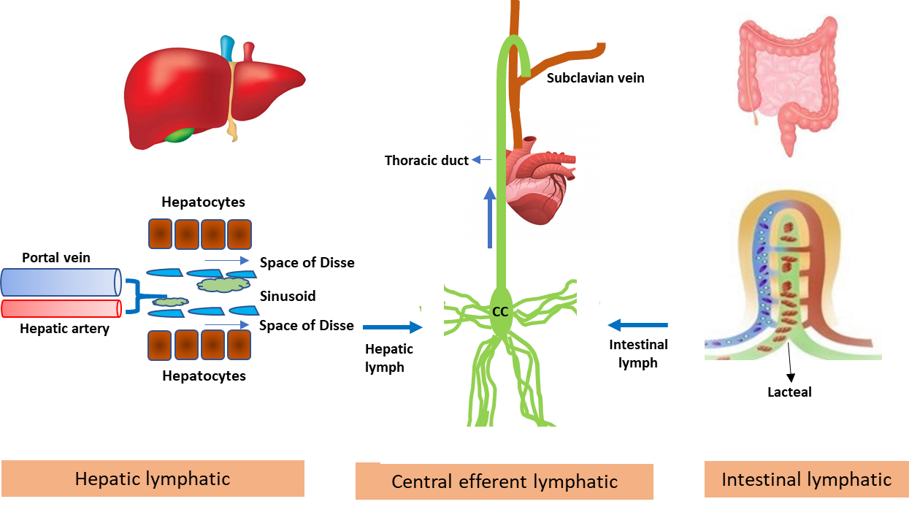
Figure 1 Schematic diagram showing lymph flow kinetics from liver and intestine to the systemic circulation. The capillary filtrate enters the lymphatic capillaries, as lymph, and moves towards larger lymphatic vessels. In liver, lymph is produced by filtration of plasma through the sinusoidal endothelial cells into the space of Disse. The collecting lymphatic vessels from all organs connect to one or more lymph nodes, and finally to the lymph trunks which ultimately drain into subclavian vein via cysterna chyli and thoracic duct. Approximately 80% of thoracic duct lymph comes from the intestines and liver.
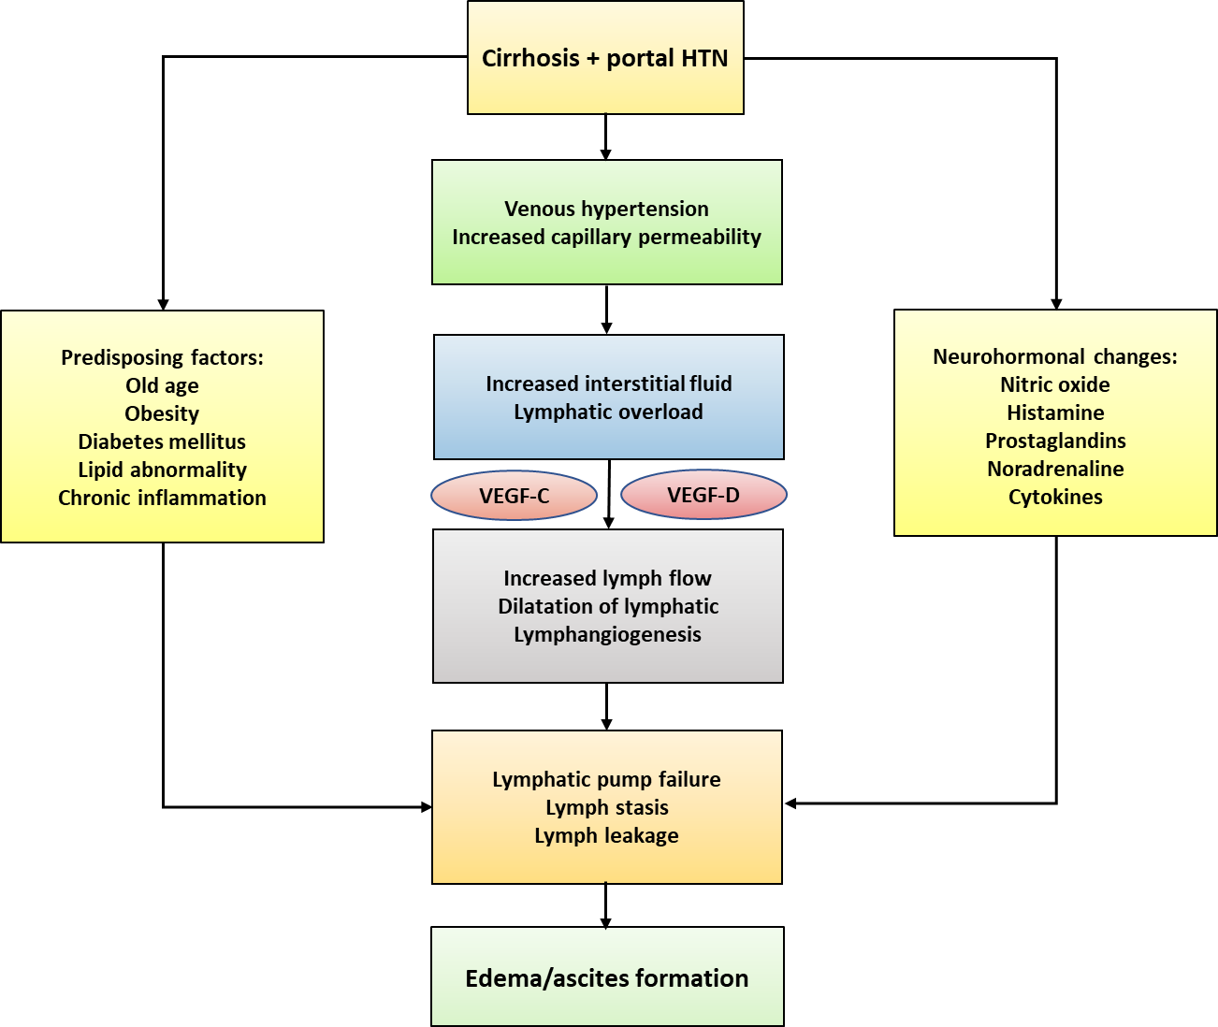
Figure 2 Flow diagram showing the possible pathophysiological mechanism behind lymphatic abnormalities in cirrhosis patients leading to fluid imbalance. The exact pathophysiological mechanism, at cellular and molecular level, is poorly understood in human cirrhosis. Some of the information has been derived from the experimental study on animal. VEGF: Vascular endothelial growth factor; HTN: Hypertension.
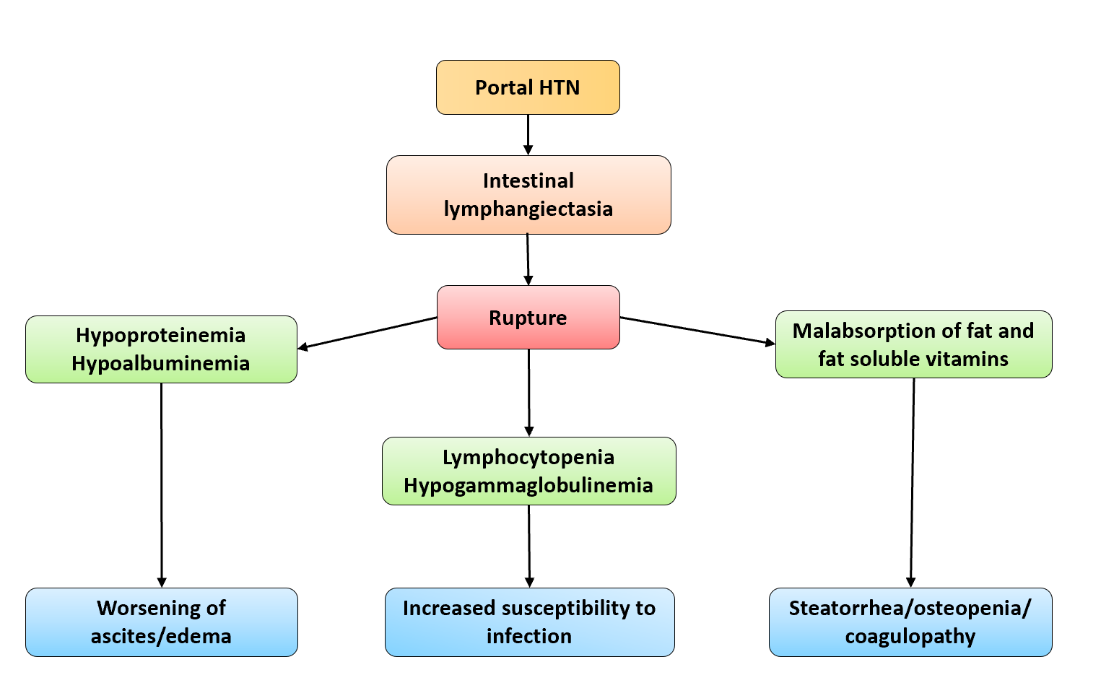
Figure 3 Flow diagram showing clinical consequences arising from the rupture of intestinal lymphangiectasia. HTN: Hypertension.
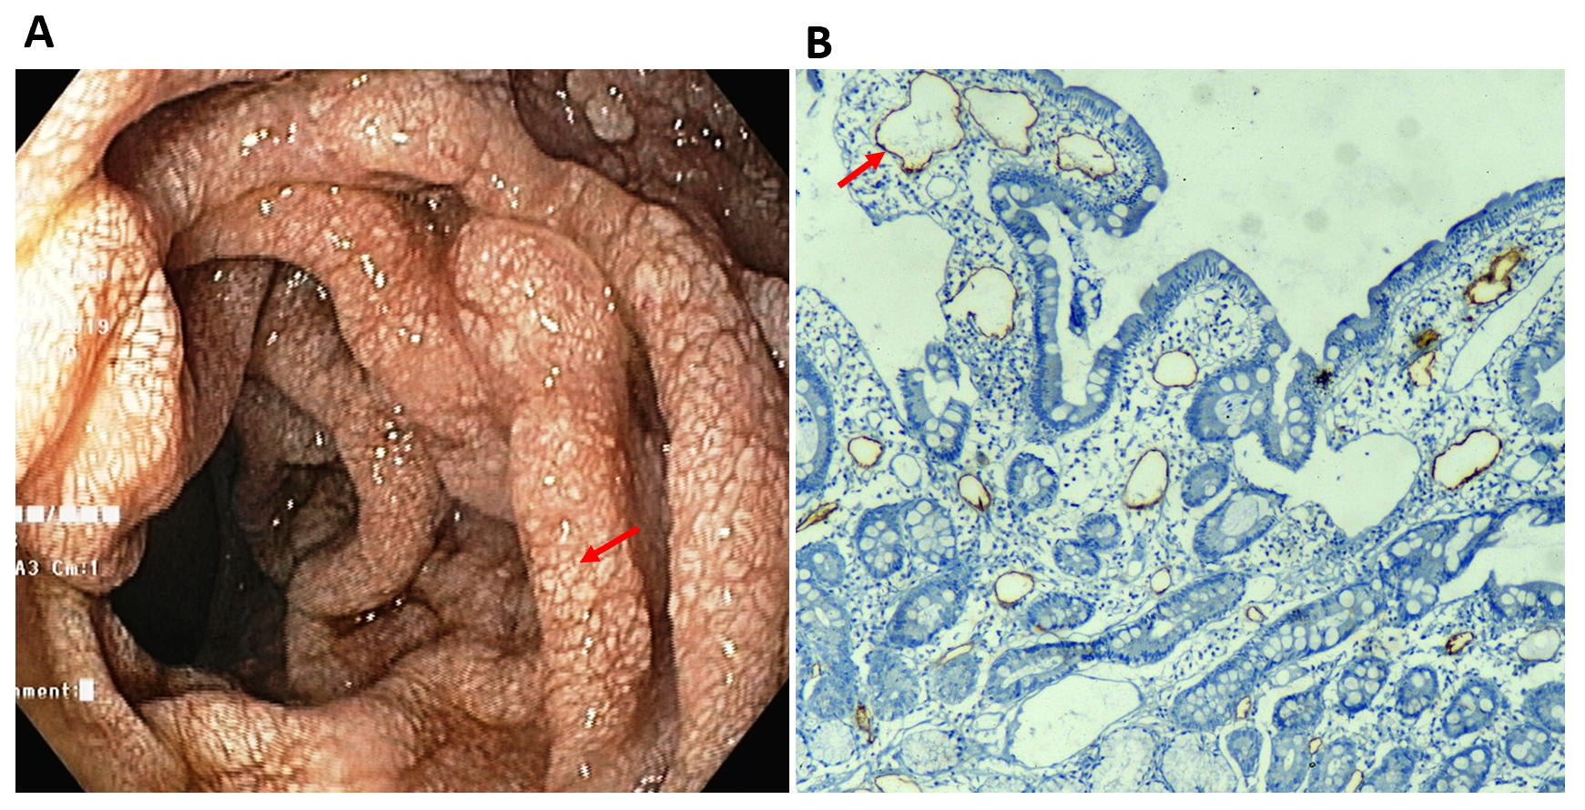
Figure 4 Intestinal lymphangiectasia in a patient with cirrhosis. A: Upper gastrointestinal endoscopy of a patient showing whitish swollen villi in the duodenum, suggestive of intestinal lymphangiectasia; B: On immunohistochemistry (× 10), markedly dilated vessels were seen in the lamina which showed strong D2-40 positivity indicating dilated lymphatics.
Table 1 Assessment of risk factors, clinical markers and investigations for lymphatic dysfunction in cirrhosis
Parameters | Findings that support or indicate lymphatic dysfunction
Risk factors | (1) Old age; (2) metabolic syndrome (obesity, diabetes, dyslipidemia); and (3) concomitant inflammatory disorders
Clinical examination | (1) Diuretic-resistant ascites; (2) severe generalised edema, scrotal/penile swelling; (3) lymphedema: Peau-d’orange appearance and a positive stemmer sign; (4) frequent cellulitis/lymphangitis of affected limbs; and (5) hyperkeratotic skin lesions, yellow nail
Blood investigations | (1) Hypoproteinaemia and hypoalbuminemia; (2) lymphocytopenia; and (3) hypogammaglobulinemia
Ascitic fluid analysis | Chylous ascites: Milky appearance, fluid triglyceride level ≥ 110mg/dL
Upper endoscopy | Intestinal lymphangiectasia: Whitish congested villi in duodenum
Radiological imaging: (lymphography, lymphoscintigraphy) | Abnormal lymphatic structure and/or lymph flow dynamics: Dilated lymphatic vessels, lymph stasis, lymph leakage
Histopathological examination (liver/intestine) | (1) Increase in number and size of lymphatic structures; and (2) specific lymphatic endothelial markers for accurate identification: Prox-1, podoplanin, LYVE-1
LYVE-1: Lymphatic vessel endothelial hyaluronan receptor.
Table 2 Possible therapeutic strategies for treatment of lymphatic dysfunction in cirrhosis
To decrease formation of lymph
Decrease water retention | Low salt diet, diuretic therapy
Control of portal hypertension | Beta-blocker, octreotide, transjugular intrahepatic portosystemic shunt
Increase interstitial pressure | Compression therapy
To promote lymphatic drainage
Facilitate fluid movement into the lymphatic vessels | Compression therapy, limb elevation, diuretic therapy (limited role)
Increase contractility of the lymphatic vessels | Nor-adrenaline, phenylephrine, nitric oxide-inhibitors (experimental)
Facilitate lysis of interstitial protein | Benzopyrones (coumarin and flavoids)
Promote lymphangiogenesis | Prostaglandins E2 (experimental), vascular endothelial growth factor-C (experimental)
To control aggravating factors for lymphatic dysfunction
Care of lymphedema | Control of infection (aggressive use of antibiotics), avoidance of trauma, hot bath and other heat-producing treatment
Control risk factors | Control of diabetes, dyslipidemia and obesity
To decrease leakage of lymph
Decrease stimulants of intestinal lymph flow | Low fat diet, octreotide
Decrease leakage of lymph by intervention | Compression therapy, antiplasmin (tranexamic acid); radiological intervention to obliterate the site of leak
To correct underlying condition
Definitive therapy of cirrhosis | Liver transplantation

Published by Baishideng Publishing Group Inc
7041 Koll Center Parkway, Suite 160, Pleasanton, CA 94566, USA
Telephone: +1-925-3991568
E-mail: bpgoffice@wjgnet.com
Help Desk: https://www.f6publishing.com/helpdesk
https://www.wjgnet.com

© 2021 Baishideng Publishing Group Inc. All rights reserved.

