Name of Journal: World Journal of Gastroenterology
Manuscript NO: 51551
Manuscript Type: CASE REPORT

Flushing as atypical initial presentation of functional gallbladder neuroendocrine carcinoma: A case report

Jin M et al. Functional neuroendocrine carcinoma of gallbladder

Ming Jin, Bo Zhou, Xiong-Ling Jiang, Qi-Yi Zhang, Xiang Zheng, Yuan-Cong Jiang, Sheng Yan

Ming Jin, Bo Zhou, Qi-Yi Zhang, Xiang Zheng, Yuan-Cong Jiang, Sheng Yan, Department of General Surgery, Second Affiliated Hospital, School of Medicine, Zhejiang University, Hangzhou 310009, Zhejiang Province, China

Xiong-Ling Jiang, Department of Pathology, First Affiliated Hospital, School of Medicine, Zhejiang University, Hangzhou 310003, Zhejiang Province, China

Author contributions: Jin M and Zhou B reviewed the literature, acquired the data and contributed to manuscript drafting; Jiang XL analyzed and interpreted the pathological and immunohistochemical findings, and contributed to manuscript drafting; Zhang QY was the patient’s surgeon, acquired the data, and contributed to manuscript drafting; Zheng X and Jiang YC analyzed and interpreted the imaging findings and contributed to manuscript drafting; Yan S acquired the data and was responsible for the revision of the manuscript for important intellectual content; All authors issued final approval for the version to be submitted.

Supported by The National Natural Science Foundation of China, No. 81572975; Key research and development project of science and technology department of Zhejiang, China, No. 2015C03053.

Corresponding author: Sheng Yan, MD, PhD, Chief Doctor, Associate Professor of Medicine, Department of General Surgery, Second Affiliated Hospital, School of Medicine, Zhejiang University, No. 88 Jiefang Road, Hangzhou 310009, Zhejiang Province, China. shengyan@zju.edu.cn

Received: September 21, 2019
Revised: December 31, 2019
Accepted: January 11, 2020
Published online: February 14, 2020
Abstract
BACKGROUND
Neuroendocrine neoplasms are rarely located in the gallbladder (GB), and carcinoid syndrome is exceedingly rare in patients with GB neuroendocrine neoplasms.

CASE SUMMARY
We report a case of GB neuroendocrine carcinoma (GB-NEC) in a 65-year-old man, who presented with flushing for 2 mo. Pathological specimens of the flushed skin revealed that mucin was deposited between the collagen bundles in the dermis. Computed tomography and magnetic resonance imaging indicated neoplasm in the GB with liver invasion and enlarged lymph nodes in the portacaval space. High fluorodeoxyglucose uptake was detected in lymph nodes in the portacaval space, but distant metastasis was not seen by positron emission tomography. Ultrasound-guided needle biopsy of the GB neoplasm was suggestive of high-grade NEC. Because of the functional characteristics of poorly differentiated NEC, en bloc cholecystectomy, resection of hepatic segments IVb and V, pancreaticoduodenectomy, and regional lymphadenectomy were performed. A diagnosis of poorly differentiated NEC was made by pathological findings and immunohistochemical staining data. Ki-67 index was > 80%. The patient refused adjuvant therapy and passed away in the 7th month.

CONCLUSION
Distinctive manifestation combined with imaging helps make correct preoperative diagnosis. Radical surgery and adjuvant chemotherapy might improve prognosis.

Key words: Malignant carcinoid syndrome; Neuroendocrine tumors; Carcinoma; Gallbladder; Carcinoid tumor; Case report

Jin M, Zhou B, Jiang XL, Zhang QY, Zheng X, Jiang YC, Yan S. Flushing as atypical initial presentation of functional gallbladder neuroendocrine carcinoma: A case report. World J Gastroenterol 2020; 26(6): 686-695
URL: https://www.wjgnet.com/1007-9327/full/v26/i6/686.htm
DOI: https://dx.doi.org/10.3748/wjg.v26.i6.686

Core tip: Neuroendocrine neoplasms are rarely located in the gallbladder (GB), and carcinoid syndrome is exceedingly rare in patients with GB neuroendocrine neoplasms. We present herein, a rare case of GB neuroendocrine carcinoma in a 65-year-old man, who presented with flushing for 2 mo. En bloc cholecystectomy, resection of hepatic segments IVb and V, pancreaticoduodenectomy, and regional lymphadenectomy were performed. Surgery helped to alleviate his symptoms. Distinctive manifestation combined with imaging helps make correct preoperative diagnosis. Radical surgery followed by adjuvant chemotherapy might improve the prognosis of advanced GB neuroendocrine carcinomas.

INTRODUCTION
Neuroendocrine neoplasms (NENs) refer to a family of neoplasms originating from neuroendocrine cells throughout the body, mostly originating in the gastrointestinal tract, pancreas, and lungs^{[1,2]}. Neuroendocrine carcinoma (NEC) always refers to high-grade neoplasms with poor differentiation. NENs are traditionally divided into functional and nonfunctional neoplasms. Functional NENs produce peptide hormones that cause symptoms, while nonfunctional NENs are clinically silent until neoplasm is large, metastatic disease or bleeding occurs. Primary gallbladder (GB)-NENs are infrequent and make up < 1% of all NENs^{[1,3]}. Among 875 GB carcinomas diagnosed by ultrasound-guided fine needle aspiration cytology, only 20 were GB-NENs^{[4]}. In addition, among GB-NENs, carcinoid syndrome caused by functional neoplasm is exceedingly rare (< 1%)^{[5,6]}.
Here, we report a case of functional GB-NEC, in which an initial presentation of the patient was suspected as manifestation of carcinoid syndrome. The patient underwent radical surgery that helped to alleviate his symptoms. In addition, we reviewed cases of functional GB-NENs associated with rare manifestations reported from 1986 to 2018.

CASE PRESENTATION
Chief complaints
A 65-year-old man was admitted to our hospital with a history of flushing for 2 mo. The patient had no symptoms of abdominal pain, diarrhea, or jaundice.

History of present illness
Patient’s symptoms started 2 mo ago.

History of past illness
The patient denied a history of hypertension, diabetes, and other relevant illness.

Family history
His father had esophageal cancer.

Physical examination
The physical examination was normal except for the skin. The skin over the face, neck, upper chest, and limbs was flushed and scaly (Figure 1A and B).

Laboratory examinations
Complete blood count, renal and liver function tests, and erythrocyte sedimentation rate were within normal limits. Autoimmune serology showed an increased antinuclear antibody titer (1:40), but antibodies to double-stranded DNA, ribonucleoprotein, Sm nuclear antigen, scleroderma-70 protein, and Jo-1 protein were negative. Neuron-specific enolase (NSE) was 34.7 ng/mL (normal range 0–30.0 ng/mL). Levels of tumor markers including α-fetoprotein, carcinoembryonic antigen, carbohydrate antigen 125, and carbohydrate antigen 19-9 were in the normal ranges.

Imaging examinations
Computed tomography (CT) revealed GB neoplasm and enlarged lymph nodes (Figure 2). Magnetic resonance imaging revealed GB neoplasm with liver invasion, and several enlarged lymph nodes were found in the portacaval space (Figure 3). High fluorodeoxyglucose uptake was detected in lymph nodes in the portacaval space, which was considered metastasis, but distant metastasis was not seen by positron emission tomography (PET) (Figure 4).

Further diagnostic work-up
Pathological specimens of the flushed skin revealed that mucin was deposited between the collagen bundles in the dermis. Ultrasound-guided needle biopsy from the GB neoplasm was suggestive of high-grade NEC. Immunohistochemical staining of the biopsy specimen revealed expression of chromogranin A (CgA), synaptophysin (SYN), pan-cytokeratin (pan-CK), CK19, and cluster of differentiation (CD) 56.

FINAL DIAGNOSIS
The final diagnosis was GB-NEC due to pathology and immunohistochemistry of the biopsy specimen.

TREATMENT
Intraoperative exploration showed that two lymph nodes in the portacaval space were firm and immovable, which adhered to the pancreas and duodenum respectively, and therefore could not be harvested completely. En bloc cholecystectomy, resection of hepatic segments IVb and V, pancreaticoduodenectomy, and regional lymphadenectomy were performed.

OUTCOME AND FOLLOW-UP
Intraoperative blood loss volume was approximately 300 mL. Operative time was 6 h and 35 min. No adverse events occurred in the postoperative period. And postoperative hospitalization duration was 1 mo.
Pathological findings were poorly differentiated NEC with adjacent liver invasion (Figure 5A), pancreatic invasion, and duodenal invasion. Vascular cancer embolus was revealed. No lymph node metastasis was revealed in six peripancreatic lymph nodes and eight perigastric lymph nodes. The neoplasm measured 4.0 cm × 2.0 cm and was located in the neck of GB. Immunohistochemical staining showed expression of CgA (Figure 5B), SYN (Figure 5C), pan-CK, CK19, and CD56. Thyroid transcription factor-1 was detected in a few cells. The GB-NEC was negative for CK7 and glypican-3. Ki-67 index was > 80% (Figure 5D).
The level of NSE decreased to 12.6 ng/mL 2 d after surgery. Flushing was obviously relieved at day 5 postoperatively (Figure 1C and D), and 2 wk after surgery, flushing faded entirely and skin pigmentation was visible (Figure 1E and F). The patient refused adjuvant therapy, such as chemotherapy. On telephonic follow-up, the son stated that the skin became flushed in the 3rd month after surgery and the patient passed away in the 7th month.

DISCUSSION
GB-NENs account for a particularly small group of NENs. According to a survey by the Surveillance, Epidemiology and End Result program, the incidence of GB-NEN was < 0.74/100000 between 1973 and 2005, accounting for 0.5% of all NENs^{[7]}. Compared to GB adenocarcinomas, GB-NEC has a tendency of advanced disease progression at diagnosis, poor differentiation of cells and high rate of lymphatic metastases^{[8]}.
Functional NENs might cause symptoms due to peptide hormones. Typical symptoms of carcinoid syndrome are flushing, diarrhea, wheezing, and edema. Nevertheless, the most common symptom of GB-NENs is epigastric pain. Lack of distinctive manifestations adds to the difficulty of making correct diagnosis preoperatively^{[9]}. In addition, because of the lack of early-stage symptoms and aggressiveness of the carcinoma, GB-NECs are often diagnosed at an advanced stage with adjacent liver invasion and lymph node metastasis, resulting in poor prognosis^{[5,10]}. The classification and grading criteria for GB-NENs correlates with Ki-67 index and mitotic rate. According to the 2019 World Health Organization classification of tumors of the digestive system^{[11]}, our patient had high-grade and poorly differentiated NEC, because Ki-67 index was > 80% and the carcinoma was small-cell type. According to the Eighth Edition of the AJCC Cancer Staging Manual, the NEC in our case report is classified as T4N0M0.
The clinicopathological features and follow-up results of the reported GB-NENs associated with rare manifestations, including the present case, are described in Table 1^{[12-17]}. The patient age ranged from 52 to 79 years (mean: 65 years). There were no significant gender-related differences. Patients had various symptoms, such as flushing (cases 1 and 6), wheezing (case 1), Cushing’s syndrome (cases 2 and 3), hypoglycemia (case 4), and watery diarrhea (case 5). GB-NEN can arise in any part of GB. Immunohistochemically, cases 1, 2, 4, and 6 presented with intense immunoreactivity for chromogranin and SYN, while cases 1, 4, and 6 presented with intense immunoreactivity for CD56.
Imaging examinations including ultrasonography, CT, magnetic resonance imaging, and PET can indicate GB neoplasm. According to an article that compared CT features between GB-NEN and GB adenocarcinoma, the former showed well-defined margins and had larger hepatic and lymph node metastasis than adenocarcinomas^{[18]}. One recent study found that primary small cell GB-NENs mainly presented as a large, heterogeneous GB neoplasm with extraluminal growth^{[19]}. The GB-NEC in our case manifested as a large neoplasm with hepatic and lymph node metastasis, in accordance with the above findings. ¹⁸F-fluorodeoxyglucose PET/CT plays an important role in defining aggressiveness of high-grade gastro-entero-pancreatic NENs and providing with prognostic information, especially when combined with ⁶⁸Ga-labelled somatostatin analogues PET/CT^{[20]}. High sensitivity has been proved for PET/CT with ⁶⁸Ga-labeled peptides in patients with suspected NENs^{[21,22]}. The utility of Gallium-68-1,4,7,10-tetraazacyclododecane-N,N',N″,N‴-tetra acetic acid-D-Phe1-Tyr3-octreotate (⁶⁸Ga-DOTATATE) PET/CT has been discussed recently, which gives relevant information for accurate staging of gastro-entero-pancreatic NENs and selection of appropriate treatment intervention^{[23]}. Gallium-68-1,4,7,10-tetraazacyclododecane-N,N',N'',N'''-tetra acetic acid-D-Phe1-Try3-octreotide (⁶⁸Ga-DOTATOC) PET/CT is reported as an effective tool in the localization of unknown primary NENs^{[24,25]}.
GB-NEN is often misdiagnosed preoperatively, and most GB-NENs are discovered by pathology and immunohistochemistry^{[26-28]}. In order to make a definite diagnosis preoperatively and selection of appropriate treatment intervention, percutaneous biopsy can be performed to assess GB neoplasm^{[29-31]}. In 75% of NENs, neoplasm can stain positive for SYN, followed by CgA.
According to the National Comprehensive Cancer Network Guidelines for Hepatobiliary Cancer (Version 4. 2019), if GB-NEC is restricted to the lamina propria, a simple cholecystectomy is adequate. However, for patients with T2 or higher carcinoma, cholecystectomy combined with hepatic resection and lymphadenectomy can improve survival. The increased survival rate has been realized for locally invasive GB-NECs based on radical surgery followed by adjuvant chemotherapy^{[32]}. In some cases, in which the neoplasm is unresectable or specimen margins have neoplasm involvement, systemic chemotherapy can be the treatment intervention^{[2]}. Adjuvant therapy is based on dissemination state, resection margin and histological classification. However, for biliary NEN there are no consensual indications for adjuvant therapy^{[33]}. Gemcitabine-based and fluoropyrimidine-based combination chemotherapy regimens are recommended for the treatment of patients with advanced biliary tract cancer. The role of radiotherapy is unclear. Radiotherapy might be useful for local control and palliation of pain from metastatic bone disease, but NENs are generally not sensitive to traditional radiotherapy^{[34,35]}. The effectiveness of biotherapy (like SST analogs) has been demonstrated in controlling symptoms in some gastro-entero-pancreatic NENs, such as SST-receptor-positive inoperable gastro-entero-pancreatic NEN^{[36]}. In the present case, the patient refused adjuvant therapy and survived for 7 mo after surgery. Maybe chemotherapy would have inhibited the recurrence and done some good to the patient’s survival period.
Our case report had several limitations. First, we did not determine levels of serum CgA, serum serotonin and urinary 5-hydroxyindole acetic acid preoperatively. So we could not diagnosis the patient’s disease as carcinoid syndrome^{[37]}. However, the patient’s symptom was of 2 mo duration and was obviously relieved at day 5 postoperatively. In addition, we ruled out immunological disease and dermatosis by the examination of antinuclear antibody titer, antibodies to double-stranded DNA, ribonucleoprotein, Sm nuclear antigen, scleroderma-70 protein, Jo-1 protein and pathological finding of the flushed skin. Therefore, his disease was suspected as carcinoid syndrome. Second, our case report lacked intra-operatory images and photographs of the resected neoplasm. We provided the size of the neoplasm and location to make up for this limitation.

CONCLUSION
In most cases, the symptoms of patients with GB-NEN are not distinctive, but it should be kept in mind that a few patients present with carcinoid syndrome. Distinctive manifestation combined with imaging helps to make correct preoperative diagnosis. Percutaneous biopsy can be an option to identify the neoplasm characteristics. Radical surgery including cholecystectomy and hepatic resection combined with regional lymphadenectomy plus adjuvant chemotherapy is recommended for advanced GB-NEC. Further studies on chemotherapy, radiotherapy, and biotherapy are needed for the standardization of treatment intervention including surgery.

REFERENCES
1 Zheng Z, Chen C, Li B, Liu H, Zhou L, Zhang H, Zheng C, He X, Liu W, Hong T, Zhao Y. Biliary Neuroendocrine Neoplasms: Clinical Profiles, Management, and Analysis of Prognostic Factors. Front Oncol 2019; 9: 38 [PMID: 30805307 DOI: 10.3389/fonc.2019.00038]
2 Chen H, Shen YY, Ni XZ. Two cases of neuroendocrine carcinoma of the gallbladder. World J Gastroenterol 2014; 20: 11916-11920 [PMID: 25206300 DOI: 10.3748/wjg.v20.i33.11916]
3 You YH, Choi DW, Heo JS, Han IW, Choi SH, Jang KT, Han S. Can surgical treatment be justified for neuroendocrine carcinoma of the gallbladder? Medicine (Baltimore) 2019; 98: e14886 [PMID: 30882701 DOI: 10.1097/MD.0000000000014886]
4 Yadav R, Jain D, Mathur SR, Iyer VK. Cytomorphology of neuroendocrine tumours of the gallbladder. Cytopathology 2016; 27: 97-102 [PMID: 25689921 DOI: 10.1111/cyt.12239]
5 Eltawil KM, Gustafsson BI, Kidd M, Modlin IM. Neuroendocrine tumors of the gallbladder: an evaluation and reassessment of management strategy. J Clin Gastroenterol 2010; 44: 687-695 [PMID: 20375728 DOI: 10.1097/MCG.0b013e3181d7a6d4]
6 Liu W, Chen W, Chen J, Hong T, Li B, Qu Q, He X. Neuroendocrine carcinoma of gallbladder: a case series and literature review. Eur J Med Res 2019; 24: 8 [PMID: 30717775 DOI: 10.1186/s40001-019-0363-z]
7 Ayub F, Saif MW. Neuroendocrine Tumor of the Cystic Duct: A Rare and Incidental Diagnosis. Cureus 2017; 9: e1755 [PMID: 29226045 DOI: 10.7759/cureus.1755]
8 Chen C, Wang L, Liu X, Zhang G, Zhao Y, Geng Z. Gallbladder neuroendocrine carcinoma: report of 10 cases and comparision of clinicopathologic features with gallbladder adenocarcinoma. Int J Clin Exp Pathol 2015; 8: 8218-8226 [PMID: 26339390]
9 Zou YP, Li WM, Liu HR, Li N. Primary carcinoid tumor of the gallbladder: a case report and brief review of the literature. World J Surg Oncol 2010; 8: 12 [PMID: 20175936 DOI: 10.1186/1477-7819-8-12]
10 Albores-Saavedra J, Batich K, Hossain S, Henson DE, Schwartz AM. Carcinoid tumors and small-cell carcinomas of the gallbladder and extrahepatic bile ducts: a comparative study based on 221 cases from the Surveillance, Epidemiology, and End Results Program. Ann Diagn Pathol 2009; 13: 378-383 [PMID: 19917473 DOI: 10.1016/j.anndiagpath.2009.08.002]
11 Nagtegaal ID, Odze RD, Klimstra D, Paradis V, Rugge M, Schirmacher P, Washington KM, Carneiro F, Cree IA; WHO Classification of Tumours Editorial Board. The 2019 WHO classification of tumours of the digestive system. Histopathology 2020; 76: 182-188 [PMID: 31433515 DOI: 10.1111/his.13975]
12 Monier A, Saloum N, Szmigielski W, Alrashid A, Napaki SM. Neuroendocrine tumor of the gallbladder. Pol J Radiol 2015; 80: 228-231 [PMID: 26000067 DOI: 10.12659/PJR.893705]
13 Lin D, Suwantarat N, Kwee S, Miyashiro M. Cushing's syndrome caused by an ACTH-producing large cell neuroendocrine carcinoma of the gallbladder. World J Gastrointest Oncol 2010; 2: 56-58 [PMID: 21160818 DOI: 10.4251/wjgo.v2.i1.56]
14 Howlett TA, Drury PL, Perry L, Doniach I, Rees LH, Besser GM. Diagnosis and management of ACTH-dependent Cushing's syndrome: comparison of the features in ectopic and pituitary ACTH production. Clin Endocrinol (Oxf) 1986; 24: 699-713 [PMID: 3024870 DOI: 10.1111/j.1365-2265.1986.tb01667.x]
15 Coates PJ, Doniach I, Howlett TA, Rees LH, Besser GM. Immunocytochemical study of 18 tumours causing ectopic Cushing's syndrome. J Clin Pathol 1986; 39: 955-960 [PMID: 3020095 DOI: 10.1136/jcp.39.9.955]
16 Ahn JE, Byun JH, Ko MS, Park SH, Lee MG. Case report: neuroendocrine carcinoma of the gallbladder causing hyperinsulinaemic hypoglycaemia. Clin Radiol 2007; 62: 391-394 [PMID: 17331836 DOI: 10.1016/j.crad.2006.11.016]
17 Salimi Z, Sharafuddin M. Ultrasound appearance of primary carcinoid tumor of the gallbladder associated with carcinoid syndrome. J Clin Ultrasound 1995; 23: 435-437 [PMID: 7560158 DOI: 10.1002/jcu.1870230708]
18 Kim TH, Kim SH, Lee KB, Han JK. Outcome and CT differentiation of gallbladder neuroendocrine tumours from adenocarcinomas. Eur Radiol 2017; 27: 507-517 [PMID: 27225621 DOI: 10.1007/s00330-016-4394-3]
19 Faraoun SA, Guerrache Y, Dautry R, Boudiaf M, Dohan A, Barral M, Hoeffel C, Rousset P, Fohlen A, Soyer P. Computed Tomographic Features of Primary Small Cell Neuroendocrine Tumors of the Gallbladder. J Comput Assist Tomogr 2018; 42: 707-713 [PMID: 29901505 DOI: 10.1097/RCT.0000000000000753]
20 Carideo L, Prosperi D, Panzuto F, Magi L, Pratesi MS, Rinzivillo M, Annibale B, Signore A. Role of Combined [⁶⁸Ga] Ga-DOTA-SST Analogues and [¹⁸F] FDG PET/CT in the Management of GEP-NENs: A Systematic Review. J Clin Med 2019; 8 [PMID: 31337043 DOI: 10.3390/jcm8071032]
21 Sampaio Vieira T, Borges Faria D, Souto Moura C, Francisco E, Barroso S, Pereira de Oliveira J. Incidental finding of a breast carcinoma on Ga-68-DOTA-1-Nal3-octreotide positron emission tomography/computed tomography performed for the evaluation of a pancreatic neuroendocrine tumor: A case report. Medicine (Baltimore) 2018; 97: e11878 [PMID: 30200073 DOI: 10.1097/MD.0000000000011878]
22 Deppen SA, Liu E, Blume JD, Clanton J, Shi C, Jones-Jackson LB, Lakhani V, Baum RP, Berlin J, Smith GT, Graham M, Sandler MP, Delbeke D, Walker RC. Safety and Efficacy of 68Ga-DOTATATE PET/CT for Diagnosis, Staging, and Treatment Management of Neuroendocrine Tumors. J Nucl Med 2016; 57: 708-714 [PMID: 26769865 DOI: 10.2967/jnumed.115.163865]
23 Sadowski SM, Neychev V, Millo C, Shih J, Nilubol N, Herscovitch P, Pacak K, Marx SJ, Kebebew E. Prospective Study of 68Ga-DOTATATE Positron Emission Tomography/Computed Tomography for Detecting Gastro-Entero-Pancreatic Neuroendocrine Tumors and Unknown Primary Sites. J Clin Oncol 2016; 34: 588-596 [PMID: 26712231 DOI: 10.1200/JCO.2015.64.0987]
24 Menda Y, O'Dorisio TM, Howe JR, Schultz M, Dillon JS, Dick D, Watkins GL, Ginader T, Bushnell DL, Sunderland JJ, Zamba GKD, Graham M, O'Dorisio MS. Localization of Unknown Primary Site with ⁶⁸Ga-DOTATOC PET/CT in Patients with Metastatic Neuroendocrine Tumor. J Nucl Med 2017; 58: 1054-1057 [PMID: 28153957 DOI: 10.2967/jnumed.116.180984]
25 Cingarlini S, Ortolani S, Salgarello M, Butturini G, Malpaga A, Malfatti V, DʼOnofrio M, Davì MV, Vallerio P, Ruzzenente A, Capelli P, Citton E, Grego E, Trentin C, De Robertis R, Scarpa A, Bassi C, Tortora G. Role of Combined 68Ga-DOTATOC and 18F-FDG Positron Emission Tomography/Computed Tomography in the Diagnostic Workup of Pancreas Neuroendocrine Tumors: Implications for Managing Surgical Decisions. Pancreas 2017; 46: 42-47 [PMID: 27906872 DOI: 10.1097/MPA.0000000000000745]
26 Hirose Y, Sakata J, Endo K, Takahashi M, Saito R, Imano H, Kido T, Yoshino K, Sasaki T, Wakai T. A 0.8-cm clear cell neuroendocrine tumor G1 of the gallbladder with lymph node metastasis: a case report. World J Surg Oncol 2018; 16: 150 [PMID: 30037336 DOI: 10.1186/s12957-018-1454-y]
27 Du H, Zhang H, Xu Y, Wang L. Neuroendocrine tumor of the gallbladder with spectral CT. Quant Imaging Med Surg 2014; 4: 516-518 [PMID: 25525590 DOI: 10.3978/j.issn.2223-4292.2014.08.04]
28 Fujii M, Saito H, Shiode J. Rare case of a gallbladder neuroendocrine carcinoma. Clin J Gastroenterol 2019; 12: 38-45 [PMID: 30003469 DOI: 10.1007/s12328-018-0883-z]
29 Jun SR, Lee JM, Han JK, Choi BI. High-grade neuroendocrine carcinomas of the gallbladder and bile duct: Report of four cases with pathological correlation. J Comput Assist Tomogr 2006; 30: 604-609 [PMID: 16845291 DOI: 10.1097/00004728-200607000-00009]
30 El Fattach H, Guerrache Y, Eveno C, Pocard M, Kaci R, Shaar-Chneker C, Dautry R, Boudiaf M, Dohan A, Soyer P. Primary neuroendocrine tumors of the gallbladder: Ultrasonographic and MDCT features with pathologic correlation. Diagn Interv Imaging 2015; 96: 499-502 [PMID: 25543866 DOI: 10.1016/j.diii.2014.11.027]
31 Chakraborty PS, Dhull VS, Karunanithi S, Roy SG, Kumar R. Rare case of gall bladder neuroendocrine tumor: ¹⁸F-FDG and ⁶⁸Ga-DOTANOC PET/CT findings. Rev Esp Med Nucl Imagen Mol 2014; 33: 316-317 [PMID: 25043774 DOI: 10.1016/j.remn.2013.10.009]
32 Moskal TL, Zhang PJ, Nava HR. Small cell carcinoma of the gallbladder. J Surg Oncol 1999; 70: 54-59 [PMID: 9989422 DOI: 10.1002/(sici)1096-9098(199901)70:1<54:aid-jso10>3.0.co;2-w]
33 Kim J, Lee WJ, Lee SH, Lee KB, Ryu JK, Kim YT, Kim SW, Yoon YB, Hwang JH, Han HS, Woo SM, Park SJ. Clinical features of 20 patients with curatively resected biliary neuroendocrine tumours. Dig Liver Dis 2011; 43: 965-970 [PMID: 21856258 DOI: 10.1016/j.dld.2011.07.010]
34 Shimono C, Suwa K, Sato M, Shirai S, Yamada K, Nakamura Y, Makuuchi M. Large cell neuroendocrine carcinoma of the gallbladder: long survival achieved by multimodal treatment. Int J Clin Oncol 2009; 14: 351-355 [PMID: 19705247 DOI: 10.1007/s10147-008-0843-6]
35 Modlin IM, Kidd M, Drozdov I, Siddique ZL, Gustafsson BI. Pharmacotherapy of neuroendocrine cancers. Expert Opin Pharmacother 2008; 9: 2617-2626 [PMID: 18803449 DOI: 10.1517/14656566.9.15.2617]
36 Nikou GC, Lygidakis NJ, Toubanakis C, Pavlatos S, Tseleni-Balafouta S, Giannatou E, Mallas E, Safioleas M. Current diagnosis and treatment of gastrointestinal carcinoids in a series of 101 patients: the significance of serum chromogranin-A, somatostatin receptor scintigraphy and somatostatin analogues. Hepatogastroenterology 2005; 52: 731-741 [PMID: 15966194]
37 Boutzios G, Kaltsas G. Clinical Syndromes Related to Gastrointestinal Neuroendocrine Neoplasms. Front Horm Res 2015; 44: 40-57 [PMID: 26303703 DOI: 10.1159/000382053]

Footnotes
Informed consent statement: Informed written consent was obtained from the patient for publication of this report and any accompanying images.

Conflict-of-interest statement: The authors declare that they have no conflicts of interest.

CARE Checklist (2016) statement: The authors have read the CARE Checklist (2016), and the manuscript was prepared and revised according to the CARE Checklist (2016).

Open-Access: This article is an open-access article that was selected by an in-house editor and fully peer-reviewed by external reviewers. It is distributed in accordance with the Creative Commons Attribution Non Commercial (CC BY-NC 4.0) license, which permits others to distribute, remix, adapt, build upon this work non-commercially, and license their derivative works on different terms, provided the original work is properly cited and the use is non-commercial. See: http://creativecommons.org/licenses/by-nc/4.0/

Manuscript source: Unsolicited manuscript

Peer-review started: September 21, 2019
First decision: November 4, 2019
Article in press: January 11, 2020

Specialty type: Gastroenterology and Hepatology
Country of origin: China
Peer-review report classification
Grade A (Excellent): 0
Grade B (Very good): 0
Grade C (Good): C, C, C
Grade D (Fair): 0
Grade E (Poor): 0

P-Reviewer: Aosasa S, Iliescu EL, Yang ZH S-Editor: Zhang L L-Editor: Filipodia E-Editor: Zhang YL

Figure Legends

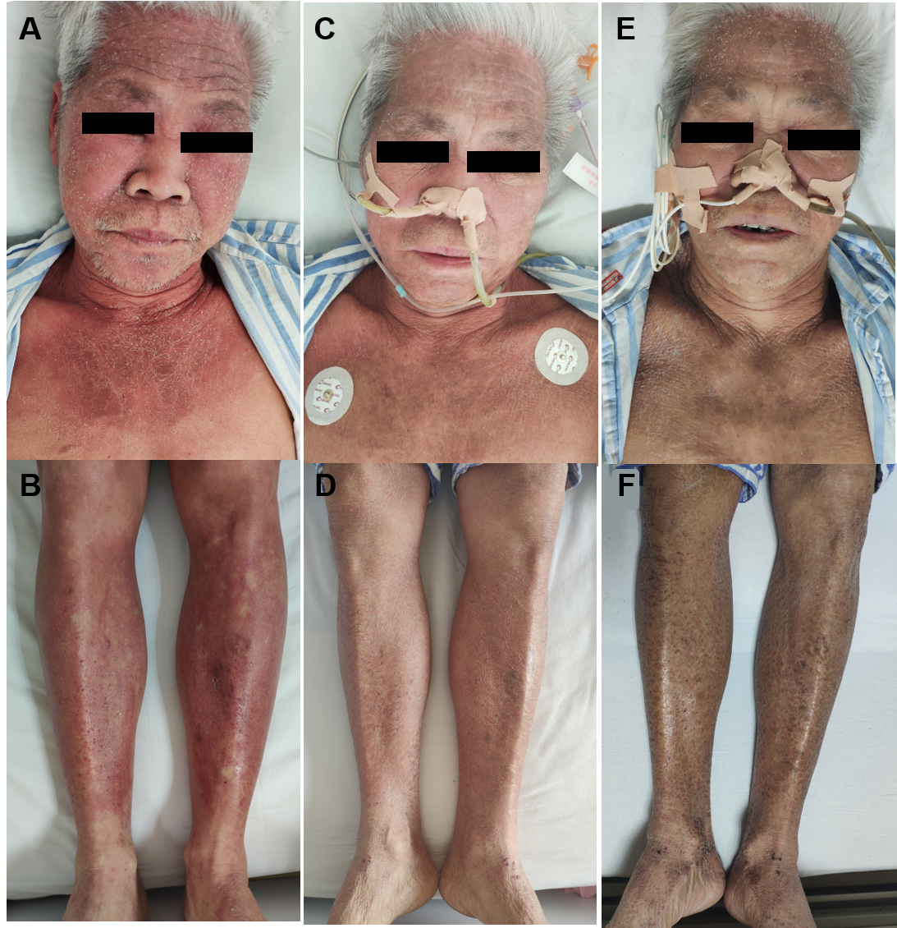
Figure 1 Visible changes of the skin. A, B: The skin over the face, neck, upper chest, and limbs was flushed, accompanied by desquamation before surgery; C, D: Flushing was obviously relieved on day 5 postoperatively; E, F: At 2 wk after surgery, flushing faded entirely and skin pigmentation was visible.

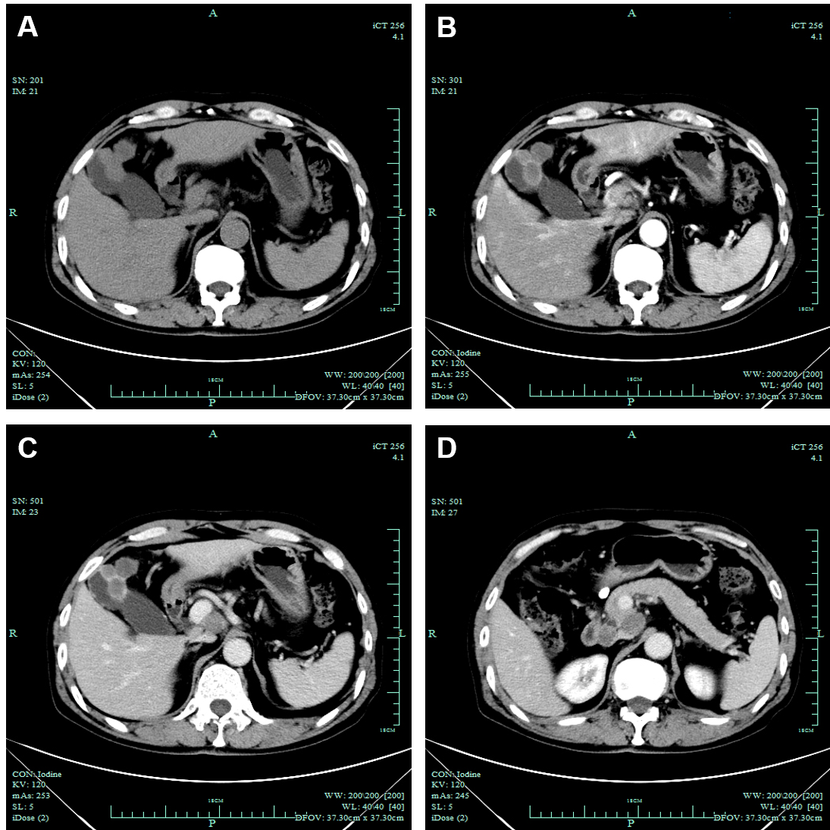
Figure 2 Computed tomography examination. A: Gallbladder neoplasm was visible in unenhanced imagery; B: Gallbladder neoplasm was mildly enhanced in arterial phases; C: Gallbladder neoplasm was mildly enhanced in venous phases; D: Enlarged lymph nodes were seen in the portacaval space.

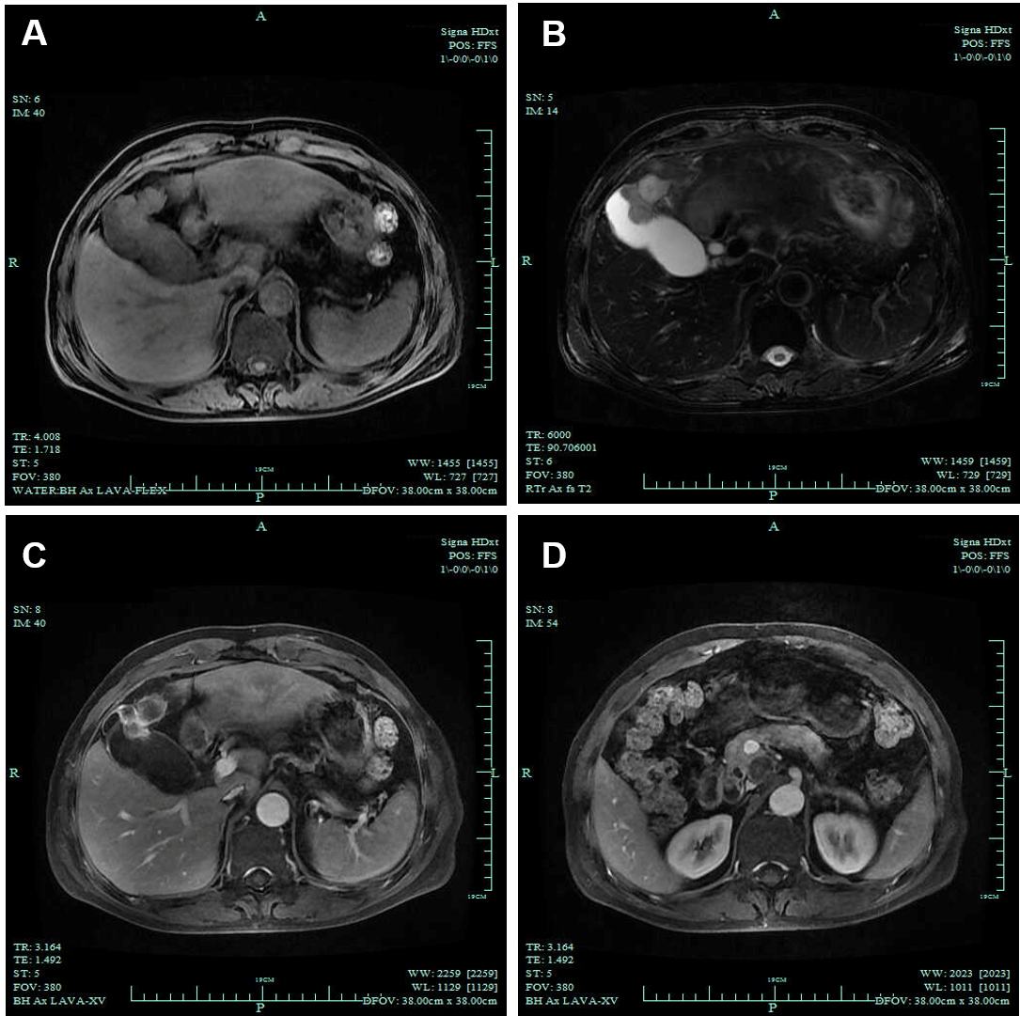
Figure 3 Magnetic resonance imaging examination. A: The gallbladder neoplasm was revealed with liver invasion on T1-weighted imaging; B: The gallbladder neoplasm was revealed with liver invasion on T2-weighted imaging; C: The neoplasm showed increased signals in contrast-enhanced phase; D: Several enlarged lymph nodes were found in the portacaval space.

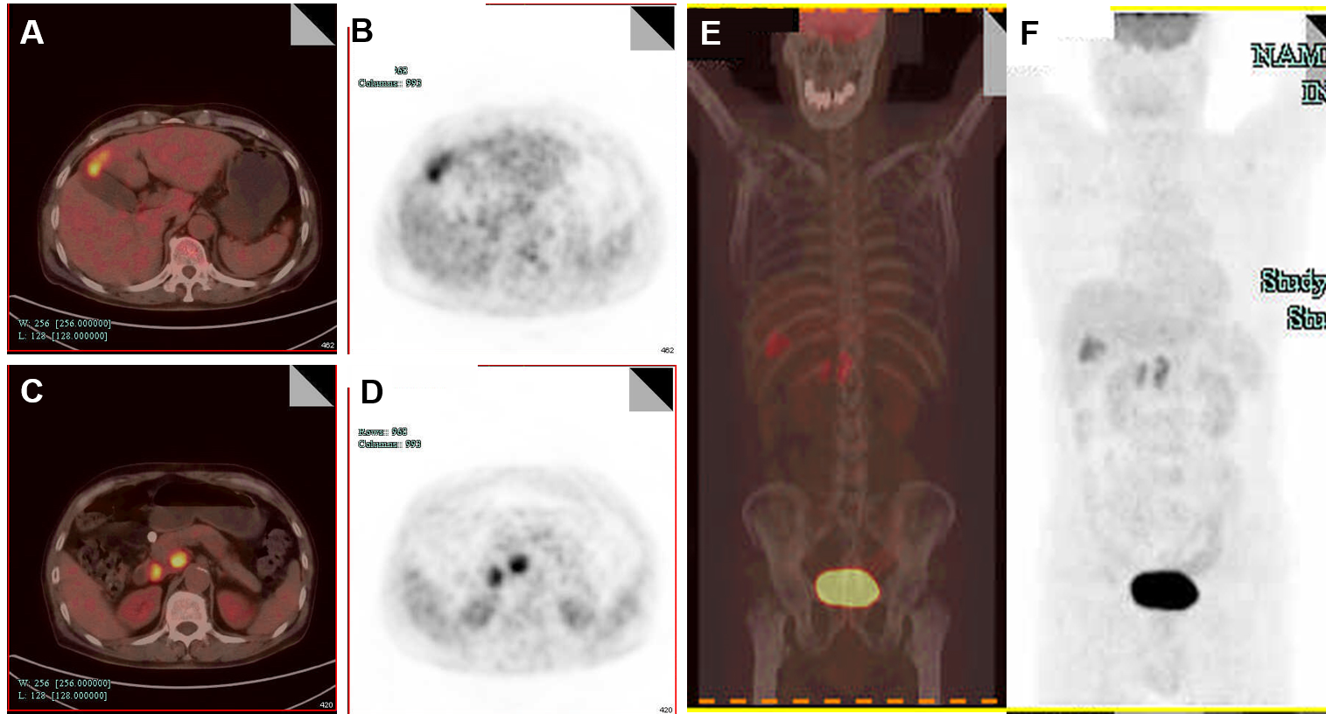
Figure 4 Positron emission tomography examination. A, B: Fluorodeoxyglucose uptake was higher in the gallbladder; C, D: Fluorodeoxyglucose uptake was higher in lymph nodes in the portacaval space; E, F: Fluorodeoxyglucose uptake did not significantly increase in other tissue.

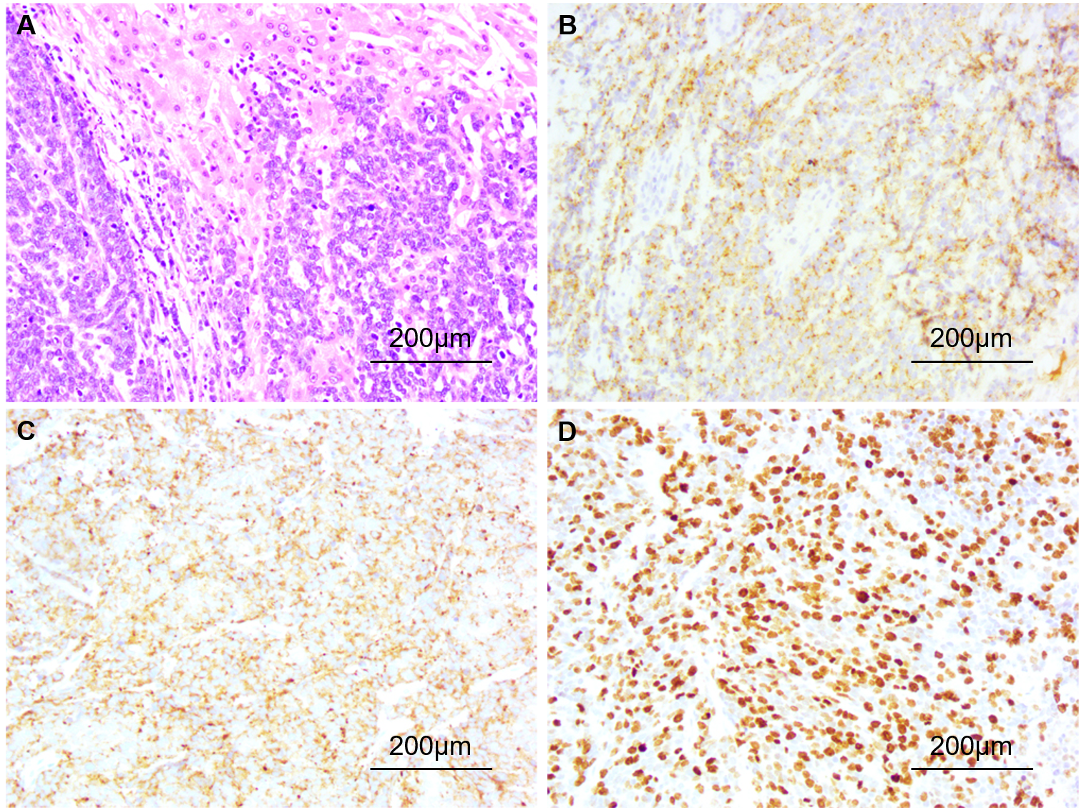
Figure 5 Pathological examination and immunohistochemical staining (20 ×). A: Hematoxylin and eosin staining revealed poorly differentiated gallbladder neuroendocrine carcinoma with liver invasion; B: Immunohistochemical staining revealed positive expression of chromogranin A; C: Immunohistochemical staining revealed positive expression of synaptophysin; D: Immunohistochemical staining revealed that the Ki-67 index was > 80%.

Table 1 Patient details, neoplasm localization, pathology, treatment, and follow-up of reported functional gallbladder neuroendocrine neoplasms
Case | Ref. | Age in yr, sex | Presentation | Physical examination | Primary site | Pathology | Treatment | Follow-up
1 | Monier et al^{[12]} | 60, M | Epigastric pain, jaundice, flushing, cough, wheezing | NA | fundus of GB | Size: NA; PI: ~ 60%; IHC: Chromogranin A (+), synaptophysin (+), CD56 (+), CK7 (+), polyclonal carcinoembryonic antigen (+), Caudal-type homeobox transcription factor 2 (+), S-100 (−), CK20 (−), CD10 (−), CK19 (−), prostate-specific antigen (−),thyroid transcription factor-1 (−), HepParl (−) | NA | NA
2 | Lin et al^{[13]} | 65, F | 3 mo progressive generalized weakness and anorexia | Proximal muscle weakness, hirsutism, moon face, buffalo hump | Body of GB | Size: NA; PI: NA; IHC: Chromogranin (+), synaptophysin (+), adrenocorticotropic hormone -stain (+) | Cholecystectomy and wedge-shaped liver resection | Hepatic metastasis 2 mo after surgery
3 | Howlett et al^{[14]} and Coates et al^{[15]} | 68, F | NA | Cushing’s syndrome | GB | Size: NA; PI: NA; IHC: Neuron specific enolase immunostaining (+) | NA | Survived for 1 mo following presentation
4 | Ahn et al^{[16]} | 52, F | Episodic hypoglycemia of 10 mo duration | NA | GB | Size: 10.3 cm × 7 cm × 5.3 cm; PI: NA; IHC: CD56 (+), chromogranin (+), synaptophysin (+), immunochemical staining for insulin (+) | Hepatic segmentectomy, cholecystectomy, pancreaticosplenectomy | NA
5 | Salimi et al^{[17]} | 79, M | Watery diarrhea, abdominal pain, and weakness for several weeks | NA | GB | Size: 0.5 cm in thickness and 1.5 cm in diameter; PI: NA; IHC: Neuron specific enolase immunostaining (+), chromogranin (+) | NA | The patient died on his 3rd day of hospitalization from multiple organ failure
6 | Present case | 65, M | A history of flushing for 2 mo | The skin over face, neck, upper chest and limbs flushed and was scaly | neck of GB | Size: 4.0 cm × 2.0 cm; PI: Ki-67 (80%+++); IHC: Chromogranin A (+), synaptophysin (+), pan-CK (+), CK19 (+), CD56 (+), thyroid transcription factor-1 (a few +), CK7 (−), glypican-3 (−) | En bloc cholecystectomy, resection of hepatic segment IVb and V, Whipple and regional lymphadenectomy were performed | The skin became flushed in 3rd month after surgery and the patient passed away in 7th month.
M: Male; F: Female; NA: Not available; GB: Gallbladder; PI: Proliferation index; IHC: Immunohistochemistry; CD: Cluster of differentiation; CK: Cytokeratin.

