Name of journal: World Journal of Gastrointestinal Endoscopy
ESPS Manuscript NO: 15008
Columns: MINIREVIEWS

Optimal management of biopsy-proven low-grade gastric dysplasia

Kim JW et al. Management of low-grade gastric dysplasia

Jung-Wook Kim, Jae Young Jang

Jung-Wook Kim, Jae Young Jang, Division of Gastroenterology, Department of Internal Medicine, College of Medicine, Kyung Hee University, Seoul 130-702, South Korea

Author contributions: Kim JW wrote the paper; Jang JY designed and edited the paper.

Conflict-of-interest: The authors declare that they have no competing interests.

Open-Access: This article is an open-access article which was selected by an in-house editor and fully peer-reviewed by external reviewers. It is distributed in accordance with the Creative Commons Attribution Non Commercial (CC BY-NC 4.0) license, which permits others to distribute, remix, adapt, build upon this work non-commercially, and license their derivative works on different terms, provided the original work is properly cited and the use is non-commercial. See: http://creativecommons.org/licenses/by-nc/4.0/

Correspondence to: Jae Young Jang, MD, PhD, Division of Gastroenterology, Department of Internal Medicine, College of Medicine, Kyung Hee University, 1 Hoegi-dong Dongdaemun-gu, Seoul 130-702, South Korea. jyjang@khu.ac.kr

Telephone: +82-2-9588200
Fax: +82-2-9681848
Received: November 3, 2014
Peer-review started: November 4, 2014
First decision: November 27, 2014
Revised: December 22, 2014
Accepted: Janurary 15, 2015
Article in press:
Published online:

Abstract
Gastric adenocarcinoma generally culminates via the inflammation–metaplasia–dysplasia-carcinoma sequence progression. The prevalence of gastric adenomas shows marked geographic variation. Recently, the rate of diagnosis of low-grade dysplasia (LGD) has increased due to increased use of upper endoscopy. Many investigators have reported that gastric high-grade dysplasia has high potential for malignancy and should be removed; however, the treatment for gastric LGD remains controversial. Although the risk of LGD progression to invasive carcinoma has been reported to be inconsistent, progression has been observed during follow-up. Additionally, the rate of upgraded diagnosis in biopsy-proven LGD is high. Therefore, endoscopic resection (ER) may be useful in the treatment and diagnosis of LGD, especially if lesions are found to have risk factors for upgraded histology after ER, such as large size, surface erythema or depressed morphology. Fatal complications in endoscopic submucosal dissection (ESD) are extremely low and its therapeutic and diagnostic outcomes are excellent. Therefore, ESD should be applied preferentially instead of endoscopic mucosal resection.

Key words: Intraepithelial neoplasia; Low-grade dysplasia; Adenoma; Endoscopic resection; Endoscopic submucosal dissection

© The Author(s) 2015. Published by Baishideng Publishing Group Inc. All rights reserved.

Core tip: According to the guideline, endoscopic resection or follow-up is recommended for noninvasive category 3 low-grade dysplasias (LGDs), while category 4 lesions such as high-grade dysplasia, non-invasive carcinoma and intramucosal carcinoma should be removed by local resection. However, as LGD has a relatively high underdiagnosis rate and rarely contains submucosal cancer, a follow-up strategy might result in the opportunity for endoscopic therapy being missed. Furthermore, repeated endoscopic examinations with biopsies might impose a psychological and financial burden on the patient. Based on its efficacy and safety, the use of endoscopic submucosal dissection as a primary procedure for LGD should be considered.

Kim JK, Jang JY. Optimal management of biopsy-proven low-grade gastric dysplasia. World J Gastrointest Endosc 2015; In press

INTRODUCTION
Gastric cancer (GC) is the fourth-most common cancer and the second-leading cause of cancer-related deaths worldwide, and is especially prevalent in Asia-Pacific countries, including Korea^{[1]}. In general, gastric adenocarcinoma culminates via the inflammation–metaplasia–dysplasia–carcinoma sequence progression, which is described as the Correa cascade of multi-step gastric carcinogenesis^{[2]}. Gastric atrophy and intestinal metaplasia are lesions that confer a high risk for the development of gastric adenocarcinoma, and gastric epithelial dysplasia (GED) is considered the penultimate stage of gastric carcinogenesis^{[3,4]}. Understanding the clinicopathological characteristics of GC is important for prevention. Along with the increasing number of endoscopies performed, the detection of precancerous lesions has increased in clinical practice^{[5]}.
The prevalence of gastric adenomas shows marked geographic variation. The reported prevalence is approximately 0.5%-3.75% in western countries and ~9%-20% in Asian countries where the prevalence of GC is high^{[6-8]}. Some precancerous lesions progress to adenocarcinoma, whereas others remain unchanged for an extended period of time^{[9,10]}. Furthermore, irrespective of used classification, several studies have demonstrated inter-observer variation in the histological assessment of GED^{[11-13]}. Therefore, it is difficult to establish coincident international guidelines for the management of such lesions.
This review discusses the current optimal strategies for managing gastric low-grade dysplasia (LGD). In preparation for this review, we searched for epidemiological studies, clinical studies, meta-analyses and published guidelines related to GED in the Medline and PubMed databases. The search was performed using index words related to LGD (“gastric epithelial dysplasia” or “low grade dysplasia” or “gastric adenoma” or “gastric dysplasia”) and treatment (“endoscopic resection” or “endoscopic submucosal dissection”).

DEFINITION
Dysplasia is defined as an unequivocally neoplastic but non-invasive lesion, distinguished from regenerative changes^{[14]}. Used initially to define inflammatory bowel diseases, the term is currently applied throughout the gastrointestinal tract and other organs. Grundmann^{[15]} first used the term gastric dysplasia, and the World Health Organization (WHO) defined dysplasia as cellular atypia, abnormal differentiation and disorganized architecture^{[4,6]}. Conventionally, dysplasia was a term used to describe flat or depressed lesions, whereas adenoma described raised circumscribed lesions that were either sessile or pedunculated. Therefore, a WHO committee defined adenoma as a circumscribed benign neoplasm composed of tubular and/or villous structures lined by dysplastic epithelium. On the other hand, Lewin^{[16]} defined adenoma as a circumscribed lesion unassociated with underlying inflammation whether pedunculated, sessile, flat or depressed; and dysplasia was defined as a benign neoplastic lesion associated with underlying inflammation. However, most clinicians use these terms widely without distinction between adenoma and dysplasia in clinical practice.
Although the biological potential of GED as a precancerous lesion is clear, the classification of these lesions has been controversial in the diagnostic approach. For example, Japanese studies have referred to these lesions as borderline (Group 3 or 4), while the terms gastric adenoma or dysplasia have been used widely in western countries (Table 1)^{[12,17]}. Because dysplasia implies carcinoma in Japan, pathologists are reluctant to use the term gastric adenoma with LGD^{[18]}. Furthermore, intraepithelial gastric neoplasias are classified into adenoma or carcinoma with low and high-grade cytological atypia^{[19]}. Therefore, the term adenoma with low-grade atypia has been substituted for dysplasia in Japan. From the Japanese viewpoint, gastric adenoma with LGD diagnosed using western criteria include typical adenomas of the small intestinal type and tubular structures, and are thus diagnosed as carcinoma without invasion in Japan^{[18]}. The Vienna classification for GED was proposed as a consensus between western and Asian countries (Table 1)^{[11,20]}. In this classification, dysplastic lesions without invasion of the lamina propria are placed as category 3 or 4 according to the degree of cytologic atypia or architectural complexity^{[9,11]}. Category 3 is a non-invasive low-grade neoplasia, also known as low-grade adenoma/dysplasia. Currently, the WHO recommends the terminology of non-invasive low-grade and high-grade intraepithelial neoplasia and defines carcinoma as invasion into the lamina propria or beyond^{[21]}.

NATURAL HISTORY
Although several studies have addressed the risk of carcinoma in GED^{[22-24]}, its natural course remains unclear. A large cohort study from the Netherlands suggested that the risk of progression to cancer within 10 years was 3.9% in individuals with LGD^{[25]}. The differences among previous studies regarding the natural course of LGD are due primarily to the differences in diagnostic criteria including the classification and grading (Table 1). Additional reasons for these differences include sampling error in forceps biopsy, discrepancies between forceps biopsy and endoscopic resection (ER), and variations in the rate of malignant transformation. As mentioned earlier, noninvasive intramucosal neoplastic lesions with high-grade cellular and architectural atypia are termed intramucosal carcinoma in Japan, whereas the same lesions are diagnosed as high-grade dysplasia (HGD) by most pathologists in western countries^{[26]}. Under these definitions, lesions diagnosed as gastric adenomas in Japan rarely progress to cancer^{[18]}. Yamada et al^{[27]} reported follow-up data for 48 gastric adenomas (38 LGD and 10 HGD) with a median of 4.7 years. During the follow-up period, 37 (97%) LGD lesions showed no histological change, while the remaining lesions progressed to HGD. However, this description of an indolent natural course may have been influenced by selection bias and the use of different LGD classifications in Japan. LGD lesions with invasive carcinoma were more likely to be excluded at the time of the first biopsy. Additionally, a substantial number of patients were excluded since they underwent ER or surgery due to a larger lesion or greater malignant potential. Therefore, half of the patients (19/38) in the study had lesions < 0.5 cm, with most lesions (76.3%, 29/38) measuring < 1 cm. This selection bias may influence a favorable LGD prognosis^{[28]}. In contrast, Rugge et al^{[29]} performed a prospective long-term follow-up study to evaluate the clinicopathological behavior of GED. A total of 118 gastric non-invasive neoplasias, including 90 LGDs, were followed for a mean of 52 months. Among 90 LGDs, 48 (53.3%) were no longer detectable and 28 (31.1%) were unchanged; however, 14 (15.5%) LGDs evolved into HGD and GC.
To date, few studies have determined the predictors for malignant transformation of GEDs^{[30-32]}. Gastric inflammation is a well-known risk factor for gastric carcinoma^{[33,34]}. Correa^{[2]} postulated that chronic gastritis may lead to intestinal metaplasia and atrophy, and that these lesions should be considered a GC risk factor as they are frequently found to be closely related to cancer. In a study that evaluated the endoscopic, pathological and immunophenotypic differences in LGD and HGD lesions according to the revised Vienna classification, Jung et al^{[32]} determined that the size, color change and ulceration of the lesion, as well as gastritis score of the surrounding mucosa and positive expression of MUC6, were risk factors for malignant transformation. Because of the use of different diagnostic criteria and ethical reason, it is difficult to confirm a consistent natural history of LGD at present. Recent observational studies have indicated that the cancer progression risk of LGD is relatively low^{[27,29]}. Nonetheless, it is possible that LGD can progress to invasive carcinoma^{[24,29,35]}. Therefore, further studies are needed to understand the natural course of LGD to determine the most effective management option for follow-up treatment.

DISCREPANCIES BETWEEN BIOPSY AND ER
The endoscopic forceps biopsy (EFB) is crucial for grading pre-neoplastic gastric lesions and determining an appropriate treatment strategy. Because EFB specimens are not representative of the entire lesion, significant histologic discrepancies have been found between diagnoses based on EFB and subsequent ER (Figure 1). Recent advances in technology such as image-enhanced endoscopy with narrow-band imaging have led to improvements in the diagnostic accuracy of gastric lesions. However, the discrepancy between pre-endoscopic and post-ER diagnoses remains a concern^{[36]}. Several studies have indicated that pretreatment EFB is inadequate for obtaining a correct diagnosis. We retrospectively reviewed 285 lesions that were initially diagnosed as LGD by EFB^{[37]}. After ER, 46 LGDs (16.1%) showed an upgraded histology: 22 HGD (7.7%) and 24 differentiated adenocarcinoma (8.4%)^{[37]}. In another study from Korea, Kim et al^{[38]} reported that the histologic discrepancy rate was 18.7% (51/273) in LGDs detected using forceps biopsy. Among 51 upgraded lesions, 24 lesions (8.8%) were upgraded to a diagnosis of adenocarcinoma.
Discrepancies in EFB and ER diagnoses contribute to the suboptimal treatment of biopsy-proven LGDs. Therefore, it is essential to identify the risk factors affecting these discrepancies for the proper management of LGD. We found that a lesion size ≥ 2 cm, surface erythema and a depressed-type lesion were significant predictors of upgraded LGDs. Several studies have reported similar results regarding the endoscopic risk factors for histologic discrepancies in patients with LGD (Figure 2). Kim et al^{[38]} reported that lesion size and the presence of spontaneous bleeding were significant factors predicting an upgraded histology after ER; in contrast, the presence of whitish discoloration was a significant negative factor. In a different retrospective study, Cho et al^{[28]} demonstrated that a lesion size ≥ 1 cm, depressed morphology, and erythema were significantly associated with HGD and carcinoma. In a study from Japan^{[39]}, a lesion size > 2 cm and depressed appearance were significant independent factors suggesting cancer. To summarize, lesions of larger size and morphology with surface erythema and depression in biopsy-proven LGDs were predictive of an upgraded histology after ER. Therefore, when selecting treatment methods for these lesions, the collection method of the suspected malignant foci should be taken into consideration. ER should be considered for diagnostic and therapeutic purposes in lesions with these risk factors.

MANAGEMENT
In developing a therapeutic plan for LGD management, it is important to identify LGDs that have histological and classical risk factors for GC progression. In Korea, ERs—including endoscopic mucosal resection (EMR) and endoscopic submucosal dissection (ESD)-are performed widely for the treatment of gastric adenoma, in which early GC and gastric adenoma are prevalent. According to the revised Vienna classification, ER or follow-up is recommended for noninvasive category 3 LGD lesions, while category 4 lesions such as HGD, non-invasive carcinoma and intramucosal carcinoma should be removed by endoscopic or surgical resection^{[20]}. Some investigators have suggested regular endoscopic surveillance with repetitive biopsy, while others have proposed ER for accurate diagnosis and treatment of LGDs. As mentioned earlier, various factors account for these discrepancies, including differences in diagnostic criteria, inconsistent results among studies of the natural course in LGD, and histologic discrepancies in EFB and ER.
Recent advances in endoscopic techniques have enabled the removal and histological diagnosis of most intra-mucosal lesions regardless of size, shape and location in the stomach^{[40]}. However, performing resections in all patients with LGDs with relatively low malignant potential may lead to significant increases in cost, procedure time, risk of complication, and requirement for advanced technical skills. Although EMR is an easily and rapidly applicable method for therapeutic and diagnostic modalities, it has some limitations. Conventional EMR techniques are unreliable for lesion > 2 cm in diameter due to high rates of positive lateral and/or deep resection margins^{[41,42]}. Even in lesions < 2 cm, the complete resection rate with EMR was 33%-76%^{[43,44]}. Lesion factors, such as tumor size and location, contribute to the difficulty of en bloc resection. To overcome these problems, the development of ESD has allowed complete resection regardless of tumor size and location. In a meta-analysis^{[45]}, ESD was significantly more effective than EMR for en bloc resection, complete resection, curative resection and local recurrence. Whereas intra-operative bleeding, perforation risk, and operation time were significantly greater for ESD, overall bleeding risk and all-cause mortality did not differ significantly between ESD and EMR. One meta-analysis^{[46]} showed that procedure-related bleeding (OR = 2.2, 95%CI: 1.58-30.7) and perforation rates (OR = 4.09, 95%CI: 2.47-6.80) during ESD were much higher compared with those for EMR. However, these were not statistically significant in another meta-analysis including 12 studies^{[45]}. Both studies^{[45,46]} showed that ESD was more time-consuming.
Several studies have evaluated endoscopic techniques as a treatment for LGD. Kim et al^{[47]} compared the therapeutic outcomes of ESD and EMR in histologically confirmed LGD cases. The en bloc resection rate was significantly lower in the EMR groups (31.1%) compared with the ESD group (75.0%) (P < 0.001). However, no significant difference was observed in the prevalence of remnant lesion or recurrence rate (P = 0.911). On the other hand, Choi et al^{[48]} reported a 96.1% complete resection rate using ESD, and the local recurrence rate was 1.4% in patients with biopsy-proven LGD. In this study, no patient had perforation and four (1.4%) patients had significant post-ESD bleeding that was treatable by endoscopic intervention. A multicenter study by the Osaka University ESD study group^{[49]} analyzed a total of 468 subjects with GED. The results showed that the complete en bloc resection rate was 97%, and the incidences of post-ESD bleeding, perforation and serious complication were 5.5%, 4.7% and 0.43%, respectively. Miyamoto et al^{[50]} reported that tumor size and location of the lesion are important factors that affect the success rate of en bloc resection. Because not all lesions can be resected en bloc for technical difficulty, another treatment option such as ablation therapy should be considered for the treatment of LGDs^{[51]}.
As LGD has a relatively high underdiagnosis rate and rarely contains submucosal cancer, a follow-up strategy might result in the opportunity for endoscopic therapy being missed^{[49]}. Furthermore, repeated endoscopic examinations with biopsies might impose a psychological and financial burden on the patient. Based on its efficacy and safety, the use of ESD as a primary procedure for LGD should be considered.

CONCLUSION
The increased use of upper endoscopy has resulted in increased diagnosis of gastric adenoma. Although many investigators have suggested that gastric HGD should be removed due to its high potential for malignancy^{[20]}, the treatment of gastric LGD remains controversial. Although previous studies have reported inconsistent results regarding the risk of LGD progression to invasive carcinoma, such progression can occur during follow-up. Additionally, the rate of upgraded diagnosis in biopsy-proven LGDs is high. Considering these results, the use of ER might enhance treatment and diagnosis, especially of lesions with risk factors such as large size, surface erythema or depressed morphology. Furthermore, the incidence of fatal complications of ESD has been extremely low, with excellent therapeutic and diagnostic outcomes. Therefore, ESD should be applied in preference to EMR.

REFERENCES
1 Kamangar F, Dores GM, Anderson WF. Patterns of cancer incidence, mortality, and prevalence across five continents: defining priorities to reduce cancer disparities in different geographic regions of the world. J Clin Oncol 2006; 24: 2137-2150 [PMID: 16682732 DOI: 10.1200/JCO.2005.05.2308]
2 Correa P. A human model of gastric carcinogenesis. Cancer Res 1988; 48: 3554-3560 [PMID: 3288329]
3 Ming SC, Bajtai A, Correa P, Elster K, Jarvi OH, Munoz N, Nagayo T, Stemmerman GN. Gastric dysplasia. Significance and pathologic criteria. Cancer 1984; 54: 1794-1801 [PMID: 6478415 DOI: 10.1002/1097-0142(19841101)54: 9<1794: : AID-CNCR2820540907>3.0.CO; 2-W]
4 Morson BC, Sobin LH, Grundmann E, Johansen A, Nagayo T, Serck-Hanssen A. Precancerous conditions and epithelial dysplasia in the stomach. J Clin Pathol 1980; 33: 711-721 [PMID: 7430384 DOI: 10.1136/jcp.33.8.711]
5 Yeh JM, Hur C, Kuntz KM, Ezzati M, Goldie SJ. Cost-effectiveness of treatment and endoscopic surveillance of precancerous lesions to prevent gastric cancer. Cancer 2010; 116: 2941-2953 [PMID: 20564399 DOI: 10.1002/cncr.25030]
6 Serck-Hanssen A. Precancerous lesions of the stomach. Scand J Gastroenterol Suppl 1979; 54: 104-105 [PMID: 295493]
7 Farinati F, Rugge M, Di Mario F, Valiante F, Baffa R. Early and advanced gastric cancer in the follow-up of moderate and severe gastric dysplasia patients. A prospective study. I.G.G.E.D.--Interdisciplinary Group on Gastric Epithelial Dysplasia. Endoscopy 1993; 25: 261-264 [PMID: 8330542 DOI: 10.1055/s-2007-1010310]
8 Bearzi I, Brancorsini D, Santinelli A, Rezai B, Mannello B, Ranaldi R. Gastric dysplasia: a ten-year follow-up study. Pathol Res Pract 1994; 190: 61-68 [PMID: 8065990 DOI: 10.1016/S0344-0338(11)80497-8]
9 Kamiya T, Morishita T, Asakura H, Miura S, Munakata Y, Tsuchiya M. Long-term follow-up study on gastric adenoma and its relation to gastric protruded carcinoma. Cancer 1982; 50: 2496-2503 [PMID: 7139542 DOI: 10.1002/1097-0142(19821201)50: 11<2496: : AID-CNCR2820501140>3.0.CO; 2-1]
10 Orlowska J, Jarosz D, Pachlewski J, Butruk E. Malignant transformation of benign epithelial gastric polyps. Am J Gastroenterol 1995; 90: 2152-2159 [PMID: 8540506]
11 Schlemper RJ, Riddell RH, Kato Y, Borchard F, Cooper HS, Dawsey SM, Dixon MF, Fenoglio-Preiser CM, Fléjou JF, Geboes K, Hattori T, Hirota T, Itabashi M, Iwafuchi M, Iwashita A, Kim YI, Kirchner T, Klimpfinger M, Koike M, Lauwers GY, Lewin KJ, Oberhuber G, Offner F, Price AB, Rubio CA, Shimizu M, Shimoda T, Sipponen P, Solcia E, Stolte M, Watanabe H, Yamabe H. The Vienna classification of gastrointestinal epithelial neoplasia. Gut 2000; 47: 251-255 [PMID: 10896917 DOI: 10.1136/gut.47.2.251]
12 Goldstein NS, Lewin KJ. Gastric epithelial dysplasia and adenoma: historical review and histological criteria for grading. Hum Pathol 1997; 28: 127-133 [PMID: 9023391 DOI: 10.1016/S0046-8177(97)90095-2]
13 Tosi P, Baak JP, Luzi P, Miracco C, Lio R, Barbini P. Morphometric distinction of low- and high-grade dysplasias in gastric biopsies. Hum Pathol 1989; 20: 839-844 [PMID: 2777240 DOI: 10.1016/0046-8177(89)90094-4]
14 Riddell RH, Goldman H, Ransohoff DF, Appelman HD, Fenoglio CM, Haggitt RC, Ahren C, Correa P, Hamilton SR, Morson BC. Dysplasia in inflammatory bowel disease: standardized classification with provisional clinical applications. Hum Pathol 1983; 14: 931-968 [PMID: 6629368 DOI: 10.1016/S0046-8177(83)80175-0]
15 Grundmann E. Histologic types and possible initial stages in early gastric carcinoma. Beitr Pathol 1975; 154: 256-280 [PMID: 165808 DOI: 10.1016/S0005-8165(75)80034-5]
16 Lewin KJ. Nomenclature problems of gastrointestinal epithelial neoplasia. Am J Surg Pathol 1998; 22: 1043-1047 [PMID: 9737235 DOI: 10.1097/00000478-199809000-00001]
17 Schlemper RJ, Kato Y, Stolte M. Review of histological classifications of gastrointestinal epithelial neoplasia: differences in diagnosis of early carcinomas between Japanese and Western pathologists. J Gastroenterol 2001; 36: 445-456 [PMID: 11480788 DOI: 10.1007/s005350170067]
18 Lee SY. Gastric adenoma with low-grade dysplasia: two countries, two outcomes. Dig Dis Sci 2014; 59: 235-237 [PMID: 24052193 DOI: 10.1007/s10620-013-2860-1]
19 Japanese Gastric Cancer Association. Japanese classification of gastric carcinoma: 3rd English edition. Gastric Cancer 2011; 14: 101-112 [PMID: 21573743 DOI: 10.1007/s10120-011-0041-5]
20 Dixon MF. Gastrointestinal epithelial neoplasia: Vienna revisited. Gut 2002; 51: 130-131 [PMID: 12077106 DOI: 10.1136/gut.51.1.130]
21 Hamilton S, Aaltonen L, editors. Pathology and genetics of tumours of the digestive system. Lyon, France: IARC Press, 2000
22 Ginsberg GG, Al-Kawas FH, Fleischer DE, Reilly HF, Benjamin SB. Gastric polyps: relationship of size and histology to cancer risk. Am J Gastroenterol 1996; 91: 714-717 [PMID: 8677935]
23 Tsujitani S, Furusawa M, Hayashi I. Morphological factors aid in therapeutic decisions concerning gastric adenomas. Hepatogastroenterology 1992; 39: 56-58 [PMID: 1568709]
24 Park SY, Jeon SW, Jung MK, Cho CM, Tak WY, Kweon YO, Kim SK, Choi YH. Long-term follow-up study of gastric intraepithelial neoplasias: progression from low-grade dysplasia to invasive carcinoma. Eur J Gastroenterol Hepatol 2008; 20: 966-970 [PMID: 18787462 DOI: 10.1097/MEG.0b013e3283013d58]
25 de Vries AC, van Grieken NC, Looman CW, Casparie MK, de Vries E, Meijer GA, Kuipers EJ. Gastric cancer risk in patients with premalignant gastric lesions: a nationwide cohort study in the Netherlands. Gastroenterology 2008; 134: 945-952 [PMID: 18395075 DOI: 10.1053/j.gastro.2008.01.071]
26 Lauwers GY, Srivastava A. Gastric preneoplastic lesions and epithelial dysplasia. Gastroenterol Clin North Am 2007; 36: 813-829, vi [PMID: 17996792 DOI: 10.1016/j.gtc.2007.08.008]
27 Yamada H, Ikegami M, Shimoda T, Takagi N, Maruyama M. Long-term follow-up study of gastric adenoma/dysplasia. Endoscopy 2004; 36: 390-396 [PMID: 15100945 DOI: 10.1055/s-2004-814330]
28 Cho SJ, Choi IJ, Kim CG, Lee JY, Kook MC, Park S, Ryu KW, Lee JH, Kim YW. Risk of high-grade dysplasia or carcinoma in gastric biopsy-proven low-grade dysplasia: an analysis using the Vienna classification. Endoscopy 2011; 43: 465-471 [PMID: 21425043 DOI: 10.1055/s-0030-1256236]
29 Rugge M, Cassaro M, Di Mario F, Leo G, Leandro G, Russo VM, Pennelli G, Farinati F. The long term outcome of gastric non-invasive neoplasia. Gut 2003; 52: 1111-1116 [PMID: 12865267 DOI: 10.1136/gut.52.8.1111]
30 Tsukashita S, Kushima R, Bamba M, Sugihara H, Hattori T. MUC gene expression and histogenesis of adenocarcinoma of the stomach. Int J Cancer 2001; 94: 166-170 [PMID: 11668493 DOI: 10.1002/ijc.1460]
31 Minematsu H, Saito Y, Kakinoki R, Andoh A, Kushima R, Fujiyama Y. Evaluation of mucin expression patterns in gastric borderline (group III) lesions. J Gastroenterol 2006; 41: 547-553 [PMID: 16868802 DOI: 10.1007/s00535-006-1798-x]
32 Jung SH, Chung WC, Lee KM, Paik CN, Jung JH, Lee MK, Lee YK, Chung IS. Risk factors in malignant transformation of gastric epithelial neoplasia categorized by the revised Vienna classification: endoscopic, pathological, and immunophenotypic features. Gastric Cancer 2010; 13: 123-130 [PMID: 20602200 DOI: 10.1007/s10120-010-0550-7]
33 Meining A, Bayerdörffer E, Müller P, Miehlke S, Lehn N, Hölzel D, Hatz R, Stolte M. Gastric carcinoma risk index in patients infected with Helicobacter pylori. Virchows Arch 1998; 432: 311-314 [PMID: 9565339 DOI: 10.1007/s004280050171]
34 Miehlke S, Hackelsberger A, Meining A, Hatz R, Lehn N, Malfertheiner P, Stolte M, Bayerdörffer E. Severe expression of corpus gastritis is characteristic in gastric cancer patients infected with Helicobacter pylori. Br J Cancer 1998; 78: 263-266 [PMID: 9683304 DOI: 10.1038/bjc.1998.475]
35 Rugge M, Farinati F, Baffa R, Sonego F, Di Mario F, Leandro G, Valiante F. Gastric epithelial dysplasia in the natural history of gastric cancer: a multicenter prospective follow-up study. Interdisciplinary Group on Gastric Epithelial Dysplasia. Gastroenterology 1994; 107: 1288-1296 [PMID: 7926493]
36 Mine T. The role of magnifying endoscopy in the diagnosis of early gastric carcinoma. J Gastroenterol 2006; 41: 397-398 [PMID: 16741625 DOI: 10.1007/s00535-006-1822-1]
37 Kim MK, Jang JY, Kim JW, Shim JJ, Lee CK, Chang YW, Choe BK. Is lesion size an independent indication for endoscopic resection of biopsy-proven low-grade gastric dysplasia? Dig Dis Sci 2014; 59: 428-435 [PMID: 23912249 DOI: 10.1007/s10620-013-2805-8]
38 Kim YJ, Park JC, Kim JH, Shin SK, Lee SK, Lee YC, Chung JB. Histologic diagnosis based on forceps biopsy is not adequate for determining endoscopic treatment of gastric adenomatous lesions. Endoscopy 2010; 42: 620-626 [PMID: 20623445 DOI: 10.1055/s-0030-1255524]
39 Kasuga A, Yamamoto Y, Fujisaki J, Okada K, Omae M, Ishiyama A, Hirasawa T, Chino A, Tsuchida T, Igarashi M, Hoshino E, Yamamoto N, Kawaguchi M, Fujita R. Clinical characterization of gastric lesions initially diagnosed as low-grade adenomas on forceps biopsy. Dig Endosc 2012; 24: 331-338 [PMID: 22925285 DOI: 10.1111/j.1443-1661.2012.01238.x]
40 Onozato Y, Ishihara H, Iizuka H, Sohara N, Kakizaki S, Okamura S, Mori M. Endoscopic submucosal dissection for early gastric cancers and large flat adenomas. Endoscopy 2006; 38: 980-986 [PMID: 17058161 DOI: 10.1055/s-2006-944809]
41 Tanabe S, Koizumi W, Kokutou M, Imaizumi H, Ishii K, Kida M, Yokoyama Y, Ohida M, Saigenji K, Shimao H, Mitomi H. Usefulness of endoscopic aspiration mucosectomy as compared with strip biopsy for the treatment of gastric mucosal cancer. Gastrointest Endosc 1999; 50: 819-822 [PMID: 10570343]
42 Inoue H, Takeshita K, Hori H, Muraoka Y, Yoneshima H, Endo M. Endoscopic mucosal resection with a cap-fitted panendoscope for esophagus, stomach, and colon mucosal lesions. Gastrointest Endosc 1993; 39: 58-62 [PMID: 8454147]
43 Oka S, Tanaka S, Kaneko I, Mouri R, Hirata M, Kawamura T, Yoshihara M, Chayama K. Advantage of endoscopic submucosal dissection compared with EMR for early gastric cancer. Gastrointest Endosc 2006; 64: 877-883 [PMID: 17140890 DOI: 10.1016/j.gie.2006.03.932]
44 Kojima T, Parra-Blanco A, Takahashi H, Fujita R. Outcome of endoscopic mucosal resection for early gastric cancer: review of the Japanese literature. Gastrointest Endosc 1998; 48: 550-54; discussion 550-54; [PMID: 9831855]
45 Park YM, Cho E, Kang HY, Kim JM. The effectiveness and safety of endoscopic submucosal dissection compared with endoscopic mucosal resection for early gastric cancer: a systematic review and metaanalysis. Surg Endosc 2011; 25: 2666-2677 [PMID: 21424201 DOI: 10.1007/s00464-011-1627-z]
46 Cao Y, Liao C, Tan A, Gao Y, Mo Z, Gao F. Meta-analysis of endoscopic submucosal dissection versus endoscopic mucosal resection for tumors of the gastrointestinal tract. Endoscopy 2009; 41: 751-757 [PMID: 19693750 DOI: 10.1055/s-0029-1215053]
47 Kim SY, Sung JK, Moon HS, Kim KS, Jung IS, Yoon BY, Kim BH, Ko KH, Jeong HY. Is endoscopic mucosal resection a sufficient treatment for low-grade gastric epithelial dysplasia? Gut Liver 2012; 6: 446-451 [PMID: 23170148 DOI: 10.5009/gnl.2012.6.4.446]
48 Choi CW, Kang DH, Kim HW, Park SB, Kim S, Cho M. Endoscopic submucosal dissection as a treatment for gastric adenomatous polyps: predictive factors for early gastric cancer. Scand J Gastroenterol 2012; 47: 1218-1225 [PMID: 22839759 DOI: 10.3109/00365521.2012.666674]
49 Kato M, Nishida T, Tsutsui S, Komori M, Michida T, Yamamoto K, Kawai N, Kitamura S, Zushi S, Nishihara A, Nakanishi F, Kinoshita K, Yamada T, Iijima H, Tsujii M, Hayashi N. Endoscopic submucosal dissection as a treatment for gastric noninvasive neoplasia: a multicenter study by Osaka University ESD Study Group. J Gastroenterol 2011; 46: 325-331 [PMID: 21107615 DOI: 10.1007/s00535-010-0350-1]
50 Miyamoto S, Muto M, Hamamoto Y, Boku N, Ohtsu A, Baba S, Yoshida M, Ohkuwa M, Hosokawa K, Tajiri H, Yoshida S. A new technique for endoscopic mucosal resection with an insulated-tip electrosurgical knife improves the completeness of resection of intramucosal gastric neoplasms. Gastrointest Endosc 2002; 55: 576-581 [PMID: 11923778]
51 Jung SJ, Cho SJ, Choi IJ, Kook MC, Kim CG, Lee JY, Park SR, Lee JH, Ryu KW, Kim YW. Argon plasma coagulation is safe and effective for treating smaller gastric lesions with low-grade dysplasia: a comparison with endoscopic submucosal dissection. Surg Endosc 2013; 27: 1211-1218 [PMID: 23076459 DOI: 10.1007/s00464-012-2577-9]
P-Reviewer: Baba H, Lai S S-Editor: Tian YL
L-Editor: E-Editor:

Table 1 Common reporting classifications of gastric epithelial neoplasia
Vienna classification^{[11,20]} | WHO^{[21]} | JGCA^{[19]}
1. Negative for neoplasia/dysplasia |  | Group 1; Normal tissue or non-neoplastic lesion
2. Indefinite for neoplasia/dysplasia |  | Group 2; Material for which diagnosis of neoplastic or non-neoplastic lesion is difficult
3. Noninvasive neoplasia, low grade  (low-grade adenoma/dysplasia) | Low-grade intraepithelial neoplasia | Group 3; Adenoma
4. Noninvasive neoplasia, high grade | High-grade intraepithelial neoplasia
4.1 High grade adenoma/dysplasia |  | Group 4; Neoplastic lesion that is suspected to be carcinoma
4.2. Noninvasive carcinoma |  | Group 5; Carcinoma
4.3. suspicious of invasive carcinoma
5. Invasive carcinoma | Carcinoma
WHO: World Health Organization; JGCA: Japanese Gastric Cancer Association.

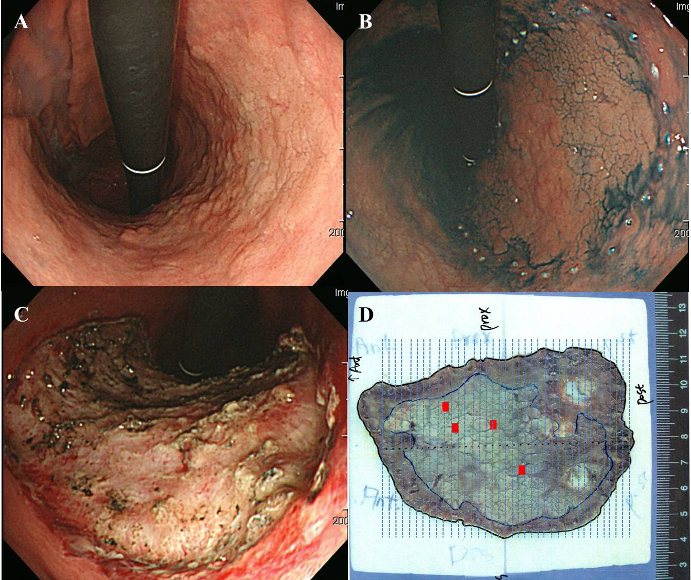
Figure 1 A lesion with a histologic upgraded from extended low-grade dysplasia to adenocarcinoma following endoscopic submucosal dissection. A: White light endoscopy reveals a large elevated mucosal lesion with nodularity in the lesser curvature side of the body. This lesion was diagnosed as LGD by the endoscopic forceps biopsy; B: This lesion is removed by ESD; C: A large mucosal defect is noted over the gastric body after ESD; D: Mapping of the resected specimen. The tumor size is 75 mm, focal cancer lesions (red bar) mixed with LGD are evident. The lateral and vertical margins are free from tumor. LGD: Low-grade dysplasia; ESD: Endoscopic submucosal dissection.
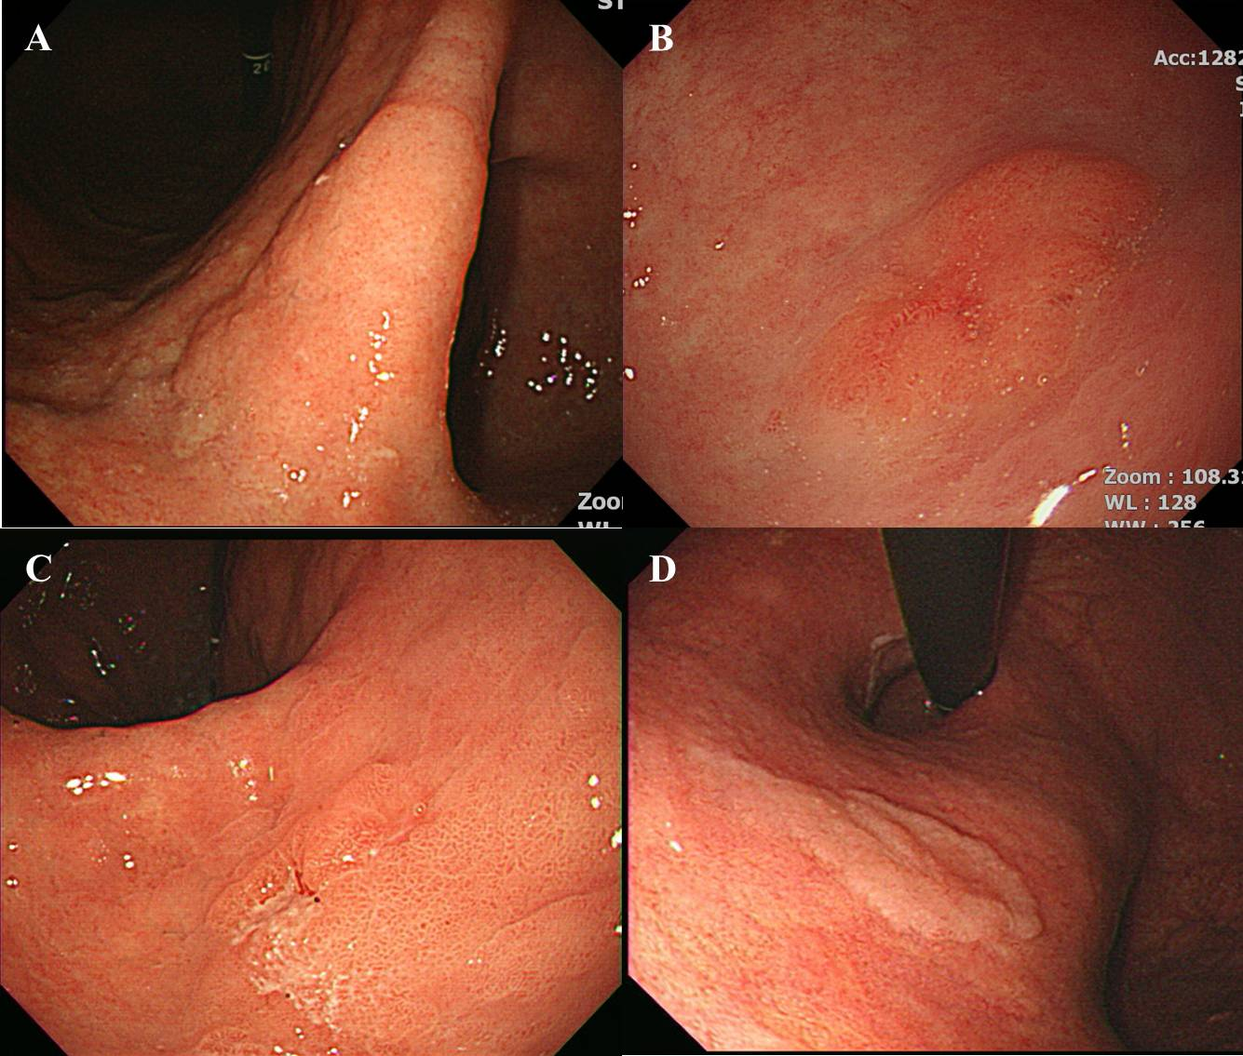
Figure 2 Endoscopic images of biopsy-proven low-grade dysplasia. A lesion size > 2 cm (A), surface erythema, and depressed appearance (C) are endoscopic risk factors for an upgraded histology after endoscopic resection; D: In contrast, the presence of whitish discoloration was a negative factor.

